Original Research Article

Quantitative Ethnobotanical Approach to Analyze Plants that Used for Skin Problem of
Local People in Damoh District, Madhya Pradesh, India.

.
ABSTRACT

Skin disorders are a worldwide health problem that normally affect human life. This study aimed to determine the traditional knowledge and the use of medicinal plants for the treatment of skin diseases among local people of study area. The information was obtained through open-ended, semi-structured questionnaires. The benefits, importance and coverage of ethnomedicine were expressed through several quantitative indices including Informant Consensus Factor (ICF), Use Value, Frequency of Citation (FC) and Relative Frequency of Citation (RFC). A total of 71 ethnomedicinal plant species, which were distributed in 67 genera under 40 families, were documented from 98 informants. Fabaceae, Asteraceae, and Euphorbiaceae were the majority of the cited families. The UV and RFC of different tree species ranged from 0.03 to 0.69 and 0.04 to 0.98, respectively. This quantitative information suggest that ethnobotanical knowledge could potentially guide the search for developing new nutraceutical products in the future.

Keywords: Skin disease, quantitative analysis, Local people, Frequency of Citation, Informant Consensus Factor.

1. INTRODUCTION

The skin is the largest and one of the most vital organs of the human body. It forms an interface between the body and the environment; hence it is adversely affected by different abiotic and biotic factors, (Rao, D. M., et al., 2006; Carman, H., 2009; Asong, J. A., et al., 2019). It performs salient functions to ensure the well-being of the human body such as sensory, disease control, protection, fluid maintenance, percutaneous absorption and temperature regulation (Carman, H., 2009; Adhikari, C., et al., 2023). Globally, skin infections contribute approximately 34% of occupational health diseases (Hay, R. J., et al., 2014). These infections cut across all ages and present a major problem to public health in both developed and developing countries (Abbasi, A. M., et al., 2010; De Wet, H., Nciki, S., & van Vuuren, S. F., 2013). The symptoms associated with skin infections are highly visible to the patients and other people and impact negatively on the well-being of affected individuals, (Carman, H., 2009). Herbal medicine refers to the study of traditional medical practice, which interacts with the social and cultural impacts of health, disease and illness, as well as the process of finding health care and healing practices, (Maurya, D., et al., 2021; Sarkar, K., et al., 2023).
Medicinal plants are the backbone of traditional medicine, which means more than 3.3 billion people in the less developed countries utilize medicinal plants on a regular basis, (Topno, S. C., & Sinha, M. R., 2018; Davidson-Hunt, I., 2000). Before the introduction of chemical medicines, man relied on the healing properties of medicinal plants. Some people value these plants due to the ancient belief which says plants are created to supply man with food, medical treatment, and other effects (Ahvazi, M., et al., 2012). Plants have been an obligatory source of innate products for their relief from illness for many years. The forest is referred toas God’s own pharmacy (Nanadini, N., 2014). The World Health Organization (WHO, 2000), estimates that as much as 80%of the world’s population is currently using some type of herbal treatment. Skin diseases are numerous and a frequently occurring health problem affecting all ages from the neonates to the elderly and cause harm in number of ways, (Tabassum, N., & Hamdani, M., 2014; Gupta, P., 2017). Maintaining healthy skin is important for a healthy body, (Verdier‐Sévrain, S., & Bonté, F., 2007). Many people may develop skin diseases that affect the skin, including cancer, herpes, cellulitis, leprosy, eczema, leukoderma, acne, scabies, etc., (Topno, S. C., & Sinha, M. R., 2018; Adhikari, C., et al., 2021). Some wild plants and their parts are frequently used to treat these diseases (Lense, O., 2012; Maurya, D., et al., 2022). The use of plants is as old as the mankind. Natural treatment is cheap and claimed to be safe. It is also suitable raw material for production of new synthetic agents (Al-Sereiti, M. R., Abu-Amer, K. M., & Sen, P., 1999). The therapeutic properties of medicinal plants are conditioned by the presence in their organs of active substances, such as alkaloids, flavonoids, glycosides, vitamins, tannins and coumarin compounds, which physiologically affect the bodies of humans and are biologically active in relation to the causative agents of various diseases, (Oluwabunmi, I. J., & Abiola, T., 2015). The main objective of this study was to explore and document the plants species that use for treatment of skin problem of local people of Damoh district of Madhya Pradesh.

2. material and methods

2.1. Study area
Damoh District lies between 23˚9’ and 24˚27’ North latitude and between 79˚3’ and 79˚57’ East longitude in the Northern part of Jabalpur Division (fig. 1). The shape of the district is irregular and elongated from North to South with projection in the East and West. It is at an average elevation of 595 meters (1,952 ft). The district is bounded by the district of Chhatarpur in the North and Northwest, Sagar in the West, Narsinghpur and Jabalpur in the South and part of Jabalpur and Panna in the East. The total geographical area is 7306 Sq.km. In the recent years forests are restricted only to the hilly areas which are not suitable for cultivation, (Maurya, D., et al., 2025). According to the information of the district forest office of the region total area covered by the government forests in the region under study comes to about 3043 sq. kms. and the forests are classified as –
1. Reserved Forest - 615 sq. kms (20 per cent)
2. Protected Forest - 2428 sq. kms (80 per cent)
The region has an almost ideal proportion of forest as 20 per cent the total geographical area of the region and the reserved forest in the area were demarcated as early as in the year 1879 the reserved forests are still under the scientific management of government, (Maurya, D., et al., 2023).
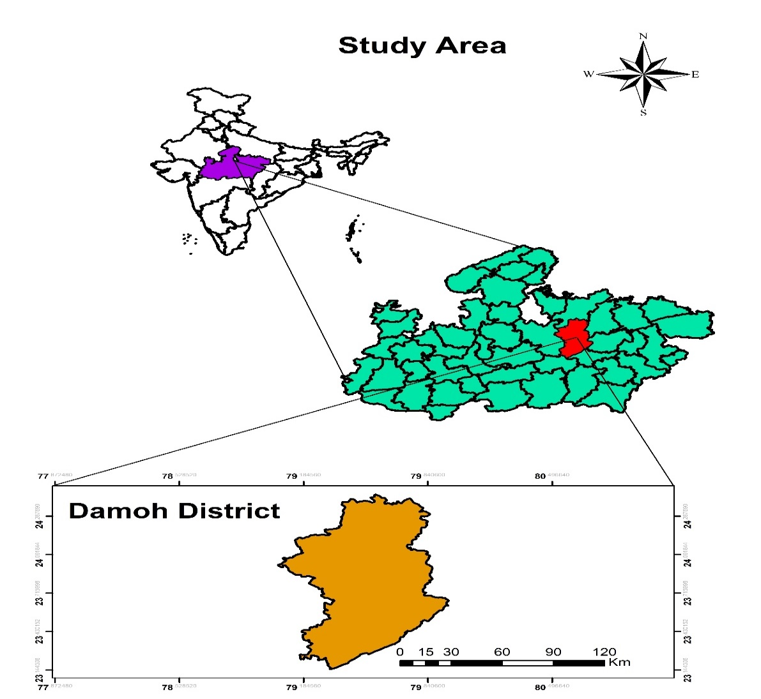
Figure 1 Map of study area
2.2. Ethnobotanical survey
Field Studies was conducted in regular intervals in different seasons between 2021 and 2022 to collect the primary data. The questionnaire was designed to obtain information about the locality; socio-demographic details (age, gender and educational background); types of skin disorders treated by the plants, local names of plants mentioned, parts used, method of preparation.
2.3. Quantitative Ethnobotany
Data collected through interviews of the informant were analyzed using four quantitative indices: (a) use value, (b) Frequency of Citation (FC), (c) informant consensus factor (ICF) and (d) Relative frequency citation (RFC):
2.3.1. Informant Consensus Factor (ICF)
Informant Consensus Factor, (Heinrich, M., et al., 1998; Trotter, R. T., & Logan, M. H., 2019), was calculated using the following formula:
FIC = Nur − Nt/ (Nur − 1)
Where, “Nur” refers to the total number of use reports for each disease cluster and “Nt” refers the total number of species used for that cluster. This formula was used to find out the homogeneity in the ethnomedicinal information documented from the traditional informants.
2.3.2. Use Value
According to (Phillips, O., 1994), the UV was calculated using the following formula:
UV =X/N
Where, “U” refers to the number of uses mentioned by the informants for a given species and “N” refers to the total number of informants interviewed. If a plant secures a high UV score that indicates there are many use reports for that plant, while a low score indicates fewer use reports cited by the informants.
2.3.3. Frequency of Citation (FC)
The FC was calculated as follows:
FC = (Number of times a particular species was mentioned/)
(total number of times that all species were mentioned) × 100.
2.3.4. Relative Frequency of Citation (RFC)
The RFC index, (Tardío, J., & Pardo-de-Santayana, M., 2008), was evaluated by dividing the number of informants who mentioned the use of the species (FC) by the total number of informants participating in the survey (N). The RFC index ranges from “0” when nobody referred to a plant as useful to “1” when all informants referred to a plant as useful.
RFC = FC/N.
2.4. Statistical analysis
All statistical analyses were performed using the Microsoft Excel for preparation of table and making of graph and plants were analyzed regarding their habits of plants, and plant parts used in treatment of skin diseases, frequency in families, and quantitative ethnobotany analysis including (a) use value, (b) Frequency of Citation (FC), (c) informant consensus factor (ICF) and (d) Relative frequency citation (RFC).

3. results and discussion

3.1. Socio-demographic information
A total of 98 people who participated in the survey, 46 were women (46.94%) and 52 were men (53.06%). The family status is married category is (62.24%) and unmarried category is (37.76%). The Age classes is divided in five categories of age class <30 (23.47%) age class 30-39 (19.39%), age class 40-49 (32.65%), age class 50-59 (22.45%), and age class >60 (2.04%). Regarding the education level, the illiteracy rate is 25.51%; primary school level represented 34.69%, secondary school level represented 21.43%, tertiary school level represented 11.22%, while relatively high levels represented 7.14%. The occupation of informant is, farmer- 41.84%, labor-30.61%, students-23.47%, and traditional health has 3.06%. This all information is show in table 1.
Table 1 All Socio-demographic information
3.2. Floristics diversity of plant species
During the present study a totals number of plant species is 71 belong 40 families and 67 genera is recoded during survey periods. The most dominated families are Fabaceae (11), Asteraceae (4), Euphorbiaceae (4), Amaranthaceae (3) and Convolvulaceae (3) numbers of species recoded. The given (fig.2) is showing top ten families recoded maximum numbers of species. Other information about plant species including scientific name, common name, family, habits, plant part use, mode of preparation, type of skin disease, frequency of citation (FC), Relative frequency citation (RFC) and use value is given in table 2.
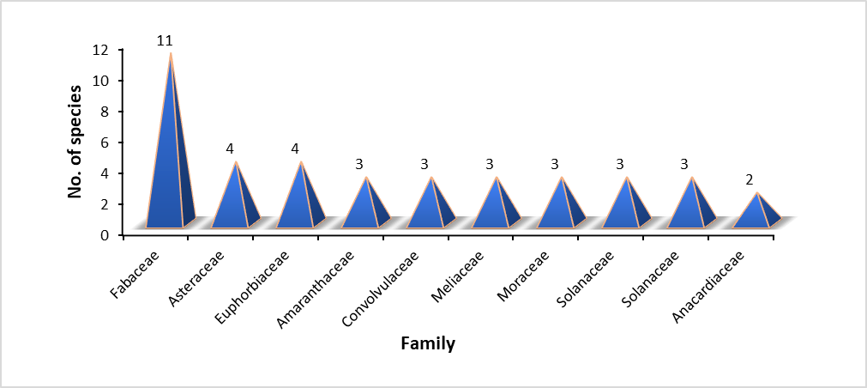
Figure 2 Top ten families recoded maximum number of species.

Table 2 All details about plant species.
SL No. | Scientific Name | Common Name | Family | Habit | Parts Used | Skin Diseases | Methods of Preparation | FC | RFC | UV
1 | Abelmoschus moschatus Medik. | Kasturi Bhindi | Malvaceae | Herb | Leaf, seeds | Cuts, Wounds | A paste of leaves is applied on the cuts, wounds and sprains. Seeds are also used for same purpose. | 18 | 0.19 | 0.13
2 | Abrus precatorius L. | Ratti | Fabaceae | Climbing shrub | Root | Ringworm Spot | The juice of root, mixed with the half the amount of the juice of Allium sativum is applied on ringworm Spot. | 20 | 0.20 | 0.14
3 | Achyranthes aspera L. | Chirchita | Amaranthaceae | Herb | Leaf | Cuts, Wounds | Leaf juice with a pinch of salt is applied to cure skin infection | 17 | 0.17 | 0.12
4 | Ailanthus excelsa Roxb. | Adu, Ghoda Neem | Simaroubaceae | Tree | Leaf | Cuts, Wounds | The leaf powder mixed with whole plant of Solanum xanthocarpum is used for skin infection | 15 | 0.16 | 0.11
5 | Allium tuberosum Roxb. | Ban lahsun | Amaryllidaceae | Herb | Leaf and bulb | Insect bites, wounds etc. | The leaves and bulbs are applied to insect bites, cuts, and wounds. | 32 | 0.33 | 0.23
6 | Aloe vera Burm.f. | Gwarpatha | Liliaceae | Herb | Leaf | Dry skin, Rash etc. | Leaf pulp is used as a moisturizer | 96 | 0.98 | 0.69
7 | Alternanthera sessilis (Linn.) R.Br. Ex DC. | Gudari shak | Amaranthaceae | Herb | Whole Plant | Burning sensation | The whole plant is used for burning sensation and other skin diseases. | 23 | 0.23 | 0.16
8 | Amaranthus spinosus Linn. | Chaulai | Amaranthaceae | Herb | Leaf | Scorpion stings and snake bites | Traditionally, leaves are used to treat scorpion sting and snake bite. | 14 | 0.14 | 0.10
9 | Andrographis paniculata (Burm. fil.) Nees | Kalmegha, kirayat | Acanthaceae | Herb | Leaf | Tineacruris, Cut | Leaf juice mixed with cow milk is taken orally twice a day for six to eight days to cure tineacruris. | 48 | 0.49 | 0.35
10 | Antigonon leptopus Hook. & Arn. |  | Polygonaceae | Climbing shrub | Leaf | Cuts, Wounds | Paste of fresh leaves applied externally in skin disorders. | 18 | 0.19 | 0.13
11 | Argemone mexicana L. | Peelikatili | Papavaraceae | Herb | Whole Plant | Wound | Pounded seed along with rhizome of curcuma aromatica and Calamus made in to paste are applied on all kinds of skin diseases twice a day till recovery. | 28 | 0.29 | 0.20
12 | Argyreia nervosa (Burm. fil.) Bojer. | Vidhara | Convolvulaceae | Herb | Leaf | Wound | Leaf paste is applied topically on wounds. | 7 | 0.07 | 0.05
13 | Azadirachta indica A. Juss. | Neem | Meliaceae | Tree | Leaf,bark,young stem. | Wounds, Cuts, Ringworms, Scabies etc. | 1 spoon of powder mixed with water/orally thrice in a day/3day. Effective against skin diseases like ringworms, scabies, wounds. | 93 | 0.95 | 0.67
14 | Bacopa monnieri Pennell | Brahmi | Plantaginaceae | Herb | Whole Plant | Psoriasis, Eczema etc. | Whole plant juice taken orally to reduced such problems. | 30 | 0.30 | 0.21
15 | Butea monosperma (Lam.) Taub. | Palas | Fabaceae | Tree | Seeds | General wounds and infections. | Seed paste is used to cure skin diseases. | 21 | 0.22 | 0.15
16 | Calotropis procera (Aiton) R. Br. | Arka, Mudar | Asclepiadaceae | Shrub | Root, Latex, Flower, Leaves | Boils, Wounds etc. | The leaves and flower are crushed together, made in to pest and applied tropically on boils. | 13 | 0.13 | 0.09
17 | Carica papaya L. | Papita, Papaya | Caricaceae | Tree | Fruits | Dull skin | Clean and attractive fresh in skin | 27 | 0.27 | 0.19
18 | Cascabela thevetia H. Lippold | Kaner | Apocynaceae | Shrub | Leaf, Root | Ring worm | Oil is used externally for skin ailments, and ring worm treatment. | 8 | 0.09 | 0.06
19 | Cassia alata L. | Dadukapatta | Fabaceae | Shrub | Leaf | Wound, cuts | Leaf paste mixed with seed oil of Pongamia pinnata applied externally on skin diseases. | 11 | 0.11 | 0.08
20 | Cassia fistula L. | Amaltas | Fabaceae | Tree | Bark | Fungal skin problems. | Bark is used for fungal diseases. | 20 | 0.20 | 0.14
21 | Cassia tora L. | Charota | Fabaceae | Shrub | Leaf | Wound, cuts | Paste of leaf is applied over skin to cure infections. | 18 | 0.19 | 0.13
22 | Centella asiatica Urb. | Brahmi,Thankuni | Apiaceae | Creeping Herb | whole Plant | Wound, UV damage. | Treatment of wound, and protection of skin ageing damage, UV damage. | 15 | 0.16 | 0.11
23 | Coccinia grandis Voigt | Kunduru | Cucurbitaceae | Herb | Leaf | Bacterial infections and ring worm. | The leaf paste is used as antibacterial and in treatment of ring worm. | 15 | 0.16 | 0.11
24 | Crotalaria retusa L. | Khunkuniyan, Devil bean | Fabaceae | Shrub | Root, leaf, Seed | Wound, cuts. | Seed oil is used to treat hair problems, Leaf and root paste applied to external skin problems. | 17 | 0.17 | 0.12
25 | Curcuma aromatica Salisb. | Van haldi | Zingiberaceae | Herb | Rhizome | Eczema | The Paste of the rhizome with a 50% of Neem leaf’s powder is applied on the skin against eczema. | 93 | 0.95 | 0.67
26 | Curcuma longa L. | Haldi, Turmeric | Zingiberaceae | Herb | Whole Plant | Stimulation, expectorant, ring worm | Used as stimulative, expectorant, face cream, in ringworm etc. | 92 | 0.93 | 0.66
27 | Cuscuta reflexa Roxb. | Amarbel | Convolvulaceae | Herb | Whole Plant | Ring worm | Paste is applied on affected area. | 4 | 0.04 | 0.03
28 | Dalbergia sissoo DC. | Bahabija, Hermala | Fabaceae | Tree | Wood, Leaf | Wound, cuts. | Decoction of bark and heartwood are useful in Skin diseases. | 10 | 0.10 | 0.07
29 | Datura metel L. | Dhatura | Solanaceae | Shrub | Whole Plant | Wound, cuts. | Leaf juice is mixed with a little opium and applied to the affected area to reduce swelling of gums or base of ears. | 52 | 0.53 | 0.38
30 | Diplocyclos palmatus (L). C. jeffrey | Shivlingi | Cucurbitaceae | Climbing herb | Whole Plant | Wound, cuts. | The seed oil and coconut oil in equal preparation is applied on body in skin disease. | 21 | 0.22 | 0.15
31 | Eclipta prostrata L. | Bhringraj | Asteraceae | Herb | Whole Plant | Eczema | Leaf juice is given in eczema and as hair tonic. | 34 | 0.34 | 0.24
32 | Euphorbia hirta L. | Dudhi | Euphorbiaceae | Herb | Whole Plant | Wound, eczema, ring worm | The latex of the plant is applied topically on wounds. Latex is also applied on eczema. The pest of whole plant applied topically on ring warm. | 51 | 0.52 | 0.37
33 | Ficus hispida L. f. | Gobla | Moraceae | Tree | Leaf, fruits | Leukoderma | Fresh Leaf juice is applied externally for skin disorders like Leukoderma and fruit juice is given internally for 3 days. | 18 | 0.19 | 0.13
34 | Ficus racemosa L. | Gullor | Moraceae | Tree | Latex | Boils | The latex is applied topically on boils. | 34 | 0.34 | 0.24
35 | Ficus religiosa L. | Peepal | Moraceae | Tree | Bark | Wound, cuts. | Paste of powdered bark is good for skin diseases | 37 | 0.37 | 0.27
36 | Hemidesmus indicus R. Br. | Anantmool | Apocynaceae | Climbing shrub | Root | Gout, syphilis, wound | Skin diseases gout, syphilis and non- healing wound, soft skin. | 20 | 0.20 | 0.14
37 | Ipomoea carnea Jacq. | Beshram | Convolvulaceae | Herb | Leaf | Cuts, Wounds | The leaves are fried in mustard oil and tied topically on cuts and wound. | 25 | 0.26 | 0.18
38 | Jatropha gossypiifolia L. | Lal ratanjyat | Euphorbiaceae | Shrub | Latex | Burn | Latex of plant is applied on burn part of body. | 24 | 0.24 | 0.17
39 | Lablab purpureus Sweet | Semi, Seem | Fabaceae | Herb | Leaf | Dull skin | Leaves paste used bleaching cream, and Skin cool. | 27 | 0.27 | 0.19
40 | Lantana camara L. | Machhimudhi | Verbenaceae | Shrub | Leaf | Wounds, Cuts | Leaf paste is an externally applied to wounds and cuts. | 31 | 0.32 | 0.22
41 | Lawsonia inermis L. | Mehndi | Lythraceae | Shrub | Whole Plant | Dry skin, Mud infections | The leaf paste is applied on cracked heels in rainy season due to mud infection. | 30 | 0.30 | 0.21
42 | Leea macrophylla Roxb. ex Hornem. | Hathikana | Vitaceae | Shrub | Root | Cuts, Swelling | Root paste is applied topically on cuts and swelling. | 30 | 0.30 | 0.21
43 | Lens culinaris Medik. | Masoor, Lentil | Fabaceae | Herb | Whole Plant | Cuts, Swelling | Seed pest is known to cure skin diseases. | 11 | 0.11 | 0.08
44 | Linum usitatissimum L. | Alsi | Fabaceae | Herb | Whole Plant | Wounds | The paste of whole plant is applied topically on wounds. | 25 | 0.26 | 0.18
45 | Madhuca indica J.F.Gmel. | Mahua | Sapotaceae | Tree | Leaf | Wounds | Leaves paste is used topically on wounds. | 32 | 0.33 | 0.23
46 | Mallotus philippensis (Lam.) Müll. Arg. | Kamala, Sindoori | Euphorbiaceae | Tree | Whole Plant | Parasitic infection, wounds | All parts are used in treat parasitic infection of the skin. Wounds treatment. | 13 | 0.13 | 0.09
47 | Mangifera indica L. | Aam | Anacardiaceae | Tree | Gum | Scorpion stings | The gum of the plant is mixed with salt thoroughly and the formed paste is applied on bitten area in scorpion bite. | 13 | 0.13 | 0.09
48 | Melia azedarach L. | Bakayan | Meliaceae | Tree | Leaf | Boils, Eczema, Wounds | Paste of leaves are applied on Boils, Eczema, Wounds. | 77 | 0.79 | 0.56
49 | Moringa oleifera Lam. | Munga, Sajan | Moringaceae | Tree | Leaf | Cuts, Swelling | Plant powder is taken internally to treat skin diseases. | 45 | 0.46 | 0.33
50 | Murraya koenigii Spreng. | Meethi neem, Kadipatta | Rutaceae | Tree | Root | Wounds | Roots are used to curing of wound. | 46 | 0.47 | 0.34
51 | Ocimum tenuiflorum L. | Tulsi | Lamiaceae | Herb | Leaf | Wounds | Leaf juice is applied topically on the affected area. | 31 | 0.32 | 0.22
52 | Oxalis corniculata L. | Amrit sak, Amrul | Oxalidaceae | Creeping Herb | Whole Plant | Allergy | The juice of the whole plant is gently rubbed on the skin against allergies for 2-5 days. | 30 | 0.30 | 0.21
53 | Phyllanthus emblica L. | Amla, Amlaki | Phyllanthaceae | Tree | Fruits, Leaf | Skin infections | Fruits juice, leaf powder, with Neem leaf and honey is taken for skin infection. | 49 | 0.50 | 0.36
54 | Plumbago zeylanica L. | Chitrak, Chita | Plumbaginaceae | Herb | Root | Fungal and bacterial skin problems | Root paste is used as antibacterial and antifungal. | 34 | 0.34 | 0.24
55 | Psidium guajava L. | Amrood, Guava | Myrtaceae | Tree | Fruits, Leaf | Skin complaints, Ring worm, Wounds | The leaves and bark are taken externally as a lotion for skin complaints, ring worm, wound. | 48 | 0.49 | 0.35
56 | Ricinus communis L. | Arandi | Euphorbiaceae | Shrub | Seeds | Inflammatory skin disorder | Seed pest to the skin as a poultice for inflammatory skin disorders. | 49 | 0.50 | 0.36
57 | Semecarpus anacardium L. f. | Bhilwa, Gheru | Anacardiaceae | Tree | Seeds, Fruits | Face ring worm | Boil the fruit in oil & apply on face ring worm. | 7 | 0.07 | 0.05
58 | Sesamum indicum L. | Til, Safed til | Pedaliaceae | Herb | Seeds | Leprosy, Boils | The oil of seed is applied topically in leprosy, seed paste is applied on boils. | 37 | 0.37 | 0.27
59 | Solanum nigrum L. | Makoi | Solanaceae | Herb | Leaf | Wounds | Leaves are used as poultice for skin diseases. | 51 | 0.52 | 0.37
60 | Soymida febrifuga (Roxb.) Juss. | Rohni | Meliaceae | Tree | Bark | Wound | The paste of bark is used for wounds. | 34 | 0.34 | 0.24
61 | Sphaeranthus indicus L. | MurmuriyaBhuikadam | Asteraceae | Herb | Whole Plant | Wounds | Plant powder is taken internally to skin disease. | 15 | 0.16 | 0.11
62 | Strychnos nux-vomica L. | Kuchila, Bilewa | Loganiaceae | Tree | Leaf | Wounds | Leaf paste is applied on common skin diseases. | 8 | 0.09 | 0.06
63 | Tephrosia purpurea Pers. | Meghapati, Sarpankha | Fabaceae | Shrub | Aerial part | Burn wound | Paste of aerial part used to treat burn wound. | 10 | 0.10 | 0.07
64 | Terminalia arjuna (Roxb.) Wight & Arn. | Kahuwa, Arjun | Combretaceae | Tree | Bark, Leaf | Wound | Leaves are used to wound healing. | 18 | 0.19 | 0.13
65 | Terminalia chebula Retz. | Harra, Hartaki | Combretaceae | Tree | Fruits | Boils | Fruits of Harra along with mustard oils are applied on affected area. | 14 | 0.14 | 0.10
66 | Vanda tessellata (Roxb.) Hook. ex G. Don | Mai ki bagia | Orchidaceae | Epiphytic herb | Root, Leaf | Inflammation, Cuts, Wounds | Leaf paste is applied on the affected area for immediate relief. | 31 | 0.32 | 0.22
67 | Vernonia cinerea Less. | Sahadevi, Sadodi | Asteraceae | Herb | Whole Plant | Eczema, Ringworm, Tumer | Leaf juice is useful for amebiasis, eczema, ring worm and other skin tumers. | 8 | 0.09 | 0.06
68 | Withania somnifera Dunal. | Aswagandha | Solanaceae | Shrub | Whole Plant | Wounds | Small pieces of plant are mixed with cow’s urine and applied on the Affected skin. | 45 | 0.46 | 0.33
69 | Woodfordia fruticosa Kurz. | Dhawa | Lythraceae | Tree | Stem, Leaf | Scabies | Stems are pounded, mixed with curds and applied to scabies. Leaf paste are used many other skin diseases. | 17 | 0.17 | 0.12
70 | Xanthium indicum Koen. | Gokharoo | Asteraceae | Shrub | Fruits | Boils, Wound, Cut | Fruit oil is applied externally on skin diseases for three days. | 17 | 0.17 | 0.12
71 | Ziziphus nummularia (Burm. f.) Wight & Walk. -Arn. | Jharbery | Rhamnaceae | Tree | Leaf | Boils, Wound, Cut | Leaf paste is applied on boils, wounds and cuts. | 35 | 0.36 | 0.26

3.3. The habits of medicinal plants and plant part used
The predominance of different habit form of plant species is herbs (40%), tree (33%), shrub (18%) (fig.3). The importance of medicinal plants in this forest region was illustrated by the diversity of their uses. Plant parts used either in their fresh or dried state included root, bark, stem, leaf, fruit, seeds, the whole plant, or its aerial part (fig.4).
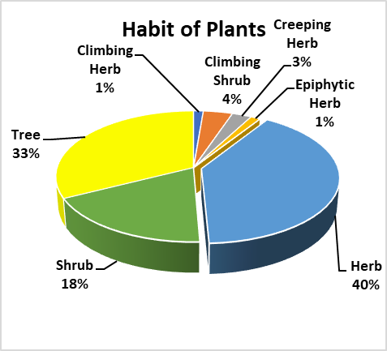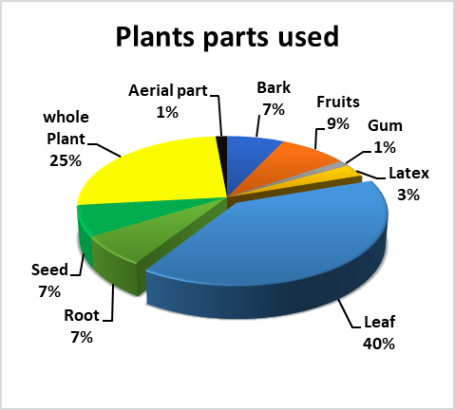
Figure 3,4 Habits of plant species and plant’s part used respectively
3.4. Quantitative Ethnobotany
3.4.1. Informant Consensus Factor (ICF) and Use Value
The treatment for different types of skin diseases by the local people are classified into 24 categories and the ICF values for each category are given (Table 3). ICF values obtained for the reported categories indicate the degree of shared knowledge for the treatment of each category of ailment. As indicated in Table 3, UV is calculated for all the species that use for skin discase treatment.
Table 3 Total number of skin disease and ICF value.

Notes: Nur- refers to the total number of use reports for each disease cluster and, Nt- refers the total number of species used for that cluster, ICF- Informant Consensus Factor.
3.4.2. Frequency of Citation (FC) and Relative Frequency of Citation (RFC)
In the present study, FC values ranged from 4 to 98. The highest FC was recorded for Aloe vera (98). The top ten FC value is given in fig.5 and other all plant species RFC value is given in table 2. In the present study, RFC values ranged from 0.04 to 0.98. The highest RFC was recorded for Aloe vera (0.98). The top ten RFC value is given in fig. 6 and other all plant species RFC value is given in table 2. The ethnomedicinal plants species having high RFC values indicated their abundant use and widespread knowledge among the local communities.

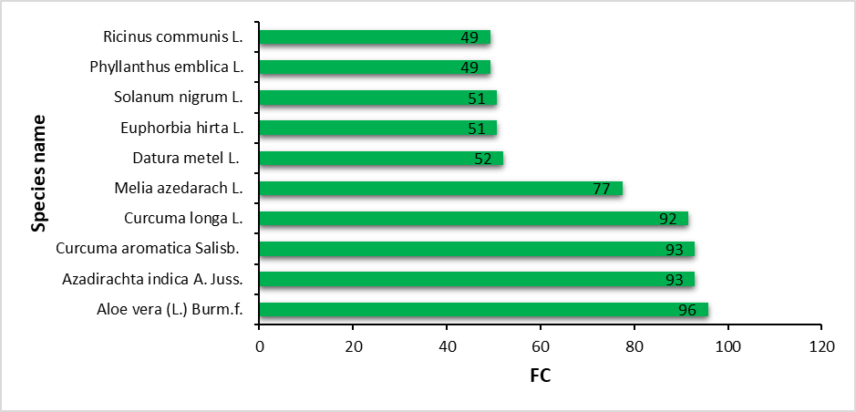
Figure 5 The showing the top ten FC value of plant species.
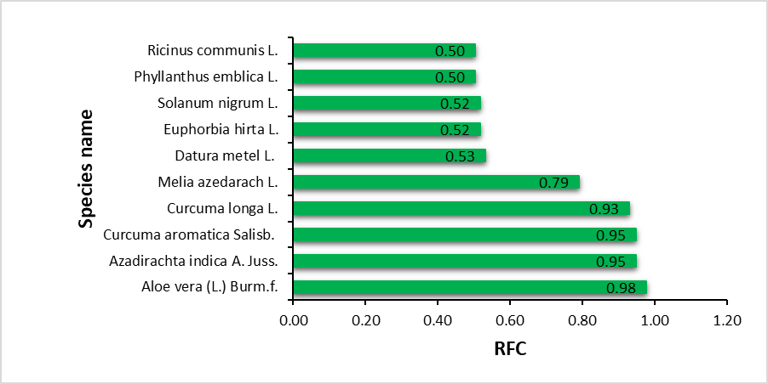
Figure 6 The showing the top ten RFC value of plant species.
4. Discussion
The socio-demography of study area is, total of 98 people who participated in the survey, 46 were women (46.94%) and 52 were men (53.06%). The family status is married category is (62.24%) and unmarried category is (37.76%). The Age classes is divided in five categories of age class <30 (23.47%) age class 30-39 (19.39%), age class 40-49 (32.65%), age class 50-59 (22.45%), and age class >60 (2.04%). Regarding the education level, the illiteracy rate is 25.51%; primary school level represented 34.69%, secondary school level represented 21.43%, tertiary school level represented 11.22%, while relatively high levels represented 7.14%. The occupation of informant is, farmer- 41.84%, labor-30.61%, students-23.47%, and traditional health has 3.06%. The similar result is perversely published; the ages of the 30 purposively sampled participants ranged from 20 to 70 years. An equal proportion of males and females participated in the study, which indicates an even spread of knowledge of medicinal plant for skin disorders among men and women. During the present study a totals number of plant species is 71 belong 40 families and 67 genera is recoded during survey periods. The most dominated families are Fabaceae (11), Asteraceae (4), Euphorbiaceae (4), Amaranthaceae (3) and Convolvulaceae (3) numbers of species recoded. The documentation of plant materials used in traditional medicine could well benefit skin care and promote forest conservation and ecological research discuss earlier, (Rao, D. M., et.al., 2006; Carman, H., 2009; Asong, J. A., et al., 2019; Hay, R. J., et al., 2014; Abbasi, A. M., et al., 2010; Tabassum, N., & Hamdani, M., 2014; Adhikari, C., et al., 2021). The FC values ranged from 4 to 98. The highest FC was recorded for Aloe vera (98), RFC values ranged from 0.04 to 0.98. The highest RFC was recorded for Aloe vera (0.98) and UV values ranged from 0.03 to 0.69. The highest UV was recorded for Aloe vera (0.69), similar work cared by many researchers of different part of country and worlds, (Hoffman, B., & Gallaher, T., 2007; de Albuquerque, U. P., et al., 2011; Ahmad, M., et al., 2014; Ahmed, J., et al., 2018; Joshi, B. C., 2019; Sarkar, K., et al., 2023).

4. Conclusion

The present study showed that traditional treatment systems using medicinal plants is still prevalent in the studied areas, and it underlines the importance in the documentation of traditional ethnomedicinal knowledge before losing this diverse resource. To the best of our knowledge, this is the first quantitative ethnomedicinal study in the study area indicating UV, ICF, FC, and RFC indices. The most prominent plant families were Fabaceae, Asteraceae, and Euphorbiaceae. The highest use values were reported for Aloe vera (L) Burm.f. (0.69), Azadirachta indica A. Juss. (0.67) and Curcuma aromatica Salisb (0.67) Based on RFC, the highest was found for Aloe vera (L) Burm.f. (0.98), Azadirachta indica A.Juss. (0.95) and Curcuma aromatica Salisb (0.95). Although local treatment of herbal prescriptions and ethnobotanical surveys are underway, more research on phytochemicals and their pharmacological activities is needed to ensure the application of plants used by local people, as well as product development in herbal medicine for the treatment of skin diseases, in order to promote the sustainable and safe use of natural resources.

Consent (where ever applicable)

Not Applicable

Ethical approval (where ever applicable)

Not Applicable

References

Asong, J. A., Ndhlovu, P. T., Khosana, N. S., Aremu, A. O., & Otang-Mbeng, W. (2019). Medicinal plants used for skin-related diseases among the Batswanas in Ngaka Modiri Molema District Municipality, South Africa. South African Journal of Botany, 126, 11-20. https://doi.org/10.1016/j.sajb.2019.05.002 .
Abbasi, A. M., Khan, M. A., Ahmad, M., Zafar, M., Jahan, S., & Sultana, S. (2010). Ethnopharmacological application of medicinal plants to cure skin diseases and in folk cosmetics among the tribal communities of North-West Frontier Province, Pakistan. Journal of Ethnopharmacology, 128(2), 322-335. https://doi.org/10.1016/j.jep.2010.01.052 .
Ahvazi, M., Khalighi-Sigaroodi, F., Charkhchiyan, M. M., Mojab, F., Mozaffarian, V. A., & Zakeri, H. (2012). Introduction of Medicinal Plants Species with the Most Traditional Usage in Alamut Region. Iranian Journal of Pharmaceutical Research, 11(1), 185-194. https://doi.org/10.22037/IJPR.2011.1018 .
Adhikari, C., Devanand, Kumar, T., & Bishwas, A. J. (2021). Review on ethno-medicinal plants used for healing skin ailments in Madhya Pradesh, India. *Indian Journal of Ecology*, *48*(3), 709-715. https://indianjournals.com/ijor.aspx?target=ijor:ije&volume=48&issue=3&article=009 .
Adhikari, C., Maurya, D., & Bishwas., A.J., (2023). “An Ethnobotanical Documentation of Wild Plants Used for the Treatment of Livestock Ailments in Panna District of Madhya Pradesh, India”, International Journal of Research and Analytical Reviews (IJRAR), 10(4): 252-261.
Al-Sereiti, M. R., Abu-Amer, K. M., & Sen, P. (1999). Pharmacology of rosemary (Rosmarinus officinalis Linn.) and its therapeutic potentials. Indian Journal of Experimental Biology, 37(2), 124-130. https://pubmed.ncbi.nlm.nih.gov/10641130/ .
Ahmad, M., Sultana, S., Fazl-i-Hadi, S., Ben Hadda, T., Rashid, S., Zafar, M., Khan, M. A., Khan, M. P. Z., & Yaseen, G. (2014). An ethnobotanical study of medicinal plants in high mountainous region of Chail valley (District Swat-Pakistan). Journal of Ethnobiology and Ethnomedicine, 10(1), 36. https://doi.org/10.1186/1746-4269-10-36 .
Ahmed, J., Sharma, S., & Kumar, D. (2016). Quantitative Ethnobotanical Approach to Analyze Local Importance of Tree Species in North Western Himalaya: A Case Study of Ponda Watershed, J&K. Proceedings of the National Academy of Sciences, India Section B: Biological Sciences, 88(1). https://doi.org/10.1007/s40011-016-0828-6 .
Carman, H. (2009). Skin diseases in South Africa. Emergency Services SA/Occupational Risk, 1(2), 19-21.
De Wet, H., Nciki, S., & van Vuuren, S. F. (2013). Medicinal plants used for the treatment of various skin disorders by a rural community in northern Maputaland, South Africa. Journal of Ethnobiology and Ethnomedicine, 9(1), 51. https://doi.org/10.1186/1746-4269-9-51 .
de Albuquerque, U. P., Soldati, G. T., Sieber, S. S., Ramos, M. A., de Sá, J. C., & de Souza, L. C. (2011). The use of plants in the medical system of the Fulni-ô people (NE Brazil): a perspective on age and gender. Journal of Ethnopharmacology, 133(2), 866-873. https://doi.org/10.1016/j.jep.2010.11.021 .
Heinrich, M., Ankli, A., Frei, B., Weimann, C., & Sticher, O. (1998). Medicinal plants in Mexico: Healers' consensus and cultural importance. Social Science & Medicine, 47(11), 1859-1871. https://doi.org/10.1016/s0277-9536(98)00181-6 .
Hoffman, B., & Gallaher, T. (2007). Importance Indices in Ethnobotany. Ethnobotany Research and Applications. https://doi.org/10.17348/era.5.0.201-218 .
Hay, R. J., Johns, N. E., Williams, H. C., Bolliger, I. W., Dellavalle, R. P., Margolis, D. J., & Naghavi, M. (2014). The global burden of skin disease in 2010: An analysis of the prevalence and impact of skin conditions. Journal of Investigative Dermatology, 134(6), 1527-1534. https://doi.org/10.1038/jid.2013.446 .
Gupta, P., Kumar, A., Sharma, N., Patel, M., Maurya, A., & Srivastava, S. (2017). A review on phytomedicines used in treatment of most common skin diseases. Indian Journal of Drugs, 5(4), 150-164.
Joshi, B. C., Rawal, R. S., Chandra Sekar, K., & Pandey, A. (2019). Quantitative ethnobotanical assessment of woody species in a representative watershed of west Himalaya, India. Energy, Ecology and Environment. https://doi.org/10.1007/s40974-019-00114-9 .
Lense, O. (2012). The wild plants used as traditional medicines by indigenous people of Manokwari, West Papua. Biodiversitas Journal of Biological Diversity, 13(2), 98-106. https://doi.org/10.13057/biodiv/d130208 .
Maurya, D., Adhikari, C., Kumar, T., & Bishwas, A. J. (2021). A review: Aganosma dichotoma (Roth) K. Schum.: Traditional use, phytochemical constituents and pharmacological properties. International Journal of Botany Studies, 6(6), 1276-1279. https://www.researchgate.net/publication/357200000_A_review_Aganosma_dichotoma_Roth_K_Schum_Traditional_use_phytochemical_constituents_and_pharmacological_properties .
Maurya, D., Kumar, T., Adhikari, C., Kumar, A., & Bishwas, A. J. (2022). Medicinal plants and their traditional knowledge in past history and future perspective. In D. Das (Ed.), Medicinal Plants and Traditional Knowledge in the Indian Subcontinent (pp. 34-45). Shashwat Publication. https://shashwatpublication.com/product/medicinal-plants-and-traditional-knowledge-in-the-indian-subcontinent/ .
Maurya, D., Adhikari, C., Kumar, T., & Bishwas, A. J., (2023). The practice of using Ethno-medicinal plants in maintaining oral health: Knowledge, perception and attitude of Damoh district Madhya Pradesh, India, International Journal of Research and Analytical Reviews (IJRAR), 10(4), 614-621.
Maurya, D., Adhikari, C., & Bishwas, A. J. (2025). Ethnobotanical Study on Wild Edible Plants Traditionally Used by Local People of Damoh District Madhya Pradesh, India. Journal of Biology and Nature, 17(2), 735–746. https://doi.org/10.56557/joban/2025/v17i29983 .
Nanadini, N., Nagababu, P., Rao, V. U., & Venugopal, N. (2014). Phytochemical, antimicrobial and antioxidant properties of an invasive weed-Chromolaena odorata (L.) King & Robinson. International journal of phytomedicine, 6(2), 286.
Oluwabunmi, I. J., & Abiola, T. (2015). Gastroprotective effect of methanolic extract of Gomphrena celosioides on indomethacin induced gastric ulcer in Wistar albino rats. International Journal of Applied and Basic Medical Research, 5(1), 41-45. https://doi.org/10.4103/2229-516X.149238 .
Phillips, O., Gentry, A. H., Reynel, C., Wilkin, P., & Gálvez‐Durand B, C. (1994). Quantitative ethnobotany and Amazonian conservation. Conservation biology, 8(1), 225-248. http://www.jstor.org/stable/2386737 .
Rao, D. M., Rao, U. V. U. B., & Sudharshanam, G. (2006). Ethno-Medico-Botanical Studies From Rayalaseema Region of Southern Eastern Ghats, Andhra Pradesh, India. Ethnobotanical Leaflets, 2006(10), Article 21. https://opensiuc.lib.siu.edu/ebl/vol2006/iss10/21/ .
Sarkar, K., Roy, P., Panda, S., Choudhuri, C., & Chowdhury, M. (2023). Ethnomedicinal study on plant resources from sacred groves of Dakshin Dinajpur district, West Bengal, India. Ethnobotany Research and Applications, 25, 1-35. https://doi.org/10.32859/era.25.4415 .
Tabassum, N., & Hamdani, M. (2014). Plants used to treat skin diseases. Pharmacognosy Reviews, 8(15), 52-60. https://doi.org/10.4103/0973-7847.125531 .
Tardío, J., & Pardo-de-Santayana, M. (2008). Cultural importance indices: A comparative analysis based on the useful wild plants of Southern Cantabria (Northern Spain). Economic Botany, 62(1), 24-39. https://doi.org/10.1007/s12231-007-9004-5 .
Topno, S. C., & Sinha, M. R. (2018). Study of medicinal plants used to heal skin diseases by tribes of west Singhbhum district of Jharkhand (India). Journal of Pharmacognosy and Phytochemistry, 7(1), 371-376. https://www.jpp.com/abstract/2018/7/1/371-376 .
Trotter, R. T., & Logan, M. H. (2019). Informant consensus: a new approach for identifying potentially effective medicinal plants. In N. L. Etkin (Ed.), Plants and indigenous medicine and diet (pp. 91-112). Routledge. https://doi.org/10.4324/9781315060385 .
Verdier-Sévrain, S., & Bonté, F. (2007). Skin hydration: A review on its molecular mechanisms. Journal of Cosmetic Dermatology, 6(2), 75-82. https://doi.org/10.1111/j.1473-2165.2007.00300.x .
World Health Organization. (2000). General guidelines for methodologies on research and evaluation of traditional medicine (No. WHO/EDM/TRM/2000.1). World Health Organization. https://www.who.int/publications/i/item/general-guidelines-for-methodologies-on-research-and-evaluation-of-traditional-medicine .

