Original Research Article

Study of Osmotic Dehydration Characteristics of Pink Radish ( Raphanus sativus)

.

ABSTRACT

Aims: This study investigates the osmotic dehydration behaviour of pink radish (Raphanus sativus), an inherently high-moisture root vegetable with a very short ambient shelf life, under varying salt concentrations and temperatures.
Study design: Laboratory-based experimental study.
Place and Duration of Study: Uttar Banga Krishi Viswavidyalaya, Cooch Behar, India, during 2023–2024.
Methodology: Fresh pink radish slices (0.5 cm thickness) were immersed in sodium chloride (NaCl) solutions of 5%, 15% and 25% (w/w). Osmotic dehydration was conducted at temperatures of 40°C, 50°C and 60°C for 4 h, maintaining a radish-to-solution ratio of 1:5. Samples were withdrawn at 0.5, 1, 2, 3 and 4 h intervals, blotted, weighed, and analyzed for moisture content using an infrared moisture analyzer. Mass transfer parameters—water loss (WL), solid gain (SG), and weight reduction (WR)—were computed using standard equations.
Results: Moisture content reduced from 95.7% w.b. to as low as 66.04% after 4 h in 25% NaCl at 60°C. WL and SG increased with rising temperature and concentration, with most mass exchange occurring during the first 2–2.5 h. Maximum WL values ranged from 0.122–0.349, and SG ranged from 0.027–0.254 across treatments.From the results, it was observed that at 50 °C with 25% concentrated salt solution the water loss, solid gain and weight loss were highest.
Conclusion: Higher osmotic concentrations and temperatures significantly enhanced WL and SG. Osmotic dehydration is an efficient and gentle moisture reduction technique for pink radish, improving its storability and suitability for further processing.

Keywords: Pink radish, osmotic dehydration, water loss, solid gain, mass transfer, preservation.

1. INTRODUCTION

1.1 Factual Background

The pink radish (Raphanus sativus) is a fast-growing, edible root vegetable belonging to the Brassicaceae family. Originally from northern China, it is widely consumed globally, being particularly popular in most regions of India. Radishes are primarily consumed raw as a crunchy salad ingredient and can be further processed into various dried, pickled, or fermented products. Nutritionally, pink radishes are highly valuable, being rich in ascorbic acid, folic acid, and potassium, as well as a good source of vitamin B₆, riboflavin, magnesium, and copper. These nutrients contribute to the radish’s efficacy as a cancer-fighting food and its benefits for the digestive and respiratory systems. Furthermore, the pink-skinned varieties are richer in ascorbic acid compared to their white-skinned counterparts.

1.2 Clearly Defined Problem

Despite its quick growth and numerous health benefits, the primary challenge associated with pink radish is its short post-harvest life. Due to its exceptionally high moisture content (approximately 95% w.b.), the vegetable's shelf life is severely limited to only 7 to 10 days under ambient conditions. While conventional methods like sun drying and hot air drying can extend preservation, they result in an unacceptable loss of the radish’s vital colour and texture. Freezing, another alternative, compromises the desirable crisp qualities of the root. A method is thus required that can effectively reduce moisture content and water activity while retaining the product's natural characteristics.

1.3 Proposed Solution

To overcome the limitations of conventional drying and freezing, Osmotic Dehydration (OD) is proposed as a viable alternative for the preservation of pink radish. Osmotic Dehydration is defined as a 'dewatering and impregnation soaking process' (DISP) (Torreggiani et al, 2001) where biological materials are immersed in a hypertonic (high osmotic pressure) aqueous solution. This method is advantageous because it is performed at moderate temperatures without a phase change, leading to better retention of initial characteristics such as colour, aroma, and nutritional compounds, and less tissue damage. Osmotic dehydration is also significantly less energy-intensive than traditional air or vacuum drying processes, offering a valuable preservation method for both farmers and consumers.

1.4 Brief Literature Survey

Radish is an edible root vegetable of the Brassicaceae family, widely cultivated and consumed across the world. It is valued for its crunchy texture, mild to pungent flavour, and diverse root morphology, which varies in shape, size and colour. Radishes are traditionally consumed raw, pickled, or cooked, and can also be incorporated into dried, salted or fermented products (Lee & Kim, 2009)
Owing to their rich nutritional composition—particularly vitamin C, folic acid, anthocyanins, and minerals—they possess various health-promoting properties, including detoxification, respiratory relief, digestive support, and antioxidant activity.
However, due to their high moisture content (~95% w.b.), radishes exhibit poor shelf stability, especially in ambient conditions of regions like Sikkim, where storage life is limited to 7–10 days.

Traditional methods such as sun drying, hot-air drying, or freezing can extend shelf life but often cause undesirable changes in colour, texture, and sensory attributes. These limitations underscore the need for alternative mild-processing techniques such as osmotic dehydration.

1.4.1 Osmotic Dehydration
Osmotic dehydration (OD) is a partial dewatering technique based on the principle of osmosis, where food pieces are immersed in a hypertonic solution, typically salt or sugar. Water moves out of the tissue due to a difference in osmotic pressure, while solutes simultaneously diffuse into the product. This dual process has been widely described as a dewatering and impregnation soaking process (DISP) (Torreggiani et al, 2001). The bidirectional mass transfer modifies the physical, sensory and functional characteristics of the material, making OD suitable for developing minimally processed or value-added foods. OD preserves colour, aroma and nutrients better than conventional drying because it occurs at moderate temperatures without phase change (Alakali et al., 2006). It also reduces energy requirements in subsequent air or vacuum drying processes (Lenart & Lewicki, 1988; Lazarides & Mavroudis, 1995). By lowering water activity, OD inhibits chemical reactions and microbial growth, thereby extending shelf life. The process involves simultaneous water loss, solid gain, and limited leaching of inherent solutes such as organic acids, pigments, and sugars (Fito et al., 2001). These mass-transfer events depend on the food’s cellular structure which behaves as a semi-permeable system.

1.4.2 Factors Affecting Osmotic Dehydration
Size and Shape, Geometry of food pieces determines surface-area-to-volume ratio and thereby influences mass-transfer kinetics. Larger produce is usually cut into slices or cubes to improve osmotic efficiency (Panagiotou et al., 1998)

1.4.3 Osmotic Agents
Common agents include sucrose and sodium chloride. Solute type, molecular weight and ionic behaviour influence rates of water loss and solid gain (Sutar & Gupta, 2007; Nieto et al., 2001). Binary solutions (e.g., sucrose + NaCl) have been used effectively for carrots and other vegetables (Singh et al., 2010)

1.4.4 Concentration of Osmotic Solution
Higher solute concentration increases osmotic pressure and water removal. Studies report improved mass transfer in apricot, carrot and pumpkin with elevated sucrose or salt concentrations (Khoyi & Hesari, 2007; Gupta et al., 2005; Garcia et al., 2007)

1.4.5 Temperature
Temperature enhances diffusivity and osmotic pressure, but excessive heat may damage tissues. Most OD studies use temperatures between 25–60°C (Ade-Omowaye et al., 2002; Singh et al., 2007).
Temperatures above 60°C increase solute uptake due to structural softening (Sreenivasan, 1977)

1.4.6 Sample-to-Solution Ratio
Improved mass transfer occurs when dilution effects of the osmotic medium are minimised. Ratios between 1:4 and 1:10 are commonly used (Silva et al., 2011)

1.4.7 Immersion Time
Water loss increases with time but tends to plateau as equilibrium approaches. Immersion durations reported range from 1 to 12 hours depending on the commodity (Park et al., 2002; Singh et al., 2007; Ketata et al., 2013)

1.4.8 Pressure and Vacuum Treatments
Vacuum pulses accelerate solute impregnation and enhance water loss by altering tissue porosity (Barat et al., 2001; Peiró-Mena et al., 2007)

1.4.9 Agitation
Agitation or recirculation of osmotic solution reduces external mass-transfer resistance, increasing water loss and solid gain (Matusek & Meresz, 2002; Sacchetti et al., 2001; Fernandes et al., 2006)

1.4.10 Pretreatments
Pretreatments such as blanching, acid dipping or chemical treatment can influence browning and texture. Ascorbic acid and KMS improve colour retention, while extreme pretreatments may degrade quality (Hussain et al., 2004; Sunkja & Raghavan, 2004)

1.4.11 Mass-Transfer Kinetics During Osmotic Dehydration
Mass-transfer in OD involves three primary mechanisms: Water outflow from the product to the solution, Solute uptake from the solution to the food matrix and Leaching of native solutes, generally minimal but relevant to product composition. The initial stages typically show the highest rates of water removal due to large osmotic pressure differences. Equilibrium is reached when osmotic gradients decrease, slowing mass transfer.

1.5 Objectives
the present study has been conducted to study osmotic dehydration of pink radish in salt solution. The following objectives were fixed for the present study.
1. To study the effect of temperature on the mass transfer parameters during osmotic
dehydration of pink radish
2. To study the effect of concentration of osmotic solution on the mass transfer
parameters during osmotic dehydration of pink radish

2. material and methods

2.1 Raw Materials
Fresh pink radishes were procured from the local market of Ranipool, Sikkim, India. The radishes were stored inside a refrigerator at temperature 4.5 ± 0.5 oC and taken out to bring them to room temperature 2 – 3 h prior to each experiment. Pink radishes with average diameter of 3.5 ± 0.2 cm were used for the experiments of osmotic dehydration. They were washed, wiped and peeled before each experiment. They were cut into 0.5 cm thick slices using a stainless steel knife. Fig. 1 – 2 shows the fresh raw materials and the cut slices of radishes. Osmotic solutions of different concentrations were prepared by dissolving required amount of salt in distilled water.
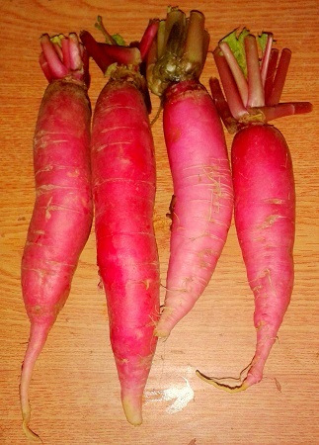
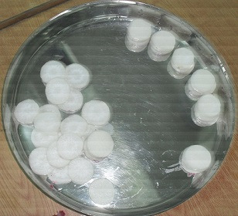

Fig. 1 Fresh pink radishes Fig. 2 Radish slices for osmotic dehydration

2.2 Analysis of samples
The fresh and osmo-dehydrated radish slices were weighed using a digital weighing balance (Shimadzu Corporation, Japan, type: BL-2200H) with an accuracy of ± 0.0. Moisture content of the fresh and osmo-dehydrated radish slices was determined using a digital infrared moisture analyzer (Satorius MA35, India) at 103 ºC.
2.3 Osmotic dehydration
The osmotic solution was taken inside beakers and heated to desired osmotic dehydration temperature by keeping them in a hot water bath prior to each experiment. The cut slices of radish were completely immersed into osmotic solution of desired concentration in beakers (Fig. 3). The beakers were maintained at different osmotic dehydration temperatures by keeping in a hot water bath (Fig. 4).
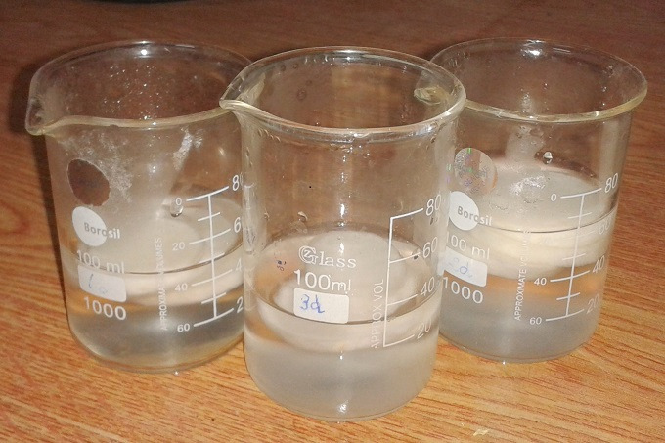

Fig. 3 Samples immersed in osmotic solution
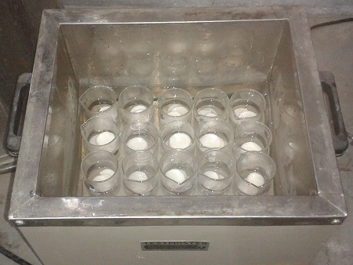

Fig. 4 Radish samples for osmotic dehydration in water bath

The ratio of radish slices to osmotic solution was kept at 1:5 for all the experiments. Each osmotic dehydration experiment was carried out for 4 h. During the process, the osmotic solution was stirred manually at every 10 min interval to maintain uniform temperature of the solution. The radish slices were removed from the beakers after selected time intervals and rinsed with water. The surface moisture of the rinsed radish slices was removed using tissue paper. Weight of osmo-dehydrated radish slices was noted down. Moisture content of this osmo-dehydrated radish slices was estimated. Experiments were carried out taking three independent parameters: Temperature of osmotic solution, concentration of osmotic solution and osmotic dehydration time. The levels of these individual parameters are presented in Table 1.

Table 1 Independent parameters and their levels for osmo-dehydration of pink radish
Independent variables | No. of levels | Levels
Concentration of osmotic solution (%) | 3 | 5, 15 and 25
Temperature of osmotic solution (ºC) | 3 | 40, 50 and 60
Duration of osmotic dehydration (h) | 5 | 0.5, 1.0, 2.0, 3.0 and 4.0

Experiments were conducted at different levels of these independent parameters with two replications. A total of 90 experiments were conducted at the different levels of the independent parameters mentioned in Table 1 with two replications. The data presented in
the Results and Discussion section is the average of the two replications conducted for each
experiment.

2.4 Mass Transfer during osmotic dehydration
The mass transfer parameters during osmotic dehydration were calculated in terms of water loss (WL) in %, solid gain (SG) in % and weight reduction (WR) based on the weight, moisture content and solid content of the samples, according to Eq. (1), (2) and (3), respectively.
Water Loss (WL):
$WL=\frac{\left(Xi-Xf\right)}{Xi}×100$ ….equation 1
Solid Gain (SG):
$SG=\frac{\left(Xsf-Xsi\right)}{Xsi}×100$ ….equation 2
Weight Reduction (WR):
$WR=\left(wi-wf\right)​$ ….equation 3
Where:
Xi, Xf = initial and final moisture contents (in kg moisture/kg dry matter)
Xsi, Xsf = initial and final solid contents (kg solid/kg sample)
wi, wf = initial and final weights of samples (kg).

3. results and discussion

3.1 Analysis of raw materials
Moisture content of radish samples as measured using infrared moisture analyzer was found to be 95.7 ± 0.2% wet basis. The average initial weight of the radish slice of 0.5 cm thickness was 15 ± 0.7 g as measured through weighing balance.

3.2 Change in moisture content and mass transfer parameters with duration of osmotic dehydration
Osmotic dehydration of radish slices was carried out for 4 h. The samples were removed from the osmotic solution at 0.5, 1.0, 2.0, 3.0 and 4.0 h interval for measurement of weight and moisture content. Moisture content of the osmo-dehydrated pink radish slices were measured using infrared moisture analyzer. Water loss (WL), solid gain (SG) and weight reduction (WR) during osmotic dehydration of radish slices were calculated using Eqns. 1 – 3. A gradual decrease in moisture content and increase in water loss, solid gain and weight reduction is observed with increased osmotic dehydration time (Fig. 5 – 6).
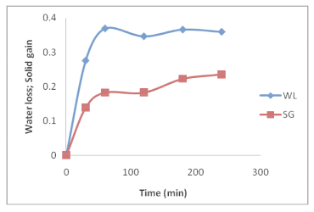
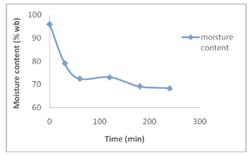

(a) (b)
Fig. 5 Change in (a) Water loss (WL), Solid gain (SG) and (b) moisture content at
temperature of 40 oC and 25% concentration of osmotic solution

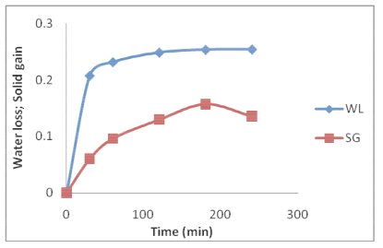
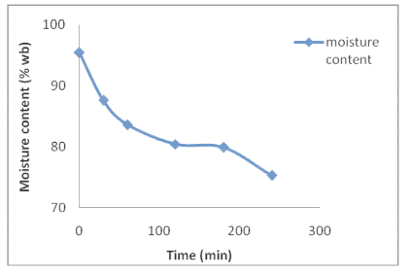

(a) (b)
Fig. 6 Change in (a) Water loss (WL), Solid gain (SG) and (b) moisture content at temperature of 60 ºC and 15% concentration of osmotic solution
The increase in WL and SG was rapid and steady during the initial stages and in most of the cases, after 2 – 2.5 h these parameters became stabilized. This trend has been shown in Fig. 5 and 6 for a few selected experimental conditions for water loss and solid gain. During the initial stage of osmotic dehydration, the driving force, i.e. the difference in osmotic pressure between the radish slices and the osmotic solution is higher. As the dehydration time proceeds, the osmotic solution becomes slightly diluted and some solute from the solution migrates into the radish slices. This, in turn reduces the difference in the osmotic pressure and the rate in moisture reduction decreases. Also, during the initial stages a solid layer is formed on the surface of radish cells which acts as a solid barrier to water flow.

3.3 Effect of temperature of osmotic solution on moisture reduction and mass transfer
parameters
The rate of moisture reduction was higher at higher temperature. Change in moisture content of the samples at different temperature of osmotic solution is shown in Fig. 7 (a), (b) and (c).
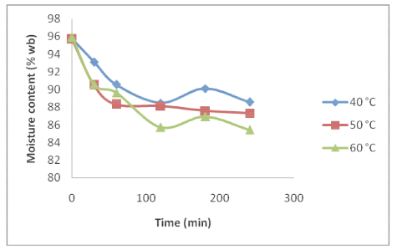
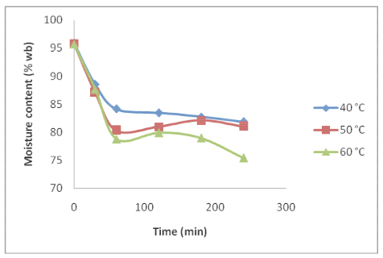
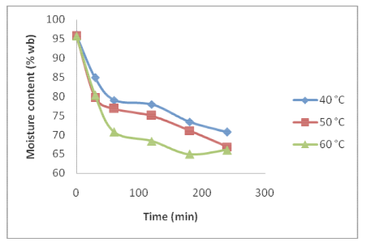

(a) (b) (c)

Fig. 7 Change in moisture content of the radish slices at different temperature in
(a) 5%, (b) 15% and (c) 25% concentration of osmotic solution

Moisture content of the radish slices were decreased from 95.7 ± 0.2% to a lowest level of 70.73% at 40 oC temperature, 66.81% at 50 oC temperature and 66.04% at 60 ºC temperature. Fig. 8 and 9 shows the effect of temperature of osmotic solution on water loss and sugar gain at 15% and 25% concentration of osmotic solution. A gradual increase in water loss (WL) is observed with increased temperature of osmotic solution (Fig. 8 – 9) and maximum water loss was found at 60oC temperature. This may be attributed to lower viscosity of the osmotic solution at higher temperature, which leads to high diffusion rates for the movement of both water and solutes.

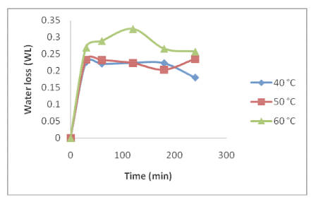
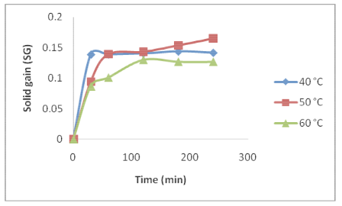

(a) (b)
Fig. 8 Change in (a) Water loss (WL) and (b) Solid gain (SG) of the radish slices at
different temperature in 15% concentration of osmotic solution
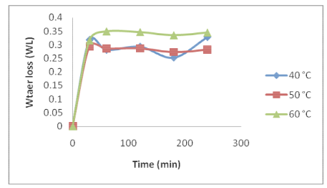
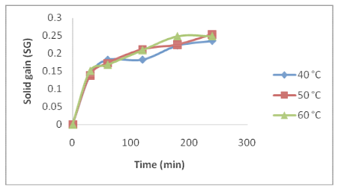

(a) (b)

Fig. 9 Change in (a) Water loss (WL) and (b) Solid gain (SG) of the radish slices at
different temperature in 25% concentration of osmotic solution

From Fig. 8 (b) and 9 (b), it can be observed that the effect of temperature of osmotic solution on the solid gain (SG) is not very pronounced at higher concentration (25%) of osmotic solution. However, the solid gain was highest at 50oC for different concentrations of osmotic solution.
After 4 h of osmotic dehydration in 15% concentration of the osmotic solution, at 40°C temperature, the moisture content, water loss (WL) and solid gain (SG) from the radish slices was found to be 81.85%, 0.257 and 0.142 respectively. At 50°C temperature, the moisture content, water loss (WL) and solid gain (SG) was found to be 81.06%, 0.235 and 0.165 respectively. Similarly, for 60°C temperature, the average values for moisture content, water loss (WL) and solid gain (SG) were 75.45%, 0.180 and 0.127 respectively.

3.4 Effect of concentration of osmotic solution on moisture reduction and mass transfer parameters
Fig. 10 shows the change in moisture content, water loss and solid gain of the radish slices during osmotic dehydration in different concentration (5%, 15% and 25%) of the osmotic solution at 50 oC. Rate of moisture reduction and increase in water loss (WL) and solid gain (SG) was higher in more concentrated solutions. At higher concentration of the osmotic solutions, the difference in the osmotic pressure between the radish cell sap and the osmotic solution is higher. This results in faster moisture movement from the samples. For 5% concentration of osmotic solution, the moisture content and the water loss and solid gain became almost constant only after 1 h of osmotic dehydration, whereas, in 25%concentration of osmotic solution, the change in moisture content, water loss and solid gain could be observed upto 2 – 3 h of osmotic dehydration.

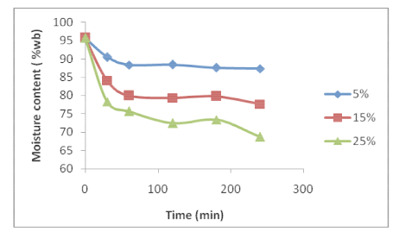
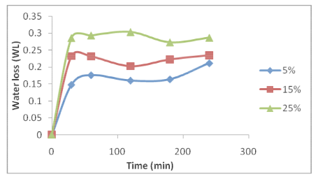
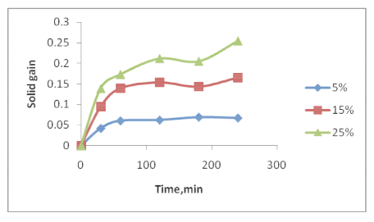

(a) (b) (c)
Fig. 10 Change in (a) moisture content, (b) Water loss (WL) and (c) Solid gain (SG)
in different concentrations at 50 oC temperature of osmotic solution
Depending on experimental temperature, the maximum water loss (WL) obtained was in the range of 0.122 – 0.349, while solid gain values (SG) were in the range of 0.027 – 0.254 at different concentrations of the osmotic solution.

Changes in moisture content, water loss and solid gain at 40oC temperature of osmotic solutions of different concentrations are shown in Fig. 11. Similar trend in change in the parameters at different concentrations can be observed.
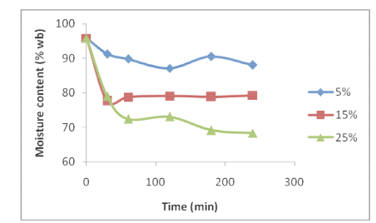
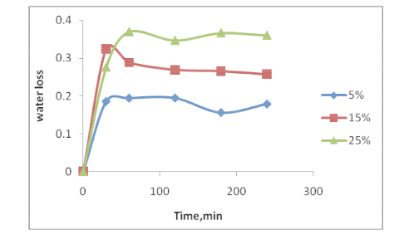
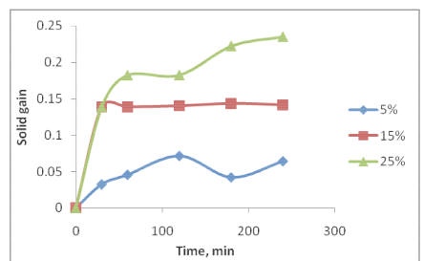

(a) (b) (c)

Fig. 11 Change in (a) moisture content, (b) Water loss (WL) and (c) Solid gain (SG)
in different concentrations at 40 ºC temperature of osmotic solution

A similar trend of increasing water loss and solid gain at higher temperatures and concentrations of osmotic solution has been reported by Lara et al. (2013) for osmotic dehydration of radish slices in salt solution.

4. Conclusion

Osmotic dehydration using sodium chloride solution proves to be an efficient and effective pre-treatment for reducing the high moisture content of pink radish slices. The key conclusions drawn are:
- Moisture content of radish slices were reduced from 95.7 ± 0.2% to a minimum level of 66.04% after 4 h of osmotic dehydration in 25% salt solution at 60°C temperature.
- A gradual decrease in moisture content and increase in water loss, sugar gain and weight reduction is observed with increased osmotic dehydration time.
- The increase in water loss and solid gain was rapid during the initial stages and in most of the cases, after 2 – 2.5 h these parameters became stabilized.
- An increase in water loss (WL) and solid gain (SG) from the radish slices was observed with increase in the temperature of the osmotic solution.
- After 4 h of osmotic dehydration in 15% concentration of the osmotic solution, at 40°C temperature, the moisture content, water loss (WL) and solid gain (SG) from the radish slices was found to be 81.85%, 0.257 and 0.142 respectively. At 50°C temperature, the moisture content, water loss (WL) and solid gain (SG) was found to be 81.06%, 0.235 and 0.165 respectively. Similarly, for 60°C temperature, the average values for moisture content, water loss (WL) and solid gain (SG) were 75.45%, 0.180 and 0.127 respectively.
- Rate of moisture reduction and increase in water loss (WL) and solid gain (SG) was higher in more concentrated solutions.
- The effect of temperature of osmotic solution on the solid gain (SG) is not very pronounced at higher concentration (25%) of osmotic solution. However, highest solid gain was observed at 50 oC for different concentrations of osmotic solution.
- Depending on experimental temperature, the maximum water loss (WL) obtained was in the range of 0.122-0.349, while solid gain values (SG) were in the range of 0.027- 0.254 at different concentrations of the osmotic solution.
The adoption of osmotic dehydration offers a low-cost, gentle, and energy-saving preservation method for pink radish, which is highly suitable for small-scale processors, thereby extending the commodity's shelf life and improving its suitability for subsequent drying or processing steps.

References

Ade-Omowaye, B. I. O., Rastogi, N. K., Angersbach, A., & Knorr, D. (2002). Osmotic dehydration of bell peppers: Influence of high intensity electric field pulses and elevated temperature treatment. Journal of Food Engineering, 54, 35–43. https://doi.org/10.1016/S0260-8774(01)00183-2

Alakali, J. S., Ariahu, C. C., & Nkpa, N. N. (2006). Kinetics of osmotic dehydration of mango. Journal of Food Processing and Preservation, 30, 597–607. https://doi.org/10.1111/j.1745-4549.2006.00080.x

Barat, J. M., Fito, P., & Chiralt, A. (2001). Modelling of simultaneous mass transfer and structural changes in fruit tissues. Journal of Food Engineering, 49, 77–85. https://doi.org/10.1016/s0260-8774(00)00205-3

Fernandes, F. A. N., Rodrigues, S., Gaspareto, O. C. P., & Oliveira, E. L. (2006). Optimisation of osmotic dehydration of bananas followed by air drying. Journal of Food Engineering, 77, 188–193. https://doi.org/10.1016/j.jfoodeng.2005.05.058

Fito, P., Chiralt, A., Betoret, N., Gras, M., Cháfer, M., Martínez-Monzó, J., Anders, A., & Vidal, D. (2001). Vacuum impregnation and osmotic dehydration in matrix engineering: Application in functional fresh-food development. Journal of Food Engineering, 49, 175–183. https://doi.org/10.1016/S0260-8774(00)00220-X

Garcia, C., Mauro, M., & Kimura, M. (2007). Kinetics of osmotic dehydration and air-drying of pumpkins. Journal of Food Engineering, 82, 284–291. https://doi.org/10.1016/j.jfoodeng.2007.02.004

Hussian, I., Iqbal, M., & Arub, N. (2004). Effect of sucrose and glucose mixture on the quality characteristics of osmotically dehydrated banana slices. Pakistan Journal of Nutrition, 4(6), 83–92. https://doi.org/10.3923/pjn.2004.282.284

Ketata, M., Desjardins, Y., & Ratti, C. (2013). Effect of liquid nitrogen pre-treatments on osmotic dehydration of blueberries. Journal of Food Engineering, 116, 202–212.
https://doi.org/10.1016/j.jfoodeng.2012.10.035
Khoyi, M., & Hesari, J. (2007). Osmotic dehydration kinetics of apricot using sucrose solution. Journal of Food Engineering, 78, 1355–1360. https://doi.org/10.1016/j.jfoodeng.2006.01.007

Lara, E., Sánchez, C., Angulo, H., Garcia, R., Espinosa, H., & Lopez, I. (2013). Mass transfer modeling of equilibrium and dynamic periods during osmotic dehydration of radish in NaCl solutions. Food and Bioproducts Processing, 91, 216–224. https://doi.org/10.1016/J.FBP.2012.10.001

Lazarides, H. N., & Mavroudis, N. (1995). Freeze–thaw effect on mass-transfer rates during osmotic dehydration. Journal of Food Science, 60, 826–829. https://doi.org/10.1111/j.1365-2621.1995.tb06239.x

Lee, J. H., & Kim, H. J. (2009). Vacuum drying kinetics of Asian white radish (Raphanus sativus L.) slices. LWT – Food Science and Technology, 42(1), 180–186. https://doi.org/10.1016/j.lwt.2008.05.017

Lenart, A., & Lewicki, P. P. (1988). Energy consumption during osmotic and convective drying of plant tissues. Acta Alimentaria Polonica, 14, 65–72.

Matusek, A., & Merész, P. (2002). Modeling of sugar transfer during osmotic dehydration of carrots. Periodica Polytechnica Chemical Engineering, 46, 83–92. https://pp.bme.hu/ch/article/download/9000/5000

Nieto, A., Castro, M. A., & Alzamora, S. M. (2001). Kinetics of moisture transfer during air drying of blanched and/or osmotically dehydrated mango. Journal of Food Engineering, 50, 175–185. https://doi.org/10.1016/S0260-8774(01)00026-7

Panagiotou, N. M., Karanthanos, V. T., & Maroulis, Z. B. (1998). Mass-transfer modelling of the osmotic dehydration of some fruits. International Journal of Food Science and Technology, 33, 267–284. https://doi.org/10.1046/j.1365-2621.1998.00167.x

Park, K., Bin, A., Brod, F., & Park, T. (2002). Osmotic dehydration kinetics of pear D’Anjou. Journal of Food Engineering, 52, 293–298. https://doi.org/10.1016/S0260-8774(01)00118-2

Peiró-Mena, R., Camacho, M. M., & Martínez-Navarrete, N. (2007). Compositional and physicochemical changes associated with successive osmodehydration cycles of pineapple (Ananas comosus). Journal of Food Engineering, 79, 824–849. https://doi.org/10.1016/j.jfoodeng.2006.03.004

Sacchetti, G., Gianotti, A., & Dalla Rosa, M. (2001). Sucrose–salt combined effects on mass-transfer kinetics and product acceptability: A study on apple osmotic treatment. Journal of Food Engineering, 49, 163–173. https://doi.org/10.1016/S0260-8774(00)00170-X

Silva, K., Caetano, L., Garcia, C., Romero, J., Santos, A., & Mauro, M. (2011). Osmotic dehydration process for low-temperature blanched pumpkin. Journal of Food Engineering, 105, 56–64. https://doi.org/10.1016/j.jfoodeng.2011.01.025

Singh, B., Kumar, A., & Gupta, A. K. (2007). Study of mass-transfer kinetics and effective diffusivity during osmotic dehydration of carrot cubes. Journal of Food Engineering, 79, 471–480. https://doi.org/10.1016/j.jfoodeng.2006.01.074

Singh, B., Panesar, P. S., Nanda, V., & Kennedy, J. F. (2010). Optimisation of osmotic dehydration of carrot cubes in mixtures of sucrose and sodium chloride solutions. Food Chemistry, 123, 590–600. https://doi.org/10.1016/j.foodchem.2010.04.075

Sunkja, P. S., & Raghavan, G. S. V. (2004). Assessment of pretreatment methods and osmotic dehydration of cranberries. Canadian Biosystems Engineering, 46, 52–56.

Sutar, P. P., & Gupta, D. K. (2007). Mathematical modeling of mass transfer in osmotic dehydration of onion slices. Journal of Food Engineering, 78(1), 90–97. https://doi.org/10.1016/j.jfoodeng.2005.09.008

Torreggiani, D., & Gianni, B. (2001). Osmotic pre-treatment in fruit processing: Chemical, physical and structural effects. Journal of Food Engineering, 49, 247–253. https://doi.org/10.1016/S0260-8774(00)00210-7

