Climate-resilient rice agronomy: from stress-tolerant varieties to direct-seeded and low-emission systems
Abstract
Climate change poses escalating risks to rice production through rising temperatures, water scarcity, increased salinity, and frequent extreme weather events. Developing climate-resilient and low-emission rice systems is therefore essential for sustaining yields and strengthening global food security. This manuscript synthesizes recent advances in stress-tolerant rice varieties, water-smart agronomy, direct-seeded systems, and greenhouse-gas mitigation strategies. Drought-, salinity-, heat-, and cold-tolerant cultivars demonstrate significant potential to stabilize productivity across diverse stress-prone environments, supported by multi-omics tools and targeted breeding. Water-efficient practices—including aerobic rice, alternate wetting and drying, and integrated water–fertilizer management—enhance water productivity while reducing labor and input costs. Direct-seeded rice emerges as a viable alternative to puddled transplanted systems, offering major reductions in water use, energy demand, and carbon footprint when supported by appropriate varieties and weed-management strategies. Finally, a mechanistic understanding of methane and nitrous oxide dynamics highlights how water regimes govern trade-offs between CH₄ suppression and N₂O generation. Together, these innovations form a framework for transforming rice cultivation into a climate-resilient, resource-efficient, and low-emission production system.
Keywords: Aerobic rice cultivation; Climate resilient rice; Climate smart agriculture; Low emission rice system.
- Introduction
Rice is an essential component of global food security, serving as a staple diet for over half the world's population. However, its cultivation is increasingly vulnerable to the consequences of climate change. Studies indicate that rising global temperatures, altered precipitation patterns, and the increased occurrence of extreme weather events are negatively impacting rice yields across various regions (Cao et al., 2022; Shin et al., 2017). This vulnerability poses significant challenges to food systems, particularly in regions largely dependent on rainfed rice, such as India, Sri Lanka and West Africa, where climate impacts threaten both agricultural productivity and farmer livelihoods (Cordell et al., 2021; Gérardeaux et al., 2021).
Recent research emphasizes the urgent need for adapting rice cultivation practices to mitigate these impacts. Strategies such as adopting climate-smart agriculture, employing new resilient rice cultivars, and optimizing resource management are being explored to enhance resilience to climate change. These adaptations are crucial for maintaining rice production and, by extension, global food security (Akinsemolu et al., 2023; Qiu et al., 2019). Moreover, climate change's spatially varied impact necessitates region-specific adaptation strategies. For instance, autonomous adaptation methods like changing crop varieties and planting dates show promise in certain mid-latitude countries, while their effectiveness is markedly reduced in low-latitude regions, which already face temperature thresholds detrimental to rice growth (Shin et al., 2017).
The push for climate-resilient and low-emission rice agronomy arises from the dual necessity of ensuring food security and mitigating environmental impacts. Rice is a critical staple crop worldwide but is also responsible for significant greenhouse gas emissions, primarily methane, due to conventional flooded rice paddies. Thus, there is an urgent need to transition rice farming towards practices that withstand climate variability and reduce emissions (Ling et al., 2022; Sun et al., 2023).
Climate-resilient rice agronomy involves developing and implementing agricultural practices that enhance the ability of rice systems to cope with the effects of climate change. This includes strategies such as utilizing climate-tolerant rice varieties, optimizing planting schedules, and improving water management. For example, methods like the system of rice intensification (SRI) and aerobic rice cultivation have shown promising results in increasing yields while using less water (Bhuvaneswari et al., 2022). Moreover, the transition to low-emission rice production is crucial in reducing the carbon footprint of agriculture. A key focus is on reducing methane emissions from paddy fields by integrating practices such as alternate wetting and drying (AWD) and utilizing rice straw in biogas production rather than burning it. This not only reduces emissions but can also improve soil organic carbon sequestration, thereby enhancing soil health and productivity (Das et al., 2023; Li et al., 2024; Röder et al., 2024).
Collectively, advancing rice agronomy to be both climate-resilient and low-emission not only addresses the need for sustainable food production but also plays a significant role in global climate change mitigation efforts. These adaptations require a collaborative effort across different regions and stakeholders, integrating technological, management, and policy innovations for a sustainable agricultural future.
- Stress tolerant rice varieties for resilience
In India, the development of stress-tolerant rice varieties is imperative to enhance resilience against the increasing pressures of climate change, such as drought, salinity, alkalinity, and flooding. Drought is a major challenge in Indian agriculture. The identification and cultivation of drought-tolerant rice varieties are crucial for sustaining agricultural productivity amid fluctuating climate conditions. Drought-tolerant varieties such as 'Sahbhagi Dhan', 'RCPL-1-82', and 'Banglami' have shown promising traits in withstanding water scarcity (Bhattacharjee et al., 2023; Verma et al., 2022). These genotypes maintain higher seed germination rates, robust antioxidant activities, and the expression of drought-responsive genes, which aid in their resilience to drought conditions. In the Northeast region of India, which experiences significant seasonal drought stress, traditional rice cultivars exhibit a unique genetic diversity that carries traits favorable for drought tolerance (Bhattacharjee et al., 2023). The integration of these genetic traits through breeding programs can produce new climate-smart rice varieties that are both high-yielding and drought-resistant. Agronomic practices play a significant role in maximizing the potential of these drought-tolerant varieties. Aerobic rice cultivation, which uses significantly less water than traditional methods, has been shown to improve water use efficiency while supporting drought-tolerant genotypes (Mousa et al., 2024). Practices like the system of rice intensification (SRI) have also been successfully implemented in India to enhance root health and increase yields by up to 40% during drought conditions, compared to traditional practices (Balamatti & Uphoff, 2017). Furthermore, enhanced nutrient management tailored to drought conditions can significantly improve the productivity of these rice varieties. For example, the variety NSIC Rc282 demonstrated higher drought adaptation and yielded more than popular varieties under stress (Banayo et al., 2020). The combination of targeted breeding, proper agronomic practices, and adaptive management strategies is essential for bolstering rice production in India's drought-prone areas.
Coastal and arid regions in India contend with salinity and alkalinity, impairing rice growth. Rice varieties like Kala Rata, which has shown salt tolerance, are cultivated in regions with brackish water and manage to maintain high internal potassium levels, crucial for salinity tolerance (Hegde & Joshi, 1974). The importance of these tolerant varieties lies in their ability to grow in environments where traditional rice varieties would struggle, thereby securing food production in challenging conditions (Fig. 1). The use of microbial strategies to mitigate sodic stress in rice has also been explored. Exopolysaccharide-producing sodic tolerant bacteria (EPS-STB) have been identified as beneficial, as they can reduce the uptake of sodium by rice plants, thus alleviating the adverse effects of sodicity. Isolates such as Franconibacter helveticus, when inoculated in rice, have shown to enhance plant growth under sodic conditions (Gunasekaran et al., 2022). Additionally, understanding and leveraging transcription factors (TFs) associated with salinity tolerance can offer another layer of resilience. Research aimed at decoding the role of TFs in salinity tolerance suggests that targeting these could influence various genes responsible for stress tolerance, providing a multifaceted defence against salinity (Tiwari et al., 2022). The implementation of such resilient rice varieties and agronomic practices around them is critical for the salinized and sodified regions of India. They are essential not just for maintaining the yields but also for ensuring sustainable agricultural practices and food security in regions threatened by salinity and sodicity.
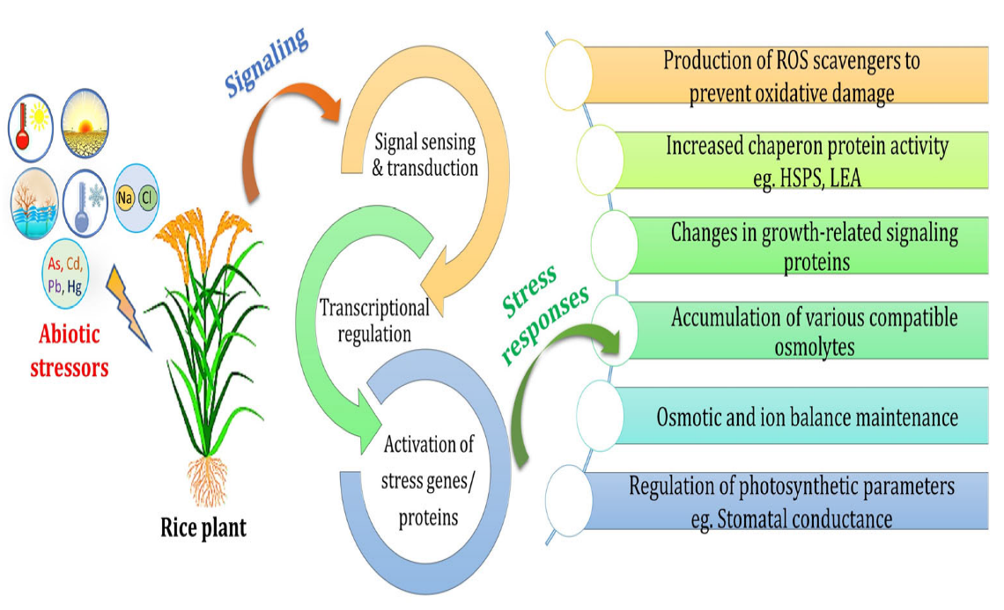
Additionally, heat stress poses significant threats to rice, affecting yield and grain quality. To counter this, breeding heat-tolerant rice varieties is a key adaptation strategy. Research highlights the necessity of enhancing rice's heat tolerance by at least 3°C by the 2040s to combat global warming impacts effectively. Strategies such as canopy temperature management, using heat-tolerant genetic resources, and applying exogenous regulators are employed to bolster rice's heat resistance (Masutomi et al., 2022; Yu et al., 2024). Conversely, cold stress can significantly impede rice development, leading to drastic yield reductions. The identification of cold-responsive genes and advancements in molecular breeding have been pivotal in developing cold-tolerant varieties. These discoveries have accelerated the breeding of rice cultivars that are resilient to cold stress, aiding in maintaining productivity in cooler climates (Shahzad et al., 2024). The integration of multi-omics approaches, encompassing genomics, transcriptomics, and metabolomics, enhances our understanding of rice's response mechanisms to extreme temperatures. This comprehensive view facilitates the development of rice varieties capable of withstanding both heat and cold stresses, thus ensuring sustainable production and global food security amid unpredictable climatic conditions (Singh et al., 2024).

Fig. 1. Response to rice to various abiotic stress (Reused from Sarma, B., Kashtoh, H., Lama Tamang, T., Bhattacharyya, P. N., Mohanta, Y. K., & Baek, K. H. (2023). Abiotic stress in rice: Visiting the physiological response and its tolerance mechanisms. Plants, 12(23), 3948, under CC BY 4.0)
- Water smart rice agronomy
Traditional puddled transplanted rice (PTR) is a long-established method where seedlings are transplanted into waterlogged, puddled fields, and it remains popular because it offers some clear agronomic advantages. The standing water helps suppress weed growth, reducing the need for herbicides (Singh et al., 2018). Puddling also improves nutrient availability by speeding up the decomposition of organic matter and enhancing nutrient uptake by the rice plants (Obalum et al., 2012). In many environments, PTR is associated with relatively stable yields, partly because puddled soils encourage greater root plasticity, which helps rice plants cope with variable soil conditions (Xie et al., 2021). Another important benefit is water retention: puddling creates a hardpan that limits water percolation losses, helping to conserve soil moisture and offering a buffer during dry spells (Obalum et al., 2012).
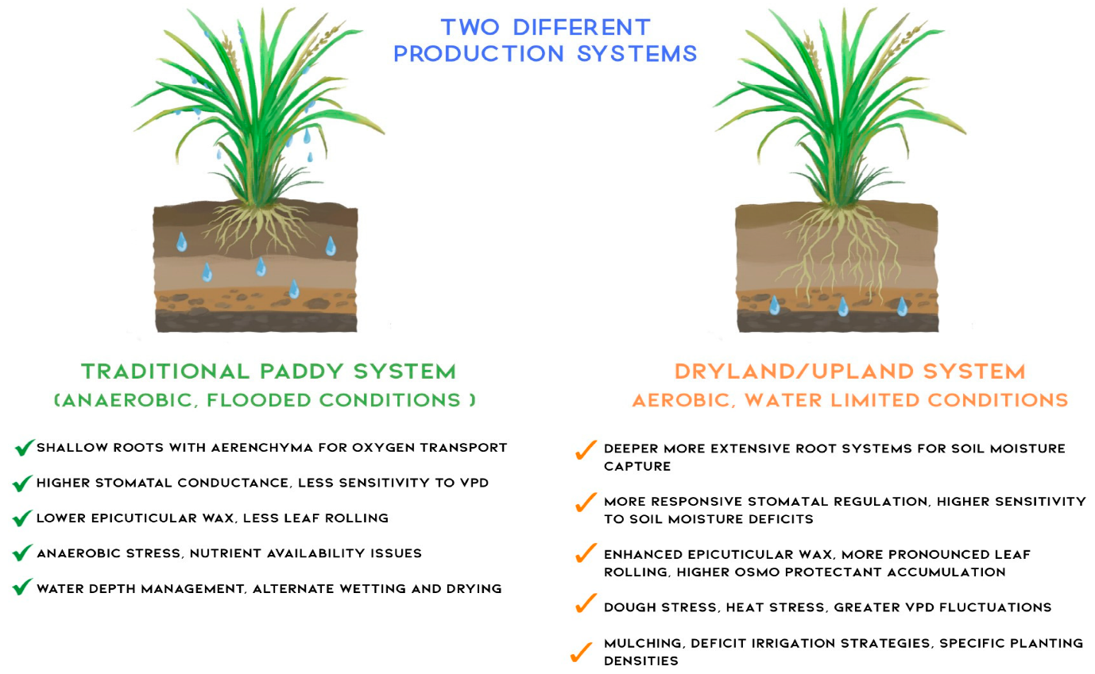
At the same time, PTR has several limitations that are increasingly important in today’s context. It is highly water-intensive, demanding large amounts of water for both land preparation and maintaining flooded conditions, which is a serious concern in water-scarce regions (Singh et al., 2018). The system is also very labor intensive, especially during transplanting and managing puddled fields, contributing to significant drudgery for workers often disproportionately affecting women (Singh, 2009). Over years of continuous use, puddling can contribute to soil degradation, as the persistent hardpan and poor aeration can hinder root growth and reduce the performance of subsequent non-rice crops (Rahman & Islam, 1991). In addition, the high demands for water, labor, and energy translate into higher production costs, making PTR less competitive compared with alternatives such as direct seeded rice (DSR) in many regions (Ratnayake & Balasoriya, 2013). Water smart rice agronomy focuses on optimizing water use while maintaining or enhancing rice productivity (Fig. 2). This approach is particularly vital in addressing the challenges posed by water scarcity and climate change.

Fig. 2. Comparison of traditional irrigated paddy systems (left) operating under anaerobic, flooded conditions with dryland/upland systems (right) under aerobic, water-limited conditions. (Reused from Fernando, Y., Adams, M., & Kuhlmann, M. (2025). Stomatal and Non-Stomatal Leaf Traits for Enhanced Water Use Efficiency in Rice. Biology, 14(7), 843, under CC BY 4.0)
Some key practices and benefits from recent studies in water-smart rice agronomy:
- Alternate Wetting and Drying (AWD): AWD involves alternating periods of submergence and drying during rice cultivation, reducing water usage without significantly affecting yield (Fig. 3). This practice enhances water productivity and maintains grain yield comparably to traditional methods, offering up to a 17.3% increase in water savings with minimal yield loss (Zabihpour Roushan et al., 2023). Additionally, AWD combined with the System of Rice Intensification (SRI) shows potential in increasing soil organic carbon and nutrient retention, further promoting sustainable cultivation (Alavaisha et al., 2022).
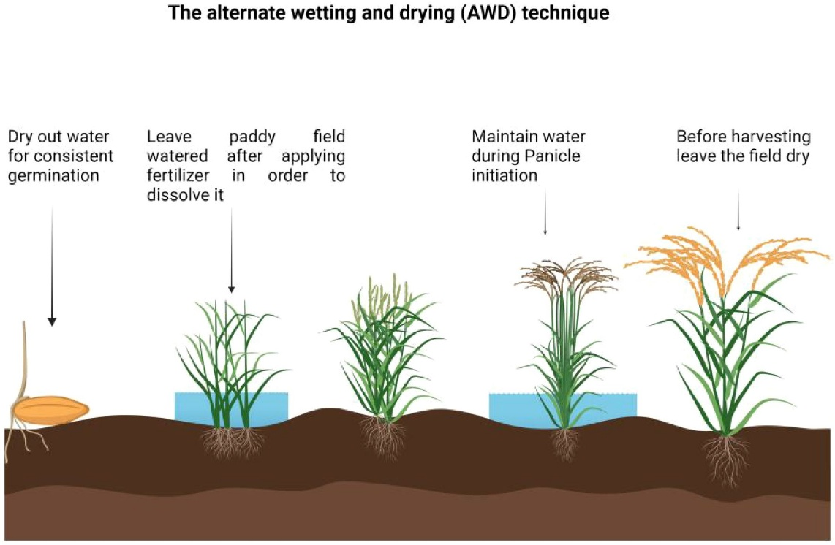

Fig. 3. Illustration of alternate wetting and drying technique in rice (Reused from Danso Ofori, A., Titriku, J. K., Xiang, X., Charlotte, A., Ahmed, M. I., & Zheng, A. (2025). Rice production in Ghana: a multi-dimensional sustainable approach. Frontiers in Agronomy, 7, 1508896, under CC BY 4.0)

- Aerobic Rice Cultivation: Aerobic rice is grown in non-puddled, non-flooded fields, significantly reducing water usage. This method is especially beneficial in water-scarce regions where it can cut irrigation needs by up to 50%, balancing the reduction in water use with the maintenance of yield. Aerobic rice cultivation is advantageous for its decreased labor demands and enhanced water productivity, making it a sustainable alternative to traditional paddy fields (Mahapatra et al., 2001).
- Water-Fertilizer Integration Management (AIM): AIM systems integrate water and fertilizer management to improve resource use efficiency while reducing environmental impacts. AIM reduces water and fertilizer inputs by 12.18-28.57% compared to traditional methods, lowers carbon emissions, and enhances energy efficiency and profitability, supporting sustainable large-scale rice production (Liao et al., 2024).
- Climate-Adaptive Water Management: Efficient water management using agro-hydrological models assists in adapting to climate variations by optimizing irrigation scheduling and water distribution. Such models can integrate climate data to predict water availability and adjust cropping patterns, ensuring water security under changing climatic conditions (Ismail et al., 2020).
- Direct-seeded rice (DSR)
Direct-seeded rice (DSR) offers strong potential as a climate-resilient agronomic practice and is increasingly viewed as a viable alternative to conventional puddled transplanted rice (CT-PTR), particularly under conditions of water scarcity, rising production costs, and a changing climate (Singh et al., 2018). By eliminating continuous standing water and the puddling process, DSR substantially reduces water use and the energy needed for irrigation (Fig. 4). This shift not only helps address growing water constraints but also cuts the energy footprint associated with pumping, with studies showing reductions of about 37.47% in energy inputs and 29.35% in carbon footprints compared with CT-PTR, underscoring its appeal as an environmentally sustainable option (Jin et al., 2023).
When combined with conservation agriculture (CA) principles, DSR can also contribute positively to soil health and natural resource management. Reduced soil disturbance, zero tillage, and residue retention help improve soil structure, enhance soil organic carbon, and support better nutrient cycling, thereby strengthening the long-term sustainability of production systems (Saurabh et al., 2022). On the genetic side, recent breeding efforts have focused on traits such as mesocotyl elongation and strong seedling vigor, which are particularly valuable in DSR because they enable better emergence from deeper sowing depths. Marker-assisted selection and targeted breeding are increasingly being used to incorporate these traits into new rice varieties specifically suited to DSR conditions (Huang et al., 2022; Sandhu et al., 2023).
Economically, DSR reduces dependence on labor-intensive operations like nursery raising and manual transplanting, which is especially important in regions facing labor shortages or high wage rates. The combined savings in labor, tillage operations, and irrigation energy can improve farm profitability and make DSR an attractive option for farmers struggling with high input costs (Bhuvaneswari et al., 2022). However, DSR also brings its own challenges, particularly higher weed pressure due to the absence of standing water, which traditionally suppresses many weeds in CT-PTR. Managing this requires integrated weed management strategies that blend cultural, mechanical, and chemical control methods, supported by the use of competitive rice cultivars. Such integrated approaches are crucial for sustaining high yields and realizing the full agronomic and environmental benefits of DSR (Singh et al., 2018).
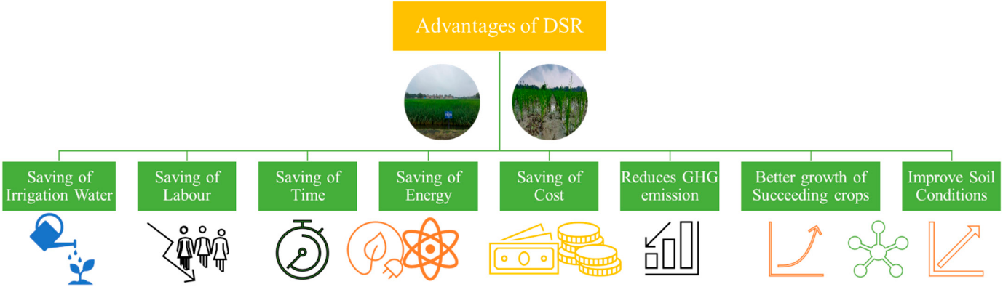
Fig. 4. Benefits of adopting direct seeded rice (Reused from Jat, R. K., Meena, V. S., Kumar, M., Jakkula, V. S., Reddy, I. R., & Pandey, A. C. (2022). Direct seeded rice: strategies to improve crop resilience and food security under adverse climatic conditions. Land, 11(3), 382, under CC BY 4.0)
- Low-emission rice system
In flooded soils, such as those found in rice paddies or re-wetted peatlands, conditions become anaerobic due to the lack of oxygen. This environment is conducive to the growth of methanogenic archaea, microorganisms that produce methane as a by-product of anaerobic decomposition. In these settings, organic matter undergoes a series of reductive processes, culminating in methane production, which is influenced by environmental factors like temperature and nutrient availability. For instance, re-wetted peatlands showed high CH₄ emissions due to the presence of dissolved organic carbon and nitrogen, which are supportive of methanogenic activity (Osterloh et al., 2017). In non-flooded soils, CH₄ production is minimal due to oxidative conditions that do not support methanogens. Instead, these environments may act as CH₄ sinks, as methane-oxidizing bacteria can consume any methane produced in minor anaerobic niches (Yang et al., 2023).
However, in non-flooded soils, N₂O emissions are often higher due to the nitrification and denitrification processes. Nitrification is the microbial oxidation of ammonium (NH₄⁺) to nitrate (NO₃⁻), while denitrification is the reduction of NO₃⁻ in low-oxygen environments, releasing N₂O as an intermediate. These processes are particularly enhanced under fluctuating moisture regimes, such as those induced by intermittent watering strategies or drainage events in agricultural fields (Moterle et al., 2020). For example, in saline soils, nitrogen application can significantly increase N₂O emissions, more so under varying salinity conditions (Yang et al., 2023). In flooded conditions, the production of N₂O is usually limited due to the dominance of anaerobic respiration pathways that favor methane production instead. However, any periodic exposure to air or subsequent rewetting that introduces oxygen can stimulate nitrification temporarily, leading to N₂O production (Zhao et al., 2024). Understanding the dynamic between CH₄ and N₂O emissions in different soil conditions is crucial for developing strategies to mitigate greenhouse gas releases from agricultural lands, particularly under changing climatic conditions and water management practices.
- Conclusion
Rice production stands at a crossroads where environmental pressures and rising food demand compel a shift toward more resilient and sustainable agronomic systems. The evidence synthesized in this manuscript shows that stress-tolerant rice varieties, when paired with adaptive management, can buffer crops against drought, salinity, heat, and cold-conditions that are projected to intensify under climate change. Water-smart practices such as AWD, aerobic cultivation, and integrated water-fertilizer management offer substantial reductions in water use and input requirements, while direct-seeded rice provides a pathway to lower labor dependence, reduced energy demand, and improved soil health under conservation agriculture frameworks. At the same time, understanding the interplay between methane and nitrous oxide emissions across flooded and aerobic soil conditions allows more precise design of low-emission rice systems. Collectively, these strategies demonstrate that climate-resilient and low-emission rice agronomy is achievable through a combination of improved genetics, optimized resource management, and context-specific adaptation. Scaling these approaches will require coordinated efforts in breeding, extension, and policy support, particularly in regions where rice is both a livelihood foundation and a climate-vulnerable crop. Advancing such integrated systems is essential for ensuring long-term productivity, environmental sustainability, and global food security in a rapidly changing climate.
Disclaimer (artificial intelligence)
Author(s) hereby declares that no generative AI technologies such as Large Language Models (ChatGPT, COPILOT, etc) and text-to-image generators have been used during writing or editing of this manuscript.
\References
- Akinsemolu, A. A., Onyeaka, H. N., & Tamasiga, P. (2023). Climate‐smart agriculture as a possible solution to mitigate climate change impact on food security in Sub‐Saharan Africa. Food and Energy Security. https://doi.org/10.1002/fes3.509
- Alavaisha, E., Tumbo, M., Senyangwa, J., & Mourice, S. (2022). Influence of Water Management Farming Practices on Soil Organic Carbon and Nutrients: A Case Study of Rice Farming in Kilombero Valley, Tanzania. Agronomy, 12(5), 1148. https://doi.org/10.3390/agronomy12051148
- Balamatti, A., & Uphoff, N. (2017). Experience with the system of rice intensification for sustainable rainfed paddy farming systems in India. Agroecology and Sustainable Food Systems, 41(6), 573–587. https://doi.org/10.1080/21683565.2017.1308898
- Banayo, N. P. M., Rahon, R. E., Sta Cruz, P., & Kato, Y. (2020). Fertilizer responsiveness of high-yielding drought-tolerant rice in rainfed lowlands. Plant Production Science, 24(3), 279–286 https://doi.org/10.1080/1343943x.2020.1847668
- Bhattacharjee, B., Ali, A., Rangappa, K., Choudhury, B. U., & Mishra, V. K. (2023). A detailed study on genetic diversity, antioxidant machinery, and expression profile of drought-responsive genes in rice genotypes exposed to artificial osmotic stress. Scientific Reports https://doi.org/10.1038/s41598-023-45661-8
- Bhuvaneswari, K., Geethalakshmi, V., Lakshmanan, A., Anbhazhagan, R., & Nagothu Udaya Sekhar, D. (2022). Climate change impact assessment and developing adaptation strategies for rice crop in western zone of Tamil Nadu. Journal of Agrometeorology, 16(1), 38–43. https://doi.org/10.54386/jam.v16i1.1484
- Cao, W., Duan, C., Yang, T., & Wang, S. (2022). Higher Heat Stress Increases the Negative Impact on Rice Production in South China: A New Perspective on Agricultural Weather Index Insurance. Atmosphere, 13(11), 1768. https://doi.org/10.3390/atmos13111768
- Cordell, D., Jacobs, B., Nanda, M., Dominish, E., & Esham, M. (2021). Adapting food systems to the twin challenges of phosphorus and climate vulnerability: the case of Sri Lanka. Food Security, 13(2), 477–492. https://doi.org/10.1007/s12571-020-01118-8
- Das, S. R., Dey, S., Pradhan, A., Chatterjee, D., Nayak, A. K., Nayak, B. K., Sarkar, D., Sarkar, S., Saha, S., & Saha, S. (2023). Potential soil organic carbon sequestration vis-a-vis methane emission in lowland rice agroecosystem. Environmental Monitoring and Assessment, 195(9) https://doi.org/10.1007/s10661-023-11673-0
- Gérardeaux, E., Muller, B., Affholder, F., Falconnier, G. N., Kouakou, P. M., Sultan, B., Defrance, D., Gozé, E., & Loison, R. (2021). Adapting rainfed rice to climate change: a case study in Senegal. Agronomy for Sustainable Development, 41(4) https://doi.org/10.1007/s13593-021-00710-2
- Gunasekaran, Y., Thiyageshwari, S., Ariyan, M., Roy Choudhury, A., Park, J.-H., Selvi, D., Chithra, L., & Anandham, R. (2022). Alleviation of Sodic Stress in Rice by Exploring the Exopolysaccharide-Producing Sodic-Tolerant Bacteria. Agriculture, 12(9), 1451. https://doi.org/10.3390/agriculture12091451
- Hegde, B. A., & Joshi, G. V. (1974). Mineral salt absorption in saline rice variety, Kala Rata. Plant and Soil, 41(2), 421–424. https://doi.org/10.1007/bf00017269
- Huang, Q., Han, B., Zhao, Z., Han, L., Ma, X., Cheng, Y., Cui, D., & Ju, C. (2022). QTL Mapping of Mesocotyl Elongation and Confirmation of a QTL in Dongxiang Common Wild Rice in China. Agronomy, 12(8), 1800. https://doi.org/10.3390/agronomy12081800
- Ismail, H., Kamal, M. R., Bin Abdullah, A. F., & Bin Mohd, M. S. F. (2020). Climate-Smart Agro-Hydrological Model for a Large Scale Rice Irrigation Scheme in Malaysia. Applied Sciences, 10(11), 3906. https://doi.org/10.3390/app10113906
- Jin, Z., Mu, Y., Li, Y., & Nie, L. (2023). Dry direct-seeded rice has higher energy and carbon production efficiencies without reducing economic benefits. Journal of the Science of Food and Agriculture, 103(12), 6044–6054. https://doi.org/10.1002/jsfa.12675
- Li, S., Lu, H., Li, X., Shao, Y., Tang, Y., Chen, G., Chen, Z., Zhu, Z., Zhu, J., Tang, L., & Liang, J. (2024). Toward Low-Carbon Rice Production in China: Historical Changes, Driving Factors, and Mitigation Potential. Environmental Science & Technology, 58(13), 5772–5783. https://doi.org/10.1021/acs.est.4c00539
- Liao, Q., Nie, J., Yin, H., Luo, Y., Shu, C., Cheng, Q., Fu, H., Li, B., Li, L., Sun, Y., Chen, Z., Ma, J., Li, N., Zhang, X., & Yang, Z. (2024). Can the Integration of Water and Fertilizer Promote the Sustainable Development of Rice Production in China? Agriculture, 14(4), 585. https://doi.org/10.3390/agriculture14040585
- Ling, J., Xue, Y., Yang, C., & Zhang, Y. (2022). Effect of Farmers’ Awareness of Climate Change on Their Willingness to Adopt Low-Carbon Production: Based on the TAM-SOR Model. International Journal of Environmental Research and Public Health, 20(1), 619. https://doi.org/10.3390/ijerph20010619
- Mahapatra, B. S., Kumar, A., Bora, S. S., Bhupenchandra, I., Verma, G., Devi, S. H., Singh, R., Babu, S., Devi, E. L., & Chongtham, S. K. (2021). Aerobic Rice and its significant perspective for sustainable crop production. Indian Journal of Agronomy, 66(4), 383–392. https://doi.org/10.59797/ija.v66i4.2871
- Masutomi, Y., Takimoto, T., Manabe, T., Imai, Y., Tamura, M., & Kobayashi, K. (2022). Breeding targets for heat-tolerant rice varieties in Japan in a warming climate. Mitigation and Adaptation Strategies for Global Change, 28(1). https://doi.org/10.1007/s11027-022-10027-4
- Moterle, D. F., Drescher, G. L., Da Silva, L. S., & Müller, E. A. (2020). Relationship between soil solution electrochemical changes and methane and nitrous oxide emissions in different rice irrigation management systems. Environmental Science and Pollution Research, 27(28), 35591–35603. https://doi.org/10.1007/s11356-020-09744-7
- Mousa, A. M. A., Ali, A. M. A.-G., Omar, A. E. A., Alharbi, K., Abd El-Moneim, D., Mansour, E., & Elmorsy, R. S. A. (2024). Physiological, Agronomic, and Grain Quality Responses of Diverse Rice Genotypes to Various Irrigation Regimes under Aerobic Cultivation Conditions. Life, 14(3), 370. https://doi.org/10.3390/life14030370
- Obalum, S. E., Oppong, J., Nwite, J. C., Watanabe, Y., Buri, M. M., Igwe, C. A., & Wakatsuki, T. (2012). Long-term effects of lowland sawah system on soil physicochemical properties and rice yield in Ashanti Region of Ghana. Spanish Journal of Agricultural Research, 10(3), 838–848. https://doi.org/10.5424/sjar/2012103-566-11
- Osterloh, K., Tauchnitz, N., Spott, O., Hepp, J., Bernsdorf, S., & Meissner, R. (2017). Changes of methane and nitrous oxide emissions in a transition bog in central Germany (German National Park Harz Mountains) after rewetting. Wetlands Ecology and Management, 26(1), 87–102. https://doi.org/10.1007/s11273-017-9555-x
- Qiu, X., Zhu, Y., Cao, W., Tang, L., & Liu, L. (2019). Quantification of Cultivar Change in Double Rice Regions under a Warming Climate during 1981–2009 in China. Agronomy, 9(12), 794. https://doi.org/10.3390/agronomy9120794
- Rahman, S. M., & Islam, A. (1991). Yield and water relations of wheat as influenced by irrigation and depth of tillage. Irrigation Science, 12(2). https://doi.org/10.1007/bf00190012
- Rajasekar, P., & Selvi, J. A. V. (2022). Sensing and Analysis of Greenhouse Gas Emissions from Rice Fields to the Near Field Atmosphere. Sensors (Basel, Switzerland), 22(11), 4141. https://doi.org/10.3390/s22114141
- Ratnayake, R. M. C., & Balasoriya, B. M. C. P. (2013). Re-Design, Fabrication, and Performance Evaluation of Manual Conical Drum Seeder: A Case Study. Applied Engineering in Agriculture. https://doi.org/10.13031/2013.42644
- Röder, M., Thornley, P., & Jamieson, C. (2024). The greenhouse gas performance and climate change mitigation potential from rice straw biogas as a pathway to the UN sustainable development goals. Biomass and Bioenergy, 182, 107072. https://doi.org/10.1016/j.biombioe.2024.107072
- Sandhu, N., Ankush, A. P., Singh, J., Raigar, O. P., Bains, S., Jindal, T., Singh, M. P., Sethi, M., Pruthi, G., Augustine, G., Verma, V. K., Goyal, S., Kumar, A., Panwar, H., Sihag, M. K., Kaur, R., Kurup, S., & Kumar, A. (2023). Integrating Association Mapping, Linkage Mapping, Fine Mapping with RNA Seq Conferring Seedling Vigor Improvement for Successful Crop Establishment in Deep Sown Direct-Seeded Rice. Rice, 16(1). https://doi.org/10.1186/s12284-023-00665-w
- Saurabh, K., Meena, R. S., Jeet, P., Kumar, M., Choudhary, J. S., Mishra, J. S., Mondal, S., Biswas, A. K., Kumar, R., Hans, H., Upadhyaya, A., Raman, R. K., Yadav, S. K., Roy, H. S., Singh, N. R., Singh, A. K., & Sundaram, P. K. (2022). Sustainable Intensification of Rice Fallows with Oilseeds and Pulses: Effects on Soil Aggregation, Organic Carbon Dynamics, and Crop Productivity in Eastern Indo-Gangetic Plains. Sustainability, 14(17), 11056. https://doi.org/10.3390/su141711056
- Shahzad, N., Nabi, H. G., Qiao, L., & Li, W. (2024). The Molecular Mechanism of Cold-Stress Tolerance: Cold Responsive Genes and Their Mechanisms in Rice (Oryza sativa L.). Biology, 13(6), 442. https://doi.org/10.3390/biology13060442
- Shin, Y., Lee, E.-J., Im, E.-S., & Jung, I.-W. (2017). Spatially distinct response of rice yield to autonomous adaptation under the CMIP5 multi-model projections. Asia-Pacific Journal of Atmospheric Sciences, 53(1), 21–30. https://doi.org/10.1007/s13143-017-0001-z
- Singh, A., Nandal, D. P., Punia, S. S., & Malik, P. (2018). Integrated weed management in direct seeded rice in Trans Indo-Gangetic plains of India- A review. Journal of Applied and Natural Science, 10(2), 779–790. https://doi.org/10.31018/jans.v10i2.1679
- Singh, S. P. (2009). Physiological Workload of Women Workers in the Operation of Manual Rice Transplanters. Gender, Technology and Development, 13(2), 271–284. https://doi.org/10.1177/097185241001300205
- Singh, S., Praveen, A., Dudha, N., & Bhadrecha, P. (2024). Integrating physiological and multi-omics methods to elucidate heat stress tolerance for sustainable rice production. Physiology and Molecular Biology of Plants: An International Journal of Functional Plant Biology https://doi.org/10.1007/s12298-024-01480-3
- Sun, J., Chen, L., Ogle, S., Cheng, K., Xu, X., Li, Y., & Pan, G. (2023). Future climate change may pose pressures on greenhouse gas emission reduction in China’s rice production. Geoderma, 440, 116732. https://doi.org/10.1016/j.geoderma.2023.116732
- Tiwari, S., Singla‐Pareek, S. L., Gupta, K. J., Nutan, K. K., Pareek, A., Deshmukh, R., Sarsu, F., & Singh, A. K. (2022). Seedling-stage salinity tolerance in rice: Decoding the role of transcription factors. Physiologia Plantarum https://doi.org/10.1111/ppl.13685
- Verma, R. K., Modi, M. K., Devi, K., Sharma, V., Kumar, A., & Chetia, S. K. (2022). Identification and characterization of genes for drought tolerance in upland rice cultivar 'Banglami' of North East India. Molecular Biology Reports, 49(12), 11547–11555. https://doi.org/10.1007/s11033-022-07859-3
- Xie, X., Quintana, M. R., Sandhu, N., Subedi, S. R., Zou, Y., Rutkoski, J. E., & Henry, A. (2021). Establishment method affects rice root plasticity in response to drought and its relationship with grain yield stability. Journal of Experimental Botany, 72(14), 5208–5220. https://doi.org/10.1093/jxb/erab214
- Yang, W., Wen, H., Jiao, Y., Yang, M., & Hu, Y. (2023). Methane Uptake and Nitrous Oxide Emission in Saline Soil Showed High Sensitivity to Nitrogen Fertilization Addition. Agronomy, 13(2), 473. https://doi.org/10.3390/agronomy13020473
- Yu, J., Du, T., Zhang, P., Ma, Z., Chen, X., Cao, J., Li, H., Li, T., Zhu, Y., Xu, F., Hu, Q., Liu, G., Li, G., & Wei, H. (2024). Impacts of High Temperatures on the Growth and Development of Rice and Measures for Heat Tolerance Regulation: A Review. Agronomy, 14(12), 2811 https://doi.org/10.3390/agronomy14122811
- Zabihpour Roushan, M., Bagheri, A., Akbari Nodehi, D., Asadi, R., & Shirdel Shahmiri, F. (2023). Growth, grain yield, and water productivity of different rice varieties in response to irrigation management techniques. Water Supply, 23(3), 1208–1219. https://doi.org/10.2166/ws.2023.057
- Zhao, C., Qiu, R., Zhang, T., Luo, Y., & Agathokleous, E. (2024). Effects of Alternate Wetting and Drying Irrigation on Methane and Nitrous Oxide Emissions From Rice Fields: A Meta-Analysis. Global Change Biology, 30(12) https://doi.org/10.1111/gcb.17581

