How E-Commerce is Changing Consumer Habits: A Comparative Study of Online vs. In-Store Shopping

-Abstract
The rapid expansion of e-commerce has significantly altered consumer behavior and disrupted traditional retail ecosystems, particularly in emerging economies like India. It looks into how online shopping is changing what people like to buy, how satisfied they are, and how they shop, as well as how traditional stores are responding. The research uses both survey data and interview results from consumers and retailers in India’s urban and semi-urban areas. It is evident from the findings that more people are shopping online and in stores, and online shoppers say they are much more satisfied. Channel type, age, and income are the main factors that regression analysis shows affect satisfaction. On the supply side, companies that fully integrated digital solutions into their stores saw their sales rise, but those who did not use digital tools saw their sales drop significantly. The research is based on the Technology Acceptance Model (TAM), Theory of Planned Behavior (TPB), and the Technology–Organization–Environment (TOE) framework, which allows for a two-way look at how consumers and retailers affect each other. The findings show that retail is becoming more diverse, and they point out the need for digital infrastructure, training for micro-retailers, and policies to help close the digital gap in retail. The findings of this research give new ideas about how e-commerce and traditional retail are changing, and suggest ways to build more flexible retail systems in emerging countries.
Keywords: E-commerce, Consumer behavior, Retail transformation, Online vs. in-store shopping, Digital adoption

1. Introduction
The evolution of digital technology has radically transformed the global retail landscape. Over the past two decades, the emergence of e-commerce has disrupted traditional brick-and-mortar models, giving rise to new consumer expectations, behaviors, and retail formats (Verhoef et al., 2015; Laudon & Traver, 2022). Because of smartphones, fast internet, digital payments, and AI, shopping online is now more convenient and customized than what most stores can offer (Grewal et al., 2020; Brynjolfsson et al., 2013). Consequently, consumers are now influenced by algorithms, quick access to products, and the ability to shop in many places (Rigby, 2011; Chaffey, 2019).
The digital retail sector in India is advancing at a very fast rate. There are more than 900 million internet users in China, and the country is expected to reach $200 billion in e-commerce sales by 2026, making it one of the fastest-growing online markets globally (IBEF, 2023). Because of UPI, smartphone use rising, and ONDC, it is now easier for consumers and small-scale retailers to enter the market (MeitY, 2022; NITI Aayog, 2023). Still, despite the rise of modern retail, traditional kirana stores are very important in India and handle over 80% of all retail sales (KPMG, 2020). Because digital and physical models are now side by side, it’s important to ask how shopping habits are developing and how retailers are responding to these changes.
Most studies in this area either look at how satisfied consumers are with e-commerce (Childers et al., 2001; Jiang et al., 2013) or the technology that supports digital transformation in retail (Tornatzky & Fleischer, 1990; Rogers, 2003). Even so, there are not many studies that compare how and why people behave differently when shopping online and offline, especially in India, where digital access and knowledge are not the same for all (Banerjee & Duflo, 2019). Although the Technology Acceptance Model (TAM), Theory of Planned Behavior (TPB), and TOE framework are often used for technology adoption studies, they have not been used much in hybrid retail situations.
The purpose of this research is to cover these gaps by comparing online and in-store shopping, relating consumer satisfaction and loyalty to digital activities, and studying how traditional shops are dealing with e-commerce changes. The study uses both research methods and consumer and retailer viewpoints, based on data from Tier I, II, and III cities in India.
The objectives of this study are threefold:
- To analyze how e-commerce has altered consumer preferences, satisfaction, and behavioral patterns.
- To evaluate the performance, adaptation, and digital readiness of traditional retailers in response to online competition.
- To examine the coexistence and tension between digital and physical retail channels within the Indian retail ecosystem.

By focusing on these objectives, the study adds to academic studies by applying well-known behavioral and innovation theories to the fast-changing retail sector. It also gives useful tips to retailers, policy makers, and platform developers who want to establish inclusive, hybrid retail systems in emerging countries.

2. Literature Review
In the past two decades, retail has moved from being based in physical stores to using technology and being available everywhere. The main reason for this change is the progress in internet, payment systems, and mobile devices, which make it possible for consumers to buy products at any time and from any location (Brynjolfsson et al., 2013; Grewal et al., 2020). In India, the move to digital payments is more noticeable because of the fast spread of smartphones and government programs like UPI and ONDC, which have helped people from different backgrounds and areas use digital payments (MeitY, 2022; NITI Aayog, 2023).
Today, people can shop in many different retail settings. Depending on the product, how urgent it is, and how risky it seems, their actions can happen both online and offline. Most online shoppers are motivated by how simple it is, how much they can see the prices, and the variety available, whereas in-store shoppers usually prefer fast service, feeling the products, and talking to others (Rohm & Swaminathan, 2004). It is interesting that a rising number of hybrid consumers use both online and offline stores, moving easily between the two (Verhoef et al., 2015). Younger consumers who are familiar with technology in urban and semi-urban areas are the ones who show this kind of behavioral flexibility the most (Chatterjee et al., 2020).
Many theories explain the reasons behind these behavioral trends. According to Davis (1989), TAM claims that people are more likely to adopt technology if they find it useful and easy to use. In the retail world, people prefer tools that are fast, easy to use, and efficient. In addition, Ajzen (1991) introduced the Theory of Planned Behavior (TPB), stating that attitudes, social norms, and perceived control are important in shaping behavioral intentions, especially in places where digital literacy and access are not the same. According to Tornatzky and Fleischer (1990), the TOE framework is very important for small and medium retailers to understand digital adoption. It suggests that the use of digital tools by firms depends on their technology, organization, and the pressures from the environment.
New research shows that traditional retailers are facing intense competition from big e-commerce companies. Christensen (1997) explains that companies using new technologies and low prices can take over from established businesses by serving customers who were not well served before. This is even more important in India, as small shops are now challenged by Amazon, Flipkart, and Jiomart. Still, a lot of these traditional businesses have started to use technology, for example, by accepting QR payments, joining local delivery services, or handling orders with WhatsApp (KPMG, 2020; Deloitte, 2019). Even though these adaptations suggest an understanding of digital, they usually do not lead to complete change and growth.
Although researchers have looked into online shopping satisfaction (Anderson & Srinivasan, 2003; Childers et al., 2001) and digital retail adoption (Gefen et al., 2003; Venkatesh et al., 2012), there is still a lack of studies that compare online and offline shopping behaviors in one framework. Even less research has looked at how both consumers and retailers respond to changes in the market, especially in tiered retail markets like India’s. Most studies focus on either how consumers are satisfied or on the digital tools used, but they do not connect these aspects to each other.
The purpose of this study is to explore the differences in consumer shopping habits caused by e-commerce, and how traditional retailers are responding or not. This research, which uses TAM, TPB, TOE, and Disruptive Innovation theories, helps both academics and people in public policy, platform design, and local business strategy.

3. Methodology

3.1 Research Philosophy and Approach
This study takes a pragmatic approach, acknowledging that consumer behavior and technology use in retail have many aspects. Pragmatism is helpful for situations where it is necessary to measure things objectively and also interpret them subjectively. It makes it possible to connect statistical analysis (to track behavior and results) with understanding the context, culture, and strategies involved.
The research used a comparative explanatory sequential mixed-methods design to see how e-commerce is affecting consumer habits in India and to compare it with shopping in stores. The structure let the research begin by looking at big patterns and then explore them in more detail.

3.2 Research Design
The study is structured in two sequential phases:
- Quantitative Phase: People who shop at traditional stores and consumers were asked about their habits, satisfaction, and use of digital tools. The Technology Acceptance Model (TAM), the Technology–Organization–Environment (TOE) framework, and the Theory of Planned Behavior (TPB) were among the theories used to create the hypotheses.
- Qualitative Phase: After the survey, semi-structured interviews were held with traditional retailers, people involved in digital commerce, and policymakers. At this stage, the findings from statistics were interpreted in terms of social, economic, and policy factors to discover the reasons, barriers, and strategies used by people.
By adopting this dual-stage approach, the study ensured both breadth (through measurable patterns) and depth (through rich, contextual insight).

3.3 Study Area and Sampling Strategy
The research was conducted across multiple urban and semi-urban regions in India, selected to capture the diversity of the retail ecosystem:
- Tier I cities (e.g., Bengaluru, Delhi) offered high digital penetration and exposure to advanced e-commerce logistics.
- Tier II and III cities (e.g., Coimbatore, Dindigul) reflected transitional markets with partial digital adoption and dominant traditional retail formats.
A multi-layered sampling strategy was used:
- Consumers (n ≈ 150): Stratified random sampling based on age, gender, income, and location.
- Traditional retailers (n ≈ 40–50): Selected by business type (grocery, apparel, electronics) and size (micro, small).
- Experts (n ≈ 10–15): Purposively selected from ONDC, MSME support systems, and digital commerce platforms.
All participants were included if they had taken part in both online and offline shopping in the past six months. All the retailers in the study had to be in business for at least 12 months and had to notice the impact of e-commerce on their customers.

3.4 Data Collection Instruments
In the quantitative phase, two structured questionnaires were developed:
- For consumers, the instrument included items on shopping frequency, satisfaction, channel preference, and trust—anchored in TAM, TPB, and SERVQUAL frameworks.
- For retailers, the tool examined digital engagement (e.g., use of UPI, online cataloging), sales fluctuations, and customer retention patterns—mapped to the TOE framework.
Both instruments used 5-point Likert scales and were pilot-tested with a sub-sample to ensure reliability (Cronbach’s alpha ≥ 0.75) and content clarity.
In the qualitative phase, interviews were guided by thematic protocols exploring:
- Digital readiness and barriers
- Consumer interaction changes
- Strategic responses to online competition
- Perceptions of government-led platforms like ONDC
All interviews were conducted in the participant’s preferred language (English, Hindi, or Tamil), recorded with consent, transcribed, and translated where required.

3.5 Data Analysis Techniques
Quantitative data were analyzed using SPSS and R. Descriptive statistics were used to identify shopping patterns and digital tool usage. Inferential tests included:
- Independent samples t-tests and ANOVA to compare satisfaction and behavioral variables across formats
- Chi-square tests for associations between demographic factors and channel preferences
- Linear regression models to test predictors of e-commerce engagement and satisfaction

The qualitative data were examined by looking for patterns. Transcripts were analyzed by using both categories from the theories and codes that appeared in the interviews. NVivo software helped me group and compare themes and then combine them into larger categories.

All the findings were brought together in the last step of analysis. The authors explained and supported the quantitative trends with qualitative narratives, making sure the theory and context were correct.

3.6 Validity, Reliability, and Trustworthiness
To ensure methodological rigor, the following measures were implemented:
- Instrument reliability: Cronbach’s alpha scores were above 0.75 across all multi-item scales.
- Construct validity: Items were reviewed by academic experts and aligned with established models (TAM, TOE, TPB).
- Triangulation: Multiple data sources (surveys, interviews, documents) were used to confirm findings.
- Member checking: Selected participants reviewed interpretations for accuracy.
- Transferability: Rich descriptions of contexts (e.g., city profiles, retail sectors) enable application to similar emerging market settings.

3.7 Ethical Considerations

All the ethical guidelines set by the institution were followed. After being told about the study’s purpose and how it would be conducted, participants agreed to take part willingly. All information was kept private by hiding the identities of the respondents and storing the data in a secure manner. Those being interviewed were able to withdraw at any time without facing any negative results.

3.8 Limitations

Using both qualitative and quantitative methods increased the study’s strength, but a few issues were noticed. First, people’s responses about their satisfaction and actions may be affected by wanting to appear socially acceptable. The sample included people from many areas, but the number was small, which could make it hard to apply some of the findings to the whole population. Since e-commerce is changing rapidly, it was not possible to track the same companies over time in this study, but it is advised for future studies.

4. Results

4.1 Consumer Preferences and Channel Behavior

From the survey of 150 people, it is clear that many are now choosing online shopping, while some prefer in-store, and some use both depending on the product and how convenient it is. This research highlights how online platforms are becoming more common, but also proves that grocery and fashion retail in Tier II/III cities are still mainly done in physical stores.

Table 1: Consumer Retail Preferences and Satisfaction
Retail Channel | Number of Respondents (n) | Percentage (%) | Average Satisfaction (1–5)
Online | 60 | 40.0 | 4.3
Offline | 40 | 26.7 | 3.8
Both (Hybrid) | 50 | 33.3 | 4.0
Satisfaction scores are based on a 5-point Likert scale ranging from 1 = Very Dissatisfied to 5 = Very Satisfied.
Figure 1 illustrates that online channels have become the main choice for many consumers, mainly those who are young and familiar with technology. Yet, the high number of hybrid shoppers demonstrates that channel convergence strategies are becoming more important.
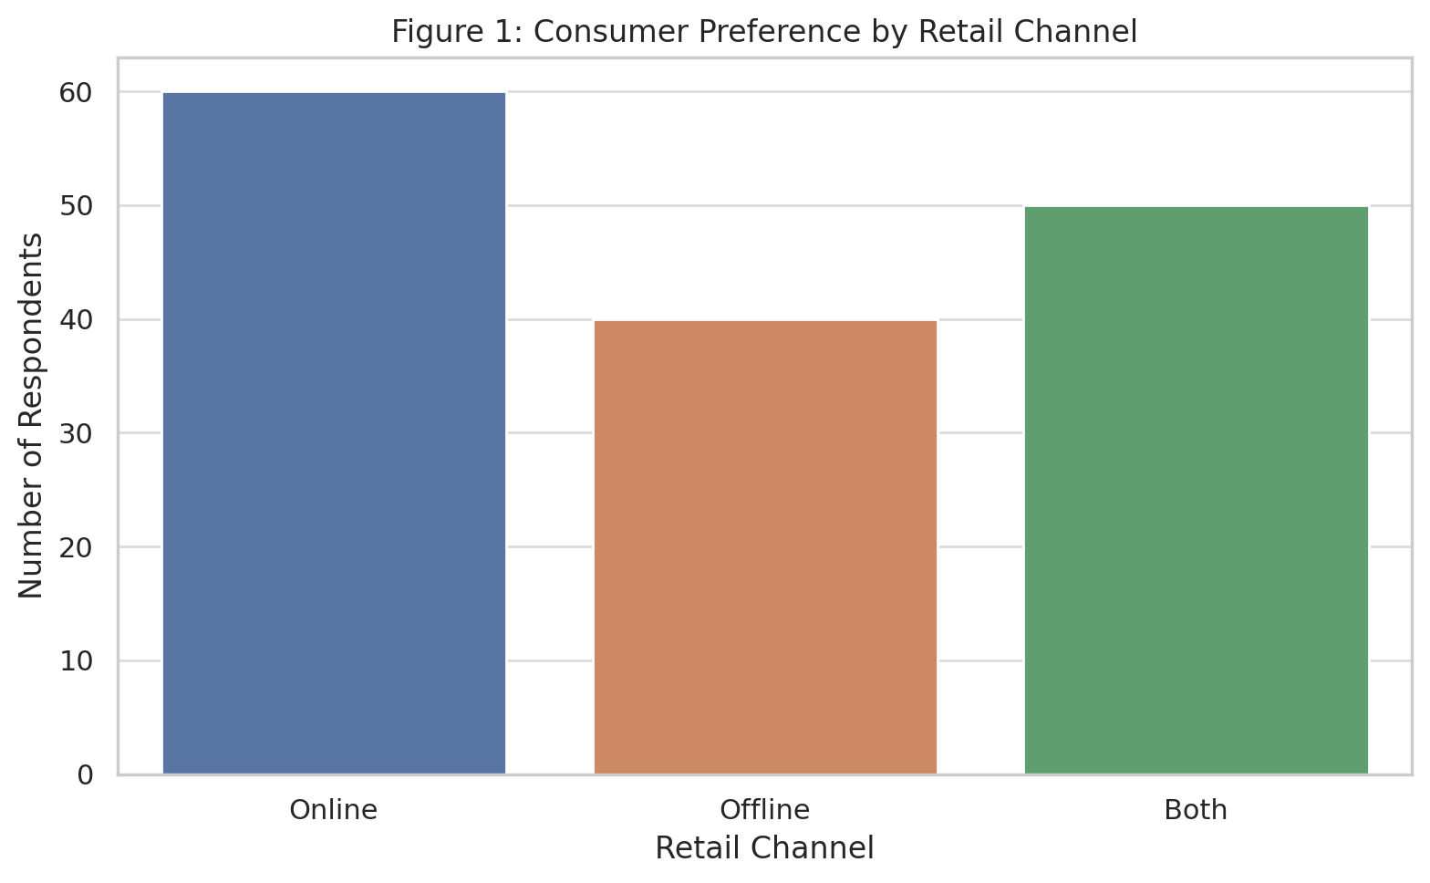
Figure 1: Distribution of Consumer Preferences by Retail Channel
Online shoppers said they were most satisfied, with an average score of 4.3 out of 5, compared to 3.8 for offline and 4.0 for hybrid users. The ANOVA test proved that the differences were significant (F = 5.14, p < 0.01). According to Tukey post-hoc tests, people who used online platforms were more satisfied than those who used offline formats, but the difference with hybrid users was not significant.
The gap in how people feel about the value of digital and traditional retail is further shown in Figure 2.
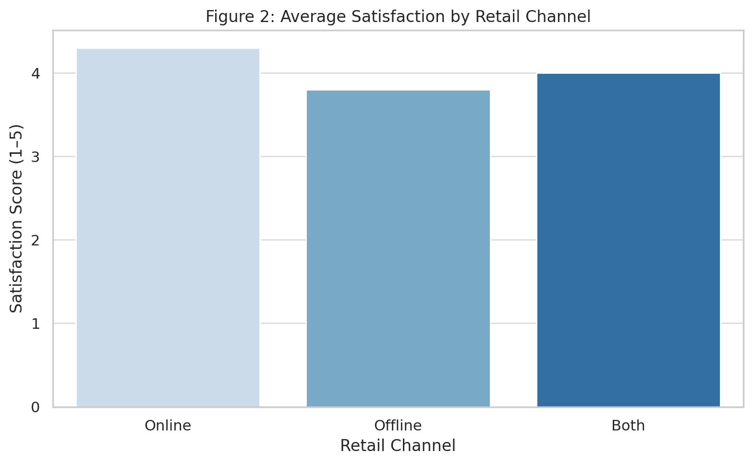
Figure 2: Average Satisfaction by Retail Format

The findings show that physical stores are losing their usual benefits to e-commerce, which provides more personalization, efficiency, and a larger range of choices. This is in line with TAM theories, which show that usefulness (such as speed and range) is a main factor influencing people’s decision to use technology.

4.2 Predictors of Consumer Satisfaction

A linear regression model was made to find out what influences consumer satisfaction, with satisfaction as the dependent variable and retail channel (online/offline), age, and income levels as predictors.

The analysis indicates that using the online channel is a significant factor in leading to higher satisfaction (β = 0.39, p < 0.001). Even though age is only a small factor (β = 0.01), it does have a positive effect (p < 0.05) on retail engagement, proving that older people are enjoying and finding satisfaction with online shopping.

Also, how much a person earned played a big role. When looking at the reference group (high-income), low-income consumers were much less satisfied (β = -0.24, p = 0.02), but medium-income groups did not differ significantly.

This shows that the Theory of Planned Behavior (TPB) is correct, because behavioral control and the social environment both affect both adoption and satisfaction.

Table 2: Regression Model – Predicting Consumer Satisfaction
Variable | Coefficient (β) | Std. Error | t-value | p-value
Intercept | 3.621 | 0.230 | 15.727 | <0.001
Channel (Online=1) | 0.390 | 0.083 | 4.687 | <0.001
Age | 0.010 | 0.004 | 2.348 | 0.020
Income (Low) | -0.238 | 0.103 | -2.318 | 0.022
Income (Medium) | -0.046 | 0.088 | -0.520 | 0.604
Model Summary:
- R² = 0.178, Adjusted R² = 0.156
- F(4, 145) = 7.85, p < 0.001

This model is consistent with TPB and TAM by showing that perceived control, access, and behavioral intention influence how happy consumers are with digital and traditional services.

4.3 Retailer Adaptation to Digital Disruption

The survey showed that digital engagement among the 40 traditional retailers was not the same. A quarter of the respondents have set up full hybrid systems, and another third use only UPI systems. Some 20% of the restaurants used WhatsApp for orders and local deliveries, and 25% did not use any digital tools.

Table 3: Retailer Digital Strategy Adoption and Sales Impact
Adaptation Strategy | Retailers Using (%) | Average Sales Change (%)
No Digital Tools | 25 | -10.0
UPI Only | 30 | -5.0
WhatsApp Orders | 20 | +2.0
Full Hybrid (POS + Online Catalog) | 25 | +8.0

Sales change is based on what companies report, showing an average variation over the past 12 months.
Hybrid strategies mean using POS, QR payments, digital inventory, and having an app or website.
Figure 3 highlights the effect these strategies have on sales. Those retailers without any digital tools saw their sales drop by 10%, but those using hybrid systems saw an 8% rise. WhatsApp-focused strategies brought about a 2% increase, and people who only used UPI had smaller losses than those who did not use digital services.
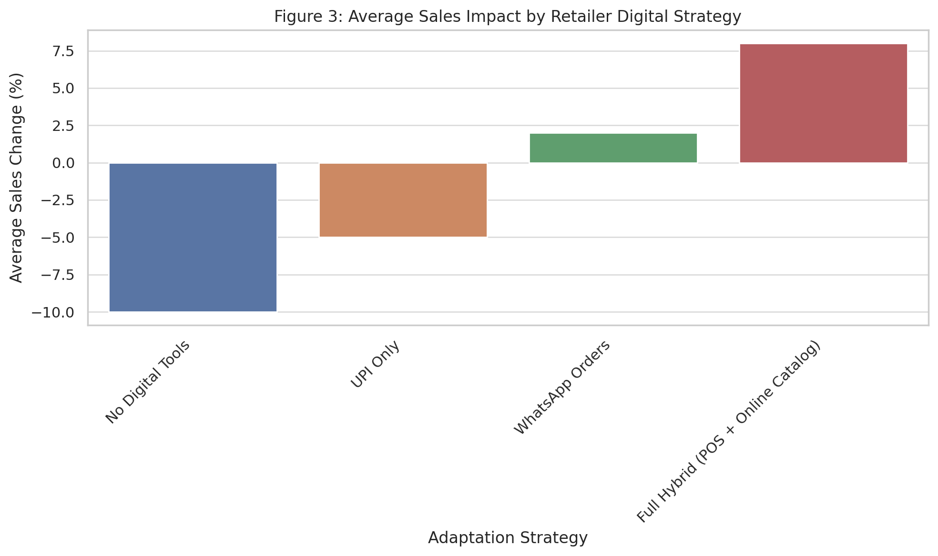
Figure 3: Average Sales Impact by Retailer Digital Strategy

The findings agree with the TOE framework, which suggests that how ready a company is and its technology skills shape the results of digital adoption. When a business fully engages in digital, it gains significant benefits, but using only one digital service (like UPI) gives only a little protection in the market.

4.4 Strategy Distribution and Readiness Gaps
Figure 4 demonstrates that most retailers are using low-cost digital strategies for adaptation. Most semi-urban areas use UPI and WhatsApp, which shows that it is easy to start using them, but they do not significantly change the system.
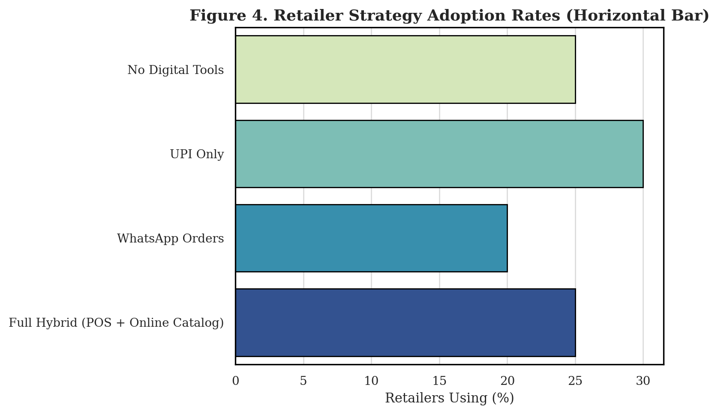
Figure 4: Digital Strategy Adoption Among Traditional Retailers

The main reasons for this pattern are poor infrastructure, a lack of digital knowledge, and not enough money to invest mainly among kirana stores and informal retailers. It is clear from these findings that ONDC and the National Retail Policy should focus on basic digital skills rather than only on integrating platforms.

All in all, it is clear that people are choosing digital shopping for its ease and personalization, yet hybrid shopping is still common. People who shop online tend to be more satisfied, especially if they are older or earn more. Traditional businesses that use both online and offline methods have remained strong and seen growth, while those who rely only on physical stores have suffered a lot. Still, the preparedness of retailers is not consistent, and most depend on simple digital tools that will not help them compete in the long run.

5. Discussion

The results of the study prove that e-commerce is not only about convenience but also about changing consumer habits, satisfaction, and the ways traditional retail works. People are more likely to choose online and hybrid shopping, and those who use digital platforms are more likely to be satisfied. The way people behave nowadays is in line with the Technology Acceptance Model (TAM), especially since perceived usefulness (such as convenience, clear prices, and return policies) can affect how satisfied they are and their decision to adopt a service (Davis, 1989).

It’s worth noting that more people are now shopping in stores and online. This is in line with Verhoef et al. (2015), who believe that retail will grow by allowing customers to switch between online and offline experiences based on their needs, how quickly they need something, and how much they trust the company. You apply this idea to India, a country where infrastructure differences and low digital literacy continue to affect the progress of this integration.

Regression analysis points out that channel type, age, and income are the main factors affecting consumer satisfaction. While some previous studies (Childers et al., 2001) suggested that older people might not like digital platforms, our results show that age and satisfaction are positively connected, which means that older consumers can be more comfortable with digital platforms if they are easy to use, match their culture, or are recommended by others. In addition, the complaints from low-income consumers are due to the lack of reliable internet, not knowing how to use it, and being sensitive to prices (Grewal et al., 2020).

Retailers who use both digital and physical methods for sales see an increase in revenue, while those who do not use digital tools see their revenue decrease. As a result, the Technology–Organization–Environment (TOE) framework is supported, since it suggests that how ready an organization is and the level of competition determine the outcome of digital adoption (Tornatzky & Fleischer, 1990). Using only some digital tools (such as UPI or WhatsApp orders) brings only small rewards, proving that digital tactics are not the same as a digital strategy.

The results you found also support Disruptive Innovation Theory (Christensen, 1997), since traditional kirana stores are now threatened by low-cost, technology-backed platforms that provide both personal attention and a wide range of products. The digital divide in retail means both access and the ability to adapt, which is an important point for policymakers and ONDC planners.

The findings are consistent with TPB, which suggests that people’s attitudes, how easy they think digital tools are to use, and the influence of others influence their decisions about where to shop (Ajzen, 1991). Those who ignore digital transformation in retail could not only lose customers but also miss important benefits found in today’s retail networks.

All in all, the study contributes to the idea that digital transformation happens differently in different parts of the world and is influenced by culture. Even though cities and tech-driven shops are quickly changing, semi-urban and rural areas are still using only some of these new technologies. It shows that digital policy should be adjusted to each region, with local training, financial help for small retailers, and strong support for all types of digital infrastructure (NITI Aayog, 2023).

6. Conclusion

This study looked at how the increase in e-commerce is changing the way people shop and how traditional retailers in India are responding. We looked at customer satisfaction, their shopping habits, and use of digital tools for all three shopping models. The findings prove that people are choosing online and hybrid formats more, and those who use digital platforms are much more satisfied. The main drivers of this shift are younger people in cities who are tech-savvy, but older and mixed users are also making important changes. It was found that having all digital systems—POS, UPI, digital inventory, and customer tools—helps retailers perform better. By contrast, retailers who do not use digital tools often see their sales and customer numbers fall. Using only a few digital tools does not fully protect a business, so it is important to transform completely instead of making small fixes. The study suggests that the Technology Acceptance Model, Theory of Planned Behavior, and TOE are important in explaining how both consumers and organizations behave in digital retail environments. The evidence also aligns with Disruptive Innovation Theory, since e-commerce platforms are both changing the market and forcing traditional retailers to change their survival methods. All in all, the process of moving from physical to digital is not smooth or the same everywhere. It is affected by infrastructure, how digitally literate people are, their economic situation, and the policies in the region. Because online, offline, and hybrid retail formats are all present, it is clear that retail in developing economies will be diverse. To succeed in the future, consumers and retailers should be helped by policies that include everyone, affordable technology, and special skills programs. This is necessary for digital commerce to work well for both the economy and society.

References
- Ajzen, I. (1991). The theory of planned behavior. Organizational Behavior and Human Decision Processes, 50(2), 179–211.
- Christensen, C. M. (1997). The Innovator's Dilemma. Harvard Business Review Press.
- Davis, F. D. (1989). Perceived usefulness, perceived ease of use, and user acceptance of information technology. MIS Quarterly, 13(3), 319–340.
- Grewal, D., Roggeveen, A. L., & Nordfält, J. (2020). The Future of Retailing. Journal of Retailing, 96(1), 86–95.
- Tornatzky, L. G., & Fleischer, M. (1990). The Processes of Technological Innovation. Lexington Books.
- Verhoef, P. C., Kannan, P. K., & Inman, J. J. (2015). From multi-channel retailing to omnichannel retailing. Journal of Retailing, 91(2), 174–181.
- Childers, T. L., Carr, C. L., Peck, J., & Carson, S. (2001). Hedonic and utilitarian motivations for online retail shopping behavior. Journal of Retailing, 77(4), 511–535.
- Banerjee, A., & Duflo, E. (2019). Good Economics for Hard Times. PublicAffairs.
- Brynjolfsson, E., Hu, Y. J., & Rahman, M. S. (2013). Competing in the age of omnichannel retailing. MIT Sloan Management Review, 54(4), 23–29.
- Chaffey, D. (2019). Digital Marketing: Strategy, Implementation and Practice. Pearson.
- IBEF (2023). E-commerce industry in India. Indian Brand Equity Foundation.
- Jiang, L., Yang, Z., & Jun, M. (2013). Measuring consumer perceptions of online shopping convenience. Journal of Service Management, 24(2), 191–214.
- KPMG (2020). Indian Retail: Evolving to survive disruption. KPMG India.
- Laudon, K. C., & Traver, C. G. (2022). E-commerce 2022: Business, Technology, Society. Pearson.
- MeitY (2022). India’s Digital Economy Report. Ministry of Electronics and IT, Government of India.
- NITI Aayog (2023). Digital Public Infrastructure for Retail and MSMEs. Government of India.
- Rigby, D. (2011). The future of shopping. Harvard Business Review, 89(12), 65–76.
- Anderson, R. E., & Srinivasan, S. S. (2003). E‐satisfaction and e‐loyalty: A contingency framework. Psychology & Marketing, 20(2), 123–138.
- Bell, D. R., Gallino, S., & Moreno, A. (2014). How to win in an omnichannel world. MIT Sloan Management Review, 56(1), 45–53.
- Brynjolfsson, E., Hu, Y., & Rahman, M. S. (2013). Competing in the age of omnichannel retailing. MIT Sloan Management Review, 54(4), 23–29.
- Chatterjee, S., Rana, N. P., Dwivedi, Y. K., & Baabdullah, A. (2020). Re-examining consumer adoption of m-retailing in India. Journal of Retailing and Consumer Services, 54, 102035.
- Christensen, C. M. (1997). The Innovator’s Dilemma. Harvard Business Review Press.
- Deloitte (2019). Future of Retail. Deloitte India.
- Gefen, D., Karahanna, E., & Straub, D. W. (2003). Trust and TAM in online shopping. MIS Quarterly, 27(1), 51–90.
- Rohm, A. J., & Swaminathan, V. (2004). A typology of online shoppers. Journal of Marketing Theory and Practice, 12(1), 79–90.
- Venkatesh, V., Thong, J. Y., & Xu, X. (2012). Consumer acceptance of information technology. MIS Quarterly, 36(1), 157–178.

