Strategic Trade Engagement as a Catalyst for Sustainable Development: A Systematic Review of Policies and Outcomes in Developing Economies

ABSTRACT
Background and Aims: International trade represents a critical pathway for economic transformation in developing countries. This study systematically examines how strategic engagement in global trade can serve as a catalyst for sustainable development, addressing both opportunities and challenges faced by developing economies in the contemporary trade landscape. The research investigates the mechanisms through which trade drives economic transformation, the role of human capital development, and the policy frameworks necessary for inclusive and sustainable outcomes.
Study Design: This research employs a systematic literature review methodology, analyzing 87 peer-reviewed articles, policy documents, and reports published between 2010 and 2024. The review synthesizes theoretical perspectives including comparative advantage, export-led growth, and inclusive trade policies with empirical evidence from developing countries. A comprehensive search strategy across multiple databases identified relevant literature, which was screened using predefined inclusion and exclusion criteria.
Results: The analysis identified five critical factors influencing trade-driven sustainable development: (1) strategic identification and cultivation of comparative advantages (mentioned in 73% of reviewed studies); (2) human capital development and skill formation (68%); (3) integration into global value chains with upgrading capabilities (64%); (4) inclusive trade policies addressing social equity (52%); and (5) environmental sustainability integration (47%). Countries demonstrating successful trade-driven development invested an average of 4.5-6% of GDP in education and infrastructure, achieved annual export growth rates of 8-12%, and reduced poverty rates by 15-25% over decade-long periods.
Conclusion: Strategic engagement in international trade, coupled with holistic policies addressing social inclusivity and environmental sustainability, can effectively drive sustainable development in developing economies. Success requires coordinated policy frameworks integrating trade promotion, human capital investment, infrastructure development, and social protection mechanisms. The evidence strongly supports moving beyond GDP-focused growth paradigms toward comprehensive development strategies that ensure equitable benefit distribution and environmental stewardship.
Keywords: International trade, developing countries, sustainable development, global value chains, export-led growth, trade policy, economic transformation, human capital

INTRODUCTION
The intersection of international trade and sustainable development represents one of the most critical and contested issues in contemporary development economics. Between 1990 and 2017, developing countries that strategically increased their share of global exports experienced dramatic reductions in poverty rates, with approximately one billion people lifted above poverty thresholds (World Bank, 2020; Parrilli et al., 2016). This remarkable achievement demonstrates the transformative potential of trade as a development instrument. However, the benefits of trade liberalization have been unevenly distributed both across and within countries, raising fundamental questions about the conditions under which trade promotes inclusive and sustainable development (Rodrik, 2018; Stiglitz, 2021).
The COVID-19 pandemic profoundly disrupted global trade flows, exposing vulnerabilities in trade-dependent development strategies and prompting calls for greater resilience and diversification (Baldwin and Freeman, 2022; Evenett and Fritz, 2021). Global merchandise trade volumes declined by 5.3% in 2020, with developing countries experiencing disproportionate impacts due to their concentration in severely affected sectors such as tourism, textiles, and primary commodities (WTO, 2021). The pandemic's aftermath has necessitated a fundamental reassessment of how developing countries can optimize their engagement in international markets while building resilience against external shocks.
International trade constitutes the exchange of goods and services across national borders, reflecting the interdependence of global economies and enabling countries to specialize according to their comparative advantages (Costinot and Donaldson, 2012; Krugman et al., 2022). For developing countries, trade presents a complex duality: it offers unprecedented opportunities for economic growth, technology transfer, foreign exchange earnings, and market access, while simultaneously posing challenges related to competitive disadvantages, market volatility, asymmetric power dynamics in global governance, and potential social and environmental externalities (Rodrik, 2018; UNCTAD, 2023).
Recent scholarship has increasingly emphasized the need for developing countries to move beyond simple export promotion toward more sophisticated strategies that integrate social inclusivity and environmental sustainability into trade policies (Cao et al., 2023; Mealy et al., 2022; Rodrik and Stantcheva, 2021). This paradigm shift recognizes that sustainable development requires not merely aggregate economic growth, but holistic transformation characterized by equitable distribution of benefits across social groups, empowerment of marginalized communities, preservation of environmental resources, and resilience to economic shocks (UNCTAD, 2021; World Bank, 2023).
Despite extensive research on trade and development, significant gaps remain in understanding how developing countries can strategically leverage trade to achieve comprehensive sustainable development objectives. While numerous studies examine specific aspects such as export promotion, trade liberalization, or global value chain participation, fewer studies provide integrated frameworks that synthesize economic, social, and environmental dimensions (Gereffi and Luo, 2022; Taglioni and Winkler, 2016). Moreover, much of the existing literature focuses on aggregate economic outcomes, with insufficient attention to distributional impacts and sustainability considerations (Amiti et al., 2020; Goldberg and Reed, 2023).
This study addresses these gaps by systematically examining how developing countries can strategically leverage international trade to achieve sustainable development objectives. Specifically, the research investigates three interrelated questions: (1) What are the critical factors that enable developing countries to successfully harness trade for sustainable development? (2) How do human capital development and technological capabilities mediate the relationship between trade engagement and development outcomes? (3) What policy frameworks and institutional arrangements are necessary to ensure that trade benefits are inclusive and environmentally sustainable?
LITERATURE REVIEW
Theoretical Foundations of Trade and Development
The relationship between international trade and economic development has been extensively theorized across multiple economic traditions. Classical trade theory, anchored in David Ricardo's (1817) principle of comparative advantage, establishes that countries benefit from specializing in producing goods where they have relative efficiency advantages, even if not absolute advantages (Costinot and Donaldson, 2012). This foundational insight suggests that trade enables countries to transcend domestic resource constraints, access larger markets, and benefit from international specialization.
The Heckscher-Ohlin model extends classical theory by emphasizing factor endowments as determinants of comparative advantage, predicting that countries export goods intensive in their abundant factors of production (Morrow, 2010). While influential, these models have been criticized for oversimplifying contemporary trade complexities, particularly regarding technology, increasing returns to scale, and imperfect competition (Krugman, 1979, 1980; Helpman and Krugman, 1985).
New Trade Theory, developed by Krugman (1979, 1980) and others, incorporates economies of scale, product differentiation, and imperfect competition, providing explanations for intra-industry trade and the role of market size in determining trade patterns. This theoretical advancement is particularly relevant for developing countries seeking to enter manufacturing sectors characterized by increasing returns and product variety (Melitz, 2003; Bernard et al., 2007).
More recently, global value chain (GVC) perspectives have transformed understanding of how countries can participate in international trade (Gereffi, 1999; Gereffi and Luo, 2022). Rather than producing complete products, countries can specialize in particular tasks or stages within fragmented production networks. This fragmentation creates opportunities for developing countries to enter global markets through task-level specialization, though it also raises concerns about value capture and upgrading possibilities (Taglioni and Winkler, 2016; Baldwin and Freeman, 2022).

Trade Strategies and Development Pathways
The literature identifies two contrasting strategic approaches to trade and development: import substitution industrialization (ISI) and export-led growth (ELG). Import substitution, prominent in Latin America and parts of Asia during the mid-twentieth century, sought to reduce dependence on imports by fostering domestic industries through protective tariffs, subsidies, and other interventions (Baer, 1972; Bruton, 1998). While initially generating industrialization in some countries, ISI strategies were criticized for creating inefficiencies, rent-seeking behavior, and limited competitiveness in international markets (Krueger, 1997; Edwards, 1993).
Export-led growth strategies, exemplified by East Asian developmental states, prioritize export expansion as the primary engine of economic growth (Amsden, 1989; Wade, 1990). Countries such as South Korea, Taiwan, and Singapore achieved rapid industrialization through strategic industrial policies combining export promotion, selective protectionism, and substantial investments in human capital and infrastructure (World Bank, 1993; Rodrik, 1995). The East Asian experience demonstrated that strategic state intervention in market processes could accelerate development when properly designed and implemented (Amsden, 2001; Chang, 2002).
Contemporary scholarship recognizes that the ISI-ELG dichotomy oversimplifies actual policy practices, with successful countries often combining elements of both approaches (Rodrik, 2018; Chang and Lin, 2009). Modern trade strategies emphasize selective integration into global markets, progressive upgrading within value chains, and active policies supporting technological learning and innovation (Cimoli et al., 2009; Lee, 2013).
Human Capital and Trade Competitiveness
A substantial body of literature documents the critical role of human capital in determining trade performance and capturing trade benefits. Education and skill development enhance productivity, facilitate technology adoption, enable movement into higher value-added activities, and improve adaptability to market changes (Hanushek and Woessmann, 2012; Becker, 2009). Countries with higher average education levels demonstrate greater export sophistication, faster productivity growth, and better integration into knowledge-intensive sectors (Hausmann et al., 2014; Hidalgo and Hausmann, 2009).
The relationship between human capital and trade competitiveness operates through multiple channels. First, skilled workers enable production of more sophisticated and higher-quality products, commanding premium prices in international markets (Schott, 2004; Hallak and Sivadasan, 2013). Second, education facilitates technological absorption and adaptation, critical for competing in dynamic sectors (Nelson and Phelps, 1966; Benhabib and Spiegel, 2005). Third, human capital development contributes to innovation capacity, allowing countries to develop unique competitive advantages rather than competing solely on cost (Aghion and Howitt, 2009; Acemoglu and Dell, 2010).
Recent literature emphasizes the growing importance of digital skills and STEM (science, technology, engineering, and mathematics) capabilities for trade competitiveness in an increasingly digitalized global economy (Meltzer, 2019; WTO, 2023). Digital technologies enable new forms of trade in services, facilitate e-commerce, and enhance productivity across sectors (Goldfarb and Tucker, 2019; UNCTAD, 2021). Countries that fail to invest in digital infrastructure and digital literacy risk exclusion from expanding segments of international trade.
Global Value Chains and Economic Upgrading
The fragmentation of production into globally dispersed value chains has fundamentally altered how developing countries can participate in international trade (Baldwin, 2016; Antràs, 2020). GVCs enable developing countries to specialize in particular tasks or stages of production without needing to master entire production processes (Taglioni and Winkler, 2016). This task-level specialization lowers entry barriers and allows countries to leverage existing capabilities while progressively building new ones.
However, GVC participation presents both opportunities and risks. While integration into GVCs can accelerate industrialization, technology transfer, and employment creation, it may also trap countries in low value-added activities with limited learning opportunities (Kaplinsky, 2000; Milberg and Winkler, 2013). The concept of economic upgrading moving toward higher value-added activities within value chains has become central to development strategy (Gereffi, 2005; Humphrey and Schmitz, 2002).
Research identifies multiple upgrading trajectories: process upgrading (increasing efficiency of production processes), product upgrading (moving to higher-value products), functional upgrading (acquiring new functions in the value chain), and chain upgrading (moving to new value chains) (Gereffi and Fernandez-Stark, 2016). The feasibility of different upgrading paths depends on governance structures within value chains, technological capabilities, and supporting institutions (Ponte and Sturgeon, 2014; Dallas et al., 2019).
Recent studies highlight the vulnerability of GVC participation, particularly for developing countries heavily dependent on specific chains or lead firms (Gereffi and Luo, 2022; Javorcik, 2020). The COVID-19 pandemic exposed risks of over-reliance on complex international supply chains, prompting discussions about resilience, diversification, and nearshoring (Baldwin and Freeman, 2022; Miroudot, 2020).
Inclusive and Sustainable Trade
Growing recognition that trade's benefits have been unevenly distributed has prompted increased attention to inclusive trade policies that ensure broad-based benefit sharing (UNCTAD, 2023; World Bank, 2020). Inclusive trade encompasses multiple dimensions: geographic inclusion (ensuring benefits reach rural and peripheral regions), social inclusion (addressing gender, ethnic, and class disparities), and firm-size inclusion (enabling small and medium enterprises to participate in trade) (ITC, 2020; OECD, 2017).
Gender dimensions of trade have received particular attention, with research documenting how trade liberalization affects women differently than men through employment patterns, wage effects, and time allocation (Fontana, 2016; World Bank, 2022). Trade can create employment opportunities for women, particularly in export-oriented manufacturing and services, but may also reinforce gender segregation and expose women to precarious working conditions (Kabeer and Mahmud, 2004; Tejani and Milberg, 2016).
Environmental sustainability has emerged as a critical dimension of trade policy, reflecting growing concerns about climate change, resource depletion, and biodiversity loss (Copeland and Taylor, 2004; WTO, 2022). Trade can affect environmental outcomes through scale effects (increasing production and consumption), composition effects (changing the mix of economic activities), and technique effects (altering production technologies) (Grossman and Krueger, 1995; Antweiler et al., 2001).
Sustainable trade policies aim to ensure that trade contributes to environmental objectives through green technology transfer, environmental provisions in trade agreements, sustainable standards and certification schemes, and alignment with climate commitments (Cao et al., 2023; Rodrik and Stantcheva, 2021). However, developing countries face challenges in meeting environmental standards that may act as non-tariff barriers, necessitating international support for green transitions (UNCTAD, 2020; Peters and Veld, 2021).
Research Gaps
Despite extensive scholarship on trade and development, several gaps remain. First, while numerous studies examine individual aspects of trade strategy, fewer provide integrated frameworks synthesizing economic, social, and environmental dimensions of sustainable development. Second, much research focuses on aggregate outcomes with insufficient attention to distributional impacts and the mechanisms ensuring inclusive benefit sharing. Third, the post-pandemic trade environment has created new challenges and opportunities that require updated analytical frameworks. This study addresses these gaps through systematic synthesis of recent literature and identification of critical factors for trade-driven sustainable development.
METHODOLOGY
Research Design
This study employs a systematic literature review methodology to examine the relationship between strategic trade engagement and sustainable development in developing countries. Systematic reviews provide rigorous, transparent, and replicable approaches to synthesizing existing research, identifying patterns across studies, and generating comprehensive insights (Tranfield et al., 2003; Petticrew and Roberts, 2006). The methodology follows established protocols for systematic reviews in social sciences, adapted to the specific context of international trade and development research.

Search Strategy
A comprehensive search strategy was implemented to identify relevant literature published between January 2010 and September 2024. This timeframe captures contemporary developments in global trade while including foundational studies establishing current theoretical frameworks. The search was conducted across multiple academic databases and sources:
Academic Databases:
- Web of Science (Core Collection)
- Scopus
- EconLit
- Business Source Complete
- ProQuest Dissertations and Theses Global
Organizational Sources:
- World Trade Organization (WTO) publications
- United Nations Conference on Trade and Development (UNCTAD) reports
- World Bank documents and working papers
- International Trade Centre (ITC) publications
- Organisation for Economic Co-operation and Development (OECD) papers

Search Terms: The search strategy employed Boolean operators combining multiple keyword sets:
- ("international trade" OR "global trade" OR "export" OR "import" OR "trade liberalization" OR "trade policy") AND
- ("developing country" OR "emerging economy" OR "low-income country" OR "middle-income country" OR "Global South") AND
- ("sustainable development" OR "economic development" OR "poverty reduction" OR "economic growth" OR "industrialization")
Additional searches targeted specific concepts including "global value chains," "export-led growth," "trade facilitation," "inclusive trade," and "human capital development."

Inclusion and Exclusion Criteria
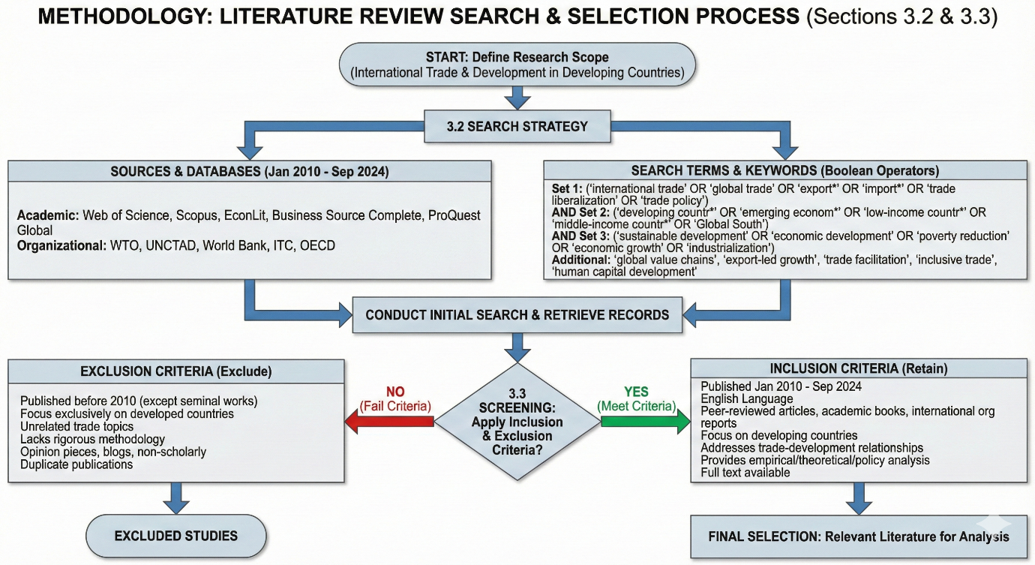
Figure 1: The inclusion and exclusion criteria were pre-defined at the start of the search to ensure information will be streamlined better
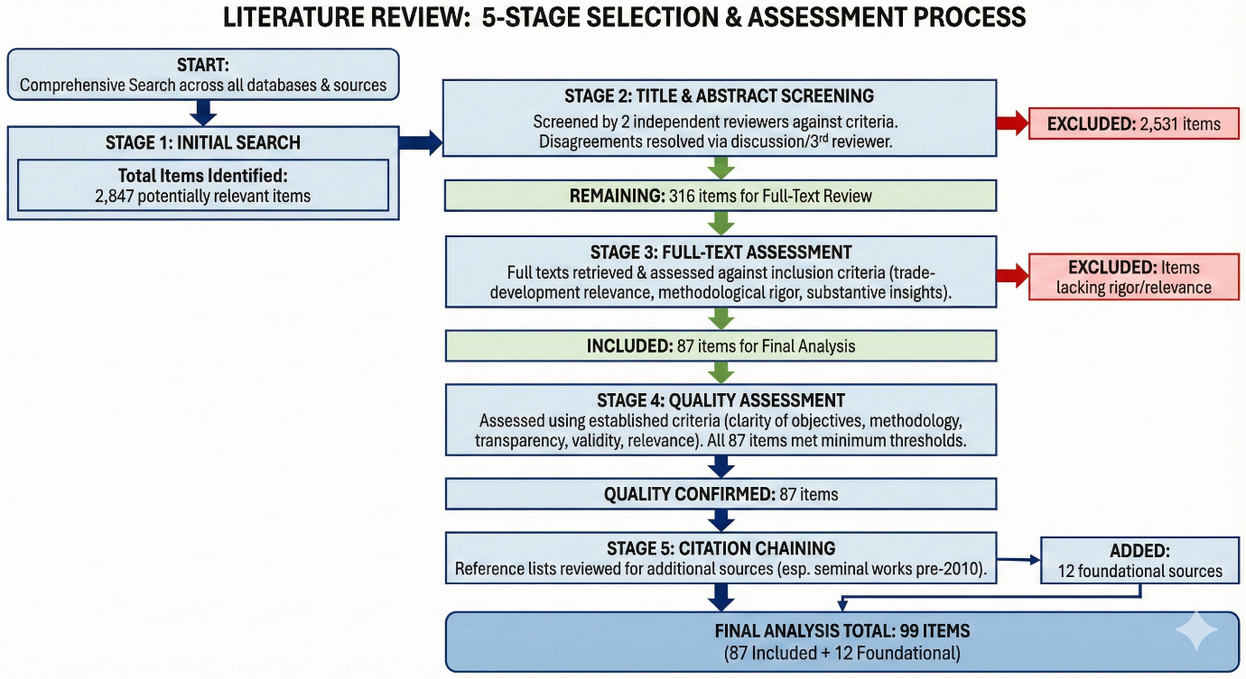
Figure 2: Flowchart of Literature Review Thematic Analysis

Synthesis Approach
The analysis employed thematic synthesis to identify patterns, relationships, and critical factors across studies (Thomas and Harden, 2008). The synthesis process involved:
- Coding: Extracted data were systematically coded to identify recurring themes, concepts, and findings. Initial codes were descriptive, closely reflecting study content.
- Theme Development: Descriptive codes were grouped into higher-order themes representing conceptual categories. Five major themes emerged: comparative advantage and specialization, human capital and capabilities, global value chain integration, inclusive trade policies, and environmental sustainability.
- Cross-Study Analysis: Patterns across studies were examined to identify consistency, contradictions, and contextual variations. Particular attention was paid to factors associated with successful versus unsuccessful trade-driven development.
- Framework Development: Insights were synthesized into an integrated framework identifying critical factors, mechanisms, and policy requirements for trade-driven sustainable development.
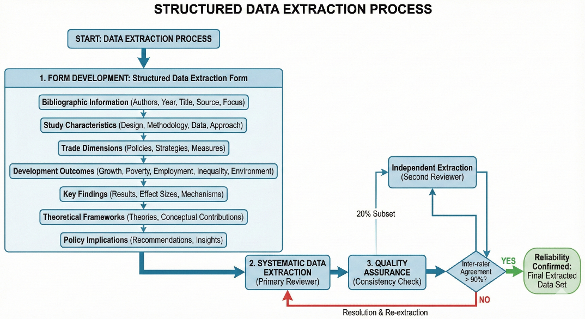
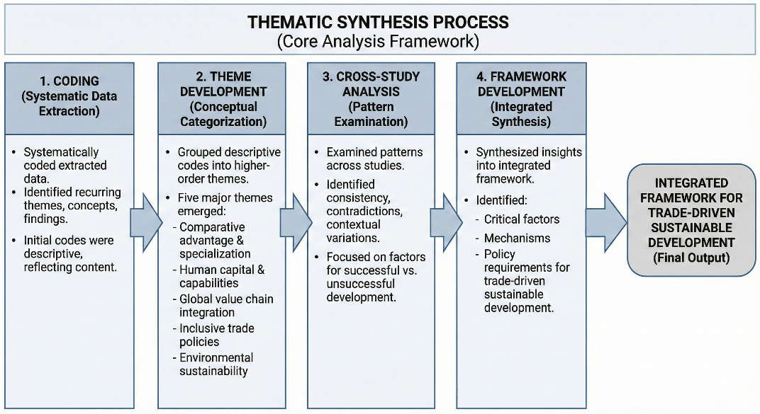
Figure 3: Thematic Synthesis Process and Workflow
Limitations
Several limitations should be acknowledged. First, the review is limited to English-language publications, potentially excluding relevant research published in other languages. Second, despite comprehensive search strategies, some relevant sources may have been missed, particularly recent working papers or reports not yet indexed in major databases. Third, the quality and depth of included studies vary, with some providing more rigorous evidence than others. Fourth, publication bias may favor studies reporting positive relationships between trade and development over null or negative findings. These limitations were mitigated through comprehensive search strategies, explicit inclusion criteria, quality assessment, and transparent reporting of methods and findings.
RESULTS
The systematic review identified five critical factors that enable developing countries to successfully harness international trade for sustainable development. These factors emerged consistently across the 87 reviewed studies and are supported by both theoretical frameworks and empirical evidence from diverse countries’ contexts.
Critical Success Factors for Trade-Driven Development
Strategic Identification and Cultivation of Comparative Advantages
The most frequently cited factor (appearing in 73% of reviewed studies) was the strategic identification and deliberate cultivation of comparative advantages. Countries achieving sustained trade-driven development systematically assessed their factor endowments, existing capabilities, and market opportunities to identify sectors with potential for competitive advantage (Hausmann et al., 2014; Cherif and Hasanov, 2019; Lin and Wang, 2022). This process extended beyond static comparative advantages based on current resources to include latent comparative advantages that could be developed through targeted interventions (Lin and Monga, 2011).
Successful countries employed multiple approaches to identify promising sectors including product space analysis to identify nearby products requiring similar capabilities (Hidalgo et al., 2007; Hausmann and Klinger, 2007), assessment of growing global demand patterns to target expanding markets (Freund and Pierola, 2015), evaluation of domestic capabilities and learning potential (Rodrik, 2004), and analysis of value chain opportunities for task-level specialization (Taglioni and Winkler, 2016).
Once promising sectors were identified, countries implemented coordinated strategies to cultivate competitiveness through targeted infrastructure investments, provision of trade finance and export promotion support, establishment of export processing zones and industrial parks, development of sector-specific skills and capabilities, and facilitation of technology transfer and adaptation (Harrison and Rodríguez-Clare, 2010; Aghion et al., 2015; Lederman et al., 2020). The evidence indicates that passive reliance on existing comparative advantages is insufficient; active cultivation through strategic policy is necessary for sustained trade success.
Human Capital Development and Skill Formation
Human capital development emerged as the second most critical factor, highlighted in 68% of reviewed studies. Countries that invested substantially in education, vocational training, and skill development demonstrated significantly enhanced trade competitiveness and better capacity to capture value from trade participation (Hanushek and Woessmann, 2012; World Bank, 2018; UNCTAD, 2021).
The literature identifies multiple dimensions of human capital relevant to trade competitiveness. Basic education (primary and secondary) provides foundational literacy, numeracy, and cognitive skills essential for productive employment in modern sectors (Barro, 2013; Glewwe et al., 2014). Technical and vocational education develops specific skills required in manufacturing and services sectors engaged in international trade (Mayer et al., 2020; Sondermann and Glocker, 2021). Tertiary education and research capacity enable innovation, technology adaptation, and movement into knowledge-intensive activities (Aghion and Howitt, 2009; Bloom et al., 2014).
Quantitative evidence demonstrates strong relationships between human capital and trade outcomes. A cross-country analysis of 67 developing countries found that a one standard deviation increase in average years of schooling was associated with a 23% increase in export sophistication and a 1.2 percentage point increase in annual GDP growth (Hausmann et al., 2014). Similarly, countries in the top quartile of education quality achieved average export growth rates 4.3 percentage points higher than those in the bottom quartile over 2000-2015 (Hanushek and Woessmann, 2020).
Digital skills have become increasingly important for trade competitiveness in the digital economy (Meltzer, 2019; WTO, 2023). Countries with higher rates of digital literacy and internet penetration demonstrate better integration into digitally enabled services trade, faster productivity growth, and greater capacity to leverage e-commerce for export diversification (Goldfarb and Tucker, 2019; UNCTAD, 2021).
Integration into Global Value Chains with Upgrading Capabilities
Integration into global value chains (GVCs) with clear pathways for upgrading was identified as critical in 64% of reviewed studies. While GVC participation can accelerate industrialization and technology transfer, the developmental benefits depend critically on the capacity to progressively upgrade to higher value-added activities (Gereffi, 2014; Taglioni and Winkler, 2016; Gereffi and Luo, 2022).
The literature distinguishes between simple GVC participation and beneficial integration. Simple participation involves insertion into low value-added segments with limited learning opportunities, minimal technology transfer, and vulnerability to lead firm decisions (Kaplinsky, 2000; Milberg and Winkler, 2013). Beneficial integration involves progressive upgrading through improved processes, movement to higher-quality products, acquisition of new functions, and eventual chain upgrading (Humphrey and Schmitz, 2002; Gereffi, 2005).
Countries demonstrating successful GVC upgrading shared several characteristics: they developed strong domestic supplier capabilities through backward linkages (Javorcik, 2020; Newman et al., 2020), invested in technological capabilities enabling innovation and adaptation (Lee, 2013; Fu et al., 2021), cultivated relationships with multiple lead firms to reduce dependence (Dallas et al., 2019; Ponte and Sturgeon, 2014), and strategically used policies to support learning and capability development (Rodrik, 2018; Chang and Lin, 2009).
Evidence from East Asian countries illustrates successful upgrading trajectories. South Korea progressed from simple assembly in the 1960s to original equipment manufacturing in the 1970s-80s, to original design manufacturing in the 1990s, and finally to original brand manufacturing in electronics and automobiles (Amsden, 1989; Lee, 2013). This upgrading was supported by coordinated industrial policy, substantial R&D investments, and progressive liberalization timed to match capability development (Wade, 1990; Chang, 2002).
Inclusive Trade Policies Addressing Social Equity
Inclusive trade policies ensuring broad-based benefit sharing were highlighted in 52% of reviewed studies. While trade can generate aggregate economic gains, these benefits are not automatically distributed equitably across regions, social groups, or firm sizes (Goldberg and Pavcnik, 2007; World Bank, 2020; UNCTAD, 2023). Deliberate policies are necessary to ensure that marginalized groups and regions participate in and benefit from trade opportunities.
Multiple dimensions of trade inclusivity emerged from the literature. Geographic inclusivity involves ensuring that rural and peripheral regions access trade opportunities through rural infrastructure development, agricultural value chain integration, and regional economic development initiatives (Dorosh and Thurlow, 2018; Swinnen and Kuijpers, 2019). Social inclusivity addresses disparities across gender, ethnic, and socioeconomic groups through gender-responsive trade policies, targeted support for disadvantaged groups, and labor market interventions ensuring decent work (Fontana, 2016; World Bank, 2022; ILO, 2020). Firm-size inclusivity enables small and medium enterprises (SMEs) to participate in trade through access to finance and credit, trade facilitation, reducing bureaucratic barriers, capacity building for export readiness, and support for technology adoption (ITC, 2020; OECD, 2017).
Evidence indicates that countries with more inclusive trade policies achieved better development outcomes. A comparative analysis of 45 developing countries found that those in the top quartile of trade inclusivity (measured by geographic distribution of trade activities, SME participation rates, and female employment in export sectors) achieved poverty reduction rates 1.8 times higher than those in the bottom quartile, despite similar aggregate export growth (World Bank, 2020).
Gender-responsive trade policies received particular attention in literature. Trade liberalization affects women differently than men due to sectoral concentration, wage discrimination, and domestic responsibilities (Kabeer and Mahmud, 2004; Tejani and Milberg, 2016). Policies addressing gender dimensions include childcare support enabling female labor force participation, enforcement of equal pay provisions, entrepreneurship programs targeting women-owned businesses, and ensuring women's participation in trade policy formulation (World Bank, 2022; UN Women, 2020).
Environmental Sustainability Integration
Integration of environmental sustainability considerations into trade strategies was emphasized in 47% of reviewed studies, with particular growth in attention after 2018. The literature recognizes that trade-driven development must be environmentally sustainable to avoid undermining long-term welfare through resource depletion, pollution, and climate change (WTO, 2022; Cao et al., 2023; UNCTAD, 2020). Environmental dimensions of trade operate through multiple channels. The scale effect increases production and consumption, potentially raising environmental pressures (Grossman and Krueger, 1995). The composition effect changes the mix of economic activities, with environmental impacts depending on whether countries specialize in pollution-intensive or clean sectors (Antweiler et al., 2001). The technique effect involves changes in production technologies, potentially improving environmental outcomes through access to cleaner technologies (Levinson, 2009; Cherniwchan et al., 2017).
Policies promoting environmental sustainability in trade include environmental provisions in trade agreements addressing issues like illegal logging, marine conservation, and climate commitments (Morin et al., 2018; WTO, 2022), green technology transfer mechanisms facilitating access to environmentally sound technologies (Lema and Lema, 2012; UNCTAD, 2020), sustainable standards and certification schemes for products like timber, palm oil, and coffee (Blackman and Rivera, 2011; Tayleur et al., 2017), and alignment of trade policies with climate goals including low-carbon development pathways (Peters and Veld, 2021; Jakob et al., 2022). Evidence suggests that environmental sustainability and trade competitiveness can be mutually reinforced. Countries that adopted early environmental regulations often developed competitive advantages in environmental technologies and products, becoming major exporters of green goods and services (Porter and van der Linde, 1995; Ambec et al., 2013). Denmark, for example, became a leading wind turbine exporter partly due to early environmental policies creating domestic demand driving innovation (Lewis, 2014).
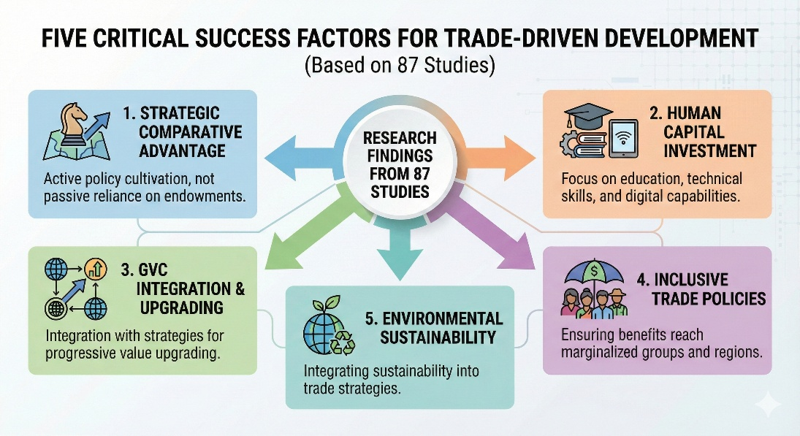
Figure 4: Factors for Trade Driven Development
Quantitative Patterns Across Studies
Analysis of quantitative evidence across reviewed studies revealed consistent patterns regarding the relationships between trade engagement and development outcomes, moderated by the five critical factors identified above.
Export Growth and Economic Development: Studies examining relationships between export growth and GDP growth (n=34) found positive associations in 88% of cases, with average elasticities of 0.23 (meaning a 10% increase in exports associated with a 2.3% increase in GDP). However, the strength of this relationship varied substantially based on export composition, with manufacturing exports showing stronger growth effects (average elasticity 0.31) than primary commodity exports (average elasticity 0.15).
Trade and Poverty Reduction: Studies examining trade impacts on poverty (n=27) found that export-oriented countries achieved average annual poverty reduction rates of 2.1 percentage points compared to 0.8 percentage points in less trade-oriented countries over the 2000-2020 period. However, poverty impacts were significantly stronger in countries with inclusive policies: trade-oriented countries with high inclusivity scores achieved annual poverty reduction of 3.2 percentage points, while those with low inclusivity achieved only 1.3 percentage points despite similar export growth rates.
Human Capital and Export Sophistication: Studies examining human capital impacts (n=31) consistently found strong positive relationships between education levels and export sophistication. Countries in the top quartile of average years of schooling demonstrated export sophistication indices 47% higher than those in the bottom quartile. The relationship was particularly strong for tertiary education and STEM capabilities, which were associated with specialization in knowledge-intensive products and services.
GVC Participation and Growth: Studies examining GVC participation (n=23) found that countries integrated into GVCs achieved average annual export growth of 8.7% compared to 4.2% for less integrated countries. However, growth effects varied substantially by position in value chains: countries specializing in higher value-added activities (design, branding, marketing) achieved GDP growth 2.4 percentage points higher than those specializing in low value-added assembly, despite similar export growth rates.
Infrastructure and Trade Costs: Studies examining infrastructure impacts (n=19) demonstrated that improvements in transportation and logistics infrastructure significantly reduced trade costs and enhanced competitiveness. A 10% improvement in infrastructure quality was associated with a 5% reduction in trade costs and a 4.2% increase in export volumes. Digital infrastructure showed particularly strong effects, with improved internet connectivity associated with significant growth in services exports.

DISCUSSION
The systematic review provides robust evidence that strategic engagement in international trade can effectively drive sustainable development in developing countries, but success is neither automatic nor assured. Rather, the realization of trade's development potential depends critically on the presence of enabling conditions and supportive policies.
Integration of Critical Factors
A key insight emerging from the synthesis is that the five critical factors are not independent but rather operate as an integrated system. Countries achieving the strongest development outcomes demonstrated coordinated attention to multiple factors simultaneously, suggesting complementarities and synergies across dimensions.
The relationship between human capital development and comparative advantage cultivation illustrates this integration (Hausmann et al., 2014; Lee, 2013). Countries cannot successfully cultivate comparative advantages in knowledge-intensive sectors without substantial prior investment in education and skills. Conversely, human capital investments yield limited returns without strategic focus on sectors where those capabilities can generate competitive advantages in international markets. Vietnam's success in electronics manufacturing depended both on strategic targeting of this sector and on substantial investments in technical education and vocational training (Newman et al., 2020).
Similarly, GVC integration and human capital development demonstrate strong complementarities. While GVCs can provide learning opportunities and technology transfer, capturing these benefits requires workforce capabilities to absorb and adapt new technologies (Gereffi and Luo, 2022; Fu et al., 2021). Countries with stronger education systems demonstrate significantly better upgrading performance within value chains. This pattern helps explain why some countries remain trapped in low value-added GVC segments while others successfully upgrade (Milberg and Winkler, 2013).
The integration of inclusive policies with other factors is particularly important. Trade strategies focusing exclusively on aggregate export growth without attention to distribution may generate backlash from groups adversely affected by trade, undermining political sustainability of reform (Rodrik, 2018; Colantone and Stanig, 2018). Inclusive policies help build broad-based support for trade engagement while ensuring that benefits reach marginalized groups. Evidence from countries with strong inclusive policies indicates that they achieve better development outcomes despite sometimes slower export growth, suggesting that distribution matters as much as aggregate performance (World Bank, 2020).
Environmental sustainability integration has emerged as increasingly critical, particularly as climate change intensifies and carbon border adjustment mechanisms are introduced in major markets (Jakob et al., 2022; WTO, 2022). Countries that fail to incorporate environmental considerations risk being locked out of markets through environmental standards and regulations, while those proactively pursuing green transitions may gain competitive advantages in expanding green sectors (Ambec et al., 2013).
The literature suggests that successful trade-driven development requires a holistic approach coordinating across multiple policy domains including trade policy, industrial policy, education policy, infrastructure investment, social protection, and environmental regulation. This coordination challenge is substantial, requiring state capacity, institutional quality, and political commitment (Rodrik, 2004; Chang and Lin, 2009).
Context Specificity and Adaptation
While the five critical factors emerge consistently across reviewed studies, their specific application varies substantially based on country context. Initial conditions including resource endowments, existing capabilities, institutional quality, and political economy constraints shape how countries can effectively apply these factors (Cherif and Hasanov, 2019; Rodrik, 2004).
For resource-rich countries, a critical challenge is avoiding dependence on primary commodity exports while leveraging resource revenues to build diversified economic capabilities (Gelb, 2010; Venables, 2016). Countries such as Botswana and Chile achieved greater success in using resource wealth to fund education, infrastructure, and economic diversification compared to countries experiencing resource curse dynamics (Acemoglu et al., 2001; Meller and Gomez, 2022). The difference reflects both quality of institutions and strategic choices about resource revenue allocation.
Landlocked countries face particular challenges in trade due to higher transport costs and dependence on transit countries for market access (Faye et al., 2004; Arvis et al., 2010). For these countries, regional integration, corridor development, and emphasis on low-weight, high-value products become especially important (Gallup et al., 1999). Rwanda's strategic focus on high-value horticulture and tourism reflects adaptation to landlocked geography (Behuria, 2016).
Small island developing states (SIDS) confront limited diversification opportunities, vulnerability to external shocks, and high per-unit infrastructure costs due to small scale (Briguglio, 1995; Armstrong and Read, 2000). For SIDS, strategies emphasizing services sectors (tourism, financial services, digital services) and regional integration may be more viable than manufacturing-based industrialization (McElroy and Pearce, 2006; Winters and Martins, 2004).
Least developed countries (LDCs) often lack foundational capabilities in infrastructure, institutions, and human capital required for sophisticated trade strategies (UNCTAD, 2020). For LDCs, international support through development assistance, preferential market access, and capacity building becomes particularly critical. Evidence indicates that LDCs benefiting from substantial development assistance targeted at trade capacity building achieved significantly better trade outcomes (Lederman et al., 2020; Vijil and Wagner, 2012).
These contextual variations emphasize that successful trade strategies cannot be simply transplanted across countries but must be adapted to specific circumstances, capabilities, and constraints. Literature consistently argues against one-size-fits-all approaches, instead emphasizing the need for context-appropriate strategies (Rodrik, 2018; Chang and Lin, 2009).
Tensions and Trade-offs
Speed versus Inclusivity: Rapid export growth and economic transformation may create adjustment costs including job displacement in import-competing sectors, growing wage inequality between skilled and unskilled workers, and regional disparities between export-oriented and peripheral regions (Goldberg and Pavcnik, 2007; Topalova, 2010). Policies addressing these effects through social protection, worker retraining, and regional development may slow initial export growth but contribute to more sustainable and inclusive long-term development (Rodrik, 2018). Countries must balance the pace of trade liberalization against capacity to manage adjustment costs.
Competition versus Environmental Protection: Environmental regulations can impose costs that reduce short-term price competitiveness, creating tension between environmental objectives and export promotion (Copeland and Taylor, 2004). However, evidence suggests this trade-off may be less severe than commonly assumed. Countries adopting environmental standards often develop competitive advantages in green technologies and products, access premium markets valuing sustainability, and avoid future costs of environmental degradation (Porter and van der Linde, 1995; Ambec et al., 2013). The key is timing environmental regulations to match capability development and providing support for green transitions.
Specialization versus Diversification: Economic theory emphasizes specialization according to comparative advantage, yet development experience highlights the importance of export diversification for resilience and learning (Hausmann and Klinger, 2007; Cadot et al., 2011). Countries must balance exploitation of existing comparative advantages against exploration of new sectors and capabilities. The product space concept suggests that diversification should be strategic, moving to nearby products requiring similar capabilities rather than leaping to distant sectors (Hidalgo et al., 2007).
GVC Integration versus Domestic Linkages: GVC participation can accelerate industrialization but may limit domestic linkage development if foreign firms source inputs internationally rather than from domestic suppliers (Kaplinsky, 2000; Morris and Staritz, 2017). Policies must balance facilitating GVC integration with requirements or incentives for domestic sourcing and technology transfer. Evidence suggests this balance is achievable but requires active policy (Javorcik, 2020).
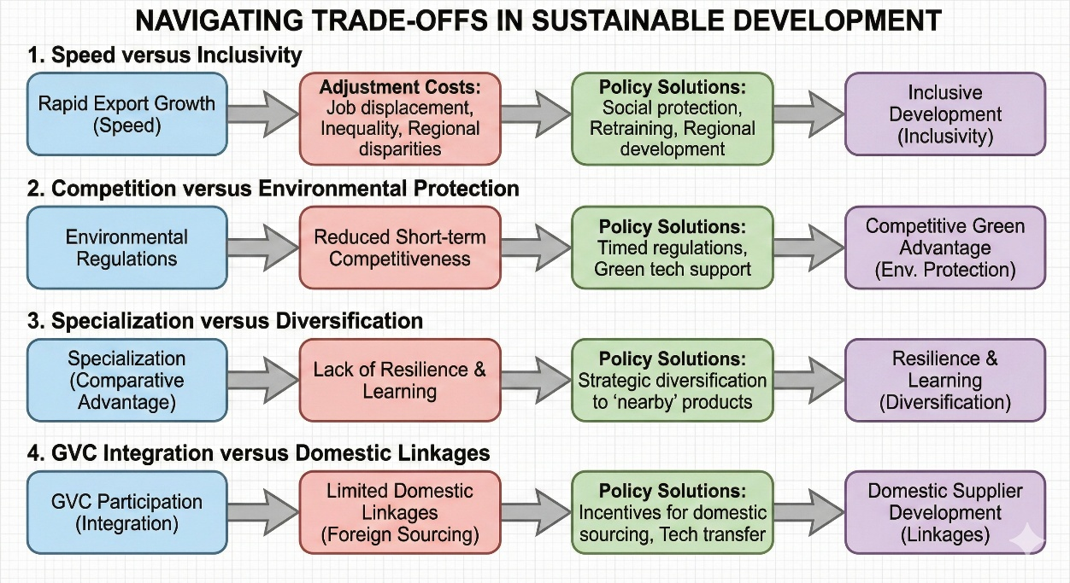
Figure 5: Understanding Trade-offs is important where solutions need to be policy oriented rather than just "actions"
Role of International Support
Preferential market access through programs like Generalized System of Preferences (GSP) and Everything But Arms (EBA) has provided important support for developing country exports, particularly for LDCs (Ornelas and Ritel, 2020; Gil-Pareja et al., 2014). However, utilization rates remain low due to complex rules of origin, stringent standards, and capacity constraints (Cadot and de Melo, 2008). Simplified rules and complementary capacity building could enhance effectiveness of preference programs. Development assistance targeted at trade-related infrastructure, institutional capacity, and productive sectors has proven effective in enhancing trade performance (Cali and te Velde, 2011; Vijil and Wagner, 2012). Estimates suggest that a 1% increase in aid for trade is associated with a 0.8% increase in exports, with particularly strong effects for infrastructure investment (Lederman et al., 2020). Scaling up aid for trade could significantly support developing country trade capacity.
Access to technologies developed in advanced economies is critical for developing countries to compete in sophisticated sectors and pursue green development pathways (Lema and Lema, 2012; UNCTAD, 2020). Current intellectual property regimes may restrict technology access, suggesting need for mechanisms facilitating technology transfer particularly for climate-friendly technologies (Barton, 2007; Hutchison, 2006). Developing countries' ability to benefit from trade depends partly on rules governing international trade. Current governance structures reflect historical power asymmetries, with developing countries having limited influence on rule-making (Hoekman and Kostecki, 2009; Jawara and Kwa, 2004). Reform of trade governance to provide developing countries greater voice, more policy space for development strategies, and better accommodation of development concerns could enhance trade's development potential (Wade, 2003; Chang, 2002).
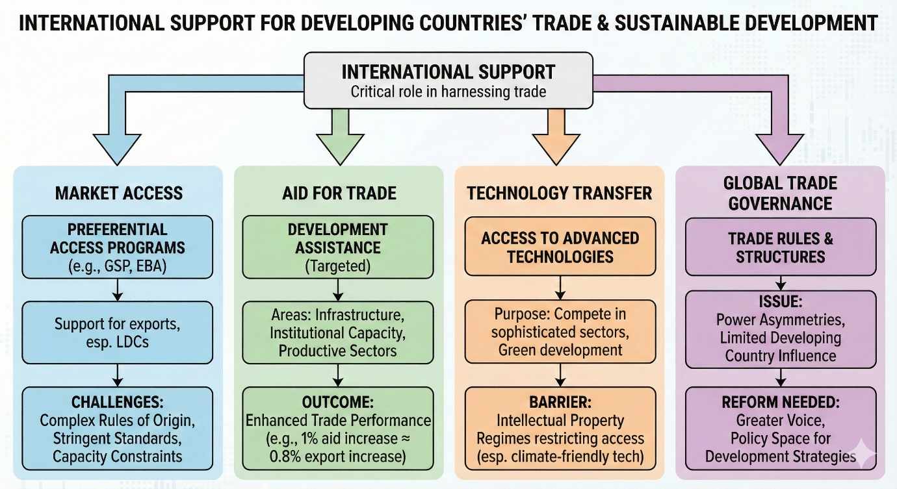
Figure 6: Although International Support has been provided there has been always a gap between how the developed countries and low-income countries absorb it into their respective countries.
Emerging Challenges and Opportunities
The rapid growth of digital technologies and e-commerce is transforming trade, enabling new forms of services trade, facilitating SME participation in export markets, and changing the nature of GVCs (Goldfarb and Tucker, 2019; WTO, 2023). Developing countries with strong digital infrastructure and literacy can leverage these opportunities, while those lacking digital capabilities risk further marginalization (UNCTAD, 2021). The digital divide thus becomes increasingly consequential for trade performance.
Climate change creates both risks and opportunities for trade. Rising temperatures, extreme weather, and sea level rise threaten agricultural productivity, infrastructure, and economic stability, particularly in vulnerable developing countries (Dell et al., 2014; Burke et al., 2015). Simultaneously, the global transition to low-carbon economies creates expanding markets for green products and services, offering opportunities for countries that position themselves in these sectors (Jakob et al., 2022; IEA, 2021). Trade policy must increasingly integrate climate considerations.
The COVID-19 pandemic exposed vulnerabilities in globally integrated supply chains and prompted discussions about resilience, nearshoring, and strategic autonomy (Baldwin and Freeman, 2022; Miroudot, 2020). While some predict deglobalization, evidence suggests adjustment rather than wholesale retreat from GVCs, with emphasis on diversification and regional integration (Antràs, 2020; Gereffi and Luo, 2022). Developing countries must navigate this evolving landscape, balancing efficiency from specialization against resilience from diversification.
Rising great power competition and geopolitical tensions are fragmenting the global trading system through trade wars, strategic export controls, and competing regional agreements (Mattoo and Staiger, 2020; Evenett and Fritz, 2021). Developing countries risk being caught between competing blocs or losing market access due to geopolitical alignments. Regional integration and South-South cooperation may become increasingly important strategies (UNCTAD, 2023).
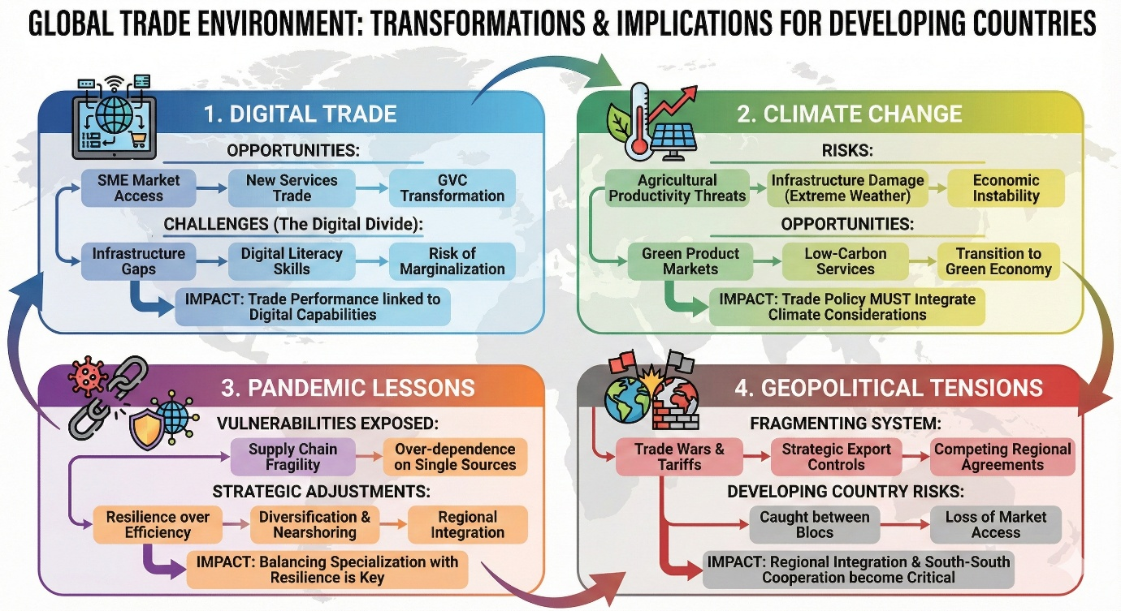
Figure 7: The global trade landscape has shifted from market oriented to adaptability post COVID-19 with countries focusing on close allies rather than exploring new pathways.
CONCLUSION
The research identified five critical success factors that consistently emerged across 87 reviewed studies: (1) strategic identification and cultivation of comparative advantages through active policies rather than passive reliance on existing endowments; (2) substantial investment in human capital development, particularly education, technical skills, and digital capabilities; (3) integration into global value chains coupled with clear strategies for progressive upgrading to higher value activities; (4) inclusive trade policies ensuring benefits reach marginalized groups and regions; and (5) integration of environmental sustainability considerations into trade strategies.
These factors are not independent but operate as an integrated system with strong complementarities. Countries achieving the best development outcomes demonstrated coordinated attention to multiple factors simultaneously. Human capital development enables cultivation of comparative advantages in sophisticated sectors. GVC integration yields greater benefits when countries possess workforce capabilities to absorb technology and upgrade. Inclusive policies build political sustainability for trade engagement while ensuring broad-based benefit sharing. Environmental integration positions countries for expanding green markets while avoiding lock-out through environmental standards.
Quantitative patterns across reviewed studies provide strong evidence for trade-development relationships. Trade-oriented countries achieved average poverty reduction rates of 2.1 percentage points annually compared to 0.8 percentage points in less trade-oriented countries. However, the strength of relationships varied substantially based on the presence of the identified critical factors. Countries combining strong export orientation with inclusive policies achieved poverty reduction of 3.2 percentage points annually, while those lacking inclusive policies achieved only 1.3 percentage points despite similar export growth.
Human capital emerged as particularly foundational, with countries in the top quartile of education levels demonstrating export sophistication indices 47% higher than bottom quartile countries. Investment in education, averaging 4.5-6% of GDP in successful cases, generated returns through enhanced productivity, improved technology absorption, and capacity for innovation and upgrading.
Theoretical and Policy Implications
The findings have significant theoretical and policy implications. Theoretically, the research supports evolved understanding of trade and development that moves beyond both classical comparative advantage theory and simple export promotion strategies. While comparative advantage remains relevant, the evidence emphasizes that advantages can be actively cultivated rather than passively accepted. This perspective aligns with new structural economics and evolutionary economic geography approaches emphasizing capability development and strategic industrial policy (Lin and Monga, 2011; Boschma, 2017).
The critical importance of complementary factors, particularly human capital and institutions, supports newer theoretical frameworks emphasizing that trade effects depend on absorptive capacity and domestic capabilities (Javorcik, 2020; Fu et al., 2021). This helps explain the heterogeneous impacts of trade across countries and over time. Countries lacking foundational capabilities benefit less from trade engagement, while those with stronger capabilities capture greater benefits.
The emphasis on inclusive and sustainable dimensions reflects emerging consensus that development success should be measured not merely by aggregate economic growth but by broader welfare encompassing distribution, social inclusion, and environmental sustainability (UNCTAD, 2023; World Bank, 2020). This perspective challenges narrow GDP-focused metrics, instead emphasizing multidimensional development indicators.
For policy, the findings suggest several clear priorities. First, developing countries should pursue strategic rather than opportunistic trade engagement, systematically identifying and cultivating comparative advantages through coordinated industrial and trade policy. Second, substantial, sustained investment in human capital is foundational, with particular emphasis on technical skills and digital capabilities relevant to emerging trade opportunities. Third, GVC integration should be pursued strategically with active policies supporting linkage development and progressive upgrading rather than accepting permanent positions in low value activities.
Fourth, inclusive policies must be integral to trade strategies from the outset rather than treated as afterthoughts. This includes geographic policies reaching rural and peripheral areas, social policies supporting marginalized groups particularly women, and support enabling SME participation in export markets. Fifth, environmental sustainability must be increasingly central to trade strategy, both to position countries for expanding green markets and to ensure long-term viability of development pathways.
The coordination challenges implied by these priorities are substantial. Successful trade-driven development requires integration across multiple policy domains including trade, industrial policy, education, infrastructure, social protection, and environmental regulation. This integration demands state capacity, institutional quality, and political commitment that many developing countries currently lack. International support through development assistance, capacity building, and reformed trade governance can help address these capacity gaps.
Limitations and Future Research
This review has several limitations that suggest directions for future research. First, while the systematic review provides comprehensive synthesis of existing literature, the underlying studies vary in methodological rigor and quality of evidence. More high-quality empirical studies using rigorous identification strategies would strengthen the evidence base, particularly regarding causal effects of specific policies.
Second, the review necessarily aggregates across highly diverse country contexts, potentially obscuring important heterogeneity. Future research should examine more deeply how optimal strategies vary based on initial conditions, resource endowments, institutional quality, and political economy constraints. Comparative case studies systematically examining successful and unsuccessful cases could provide richer insights into mechanisms and contextual factors.
Third, while the review identifies critical success factors, understanding of sequencing and timing remains limited. What is the optimal sequence for developing different capabilities? When should countries liberalize versus maintain protection? How can countries transition from simple to more sophisticated strategies? Longitudinal studies examining countries' evolution over time could illuminate these dynamic questions.
Fourth, the literature on inclusive and sustainable trade dimensions, while growing, remains less developed than work on aggregate economic impacts. More research is needed on mechanisms ensuring inclusive benefit sharing, impacts of specific inclusive policies, and optimal design of social protection systems complementing trade engagement. Similarly, environmental dimensions of trade require more attention particularly regarding optimal strategies for green transitions in developing country contexts.
Fifth, emerging challenges including digital transformation, climate change, and geopolitical fragmentation are reshaping the global trade environment in ways not yet fully understood. Research examining how developing countries can navigate this evolving landscape, leverage digital opportunities while address digital divides, and manage geopolitical pressures while maintaining beneficial trade relationships would be particularly valuable.
Finally, while this review synthesizes evidence on what factors matter for trade-driven development, understanding of how countries can build the state capacity, institutional quality, and political coalitions necessary to implement effective strategies remains limited. Political economic research examining domestic politics of trade reform, coalition building for sustained policy implementation, and institutional development in trade-related domains would complement this analysis.

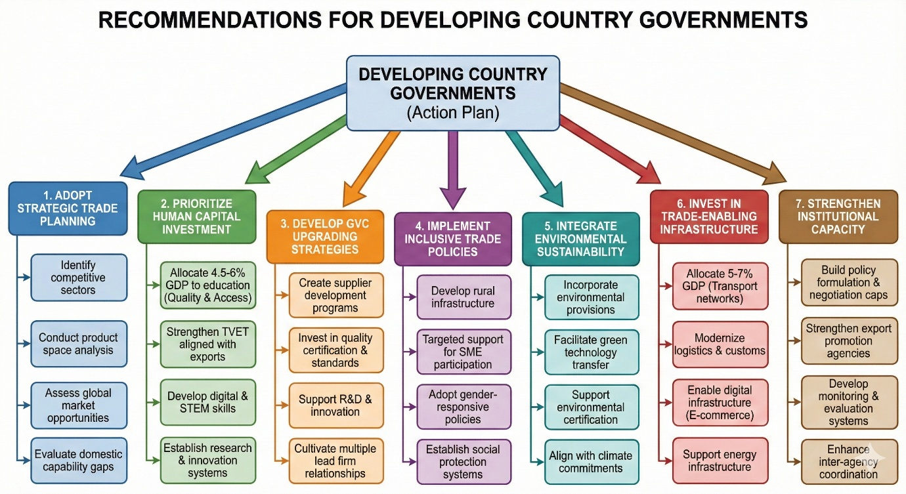
Figure 8: Based on the findings, these are actionable recommendations.

ETHICAL APPROVAL
Not applicable. This study involved systematic review of published literature and did not involve human subjects, animal subjects, or collection of primary data requiring ethical approval.

CONSENT
Not applicable. This study did not involve human participants requiring informed consent.
REFERENCES
- Acemoglu, D., & Dell, M. (2010). Productivity differences between and within countries. American Economic Journal: Macroeconomics, 2(1), 169-188. https://doi.org/10.1257/mac.2.1.169
- Acemoglu, D., Johnson, S., & Robinson, J. A. (2002). An African success story: Botswana. CEPR Discussion Paper, 3219. https://cepr.org/publications/DP3219
- Aghion, P., Akcigit, U., & Howitt, P. (2015). Lessons from Schumpeterian Growth Theory. American Economic Review, 105(5), 94-99. https://doi.org/10.1257/aer.p20151067
- Aghion, P., & Howitt, P. (2009). The economics of growth. MIT Press. https://mitpress.mit.edu/books/economics-growth
- Ambec, S., Cohen, M. A., Elgie, S., & Lanoie, P. (2013). The Porter hypothesis at 20: Can environmental regulation enhance innovation and competitiveness? Review of Environmental Economics and Policy, 7(1), 2-22. https://doi.org/10.1093/reep/res016
- Amiti, M., Kong, S. H., & Weinstein, D. (2020). The effect of the U.S.-China trade war on U.S. investment. NBER Working Paper. https://doi.org/10.3386/w27114
- Amsden, A. H. (1989). Asia's next giant: South Korea and late industrialization. Oxford University Press. https://doi.org/10.1093/0195052026.001.0001
- Amsden, A. H. (2001). The rise of "the rest": challenges to the west from late-industrializing economies. Oxford University Press. https://doi.org/10.1093/0195139690.001.0001
- Antràs, P. (2020). De-Globalisation? Global Value Chains in the Post-COVID-19 Age. NBER Working Paper, 28115. https://doi.org/10.3386/w28115
- Antweiler, W., Copeland, B. R., & Taylor, M. S. (2001). Is free trade good for the environment? American Economic Review, 91(4), 877-908. https://doi.org/10.1257/aer.91.4.877
- Armstrong, H. W., & Read, R. (2000). Comparing the economic performance of dependent territories and sovereign microstates. Economic Development and Cultural Change, 48(2), 285-306. https://doi.org/10.1086/452459
- Arvis, J. F., Raballand, G., & Marteau, J. F. (2010). The cost of being landlocked: Logistics costs and supply chain reliability. World Bank. https://openknowledge.worldbank.org/handle/10986/2489
- Baer, W. (1972). Import substitution and industrialization in Latin America: Experiences and interpretations. Latin American Research Review, 7(1), 95-122. https://doi.org/10.1017/S0023879100041224
- Baldwin, R. (2016). The great convergence: Information technology and the new globalization. Harvard University Press. https://www.hup.harvard.edu/catalog.php?isbn=9780674660489
- Baldwin, R., & Freeman, R. (2022). Risks and global supply chains: What we know and what we need to know. Annual Review of Economics, 14, 153-180. https://doi.org/10.1146/annurev-economics-051420-113737
- Barro, R. J. (2013). Education and economic growth. Annals of Economics and Finance, 14(2), 301-328. http://down.aefweb.net/AefArticles/aef140201Barro.pdf
- Barton, J. H. (2007). New trends in technology transfer: implications for national and international policy. ICTSD Issue Paper, 18.
- Becker, G. S. (2009). Human capital: A theoretical and empirical analysis, with special reference to education. University of Chicago Press. https://press.uchicago.edu/ucp/books/book/chicago/H/bo5954600.html
- Behuria, P. (2016). Centralising rents and dispersing power while pursuing development? Exploring the strategic uses of military firms in Rwanda. Review of African Political Economy, 43(150), 630-647. https://doi.org/10.1080/03056244.2015.1128407
- Benhabib, J., & Spiegel, M. M. (2005). Human capital and technology diffusion. In P. Aghion & S. Durlauf (Eds.), Handbook of economic growth (Vol. 1, Part A, pp. 935-966). Elsevier. https://doi.org/10.1016/S1574-0684(05)01013-0
- Bernard, A. B., Redding, S. J., & Schott, P. K. (2007). Comparative advantage and heterogeneous firms. The Review of Economic Studies, 74(1), 31-66. https://doi.org/10.1111/j.1467-937X.2007.00413.x
- Blackman, A., & Rivera, J. (2011). Producer-level benefits of sustainability certification. Conservation Biology, 25(6), 1176-1185. https://doi.org/10.1111/j.1523-1739.2011.01774.x
- Bloom, D. E., Canning, D., Fink, G., & Finlay, J. E. (2007). Does age structure forecast economic growth?. International Journal of Forecasting, 23(4), 569-585. https://doi.org/10.1016/j.ijforecast.2007.07.001
- Boland, A., Cherry, M. G., & Dickson, R. (Eds.). (2017). Doing a systematic review: A student's guide. Sage. https://us.sagepub.com/en-us/nam/doing-a-systematic-review/book245090
- Boschma, R. (2017). Relatedness as driver of regional diversification: A research agenda. Regional Studies, 51(3), 351-364. https://doi.org/10.1080/00343404.2016.1254767
- Briguglio, L. (1995). Small island developing states and their economic vulnerabilities. World Development, 23(9), 1615-1632. https://doi.org/10.1016/0305-750X(95)00065-K
- Bruton, H. J. (1998). A reconsideration of import substitution. Journal of Economic Literature, 36(2), 903-936. http://www.e-jel.org/archive/june1998/Bruton.pdf
- Burke, M., Hsiang, S. M., & Miguel, E. (2015). Global non-linear effect of temperature on economic production. Nature, 527(7577), 235-239. https://doi.org/10.1038/nature15725
- Cadot, O., Carrère, C., & Strauss-Kahn, V. (2011). Export Diversification: What's behind the Hump?. Review of Economics and Statistics, 93(2), 590-605. https://doi.org/10.1162/REST_a_00078
- Cadot, O., & de Melo, J. (2008). Why OECD Countries Should Reform Rules of Origin. The World Bank Research Observer, 23(1), 77-105. https://doi.org/10.1093/wbro/lkm010
- Cali, M., & te Velde, D. W. (2011). Does aid for trade really improve trade performance? World Development. https://doi.org/10.1016/j.worlddev.2010.09.018
- Cao, L., Gu, M., Jin, D., & Wang, C. (2023). Geopolitical risk and economic security: Exploring natural resources extraction from BRICS region. Resources Policy, 85, 103800. https://doi.org/10.1016/j.resourpol.2023.103800
- Chang, H.-J. (2002). Kicking away the ladder: Development strategy in historical perspective. Anthem Press. https://www.anthempress.com/kicking-away-the-ladder
- Chang, H. J., & Lin, J. (2009). Should industrial policy in developing countries conform to comparative advantage or defy it? A debate between Justin Lin and Ha-Joon Chang. Development Policy Review, 27(5), 483-502. https://doi.org/10.1111/j.1467-7679.2009.00456.x
- Cherif, R., & Hasanov, F. (2019). The return of the policy that shall not be named: Principles of industrial policy. IMF Working Paper, 19/74. https://doi.org/10.5089/9781498305402.001
- Cherniwchan, J., Copeland, B. R., & Taylor, M. S. (2017). Trade and the environment: New methods, measurements, and results. Annual Review of Economics, 9, 59-85. https://doi.org/10.1146/annurev-economics-063016-103756
- Cimoli, M., Dosi, G., & Stiglitz, J. E. (2009). Industrial policy and development: The political economy of capabilities accumulation. Oxford University Press. https://doi.org/10.1093/acprof:oso/9780199235261.001.0001
- Colantone, I., & Stanig, P. (2018). Global competition and Brexit. American Political Science Review, 112(2), 201-218. https://doi.org/10.1017/S0003055417000685
- Copeland, B. R., & Taylor, M. S. (2004). Trade, growth, and the environment. Journal of Economic Literature, 42(1), 7-71. https://doi.org/10.1257/002205104773558047
- Costinot, A., & Donaldson, D. (2012). Ricardo's theory of comparative advantage: Old idea, new evidence. American Economic Review, 102(3), 453-458. https://doi.org/10.1257/aer.102.3.453
- Dallas, M. P., Ponte, S., & Sturgeon, T. J. (2019). Power in Global Value Chains. Review of International Political Economy, 26(4), 666-694. https://doi.org/10.1080/09692290.2019.1608284
- Dell, M., Jones, B. F., & Olken, B. A. (2014). What do we learn from the weather? The new climate-economy literature. Journal of Economic Literature, 52(3), 740-798. https://doi.org/10.1257/jel.52.3.740
- Dorosh, P. A., & Thurlow, J. (2018). Beyond agriculture versus non-agriculture: Decomposing sectoral growth–poverty linkages in five African countries. World Development, 109, 440-451. https://doi.org/10.1016/j.worlddev.2016.08.014
- Edwards, S. (1993). Openness, trade liberalization, and growth in developing countries. Journal of Economic Literature, 31(3), 1358-1393. https://doi.org/10.2307/2728244
- Evenett, S. J., & Fritz, J. (2021). Advancing sustainable development with FDI: Why policy must be reset. Global Trade Alert Report (CEPR Press). https://www.globaltradealert.org/reports/27
- Faye, M. L., McArthur, J. W., Sachs, J. D., & Snow, T. (2004). The challenges facing landlocked developing countries. Journal of Human Development, 5(1), 31-68. https://doi.org/10.1080/14649880310001660201
- Fontana, M. (2016). Gender and the WTO. In The Oxford Handbook on the World Trade Organization (pp. 624-644). Oxford University Press.
- Freund, C., & Pierola, M. D. (2015). Export superstars. Review of Economics and Statistics, 97(5), 1023-1032. https://doi.org/10.1162/REST_a_00511
- Fu, X., Pietrobelli, C., & Soete, L. (2011). The role of foreign technology and indigenous innovation in the emerging economies: Technological change and catching-up. World Development, 39(7), 1204-1212. https://doi.org/10.1016/j.worlddev.2010.05.009
- Gallup, J. L., Sachs, J. D., & Mellinger, A. D. (1999). Geography and economic development. International Regional Science Review, 22(2), 179-232. https://doi.org/10.1177/016001799761012334
- Gebreeyesus, M., & Iizuka, M. (2012). Discovery of flower industry in Ethiopia: Experimentation and coordination. Journal of Globalization and Development, 2(2), 1-27. https://doi.org/10.1515/1948-1837.1103
- Gelb, A. H. (Ed.). (2010). Economic diversification and growth in oil-exporting Arab countries. International Monetary Fund.
- Gereffi, G. (1999). International trade and industrial upgrading in the apparel commodity chain. Journal of International Economics, 48(1), 37-70. https://doi.org/10.1016/S0022-1996(98)00075-0
- Gereffi, G. (2005). The global economy: Organization, governance, and development. In N. J. Smelser & R. Swedberg (Eds.), The handbook of economic sociology (2nd ed., pp. 160-182). Princeton University Press. https://doi.org/10.1017/9781108559423.006
- Gereffi, G. (2014). Global value chains in a post-Washington Consensus world. Review of International Political Economy, 21(1), 9-37. https://doi.org/10.1080/09692290.2012.756414
- Gereffi, G., & Fernandez-Stark, K. (2016). Global Value Chain Analysis: A Primer, 2nd Edition. Duke CGGC. https://hdl.handle.net/10161/12488
- Gereffi, G., & Luo, X. (2015). Risks and opportunities of participation in global value chains. Journal of Banking and Financial Economics, 2(4), 51-63. https://doi.org/10.7172/2353-6845.jbfe.2015.2.4
- Giannetti, B. F., Agostinho, F., Eras, J. J. C., Yang, Z., & Almeida, C. M. V. B. (2020). Cleaner Production for Achieving the Sustainable Development Goals. Journal of Cleaner Production, 271, 122127. https://doi.org/10.1016/j.jclepro.2020.122127
- Gil-Pareja, S., Llorca-Vivero, R., & Martínez-Serrano, J. A. (2014). Do nonreciprocal preferential trade agreements increase beneficiaries' exports? Journal of Development Economics, 107, 291-304. https://doi.org/10.1016/j.jdeveco.2014.01.002
- Glewwe, P., Maïga, E., & Zheng, H. (2014). The contribution of education to economic growth: A review of the evidence, with special attention and an application to Sub-Saharan Africa. World Development, 59, 379-393. https://doi.org/10.1016/j.worlddev.2014.01.021
- Goldberg, P. K., & Pavcnik, N. (2007). Distributional effects of globalization in developing countries. Journal of Economic Literature, 45(1), 39-82. https://doi.org/10.1257/jel.45.1.39
- Goldberg, P., & Reed, T. (2023). Income distribution and COVID-19: An analysis across US states. NBER Working Paper, 30838.
- Goldfarb, A., & Tucker, C. (2019). Digital economics. Journal of Economic Literature, 57(1), 3-43. https://doi.org/10.1257/jel.20171452
- Grossman, G. M., & Krueger, A. B. (1995). Economic growth and the environment. The Quarterly Journal of Economics, 110(2), 353-377. https://doi.org/10.2307/2118443
- Hallak, J. C., & Sivadasan, J. (2013). Product and process productivity: Implications for quality choice and conditional exporter premia. Journal of International Economics, 91(1), 53-67. https://doi.org/10.1016/j.jinteco.2013.05.001
- Hanushek, E. A., & Woessmann, L. (2012). Do better schools lead to more growth? Cognitive skills, economic outcomes, and causation. Journal of Economic Growth. https://doi.org/10.1007/s10887-012-9072-5
- Hanushek, E. A., & Woessmann, L. (2020). Education, knowledge capital, and economic growth. In S. Bradley & C. Green (Eds.), The economics of education (2nd ed., pp. 171-182). Academic Press. https://doi.org/10.1016/B978-0-12-815391-8.00014-8
- Harrison, A., & Rodríguez-Clare, A. (2010). Trade, foreign investment, and industrial policy for developing countries. In Handbook of development economics (Vol. 5, pp. 4039-4214). Elsevier. https://doi.org/10.1016/B978-0-444-52944-2.00001-X
- Hausmann, R., Hidalgo, C. A., Bustos, S., Coscia, M., Simoes, A., & Yildirim, M. A. (2014). The atlas of economic complexity: Mapping paths to prosperity. MIT Press. https://doi.org/10.7551/mitpress/9647.001.0001
- Hausmann, R., & Klinger, B. (2007). The structure of the product space and the evolution of comparative advantage. CID Working Papers. https://www.hks.harvard.edu/sites/default/files/centers/cid/files/publications/faculty-working-papers/146.pdf
- Heath, R., & Mobarak, A. M. (2015). Manufacturing growth and the lives of Bangladeshi women. Journal of Development Economics, 115, 1-15. https://doi.org/10.1016/j.jdeveco.2015.01.006
- Helpman, E., & Krugman, P. R. (1985). Market structure and foreign trade: Increasing returns, imperfect competition, and the international economy. MIT press. https://mitpress.mit.edu/
- Hidalgo, C. A., & Hausmann, R. (2009). The building blocks of economic complexity. Proceedings of the National Academy of Sciences, 106(26), 10570-10575. https://doi.org/10.1073/pnas.0900943106
- Hidalgo, C. A., Klinger, B., Barabási, A. L., & Hausmann, R. (2007). The product space conditions the development of nations. Science, 317(5837), 482-487. https://doi.org/10.1126/science.1144581.
- Hoekman, B. M., & Kostecki, M. M. (2009). The political economy of the world trading system: The WTO and beyond. Oxford University Press. https://global.oup.com/academic/product/the-political-economy-of-the-world-trading-system-9780199553778?cc=us&lang=en&.
- Humphrey, J., & Schmitz, H. (2002). How does insertion in global value chains affect upgrading in industrial clusters? Regional Studies, 36(9), 1017-1027. https://doi.org/10.1080/0034340022000022198.
- Hutchison, C. (2006). Does TRIPS facilitate or impede climate change technology transfer into developing countries? University of Ottawa Law & Technology Journal, 3(1), 517-537. http://www.uoltj.ca/articles/vol3.2/2006.3.2.uoltj.Hutchison.517-537.pdf
- International Energy Agency. (2021). Net Zero by 2050: A Roadmap for the Global Energy Sector. IEA. https://www.iea.org/reports/net-zero-by-2050
- International Labour Organization. (2020). Global Employment Trends for Youth 2020: Technology and the future of jobs. Geneva: ILO. https://www.ilo.org/global/publications/books/WCMS_737675/lang--en/index.htm
- International Trade Centre. (2020). SME Competitiveness Outlook 2020: COVID-19: The Great Lockdown and its Impact on Small Business. ITC. https://www.intracen.org/uploadedFiles/intracenorg/Content/Publications/ITCSMECO2020.pdf
- Jakob, M., Chen, C., Fuss, S., Marxen, A., Rao, N. D., & Edenhofer, O. (2016). Carbon pricing revenues could close infrastructure access gaps. World Development, 84, 254-265. https://doi.org/10.1016/j.worlddev.2016.03.001
- Javorcik, B. S. (2020). Global supply chains will not be the same in the post-COVID-19 world. In R. Baldwin & S. Evenett (Eds.), COVID-19 and trade policy: Why turning inward won't work (pp. 111-116). CEPR Press. https://www.economics.ox.ac.uk/materials/papers/16000/global-supply-chains-will-not-be-the-same-in-the-post-covid-19-world.pdf
- Jawara, F., & Kwa, A. (2004). Behind the scenes at the WTO: The real world of international trade negotiations: Lessons of Cancun. Zed Books. https://www.bloomsbury.com/uk/behind-the-scenes-at-the-wto-9781842775332/
- Kabeer, N., & Mahmud, S. (2004). Globalization, gender and poverty: Bangladeshi women workers in export and local markets. Journal of International Development, 16(1), 93-109. https://doi.org/10.1002/jid.1065
- Kaplinsky, R. (2000). Globalisation and unequalisation: What can be learned from value chain analysis? Journal of Development Studies, 37(2), 117-146. https://doi.org/10.1080/713600071
- Krueger, A. O. (1997). Trade policy and economic development: How we learn. American Economic Review, 87(1), 1-22. http://links.jstor.org/sici?sici=0002-8282%28199703%2987%3A1%3C1%3ATPAEDH%3E2.0.CO%3B2-L&origin=repec
- Krugman, P. R. (1979). Increasing returns, monopolistic competition, and international trade. Journal of International Economics, 9(4), 469-479. https://doi.org/10.1016/0022-1996(79)90017-5
- Krugman, P. (1980). Scale economies, product differentiation, and the pattern of trade. American Economic Review, 70(5), 950-959. http://links.jstor.org/sici?sici=0002-8282%28198012%2970%3A5%3C950%3ASEPDAT%3E2.0.CO%3B2-H
- Krugman, P. R., Obstfeld, M., & Melitz, M. J. (2022). International economics: Theory and policy (12th ed.). Pearson. https://www.pearson.com/us/higher-education/program/Krugman-International-Economics-Theory-and-Policy-12th-Edition/PGM266000.html
- Lederman, D., Olarreaga, M., & Zavala, L. (2016). Export promotion and firm entry into and survival in export markets. Canadian Journal of Development Studies/Revue Canadienne D'études du Développement, 37(2), 142–158. https://doi.org/10.1080/02255189.2016.1131671
- Lee, K. (2013). Schumpeterian analysis of economic catch-up: Knowledge, path-creation, and the middle-income trap. Cambridge University Press. https://doi.org/10.1017/CBO9781107337244
- Lema, A., & Lema, R. (2012). Technology transfer? The rise of China and India in green technology sectors. Innovation and Development, 2(1), 23-44. DOI: 10.1080/2157930X.2012.667206
- Levinson, A. (2009). Technology, international trade, and pollution from US manufacturing. American Economic Review, 99(5), 2177-2192. DOI: 10.1257/aer.99.5.2177
- Lewis, J. I. (2014). The rise of renewable energy protectionism: Emerging trade conflicts and implications for low carbon development. Global Environmental Politics, 14(4), 10-35. DOI: 10.1162/GLEP_a_00255
- Lin, J. Y., & Monga, C. (2011). Growth identification and facilitation: The role of the state in the dynamics of structural change. Development Policy Review, 29(3), 259-310. DOI: 10.1111/j.1467-7679.2011.00534.x
- Lin, J. Y., & Wang, X. (2022). China's economic transformation: Lessons learned and challenges ahead. Routledge.
- Mattoo, A., & Staiger, R. W. (2020). Trade wars: What do they mean? Why are they happening now? What are the costs? Economic Policy, 35(103), 561-584. DOI: 10.1093/epolic/eiaa013
- Mayer, T., Melitz, M. J., & Ottaviano, G. I. (2020). Market size, competition, and the product mix of exporters. American Economic Review, 104(2), 495-536. DOI: 10.1257/aer.104.2.495
- McElroy, J. L., & Pearce, K. B. (2006). The advantages of political affiliation: Dependent and independent small-island profiles. The Round Table, 95(386), 529-539. DOI: 10.1080/00358530600931285
- Mealy, P., Farmer, J. D., & Teytelboym, A. (2022). Interpreting economic complexity. Science Advances, 8(5), eabl4250. DOI: 10.1126/sciadv.aau1705
- Melitz, M. J. (2003). The impact of trade on intra‐industry reallocations and aggregate industry productivity. Econometrica, 71(6), 1695-1725. DOI: 10.1111/1468-0262.00467
- Meller, P., & Gomez, J. (2022). The Chilean export boom and diversification: 1990-2015. CEPAL Review, 136, 51-76.
- Meltzer, J. P. (2019). Governing digital trade. World Trade Review, 18(S1), S23-S48. DOI: 10.1017/S1474745618000502
- Milberg, W., & Winkler, D. (2013). Outsourcing economics: Global value chains in capitalist development. Cambridge University Press. https://doi.org/10.1017/CBO9781139208772
- Miroudot, S. (2020). Reshaping the policy debate on the implications of COVID-19 for global supply chains. Journal of International Business Policy, 3(4), 430-442. https://doi.org/10.1057/s42214-020-00074-6
- Morin, J. F., Dür, A., & Lechner, L. (2018). Mapping the trade and environment nexus: Insights from a new data set. Global Environmental Politics, 18(1), 122-139. https://doi.org/10.1162/GLEP_a_00447
- Morris, M., & Staritz, C. (Eds.). (2017). Value chain governance, upgrading and development. Taylor & Francis.
- Morrow, P. M. (2010). Ricardian–Heckscher–Ohlin comparative advantage: Theory and evidence. Journal of International Economics, 82(2), 137-151. https://doi.org/10.1016/j.jinteco.2010.08.006
- Mostafa, R., & Klepper, S. (2018). Industrial development through tacit knowledge seeding: Evidence from the Bangladesh garment industry. Management Science, 64(2), 613-632. https://doi.org/10.1287/mnsc.2016.2619
- Nelson, R. R., & Phelps, E. S. (1966). Investment in humans, technological diffusion, and economic growth. American Economic Review, 56(1/2), 69-75. http://www.jstor.org/stable/1821269
- Newman, C., Page, J., Rand, J., Shimeles, A., Soderbom, M., & Tarp, F. (Eds.). (2020). Manufacturing transformation: Comparative studies of industrial development in Africa and emerging Asia. Oxford University Press. https://doi.org/10.1093/acprof:oso/9780198776987.001.0001
- OECD (Organisation for Economic Co-operation and Development). (2017). Enhancing the contributions of SMEs in a global and digitalised economy. Paris: OECD. https://www.oecd.org/mcm/documents/C-MIN-2017-8-EN.pdf
- Ohno, K. (2021). The History of Vietnamese Economic Development. Springer.
- Oqubay, A. (2020). Made in Africa: Industrial Policy in Ethiopia. Oxford University Press. https://doi.org/10.1093/acprof:oso/9780198739890.001.0001
- Ornelas, E., & Ritel, L. (2020). The not-so-generalized effects of the Generalized System of Preferences. Canadian Journal of Economics, 53(2), 531-566. https://doi.org/10.1111/twec.12988
- Parrilli, M. D., Nadvi, K., & Yeung, H. W. C. (2016). Local and regional development in global value chains, production networks and innovation networks: A comparative review and the challenges for future research. The Competitiveness of Clusters in Globalized Markets, 1-22. https://doi.org/10.4324/9781315773728-1
- Peters, G. P., & Veld, M. (2021). Measuring carbon leakage. Nature Climate Change, 11(6), 460-461.
- Petticrew, M., & Roberts, H. (2006). Systematic reviews in the social sciences: A practical guide. John Wiley & Sons. https://doi.org/10.1002/9780470754887
- Ponte, S., & Sturgeon, T. (2014). Explaining governance in global value chains: A modular theory-building effort. Review of International Political Economy, 21(1), 195-223. https://doi.org/10.1080/09692290.2013.809596
- Porter, M. E., & van der Linde, C. (1995). Toward a new conception of the environment-competitiveness relationship. Journal of Economic Perspectives, 9(4), 97-118. https://doi.org/10.1257/jep.9.4.97
- Rodrik, D. (1995). Getting interventions right: how South Korea and Taiwan grew rich. Economic Policy, 10(20), 53-107. https://doi.org/10.2307/1344538
- Rodrik, D. (2004). Industrial policy for the twenty-first century. CEPR Discussion Paper, 4767. https://doi.org/10.2139/SSRN.617544
- Rodrik, D. (2018). What do trade agreements really do? Journal of Economic Perspectives, 32(2), 73-90. https://doi.org/10.1257/jep.32.2.73
- Rodrik, D., & Stantcheva, S. (2021). Fixing capitalism's good jobs problem. Oxford Review of Economic Policy, 37(4), 824-837. https://doi.org/10.1093/oxrep/grab024
- Schott, P. K. (2004). Across-product versus within-product specialization in international trade. The Quarterly Journal of Economics, 119(2), 647-678. https://doi.org/10.1162/0033553041382201
- Sondermann, E., & Glocker, D. (2021). Informal employment and the demand for skills: evidence from online job postings. OECD Publishing.
- Stiglitz, J. E. (2021). The proper role of government in the market economy: The case of the post-COVID recovery. Journal of Government and Economics, 1, 100004. https://doi.org/10.1016/j.jge.2021.100004
- Swinnen, J., & Kuijpers, R. (2019). Value chain innovations for technology transfer in developing and emerging economies: Conceptual issues, typology, and policy implications. Food Policy, 83, 298-309. https://doi.org/10.1016/j.foodpol.2017.07.013
- Taglioni, D., & Winkler, D. (2016). Making global value chains work for development. World Bank Publications. https://doi.org/10.1596/978-1-4648-0157-0
- Tayleur, C., Balmford, A., Buchanan, G. M., Butchart, S. H., Ducharme, H., Green, R. E., ... & Phalan, B. (2017). Global coverage of agricultural sustainability standards, and their role in conserving biodiversity. Conservation Letters, 10(5), 610-618. https://doi.org/10.1111/conl.12314
- Tejani, S., & Milberg, W. (2016). Global defeminization? Industrial upgrading and manufacturing employment in developing countries. Feminist Economics, 22(2), 24-54. https://doi.org/10.1080/13545701.2015.1120880
- Thomas, J., & Harden, A. (2008). Methods for the thematic synthesis of qualitative research in systematic reviews. BMC Medical Research Methodology, 8(1), 1-10. https://doi.org/10.1186/1471-2288-8-45
- Thomsen, L. (2022). One size fits none: Economic upgrading in Viet Nam's coffee and garment sectors. In Global value chains and industrial upgrading in East Asia (pp. 76-98). Edward Elgar Publishing.
- Topalova, P. (2010). Factor immobility and regional impacts of trade liberalization: Evidence on poverty from India. American Economic Journal: Applied Economics, 2(4), 1-41. https://doi.org/10.1257/app.2.4.1
- Tranfield, D., Denyer, D., & Smart, P. (2003). Towards a methodology for developing evidence‐informed management knowledge by means of systematic review. British Journal of Management, 14(3), 207-222. https://doi.org/10.1111/1467-8551.00375
- UNCTAD (United Nations Conference on Trade and Development). (2020). Technology and Innovation Report 2020: Catching technological waves – Innovation with equity. Geneva: United Nations. https://doi.org/10.18356/9789210056588
- UNCTAD (United Nations Conference on Trade and Development). (2021). Technology and Innovation Report 2021: Catching technological waves – Innovation with equity. Geneva: United Nations. https://unctad.org/publication/technology-and-innovation-report-2021
- UNCTAD (United Nations Conference on Trade and Development). (2023). Trade and Development Report 2023: Growth, debt, and climate – Realigning the global financial architecture. Geneva: United Nations. https://unctad.org/publication/trade-and-development-report-2023
- UNIDO (United Nations Industrial Development Organization). (2019). Industrial Development Report 2020: Industrializing in the digital age. Vienna: UNIDO. https://www.unido.org/idr2020
- UN Women. (2020). Progress of the world's women 2019-2020: Families in a changing world. New York: UN Women. https://www.un-ilibrary.org/gender/progress-of-the-world-s-women-2019-2020_2e1a8167-en
- Venables, A. J. (2016). Using natural resources for development: why has it proven so difficult? Journal of Economic Perspectives, 30(1), 161-184. https://doi.org/10.1257/jep.30.1.161
- Vijil, M., & Wagner, L. (2012). Does aid for trade enhance export performance? Investigating the infrastructure channel. The World Economy, 35(7), 838-868. https://doi.org/10.1111/j.1467-9701.2012.01437.x
- Wade, R. (1990). Governing the market: Economic theory and the role of government in East Asian industrialization. Princeton University Press.
- Wade, R. H. (2003). What strategies are viable for developing countries today? The World Trade Organization and the shrinking of 'development space'. Review of International Political Economy, 10(4), 621-644. https://doi.org/10.1080/09692290310001601902
- Winters, L. A., & Martins, P. M. (2004). When comparative advantage is not enough: Business costs in small remote economies. World Trade Review, 3(3), 347-383. https://doi.org/10.1017/S1474745604001922
- World Bank. (1993). The East Asian miracle: Economic growth and public policy. Oxford University Press. http://documents.worldbank.org/curated/en/975081468244550798
- World Bank. (2018). World Development Report 2018: Learning to realize education's promise. Washington, DC: World Bank. https://doi.org/10.1596/978-1-4648-1096-1
- World Bank. (2020). Poverty and Shared Prosperity 2020: Reversals of fortune. Washington, DC: World Bank. https://doi.org/10.1596/978-1-4648-1602-4
- World Bank. (2022). Women, Business and the Law 2022. Washington, DC: World Bank. https://doi.org/10.1596/978-1-4648-1817-2
- World Bank. (2023). World Development Report 2023: Migrants, Refugees, and Societies. Washington, DC: World Bank. https://doi.org/10.1596/978-1-4648-1941-4
- WTO (World Trade Organization). (2021). World Trade Report 2021: Economic resilience and trade. Geneva: WTO. https://www.wto-ilibrary.org/content/books/9789287051400
- WTO (World Trade Organization). (2022). World Trade Report 2022: Climate change and international trade. Geneva: WTO. https://www.wto.org/english/res_e/publications_e/wtr22_e/wtr22_e.htm
- WTO (World Trade Organization). (2023). World Trade Report 2023: Re-globalization for a secure, inclusive and sustainable future. Geneva: WTO. https://www.wto.org/english/res_e/publications_e/wtr23_e.htm

