Antidiabetic and Anti-Obesity Potential of Solanum scabrum Stem Extract: An Experimental Study on Wistar Rats

ABSTRACT
Solanum scabrum is an indigenous plant vegetable and a source of traditional medicine in Cameroon and other parts of the world. The leaves and young shoots of this plant are eaten as a vegetable and the matured stems are discarded while the berries are used as dyes or seeds. This study was aimed at characterizing the phytochemical and antioxidant constituents of the of Solanum scabrum stem and to evaluate the antidiabetic and anti-obesity effects of the biomass on diabetic and obese male Wistar rats.
Methodology: Nutritional analysis, phytochemical and antioxidant properties were determined using AOAC standards. . Carrying out in vivo studies, male albino Wister rats were induced with diabetes using streptozotocin at dosage of 40mg/kg body weight and high fat diet used to induced obesity. Solanum scabrum stem extract at dose of 140mg/kg and 280mg/kg body weight were used to treat the animals for a period of 21 days. For the oral glucose tolerance, extracts at different dose also reduced blood glucose from 237mg/dL- 87mg/dL at dose of 40mg and from 124mg/dl to 51mg/dL at dose of 280mg.
Results: The stem was reported to contain some phytochemicals like saponins, terpenoids, steroids, tannins alkaloids. Also, the plant content nutrients like Proteins (7.62%-17.95%), Fiber of 5.29%-39.43%, Iron 26.16mg/kg-227.5mg/kg among other nutrients plant extracts had significance of P<0.0001 of 140mg lowered the blood glucose levels from 600mg/dL to 70mg/dL and extract of 280mg also lowered the blood glucose from 486mg/dL to 81mg/dl. In the obese rats, the stem extract showed no significance on BMI. Examining the lipid profile of the obese animals, the extracts also did not show any significance. Liver biomarkers AST and ALT were analyzed to ascertain the effect of extract in the liver and no significance (P>0.05) of the extract was noticed when compared to the control groups.
Conclusion: In conclusion, Solanum scabrum was found to contain phytochemicals, have antioxidant properties and good nutrient source. The stem was recognized to have antidiabetic properties but no antilipidemic properties.
Keywords: Solanum scabrum, antidiabetic properties, anti-obesity properties, phytochemicals, antioxidants, nutritional analysis, Wistar rats.
.

1.0 INTRODUCTION
Type 2 diabetes mellitus (T2DM) is a metabolic disorder characterized by chronic hyperglycemia as a result of impairments in insulin secretion from pancreatic β-cells and insulin action in target tissues (Yang et al., 2011). Type 2 diabetes is often named a “lifestyle disease” since it is largely due to obesity, lack of exercise and poor diet. It is reported that 80 to 90% of type 2 diabetics are overweight or obese (Cabot and Jasinska, 2007). Rosenthal 1999 divided these factors into two groups: “modifiable risk factors” and “non-modifiable risk factors”. Modifiable risk factors are the factors that can be changed by humans, like obesity, high cholesterol, hypertension, sedentary lifestyle, smoking, sleep deprivation or sleep disorders and vitamin deficiency. Non-modifiable risk factors refer to the factors cannot be changed such as age, genetics, gender, race and medication. Also, Xiangxi et al., (2021) enumerates a number of influence factors and the complications involved in diabetes mellitus. These factors are: pancreatic islet cell dysfunction, genes, food, environmental factors. Long term hyperglycemia can lead to multiple complications like: intestinal flora disturbance, musculoskeletal, hepatic, cognitive function and mental health disorders, Retinopathy, renal, cardiovascular and other related diseases.
Obesity occurs when there is an imbalance between energy intake and energy expenditure. In past history, energy intake was thought to be primary in the pathogenesis of obesity but in recent times, energy expenditure is also considered to be equal likely another factor of obesity (Bensimhon et al., 2006). Energy intake is primarily regulated by appetite which is controlled by neuroregulatory factors (hormones and neurotransmitters) (Kalra et al.,1999). The total energy expenditure is constituted by three main components which are; basal metabolism, thermogenesis and physical activities (Garza, 2015). Additionally, the susceptibility of obesity involves genetic factors (Temelkova-Kurktschiev et al.,2011). This is demonstrated with appetite and leptin deficiency. This gene variation contributes to produce energy imbalance resulting to obesity (Schuster, 2010).
Solanum scabrum (huckleberry) belonging to the Solaneceae family is a common leafy vegetable among many others. It is an important source of daily nutrient and a source of income for small scale farmers in Cameroon (Ojiewo et al., 2013). It is the most intensively cultivated species for leaf cropping within the Solanum nigrum complex, and as such has undergone genetic selection by farmers from leaf size and other characteristics (Manoko et al., 2008). This vegetable consist of the stem, leaves and its fruits but only its leaves are consumed, the fruits are crushed and stored as seeds for planting while its stem discarded. Fortunately, these stems have almost the same amount of nutrients as in the leaves but due to its unappealing organoleptic attributes it is thrown away (Abukutsa et al.,2007).
Vegetable-rich diet are associated with lower risk of several chronic diseases and can help achieve a healthy weight (Wilkins et al.,2015). Despite the high value of vegetables, a greater portion of it is wasted, this waste is considered the second leading cause of greenhouse emission (FAO, 2021)
Beyond environmental impact, a great portion of the nutrients in food is wasted or lost. Food meant for health and strength goes to waste and pollution but can be managed back to health(tea) and wealth (nutraceuticals)
2. MATERIAL AND METHODS
2.1 Preparation of Methanolic extract of Solanum scabrum stem
The fresh stems were sorted and chopped to small sizes of 2-3cm.The samples were then washed and blanched at 110 0C for 10mins. The sample was divided into three and dried at temperatures of 400⁰c, 500⁰c, 600⁰c in a dehydrator (Adeboye et al., 2019). The samples were then blended and the coarse samples were sieved using three Endecott sieves of pore sizes 300µm, 500µm, 1000µm then packaged in labelled paper bags and stored at room temperatures. 10g of each powder sample was weighed and extracted in 100ml of methanol and shaken vigorously for 12 hours to maximize dissolution of phenols into the filtrate. Using filter paper, the solution was filtered and evaporated to dryness at 40⁰c to remove the solvent.
2.2 Proximate and Phytochemical Analysis of Solanum scabrum stem powder
The crude fiber, protein lipid and ash content of Solanum scabrum stem powder was determined following the AOAC (2005) standard while the moisture content and carbohydrate content was analysed using AOAC (1990) standard.
Qualitatively, the total phenolic content and radical scavenging activity (DPPH) of the powder was determined using the methods of Gao et al., 2000 and Braca et al.,2000 respectively
Table 1: Qualitative phytochemical analysis
Phytochemical | Reference
Tanins and Saponins | Banso et al 2006
Polyphenol and Flavanoids | Iqbal 2015
Steroids | Stankovic et al 2011
Alkaloids | Joshi et al 2013
Terpenoids and Cardiac glycoside | Ayoola et al 2008

2.3 Experimental Animal Model and Induction of diabetes and obesity
Diabetes and obesity were induced according to the method of Dieudonne et al., 2015 with slight modifications. Male Wister rats were acclimatized for one week then placed on a high fat/sugar diet for three weeks. The animals were then induced with diabetes using streptozotocin intraperitoneally at a dose of 40mg/kg body weight. The animals were confirmed diabetic after 48hours by taking their fasting blood glucose levels with a glucometer (fasting blood sugar above 200mg/dl was considered diabetic). The animals for obesity were confirmed obese after recording a body weight of 200g and above. The animals were then grouped into 8 groups of five animals in each group (HFD+Strep+Water, HFD+Strep+Metformin, HFD+Strep+Glibenclamide, HFD+Strep+Solanum 140mg, HFD+Strep+Solanum 280mg, HFD+Obesity+Water, HFD+Obesity+Solanum 140mg, HFD+Obesity+Solanum 280mg). The animals were then fed normally for diet and treated for 21 days. Fasting blood sugar levels were recorded after every 5 days and clinical parameters like urine volume, water and food intake levels were also recorded. On the 21stday the animals were then sacrificed and blood serum sample collected.

Table 2: Feed composition
Food composition |  | Quantity | Energy
Carbohydrate | Corn flour | 10kg | 40kg/kcal
Protein | Soybeans | 2kg | 8kg/kcal
Protein | Fish powder | 2kg | 8kg/kcal
Carbohydrate | Wheat brand | 4kg | 16kg/kcal
Mineral | Bone/sea shells | 1kg | -
Mineral | Concentrate | 1kg | -
Lipid | Margarine | 4.5kg | 40.5kg/kcal
water | / | 250ml | /

2.4 Biochemical Analysis
Total cholesterol, low density lipoproteins, triglycerides, alanine aminotransferase and aspartate aminotransferase were determined using the protocol of the Chronolab sytem kit according to manufacturer’s guideline.
Oral glucose tolerance test (OGTT) was carried out following the method of Dieudonne et al., 2015 with some modifications. These animals were fasted overnight prior to commencement of the test. Their glucose levels were collected using the glucometer. immediately after this the extract was given per body weight of each animal. Blood glucose levels were measured at 0 minutes and the animals given oral dose of glucose (2g/kg body weight). Blood glucose was further read at time interval of 30, 60, 90, 120 and 240 minutes.
Body Mass Index (BMI) was determined following the method of Novelli et al., 2007 where the animal’s weight and height were measured
$BMI=body weight\left(g\right)/length(cm$)
3.0 RESULTS AND DISCUSION
Proximate composition of Solanum scabrum stems are presented in the table below.
The protein content of solanum stems varied from 7.62% to 17.95%. Akubugwo et al., 2007 reported a value of 24.09% in the leaves of huckleberry. Samples 1c,2c and 3c had the lowest values followed by samples 1b and 2b with the exception of sample 3b having the highest value 17.95. 1a, 2a and 3a were very high. These values were lower than those in the fresh leaves of huckleberry 24.09% (Akubugwo et al., 2007).
The lipid content of the powder fraction ranged from 12.88% to 17.62%. All the samples had a slight variation with a +3-value difference between them, with the exception of sample 2b having the highest value of 17.62%. These values were higher than that of Akubugwo 2007 who had 4.60% in the dry leaves of huckleberry.
Fiber content varied from 5.26% to 39.43. there was no significance different between all the samples. The highest concentration was 39.43 which was achieved at temperature of 60⁰c and a particle size of 1000µm. Overall, the B-samples had high values of fiber followed by C’s and then the A samples with the list percentage of fiber. Oyeyemi et al., 2015 had similar results working on the nutritional and phytochemical composition of Solanum anguivi fruits.
The ash content of the extract ranged from 7.70% to 9.145% with little variation among samples. The results were similar with Oyeyemi et al.,2015 on solanum anguivi fruit. Sarma and Sarma, 2011 also had similar results of 7.8%. Among the samples, there was a slight significant difference.
Carbohydrates varied from 15.97% to 43.19% with a significant difference between samples. The highest value 43.19% was obtained at temperature of 60⁰c and particle size of 300µm. Overall, the A samples had the highest percentage followed by sample Cs and B samples having the least percentage. Degrain et al., 2020 also had results of 43% for the total dietary carbohydrates of Solanum retroflexum protein shake powder.
Moisture content of the samples varied significantly with values ranging from 8.5% (1A) to 16.0% (3A). According to EL Wakeel 2007, moisture content less than 10% is considered more proper for keeping quality of food.

Table 3: Proximate composition of Solanum scabrum
Samples | Protein | Lipid% | Fiber% | Ash% |  | Carb% | MC%
S1a | 15.95±0.35 | 14.96±2.87 | 11.85±0.25 |  | 9.14±0.25 | 40.18 | 8.5±2.12
S1b | 8.0±0.35 | 15.64±4.61 | 38.71±0.99 |  | 8.28±0.42 | 17.64 | 12.0±0.2
S1c | 7.62±0.38 | 12.88±2.67 | 28.62±5.21 |  | 7.87±0.14 | 33.72 | 9.5±0.70
S2a | 12.61±0.35 | 13.57±2.39 | 24.10±5.01 |  | 7.89±0.12 | 32.36 | 10.0±0.02
S2b | 9.50±0.35 | 17.62±0.53 | 32.25±0.84 |  | 8.74±0.84 | 17.23 | 15.0±0.02
S2c | 11.25±0.35 | 12.90±2.15 | 36.97±0.29 |  | 8.02±0.29 | 31.76 | 10.3±1.27
S3a | 12.26±0.35 | 15.70±3.11 | 5.29±3.66 |  | 7.70±0.57 | 43.19 | 16.0±1.41
S3b | 17.95±0.35 | 14.86±4.75 | 26.37±0.83 |  | 9.13±0.12 | 20.62 | 11.5±2.12
S3c | 11.65±.35 | 15.83±4.07 | 39.43±1.53 |  | 8.06±0.58 | 15.97 | 9.5±0.70
Key: S1a= Solanum stem 300µm/40⁰c, S1b= Solanum stem 500µm/40⁰c, S1c= 1000µm/40⁰c
S2a= Solanum stem 300µm/50⁰c, S2b= Solanum stem 500µm/50⁰c, S2c= 1000µm/50⁰c
S3a=Solanum stem 300µm/60⁰c, S3b= Solanum stem 500µm/60⁰c, S3c= 1000µm/60⁰c
The total phenolic content in the samples was calculated in gallic acid equivalent using the standard curve equation y = 0.003x + 0.2403, R² =0.9395. The TPC values of huckleberry stem powder varied from 52.3mgGAE/g to 113.01mgGAE/g. The highest value was seen in sample 2c at temperature of 50⁰ and particle size 0f 1000µm. (Hayat et al., 2018) reported values of 52. Imane, 2021 also reported 52.70 to 87.68mgGAE/g of solanum nigrum extracts in different solvents.

Figure 1: Garlic acid curve

The DPPH values for the huckleberry biomass ranged from 55.33%-75.85% A higher DPPH value indicates its high antioxidant capacity. The radical scavenging activity was highest in Sample 1A (40ºc/300µm). The radical scavenging activities of these powder extracts could be attributed to their phytochemical contents mainly phenolic content. One of the most active dietary antioxidants belongs to the family of phenolic and polyphenolic compounds due to hydroxyl groups found in their chemical structure (Doss et al., 2010). Polyphenolic compounds express their antioxidant activity through their redox properties that allow them to act as reducing agents, hydrogen donors and single oxygen quenchers (Doss et al., 2010)

Figure 2: Antioxidant activity of Solanum stems

3.1 Qualitative Phytochemicals of huckleberry
Table 4 Qualitative Phytochemical Screening of Methanolic and Aqueous Extracts
Phytochemical | Methanolic Extract | Aqueous Extract
Flavanoids | N. D | N. D
Alkaloids | ++ | ++
Tannins | N. D | N. D
Terpanoids | ++ | N. D
Steroids | + | N. D
Polyphenols | + + | N. D
Cardiac glycosides | + + + | N. D
Saponins | + + + | +
+= slightly present, ++= Moderately present , +++ =Highly present, ND= Not Detected
The qualitative results of the phytochemicals present in Solanum scabrum showed high levels of saponins and glycosides followed by terpenoids, polyphenols and alkaloids. The phytochemical flavonoids and tannins were totally absent in the methanolic extract of the plant huckleberry. In the aqueous extracts only alkaloids, glycosides and saponins were present and in trace quantities. (Oyeyemi et al., 2015) in his study report on the nutritional and phytochemical of Solanum anguivi studies had same results with the exception of glycosides which he reported absent in the fruit. Solanum nigrum also contained these phytochemicals as reported by (Mwaura, 2012)
3.2 Effects of huckleberry waste on diabetic rats
3.2.1 Fasting blood glucose level
Fasting blood glucose levels were taken on day 0, 5, 10, 15 and 20. Fasting blood glucose decreased progressively in the group treated with 140mg/kg body weight of huckleberry extract then followed by the positive control group receiving metformin and then followed by the group that received solanum extract at 280mg. As days went by FBS of the treatment group showed a significant decrease when compared with the groups receiving metformin, glibenclamide and distilled water (P<0.01), with the extract of 140mg being the highest. This result is similar to those of Sengottaiyan et al 2016. The animals in the negative group also turned to recover after 21 days of treatment, this shows that STZ induced diabetes is self-limiting. Huckleberry is a common vegetable which contains phytochemicals like glycosides, steroids among others, it also has high antioxidants like Ter-hydroquinone as shown above. The hypoglycemic effect of this extract could be explained by the presences of terpenoids. Terpenoids inhibit the transcription factors associated with genes involved in biosynthesis of cholesterol, fatty acids and triglycerides, resulting in a decrease of cellular lipid levels causing an improve insulin resistance (Tang et al., 2011). The antioxidants present in the biomass also have scavenging effect which help reduce free radicals like reactive oxygen species (ROS) within the body caused by the inducer (STZ) and diet of the animals (Richard et al., 2008).
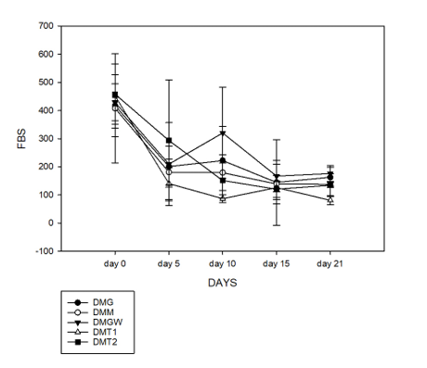
Fig .3 Effect of Different Treatments (DMG, DMM, DMGW, DMT1, DMT2) on Fasting Blood Sugar (FBS) Levels Over 21 Days
3.2.2 Oral glucose tolerance test
The oral glucose tolerance test was conducted to determine the effect of Solanum scabrum extract on glucose metabolism after receiving a high load of glucose (2g/kg body weight) orally. Before the experiment was done, the animals were given the various controls and treatments, their blood glucose levels at T=0 was read then 2g/kg glucose was given. There was a high increase in blood glucose levels at T=30 in all the groups but the negative control increased more. This increase indicated that all the glucose had been absorbed into blood and therefore a need for a feedback action like excretion, energy production or storage to bring down this glucose levels. The group that received glibenclamide greatly reduced the glucose levels leading the animals to a hypoglycemic state while the groups that received solanum extracts also reduced glucose level towards the normal. These results showed Solanum extracts’ efficient rate to metabolize glucose in the body reducing hyperglycemia. Sengottaiyan et al., 2016 also reported a drop in glucose levels when Wistar rats were treated with solanum nigrum at a dose of 10 and 20mg/kg body weight of the extract. The higher dose (20mg) showed a high effect in bringing down blood glucose after glibenclamide the standard drug. Saponins found in huckleberry have potent hypoglycemic effects. Barky et al., 2017 reported that saponins stimulate secretion and action of insulin in streptozotocin diabetic rats.
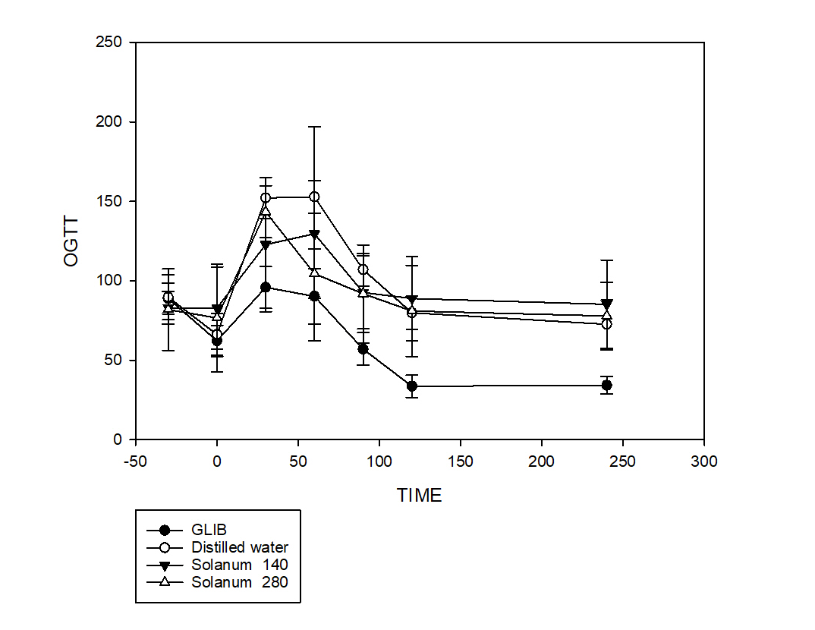
Fig.4 Effect of Solanum Extracts and Glibenclamide on Glucose Tolerance
3.2.3 Alanine Aminotransferase (ALT) and Aspartate Aminotransferase levels (AST)
From the figure above, there was no significant decrease in the ALT and AST levels of the animals treated with huckleberry biomass at the different doses of 140 and 280mg/kg body weight when compared with the vehicle from 59.28±8.31 (control) to 113.7±43.10 and 67.77±55.02 with P>0.05 at dose of 140mg/kg BW and 280mg/kg BW respectively
ALT and AST are major hepatic marker enzymes. These enzymes are found in great quantities in the liver and in minute quantities in other organs but a leakage from damaged cells result in elevation of these makers in blood (Liu X et al., 2018). Consumption of high energy foods suggest elevation in the enzyme levels, this shows that diet plays a key role in the development of non-alcoholic fatty liver disease (NAFLD). Fructose intake could also stimulate novo lipogenesis, inhibiting mitochondrial beta-oxidation of fat resulting in increased liver fat content causing insulin resistance and elevated liver enzymes (Jensen et al.,2018). This explains why there was no significant decrease as the animals were placed on a high fat/sugar diet before treatment began. This shows the huckleberry had no effect on the liver.

ALT and AST levels on diabetic rats
Fig .5 ALT and AST levels on diabetic rats
3.2.4Effects of huckleberry biomass extract on lipid profile of diabetic rats
The effect of the huckleberry biomass waste after administration for 21days on blood lipid profile that is total cholesterol, triglycerides, HDLC and LDLC are presented below
- Total Cholesterol
The total cholesterol levels had a significant decrease when solanum extract at 140mg was compared with group that received glibenclamide (P<0.05). the significance increased with increase concentration of solanum extract at 280mg (P<0.01). (Nandita et al., 2016) reported a decrease in cholesterol levels when male diabetic rats were treated with Solanum nigrum. This cholesterol decrease is possibly explained by the decrease in insulin levels in the diabetic rats favoring lipolysis of stored fats and release of fatty acids which are then metabolized to release energy for body cells (Dimitriadis et al., 2011).
Total Cholesterol levels of diabetic rats
Fig .6 Total Cholesterol levels of diabetic rats
- LDL-Cholesterol
The LDL levels had no significant decrease when compared with the positive control groups. Rather, there was a significant decrease comparing the treatment groups with the vehicle group. Biomass at dose of 140mg/kg body weight having the highest decrease than dose of 280mg/kg. This decrease in LDL was also reported in diabetic rats treated with solanum nigrum at dose of 10 and 20mg/kg (Sengottaiyan et al 2016).
The decrease in LDL levels is explained by the change in diet. The animals were on a high fat diet before treatment rendering them semi obese but upon treatment the diet was normalized.
LDL- Cholesterol levels of diabetic rats
Fig .7 LDL- Cholesterol levels of diabetic rats
C. HDL- Cholesterol
There was a variation in HDL levels among the groups. Low dose of solanum 140mg had a significant increase on HDL levels when compared with the treatment group that received metformin (P<0.001). While at dose of 280mg showed a significant effect compared to metformin (P<0.02). Comparing the extract with the negative control, solanum at dose of 280mg had a significance (P<0.001). The positive control glibenclamide increased HDL significantly when compared with vehicle group also.
The protective role of HDL cholesterol against coronary artery disease can be explained by its ability to counteract LDL cholesterol oxidation and to promote the reverse cholesterol transport pathway by inducing an efflux of excess accumulated cellular cholesterol (Yokozawa et al., 2006).
Fig .8 HDL- Cholesterol Levels in diabetic rats
D. Triglyceride
Triglycerides are fat molecules found in the liver or gotten from the diet to provide the body with energy. The triglycerides levels in the treatment groups had no significance compared to the control groups. There was no significant differ between treatment groups and the control groups.
Fig .9 Triglyceride levels of diabetic rats

3.3 Effects of huckleberry waste on obese rats
Body mass index of obese rats
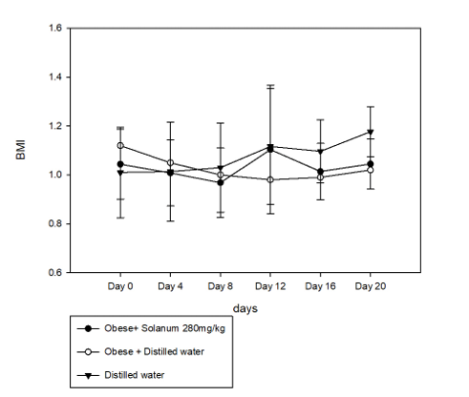
Fig.10 Body mass index of obese rats
Comparing the treatment groups to the controls there was no significant decrease in body mass index of the rats but as treatment time continued, there was a slight decrease in the BMI of the treated group. This result suggest obesity could take a longer time to be treated with solanum extract.

4.0 Lipid profile of obese rats
The total cholesterol levels of the treatment groups were slightly lower than those of the control group although with no significant. The LDL-Cholesterol showed no significant decrease as well with P>0.05 and triglyceride levels remained high as well. Overall, there was no significant effect of the extract on lipid profile of the obese rats

Fig.11 Lipid Profile of obese rats
Conclusion
From this study, it was concluded that Solanum scabrum stem possesses nutritional and phytochemical compounds that gives the plants its nutraceutical importance in food and drug industry. The stems also showed antidiabetic properties as blood glucose levels were seen to drop upon treatment of male diabetic rats with the treatment as well as improved levels of triglyceride but did not show anti-obese properties on the male obese animals.

REFERENCES
Adeboye, A.O, Bolaji, O.A, Fasogbon, B.M., Okunyemi. B. (2019). An evaluation of the impact of drying on the nutritional composition, functional properties and sensory characteristics of a ready-to-cook C.volubile leaf soup powder. Journal of Culinary Science & Technology
Akubugwo, I. E., Obasi, A. N., & Ginika, S. C. (2007). Nutritional potential of the leaves and seeds of black nightshade-Solanum nigrum L. Var virginicum from Afikpo-Nigeria. Pakistan journal of Nutrition, 6(4), 323-326.
AOAC. (1990). Association of Official Analytical Chemists. Official Methods of Analysis, 15th Ed.; Washington DC.
Association of Official Analytical Chemists A.O.A.C. (2005). Official Methods of Analysis of the Association of Analytical Chemists International, 18th ed. Gathersburg, MD U.S.A Official methods, .08 A.O.A.C.
Ayoola, G. A., Coker, H. A., Adesegun, S. A., Adepoju-Bello, A. A., Obaweya, K., Ezennia, E. C., & Atangbayila, T. O. (2008). Phytochemical screening and antioxidant activities of some selected medicinal plants used for malaria therapy in Southwestern Nigeria. Tropical Journal of Pharmaceutical Research, 7(3), 1019-1024.
Banso, A., & Adeyemo, S. (2006). Phytochemical screening and antimicrobial assessment of Abutilon mauritianum, Bacopa monnifera and Datura stramonium. Biokemistri, 18(1).
Bensimhon, D. R., Kraus, W. E., & Donahue, M. P. (2006). Obesity and physical activity: a review. American heart journal, 151(3), 598-603.
Braca, A., Sortino, C., Politi, M., Morelli, I., & Mendez, J. (2002). Antioxidant activity of flavonoids from Licania licaniaeflora. Journal of ethnopharmacology, 79(3), 379-381.
Degrain, A., Manhivi, V., Remize, F., Garcia, C., & Sivakumar, D. (2020). Effect of lactic acid fermentation on color, phenolic compounds and antioxidant activity in African nightshade. Microorganisms, 8(9), 1324.
Dieudonne K, Anne P.N, Cabral P.N, Boris G. K & Wan A.M. (2015). Tetrapleura tetraptera spice attenuates high carbohydrate, high fat diet-induced obese and type 2 diabetic rats with metabolic syndrome feature. Lipid in Health and Disease 14:50,
Dimitriadis, G., Mitrou, P., Lambadiari, V., Maratou, E., & Raptis, S. A. (2011). Insulin effects in muscle and adipose tissue. Diabetes research and clinical practice, 93, S52-S59.
Gao, X., Ohlander, M., Jeppsson, N., Björk, L., Trajkovski, V. (2000). Changes in antioxidant effects and their relationship to phytonutrients in fruits of sea buckthorn (Hippophaerhamnoides L) during maturation. Journal of Agricultural and Food Chemistry, 48: 1485-1490.
Garza, A. L. (2015). Anti-obesity and anti-diabetic properties of two natural extracts rich in flavonoids (helichrysum and grapefruit): physiological and molecular mechanisms.
Hayat, S., Ahmad, H., Ali, M., Ren, K., & Cheng, Z. (2018). Aqueous garlic extract stimulates growth and antioxidant enzymes activity of tomato (Solanum lycopersicum). Scientia Horticulturae, 240, 139-146.
Iqbal, Z., Kamran, Z., Sultan, J. I., Ali, A., Ahmad, S., Shahzad, M. I., ... & Sohail, M. U. (2015). Replacement effect of vitamin E with grape polyphenols on antioxidant status, immune, and organs histopathological responses in broilers from 1-to 35-d age. Journal of Applied Poultry Research, 24(2), 127-134.
Jensen, V. S., Hvid, H., Damgaard, J., Nygaard, H., Ingvorsen, C., Wulff, E. M., ... & Fledelius, C. (2018). Dietary fat stimulates development of NAFLD more potently than dietary fructose in Sprague–Dawley rats. Diabetology & metabolic syndrome, 10(1), 1-13.
Joshi, N., Bhatt, S., Dhyani, S., & Nain, J. (2013). Phytochemical screening of secondary metabolites of Argemone mexicana linn. flowers. Int J Curr Pharm Res, 5(2), 144-147.
Kalra, S. P., Dube, M. G., Pu, S., Xu, B., Horvath, T. L., & Kalra, P. S. (1999). Interacting appetite-regulating pathways in the hypothalamic regulation of body weight. Endocrine reviews, 20(1), 68-100.
Liu, C. F., Zhou, W. N., Lu, Z., Wang, X. T., & Qiu, Z. H. (2018). The associations between liver enzymes and the risk of metabolic syndrome in the elderly. Experimental gerontology, 106, 132-136.
Manoko, M. L., van den Berg, R. G., Feron, R., van der Weerden, G. M., & Mariani, C. (2008). Genetic diversity of the African hexaploid species Solanum scabrum Mill. and Solanum nigrum L.(Solanaceae). Genetic Resources and Crop Evolution, 55(3), 409-418.
Mwaura, H. M. (2016). Antimicrobial properties and phytochemical composition of solanum nigrum complex (black night shade) (Doctoral dissertation).
Nandita, D., Muthukumar, S. P., & Murthy, P. S. (2016). Solanum nigrum leaf: natural food against diabetes and its bioactive compounds. Research Journal of Medicinal Plant, 10(2), 181-193.
Novelli, E.L., Diniz, Y.S., Cristiano, G., Geovana, M.X & Rodriques, H.G. (2007). Anthropometrical parameter and markers of obesity in rats. Laboratory animals 41,111-112.
Ojiewo, C. O., Mwai, G. N., Abukutsa-Onyango, M. O., Agong, S. G., & Nono-Womdim, R. (2013). Exploiting the genetic diversity of vegetable African nightshades. Bioremediation, biodiversity and bioavailability, 7(1), 6-13.
Oyeyemi, S. D., Ayeni, M. J., Adebiyi, A. O., Ademiluyi, B. O., Tedela, P. O., & Osuji, I. B. (2015). Nutritional quality and phytochemical studies of Solanum anguivi (Lam.) fruits. J. Nat. Sci. Res, 5(4), 99-105.
Richard, D., Kefi, K., Barbe, U., Bausero, P., & Visioli, F. (2008). Polyunsaturated fatty acids as antioxidants. Pharmacological research, 57(6), 451-455.
Sarma, H., & Sarma, A. (2011). Solanum nigrum L., a nutraceutical enriched herb or invasive weed?. In International Conference on Environment and BioScience IPCBEE (Vol. 21, pp. 105-109).
Schuster, D. P. (2010). Obesity and the development of type 2 diabetes: the effects of fatty tissue inflammation. Diabetes, metabolic syndrome and obesity: targets and therapy, 3, 253.
Sengottaiyan, A., Aravinthan, A., Sudhakar, C., Selvam, K., Srinivasan, P., Govarthanan, M., ... & Selvankumar, T. (2016). Synthesis and characterization of Solanum nigrum-mediated silver nanoparticles and its protective effect on alloxan-induced diabetic rats. Journal of Nanostructure in Chemistry, 6(1), 41-48.
Stankovic, M. S. (2011). Total phenolic content, flavonoid concentration and antioxidant activity of Marrubium peregrinum L. extracts. Kragujevac J Sci, 33(2011), 63-72.
Tang, J. J., Li, J. G., Qi, W., Qiu, W. W., Li, P. S., Li, B. L., & Song, B. L. (2011). Inhibition of SREBP by a small molecule, betulin, improves hyperlipidemia and insulin resistance and reduces atherosclerotic plaques. Cell metabolism, 13(1), 44-56.
Temelkova-Kurktschiev, T., & Stefanov, T. (2012). Lifestyle and genetics in obesity and type 2 diabetes. Experimental and clinical endocrinology & diabetes, 120(01), 1-6.
Yang, B.T., Dayeh, T.A., Kirkpatrick, C.L., Taneera, J., Kumar, R., Groop, L., Wollheim, C.B., Nitert, M.D., Ling, C., 2011. Insulin promoter DNA methylation correlates negatively with insulin gene expression and positively with HbA(1c) levels in human pancreatic islets. Diabetologia 54,
360-367.
Yokozawa, T., Cho, E. J., Sasaki, S., Satoh, A., Okamoto, T., & Sei, Y. (2006). The protective role of Chinese prescription Kangen-karyu extract on diet-induced hypercholesterolemia in rats. Biological and Pharmaceutical Bulletin, 29(4), 760-765.

