Ecotoxicological Assessment of Thiamethoxam on the Behavior and Population Dynamics of Eisenia fetida.

ABSTRACT

Neonicotinoid pesticides, such as thiamethoxam, are widely used in agriculture, but their impact on non-target organisms, particularly soil invertebrates like earthworms, is a growing concern. This study investigated the ecotoxicological effects of thiamethoxam on Eisenia fetida, a key soil organism, focusing on behavioral alterations and population dynamics. Earthworms were exposed to varying concentrations of thiamethoxam (control, low-dose, and high-dose) for 28 days. The results demonstrated dose-dependent detrimental effects. The high-dose group exhibited significant mortality, reduced biomass, aberrant behavior, and cyst formation. Hydro taxis, photo taxis, chemotaxis, and geotaxis tests revealed significant impairments in the high-dose group. These findings underscore the need for rigorous regulation of thiamethoxam and the promotion of sustainable pest management strategies to protect soil biodiversity and ecosystem health.

Keywords: Thiamethoxam, Eisenia fetida, Hydro taxis, Cysts, Biodiversity.

____________________

INTRODUCTION
Neonicotinoid pesticides, such as thiamethoxam, are widely used in agriculture due to their systemic action and efficacy against a broad spectrum of insect pests (Laurent et al., 2017). However, their widespread application has led to concerns regarding their potential impact on non-target organisms, particularly soil invertebrates like earthworms, which are crucial for maintaining soil health (T. Basal et al., 2020; Mao et al., 2022). Thiamethoxam, a neonicotinoid, is known to stimulate nicotinic acetylcholine receptors, leading to convulsive paralysis and mortality in insects (Lončarić et al., 2024). This mechanism of action, while effective against pests, raises critical questions about its effects on beneficial organisms that share similar neurological pathways (Mulla et al., 2023). The accumulation of agrochemical residues, including thiamethoxam and its degradation products, significantly contributes to the contamination of terrestrial and aquatic ecosystems, thereby posing a substantial risk to environmental and human health (T. Basal et al., 2020; Nyoka et al., 2021). Given these concerns, understanding the ecotoxicological impact of thiamethoxam on key soil organisms, such as Eisenia fetida, is crucial for comprehensive environmental risk assessment (Lončarić et al., 2024; Laurent et al., 2017). Moreover, thiamethoxam has been documented to induce adverse effects in both humans and animals, necessitating a thorough examination of its broader ecological consequences (Qamar et al., 2023). Furthermore, neonicotinoids, including thiamethoxam and imidacloprid, are frequently detected in surface waters, posing considerable risks to avian, mammalian, and aquatic biota (Gul, 2020). These compounds are readily transported by atmospheric processes and can accumulate in regions far from their application sites, leading to widespread environmental contamination (T. Basal et al., 2020). Consequently, this pervasive distribution necessitates a comprehensive assessment of thiamethoxam's ecotoxicological profile, especially concerning its chronic effects on soil invertebrates such as Eisenia fetida, given their indispensable role in ecosystem functioning (Elkader et al., 2023). Therefore, evaluating the behavioral and population-level responses of Eisenia fetida to thiamethoxam exposure provides a critical understanding of the ecological ramifications of this widely used pesticide. This study specifically investigated the behavioral alterations and population dynamics of Eisenia fetida under varying concentrations of thiamethoxam, aiming to elucidate the sublethal and lethal effects on this keystone soil organism. This research thus provides crucial insights into the environmental safety of thiamethoxam, particularly concerning its long-term ecological consequences on soil biodiversity and ecosystem services. The findings will contribute to the broader understanding of neonicotinoid ecotoxicology and inform regulatory decisions regarding the sustainable use of these pesticides.

MATERIALS AND METHODS
Study organism: The study utilized Eisenia fetida as the test species. Adult, clitellate earthworms were sourced and visually inspected to confirm their healthy condition, ensuring the absence of lesions or other physical abnormalities. Prior to experimentation, the earthworms underwent an acclimation period of 28 days, during which they were maintained in moistened, pesticide-free test soil under controlled experimental conditions. During this acclimation phase, earthworms were fed an organic diet and monitored daily for mortality or signs of stress, with any compromised individuals being removed.

Insecticide: The active ingredient utilized in this investigation was thiamethoxam. A fresh stock solution of thiamethoxam was prepared in deionized water immediately prior to application. Adherence to standard safety protocols was maintained, all weighing and mixing procedures were executed within a fume hood. The insecticide was acquired from Shri Pete Basaveshwara Agro Traders, Ballari.

Soil/Substrate Preparation: The experimental substrate, an organic vermicomposting mixture rather than mineral soil, was prepared following a rigorous multi-step process. Initially, all constituent materials were meticulously inspected to ensure the removal of any contaminants. Subsequently, the dry components were thoroughly homogenized. Vegetable peels and cow dung were then integrated into this dry blend (Table 1). The moisture content was precisely regulated to approximately 60%. This prepared mixture was then allowed to partially decompose for 15-20 days before the introduction of thiamethoxam. Finally, the pH of the mixture was adjusted as necessary: agricultural lime was incorporated if the pH dropped below 6.0, while additional vegetable matter was introduced to mitigate acidity if the pH surpassed 7.5.
Experimental setup: The experimental procedures were executed under rigorously controlled laboratory conditions to ensure consistency and minimize variability among treatment groups. A constant temperature of was sustained throughout the investigation, complemented by a fixed 12-hour light/12-hour dark photoperiod. Relative humidity was meticulously regulated, maintaining a range of 50% to 70% to preclude substrate desiccation and mitigate stress on the earthworms. Experimental containers were overlaid with breathable material (e.g., gunny bags) to facilitate sufficient ventilation while simultaneously preventing organism escape and pest infiltration (Gobi and Gunashekaran, 2010). The substrate's moisture content was consistently monitored and maintained at approximately 60% through the measured addition of deionized water. Furthermore, the substrate pH was precisely controlled, remaining within the optimal range of 6.0 to 7.5 to foster ideal conditions for earthworm physiological activity and survival.
Experimental Design: This experiment incorporated three distinct treatment groups: a Control(G1), a Low-dose(G2), and a High-dose(G3), with each group allocated to a separate experimental pit. Each pit was provisioned with approximately 9 kg of a prepared organic vermicompost substrate. Specifically, the Low-dose and High-dose treatment groups were prepared by incorporating Thiamethoxam 75% insecticide into their respective substrates at concentrations of 6 mg/kg and 26 mg/kg, respectively. In contrast, the Control pit was treated with an equivalent volume of water, devoid of insecticide (Table 2). Following a 24-hour equilibration period after insecticide application, thirty healthy, clitellate adult Eisenia fetida specimens were introduced into each experimental pit. All experimental pits were maintained under controlled conditions and received equal quantities of pre-composted cow dung as supplementary feed on a weekly basis. Observations pertaining to survival, biomass, and other relevant parameters were systematically recorded at predetermined intervals throughout the duration of the study.
Dose calculation and application: Target concentrations were determined and articulated as milligrams of active ingredient per kilogram of dry soil. Specifically, the designated low and high concentrations were 6.6mg a.i./kg soil and 26.6mg a.i./kg soil, respectively. For each 9 kg experimental pit, the necessary quantity of active ingredient was computed utilizing the formula:
Required a.i. (mg) = Target (mg/kg) × Soil mass (kg)
Low: 6.67× 9 = 60 mg a.i., High: 26.67× 9 = 240 mg a.i.
Application Method (soil spiking): A predetermined mass of the product was accurately weighed and subsequently dissolved in a minimal volume of deionized water to formulate a homogeneous dosing solution for each experimental plot. The soil within each plot was then systematically partitioned into three equivalent segments. Control plots were exclusively treated with an equivalent volume of deionized water. Low-dose plots received a treatment comprising 60 mg of the substance, dissolved in 100 ml of water. Conversely, high-dose plots were administered 240 mg of the substance, similarly dissolved in 100 ml of water.
Test duration and end points: The experiment was conducted over a period of 28 days to assess the acute toxicity of Thiamethoxam 75% insecticide to adult Eisenia fetida under controlled laboratory conditions. Observations were systematically recorded at predetermined intervals on days 0, 7, 14, 21, and 28. Key endpoints evaluated included adult survival, quantified by counting live earthworms, and changes in biomass, determined through mean body weight measurements at each observation point. Supplementary observations encompassed manifestations of abnormal behavior, such as surface crawling, sluggish movement, or coiling, alongside any discernible alterations in substrate texture or odor. Mortality was documented immediately upon detection, and deceased individuals were promptly removed to mitigate potential secondary effects stemming from decomposition.
Development and Population Test: To quantify the population of Eisenia fetida across experimental units, specifically control, low-dose, and high-dose treatment groups, a population dynamics assessment was conducted. This evaluation aimed to ascertain the effects of insecticide exposure on Eisenia fetida by monitoring changes in both population size and distribution. The underlying premise of this methodology is that any alteration to the soil environment, whether naturally occurring or experimentally induced, will elicit quantifiable responses in earthworm population density and biomass. The experimental setup utilized Eisenia fetida, specific experimental containers, thiamethoxam insecticide, deionized water, and a water sprayer. Initially, 30 adult Eisenia fetida individuals, with their baseline body weights meticulously recorded, were uniformly introduced into each experimental unit. The control group received no insecticide (Table 3 & Fig 2). Soil moisture was consistently maintained by daily spraying with deionized water throughout the entire 28-day experimental period (Marques et al., 2009).
Hydro taxis test: The hydro taxis test evaluates an organism's directed movement in response to moisture or humidity. Earthworms, specifically Eisenia fetida, exhibit positive hydro taxis, moving towards moist environments, which is crucial for their respiration and locomotion. This test aims to quantify these hydro tactic responses by establishing a moisture gradient within a controlled arena. The underlying principle is that earthworms necessitate a damp environment to avert desiccation and facilitate cutaneous respiration. By presenting a gradient from moist to dry conditions, researchers can observe and quantify the earthworm's preferential movement. The experimental setup involves placing a sheet of filter paper in a rectangular tray or Petri dish, divided into two equal sections. One section is designated as the moist side, where the filter paper is moistened with distilled water until it is damp but not saturated. The other section serves as the dry side, with the filter paper remaining completely dry. Before testing, earthworms are acclimatized in a moist environment at room temperature for at least one hour. An individual earthworm is then positioned precisely on the centerline separating the moist and dry halves. A stopwatch is initiated immediately to record the time taken for the earthworm to move towards the wet region. Throughout the experiment, observations are made at regular intervals (e.g., 5, 10, and 15 minutes) to document the earthworm's movement patterns and its final resting position on either the moist or dry side (Table 4 & Fig 3A). This methodical design enables the quantitative assessment of Eisenia fetida's preferential movement in response to varying moisture conditions, thereby offering critical insights into their hydro tactic behavior under different environmental stressors (Kaka et al., 2023).
Photo taxis: The objective of this investigation was to evaluate and quantify the phototactic behavior of earthworms. Despite lacking image-forming eyes, earthworms possess dermal photoreceptors that enable them to detect light intensity, leading to directional movement either away from or towards a light source. The experimental setup comprises earthworms, a light source, a rectangular tray, a stopwatch, cardboard, and a data sheet. Initially, worms are to be acclimatized for 30 to 60 minutes under dark or dim light conditions. A light source should then be positioned at one extremity of a container to establish a gradient of light, while a dark enclosure, such as a cardboard lid, is provided at the opposing end. Earthworms are subsequently introduced into the center of the container, and their movement duration and patterns are observed and documented (Table 5 & Fig 3B). The collected data was then utilized to compare the movement responses of earthworms in the presence of light. Such behavioral assays are crucial because changes in phototaxis can serve as sensitive indicators of sublethal toxicity, often preceding more severe physiological or reproductive impairments (Liang et al., 2023).
Chemotaxis test: Chemotaxis, defined as the directed movement of an organism in response to a chemical gradient, is a fundamental behavioral assay used to evaluate an organism's attraction or avoidance response to specific chemical stimuli. Earthworms, utilizing specialized chemoreceptors, are capable of detecting chemical gradients within their soil environment, prompting movement either towards attractive cues or away from repellent or toxic substances.

For the chemotaxis test, the following materials are typically required: six Eisenia fetida earthworms, an ammonia solution (or other test chemical), a rectangular tray, cotton balls, moist filter paper, a stopwatch, and a data sheet for recording observations.
The experimental setup involves moistening two halves of a filter paper with equal volumes of solution: one half with the test chemical and the other with a control solution(water), ensuring consistent volumes and moisture levels. A cotton ball saturated with the chemical is then positioned in one half of the tray. An individual earthworm is subsequently placed at the center or edge of each designated zone, equidistant from the chemical sources. The earthworm's movement is then observed and recorded over a defined period (e.g.; 5-15 minutes), allowing for a comparative analysis of its directional response (attraction or avoidance) relative to the chemical stimulus (Table 6 & Fig 3C). This methodology allows for the quantification of chemotactic behavior, indicating whether the earthworms exhibit a preference or aversion to the tested chemical (Painter, 2018).
Geotaxis test: Geotaxis is defined as the directional movement or orientation exhibited by an organism in response to gravitational stimuli, either aligning with or opposing the gravitational vector. For instance, Eisenia fetida commonly demonstrates positive geotaxis by burrowing into the soil for shelter, yet can exhibit negative geotaxis, ascending towards the surface, under conditions such as heavy rainfall or during reproductive periods. The objective of a geotaxis assay is to evaluate an organism's orientational and locomotor responses concerning gravitational cues. Earthworms perceive their body orientation relative to gravity via specialized mechanoreceptors, which subsequently influences their movement, potentially manifesting as positive or negative geotaxis, or as gravitactic righting reflexes. The experimental setup comprised six Eisenia fetida earthworms, a vermicompost or soil-filled pit, a moist substrate, a stopwatch, and a data sheet for recording observations. The procedure involved filling a designated pit with vermicompost or soil, leaving a small headspace. The substrate was then gently moistened to achieve an optimal environmental condition. Earthworms were introduced at a marked starting position or on the substrate's surface. Downward movement of the earthworms within the pit was observed and recorded over a predetermined time interval (e.g.: 5-30 minutes). Subsequently, observed movement patterns were compared across various experimental pits (Table 7 & Fig 3D). This comparative analysis facilitates the assessment of thiamethoxam's impact on gravity-mediated behavior, revealing potential neurotoxic effects that could disrupt this essential ecological function (Chen et al., 2021). Such disruptions are particularly concerning given that even subtle alterations in geotaxis can impact critical behaviors like foraging, predator avoidance, and osmoregulation, thus compromising overall earthworm fitness and ecosystem services (Merivee et al., 2025).
RESULTS
This study confirmed the taxonomic identification of the Eisenia fetida species, and their growth and population dynamics were monitored across control, low-dose, and high-dose treatment groups. Earthworms in the control group exhibited normal growth and maintained a stable or slightly increased population. Conversely, the low-dose group demonstrated mild growth reduction and a moderate decline in numbers. In contrast, the high-dose group experienced marked inhibition of growth, reduced biomass, and a significant population decline, indicating a dose-dependent negative impact on earthworm health and reproduction.

Weight and Population Test Results
The mean biomass and population count of earthworms were recorded at the initiation and conclusion of the experiment.

Control Group
In the absence of thiamethoxam insecticide, earthworms in the control group remained alive and active, displaying normal population growth and body size, with no injuries observed. The population and biomass increased as follows:
- Population increased from 30 to 37 earthworms, indicating the emergence of 7 hatchlings.
- Total biomass increased from 27 g to 30 g.

Low-Dose Group
Exposure to 60 mg of thiamethoxam insecticide resulted in moderate earthworm activity, with no abnormalities observed except for a minor reduction in individual size. The population remained relatively stable, with the following variations:
- Population increased from 30 to 32 earthworms, with 2 hatchlings observed.
- Total biomass decreased from 37.8 g to 32.2 g.

High-Dose Group
In the high-dose group, exposed to 240 mg of thiamethoxam insecticide, earthworms remained alive, and hatchlings were observed; however, their activity was notably diminished. A morphological alteration, specifically the presence of cysts on the earthworm bodies, was also observed (Pelosi et al., 2014).
Cyst Formation in earthworms: In the high-dose treatment group, where earthworms were exposed to Thiamethoxam 75% at its maximum application concentration, discernible pathological alterations were evident by the conclusion of the 28-day experimental period. The most salient change observed was the development of nodule-like swellings along various segments of the earthworm's body. These nodules typically presented as small to medium-sized, firm, raised, and pale to whitish nodular structures on the epidermal surface (Fig 4A). While some specimens exhibited isolated nodules, others displayed clusters of multiple cysts within specific regions, frequently in the mid-body or posterior segments (Fig 4B). The formation of these cysts was accompanied by localized swelling and a slight distortion of the annuli, suggesting potential compromise of cuticular integrity and underlying tissues. In certain individuals, these cysts were correlated with diminished mobility and a reluctance to burrow, indicative of discomfort or mechanical impediment to movement (Jansch et al., 2005). Such pathological manifestations were entirely absent in the control group and seldom observed in the low-dose treatment group, where only minor skin roughness or minimal cysts were sporadically noted. The consistent appearance of cyst formation in the high-dose group points to a dose-dependent adverse effect of Thiamethoxam on the earthworm integumentary system, potentially stemming from chronic irritation, inflammatory responses, or toxicologically induced tissue degeneration (Capowiez et al., 2010). This morphological evidence substantiates the hypothesis that elevated concentrations of Thiamethoxam impose significant stress and inflict damage upon non-target soil invertebrates such as earthworms (Pelosi et al., 2014).
Furthermore, observations regarding population and biomass variations revealed significant impacts. Out of an initial population of 30 earthworms, two mortalities were recorded in the high-dose pit, resulting in 28 surviving individuals (Fig 4C). Concurrently, the average weight of an earthworm in this group decreased substantially, from an initial measurement of 29.7 grams to 18 grams by the end of the study (Fig 4D).
Hydro taxis Test: The hydro tactic behavior of Eisenia fetida was assessed in control, low-dose, and high-dose treatment groups following a 28-day exposure period. Earthworms in the control group demonstrated robust positive hydro taxis, migrating towards the moist section of the test chamber within 2–3 minutes, with all individuals (100%) reaching the moisture zone within 3 minutes. Conversely, the low-dose thiamethoxam treatment induced a delayed response time; initial movement towards moisture was observed only after 5 minutes, and approximately 70–80% of the worms reached the moist zone within 7 minutes, while the remaining exhibited sluggish or erratic locomotion.
In the high-dose treatment group, hydro taxis was significantly compromised (Fig 4E). A substantial number of worms displayed reduced locomotor activity and disorientation. Only 30–40% of the individuals reached the moist zone within 12 minutes, and several remained in the dry zone, suggesting a potential disruption of sensory or neuromuscular function (Capowiez et al., 2010).
Phototaxis Test: During the 28-day acute toxicity study, the phototactic behavior of earthworms was assessed across each experimental cohort. Earthworms in the control group displayed characteristic negative phototaxis, manifested by rapid withdrawal from light exposure and swift burrowing into the soil within seconds, signifying uncompromised sensory and locomotor capabilities. In contrast, the low-dose group exhibited a delayed response to light compared to controls. These earthworms demonstrated hesitation before burrowing, necessitating an extended period to seek subterranean refuge, which implies a subtle impairment of sensory perception or motor coordination. In the high-dose group, phototaxis was significantly attenuated or entirely abolished (Fig 4F). A substantial proportion of individuals either failed to elicit an avoidance response to light or exhibited disorganized locomotion, suggesting severe disruption of nervous system function attributable to the pesticide exposure (Capowiez et al., 2010).
Chemotaxis Test: The chemotactic response of earthworms to ammonia exhibited a distinct dose-dependent variability. Earthworms in the control group demonstrated robust avoidance behavior, characterized by rapid displacement from the ammonia source, which signifies intact sensory and locomotor functions. In contrast, the low-dose treatment group displayed a diminished and less coordinated avoidance response compared to the control, suggesting a mild compromise in sensory perception or motility. The high-dose treatment group exhibited minimal to no avoidance, with movement away from the ammonia source being either delayed or entirely absent (Fig 4G). This indicates a severe perturbation of sensory pathways and potential neurotoxicity (Capowiez et al.,2010) attributed to thiamethoxam exposure.
Geotaxis Test: The geotactic response of Eisenia fetida was evaluated. Earthworms in the control group demonstrated unimpaired geotactic behavior, rapidly descending into the soil within minutes, which indicated normal orientation and burrowing capabilities. In the low-dose treatment group, a minor delay in downward locomotion was observed in a subset of individuals; however, the majority of worms maintained effective burrowing, suggesting a subtle effect on geotaxis. Conversely, the high-dose treatment group exhibited significant geotactic impairment, characterized by numerous earthworms remaining at or near the soil surface and displaying diminished burrowing activity (Fig 4H). This outcome suggests a notable disruption in normal orientation and potential neurotoxicological consequences (Zhang et al., 2014).

DISCUSSION
The current investigation assessed the toxicity of Thiamethoxam 75% WG on Eisenia fetida under controlled laboratory conditions over 28 days, utilizing three distinct treatment groups: a control, a low-dose, and a high-dose exposure. The findings unequivocally demonstrated dose-dependent detrimental effects on earthworm survival, behavior, growth, and physiological functions (Farrukh et al., 2011). In the control group, earthworms exhibited typical burrowing, feeding, and locomotory activities, alongside stable weight maintenance and population growth. The soil in this group remained well-aerated, devoid of anomalous odors or compaction. In contrast, the low-dose treatment induced subtle behavioural alterations, such as diminished feeding activity, slower burrowing, and sporadic surface avoidance. Over the experimental period, minor weight loss and reduced cocoon production were observed, indicative of sub-lethal physiological stress. These changes are likely attributable to Thiamethoxam's interference with neural transmission through nicotinic acetylcholine receptor binding, which can impair both movement and feeding mechanisms. The high-dose treatment elicited the most pronounced toxicological responses, characterized by erratic movement, prolonged surface exposure, curling, and, in some instances, cyst formation. This group experienced a significant reduction in biomass, elevated mortality rates, and a substantial decline in cocoon production. Furthermore, several worms appeared flaccid with depigmented segments, suggesting systemic damage. These severe effects are hypothesized to result from direct neurotoxicity compounded by secondary impacts on digestive and reproductive systems (Daam et al., 2011).
Collectively, the impact of Thiamethoxam appears to be concentration-dependent, manifesting through both behavioral and physiological disruptions. Such impairments could compromise the critical ecological roles of earthworms in soil aeration, organic matter decomposition, and nutrient cycling. These results are consistent with prior research documenting the adverse effects of neonicotinoids on non-target soil invertebrates, thereby accentuating concerns regarding long-term soil health and ecosystem stability when these insecticides are applied indiscriminately (Buch et al., 2013). For instance, studies on other insecticides, such as carbamates and organophosphates, have revealed significant decreases in nerve conduction velocity and acetylcholinesterase activity in earthworms, indicating similar neurotoxic mechanisms (Trapp & Clausen, 2016). The observed neurotoxicological effects in Eisenia fetida align with documented impacts of neonicotinoids on insect locomotion and foraging, further emphasizing the broad-spectrum ecological ramifications of these compounds (Merivee et al., 2025). This consistency underscores the urgent need for a more comprehensive understanding of neonicotinoid impacts on beneficial soil organisms, given their established role as neurological toxicants (Mulla et al., 2023). Further investigation into the precise molecular mechanisms underlying thiamethoxam-induced neurotoxicity in Eisenia fetida could reveal specific receptor interactions or enzymatic inhibitions.
CONCLUSION
This investigation into the effects of the Thiamethoxam 75% insecticide on the earthworm Eisenia fetida under controlled soil conditions has yielded significant insights into the toxicological implications of chemical pesticides for soil biota. Earthworms, frequently referred to as "ecosystem engineers," are instrumental in preserving soil fertility, facilitating organic matter decomposition, and regulating nutrient cycling. Consequently, any deleterious impact on their growth, survival, or behavioral patterns signals potential long-term risks to soil health and agricultural sustainability. The study design incorporated three distinct treatment conditions—a control, a low-dose exposure, and a high-dose exposure—each standardized with equivalent soil mass and earthworm populations. Observations indicated that earthworms in the control group exhibited normal growth, reproductive success, and characteristic behavioral responses, including active burrowing, feeding, and positive geotaxis and hydrotaxis. This confirms the suitability of the experimental conditions for their survival and physiological functioning. In the low-dose treatment, minor alterations were recorded in biomass, population size, and behavioral activity. Although significant mortality was not observed, earthworms displayed reduced mobility and diminished feeding activity, indicative of sublethal stress induced by Thiamethoxam. Conversely, the high-dose treatment elicited pronounced toxicity symptoms in earthworms, characterized by reduced biomass, population decline attributable to mortality, aberrant behavioral patterns, and, in certain instances, cyst formation. These results unequivocally demonstrate that elevated concentrations of Thiamethoxam directly compromise the survival, reproductive capacity, and normal physiological processes of Eisenia fetida.
Collectively, these findings demonstrate a dose-dependent toxic effect of Thiamethoxam on earthworms. While lower concentrations may not induce immediate acute mortality, they nonetheless disrupt the intrinsic biological functions of earthworms, thereby posing long-term ecological risks. At higher concentrations, the impact is considerably more severe, manifested by substantial mortality and behavioural disarray, underscoring how the injudicious application of such insecticides imperils soil biodiversity (Jansch et al., 2006). Consequently, it is imperative that the application of Thiamethoxam and analogous neonicotinoid insecticides be rigorously regulated to avert imbalances within soil ecosystems. The promotion of sustainable pest management strategies, such as integrated pest management and organic alternatives, is advocated to mitigate dependence on deleterious chemical agents. Safeguarding earthworms and other soil organisms are fundamental for the maintenance of soil fertility, enhancement of crop productivity, and preservation of environmental health.

REFERENCES
Buch, A. C., Brown, G. G., Niva, C. C., Sautter, K. D., & Sousa, J. P. (2013). Toxicity of three pesticides commonly used in Brazil to Pontoscolex corethrurus (Müller, 1857) and Eisenia andrei (Bouché, 1972). Applied Soil Ecology, 69, 32–38. https://doi.org/10.1016/j.apsoil.2012.12.011 .

Capowiez, Y., Dittbrenner, N., Rault, M., Triebskorn, R., Hedde, M., & Mazzia, C. (2010). Earthworm cast production as a new behavioural biomarker for toxicity testing. Environmental Pollution, 158(2), 388–393. https://doi.org/10.1016/j.envpol.2009.09.003

Chen, W.-L., Ko, H., Chuang, H.-S., Raizen, D. M., & Bau, H. H. (2021). Caenorhabditis elegans exhibits positive gravitaxis. BMC Biology, 19(1), 186. https://doi.org/10.1186/s12915-021-01119-9

Daam, M. A., Leitão, S., Cerejeira, M. J., & Sousa, J. P. (2011). Comparing the sensitivity of soil invertebrates to pesticides with that of Eisenia fetida. Chemosphere, 85, 1040-1047. https://doi.org/10.1016/j.chemosphere.2011.07.032 .

Elkader, H. T. A. E., Hussein, M. M., Mohammed, N. A., & Abdou, H. M. (2023). The protective role of L-carnitine on oxidative stress, neurotransmitter perturbations, astrogliosis, and apoptosis induced by thiamethoxam in the brains of male rats. Naunyn-Schmiedeberg's Archives of Pharmacology, 397(6), 4365-4379 https://doi.org/10.1007/s00210-023-02887-7

Farrukh, S., & Ali, A. S. (2011). Effects of endosulfan, an organochlorine pesticide on growth, reproduction and avoidance behaviour of earthworm Eisenia fetida. Bioscience Biotechnology Research Communications, 4(1), 84-89. https://doi.org/10.21786/bbrc/4.1/14

Gobi, M., & Gunasekaran, P. (2010). Effect of Butachlor Herbicide on Earthworm Eisenia fetida—Its Histological Perspicuity. Applied and Environmental Soil Science, 2010, 1–4. https://doi.org/10.1155/2010/850758

Gul, S. T., Ahamd, I., Saleemi, M. K., Ahmad, M., Ahmad, L., & Khan, A. (2020). Toxico-pathological Effects of Thiamethoxam on Hemato-biochemical and Productive Performance of Commercial Laying Hens. Pakistan Veterinary Journal, 40(4), 449-454. https://doi.org/10.29261/pakvetj/2020.052
Jänsch, S., Amorim, M. J. B., & Römbke, J. (2005). Identification of the ecological requirements of important terrestrial ecotoxicological test species. Environmental Reviews, 13(2), 51–83. https://doi.org/10.1139/a05-007

Kaka, H., Opute, P., & Maboeta, M. (2023). Single and combined effects of metal-based fungicides on Eisenia andrei in different scenarios of climatic change. Research Square. https://doi.org/10.21203/rs.3.rs-3558318/v1

Faragò, M., Benini, L., Sala, S., Secchi, M., & Laurent, A. (2019). National inventories of land occupation and transformation flows in the world for land use impact assessment. International Journal of Life Cycle Assessment. https://doi.org/10.1007/s11367-018-01581-8

Liang, X., Li, Y., Zheng, Z., Tian, F., Du, Y., Yang, Y., Wang, M., & Zhang, Y. (2023). Effects of mixed application of avermectin, imidacloprid and carbendazim on soil degradation and toxicity toward earthworms. Scientific Reports, 13(1) https://doi.org/10.1038/s41598-023-41206-1

Lončarić, Ž., Lackmann, C., Bjedov, D., Šimić, A., Ečimović, S., Seiler, T., Hollert, H., & Velki, M. (2024). Chronic effects of commercial pesticide preparations on biomarkers and reproductive success in earthworm Eisenia andrei. Environmental Sciences Europe https://doi.org/10.1186/s12302-024-00940-7

Mao, L., Geng, Y., Guo, J., Zafar, M. I., & Wang, Y. (2022). Editorial: Environmental impacts of pesticides: Environmental fate, ecotoxicology, risk assessment, and remediation. Frontiers in Environmental Science. https://doi.org/10.3389/fenvs.2022.1065958

Marques, C. R., Pereira, R., & Gonçalves, F. (2009). Using earthworm avoidance behaviour to assess the toxicity of formulated herbicides and their active ingredients on natural soils. Journal of Soils and Sediments, 9(2), 137-147. https://doi.org/10.1007/s11368-009-0058-0

Merivee, E., Must, A., Nurme, K., Koppel, M., & Mänd, M. (2025). Automated video-tracking analysis of Agriotes obscurus wireworm behaviour before, during and after contact with thiamethoxam- and imidacloprid-treated wheat seeds. Scientific Reports, 15(1). https://doi.org/10.1038/s41598-025-91175-w
Mulla, M. S. A., Bhatnagar, U., Subramanian, V., Masireddy, N., Rajesh, N., & Narayanan, L. (2023). Developmental Neurotoxicity of Thiamethoxam in Wistar Rats. International Journal on Veterinary Medicine. https://doi.org/10.51626/ijvm.2023.02.000010

Nyoka, N. W.-K., Ogbeide, O., & Otomo, P. V. (2021). Reproduction and biomarker responses of Eisenia fetida after exposure to imidacloprid in biochar-amended soil. Biochar, 3(4), 615. https://doi.org/10.1007/s42773-021-00103-4

Painter, K. J. (2018). Mathematical models for chemotaxis and their applications in self-organisation phenomena. Journal of Theoretical Biology https://doi.org/10.1016/j.jtbi.2018.06.019

Pelosi, C., Barot, S., Capowiez, Y., Hedde, M., & Vandenbulcke, F. (2014). Pesticides and earthworms. A review. Agronomy for Sustainable Development, 34, 199–228. https://doi.org/10.1007/s13593-013-0151-z

Qamar, W., Shahid, M. U., Irfan, M., Abbas, R. Z., Faraz, A., Hussain, R., & Alvi, M. A. (2023). Thiamethoxam Toxicity: A Review in One-Health Perspective. Kafkas Universitesi Veteriner Fakultesi Dergisi, 29(5), 557-570. https://doi.org/10.9775/kvfd.2023.30161

Basal, W. T., Ahmed, A. R. T., Mahmoud, A. A., & Omar, A. R. (2020). Lufenuron induces reproductive toxicity and genotoxic effects in pregnant albino rats and their fetuses. Scientific Reports. https://doi.org/10.1038/s41598-020-76638-6

Trapp, S., & Clausen, L. P. W. (2016). Toxicity testing with the willow tree transpiration test - 15 years of results. In SETAC Europe 26th Annual Meeting - abstract book (pp. 8-8). SETAC Europe.

Zhang, Q., Zhang, B., & Wang, C. (2014). Ecotoxicological effects on the earthworm Eisenia fetida following exposure to soil contaminated with imidacloprid. Environmental Science and Pollution Research, 21(21), 12345–12353. https://doi.org/10.1007/s11356-014-3178-z

  A |  |   B
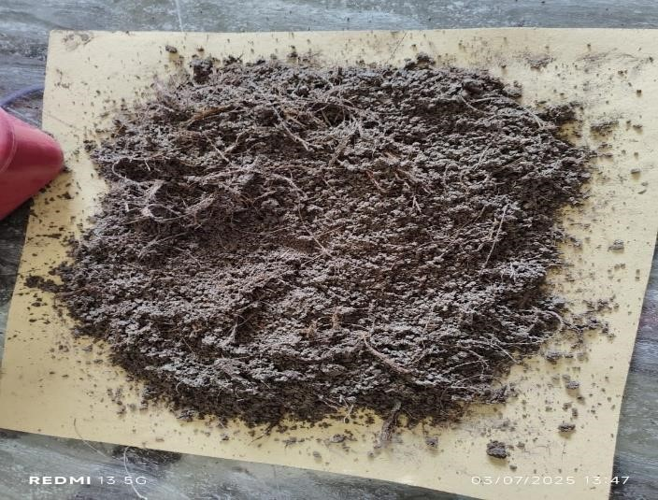
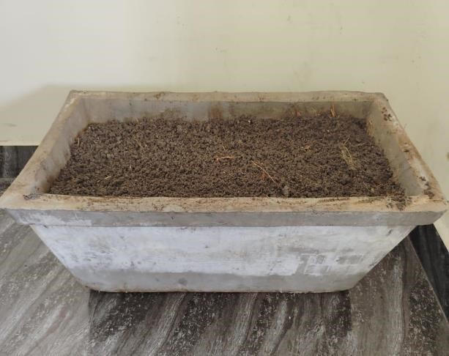
C

Fig: 1 A - Eisenia fetida selected for the present experiment, B-Thiamethoxam 75.0%w/w,
C- Vermicompost

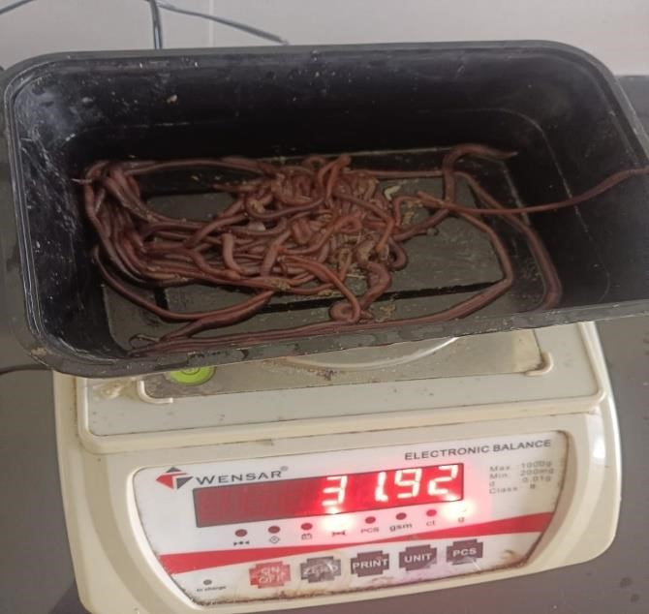
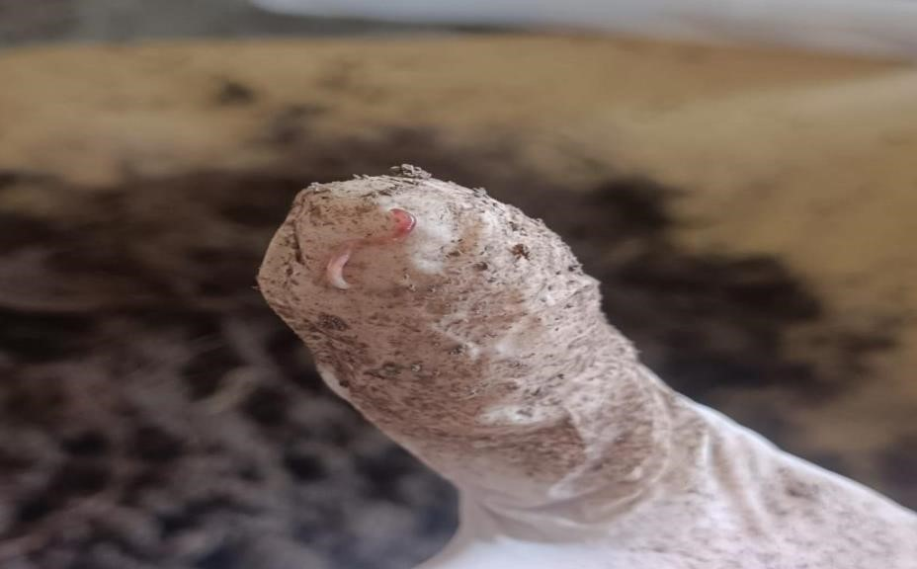

Fig: 2 Weighing of earthworms and hatchlings
  A | 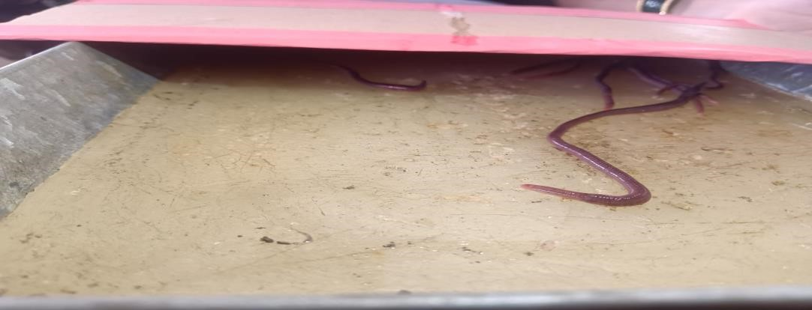  B
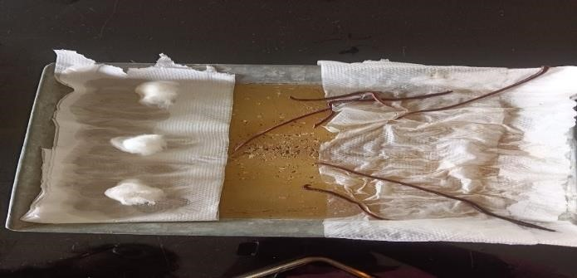  C | 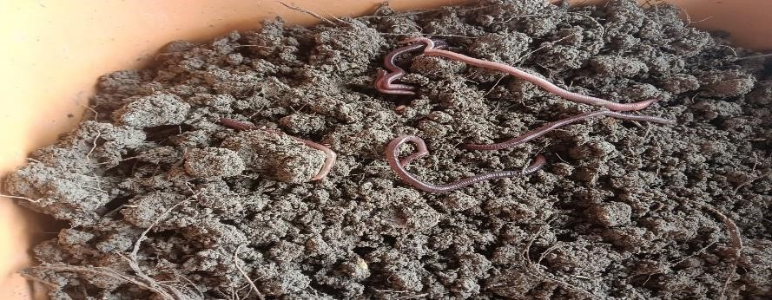  D

Fig 3: A- Earthworms response to hydro taxis, B-Earthworms showing response to phototaxis, C-Response of earthworms towards ammonia, D- Earthworms response to geotaxis

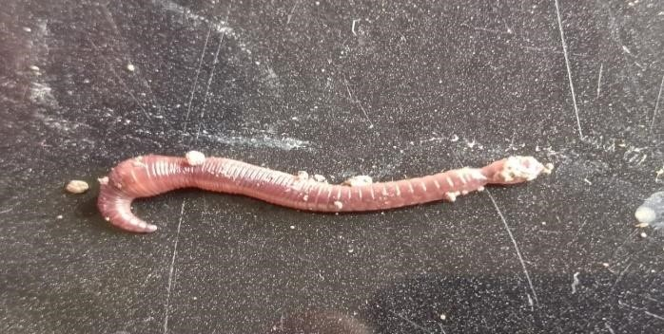 | 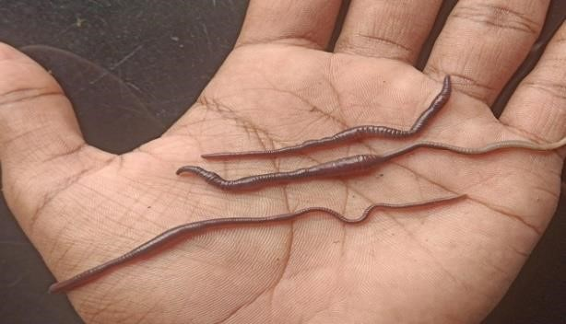  B
C  A | D
E | F
G | H
Fig 4: A- Nodule formation in high-dose treated group, B- Cysts within specific regions of earthworm, C- Population test results of earthworms from different treated groups, D- Biomass variations observed in earthworms, E- Hydro taxis results showing the percentage of earthworms in moist zone, F- Phototaxis test results showing ppercentage of earthworm’s movement towards light, G- Chemotaxis results showing percentage of earthworm’s movement towards chemical, H-Population of earthworm’s showing positive response

Table 1: Components used in experimental substrate preparation

Component | Proportion (% by weight) | Preparation Notes
Soil | 60 | Used black soil
Vegetable peels | 5 | Chopped ≤2 cm pieces
Newspaper (unbleached, shredded) | 5 | Avoid glossy/colored print
Cow dung | 20 | Pre-composted ≥15 days
Dry leaves and rice husk | 5 | Sun-dried before mixing
Cocopeat | 5 | Soaked & drained before use

Table 2: Experimental design
Pit No | Treatment groups | Dose (mg/kg) | Substrate weight | Number of earthworms
1 | G1 | - | 9kg | 30
2 | G2 | 6 | 9kg | 30
3 | G3 | 26 | 9kg | 30

Table 3: Weight and number of earthworms before and after treatment
Pits | Number of  worms before  treatment | Number of worms after  treatment | Weight in grams before treatment | Weight in grams after  treatment
Control pit | 30 | 37 | 27gms | 30gms
Low dose pit | 30 | 32 | 37.8gms | 32.2gms
High dose pit | 30 | 28 | 29.75gms | 18gms

Table 4: Time taken by earthworms to the response of hydro taxis
Pits | Positive | Negative | Time taken
G1 | 6 | - | 3 min’s
G2 | 4 | 2 | 7 min’s
G3 | 3 | 3 | 12 min’s
Table 5: Time taken by earthworms to response of phototaxis
Pits | Positive | Negative | Time
G1 | 0 | 6 | 4 min's
G2 | 1 | 5 | 10 min's
G3 | 3 | 3 | 18 min's

Table 6: Time taken by earthworms to response of chemotaxis
Pits | Positive response | Negative response | Time taken
G1 | - | 6 | 5 min’s
G2 | 2 | 4 | 12 min’s
G3 | 3 | 3 | 22 min’s

Table 7: Time taken to show response for geotaxis by Earthworms
Pits | Positive response | Negative response | Time taken
G1 | 6 | - | 2 min’s
G2 | 6 | - | 5 min’s
G3 | 6 | - | 13 min’s

