ASPECTS OF FISH BIOLOGY: SEXUAL DIMORPHISM OF MOUTH BROODER (NILE TILAPIA) Oreochromis niloticus CICHLIDAE AT THE QUA IBOE RIVER ESTUARY IBENO LOCAL GOVERNMENT AREA OF AKWA IBOM STATE, NIGERIA

Abstract
The aspects of the biology of Oreochromis niloticus sexual dimorphism from Qua Iboe River Estuary, Nigeria was studied from April 2021 $-$ March 2022. Samples of the species were collected from the catches of artisanal fisheries using various mesh sizes of gill and cast nets. A total of 1,267 specimens of O. niloticus were collected and examined for their sex dimorphism. The species showed sexual dimorphism were males possessing one opening and genital papilla while females had two openings.The result revealed that 689 (54.38%) fish specimens were males and 578 (45.62%) specimens were females giving a male: female ratio of 1:0.83 which was significantly different from unity (x²=87.299, df=1, P<0.05) in favour of males.This study provides the basic information which could enhance production potential of O. niloticus and its and its sustainable development, culture and management in Qua Iboe River Estuary Nigeria.

INTRODUCTION
An aspect of fish biology such as sexual dimorphism is important in studying fish biology and approach in fishery production. The functional importance of fish to human and national development cannot be over-emphasized. Studies have highlighted the potentials of fish to include but not limited to serving as the important natural source of protein and main source of liver oil containing vitamin A and D (Adeyemi, 2010), In estimating the reproductive potential of fish. Information on sex ratio of fish can be included to determine female spawning biomass.
The addition of sex ratio to estimates of reproductive potential can produce some differences in understanding the status of fish stock in relation to a selected point of biological reference (Morgan, 2008).
Sexual dimorphism is the condition where two sexes of the same species exhibit different characteristics beyond the difference in their sexual organs example colour of eyes, shape and size (Britannica, 2023). Differences in secondary sexual characteristics between males and females of a species. The importance of this is trait amendable to sexual selection which give an organism an advantage over its rivals. This is the structural differences that exist between males and female individual in a population of the same species (Ralls and Mesnick, 2009). These differences could be by the genital papillae, colour of the skin and other morphological characteristics. The import of sexual dimorphism is that it allows the aquaculturist to identify male and female sample with desirable traits to be used in artificial propagation. The management of fishes could be considered as effective when attention is given to their sexual dimorphism. This can be used to explain existing morphologic difference in size, weight, colour, behavioural and cognitive development between sexes of the same species (Ralls and Mesnick, 2009). Thus, enhancing the functional knowledge of fish domestication and culturing for sustainable maximum yield (Nkanta et al. 2023). The knowledge of sexual dimorphism also allows the fisheries scientists to select desirable males and females for hypophysation and to cross breed fish with characters that enhances the fisheries and aquaculture production (FAO, 2019; Nkanta et al. 2023).
Information on the reproductive biology of some economically important fish species which include West African Ilisha Ilisha africana, the croakers Pseudotolithus typus and Pseudotolithus senegalensis off the Lagos coast Nigeria has been reported by some authors (Marcus and Kusemiju, 1984; Anyanwu, 1990). There is paucity of information on the study of reproductive biology of the grunts in the Lagos coast. The reproductive biology of P. jubelini has not been widely reported in literature. The aim of this study was to investigate the sex ratio, gonadosomatic index, stages of gonadal development and fecundity which are some aspects of the reproductive biology of P. jubelini off the Lagos coast, Nigeria. It is hoped that the information obtained from this study will contribute to our knowledge of the reproductive biology of P. jubelini and will be useful for fisheries and aquaculture production.
The aim of this study is to investigate the sexual dimorphism of Oreochromis niloticus from Qua Iboe River estuary in Ibeno Local Government Area; Akwa Ibom State, through: to determine sexual dimorphism Oreochromis niloticusand and monthly and seasonal variations in sex ratio Oreochromis niloticus

MATERIALS AND METHODS
Study Area
The study was carried out in the estuarine water of Mkpanak, Qua Iboe River in Ibeno Local Government Area in Akwa Ibom State, Nigeria (4049’’02.88’N; 7056’’.09’E) (Fig. 1) It is one of the three major hydrographic features in Akwa Ibom State, Nigeria. It is located in the tropical belt with an equatorial climate regime characterized by dry (November-March) and a wet (April – October) seasons (Imaobong et al. 2014). The southern-most part of the river basin which constitutes the estuarine zone which consists of sandy coastal beach ridges covering an area of 560km2. It has a distance of appropriately C.40km from Eket to Ibeno where it empties into the Atlantic Ocean (King et al.1990). The nature of the substratum consists of fine sand, salty and muddy deposits. The estuary consists of tidal creeks, small brackish water lagoons and fringing mangrove swamps. Hence, the shoreline is characterized by muddy/marshy edges. The channel morphology is characterized by very wide channel and very deep pools. Qua Iboe River estuary is one of the largest fishing settlements on the Nigeria coast. The climatic condition is favourable all year round for fishing and farming. The vegetation of Qua Iboe River estuary is mangrove swamps comprises predominantly the red mangroves (Rhizophora harrisonii, R. mangle and R. racemosa), white mangroves (Avicenna Africana) and black mangroves (Laguncularia racemosa), stands of Nypa fruiticans, phonenix reclinata and Acrostichum aureum also grow in some places (Akpan et al. 2022).
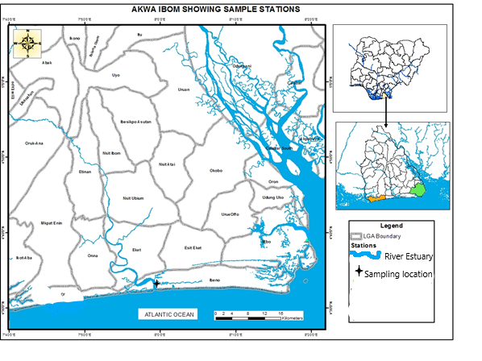

Map 1- Map of sampling area (Nkanta et al., 2023)

Sample collection
Monthly samples of Oreochromis niloticus (Plate 1) were collected with the help of local fishermen using traditional fishing tools such as hook and line, traps, basket, gill and cast nets from April 2021 – March 2022. The fish specimens were washed with the river water to remove any foreign debris such as leaf, mud, sand, that must have been attached to the body. They were preserved immediately in 10 % formalin solution in a plastic container and transported to the Department of Fisheries and Aquaculture Laboratory, Akwa Ibom State University, Obio Akpa campus the same day and kept till the period of analysis.
Laboratory Analyses
In the laboratory, fish specimens were identified using monographs, descriptions, checklists and keys (Poll, 1974; Whitehead, 1984). Samples preserved in 10% formaldehyde were removed, rinsed with distilled water and measured by means of measuring board to the nearest 0.01cm (total length (TL) and standard length (SL) and weighed on a top loading electronic metler balance PR-series model PR 2202 / EOHAUS to the nearest 0.01g total weight (TW).
Sexual Dimorphism
The sexes of O. niloticus were differentiated and the following morphological and morphometric parameters were examined for possible sexual dimorphism namely; colour, genital papillae, head length (distance between tip of snout and end of operculum), maximum body depth (dorso–ventral distance immediately behind the operculum), maximum height and length of dorsal fin, (distance between anterior and posterior ends), pectoral fin length (distance between anterior and posterior ends), and caudal fin base (dorso-ventral distance of fin base).
RESULTS
Sexual Dimorphism
Observation of the shape of the dorsal and anal fins of the fish showed that the dorsal and anal fins of the males were pointed while those of the females were rounded and expanded. Moreover, the genital papillae on the postero-ventral surface of the abdomen of the male possessed one opening and genital papilla whereas the female had two openings.
A total of 1,267 specimens of O. niloticus were examined, of this number 689 (54.38%) were males and 578 (45.62%) were females giving a male: female ratio of 1:0.83 which was significant different from unity (X²=87.299, df=1, P<0.05) in favour of males (Table 1)
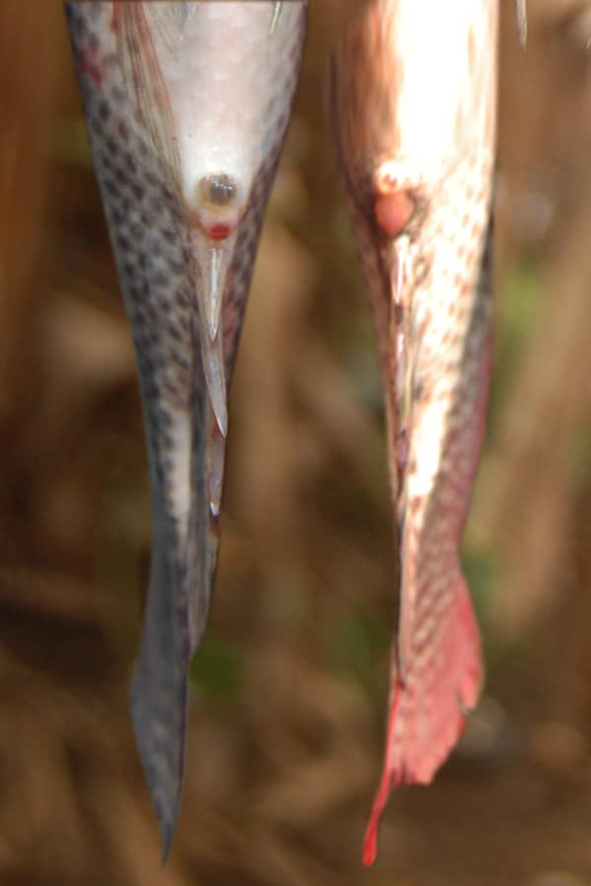

Female
Male

MaleO. niloticus showing one opening and genital papilla

Plate 1 Genital papillae of male and female O. niloticus where Female O. niloticus shows two Openings (left) and Male O. niloticus shows one Openings andgenital papilla (right)
Table 1: Overall sex ratio of male and female sample of O. niloticus from Qua Iboe River
Sexes | Male | Female | Ratio |  | Combined
Sexes | Male | Female | Male | Female | Combined
 | 689  (54.38%) | 578  (45.62%) | 1 | 0.98 | 1,267  X²= 87.299  P<0.05

4.1.2 Sex Ratio
The seasonal variations in sex ratio of O. niloticus are presented in Table 2. The dry season sample of 508 tilapia consisted of 257 (50.59%) males and 251 (49.41%) females, giving a sex ratio of 1:0.98 which was not different from 1:1 (P>0.05). Similarly, of the 759 individuals sampled in the wet season, males were 432 (56.92%) and 327 (43.08%) females, giving a sex ratio of 1:0.76 which was significantly male biased (P<0.05). The seasonal variation in sex ratio was not homogenous as the male dominance was observed in wet season and there was unity during the dry season.

Table 2: Seasonal Sex Ratio of male and female sample of O. niloticus from Qua Iboe River
Sexes  Season | Males | Females | Ratio |  | Combined
Sexes  Season | Males | Females | Male | Female | Combined
Dry | 257  (50.59%) | 251  (49.41%) | 1 | 0.98 | 508  (P>0.05)
Wet | 432  (56.92%) | 327  (43.08%) | 1 | 0.76 | 759  (p<0.05)

The monthly variations in sex ratio of O. niloticus are presented in Table 3. Male dominance was observed in all the months except July where females were significantly more than males and December where there was unity.

Table 3: Monthly Sex Ratio of O. niloticus and Chi-square Values
 | Month | Sex(N) |  | Ratio |  | Calculated X² test
 |  | Male | Female | Male | Female
Wet season | April | 60 | 42 | 1 | 0.70 | 14.235ª
 | May | 55 | 51 | 1 | 0.92 | 21.254ª
 | June | 76 | 42 | 1 | 0.55 | 7.410ª
 | July | 47 | 61 | 1 | 1.29 | 19.753ª
 | August | 73 | 33 | 1 | 0.45 | 30.201ª
 | September | 65 | 44 | 1 | 0.67 | 13.728ª
 | October | 56 | 54 | 1 | 0.96 | 14.048ª
Dry season | November | 51 | 56 | 1 | 1.09 | 29.312ª
 | December | 50 | 50 | 1 | 1 | 0
 | January | 51 | 50 | 1 | 0.98 | 12.347ª
 | February | 53 | 47 | 1 | 0.88 | 25.813ª
 | March | 52 | 48 | 1 | 0.92 | 28.213ª
 | Overall | 689 | 578 | 1 | 0.83 | 87.299ª

The monthly numerical abundance of male and female species sampled during the period of study is depicted in Figure 1. Male dominance was observed in ten out of the twelve months sampled except in July and November. Larger abundance of the species was found in June (wet season). Females were more than males in July and there was unity in December.

Figure 1: Monthly numerical abundance of O. niloticus from Qua Iboe River estuary

Discussion
The sexes of O. niloticus were differentiated on the basis of the genital papillae on the postero-ventral surface of the abdomen. The papilla had one opening in the males and two in the females. Moreover, males dorsal and anal fins were pointed while in the females they were rounded and more expanded. These results were similar to those obtained by Hannah et al. (2019) who reported that sex can be differentiated by differences of the genital opening in the genital papilla. However, the result was different because in their findings, the male possessed two openings while the female had three. Pruginin and Shell (1962) sexed tilapia with mechanical grader. While working with Tilapia aurea and Tilapia galilaca, it was noticed that sexing can be done either according to genital papilla or according to the shape of the dorsal and anal fins. Males possess pointed dorsal and anal fins while female had round and more expanded fins.
The overall sex ratio during the period of study showed male dominance. Seasonal sex ratio was significantly male biased during the wet season while there was no significant difference between males and females during the dry months. Monthly variation showed that males recorded higher numbers than females except in July where the sex ratio was female biased and December where there was unity (1:1). Given that 1:1 sex ratio indicates the absence of a sex-based dichotomy in longevity (Nikolsky, 1969), the 1:0.83 males: female’s ratio of Tilapia Probably depicted that male lived longer than females. Pena-mendoza et al. (2005) reported that variation in sex ratio can occur because once fertilization of eggs has been concluded, the males possibly emigrate from the area of spawning towards feeding areas located in the shallow part of the water body where they are captured. The females most likely move toward submerged vegetation and rocky areas to avoid predation including fishers and to carry out incubation and protection of the offsprings. These results agreed with those of Waithaka et al. (2017) on population biology of Nile tilapia, O. niloticus in lake Naivasha, Kenya, who recorded a sex ratio of 2.21:1.0 (male: female) that significantly deviated from the 1:1 ratio. Ojuok et al. (2000) working on gonadal pattern and reproductive strategy of O. niloticus in the Nyahza gulf of Lake Victoria, Kenya recorded a sex ratio of 1.49:1 (male: female). Njiru et al. (2006); Onta et al. (2014); Yongo et al. (2018) and Laurent et al. (2020) recorded also sex ratio that showed male dominance. The sex ratio of small spotted grunt (Pomadasys commersonnii) which indicated homogenous distribution of males and females in the population was reported by (Al-Nahdi et al. 2010). (Fatimat, 2013) reported that, however, in classes 215.5cm, 265.5cm and 315.5cm, significant differences (P>0.05) were observed in the sex ratio. In the study, sex ratio of P. jubelini was in favour of male dominance and there was no significant difference (P>0.05) in the sex ratio. According to Pajuelo et al. (2003), the sex ratio of bastard grunt (Pomadasys incisus) in Canarian archipelago was not significantly different (P>0.05) from study carried out by Fatimat, (2013). The sex ratio of (Pomandasys jubelini) in the study which was not significantly different (P>0.05) from 1:1 distribution.
According to Vicentini and Aralyo (2003) sex ratio studies provide information on the representation of male and female fish present in a population. It states the proportion of male to female fish in a population and indicates the dominance of sex of fish species in a given population. Sex ratio constitutes basic information required for the assembly of potential of fish reproduction and stock size estimation in fish population.
Conclusion
From the results obtained in this research it could be concluded that:
- The population of Oreochromis niloticus could be differentiated into males and females using the genital openings.
- Males had larger size structure and were dominance in the catches.
- Male dominant was observed in all the months except July where females were dominance significantly more than males and December where there was unity.

References
Adeyemi, S. O. (2010). Food and feeding habit of Synodontis resupinatus (Boulenger, 1904) at Idah area of River Niger, Kogi State, Nigeria. Animal Research International, 7(1), 1281–1286.
Akpan, U. E., Ita, E.-O., & Etim, I.-I. N. (2022). Effect of flood on fringe mangrove in South-Eastern Nigeria. Journal of Global Ecology and Environment, 16(4), 113–127.
Al-Nahdi, A., Al-Marzouqi, A., Jayabalan, N., & Al-Habsi, S. (2011). Maturation and spawning of the small-spotted grunt Pomadasys commersonnii (Lacepède, 1801) in the Arabian Sea off Oman. Thalassas: An International Journal of Marine Sciences, 27(1), 67–79.
Britannica, T. Editors of Encyclopaedia. (2023). Sex chromosome. Encyclopedia Britannica. https://www.britannica.com/science/sex-chromosome
FAO. (2019). The state of world fisheries and aquaculture. Rome: FAO.
Adebiyi, F. A. (2013). The sex ratio, gonadosomatic index, stages of gonadal development and fecundity of sompat grunt, Pomadasys jubelini (Cuvier, 1830). Pakistan Journal of Zoology, 45(1), 41–46.
Ekpo, I. E., Essien-Ibok, M. A., & Nkwoji, J. N. (2014). Food and feeding habits and condition factor of fish species in Qua Iboe River estuary, Akwa Ibom State, southeastern Nigeria. International Journal of Fisheries and Aquatic Studies, 2(2), 38–46.
Hannah, R., & Roser, M. (2019). Gender ratio. Our World in Data. https://ourworldindata.org/gender-ratio
King, R. P., Udoidiong, O. M., Egwali, E. C., & Nkanta, N. A. (1990). Some aspects of the trophic biology of Ilisha africana (Teleostei: Clupeidae) in Qua Iboe estuary, Nigeria. Cybium, 14(3), 261–274.
Laurent, C., Yongo, E., Waithaka, E., & Mutethya, L. (2020). Analysis of some biological aspects of the blue-spotted tilapia, Oreochromis leucostictus (Trewavas, 1933) in Lake Naivasha, Kenya. OSF Preprints. https://doi.org/10.31219/osf.io
Morgan, M. J. (2008). Integrating reproductive biology into scientific advice for fisheries management. Journal of Northwest Atlantic Fishery Science, 41, 37–51.
Nikolsky, G. V. (1965). The ecology of fishes. London: Academic Press.
Njiru, J. M., Ojuok, J. E., Okeyo-Owuor, J. B., Muchiri, M., Ntiba, M. J., & Cowx, I. G. (2006). Some biological aspects and life history strategies of Nile tilapia, Oreochromis niloticus (L.) in Lake Victoria, Kenya. East African Journal of Ecology, 144, 30–37.
Nkanta, G. U., Abiaobo, N. O., & Ukpatu, J. E. (2023). Assessment of length-weight relationship of Nile tilapia Oreochromis niloticus (Linnaeus, 1758) from Qua Iboe River estuary, southeastern Nigeria. Asian Journal of Biology, 17(2), 21–33.
Ojuok, J. E., Mavuti, K. M., & Ntiba, M. J. (2000). Gonadal patterns and reproductive strategy of Nile tilapia Oreochromis niloticus (L.) in the Nyanza Gulf of Lake Victoria. In Proceedings of Lake Victoria: A New Beginning Conference (pp. 161–168). Lake Victoria Fisheries Organization.
Outa, N., Otieno, N., Kitaka, J., & Njiru, M. (2014). Length-weight relationship, condition factor, length at first maturity, and sex ratio of Nile tilapia, Oreochromis niloticus in Lake Naivasha, Kenya. International Journal of Fisheries and Aquatic Studies, 2(2), 67–72.
Pajuelo, J. G., Lorenzo, J. M., Gregoire, M., & Dominguez-Seoane, R. (2003). Life history of Pomadasys incisus (Osteichthyes: Haemulidae) of the Canarian Archipelago. Scientia Marina, 67(2), 241–248.
Pena-Mendoza, B., Gomez-Marquez, J. L., Salgado-Ugarte, I. H., & Ramirez-Noguera, D. (2005). Reproductive biology of Oreochromis niloticus (Perciformes: Cichlidae) at Emiliano Zapata Dam, Morelos, Mexico. Revista de Biología Tropical, 53(3), 515–522.
Poll, M. (1974). Synopsis and geographical distribution of the Clupeidae in fresh water: Description of three new species. Bulletin du Centre d'Études et de Recherches Scientifiques de Saint-Tomé, 60(2), 141–161.
Pruginin, Y., & Shell, E. W. (1962). Separation of sexes of Tilapia nilotica with a mechanical grader. The Progressive Fish-Culturist, 24(2), 80–82.
Ralls, K., & Mesnick, S. (2009). Sexual dimorphism. Academic Press, 1(1), 1005–1011.
Vincentini, R. N., & Araujo, F. G. (2003). Sex ratio and size structure of Micropogonias furnieri (Desmarest, 1823) (Perciformes: Sciaenidae) in Sepetiba Bay, Rio de Janeiro, Brazil. Brazilian Journal of Biology, 63(4), 46–54.
Waithaka, E., Mugo, J., Obegi, B., & Keyombe, J. L. (2017). Socio-economic aspects of the re-introduced Oreochromis niloticus in Lake Naivasha, Kenya. International Journal of Fisheries and Aquatic Studies, 5(2), 89–97.
Whitehead, P. J. P. (1984). Family Clupeidae. In D. J. P. Gosse, P. Van den Audenarde, & D. F. S. Audennered (Eds.), Checklist of the freshwater fishes of Africa (Vol. 1). ORSTOM.
Yongo, E., Olukoye, J., Makame, A., & Chebon, B. (2019). Changes in some biological parameters of the silver cyprinid, Rastrineobola argentea (Pellegrin, 1904) in the Nyanza Gulf of Lake Victoria, Kenya. Lakes & Reservoirs: Research and Management, 24(3), 255–278.

