PREVALENCE, MOLECULAR DETECTION AND ANTIMICROBIAL RESISTANCE PATTERNS OF BACTERIAL PATHOGENS CAUSING BOVINE MASTITIS

Abstract:
Antimicrobial resistance (AMR) is a global health concern affecting both human and veterinary sectors. Overuse and misuse of antibiotics is accelerating the problem of antimicrobial resistance in the pathogens causing infectious diseases. Mastitis is the painful inflammation of mammary gland and is considered as common infection of dairy cattle. Several studies emphasized that the bacterial pathogens associated with bovine mastitis are multidrug resistant. Hence, the present study is carried out to determine prevalence and antimicrobial resistance patterns of bacterial pathogens causing bovine mastitis. A total of 120 bovine mastitis milk samples were collected and the prevalence rates were analyzed according to breed, age, parity and lactation stages. The identification of bacterial strains was performed based on cultural characteristics on specific media, biochemical tests and molecular identification using specific primers. Antibiotic susceptibility testing of the isolates was done by Kirby-Bauer disk diffusion test. Results indicated the presence of Staphylococcus aureus, Escherichia coli, Klebsiella, and Salmonella spp. at prevalence rates of 19.53%, 10%, 2.5%, and 5.8%. Determination of the AMR profile revealed highest resistance of all pathogens towards ampicillin. S. aureus is predominantly resistant to penicillin (100%), followed by methicillin (94.74%), and ampicillin (89.47%), E. coli to ampicillin (96.6%), amoxicillin and ciprofloxacin (83.33% each), Klebsiella to ampicillin and amoxicillin (100%) whereas Salmonella spp. to ampicillin (100%) and amoxicillin (85.71%). The findings of the study suggested the high prevalence of multidrug resistant pathogens causing mastitis, increasing the risk of reduced antimicrobial efficacy and affecting the public health.
KEY WORDS
Mastitis, Bovines, Antimicrobial Resistance, Prevalence, Molecular detection
- INTRODUCTION
Bovine mastitis is the inflammation of mammary gland, one of the common and highly critical infectious condition of dairy cattle worldwide (Cheng and Han, 2020). The condition incurs severe economic losses in the dairy industry due to reduction in milk yield, altered milk quality, treatment costs and premature culling of affected animals (Dejyong et al., 2022). The incidence of mastitis in dairy animals has been raised to 50% (Kumar et al., 2016) and the estimated economic loss per animal for a single lactation period is ₹ 21,677 to ₹ 88,340 (Saini et al., 2021)
Mastitis is multi-etiological disease caused by variety of pathogens including viruses, fungi and parasites, but predominantly of bacterial origin. About 150 various bacterial species/sub-species can induce mastitis in dairy cattle (El-Sayed and Kamel, 2021). The common bacterial agents include Staphylococcus aureus, Streptococcus agalactiae, Mycoplasma spp, Pseudomonas aeruginosa, Corynebacterium bovis, Escherichia coli, Klebsiella spp, Salmonella spp and Enterobacter spp. (Cobirka et al., 2020).
Treatment of clinical mastitis significantly relies on antimicrobial agents, yet in recent years, this approach has become increasingly difficult due to the rise of antimicrobial resistance (AMR). Widespread misuse of antibiotics, both in human and veterinary medicine, hastens the evolution of AMR, complicating the treatment of even routine infections and potentially paving the way for the emergence of more virulent microbial strains. AMR arises due to the evolution of resistance-causing genes in bacteria; limited uptake (or) inactivation of a therapeutic agent; modifying a drug target and/or active drug efflux (Blanco et al., 2016). The resistance-causing genes are of plasmid origin and/or obtained from virulent bacteria by means of horizontal gene transfer (Santos-Lopez et al., 2019).
The main public health concern with mastitis instances include emergence of multi drug resistant (MDR) bacteria and the potential for human transmission through consumption of raw dairy products. Mastitis milk has been documented to harbour MDR bacterial strains (Emon et al., 2024; Getahun et al., 2025). The majority of the bacteria isolated from mastitis showed resistance to commonly used antibiotics. Keeping in view of the emergence of MDR isolates, the current investigation was carried out in Tirupati district of Andhra Pradesh, India to know the prevalence of bacterial pathogens associated with bovine mastitis along with their antimicrobial resistance profiles to suggest better treatment protocols as well as for the welfare of the ailing animals.
2. MATERIALS AND METHODS
2.1 Study area and study population
The study was carried out from February to September, 2024 in the district of Tirupati, Andhra Pradesh, India. The study population comprised of Jersey, Holstein-Friesian and cross bred dairy cows with clinical mastitis that were presented to various veterinary hospitals in the study area. The udder of the suspected animals had signs like swollen, redness, pain and the milk appeared watery with clots or in some cases blood tinged.
  - Collection of samples
Samples were carefully collected after cleaning the teats with 70% ethanol swabs. The initial three drops of milk were discarded and then 10ml of milk was collected aseptically in sterile tubes. Mastitis was confirmed in the collected samples by California mastitis test and brought to the laboratory. Samples were stored at 4℃ until further processing and the data was analyzed according to their breed, age, parity, and stage of lactation.
  - Isolation and identification of bacteria
For preliminary isolation and identification of bacteria, milk samples were mixed well and inoculated into nutrient broth and kept for 18-24 h at 37℃. A loopful of broth was streaked initially on nutrient agar followed by grams staining. After grams staining procedure, colonies were streaked on specific media like Mannitol salt agar (MSA), Eosin-Methylene Blue agar (EMB), MacConkey’s agar (MCC), and Brilliant green agar (BGA) to isolate the organisms. Golden yellow-colored colonies with yellowish discoloration of MSA indicated the characteristic growth of S. aureus, for E. coli characteristic metallic sheen formation on EMB agar, for Klebsiella spp pink-coloured mucoid colonies on MCC, and pinkish red colonies on BGA indicated Salmonella spp.
  - Molecular confirmation
Molecular confirmation of the isolates was done by amplification of the specific genes, nuc gene for S. aureus, 16s rRNA gene for E. coli and Klebsiella spp and random chromosomal fragment for Salmonella spp. The sequence of the primers used and the amplification conditions were mentioned in table1. The amplified products were visualized in 1.2% agarose gels.
Table 1: Oligonucleotide primer sequences
Species | Gene | Primer Sequence (5’-3’) | Amplicon Size (bp) | Reference
S. aureus | nuc | F- GCGATTGATGGTGATACGGTT | 279 | Brakstad et al., 2020
S. aureus | nuc | R- AGCCAAGCCTTGACGAACTAAAGC | 279 | Brakstad et al., 2020
E. coli | 16S rRNA | ECO223: F-ATCAACCGAGATTCCCCCAGT | 232 | Ahmed, 2021
E. coli | 16S rRNA | ECO455: R-TCACTATCGGTCAGTCAGGAG | 232 | Ahmed, 2021
K. pneumonia | 16S rRNA | SSKP 1: F-ATTTGAAGAGGTTGCAAACGAT | 130 | Ahmed, 2021
K. pneumonia | 16S rRNA | SSKP 2: R- TTCACTCTGAAGTTTTCTTGTGTTC | 130 | Ahmed, 2021
Salmonella | random chromosomal fragment | ST 11: F-GCCAACCATTGCTAAATTGGCGCA | 429 | Soumet et al., 1999
Salmonella | random chromosomal fragment | ST 15: R-GGTAGAAATTCCCAGCGGGTACTGG | 429 | Soumet et al., 1999

2.5 In-vitro antibiotic sensitivity testing by disc diffusion method
Antibiotic resistance pattern of the isolates against different antibiotics was tested by using disk diffusion method according to Clinical and Laboratory Standards Institute (CLSI, 2022) guidelines. Bacterial suspensions were prepared in 0.9% phosphate-buffered saline (PBS) and adjusted to 0.5 McFarland standard. The suspensions were uniformly spread over MHA plates using sterile cotton swabs. The following antibiotics were tested: Ampicillin (10 µg), Doxycycline (30 µg), Enrofloxacin (10 µg), Penicillin (10 µg), Cefotaxime (30 µg), Methicillin (30 µg), Kanamycin (30 µg), Ciprofloxacin (5 µg), Gentamicin (10 µg), Vancomycin (10 µg), Streptomycin (300 µg), Cephalexin (30 µg), Tetracycline (10 µg), and Erythromycin (10 µg). Antibiotics were selected based on their relevance in veterinary and human medicine. Antibiogram data were analyzed using WHONET 2023 software.
- RESULTS AND DISCUSSION
A total of 120 bovine mastitis milk samples were collected aseptically and the presence of clinical or subclinical mastitis in milk samples was confirmed by physical examination of milk and California mastitis test (Fig. 1). The prevalence and incidence of mastitis was analyzed based on breed, age and stage of lactation. Highest prevalence of mastitis was observed in cross bred animals with incidence rate of 64.17% compared to Jersey (17.5%) and Holstein-Friesian (18.33%). A higher prevalence rate of 54.17% and 43.33% was noticed in early and mid-lactation stages compared to 2.5% in the late stages of lactation. Animals of ages 3-5 years (44.17%) and 6-9 years (49.17%) were highly affected of mastitis (table 2). The findings of higher incidence of mastitis at 6-9 years age and parity (4-7) was similar to the study conducted by Haftu et al. (2012) indicating the increased frequency of mastitis occurrence with time and prolonged period of infection.
Table 2: Occurrence of mastitis according to breed, age, parity, and stage of lactation
Risk factors | Category level | Number | Prevalence (%)
Breed | Jersey | 21 | 17.5
 | Holstein-Friesian | 22 | 18.33
 | Crossbred | 77 | 64.17
Age | 3-5 years | 53 | 44.17
 | 6-9 years | 59 | 49.17
 | 9 years and above | 8 | 6.66
Parity | 1-3 | 47 | 39.17
 | 4-7 | 62 | 51.67
 | >7 | 11 | 9.16
Lactation stage | Early (<3 months) | 65 | 54.17
 | Mid (3-6 months) | 52 | 43.33
 | Late (>6 months) | 3 | 2.5

Bacterial isolation of S. aureus, E. coli, Salmonella and Klebsiella species from clinical mastitis cases has been carried out using specific agar media. The prevalence rates of predominant bacterial isolates identified in this study include 19.53% S. aureus (19/120), 10% E. coli (12/120), 2.5% Klebsiella spp. (3/120), and 5.8% Salmonella spp. (7/120) based on their cultural characteristics and molecular confirmation (Fig.1, 2 and 3). The results showed that S. aureus was the predominant bacteria associated with mastitis cases followed by E. coli and Salmonella while Klebsiella was the least occurring bacterial isolate.

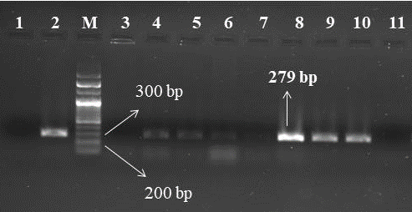
Fig. 1: PCR amplification of nuc gene of Staphylococcus aureus
Note: 1: Negative control; 2: Positive control; M: DNA ladder (100 bp) 4,5,6,8,9,10: Positive Staphylococcus aureus isolates

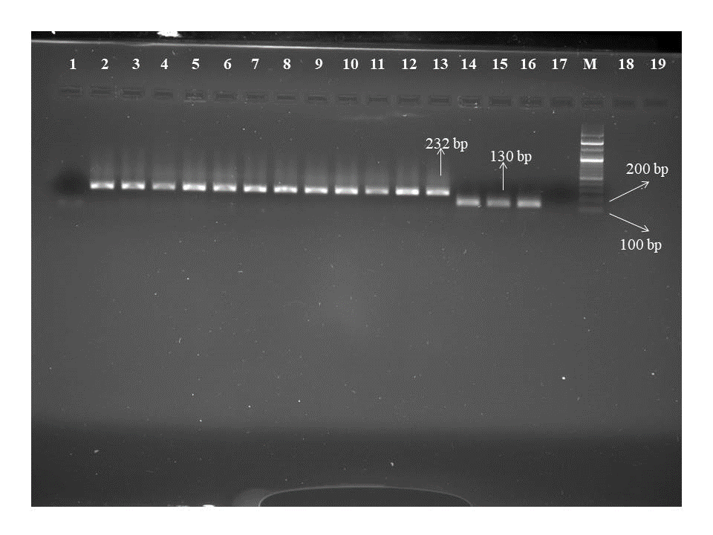
Fig. 2 PCR amplification of 16S rRNA gene of Escherichia coli and Klebsiella pneumoniae
Note: 1, 17: Negative control; M: DNA ladder (100 bp); 2-13: Positive Escherichia coli isolates; 14-16: Positive Klebsiella pneumoniae isolates.
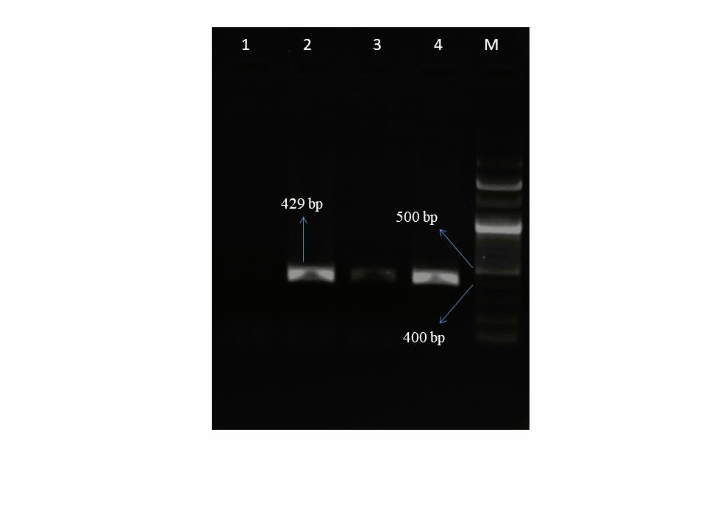
Fig. 3: PCR amplification of random chromosomal fragment of Salmonella isolates.
Note: 1: Negative control; 2-4: Positive Salmonella isolates; M: DNA ladder (100 bp)
The prevalence of S. aureus (15.83%) observed in this study was identical to the prevalence rate of 15.93% as reported by Khoramrooz et al. (2016), and the prevalence of E. coli (10%) and K. pneumoniae (2.5%) was identical to the reports of Navaneethan et al. (2017) and Alekish et al. (2013) as 10.57% and 2.9%, respectively. Given that nuc gene is highly specific for S. aureus and was not detected in other species like S. intermedius, S. hyicus or other mastitis causing bacteria, it was used for confirmation of S. aureus (Graber et al., 2007). 16S rRNA gene used for the confirmation of E. coli and Klebsiella is highly conserved in bacteria and the degree of conservation is assumed to result from its importance as a critical component of cell function and it marks evolutionary distance and relatedness of organisms (Clarridge, 2004).
The antibiogram patterns of the isolates were tested by modified Kirby-Bauer disc diffusion method and the results analyzed by WHONET software showed that most of the isolates were multidrug resistant except for Salmonella spp. (tables 3, 4,5 and 6). Among the mastitis pathogens, S. aureus isolates showed 100 % resistance to penicillin (100%), followed by methicillin (94.74%), ampicillin (89.47%), kanamycin and vancomycin (73.68 % each), and cefotaxime (68.42 %) (Fig. 4). Highest resistance in E. coli was exhibited to ampicillin (96.6%), followed by amoxicillin and ciprofloxacin (83.33% each) (Fig. 4). The Klebsiella showed 100% resistance to ampicillin and amoxicillin, followed by doxycycline, ciprofloxacin, and cefotaxime (66.66% each) (Fig. 4). Salmonella spp. isolates showed 100% resistance to ampicillin followed by amoxicillin (85.71%), doxycycline, and cefotaxime (57.1% each) (Fig. 4). Analysis of the resistance profile of the isolates in WHONET suggested that all the isolates of S. aureus and Klebsiella and 10 isolates of E. coli were for possible extensively drug resistant. Four of the S. aureus isolates, nine and three isolates of E. coli and Klebsiella respectively were possibly pan drug resistant.
Table 3: Antibiotic-resistant profile of Staphylococcus aureus isolated from bovine mastitis milk samples
Isolate No. | Resistance profile (Intermediate to resistant) | MDR | XDR | PDR
St1 | AMP CTX LEX CIP DOX ERY GEN KAN MET PNV TCY VAN | MDR | Possible XDR | Possible PDR
St2 | AMP CTX GEN KAN MET PNV STH VAN
St3 | AMP CTX CIP DOX ERY GEN KAN MET PNV VAN | MDR | Possible XDR
St4 | CTX CIP DOX ERY GEN KAN MET PNV TCY VAN | MDR | Possible XDR | Possible PDR
St5 | CTX LEX CIP ERY GEN KAN MET PNV VAN | MDR | Possible XDR
St6 | AMP CIP DOX GEN KAN MET PNV TCY VAN | MDR | Possible XDR
St7 | AMP CTX CIP ERY GEN KAN MET PNV TCY VAN | MDR | Possible XDR | Possible PDR
St8 | AMP CTX DOX GEN KAN MET PNV TCY VAN | MDR | Possible XDR
St9 | AMP CTX LEX CIP DOX KAN MET PNV TCY VAN | MDR | Possible XDR
St10 | AMP CTX CIP ENR KAN PNV VAN
St11 | AMP CTX CIP ENR ERY MET PNV VAN | MDR | Possible XDR
St12 | AMP CTX LEX CIP ERY GEN KAN MET PNV VAN | MDR | Possible XDR
St13 | AMP CTX DOX ENR GEN KAN MET PNV VAN
St14 | AMP CTX CIP DOX ENR ERY GEN KAN MET PNV STH TCY | MDR | Possible XDR | Possible PDR
St15 | AMP CTX CIP DOX ERY KAN MET PNV TCY VAN | MDR | Possible XDR
St16 | AMP CIP MET PNV VAN
St17 | AMP CTX LEX CIP DOX ERY MET PNV STH TCY VAN | MDR | Possible XDR
St18 | AMP LEX DOX ERY GEN MET PNV STH TCY VAN | MDR | Possible XDR
St19 | AMP CTX CIP GEN KAN MET PNV STH VAN | MDR | Possible XDR
Note: Data was analyzed using WHONET 2023. MDR- Multidrug-resistant; XDR- Extensively drug-resistant; PDR- pandrug-resistant; AMP- Ampicillin; CTX- Cefotaxime; LEX- Cephalexin; CIP-Ciprofloxacin; DOX- Doxycycline; ENR- Enrofloxacin; ERY- Erythromycin; GEN- Gentamicin; KAN-Kanamycin; MET- Methicillin; PNV- Penicillin; STH- Streptomycin; TCY- Tetracycline; VAN-Vancomycin.
Table 4: Antibiotic-resistant profile of Escherichia coli isolated from bovine mastitis milk samples
Isolate No. | Resistance profile (Intermediate to resistant) | MDR | XDR | PDR
E1 | AMX AMP CTX CIP DOX GEN KAN | MDR | Possible XDR | Possible PDR
E2 | AMX AMP CTX CIP DOX ENR GEN KAN | MDR | Possible XDR | Possible PDR
E3 | AMX AMP CTX CIP DOX GEN KAN | MDR | Possible XDR | Possible PDR
E4 | AMX AMP CTX CIP DOX ENR GEN KAN | MDR | Possible XDR | Possible PDR
E5 | AMX AMP CTX CIP DOX GEN KAN | MDR | Possible XDR | Possible PDR
E6 | AMX AMP CTX CIP DOX ENR GEN KAN | MDR | Possible XDR | Possible PDR
E7 | CIP GEN KAN | - | - | -
E8 | AMX AMP | - | - | -
E9 | AMX AMP CTX CIP DOX GEN KAN | MDR | Possible XDR | Possible PDR
E10 | AMX AMP CTX CIP ENR GEN | MDR | Possible XDR
E11 | AMX AMP CTX CIP DOX GEN KAN | MDR | Possible XDR | Possible PDR
E12 | AMX AMP CTX CIP DOX GEN KAN | MDR | Possible XDR | Possible PDR
Note: Data was analyzed using WHONET 2023. MDR- Multidrug-resistant; XDR- Extensively drug-resistant; PDR- pandrug-resistant; AMX- Amoxicillin; AMP- Ampicillin; CTX- Cefotaxime; CIP- Ciprofloxacin; DOX- Doxycycline; ENR- Enrofloxacin; GEN- Gentamicin; KAN- Kanamycin
Table 5: Antibiotic-resistant profile of Klebsiella pneumoniae isolated from bovine mastitis milk samples
Isolate No. | Resistance profile (Intermediate to resistant) | MDR | XDR | PDR
K1 | AMX AMP CTX CIP DOX GEN KAN | MDR | Possible XDR | Possible PDR
K2 | AMX AMP CTX CIP DOX GEN KAN | MDR | Possible XDR | Possible PDR
K3 | AMX AMP CTX CIP DOX GEN KAN | MDR | Possible XDR | Possible PDR
Note: Data was analyzed using WHONET 2023. MDR- Multidrug-resistant; XDR- Extensively drug-resistant; PDR- pandrug-resistant; AMX- Amoxicillin; AMP- Ampicillin; CTX- Cefotaxime; CIP- Ciprofloxacin; DOX- Doxycycline; ENR- Enrofloxacin; GEN- Gentamicin; KAN- Kanamycin
Table 6: Antibiotic-resistant profile of Salmonella isolated from bovine mastitis milk samples
Isolate No. | Resistance profile (Intermediate to resistant) | MDR | XDR | PDR
S1 | AMX AMP CTX CIP GEN KAN | - | - | -
S2 | AMP CIP | - | - | -
S3 | AMX AMP CTX CIP DOX KAN | - | - | -
S4 | AMX AMP CTX CIP DOX GEN KAN | - | - | -
S5 | AMX AMP CTX CIP DOX GEN KAN | - | - | -
S6 | AMX AMP CIP GEN KAN | - | - | -
S7 | AMX AMP CTX CIP DOX KAN | - | - | -
Note: Data was analyzed using WHONET 2023. MDR- Multidrug-resistant; XDR- Extensively drug-resistant; PDR- pandrug-resistant; AMX- Amoxicillin; AMP- Ampicillin; CTX- Cefotaxime; CIP- Ciprofloxacin; DOX- Doxycycline; ENR- Enrofloxacin; GEN- Gentamicin; KAN- Kanamycin

A | 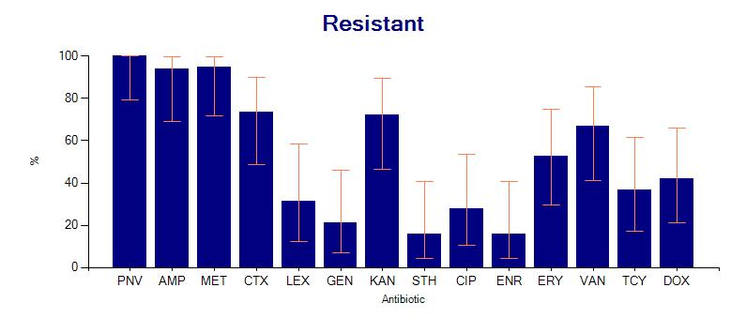 | B | 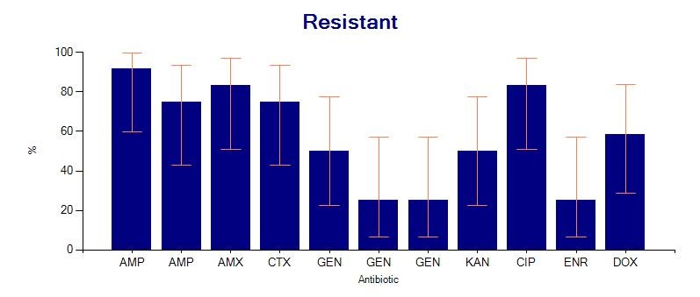
C | 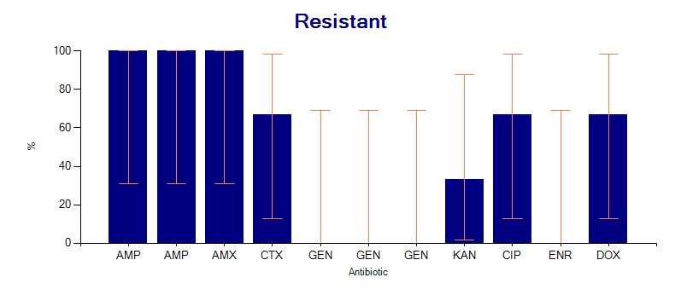 | D | 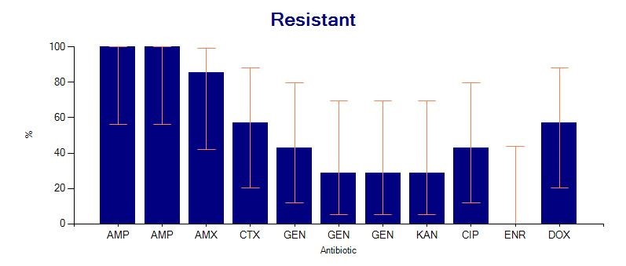
Fig. 4: Resistance profile (Intermediate to resistant) of isolates to different antibiotics
A. Staphylococcus aureus B. Escherichia coli C. Klebsiella pneumoniae and D. Salmonella
Note: Data obtained from WHONET 2023 data analysis. AMP- Ampicillin; CTX- Cefotaxime; LEX- Cephalexin; CIP-Ciprofloxacin; DOX- Doxycycline; ENR- Enrofloxacin; ERY- Erythromycin; GEN- Gentamicin; KAN-Kanamycin; MET- Methicillin; PNV- Penicillin; STH- Streptomycin; TCY- Tetracycline; VAN-Vancomycin.

In the current study, the S. aureus isolates recovered have shown 100% resistance to penicillin and the results were identical (96%) to the studies of Pati and Reena (2016). Further, it was found that 94.74% of isolates showed resistance to methicillin (94.74%), and 89.47% isolates were resistant to ampicillin. The resistance exhibited towards ampicillin was in accordance with the reports of Abed et al. (2021) and Pati and Reena (2016) at 96% and 93%, respectively. High resistance developed against ampicillin may be because of the most common usage of β-lactam antibiotics in the treatment of mastitis (Abed et al., 2018). Resistance to methicillin reported in this study was lower (80%) than the results of Yuan et al. (2017). The highest AMR exhibited by the E. coli, K. pneumoniae, and Salmonella spp. isolates to ampicillin (96.6%, 100% and 100%, respectively) were identical to the reports of Raorane et al. (2013); Alekish et al. (2013), and Gebeyehu et al. (2022), respectively and the amoxicillin resistance exhibited by the isolates (E. coli- 83.33%, Klebsiella - 100%, and Salmonella spp.- 85.71%) were identical to the reports of Cheng et al. (2019) (81%), Singh et al. (2018) (96%), and Jaja et al. (2019) (82%), respectively. Frequent usage of antibiotics without corresponding to the culture and antibiotic sensitivity test might be the reason for the similar drug resistance patterns observed among most of the mastitis pathogens (Alekish et al., 2013).
- CONCLUSION
According to the results of this study, the antibiogram pattern of bovine mastitis bacterial isolates to different antibiotics was almost similar, suggesting the possibility for the emergence of antimicrobial resistance among mastitis bacterial pathogens which might be due to inappropriate dosage regimen and indiscriminate usage of antimicrobials. A high percentage of methicillin resistance exhibited by the S. aureus isolates should also be considered a serious issue due to its zoonotic importance. Isolation and identification of mastitis bacterial isolates along with their resistance profile studies from different parts of the country is necessary to ensure the prevalence of this problem. The usage of antibiotics in accordance with guidelines minimizes the risk of the evolution of multidrug resistance in bacteria affecting mastitis. In brief, our results demonstrate the importance of establishing a nationwide plan for monitoring the AMR pattern and ensuring the appropriate usage of antibiotics in Veterinary Science.

REFERENCES
- Abed, A.H., Al Sayed, R.A., & Atia, A.A. (2018). Genotyping of β-lactams resistant Staphylococci isolated from bovine subclinical mastitis. Beni-Suef University Journal of Basic and Applied Sciences, 7(4), 499-504. https://doi.org/10.1016/j.bjbas.2018.05.004
- Abed, A.H., Menshawy, A.M., Zeinhom, M.M., Hossain, D., Khalifa, E., Wareth, G., & Awad, M.F. (2021). Subclinical mastitis in selected bovine dairy herds in North Upper Egypt: Assessment of prevalence, causative bacterial pathogens, antimicrobial resistance and virulence-associated genes. Microorganisms, 9(6), 1175. https://doi.org/10.3390/microorganisms9061175
- Ahmed, I. M. (2021). Detection of CTX-M gene in extended spectrum β-lactamases producing Enterobacteriaceae isolated 10from bovine milk. Iraqi Journal of Veterinary Sciences, 35(2), 397-402 http://www.doi.org/10.33899/ijvs.2020.126909.1412
- Alekish, M.O., Al-Qudah, K.M., & Al-Saleh, A. (2013). Prevalence of antimicrobial resistance among bacterial pathogens isolated from bovine mastitis in northern Jordan. Revue de Medecine Veterinaire, 164(6), 319-326. https://www.researchgate.net/publication/260266455_Prevalence_of_antimicrobial_resistance_among_bacterial_pathogens_isolated_from_bovine_mastitis_in_northern_Jordan
- Blanco, P., Hernando-Amado, S., Reales-Calderon, J. A., Corona, F., Lira, F., Alcalde-Rico, M., Bernardini, A., Sanchez, M.B., & Martinez, J. L. (2016). Bacterial multidrug efflux pumps: Much more than antibiotic resistance determinants. Microorganisms, 4(1), 14. https://doi.org/10.3390/microorganisms4010014
- Brakstad, O.G., Aasbakk, K., & Maeland, J.A. (1992). Detection of Staphylococcus aureus by polymerase chain reaction amplification of the nuc gene. J Clin Microbiol, 30(7),1654-60. https://doi.org/10.1128/jcm.30.7.1654-1660.1992
- Cheng, J., Qu, W., Barkema, H.W., Nobrega, D.B., Gao, J., Liu, G., De Buck, J., Kastelic, J.P., Sun, H., & Han, B. (2019). Antimicrobial resistance profiles of 5 common bovine mastitis pathogens in large Chinese dairy herds. Journal of Dairy Science, 102(3), 2416-2426. https://doi.org/10.3168/jds.2018-15135
- Cheng, W.N., & Han, S.G. (2020). Bovine mastitis: risk factors, therapeutic strategies, and alternative treatments - A review. Asian-Australas J Anim Sci, 33(11),1699-1713. https://doi.org/10.5713/ajas.20.0156
- Clarridge J. E. (2004). Impact of 16S rRNA gene sequence analysis for identification of bacteria on clinical microbiology and infectious diseases. Clinical microbiology reviews, 17(4), 840–862 https://doi.org/10.1128/cmr.17.4.840-862.2004
- Cobirka, M., Tancin, V., & Slama, P. (2020). Epidemiology and Classification of Mastitis. Animals (Basel), 10(12), 2212. https://doi.org/10.3390/ani10122212
- Dejyong, T., Chanachai, K., Immak, N., Prarakamawongsa, T., Rukkwamsuk, T., Tago Pacheco, D., & Phimpraphai, W. (2022). An economic analysis of high milk somatic cell counts in dairy cattle in Chiang Mai, Thailand. Front Vet Sci. 4(9), 958163. https://doi.org/10.3389/fvets.2022.958163
- El-Sayed, A., & Kamel, M. (2021). Bovine mastitis prevention and control in the post-antibiotic era. Trop Anim Health Prod, 53(2), 236. https://doi.org/10.1007/s11250-021-02680-9
- Emon, A. A., Hossain, H., Chowdhury, M.S.R., Rahman, M.A., Tanni, F.Y., Asha, M.N., Akter, H., Hossain, M.M., Islam, M.R., & Rahman, M.M. (2024). Prevalence, antimicrobial susceptibility profiles and resistant gene identification of bovine subclinical mastitis pathogens in Bangladesh. Heliyon, 10(14):e34567. https://doi.org/10.1016/j.heliyon.2024.e34567
- Gebeyehu, A., Taye, M., & Abebe, R. (2022). Isolation, molecular detection and antimicrobial susceptibility profile of Salmonella from raw cow milk collected from dairy farms and households in southern Ethiopia. BMC Microbiology, 22(1), 84. https://doi.org/10.1186/s12866-022-02504-2
- Getahun, D.D., Tarekegn, H.T., Azene, B.T., Abebe, L.T., Belete, M.A., & Tessema, T.S. (2025). Virulence genes and antibiotic resistance profiling of staphylococcus species isolated from mastitic dairy cows in and around Bahir dar, Ethiopia. BMC Microbiol, 25(1):210. https://doi.org/10.1186/s12866-025-03886-9
- Graber, H.U., Casey, M.G., Naskova, J., Steiner, A., & Schaeren, W. (2007). Development of a highly sensitive and specific assay to detect Staphylococcus aureus in bovine mastitic milk. Journal of dairy science, 90(10), 4661–4669 https://pubmed.ncbi.nlm.nih.gov/17881687/
- Haftu, R., Taddele, H., Gugsa, G., & Kalayou, S. (2012). Prevalence, bacterial causes, and antimicrobial susceptibility profile of mastitis isolates from cows in large-scale dairy farms of Northern Ethiopia. Tropical animal health and production, 44(7), 1765–1771 https://doi.org/10.1007/s11250-012-0135-z .
- Jaja, I.F., Bhembe, N.L., Green, E., Oguttu, J., & Muchenje, V. (2019). Molecular characterisation of antibiotic-resistant Salmonella enterica isolates recovered from meat in South Africa. Acta tropica, 190, 129–136 https://doi.org/10.1016/j.actatropica.2018.11.003
- Khoramrooz, S.S., Mansouri, F., Marashifard, M., Hosseini, S.A.A.M., Chenarestane-Olia, F.A., Ganavehei, B., & Darban-Sarokhalil, D. (2016). Detection of biofilm related genes, classical enterotoxin genes and agr typing among Staphylococcus aureus isolated from bovine with subclinical mastitis in southwest of Iran. Microbial Pathogenesis, 97, 45-51 https://doi.org/10.1016/j.micpath.2016.05.022
- Kumar, N., Manimaran, A., Kumaresan, A., Sreela, L., Patbandha, T.K., Tiwari, S., & Chandra, S. (2016). Episodes of clinical mastitis and its relationship with duration of treatment and seasonality in crossbred cows maintained in organized dairy farm. Vet World, 9(1),75-9. https://doi.org/10.14202/vetworld.2016.75-79
- Navaneethan, R., Saravanan, S., Suresh, P., Ponnuswamy, K.K., & Palanivel, K.M. (2017). Prevalence of clinical mastitis due to E. coli in bovines. International Journal of Current Microbiology and Applied Sciences, 6(10), 405-409 https://doi.org/10.20546/ijcmas.2017.610.050
- Pati, B.K. & Reena, M. (2016). Characterization of Staphylococcus aureus isolates of bovine mastitis origin and antibiotic sensitivity pattern from Northern Plains of India. Journal of Veterinary Research and Animal Husbandry, 1(1), 105
- Raorane, A., Chothe, S., Dubal, Z.B., Barbuddhe, S.B., Karunakaran, M., Doijad, S., Pathak, A., K.P., & Singh,N.P. (2013). Antimicrobial resistance of the pathogens isolated from bovine mastitis in Goa. Ruminant Science, 2(2), 139-144. https://www.cabidigitallibrary.org/doi/full/10.5555/20153076571
- Saini, G., Yadav, V., Sharma, M., & Bisla, A. (2021). Mastitis: A challenge in doubling the farmer’s income by 2022. Indian farming, 70(7), 16–19. https://www.researchgate.net/profile/Amarjeet-Bisla/publication/349734214_Mastitis_A_challenge_in_doubling_the_farmer's_income_by_2022/links/603f8e814585154e8c73de10/Mastitis-A-challenge-in-doubling-the-farmers-income-by-2022.pdf
- Santos-Lopez, A., Marshall, C. W., Scribner, M. R., Snyder, D. J., & Cooper, V. S. (2019). Evolutionary pathways to antibiotic resistance are dependent upon environmental structure and bacterial lifestyle. Elife, 8:e47612. https://doi.org/10.7554/eLife.47612
- Singh, K., Chandra, M., Kaur, G., Narang, D., & Gupta, D.K. (2018). Prevalence and antibiotic resistance pattern among the mastitis causing microorganisms. Open Journal of Veterinary Medicine, 8(4), 54. https://doi.org/10.4236/ojvm.2018.84007
- Soumet, C., Ermel, G., Rose, V., Rose, N., Drouin, P., Salvat, G., & Colin, P. (1999). Identification by a multiplex PCR‐based assay of Salmonella Typhimurium and Salmonella Enteritidis strains from environmental swabs of poultry houses. Letters in applied microbiology, 29(1), 1-6. https://doi.org/10.1046/j.1365-2672.1999.00559.x
- Yuan, Y.G., Peng, Q.L., & Gurunathan, S. (2017). Effects of silver nanoparticles on multiple drug-resistant strains of Staphylococcus aureus and Pseudomonas aeruginosa from mastitis-infected goats: An alternative approach for antimicrobial therapy. International Journal of Molecular Sciences, 18(3), 569. https://doi.org/10.3390/ijms18030569

