The Resurgence of Terracotta in Contemporary Nigerian Sculpture

Abstract
This essay discusses the renaissance of terracotta as a primary medium in modern Nigerian sculpture, its evolution from a traditionally historical material to one of conceptual and aesthetic significance. Terracotta has strong roots in Nigeria's sculptural history, particularly in the Nok, Ife, and Benin civilizations, where it was used ritualistically, spiritually, and symbolically. But its use diminished under the influence of colonial power, modernist tendencies, and the embracing of industrial materials such that it was relegated to the periphery of modern art practice. Based on fieldwork, interviews with practicing artists, and observation of exhibitions, the research explores how Nigerian sculptors are envisioning a renewed interest in terracotta to contest existing art hierarchies and reconstitute material value. These artists are engaging with the medium not only for its natural and material potential but also for its ability to address subject matter of identity, cultural memory, environmental sustainability, and postcolonial critique. Grounded in postcolonial and material culture theory, the article argues that terracotta's revival reflects a broader trend of re-centring indigenous materials and epistemologies in Nigerian art. It argues that this re-engagement places terracotta as a medium of resistance and innovation and lends to a vibrant sculptural vocabulary mediating between tradition and modern relevance.

Keywords, Terracotta, Contemporary Nigerian Sculpture, Material Culture, Postcolonial Theory, Indigenous Materials

Introduction
Terracotta has consistently occupied a central position in Nigerian art's visual and cultural heritage. Starting from prehistoric Nok culture, which existed between 1500 BCE and 1 CE, to the height of classical civilizations of Ife and Benin, terracotta was an indispensable medium for art, ceremony, and social symbolism. The Nok terracottas, with their cylindrical crania, elaborate hairstyles, and simplified faces, are some of the earliest large-scale figural sculptures in sub-Saharan Africa, probably made for ritual or ancestral purposes (Mitchell & Lane 2013). Between the 12th and 15th centuries CE, the Ife people had developed terracotta modelling to a remarkable degree of anatomical accuracy. The Ife busts and figurines exhibit accurate facial geometry, naturalistic musculature, and subtle facial expressions, indicative of their potential application in royal and religious rituals, perhaps as a means of paying respect to rulers or higher beings (Thompson, 1974). They are at the crossroads of masterful craftsmanship, political authority, and cosmic conception.
Despite the long-standing cultural significance placed upon the terracotta tradition, the colonial period caused deep epistemological breakdowns. Colonial administrators, missionaries, and art historians tended to class African art particularly that crafted from earth into primitive or ethnographic categories, as something to be considered only artifacts and not pieces of fine art (Ogbechie, 2008). Terracotta artifacts were relocated to museums in Europe and North America, where they were placed in ethnographic exhibitions, cut loose from their native ceremonial and cultural contexts. This isolated categorization relegated terracotta to historical interest as opposed to contemporary art (Coombes, 2006).
Following Nigerian independence, artists wishing to reassert cultural identity continued to operate within a global art economy largely controlled by Western and industrial media. Although foremost artists like Ben Enwonwu and Uche Okeke incorporated native symbols into works, they did so by using materials such as oil paint and metal; mediums more readily accepted within international modern art frameworks (Enwezor & Agulu, 2009). As a result, terracotta was marginalized, being viewed as outdated or too naive within these new artistic paradigms.
Over the last decade, Nigerian artists have revived the potential of terracotta (both formal and conceptual relevance) rather as a tool for artistic production and critical inquiry. Among numerous others, the ceramist and scholar Ozioma Onuzulike employs palm kernel shell-inspired terracotta beads painstakingly threaded into tapestry-like structures to engage with themes of colonial history, environmental degradation, and cultural resilience. His artworks have been investigated in recent research, including Nwigwe, Asogwa, and Okafor's (2024) examination of his "Dress as Agency of Power" series with a focus on the potency of clay for social commentary. All the ceramic pieces are bisque fired and then dipped into ash glazes and decorated with recycled glass that symbolize the sociological and historical origins of war in Africa (Say-Hi-To-Atlas, 2024).
Additionally, Ngozi Omeje Ezema has shown suspended terracotta installations frequently rendered in biomorphic shapes, including elephants or foliage designed to question identity, memory, and femininity. Her Lagos and Nsukka solo exhibitions have received overwhelming media attention and critical success for their poetic exploration of suspension, materiality, and spatial perception (Temporary-Art-Review, 2021; Omeje, 2025).
These emergent practices represent an intersection of decolonial theory and material culture. Anthropologists and postcolonial critics like Bénédicte Savoy and Bernard Lahire have argued that the return of colonial materials to their contexts of origin and reintegrating them into local sensorial traditions is key to recovery of memory and identity (Sarr & Savoy, 2018). Nigerian terracotta practice demonstrates such a decolonial turn in actually and symbolically returning clay to collective life, capitalizing on its organic, local nature to contest colonial pasts and envision ecological futures.
This study examines the modern revival of terracotta in Nigerian sculpture based on fieldwork, artist interviews, and discourse analysis. It emphasizes how artists use terracotta as a means of cultural reappropriation, environmentalism, and aesthetic commentary. Grounded in postcolonial art theory and material culture studies, drawing on the work of Appadurai (1986) and Miller (2005), studies argue that the terracotta revival enhances its agency: it reclaims a once marginalized medium to contest and reimagine Nigeria's artistic and political landscape.
Theoretical Framework
This research is at the intersection of material culture studies and postcolonial theory, both of which offer essential tools for engaging with the resurgence of terracotta in modern Nigerian sculpture. Postcolonial theory, (as shaped by theorists like Homi Bhabha and Ngũgĩ wa Thiong'o) resists the colonial legacies, particularly regarding the construction of cultural identity and artistic creation informed by histories of exploitation, displacement, and resistance (Bhabha, 1994; wa Thiong'o, 1986). Here, the return to terracotta can be interpreted as an act of cultural reclamation, a gesture on the part of Nigerian artists to reassert indigenous knowledge systems and challenge the Eurocentric hierarchies that have historically favoured non-African materials and aesthetics.
Material culture analysis also adds to this analysis by bringing to the forefront the meaning that objects, and more particularly art objects, derive from social, historical, and cultural contexts. Building on the scholarship of Daniel Miller and Alfred Gell, this strand of analysis underscores the agency of materials in making the point that materials such as terracotta are not passive but play a part in artistic narrative and cultural memory (Gell, 1998; Miller, 2005).
Here, terracotta is more than a sculptural medium; it is unveiled as a site of epistemological resistance and a vector of indigenous worldviews. At the core of this model is the essential discussion of the tradition–modernity binary in African art history. Researchers like Olu Oguibe has critiqued the faulty binary that utilizes "traditional" African art as fixed and "modern" or "contemporary" art as dynamic and world-engaged (Oguibe, 1999). The binary has the effect of marginalizing media such as terracotta from the contemporary art discourse regardless of their ongoing relevance. By reinventing terracotta in newer conceptual paradigms, Nigerian sculptors challenge such binaries, placing local materials in a contemporary aesthetic idiom that is simultaneously locally invested and globally articulate. Such a framework of analysis enables the nuanced exploration of how terracotta functions not just as material but also as cultural strategy, a means by which artists negotiate identity, power, and historical continuity in postcolonial Nigeria
This project uses a qualitative research approach to investigate the revived terracotta in modern Nigerian sculpture. These approaches were appropriate for in-depth analysis of artistic practice. It enabled understanding of the cultural, historical, and biographical contexts that shaped artists' decisions (Patton, 2015). This method, emphasizing the artists' own experiences and observations, makes it easier to see more deeply into how terracotta is being reinterpreted in today's art. Data were collected using a multilateral methodology involving fieldwork, interviews with artists, and visits to exhibitions:
• Fieldwork: Trips to studios and galleries in Nigeria allowed for direct observation of the creative process along with the environments where terracotta artworks are created and exhibited.
• Artist Interviews: Semi-structured in-depth interviews were carried out with several Nigerian sculptors who use terracotta. The interviews were designed to gather the artists' inspirations, conceptual underpinnings, and meaning given to the material.
• Exhibition Analysis: Critically examined and analysed were recent terracotta sculpture exhibitions to determine how these works are situated within the wider context of art. This included examining curatorial narrative, audience reception, and critical discourse.
Artists were chosen from purposive sampling, with emphasis on artists who:
1. demonstrated a keen interest in terracotta in their sculptural work.
2. have had their work exhibited in mainstream art institutions in the past five years.
3. Show commitment to the exploration of cultural identity, and materiality.
Case Studies: Contemporary Artists Reinterpreting Terracotta
This article provides in-depth profiles of four Nigerian sculptors such as Ato Arinze, Ozioma Onuzulike, Ngozi Omeje, and Djakou Kassi Nathalie, who are at the forefront of reworking terracotta in modern Nigerian sculpture. Their works constitute diverse attitudes towards materiality, theoretical grounding, and thematic engagement, reflecting a rich tension between modernity and tradition.
Ato Arinze:
Ato Arinze's works are characterized by relatively medium-sized terracotta figures that convey the themes of human resilience and metaphysical resilience. These sculptures have intricate surfaces and spatial interruptions that invite a dialogue between metaphysics and physicality (Plate 1 - 5). Arinze's process demonstrates a blending of conventional Nigerian forms of art with contemporary sculptural traditions. Nigerian sculptor and ceramic artist Arinze has just been appointed the Interim President of the Sculptors Association of Nigeria. Arinze is highly reputed for his portraiture, large sculpture, and pottery work and has been a foremost practitioner in the development of modern sculpture in Nigeria. Born in Mushin, Lagos, his roots were in Onitsha, and he remains an influential voice in the promotion and development of traditional sculptural arts as well as modern ceramics. Arinze received formal art training at Federal Polytechnic, Oko, and then at Yaba College of Technology, Lagos. He committed to full-time studio work in 1993, the start of a highly successful and influential career. He is the co-founder and current Chairman of the Board of Trustees of Visions in Clay Artists Network (VICAN) and Coordinator of Artzero Group, projects which provide group development and visibility for Nigerian ceramic artists and sculptors. Some of his significant works are the bust of Dr. Nnamdi Azikiwe, which is beautifully sited at the Nnamdi Azikiwe University Teaching Hospital in Nnewi, and the statue of Chief Bode Akindele. Arinze has enjoyed extensive exposure of his works throughout Nigeria and has been honoured with numerous awards, including the Solidra Award for Sculpture and Pottery (2002) and the Distinguished Artist Award from the Society of Nigerian Artists (2008).
Apart from his own artistic achievements, Arinze also demonstrates a deep commitment to mentorship and the nurturing of new talent. His unshakeable dedication to teaching, community engagement, and the sustenance of local artistic heritage is a testament to his belief in art's transformational possibilities as both a cultural and humanitarian pursuit.

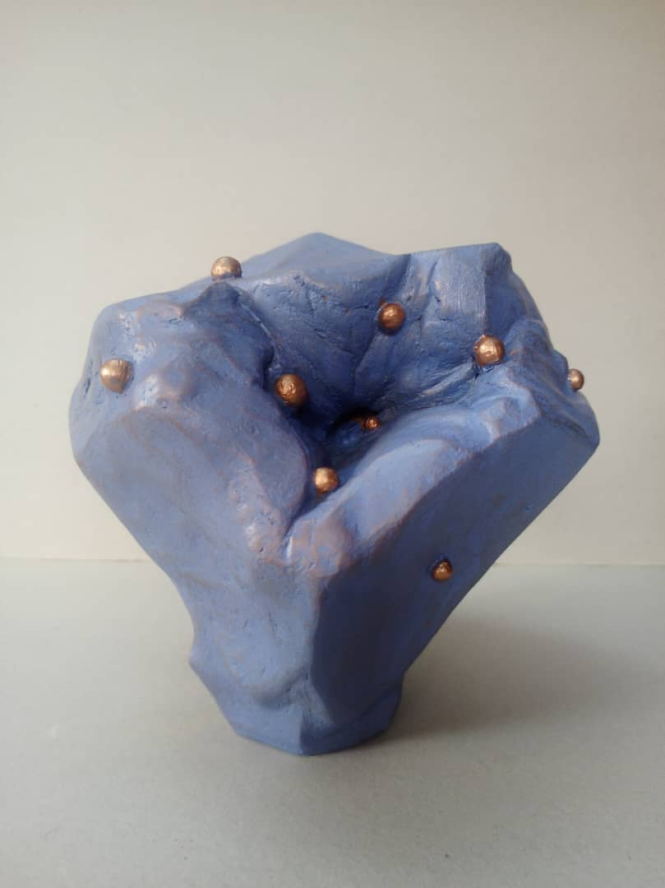
Plate 1: "Cosmic Returns" Medium: Fired Clay, Size:28/22/20cm
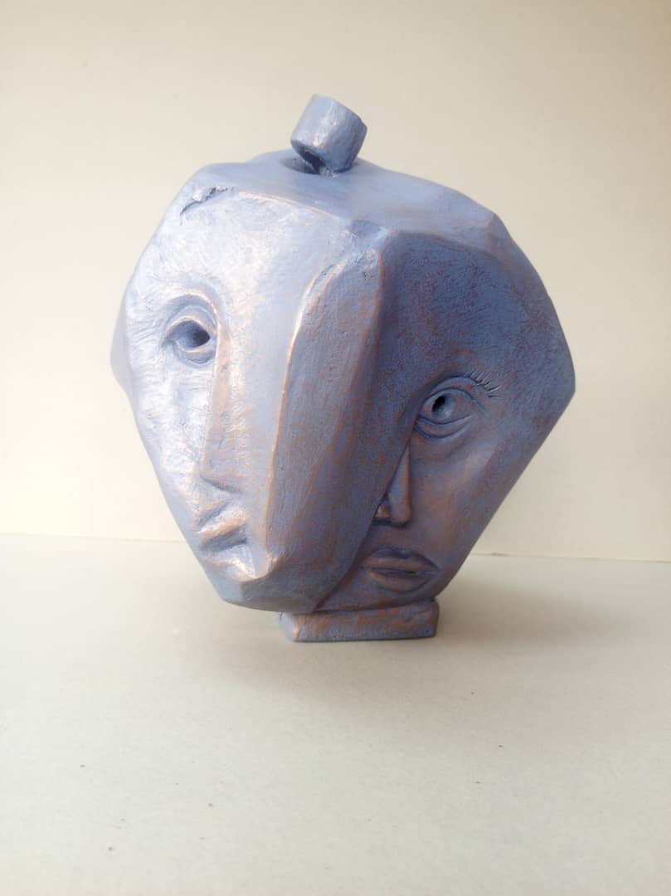
Plate 2: "Rock with Masks” Medium: Fired Clay, Size: 27/23/23cm, Date: 2023

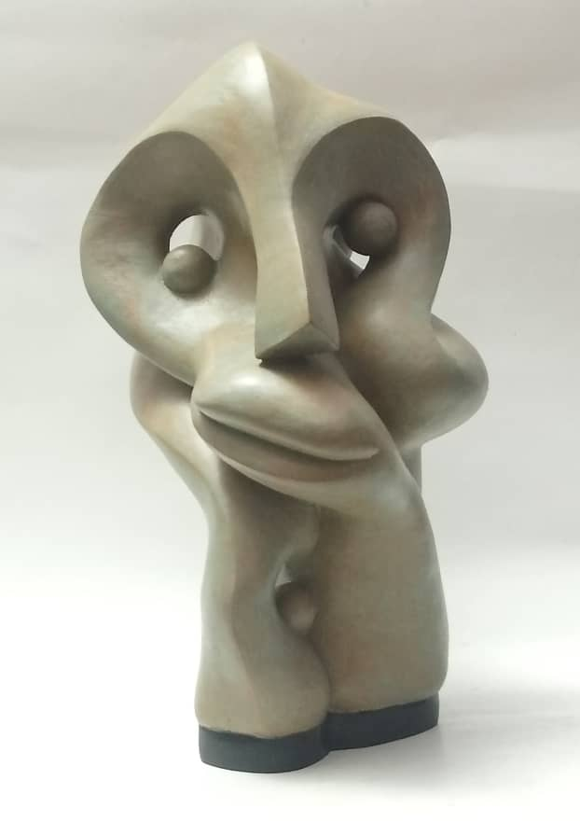
Plate 3: “Head II" Medium: Fired Clay Size: 44/28/32cm Date: 2024

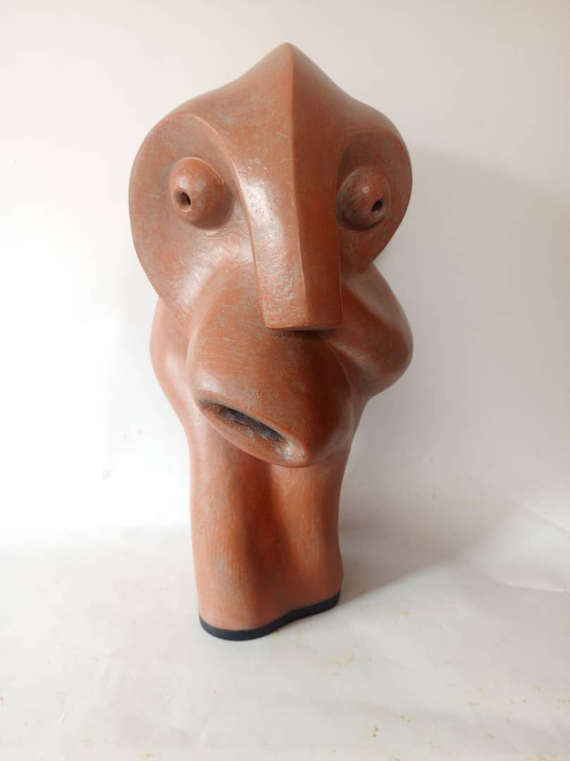
Plate 4: “Head I" Medium: Fired Clay, Size: 41/23/26cm

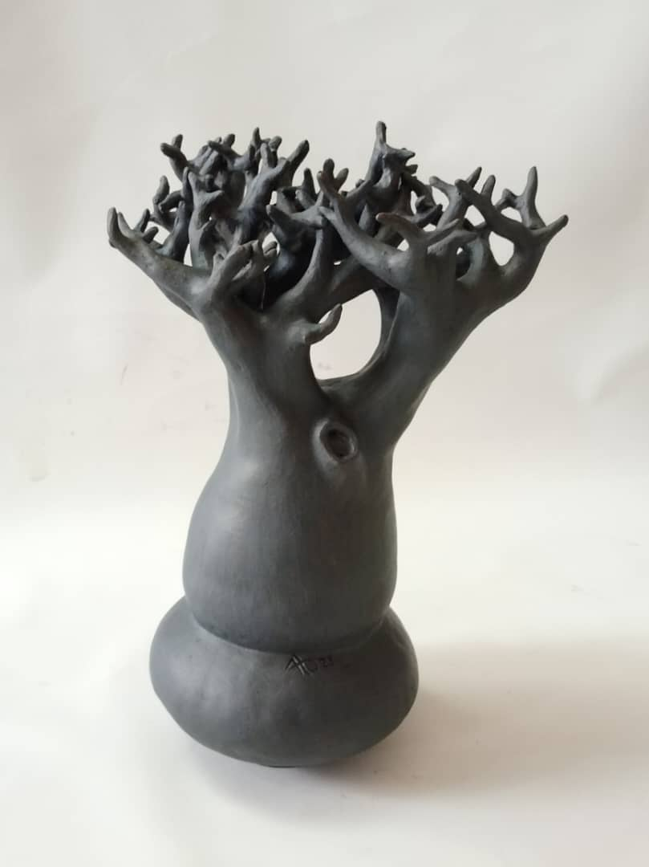
Plate 5: "Baobab Tree IV" Medium Fired Clay Size: 55/34/29cm, Date: 2025

Ozioma Onuzulike
Ozioma Onuzulike is a ceramic artist, African art and design historian, and poet whose studio practice has to a large degree addressed the historical and sociological roots of the political and socio-economic crises in Africa and their incapacitating impacts on everyday life in the continent. He uses terracotta to explore the sociological and historical foundations of political and socio-economic upheaval in Africa. His sculptures tend to assume textured surfaces and organic forms reminiscent of traditional African aesthetics with a focus on contemporary concerns (Plate 6 - 9). Onuzulike's production is marked by a firm commitment to material culture, employing terracotta to remark on colonialism, identity, and resilience (AFIKARIS).

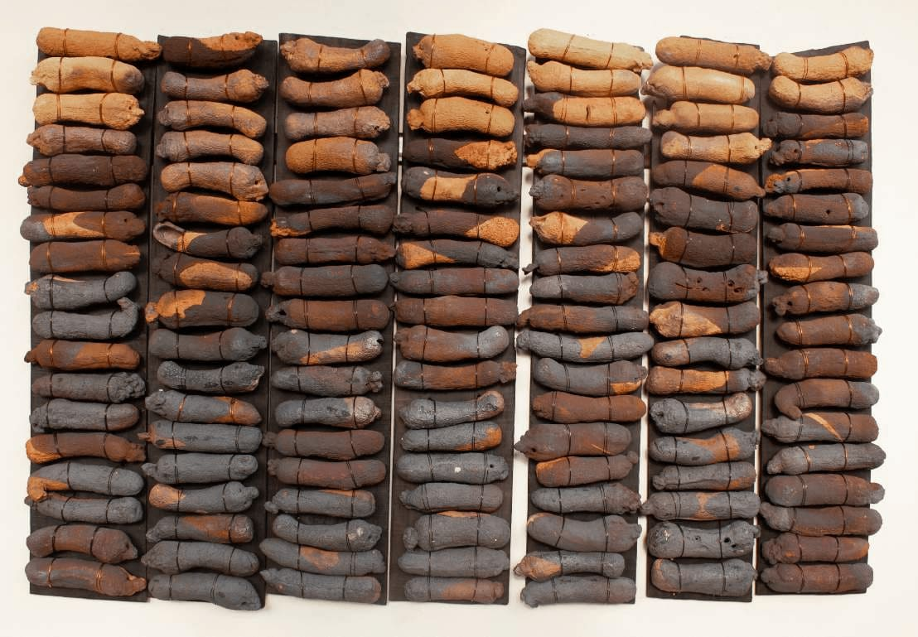
Plate 6: Burnt Yam Barn II, 2023
Earthenware and stoneware clays, burnt wood, iron oxide engobe, glaze, recycled glass and copper wire (91 kg)
127$×$193$×$10cm 50 $×$ 76 $×$ 4 in.

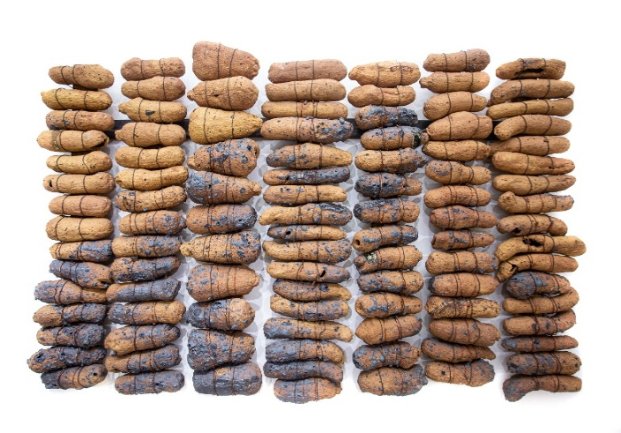
Plate 7: Yam Bodies: Dry Season I, 2019
Terracotta (iron-saturated stoneware clay body), mild steel, copper-coated aluminum wire and wood 103 $×$ 164 $×$ 17 cm (variable installation)
https://ko-artspace.com/artists/51-ozioma-onuz

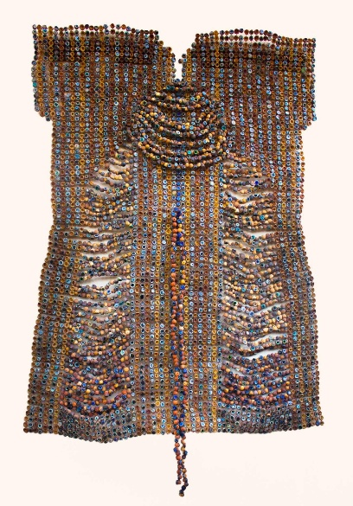
Plate 8: Beaded Blouse for Aisha, 2023
Earthenware and stoneware clays, ash glazes, recycled glasses and copper wire (5040 ceramic palm kernel shell beads) (53 kg) 70$×$50$×$15 in
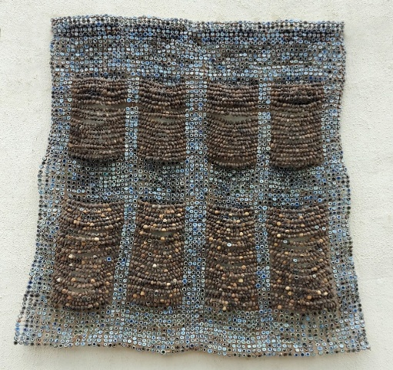
Plate 9: Royal Skirt, 2022
Stoneware clay bodies, palm kernel shells, recycled glass, and copper
wire (5,382 ceramic and natural palm kernel shell beads) 70 1/2$×$47$×$6 in 179.1$×$119.4 $×$ 15.2 cm.

Ngozi Omemee:
Ngozi Omeje is celebrated for complex ceramic installations that frequently include terracotta components. Her pieces address identity, spirituality, and the human condition, derived from Nigerian cultural symbols and personal biography (Plate 10 - 13). Technical experimentation and conceptual rigor have placed Omeje at the forefront of African ceramics in the contemporary period (SMO Contemporary Art).

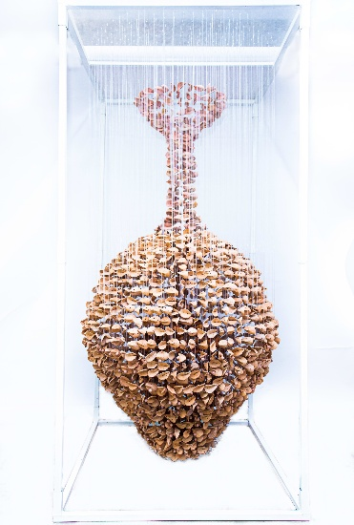
Plate 10: Freedom, from the Leaf series, 2020
Terracotta, acrylic, monofilament fishing line, metal 35 7/8$×$35 7/8$×$763/4 in
91$×$91$×$195cm.https://koartspace.com/artists/34-ngozi-omeje-ezema/works/223-ngozi-omeje-ezema-union-ii-2020/
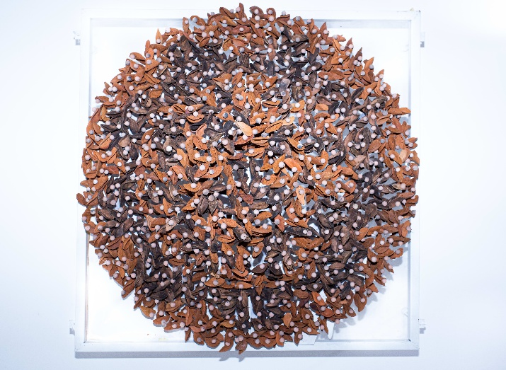
Plate 11: Keeper of light, 2020
Terracotta, acrylic, monofilament fishing line, metal 35 7/8$×$35 7/8$×$11 3/4 in
91$×$91$×$30cm. https://koartspace.com/artists/34-ngozi-omeje-ezema/works/223-ngozi-omeje-ezema-union-ii-2020/

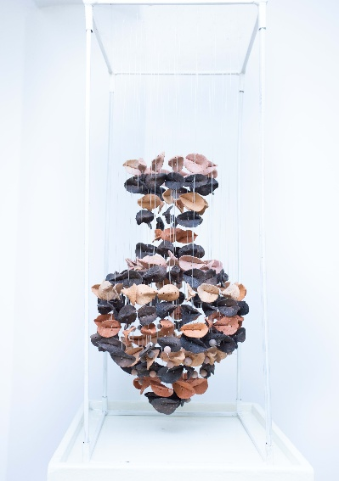

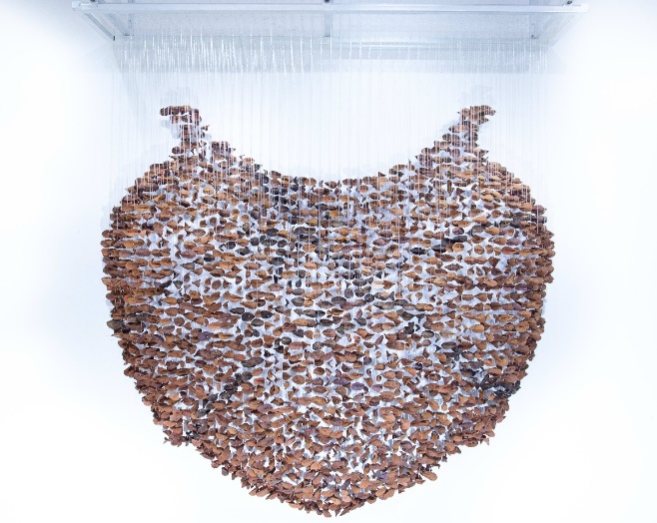
Plate 12: Vase, 2020
Terracotta, acrylic, monofilament fishing line, metal 11 3/4$×$11 3/4$×$29 7/8 in
30$×$30$×$76cm.https://koartspace.com/artists/34-ngozi-omeje-ezema/works/223-ngozi-omeje-ezema-union-ii-2020/

Plate 13: Union II, 2020
Terracotta, acrylic, monofilament fishing line, metal 59 7/8$×$11 3/4$×$83 7/8in
152$×$30$×$213cm.https://koartspace.com/artists/34-ngozi-omeje-ezema/works/223-ngozi-omeje-ezema-union-ii-2020

Djakou Kassi Nathalie
Djakou Kassi Nathalie is a Cameroonian painter and ceramist based in Lagos, Nigeria. Spanning over two decades of studio practice, her work encompasses ceramics, bonded stone, wood, and bronze, inspiring deep interest in materiality, form, and contemporary African identity. She started training to be an artist in Cameroon and started working professionally in 1998, before teaching at the Institut de Formation Artistique and running ceramic studios at the Centre d'Art Appliqué, Mbalmayo. She is also the founder of DECERAM, a group dedicated to ceramic arts. Djakou has shown work in many exhibitions in Europe, Asia, Africa, and the US, such as China Changchun International Ceramic Symposium, SAY MY NAME in London, DEUS EX FEMINA in Dubai, and FACE 2025 in the UK. She has also had significant two-person shows with Nigerian sculptor Ato Arinze and been featured in high-visibility group exhibitions curated by SMO Contemporary and Alexis Galleries. A committed mentor and workshop facilitator, Djakou belongs to the Guild of Professional Fine Artists of Nigeria (GFA), Society of Nigerian Artists (SNA), Sculptors Association of Nigeria (ScAN), and Visions in Clay Artists Network (VICAN). Her pieces are found in private and institutional collections, such as HRM Nnaemeka Achebe, Access Bank, and private individuals in Nigeria, Cameroon, and India. Her practice has been extensively recorded in scholarly research in Africa, Europe, and North America (Plate 14 - 16).

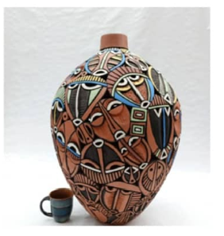
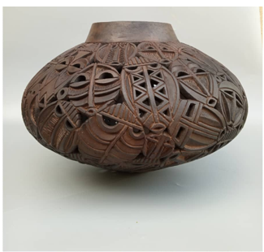

Plate 14: Euphoria, medium glazed clay. Size: 78cm$×$56cm 2022.
Plate 15: Tribals, 2021. Nicole Kadji Collection

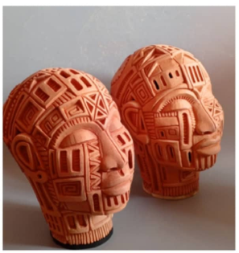
Plate 16: The architect. Medium terracotta. Size 37cm$×$35cm 2024.

These case studies demonstrate terracotta's versatility and modern-day applicability in Nigerian sculpture. Every artist interacts with the material in novel and fresh ways, pushing conventional boundaries and challenging the frontiers of ceramic art. These artists' practices highlight terracotta's possibilities as a vehicle for critical practice, cultural exchange, and aesthetic investigation.
Terracotta as a Resistant and Innovative Medium
Following the foregoing analyses, this section explores how terracotta is a tool of resistance and a means of innovation in modern Nigerian sculpture. Not only did the artists featured herein resuscitate an older material, but they also used it tactically to undermine dominant hierarchies in art and material culture.
Challenging Material Hierarchies
Historically, the imposition of Western art canons during and after colonialism pushed local materials such as terracotta to the margins of global art discourse (Kasfir, 2007). By working with terracotta, Nigerian artists actively challenge the colonial-material hierarchy that favours industrial and "modern" materials such as bronze, plastic, and steel. Their works challenge assumptions that identify terracotta with primitivism or cultural stasis, instead casting it as a vibrant and intellectually engaging medium (Okeke-Agulu, 2015).
Re-centring Indigenous Media in the Global Discourse
Such artists as Onuzulike and Omeje reinstate terracotta within modern aesthetic discourse, showing that local material is not a remnant of the past but an effective marker of identity and cultural continuity. By showing their work in local and even international venues, the artists move terracotta from the periphery to the centre of global contemporary practice, adding to a wider decolonial discourse (Salemink et al., 2023; Oguibe, 1999).
Sustainability and Environmental Issues
Terracotta, clay fired at relatively low temperatures, is arguably the most ecologically friendly sculptural material. Artists such as Djakou Kassi Nathalie highlight this merit by employing terracotta to remark on environmental decline, mass consumption, and the necessity of ecologically sustainable artistic production. Utilization of local, biodegradable materials not only complies with international environmental ethics but also bolsters indigenous frugality cultures (Miller, 2005).
Expressive Potential of Recent Narrative-construction
The haptic and malleability of terracotta as medium are especially adaptable to narrative construction. Artists from the scarred surfaces of Onuzulike to Arinze's complex forms utilize the material's expressiveness to narrate experiences of trauma, healing, resilience, and spirituality. These narratives are not only culturally located but possess international resonance, and terracotta is a conceptual art medium of depth and artistic experimentation today (Gell, 1998)
Discussion
The above is case studies and thematic analyses casting light on the changing status of terracotta in modern Nigerian sculpture, demonstrating the renaissance of a material both with historical and contemporaneous relevance. A synthesis of these findings not only demonstrates a material renaissance but also a paradigmatic shift in how Nigerian artists is negotiating tradition, modernity, and the global art canon.
Synthesis of Results
Through the selected case studies (Ato Arinze, Ozioma Onuzulike, Ngozi Omeje, and Djakou Kassi Nathalie) terracotta is demonstrated as a powerful force of artistic resistance and innovation. These artists defy linear narratives of progress that favour imported industrial materials by employing terracotta to produce conceptually dense, ecologically sensitive, and culturally attuned art. The material's inherent tactility and natural state allow for expressive experimentation while evoking ancestral knowledge and spiritual symbolism.

Implications for Nigerian and African Art History
Terracotta's revival defies the expectation that native media are the exclusive preserve of the pre-modern or ethnographic past. Instead, its modern applications highlight the permeable boundaries between modernity and tradition in African art history. By tapping into terracotta's cultural past and experimenting with new forms and significance, Nigerian sculptors claim authorship in inscribing counternarratives that remake colonial temporality and aesthetic hierarchies (Okeke-Agulu, 2015; Kasfir, 2007). This reclamation calls for a revision of African art history by material continuity, rather than rupture.
Relevance to Modern Sculpture Globally
This reimagining of terracotta puts Nigerian artists in conversation with global debates of materiality, sustainability, and cultural identity. Within an increasingly ethics-conscious international art world attuned to the decolonialization of curatorial practice and the politics of material use, the works speak as both local and transnational utterances. The global visibility of these artists (through international exhibitions, biennales, and critical scholarship) positions terracotta as a strong and viable sculptural language in today's vocabulary (Salemink et al., 2023).
Contributions to Decolonial Aesthetics and Material Re-evaluation
Terracotta's re-visibility makes a strong decolonial aesthetic contribution by reasserting local materiality and knowledges that were previously denied by Eurocentric art history. These artists defy the "traditional" versus "contemporary" binary by showing that terracotta can simultaneously be ancient knowledge and revolutionary innovation. Their work demonstrates material agency, not merely as matter, but as a vehicle of memory, critique, and transformation (Gell, 1998; Miller, 2005). This re-engagement with materials promotes a longer view of modernity that encompasses indigenous philosophies, technologies, and aesthetics.
Conclusion
Throughout this essay, we have seen the renaissance of terracotta as a significant medium in modern Nigerian sculpture, and how a new generation of artists is revisiting its expressive and conceptual possibilities. Through a combination of historical context, theoretical framework, field-based research, and case studies, the study has demonstrated that terracotta is much more than a cultural medium; it is a vibrant site for contemporary artistic experimentation, cultural critique, and material innovation. The main findings are that artists like Ozioma Onuzulike, Ngozi Omeje, Ato Arinze, and Djakou Kassi Nathalie are not simply resurrecting terracotta for aesthetic appeal; they are using it as a way of resisting colonial hierarchies of material, legitimizing indigenous knowledge systems, and addressing pressing socio-political and environmental concerns. Their artworks show the potential of terracotta to connect the past and the future, and to make a distinctive contribution in an African way to international contemporary sculpture. Terracotta's changing function also attests to its ability to challenge dominant art histories and create space for decolonial visualities. It demands a material reimagination of modernity according to local terms but of global consequence. Future research could explore further the reception of terracotta-based art by international audiences in global art markets, conduct comparative analysis with other local materials, and explore the pedagogical potential of terracotta for art education on the African continent.

References
Appadurai, A. (1986). The social life of things: Commodities in cultural perspective. Cambridge University Press. https://doi.org/10.1017/CBO9780511819582
Braun, V., & Clarke, V. (2006). Using thematic analysis in psychology. Qualitative Research in Psychology. https://doi.org/10.1191/1478088706qp063oa
Coombes, A. E. (Ed.). (2006). Rethinking settler colonialism: History and memory in Australia, Canada, Aotearoa New Zealand and South Africa. Manchester University Press. https://doi.org/10.7765/9781526121547
Creswell, J. W., & Poth, C. N. (2018). Qualitative inquiry and research design: Choosing among five approaches (4th ed.). Sage Publications. https://us.sagepub.com/en-us/nam/qualitative-inquiry-and-research-design/book246267
Salemink, O., Corrêa, A. S., Sejrup, J., & Nielsen, V. (Eds.). (2023). Global art in local art worlds: Changing hierarchies of value. Routledge Taylor & Francis Group. https://doi.org/10.4324/9781003128908
Enwezor, O., & Okeke-Agulu, C. (2009). Contemporary African art since 1980. Damiani. https://www.damianieditore.com/usa/product/contemporary-african-art-since-1980
Gell, A. (1998). Art and agency: An anthropological theory. Oxford University Press. https://doi.org/10.1093/oso/9780198280132.001.0001
Kasfir, S. L. (2007). African art and the colonial encounter: Inventing a global commodity. Indiana University Press. https://iupress.indiana.edu/9780253219220/african-art-and-the-colonial-encounter/
Miller, D. (2005). Materiality: An introduction. In D. Miller (Ed.), Materiality (pp. 1–50). Duke University Press. https://doi.org/10.1215/9780822386711
Mitchell, P., & Lane, P. (Eds.). (2013). The Oxford handbook of African archaeology. Oxford University Press. https://doi.org/10.1093/oxfordhb/9780199569885.001.0001
Nwigwe, C., Asogwa, O., & Okafor, M. (2024). Dress as the agency of power: Ozioma Onuzulike’s ceramic art. Fashion Theory, 28(5–6), 789–812. https://doi.org/10.1080/1362704X.2024.2388945
Oguibe, O. (2004). The culture game. University of Minnesota Press. https://www.bibliovault.org/BV/showpage.asp?ISBN=9780816641314
Ogbechie, S. O. (2008). Ben Enwonwu: The making of an African modernist. University of Rochester Press. ISBN: 9781580462358
Okeke-Agulu, C. (2015). Postcolonial modernism: Art and decolonization in twentieth-century Nigeria. Duke University Press. https://www.dukeupress.edu/postcolonial-modernism
Omeje, N. (2025). The tale of Nneburube. Garland Magazine. https://garlandmag.com/article/the-tale-of-nneburube/
Palinkas, L. A., Horwitz, S. M., Green, C. A., Wisdom, J. P., Duan, N., & Hoagwood, K. (2015). Purposeful sampling for qualitative data collection and analysis in mixed method implementation research. Administration and Policy in Mental Health and Mental Health Services Research, 42(5), 533–544. https://doi.org/10.1007/s10488-013-0528-y

Patton, M. Q. (2015). Qualitative research & evaluation methods: Integrating theory and practice (4th ed.). Sage Publications. https://us.sagepub.com/en-us/nam/qualitative-research-evaluation-methods/book242592
Savoy, B., & Bodenstein, F. (Eds.). (2018). Spoliation or restitution? Critical perspectives on museum heritage. Berghahn Books. https://doi.org/10.2307/j.ctvw04h7c
Sarr, F., & Savoy, B. (2018). The restitution of African cultural heritage. Toward a new relational ethics. Report to the President of the French Republic. http://restitutionreport2018.com/sarr_savoy_en.pdf
Onuzulike, O. (2024, September 26). Profile of Nigerian ceramicist Ozioma Onuzulike. Say Hi to Atlas. https://sayhito-atlas.com
Bright, J. C. (2018). Ngozi Omeje: Connecting Deep at Centre for Contemporary Art Lagos. Temporary Art Review. https://temporaryartreview.com/ngozi-omeje-connecting-deep-at-centre-for-contemporary-art-lagos/
Thompson, R. F. (1974). African art in motion: Icon and act. University of California Press. https://www.ucpress.edu/book/9780520324633/african-art-in-motion https://www.abebooks.co.uk/9780520026858/African-art-motion-Icon-act-0520026853/plp
Ngũgĩ wa Thiong’o. (1986). Decolonising the mind: The politics of language in African literature. Heinemann. https://eastafricanpublishers.com/product/decolonising-the-mind-the-politics-of-language-in-african
Willett, F. (1967). Ife in the history of West African sculpture. Thames & Hudson. https://www.cambridge.org/core/journals/antiquity/article/frank-willett-ife-in-the-history-of-west-african-sculpture-london-thames-and-hudson-1967-232-pp-including-123-pls-13-in-colour-41-figs-84s/12111111111111111111111111111111
Willett, F. (1967). Ife in the history of West African sculpture. Thames & Hudson. https://www.cambridge.org/core/journals/antiquity/article/frank-willett-ife-in-the-history-of-west-african-sculpture-london-thames-and-hudson-1967-232-pp-including-123-pls-13-in-colour-41-figs-84s/11111111111111111111111111111111

