Original Research Article
UNDER PEER REVIEW

Optimization of Plant Growth Regulators for Efficient In Vitro Morphogenesis and Plantlet Regeneration in Bambusa vulgaris

Abstract
Bamboo is the world’s sturdiest and multipurpose woody plant proficient in providing environmental, commercial, and livelihood safety to society, and is also recognized as ‘Green Gold’, ‘Miracle plant’. It has conventionally been propagated through seed or vegetative methods, but these methods are beset with several problems. Functioning arrangements prerequisite to be implemented to protect bamboo from excessive pruning and to inspire its sustainable growth and development to meet demands and ecological safeguarding. Thus, during the current investigation, a protocol has been established to regenerate plantlets through direct in vitro organogenesis from inoculated nodal segments excised from thee-year-old plants. Nutrient medium MS3B.5Kn.5G encompassing MS basal medium supplemented with 3.0 mgl-1 BAP in combination with 0.5 mgl-1 Kn and 0.5 mgl-1 GA3 proliferated maximum shootlets (78.03%) with higher number (7.0) and a bigger length (6.32 cm). The highest rooting efficiency (77.78%) with higher root number (4.07) and length (9.50cm) was evident on MS medium amended with 5.0 mgl-1 IBA. Whereas, maximum survival percentage (86.67) of regenerants was recorded on potting mixture comprising sand, soil, and farmyard in a 1:1:1 ratio under greenhouse conditions after six weeks of primary hardening. The in vitro raised regenerants were accustomed and established effectively under the field conditions. Although the characters were not scored quantitatively, regenerated plantlets appeared phenotypically normal and similar to the mother plants.
Keywords: Bambusa balcooa, in vitro propagation, morphogenesis, nodal segment and plantlet regeneration.

Introduction
Bamboo is the world’s toughest and multipurpose woody plant capable of providing ecological, economic and livelihood security to the society, and also recognized as ‘Green Gold’, ‘Wonder plant’ (Tamang et al., 2013). These are long-standing, woody, evergreen-members of the subfamily Bambusoideae of the of family Poaceae (Singh et al., 2012). These are disseminated all over the universe with 75 genera and 1400 species, but the majority are found in the tropics, although they are found naturally in all subtropical and temperate zones except in Europe (Nirala et al., 2017). Out of 157 species of the genus Bambusa, Bambusa balcooa Roxb., commonly known as Beema bamboo or female bamboo, stands out as a precedence species for farmers owing to its extraordinarily thick and hardy clumps (Jeyachitra et al., 2025).
UNDER PEER REVIEW
The species has manifold uses including paper making, since it delivers good quality paper pulp, biofuel-based energy production, insect pest management through pyrolyzed vinegar, fiber development, edible and nutritious tender shoots, seeds for making pickles and beer, leaves for treating diabetes and other ailments, scaffolding, furniture making and decorative items (Subbanna and Viswanath, 2018; Arsyad et al., 2020; Dahal et al., 2020; Viswanath et al., 2021; Ma et al., 2023 ). Selected B. balcooa clones have been used to create an 'oxygen park' (Sundararaju, 2021). The bamboo species stabilizes the earth with its roots, preventing erosion (Yasodha et al., 2008) and used as activated charcoal (Suwal et al., 2020). Gasification of bamboo can produce electricity using bamboo biomass as fuel National Mission on Bamboo Application (NMBA). Carbon sequestration in bamboo recycles a huge amount of CO2 (12 tons/hectare) and produces 35% more oxygen than an equivalent stand of trees (Venkatachalam et al., 2015). They also play a vital role in water conservation, wind barrier, and as bio-fencing (Venkatachalam et al., 2015). Bamboo leaf extract has been reported for anticancer properties (Wei et al., 2015), anti-inflammatory and antiulcer properties (Thapa et al., 2018; Verma & Mishra, 2018).
Due to its multiple uses, the global demand for bamboo is expected to reach a revenue of USD 98.3 billion with a Computed Annual Growth Rate (CAGR) of 5% by 2025. The same study predicted that the biomass energy market will reach USD 98.0 billion by 2027 with a CAGR of 9.2% from 2020 to 2027 (FSI Report, 2021). India has 16.1 million hectares of bamboo forest (12.6% of the country’s total forest area) (FSI Report, 2021). Therefore, it is necessary to ensure the availability of bamboo plants for transplantation to achieve this goal.
It has traditionally been propagated through seed or through vegetative methods, but these methods are associated with several problems (Anand & Brar, 2013). For bamboo as various propagation techniques are available, including, seed propagation, clump division, rhizome and culm cuttings (Yuan et al., 2017; Chavan et al., 2021; Waghmare et al., 2021; Anbuselvi et al., 2022). Conventional methods of propagation are limited due to issues such as seed sterility, the non-availability of seeds, unpredictable and lengthy flowering cycles, and the long flowering cycles, and bulkiness of rhizomes (Choudhary et al., 2022). Furthermore, the habit of unpredictable and gregarious flowering and seeding, followed by death, makes bamboo propagation uncertain through seeds which have short viability (Devi et al., 2012). Tissue culture may prove an excellent substitute to address these issues by producing uniform planting materials without endangering the mother plants (Ahuja et al., 2016; Tiwari et al., 2021; Tripathi et al., 2021a; Tripathi et al., 2021b; Tripathi et al., 2022a).
UNDER PEER REVIEW
In order to achieve the goal of large-scale production, in vitro micropropagation through different explants offers great potential for commercial-scale production of bamboo. Therefore, it is imperative to adopt the latest plant biotechnologies, new utilities of bamboo could progress beyond the current level. Tissue culture is one essential technique to micro propagate from plant tissues, and it is also used for genetic improvement by different transformation strategies (García-Ramírez et al., 2014; Kalaiarasi et al., 2014; Goyal et al., 2015; Raju et al., 2016; Khare et al., 2021). Extensive research on micropropagation of bamboo species has been carried out employing seed or seedling (Devi et al., 2012; Sood et al., 2014) and nodal segments (Devi & Sharma, 2009; Kapruwan et al., 2014; Kavitha et al., 2014; Kaladhar et al., 2017; Gunasena et al., 2024) with more than 40 species of bamboo by various researchers throughout the world with varying degrees of success.
Though there were reports on shoot bud regeneration from different bamboo species, the regeneration rate was found to be low (Zhang et al., 2010) and still an efficient protocol for in vitro propagation is a prerequisite for large-scale production of bamboo seedlings, thus paving the way for successful genetic manipulation. In vitro morphogenesis, seems to be reliant on the genotype, explant source and culture medium, and therefore, it is essential to develop specific regeneration protocols for each explant (Tiwari et al., 2007; Jhankare et al., 2011; Ray et al., 2016; Tripathi et al., 2022b; Tripathi et al., 2022c). Hence, the present study meant to establish an inclusive system for the extensive propagation of Bambusa vulgaris using nodal segments as an explant, as it is obtainable all over the year, by computing optimal concentrations and combinations of plant growth regulators to be added in the culture medium revealing higher in vitro morphogenesis tracked by an efficient plantlet regeneration.

Material and Methods

Explant material
The present study was conducted at the Plant Tissue Culture & Genetic Transformation Laboratory, Department of Plant Molecular Biology & Biotechnology, Rajmata Vijayaraje Scindia Agricultural University, Gwalior M.P., India during the years 2020- 2021. The nodal segments explants were three-year-old Bambusa vulgaris plants, planted at the Agricultural Farm, Sirsod, Rajmata Vijayraje Scindia Agricultural University, Gwalior, M. P., India.
UNDER PEER REVIEW

Culture media

To start with a preliminary experiment, two different fortifications of basal media viz, MS (Murashige and Skoog, 1962) and WP (Lloyd and McCown, 1980), were evaluated to search for better in vitro response. In the initial study, MS basal medium was found to be more responsive than WP media (data interpreted primarily through visual observations); henceforward, for later investigations, basal MS medium was employed. All nutrient media were prepared using readymade basal MS medium (HiMidiaTM) and supplemented with two distinct sets of plant growth regulators. In the first set: three diverse cytokinins, viz., BAP, Kn, and TDZ alone, and in the second set: three diverse cytokinins, i. e., BAP, Kn, and TDZ in combination with two auxins, i.e., NAA and IBA, and GA₃ in varying concentrations and combinations to accomplish enhanced in vitro response. Besides MS basal macro and micro salts, vitamins, all nutrient mediawere added with 30.0 gl-1 sucrose, and the final volume was made to 1000 ml, and pH was adjusted to 5.8 ± 0.1 with 1N KOH. After adjusting the pH, agar @ 7.5 gl-1 was added to the media as a semi-solidifying agent. Warm nutrient media, still in liquid state were bestowed into culture bottles (50-60 ml / bottle) and culture tubes (15-20 ml/ tube), tracked by autoclaving at 121 °C under 15 psi pressures for 20-25 min. Readymade basal media, plant growth regulators and other ingredients were acquired from Hi-media Laboratories, Mumbai, India.

Surface sterilization of donor plant

Nodal segments were acquired from the elite plants excised as a single node from the mother plant and were cleaned gently employing a paintbrush and dipped in distilled Tween 20 (3.0 ml⁻¹) solution, tracked by washing with double-distilled water with mild agitation. The explants were again dipped in a fungicide: carbendazim (2.0% w/v) solution made in 100 ml distilled water and kept in a rotatory shaker for 20-45 min and then systematically washed with double-distilled water. Then surface sterilization was carried out inside the Laminar Air Flow Cabinet where they were treated with either aqueous solution of 0.1% (w/v) mercuric chloride (HgCl₂) or 0.2% NaOCl for 5 to 20 min, followed by washing with double-distilled- water four to five times. The explants were then treated with 7 0% (v/v) ethanol for diverse durations and then washed with autoclaved sterile double- distilled water four to five times before inoculation.

Nodal segment excision and plating technique

The surface-sterilized nodal explants were trimmed at cut ends with a surgical blade, and nodal portions measuring 2.0- 3.0 cm in length were inoculated on nutrient media.

Culture conditions

Baby food bottles/culture tubes containing cultures, shielded with Lab film (Parafilm®), were incubated under complete darkness at 25±2°C for one week. Later in vitro inoculated nodal segments were exposed to photoperiod Photosynthetically Active Radiation lamps at 25±20C °C management of 16 hours light/8 hours dark series at an intensity of 2000-lux luminance providing combinations of fluorescent tubes and and 65-70% relative humidity.

Subculture
The responding nodal segments were transferred recurrently every 15 days into fresh media with similar composition to the initial media.

Regeneration of plantlets
After 3-4 weeks of initial inoculation, nodal segments tracked mostly direct plant regeneration i.e., via auxiliary bud proliferation. Shootlets obtained from direct proliferation were transferred to MS elongation medium amended with 0.5 mgl-1 GA3, 20.0 gl-1 sucrose and 7.5 gl-1 agar. For regeneration, an abbreviated amount of sucrose was employed based on previous work conducted by different scientists as well as our laboratory's earlier experiences (Sharma et al., 2003; Baghel et al., 2008; Mishra et al., 2021; Shyam et al., 2021; Sharde et al., 2023). Cultures were subjected to 25±2oC temperature and photoperiod commands of 60 μmol m⁻² s⁻¹luminance facilitated by cool fluorescent tubes for 16 hr.
  - In vitro rooting of regenerants
If root formation was not seen in regenerants, they were subsequently transferred to MS medium fortified with diverse concentrations of IBA and NAA in different concentrations, as well as in various concentrations and combinations, 15.0 gl-1 sucrose and 7.5 gl-1 agar. For rooting, an abridged level of sucrose was supplemented on the basis of work conducted by various scientists as well as earlier experiences of this laboratory (Uikey et al., 2016; Tripathi et al., 2022d; Tripathi et al., 2023a; Tripathi et al., 2024a; Tripathi et al., 2025a).

Acclimatization of regenerants

After regeneration of plantlets following successive culturing stages, the rooted healthy plants were carefully removed from the culture vessels and thoroughly washed with distilled water to eliminate traces of agar. Before planting in plastic pro-trays filled with diverse potting mixtures viz., sand, soil and FYM in different ratios and combinations, the regenerants were treated with fungicide by dipping them in 0.5 percent Bavistin solution for 2 min. Root trainers wit transplanted plantlets were then transferred under 30±2oC and 60±5% relative humidity for 40-45 days in greenhouse/polyhouse for primary hardening. Then these were transferred under the field conditions.
REVIEW

Experimental design and analysis of data
PEER

All experiments were carried out in a Completely Randomized Design (CRD) with two replications. Each treatment and each replication contained 70-80 nodal segments. Phenotypic observations of the cultures were made every week and data interrelated to shoot proliferating competence, numbers of shootlets, root proliferating efficiency, numbers of roots, and root length were recorded. Data were analyzed employing Duncan’s Multiple 35- Range Test (DMRT). Mean denoted with different letters in the same column differed significantly at p = 0.05. The SPSS version 23.0 programme was employed for analysis. Whereas the survival percentage was analyzed by using percentage the arcsine transformation since the data were in percentages. The data were analyzed for means and standard error as per suggestions proposed by Snedecor and Cochran's (1997).

Results and Discussion
UNDER

Establishment of Aseptic Culture

Nodal segments isolated from field-grown mother plants are seeded with an array of microorganisms that must be eliminated before inoculation into the culture media. Contamination may blow out from the nodal segment to the cultures even if most of the microorganisms are eliminated (Tripathi et al., 2023b; Tripathi et al., 2023c). Henceforth, one of the most critical movements in establishing an aseptic culture is standardizing the explant surface sterilization method. The most frequently employed surface sterilants in plant tissue culture are carbendazim (fungicide), mercuric chloride (HgCl₂), sodium hypochlorite (NaOCl), and 70% (v/v) ethanol (Tripathi et al., 2023d; Tripathi et al., 2024b; Sharma et al., 2025). Different sterilants, their concentrations, and exposure times are well recognized to influence the in vitro culture establishment to a great extent (Vibhute et al., 2022). Similarly, surface sterilization procedure for Bambusa species has been delineated by several scientists previously by Singh et al. (2013), Yuan et al. (2013), Kapruwan et al. (2014), Mudoi et al. (2014), and Kumar et al. (2018). However, depending on the type of tissue or explant used, a different sterilization procedure needs to be established.

In the current investigation, highly significant (p < 0.05) differences existed among the responses to diverse surface sterilizing and antifungal agents. The data presented in Table 1 exhibited that for nodal segments a noteworthy reduction in microbial contamination was recorded when nodal segments were treated with a combination of carbendazim + HgCl2 (2.0% + 0.10%) for 10 + 15 min correspondingly, resulting in a survival rate (61.65%) as bacterial contamination was detected after 5-6 days of inoculation. Fungal contamination was controlled using 0.2 % carbendazim, as previously suggested by Singh et al. (2012) and Kumar et al. (2018). According to Wei et al. (2015), treatment of explants with 0.1% HgCl2 for a shorter period of time increased the explants' survival rate and bud break frequency. Kumar et al. (2018) also found that sterilization of the nodal segments of D. asper with 0.1% HgCl2 in combination with 0.2% carbendazim, increased the chances of aseptic culture establishment. Waikhom and Louis (2014) also found that treatment with 0.1 percent HgCl2 for a long duration proved the best for the sterilization of explants. The amount of bacterial and fungal contamination in D. strictus reduced when treatment duration was extended while maintaining a similar HgCl2 concentration (Devi et al., 2012). NaOCl was also proved operative with varying time intervals to control bacterial contamination in some cases as addressed by Jimenez et al. (2007). Several researchers have also employed antiseptics such as savlon, Tempol, streptomycin sulphate, gentamicin, cetavelon, etc. for the formation of a pure culture of bamboo (Anand & Brar, 2013; Sood et al., 2014) and fungicides such as tetracycline, bavistin, benomyl, mancozeb etc. (Anand & Brar, 2013).

Furthermore, nodal segments excised from the top 1-10 nodes could not induce higher bud break, possibly because of the tender nature of buds (Kurmi et al., 2011). The exposure of explants to sterilants antioxidants may damage these soft tissues (Sharma et al., 2010). Maximum bud break was observed at 10-12 nodes, likely due to the juvenile status and the ability to withstand the toxic effects of surface sterilizing agents (Tripathi et al., 2023e). These findings are in accordance with the results of Tripathi et al. (2025a) and Tripathi et al. (2025b), who also obtained higher morphogenic response tracked by plantlet regeneration that seems to be remarkably dependent on the position of the explant in many horticultural and medicinal crop plants. Investigations have also shown that the lower or mid portion of the branch is calmer to establish in vitro than the upper portion (Vibhute et al., 2022). Moreover, due to the strong endogenous hormonal influence, explants 2.5 mm in size were found to be more effective than explants 5-7 mm in initiating the culture quickly in bamboo (Oprins et al., 2004).

In Vitro Morphogenesis
In the present investigation, inoculated nodal segments followed mostly the direct path of plantlet regeneration, where they were regenerated directly on the explant surface via auxiliary bud proliferation without an intervening callus phase. In Fig.1: A mother plant has been demonstrated from which nodal segments were excised and depicted in Fig. 1: B. Shootlets were developed directly from the meristematic zones of inoculated nodal segments (Fig.1: C). Shoot formation was started around 7 days after initial culturing (Fig. 1: C) and elongated gradually after increased time intervals (Fig. 1: D-F). These elongated and well-developed shootlets have been used for massive in vitro propagation (Fig.1: G). Root began after 20-25 days of transferring shootlets to the rooting medium (Fig. 1: H) and subsequently elongated (Fig. 1: I). Regenerated plantlets were subsequently transferred to green/polyhouse house (Fig. 1: J-M) conditions for hardening before being shifted to the field (Fig. 1: J-N).
  - In Vitro Shooting Response
The MS (Wei et al., 2015) medium has been widely used for superior responsive bud proliferation and further multiplication of bamboo in comparison to other media. Furthermore, plant growth regulators, the function of cytokinin in tissue culture is well recognized, and the synergistic action of appropriate cytokinins and their combinations may result in the most morphogenetic response (Sharma et al., 2025; Verma et al., 2025). Cytokinins are added to culture media to stimulate the initiation of axillary bud proliferation. Effects of cytokinins viz., BAP, TDZ and Kn pointedly enhanced the shoot proliferation competence, average number of shoots, and shoot length over the shooting and their proliferation were investigated in present research. Enrichment of MS medium with different levels of BAP, TDZ and Kn pointedly enhanced the shoot proliferation competence, average number of shoots and shoot length over control.
The nodal segments started to grow within 7-10 days of culturing on media containing BAP. After 20-25 days of inoculation, shoot formation and new leaves were seen on media amended with diverse concentrations of BAP. The best shoot proliferation efficiency (76%), number of shootlets (5.0), and greater length (5.18 cm) were evident with the application of 3.0 mg l⁻¹ BAP after 30 days of inoculation (Table 2). Similar results were also reported by Waikhom and Louis (2014) in B. tulda. Among different concentrations of Kn, the nodal section explants started to initiate shootlets after 10-12 days of culture. The best shoot proliferation (31.69 %), number of shoots (1.80), and greater length (3.02) were observed at a similar concentration (Table 2). While TDZ was proven more effective at the concentration of 2.0 mgl⁻¹ with 33.01% shoot proliferation competence, 1.85 shoots of 3.12 cm length (Table 2).
When three cytokinins were compared for shoot proliferation, it was evident that shoot proliferating efficiency, and the number of shoots with a longer length were better on the BAP-amended nutrient medium than Kn and TDZ. BAP was shown to be the most effective for bud breaking with an increase in concentration as compared to kinetin when it was added to the medium (Sharma et al., 2012; Kavita and Kiran, 2014; Arya & Arya, 2015; Thapa et al., 2018).
To attain a higher in vitro response, the MS medium was also added with three cytokinins viz., BAP, Kn and TDZ in combination with auxins NAA and IBA along with GA3. The maximum shoot proliferation (78.03%), shoot numbers (7.0) with greater length (6.32 were evident on MS3B.5Kn.5G medium amended with 3.0 mgl-1 BAP in combination with 0.5mgl-1 Kn and 0.5 mgl-1 GA3. Remarkable increment in the numbers of shoots was recorded at the application of 3.0 mg l-1 BAP in association with 0.5 mgl-1 Kn and 0.5 mgl-1 GA3; nevertheless, any further increment was not evident, w i t h increased concentrations of BAP and Kn in combination and resulted in drastic reduction in numbers of shoots and led to root formation at the basal ends of the nodal segments (Table 3). Anand & Brar (2013) also suggested that medium containing 3.0 mgl-1 BAP in combination with 1.0 mgl-1 kinetin enhanced in vitro shooting aptitude in bamboo. Nadha et al (2013) and Kalaiarasi et al. (2014) also obtained the best performance with the application of BA in association with Kn. For direct shoot induction, however, in contrast to the present findings, MS medium supplemented with 2.0 mg l⁻¹ BAP in association with 1.0 mg l⁻¹ TDZ was shown to be the most effective in Raju and Roy's (2016) experiment. Das & Pal (2005) and Pratibha & Sharma (2014) also found similar responses.
3.6 In Vitro Rooting
The key endogenous plant growth regulator acknowledged for encouraging the adventitious rooting procedure is auxins (Tripathi et al., 2023c; Tripathi et al., 2023d). Auxins assist in the deployment of reserve food resources, the elongation of meristematic cells and the differentiation of cambial initials into root primordia, which may account for the upsurge in the proportion of rooting on auxin-rich medium (Tripathi et al., 2023e). Generally, a higher rooting competence is commonly associated with low auxin concentrations during the early stages of rooting (Tripathi et al., 2022d). It was evident that bamboo shoots failed to induce the formation of roots without providing an additional plant growth regulator. As a consequence, the addition of auxins, especially IBA and NAA, is critical for the induction of functional and quality roots (Tripathi et al., 2024a; Tripathi et al., 2025b). Since, the rooting media has been amended with different types and concentrations of plant growth regulators in the present investigation.
UNDER PEER REVIEW
Momentous enhancement was evident in rooting with the supplementation of rooting media with different concentrations of auxins viz., IBA and NAA (Table 4). Early induction of good quality roots with higher rooting proliferation ability (77.78%) with the maximum numbers of roots per micro shoot (4.07) with bigger length (9.50 cm) was evident on MS media supplemented with 5.0 mgl-1 IBA after 40-45 days of transferring shootlets to rooting media (Table 4). In comparison to NAA, IBA performed better when the two auxins were employed to induce roots. IBA was proven to be more effective than any other synthetic auxins in most cases, perhaps because it is not demolished by IAA oxidase or other enzymes and thus persists longer (Patel et al., 2025; Sharma et al., 2025; Verma et al., 2025). The efficacy of IBA in inducing quality roots has previous been supported by Das & Pal (2005), Yashodha et al. (2008), Mehta et al. (2011), García-Ramírez et al. (2014), Patel et al. (2015) and Venkatachalam et al. (2015). NAA treatments were also evident effective in encouraging roots on bamboo shoots produced from mature tissue, such as in case of Dendrocalamus latiflorus (Suwal et al., 2020). Arya & Arya (2015) reported 80-90% of roots obtained on MS medium with the supplementation of NAA or IBA within 5 weeks of transferring while working in D. asper and D. falcatum. But Singh et al. (2012) have observed 100% rooting in D. asper using a combination of IBA and NAA. Devi et al. (2012) and Singh et al. (2012) reported that the combination of IBA and NAA had a synergistic effect on rooting in D. asper, as opposed to the use of single agents. But Mudoi et al. (2014) observed that a combination of NAA and BAP was found most effective in rooting of B. balcooa, which was also confirmed by Goyal et al. (2015) in D. strictus. The limited number of the report was available for rooting with application of IAA. However, in the research of Kapruwan et al. (2014), IAA was proven effective to induce in vitro rooting in D. strictus.
UNDER PEER REVIEW

3.7 Standardization of In Vivo Hardening
Another broad requirement of micropropagation is the transfer of in vitro-propagated plantlets from the laboratory to the field (Bhatt et al., 2022). Despite having well- developed roots, the plant grown under lab conditions is often unable to thrive in the wild due to a lack of adaptation and adequate hardening (Sandhu et al., 2018). The high-risk of plantlet death is evident when in vitro regenerated regenerants are transplanted in to an in vivo environment. This is mainly instigated by weak root systems and the necessity for newly raised regenerants to acclimatize to an array of abnormalities that exist in in vivo conditions, including high levels of radiation, low relative humidity, a lack of water, etc. Thus, the subsistence of tissue culture raised plantlets in the greenhouse/polyhouse or under field conditions, decides the ultimate success of any gainful tissue culture process (Chaudhary et al., 2024).
In the current study, the efficiency of in vitro hardening in increasing plant survival and reducing mortality of in vitro regenerated plantlets was standardized. After multiplication well rooted plantlets were used for primary hardening. Step-by-step acclimatization and hardening were applied to the rooted plantlets. Sand, soil and farmyard manure were used in combination or alone in varying ratios. Maximum survival (86.67%) was achieved in combination of sand: soil: farmyard (1:1:1), followed by sand: soil: farmyard in a 1:1:2 ratio (53.33%) (Table 5). Parallel results have also been previously addressed by Rathore & Rai (2005) in D. asper, Singh et al. (2012) in B. nutans and Kant et al. (2009) in D. hamiltonii. Waghmare et al. (2021) also found that sand, soil and farmyard manure provided a good survival rate of the Bamboo species. However, Negi and Saxena (2011) obtained a 95.83% success rate by directly hardening in 2:1 mixture of soil: agropeat in B. nutans. Similarly, several workers reported on hardening of in vitro plants in the mixture of soil: sand: cow dung (1:1:2) in B. balcooa (Arya & Arya, 2015) and B. nutans (Sharma et al. 2012); soil mixture of peat, perlite and vermiculite (1:1:1) in B. oldhamii (Cheah & Chaille, 2011), perlite, soil, and farmyard manure (1:1:1) in D. strictus (Devi et al., 2012) ; 3:1 ratio of coco peat and vermicompost in B. balcooa (Sandhu et al., 2018). Without other substrates the in vitro plantlet was successfully acclimatized in B. bamboos (Jimenez et al., 2007; Singh et al., 2012; Malini & Anandkumar, 2013; Pratibha & Sarma, 2013; Mudoi et al., 2014).

Conclusion
UNDER PEER REVIEW
The present research highlights that under appropriate conditions, nodal segment explant of Bambusa vulgaris is more effective in contrast to other hardy species. Higher morphogenic aptitude, regeneration percentage, and number of shoots with longer lengths have been achieved in this study compared to the earlier findings. Commissioning our regeneration system in bamboo could carry forward an added tactic for the enhancement of exclusive advance cultivars, along with raising embryogenic cell suspension cultures, which may be further used for advanced biotechnological work.

DISCLAIMER (ARTIFICIAL INTELLIGENCE)
Author(s) hereby declares that NO generative AI technologies such as Large Language Models (ChatGPT, COPILOT, etc) and text-to-image generators have been used during writing or editing of this manuscript.

COMPETING INTERESTS
Authors have declared that no competing interests exist.
Abbreviations: BAP-6-benzylaminopurine; IBA-Indole-3-butyric acid; GA3: Gibberellic acid; Kn- Kinetin, MS-Murashige and Skoog’s medium; NAA-α-Naphthalene acetic acid; TDZ- Thidiazuron; WP: Llyod and McCown’s medium.

References
- Ahuja, A., Kitchlu, S.K., Bakshi, S.K., Tripathi, M.K.& Tiwari G. (2016). Volatile terpenoid spectrum of essential oil of micro propagated and naturally grown plants in cotton lavender (Santolina chamaecyparissus L.). International Journal of Agriculture Sciences, 8(53):2718-2720.
- Anand, M. & Brar J. (2013). In vitro propagation of an edible bamboo Bambusa Bambos and assessment of clonal fidelity through molecular markers. Journal of Medical and Bioengineering, 2(4). https://doi.org/10.12720/jomb.2.4.257-261
- Anbuselvi, S., Priyanka, P.S., Monitha, B. & Saroja P. R. (2022). In vitro propagation of
Bambusa balcooa by plant tissue culture technique. Food Research 6: (2): 124 – 127.

- Arya, I, D., & Arya, S. (2015). In vitro shoot proliferation and somatic embryogenesis: means of rapid bamboo multiplication. In10th World Bamboo Congress, Propagation, Plantation and Management, Korea.
UNDER PEER REVIEW
- Arsyad, W.O.M., Efiyanti, L., & Trisatya, D.R. (2020). Termiticidal activity and chemical components of bamboo vinegar against subterranean termites under different pyrolysis temperatures. Journal of the Korean Wood Science and Technology, 48(5),641–650. https://doi.org/10.5658/WOOD.2020.48.5.641
- Baghel, R.S., Tiwari, S., &Tripathi, M. K. (2008). Comparison of morphogenic and plant regeneration ability of some explants of teak (Tectona grandis L inn. F) J. Agric Technol. 4:125-136.
- Bhatt, D., Tripathi, M.K., Vidhya Sankar, M., Tiwari, S., Sharma, M.& Tripathi, N. (2022). Standardization of in vitro regeneration protocol in Gerbera jamesonii Bolus Ex Hooker F. In book: Current Topics in Agricultural Sciences. 7:105-121. DOI: 10.9734/bpi/ctas/v7/2303B
- Chavan, N.S., Kale, S.S. Deshmukh, V.S. (2021). Effect of different concentrations of BAP on in vitro shoot multiplication of bamboo. The Pharma Innovation Journal, 10(9): 161-166.
- Choudhary, A. K., Kumari, P. & Kumari, S. (2022). In vitro propagation of two commercially important bamboo species (Bambusa tulda Roxb. and Dendrocalamus stocksii Munro.). African Journal of Biotechnology, 21(2:83-94, DOI: 10.5897/AJB2021.17437
- Cheah, K.T., & Chaille, L.C. (2011). Somatic embryogenesis from mature Bambusa ventricosa. College of Tropical Agriculture and Human Resources, University of Hawaii.
- Choudhary, R., Gurjar P.K.S., Tripathi, M.K., Kantwa, R.S., Sharma, A.A., Khandoliya, S. & Ram, G. (2024). Effect of different potting mixtures on acclimatization of in vitro developed plants on survival percentage under glass house condition. International Journal of Environment & Climate Change.14 (3), 445-449.
- Dahal, R.K., Norouzi, O., Cameron, J., Pandian, A., Shrestha, A., Acharya, B., Srividya, P.K., & Dutta, A. (2020). A study on potential recovery of energy and value added chemicals from in situ pyrolysis of Bambusa balcooa over basic metal oxides. Journal of Analytical and Applied Pyrolysis,147, e104801.https://doi.org/10.1016/j.jaap.2020.104801

- Das, M., & Pal, A. (2005). In vitro regeneration of Bambusa balcooa Roxb: factors affecting changes of morphogenetic competence in the axillary buds. Plant Cell Tissue and Organ Culture, 81(1): 109-112.
UNDER PEER REVIEW
- Devi, W.S., Bengyella, L., & Sharma, G.J. (2012). In vitro seed germination and micropropagation of edible bamboo Dendrocalamus giganteus Munro using seeds. Biotechnology, 11(2):74-80. https://doi.org/10.3923/biotech.2012.74.80
- Devi, W. S. & Sharma, G. J. (2009). In vitro propagation of Arundinaria callosa Munro an edible bamboo from nodal explants of mature plants. The Open Plant Science Journal, 3: 35-39.
- FSI (Forest Survey of India). (2021). https://fsi.nic.in/isfr-volume-i?pgID=isfr-volume-i
- García-Ramírez, Y., Gonzáles, M.G., Mendoza, E.Q., Seijo, M.F., Cárdenas, M.L., Moreno-Bermúdez, L. J.& Ribalta, O.H. (2014). Effect of BA treatments on morphology and physiology of proliferated shoots of Bambusa vulgaris Schrad. Ex Wendl in temporary immersion. American Journal of Plant Sciences. 24: https://doi.org/10.4236/ajps.2014.52027
- Goyal, A.K., Pradhan, S., Basistha, B.C. & Sen, A. (2015). Micropropagation and assessment of genetic fidelity of Dendrocalamus strictus (Roxb.) nees using RAPD and ISSR markers. 3 Biotech. 1:5(4):473-82. https://doi.org/10.1007/s13205-014-0244-7
- Gunasena, M.D.K.M., Chandrasena, P.H.& Senarath, W.T.P.S.K. (2024). In vitro mass propagation of Dendrocalamus asper (Giant bamboo) through direct organogenesis. Advances in Bamboo Science 8: 10009
- Jeyachitra, S.P., Ganguly, S. & Warrier, R. R. (2025). Micropropagation of Bambusa balcooa Roxb.: Insights, challenges and sustainable approaches in cultivating this green gold, Advances in Bamboo Science, doi: https://doi.org/10.1016/j.bamboo.2025.100204
- Jimenez, V. M., Jhamna, C., Elena, T., Eric, G., & Mayra, M. (2007). In vitro propagation of the Neotropical giant bamboo, Guadua angustifolia Kunth, through axillary shoot proliferation. Plant Cell Tissue and Organ Culture, 86: 389-395.
- Jhankare, A., Tiwari, G., Tripathi, M.K., Tiwari, S. & Baghel, B.S. (2011). Plant regeneration from mature cotyledon, embryo and hypocotyl explants of Withania somnifera (L.) Dunal. J Agric Technol. 7:1021-1033.

- Kaladhar, D.S.V.G.K., Tiwari, P.& Duppala S. K. (2017). A rapid in vitro micro propagation of Bambusa vulgaris using inter- node explant. Int. J. Life. Sci. Scienti. Res., 3(3): 1052-1054.
UNDER PEER REVIEW
- Kalaiarasi, K., Sangeetha, P., Subramaniam, S. & Venkatachalam, P. (2014). Development of an efficient protocol for plant regeneration from nodal explants of recalcitrant bamboo (Bambusa arundinacea Retz. Willd) and assessment of genetic fidelity by DNA markers. Agroforestry systems 1:88(3):527-37. https://doi.org/10.1007/s10457-014-9716-3
- Kant, A., Arya, S., & Arya, I.D. (2009). Micropropagation protocol for Melocanna baccifera using nodal explants from mature clump. In 8th World Bamboo Congress, Thailand, pp. 2-12.
- Kapruwan, S., Bakshi, M.& Kaur, M. (2014). Rapid in vitro propagation of the solid bamboo, Dendrocalamus strictus nees, through axillary shoot proliferation. Biotechnology International. 7(3):58-68.
- Kavitha, B. & Kiran, S. (2014). An efficient technique for in vitro propagation of Dendrocalamus brandisii Kurz using nodal segments. Global Journal of Microbiology and Biotechnology. 2(1):1-0.
- Khare, S. R., Kharate, P. S., Sahu, R. K. & Jha, Z. (2021). The rapid in vitro micropropagation of bamboo (Dendrocalamus strictus) and its genetic fidelity testing using ISSR markers. Environment Conservation Journal, 22(3): 69–77. https://doi.org/10.36953/ECJ.2021.22308
- Kumar, V., Singh, S. & Banerjee, M. (2018). Albino regenerants proliferation of
Dendrocalamus asper in vitro. Int. J. Curr. Microbiol. Appl. Sci. 7: 5027–5033.
- Kurmi, U.S., Sharma, D.K., Tripathi, M.K., Tiwari, R., Baghel, B.S. &Tiwari, S. (2011). Plant regeneration of Vitis vinifera (L.) via direct and indirect organogenesis from cultured nodal segments. J Agric Technol. 7:721-737.
- Lloyd, G. & McCown, B. (1980). Commercially feasible micropropagation of mountain laurel (Kalmia latifolia) by use of shoot tip culture. Proceeding Int. Plant Prop. Soc. 30: 421- 427.
- Ma, S., Li, J., Chen, J. Y., Mei, R. M., Cui, K. & Lan, L. (2023). Research progress and a prospect analysis of asexual bamboo reproduction. Horticulturae, 9(6), 685.

- Malini, N.& Anandakumar, C.R. (2013). Micropropagation of bamboo (Bambusa vulgaris) through nodal segment. Int J Forest Crop Improv. 4:36-9.
UNDER PEER REVIEW
- Mehta, R., Sharma, V., Sood, A., Sharma, M.& Sharma, R.K. (2011). Induction of somatic embryogenesis and analysis of genetic fidelity of in vitro-derived plantlets of Bambusa nutans Wall., using AFLP markers. European Journal of Forest Research. 1:130(5):729-36. https://doi.org/10.1007/s10342-010-0462-4
- Mishra, N., Tripathi, M.K., Tiwari, S., Tripathi, N., Sapre, S., Ahuja, A. & Tiwari, S. (2021). Cell suspension culture and in vitro screening for drought tolerance in soybean using polyethylene glycol. Plants. 10(3):517-536.
- Mudoi, K.D., Saikia, S.P.& Borthakur, M. (2014). Effect of nodal positions, seasonal variations, shoot clump and growth regulators on micropropagation of commercially important bamboo, Bambusa nutans Wall. ex. Munro. African Journal of Biotechnology. 13(19):1961-72. https://doi.org/10.5897/AJB2014.13659
- Murashige, T.& Skoog, F. (1962). A revised medium for rapid growth and bioassays with tobacco tissue cultures. Physiol Plant. 15(3): 473–97.
- Nadha, H.K., Rahul, K., Sharma, R.K., Anand, M. & Sood, A. (2013). In vitro propagation of Dendrocalamus asper and testing the clonal fidelity using RAPD and ISSR markers. International Journal of Current Research. 5(8):2060-7.
- Negi, D. & Saxena, S. (2011). Micropropagation of Bambusa balcooa Roxb. through axillary shoot proliferation. In vitro Cellular & Developmental Biology-Plant. 47(5):604-
10. https://doi.org/10.1007/s11627-011-9403-2
- Nirala, D.P., Nirbhay, A., & Kumari, P. (2017). A review on distribution of bamboos. Life Sciences Leaflets, 92, 70–78.
- Oprins, J., Grunewald, W., Gillis, K., Delaere, P., Peeters, H., & Gielis, J. (2004). Micropropagation: a general method for commercial bamboo production. In World Bamboo Congress, 7, 1-11.
- Patel, G., Tripathi, M.K., Pandey, A., Mishra, R., Payasi, D. K., Sharma, M/. Verma, A., Sharma, A., Mishra, N., Sharma, S., Tripathi, N. & Tiwari S. (2025). Effect of plant growth regulators on in vitro morphogenesis in Tinospora cordifolia (Willd.) Miers Hook. F. & Thomson from cultured nodal segments. Plant Cell Biotechnology & Molecular Biology 26 (9-10):237–256. https://doi.org/10.56557/pcbmb/2025/v26i9-
109805

- Patel, B., Gami, B., Patel, N.& Bariya, V. (2015). One step pre-hardening micropropagation of Bambusa balcooa Roxb. Journal of Phytology. 10:1-9. https://doi.org/10.5455/jp.2015-06-02
UNDER PEER REVIEW
- Pratibha, S.& Sarma, K. P. (2014). In vitro propagation of Bambusa nutan in commercial scale in Assam, India. Journal of Environmental Research and Development. 9(2):348.
- Pratibha, S.& Sarma, K.P. (2013). In vitro propagation of Bambusa tulda: An important plant for better environment. Journal of Environmental Research and Development. 7:1216-23.
- Ray, S.S. & Ali, M. N. (2016). Factors influencing micropropagation of bamboo species using nodal explants: A review. RJPBCS 7(5): 2877.
- Raju, R. I. & Roy, S. K. (2016). Mass propagation of Bambusa bambos (L.) Voss through in vitro culture. Jahangirnagar University Journal of Biological Sciences, 5 (2): 15-26. https://doi.org/10.3329/jujbs.v5i2.32514
- Rathore, T.S., & Rai, V.R. (2005). Micropropagation of Pseudoxytenanthera stocksii Munro. In Vitro Cellular & Developmental Biology-Plant. 41(3):333-7. https://doi.org/10.1079/IVP2004625
- Sandhu, M., Wani, S.H. & Jiménez, V.M. (2018). In vitro propagation of bamboo species through axillary shoot proliferation: a review. Plant Cell, Tissue and Organ Culture 1:132(1):27-53. https://doi.org/10.1007/s11240-017-1325-1
- Sharde, R., Tripathi, M.K., Bhatt, D., Tiwari, S., Sharma, M., Tomar, Y.S. & Tripathi, N. (2023). Influence of plant growth regulators on in vitro morphogenesis in sprout culture of potato (Solanum tuberosum L.) Potato Research, doi: https//doi.org.
/10.1007/s11540-023-09640-w
- Sharma, N., Tiwari, S., & Tripathi, M. (2003). In vitro response of pigeon pea mature cotyledons from various genotypes on different culture media. Plant Cell Biotechnology and Molecular Biology, 4(3-4):117-124.
- Sharma, P., Tripathi, M.K., Tiwari, G., Tiwari, S. & Baghel, B.S. (2010). Regeneration of liquorice (Glycyrrhiza glabra L.) from cultured nodal segments. Indian J Plant Physiol. 15:1-10.
- Sharma, S.K., Kalia, S., & Kalia, R.K. (2012). Rapid in vitro regeneration from 40-year- old clump of Bambusa nutans wall. Ex Munro. The Journal of Indian Botanical Society, 91(4):365-78.

- Sharma, A., Tripathi, M.K. Pandey, A., Payasi, D. K., Sharma, M., Mishra, R., Patel, G., Verma, A., Sharma, S. & Tiwari, S. (2025). Standardization of in vitro propagation protocol for Asparagus racemosus employing nodal segments. Plant Cell Biotechnology & Molecular Biology, 26 (9-10):73–90. https://doi.org/10.56557/pcbmb/2025/v26i9-
UNDER PEER REVIEW
109693.
- Shyam, C., Tripathi, M.K., Tiwari, S., Ahuja, A., Tripathi, N. & Gupta, N. (2021). In vitro regeneration from callus and cell suspension cultures in Indian mustard [Brassica juncea (Linn.) Czern & Coss]. International Journal of Agricultural Technology. 17(3):1095-1112.
- Singh, S.R., Dalal, S., Singh, R., Dhawan, A.K. & Kalia, R.K. (2012). Micropropagation of Dendrocalamus asper {Schult. & Schult. F.} Backer ex k. Heyne): an exotic edible bamboo. Journal of Plant Biochemistry and Biotechnology. 1:21(2):220-8. https://doi.org/10.1007/s13562-011-0095-9
- Singh, S.R., Singh, R., Kalia, S., Dalal, S., Dhawan, A.K.& Kalia, R.K. (2013). Limitations, progress and prospects of application of biotechnological tools in improvement of bamboo-a plant with extraordinary qualities. Physiology and Molecular Biology of Plants. 1:19(1):21-41. https://doi.org/10.1007/s12298-012-0147-1
- Sood, A., Nadha, H.K., Sood, S., Walia, S.& Parkash, O. (2014). Large scale propagation of an exotic edible bamboo, Phyllostachys pubescens Mazel ex H. De Lehale (Moso Bamboo) using seeds. Indian J Exp Biol. 52:755-758.
- Snedecor, G.W. & Cochran, W. G. (1997). Statistical Methods. 6th ed. Delhi: Oxford and IBH Publishing Co.
- Suwal, M. M., Lamichhane, J.& Gauchan, D. P. (2020). Regeneration technique of bamboo species through nodal segments: A review. Nepal J. Biotechnol. 8(1):54-68.
- Subbanna, S., & Viswanath, S. (2018). Economic analysis of cultivation of bamboo (Bambusa balcooa Roxb. and Dendrocalamus stocksii Munro.) in Konkan belt of Maharashtra, India. Journal of Bamboo and Rattan, 17(2), 36–52.
- Sundararaju, V. (2021). A wonder bamboo from Tamil Nadu to mitigate climate change. Down to Earth, May 9, 2021. https://www.downtoearth.org.in/climate-change/awonder- bamboo-from-tamil-nadu-to-mitigate-climate-change-76851 (accessed 15 August 2025).
- Tamang, D.K., Dhakal, D., Gurung, S., Sharma, N.P. & Shrestha, D.G. (2013). Bamboo diversity, distribution pattern and its uses in Sikkim (India) Himalaya. International Journal of Scientific and Research Publications, 3: 1-6.

- Thapa, N., Gauchan, D.P., Suwal, M.M., Bhuju, S., Upreti, A., Byanju, B.& Lamichhane,
UNDER PEER REVIEW
J. (2018). In vitro assessment of Bambusa balcooa Roxb. for micropropagation. Journal of Emerging Technologies and Innovative Research. 5(12): 464-469.
- Tiwari S, Tripathi MK, Khare UK, Rana R. (2007). Initiation of embryogenic suspension cultures and plant regeneration in onion (Allium cepa L.). Indian J. Biotechnol. 6:100- 106.
- Tiwari, G., Tripathi, M.K., Tiwari, S., Tripathi, N., Uikey, D.S. & Patel, R.P. (2021). In vitro production of secondary metabolites reserpine and ajmalicine in Rauvolfia serpentina (L.) Benth. In book: Current Aspects in Pharmaceutical Research and Development. 4:132-152. DOI: 10.9734/bpi/caprd/v4/2136C
- Tripathi, M.K., Tiwari, S., Tripathi, N., Tiwari, G., Mishra, N., Bhatt, D. et al. (2021a). Plant tissue culture techniques for conservation of biodiversity of some plants appropriate propagation in degraded and temperate areas. In: book: Current Topics in Agricultural Sciences. 4:30-60. DOI: 10.9734/bpi/ctas/v4/2119C
- Tripathi, M.K., Tripathi, N., Tiwari, S., Tiwari, G., Mishra, N., Bele, D., Patel, R.P., Sapre, S. & Tiwari, S. (2021b). Optimization of different factors for initiation of somatic embryogenesis in suspension cultures in sandalwood (Santalum album L.). Horticulturae. 7(5):118. Available: https://doi.org/10.3390/horticulturae7050118
- Tripathi, M.K., Tiwari, G., Tiwari, S., Tripathi, N., Payasi, D.K. & Tiwari, S. (2022a). In vitro regeneration of sandalwood (Santalum album Linn.) employing different explants. In book: Advances in Agricultural Biotechnology. 6:83-116. DOI: 10.22271/ed.book.2048
- Tripathi, M.K., Tiwari, G., Tiwari, S., Tripathi, N., Mishra, N. & Tomar, Y.S. (2022b). Plant regeneration in Rauvolfia serpentina (L.) Benth via organogenic mode. In book: Research Aspects in Biological Science. 7:124-155. DOI: 10.9734/bpi/rabs/v7/3678A
- Tripathi, M.K., Tiwari, G., Tiwari, S., Tripathi, N., Sharma, M., Bhargav, S. et al. (2022c). Influence of plant growth regulators on in vitro morphogenesis in Plumbago zeylanica Linn. In book: Research Aspects in Biological Science. 7:96-123. DOI: 10.9734/bpi/rabs/v7/3679A
- Tripathi, M.K., Bele, D., Tiwari, S., Mishra, N., Tripathi, N. & Tiwari, G. (2022d). Plantlet regeneration from cultured nodal segments in sandalwood (Santalum album Linn.). In book: Research Developments in Science and Technology. 2:1-21, DOI: 10.9734/bpi/rdst/v2/6011F
- Tripathi, M.K., Tiwari, G., Tiwari, S., Tripathi, N., Sharma, M. & Mishra, N. (2023a).

Effect of diverse plant growth regulator concentrations and amalgamations in plantlet regeneration in Rauvolfia serpentina (L.) Benth from cell suspension culture. In book: Research Trends in Multidisciplinary Research. 42:125-153. DOI: 10.22271/ed.book.2087
UNDER PEER REVIEW
- Tripathi, M.K., Tiwari, G., Patidar, S.L., Tiwari, S., Tripathi, N. & Tiwari, S. (2023b). Optimization of an effectual and reproducible plantlet regeneration protocol from embryogenic cell suspension culture in Plumbago zeylanica Linn. In Book Advances in Agricultural Biotechnology Volume 8: 105-135.
- Tripathi, M.K., Tripathi, N., Tiwari, S., Malviya, R.K., Tiwari, P.N., Tiwari, S. et al. (2023c). Plant regeneration from cultured cormel explants in gladiolus (Hort.) In book: Recent Advances in Molecular Biology and Plant Physiology, 4:139-167. DOI: 10.22271/ed.book.2230.
- Tripathi, M.K., Tripathi, N., Tiwari, S., Payasi, D.K., Bhatt, D., Tomar, Y.S. et al. (2023d). Effect of plant growth regulators on in vitro morphogenesis and regeneration of Amaryllis belladonna L. In book: Recent Advances in Molecular Biology and Plant Physiology. 4:99-138. DOI: 10.22271/ed.book.2230.
- Tripathi, M.K., Tiwari, S., Tripathi, N., Malviya, R.K., Bhatt, D., Tiwari, P.N.& Tiwari,
S. (2023e) In vitro morphogenesis in gladiolus (Gladiolus hybridus Hort.) from corm slice. Advances in Agricultural Biotechnology 8: 73-103.
- Tripathi, M.K., Tripathi, N., Tiwari, P.N. & Tiwari, S. (2024a). Plant regeneration via direct shoot organogenesis from cultured stem disc in tuberose (Polianthes tuberosa Linn.). In book: Advances in Agricultural Biotechnology, 10: 81-111.
- Tripathi, M.K., Patidar, D.K., Tiwari, R., Tripathi, N. & Tiwari, S. (2024b). Massive in vitro propagation of Emblica officinalis from cultured nodal segments. In book: Advances in Agricultural Biotechnology, 10, 57-80.
- Tripathi, M.K., Tiwari, R., Mishra, R., Sharma, S., Tripathi, N. and Tiwari, S. (2025a). Regeneration of Vitis vinifera (L) via organogenesis from nodal segments. In Book: Advances in Agricultural Biotechnology, Volume 12, pp 115-152.
- Tripathi, M.K., Tiwari, G., Jhankare, A., Sharma, S., Tripathi, N. and Tiwari, S. (2025b). In vitro regeneration from different explants cultures in Withania somnifera (L.) Dunal. Advances in Biotechnology & Bioscience, 18, 43-75.
- Uikey, D.S., Tripathi, M.K., Tiwari, G., Patel, R.P.& Ahuja, A. (2016). Embryogenic cell suspension culture induction and plantlet regeneration of Rauwolfia serpentina (L.)

Benth.: influence of different plant growth regulator concentrations and combinations.
UNDER PEER REVIEW
Med Plants Int J Phytomed Relat Ind. 8(2):153-162.
- Venkatachalam, P., Kalaiarasi, K.& Sreeramanan, S. (2015). Influence of plant growth regulators (PGRs) and various additives on in vitro plant propagation of Bambusa arundinacea (Retz.) Wild: A recalcitrant bamboo species. J Genet Eng Biotechnol. 13(2):193-200. doi: 10.1016/j.jgeb.2015.09.006.
- Verma, P. & Mishra N. (2018). A review in vitro regeneration of bamboo plants by plant culture techniques. International Journal of Advances in Science Engineering and Technology, 6(4):58-67.
- Verma, A., Tripathi, M.K., Pandey, A., Mishra, R., Payasi, D. K., Sharma, M., Tomar, S.S., Patel, G., Sharma, A., Mishra, N., Sharma, S. & Tiwari S. (2025). Influence of plant growth regulators on in vitro morphogenesis of Moringa Oleifera L. using nodal segment cultures. Journal of Scientific Research and Reports, 31 (10):85–101. https://doi.org/10.9734/jsrr/2025/v31i103552.
- Vibhute, M., Tripathi, M.K., Tiwari, R., Tiwari, S., Tripathi, N. & Sharma, M. (2022). Massive in vitro propagation from cultured nodal segment of three Citrus species. In book: Research Aspects in Biological Science. 6:102-127. DOI: 10.9734/bpi/rabs/v6/3508B
- Viswanath, S., Sreekumar, V.B., & Sruthi, S. (2021). Bambusa balcooa Roxb: A multiutility bamboo for domestication. KSCSTE-Kerala Forest Research Institute, Peechi, Kerala, India.
- Waghmare, V.G., Raut, V.K., Kale, A. N. & Awachare, P. K. (2021). Rapid in vitro propagation of Bambusa balcooa Roxb. (Bamboo). International Journal of Current Microbiology and Applied Sciences. 10 (03): 651- 657.
- Waikhom, S. D. & Louis, B. (2014). An effective protocol for micropropagation of edible bamboo species (Bambusa tulda and Melocanna baccifera) through nodal culture. The Scientific World Journal, 345794. https://doi.org/10.1155/2014/345794
- Wei Q, Cao J, Qian W, Xu M, Li Z, Ding Y. (2015). Establishment of an efficient micropropagation and callus regeneration system from the axillary buds of Bambusa ventricosa. Plant Cell, Tissue and Organ Culture. 1:122(1):1-8. https://doi.org/10.1007/s11240-015-0743-1

- Yasodha, R., Kamala, S., Kumar, S.A., Kumar, P.D. & Kalaiarasi, K. (2008). Effect of glucose on in vitro rooting of mature plants of Bambusa nutans. Scientia Horticulturae. 10:116(1):113-6. https://doi.org/10.1016/j.scienta.2007.10.025
UNDER PEER REVIEW
- Yuan, J.L., Yue, J, J., Gu, X.P. 7& Lin, C.S. (2017). Flowering of woody bamboo in tissue culture systems. Front. Plant Sci. 8:1589. doi: 10.3389/fpls.2017.01589
- Yuan, J.L., Yue, J.J., Wu, X. L. & Gu, X.P. (2013). Protocol for callus induction and somatic embryogenesis in Moso bamboo. PLoS ONE 8(12): e81954. https://doi.org/10.1371/journal.pone.0081954
- Zhang, N., Fang, W., Shi, Y., Liu, Q., Yang, H., Gui, R., & Lin X., (2010). Somatic embryogenesis and organogenesis in Dendrocalamus hamiltonii. Plant Cell Tissue Organ Cult. 103, 325–332.

Table 1 Effects of different surface sterilizing and antifungal agents on aseptic culture establishment
UNDER PEER REVIEW

Treatment |  | Concentra tion  gl-1 / (%) |  | Exposure Time (in min) | Percent survival * | Remarks
Control |  | 0.00 |  | 0.00 | 0.00 | Contamination after 1 day
Carbendazim | + | 2.0% | + | 10 + 5 | 34.94b (35.998) | Bacterial contamination after 1-2 days
HgCl2 |  | 0.10%
Carbendazim | + | 2.0% | + | 10 + 10 | 47.88e (43.77) | Bacterial contamination after 3-4 days
HgCl2 |  | 0.10%
Carbendazim | + | 2.0% | + | 10 + 15 | 61.50f (51.634) | Bacterial | contamination after 5-6
HgCl2 |  | 0.10% |  |  |  | days
Carbendazim | + | 2.0% | + | 10 + 5 | 18.87a (25.735) | Bacterial contamination after 1-2 days
NaOCl |  | 0.20%
Carbendazim | + | 2.0% | + | 10 + 10 | 34.86b (36.177) | Bacterial contamination after2-3 days
NaOCl |  | 0.20%
Carbendazim | + | 2.0% | + | 10 + 15 | 41.43c (39.842) | Bacterial contamination after 3-4 days
NaOCl |  | 0.20%
Carbendazim | + | 2.0% | + | 10 + 20 | 46.39d (42.912) | Bacterial contamination and bleaching
NaOCl |  | 0.20% |  |  |  | after 4-5 days
Mean |  |  |  |  | 35.73
CD0.05 |  |  |  |  | 1.23
  - *Figures in parenthesis are transformed values (Arc-sine transformation)
  - Mean values within the column followed by the different letters significantly differed by Duncan’s multiple range test (P>0.05)
  - NaOCl = Sodium hypochlorite and HgCl2 = Mercuric chloride
•

Table 2 Effect of added cytokinin as alone in varying concentrations on in vitro response from cultured nodal segments
UNDER PEER REVIEW

Culture media combination | Cytokinins (mgl -  1) |  |  | Shoot proliferation (%) * | Numbers of shoots  per explant | Shoot length (cm)
Culture media combination | BA P | K  n | TD Z | Shoot proliferation (%) * | Numbers of shoots  per explant | Shoot length (cm)
MS0 (control) | - | - | - | 0.00a | 0.00a | 0.00a
MS.5B | 0.5 | - | - | 41.90h (40.32) | 1.50b | 1.92b
MSB | 1.0 | - | - | 50.92i (45.51) | 2.00cd | 2.62cd
MS2B | 2.0 | - | - | 63.23k (52.65) | 3.00e | 3.64f
MS3B | 3.0 | - | - | 76.00l (60.64) | 5.00g | 5.18h
MS4B | 4.0 | - | - | 62.36k (52.14) | 4.50f | 4.05g
MS5B | 5.0 | - | - | 53.73j (47.12) | 3.50ef | 3.59f
MS.5Kn | - | 0.5 | - | 25.89c (30.57) | 3.20e | 3.12e
MSKn | - | 1.0 | - | 27.30d (31.49) | 1.25b | 2.32c
MS2Kn | - | 2.0 | - | 28.54d (32.28) | 1.50b | 2.64d
MS3Kn | - | 3.0 | - | 31.69f (34.25) | 1.80c | 3.02e
MS4Kn | - | 4.0 | - | 30.94ef (33.78) | 1.65bc | 2.92d
MS5Kn | - | 5.0 | - | 29.61e (32.95) | 1.70c | 2.88d
MS.5Td | - | - | 0.5 | 31.51f (34.13) | 1.45b | 2.64d
MSTd | - | - | 1.0 | 32.23f (34.58) | 1.35b | 2.12b
MS2Td | - | - | 2.0 | 33.01fg (35.05) | 1.85c | 3.12e
MS3Td | - | - | 3.0 | 29.28de (32.75) | 1.45b | 2.58c
MS4Td | - | - | 4.0 | 27.00d (31.29) | 1.80c | 2.42c
MS5Td | - | - | 5.0 | 22.00b (27.96) | 1.40b | 2.98de
Mean |  |  |  | 36.69 | 2.10 | 2.82
CD0.05 |  |  |  | 1.67 | 0.31 | 0.29
  - *Figures in parenthesis are transformed values (Arc-sine transformation)
  - Mean values within the column followed by the different letters significantly differed by Duncan’s multiple range test (P>0.05)

Table 3 Combined effect of added different cytokinins, auxins and GA3 in varying concentrations and combinations on in vitro response of cultured nodal segments
UNDER PEER REVIEW

Culture media combination | Plant growth regulators (mgl-1) |  |  |  |  |  | Shoot proliferation (%) * | Average no of  shoots | Average shoot length (cm)
Culture media combination | BAP | Kn | TDZ | NAA | IBA | GA3 | Shoot proliferation (%) * | Average no of  shoots | Average shoot length (cm)
MS0 (Control) | 0.00 | - | - | - | - | - | 00.00a | 0.00a | 0.00a
MSB.5Kn.5G | 1.0 | 0.5 | - | - | - | 0.5 | 44.90b (42.05) | 2.00 b | 4.74 fg
MS2B.5Kn.5G | 2.0 | 0.5 | - | - | - | 0.5 | 54.10c (47.33) | 2.50 c | 4.89 g
MS3B.5Kn.5G | 3.0 | 0.5 | - | - | - | 0.5 | 78.03i (57.78) | 7.00 i | 6.32i
MS4B.5Kn.5G | 4.0 | 0.5 | - | - | - | 0.5 | 66.50g (48.71) | 3.50 e | 4.55e
MSBKn5G | 1.0 | 1.0 |  | - | - | 0.5 | 56.00d (48.42) | 2.50 c | 4.32d
MS2BKn.5G | 2.0 | 1.0 | - | - | - | 0.5 | 55.00d (47.85) | 3.00 d | 4.55e
MS3BKn.5G | 3.0 | 1.0 | - | - | - | 0.5 | 69.09h (51.38) | 6.00h | 4.80 g
MS4BKn.5G | 4.0 | 1.0 | - | - | - | 0.5 | 59.50e (46.98) | 3.50 c | 4.45e
MSB.5Td.5G | 1.0 | - | 0.5 | - | - | 0.5 | 55.50d (48.13) | 2.50c | 4.03c
MS2B.5Td.5G | 2.0 | - | 0.5 | - | - | 0.5 | 56.15d (48.51) | 2.50 c | 4.09c
MS3B.5T.5G | 3.0 | - | 0.5 | - | - | 0.5 | 67.65g (49.38) | 3.50 e | 4.41e
MS4B.5T.5G | 4.0 | - | 0.5 | - | - | 0.5 | 53.00c (46.70) | 3.50 e | 4.34d
MSBTd.5G | 1.0 | - | 1.0 | - | - | 0.5 | 51.50c (45.84) | 2.50 c | 4.15c
MS2BTd.5G | 2.0 | - | 1.0 | - | - | 0.5 | 62.00f (46.12) | 4.00 f | 4.19cd
MS3BTd.5G | 3.0 | - | 1.0 | - | - | 0.5 | 66.50g (48.71) | 5.00g | 4.31d
MS4BTd.5G | 4.0 | - | 1.0 | - | - | 0.5 | 54.50cd (46.41) | 3.50 e | 4.28d
MSB.5Kn.5Td.5G | 1.0 | 0.5 | 0.5 | - | - | 0.5 | 52.00c (46.12) | 2.00b | 4.01c
MS2B.5KnTd.5G | 2.0 | 0.5 | 1.0 | - |  | 0.5 | 63.50f (46.41) | 3.00d | 4.45e
MS3B.5Kn.5Td.5G | 3.0 | 0.5 | 0.5 | - | - | 0.5 | 66.90g (42.05) | 4.00 f | 4.89g
MS4B.5Kn.5Td.5G | 4.0 | 0.5 | 0.5 | - | - | 0.5 | 54.10c (47.33) | 2.50 c | 4.74g
MSB.5Kn.25N.5G | 1.0 | 0.5 | - | 0.25 | - | 0.5 | 56.00d (48.42) | 2.50 c | 4.55e
MS2B.5Kn.25N.5G | 2.0 | 0.5 | - | 0.25 | - | 0.5 | 63.50f (45.84) | 5.00 g | 4.41e
MS3B.5Kn.25N.5G | 3.0 | 0.5 | - | 0.25 | - | 0.5 | 68.56gh(55.87) | 6.00 h | 5.18h
MS4B.5Kn.25N.5G | 4.0 | 0.5 | - | 0.25 | - | 0.5 | 55.00d (47.85) | 3.00 d | 4.03c
MSBKn.5N.5G | 1.0 | 1.0 | - | 0.50 | - | 0.5 | 56.50d(48.71) | 3.50 e | 4.45 e
MS2BKn.5N.5G | 2.0 | 1.0 | - | 0.5 | - | 0.5 | 59.50e (46.98) | 2.50c | 4.69ef
MS3BKn.5N.5G | 3.0 | 1.0 | - | 0.5 | - | 0.5 | 65.50g (48.13) | 4.00 f | 4.80g
MS4BKn.5N.5G | 4.0 | 1.0 | - | 0.5 | - | 0.5 | 56.15d (48.51) | 4.00 f | 4.34d
MSB.5Td.25IB.5G | 1.0 | - | 0.5 | - | 0.25 | 0.5 | 57.65de (49.38) | 2.50 c | 4.15c
MS2B.5Td.25IB.5G | 2.0 | - | 0.5 | - | 0.25 | 0.5 | 59.00e (46.70) | 3.50 e | 4.09 c
MS3B.5Td.25IB.5G | 3.0 | - | 0.5 | - | 0.25 | 0.5 | 66.09g (51.38) | 4.00 f | 4.69ef
MS4B.5Td.25IB.5G | 4.0 | - | 0.5 | - | 0.25 | 0.5 | 52.00c (46.12) | 4.00 f | 4.19 cd
MSB.5Td.5IB.5G | 1.0 | - | 0.5 | - | 0.5 | 0.5 | 56.50d (48.71) | 2.50 c | 4.01 c
MS2B.5Td.5IB.5G | 2.0 | - | 0.5 | - | 0.5 | 0.5 | 62.50f (46.41) | 3.50 e | 4.31d
MS3B.5Td.5IB.5G | 3.0 | - | 0.5 | - | 0.5 | 0.5 | 66.00g (48.42) | 4.00 f | 4.91g
MS4B.5Td.5IB.5G | 4.0 |  | 0.5 | - | 0.5 | 0.5 | 55.00d(47.85) | 3.50 e | 3.64b
Mean |  |  |  |  |  |  | 57.88 | 3.41 | 4.35
CD0.05 |  |  |  |  |  |  | 2.23 | 0.19 | 0.15
  - *Figures in parenthesis are transformed values (Arc-sine transformation)
  - Mean values within the column followed by the different letters significantly differed by Duncan’s multiple range test (P>0.05)

Table 4 Effects of auxins IBA and NAA in different concentration and combinations supplemented in MS medium for inducing in vitro rooting
UNDER PEER REVIEW

Culture media combination | Plant growth regulators (mgl-1) |  | Root formation (%) * | Numbers of roots per shoot initiated | Root length (in cm)
Culture media combination | IBA | NAA | Root formation (%) * | Numbers of roots per shoot initiated | Root length (in cm)
MS0 (control) | - | - | 0.00a | 0.00a | 0.00a
MS.1IB | 0.1 | - | 14.81c (22.62) | 1.32c | 2.00c
MS.3IB | 0.3 | - | 18.51d (25.46) | 1.53d | 1.50b
MS.6IB | 0.6 | - | 25.92f (30.59) | 1.73e | 2.50d
MS.9IB | 0.9 | - | 29.62g (32.95) | 1.97f | 3.00e
MSIB | 1.0 | - | 40.74j (39.64) | 2.93k | 5.00h
MS2IB | 2.0 | - | 55.32m (48.03) | 3.2l | 5.50i
MS3IB | 3.0 | - | 62.96o (52.49) | 3.56m | 6.50k
MS4IB | 4.0 | - | 74.07q (59.36) | 3.81n | 7.00l
MS5IB | 5.0 | - | 77.78r(61.86) | 4.07 o | 9.50m
MSN | - | 1.0 | 11.11b (19.46) | 1.27b | 2.50d
MS2N | - | 2.0 | 14.81c (22.62) | 1.50d | 3.00e
MS3N | - | 3.0 | 22.22e (22.62) | 1.60d | 3.50f
MS4N | - | 4.0 | 37.03i (28.11) | 2.07g | 4.00 g
MS5N | - | 5.0 | 33.33h (37.46) | 2.27h | 3.00e
MS3IB2N | 3.0 | 2.0 | 59.25n (35.24) | 2.60 j | 5.50i
MS5IB3N | 5.0 | 3.0 | 66.67p (50.71) | 3.20l | 6.00j
MS7IB4N | 7.0 | 4.0 | 51.85l (46.91) | 2.53i | 6.50k
MS9IB5N | 9.0 | 5.0 | 48.14k (43.91) | 2.30h | 3.50f
Mean |  |  | 39.16 | 2.28 | 4.21
CD0.05 |  |  | 1.61 | 0.13 | 0.17
  - *Figures in parenthesis are transformed values (Arc-sine transformation)
  - Mean values within the column followed by the different letters significantly differed by Duncan’s multiple range test (P>0.05)

Table 5 Effect of different potting mixtures on acclimatization of in vitro developed plants
UNDER PEER REVIEW

Treatment | Mixture ratio | Survival percentage *
Sand: soil: farmyard | 01:00:00 | 30.00a (37.24)
Sand: soil: farmyard | 00:00:01 | 36.66b (37.24)
Sand: soil: farmyard | 01:01:01 | 86.67d (68.56)
Sand: soil: farmyard | 01:01:02 | 53.33c (46.89)
Mean |  | 51.66
CD0.05 |  | 1.91
  - *Figures in parenthesis are transformed values (Arc-sine transformation)
  - Mean values within the column followed by the different letters significantly differed by Duncan’s multiple range test (P>0.05)

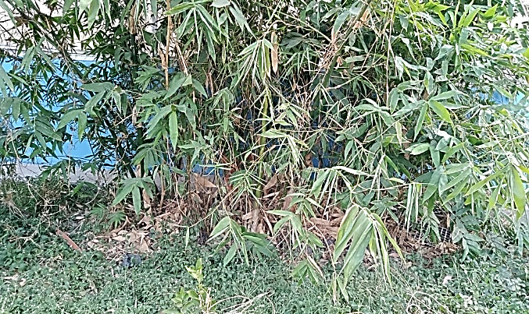
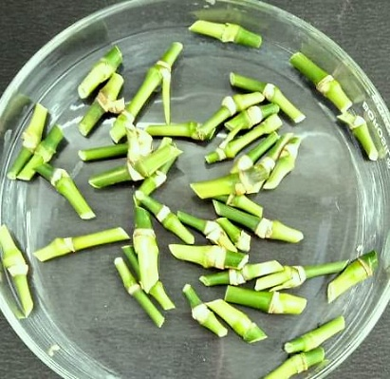
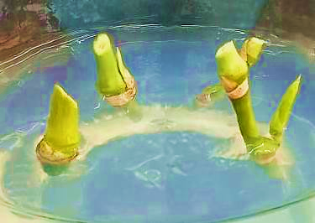
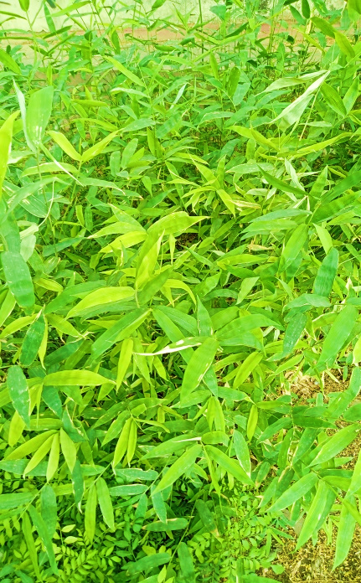
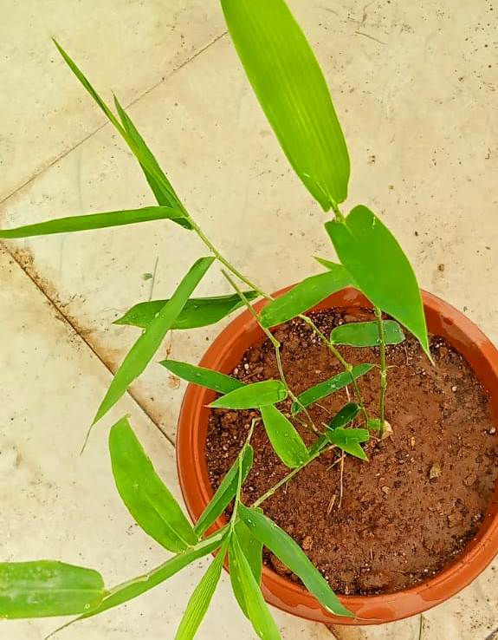
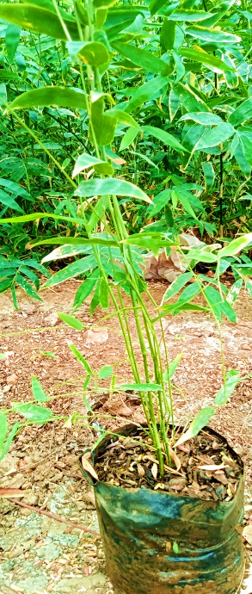
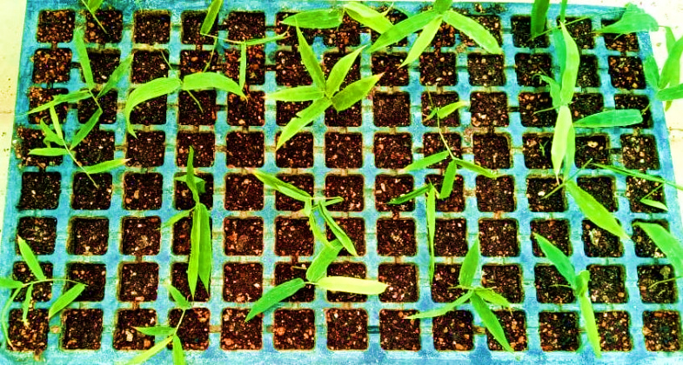
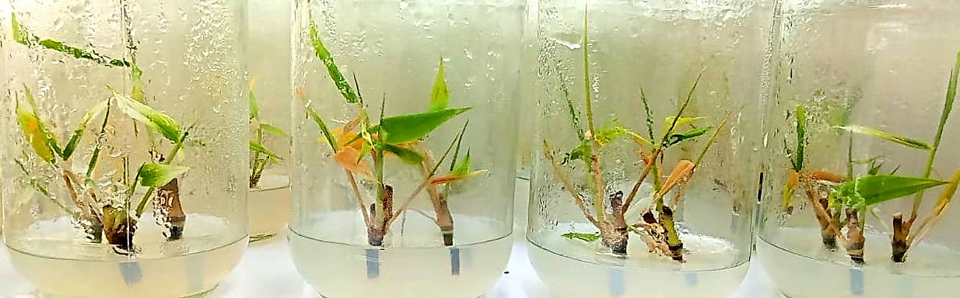
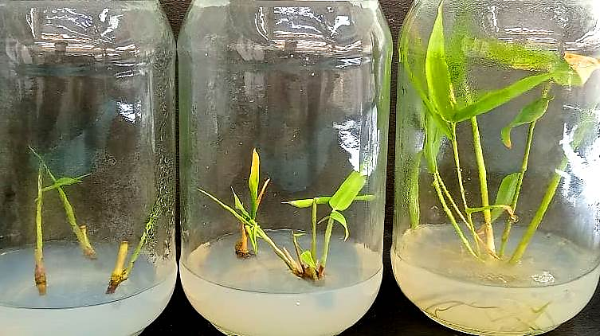
H
G
E
F
Plate 4: Hardening of in vitro developed Bamboo plants
A
B
C
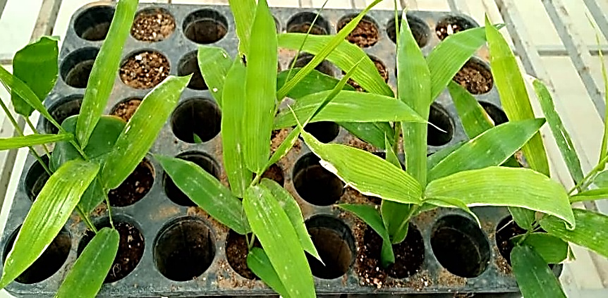
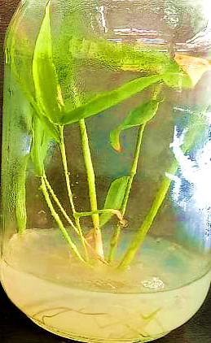
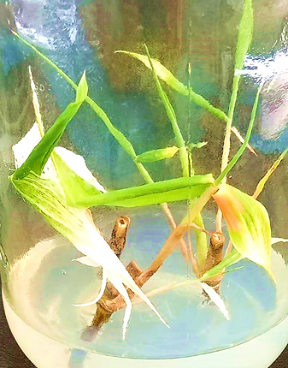
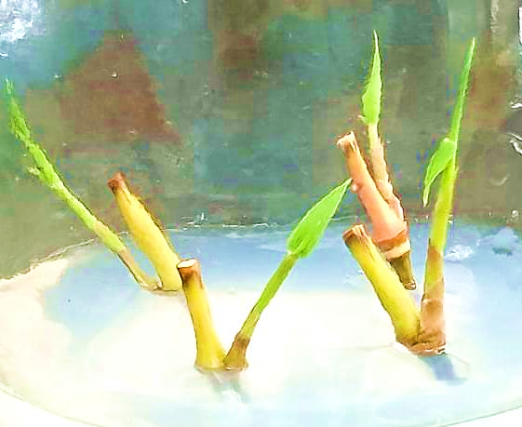
M
N

I
D

L
K
J

Fig. 1. Plantlet regeneration in Bambusa vulgaris Schrad. ex J.C. Wendl. from cultured nodal segments: A. Mother plant; B. Nodal segments used as an explant; C. Cultured nodal segments after 7 days in culture; D. Cultured nodal segments after 14 days in culture; E. Bud sprouting after 21 days of inoculation. F. Initiation of shootlet after 30 days of inoculation;
UNDER PEER REVIEW
G. Massive in vitro propagation; H. Initiation of in vitro rooting after 20-25 days of transferring on rooting medium; I. Formation of well-developed roots after 30-35 days transferring on rooting medium; J. Regenerants transferred in greenhouse/ polyhouse after 40-45 days for hardening; K. Regenerants transferred in greenhouse/ polyhouse after 55-60 days for hardening; L. Regenerants transferred in greenhouse/ polyhouse after 65-70 days for hardening. M. Regenerants transferred in greenhouse/ polyhouse after 75-80 days for hardening; and N. Regenerants transferred under field conditions.

