GREEN SYNTHESIS, CHARACTERIZATION OF COPPER OXIDE NANOPARTICLES (CuO NPs) USING CTENOLEPSIS CERASIFORMIS EXTRACT AND ITS EFFECTS ON SELECTED BACTERIAL AND FUNGAL HUMAN PATHOGENS

Abstract
Plants are often regarded as nature's chemical factories due to their minimal maintenance needs and remarkable efficiency. This prompts an exploration into the sustainable production of copper oxide nanoparticles using an aqueous extract from the medicinal plant Ctenolepis cerasiformis. Consequently, the focus shifts to the green synthesis and characterization of these nanoparticles derived from the plant's extract. Characterization techniques such as X-ray diffraction (XRD), Fourier-transform infrared spectroscopy (FT-IR), and field emission scanning electron microscopy with energy-dispersive X-ray spectroscopy (FESEM-EDS) were employed to analyze the copper oxide nanoparticles. Antibacterial assessments were conducted against clinically relevant bacteria, including Klebsiella pneumonia (MTCC 3384), Vibrio cholera (MTCC 3904), Salmonella typhi (MTCC 98), Staphylococcus epidermis (MTCC 435), Enterococcus faecalis (MTCC 439), Staphylococcus aureus (MTCC 3160), and Bacillus subtilis (MTCC 441), with Streptomycin serving as the control. Additionally, antifungal evaluations were carried out against significant human fungal pathogens such as Aspergillus niger (MTCC 5889), Aspergillus flavus (MTCC 873), Candida albicans (MTCC 183), Candida glabrata (MTCC 3019), Penicillium spp. (MTCC 517), and Trichoderma (MTCC 3439), using Amphotericin-B as the control for these studies. The findings of this research indicate that copper oxide nanoparticles derived from Ctenolepis cerasiformis exhibit significant level of anti-microbial activities. The MIC of the positive control streptomycin was 10μg/ml. The MIC of Klebsiella pneumonia, Salmonella typhi, Enterococcus faecalis, Bacillus subtilis,Vibrio cholera, Staphylococcus epidermis and Staphylococcus aureus were 11.7, 13, 11.7, 11.7, 28.6, 28.6, 23.4 μg/ml respectively. . The MIC of Aspergillusniger, Aspergillusflavus, Candida albicans, Candida glabrata, Pencillium, Tricoderma were 0.40, 0.56, 0.40, 0.89, 0.89, 1.62 μg/ml respectively. It is significantly evident that the nanoparticles from the Ctenolepsis cerasiformis possess anti-bacterial and anti-fungal activity against clinically important microorganisms.
Key words: Green synthesis, Ctenolepis cerasiformis, Klebsiella pneumonia,Candida glabrata, Antimicrobial therapies..

Introduction
Improved performance and novel characteristics of materials on the nanometer scale have attracted considerable interest [1]. Because of its anti-oxidative and anti-microbial properties, as well as its function as a drug delivery agent in biomedicine, copper oxide (CuO) nanoparticles have attracted much attention and found numerous uses among nanoparticles [2, 3].Nanoparticles range 1-100 nm and are useful in the diagnosis and treatment of cancer [4-5].Despite use in several applications lack of sufficient research on the anti-microbial activity of CuO nanoparticle compared to other metal nanoparticles has encouraged this research [6,7].Recent research has focused on green routes synthesis of nanoparticles, that possess excellent anti-microbial agents [8].
Copper oxide nanoparticles (CuO NPs) are among the most extensively studied noble metals, attributed to their remarkable photocatalytic properties and their resemblances to other metallic nanoparticles (Ashok Kumar et al., 2014). Copper oxide is characterized as a semiconductive material that exhibits a variety of magnetic, optical, and electrical characteristics (Dinesh et al., 2017). The interest in its fabrication has been piqued among researchers, owing to its diverse applications (Zoolfakar et al., 2014).
Ctenolepsiscerasiformis is a medicinal plant spread in south India and belongs to the family of Cucurbitaceae. The leaves are generally between 3.5 and 10 cm long and nearly as wide. The lamina is broadly ovate-cordate in shape, and the stem is subfiliform both above and below. The nerves and margins of the leaves are covered in scabrid hairs that point forward. The segments of the leaves are typically ovate-oblong in shape, acute and narrow at the base. The lateral segments of the leaves often have an apparent mucro. Petiole 2-4 cm in length; stipular bracts 7-15 mm in length, somewhat suborbicular, ciliate, and hairy to a length equal to the bract's breadth. The flowers are small and showy, with 1.5 mm long and 1 mm wide petals that expand outward. The male flowers are in clusters of 5–10 at the end of peduncles that are 2-4 cm long and have ebracteate pedicel that are 2-3 mm long. The female flowers are solitary and grow on short peduncles. The studies examining the phytochemical profile of Ctenolepsiscerasiformis chloroform extract were conducted. The existence of different phytochemicals is indicated by our results [9].

Materials and methods
Collection of Plant Materials
Fresh leaves of Ctenolepsis cerasiformis were gathered from a local medicinal garden in Chennai, India. A Botanist verified and authenticated the identity of the leaves.
Preparation of Plant Extract
The collected Ctenolepsis cerasiformis leaves were thoroughly washed and then shade-dried at ambient temperature. Following this, the leaves were ground into a fine powder and filtered through a 200-mesh sieve. The resulting leaf powder underwent continuous solvent extraction using a Soxhlet apparatus, with water serving as the solvent. The apparatus was maintained at a temperature range of 32 - 35°C, and the extraction process lasted approximately three hours. A rotary flash evaporator was employed to concentrate the extract, which was then filtered using a glass crucible. The concentrated extract was dried over a water bath, stored in an airtight container, and kept refrigerated.
Synthesis of Nanoparticles
Copper oxide (CuO) nanoparticles were synthesized utilizing the leaf extract of C. cerasiformis through a green combustion method. A mixture was prepared consisting of\ 1.205 g of copper (II) nitrate trihydrate, 0.3 g of C. cerasiformis extract, and 20 ml of doubledistilled water. To ensure thorough mixing, a magnetic stirrer was operated at 2000 rpm for 2to 5 minutes. the sample was dried with room temperature. After removing any debris, themixture was rinsed with distilled water followed by methanol to eliminate further impurities.The CuO nanoparticles finely grounded powder was stored in an airtight container [10].
Characterization of Copper Oxide Nanoparticles
The optical properties of the nanoparticles were assessed using UV-visible spectroscopy. The functional groups present in the sample were analyzed through Fourier transform infrared (FTIR) spectroscopy. Energy-dispersive X-ray spectroscopy (EDS) was employed to investigate the elemental composition of the nanoparticles. Additionally, the structural characteristics were evaluated using X-ray diffraction (XRD), while field emission scanning electron microscopy (FESEM) was utilized to examine the sample's morphology [11].
Microbial Cultures
The study utilized various microbial cultures, including Klebsiella pneumonia (MTCC 3384), Vibrio cholera (MTCC 3904), Salmonella typhi (MTCC 98), Staphylococcus epidermis (MTCC 435), Enterococcus faecalis (MTCC 439), Staphylococcus aureus (MTCC 3160), Bacillus subtilis (MTCC 441), as well as fungal pathogens such as Aspergillus niger (MTCC 5889), Aspergillus flavus (MTCC 873), Candida albicans (MTCC 183), Candida glabrata (MTCC 3019), Penicillium spp. (MTCC 517), and Trichoderma (MTCC 3439) [12].
Antibiotics
In this investigation, Streptomycin and Amphotericin-B were employed as control agents to evaluate the antibacterial and antifungal properties of the sample, respectively.
Determination of Minimum Inhibitory Concentration (MIC) Utilizing the Resazurin Microtitre Assay

Preparation of Resazurin Solution
Resazurin assay methods offer advantages in microbiology over other methods due to its simplicity, cost, effectiveness, rapid results, high sensitivity and non-toxic nature. Resazurin is preferred over alternative indicators because of its low toxicity and non-fluorescent characteristics in its oxidized form, which enhance sensitivity. Additionally, it can be quantified either visually or through fluorimetry/spectrophotometry, possesses cell-permeable properties, and is appropriate for both continuous monitoring and high-throughput screening. These attributes are particularly beneficial for fungal pathogens, as resazurin can be utilized for prolonged durations without adversely affecting the fungi. This allows for dynamic investigations into biofilm formation and assessments of drug susceptibility by evaluating metabolic activity, which serves as a direct measure of viability.

A resazurin solution was created by dissolving 270 mg of resazurin in 40 ml of sterile distilled water, followed by vortexing to achieve a uniform mixture. Assessment of Antibacterial and Antifungal Activity In a sterile environment, antibacterial and antifungal activity tests were performed using 96-well plates. The first well was filled with 100 μl of the sample using a pipette. Subsequently, 50 μl of nutrient broth was added, and serial dilutions were performed for the remaining wells. Each well received a bacterial or fungal suspension along with 10 μl of the resazurin indicator solution. To prevent evaporation, the plates were covered with cling film. After incubating at 37°C for 18 to 24 hours, the color change was assessed visually, with a notable transition from purple to pink indicating activity For the resazurin assay involving fungi, incubate for a duration of 3 to 4 hours, or until a noticeable color change is detected, at a temperature of 37°C, or at the optimal temperature suited for the particular fungal strain. The precise incubation duration is contingent upon the growth rate of the fungus, its initial cell concentration, and the experimental conditions; therefore, it is crucial to optimize the incubation time for your specific system to guarantee accurate results. [13].

Results and discussion
XRD pattern of the sample prepared using the green synthesis method
XRD pattern shows the peaks at angles 43.6° and 50.7° indicating the (111) and (200) reflections of copper nanoparticles having face-centered cubic structure and are in agreement with JCPDS # 89-2838. [14] The XRD pattern indicating the polycrystalline nature of the nanoparticles. The XRD pattern shows the peaks at angles 15.6°, 16.3°, 17.5°, 18.8°, 22.4° 24.2°, 25.99°, 27.1°, 29.3°, 31.7°, 32.7°, 33.6°, and 37.3°, 45.1°, 48.3°, 51.5°, 54.8°, 56.7°, denote the reflections of monoclinic cupric oxide (CuO) (JCPDS-05-0661) and orthorhombic cuprous oxide (Cu2O) nanoparticles. In the present work, the diffraction peaks were observed at 2θ = 32.7, 45.1, and 48.6 denote the reflections of CuO of monoclinic structure (Fig. 1).[15][16] There is a sharp peak at 2θ =19 °that corresponds to the (002) plane of graphite and there is a small peak ~ 45°, corresponding to (001) plane of graphite [4]. The figure also shows the high-intensity peaks for the Cu2O nanoparticles, whereas the intensity of copper nanoparticles is low and these results indicating high content of the CuO and Cu2O phases present in the sample. The Scherrer formula was used to calculate the crystallite size and found to be 29 nm for (111) Cu2O.
The Scherrer formula is used to estimate the average size of crystallites, which are coherent diffracting domains found within a material. In this instance, a crystallite size of approximately 29 nm is estimated. SEM-Measured Sizes Scanning Electron Microscopy (SEM) offers images that depict the surface morphology of the material, enabling the measurement of particle or grain sizes. These measurements reflect the physical dimensions of individual particles or grains, which may or may not correspond to single crystallites.
In the green synthesis of CuO nanoparticles, impurity phases are assessed through X-ray Diffraction (XRD), which offers a unique signature of the crystalline phases present. This enables the identification and quantification of the target CuO phase in relation to other unwanted phases. The peaks observed in the XRD pattern are associated with specific lattice planes, and by comparing these peaks to standard databases like the International Centre for Diffraction Data (ICDD), one can verify the phase purity of the synthesized material.

Figure 1: XRD pattern of the copper oxide nanoparticles

FTIR spectra of CuOnanocrystallites
According to Figure 2, the water molecules that were adsorbed caused the wide
absorption peak at approximately 3500-3000 cm −1 . With a high surface/volume ratio and theability to absorb moisture, the nanocrystallite materials are remarkable. Because the alkylgroup is stretching its C-H bonds, the peak at 2923 cm−1 is observed. The area referred to asthe OH-stretching region lies between 2700 and 3750 cm−1. [17] The symmetrical stretchingof C=C streching vibrations in alkenes are explain the peaks at 1638 cm -1. The vibrational modes of CuO are revealed by the two infrared absorption peaks that occur about 500-700cm −1 . The produced nanoparticles ; surface area changes in tandem with the slight peak shift invibrational modes. All of the previously recorded values for metal-oxygen frequencies forCuO are very concordant with one another [18,19].

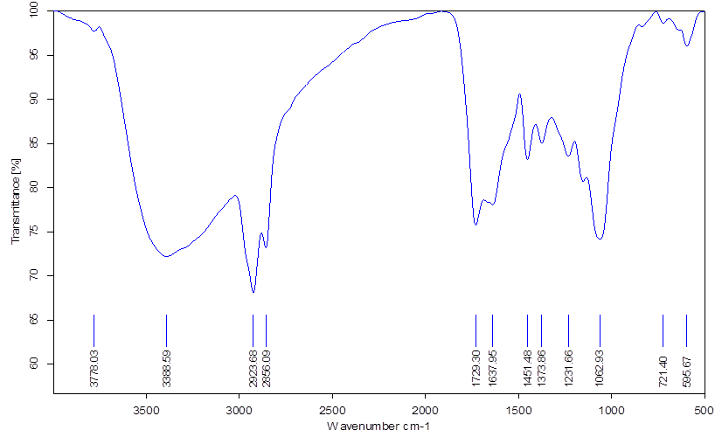
Figure 2: FTIR spectrum of the as- synthesized copper and carbon nanoparticles
The SEM images of the sample are given in figures 3 and 4with 2 different magnifications (50 K X and 200 K X). The SEM images show that the copper oxide nanoparticles are spherical. The surface morphology of the sample indicating the porous nature of the crystallites and are aggregated. The size of the nanoparticles is calculated using scanning electron micrographs, and the crystallites are homogeneous in size. The majority of the nanoparticles, in agreement with the XRD results, are less than 50 nm.

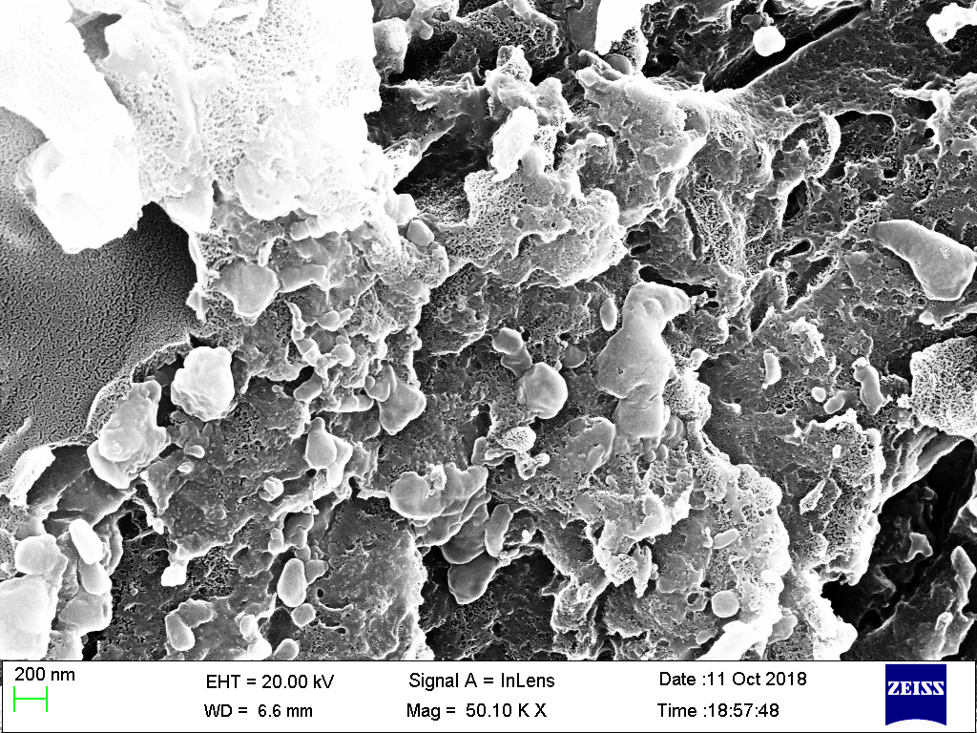
Figure 3: SEM image of the copper oxide nanoparticles at 50 KX
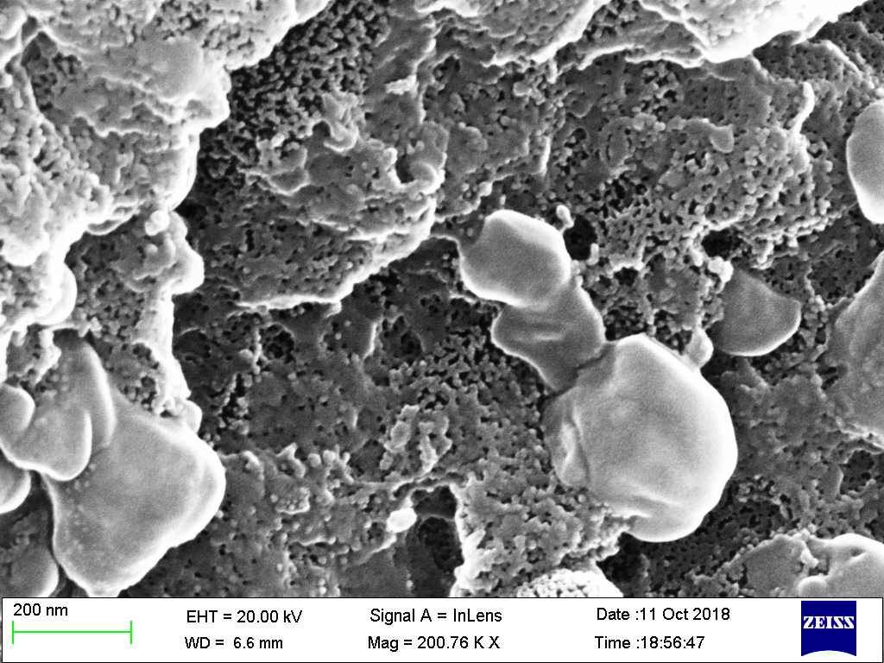
Figure 4: SEM image of the copper oxide nanoparticles at 200 KX

Energy Dispersive X-Ray Analysis (EDX) of copper oxide nanoparticles
The quantitative data indicates the nanopowders are mainly composed of carbon, copper oxide nanoparticles, and a small number of impurities such as silicon, sulphur and potassium (Figure 5). There are a large number of carbon impurities as shown in the EDAX spectra. The EDAX result confirmed the formation of CuO nanoparticles. The figure shows the elemental composition of C, Cu, Si, S, K, and O in Copper oxide nanoparticles using EDAX analysis. [20, 21]. Carbon impurities found in copper oxide nanoparticles (CuO-NPs) can affect antimicrobial activity by possibly disrupting the release of Cu2+ ions, modifying particle characteristics like surface area, or even directly engaging in or obstructing the antibacterial process, depending on their chemical composition. These impurities typically arise from the plant extracts or various organic capping agents utilized in "green" synthesis, and their effects are influenced by the synthesis technique, concentration of the extract, and the particular carbon compounds involved.

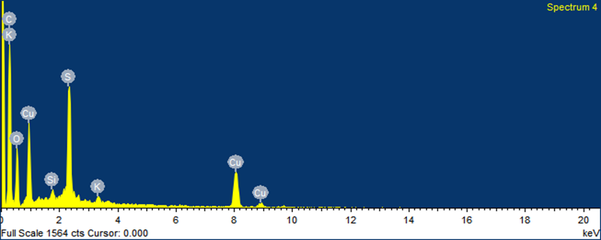 | 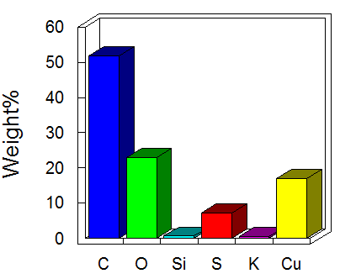
Figure 5. EDX analysis of Copper oxide nanoparticles

The quality of human life as well as the healthcare system and mean survival of human beings against many diseases are rapidly developed by the development and discovery of many newer classes of antibiotics.
Antibacterial and antifungal properties of synthesized nanoparticles from the Ctenolepsiscerasiformisaqueous was given in Table 1 and 2. The minimum inhibitory concentration of copper oxide nanoparticles against selected clinically important human bacterial and fungal pathogens were shown in figure 6 and 7. Over usage of antibiotics leads to increased development of microbial resistance on commercially available antimicrobial agents. Thus, it is of interest to search for the novel antimicrobial agents from the natural resources especially from the medicinal herbal plants because of their less or no toxicity as compared to the available drugs [11].
In this present investigation of the determination of the antimicrobial effects of copper oxide nanoparticles from the Ctenolepsiscerasiformiswas extractcarried out by resazurin based turbidometric assay. Since the enzyme oxidoreductase is responsible for the irreversible reduction of the blue colour dye, resazurin, to a pink colour and a highly red fluorescent compound, resorufin, and finally to colourless and non-fluorescent molecules like hydroresorufin, spectrophotometric analysis is unnecessary in this assay in comparison to the traditional tuberculosis (TB) test [22].
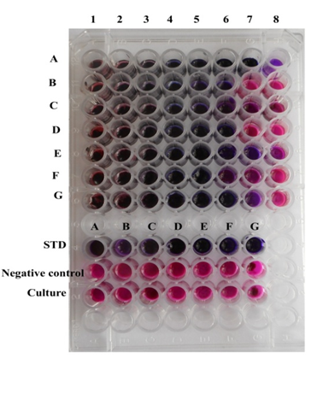 | 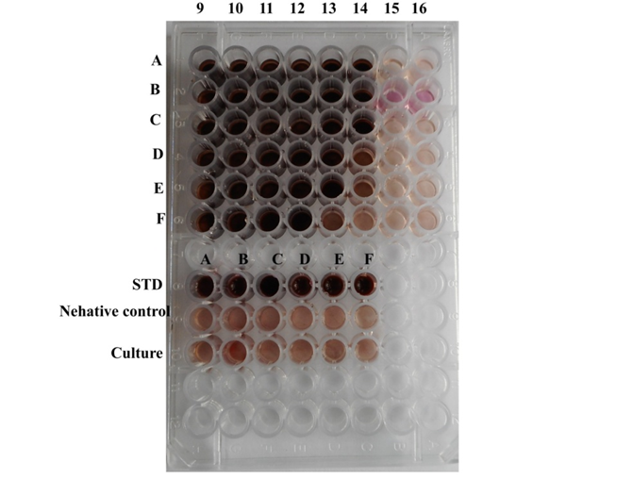
Figure 6.Antibacterial activity and antifungal activity of copper oxide nanopaticles from C.cerasiformis.
The present study aims to explore the antibacterial and antifungal activities of nanoparticles from Ctenolepsiscerasiformis against bacterial pathogensKlebsiella pneumonia, Vibrio cholera, Salmonella typhi, Staphylococcus epidermis, Enterococcus faecalis, Staphylococcus aureus, Bacillus subtilis and fungal pathogens Aspergillusniger, Aspergillusflavus, Candida albicans, Candida glabrata, Penicilliumspp and Trichoderma. The results of the present study as compared to the best available commercial antibiotics such as streptomycin and amphotericin-B respectively. Copper oxide NPs out- perform streptomycin resistance becausethey kill bacteria through broad spectrum, multi-target mechanisms such as generating ROS ,releasing toxic copper ions, disrupting the bacterial cell membrane and damaging DNA andproteins. The copper-oxide NPs offer a low possibility of resistance development due to theirin-organic nature and multi-model approach to bacterial cell death.
Figure 6(a) explores the different concentrations of copper oxide nanoparticles from C.cerasiformis. A.Klebsillapnemoniae, B. Vibrio cholera, C. Salmonella typhi, D. Staphylococcus epidermitis, E. Enterococcus fecalis, F. Staphylococcus aereus, G. Bacillus subtilis. Figure 6(b) represents the different concentrations of copper oxide nnoparticles from C.cerasiformis. AAspergillusniger, B. Aspergillusflavus, C. Candida albicans, D.Candidaglabrata, E. Pencilliumsppand F. Tricoderma.
The MIC of copper oxide nanoparticles on bacterial pathogens are represented in Figure 1. The MIC of the positive control streptomycin was 10μg/ml. The MIC of Klebsiella pneumonia, Salmonella typhi, Enterococcus faecalis, Bacillus subtilis,Vibrio cholera, Staphylococcus epidermis and Staphylococcus aureus were 11.7, 13, 11.7, 11.7, 28.6, 28.6, 23.4μg/ml respectively.

Figure 7: The Minimum Inhibitory Concentration [MIC] of copper oxide nanoparticles on bacterial pathogens
The MIC of copper oxide nanoparticles on fungus are represented in Figure 2. The MIC of the positive control Amphotericin –B was 10μg/ml. The MIC of Aspergillusniger, Aspergillusflavus, Candida albicans, Candida glabrata, Pencillium, Tricoderma were 0.40, 0.56, 0.40, 0.89, 0.89, 1.62μg/ml respectively. It is significantly evident that the nanoparticles from the Ctenolepsiscerasiformisextractpossess anti-bacterial and anti-fungal activity against clinically important microorganisms.

Figure 8: The Minimum Inhibitory Concentration [MIC] of copper oxide nanoparticles on fungus
Conclusion
The present study aims to explore the green synthesis, characterization of copper oxide nanoparticles using ctenolepsis cerasiformis extract is of our interest and its effects on selected bacterial and fungal humanpathogens. This discovery opened up new possibilities for extracting antibacterial agents fromplants. This will allow us to create a comprehensive chemical profile that will serve asvaluable guidance for the identification of anticompounds. Further investigation into thediscovery and isolation of possible antibacterial compounds should also be carried out, aswell as the screening of additional nanoparticles generated from this plant using this test. Ifthis works, these extracted and purified active ingredients might replace the harmful antibiotics.

Disclaimer (Artificial intelligence)
Author(s) hereby declare that NO generative AI technologies such as Large Language
Models (ChatGPT, COPILOT, etc.) and text-to-image generators have been used during the writing or editing of this manuscript.

References

1. Azam A, Ahmed AS, Oves M et al. Size-dependent antimicrobial properties of CuO nanoparticles against Gram-positive and-negative bacterial strains. Int. J. Nanomedicine 2012; 7:3527.
2. Ijaz F, Shahid S, Khan SA et al. Green synthesis of copper oxide nanoparticles using Abutilon indicum leaf extract: Antimicrobial, antioxidant and photocatalytic dye degradation activitie. Trop. J. Pharm. Res. 2017; 16(4):743–753.
3. Yallappa S, Manjanna J, Sindhe MA et al. Microwave assisted rapid synthesis and biological evaluation of stable copper nanoparticles using T. arjuna bark extract. Spectrochim. Acta Part A Mol. Biomol. Spectrosc. 2013; 110:108–115.
4. Seigneuric R, Markey L, SA Nuyten D et al. From nanotechnology to nanomedicine: applications to cancer research. Curr. Mol. Med. 2010; 10(7):640–652.
5. Liu Z, Kiessling F, Gätjens J. Advanced nanomaterials in multimodal imaging: design, functionalization, and biomedical applications. J. Nanomater. 2010.
6. Kwak K, Kim C. Viscosity and thermal conductivity of copper oxide nanofluid dispersed in ethylene glycol. Korea-Australia Rheol. J. 2005; 17(2):35–40.
7. Stoimenov PK, Klinger RL, Marchin GL, Klabunde KJ. Metal oxide nanoparticles as bactericidal agents. Langmuir 2002; 18(17):6679–6686.
8. Sankar R, Manikandan P, Malarvizhi V et al. Green synthesis of colloidal copper oxide nanoparticles using Carica papaya and its application in photocatalytic dye degradation. Spectrochim. Acta Part A Mol. Biomol. Spectrosc. 2014; 121:746–750.
9.A.S. Zoolfakar, R.A. Rani, A.J. Morfa, A.P. O’Mullane, K. Kalantar-zadeh
Nanostructured copper oxide semiconductors: a perspective on materials, synthesis methods and applications J. Mater. Chem. C, 2 (27) (2014), pp. 5247-5270,
10. D. Ashok Kumar, V. Palanichamy, S.M. Roopan. Photocatalytic action of AgCl nanoparticles and its antibacterial activity J. Photochem. Photobiol. B: Biol., 138 (2014), pp. 302-306,

11. M. Dinesh, S.M. Roopan, C.I. Selvaraj, P. Arunachalam. Phyllanthus emblica seed extract mediated synthesis of Pd NPs against antibacterial, heamolytic and cytotoxic studies J. Photochem. Photobiol. B: Biol., 167 (2017), pp. 64-71,

12. Kumar SS, Monica J. In Vitro Antioxidant Activities Of Chloroform Extract Of Ctenolepsis Cerasiformis. Indo Am. J. Pharm. Sci. 2018; 5(5):3976–3979.
13. Ragavendran P, Sophia D ARC and G. Functional group analysis of various extract of Aervalamata (L.,) by FT-IR Spectrum. Pharmacol. online 2011; 1:358–364.
14. Alwan RM, Kadhim QA, Sahan KM et al. Synthesis of zinc oxide nanoparticles via sol–gel route and their characterization. Nanosci. Nanotechnol. 2015; 5(1):1–6.
15. Lekshmi NC, Sumi SB, Viveka S et al. Antibacterial activity of nanoparticles from Allium sp. J Microbiol Biotechnol Res 2012; 2(2):115–119.
16. Teh CH, Nazni WA, Norazah A, Lee HL. Determination of antibacterial activity and minimum inhibitory concentration of larval extract of fly via resazurin-based turbidometric assay. BMC Microbiol. 2017; 17(1):36.
17. Kathad U, Gajera HP. Synthesis of copper nanoparticles by two different methods and size comparison. Int J Pharm Bio Sci 2014; 5(3):533–540.
18. Suárez-Cerda J, Espinoza-Gómez H, Alonso-Núñez G et al. A green synthesis of copper nanoparticles using native cyclodextrins as stabilizing agents. J. Saudi Chem. Soc. 2017; 21(3):341–348.
19. Khan A, Rashid A, Younas R, Chong R. A chemical reduction approach to the synthesis of copper nanoparticles. Int. Nano Lett. 2016; 6(1):21–26.
20. Krishnamurthy G, Namitha R. Synthesis of structurally novel carbon micro/nanospheres by low temperature-hydrothermal process. J. Chil. Chem. Soc. 2013; 58(3):1930–1933.
21. Pramila-Devamani RH, Sivakami S. Synthesis and characterization of copper chromate nanoparticles. Wkly. Sci. Res. J 2014; 1:1–10.
22. Ndana M, Grace JJ, Baba FH, Mohammed UM. Fourier transform infrared spectrophotometric analysis of functional groups in biodiesel produced from oils of Ricinus communis, Hevea brasiliensis and Jatropha curcas seeds. Int. J. Sci. Environ. Technol. 2013; 2(6):1116–1121.
23. Kouti M, Matouri L. Fabrication of nanosized cuprous oxide using fehling’s solution. 2010.
24. Singh AK, Raykar VS. Microwave synthesis of silver nanofluids with polyvinylpyrrolidone (PVP) and their transport properties. Colloid Polym. Sci. 2008; 286(14–15):1667–1673.
25. Ojha S, Sett A, Bora U. Green synthesis of silver nanoparticles by Ricinus communis var. carmencita leaf extract and its antibacterial study. Adv. Nat. Sci. Nanosci. Nanotechnol. 2017; 8(3):35009.

