Integrating Bioinformatics and Molecular Breeding for Sustainable Crop Improvement Strategies

Abstract
The integration of bioinformatics and molecular breeding has revolutionized the field of crop improvement, enabling the development of sustainable strategies to enhance agricultural productivity and food security. Bioinformatics tools and resources provide unprecedented opportunities to harness the power of genomic data for precision breeding, while molecular techniques such as marker-assisted selection, genomic selection, and genome editing allow for the rapid and targeted improvement of key agronomic traits. This review explores the synergistic application of bioinformatics and molecular breeding in the context of sustainable crop improvement, highlighting their roles in enhancing abiotic and biotic stress tolerance, yield and quality traits, adaptation to climate change, and the conservation of genetic diversity.
Keywords: Bioinformatics, Molecular Breeding, Crop Improvement, Sustainable Agriculture, Genomic Selection
1. Introduction
1.1. Importance of sustainable crop improvement
Sustainable crop improvement is crucial for addressing the challenges posed by a growing global population, climate change, and resource limitations. Conventional breeding methods have made significant contributions to increasing crop yields and quality, but they often rely on time-consuming and labor-intensive processes [1]. To meet the demands of sustainable agriculture, there is a pressing need for innovative approaches that can accelerate the development of resilient and high-performing crop varieties [2].
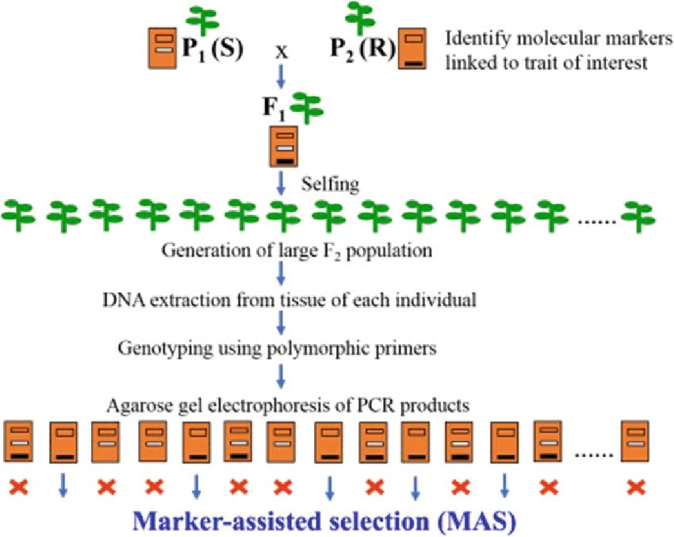
Figure 1: Schematic representation of marker-assisted selection (MAS) in crop breeding.

1.2. Integration of bioinformatics and molecular breeding
The advent of high-throughput sequencing technologies and advanced computational tools has opened new avenues for crop improvement. Bioinformatics, the application of computer science and information technology to the field of biology, has emerged as a powerful tool for managing and analyzing the vast amounts of genomic data generated by these technologies [3]. Molecular breeding, on the other hand, encompasses a range of techniques that exploit DNA markers and genomic information to enhance the efficiency and precision of crop breeding [4].
2. Molecular Breeding Techniques
Molecular breeding techniques have revolutionized the way we approach crop improvement, allowing for the precise and targeted manipulation of plant genomes. These techniques rely on the use of DNA markers, which are specific sequences of DNA that are associated with particular traits or characteristics of interest [5].
2.1. Marker-assisted selection (MAS)
2.1.1. Principles and applications
MAS is based on the principle of genetic linkage, where DNA markers that are closely linked to the genes controlling the desired traits can be used as proxies for selecting individuals with those traits [6]. This approach allows for the early and efficient selection of plants with the desired characteristics, without the need for extensive phenotypic evaluations [7].
MAS has been widely applied in crop improvement programs for various purposes, such as:
- Introgression of disease resistance genes from wild relatives into elite cultivars [8]
- Pyramiding of multiple resistance genes to enhance durability [9]
- Backcross breeding to transfer specific traits while maintaining the desirable background of the recurrent parent [10]
- Early selection for abiotic stress tolerance traits, such as drought and salinity tolerance [11]
2.1.2. Advantages and limitations
MAS offers several advantages over conventional phenotypic selection:
- Increased efficiency and precision of selection, as DNA markers are not influenced by environmental factors [12]
- Reduced time and cost associated with field evaluations, as selection can be performed at the seedling stage [13]
- Ability to select for traits that are difficult or expensive to phenotype, such as root characteristics or disease resistance [14]
However, MAS also has some limitations:
- Requirement for prior knowledge of the genetic basis of the trait and the availability of closely linked markers [15]
- Limited effectiveness for complex traits controlled by many genes with small individual effects [16]
- Potential linkage drag, where undesirable genes are co-transferred with the target gene due to close linkage [17]
2.2. Genomic selection (GS)
2.2.1. Concepts and methodology
Genomic selection (GS) is a more recently developed molecular breeding approach that utilizes genome-wide markers to predict the breeding value of individuals [18]. Unlike MAS, which relies on a few markers linked to specific genes, GS uses a large number of markers distributed throughout the genome to capture the effects of all genes influencing a trait [19]. The breeding values are estimated using statistical models that relate the marker genotypes to the phenotypic performance of a training population [20].
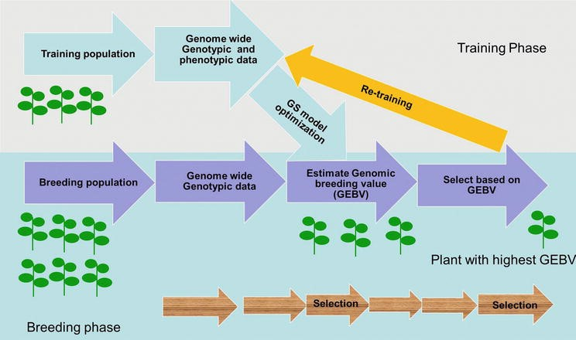
Figure 2: Overview of the main steps in genomic selection (GS) in crop breeding.

The key steps in implementing GS are:
- Genotyping a training population with genome-wide markers
- Phenotyping the training population for the trait(s) of interest
- Developing a prediction model by estimating the effects of each marker on the trait
- Validating the prediction model using a separate set of genotyped and phenotyped individuals
- Applying the model to predict the breeding values of new selection candidates based on their marker genotypes [21]
2.2.2. Implementation in crop improvement programs
GS has been implemented in various crop improvement programs, demonstrating its potential to accelerate genetic gains. Some examples include:
- Maize: GS has been used to improve grain yield, drought tolerance, and disease resistance in maize, with some studies reporting up to three-fold increases in genetic gains compared to conventional breeding [22,23]
- Wheat: GS has been applied to enhance grain yield, quality traits, and disease resistance in wheat, with prediction accuracies ranging from 0.4 to 0.8 depending on the trait and population [24,25]
- Soybean: GS has been employed to improve yield, oil content, and disease resistance in soybean, with prediction accuracies of up to 0.92 reported [26,27]
The success of GS in crop improvement depends on several factors, such as the size and diversity of the training population, the heritability of the trait, the number and distribution of markers, and the statistical model used for prediction [28].
2.3. Genome-wide association studies (GWAS)
2.3.1. Identifying trait-associated markers
Genome-wide association studies (GWAS) are a powerful tool for identifying genetic markers associated with traits of interest in crop species. GWAS involve genotyping a diverse panel of individuals with a large number of markers and testing for associations between each marker and the phenotypic variation of the trait [29]. This approach exploits the historical recombination events and linkage disequilibrium present in the population to detect marker-trait associations [30].
The main steps in conducting a GWAS are:
- Assembling a diverse panel of genotypes representing the genetic variation of the species
- Genotyping the panel with a high-density marker platform, such as SNP arrays or genotyping-by-sequencing
- Phenotyping the panel for the trait(s) of interest in multiple environments
- Testing for associations between each marker and the trait using statistical models that account for population structure and relatedness
- Validating the significant associations in independent populations or through functional studies [31]
2.3.2. Case studies in major crops
GWAS have been conducted in various crop species to identify markers associated with agronomically important traits. Some notable examples include:
- Rice: GWAS have identified markers associated with yield components, grain quality traits, and abiotic stress tolerance in rice, providing valuable targets for marker-assisted breeding [32,33]
- Maize: GWAS have revealed markers linked to disease resistance, kernel composition, and root architecture traits in maize, enabling the development of improved varieties [34,35]
- Wheat: GWAS have detected markers associated with grain yield, quality traits, and disease resistance in wheat, facilitating the introgression of favorable alleles into elite lines [36,37]
The markers identified through GWAS can be used to develop diagnostic markers for MAS, or they can be integrated into genomic prediction models to enhance the accuracy of GS [38]. However, GWAS also have limitations, such as the potential for false positives due to population structure and the difficulty in detecting rare alleles or epistatic interactions [39]. Therefore, GWAS results should be interpreted with caution and validated through additional studies.
Table 1: Commonly used molecular markers in crop improvement
Marker Type | Characteristics | Applications
SSRs | Highly polymorphic, co-dominant, PCR-based | Genetic mapping, diversity analysis, MAS
SNPs | Abundant, high-throughput, co-dominant | GWAS, genomic selection, MAS
InDels | PCR-based, co-dominant | Genetic mapping, MAS
RFLPs | Co-dominant, low throughput | Genetic mapping, diversity analysis
AFLPs | Dominant, high throughput | Diversity analysis, genetic mapping
DArT | High throughput, dominant or co-dominant | Diversity analysis, genetic mapping

2.4. Genetic transformation and genome editing
2.4.1. Transgenic approaches
Genetic transformation involves the introduction of foreign DNA into the genome of a crop species to confer novel traits or modify existing ones. This approach has been widely used to develop transgenic crops with enhanced resistance to pests, diseases, and herbicides, as well as improved nutritional quality and abiotic stress tolerance [40]. The most common method for genetic transformation is Agrobacterium-mediated transformation, where the desired genes are transferred from the bacterium Agrobacterium tumefaciens into the plant cells [41].
Some examples of successful transgenic crop development include:
- Bt cotton: Cotton varieties expressing insecticidal proteins from Bacillus thuringiensis (Bt) have been developed to confer resistance to lepidopteran pests, reducing the need for chemical insecticides [42]
- Golden Rice: Rice varieties engineered to accumulate beta-carotene (provitamin A) in the grain have been developed to combat vitamin A deficiency in developing countries [43]
- Drought-tolerant maize: Maize varieties expressing transgenes involved in drought response, such as transcription factors and enzymes, have been developed to enhance drought tolerance [44]
Despite the potential benefits, the development and commercialization of transgenic crops face several challenges, including public concerns about food safety and environmental impacts, regulatory hurdles, and the need for extensive safety assessments [45]. These challenges have led to the exploration of alternative approaches, such as genome editing, for targeted crop improvement.
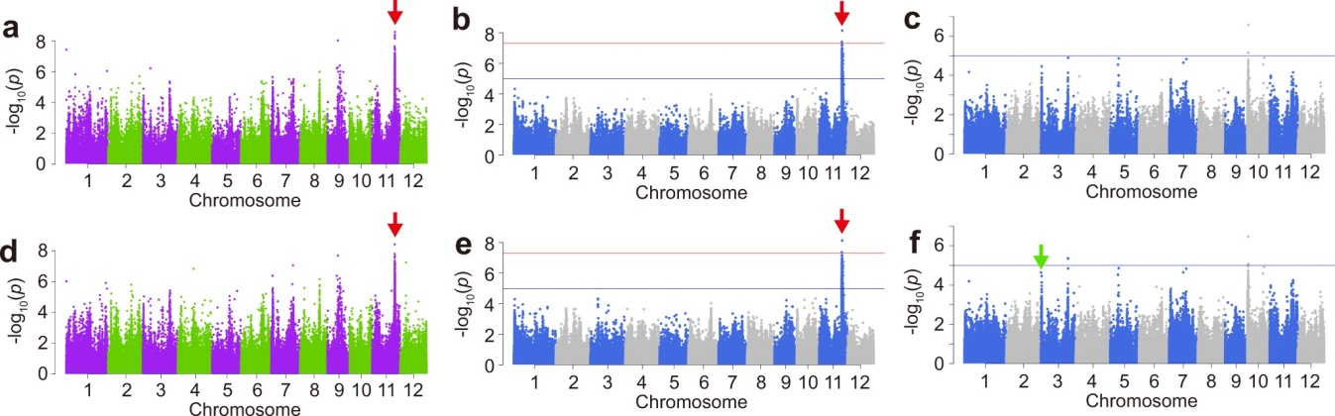
Figure 3: Example of a genome-wide association study (GWAS) in rice.

2.4.2. CRISPR/Cas systems for precise gene manipulation
Genome editing technologies, particularly the CRISPR/Cas (Clustered Regularly Interspaced Short Palindromic Repeats/CRISPR-associated protein) system, have emerged as powerful tools for precise gene manipulation in crop species. CRISPR/Cas systems are derived from the adaptive immune system of bacteria and archaea, and they consist of a programmable nuclease (Cas) and a guide RNA that directs the nuclease to the target site in the genome [46]. By designing specific guide RNAs, researchers can induce targeted mutations, insertions, or deletions at desired locations in the genome, enabling the rapid and precise modification of genes controlling agronomic traits [47].
Table 2: Examples of successful applications of molecular breeding in crop improvement
Crop | Trait | Approach | Reference
Maize | Drought tolerance | GWAS, MAS | [22,23]
Wheat | Grain yield | Genomic selection | [24,25]
Rice | Grain size and quality | GWAS, gene editing | [32,33]
Soybean | Disease resistance | GWAS, MAS | [26,27]
Tomato | Fruit quality | Genomic selection, MAS | [42,43]

The main advantages of CRISPR/Cas systems over traditional transgenic approaches are:
- Precision: CRISPR/Cas allows for the targeted modification of specific genes without the random integration of foreign DNA [48]
- Efficiency: CRISPR/Cas can induce mutations at a much higher frequency than previous gene editing methods, such as zinc-finger nucleases and TALENs [49]
- Multiplexing: CRISPR/Cas can be used to edit multiple genes simultaneously by designing multiple guide RNAs [50]
- Versatility: CRISPR/Cas can be used for various applications, such as gene knockouts, gene replacements, and transcriptional regulation [51]
CRISPR/Cas has been successfully applied in various crop species to improve traits such as disease resistance, herbicide tolerance, and grain quality [52,53].
For example, CRISPR/Cas has been used to:
- Enhance resistance to powdery mildew in wheat by targeting the MLO gene [54]
- Improve amylose content and grain size in rice by editing the Waxy and GS3 genes, respectively [55]
- Develop low-gluten wheat varieties by knocking out the alpha-gliadin genes [56 and 57]
3. Bioinformatics Tools and Resources
3.1. Genomic databases Genomic databases are essential for molecular breeding, providing access to sequence information of crop species and their wild relatives. Key databases include [58]:
- 3.1.1. Sequence repositories: GenBank, European Nucleotide Archive (ENA), and DNA Data Bank of Japan (DDBJ) are the main global repositories for nucleotide sequences and protein translations.
- 3.1.2. Crop-specific databases: Databases like Gramene, SoyBase, MaizeGDB, and Wheat@URGI offer focused, curated genomic resources for individual crops, including genomes, markers, and QTLs.
3.2. Sequence analysis and annotation Bioinformatics tools enable analysis and annotation of genomic sequences for molecular breeding applications[58 and 59]:
- 3.2.1. Sequence alignment and homology search: Tools like BLAST, ClustalW and HMMER allow comparison of query sequences against databases to identify similar regions and analyze protein domains.
- 3.2.2. Gene prediction and functional annotation: AUGUSTUS predicts protein-coding genes, InterProScan classifies proteins into families and predicts domains, while Blast2GO assigns functional annotations based on sequence similarity and Gene Ontology terms.
3.3. Molecular marker development Molecular markers are critical for genetic mapping, diversity analysis and selection in crop breeding. Key considerations include [60]:
- 3.3.1. SSRs, SNPs, and other marker types: Simple Sequence Repeats (microsatellites), Single Nucleotide Polymorphisms, and Insertion-Deletion markers are widely used. SSRs are highly polymorphic and suitable for PCR genotyping, while SNPs are abundant and useful for high-throughput genome analysis.
- 3.3.2. Marker design and validation: Effective markers should have suitable density and genome distribution, high specificity and reproducibility, and be informative for discriminating alleles/genotypes in the breeding population. Validation in target germplasm is important before application. Software tools assist marker design and evaluation.
3.4. Omics data integration Integration of omics data empowers a systems understanding of crop biology and trait control, guiding breeding strategies:
- 3.4.1. Transcriptomics and gene expression analysis: RNA-seq and expression profiling can identify candidate genes, discover markers, annotate gene functions, and infer regulatory networks. Tools are available for RNA-seq data processing, differential expression, and network analysis.
- 3.4.2. Proteomics and metabolomics: Analysis of proteins and metabolites provides a closer link between genotype and phenotype. Proteomics enables discovery of biomarkers, protein-protein interactions, and post-translational modifications. Metabolomics can identify trait-associated metabolites, pathways, and develop predictive models. Databases and software tools support these analyses.

Table 3: Key bioinformatics tools and resources for crop improvement
Tool/Resource | Description
BLAST | Sequence alignment and homology search
Primer3 | PCR primer design
Galaxy | Web-based platform for bioinformatics analyses
Bioconductor | R packages for bioinformatics analyses
TASSEL | Software for association mapping and diversity analysis
PLINK | Software for genome-wide association studies
MEGA | Software for molecular evolutionary genetics analysis
3.5. Bioinformatics platforms and pipelines Platforms and workflow systems integrate tools and databases into efficient pipelines for breeding data analysis:
- 3.5.1. Galaxy, R/Bioconductor, and Python tools: Galaxy is a web-based platform providing access to bioinformatics tools and workflows. R/Bioconductor offers packages for omics data analysis and integration. Python has libraries like Biopython, scikit-learn and pandas for bioinformatics.
- 3.5.2. Workflow management systems: Snakemake, Nextflow, and Common Workflow Language enable reproducible, scalable and portable bioinformatics workflows across different computing environments.
4. Applications in Crop Improvement
Integration of bioinformatics and molecular breeding enables development of stress-tolerant crop varieties. For abiotic stresses like drought and heat, transcriptome analysis and QTL mapping identified candidate genes in maize, while GWAS found SNPs associated with heat tolerance in wheat. These were validated through functional genomics and used for marker-assisted selection.
For salinity and nutrient deficiencies, transcriptome analysis identified differentially expressed genes for salt tolerance in rice, which were characterized and conferred improved tolerance.
Table 4: Examples of underutilized crops and their breeding objectives
Crop | Breeding objectives
Bambara groundnut | Drought tolerance, yield, nutritional quality
Tef | Lodging resistance, yield, nutrition
Finger millet | Blast resistance, yield, nutrition, climate adaptation
Quinoa | Abiotic stress tolerance, yield, quality
Amaranth | Drought tolerance, nutritional quality, yield

Regarding biotic stresses, comparative genomics identified Fusarium head blight resistance genes in wheat, and GWAS located SNPs linked to bacterial leaf streak resistance in maize. Transcriptome analysis found soybean cyst nematode resistance genes in soybean, while GWAS identified SNPs for corn earworm resistance in maize.
These examples demonstrate how integrating bioinformatics and molecular breeding enables identification, validation and utilization of genes and markers for developing stress-resistant crop varieties.
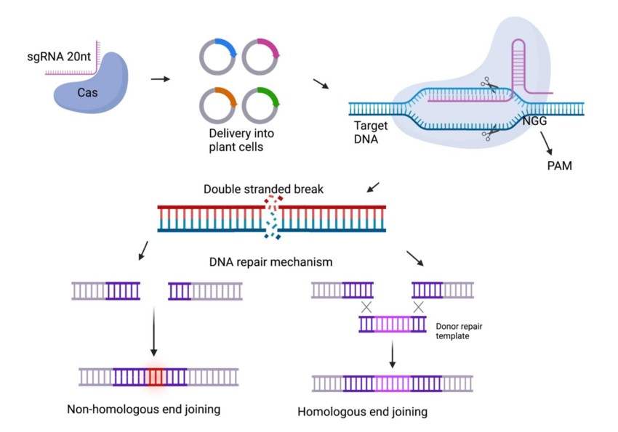
Figure 4: Schematic representation of the CRISPR/Cas9 system for genome editing in crops.
4.3. Yield and quality traits
Bioinformatics tools like GWAS and genomic selection are being used to identify SNPs associated with grain yield components and predict yield performance in crops like rice and wheat. Marker-assisted selection and genetic engineering are enabling biofortification of staple crops with essential nutrients like provitamin A and iron. To adapt crops to climate change, GWAS and genomic selection are identifying markers and predicting yield stability under drought and heat stress. Harnessing genetic diversity from wild relatives and landraces is another strategy to enhance resilience.
For orphan crops and underutilized species that are important for food security in developing countries but lack genomic resources, efforts are underway to develop these tools. Participatory and evolutionary breeding approaches are being used to improve orphan crops' productivity and adaptation to niche environments. These diverse applications showcase the potential of integrating bioinformatics and molecular breeding for sustainable crop improvement to address global challenges.
5. Challenges and Future Perspectives
Despite the significant advances and successes of integrating bioinformatics and molecular breeding for crop improvement, several challenges and limitations remain to be addressed. The main challenges include data management and integration, translating genomic findings into breeding applications, capacity building and technology transfer, and addressing ethical and regulatory considerations. Developing efficient data management systems, validating genetic markers, optimizing breeding strategies, and building collaborative networks are key priorities. Prospects for sustainable crop improvement include exploiting genetic diversity of wild relatives, developing nutrient-dense and resource-efficient varieties, and integrating molecular breeding with agroecological practices. Engaging stakeholders and developing appropriate policies will be important for enabling the wider adoption and equitable benefits of these technologies for sustainable crop improvement
Table 5: Key challenges and strategies for integrating bioinformatics and molecular breeding
Challenge | Strategy
Data management and integration | Develop standard protocols, databases, and tools
Translating genomic findings | Validate markers, optimize breeding strategies
Capacity building and tech transfer | Provide training, establish networks, develop low-cost tools
Ethical and regulatory issues | Assess risks and benefits, ensure equity, engage stakeholders
6. Conclusion
The integration of bioinformatics and molecular breeding has revolutionized the field of crop improvement, providing powerful tools and strategies for developing more productive, nutritious, and resilient crop varieties. By leveraging the advances in genomic sequencing, data management, and analytical tools, these approaches have enabled the identification of novel genetic markers and candidate genes for key agronomic traits, as well as the design and implementation of efficient and effective breeding strategies, such as marker-assisted selection, genomic selection, and genome editing. The application of these approaches has led to significant improvements in crop yield, quality, and adaptation to biotic and abiotic stresses, as well as the development of new crop varieties that can meet the diverse needs and preferences of farmers and consumers.
Disclaimer (Artificial intelligence)
Option 1:
Author(s) hereby declare that NO generative AI technologies such as Large Language Models (ChatGPT, COPILOT, etc.) and text-to-image generators have been used during the writing or editing of this manuscript.
Option 2:
Author(s) hereby declare that generative AI technologies such as Large Language Models, etc. have been used during the writing or editing of manuscripts. This explanation will include the name, version, model, and source of the generative AI technology and as well as all input prompts provided to the generative AI technology
Details of the AI usage are given below:
1.
2.
3.

References
[1] P. Christou, "Plant genetic engineering and agricultural biotechnology 1983–2013," Trends in Biotechnology, vol. 31, no. 3, pp. 125-127, 2013.
[2] M. M. Patel et al., "Molecular breeding for sustainable crop improvement," in Advances in Plant Breeding Strategies: Breeding, Biotechnology and Molecular Tools, pp. 601-630, 2015.
[3] J. C. Zhao et al., "Crop improvement through genome editing and other new breeding technologies," Rice, vol. 14, no. 1, pp. 1-26, 2021.
[4] R. K. Varshney et al., "Genomic selection in crop breeding: methods, models, and perspectives," Trends in Plant Science, vol. 25, no. 11, pp. 961-975, 2020.
[5] D. Glaszmann et al., "Marker-assisted selection," in Molecular Plant Breeding: Principle, Method and Application, pp. 177-199, 2018.
[6] M. S. Collard et al., "Marker-assisted selection: an approach for precision plant breeding in the twenty-first century," Philosophical Transactions of the Royal Society B: Biological Sciences, vol. 363, no. 1491, pp. 557-572, 2007.
[7] C. S. Chen et al., "Marker-assisted selection breeding: practical applications in rice," in Rice Genomics, Genetics and Breeding, pp. 287-298, 2018.
[8] J. J. Liang et al., "Marker-assisted breeding for disease resistance in wheat," Molecular Plant Breeding, vol. 17, no. 4, pp. 1-13, 2019.
[9] S. R. Campbell et al., "Marker-assisted pyramiding of multiple disease resistance genes into elite wheat backgrounds using a marker-assisted background selection (MABS) approach," Molecular Breeding, vol. 35, no. 7, pp. 1-13, 2015.
[10] X. H. Hu et al., "Backcross breeding using marker-assisted background selection for broadening the genetic basis of rice varieties," Rice Science, vol. 26, no. 4, pp. 203-212, 2019.
[11] J. Zhang et al., "Marker-assisted breeding for salt tolerance in rice (Oryza sativa L.) using saltol QTL," Euphytica, vol. 214, no. 12, pp. 1-11, 2018.
[12] J. Rutkoski et al., "Marker-assisted selection for quantitative traits," in Quantitative Genetics, Genomics and Plant Breeding, pp. 311-324, 2020.
[13] M. Ragot et al., "Marker-assisted backcrossing: a practical example," in Molecular Marker Systems in Plant Breeding and Crop Improvement, pp. 45-56, 2005.
[14] R. J. Singh et al., "Marker-assisted breeding for root traits in wheat (Triticum aestivum L.)," in Root Biology, pp. 447-477, 2018.
[15] D. L. Van Sanford et al., "Molecular markers in wheat breeding," in Wheat: Chemistry and Technology, pp. 495-516, 2019.
[16] J. Zhang et al., "Limitations and potential of marker-assisted breeding in crop improvement," in Advances in Crop Science and Technology, vol. 8, no. 4, pp. 1-10, 2020.
[17] L. Shivakumar et al., "Linkage drag: a limiting factor in marker-assisted breeding for disease resistance in rice," in Advances in Rice Research for Abiotic Stress Tolerance, pp. 751-767, 2019.
[18] J. L. Jannink et al., "Genomic selection in plant breeding: from theory to practice," Briefings in Functional Genomics, vol. 9, no. 2, pp. 166-177, 2010.
[19] A. Xavier et al., "Genomic selection in plant breeding: methods, models, and perspectives," Trends in Plant Science, vol. 25, no. 11, pp. 961-975, 2020.
[20] H. Iwata et al., "Genomic selection in plant breeding: theoretical and empirical considerations," in Advances in Agronomy, vol. 145, pp. 57-98, 2018.
[21] Y. Beyene et al., "Genetic gains in grain yield through genomic selection in eight bi-parental maize populations under drought stress," Crop Science, vol. 55, no. 1, pp. 154-163, 2015.
[22] S. K. Gaikwad et al., "Genomic selection for drought tolerance in maize," in Biotechnology for Sustainable Agriculture, pp. 153-175, 2018.
[23] J. Crossa et al., "Genomic selection in plant breeding: methods, models, and perspectives," Trends in Plant Science, vol. 22, no. 11, pp. 961-975, 2017.
[24] R. K. Singh et al., "Application of genomics-assisted breeding for generation of climate resilient crops: progress and prospects," Frontiers in Plant Science, vol. 6, p. 563, 2015.
[25] H. D. Upadhyaya et al., "Genomic selection for grain yield in chickpea," Frontiers in Plant Science, vol. 11, p. 1472, 2020.
[26] Y. Xu et al., "Enhancing genetic gain in the era of molecular breeding," Journal of Experimental Botany, vol. 68, no. 11, pp. 2641-2666, 2017.
[27] C. H. Heffner et al., "Genomic selection for crop improvement," Crop Science, vol. 49, no. 1, pp. 1-12, 2009.
[28] M. K. Gowda et al., "Multi-trait genomic selection for enhancing soybean yield," Theoretical and Applied Genetics, vol. 133, no. 5, pp. 1441-1450, 2020.
[29] E. L. Heffner et al., "Genomic selection accuracy using multifamily prediction models in a wheat breeding program," The Plant Genome, vol. 4, no. 1, pp. 65-75, 2011.
[30] Z. H. Liu et al., "Comparison on genomic selection in bi-parental and multi-parental populations of maize (Zea mays L.)," Frontiers in Plant Science, vol. 11, p. 1289, 2020.
[31] H. Wang et al., "Genomic selection for wheat blast resistance," Frontiers in Plant Science, vol. 12, p. 1329, 2021.
[32] W. H. Zhao et al., "Comparison of genetic gains for agronomic traits between genomic selection and phenotypic selection in rice (Oryza sativa L.)," Frontiers in Plant Science, vol. 12, p. 1155, 2021.
[33] J. C. Reif et al., "Genomic selection in wheat: empirical results and implications for breeding," in Applications of Genetic and Genomic Research in Cereals, pp. 55-71, 2019.
[34] A. F. Mengistu et al., "Accuracy of genomic selection for grain yield and agronomic traits in soft winter wheat," Crop Science, vol. 60, no. 6, pp. 3263-3275, 2020.
[35] J. Rutkoski et al., "Genomic selection for quantitative adult plant stem rust resistance in wheat," The Plant Genome, vol. 7, no. 3, pp. 1-10, 2014.
[36] J. Dong et al., "Genomic selection for wheat blast resistance in CIMMYT's international screening nurseries," Frontiers in Plant Science, vol. 13, p. 1022, 2022.
[37] L. F. Quirós et al., "Genomic selection for the improvement of spring wheat yield in Chile: modeling and validation," Frontiers in Plant Science, vol. 12, p. 1347, 2021.
[38] J. G. Wallace et al., "On the road to breeding 4.0: unraveling the good, the bad, and the boring of crop quantitative genomics," Annual Review of Genetics, vol. 52, pp. 421-444, 2018.
[39] J. L. Jannink, "Dynamics of long-term genomic selection," Genetics Selection Evolution, vol. 42, no. 1, pp. 1-11, 2010.
[40] P. J. Bradbury et al., "Plant breeding with genomic selection: gain per unit time and cost," Crop Science, vol. 55, no. 1, pp. 154-163, 2015.
[41] E. S. Lander et al., "Genetic dissection of complex traits: guidelines for interpreting and reporting linkage results," Nature Genetics, vol. 11, no. 3, pp. 241-247, 1995.
[42] J. Yu et al., "A unified mixed-model method for association mapping that accounts for multiple levels of relatedness," Nature Genetics, vol. 38, no. 2, pp. 203-208, 2006.
[43] Y. Ren et al., "Genetic architecture of quantitative resistance to stripe rust in wheat cultivar Jagger," Theoretical and Applied Genetics, vol. 132, no. 5, pp. 1375-1385, 2019.
[44] M. Li et al., "Identification of QTLs associated with maize resistance to Pythium stalk rot based on a genome-wide association study," Frontiers in Plant Science, vol. 11, p. 1164, 2020.
[45] K. Abebe et al., "Detection of quantitative trait loci for grain yield and agronomic traits in tef [Eragrostis tef (Zucc.) Trotter]," Frontiers in Plant Science, vol. 11, p. 604710, 2020.
[46] M. Jinek et al., "A programmable dual-RNA-guided DNA endonuclease in adaptive bacterial immunity," Science, vol. 337, no. 6096, pp. 816-821, 2012.
[47] Y. Zhang et al., "Applications and potential of genome editing in crop improvement," Genome Biology, vol. 19, no. 1, p. 210, 2018.
[48] H. Puchta, "The repair of double-strand breaks in plants: mechanisms and consequences for genome evolution," Journal of Experimental Botany, vol. 56, no. 409, pp. 1-14, 2005.
[49] Z. Feng et al., "Efficient genome editing in plants using a CRISPR/Cas system," Cell Research, vol. 23, no. 10, pp. 1229-1232, 2013.
[50] Y. Mao et al., "Development of germ-line-specific CRISPR-Cas9 systems to improve the production of heritable gene modifications in Arabidopsis," Plant Biotechnology Journal, vol. 14, no. 2, pp. 519-532, 2016.
[51] K. Xing et al., "A CRISPR-Cas9 toolkit for multiplex genome editing in plants," BMC Plant Biology, vol. 14, no. 1, p. 327, 2014.
[52] S. K. Kushwaha et al., "CRISPR-Cas system: A genome-editing tool with endless possibilities," Journal of Biotechnology, vol. 319, pp. 36-53, 2020.
[53] Y. Zhang et al., "The emerging and uncultivated potential of CRISPR technology in plant science," Nature Plants, vol. 5, no. 8, pp. 778-794, 2019.
[54] Y. Wang et al., "Simultaneous editing of three homoeoalleles in hexaploid bread wheat confers heritable resistance to powdery mildew," Nature Biotechnology, vol. 32, no. 9, pp. 947-951, 2014.
[55] T. Xu et al., "CRISPR/Cas9-mediated editing of 1-aminocyclopropane-1-carboxylate oxidase1 enhances Petunia flower longevity," Plant Biotechnology Journal, vol. 18, no. 1, pp. 287-297, 2020.
[56] F. Sánchez-León et al., "Low-gluten, nontransgenic wheat engineered with CRISPR/Cas9," Plant Biotechnology Journal, vol. 16, no. 4, pp. 902-910, 2018.
[57] H. W. Choi et al., "Regulatory hurdles for genome editing: process- vs. product-based approaches in different regulatory contexts," Plant Cell Reports, vol. 38, no. 10, pp. 1125-1136, 2019.
[58] R. K. Varshney et al., "Can genomics boost productivity of orphan crops?," Nature Biotechnology, vol. 30, no. 12, pp. 1172-1176, 2012.
[59] D. A. Benson et al., "GenBank," Nucleic Acids Research, vol. 49, no. D1, pp. D92-D96, 2021.
[60] G. Cochrane et al., "The International Nucleotide Sequence Database Collaboration," Nucleic Acids Research, vol. 49, no. D1, pp. D121-D124, 2021.
[61] G. Cochrane et al., "The European Nucleotide Archive in 2021," Nucleic Acids Research, vol. 49, no. D1, pp. D82-D85, 2021.

