Sodium-Treated Iron-Bridged Clay for Arsenic Removal in the Presence of Lead and Cadmium: A Comparative Study

Abstract
Contamination of environmental matrices by trace metals is mainly due to human activities. One of the chemical species released into the environment and hazardous to living organisms is arsenic. The present work aimed to study the elimination of arsenic in the presence of lead and cadmium using a sodium-treated, iron-bridged Ivory Coast clay. To achieve this goal, the fine fraction of a smectite-rich clay from Katiola in Côte d'Ivoire was extracted and treated with sodium (KAT-Na). In addition, this sodium-treated clay was iron-bridged (KAT-Na-Fe_{x}(OH)_{y}). The clay was bridged by adding the bridging solution (Fe_{x}(OH)_{y}) drop by drop to a clay suspension (0.5% w/v concentration) under constant agitation. Samples were analysed by XPS. For the analysis of clays using XPS - X-ray Photoelectron Spectroscopy, the Escalab 250 Xi ThermoFisher spectrometer was used. Survey spectra were recorded in a range from 1350 to 0 eV, with a passage energy of 140 eV. High-resolution spectra were recorded for the photoemission peaks Fe 2p_{3/2,1/2}, K 2p_{3/2,1/2}, O 1s, C 1s, Cl 2p_{3/2,1/2}, Si 2p_{3/2,1/2} and Al 2p_{3/2,1/2}. KAT-Na and KAT-Na-Fe_{x}(OH)_{y} clays were used to adsorb arsenic in aqueous solution. The method used was that of batch adsorption. Arsenic was determined by ICP-AES. For an initial concentration ranging from 0 to 20 ppm, arsenic removal on KAT-Na clay reached 73.64%. In contrast, bridging the clay with iron significantly improved the arsenic removal rate, reaching 91.75%. The adsorption isotherms plotted indicate that arsenic removal on KAT-Na is best represented by the Langmuir model. Whereas Freundlich linearization better describes arsenic adsorption on KAT-Na-Fe_{x}(OH)_{y} clay. The presence of metal cations (Cd and Pb) did not prevent good arsenic removal. The higher Q_{max} of KAT-Na-Fe_{x}(OH)_{y} than KAT-Na confirms that the bridged clay has a better adsorption capacity. The values of n and R_{L} lie respectively in the intervals ]1; 10[ and ]0; 1[. These results suggest that the adsorption of arsenic in the presence of lead and cadmium on KAT-Na and KAT-Na-Fe_{x}(OH)_{y} clays is favourable. This research contributes to the treatment of water to improve the health of living beings, using iron-bridged Katiola clay as an adsorbent.

Keywords: Clay, bridged clay, smectite, adsorption, arsenic
1. INTRODUCTION
In recent decades, environmental pollution by trace metals has become a major concern for the scientific community (Nesta et al., 2015; Vodela et al., 1997). Effluents from human activities are the main sources of environmental pollution (Ouattara et al., 2022). Polluting substances can accumulate along the food chain and concentrate in environmental matrices and in certain organs of the human body. Heavy Metals are naturally occurring elements with a large atomic weight and at least five times the density of water. Assuming that heaviness and toxicity are intertwined. It also includes metalloids, such as arsenic (As), that can induce toxicity at low exposure levels. The level of toxicity exhibited by these hazardous materials is contingent upon the amount and length of time that living organisms are exposed to them (Abd Elnabi et al., 2023). “Côte d'Ivoire is no stranger to pollution caused by human activities. Several Ivory Coast rivers, such as the Cavally in the west, Bandama and N'zi in the centre and Bia in the east, are polluted by trace metals. Studies have revealed concentrations of arsenic, cadmium, mercury, nickel and lead well in excess of WHO limits in sediments, drinking water and irrigation water in the sub-prefecture of Hiré and in Aboisso” (Kinimo et al., 2018; Yapi et al., 2014). “People living in these regions and surrounding areas mainly use contaminated water for their various needs. These pollutants are highly toxic and have a detrimental effect on human and animal health, as well as on plant growth” (Harmandon, 2004; Koller et al., 2013). It is therefore essential to eliminate these toxic elements from the various effluents or to reduce their quantity below the admissible thresholds defined by the standards.
In response to increasingly stringent regulations, industries are required to treat their effluents before discharging them into the natural environment. On the other hand, scientific researchers are interested in eliminating pollutants likely to cause serious disorders in both animals and humans (Waribo et al., 2022). As the various studies on water decontamination by adsorption on clays have given satisfactory results, the valorisation of the clay raw materials available in Côte d'Ivoire presents itself as the best alternative to respond to the problem of water contamination (Ouakouak and Youcef, 2016 ; Mockovčiaková et al., 2010 ; Mimanne et al., 2014). “Arsenic is commonly found in groundwater, forming arsenite (As(III)) and arsenate (As(V)) species. The As(III) species is more difficult to remove from water than As(V) and is more harmful to health due to its higher cellular uptake. Arsenic water contamination represents a serious public health problem worldwide due to the severe health damage it causes” (Reyes-Bozo et al., 2025).
To optimise effluent decontamination, many researchers have turned to clays intercalated with organic or inorganic compounds, also known as “bridged clays”. Researchers have discovered that these bridged clays have unique properties that make them ideal for depolluting contaminated solutions (Bouras, 2003).
“Our previous study revealed that in the presence of lead and cadmium in aqueous solution, Katiola raw clay removed 59.04% of arsenic. In addition, the magnesium-treated and sodium-treated samples adsorbed 72.53% and 73.64% arsenic, respectively” (Kouadio et al., 2024). As arsenic removal is not complete, we plan to improve the adsorbent properties of the clay to increase arsenic removal.
Following on from the above, the general aim of this work is to study the removal of arsenic in the presence of lead and cadmium using a sodium-treated, iron-bridged clay.
2. MATERIALS AND METHODS
2.1. Clay material
The raw clay (Fig. 1) used in this study in this study comes from the town of Katiola (northern Côte d'Ivoire) at 8°08' north latitude and 5°06' west longitude. The main characteristics of the raw clay (KAT) are listed in Table 1 (mineralogical composition, specific surface area and cation exchange capacity) below (Kang et al., 2019).
Table 1. Mineralogical composition and physicochemical properties of KAT clay ( Kouadio et al., 2022)
Sample | % Kaolinite | % Illite | % Smectite | % Quartz | % Goethite | CEC (méq/100g) | S_{BET} (m²/g)
KAT | 48.08 | 3.55 | 20.14 | 6.11 | 16.86 | 35.47 | 48.5

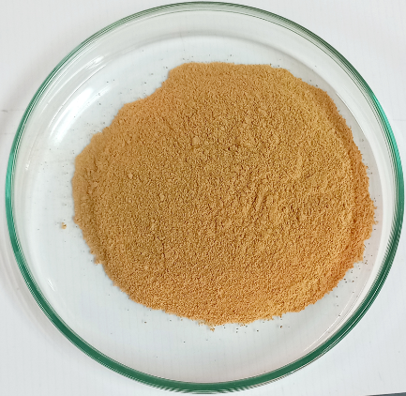

Fig. 1. Image of the KAT clay sample
2.2. Extraction of fine clay fraction and sodium treatment
Extraction of the fine clay fraction relies on granulometric separation techniques based on sedimentation (Robert and Tessier, 1974). The process involved dispersing 20 g of finely ground clay, sieved to 63 µm, in one litre of distilled water. To stabilise the suspension, the pH was gradually raised to 8.5 by the careful addition of a normal solution of sodium hydroxide (1 M), followed by thorough stirring with a magnetic stirrer for 4 hours. The clay suspension is left to settle for 16 hours to separate the different particle size fractions. After the coarse particles have settled to the bottom, 15 cm of the clay fraction (supernatant) collected by siphoning and placed in a 2 L beaker is added to a normal solution of hydrochloric acid to obtain a pH of around 5. The clay is then made sodium homoionic by 2 successive treatments with sodium chloride. To achieve this, 100 mL of sodium chloride solution (1M) is added to the clay fraction. This operation allows complete flocculation of the clay a few hours later. The supernatant is then siphoned off. The clay is washed several times with distilled water, removing the chloride ion by centrifugal separation, until the rinse water test is negative for silver nitrate (removal of excess salt). Finally, the sample was collected and oven-dried at 40°C. This treatment yielded a fine fraction of sodium-saturated clay: KAT-Na. Figure 2 shows the KAT-Na clay.
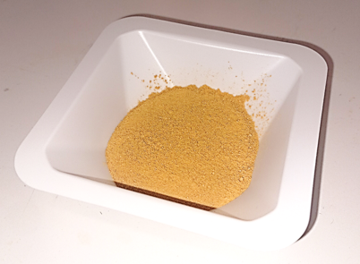

Fig. 2. Image of KAT-Na clay sample
2.3. Preparation of iron-bridged clay
2.3.1. Preparation of iron-bridge solution
The procedure involved slowly titrating 40 mL FeCl3.6H2O (0.43M) with 46 mL NaOH solution (0.75M), with stirring, so that the ratio of OH⁻/Fe³⁺ = 2. The final solution contains 0.2M iron. The mixture is left to stand in the dark for 48 h (Haffane et al., 2016). The bridging solution is referenced Fe_{x}(OH)_{y}.
2.3.2. Clay bridging
The fine fraction of Katiola clay obtained by NaCl treatment (KAT-Na) was intercalated with iron polycation. The clay was bridged by adding the bridging solution (Fe_{x}(OH)_{y}) drop by drop to a clay suspension (0.5% w/v concentration) under constant agitation. The clay suspension consists of 2.45g of clay in 490 mL of water. The Fe/clay ratio is 7 mmol.g⁻¹. This ratio was chosen as it appears to give satisfactory results in the literature (Khalaf et al.,1997 ; Lenoble, 2003). At the end of titration, the clays were left in contact with the metal polycation for 24 hours to ensure proper insertion. After three washes with milliQ water (until the rinse water test was negative for AgNO₃), the intercalated clays were recovered, oven-dried at 70°C and then calcined at 450°C for 4 hours. The material synthesised is referenced KAT-Na-Fe_{x}(OH)_{y} and is shown in Figure 3.

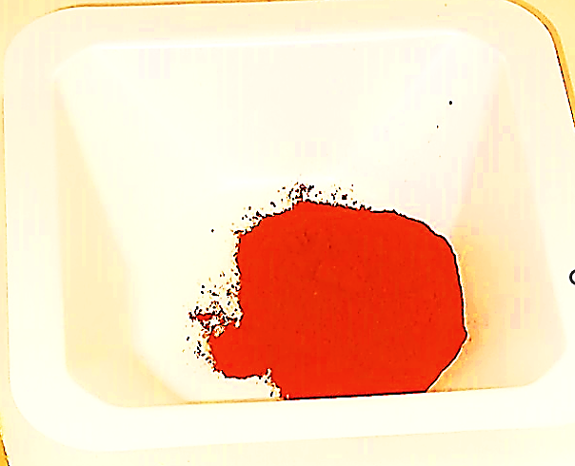

Fig. 3. Image of KAT-Na-Fe_{x}(OH)_{y} clay sample
2.4. Analysis of clays by XPS - X-ray Photoelectron Spectroscopy
The instrument used was an Escalab 250 Xi ThermoFisher spectrometer. The experiments were carried out on three clay samples: Katiola raw clay (KAT), sodium-treated clay (KAT-Na) and iron-bridged clay (KAT-Na-Fe_{x}(OH)_{y}).
The powdered sample was fixed on an adhesive support and then introduced into the analysis chamber. An aluminium monochromatic X-ray source (Al Kα) with an energy of 1486.6 eV and a power of 162 watts was used.
Survey spectra were recorded in a range from 1350 to 0 eV, with a passage energy of 140 eV. High-resolution spectra were recorded in the regions of the elements identified in the survey spectra, with a pass energy of 30 eV. The ThermoFisher charge compensation system was used. Spectra were calibrated for binding energy using the C 1s (C-C, C-H) photoemission peak at 284.8 eV. High-resolution spectra were recorded for the photoemission peaks Fe 2p_{3/2,1/2}, K 2p_{3/2,1/2}, O 1s, C 1s, Cl 2p_{3/2,1/2}, Si 2p_{3/2,1/2} and Al 2p_{3/2,1/2}.
2.5. Preparation of adsorbate solutions
Three 1000 mg/L adsorbate stock solutions of Cd, Pb and As were prepared by dissolving 0.277g Cd(NO₃)₂.4H₂O (purity ≥ 99%); 0.162g Pb(NO₃)₂ (purity = 98.5%) and 0.425g Na₂HAsO₄.7H₂O (purity ≥ 98%) in 100 mL MilliQ water, respectively. Polymetallic solutions (containing both Cd, As and Pb) at 5, 10, 15 and 20 ppm were prepared by dilution of the stock solutions. The ionic strength of each solution was maintained at 0.1M NaNO₃.
2.6. Adsorption reactions
0.1g of clay was brought into contact with 10 mL of a polymetallic solution in a polypropylene tube. “The clay/solution mixture was stirred for 90 min at room temperature. After stirring, the mixture was centrifuged at 5000 rpm for 30 min. The supernatant was collected and filtered at 0.45 µm for ICP arsenic determination. Each assay was performed in duplicate. The effect of initial concentration on adsorption was evaluated (from 0 to 20 ppm). The efficiency of the adsorption process was defined by calculating the adsorption capacity (Q_{ads}) and the arsenic removal efficiency (R) according to equations 1 and 2 below (Achour and Youcef, 2003) :
Q_{ads} = $\frac{C_{0}-C_{t}}{m}V$ (1)
R (%) = $\left(1-\frac{C_{e}}{C_{0}}\right)*100$ (2)
C₀ : Initial pollutant concentration (mg/L or mol/L)
C_{t} : Pollutant concentration at time t in liquid phase (mg/L or mol/L)
V : Volume of solution (L)
m : adsorbent mass (g or kg)
3. Results and discussion
3.1. Surface chemical analysis of clays and chemical status of the element Fe
The results of the atomic concentrations (%) of the elements present on the surface of the samples and the binding energies of the photoemission peaks (eV) recorded are presented in Table 2. High-resolution spectra of the Fe 2p_{3/2,1/2} region of the KAT, KAT-Na and KAT-Na-Fe_{x}(OH)_{y} samples are shown in Figure 4.
Table 2. Atomic element concentrations (%) and binding energies (eV) for KAT, KAT-Na and KAT-Na-Fe_{x}(OH)_{y} samples
Element | KAT |  | KAT-Na |  | KAT-Na-Fe_{x}(OH)_{y}
Photoemission Peak | Binding Energy(eV) | %Atomic | Binding Energy(eV) | %Atomic | Binding Energy(eV) | %Atomic
Al 2p Clay | 74.4 | 10.1 | 74.4 | 10.4 | 74.7 | 10.1
Si 2p Clay | 102.6 | 15.5 | 102.7 | 16.4 | 102.7 | 15.7
O 1s (1) Fe^{lattice} | 529.8 | 1.6 | 529.6 | 0.5 | 530.0 | 7.7
O 1s (2)  Clay, carbon,  Fe* | 531.9 | 53.3 | 532.0 | 54.6 | 532.0 | 48.7
O 1s (3)  Clay, H₂O | 534.0 | 2.9 | 534.0 | 2.2 | - | -
C 1s (1)  (C-C, C-H) | 284.8 | 8.7 | 284.8 | 7.4 | 284.8 | 8.4
C 1s (2)  (C-OH, C-O-C) | 286.3 | 2.1 | 286.3 | 1.8 | 286.3 | 1.9
C 1s (3)  (O-C=O) | 289.0 | 0.8 | 289.0 | 0.8 | 288.8 | 0.9
K 2p_{3/2} | 293.1 | 0.1 | 293.3 | 0.1 | 293.1 | 0.1
K 2p_{1/2} | 296.2 | 0.1 | 296.1 | 0.1 | 296.2 | 0.1
Cl 2p_{3/2} | 199.1 | 0.2 | 198.4 | 0.4 | -  - | -
Cl 2p_{1/2} | 199.1 | 0.2 | 200.1 | 0.4 | -  - | -
Fe 2p_{3/2} | 712.0 | 3.4  Fe₃O₄ | 712.4 | 3.0  Fe₃O₄ | 710.9 | 5.4  Fe(III)
satelite 1 | 721.4 | 3.4  Fe₃O₄ | 722.1 | 3.0  Fe₃O₄ | 719.2 | 5.4  Fe(III)
Fe 2p_{1/2} | 725.7 | 3.4  Fe₃O₄ | 726.1 | 3.0  Fe₃O₄ | 724.3 | 5.4  Fe(III)
satelite 2 | 735.0 | 3.4  Fe₃O₄ | 735.5 | 3.0  Fe₃O₄ | 733.0 | 5.4  Fe(III)
Mg 1s | 1306.9 | 0.7 | 1306.8 | 0.4 | 1306.6 | 0.4
N 1s | 401.0 | 0.7 | 400.8 | 0.4 | 401.2 | 0.7
Na 1s (1) | - | - | 1072.7 | 0.4 | - | -
Na 1s (2) | - | - | 1074.8 | 0.5 | - | -
Na 1s (3) | - | - | 1076.6 | 1.0 | - | -
Total |  | 100.0 |  | 100.0 |  | 100.0
O1s (2): Fe* : Hydroxide, Hydrated or defective oxide
For all the samples studied, oxygen (O), silicon (Si) and aluminium (Al) are the major elements, with iron (Fe) associated with them. The surface of the KAT and KAT-Na samples contains 3.4 and 3.0% Fe, respectively. In contrast, the surface of the iron-bridged sample (KAT-Na-Fe_{x}(OH)_{y}) contains 5.4% Fe.
The results clearly indicate the silico-aluminous nature of the 3 samples and confirm that they are clays.

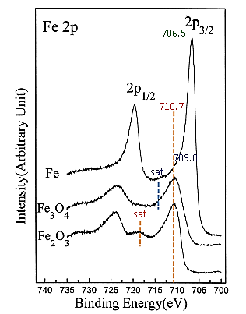

Fig. 4. High-resolution spectra of the Fe 2p_{3/2,1/2} regions of the 3 samples and classical references of Fe (0), Fe²⁺/Fe³⁺ (Fe₃O₄) and Fe³⁺ (Fe₂O₃) (Alraddadi, 2021)
Iron is already present in the Kat and Kat-Na clays. The increase in Fe content in the KAT-Na-Fe_{x}(OH)_{y} sample confirms that this clay has been treated with iron. In all three samples, iron is in +2 and +3 oxidation states (Fe₃O₄ type). Compared with the Kat and Kat-Na samples, the presence of Fe³⁺ is greater in the KAT-Na-Fe_{x}(OH)_{y} clay (Fe₂O₃ and/or Fe hydroxides). The observation of an individualised satellite at 719 eV supports this assertion. This result justifies that the KAT-Na clay was treated with FeCl₃.6H₂O to obtain KAT-Na-Fe_{x}(OH)_{y}. The presence of water is identified in Kat and Kat-Na (2.9 and 2.2% respectively) but not in KAT-Na-Fe_{x}(OH)_{y}. Moreover, Na, which was only observed in KAT-Na, is no longer present after iron treatment. All these remarks suggest that the treatment of KAT-Na (iron bridging) brought Fe³⁺ ions that substituted for Na⁺ ions and associated water molecules into the interfoliar space of the clay.
3.2. Adsorption of arsenic in the presence of lead and cadmium (As/(Cd+Pb))
Tables 3 and 4 and Figure 5 show the results of arsenic adsorption on KAT-Na and KAT-Na-Fe_{x}(OH)_{y} clays. In order to describe arsenic removal in the presence of lead and cadmium, adsorption isotherms have been represented (Figure 6).
Table 3. Adsorption of arsenic in the presence of Pb and Cd on KAT-Na clay
KAT-Na
Ci(mg/L) | 5 | 10 | 15 | 20
Ce(mg/L) | 1.67 ± 0.04 | 4.57 ± 0.02 | 8.95 ± 0.02 | 14.35 ± 0.2
Q_{ads}(mg/g) | 0.33 ± 0.0 | 0.54 ± 0.0 | 0.62 ± 0.0 | 0.60 ± 0.02
R(%) | 73.64 ± 0.8 | 61.32 ± 0.2 | 58.18 ± 0.2 | 42.22 ± 1.5
Table 4. Adsorption of arsenic in the presence of Pb and Cd on KAT-Na-Fe_{x}(OH)_{y} clay
KAT-Na-Fe_{x}(OH)_{y}
Ci(mg/L) | 5 | 10 | 15 | 20
Ce(mg/L) | 0.41 ± 0.01 | 1.97 ± 0.00 | 3.41 ± 0.10 | 5.84 ± 0.00
Q_{ads}(mg/g) | 0.46 ± 0.00 | 0.79 ± 0.01 | 1.13 ± 0.00 | 1.37 ± 0.00
R (%) | 91.75 ± 0.23 | 80.34 ± 0.01 | 77.27 ± 0.65 | 70.79 ± 0.02

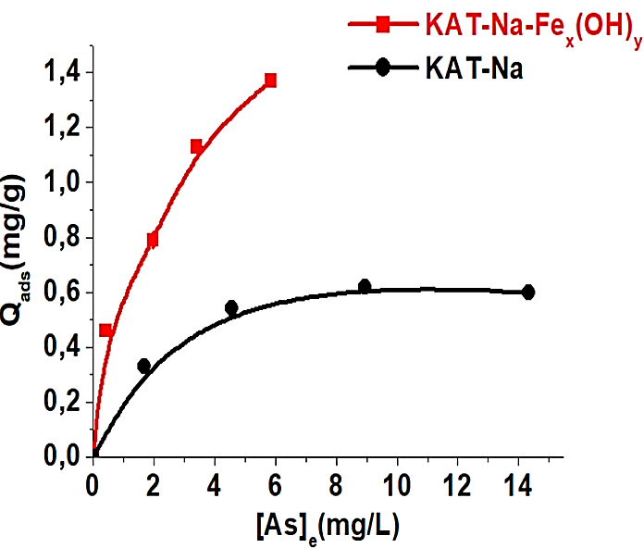
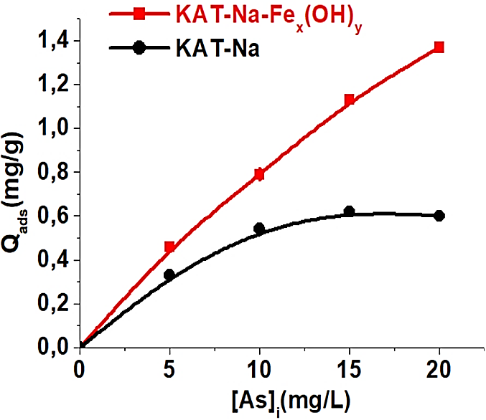

Fig. 6. Adsorption isotherms for As on KAT-Na and KAT-Na-Fe_{x}(OH)_{y}

Fig. 5. Influence of initial concentration on As adsorption in the presence of Pb and Cd
The results clearly show that arsenic adsorption on KAT-Na and KAT-Na-Fe_{x}(OH)_{y} clays is influenced by the variation in initial concentration (5 to 20 ppm).
For an initial arsenic concentration ranging from 5 to 20 ppm, the adsorption capacity of KAT-Na clay varies from 0.33 to 0.62 mg/g. The adsorption capacity of the bridged clay KAT-Na-Fe_{x}(OH)_{y} ranges from 0.46 to 1.37 mg/g. Arsenic removal in the presence of lead and cadmium reached 73.64% and 91.75% on KAT-Na and KAT-Na-Fe_{x}(OH)_{y} clays, respectively.
Two key points are worth noting:
- The adsorption capacity of both clays increases with initial concentration. The KAT-Na clay reaches a pseudo-peak between 15 and 20 ppm. On the other hand, the KAT-Na-Fe_{x}(OH)_{y} clay barely begins to plateau;
- Bridged clay (KAT-Na-Fe_{x}(OH)_{y}) has a much higher adsorption capacity than sodic clay (KAT-Na).
The increase in adsorption capacity as a function of initial arsenic concentration is in line with several studies (Coles and Yong, 2002 ; Uzunkavak and Özdemir, 2019). The increase in concentration gradient and driving force with increasing initial content could explain this observation. Indeed, an increase in initial concentration exposes more ions to each unit mass of adsorbent. “This increase in initial concentration also intensifies the interaction between the adsorbate and the adsorbent” (El-Wakil et al., 2014; Bhattacharyya and Gupta, 2007). Consequently, the quantity adsorbed per unit mass of clay increases.
The pseudo-bearing obtained from 15 ppm onwards suggests that the surface of the KAT-Na adsorbent is saturated. Thus, above this concentration, there is no further adsorption. However, for the KAT-Na-Fe_{x}(OH)_{y} clay, the increase in adsorption capacity above 15 and 20 ppm shows that the adsorbent surface is not yet saturated. There are still several active sites on the KAT-Na-Fe_{x}(OH)_{y} clay surface capable of adsorbing arsenic. This observation suggests that the nature of the surface of the bridged clay is different from that of the sodic clay.
The high adsorption capacity of iron-bridged clay (KAT-Na-Fe_{x}(OH)_{y}) compared with sodium-treated clay (KAT-Na) is linked to the presence of iron polycations in the clay's interfoliar space. In fact, iron bridging in clay gives this material high stability, a well-developed microporous surface and high acidity. In addition, it also allows the sheets to spread apart, creating a larger interfoliar space and thus favouring adsorption (Bouras, 2003). Several studies have shown that the presence of iron on the surface of clays, in principle, favours arsenic retention (Goldberg and Johnston, 2001). Mohapatra et al. asserted that the presence of iron in oxide form on the clay surface can improve its arsenic adsorption capacity (Mohapatra et al., 2007). In their study of arsenic adsorption on pillar clays and iron oxides, Lenoble et al. stated that iron pillar clay appears to be a good matrix for arsenic removal in water treatment (Lenoble et al., 2002). “The shapes of the adsorption isotherms are in line with observations made on the evolution of adsorption capacity as a function of initial arsenic concentration. Based on the classification established by Giles and his collaborators” (Giles et al., 1974), “the adsorption isotherms in this study correspond to type L. This type of isotherm indicates that adsorption takes place on microporous adsorbents, with gradual saturation of the active sites” (Limousin et al., 2007).
3.3. Modelling adsorption isotherms
In order to qualify and quantify arsenic removal, Langmuir (Fig. 7) and Freundlich (Fig. 8) mathematical models were applied to the adsorption isotherms. The Langmuir and the Freundlich linearization equations are respectively : $\frac{C_{e}}{Q_{e}}= \frac{1}{Q_{max}}C_{e}+\frac{1}{Q_{max}K_{L}}$ and ${Log Q}_{e}={Log K}_{f}+ \frac{1}{n}{Log C}_{e}$, where $K_{L}$ is the Langmuir constant ; $Q_{max}$is the maximum adsorption capacity and $K_{f}$ and $n$ are Freundlich constants. The parameters K_{L} ; Q_{max} ; n ; K_{f} and R² were determined and reported in Table 5. In addition, the values of the separation factor R_{L} characteristic of the Langmuir model and defined by the equation : $R_{L}=\frac{1}{1+ K_{L }C_{0}}$ are presented in Table 6.

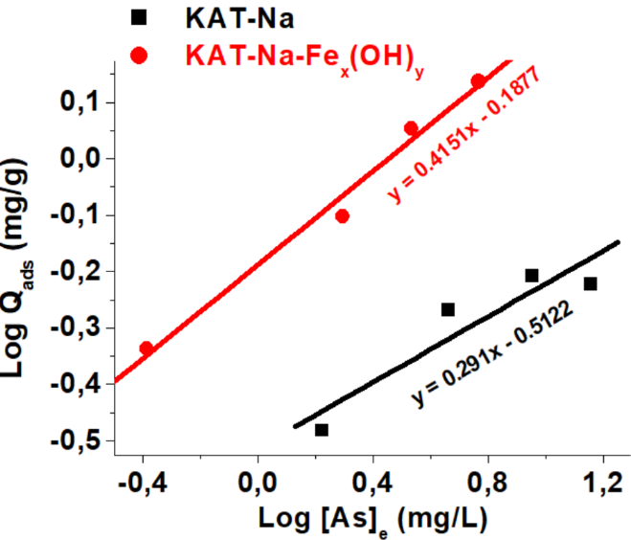
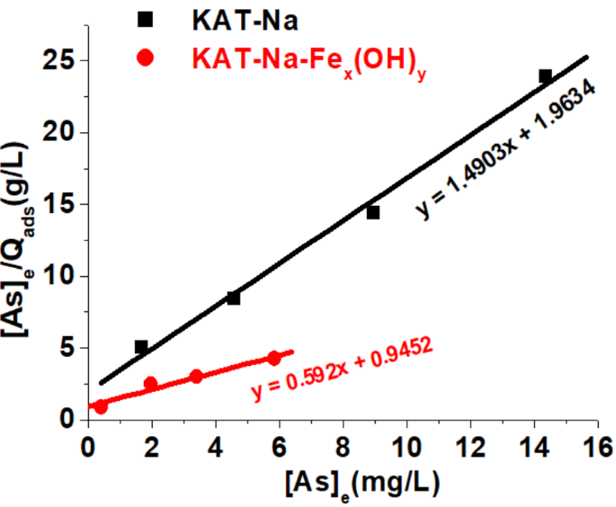

Fig. 8. Application of the Freundlich model to As adsorption on clay KAT-Na and KAT-Na-Fe_{x}(OH)_{y}
Fig. 7. Application of the Langmuir model to As adsorption on clay KAT-Na and KAT-Na-Fe_{x}(OH)_{y}

Table 5. Langmuir and Freundlich parameters
 | Langmuir isotherm |  |  | Freundlich Isotherm
 | Q_{max} | K_{L} | R² | n | K_{f} | R²
KAT-Na | 0.67 | 0.759 | 0.9925 | 3.44 | 0.3075 | 0.8592
KAT-Na-Fe_{x}(OH)_{y} | 1.69 | 0.626 | 0.9562 | 2.41 | 0.6491 | 0.9853
Table 6. Separation factors for As adsorption on clay KAT-Na and KAT-Na-Fe_{x}(OH)_{y}
[As]_{i} | R_{L,} _{KAT-Na} | R_{L, KAT-Na-Fex(OH)y}
5 | 0.21 | 0.24
10 | 0.12 | 0.14
15 | 0.08 | 0.10
20 | 0.06 | 0.07
Arsenic adsorption on KAT-Na clay correlates better with the Langmuir model (R² = 0.9925) than with the Freundlich model (R² = 0.8592). The maximum adsorption capacity (Q_{max}) of KAT-Na clay obtained by the Langmuir model is 0.67 mg/g. As for adsorption on the bridged clay KAT-Na-Fe_{x}(OH)_{y}, application of the Freundlich model is the most suitable (R² = 0.9853). According to the Langmuir model, the maximum adsorption capacity (_{Qmax}) of the KAT-Na-Fe_{x}(OH)_{y} clay is 1.69 mg/g.
“The higher Q_{max} of KAT-Na-Fe_{x}(OH)_{y} than KAT-Na confirms that the bridged clay has a better adsorption capacity. The good fit of the Langmuir model to adsorption on KAT-Na clay suggests that the number of active sites likely to adsorb arsenic is limited and that the surface of this clay is homogeneous” (Adie et al., 2010). “On the other hand, adsorption on KAT-Na-Fe_{x}(OH)_{y} clay, in accordance with the Freundlich model, assumes that arsenic binding takes place on a heterogeneous surface and that the number of adsorption sites is unlimited” (Fayoud et al., 2015).
“The values of n and R_{L} lie respectively in the intervals ]1; 10[ and ]0; 1[. These results suggest that the adsorption of arsenic in the presence of lead and cadmium on KAT-Na and KAT-Na-Fe_{x}(OH)_{y} clays is favourable” (El-Wakil et al., 2014 ; Kamal et al., 2010).
4. Conclusion
The aim of the present study was to compare the effectiveness of a sodium-treated (KAT-Na) and iron-bridged (_{KAT-Na-Fex}(OH)_{y}) Ivory Coast clay in removing arsenic in the presence of lead and cadmium in aqueous media.
Initially, a clay intercalated with iron polycations was synthesised from a sodium-treated clay. Raw (KAT), sodium-treated (KAT-Na) and iron-bridged (KAT-Na-Fe_{x}(OH)_{y}) samples were analysed by XPS to assess their surface chemical composition and iron oxidation state.
Arsenic removal was then carried out by adsorption using 0.1g of clay in 10 mL of solution. The pH of the solutions was set at 7, and 90 min of adsorbent/adsorbent stirring time. The effect of initial concentration (from 5 to 20 ppm) on adsorption was studied.
This work shows that iron bridging of the KAT-Na clay increased the iron content. In addition, this treatment introduced Fe³⁺ ions that replaced Na⁺ ions and associated water molecules in the interfoliar space of the clay. The two clay materials KAT-Na and KAT-Na-Fe_{x}(OH)_{y} adsorb arsenic well, with removal percentages reaching 73.64 and 91.75% respectively. However, it should be noted that bridging the clay with iron significantly improved the adsorption percentage. Plotting the adsorption isotherms indicated that the Langmuir model perfectly represents the adsorption of arsenic on KAT-Na clay. Arsenic removal from KAT-Na-Fe_{x}(OH)_{y} clay is best described by the Freundlich model.
In light of the results obtained, the iron-bridged clay KAT-Na-Fe_{x}(OH)_{y} has an excellent capacity to remove arsenic in aqueous solution. This research aims to contribute to the treatment of water to improve the health of living beings, using iron-bridged Katiola clay as an adsorbent.

Acknowledgements
We would like to thank the Institute of Analytical Sciences and Physical Chemistry for the Environment and Materials (IPREM) at the University of Pau and of Country of Adour in France for allowing us to carry out this work. This work was carried out thanks to an internship funded by the AMRUGE-CI project developed as part of the Debt Reduction and Development Contract (C2D) between France and Côte d'Ivoire.

Disclaimer (Artificial intelligence)
Option 1:
Author(s) hereby declare that NO generative AI technologies such as Large Language Models (ChatGPT, COPILOT, etc.) and text-to-image generators have been used during the writing or editing of this manuscript.

References
Achour, S. and Youcef L. (2003). Removal of cadmium by adsorption on sodium and calcium bentonites. Larhyss Journal, 02, 68-81.
Adie, D. B., Olarinoye, N. O., Oke, I. A., Ismail, A., Lukman, S. and Otun, J. A. (2010). Removal of Lead Ions From Aqueous Solutions Using Powdered Corn Cobs. The Canadian Journal of Chemical Engineering, 88, 241-255.
Alraddadi, S. (2021). Electronic structure and magnetic properties of (γ‑Fe2O3/MgO)N multilayers. Applied Physics A, 127(53), 6p. https://doi.org/10.1007/s00339-020-04204-y.
Bhattacharyya, K. G. and Gupta, S. S. (2007). Adsorptive accumulation of Cd(II), Co(II), Cu(II), Pb(II), and Ni(II) from water on montmorillonite: Influence of acid activation. Journal of Colloid and Interface Science, 310(2), 411–424.
Bortey-Sam, N., Nakayama, S. M., Ikenaka, M., Akoto Y., Baidoo O., Mizukawa E. H. and Ishizuka, M. (2015). Health risk assessment of heavy metals and metalloid in drinking water from communities near gold mines in Tarkwa, Ghana. Environmental Monitoring and Assessment. 187(397), 12 p. doi :10.1007/s10661-015-4630-3.
Bouras, O. (2003). Adsorbent properties of organophilic bridged clays: Synthesis and characterization. Doctoral thesis, University of Limoges, 159p.
Coles, C. A. and Yong, R. N. (2002). Aspects of kaolinite characterization and retention of Pb and Cd. Applied Clay Science, 22(1-2), 39 – 45.
El-Wakil, A. M., El-Maaty, W. M. A. and Awad, F. S. (2014). Studies on biosorption of mercury (II) from aqueous solution on nitric acid modified activated carbon prepared from water hyacinth. ABC Journal of Advanced Research, 3 (1), 51-73.
Fayoud, N., Younssi, S. A., Tahiri, S. and Albizane, A. (2015). Kinetic and thermodynamic study of the adsorption of methylene blue on wood ash. Journal of Materials and Environmental Science, 6 (11), 3295-3306.
Giles, C. H., Smith, D. and Huitson, A. (1974). A general treatment and classification of the solute adsorption isotherm. I. Theoretical. Journal of Colloid and Interface Science, 47(3), 755-765.
Goldberg, S. and Johnston, C. T. (2001). Mechanisms of arsenic adsorption on amorphous oxides evaluated using macroscopic measurements, vibrational spectroscopy, and surface complexation modeling. Journal of Colloid and Interface Science, 234, 204-216. https://doi.org/10.1006/jcis.2000.7295.
Haffane, S., Ouafae, A. and Chafik, T. (2016). Study of the effect of purification and modification of a local clay on the structural and textural properties. Journal of Materials and Environmental Science, 7(2), 525-530.
Harmandon, F. (2004). Toxic effects of sodium arsenite on human health and user exposure. Occupational Medicine - M.S.A. Tarn-Aveyron, Wood Diseases in Midi-Pyrénées, 8-12.
Kamal, M. H. M. A., Azira, W. M. K. W. K., Kasmawati, M., Haslizaidi, Z. and Saime, W. N. W. (2010). Sequestration of toxic Pb(II) ions by chemically treated rubber (Hevea brasiliensis) leaf powder. Journal of Environmental Sciences, 22(2), 248–256.
Khalaf, H., Bouras, O. and Perrichon, V. (1997). Synthesis and Characterization of Al-Pillared and Cationic Surfactant Modified Al-Pillared Algerian Bentonite. Microporous Materials, 8, 141-150.
Kinimo, K. C., Yao, K. M., Marcotte, S., Kouassi, N. L. B. and Trokourey, A. (2018). Distribution trends and ecological risks of arsenic and trace metals in wetland sediments around gold mining activities in central-southern and southeastern Côte d’Ivoire. Journal of Geochemical Exploration, 190, 265–280. doi:10.1016/j.gexplo.2018.03.013.
Kouadio, L. M., Larregieu, M., Tillous, K. E. N., Sei, J., Tison, Y., Parat, C., Pannier, F. and Martinez, H. (2024). Evaluation of the capacity of Ivory Coast clay to depollute water contaminated by Hg, Pb, Cd and As. Saouth African Journal of Chemistry, 78, 170–177. https://doi.org/10.17159/0379-4350/2024/v78a23.
Kouadio, L. M., El Islam Lebouachera, S., Blanc, S., Sei, J., Miqueu, C., Pannier, F. and Martinez, H. (2022). Characterization of clay materials from Ivory Coast for their use as adsorbents for wastewater treatment. Journal of Minerals and Materials Characterization and Engineering, 10, 319-337.
Lenoble, V. (2003). Arsenic Removal for Drinking Water Production: Chemical Oxidation and Adsorption on Innovative Solid Substrates. Doctoral Thesis, University of Limoges, 150p.
Lenoble, V., Bouras, O., Deluchat, V., Serpaud, B., and Bollinger, J.-C. (2002). Arsenic Adsorption onto Pillared Clays and Iron Oxides. Journal of Colloid and Interface Science, 255, 52–58. Doi :10.1006/jcis.2002.8646.
Limousin, G., Gaudet, J.-P., Charlet, L., Szenknect, S., Barthès, V. and Krimissa M. (2007). Sorption isotherms : A review on physical bases, modeling and measurement. Applied Geochemistry, 22 (2), 249–275.
Mimanne, G., Benhabib, K., Benghalem, A. and Taleb, S. (2014). Study of the adsorption of heavy metals (Pb and Cd) in aqueous solution on activated carbon and sodium montmorillonite from western Algeria. Journal of Materials and Environmental Science, 5(4), 1298-1307.
Mockovčiaková, A., Orolínová, Z. and Škvarla, J. (2010). Enhancement of the bentonite sorption properties. Journal of Hazardous Materials, 180(1-3), 274–281. Doi : 10.1016/j.jhazmat.2010.04.027.
Mohapatra, D., Mishra, D., Chaudhury, G. R. and Das, R. P. (2007). Arsenic adsorption mechanism on clay minerals and its dependence on temperature. Korean Journal of Chemical Engineering, 24(3), 426-430.
Ouakouak, A. and Youcef, L. (2016). Adsorption of Cu²⁺ ions on powder activated carbon and a sodique bentonite. Larhyss Journal, 27, 39-61.
Ouattara, A. A., Sangare, N., N’goran, K. P. D. A., Yao, K. M., Trokourey, A. and Diaco, T. (2022). Assessment of trace metals contamination in sediments of N’zi River, Côte d’Ivoire. Int. J. Bio. Chem. Sci, 15(5), 2199‑2208. doi: 10.4314/ijbcs.v15i5.38.
Robert, M. and Tessier, D. (1974). Methods for preparing soil clays for mineralogical studies. Annales Agronomiques, 25, 859-882.
Uzunkavak, O. and Özdemir, G. (2019). Removal of Lead and Cadmium Ions from Aqueous Solutions by Olive Pomace as a Low-Cost Biosorbent. Journal of the Turkish Chemical Society Section B: Chemical Engineering, 2(2), 121-132.
Vodela, J., Lenz, S., Renden, J., McElhenney, W. and Kemppainen, B. (1997). Drinking water contaminants (arsenic, cadmium, lead, benzene, and trichloroethylene). Interaction of contaminants with nutritional status on general performance and immune function in broiler chickens. Poultry Science, 76(11), 1493–1500. Doi : 10.1093/ps/76.11.1493.
Yapi, Y. H. A., Dongui, B. K., Trokourey, A., Barima, Y. S. S., Essis, Y. and Atheba, P. (2014). Assessment of metal pollution of groundwater and surface water in a gold mining environment in Hiré (Côte d’Ivoire). International Journal of Biological and Chemical Sciences, 8(3), 1281-1289. Doi: 10.4314/ijbcs.v8i3.41.
Kang, X., Bate, B., Chen, R. P., Yang, W., & Wang, F. (2019). Physicochemical and mechanical properties of polymer-amended kaolinite and fly ash–kaolinite mixtures. Journal of Materials in Civil Engineering, 31(6), 04019064.
Abd Elnabi, M. K., Elkaliny, N. E., Elyazied, M. M., Azab, S. H., Elkhalifa, S. A., Elmasry, S., ... & Mahmoud, Y. A. G. (2023). Toxicity of heavy metals and recent advances in their removal: a review. Toxics, 11(7), 580.
Reyes-Bozo, L., Vyhmeister, E., Castane, G. G., Chirinos, J., Zárraga, J., Sandoval-Yáñez, C., & Valdés-González, H. (2025). A Systematic Literature Review on the Use of Clays for Arsenic Removal. Water, 17(9), 1402.
Waribo, H. A., Kalu, C. R., Anyalebechi, E. O., Briggs, O. N., & Bartimaeus, E. S. (2022). Evaluation of heavy metal content and human health risk assessment of water leaf (Talinum triangulare) grown on arsenic spiked soils. Journal of Advances in Medical and Pharmaceutical Sciences, 24(6), 5–17.

