DESIGN OF ECG CIRCUIT AND PATIENT REMOTE MONITORING SYSTEM USING MQTT PROTOCOL FOR ECG SIGNALS

Abstract - In the healthcare sector, leveraging the Internet of Things (IoT) brings significant advantages, especially in remote monitoring of patients' health using electrocardiogram (ECG) signals. This study employs IoT technology to enable remote ECG monitoring, utilizing the MQTT (Message Queuing Telemetry Transport) protocol to establish a web server. The dedicated measuring device integrates the ADAS1000-3 IC with ESP32 for real-time ECG signal acquisition. In this study, we utilize the Pan-Tompkins algorithm to extract QRS complexes from electrocardiographic signals, count heartbeats, and early detect cardiovascular abnormalities. This solution was tested on a sample dataset from the MIT-BIH (Massachusetts Institute of Technology - Beth Israel Deaconess Medical Center) database. Finally, the article proposes to design and develop a device using advanced IC technologies such as IC ADAS1000-3 combined with ESP32. This device will be designed to meet the requirements of real-time processing and data transmission via webserver.
Keyword: Electrocardiogram (ECG) Signals, MQTT protocol, IoT, ESP32, ADAS1000-3.

Introduction
The need for healthcare solutions that are not only highly efficient but also easily accessible is growing as the world's population ages. The traditional healthcare system often faces complex administrative challenges, which disproportionately affect people with limited mobility or those who live in rural areas. The emergence of innovative remote monitoring systems has been sparked by the growing adoption of Internet of Things (IoT) technology in homes and healthcare facilities as a response to these difficulties [1]. This shift in technology is becoming essential for improving patient care, addressing healthcare disparities, and guaranteeing that healthcare services are accessible to everyone, wherever they may be in the world. IoT integration is starting to show signs of being a game-changer in the healthcare industry, opening doors for creative solutions that meet the changing demands of an aging world population [2, 3, 9]. Building upon the widely accepted practice of using wearable biometric sensors to support continuous, real-time, non-invasive physiological monitoring, this paper explores the design and development of a sophisticated multichannel biomedical signal acquisition apparatus. In addition to its webserver-based alerting system, this device differs from other platforms that focus on individual bio-signals like ECG, EMG, or EEG. It also comes with specialized remote patient monitoring software [4, 5, 11]. In contrast to earlier models, this novel system allows for the monitoring of present physiological conditions and may also be able to anticipate future health issues, giving patients the ability to take proactive measures to prevent major events such as heart attacks and strokes [6, 7]. Through the simultaneous capture of a wider range of physiological parameters, the monitoring system facilitates more comprehensive evaluations and diagnoses, thereby supporting an integrated approach to healthcare monitoring.
There is a need for a smart, handheld ECG measuring device with the ability to automatically recognize ECG signals. This device is necessary for people at high risk of disease (such as obese people, the elderly, smokers, etc.) to help detect cardiovascular diseases early. In addition, people undergoing treatment need a compact measuring device to carry around to continuously monitor and store ECG signals. The device needs to have convenient software to support easy connection with doctors and hospitals remotely (for example via the internet) to facilitate the process of monitoring and rapid diagnosis.
Currently, many studies have applied deep learning and machine learning in the medical field (such as analyzing ECG signals) [14,15,19]. These methods help improve the accuracy of diagnosing and classifying health conditions from complex physiological signals, such as early detection of cardiovascular diseases. Deep learning methods, such as deep convolutional neural networks (DCNN) [16], recurrent neural networks (RNN) [17], and customized deep learning models [18], have been applied to early detection of cardiovascular diseases, epilepsy, and other disorders, thanks to their ability to process and analyze complex physiological data with high accuracy.
The main research content of the article includes:
Building a handheld ECG device capable of transmitting ECG signals to a server, facilitating remote health monitoring by doctors and early disease diagnosis.
Designing software for ECG signal collection and monitoring via a web server.
This study proposes an IoT application model for monitoring ECG signals (Figure 1). Patient ECG signals are collected and transmitted via WIFI/3G using a specialized device. The server utilizes an accurate automatic analysis and classification program, providing reliable results and immediate notifications to mobile users. The software supports doctors in swiftly analyzing ECG data, enabling timely remote patient monitoring and treatment, thereby enhancing diagnostic efficiency and healthcare.
Figure 1: General Model of Remote Health System.
Design of ECG signals device

Build the block diagram of the device
The electrical signals of an ECG (Electro Cardio Gram) primarily contain information essential for identifying cardiovascular diseases. As depicted in Figure 2, the ECG signal is a waveform that records the heart's voltage variations during activity. The main components of the ECG signal include P waves, QRS complexes, and T waves. Among these, the QRS complex contains the most crucial information [9,10,11,13].
Figure 2. Shape and main components of the ECG electrical signal, QRS complex
The overall block diagram of the basic functional modules of the device is presented in Figure 3.
Figure 3: Block diagram of the device
Here are the specifications for designing the measuring equipment:
- Capable of measuring 03 ECG lead channels, designed for medical applications and cardiovascular healthcare.
- Compact, portable, and powered by batteries.
- Transmits ECG signals wirelessly to a server via WiFi, enabling remote diagnosis by doctors accessing patient data on a web server.
- Includes an LCD screen for real-time display and stores data on an SD memory card.

Select components for the device:
Based on the requirements and specifications provided, here are the selected components for the device:
- For the Signal Normalization Block, the selected integrated circuit (IC) is the ADAS1000-3: The ADAS1000-3 integrated circuit is dedicated to measuring and processing ECG signals, simplifying hardware design while ensuring high-quality signal acquisition. It provides a compact solution for biomedical data acquisition systems, surpassing traditional analog circuits that use discrete components like inductors, resistors, capacitors, and operational amplifiers.
- ESP32 - A low-power microcontroller with integrated WiFi for IoT applications, enabling wireless ECG data transmission for remote diagnosis and web platform connectivity.
- SD Card - Onboard storage supporting large-scale ECG recordings, ensuring data integrity and accessibility for analysis.
- Display Screen: 3.2 Inch TFT LCD.

Design principal diagram of the device:
Figure 4: Diagram of the ECG Signal Normalization Block
ECG Signal Processing
Method to separate the QRS complex
The QRS complex in an ECG signal contains significant and crucial information for identifying various cardiac conditions. Specifically, it aids in diagnosing arrhythmias, local ischemia, and abnormalities in conduction. In this study, a decision was made to select a time window of 250ms around the R peak, a duration wide enough to encompass the QRS complex. Assuming the ECG signal is sampled at a frequency of 360Hz (equivalent to approximately 90 values around the R peak).
To detect the Q, R, and S peaks in the ECG signal, this paper utilizes the complex QRS decomposition algorithm developed by Hamilton and Tompkins [11, 12]. After preprocessing, the signal is first examined for R peaks by scanning for points that exceed a dynamically adjusted threshold, which helps in pinpointing the most prominent upward spikes typically representing the R peaks. Following the identification of each R peak, the Q peak is detected by analyzing the signal backward from the R peak to locate the first significant negative deflection, marking it as the Q peak. Similarly, the S peak is found by moving forward from the R peak to identify the first significant negative deflection after the R peak. This systematic approach ensures that each component of the QRS complex is distinctly recognized, crucial for subsequent cardiac analysis and diagnosis. Different steps of this algorithm are applied and adjusted to achieve the goal of accurately and efficiently detecting the Q, R, and S peaks in the ECG signal, as illustrated in Fig.5.

Figure 5: Operation diagram of detecting peak R algorithm
The tested results for the ECG signal are shown in Fig. 6.
Figure 6: Steps of detecting peak R

MQTT-based Remote ECG Monitoring
We built a system focused on fast data transfer rate and reliability. Furthermore, having a database to store data serves for analyzing and displaying tasks later on. General data flow of our system is illustrated in fig 7. below:
Figure 7: IoT Healthcare Monitoring System
We used the MQTT protocol because of its simple mechanism and small message size, making it well-suited for IoT applications which have limited resources [11,12].

Results
The hardware circuit of the complete ECG signal acquisition device is shown in Figure 8 below [13].
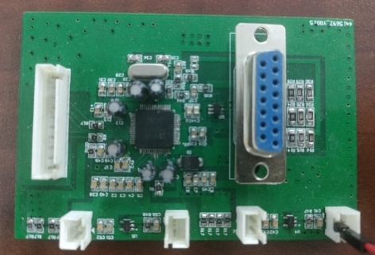 | 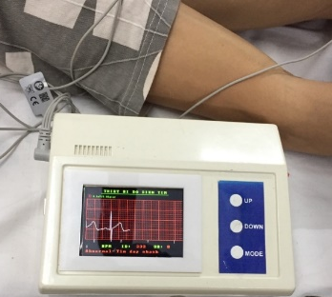
Figure 8: Completed ECG signal acquisition module
The website features advanced functionality that allows it to display real-time electrocardiogram (ECG) signals along with the patient's heart rate measured in beats per minute. This innovative feature is crucial for enabling physicians to monitor their patients' cardiovascular health remotely. By accessing these real-time data, doctors can observe any cardiac irregularities as they occur, which is particularly vital for patients with known heart conditions or those under critical care. The display of these vital signs is depicted clearly in Figure 8 and Figure 9 [9].

Fig. 9. Display ECG signals on the website using MQTT protocol.
To test the measuring device, we compared the results with the NT Cardio ECG-1100 electrocardiogram device. Using the SKX-2000 ECG signal generation module, the results are shown in the following Figures [13].

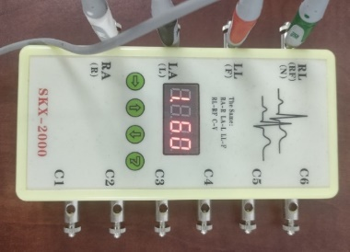 | 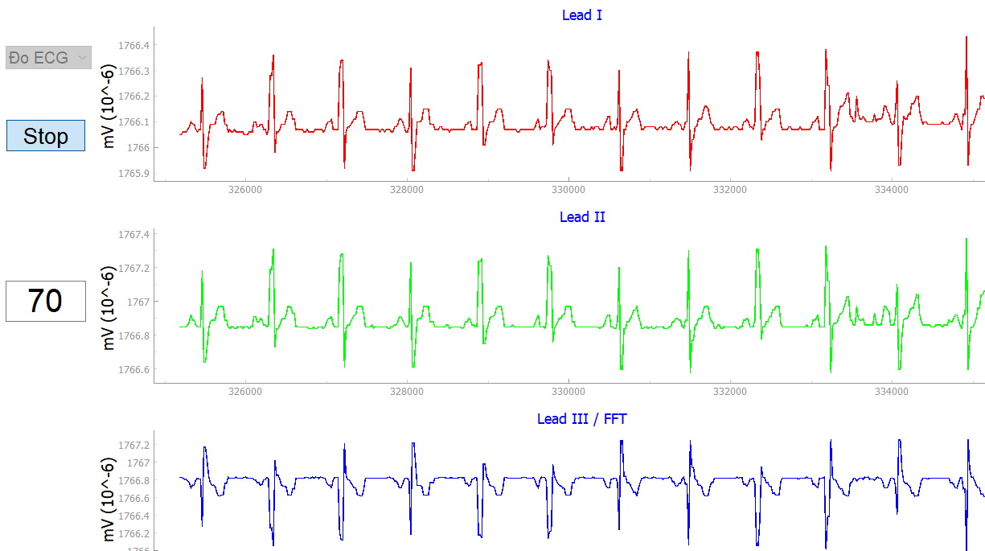

Figure 10: SKX-2000 ECG signal generation module and Measurement results on self-designed equipment
The results of measuring the electrocardiogram signal in Figure 10, we see that the electrocardiogram signal of the measuring device using IC ADAS1000-3 gives results equivalent to the electrocardiogram device NT Cardio ECG-1100 in terms of measured heart rate. and ECG waveforms on all 3 leads. Some published works on the design of ECG measurement modules only measure 1 lead, and the noise filtering is not thorough. The device is designed to measure 3 leads simultaneously, and give clearer signals.
Results of testing the R peak detection and preprocessing algorithm on the measuring device, performed with 04 records 101, 102, 103, 104, 105 from the MIT-BIH database.

Table 1: Results of device testing on the MIT-BIH database
Record | Total beats | Number of beats not detected | Number of beats detected incorrectly | Error (%)
101 | 1523 | 1 | 2 | 0.19
102 | 1820 | 1 | 0 | 0.05
104 | 1849 | 8 | 3 | 0.59
105 | 2149 | 7 | 52 | 2.74
Table 1 shows that the application of the R peak detection algorithm of Hamilton and Tompkins on IC ESP32 has good results. However, for recording 105, the results were somewhat higher due to large baseline drift in this recording, which was caused by poor contact between the electrode and the patient during sampling.
Conclusions
This paper has proposed an effective and accurate IoT solution of remote health-condition monitoring. The system uses an ADAS100-3 sensor collecting ECG signals to transfer to the ESP32 microcontroller. The signals will be pre-processed using the Pan-Tompkins algorithm before sent via the Internet to the MQTT Broker. The Broker will coordinate messages to the database to serve for data processing tasks later on. Doctors can log in the website which requests data from the broker and it will display necessary information for monitoring. The system has the ability to send and receive data in real time so doctors can make the necessary diagnosis in an emergency and has the ability to expand connections to multiple devices at the same time. In the future, we will integrate machine learning models to be able to analyze ECG signals so that we can diagnose related diseases. This work was supported by the Project Granted number [33-2022-RD/HĐ – ĐHCN], Hanoi University of Industry.

Disclaimer (Artificial intelligence)
Option 1:
Author(s) hereby declare that NO generative AI technologies such as Large Language Models (ChatGPT, COPILOT, etc) and text-to-image generators have been used during writing or editing of manuscripts.
Option 2:
Author(s) hereby declare that generative AI technologies such as Large Language Models, etc have been used during writing or editing of manuscripts. This explanation will include the name, version, model, and source of the generative AI technology and as well as all input prompts provided to the generative AI technology
Details of the AI usage are given below:
1.
2.
3.

References
1. Palumbo, Arrigo, Patrizia Vizza, Barbara Calabrese, and Nicola Ielpo. "Biopotential signal monitoring systems in rehabilitation: A review." Sensors 21, no. 21 (2021): 7172. https://doi.org/10.3390/s21217172.
2. Rezayi, Sorayya, Ali Asghar Safaei, and Niloofar Mohammadzadeh. "Design and evaluation of a wearable smart blanket system for monitoring vital signs of patients in an ambulance." Journal of Sensors 2021 (2021): 1-11. https://doi.org/10.1155/2021/8820740.
3. Manas, Munish, Aniruddha Sinha, Shubham Sharma, and Md Rahat Mahboob. “A Novel Approach for IoT Based Wearable Health Monitoring and Messaging System.” Journal of Ambient Intelligence and Humanized Computing 10, no. 7 (November 2, 2018): 2817–28. https://doi.org/10.1007/s12652-018-1101-z.
4. Qamar, Shamimul. “ECG Signal Processing by Feature Selection with Classification Based on Machine Learning Architectures in Cardiovascular Disease Detection,” August 11, 2022. https://doi.org/10.21203/rs.3.rs-1953217/v1.
5. Mehendale, Ninad, and Vidhi Gohel. “Review on Electromyography Signal Acquisition, Processing and Its Applications.” SSRN Electronic Journal, 2020. https://doi.org/10.2139/ssrn.3598928.
6. Chen, Jiaming, Ali Valehi, and Abolfazl Razi. “Smart Heart Monitoring: Early Prediction of Heart Problems Through Predictive Analysis of ECG Signals.” IEEE Access 7 (2019): 120831–39. https://doi.org/10.1109/access.2019.2937875.
7. Stuart, Tucker, Jessica Hanna, and Philipp Gutruf. “Wearable Devices for Continuous Monitoring of Biosignals: Challenges and Opportunities.” APL Bioengineering 6, no. 2 (April 13, 2022). https://doi.org/10.1063/5.0086935.
8. Gilgen-Ammann, Rahel, Theresa Schweizer, and Thomas Wyss. “RR Interval Signal Quality of a Heart Rate Monitor and an ECG Holter at Rest and during Exercise.” European Journal of Applied Physiology 119, no. 7 (April 19, 2019): 1525–32. https://doi.org/10.1007/s00421-019-04142-5.
9. Pham, V.N., Tran, H.L. (2023). “Electrocardiogram (ECG) Circuit Design and Using the Random Forest to ECG Arrhythmia Classification”. Advances in Engineering Research and Application. ICERA 2022, vol 602. Springer, Cham. DOI: https://doi.org/10.1007/978-3-031-22200-9_54
10. Tran H. L., Pham V. N., and Nguyen D. T., “A hardware implementation of intelligent ECG classifier”, COMPEL: The International Journal for Computation & Mathematics in Electrical & Electronic Engineering. (2015) 34, no. 3, 905–919. DOI: https://doi.org/10.1108/COMPEL-05-2014-0119
11. D. -A. T. Le et al., "Patient Remote Monitoring System Using MQTT Protocol for ECG Signals," 2024 9th International Conference on Integrated Circuits, Design, and Verification (ICDV), Hanoi, Vietnam, 2024, pp. 114-118, doi: https://doi.org/10.1109/ICDV61346.2024.10617252
12. P.S. Hamilton and W.J. Tompkins (2016). Quantitative investigation of QRS detection rules using the MIT/BIH arrhythmia database. IEEE Trans. Biomed Eng., vol. BME-33, pp. 1157-1165, 1986.
13. Nguyen, T.T, Vuong, T.T, Pham, V.N., (2024) "Application of ARM IC and ADAS1000-3 for Designing a Cardiac Electrical Measurement Device with QRS Complex Detection Function," Vietnam International Conference and Exhibition on Control and Automation – VCCA, Hanoi, Vietnam.
14. Faust, O., Hagiwara, Y., Hong, W., Lih, O. S., & Acharya, U. R. (2018). Deep learning for healthcare applications based on physiological signals: A review. Computer Methods and Programs in Biomedicine, vol. 161, pp. 1-13. DOI: https://doi.org/10.1016/j.cmpb.2018.04.005.
15. Zheng, G., Ji, S., Dai, M., Sun, Y. (2017). ECG Based Identification by Deep Learning. In: Zhou, J., et al. Biometric Recognition. CCBR 2017. Lecture Notes in Computer Science(), vol 10568. Springer, Cham. https://doi.org/10.1007/978-3-319-69923-3_54
16. Acharya, U. R., Oh, S. L., Hagiwara, Y., Tan, J. H., Adeli, H. (2018). Deep Convolutional Neural Network for the Automated Detection and Diagnosis of Seizure Using EEG Signals. Computers in Biology and Medicine, vol. 100, pp. 270-278. DOI:https://doi.org/10.1016/j.compbiomed.2017.09.017.
17. M. Cheng, W. J. Sori, F. Jiang, A. Khan and S. Liu, "Recurrent Neural Network Based Classification of ECG Signal Features for Obstruction of Sleep Apnea Detection," 2017 IEEE International Conference on Computational Science and Engineering (CSE) and IEEE International Conference on Embedded and Ubiquitous Computing (EUC), Guangzhou, China, 2017, pp. 199-202, doi: 10.1109/CSE-EUC.2017.220.
18. Yao, Q., Wang, R., Fan, X., Liu, J., & Li, Y. (2017). Patient-Specific Deep Architectural Model for ECG Classification. Journal of Healthcare Engineering, vol. 2017, DOI: https://doi.org/10.1155/2017/4108720
19. A. Majumdar and R. Ward, "Robust greedy deep dictionary learning for ECG arrhythmia classification," 2017 International Joint Conference on Neural Networks (IJCNN), Anchorage, AK, USA, 2017, pp. 4400-4407, doi: 10.1109/IJCNN.2017.7966413.

