Pathological investigation and management of proliferative nodular intestinal coccidiosis in a goat farm: A case study from Tamil Nadu, India

Abstract
The current study focused on a small goat farm in the Kallakurichi District of Tamil Nadu. A flock of 40 non-descript goats experienced clinical signs of weakness, anorexia, lethargy, and diarrhoea over a 10-day period in July 2025, resulting in mortality. The necropsy examination was performed at the Department of Veterinary Pathology, Veterinary College and Research Institute in Salem. Duodenal mucosa showed extensive haemorrhagic streaks, and the lesions were predominantly observed in the jejunum and ileum, showing thickening of the mucosa with multifocal non-pedunculated nodules on the mucosal surface. Microscopic examination of intestinal scrapings demonstrated unsporulated oocysts of Eimeria arloingi. Histopathological examination showed proliferative enteritis with a moderate inflammatory response characterised by infiltration of lymphocytes, plasma, and eosinophils, with affected intestinal epithelial cells exhibiting the various stages of the life cycle of E. arloingi, including trophozoites, schizonts, microgamonts, macrogamonts, and oocysts. The present study identified coccidiosis infection in the affected goats, and treatment with amprolium 20% powder at a dosage of 2 g/40 kg for 5 days resulted in clinical recovery from the infection.
Key words: Goat, Eimeria spp. Coccidiosis, Histopathology, Amprolium
1. Introduction
Goat farming in India is a major sector of agriculture, especially for small and marginal farmers, owing to its minimal investment needs and adaptability to diverse environments. India, being the second-largest worldwide producer of goats, significantly contributes to the improvement of rural lives and food security (Rajak et al., 2024). The goat population in India is at 148.88 million, constituting 27.7% of the overall livestock population (DAHD, 2019). Goat milk production is the most popular worldwide, and goat meat (chevon) and milk are in high demand (Singh et al., 2023a). India is home to 39 goat breeds, including prominent dairy breeds such as Beetal and Jamunapari, which produce from 150 to 500 litres of milk (Singh et al., 2023b). Goat farming has potential, but it also has limitations, including poor market accessibility, diseases, and insufficient infrastructures (Kumawat et al., 2017; Rajak et al., 2024). Efficient management methods are crucial for maximising output and health, involving appropriate healthcare and nutrition (Islam, 2024).
In India, infectious diseases significantly impact goat farming, leading to considerable morbidity and mortality, which in turn cause economic losses for farmers. These diseases affect goats of all ages and are influenced by various factors such as season, sex, and breed. Key issues include poor hygiene, inadequate veterinary care, and intensified farming, which leads to problems like diarrhoea, pneumonia, internal parasites, and specific infections like PPR and enterotoxaemia. Morbidity and mortality rates peak during the rainy season due to increased prevalence of diseases like respiratory infections (Karna et al., 2020; Chandran et al., 2021). These diseases result in mortality, which ranges from 5 to 25% in adults and 10 to 40
% in kids, particularly those aged 0-3 months (Rekib and Vihan, 1997; Sharma & Singh, 1997; Chandran et al., 2021).
Goat farming is significantly affected by coccidiosis, a protozoal affliction caused by Eimeria species, both in India and other parts of the world. Globally, the prevalence of Eimeria spp. in goats is estimated at 62.9%, with regional variations. North America and Europe report higher prevalence rates compared to Asia (Ali et al., 2025). It primarily affects young goats aged 6–12 months, leading to symptoms such as diarrhoea, weight loss, and, in severe cases, mortality, which results in decreased productivity, increased veterinarian costs, and substantial economic losses for the goat industry. Factors like environmental stress and contamination levels exacerbate the disease's prevalence. The disease is seasonally prevalent, with the highest incidence during the rainy and winter seasons (Sharma et al., 2017; Das et al., 2024). The overall prevalence in India stands at 86.71%, primarily affecting younger animals. Coccidiosis was responsible for 6.70% of goat deaths in a study involving 2,538 postmortems conducted between 1986 and 1994 (Sharma & Singh, 1997; Sharma et al., 2017). Certain breeds like Barbari and Jamunapari in the semi-arid tropical region of India are reported to have a prevalence of 94.37% (Singh et al., 2023b). The predominant Eimeria species in India include E. arloingi and E. ninakohlyakimovae, which are responsible for coccidiosis in goats (Sharma et al., 2017; Singh et al., 2023b). The current study reports the incidence of coccidiosis and its therapeutic management in a goat farm located in the Kallakurichi District of Tamil Nadu.
2. Materials and methods
The current study examined a small goat farm with the flock strength of 40 in the Kallakurichi District of Tamil Nadu. The two-month-old non-descript goat kids showed signs of weakness, anorexia, lethargy, and diarrhoea throughout a 10-day period, and two animals during the first week of July, 2025. A detailed necropsy examination was carried out at the Department of Veterinary Pathology, Veterinary College and Research Institute in Salem. A flotation technique using sucrose-saturated solutions was used to examine the faeces for oocysts, as described by Bowman and Lynn (1995). Tissue samples from the duodenum, jejunum, and ileum were collected for histopathological analysis. The tissues were preserved in 10 per cent neutral buffered formalin and processed in accordance with standard histopathologic protocol. Haematoxylin and eosin were used to stain 5 μm thick tissue sections, which were then viewed under a light microscope (Suvarna et al., 2019).
3. Results and Discussion
In this study, the affected goat kids were two months old, and the disease occurrence was during the month of July with 5% mortality, when southwest monsoon rains are common in Tamil Nadu, which concurred with the earlier reports. Singh et al., (2023b) reported an overall coccidiosis prevalence of 96.62% among 474 goats in semi-arid regions of India Another study indicated a prevalence of 71.45% for coccidia among 1419 goats, with the highest rates in Jamunapari goats (81.07%) (Verma et al., 2018). Singh et al. (2015) found a prevalence rate of 82.4% for coccidiosis among 960 goats in Madhya Pradesh, India. Their study noted that the incidence of the disease peaks during the monsoon season at 98.06% and is particularly high among kids, reaching 96.25% prevalence. Sharma et al. (2009) observed that the incidence of coccidiosis is highest during the rainy season (54.55%), followed by the summer (46.0%) and winter (37.0%) seasons. The highest prevalence (92.31%) was observed in goats aged 3–6 months, indicating susceptibility during early growth stages, followed by 6–12 months (75.51%), which exhibited a significant rise in fecal oocyst counts. The prevalence markedly declines to 40.86% in older goats, suggesting the development of some degree of immunity.

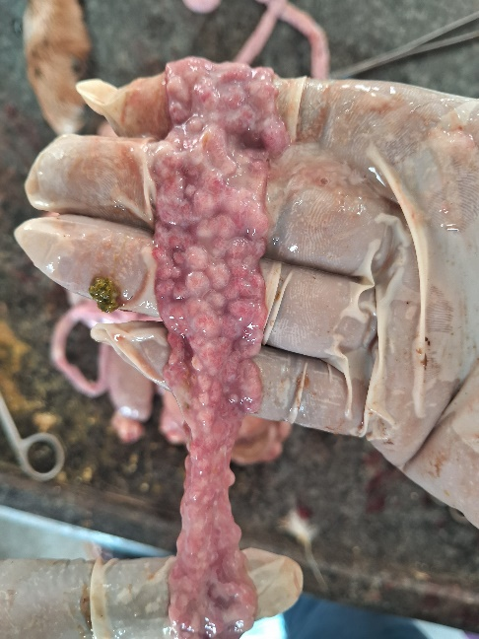 | 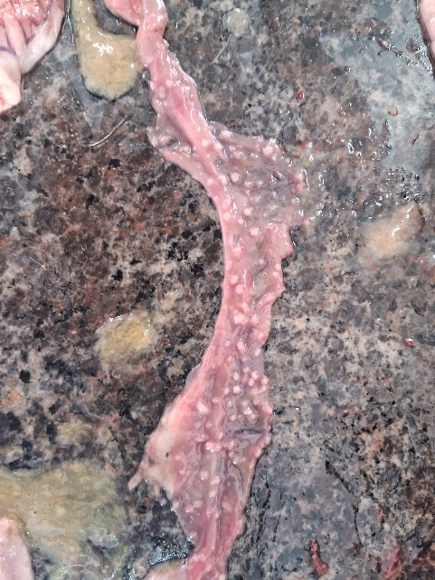
Fig. 1: Intestine - Jejunum mucosa was thickened with variable sized, multifocal dispersed non-pedunculated white raised nodules of less than one cm in diameter | Fig. 2: Intestine - Ileal mucosa showing multifocal, tiny, dispersed non-pedunculated white nodules
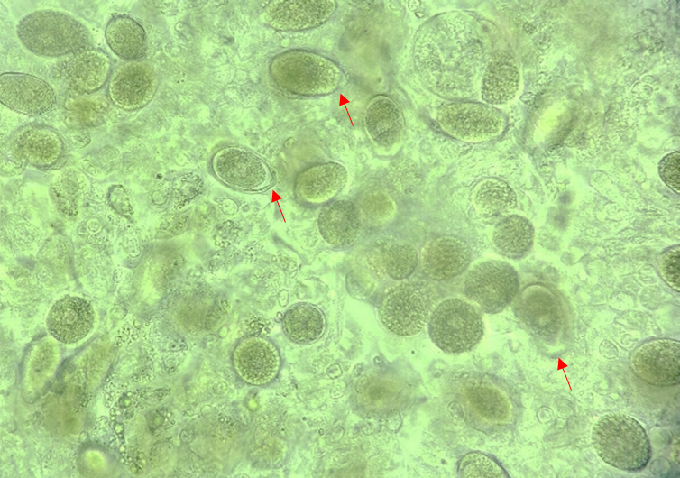 | 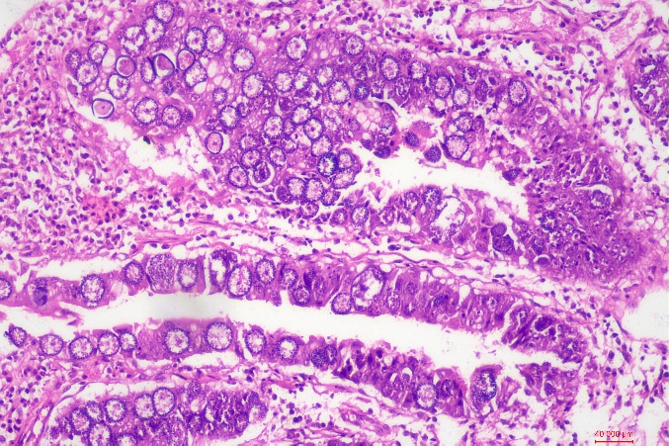
Fig. 3: Intestinal scrappings smear - Presence of numerous unsporulated oocysts of E. arloingi - micropyle cap (Red arrow) (Light microscope- x100) | Fig. 4: Intestine - Presence of various developing stages of Eimeria arloingi studded in the epithelial cells (Haematoxylin and eosin staining, x100)
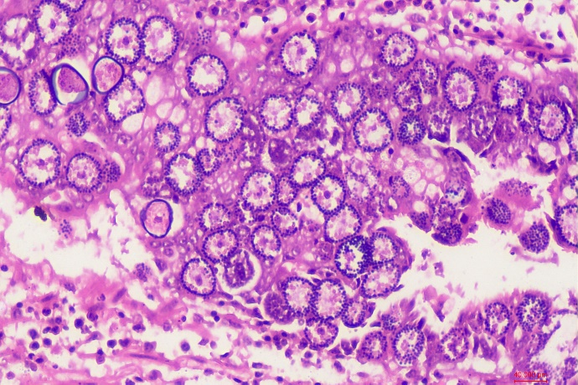 | 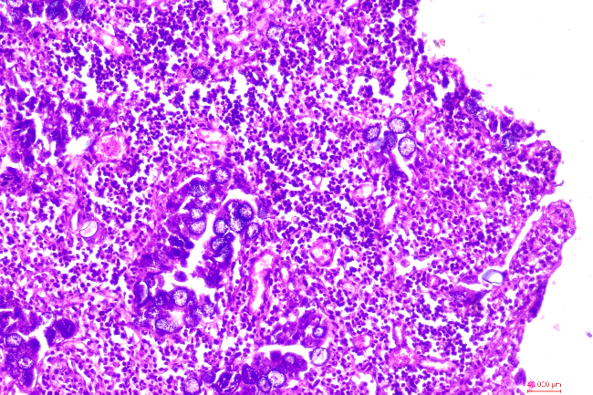
Fig. 5: Intestine - Presence of various developing stages of Eimeria arloingi in the epithelial cells (Haematoxylin and eosin staining, x400) | Fig. 6: Intestine - Presence of various developing stages of Eimeria arloingi in the epithelial cells and severe infiltration of inflammatory cells (Haematoxylin and eosin staining, x100)

The affected goats showed diarrhoea with occasional blood tinge in it, along with symptoms such as loss of appetite, dehydration, and general weakness, which were in accordance with the previous reports (Tafti and Mansourian, 2008; Kheirandish et al., 2014). On necropsy, extensive haemorrhagic streaks were seen on the duodenal mucosa. The jejunum and ileum exhibited mucosal thickening along with small, multifocal non-pedunculated nodules that were white and varied in size, measuring approximately less than one centimetre in diameter (Figs. 1 and 2). Gross lesions characterized by multifocal, non-pedunculated whitish raised nodules in the jejunum, ileum, and cecum were reported by previous studies (Tafti and Mansourian, 2008; Kheirandish et al., 2014). The lungs exhibited multifocal congestion, and the bronchi contained foamy exudates. The liver was friable, and the rumen mucosa sloughed off readily. The life cycle of the coccidia parasites is normally finished inside the intestinal epithelial cells; they seldom grow in extra-intestinal locations in goats. Changes observed in other organs may be attributed to the significant damage to the digestive tract, resulting in secondary complications such as dehydration, electrolyte imbalances, and increased susceptibility to other infections, so impacting the overall health of the animal and its other organ systems.
Intestinal scraping revealed unsporulated oocysts with a micropyle cap of E. arloingi under microscopic examination (Fig. 3). Infected villi, crypts, and Lieberkühn glands revealed all stages in the life cycle of E. arloingi, encompassing trophozoites, schizonts, microgamonts, macrogamonts, and oocysts. At the base of polypoid nodules, crypt epithelial cells contained trophozoites with basophilic nuclei situated within a parasitophorous vacuole. Within enterocytes, schizonts included many banana-shaped merozoites. Mature macrogamonts had a core nucleus surrounded by eosinophilic structures constituting the outside wall. The microgamonts were spherical, with their nuclei located at the outer edges. The mucosa, and rarely necrotic-haemorrhagic exudates in the intestinal lumen, included oval oocysts with a double-layered wall (Figs. 4 and 5). A progressive nodular enteritis was revealed by the moderate to severe infiltration of lymphocytes, plasma cells, and eosinophils in the mucosa and lamina propria of the intestine (Fig. 6). In our study, the histopathologic changes included desquamation and necrosis of intestinal mucosa, particularly in the jejunum and ileum. The presence of developmental stages of Eimeria within epithelial cells, resulting in substantial inflammatory responses, aligns with previous reports (Oruc, 2007; Tafti and Mansourian, 2008; Kheirandish et al., 2014; Hashemnia et al., 2015).
Effective management of coccidiosis involves integrated parasite management approaches, including improved sanitation, strategic use of anticoccidial drugs, and monitoring of infection rates (Ali et al., 2025). In this study, the affected animals were clinically recovered from the infection after treatment with amprolium 20% powder at a dose rate of 2 g/40 kg body weight for 5 days. The specific dosage regimen of amprolium, which is effective against the later stages of infection (Chartier and Paraud, 2012), was selected for treatment based on the previously investigated favourable reports in goat coccidiosis (Kaur et al., 2018).
4. Conclusions:
The current study identified the condition as coccidiosis in goats, which caused severe proliferative enteritis and mortality among the farm. Effective management practices for coccidiosis in goats are crucial to mitigate the economic losses associated with this protozoan disease, particularly in young animals. Therefore, integrating management strategies with careful use of drugs is recommended to sustainably control coccidiosis in goats. Treatment with amprolium showed a clinical recovery from the infection, and effective sanitation measures were advised to the farmer.
Disclaimer (Artificial intelligence)

Authors hereby declares that NO generative AI technologies such as Large Language Models (ChatGPT, COPILOT, etc.) and text-to-image generators have been used during the writing or editing of this manuscript.

5. References:
- Rajak, S. K., Kumar, A., Rani, D., & Sharnam, K. S. (2024). Profitable farming business and marketing strategy for financial benefit of goat production. In T. Rana (Eds.), Trends in Clinical Diseases, Production and Management of Goats, Academic Press, Elsevier BV, pp. 217–231. https://doi.org/10.1016/b978-0-443-23696-9.00016-x.
- DAHD (Department of Animal Husbandry and Dairying). (2019). 20th Livestock Census - All India Report. Ministry of Fisheries, Animal Husbandry and Dairying, Government of India, 119p.
- Singh, M. K., Singh, S. K., & Chauhan, M. S. (2023a). Exploring potential of goat based dairy farming in India and way forward. The Indian Journal of Animal Sciences, 93(3), 243–250.
- Singh, A., Shanker, D., Rout, P. K., Kumar, A., & Kumar, P. (2023b). Coccidiosis in Barbari and Jamunapari goats at an organized farm in semi-arid tropical region of India. Indian Journal of Animal Sciences, 93(10), 963–966. https://doi.org/10.56093/ijans.v93i10.128208.
- Kumawat, M., Uddin, A., Bhinda, R., Khichar, S. L., & Jat, G. R. (2017). Constraints Faced by Farmers in Goat Rearing Practices in Jaipur District of Rajasthan, India. International Journal of Current Microbiology and Applied Sciences, 6(12), 942–944. https://doi.org/10.20546/IJCMAS.2017.612.103.
- Islam, M. M. (2024). Farm flock health, production, and its management in goats. In: T. Rana (Eds.), Trends in Clinical Diseases, Production and Management of Goats, Academic Press, Elsevier BV, pp. 245-253. https://doi.org/10.1016/b978-0-443-23696-9.00015-8.
- Karna, D. K., Acharya, A. P., Das, B. C., Nayak, G., & Dibyadarshini, M.R. (2020). Morbidity and mortality rates of Ganjam goats of Odisha in field condition. Journal of Entomology and Zoology Studies, 8(5), 565–568.
- Chandran, D., Rojan, P M., Thirupathy, V. R. & Lejaniya, A.K.S. (2021). Mortality and morbidity pattern in goats under organized farm conditions of Kerala. Journal of Veterinary and Animal Sciences. 52(2), 175-179.
- Sharma, D. K., & Singh, N. (1997). Mortality among goats due to parasitic infections: A postmortem analysis. Indian Journal of Animal Sciences, 67(6), 463–465. http://epubs.icar.org.in/ejournal/index.php/IJAnS/article/view/34585.
- Rekib, A. & Vihan, V.S., 1997. Economic losses in goat production due to diseases. In: Proceedings of the Third National Seminar on Small Ruminant Diseases. Central Institute for Research on Goats, Makhdoom, India, pp. 1–9.
- Ali, E., Ghafar, A., Ángeles-Hernández, J. C., Yaseen, M., Gauci, C. G., Beveridge, I., Baxendell, S., & Jabbar, A. (2025). Global prevalence of Eimeria species in goats: a systematic review and meta-analysis. Frontiers in Veterinary Science, 11, 1537171. https://doi.org/10.3389/fvets.2024.1537171.
- Sharma, D. K., Paul, S., Rout, P. K., Mandal, A., Bhusan, S., Sharma, N. & Kushwah, Y. K. (2017). Caprine coccidiosis in semi-arid India: Dynamics and factors affecting fecal oocysts count. Journal of Advanced Veterinary and Animal Research, 4(1), 52-57. https://doi.org/10.5455/JAVAR.2017.D190.
- Das, B., Sivajothi, S., Parsani, H. R., & Suthar, A. N. (2024). Coccidiosis. In Elements of Reproduction and Reproductive Diseases of Goats, T. Rana (Eds.), John Wiley & Sons, Inc., Hoboken, New Jersey. pp 501–516. https://doi.org/10.1002/9781394190089.ch45.
- Sharma, D. K. & Singh, N. (1997). Mortality among goats due to parasitic infections: A postmortem analysis. Indian Journal of Animal Sciences, 67(6), 463–465. http://epubs.icar.org.in/ejournal/index.php/IJAnS/article/view/34585.
- Bowman DD, Lynn RC. Georgis Parasitology for Veterinarians. (6th Ed.), W.B. Saunders company, Sydney, 1995, 440.
- Suvarna K, Layton C, Bancroft JD. Bancroft's Theory and Practice of Histological Techniques. (8th Ed.), Elsevier Health Sciences, Churchill, 2019, 584.
- Verma, R., Sharma, D. K., Paul, S., Gururaj, K., Dige, M. S., Saxena, V. K., Rout, P. K., Bhusan, S., & Banerjee, P. S. (2018). Epidemiology of Common Gastrointestinal Parasitic Infections in Goats reared in Semi-Arid Region of India. Journal of Animal Research, 8(1), 39–45.
- Singh, A. K., Das, G., Roy, B., Nath, S., Naresh, R., & Kumar, S. (2015). Prevalence of gastro-intestinal parasitic infections in goat of Madhya Pradesh, India. Journal of Parasitic Diseases, 39(4), 716–719. https://doi.org/10.1007/S12639-014-0420-Z.
- Sharma, D. K., Agrawal, N., Mandal, A., & Nigam, P. (2009). Coccidia and gastrointestinal nematode infections in semi- intensively managed Jakhrana goats of semi- arid region of India. Tropical and Subtropical Agroecosystems, 11, 135-139.
- Tafti, A. K. & Mansourian, M. (2008). Pathologic lesions of naturally occurring coccidiosis in sheep and goats. Comparative Haematology International, 17(2), 87–91. https://doi.org/10.1007/S00580-008-0719-1.
- Kheirandish R., Nourollahi-Fard S. R. & Yadegari Z. (2014). Prevalence and pathology of coccidiosis in goats in southeastern Iran. Journal of Parasitic Diseases, 38(1):27-31. doi: 10.1007/s12639-012-0186-0.
- Oruc, E. (2007). Histopathological findings in naturally occurring biliary coccidiosis in a goat kid. Veterinary Record, 160(3), 93. https://doi.org/10.1136/VR.160.3.93.
- Hashemnia, M., Rezaei, F., & Chalechale, A. (2015). Prevalence, intensity, and pathological lesions of Eimeria infection in goats in western Iran. Comparative Haematology International, 24(4), 805–810. https://doi.org/10.1007/S00580-014-1986-7.
- Chartier, C. and Paraud, C. (2012). Coccidiosis due to Eimeria in sheep and goats, a review. Small Ruminant Research,103(1), 84-92.
- Kaur, S., Singla, L. D., Sandhu, B. Bal, M & Kaur, P. (2018). Coccidiosis in goats: Pathological observations on intestinal developmental stages and anticoccidial efficacy of Amprolim. Indian Journal of Animal Research, 5(2), 245-249. doi: 10.18805/ijar.B-3471.

