Investigating the Sources of Variability in Blood Pressure Monitoring Systems

ABSTRACT
Accurate and reliable blood pressure measurement is critical for diagnosing and managing hypertension properly. Based on a consensus document announced in the Journal of Hypertension, this is so much so that a 5.0 mm Hg BP measurement error can result in incorrect hypertension classification in 84 million individuals worldwide. Understanding how BP measurement goes wrong and how to tackle them can improve the diagnosis and management of hypertension. Unfortunately, BP measurement is problematically performed in clinical practice, accumulating errors that inappropriately alter management decisions in 20% to 45% of cases. In this study, the sources of variability from the aspects of the blood pressure monitoring system were attempted to be scrutinized. The variability increases with additive properties such as pressure gauge inaccuracy, cuff tightness, and cloth over-measurement. An artificial plastic arm was created to measure the pressure with multiple monitors. The study concluded that each monitor had its inherent characteristics in increasing monitor pressures concerning the actual pressure, and further, the increases in cuff loosening distance and the cloth-over layers might cause more significant variability, as hypothesized in this study. The study could more clearly verify the reason for blood pressure measurement variability.

Keywords: Accurate BP Measurement, Blood Pressure Monitoring, BP Variability, Cuff Tightness, Hypertension

1. INTRODUCTION
Accurate and reliable blood pressure measurement is essential for diagnosing and managing hypertension properly [1, 2]. A 5 mm Hg BP measurement error may increase incorrect hypertension classification in approximately 100 million patients worldwide, according to a consensus document published in the Journal of Hypertension [3]. Understanding how BP measurement goes wrong and how to tackle it can improve the diagnosis and management of hypertension [4, 5].
Despite the importance, unfortunately, BP measurement is often suboptimally performed in clinical practice, leading to mistakes that inappropriately cause patients to make wrong management decisions in 20% to 45% of cases [6]. According to the Lancet Commission on Hypertension Group's position statement, this inaccuracy has persisted even with extensive education and campaigns to alert the public of the adverse consequences of incorrect clinic BP measurement [7].

Knowing that blood pressure variability (BPV) is not only a background noise of blood pressure (BP) but an independent risk entity and that evidence lacks the best quantitative method for measuring it, more questions on BPV reliability arise [8]. Different approaches to estimating BPV have been proposed in recent years; among them, the most commonly applied is the average actual variability (ARV), which is the average of the absolute differences among the consecutive BP readings [9, 10]. ARV has the advantage of considering the temporal order of BP measurements and, therefore, the BP time series variability. Another frequently employed parameter is the coefficient of variation (CV), defined from the standard deviation divided by the corresponding mean [11]. However, even if CV provides a reasonable intra-individual estimate of BPV, it does not consider the order of BP measurements. Further, to quantify the extremes of BP excursions, it was proposed to calculate the difference between the maximum and the minimum BP values (ΔBP), which can be independent of the mean [12, 13].
If a cuff is too small or too large, measurement errors can occur. Automated devices that have yet to be examined for accuracy add to inaccuracy, which can accumulate errors in systolic BP. An essential issue with automated devices is that many still need to be clinically validated for measurement accuracy. Clinical validation involves demonstrating that the device guarantees the accuracy requirements of international BP monitoring standards [14, 15].
The process of clinical validation involves performing a protocol-based comparison using multiple measurements against a blinded, two-observer auscultatory reference standard. Only validated devices should be developed for greater accuracy [16, 17]. Therefore, this calibration system for blood pressure monitoring should be essential. In this study, the sources of variability from the aspects of the blood pressure monitoring system were designed to be scrutinized. These aspects have yet to be much studied. (Are there still errors existing even after the clinical validation?)
Most studies on BPV [18] have been focused on the results of 24-hour ambulatory BP monitoring (ABPM), and comparisons of BPV on other measurement modalities still need to be made [19]. Moreover, BP fluctuations reflect the complex interactions of several, and at least in part, dynamic factors, such as environmental, behavioral, drug-related, and dependent on cardiovascular regulatory mechanisms, which could produce different patterns of BPV. In this complex panorama, specific BP measurement technique predictor factors for BPV are unavailable [20].
The sources of variability in blood pressure monitoring can be explained as follows. The blood pressure [21] monitors consist of various parts. They should be operated flawlessly to read blood pressure with minimal disturbances. Multiple blood pressure monitors need to be examined for accuracy and precision using a pressure-sharing system created for this study. Various hypotheses were set up; the first hypothesis was that the standard pressure gauge measures the artificial arm's pressure accurately. The second hypothesis was that the errors would originate mainly from these three factors: the inability of the BP monitors to read the actual pressure value, the looseness of the cuff, and wearing sleeves when measuring BP.

In theory, the cumulative errors might be described as
Accumulative variability = monitor gauge variability + tightness variability + cloth variability ---- Eq.1
In most cases, the accumulative variability has been evaluated and studied. This study attempted to examine the three terms in Eq. 1 from which the blood pressure variability could originate.

The study should facilitate our understanding of the sources of variability in blood pressure monitoring. It should be essential to have a reliable blood pressure monitoring system that is easily on hand. We might pinpoint the sources of errors and could have confidence in the performance of blood pressure monitoring.

2. EXPERIMENTAL METHODS
2.1 Main Components of Our Experimental Setup
The variability of the blood pressure monitoring system derives from two sources of origin. The first one originates from the actual blood pressure from the human arms because the blood pressure usually changes so frequently in the morning and evening, before and after drinking coffee, before and after exercise, and before and after each meal. The second source of error comes from the blood pressure monitors, which can malfunction, be non-calibrated, and not be correctly used. Out of the two sources, we decided to focus on the latter and find out if there are errors in the blood pressure monitors. We want to create an artificial arm with the same pressure ranges for monitoring to eliminate possible human errors. The artificial arm will give the same pressure to the standard gauge and the blood pressure monitors. The difference between the standard pressure gauge and the blood pressure monitors will be measured and compared. Various blood pressure monitors will be examined to investigate their repeatability, reproducibility, and variability.
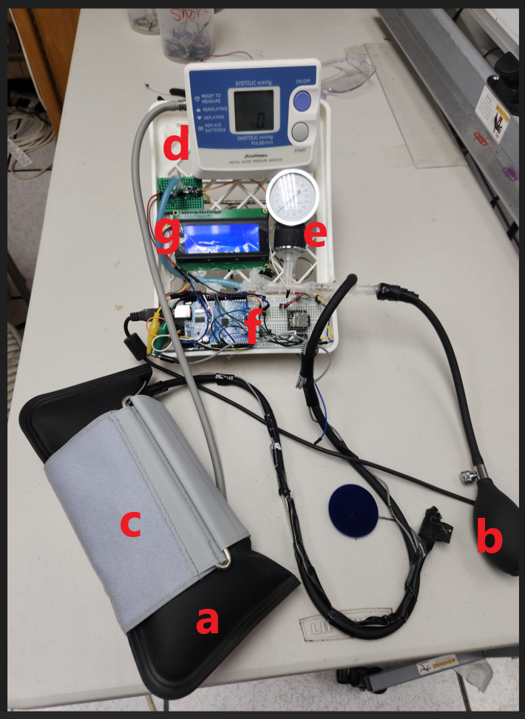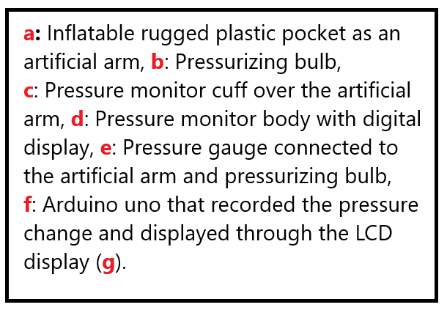
Fig.1 presents the pictorial demonstration of our artificial arm and pressure gauge system.

2.1 Materials and Devices
Most parts and devices were able to be purchased from Amazon.com, such as Arduino Uno, Pressure Transducer, Pressure Gauge, Pressurizing Rubber Bulb, Artificial Arm Pressure Pocket, Soldering machine, Solder, Electric Glue Gun, and Glue Stick, Lazle Electronic Blood Pressure Monitor (Monitor A), Model IP21, SunMark Digital Blood Pressure Monitor (Monitor B), Blood Pressure Monitor Upper Arm Automatic Blood Pressure Machine (Monitor C) with Adjustable BP Cuff 8.7"-16.5", 2x120 Sets Memory High Blood Pressure Monitors for Home Use Include Batteries with Storage Bag and others.

2.2 Procedural Development
2.2.1 Pressure Gauge Variability Estimation
After the parts and system blueprint creation were completed, a three-way valve was fixed in a bite to connect the first opening to a standard analog pressure gauge considered an absolute pressure for other testing gauges and blood pressure monitors. The second opening was attached to the tubing of the pressurizing bulb with a controlled valve, which could adjust the pressure in the artificial arm. The third opening was connected to the tubing from the artificial arm created with a rugged, air-tight, pliable, and elastic-plastic thin fabric, as seen in Fig.1 above.

2.2.2 Pressure Difference Estimation with Gauge and Blood Pressure Monitor
We are verifying the difference in pressure between the pressure monitor and the gauge.
At first, the air from the rubber bulb was repeatedly pumped until the pressure in the artificial plastic arm reached 60 mmHg. At this point, the START button of the electronic blood pressure monitor was pressed to start air pumping from the blood pressure monitor after the cuff was placed around the artificial arm. The blood pressure monitor puts air up to 180 ~ 220 mmHg into the cuff. The movement of the pressure values from the pressure gauge and blood pressure monitor was videotaped. The video was used to read both pressures at every 10 mmHg and recorded into Microsoft Excel Worksheet. The differences in the pressure of both displays were compared and plotted accordingly.

After the pressure monitoring study, verifying the variability from the tightness of the arm cuff-wearing pattern was continued. The cuff was wrapped around the artificial arm in various ways to tighten it. The tightness of the arm cuff into the artificial arm was measured with a gap distance between the cuff and the artificial arm. The distance was marked from the typical measuring tightness as 0 cm, 2 cm, 4 cm, and 6cm. After the tightness measurement, the pressure was increased to examine the difference between the pressure and any abnormal activities that might have occurred due to the tightness or looseness of the cuff.

Sequentially, the variability of the pressure and monitoring activities, according to the different patterns of materials over the bare skin, hood, and jacket, which were defined as 0, 1, and 2 layers, was evaluated with multiple layers of cloth under the cuff.

2.3 Data Analysis
All the data collected was presented with mean and standard deviation. A percentage difference may be calculated as (P2-P1)*100/P2 as a regular percentage converting formula. A student's t-test was performed (P<0.05).

3. RESULTS AND DISCUSSIONS
3.1 Monitor A’s Difference to the Actual Pressure
The pressures from the blood pressure monitor and in-arm gauge pressure might be the same. However, as seen in Fig. 2 below, the pressure difference was increased when the pressure was high. The orange line was the pressure in the arm, while the blue line was the pressure on the BP monitor. It implies that the pressure in the cuff was not reflected in the artificial arm. Although the difference could come from an actual condition, considering the artery in the skin, this study solely showed the feasibility of disagreements between in-arm and cuff pressures. Even though there could be some other potential possibilities of causing variability in actual and monitored pressures, the data casts the question of how the pressure monitor reflects the difference with the actual blood pressure.
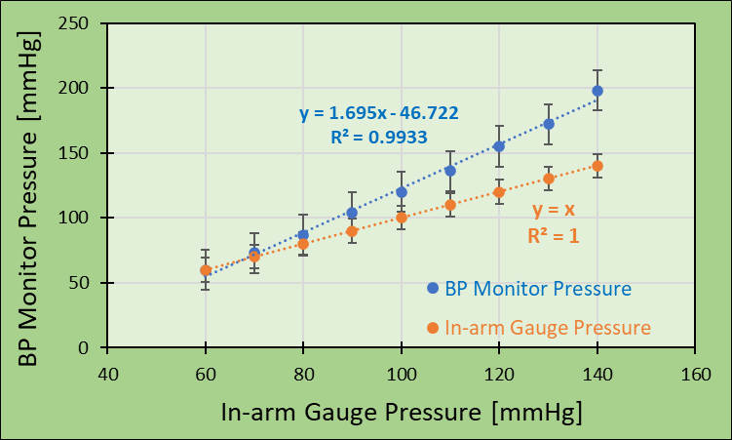
Fig. 2 presents the relationship between BP monitor pressure and in-arm gauge pressure using BP Monitor A (n=4).

3.2 Monitor B’s Pressure Difference to the Actual Pressure
In Fig. 3 below, exactly as in the previous figure, the pressure difference between the in-arm pressure and BP monitor was increased when the pressure was high. The orange line was the pressure in the arm, while the blue line was the pressure on the BP monitor. When comparing the data with monitor B, the slope of linearity was different. The hill from monitor B was more significant than that from monitor A. The data might suggest that there could be far more complicated adjustments for making each blood pressure monitor identically work. The study has shown the feasibility of differences between in-arm and cuff pressure.
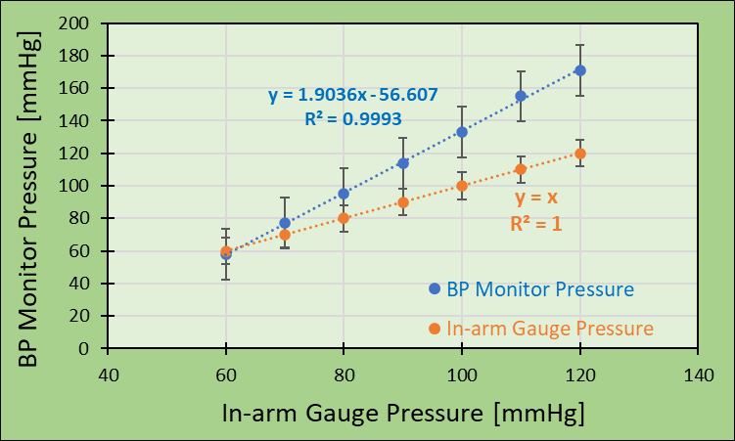
Fig. 3 presents the relationship between BP monitor pressure and in-arm gauge pressure using BP Monitor B (n=4).

3.3 Pressure Monitor C’s Pressure Difference to the Actual Pressure
Monitor C measured the blood pressure using different methods. For example, it records the sound and pulse with changing pressure in the cuff while pressure is increased from down to up. Because this monitor could not read at a certain pressure, it displayed errors at that pressure. So, in this case, we took the moving images while the pressure was increased. The slope of the regression line does not look very different from that of other monitors. When the regression linear slopes of the three were compared, the magnitudes of the slopes were different, as seen in Fig. 2 ~ 4, which should mean that every monitor has their characteristics of pressure-increasing patterns. Large slopes might demonstrate high feasibility reading with high variability. In this data, monitor B showed a slope of 0.9, which might have caused the highest variability.
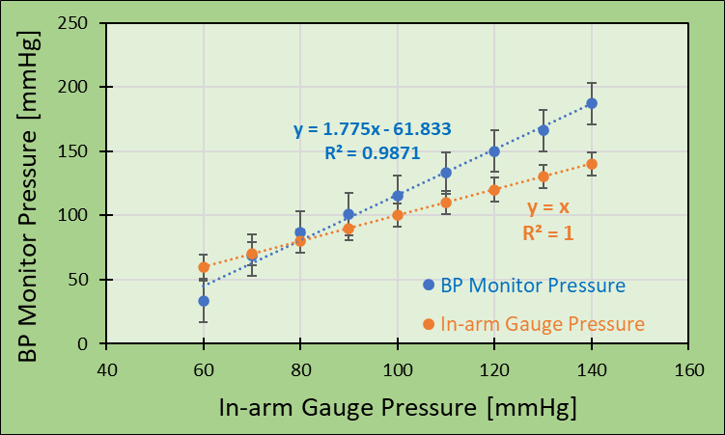
Fig. 4 presents the relationship between BP monitor pressure and in-arm gauge pressure using BP Monitor C (n=4).

3.4 Monitor A’s Cuff Loosen Variable Factor
It has been known that the cuff should be tightly wrapped around the arm before the blood pressure starts to be air-pressured for the measurement. Fig. 5 below shows exciting findings: the increasing linearity looks similar to the previous data, but the magnitude of the linear slopes shows some relationship with the length of the loosened cuff.
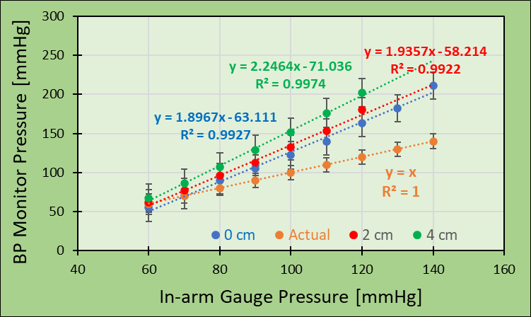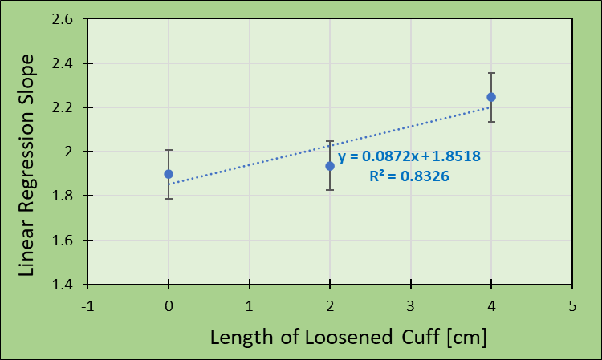
Fig. 5a illustrates the relationship between BP monitor pressure and in-arm gauge pressure using BP Monitor A, while 5b shows the highly linear relation with loosened length and slope. The number in the legend presents the size of the loosened distance from the tightly wrapped cuff.

3.5 Monitor B’s Cuff Loosen Variable Factor
The pressure behaviors concerning the loosening distance were similar to those in the previous data. In this data set, the linear regression slopes were consistently highly related to the increase of the loosening distance, which implies that the cuff loosening could be a source of variability in blood measurement.
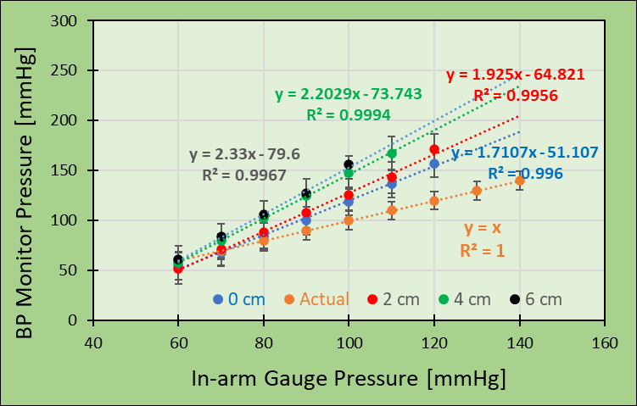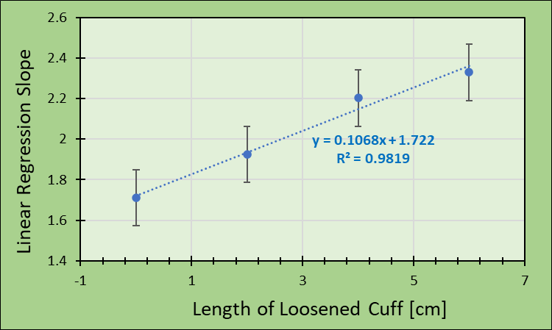
Fig. 6a illustrates the relationship between BP monitor pressure and in-arm gauge pressure using BP Monitor A, while 6b shows the highly linear relation with loosened length and slope. The number in the legend presents the size of the loosened distance from the tightly wrapped cuff.

3.6 Monitor C’s Cuff Loosen Variable Factor
The pressure behaviors concerning the loosening distance were similar to those in the previous data. The linear regression slopes were consistently highly related to the increase of the loosening distance, which implies that the cuff loosening could be a source of variability in blood measurement. Like previous data, increasing monitoring pressure concerning the gauge pressure was linearly functional with a high regression coefficient. Comparing the proper graphs of the three Monitors for loosened cuff cm, there was a highly linear relationship for the distance. This strongly implied that more loosening measurements of BP should cause greater feasibility of measuring different pressures away from the actual pressure.

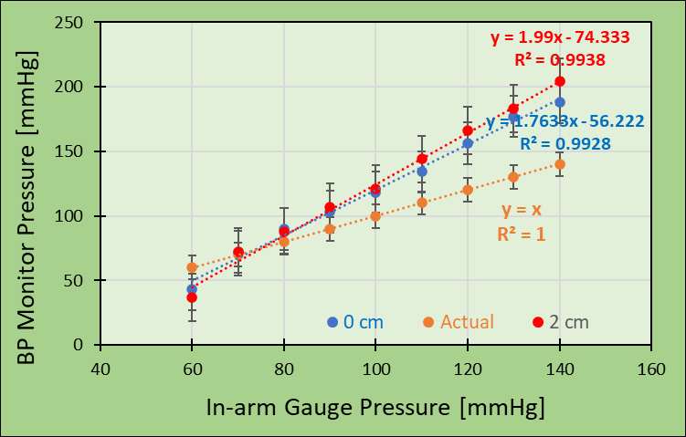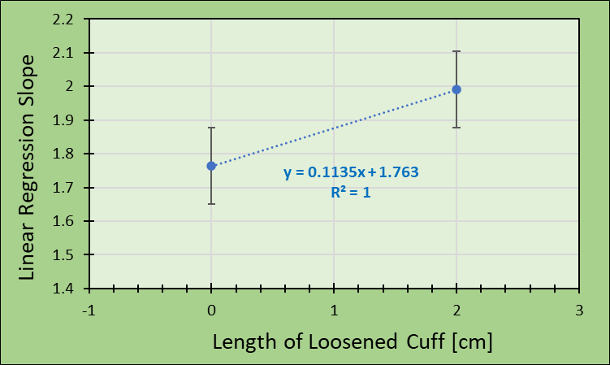
Fig. 7a illustrates the relationship between BP monitor pressure and in-arm gauge pressure using BP Monitor A, while 7b shows the highly linear relation with loosened length and slope. The number in the legend presents the size of the loosened distance from the tightly wrapped cuff.

3.7 Monitor A’s Cloth Factor
The data was acquired without any cloth, hood, or jacket on. Considering their thickness, the layers were numerically estimated as 0, 1, and 2 over the artificial arm, and the pressure was decreased as before while videotaping that was replayed for reading the pressure gauges accurately. From the data from this set of studies, the regression slopes were also changed with the cloth layer increase with a moderately linear relationship.
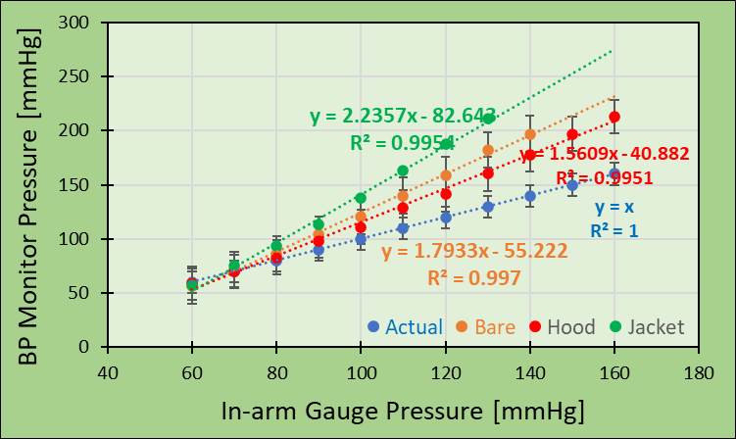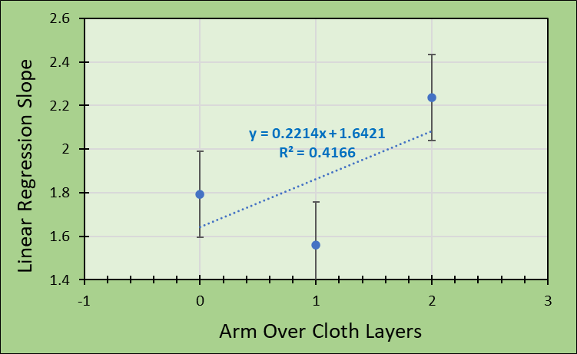
Fig. 8 presents the relationship between BP monitor pressure and in-arm gauge pressure using BP Monitor A concerning the arm-over cloth layers (n=4).

3.8 Monitor B’s Cloth Factor
We measured the pressure changes with identical methods while pressing the monitor's valve repeatedly by changing the cloth layers over the artificial arm. The data in Fig. 9b demonstrate that the linear regression slope increased with the number of cloth layers over the arm. The slope increases mean that the measuring pressure should be farther away from the ideal pressure, as seen in Fig. 9a, blue line as the actual pressure.
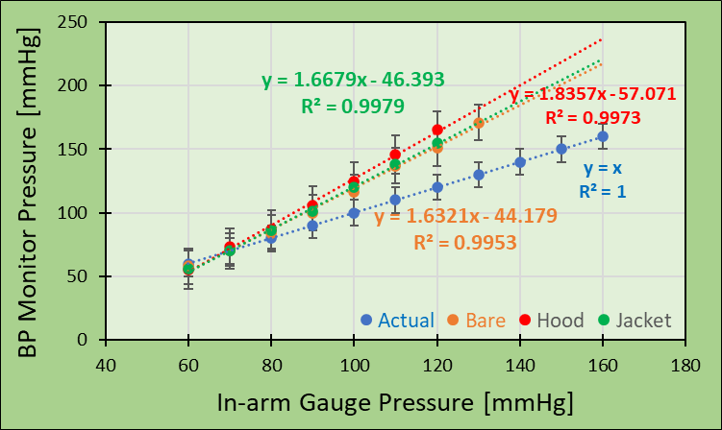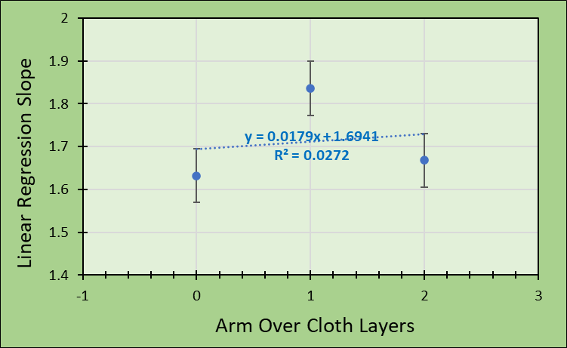
Fig. 9 presents the relationship between BP monitor pressure and in-arm gauge pressure using BP Monitor B for cloth layer increase (n=4).

3.9 Monitor C’s Cloth Factor
The data was acquired without any cloth, hood, or jacket on. Considering their thickness, the layers were numerically estimated as 0, 1, and 2 over the artificial arm. The pressure was decreased as before while videotaping and was replayed for reading the pressure gauges accurately. As seen in Fig. 8~10, the regression slopes from the BP monitor pressure have a linear relation with the number of arm-over cloth layers.
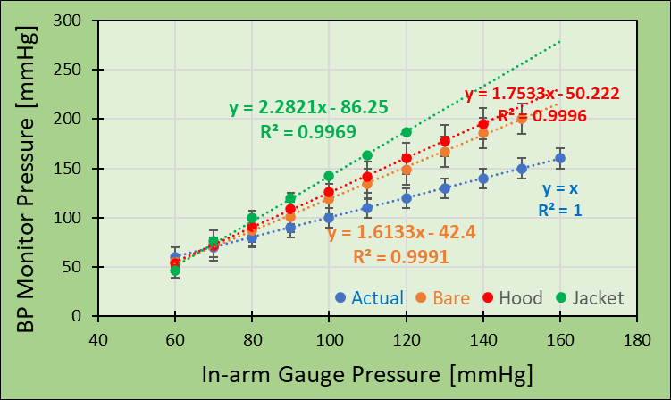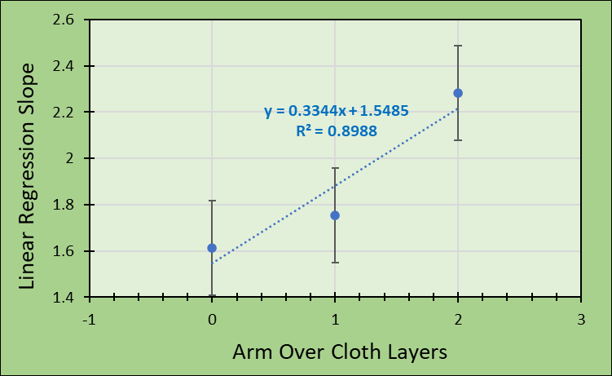
Fig. 10 presents the relationship between BP monitor pressure and in-arm gauge pressure using BP Monitor C for the arm-over cloth layer (n=4).

4. CONCLUSIONS
Accurate and reliable blood pressure measurement should be a prerequisite to diagnosing and managing hypertension properly. Understanding how BP measurement goes wrong and how to tackle them can improve the diagnosis and management of hypertension.
Ironically, BP measurement is often erratically performed in clinical practice, leading to errors that inappropriately make patients suffer from management decisions in nearly 45% of cases. In this study, the sources of variability from the aspects of the blood pressure monitoring system were attempted to be scrutinized. The variability increased with additive properties such as pressure gauge inaccuracy, cuff tightness, and cloth over-measurement. The study concluded that each monitor had their inherent characteristics in increasing monitor pressures concerning the actual pressure, and further, the increases in cuff loosening distance and the cloth-over layers might cause more significant variability proportionally. This study was able to verify the reasons for blood pressure measurement variability more clearly.

References
[1] Gulati M, Peterson LA, Mihailidou A. Assessment of blood pressure skills and belief in clinical readings. Am J Prev Cardiol. 2021 Oct 13;8:100280. doi: 10.1016/j.ajpc.2021.100280.
[2] Handler J. The importance of accurate blood pressure measurement. Perm J. 2009 Summer;13(3):51-4. doi: 10.7812/TPP/09-054. PMID: 20740091; PMCID: PMC2911816.
[3] Padwal R, Campbell NRC, Schutte AE, Olsen MH, Delles C, Etyang A, et al. Optimizing observer performance of clinic blood pressure measurement: a position statement from the Lancet Commission on Hypertension Group. J Hypertens. 2019 Sep;37(9):1737-1745. doi: 10.1097/HJH.0000000000002112.
[4] Paul M., Daichi S., Robert M. C., Jeanne B. C., Trudy G., Sanjay M., Measurement of blood pressure in humans: A scientific statement from the American Heart Association. Hypertension, 2019. 74, (5), Pages e35-e66.
[5] Rhee MY, Munakata M, Nah DY, Kim JS, Kim HY. Home blood pressure measurement for hypertension management in the real world: Do not just measure, but share with your physician. Front Cardiovasc Med. 2023 Jan 18;10:1103216. doi: 10.3389/fcvm.2023.1103216. PMID: 36742078; PMCID: PMC9889357.
[6] Badeli H, Assadi F. Strategies to reduce pitfalls in measuring blood pressure. Int J Prev Med. 2014 Mar;5(Suppl 1):S17-20. PMID: 24791186; PMCID: PMC3990924.
[7] Sharman JE, O'Brien E, Alpert B, Schutte AE, Delles C, Hecht Olsen M, Asmar R, Atkins N, Barbosa E, et. Al. Lancet Commission on Hypertension Group. Lancet Commission on Hypertension group position statement on the global improvement of accuracy standards for devices that measure blood pressure. J Hypertension. 2020 Jan;38(1):21-29.
[8] Del Giorno R, Balestra L, Heiniger PS, Gabutti L. Blood pressure variability with different measurement methods: Reliability and predictors. A proof of concept cross sectional study in elderly hypertensive hospitalized patients. Medicine (Baltimore). 2019 Jul;98(28):e16347.
[9] Costa MD, Rangasamy V, Behera A, Mathur P, Khera T, Goldberger AL, Subramaniam B. Blood pressure fragmentation as a new measure of blood pressure variability: association with predictors of cardiac surgery outcomes. Front Physiol. 2024 Feb 9;15:1277592. doi: 10.3389/fphys.2024.1277592.
[10] Del G, Rosaria & Balestra, Lorenzo & Heiniger, Pascal & Gabutti, Luca. Blood pressure variability with different measurement methods: Reliability and predictors. A proof of concept cross sectional study in elderly hypertensive hospitalized patients. Medicine. 2019. 98. e16347. 10.1097/MD.0000000000016347.
[11] Pélabon C, Hilde CH, Einum S, Gamelon M. On the use of the coefficient of variation to quantify and compare trait variation. Evol Lett. 2020 May 14;4(3):180-188. doi: 10.1002/evl3.171.
[12] Min L, Ha JK, Aubert CE, Hofer TP, Sussman JB, Langa KM, Tinetti M, Kim HM, Maciejewski ML, Gillon L, Larkin A, Chan CL, Kerr EA, Bravata D, Cushman WC. A Method to Quantify Mean Hypertension Treatment Daily Dose Intensity Using Health Care System Data. JAMA Netw Open. 2021 Jan 4;4(1):e2034059. doi: 10.1001/jamanetworkopen.2020.34059.
[13] Schutte AE, Kollias A, Stergiou GS. Blood pressure and its variability: classic and novel measurement techniques. Nat Rev Cardiol. 2022 Oct;19(10):643-654. doi: 10.1038/s41569-022-00690-0. Epub 2022 Apr 19. PMID: 35440738; PMCID: PMC9017082.
[14] Sharman JE, Ordunez P, Brady T, Parati G, Stergiou G, Whelton PK, Padwal R, Olsen MH, Delles C, Schutte AE, Tomaszewski M, Lackland DT, Khan N, McManus RJ, Tsuyuki RT, Zhang XH, Murphy LD, Moran AE, Schlaich MP, Campbell NRC. The urgency to regulate validation of automated blood pressure measuring devices: a policy statement and call to action from the world hypertension league. J Hum Hypertension. 2023 Feb;37(2):155-159. doi: 10.1038/s41371-022-00747-0. Epub 2022 Dec 7.
[15] Ng, Kim-Gau. (2013). Clinical validation protocols for noninvasive blood pressure monitors and their recognition by regulatory authorities and professional organizations: Rationale and considerations for a single unified protocol or standard. Blood Pressure Monitoring. 18. 282–289. 10.1097/MBP.0b013e3283624b3b.
[16] Padwal R, Campbell NRC, Schutte AE, Olsen MH, Delles C, Etyang A, Cruickshank JK, Stergiou G, Rakotz MK, Wozniak G, Jaffe MG, Benjamin I, Parati G, Sharman JE. Optimizing observer performance of clinic blood pressure measurement: a position statement from the Lancet Commission on Hypertension Group. J Hypertension. 2019 Sep;37(9):1737-1745. doi: 10.1097/HJH.0000000000002112. PMID: 31034450; PMCID: PMC6686964.
[17] Jung, Mi-Hyang & Kim, Gee-Hee & Kim, Ji-Hoon & Moon, Keon-Woong & Yoo, Ki Dong & Rho, Tai-Ho & Kim, Chul-Min. (2015). Reliability of home blood pressure monitoring: In the context of validation and accuracy. Blood pressure monitoring. Publish Ahead of Print. 10.1097/MBP.0000000000000121.
[18] Agbecha, A., & Gberindyer, S. J. Association of TNF-alpha with Blood Pressure Levels in Prehypertensive Adults in Makurdi, Nigeria. International Journal of TROPICAL DISEASE & Health, 2018. 32(1), 1–12. https://doi.org/10.9734/IJTDH/2018/41507.
[19] Korogiannou M, Sarafidis P, Alexandrou ME, Theodorakopoulou MP, Pella E, Xagas E, Argyris A, Protogerou A, Papagianni A, Boletis IN, Marinaki S. Ambulatory blood pressure trajectories and blood pressure variability in kidney transplant recipients: a comparative study against haemodialysis patients. Clin Kidney J. 2021. Dec 17;15(5):951-960. doi: 10.1093/ckj/sfab275.
[20] de la Sierra A. Blood Pressure Variability as a Risk Factor for Cardiovascular Disease: Which Antihypertensive Agents Are More Effective? Journal of Clinical Medicine. 2023; 12(19):6167. https://doi.org/10.3390/jcm12196167.

[21] Tabansi, P. N., Onyemkpa, K. C., & Anochie, I. C. High Blood Pressure and Related Factors among Nursery School Children in Port Harcourt, Nigeria. Journal of Advances in Medicine and Medical Research, 2018. 25(2), 1–14. https://doi.org/10.9734/JAMMR/2018/38338.

