Original Research Article

The Influence of Competence on Employee Performance with Organizational Commitment as a Mediating Variable

.
ABSTRACT

Aims: This study aims to examine the influence of employee competence on employee performance at PT XYZ and to determine whether organizational commitment mediates the relationship between competence and performance.
Study Design: A quantitative, survey-based research design was employed.
Place and Duration of Study: The study was conducted at PT XYZ, Indonesia, with data collected during the 2025 operational period.
Methodology: Primary data were collected from 195 employees using structured questionnaires, achieving a 100% response rate. Three variables were measured: competence, organizational commitment, and employee performance. Data were analyzed using Structural Equation Modeling. Key statistical indicators were used to evaluate significance.
Results: The findings show that competence has a positive and significant effect on employee performance, with a path coefficient of 0.255 and a Critical Ratio (CR) of 4.66 (p < 0.05). This demonstrates that higher competence directly enhances job effectiveness and productivity. Mediation analysis further reveals that organizational commitment significantly mediates this relationship. The Sobel test produced a t-value of 7.705 (p = 0.000), indicating that competence strengthens employee performance both directly and through increased organizational commitment.
Conclusion: Competence is a strong predictor of employee performance at PT XYZ, and its influence is amplified through the mediating role of organizational commitment. Enhancing employee competencies and fostering stronger commitment—through targeted training, supportive work environments, and competency-based HR policies—can contribute to improved performance and organizational competitiveness.

Keywords: Competence, Organizational Commitment, Employee Performance

1. INTRODUCTION

Modern organizational practice increasingly relies on human resource management (HRM) to build sustainable competitive advantage by optimizing the potential of employees. Davis (1996) define HRM as a formal system involving human resource planning, recruitment, training, performance management, and compensation to support strategic goals. Dessler (2020) emphasizes that HRM acts as a strategic partner, integrating employee management with corporate objectives and positioning employees as critical value-creating assets. Similarly, Werther and Davis (1996) underline that HRM functions—planning, organizing, directing, and controlling—are essential for ensuring effective employee development and long-term organizational success.
Employee performance remains a central indicator for evaluating HRM effectiveness. Armstrong and Taylor (2014) describe performance as measurable outcomes produced by individuals, while Robbins and Judge (2017) define it as the degree to which employees meet task expectations and contribute to organizational objectives. Empirical studies reinforce the importance of performance management. The study show that continuous feedback enhances employee engagement and productivity, while Siraj et al. (2025) find that strategic HRM practices such as training, performance appraisal, and compensation improve job satisfaction, organizational commitment, and performance. These findings highlight that competence, motivation, work environment, and managerial support jointly shape employee performance.
The complexity of operations at PT XYZ further amplifies the relevance of these HRM dynamics. Operating across plantation management, factory processing, and sugar distribution, each department plays a crucial role in an integrated agro-industrial supply chain. Internal KPI data from 2023–2024 indicate performance disparities among departments: although Plantation, Factory, and Human Resources units show improvement, their overall scores remain below the target benchmark of 5.00. These gaps suggest that despite clear organizational structures and functional support, PT XYZ’s performance potential has not been fully realized.
Competence is one of the factors suspected to contribute to these performance variations. Akkermans et al. (2013) define competence as a combination of knowledge, skills, and abilities that individuals require to navigate their careers, encompassing both technical and behavioral dimensions. Van den Broeck et al. (2010) further argue that competence levels depend heavily on job characteristics and organizational demands. In the sugar industry—characterized by seasonal operations, labor-intensive processes, and time-critical tasks—competence becomes even more crucial. The ongoing digital transformation at PT XYZ, including automation, digital monitoring systems, GIS-based mapping, and data-driven decision-making tools, requires employees with strong and continuously updated competencies. However, uneven technology exposure, limited continuous training, and inconsistent competency levels across departments (Plantation, Factory, QSHE, R&D) indicate that the organization has not fully capitalized on these technologies.
Training initiatives at PT XYZ show progress yet highlight persistent challenges. The company conducted 110 training programs for 746 employees in 2023 (45%) and 131 programs for 1,074 employees in 2024 (64%). Despite this improvement, many employees still lack equal access to development opportunities. This situation may hinder competency development and raise compliance concerns. Article 12 paragraphs (1) and (3) of Indonesian Labor Law No. 13/2003 mandate that companies must train employees and provide equal opportunities for skill enhancement. Therefore, PT XYZ must ensure more systematic and inclusive competency development to maintain both compliance and competitiveness.
However, previous organizational experience shows that high competence does not always translate directly into high performance. Competence itself, as defined by Boyatzis (1982), refers to the underlying characteristics of an individual that lead to effective or superior performance. This gap between competence and actual outcomes suggests the presence of an intervening psychological factor, with organizational commitment frequently identified as a key mediator. Meyer and Allen’s later framework (1997) conceptualizes organizational commitment as comprising affective, continuance, and normative dimensions that bind employees to their organization, building on earlier conceptualizations from Meyer et al. (1991). Similarly, Mowday et al. (1982) emphasize commitment as reflected in identification with organizational values, loyalty, and willingness to exert effort. Empirical studies by Sari et al. (2021), consistently demonstrate that organizational commitment significantly strengthens the influence of competence on performance.
Despite these findings, research examining the competence–commitment–performance relationship in agro-industrial settings, particularly in plantation-based manufacturing organizations undergoing digital transformation, remains limited. Most existing studies focus on service sectors, government institutions, or manufacturing industries with stable production cycles. This gap highlights the need to explore whether the same mechanisms apply in an industry characterized by seasonal operations, technological transitions, and heterogeneous workforce competencies.
Based on this context, the present study seeks to examine whether employee competence directly influences performance at PT XYZ and to determine whether organizational commitment serves as a mediating factor in strengthening the relationship between competence and performance.This research contributes theoretically by enriching HRM literature related to competence, organizational commitment, and performance, particularly in agro-industrial environments. Practically, the findings will support PT XYZ in designing targeted competency development programs, strengthening performance management systems, and improving career planning. Strengthening competence and organizational commitment is expected to cultivate a more adaptive, productive, and competitive workforce capable of responding to dynamic organizational challenges.
2. material and methods

2.1 Data Types and Sources
This quantitative explanatory study utilizes numerical data to uncover causal links between variables. Sekaran and Bougie (2016) state that the quantitative method tests hypotheses and models empirical connections using quantifiable statistical data. Questionnaires and Likert scales help researchers collect systematic, standardized, and analytically understandable data. This strategy uses surveys, experiments, and secondary data for more controlled observations. The quantitative method is strong in objectivity, replicability, validity, and dependability. Thus, this method supports scientific findings and evidence-based decision-making with improved precision and consistency (Sekaran & Bougie, 2016).
2.2 Population and Sample
This research includes all permanent workers who were active throughout the data collection. For proportional representation, stratified random sampling divides the population into various strata depending on organizational roles. According to Sekaran and Bougie (2016), a population is the total group of people, events, or things studied. According to the demographic statistics, PT XYZ employs 1,677 people from Senior Manager to Foreman II. The dataset is stratified such that every organizational level contributes, improving accuracy and generalizability. By identifying the population structure, the study may select a more representative sample (Sekaran & Bougie, 2016).
This subgroup of the population accurately depicts its features. Sekaran and Bougie (2016) stress that data must be representative to reflect demographic situations. This research uses basic random sampling to provide each PT XYZ employee an equal chance of selection to reduce bias. Hair et al. (2019) suggest a minimum of 100 respondents and a ratio of 5 to 10 respondents per observed variable based on questionnaire indicators. With 39 indications, a minimum sample size of 195 respondents (39 x 5) is needed, with a maximum of 390 respondents (39 x 10 The sample table shows that the research uses 195 respondents and distributes the sample proportionately across work categories to ensure population composition and methodological rigour (Hair et al., 2019).
2.3 Data Sources and Data Collection Methods
This research uses primary and secondary data. Primary data are collected by the researcher using structured questionnaires or direct observation to solve the study topic. Distributing questionnaires and performing structured interviews with respondents provided main data for this research. Sekaran and Bougie (2016) emphasize that primary data provides empirical evidence that helps researchers identify challenges and find solutions. Secondary data comes from books, academic journals, past study publications, and related electronic media. These secondary sources complement and support the core results, making the analysis more complete and founded in theoretical and empirical research. Thus, combining data kinds boosts study results.
Data was collected systematically according to Sekaran and Bougie (2016), who define data gathering as an organized process to accomplish study goals. This study used survey-based questionnaires with predetermined written questions to collect quantitative data for analysis. Large-scale quantitative data collection is efficient using questionnaires. Secondary data from academic papers, government records, and archive documents supported the original results. According to Sekaran and Bougie (2016), selecting adequate data collecting techniques is crucial for research validity and reliability. Primary and secondary data provide this research a firmer analytical basis and a more comprehensive grasp of the phenomenon under study.
2.4 Research Variables and Operational Definitions
Variables are qualities or features that vary between persons, things, or events, whether throughout time for the same unit or across many units (Sekaran & Bougie, 2016). This research divides variables into three kinds. Competence (X) is the independent variable thought to affect others. Employee Performance (Y) is impacted by the independent variable. Organizational Commitment (M) mediates how the independent variable affects the dependent variable. Sekaran and Bougie (2016) characterize operational definitions as precise explanations of how each variable is measured to guarantee consistency and reproducible methods. Competence is measured by meaning and self-efficacy (Spreitzer, 1995; Yildiz et al., 2024); organizational commitment by loyalty, value congruence, and willingness to work harder (Na-Nan et al., 2020); and employee performance by task performance, contextual performance, and counterproductive behavior.
Questionnaires, exams, and structured forms tailored to study goals are used to assess ideas and variables (Sekaran & Bougie, 2016). All factors were assessed using Likert-scale questionnaires in this research. Six questions covering two indicators comprise the competency instrument, modified from Spreitzer (1995) and Yildiz et al. (2024). Six factors were used to measure organizational commitment using a 15-item Mowday, Steers, and Porter (1979) survey. Three indices of employee performance were assessed using eighteen Campbell, McHenry, and Wise (1990) questionnaires. All variables were measured using a Likert scale, an interval-based rating scale intended to frame respondents' views (Sekaran & Bougie, 2016). Each questionnaire item has a number score: 1 for "Strongly Disagree," 2 for "Disagree," 3 for "Neutral," 4 for "Agree," and 5 for "Strongly Agree." This scoring technique quantifies answers consistently, enabling statistical analysis and maintaining comparability across indicators and factors.
2.5 Instrument Testing
This research tested all measuring methods to verify they were valid and reliable and could correctly capture the components under consideration. Validity is an instrument's capacity to measure what it's supposed to, while reliability is its consistency and stability in delivering reliable findings over time (Sekaran, 2006). Each questionnaire item was validated and reliability-tested before being included in the final analysis. These steps ensured that the items appropriately represented the research variables, bolstering the study's trustworthiness.
Confirmatory Factor Analysis (CFA) assessed how well the empirical data matched the suggested measurement model (Sekaran & Bougie, 2016). Convergent validity is determined if construct-related indicators are strongly correlated. Standardized factor loadings and the Average Variance Extracted assess convergent validity in reflective measurement models. Hair et al. (2014) define convergent validity as factor loadings above 0.70 and AVE values ​​over 0.50. Exploratory studies or early scale development may tolerate loading levels between 0.50 and 0.60. Based on these criteria, all indicators contribute significantly to their conceptions.
Reliability testing assessed whether questionnaire questions were error-free and consistently captured the desired constructs across circumstances (Sekaran & Bougie, 2016. The construct reliability formula was used to test dependability in the SEM framework. A construct is trustworthy if Cronbach's Alpha exceeds 0.60. Normality tests were also performed to verify whether the data followed a normal distribution, since non-normality might skew SEM estimates, increase chi-square values, and impair model fit accuracy (Hair et al., 2006). Sekaran & Bougie, (2016) advocated assessing normality using skewness and kurtosis measurements with a critical ratio threshold of ±2.58 at a 0.01 significance level. All normality tests used AMOS.
2.6 Data Analysis Method and SEM-AMOS Hypothesis Testing

SEM, performed using AMOS software, is the main analytical method in this investigation. SEM was chosen because Byrne (2016) noted that the method may concurrently explore complicated variable connections, including direct and indirect effects. SEM combines structural equations, which define causal links between latent variables, with measurement equations, which describe how observable indicators assess latent constructs. This study tests hypotheses and evaluates organizational commitment as a mediator using SEM-AMOS. At 95% confidence, t-statistics values ​​of 1.96 or above imply significance for hypotheses 1 and 2 (Hair et al., 2014). Hypotheses 3 and 4 propose a four-step mediation procedure: the independent variable must substantially impact the dependent variable, the mediator, and the dependent variable. Full mediation is when the mediator makes the independent variable less significant, while partial mediation is when the impact remains substantial but falls.
After establishing a valid and accurate measurement model, the theoretical framework is used to assess build structural connections. Identifying construct directed relationships and establishing hypotheses is structural model development. Once these linkages are specified, goodness-of-fit indices are used to evaluate the structural model. To test hypotheses, the critical ratio (C.R.) and p-values ​​of structural coefficients (gamma (γ) for connecting exogenous to endogenous components and beta (β) for connecting endogenous constructs) are examined. A parameter is deemed significant if its p-value falls below the predefined threshold (5% or 1%), disproving the null hypothesis (γ = 0 or β = 0). Linear regression and path analysis, an extension of multiple regression, show non-reciprocal causal linkages in this research. This research's structural equations predict employee performance (Y) based on competence (X) and organizational commitment (M) and organizational commitment based on competence. The Sobel Test further confirms the mediating effect's relevance. Since Sobel (1982), this test evaluates the statistical significance of an independent variable's indirect influence on a dependent variable via a mediator. The product of the unstandardized regression coefficients (a and b) and their standard errors are compared. Mediation is indicated by a high Sobel statistic.
3. results and discussion

3.1 Respondent Characteristics
The data gathering technique underpinned this study's empirical analysis. An online questionnaire was sent to all PT XYZ workers to collect all research data. The poll was performed using Google Forms between 3-10 October 2025. Amazingly, all sent surveys were returned full and usable, resulting in 100% response. This high participation rate lends legitimacy to the dataset and assures that the results represent organizational circumstances. A detailed demographic profile of respondents is provided by the descriptive findings. The bulk of respondents were 21–30 years old (66.7%), followed by 31–40 (29.2%). Only 3.6% were 41–50, and 0.5% were beyond 50. These numbers show that PT XYZ's staff is mostly young, a productive age group known for flexibility, vitality, and competence growth. The majority (53.3%) had bachelor's degrees, followed by diplomas (26.2%). Employees with high school diplomas made up 14.9% and those with master's degrees 0.5%. This distribution shows that PT XYZ's personnel is academically sound, meeting its operational and developmental requirements. Work tenure distribution emphasizes organization. Over half (52.3%) had worked 0–5 years, and 36.9% had worked 6–15 years. Only 0.5% had worked for more than 30 years, whereas 16–25 year (6.7%) and 26–30 year (3.6%) had smaller numbers. These patterns show a youthful to mid-tenure workforce, representing a dynamic organizational climate with a mix of new and experienced personnel that supports the company's long-term competence and commitment growth.
3.2 Instrument Testing
Validity, reliability, normalcy, structural model, hypothesis, and Sobel tests were performed during instrument testing. The assessment tools' validity and reliability were first assessed to verify that all indicators properly represented the variables under inquiry. A unidimensional method assesses validity by stressing how well each indicator reflects its variable. Valid indicators have loading factor values ​​over 0.40 and statistical significance at the 5% level. According to Hair et al. (2014), loading levels over 0.50 support validity indicator. All Competence, Organizational Commitment, and Employee Performance indicators meet validity requirements. The Average Variance Extracted (AVE) values ​​for each construct—0.659, 0.624, and 0.591—exceeded 0.50, suggesting good convergent validity across all variables.
The measuring equipment's internal consistency and stability were tested for reliability. The main metric was construct reliability (CR), with values ​​of 0.70 or above indicating dependability. The CR findings indicated Competence 0.921, Organizational Commitment 0.961, and Employee Performance 0.963, all above the necessary threshold. These results show that each construct's indicators work well and measure the relevant variables. The validity and reliability evaluations show that this study's tools are methodologically sound and suitable for structural analysis.
The critical ratio (CR) for skewness and kurtosis was used in AMOS output normality testing with a significance threshold of 0.01. According to Hair et al. (2014, data is deemed regularly distributed when CR values ​​are ±2.58. All elements satisfied the skewness and kurtosis criteria for univariate normality. Additionally, the multivariate CR value of 2.521 was acceptable. These results demonstrate that the dataset meets normality assumptions, allowing SEM structural model testing.
3.3 Descriptive Analysis of Variable Measurement
This study's descriptive analysis of variable measurement uses a Likert scale to grade statements from 1 to 5. Range = (highest score – lowest score) / (range of scores) for 195 employee respondents. Yield formula (5 – 1) / 5 = 0.8. Scores are 1.0–1.8 (Very Low), 1.8–2.6 (Low), 2.6–3.4 (Moderate), 3.4–4.2 (High), and 4.2–5.0 (Very High). These categorizations outline how to evaluate minimum, maximum, and mean values ​​to examine data distribution among study variables. Competence, Organizational Commitment, and Employee Performance have descriptive statistics of 1–5, with mean values ​​of 3,569, 3,644, and 3,298. The mean of 3,504 suggests that PT XYZ workers' working conditions are moderate, indicating an acceptable yet improveable workplace.
The Competence descriptive data includes six statement items with mean scores from 3.508 to 3.687. The statement, “The work I do is very important to me,” had the highest mean score, 3.687, indicating that workers cherish their jobs. The statement "I have mastered the skills required for my job" has the lowest mean of 3.528, indicating that workers see their technical and non-technical skills as competent but not optimal. The mean score of 3.569 indicates moderate skill. These results suggest that personnel are capable of fulfilling their duties, but more organized development would improve mastery and preparedness.
The Organizational Commitment variable has 15 statement items with mean values ​​from 3.179 to 4.041, averaging 3.644. The variable is Moderate with this score. The statement, “My personal values ​​are consistent with the values ​​of this organization,” had the highest mean score, 4.041, showing great value alignment and emotional connection among workers. The lowest mean score, 3.179, is for the statement, "I will accept nearly any assignment to work remaining here," suggests workers are not ready to tolerate substantial job flexibility. The findings show that workers have a good feeling of pride, loyalty, and identification with the firm, although task engagement and commitment to organizational efforts may be improved.
The Employee Performance variable has 18 statement items with means between 2.969 and 3.744 and an average of 3.298, also Moderate. The statement, “I discuss negative aspects of my job with my coworkers,” scored 3,744, indicating that employees communicate freely and discuss employment issues. The statement, “I can plan my work so I complete it on time,” scored the lowest at 2,969, indicating significant work planning and time management issues. PT XYZ employees perform reasonably well, but not optimally. Planning, efficiency, and problem-solving skills boost productivity and organizational performance.
3.4 Structural Model Test Results
The structural model (inner model) was evaluated following Confirmatory Factor Analysis (CFA) of the measurement model (outer model). The preliminary CFA technique verified that each survey indicator properly reflected the latent constructs being assessed. The study moved to the structural phase once all questionnaire questions fulfilled validity and reliability requirements. Latent variable connections were examined using Structural Equation Modeling (SEM). The research used SEM to determine how one variable affects another, allowing for an analytical understanding of inter-construct interactions in the proposed model.
Figure 1 shows the structural model findings after the measurement model passed CFA. Competence (X), Organizational Commitment (M), and Employee Performance (Y) are latent variables in the study's structural model, backed by 39 observable indicators. The model's degree of freedom (df) was 253, suggesting overidentification. This categorization shows that the model has more known data points than estimated parameters, validating its statistical validity and interpretation.
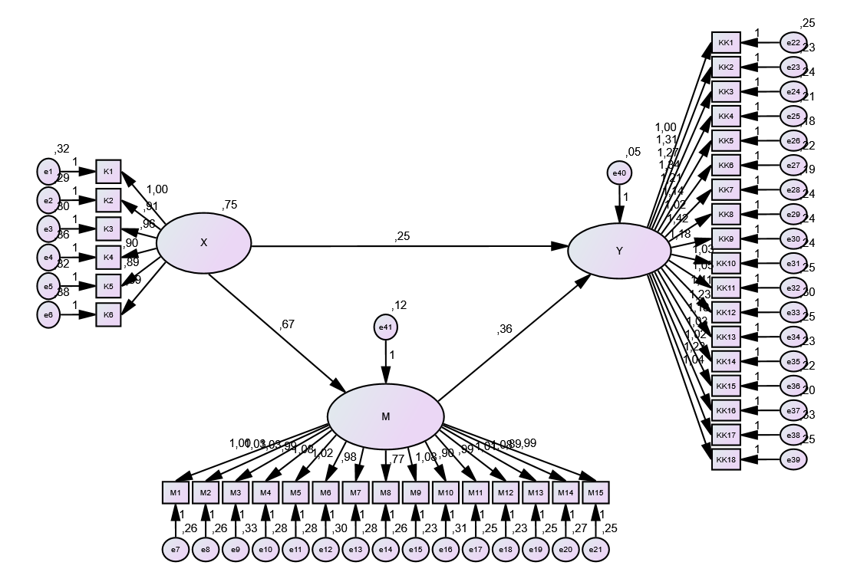
Figure 1 Structural Model Test Results
3.5 Model Fit Analysis
Several Goodness-of-Fit (GOF) metrics were used to evaluate the structural model's fit with empirical data. According to Hair et al. (2014), a model is acceptable if at least four to five GOF indices reach the cut-off values ​​and reflect the three key fit indices. Based on this criteria, the structural model in this work is suitable for hypothesis testing. Table 1 lists GOF indicator findings, cut-off values, and model classes. In Structural Equation Modeling, these indicators provide a complete assessment of model adequacy.
The Comparative Fit Index (CFI) and Incremental Fit Index (IFI) are Good Fit, indicating high model alignment with observed data. The model's PNFI and PCFI values ​​are Acceptable, indicating parsimony. Although the model is usually competent, RMSEA, GFI, NFI, CMIN/DF, and TLI are Marginal Fit, indicating that adjustments might enhance its fit. According to Hair et al. (2014), the structural model meets many GOF criteria, indicating its suitability for further research. Therefore, the model is accepted for further analysis.

3.6 Hypothesis Test Results
This research tested the notion that Competence directly affects Employee Performance. The study examined two hypotheses about how competence affects employee performance, including how organizational commitment mediates the relationship. Statistical significance is achieved when the p-value is below 0.05 and the Critical Ratio (CR) exceeds 1.96. Table below shows the direct effect testing findings, which use AMOS Version 24 statistical output to evaluate the hypothesis.
Table 1. Results of Direct Hypothesis Testing
Hypothesis Description | Estimate | S.E. | C.R. | P | Label | Conclusion
Effect of Competence on Employee Performance | 0.255 | 0.055 | 4.66 | *** | par_37 | Supported

Table above indicates a strong positive impact of competence on employee performance, with an estimated coefficient of 0.255 and a CR value of 4.66 (p < 0.05). This suggests that workers perform better with more competence. Employee performance is affected by competence, supporting the idea. These findings demonstrate the strategic relevance of competence development in the business by showing that employee knowledge, skills, and abilities directly boost job productivity and effectiveness.
3.7 Sobel/Mediation Test Results
The Sobel test was used to determine whether Organizational Commitment mediates the association between Competence and Employee Performance. This analytical method compares the estimated t-value to the crucial value of 1.96 to assess the indirect effect's size and relevance. When the t-value surpasses this standard, the mediation effect is statistically significant, showing that the mediating variable efficiently communicates the independent variable's impact to the dependent result. Sobel analysis rigorously evaluates the structural model's mediating mechanism and validates whether the indirect route adds to the model's explanatory power.
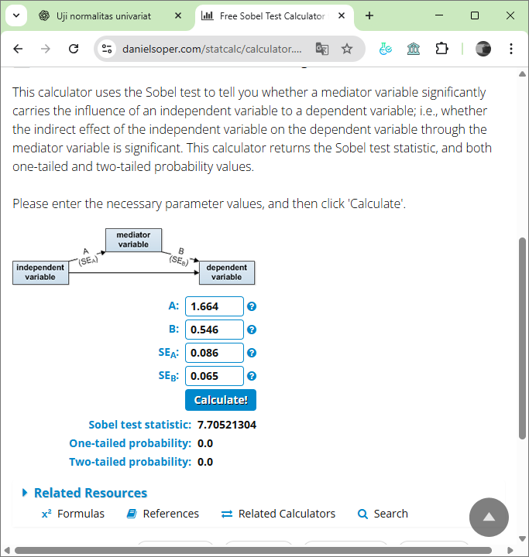
Figure 2. Sobel Test Competence (X), Organizational Commitment (M), Employee Performance (Y)
Figure 2 shows the Sobel test findings for Organizational Commitment mediation. Path A from Competence to Organizational Commitment (Path A) had a coefficient of 1.664 with a standard error of 0.086, whereas Path B from Organizational Commitment to Employee Performance (Path B) had 0.546 with 0.065. The Sobel test statistic was 7.705 with a two-tailed p-value of 0.000, indicating a statistically significant indirect impact. These data show that Organizational Commitment mediates Competence-Employee Performance. When workers are competent, their organizational commitment grows, which boosts their performance.
3.8 The Effect of Competence on Employee Performance
Hypothesis testing using the AMOS structural equation model (SEM) evaluated the direct influence of competence on employee performance. The first hypothesis proposed that higher competence would significantly improve performance. The analysis produced a path coefficient of 0.255, a Critical Ratio (CR) of 4.66, and a p-value < 0.001, all of which meet the required significance thresholds (CR > 1.96; p < 0.05). These results empirically confirm that competence has a positive and significant effect on employee performance at PT XYZ. Descriptive results further support this relationship. The mean competency score of 3.569 indicates that employees generally possess adequate knowledge, skills, and abilities to execute their tasks. Meanwhile, the average employee performance score of 3.298—categorized as moderate—shows that while most employees fulfill their responsibilities, there remains room for improvement in productivity and operational efficiency.
These findings align with prior studies by Sutanto and Kurniawan (2020) and Hidayat et al. (2021), which conclude that employee competence substantially enhances work performance. In the context of PT XYZ’s agro-industrial operations—characterized by seasonal production cycles, labor-intensive activities, and increasing technological integration—competence becomes especially critical. Employees must adapt to digital monitoring tools, automated machinery, GIS-based plantation management, and strict production timelines. Competent employees are better able to interpret operational data, troubleshoot process issues, and maintain consistent output quality. The results also reinforce Spencer and Spencer’s (1993) Competency-Based Human Resource Model, emphasizing that competence reflects deep-seated characteristics that drive effective performance. Enhancing competence—through technical training, soft-skill development, and continuous learning—is therefore essential for meeting the operational demands of the agro-industry. Overall, the findings highlight that improving employee competence at PT XYZ is a key lever for elevating performance, supporting operational reliability, and ensuring competitiveness in a dynamic industrial environment.
3.9 The Effect of Competence on Employee Performance with Organizational Commitment as a Mediating Variable at PT XYZ
The second hypothesis examines whether organizational commitment mediates the relationship between competence (X) and employee performance (Y). Results from the structural equation modeling (SEM) analysis show that competence has a positive and significant influence on organizational commitment, with a coefficient of 1.664, while organizational commitment in turn positively affects employee performance with a coefficient of 0.546. The Sobel Test further confirms the mediating effect, producing a statistical value of 7.705 and a p-value of 0.000, which meets the significance criteria of t > 1.96 and p < 0.05. These findings indicate that the indirect effect of competence on employee performance through organizational commitment is statistically meaningful, thereby supporting the second hypothesis. Descriptive statistics reinforce this conclusion. The competency score of 3.569 indicates that employees possess adequate skills and knowledge to perform their duties. Organizational commitment, with an average score of 3.644, also falls within the moderate range, suggesting that employees demonstrate attachment and loyalty to the organization, though further cultural reinforcement and managerial support could enhance these levels.
The results align with previous studies showing that competence not only improves employees’ technical abilities but also shapes positive psychological attitudes toward the organization. Competent employees tend to feel more valued, confident, and supported, which strengthens their emotional and normative commitment. In line with Social Exchange Theory (Blau, 1964), employees who perceive the organization as providing opportunities to apply and develop their competencies reciprocate through stronger commitment and improved performance. Thus, organizational commitment functions as a bridge through which competence enhances performance: higher competence increases employees’ attachment and willingness to contribute, and this heightened commitment ultimately leads to better work outcomes.

4. Conclusion

The findings of this study confirm both research hypotheses and highlight the central role of competence and organizational commitment in shaping employee performance at PT XYZ. First, competence—reflected in employees’ knowledge, technical skills, and behavioral capabilities—has a direct and significant positive effect on performance. Employees with stronger competencies are more capable of meeting operational targets, adapting to technological requirements, and contributing effectively to the company’s agro-industrial processes. Second, organizational commitment is shown to significantly mediate the competence–performance relationship. Competence not only strengthens employees’ work quality but also enhances their emotional attachment, loyalty, and sense of responsibility toward the organization. This strengthened commitment, in turn, reinforces performance outcomes by encouraging employees to put forth greater effort and maintain work consistency.
These findings offer broader implications for HRM and organizational development. Competence enhancement contributes not only to technical performance but also to motivational and affective factors that support long-term workforce stability. Therefore, PT XYZ is encouraged to invest in systematic training programs—both technical (e.g., machinery operation, digital monitoring systems, GIS tools) and behavioral (e.g., communication, problem-solving, adaptability). Implementing competency-based performance evaluations can help align employee skills with job requirements more effectively. Strengthening organizational commitment requires fair and transparent recognition systems, clear career pathways, supportive leadership practices, and continuous two-way communication to build trust and psychological ownership. Finally, performance improvement will be more sustainable if supported by regular monitoring, constructive feedback, and performance-based reward systems that reinforce desired behaviors and outcomes. Overall, this study emphasizes that competence development and organizational commitment should be integrated into PT XYZ’s strategic HRM framework to enhance workforce productivity and organizational competitiveness.
The study is limited by its focus on a single company within one specific industry, which may restrict the generalizability of the findings to other organizational contexts. In addition, the sample may not fully represent all employee characteristics within PT XYZ, and the cross-sectional design prevents the establishment of long-term causal relationships between competence, organizational commitment, and performance. Future research should expand the scope by including multiple companies across different sectors, using larger and more diverse samples, and applying longitudinal or experimental methods to better capture changes over time and strengthen causal inference.
Consent
As per international standards or university standards, Participants’ written consent has been collected and preserved by the author(s).
Disclaimer (Artificial intelligence)
Author(s) hereby declare that NO generative AI technologies such as Large Language Models (ChatGPT, COPILOT, etc.) and text-to-image generators have been used during the writing or editing of this manuscript.

References

Abu-Bader, S., & Jones, T. V. (2021). Statictical Mediation Analysis Using The Sobel Test And Hayes Spss Process Macro Sobel. International Journal of Quantitative and Qualitative Research Methods, 1(9), 42–61.
Akkermans, J., Brenninkmeijer, V., Huibers, M., & Blonk, R. W. (2013). Competencies for the contemporary career: Development and preliminary validation of the career competencies questionnaire. Journal of Career Development.
Armstrong, M., & Taylor, S. (2014). Armstrong’s Handbook of Human Resource Management Practice (13th ed.).
Boyatzis, R. E. (1982). The competent manager: A model for effective performance. John Wiley & Sons.
Byrne, B. M. (2016). Structural equation modeling with AMOS: Basic concepts, applications, and programming. New York, NY: Routledge.
Campbell, J. P., McHenry, J. J., & Wise, L. L. (1990). Modeling job performance in a population of jobs. In Personnel Psychology.
Dessler, G. (2020). Human Resource Management ((16th ed.)). Pearson Education.
Hair, J. F., Black, W. C., Babin, B. J., & Anderson, R. E. (2019). Multivariate data analysis. In Cengage Learning.
Hair, J. F., Black, W. C., Babin, B. J., Anderson, R. E., & Tatham, R. L. (2006). Multivariate Data Analysis (6 th ed). Prentice Hall.
Hair, J. F., Hult, G. T. M., Ringle, C. M., & Sarstedt, M. (2014). A primer on partial least squares structural equation modeling (PLS-SEM). In Thousand Oaks, CA: Sage Publications.
Meyer, J. P., & Allen, N. J. (1997). Commitment in the workplace: Theory, research, and application. SAGE Publications.
Meyer, P.;, J., Allen, & J., N. (1991). A three-component conceptualization of organizational commitment. Human Resource Management Review, 1. https://doi.org/10.1016/1053-4822(91)90011-Z
Mowday, T.;, R., Porter, L. W. ., & Steers, R. M. (1982). Employee–organization linkages: The psychology of commitment, absenteeism, and turnover. Academic Press.
Na-Nan, K., Kanthong, S., Joungtrakul, J., & Smith, I. D. (2020). Mediating effects of job satisfaction and organizational commitment between problems with performance appraisal and organizational citizenship behavior. Journal of Open Innovation: Technology, Market, and Complexity
Robbins, S. P., & Judge, T. A. (2017). Organizational Behavior (17th ed). Pearson Education.
Sari, E. P., & Yuhendri, M. (2021). E-Learning efektif sebagai media pembelajaran saat pandemi Covid-19. In E-Learning efektif sebagai media pembelajaran saat pandemi Covid-19. Mimbar Ilmu.
Sekaran, U. (2006). Metodologi Penelitian untuk Bisnis, Edisi 4, Buku 1. Salemba Empat.
Sekaran, U., & Bougie, R. (2016). Research Methods for Business: A Skill-Building Approach (7 th ed). Wiley.
Siraj, R., Hina, & Yasmeen, G. (2025). Strategic Human Resources Management and Employee Outcomes: A Comprehensive Literature Review on the Impact of SHRM Practices on Job Satisfaction and Organizational Commitment. The Critical Review of Social Sciences Studies.
Sobel, M. E. (1982). Asymptotic Confidence Intervals for Indirect Effects in Structural Equation Models. Sociological Methodology, 13, 290. https://doi.org/https://doi.org/10.2307/270723
Spreitzer, G. M. (1995). Psychological empowerment in the workplace: Dimensions, measurement, and validation. Academy of Management Journal, 38(5).
Van den Broeck, et al. (2010). Capturing autonomy, competence, and relatedness at work: Construction and initial validation of the Work related Basic Need Satisfaction scale. Journal of Occupational and Organizational Psychology.
Werther, W. B., & Davis, K. (1996). Human Resources and Personnel Management.
Yildiz et al. (2024). Predicting the use of chatbot systems in education: A comparative approach using PLS SEM and machine learning algorithms. Current Psychology, 43.
Yildiz, K., Akoglu, H. E., Emir, E., Angosto, S., Spain, S., & Garcia-Fernandez, J. (2024). The perceived effect of digital transformation and resultant empowerment on job performance of employees in the fitness family business. Journal of Family Business Management. https://doi.org/10.1108/JFBM-02-2024-0038

