Original Research Article

The Determinants of Employee Retention at the Ministry of Finance of the Republic of Indonesia

Abstract

This study investigates the impact of leadership, compensation, and career development on employee retention within Indonesia's Ministry of Finance. Addressing a gap in the literature on public sector employee retention, the research employs a quantitative approach, surveying 224 employees from the Directorate General of Customs and Excise. Using Partial Least Squares Structural Equation Modelling (PLS-SEM), the study finds that all three factors significantly influence employee retention. These results provide actionable insights for policymakers and management to enhance workforce stability in government organizations.

Keywords: leadership, compensation, career development and employee retention

- Introduction
Currently, every organization faces a competitive environment that shows no signs of abating; rather, it is becoming increasingly intense over time. The nature of competition has shifted from being competitive to adversarial. Competition will only be won by those who have high competitiveness, which is determined by the quality of human resources as measured by their knowledge capabilities. The stronger the knowledge of an organization's human resources, the greater its competitiveness. In this case, knowledge is in a broad sense which is seen from performance, competent, fast, innovative work behavior, and a strong drive to continue learning. Thus, high-quality human resources are a crucial and determining factor for achieving organizational performance and objectives.
One of the obstacles in managing an organization is employee turnover. The opposite of turnover is employee retention, which refers to an organization's efforts to retain high-quality employees for an extended period. Retention is the implementation of an integrated strategy or system designed to increase work productivity by developing processes to attract, develop, retain, and utilize people with the skills and talents needed to meet current and future business needs (Lockwood, 2006).
The employee retention rate is determined by various factors such as job satisfaction, fair compensation, career development, and emotional attachment to the organization (Dessler, 2016), company image, recruitment, selection, placement, leadership, learning opportunities, performance recognition, and rewards (Armstrong, 2012). In this study, the selected variables determining employee retention include leadership, compensation, and career development.
Organizational-level factors have dominated many studies on employee retention, with the acceptance of leadership style as an organizational-level factor. But the most important issue is trust and respect for team management. It is argued that organizations with leaders who value and treat employees with respect, provide compensation, benefits, and rewards that are attractive and encourage employees to remain in the organization (Huselid, 1995 as cited Wilfred, 2023).
Leadership is a crucial role requirement for managers or leaders and serves as the primary reason for the existence of managerial positions. Leadership is related to leader behavior, which includes behaviors of showing consideration for others and interpersonal relationships, as well as behaviors of initiating structure in task completion.
There are several types of leadership behavior, namely task-oriented behavior, relationship-oriented behavior, and participatory leadership (Mubarok, 2017). The study results indicate that the relationship between leaders and employees affects employees' intention to continue working and remain with the organization (Michael, 2008).
Compensation is a reward for the contribution of an individual working in an organization. Compensation is an important factor why people work for one organization rather than another. Compensation allows employees to continue working because it is relative to work results. Compensation is closely related to retention, as fair and adequate compensation leads to higher retention rates. The results of the study by Perkasa et al. (2018) and Syahareza et al. (2017) indicate that compensation has a significant effect on employee retention.
A career is all the jobs a person has had while working. For some people, every job is part of a carefully laid-out plan. But for some others, a career may just be fate. For organizations, helping employees achieve career goals is an obligation, even though the responsibility for achieving them is the individual's responsibility. From the employee's perspective, a career is an important thing to fulfill his/her desires wherever the employee works. The results of the study show that career development has a significant effect on employee retention (Budi and Ardana, 2019).
This study aimed at conducting analysis, gathering data, and collecting information related to variables such as retention, leadership, compensation, and career development.
- Literature Review
2.1 Employee Retention
Retention is related to turnover, which refers to the process by which employees leave an organization and need to be replaced (Mathis et al., 2009). Meanwhile, Huber (2006) emphasizes retention on actions to maintain or retain employees in the organization. Employee retention is a process of encouraging employees to stay with the organization for a maximum period of time or until the completion of a project (Karthi, 2012 in Pradipta et al., 2019). High-quality employees possess intangible values that are highly valuable to the organization, hence they must be retained within the organization to compete effectively. Therefore, organizations must take steps to ensure that high-quality employees are motivated to stay (Noe et al., 2014). In other words, employee retention is an organizational effort and is very important to maintain the continuity, stability, and sustainability of the organization.
There are three indicators in employee retention (Hong, 2012), namely: Career opportunities within the organization, learning and self-development opportunities at work are key factors for employees to stay with the organization; Employee relationships, employees will stay when they have good relationships with their colleagues within the organization; Recognition given, employees will stay in the organization when they are recognized for their work.
According to Hasibuan (2014), employee retention is closely related to maintenance programs, which aim to maintain the physical and mental condition and loyalty of employees to their work. Therefore, for organizations in managing employee retention, they should consider: Effective leadership aspects that focus on employee development; Maintenance programs should be integrated with welfare provision programs, while considering organizational internal and external consistency; Building good relationships with employees, providing motivation, and recognizing their contributions.

2.2 Leadership
Bold and wise leadership actions form the core of various legends and myths. The allure of leadership may be due to the mysterious nature of it, a process that touches the lives of many people. Why the passion and dedication of certain leaders (such as the Prophet Muhammad, and Mahatma Ghandi) have guided and inspired many people.
The term leadership is a word taken from commonly used vocabulary and inserted into the technical vocabulary of a particular scientific field without being properly redefined. Efforts to understand what leadership is defined as follows. Leadership is the ability of certain individuals to influence, motivate, and enable others to contribute towards the effectiveness and success of the organization (House et al., 1999, as cited in Mubarok, 2017).
The role of individual leadership in organization is to treat employee with respect and dignity (Caldwel and Dixon, 2010). The responsibility of retaining talented employees lies with leaders. Effective leadership and leadership skills create a climate conducive to retention, fostering a supportive environment and culture that encourage employees to stay. This approach serves as the best defense against unwanted turnover (Chitra, 2013). In relation to innovation and change, visionary and creative leaders are able to drive innovation in organizations (Malthis et al., 2017).
Leadership is a crucial role requirement for managers and the primary reason for the existence of managerial positions (Mubarok, 2017). Based on their studies, researchers have found some consistent patterns of activities across most types of managerial positions: Fast-paced and consistently enthusiastic work steps; Varied and segmented job content; Many reactive activities; Interactions often involve peers and external parties; Much communication is oral; Decision-making processes are political and irregular; Most achievements are adaptive and formal.
Behavioral scientists and practitioners believe that leadership is a tangible phenomenon that is important for organizational effectiveness, and can encourage employees to stay in the organization. Several study findings confirm that leadership has a significant correlation with employee retention (Lameck, 2023; Karali, 2020; and Adamska, 2020).

2.3 Compensation
Compensation is the reward for the contributions of individuals working within an organization. Compensation is an important factor influencing how and why people work for one organization rather than another. Compensation can be intrinsic or extrinsic, and can be categorized as direct and indirect. There are two fundamental compensation philosophies, namely the equity philosophy and the performance philosophy.
For employers, compensation must be competitive, encompassing various types of compensation in hiring, retaining, and rewarding the performance of each individual.
According to Kasmir (2011), compensation referred to the rewards provided by a company to its employees, both financial and non-financial. Whereas Rivai and Sagala (2011) defined compensation as something received by an employee as the exchange of their contribution to the company. Based on the above, we could conclude that compensation consists of elements, namely rewards and employees' contributions.
Yensy (2010) in Syahreza et al. (2017) revealed that well managed or properly implemented compensations in the long run could be an effective tool for increasing employee morale. There are ten forms of compensation for employees, namely salary, job bonus, holiday/pension allowance, family health insurance, employee participation in the insurance program, employee recreation program, awards for outstanding employees, and adequate leave periods (Hafanti, 2015). There are forms of compensation which are very concerned about things fundamental to the needs of the employees.
Therefore, the management of good compensation will affect the comfort and desire of employees to stay in the organization. The argument is also supported by the motivational theory of Maslow. When employees' basic needs are met, they tend to experience satisfaction and may choose to remain with the company to pursue the fulfillment of higher-level needs such as social interaction, recognition, and self-actualization. This finding aligns with previous research by Dewi and Riana (2019), Framayasa (2021), and Racman and Hamzah (2023), confirming a significant correlation between compensation and retention.

2.4 Career Development
The use of the term "career" aims to inform individuals about their respective roles. Careers in behavioral science literature are understood in three ways (Mubarok, 2017): (1) Career as a sequence of promotions or lateral transfers to positions that demand greater responsibilities or to better locations; (2) Career as an indicator of jobs forming a systematic pattern of advancement with clear pathways; and (3) Career as an individual's employment history, or a series of positions occupied throughout their working life.
Employee self-development refers to formal education, work experience, relationships, personality assessments, and abilities that help employees prepare for the future. Development can occur through involvement in planned programs, although it is often done through work experience. Since development is future-oriented, it involves learning that is not necessarily related to the employee's current job.
Self-development entails people and groups organizing and utilizing the resources necessary to promote their professional and personal growth (Phillips and Phillips 1996). Self-development encompasses actions that help individuals develop their capacities and potential, build human capital, increase adaptability, and improve their quality of life and ability to realize their goals and expectations. Individuals typically have ambitious goals for what they want to do in their lives and when they want to accomplish them and defining and accomplishing life goals may be eased by developing a simple life plan (Antonacopoulou, 2006). But the importance of readiness may begin during the professional exploration stage or through interventions focused on career guidance and decision, but it does not end there (Lent 2013). Career planning is consequently based on an assessment of an individual's abilities, interests, and motivation, an examination of organizational prospects, the establishment of career goals, and the development of a strategy to accomplish those goals (Profile 2015). Self-appraisals enable managers and supervisors to assess an employee's career growth from the employee's unique perspective. Self-appraisal can be used in conjunction with supervisory evaluations and can also be used to assist individuals in improving their job performance (Campbell and Lee 1988). Employees who scored well on the self-appraisal component expressed a greater interest in learning and commitment to the farm, which corresponded to their desire to continue on the farm (Moore et al., 2020).
Effective employee career development promotes high employee retention within the organization, as confirmed by the study results (Rachman and Hamzah, 2023; Thwin et al., 2023; Singh, 2023; Syafri et al., 2023).

2.5 Hypotheses of Research
Based on the theory and the results of previous studies, the hypotheses was formulated as follows.

Table 1: Hypotheses of Research
Hypothesis | Description
H1 | Leadership has a significant effect on employee retention.
H2 | Compensation has a significant effect on employee retention.
H3 | Career development has a significant effect on employee retention.
H4 | Leadership, compensation and career development have a significant effect on employee retention.

The theoretical description and results of previous studies relevant to this research and formulated in hypotheses can be simplified in the research model diagram as follows:

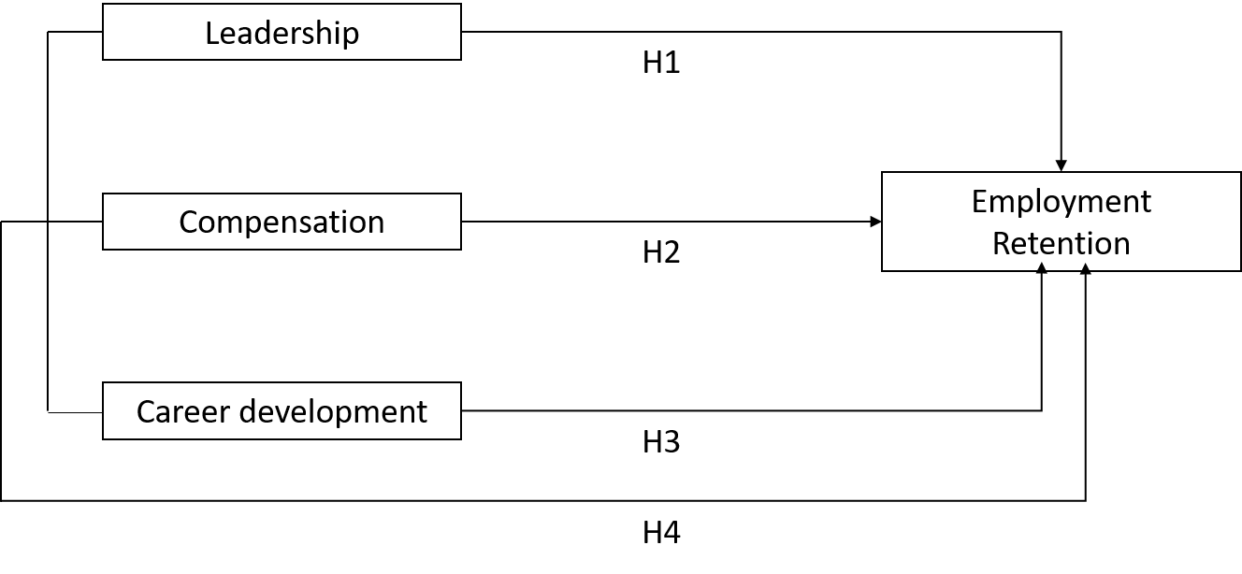
Figure 1: The Proposed Research Model

- Methodology of Research and Profile Respondents
The sampling method used in this study was probability sampling. The samples was selected by carrying out sampling. This study was conducted in 2024 on employees of the Head Office of the Directorate of Customs and Excise, Ministry of Finance of the Republic of Indonesia. The statistical analysis technique used Structural Equation Modeling (SEM) based on the partial least squares (PLS) method. This SEM-PLS method was used on limited samples and non-strict data assumptions (Hair, et al., 2021). Since SEM-PLS does not include the significance test directly, the significance level was determined by using bootstrapping assistance. For large populations, the determination of the number of samples was taken at 10-15 percent of the entire population (Arikunto, 2013). The number of samples in this study was 224 respondents (11.2 percent) from a population of 2,001 employees, so the number of samples was significant.
The profile of the respondents who were the objects of this research is shown in the Table 2.

Table 2: Respondent Profile
No. | Respondent Profile | Total | Percentage
1 | Sex  Male  Female  Total | 156  68  224 | 69  31  100
2 | Age  < 30 years old  30-40 years old  41-50 years old>  >50 years old  Total | 85  23  77  39  224 | 38  10.23  34.37  17.40  100
3 | Office Term  < 10 years old  >20 years old  10 - 15 years old  16-20 years old  Total | 114  52  39  19  224 | 50.90  23.21  17.41  8.48  100
4 | Work Unit  Directorate of Customs and Excise Audit Echelon II  Director of Directorate of Customs and Excise Information  Directorate of Customs and Excise Information  Directorate of Narcotics Interdiction  Directorate of Objections, Appeals and Regulations  Directorate of Internal Compliance  Directorate of International Cooperation for Customs and Excise  Directorate of Communication and Guidance for Service Users  Directorate of Admissions and Strategic Planning  Directorate of Enforcement and Investigation  Directorate of Technical and Excise Facilities  Directorate of Customs Technical Affairs  Secretariat of Directorate General  Total | 13  13  35  6  2  4  28  20  14  17  5  22  45  224 | 5.8  5.8  15.63  2.68  0.89  1.78  12.50  8.93  6.25  7.59  2.23  9.83  20.09  100
5 | Position  Echelon III/Senior Functional Expert  Echelon IV/Junior Functional Expert  Other functionalities  Executor  Total | 13  44  14  153  224 | 5.80  19.64  6.25  68.30  100

- Results of Research

4.1. Descriptive Analysis
Descriptive analysis was used to see an overview of research findings related to the description of each research variable.

Table 3: Analysis of Research Variable Description
Variable | N | Minimum | Maximum | Average | Standard deviation
Leadership | 224 | 2 | 5 | 4.10 | 0.76
Compensation | 224 | 1 | 5 | 3.82 | 0.99
Career Development | 224 | 1 | 5 | 4.24 | 0.80
Employee Retention | 224 | 1 | 5 | 3.83 | 0.96

Table 3 shows that the average value of the leadership variable is 4.10, compensation 3.82, CSR development 4.24, and employee retention 3.83. When these values were transformed into an interval scale, they fell into the "agree" category. Meaning that respondents agreed that leadership was needed in the institution, the existing compensation should continue to be implemented, the current career development was functioning within the institution and was needed by employees, and the existing employee retention efforts were functioning within the institution and were necessary for employees.

4.2. Evaluation Model in SEM-PLS

SEM-PLS was a statistical method consisting of a structural model and a measurement model, with measurements conducted in two stages. First, evaluation for estimation of measurement model. Second evaluation of the structural model. The sequence of model evaluation had to ensure that it measured what was previously assumed to be able to measure a latent variable before finally concluding the existence of a correlation between latent variables (Trujillo, 2009), since there were no statistical criteria capable of comprehensively assessing the quality of a model, the researcher was unable to conduct inferential statistical analysis for model fit testing. As an alternative, a non-parametric test using a re-sampling method such as jackknifing or bootstrapping was used to estimate the goodness of the model resulted.

Measurement Model (Outer Model)

The outer model describes or defines how each indicator relates to its latent variable. To examine whether or not the indicators of each construct measured what they were supposed to measure and whether or not it was necessary to conduct tests for indicator reliability, construct reliability, convergent validity, and discriminant validity.
The first step was to do an analysis with indicator reliability and construct reliability (Hair et al., 2021). The reliability indicator was examined by using the loading factor value. Based on the processing results (Figure 2 and Table 3) with the recommended value limit of 0.7, for the existing latent variables, not all indicators in all variables were suitable for use or meet the reliability indicators as seen in Table 3. Next, one by one, starting with the indicator with the smallest loading value, which is ER5, this indicator was dropped during the processing stage. After several processing iterations, the next indicators dropped from the processing were Comp4, CD1, and CD2. And so on until the results were obtained as in Figure 3 and Table 4.

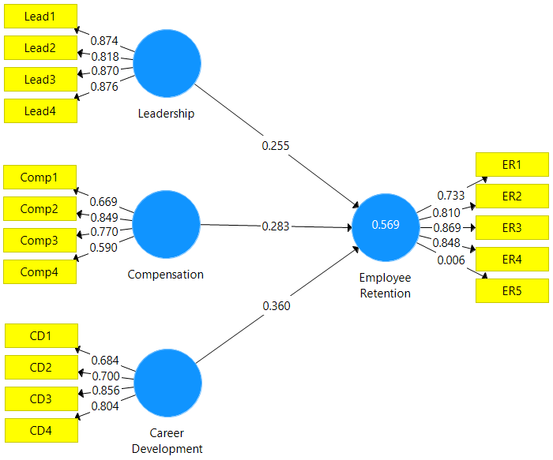
Figure 2: PLS algorithm of indicators and latent variables

Table 4: Loading Factor Value of All Items
Variables | Indicators | Loading
Leadership | Leadership1 | 0.874
 | Leadership2 | 0.818
 | Leadership3 | 0.870
 | Leadership4 | 0.876
Compensation | Compensation1 | 0.669
 | Compensation2 | 0.849
 | Compensation3 | 0.770
 | Compensation4 | 0.590
Career Development | Career Development1 | 0.684
 | Career Development2 | 0.700
 | Career Development3 | 0.856
 | Career Development4 | 0.804
Employee Retention | Employee Retention1 | 0.733
 | Employee Retention2 | 0.810
 | Employee Retention3 | 0.869
 | Employee Retention4 | 0.848
 | Employee Retention5 | 0.006

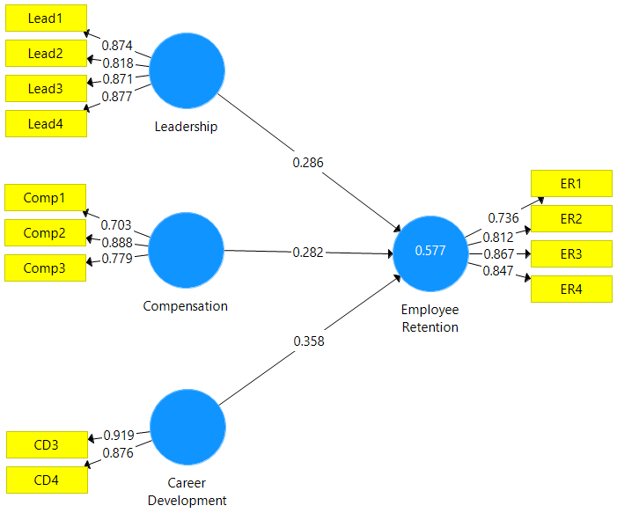
Figure 3: PLS algorithm of latent indicators and variables

Table 5: Loading Factor Value of All Items in Final Step
Variable | Indicators | Loading
Leadership | Leadership1 | 0.874
 | Leadership2 | 0.818
 | Leadership3 | 0.871
 | Leadership4 | 0.877
Compensation | Compensation1 | 0.703
 | Compensation2 | 0.888
 | Compensation3 | 0.779
Career Development | Career Development3 | 0.919
 | Career Development4 | 0.876
Employee Retention | Employee Retention1 | 0.736
 | Employee Retention2 | 0.812
 | Employee Retention3 | 0.867
 | Employee Retention4 | 0.847

Next, an examination of construct reliability was carried out. Construct reliability was examined using three measures, namely Cronbach's alpha (CA), composite reliability (CR) and the rho-A reliability coefficient. The threshold for good CR, CA, and rho-A was above 0.6 but below 0.95. While the recommended value was between 0.8 – 0.9.
Based on Table 6, it was evident that all the measures meet the recommended threshold values of 0.6 and below 0.95. Therefore, it could be concluded that the construct reliability was adequate. With the results that have been obtained, the next test could be carried out, namely convergent validity.

Table 6: Internal Consistency Reliability Value (Construct Reliability)
Variable | Cronbach's Alpha | Rho-A | Composite Reliability
Career Development | 0.762 | 0.784 | 0.893
Compensation | 0.706 | 0.744 | 0.835
Employee Retention | 0.834 | 0.852 | 0.889
Leadership | 0.882 | 0.883 | 0.919

Subsequently, the evaluation of convergent validity measured the extent to which one operation actually resembled another operation that theoretically should have been similar. Therefore, the Average Variance Extracted (AVE) size was used, in which a good AVE was above 0.5 (Henseler et al., 2016).
Table 7 indicated that all AVE values of the constructs were above the threshold value of 0.5, so it could be concluded that convergent validity has been fulfilled. Meaning, there were no convergent validity problems in the model being tested. Therefore, the next test could be carried out, viz. discriminant validity.

Table 7: Values of Average Variance Extracted
Variables | Average Variance Extracted (AVE)
Career Development | 0.806
Compensation | 0.630
Employee Retention | 0.667
Leadership | 0.740

Discriminant validity of the construct items was checked using the criteria of Fornell-Larcker and Heterotrait-Monotrait Ratio (HTMT) (Hair et al., 2021). The Fornell-Larcker criterion states that discriminant validity can be tested by comparing the square root value of AVE with the correlation value between constructs. For HTMT, a good criterion is if HTMT has a value less than 0.9. The results of calculating the Fornell-Larcker criteria are presented in Table 8. Table indicates that the square root value of AVE (main diagonal) is higher than the correlation of every constructs so that it can be said there is no problem regarding the discriminant validity.

Table 8: Fornell-Larcker Criterion
 | Leadership | Compensation | Career Development | Employee Retention
Leadership | 0.860
Compensation | 0.422 | 0.794
Career Development | 0.581 | 0.498 | 0.898
Employee Retention | 0.613 | 0.581 | 0.664 | 0.817

From Table 9, it could be seen that all HTMT values for each latent variable were less than 0.9, indicating no issues with discriminant validity. From the results of the Fornell-Larcker and HTMT criteria, it could be said that there was no problem regarding discriminant validity.

Table 9: Heterotrait-Monotrait Ratio (HTMT) Value
Variable | Leadership | Compensation | Career Development | Employee Retention
Leadership
Compensation | 0.518
Career Development | 0.705 | 0.649
Employee Retention | 0.704 | 0.731 | 0.814

The final step was to assess the collinearity of the indicators using the Variance Inflation Factor (VIF). The higher the VIF value, the greater the level of collinearity. A VIF value of 5 or higher indicated a collinearity problem. From Table 10 it can be seen that the VIF value was below 5 so there was no collinearity problem

Table 10: VIF Values
Variable | Indicators | VIF
Leadership | Leadership1 | 2.427
 | Leadership2 | 1.898
 | Leadership3 | 2.469
 | Leadership4 | 2.639
Compensation | Compensation1 | 1.429
 | Compensation2 | 1.775
 | Compensation3 | 1.347
Career Development | Career Development3 | 1.609
 | Career Development4 | 1.609
Employee Retention | Employee Retention1 | 1.550
 | Employee Retention2 | 1.887
 | Employee Retention3 | 2.124
 | Employee Retention4 | 1.943

Structural Model Evaluation (Inner Model)

After obtaining confidence that there were no issues with the measurement model, the next step was to evaluate the structural model. One of evaluations of the structural model was to assess the strength of independent variables within the entire model, by examining the coefficient of determination (R²) values of the dependent variables involved.

Table 11: R² Value of Endogen Variable
 | R Square | R Square Adjusted
Employee Retention | 0.577 | 0.571

From Table 11, it was observed that the R² value for the competency variable was 0.577. This value indicated that 57.8% of the variation in employee retention could be explained by the variable leadership, compensation, and career development, while the remaining 42.2% was influenced by other variables not included in this study.
The next evaluation was using the effect size or f². Cohen (1998) stated that the influence of the exogenous latent variable f² was small if its value was 0.02 to less than 0.15, moderate if its value was 0.15 to less than 0.35 and high if its value was 0.35 and above. The effect size value is less than 0.02, which means there is no effect. From Table 12, it was evident that the influence of the latent variables leadership and compensation on employee retention was small, while the influence of career development on employee retention was moderate.

Table 12: F-Square value
Variables | Employee Retention | Criterion
Leadership | 0.123 | Small
Compensation | 0.136 | Small
Career Development | 0.177 | Moderate

According to Ghozali (2008), Inner model evaluation can also be conducted by examining the values of predictive relevance (Q²). Predictive relevance measured how good the observed values ​​were generated by the model and also its parameter estimates. Q² value that is more than zero indicated that the model had a predictive relevance value, while a Q² value that is lower than zero indicated that the model had less predictive relevance. The Q² value obtained from the processing results is shown in the following table.

Table 13: Q² Value
Variables | SSO | SSE | Q² (=1-SSE/SSO)
Career Development | 448 | 448
Compensation | 672 | 672
Employee Retention | 896 | 566.437 | 0.368
Leadership | 896 | 896

From the table above, a value Q² of 0.368 is obtained for the employee retention variable. The value of the two variables was higher than zero that consequently, it could be said that the model obtained had predictive relevance. Based on the testing of R², f-square and Q², it could be seen that the model formed was already robust so that the hypothesis testing could be carried out.

- Hypothesis Testing
In this study, three direct influence hypotheses were tested as previously written. The following Table 14 provides the results of the correlation among the constructs of the intended hypotheses. In making a decision whether the hypothesis was statistically significant or not, the t-statistics value was compared with the t-value from the table. Or compare the p-value with an alpha value of 0.05. If the p-value was less than alpha 0.05 then the hypothesis was statistically significant.

Table 14: Path Coefficients of the model
 | Coefficient | Standard Deviation | P Values | Percentile 2.5% | Percentile 97.5% | Decision
Leadership -> Employee Retention | 0.286 | 0.060 | 0.000 | 0.175 | 0.405 | Significant
Compensation -> Employee Retention | 0.282 | 0.056 | 0.000 | 0.180 | 0.393 | Significant
Career Development -> Employee Retention | 0.358 | 0.071 | 0.000 | 0.222 | 0.495 | Significant

The data from the estimation of significant relationships at a significance level of 5 percent, indicated that the leadership, compensation and career development variables had a direct and significant effect on the employee retention variable. All exogenous variables had a positive correlation with endogenous variables. The career development variable was the variable having the greatest influence on employee retention, namely 0.358, followed by the leadership and compensation variables, each of which was 0.286 and 0.282.

- Discussion
The results of the analysis above are in line with previous theories and studies which are used as the basis for formulating the hypothesis that career development has a significant effect on employee retention. This means that the more open career development is, the higher employee retention will be. Considering a career as a sequence of promotions or transfers, a sequence of jobs that form a pattern of progression, and as a person's work history. Therefore, it is important for organizations to encourage employees to develop themselves. Development can occur through involvement in planned programs, although it is often done through work experience. Planned employee development carried out by organizations refers to formal education, work experience, relationships, personality assessments, and abilities that help employees prepare themselves for the future. Career planning is consequently based on an assessment of an individual's abilities, interests, and motivation, an examination of organizational prospects, the establishment of career goals, and the development of a strategy to accomplish those goals (Profile, 2015).
Likewise, the results of the analysis above show that the effect of leadership is in line with the theory and results of previous studies which are the basis for formulating the hypothesis that leadership has a significant effect on employee retention. This means that the more transformational the leadership and the more wisely it is carried out, the higher the employee retention. Experts acknowledge that leadership is a real symptom that is important for organizational effectiveness, and can encourage employees to remain comfortable in the organization. Therefore, leadership fundamentally involves the ability of certain individuals to influence, motivate, and enable others to contribute towards the effectiveness and success of the organization (House et al., 1999, as cited in Mubarok, 2017).
And also the results of the analysis above show that the effect of compensation is in line with the theory and results of previous studies which are the basis for formulating the hypothesis that compensation has a significant effect on employee retention. Therefore, the choice of compensation strategy must be able to create employee retention. Yensy (2010) in Syahreza et al. (2017) revealed that well managed or properly implemented compensations in the long run could be an effective tool for increasing employee morale. Good compensation will create employee retention and commitment. Commitment is a feeling of identity, loyalty and involvement shown by employees towards the organization (Wibowo, 2007). Thus, strong employee commitment means high employee retention.

- Conclusion and Managerial Implications
  - Conclusion
In accordance with the objectives of this study, namely to test the effect of leadership factors, compensation and career development on employee retention, the results of this study can be formulated into several conclusions as follows:
Leadership has a significant effect on employee retention. This means that the better and higher quality leadership that employees feel, the stronger the employee retention rate in the organization.
Compensation has a significant effect on employee retention. This means that the more fair and appropriate compensation is given to employees, the stronger the level of employee retention in the organization.
Career development has a significant effect on employee retention. This means that with the implementation of well-programmed career development, employees will be more motivated to develop their careers, so that employee retention will be stronger in the organization.
Leadership, compensation and career development simultaneously have a significant effect on employee retention. This means that the better the quality of the integration of these three variables, the stronger the level of employee retention in the organization.

  - Managerial Implications
The findings in this study revealed that leadership, compensation, and career development factors partially and simultaneously have a significant effect on employee retention. With such results, it will provide a number of implications in managerial practice.
In fact, leadership is the reason for the existence of managerial works. Leadership functions to develop vision and drive change towards its realization, communicate the direction of transformation, and motivate and inspire all levels of the organization. Therefore, the managerial implications for leadership to ensure employee retention in the organization is well maintained include: Leadership styles must vary in an unusual situation from normal situations; They have leadership principles as guidelines for internal collaboration, guidance in management situations, and guidance in building organizational cohesion; They have a strong understanding of job demands, internal and external constraints, and choices for implementing what is done and how to do it; Focus on task-oriented functions; Guide subordinates in setting high but realistic performance goals.
Compensation may be the oil in the human management process. The best fit with the company or institution, circumstances and level of development is far more important than best practices. Compensation strategies that can create employee retention can be developed by: Recognizing those who demonstrate skills and capabilities in their current positions; Acknowledging each individual's development at their own pace; Recognizing the need to appreciate behaviors related to achieving broader roles; Transforming career patterns, adopting new ways of working, and developing new technical skills; Assessing role differences and organizational levels to ensure that various responsibilities and capabilities are fairly valued; Building front line management capabilities to effectively manage and deliver reward policies.
Future-oriented career development can be built on experience and planned programs. In organizations, careers are not only how individuals’ behavior change, but also how individuals’ position and relationships within the organization change, and how individual movements influence their actions. Managerial implications for high employee review rates include: Creating a sense of pride in achieving life goals in various achievements at work; Encouraging individual employee personal development in achieving career plans; Implementing existing internal training and promotion programs need to be structured and sustainable; Ensuring that every employee has equal access to career opportunities and promotions are based on clear criteria; Existing programs need to be refined with an inclusive approach so that all employees have opportunities; Implementing mentoring programs to help employees plan and achieve their career goals.

Disclaimer (Artificial intelligence)
Option 1:
Author(s) hereby declare that NO generative AI technologies such as Large Language Models (ChatGPT, COPILOT, etc) and text-to-image generators have been used during writing or editing of manuscripts.
Option 2:
Author(s) hereby declare that generative AI technologies such as Large Language Models, etc have been used during writing or editing of manuscripts. This explanation will include the name, version, model, and source of the generative AI technology and as well as all input prompts provided to the generative AI technology
Details of the AI usage are given below:
1.
2.
3.

References
Antonacopoulou, E. P. (2000). Employee development through self-development in three retail banks. Personnel Review, 29(4). https://doi.org/10.1108/00483480010296294
Rikunt, S. (To 13). Research Procedures A Practice Approach. Rina lay flat.
Armstrong, M. (2016). Armstrong’s Handbook of Human Resource Management (12th ed.). Kogan Page Limited.
Caldwell, C., & Dixon, R. D. (2010). Love, forgiveness, and trust: Critical values of the modern leader. Journal of Business Ethics, 93(1). https://doi.org/10.1007/s10551-009-0184-z
Campbell, D. J., & Lee, C. (1988). Self-Appraisal in Performance Evaluation: Development Versus Evaluation. Academy of Management Review, 13(2). https://doi.org/10.5465/amr.1988.4306896
Chitra, K. (2013). Role of Leaders in Employee Retention – a pragmatic study with reference to private sector bank Role of a Leader in Retention Group Task Roles. International Research Journal of Business and Management, 6(3).
Cohen, J. (1992). A power primer. Psychological Bulletin, 112(1). https://doi.org/10.1037/0033-2909.112.1.155
Dessler, G. (2016). Human Resource Management (15th ed.). Publisher.
Dewi, K. O. E., & Riana, I. G. (2018). The influence of career development, compensation and organizational commitment on employee retention at bintang kuta hotel. Udayana University Management E-Journal, 8(2). https://doi.org/10.24843/ejmunud.2019.v08.i02.p11
Frimayasa, A. (2021). Effect of Compensation, Career Development and Work Environment on Employee Retention (Study on Employees of PT Telkom Witel Tangerang BSD). Journal of Research in Business, Economics and Education, 3(1).
Hair, J. F., Black, W. C., Babin, B. J., & Anderson, R. E. (2021). Multivariate Data Analysis: A Global Perspective (Seventh Ed). Pearson Prentice Hall.
Hair Jr, J. F., Hult, G. T. M., Ringle, C. M., Sarstedt M., Danks, N. P., Ray, S. (2021). Partial Least Squares Structural Equation Modeling (PLS-SEM) Using R: A Workbook. Springer Cham. https://doi.org/10.1007/978-3-030-80519-7.
Hasibuan, M. (2014). Human resource management (rabies). Pit. Earth characters.
Henseler, J., Hubona, G., Ray, P. A. (2016). Using PLS Path Modeling in New Technology Research: Updated Guidelines. Industrial Management & Data Systems, 116, 2-20. https://doi.org/10.1108/IMDS-09-2015-0382.
Hong, E., Hao, L., Kumar, R., Ramendran, C., & Kadiresan, V. (2012). An effectiveness of human resource management practices on employee retention in institute of higher learning: A regression analysis. International Journal of Business Research and Management, 3(2).
Huber, D. L. (2006). Leadership and Nursing Care Management (3rd ed.). Saunders ELsevier.
Karali, M. (2020). Leadership and its Impact on Employee Retention in Saudi Arabia. International Journal of Recent Research in Commerce Economics and Management, 7(1).
Kashmir. (2016). West Sumatra Human Management (theory and practice). Human resource management.
Lameck, Dr. wilfred. (2023). The relative influence of leadership factors on employee retention in local government. Journal of Empirical Economics and Social Sciences. https://doi.org/10.46959/jeess.1224950
Lent, R. W. (2013). Career-life preparedness: Revisiting career planning and adjustment in the new workplace. Career Development Quarterly, 61(1). https://doi.org/10.1002/j.2161-0045.2013.00031.x
Lockwood, N. R. (2006). Talent Management: Driver for Organizational Success. Research Report, 36.
Mathis, R. L., Jackson, J. H., Valentine, S. R., & Meglich, P. A. (2009). Human Resource Management (15th ed.). Cengage Learning.
Michael, S. O. (2008). Using Motivational Strategy as Panacea for Employee Retention and Turnover in Selected Public and Private Sector Organization in the Eastern Cape Province of South Africa. Master of Commerce Thesis, University of Fort Hare.
Mubarok, A. S. (2017). Human Resource Management. In media.
Noe, R. E., Hollenbeck, J. R., Gerhart, B., & Right Patrick M. (2014). Human Resource Management: Achieving Competitive Excellence (Indonesian). Salemba Four.
Phillips, K. (1993). Self-development in Organizations: Issues and Actions. Journal of European Industrial Training, 17(5). https://doi.org/10.1108/03090599310032772
Pradipta, P. S. A., & Suwandana, I. G. M. (2019). The influence of compensation, job satisfaction and career development on employee retention. Udayana University Management E-Journal, 8(4). https://doi.org/10.24843/ejmunud.2019.v08.i04.p19
Profile, S. E. E. (2015). Economics: Vol. X (II).
Rachman, A., & Hamzah, A. (2023). Compensation and Career Development on Employee Retention: A Review of Literature. Article West Science Business and Management, 1(04).
Rivai, V., & Sagala, E. J. (2011). Human Resource Management For Firms: From Theory to Practice. Eagle Press.
Singh, S. (2023). Study on Impact of Career Development Practices on Employee Retention. International Journal of Research and Analitical Review (IJRAR), 10(1).
Syafri, M., Jenni Veronika Br Ginting, Feriyadin, Darwis, & Balla Wahyu Budiarto. (2023). The Influence Of Job Satisfaction, Career Development And Teamwork On Employee Retention In Government-Owned Cultural Destinations. JEMSI (Jurnal Ekonomi, Manajemen, Dan Akuntansi), 9(6). https://doi.org/10.35870/jemsi.v9i6.1654
Thwin, P., Janarthanan, M., & Bhaumik, A. (2023). Impact of Career Advancement on Employee Retention SEE PROFILE Impact of Career Advancement on Employee Retention. In www.ijlemr.com || (Vol. 08).
Trujillo, G. S. (2009). Pathmox approach: Segmentation Trees in Partial Least Squares Path Modeling. Barcelona, ​​Spain: Universitat Politecnica de Catalunya.
Wibowo. (2007). Performance Management. PT. RajaGrafindo Persada.

