Original Research Article
Evaluation of Improved Bread Wheat (Triticum aestivum L.) Varieties for Adaptability and Yield Performance at Teticha Woreda, Sidama Region

ABSTRACT

Wheat is one of the dominantly grown major cereal crops in the highlands of the Sidama region. The relatively low wheat yield in the Teticha can be attributed to issues such as the utilization of low-yielding wheat varieties. Based on the above problem, eleven improved wheat varieties were tested over the years to evaluate the performance of recently released bread wheat varieties on adaptability and yield performance at Teticha woreda, Sidama region. The experiment was carried out using a randomized complete block design (RCBD) with three replications. The combined analysis of variance over the two years depicted significant differences (p ≤ 0.05) among the tested varieties for plant height, panicle length, and grain yield. The highest grain yield was obtained from the variety Dursa (4494.7 kg ha⁻¹); however, this variety had no significant difference statistically with all the tested varieties except Hachalu and Kulito. As a result, the varieties Dursa, Deka, Boru, Shaki, and Balcha showed similar yield performance statistically in the environment. The similarity in yield performance observed among several varieties may be explained by their comparable genetic background for yield-related traits. In addition, the consistent and better yield performance of more than two wheat varieties in a single location over the years is a strong indicator of the area's conduciveness for wheat production. Therefore, farmers can grow these varieties alternatively as an option in the studied area and other areas with similar environmental conditions.

Key words: Adaptability, Bread wheat, Grain yield, Variety

- INTRODUCTION

Wheat (Triticum aestivum L.) is among the most extensively grown cereal crops around the world. It is among the primary cereal crops cultivated in the Ethiopian highlands, playing a pivotal role as a source of food and income for farmers. It is a major staple crop and is consumed heavily in different forms in Ethiopia (FAO, 2019). Wheat is a widely cultivated major staple food for most populations in Ethiopia (Macauley and Ramadjita, 2015). Ethiopia ranks as a key wheat-producing country in sub-Saharan Africa and stands as the top wheat producer, yielding an average of 7 million tons annually from 2.3 million hectares, resulting in an average productivity of 3.04 tons per hectare (FAOSTAT, 2022). The important wheat-growing regions in Ethiopia include the Oromia region, which accounts for the production of 57-58%; Amhara, 28-32%; SNNPR, 8%; and Tigray, 3-6% (Senbeta and Worku, 2023). The largest volumes of wheat production come from the Oromia region (Zewdu and Lindi, 2022). Generally, the production of wheat, both in terms of area coverage and productivity, shows an increasing trend through time in Ethiopia due to several positive opportunities in the sector (Anteneh and Asrat, 2020). On the other hand, the consumption of wheat is growing at an annual rate of 9%, while production is only increasing by 7.8%, indicating an ongoing gap between the two. With a rising demand driven by a booming population, higher incomes, and a preference for wheat-based products, the country faces significant challenges in achieving self-sufficiency in wheat and conserving its limited foreign currency reserves spent on imports. The Ethiopian government is dedicated to achieving self-sufficiency through measures like expanding wheat cultivation areas, developing irrigation systems, and closing the yield gap (Stage and Rekve, 1998; Senbeta and Worku, 2023).

Wheat is one of the dominantly grown major cereal crops in the highlands of the Sidama region. The area has a high potential for wheat production, mainly in rain-fed conditions. Farmers have grown the crop as food for home consumption as well as an income source. Although the region has favorable soil and a climatic condition for wheat cultivation, the average yield is approximately 3600 kg ha⁻¹ (Solomon et al., 2024, unpublished manuscript), which is low compared to the yields achieved in research plots. Wheat production in Ethiopia is constrained by several abiotic and biotic stresses at different levels of intensity across rainfed and irrigated environments (Eskezia, et al., 2025). This is further heightened by increasing occurrence of climate change which is characterized by rising temperature (heat), less and erratic rainfall (drought) or sometimes excessive rainfall (flooding) and emergence of virulent pests and diseases (Easterling et al. 2022 and Huber et al. 2010). The common wheat diseases in the highlands of Ethiopia are Rusts (Puccinia spp.), Helminthosporium, septoria (Septoria tritici), tan spot (Pyrenophora tritici repentis), fusarium (Fusarium spp.), as well as smuts, take-all, and root rots (Tadesse et al., 2022). The relatively low wheat yield in the study area can be attributed to issues such as the utilization of low-yielding varieties, poor soil fertility, soil acidity, unpredictable rainfall, monocropping practices, and various diseases. Conducting an adaptability test for new crop varieties in a specific environment is important for identifying varieties those best suited to local conditions before large-scale production. This helps farmers to choose varieties that are not only adapted to a specific environment and resistant to disease but also high-yielding. Therefore, the current study was conducted to evaluate the performance of recently released bread wheat varieties on adaptability and yield performance in the study area.

- MATERIALS AND METHODS

  - Description of the study area
The experiment was conducted for two consecutive years (2023 and 2024) at Teticha woreda in the Sidama region. The specific experimental site is Sororo kebele. The experimental site is located at 7°27′52″ N latitude, 38°59′17″ E longitude, and an altitude of 2412 m above sea level.

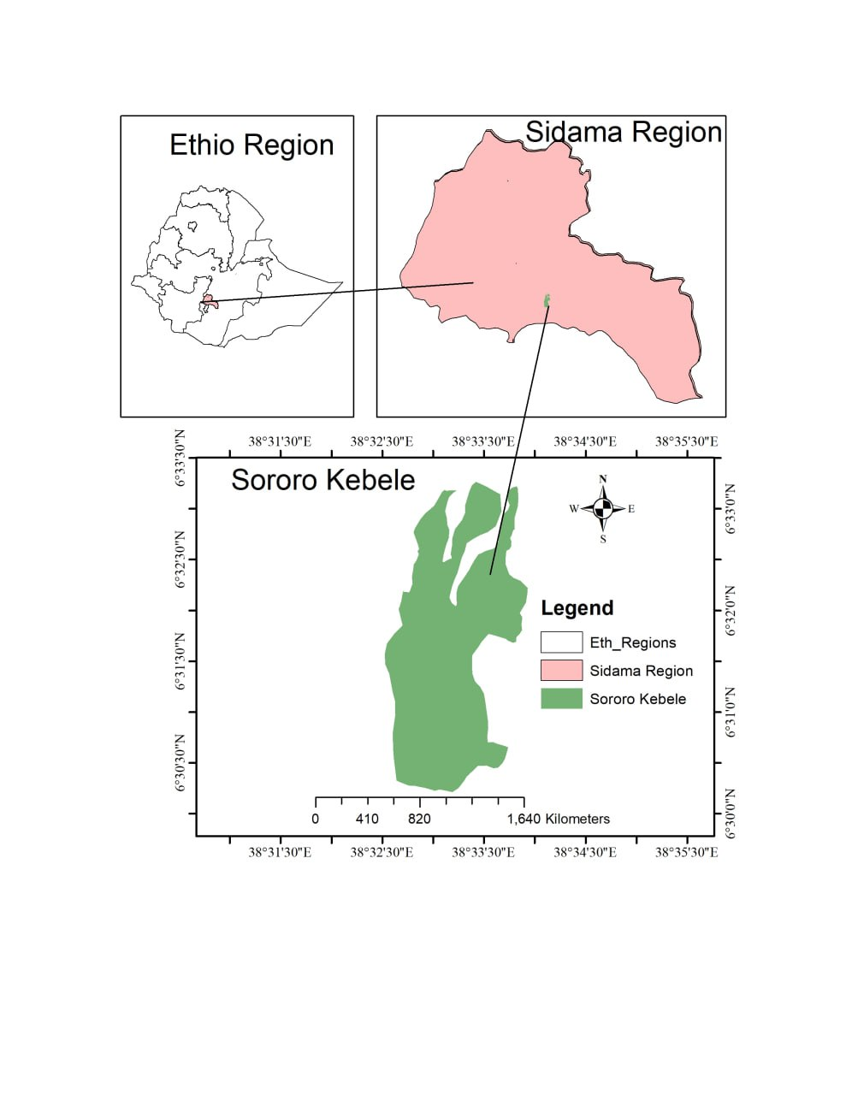
Figure 1: Map of the study location

  - Experimental Materials
Eleven improved wheat varieties (Abay, Balcha , Boru, Deka, Dursa, Gelan, Hachalu, Kingbird, Shaki, Biftu, and Kulito) were tested for their adaptability and yield performance for two years, 2023 and 2024. These improved varieties were released by federal and regional agricultural research centers.

Table 1: Description of wheat varieties
No. | Varieties | Year of release | Seed source
1 | Abay (ETBW 9396) | 2021 | Kulumsa ARC
2 | Balcha (ETBW 8260) | 2019 | Kulumsa ARC
3 | Boru (ETBW 9554) | 2020 | Kulumsa ARC
4 | Deka (ETBW 7638) | 2018 | Kulumsa ARC
5 | Dursa (ETBW 9578) | 2020 | Kulumsa ARC
6 | Gelan (ETBW 8003) | 2019 | Sinana ARC
7 | Hachalu (ETBW 8260) | 2020 | Sinana ARC
8 | Kingbird | 2015 | Kulumsa ARC
9 | Shaki (ETBW 9089) | 2021 | Kulumsa ARC
10 | Biftu (ETBW BW173528) | 2022 | Kulumsa ARC
11 | Kulito | 2023 | Hawassa ARC

  - Experimental Design and Procedures
The experiment was carried out in a Randomized Complete Block Design (RCBD) with three replications. The experimental plot consisted of six rows 20 cm apart. Each experimental plot area was 3 m² (1.2 m x 2.5 m). The total experimental area was divided into three replications, each of which was further divided into 11 plots. The gross plot size of the experiment was 1.2 by 2.5 m (3 m²). The spacing between the replications and plots was 1m. The experimental field was ploughed with an ox and leveled manually. The seeds were sown by hand drilling. The recommended 125 kg seed rate for wheat, 150 kg of urea, and 150 kg of NPS per hectare were used for the study. The whole amount of NPS was applied at planting, while urea was applied in split application; one-third was applied at planting and the remaining two-thirds at the tillering stage. Following the recommendation, all agronomic management practices were applied uniformly across all the treatments.
  - Data collected
Plant height (cm): It was measured from the ground level to the top of the spike at physiological maturity.
Spike length (cm): It was measured from the point it originates on the node to the end of the spike.
Number of seeds per spike: The number of seeds was determined by counting the seeds from five randomly chosen spikes and then dividing by the number of spikes.
Grain yield: it was determined by weighing grain samples from the net plot area using sensitive balance and adjusted to 12% MC.

  - Data analysis
The collected data were subjected to analysis of variance (ANOVA) using PROC ANOVA procedures of SAS version 9.3 (SAS Institute, 2002-2010) to determine the appropriate variety of grain yield and yield components of wheat. The treatment means of significant treatment effects were compared using the Least Significant Difference (LSD) test at a 5% probability level (P ≤ 0.05).

- RESULTS AND DISCUSSIONS

The combined analysis of variance (ANOVA) conducted over the two cropping seasons revealed that there were significant differences (p ≤ 0.05) among the tested bread wheat varieties for key agronomic traits, including plant height, panicle length, and grain yield (Table 1). This indicates that the varieties exhibited distinct genetic potentials and performance patterns across the studied environments. The presence of such significant variation suggests that the genotypes responded differently to the environmental conditions in terms of growth and productivity.
The observed differences in plant height and panicle length reflect underlying genetic diversity among the varieties, which is an essential factor in breeding programs aimed at improving plant architecture and optimizing yield potential. Varieties that maintain optimal plant height and longer panicles are often associated with better photosynthetic efficiency, improved grain filling, and higher yield stability. On the other hand, the significant variation in grain yield emphasizes the influence of both genetic factors and genotype-by-environment interactions, as yield is a complex trait controlled by multiple genes and influenced by climatic and edaphic factors.
Such interactions suggest that while some varieties may perform well under specific environmental conditions, their relative performance could vary in different locations or years due to fluctuations in rainfall, temperature, soil fertility, and disease pressure. Therefore, identifying varieties with stable performance across environment is critical for ensuring consistent productivity and adaptability. The significant genetic differences revealed by the ANOVA also provide valuable information for wheat improvement programs, as they indicate the presence of exploitable genetic variability that breeders can use to develop new high-yielding and stress-tolerant varieties.
The varieties exhibited significant differences in plant height (Table 1). The tallest variety was Hachalu (85.6 cm), which was statistically similar to Gelan, Balcha , Abay, Deka, Boru, Shaki, and Kulito. In contrast, the shortest plants were recorded from Hachalu (70.7 cm) and Dursa (74.9 cm). The observed difference in height between the varieties may be due to the inherent genetic difference among the tested varieties. Variety Hachalu recorded the highest (8.8 cm) panicle length among others but was statistically similar to all tested varieties except Abay, Balcha, and Kingbird. The shortest panicle lengths were recorded for Abay (6.2 cm), Kingbird (6.5 cm), and Balcha (7.2 cm). The observed differences in panicle length among varieties might be due to inherent genetic differences among the varieties. The genes in wheat plants directly or indirectly control the length of panicles (Kronenberg et al., 2017).

Grain yield among the tested varieties ranged from 3148.0 to 4494.7 kg ha⁻¹, with a grand mean of 3890.0 kg ha⁻¹ (Table 1). The highest yield was recorded from the variety Dursa (4494.7 kg ha⁻¹); however, this yield was not significantly different from most of the other tested varieties, except for Hachalu and Kulito. Overall, most varieties demonstrated comparable yield performance at the study site. In particular, Dursa (4494.7 kg ha⁻¹), Deka (4410.0 kg ha⁻¹), Boru (4384.0 kg ha⁻¹), Shaki (4308.0 kg ha⁻¹), and Balcha (4300.0 kg ha⁻¹) showed statistically similar and superior yield performance under the study environment. The lowest grain yields were recorded for Hachalu (3148.0 kg ha⁻¹) and Kulito (3437.3 kg ha⁻¹). The relatively high yield performance of the tested wheat varieties can be attributed to a combination of genetic and environmental factors (Degife and Demis, 2020). Most of the varieties performed well at the study site due to their adaptation to local conditions and their responsiveness to the applied management practices (Bocci et al., 2020). The similarity in yield performance observed among several varieties may be explained by their comparable genetic background for yield-related traits (Eskezia et al., 2025). In addition, the consistent and better yield performance of more than two wheat varieties in a single location over the years is a strong indicator of the area's conduciveness for wheat production. This suggests that environmental conditions, such as soil fertility, rainfall patterns, temperature, and other agro-ecological factors, are favorable for a wide range of genotypes. On the other hand, if a single variety is affected by disease, the availability of other high-performing varieties offers farmers an important alternative, mitigating the risk of complete crop failure. Depending solely on one or two varieties presents considerable risk, particularly during disease outbreaks, pest problems, or shifts in environmental conditions.

Table 2: Performance of wheat varieties on plant height, panicle length, seed number per Spike, and grain yield at Teticha woreda

Variety | Plant height (cm) | Spike Length (cm) | Seed number Spike⁻¹ | Grain yield (kg/ha)
Abay | 77.4 | 6.2 | 38.5 | 3518.7
Balcha | 80.2 | 7.2 | 34.8 | 4300.0
Boru | 75.6 | 8.0 | 41.0 | 4384.0
Deka | 75.7 | 7.3 | 38.1 | 4410.7
Dursa | 74.9 | 7.4 | 36.3 | 4494.7
Gelan | 83.7 | 8.4 | 34.8 | 3740.0
Hachalu | 85.6 | 8.8 | 40.6 | 3148.0
Kingbird | 70.7 | 6.5 | 33.6 | 3518.7
Shaki | 76.5 | 7.5 | 42.3 | 4308.0
Biftu | 73.6 | 7.4 | 40.1 | 3533.3
Kulito | 78.0 | 8.2 | 34.8 | 3437.3
Mean | 77.4 | 7.5 | 37.7 | 3890
LSD (5%) | 10.1 | 1.5 | NS | 1040.4
CV (%) | 7.7 | 12.2 | 17.3 | 15.7
LSD (%) = Least significant difference at P < 0.05; CV (%) = Coefficient of variation.

- SUMMARY AND CONCLUSION
The highest mean grain yield was recorded from the variety Dursa (4,494.7 kg ha⁻¹), which showed outstanding performance at the test environment. However, statistical analysis revealed that its yield advantage was not significantly different from those of the varieties Deka (4,410.0 kg ha⁻¹), Boru (4,384.0 kg ha⁻¹), Shaki (4,308.0 kg ha⁻¹), and Balcha (4,300.0 kg ha⁻¹). These five varieties consistently produced higher yields compared to the rest, demonstrating their superior adaptability and productivity potential under the environmental conditions of the study site. In contrast, the lowest mean grain yields were obtained from Hachalu (3,148.0 kg ha⁻¹) and Kulito (3,437.3 kg ha⁻¹), indicating that these varieties may be less suited to the prevailing soil fertility, climatic, or disease pressure conditions.
Overall, most of the evaluated varieties performed well, suggesting that the testing environment was favorable for bread wheat cultivation. The varieties Dursa, Deka, Boru, Shaki, and Balcha not only showed high yield potential but also displayed stable performance, making them reliable choices for farmers in similar agro-ecological zones. Their consistent yield advantages suggest that these varieties possess desirable agronomic and physiological traits such as efficient nutrient use, tolerance to moisture stress, and resistance to common wheat diseases that contribute to their superior productivity.
Recommending more than two high-yielding varieties for a specific area is a strategic approach to enhancing agricultural sustainability, productivity, and resilience. Such diversification allows farmers to adopt rotational cultivation practices, which provide several agronomic and ecological benefits. Planting multiple high-performing varieties alternately across seasons can help reduce production risks associated with climatic fluctuations and pest or disease outbreaks. This practice also disrupts the life cycles and adaptive evolution of pathogens by limiting their exposure to a single host genotype, thereby minimizing disease persistence and carryover between seasons.
Moreover, varietal diversity ensures production stability. If one variety performs poorly due to unfavorable weather conditions or disease susceptibility, the other recommended varieties can compensate for yield losses, ensuring a more stable overall harvest. This strategy enhances food security and reduces farmers’ vulnerability to environmental and biotic stresses. Therefore, based on the results of this study, the varieties Dursa, Deka, Boru, Shaki, and Balcha are strongly recommended for production in the study area. Furthermore, these varieties can be extended to other regions with comparable agro-ecological conditions to maximize national wheat production and contribute to breeding programs aimed at achieving yield improvement and sustainable crop management.
ACKNOWLEDGEMENT

The authors thank Hawassa Agricultural Research Center for financial support for the research activity. We would also like to acknowledge Mr. Kassaye Hifamo for his valuable contributions and assistance throughout the trial implementation.

DISCLAIMER (ARTIFICIAL INTELLIGENCE)

Author(s) hereby declare that NO generative AI technologies such as Large Language Models (ChatGPT, COPILOT, etc.) and text-to-image generators have been used during the writing or editing of this manuscript.

COMPETING INTERESETS
Authors have declared that no competing interests exist.

REFERENCES
Anteneh, A. and Asrat, D. (2020). Wheat production and marketing in Ethiopia: Review study. Cogent Food & Agriculture, 6(1): 1778893.
Bocci, R., Bussi, B., Petitti, M., Franciolini, R., Altavilla, V., Galluzzi, G., Di Luzio, P., Migliorini, P., Spagnolo, S., Floriddia, R. and Rosi, G.L. (2020). Yield, yield stability and farmers’ preferences of evolutionary populations of bread wheat: A dynamic solution to climate change. European Journal of Agronomy, 121: 126-156.
Degife, G. and Demis, E. (2020). Evaluation of Lowland Released Bread Wheat (Triticum aestivum L.) Varieties under Irrigation in Raya Valley Southern Tigray, Ethiopia. 7(3): 9-14.
Easterling WE, Aggarwal PK, Batima P, Brander KM. Food, Fibre, and Forest Products. Available from: https://ensembles-eu.metoffice.gov.uk/IPCC/rev_archive/SOD/Ch05.pdf. Accessed 2022 Jul 13.
Eskezia, A., Kefale, H. and Asrat, M. (2025). Genotype by environment interaction and yield stability analysis of bread wheat (Triticum aestivum L.) varieties in East Gojjam Zone, Northwest Ethiopia. Heliyon, 11: (12).
FAO (2019). Strategic analysis and intervention plan for wheat and wheat products in the Agro-Commodities Procurement Zone of the pilot Integrated Agro-Industrial Park in Central-Eastern Oromia, Ethiopia.
FAOSTAT. (2022). FAO Statistics Division, available at: http://faostat3.fao.org/home/E
Huber B, Rosegrant M, Martinus A, Ortiz R. (2010). The future of Food: Scenario for 2050. Crop Sci. 50 (S1): 33-50.
Kronenberg, L., Yu, K., Walter, A. and Hund, A. (2017). Monitoring the dynamics of wheat stem elongation: genotypes differ at critical stages. Euphytica, 213(7): 157.
Macauley H. and Ramadjita T. (2015). Les cultures céréalières: Riz, maïs, millet, sorgho et blé (Cereal crops: Rice, maize, millet, sorghum, wheat). In Nourrir l’Afrique, Centre International de Conférences Abdou Diouf de Dakar-Sénégal, Dakar, Sénégal, 21-23 Octobre 2015: 1-38
SAS Institute Inc., SAS 9.3 Help and Documentation, Cary, NC, USA. SAS Institute Inc., 2002-2010.
Senbeta, A.F. and Worku, W. (2023). Ethiopia’s wheat production pathways to self-sufficiency through land area expansion, irrigation advance, and yield gap closure. Heliyon, (9):10.
Solomon S, Malkamu F, Merkine M, and Shiferaw M, (2024). Crop Production Potentials, Constraints, and Recommended Interventions in the FSRP Woredas of the Sidama Region [Article in a proceeding]
Stage, O. and Rekve, P, (1998). Food security and food self-sufficiency: the economic strategies of peasants in eastern Ethiopia. The European Journal of Development Research, 10(1): 189-200.
Tadesse W, Zegeye H, Debele T, Kassa D, Shiferaw W, Solomon T, (2022). Wheat Production and Breeding in Ethiopia: Retrospect and Prospects. Crop Breed Genet Genom. 4(3): e220003.
Zewdu, T. and Lindi, S, (2022). Review of Wheat Value Chain in Ethiopia. International Journal of African and Asian Studies, (77):1-12.

