Review Article

Evolution and Performance of Post-Tensioned Concrete Bridge Systems: A Systematic Critical Review of the Disconnect Between Technological Advancement and Practical Implementation

ABSTRACT
Post-tensioned (PT) concrete remains a cornerstone of modern bridge engineering; yet, the hidden durability of its tendons ultimately governs its long-term structural performance. This systematic critical review synthesizes ninety-five studies published between 2010 and 2024 to examine the persistent disconnect between rapid technological innovation and its limited implementation in bridge management. Although significant progress has been achieved in advanced materials, non-destructive testing (NDT), and structural health monitoring (SHM) technologies, their real-world influence has lagged behind. This study argues that the gap is not a temporary delay in adoption but a systemic issue rooted in misaligned research incentives, institutional inertia, and unmanaged trade-offs between durability, monitorability, and cost. To address this imbalance, the paper introduces the PT Life-Cycle Trade-off Analysis Framework, a qualitative decision-support tool designed to make these competing objectives explicit and manageable. The review concludes that the central challenge in bridge management is no longer technological innovation, but the strategic integration of existing tools into the complex socio-technical systems that govern infrastructure. By reframing innovation as an integration challenge, this work urges a shift in both research and practice toward the translation of data into reliable, actionable intelligence.

Keywords: Post-Tensioned Concrete, Bridge Engineering, Durability, Technology Implementation Gap, NDT, Probabilistic Reliability, Life-Cycle Trade-off Analysis Framework
1. INTRODUCTION
The use of post-tensioned (PT) concrete systems in bridge construction has become a cornerstone of modern infrastructure due to their capacity for long spans, slender profiles, and improved serviceability. In such systems, high-strength tendons apply compressive forces to concrete members, reducing tensile cracking, controlling deformations, and enhancing structural efficiency (National Academies of Sciences, Engineering, and Medicine (NASEM), 2021; Hammer et al., 2019). Historically, PT bridge systems offered a promising combination of performance and durability when properly designed and executed.
Yet, despite these advantages, a growing body of research indicates that the long-term performance of PT bridges remains subject to persistent durability challenges, particularly concerning tendon corrosion, voided ducts, grout quality issues, and hidden deterioration. For example, the Federal Highway Administration’s report on corrosion-induced durability issues shows that major tendon failures in PT bridges have occurred in several U.S. states between 1990 and 2020 (Richter, 2022). Similarly, grout deficiencies and voids have been identified as significant contributors to tendon deterioration in PT systems (NASEM, 2021). These findings illustrate that while PT systems are technically sophisticated, their service-life performance frequently falls short of expectations.
Simultaneously, the research landscape over the past decade has experienced rapid growth in advanced materials, non-destructive testing (NDT) methods, structural health monitoring (SHM), and digital twin technologies. These innovations promise earlier detection of defects, real-time condition assessment, and predictive maintenance frameworks. For example, smart-strand instrumentation has recently been applied to measure prestress losses in PT members with fibre-optic sensors (Hoult et al., 2023, Opara et.al. 2025). However, despite this influx of novel diagnostic and monitoring technologies, there remains a substantial gap between technological potential and widespread practical deployment in PT bridge asset management.
This gap is not simply a matter of “innovation still finding its way into practice”. Rather, it reflects deeper systemic issues: misalignment of research outputs with agency operational needs, unresolved trade-offs between durability, monitorability, and cost, and institutional inertia within infrastructure governance. For instance, the Fédération Internationale du Béton (FiB)Bulletin 15 concluded that durability problems in PT tendons in several countries led to restrictive regulations, despite decades of execution experience (Fédération Internationale du Béton, 2001). Accordingly, what is required is not only further invention but strategic integration of existing technologies into decision-making, maintenance workflows, and asset-management frameworks.
In this context, the present study conducts a systematic critical review of PT concrete bridge systems from 2010 to 2024, focusing on the disconnect between technological advancements and operational implementation. Using a PRISMA-style methodology, ninety-five peer-reviewed studies were synthesised to identify recurring patterns, barriers to adoption, and the decision-making frameworks that affect lifecycle performance. Building on this synthesis, the paper proposes the PT Life-Cycle Trade-off Analysis Framework, designed to help practitioners explicitly evaluate and balance competing objectives such as durability, inspection capability, cost, and environmental impact.
Ultimately, the goal of this review is to shift attention from merely “what can be done” toward “what is actually implemented” and why. By reframing the research agenda around integration rather than invention, this work aims to support a transition inside the bridge-engineering community from being predominantly technology-driven to being implementation-oriented, thereby helping ensure that technological advances translate into resilient, maintainable, and long-lived infrastructure.
2. METHODOLOGY
2.1 Review Design
To maintain a structured, transparent, and reproducible approach, this study employed a systematic review design. The research process followed the guidelines of the Preferred Reporting Items for Systematic Reviews and Meta-Analyses (PRISMA) framework, which provides an evidence-based checklist for reporting systematic reviews (Page et al., 2021). Before initiating the literature search, a review protocol was developed to outline the research questions, search strategy, inclusion and exclusion criteria, and synthesis methods to ensure methodological rigor and minimize bias.
2.2 Search Method and Data Collection Process
A thorough and systematic search of the international academic literature was conducted to identify relevant studies published between 2010 and 2024. Four major electronic databases: Scopus, Web of Science, ASCE Library, and Google Scholar, were selected due to their broad coverage of civil and structural engineering, materials science, and related disciplines. The search strategy was intentionally designed to be comprehensive, integrating keywords from three main conceptual domains: (1) Bridge and Structural Type (e.g., “post-tensioned,” “prestressed concrete,” “segmental bridge”); (2) Performance and Condition (e.g., “durability,” “corrosion,” “grout defect,” “performance”); and (3) Interventions and Assessment (e.g., “design,” “monitoring,” “inspection,” “non-destructive testing,” “structural health monitoring”). Boolean operators (AND, OR) were employed to formulate database-specific search strings. For instance, a representative Scopus search query was: (TITLE-ABS-KEY ("post-tensioned" OR "prestressed concrete") AND TITLE-ABS-KEY ("bridge") AND TITLE-ABS-KEY ("durability" OR "corrosion" OR "monitoring") AND PUBYEAR > 2009 AND PUBYEAR < 2025). To further enhance completeness, the reference lists of relevant review papers and technical reports were manually examined to capture any studies not retrieved through the database search.
2.3 Study Selection Criteria
The inclusion of studies was guided by a predefined set of PICOs (Population, Intervention, Comparison, and Outcome) criteria. The Population focused on post-tensioned concrete bridges and their principal structural elements. Interventions encompassed any structural, material, or technological developments aimed at improving design efficiency, durability, or monitoring capabilities. A Comparison element was required, indicating that eligible studies must evaluate the proposed intervention relative to a baseline condition or alternative approach. The Outcomes needed to report at least one measurable performance indicator, such as corrosion rate, bond strength, load capacity, or sensor accuracy. All forms of empirical research, including laboratory testing, field investigations, computational modeling, and case studies, were eligible for inclusion. Only peer-reviewed journal papers and major conference publications written in English were considered in this review.
2.4 Selection Process of Included Studies
The process of selecting studies was conducted in two systematic phases. In the first phase, two reviewers independently screened the titles and abstracts of all retrieved records based on the predefined eligibility criteria. Any discrepancies between reviewers were addressed through discussion until a mutual agreement was reached. In the second phase, the full texts of all potentially relevant articles were obtained and carefully evaluated against the same inclusion criteria to determine their final eligibility. All reasons for exclusion at the full-text review stage were recorded to maintain transparency and reproducibility. A detailed summary of the screening and selection outcomes, including the number of studies identified, included, and excluded, is presented in Section 3.1.
2.5 Data Collection and Extraction Process
Data were systematically collected from all eligible studies using a predefined and validated extraction form. The collected information included: (1) bibliographic data (authors, publication year, title); (2) contextual factors such as bridge type, environmental exposure, and geographic setting; (3) study design and analytical methods; (4) details of the examined intervention or innovation; (5) performance metrics and reported outcomes; and (6) primary quantitative findings and conclusions. This consistent approach ensured reliable data synthesis and meaningful cross-study comparisons
2.6 Methodological Quality and Bias Assessment
To assess the methodological rigor and potential bias of the included studies, a modified version of the Cochrane Risk of Bias Tool, adapted to suit the context of non-clinical engineering research, was employed (Higgins et al., 2011). The evaluation framework covered four principal domains: (1) clarity of objectives and overall reporting quality; (2) internal validity, including potential sources of bias and confounding factors; (3) external validity, reflecting the generalizability of findings to practical engineering applications; and (4) statistical robustness and analytical power, where relevant. Each study was qualitatively categorized as “strong,” “moderate,” or “weak.” Rather than serving as an exclusion criterion, this quality appraisal informed the evidence synthesis, allowing for the relative weighting of studies, particularly in instances where results were inconsistent or contradictory.
2.7 Data Synthesis and Analysis
Due to the considerable heterogeneity among the included studies, conducting a quantitative meta-analysis was not appropriate. Instead, a critical thematic synthesis was employed, following the framework proposed by Thomas and Harden (2008). The transition from data extraction to the final synthesis involved a multi-phase analytical process. Initially, the extracted findings were organized into descriptive themes (e.g., “NDT for Voids”). These themes were subsequently refined into higher-order analytical categories through an iterative examination of relationships, contradictions, and emerging patterns, such as “The Conflict Between NDT Signal Attenuation and Concrete Durability Measures.” This interpretive and reflexive process, which deliberately explored areas of tension and debate within the literature, enabled the integration of diverse evidence streams into a coherent conceptual argument and guided the formulation of the analytical framework discussed in the Discussion section.
3. RESULTS
The body of literature spanning 2010 to 2024 reveals a field abundant in technological innovations yet challenged by difficulties in translating these advancements into practical, real-world implementation
3.1 Summary of Included Literature
The systematic search across the four selected databases initially identified 5,124 records. Following the removal of 1,876 duplicates and 78 of non-relevant records, a total of 3,170 unique articles were screened based on their titles and abstracts. This preliminary review resulted in the exclusion of 2,909 records that were deemed irrelevant to the study objectives. The full texts of 261 articles were then retrieved for comprehensive evaluation. Of these, 166 studies were excluded, primarily due to the lack of quantifiable outcome measures or their limited relevance to post-tensioned concrete applications. Ultimately, 95 studies satisfied all inclusion criteria and were incorporated into the qualitative synthesis. The complete selection process is illustrated in the PRISMA flow diagram (Figure 1).
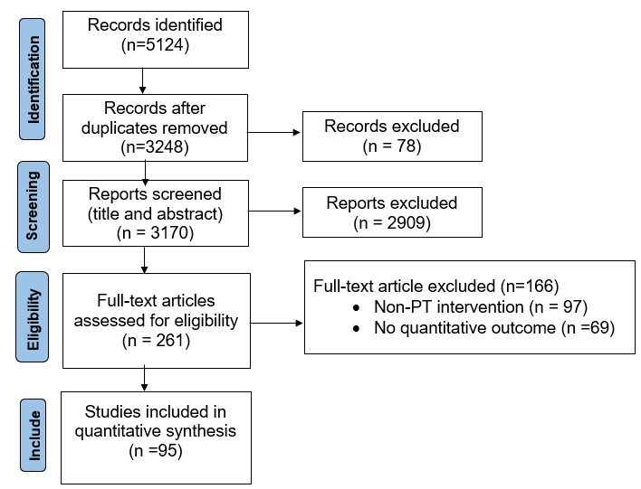
Fig. 1. PRISMA Flow Diagram
This PRISMA flow diagram visually summarizes the study selection process, showing the flow of information through the different phases of the systematic review. It maps out the number of records identified, included, and excluded, and the reasons for exclusions, as per the PRISMA standard.
Across the 95 included studies, the largest shares are from the United States (27; 28%), Spain (16; 17%), and Taiwan (12; 13%), followed by China (10; 11%) and the United Kingdom (8; 8%). Additional contributions come from Canada (7; 7%), Australia (6; 6%), Germany (4; 4%), Slovakia (3; 3%), and Italy (2; 2%). Figure 2 shows the number of publication by country.

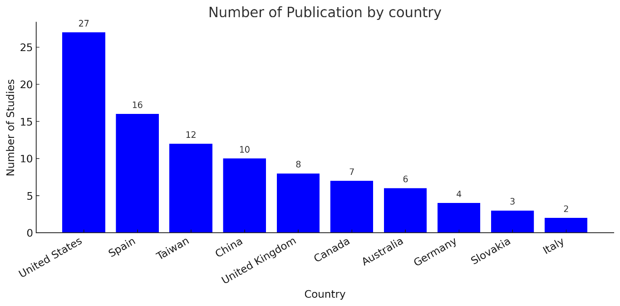
Fig. 2. Number of Publication by Country
Publication activity increases from 2010 to 2024 (Fig. 3), rising from 7 papers in 2020–2021 to 19 in 2024, signaling accelerating PT-bridge research in materials and NDT/SHM and underscoring that integration, not invention, is the present bottleneck.
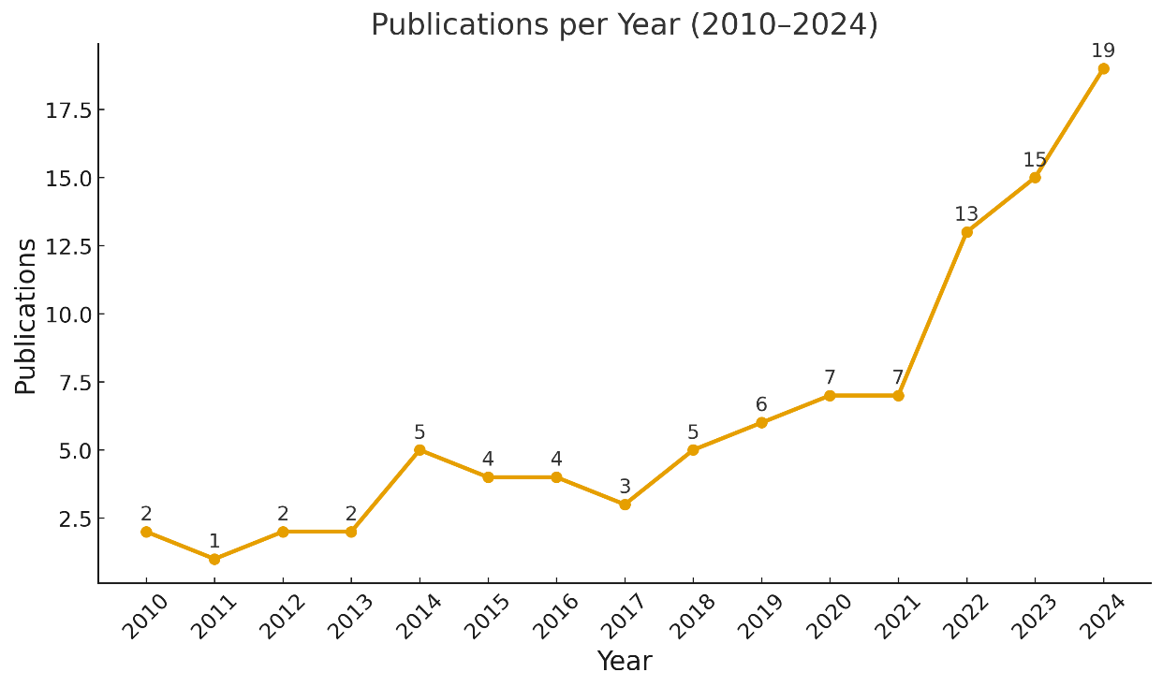
Fig. 3. Number of Publication per year

The methodological approaches were varied, with a large number of laboratory-based experimental studies (n = 48, 51%), followed by numerical simulation studies (n = 28, 29%), and field studies or case studies of in-service bridges (n = 18, 19%). The diverse and global nature of this research is evident in Table 1, which summarizes the characteristics of a representative sample of included studies.
Table 1. Characteristics of selected included studies
Author(s), Year | Location | Bridge  Component | Intervention(s) | Study Design | Key Quantitative Finding
(Jahami & Issa, 2024) | Canada | PT Concrete Beams | Carbon Fiber Reinforced Polymer (CFRP) Tendons vs. Steel Tendons | Lab Experiment | CFRP tendons maintained ~98% strength post-corrosion testing.
(Vavrus & Kralovanec, 2023) | Slovakia | Bridge Anchorage Zones | High-Performance Fiber-Reinforced Concrete | Simulation | 25% increase in ultimate load capacity of anchorage zone.
(Abdullah et al., 2016) | USA | Grouted PT Tendons | Acoustic Emission Monitoring for Wire Breaks | Lab Experiment | AE monitoring effectively detected and located wire breaks in grouted tendons during lab testing.
(Hoult et al., 2023) | China | Applied DFOS to large-scale bridge structures including pylons | Used high-frequency dynamic DFOS for strain monitoring | Field Study | Sub-meter spatial resolution for dynamic strain profiles.
(Solla et al., 2024) | Spain | Focused on reinforced concrete structures including bridge decks | Used GPR to assess corrosion and subsurface anomalies | Field Study | GPR anomalies validated against chloride concentrations.
Preethichandra et al. (2023) | Australia | Smart sensors integrated into SHM systems | Includes PT tendon monitoring among other components | Field Study | System supports precise force tracking; accuracy varies by sensor type.
Tabiatnejad et al. (2024) | USA | Focus on external tendons in PT bridges | Combines structural health monitoring with damage detection techniques | Case Study | Damage successfully identified, enabling timely intervention

3.2 Design Innovations
Design innovations have focused on creating more inherently durable systems. The increased adoption of external post-tensioning, which is conceptually similar to internal PT (Figure 4), is a prime example. This design choice explicitly prioritizes long-term inspectability and replaceability, a key tenet of modern design-for-maintenance principles (Al-Mosawe, Neves, & Owen, 2022; NASEM, 2021).
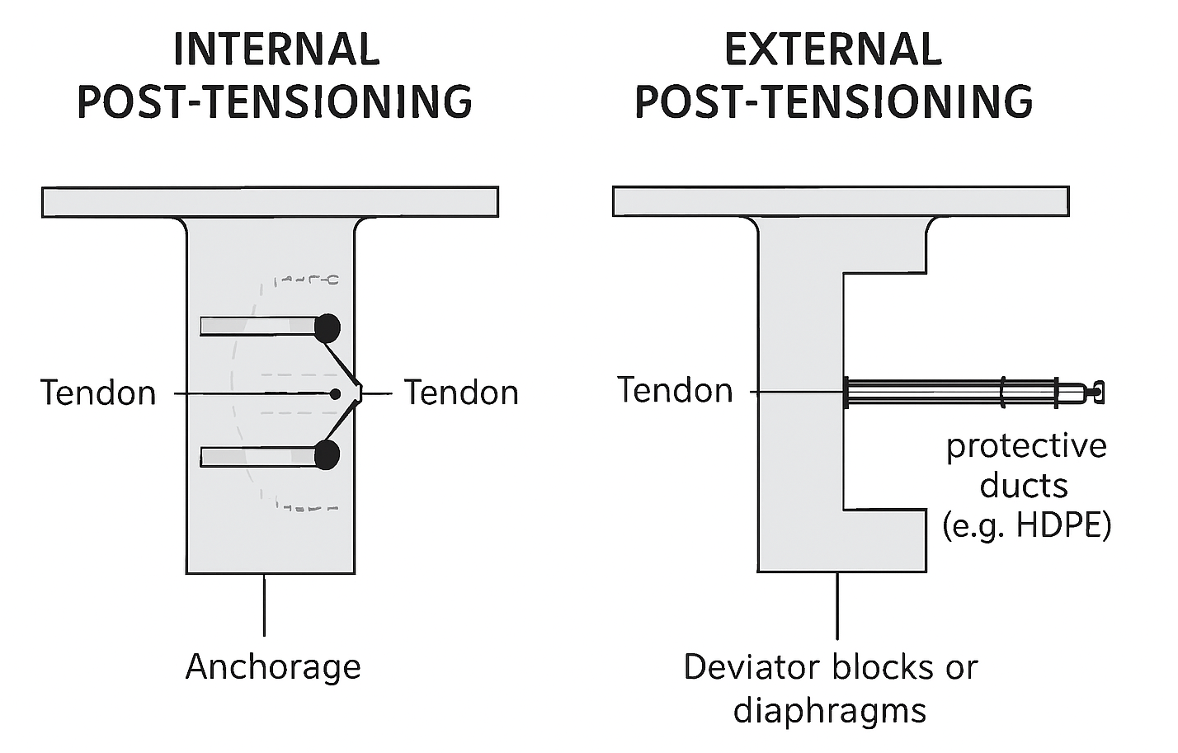
Fig. 4. Comparison of Internal and External Post-Tensioning Systems
Similarly, materials such as High-Performance Fiber-Reinforced Concrete (HPFRC) have been proven effective in simulations and laboratory tests for strengthening critical anchorage zones (Grelle & Sneed, 2013; Aduwa et al., 2025, Kim, Yang, & Kwon, 2016). However, the literature also implicitly highlights a tension: these advanced designs often require more stringent construction tolerances and specialized expertise, which increases both initial cost and quality control risks, posing significant barriers to adoption for cost-conscious public agencies (AASHTO, 2018).
3.3 Durability and Materials
The development of advanced materials starkly illustrates the disconnect between potential and practice. The benefits of corrosion-immune Fiber-Reinforced Polymer (FRP) tendons are well-documented and quantified in Table 2.
Table 2. Comparison of High-Strength Steel and CFRP Tendons
Property | High-Strength Steel | CFRP (Typical)
Tensile Strength (MPa) | 1860 | 2400 - 3000
Elastic Modulus (GPa) | 195 - 205 | 150 - 180
Density (kg/m³) | 7850 | 1600
Corrosion Resistance | Poor | Excellent
Relative Cost | 1x | 3x - 5x
Lab studies consistently demonstrate their superior performance (Grace & Singh, 2005; Awwal & Lateef, 2025; Park et al., 2012). Yet, their widespread adoption is hindered by practical concerns regarding their brittle failure mode, specialized anchorage requirements, and a lack of long-term, in-situ performance data, creating a risk-averse environment for bridge owners (Kossakowski & Wciślik, 2022; American Concrete Institute, 2015). This tension is also evident in durability modeling. The time to corrosion initiation can be modeled using the well-established formula derived from Fick's second law:
$t_{i}=\frac{x^{2}}{{4D}_{cl}}{ \left[{erf}^{-1}\left(1- \frac{C_{crit}}{C_{surf}}\right)\right]}^{2}$ (1)
However, the practical application of this model is fraught with uncertainty. As the literature on concrete durability implicitly confirms, the determination of key parameters like the chloride diffusion coefficient ($D_{cl}$) and the critical chloride threshold $C_{crit}$) is highly variable and depends on a multitude of factors related to materials and workmanship, making reliable service-life prediction a significant challenge outside the laboratory (Andrade, 2013).
3.4 Monitoring and Assessment
The proliferation of monitoring technologies is the most acute manifestation of the innovation-implementation gap. Table 3 summarizes the extensive toolkit of NDT methods.
Table 3. Overview of NDT Techniques for PT Bridge Assessment
Technique | Principle | Application | Advantages | Limitations
Impact-Echo (IE) | Stress wave propagation | Grout void detection | Portable, fast | Requires accessible surface, operator skill
Ground Penetrating Radar (GPR) | Electromagnetic wave reflection | Void and moisture detection | Fast, provides imagery | Limited penetration depth, data interpretation
Acoustic Emission (AE) | Detection of stress waves from damage | Real-time wire break detection | Passive, high sensitivity | Susceptible to noise, requires baseline data
Magnetic Flux Leakage (MFL) | Magnetic field disturbance at flaws | Detection of corrosion and wire breaks | Direct detection of steel loss | Requires tendon magnetization, access needed
However, a critical synthesis of the literature reveals a persistent tension between their performance in controlled studies and their reliability in the field. This "lab-to-field gap" is starkly illustrated by findings from the 19 field studies and case studies included in this review (e.g., Dangol, Thapa, & Pantelides, 2022). For instance, while Acoustic Emission (AE) can detect wire breaks with over 95% accuracy in a quiet lab environment (Sun & Qian, 2011), field studies like the one by Tonelli et al., (2020) on an operational bridge highlight the significant challenges in distinguishing genuine damage signals from ambient noise caused by traffic and environmental factors, a point also emphasized by Proverbio & Venturi (2016). Similarly, the field study by Elshaboury et al., (2023) demonstrated a strong correlation with GPR but also noted the significant expertise required for data interpretation in a real-world setting. This creates a critical problem for asset managers. The technology generates data, but confidence in its reliability is often low, making it difficult to justify costly interventions. This uncertainty is a major barrier to the routine use of many advanced NDT methods.
4. DISCUSSION
The synthesized evidence reveals a recurring pattern: technological advances in post-tensioned bridge management are evolving far faster than their integration into everyday practice. This gap is not a collection of isolated issues but a systemic imbalance between laboratory capability and field reliability, analytical sophistication and institutional constraint, and data generation and decision-making.
To unpack these dynamics, Table 4 maps the key tensions observed in the literature to the broader systemic barriers discussed below. Each represents a critical facet of the innovation–implementation divide.
Table 4: Mapping Synthesized Tensions to Systemic Barriers
Observed Tension/Gap | Systemic Barrier | Reasons
Advanced materials (e.g., FRP tendons) show superior lab performance but have low adoption rates. | Institutional Inertia & Risk Aversion | Bridge owners are reluctant to use FRPs due to a lack of long-term field data and the incompatibility of FRPs with deterministic design codes.
NDT methods show high accuracy in the lab but are unreliable in noisy field conditions. | Misaligned research and development (R&D) Pipeline | Academic research is incentivized to develop novel sensing principles in controlled settings, not to ruggedize existing technologies for field deployment.
Proliferation of monitoring data that is not translated into decisions. | Data-to-Decision Gap | A bridge agency may acquire a Digital Twin but lack the in-house expertise and standardized workflows to use it for asset management.
Analytical elegance of probabilistic models vs. their non-use in practice | Theory-Practice Chasm / Legal & Institutional Barriers | The legal precedent of "standard of care" makes deterministic, code-based designs more defensible in court than complex probabilistic analyses.
4.1 The PT Life-Cycle Trade-off Analysis Framework
Infrastructure design has long been guided by the assumption that performance objectives, such as durability, cost, and safety, can be simultaneously optimized. In reality, these goals are often in direct conflict. For post-tensioned bridge systems, enhancing durability through thicker concrete cover, for instance, may reduce the effectiveness of non-destructive testing (NDT) methods used to assess internal condition. The resulting tension between long-term performance and inspectability exemplifies the complex trade-offs that decision-makers face. The PT Life-Cycle Trade-off Analysis Framework (Figure 5) was developed to make these conflicts explicit and to formalize the process of negotiating among competing objectives. By structuring design choices as a transparent multi-criteria analysis, the framework shifts infrastructure decision-making from implicit judgment to explicit reasoning.
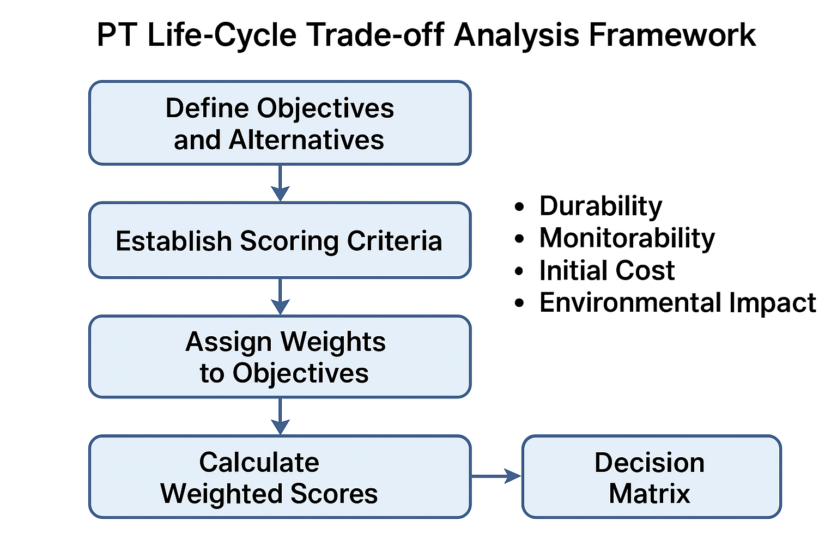
Fig 5. PT Life-Cycle Trade-off Analysis Framework.
The framework’s intellectual foundation lies in multi-criteria decision analysis (MCDA) and systems engineering principles, disciplines that emphasize structured comparison and transparent justification. Within this model, design alternatives are evaluated against defined criteria, durability, monitorability, cost, and environmental impact, each weighted according to stakeholder priorities. The process culminates in a decision matrix that consolidates both objective data and subjective priorities into a single analytical view. This approach encourages project teams to articulate and document the rationale behind design decisions, reducing the opacity that often characterizes infrastructure planning.
While the framework’s conceptual validity is clear, its full potential depends on institutional acceptance and practical refinement. It builds on previous efforts to apply multi-criteria analysis and advanced modeling, such as the use of artificial neural networks for multi-objective bridge design (Garca-Segura, Yepes, & Frangopol, 2017), by focusing on the institutional barriers to implementation. Validation through pilot projects would allow for calibration of weighting schemes and the inclusion of quantitative performance metrics. Furthermore, embedding the framework within existing design workflows, such as preliminary design reviews or environmental assessments, could strengthen its operational impact. In its current form, the PT Life-Cycle Trade-off Analysis Framework is a bridge between technical analysis and managerial accountability. It offers a pathway for agencies to integrate complex considerations into transparent, repeatable, and defensible decisions.
4.2 The Theory-Practice Chasm: The Case of Probabilistic Models
Probabilistic modeling provides a mathematically elegant means of quantifying uncertainty in structural performance; however, its practical application in bridge design and assessment remains limited. The literature demonstrates that, despite decades of academic endorsement, probabilistic reliability methods have not displaced deterministic code-based approaches in the public infrastructure sector. The reason is not primarily computational but institutional. Public agencies operate within a socio-technical environment where compliance, legal defensibility, and cost control outweigh analytical sophistication. Deterministic models provide simplicity and traceability, aligning with the long-standing legal precedent of “standard of care.” As a result, probabilistic approaches, though theoretically superior, are often perceived as opaque and difficult to justify in litigation or policy contexts.
This resistance reflects a broader cultural and legal inertia within civil engineering practice. Engineers and public officials must justify their decisions not only to peers but to auditors, insurers, and courts. This resistance reflects a broader cultural and legal inertia within civil engineering practice. Engineers and public officials must justify their decisions not only to peers but to auditors, insurers, and courts. Deterministic models provide simplicity and traceability, aligning with the long-standing legal precedent of standard of care. This precedent is heavily reinforced by established, deterministic frameworks such as Eurocode 2 (EN 1992-1-1:2004), which dictates the specific, codified rules for concrete design, and Eurocode 7 (EN 1997-1:2004) for related geotechnical design. Even when assessing existing structures, engineers default to standardized guidelines like ISO 13822:2010, which outlines the general principles for structural evaluation, and CEN/TS 13791:2007, which provides a specific, accepted methodology for in-situ concrete strength assessment. These codes provide a clear, traceable, and legally defensible methodology, which stands in stark contrast to the perceived ambiguity and complexity of custom probabilistic analyses. As a result, probabilistic approaches, though theoretically superior, are often perceived as opaque and difficult to justify in litigation or policy contexts.

Bridging this chasm will require coordinated reform across research, policy, and education. Academics can accelerate progress by developing probabilistic models tailored to the data limitations of public agencies, emphasizing transparency and interpretability over mathematical complexity. Professional societies and code committees must take parallel steps to recognize probabilistic approaches as legitimate complements to deterministic design. Equally important, university curricula and continuing education programs should integrate probabilistic thinking as a practical tool rather than a theoretical abstraction. Only by aligning institutional, educational, and legal frameworks can the profession move beyond theoretical admiration toward genuine operational adoption.
4.3 The Data-to-Decision Gap
Over the past decade, advances in NDT and SHM technologies have enabled bridge owners to collect unprecedented volumes of data. Yet the translation of this data into actionable maintenance decisions remains inconsistent and, in many cases, ineffective. The rise of Digital Twins, a convergence of sensing, simulation, and data analytics, has been heralded as the next step in predictive infrastructure management. However, evidence from both academic and industry literature reveals a persistent “data-to-decision” gap. While many agencies successfully deploy sensing systems, few possess the institutional capacity to interpret or act upon the resulting information. Consequently, Digital Twin projects often become data-rich prototypes that fail to achieve sustained operational impact.
The root of this challenge lies not in technology but in capability. Most bridge authorities lack the specialized personnel, standardized data formats, and interoperable software platforms necessary to effectively maintain and utilize digital systems. The absence of clear analytical protocols further exacerbates the problem, creating dependence on external consultants and diminishing internal learning. Without a long-term data governance strategy, many digital initiatives lose continuity as projects transition between planning, construction, and maintenance phases. These issues reveal that the barrier to digital transformation is not hardware sophistication, but institutional readiness and organizational culture.
Closing the data-to-decision gap requires a shift in how agencies conceptualize and manage digital tools. Investment in workforce development is as critical as investment in sensors and analytics platforms. Agencies should cultivate interdisciplinary teams that combine engineering expertise with data science and information management skills. Furthermore, industry-wide standards for data interoperability and model validation must be established to prevent the fragmentation of digital practices across projects. When supported by policy frameworks and stable funding, Digital Twins can evolve from isolated research endeavors into sustainable, organization-wide management systems that transform raw data into continuous operational intelligence.
4.4 Misaligned Incentives in the Research and Development Pipeline

The recurring lab-to-field gap observed in both materials and monitoring technologies underscores a deeper structural issue within the research and development ecosystem. The academic community, driven by publication metrics and funding criteria, is incentivized to prioritize novelty and complexity over practicality and scalability. Novel sensing principles, new algorithms, or advanced composites readily satisfy the criteria of scientific originality but rarely align with the pragmatic needs of infrastructure agencies. Conversely, public owners prioritize technologies that are robust, low-cost, and easy to justify under existing regulatory regimes. The resulting mismatch creates a research pipeline where innovations excel in laboratories but falter when exposed to the constraints of procurement, maintenance budgets, and code compliance.
This misalignment has far-reaching consequences. It perpetuates cycles of technological reinvention while leaving fundamental implementation barriers unaddressed. For example, while advanced non-destructive testing techniques demonstrate exceptional sensitivity in controlled conditions, field deployment often reveals calibration difficulties, data noise, and interpretation challenges. Similarly, materials such as fiber-reinforced polymer tendons, despite clear mechanical advantages, remain marginal due to their incompatibility with standard design codes and lack of long-term field data. The problem is not a lack of innovation but the absence of a shared framework that connects research output with practitioner needs and regulatory expectations.
Realigning the R&D pipeline will require structural changes in how research is funded, evaluated, and disseminated. Grant agencies can promote co-designed projects that mandate collaboration between academia, industry, and government from inception to implementation. Journals can support this shift by valuing applied and longitudinal studies that report field performance and implementation outcomes. Collaborative consortia, such as the successful partnerships behind the I-35W Bridge Monitoring Program and the Stonecutters Bridge in Hong Kong, demonstrate that integrated research models can yield durable, field-proven solutions. Making such collaborations the norm rather than the exception is essential to transforming innovation from a technical endeavor into a systemic enterprise.
4.5 Synthesis
Across all these dimensions, a consistent pattern emerges: the fundamental barrier in post-tensioned bridge management is not the absence of innovation, but the absence of integration. Technological progress has produced sophisticated tools, materials, and analytical frameworks, yet their cumulative impact remains limited by institutional fragmentation and cultural inertia. The field has reached a stage where generating new data or refining existing technologies yields diminishing returns unless paired with strategic mechanisms for adoption and governance. Integration, both conceptual and operational, has become the new frontier of engineering advancement.
Addressing this challenge requires reframing success metrics in both research and practice. The value of a new sensing technology, design methodology, or predictive model should not be measured solely by its novelty or accuracy, but by its capacity to improve decision-making in real-world settings. The PT Life-Cycle Trade-off Analysis Framework exemplifies this integrative orientation by bridging technical and managerial considerations within a transparent, replicable process. Its principles, explicit trade-offs, documented reasoning, and stakeholder inclusivity, represent the qualities that future infrastructure systems must embody to remain adaptive and resilient.
Ultimately, bridging the innovation–implementation divide demands a collective cultural shift within the bridge engineering community. Researchers, practitioners, policymakers, and educators must converge around a shared objective: transforming abundant technological capability into dependable, actionable intelligence. Only through this alignment can the field move from invention to integration, ensuring that the rapid pace of innovation translates into tangible improvements in the safety, durability, and sustainability of post-tensioned bridge infrastructure.

5. CONCLUSION
This systematic review demonstrates that the principal challenge in post-tensioned bridge management is no longer a shortage of technological innovation, but rather the difficulty of integrating existing technologies into complex, real-world systems. The field has become data-rich yet information-poor. The persistent disconnect between innovation and implementation arises not from technical limitations, but from unmanaged trade-offs, institutional inertia, and a research pipeline misaligned with operational realities.
The central contribution of this work lies in reframing this problem. Rather than cataloguing technologies, the study critically synthesizes the systemic barriers that prevent their effective adoption and introduces the PT Life-Cycle Trade-off Analysis Framework as a practical tool for navigating competing design objectives. The framework provides a structured and transparent method to balance considerations of durability, monitorability, cost, and environmental impact, transforming what are often implicit trade-offs into explicit and defensible decisions.
The future of durable and intelligent bridge infrastructure depends on a fundamental shift from the invention of new tools to their strategic integration within decision-making ecosystems. Achieving this transition requires collective effort across the research and professional communities. Researchers must redirect their focus toward long-term field studies, co-designed with practitioners, that emphasize transparency, reliability, and real-world validation over theoretical novelty. Practitioners and asset managers need to strengthen institutional capability through enhanced data literacy, digital infrastructure, and performance-based workflows that translate sensor data into actionable insights. At the same time, funding agencies and journals should create incentives that reward implementation-oriented research and prioritize studies demonstrating measurable outcomes in practice.
Bridging the innovation–implementation divide is ultimately a socio-technical challenge. It demands alignment among technology, governance, and professional culture toward a shared goal: converting abundant data into trustworthy intelligence. By embedding integration as both a research priority and an operational standard, the bridge engineering community can ensure that technological progress translates into the resilient, safe, and sustainable infrastructure essential for future generations.

DISCLAIMER (ARTIFICIAL INTELLIGENCE)
Author(s) hereby declare that NO generative AI technologies such as Large Language Models (ChatGPT, COPILOT, etc) and text-to-image generators have been used during writing or editing of this manuscript were used during the writing and editing of this manuscript.
COMPETING INTERESTS
Author has declared that they have no known competing financial interests or non-financial interests or personal relationships that could have appeared to influence the work reported in this paper.
REFERENCES
Abdullah, A. B. M., Rice, J. A., Brenkus, N. R., & Hamilton, H. R. (2016). Full-scale experimental investigation of wire breakage detection in deviated multi-strand tendon systems. Journal of Civil Structural Health Monitoring, 6(2), 217–235. https://doi.org/10.1007/s13349-016-0158-7
Aduwa, S.I., Mensah, K. E., Aderibigbe, A. A., Lateef, J., Eromosele, I. E., Adebayo, A., & Nii-Okai, E. (2025). “Integrating Climate Resilience into Construction Project Management: A Global Narrative Review of Frameworks, Policies and Implementation Challenges”. Journal of Global Ecology and Environment 21 (4):92–107. https://doi.org/10.56557/jogee/2025/v21i49902
Al-Mosawe, D., Neves, L., & Owen, J. (2022). Reliability analysis of deteriorated post-tensioned concrete bridges: The case study of Ynys-y-Gwas bridge in UK. Structures, 41, 242–259. https://doi.org/10.1016/j.istruc.2022.04.094
American Concrete Institute. (2015). ACI 440.1R-15: Guide for the design and construction of structural concrete reinforced with fiber-reinforced polymer (FRP) bars. ACI Committee 440. https://www.concrete.org/Portals/0/Files/PDF/Previews/440_1R_15.pdf
25. Andrade, C., Gulikers, J., & Polder, R. (2013). Durability of reinforced concrete from composition to protection: Selected papers of the 6th International RILEM PhD Workshop. Springer. https://link.springer.com/book/10.1007/978-3-319-09921-7
Awwal, I., & Lateef, J. (2025). Optimizing Urban Road Networks: A Systematic Review of Design, Control and Multimodal Integration. Journal of Engineering Research and Reports, 27(10), 359–372. https://doi.org/10.9734/jerr/2025/v27i101678
CENT/TS,13791:2007. (2007). Assessment of in-situ compreghensive strength in structure and pre-cast concrete components. Brussels: European Committee for Standarsization.
Dangol, I., Thapa, D., & Pantelides, C. P. (2022). Experimental evaluation of post-tensioned bridge bent under cyclic loads and comparison to hybrid bridge bents. Engineering Structures, 256, 113962. https://doi.org/10.1016/j.engstruct.2022.113962
Ellingwood, B. R. (2009). The role of risk assessment in performance-based engineering. In Frontier Technologies for Infrastructures Engineering (pp. 193–208). CRC Press. https://doi.org/10.1201/9780203875599-15
EN, 1992-1-1:2004 (Eurocode 2). (2004). Design of concrete structures- Part1-1: General rules and rules for buildings. Brussels: European Committee for Standarsization.
EN, 1997-1-1:2004 (Eurocode 7). (2004). Geotechnical design- Part1-1: General rules. Brussels: European Committee for Standarsization.
Fédération Internationale du Béton (2001) Durability of Post-Tensioning Tendons (fib Bulletin No. 15). Lausanne: fib.
Garca-Segura, T., Yepes, V., & Frangopol, D. M. (2017). Multi-objective design of post-tensioned concrete road bridges using artificial neural networks. Structural and Multidisciplinary Optimization, 56(1), 139-150. https://doi.org/10.1007/s00158-017-1653-0
Grace, Nabil & Singh, Shamsher. (2005). Durability Evaluation of Carbon Fiber-Reinforced Polymer Strengthened Concrete Beams: Experimental Study and Design. ACI Structural Journal.102. https://www.researchgate.net/publication/242538422_Durability_Evaluation_of_Carbon_Fiber-Reinforced_Polymer_Strengthened_Concrete_Beams_Experimental_Study_and_Design
Hammer, R., Toutanji, H. and Maalej, M. (2019) ‘Post-Tensioned Concrete Bridges: Design and Performance Trends’, Purdue University Civil Engineering Reports, 5(3), pp. 112–126.
Higgins, J. P., Altman, D. G., Gøtzsche, P. C., Jüni, P., Moher, D., Oxman, A. D., ... & Sterne, J. A. (2011). The Cochrane Collaboration’s tool for assessing risk of bias in randomised trials. BMJ, 343, d5928. https://doi.org/10.1136/bmj.d5928
Hoult, N. A., Woods, J., Wang, Y., Kassenaar, H., & Bao, X. (2023). High-frequency dynamic distributed fiber optic strain sensing for civil infrastructure applications. Journal of Civil Structural Health Monitoring, 14, 369–382. https://doi.org/10.1007/s13349-023-00727-z
ISO 13822:2010. (2010). Bases for design of structures- Assessment of existing structures. Geneva: International Organization for Standardization.
Jahami, A., & Issa, C. A. (2024, December 1). An Updated Review on the Effect of CFRP on Flexural Performance of Reinforced Concrete Beams. International Journal of Concrete Structures and Materials. Springer Nature Korea. https://doi.org/10.1186/s40069-023-00651-y
Kim, J.-K., Yang, J.-M., & Kwon, Y. (2016). Influence of steel fiber and reinforcing details on the ultimate bearing strength of the post-tensioning anchorage zone. Structural Engineering and Mechanics, 59(5), 867–883. https://doi.org/10.12989/sem.2016.59.5.867
20. AASHTO. (2018). Guide Specifications for Analysis and Identification of Fracture Critical Members and System Redundant Members. American Association of State Highway and Transportation Officials. https://store.transportation.org/Item/PublicationDetail?ID=4141
Kossakowski, P. G., & Wciślik, W. (2022). Fiber-reinforced polymer composites in the construction of bridges: Opportunities, problems and challenges. Fibers, 10(4), 37. https://doi.org/10.3390/fib10040037
Menga, A., Kanstad, T., Cantero, D., Bathen, L., Hornbostel, K., & Klausen, A. (2022). Corrosion-induced damages and failures of posttensioned bridges: A literature review. Structural Concrete, 24(1), 3–17. https://doi.org/10.1002/suco.202200297
National Academies of Sciences, Engineering, and Medicine. 2021. Repair and Maintenance of Post-Tensioned Concrete Bridges. Washington, DC: The National Academies Press. https://doi.org/10.17226/26172.
18. Grelle, S. V., & Sneed, L. H. (2013). Review of anchorage systems for externally bonded FRP laminates. International Journal of Concrete Structures and Materials, 7(Suppl 1), 17–33. https://doi.org/10.1007/s40069-013-0029-0
Ni, Y. Q., & Wong, K. Y. (2011). Health checks through landmark bridges to sky-high structures. Advances in Structural Engineering, 14(1), 103–119. https://doi.org/10.1260/1369-4332.14.1.103
Opara I. J., Lateef, J., Nii-Okai, E., Saah, B. P., Mensah, E. K., Wiafe, G. F. O., & Olayode, A. (2025). Digital Resilence in Construction Projects: A Narrative Review of Data Governance, BIM, and Real-Time Decision Support Systems. Journal of Management, and Development Research, 2(2), 117-124. https://doi.org/10.69739/jmdr.v2i2.1129
Page, M. J., McKenzie, J. E., Bossuyt, P. M., Boutron, I., Hoffmann, T. C., Mulrow, C. D., Shamseer, L., Tetzlaff, J. M., Aki, E. A., Brennan, S. E., Chou, R., Glanville, J., Grimshaw, J. M., Hróbjartsson, A., Lalu, M. M., Li, T., Loder, E. W., Mayo-Wilson, E., McDonald, S., ... Moher, D. (2021). The PRISMA 2020 statement: An updated guideline for reporting systematic reviews. PLOS Medicine, 18(3), e1003583. https://doi.org/10.1371/journal.pmed.1003583
Park, S. H., Kim, D. J., Ryu, G. S., & Koh, K. T. (2012). Tensile behavior of Ultra High-Performance Hybrid Fiber Reinforced Concrete. Cement and Concrete Composites 34(2), 172-184. https://doi.org/10.1016/j.cemconcomp.2011.09.009
Preethichandra, D. M. G., Suntharavadivel, T. G., Kalutara, P., Piyathilaka, L., & Izhar, U. (2023). Influence of smart sensors on structural health monitoring systems and future asset management practices. Sensors, 23(19), 8279. https://doi.org/10.3390/s23198279
Proverbio, E., & Venturi, V. (2016). Evaluation of damage evolution under repeated loading of post-tensioned concrete beams by acoustic emission. 32nd European Conference on Acoustic Emission Testing. Retrieved from https://www.researchgate.net/publication/237785656
Richter, C.A. (2022) Corrosion-Induced Durability Issues and Maintenance Strategies for Post-Tensioned Concrete Bridges. FHWA Publication No. FHWA-HRT-22-090. Washington, DC: U.S. Department of Transportation, Federal Highway Administration.
Solla, M., Pérez-Gracia, V., & Fontul, S. (2024). Corrosion assessment of reinforced concrete structures using ground-penetrating radar. In Proceedings of the 10th World Congress on New Technologies (NewTech'24), Barcelona, Spain. Paper No. ICCEIA 130. DOI: 10.11159/icceia24.130
Sun, L., & Qian, J. (2011). Experimental study on wire breakage detection by acoustic emission. Frontiers of Structural and Civil Engineering, 5(4), 503–509. https://doi.org/10.1007/s11709-011-0132-8
Thomas, J., & Harden, A. (2008). Methods for the thematic synthesis of qualitative research in systematic reviews. BMC Medical Research Methodology, 8(1), 45. https://doi.org/10.1186/1471-2288-8-45
Tonelli, D., Luchetta, M., Rossi, F., Migliorino, P., & Zonta, D. (2020). Structural health monitoring based on acoustic emissions: Validation on a prestressed concrete bridge tested to failure. Sensors, 20(24), 7272. https://doi.org/10.3390/s20247272
Unal, M., & Warn, G. P. (2015). A many-objective framework to design the restoration of damaged bridges on a distributed transportation network. In Structures Congress 2015 (pp. 1473–1484). American Society of Civil Engineers. https://doi.org/10.1061/9780784479117.128
Vavrus, M., & Kralovanec, J. (2023). Study of application of fiber reinforced concrete in anchorage zone. Buildings, 13(2), 524. https://doi.org/10.3390/buildings13020524

ABBREVIATIONS
PRISMA: Preferred Reporting Items for Systematic Reviews and Meta-Analyses
PICO: Population, Interventions, Comparison, and Outcomes
CFRP: Carbon Fiber Reinforced Polymer
DFOS: Distributed Fiber Optic Sensing
GPR: Ground-Penetrating Radar
AE: Acoustic Emission.
NDT: Non-Destructive Testing
PT: Post-tensioned
SHM: Structural Health Monitoring
R&D: Research and Development
MFL: Magnetic Flux Leakage
DFOS: Distributed Fiber Optic Sensing

