INFLUENCE OF FLY ASH AND PALM FIBRE ON THE MECHANICAL PROPERTIES OF COMPRESSED STABILIZED EARTH BLOCKS

Original Research Article
Abstract
The global population growth and escalating cost of building materials have resulted in a global housing deficit. There has also been a growing concern about environmental and ecological issues caused by human activities. This has prompted continuous research efforts into the beneficial use of these wastes in developing sustainable, affordable and eco-friendly building materials. This research evaluated the effect of fly ash and palm fibre on the density and compressive strength of compressed stabilized earth blocks. Fly ash was used to stabilize lateritic soil at 0%, 2.5%, 5%, 7.5% and 10% while palm fibre was used to reinforce the lateritic soil at a constant proportion of 1% by weight of laterite. The blocks were cured for 28 days after which they were tested. The results obtained indicate that the addition of fly ash in the matrix increased the density and compressive strength of the blocks. The blocks produced with fly ash in the matrix meet the minimum compressive strength requirements for lateritic blocks as specified by the Nigeria Building and Road Research Institute. An optimum stabilization and reinforcement of lateritic soil with 7.5% fly ash and 1% palm fibre by weight respectively of lateritic soil is recommended.
Keywords: palm fibre; compressed stabilized earth blocks; fly ash; compressive strength; density
Introduction
The provision of shelter is important as shelter is one of the basic needs of man. The global population growth has resulted in an increased demand for infrastructure, resulting in an escalation in conventional building and construction materials prices. Also, the high carbon footprint associated with most industrial activities such as cement production and usage has been an issue of global concern in recent years. The high costs of management and treatment associated with the disposal of wastes has prompted continuous research efforts into the beneficial use of these wastes in developing sustainable, affordable and eco-friendly building materials [1-4].
Earth, the oldest and most traditional building material is used by about 30% of global population for housing. Earthen construction has numerous benefits such as safety, cost-effectiveness, faster and easier construction (requiring less skilled labour), good acoustic and thermal properties, energy efficiency, no direct environmental pollution, makes it to stand out among other building materials. However, loss of strength when saturated with water, poor dimensional stability, high susceptibility to shrinkage and cracking, and rapid deterioration under severe weather conditions are its major drawbacks. The mechanical and chemical stabilization of earthen blocks have considerably overcome these drawbacks [2-10]. Blocks produced by stabilizing and compressing earth, known as compressed stabilized earth blocks (CSEBs), are an improvement of the traditional earth block production technique as standardized procedures/quality control measures have been incorporated into their production process. Various researchers have proven that CSEBs have enhanced strength and thermal properties as well as improved durability. Cement, the most common stabilizer used for CSEB production has its drawbacks which include its cost and its CO₂ emissions. This has made researchers to focus on finding other alternatives such as lime and pozzolans/supplementary cementitious materials (SCMs) that can partially or wholly substitute cement and the incorporation of fibres in the production of CSEBs. These attempts by researchers have yielded positive results [9-20].
Fly ash (FA) and palm fibre (PF) are by-products obtained from coal power plants and palm oil mills respectively. These materials are generally disposed of in the environment causing air pollution when burned. They also negatively affect plant and animal life when they leach into the ground reducing soil fertility and contaminating groundwater [21]. Their use in the production of CSEBs will promote the profitable wastes utilization and a greener environment. Islam et al. [3] studied the effectiveness of fly ash and cement for compressed earth block construction. FA and cement were used to stabilized coarse grained soil for blocks production at proportions of 5-25% and 5-10% by weight of soil respectively. Their findings revealed that 15-20% FA and 7-8% cement stabilization resulted in dry compressive strength greater than 5 MPa, wet-to-dry compressive strength greater than 0.33, and water absorption below 20%. It was also observed that the modulus of elasticity of the blocks improved with an increase in the cement and FA proportion in the blocks. They recommended an optimum fly ash proportion of 15% for 5-7% cement. Nafu et al. [4] in their study evaluated the influence of palm oil mesocarp fibres on the thermal properties of cement-stabilized compressed earth–based brick. They stabilized soil with 10% cement by mass and produced blocks reinforced with different proportions of fibres (0%, 0.25%, 0.5%, 0.75%, 1%, 1.25%, 1.5%, 2%, and 2.5%). The thermal effusivity, volume calorific capacity, thermal conductivity, and thermal diffusivity of the blocks were investigated. They observed that the addition of palm oil mesocarp fibre in the bricks resulted in improved thermal properties of the blocks, reduced weight and shrinkage of the blocks, and improved durability of the blocks. Danso et al. [22] studied the physical, mechanical and durability properties of compressed earth blocks reinforced with natural fibres (coconut husk, sugarcane bagasse and oil palm fibre). These fibres were used to reinforce soil at 0.25-1% by weight of soil. The results obtained from their study indicated that the inclusion of these fibres in the earth block matrix positively enhanced the physical, mechanical and durability properties of compressed earth blocks produced. 0.5% fibre content by weight was recommended for use. Onugba et al. [23] evaluated the effect of oil palm fibre (mesocarp of palm fruit bunch) on the compressive strength of compressed earth blocks. Oil palm fibre was added to the soil matrix at 0%, 0.5%, 1% and 1.5% by weight of lateritic soil to produce the blocks. Their results revealed that the addition of palm fibre in the matrix significantly increased the compressive strength of the blocks. They recommended an optimal of 1% palm fibre reinforcement of the blocks.
Various studies carried out have validated the suitability of the use of SCMs and fibres respectively in the production of CSEBs. However, the availability research on the combined use of SCMs and fibres in the production of CSEBs is scarce. The current study therefore investigated the combined effect of fly ash and oil palm fibre on the density and compressive strength of CSEBs.
Materials and Methods
Soil
The soil, reddish-brown laterite, used for this research was obtained from an existing borrow pit at Akpataega, Idah, Kogi State, Nigeria, at a depth of ~1.5m free from organic matter and deleterious materials. The soil index/geotechnical properties were determined in accordance with BS 1377 [24] to classify the soil. The soil tests were carried out at the Soil Mechanics Laboratory, Department of Civil Engineering, The Federal Polytechnic, Idah, Kogi State. The results of the sieve analysis and the soil index/geotechnical properties are presented in Table 1 and Table 2 respectively. Figure 1 and Figure 2 show the particle size distribution curve and dry density and moisture content curve of the soil respectively.
Table 1: Sieve analysis of the lateritic sample
Sieve opening (mm) | 4.750 | 2.000 | 0.850 | 0.600 | 0.425 | 0.250 | 0.106 | 0.075 | pan
Percentage passing (%) | 99.6 | 61.5 | 34.7 | 25.0 | 12.7 | 7.9 | 4.9 | 3.3 | -

Figure 1: Particle size distribution curve
Table 2: Geotechnical properties of the soil
TEST | RESULT
Specific gravity (%) | 2.61
% passing BS 200 sieve (0.075mm) | 3.3
Natural moisture content (%) | 10.8
Maximum dry density (kg/m³) | 2064.78
Optimum moisture content (%) | 10.3
Condition of sample | Air dried
Liquid limit (%) | 29
Plastic limit (%) | 23
Plasticity index (%) | 6
Coefficient of curvature | 1.98
Coefficient of uniformity | 8.82
USCS classification | ML (silty and clayey fine sand)
ASSHTO classification | A-2-4

Figure 2: Graph showing the dry density and moisture content of the soil
Fly ash
The Fly Ash (FA) used was sourced from Cinafindev Ltd., (a cement manufacturing plant) in Allo, Kogi state. The FA used is class C, as the coal available in Kogi State and in most parts of Nigeria is predominantly lignite or sub-bituminous [21, 25-26]. It was sieved using sieve No. 200 to obtain fine particles. The colour of the fly ash is dark grey with a specific gravity of 2.6.
Palm Fibre
The Palm fibre used for this research is the mesocarp of oil palm fruits (palm fruit bunch). It was obtained from Ogbogbo town in Idah, Kogi state. The fibre was washed with warm water to remove oil and dirt, and sun-dried before it was used. Figure 3 shows a photograph of the palm fibre used. Some of the physical and mechanical properties of the palm fibre used are presented in Table 3. This fibre was selected due to its enormous availability in most parts of Nigeria [27-29].
Figure 3: Photograph showing a sample of palm fibre used
Table 3: Physical and mechanical properties of palm fibre used
Parameter | Value
Length | 26-53 mm
Radius | 0.15-0.39 mm
Density | 524 N/mm²
Tensile strength | 76 N/mm²
Young’s modulus | 495 N/mm²
Elongation at break | 18

Water
Fresh, colourless, odourless and tasteless potable water that is free from injurious amounts of oils, alkalis, salts, sugar organic matter or any other substances, was used for this research.
Mixture Proportioning and Moulding of Blocks
The soil was stabilized with fly ash proportions of 0%, 2.5%, 5.0%, 7.5% and 10% by weight of lateritic soil and reinforced with a fixed palm fibre proportion of 1% by weight of lateritic soil for each mix. The palm fibre content was fixed at 1% as various researchers [12-16, 23, 30-32] recommend an optimum fibre content ranging from 0.5% to 1%. The mix proportion of the specimens are presented in Table 4. Block specimens of size 200 mm x 100 mm x 100 mm were moulded from the stabilized lateritic soil samples. A total of 15 blocks were moulded with three blocks for each set of mix and compaction was done in accordance with BS 1377 [24]. Mixing of the materials, moulding and compaction of the blocks was carried out manually. The freshly moulded blocks were carefully extruded in good shape on a clean, hard and flat surface after which they were left to cure under a shade for 28 days. Water was sprayed on the blocks once every morning and evening for the 28-day curing period. Figure 4 shows the freshly moulded blocks.
Table 4: Mix proportion of the specimen
Mix ID | Fly Ash  (Kg/m³) | Palm Fibre  (Kg/m³) | Laterite  (Kg/m³)
F1 (control) | 0 | 0.125 | 12.375
F2 | 0.3125 | 0.125 | 12.0625
F3 | 0.625 | 0.125 | 11.75
F4 | 0.9375 | 0.125 | 11.4375
F5 | 1.25 | 0.125 | 11.125

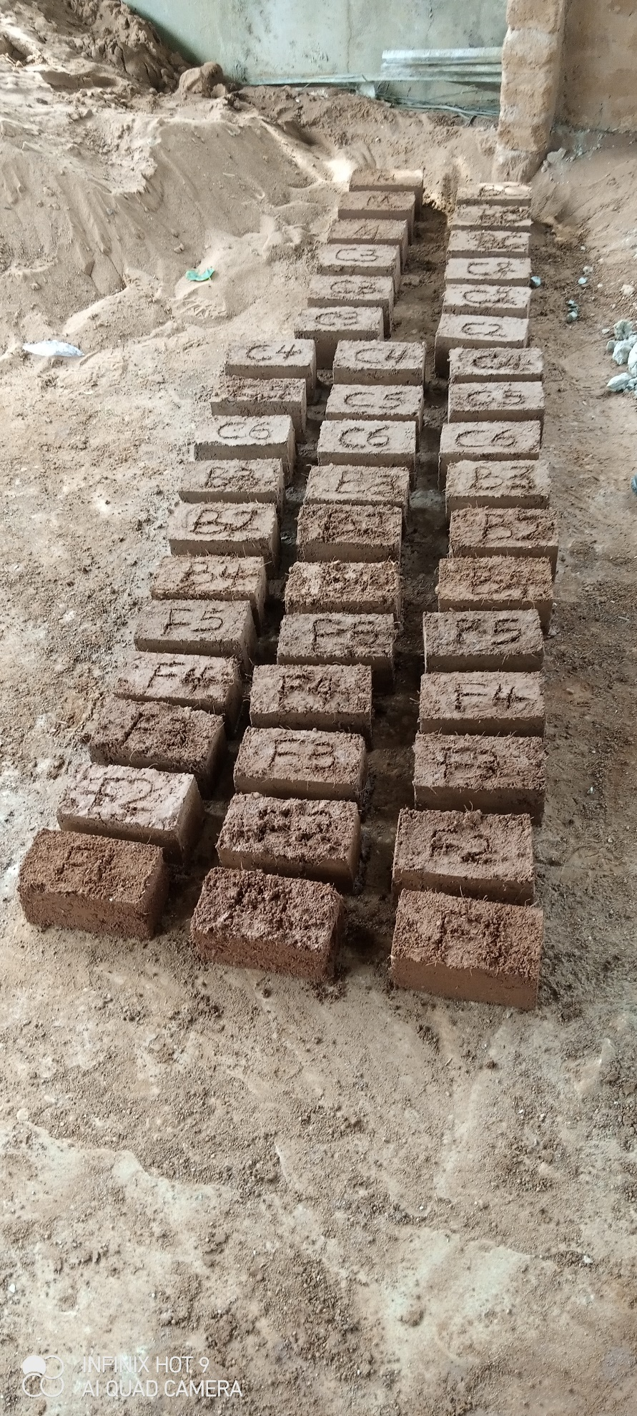
Figure 4: Photograph showing freshly moulded block specimen
Results and Discussions
Density of Blocks
The density of the specimen was determined in accordance with BS EN 771-1 [33] carried out at the Concrete Laboratory, Department of Civil Engineering, The Federal Polytechnic, Idah, Kogi State. Three blocks from each mix ratio were selected for the test. Their volumes were calculated and weighed and then the density was calculated.
The results of the average density of the blocks are presented in Table 5 and Figure 5 respectively. From the results obtained, it is observed that the addition of fly ash (from 2.5-10%) to the matrix led to a significant increase in the density of the blocks as compared with the control mix. The addition of fly ash at 2.5%, 5%, 7.5% and 10% into the matrix resulted in a 14.52%, 16.60%, 17.55% and 16.60% density increase respectively when compared with the control mix. This increase in the density can be attributed to the fact that fly ash has a filler and cementitious effect which reduces voids in the matrix [34-35].
Table 5: Average density of compressed stabilized earth blocks
Mix ID | Fly Ash (%) | Palm Fibre (%) | Average Density (Kg/m³) | Change in Density (%)
F1 (control) | 0.0 | 1 | 1766.70 | 0.00
F2 | 2.5 | 1 | 2023.30 | 14.52
F3 | 5.0 | 1 | 2060.00 | 16.60
F4 | 7.5 | 1 | 2076.70 | 17.55
F5 | 10.0 | 1 | 2060.00 | 16.60

Figure 5: Average density of compressed stabilized earth blocks
Compressive Strength
The compressive strength tests of the specimens were carried out in accordance with BS EN 771-1 [33] and BS EN 12390-4 [36] at the Concrete Laboratory, Department of Civil Engineering, The Federal Polytechnic, Idah, Kogi State. Three samples of each of the stabilized laterite blocks were crushed in a compression testing machine with metal plates placed above and below the block (see Figure 6). The load was then placed axially and uniformly until failure occurred. The maximum failure load on the brick was measured. This load divided by the cross-sectional area of the block gave the compressive strength of the block.
The results obtained from the compressive strength test are presented in Table 6 and Figure 7 respectively. The compressive strength of the blocks had a similar trend to the density. The addition of fly ash (from 2.5-10%) to the matrix resulted in a significant increase in the compressive strength of the blocks as compared with the control mix. There was a 30.53%, 55.73%, 78.63% and 75.57% increase in the compressive strength of the blocks when fly ash was added to the matrix at 2.5%, 5%, 7.5% and 10% respectively. Similar trend was reported by Ohwofasa et al., [26]; Kelechi et al., [21] and Okunade, [25], when FA was added to lateritic soils. The increase in the compressive strength can be attributed to the high lime content (above 20%) and pozzolanic nature of Class C Fly Ash as it has been reported to enhance the shear strength and bearing capacity of the soil as aids particle parking and reduces the void between the particles of the soil, thereby increasing the density of the blocks and leading to an increase in compressive strength. Furthermore, FA reduces the plasticity index, shrinkage limit and optimum moisture content, which has a positive impact on the engineering properties of lateritic soils [21, 25-26, 34-35, 37]. The increase in compressive strength can also be attributed to homogeneity of the matrix formed by the bonding of the soil, FA and fibres. Fibres have been reported by researchers to improve ductility, tensile strength and shrinkage, as well as reducing pores and cracks in soils and earthen blocks [14, 22, 38].
The blocks produced with FA in the matrix meet the minimum compressive strength requirements of 1.65 N/mm² for lateritic blocks as specified by the Nigeria Building and Road Research Institute [39].
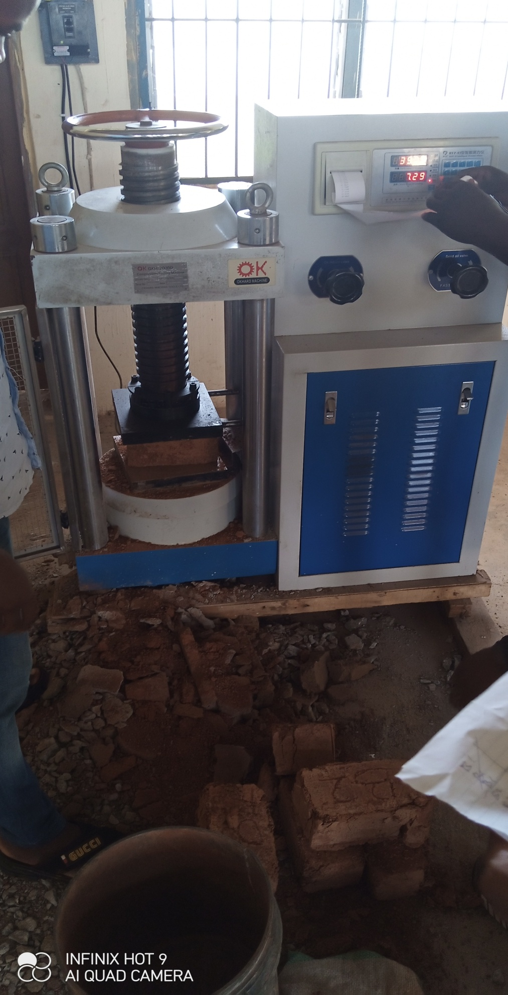
Figure 6: Specimen being tested for compression
Table 6: Average compressive strength of compressed stabilized earth blocks
Mix ID | Fly ash (%) | Palm fibre (%) | Average compressive strength (N/mm²) | Change in Compressive Strength (%)
F1 (control) | 0.0 | 1 | 1.31 | 0.00
F2 | 2.5 | 1 | 1.71 | 30.53
F3 | 5.0 | 1 | 2.04 | 55.73
F4 | 7.5 | 1 | 2.34 | 78.63
F5 | 10.0 | 1 | 2.30 | 75.57

Figure 7: Average compressive strength of compressed stabilized earth blocks
Conclusion
In this research, compressed stabilized earth blocks (CSEBs) stabilized with fly ash (0-10%) and a fixed palm fibre proportion (1%) by weight of lateritic soil were produced and tested for their densities and compressive strengths after 28 days of curing. The following conclusions were drawn from the findings of this research
- The addition of fly ash at 2.5%, 5%, 7.5% and 10% into the matrix resulted in a 14.52%, 16.60%, 17.55% and 16.60% density increase respectively when compared with the control mix.
- There was also a 30.53%, 55.73%, 78.63% and 75.57% increase in the compressive strength of the blocks when fly ash was added to the matrix at 2.5%, 5%, 7.5% and 10% respectively.
- All blocks produced with fly ash in their matrix meet the minimum compressive strength requirement of NBRRI.
- An optimum stabilization of 7.5% fly ash and 1% palm fibre by weight of lateritic soil is recommended.
- The use of fly ash and palm fibre in the production of CSEBs will help reduce the pollution caused by the disposal of these materials in the environment.
- The use of fly ash and palm fibre in the production of CSEBs will promote the profitable utilization of industrial and agricultural wastes.
Disclaimer (Artificial intelligence)
Author(s) hereby declare that NO generative AI technologies such as Large Language Models (ChatGPT, COPILOT, etc) and text-to-image generators have been used during writing or editing of manuscripts.

References
- Harper, D., Alternative Materials of Stabilisation for Unfired Mud Bricks. 2011, retrieved from https://vdocuments.mx/download/alternative--methods-of-stabilisation-for-unfired-mud-bricks.html
- Riza, F. V., Rahman, I. A. and Zaidi, A. M. A., A brief review of compressed stabilized earth brick (CSEB). International Conference on Science and Social Research (CSSR 2010), Kuala Lumpur, Malaysia, December 5-7, 2010 pp. 999-1004. https://dx.doi.org/10.1109/CSSR.2010.5773936
- Islam, M. S., Elahi, T. E., Shahriar, A. R. & Mumtaz, N., Effectiveness of fly ash and cement for compressed stabilized earth block construction. Construction and Building Materials, 255, 119392,2020, https://doi.org/10.1016/j.conbuildmat.2020.119392
- Nafu, Y. R., Loic, N. T. R., Elvis, M. T., Tendo, F. J., Influence of palm oil mesocarp fibres on the thermal properties of cement-stabilized compressed earth–based brick. European Journal of Engineering and Technology Research, 7(6), 2022, pp. 35-43, http://dx.doi.org/10.24018/ejeng.2022.7.6.2910
- Olutoge, F. A., Booth, C. A., Olawole, S. O. A. and Alebiosu, O. A., Lateritic Cement- and Lime-Stabilized Bricks and Blocks for Affordable Housing. Proceedings of the Institution of Civil Engineers – Construction Materials. 171 (5), 2017, pp. 195-202. https://doi.org/10.1680/jcoma.16.00062
- Subramanian, G. K. M., Balasubramanian, M. and Kumar, A. A. J., A Review on the Mechanical Properties of Natural Fiber Reinforced Compressed Earth Blocks. Journal of Natural Fibers. 19(14), 2022, pp. 7687-7701, https://doi.org/10.1080/15440478.2021.1958405
- Adam, E. A. and Agib, A. R. A., Compressed Stabilized Block Manufacture in Sudan. United Nations Educational, Scientific and Cultural Organization, Paris, France. 2001.
- Pacheco-Torgal, F. and Jalali, S., Earth Construction: Lessons from the Past for Future Eco-Efficient Construction, Construction and Building Materials, 29, 2012, pp. 512-519. https://doi.org/10.1016/j.conbuildmat.2011.10.054
- Okere, C. E., Strength Property of Laterite Blocks Made with Different Pozzolanic Materials. NIPES Journal of Science and Technology Research. 2(2), 2020, pp. 152-157. https://doi.org/10.37933/nipes/2.2.2020.15
- Walker, P. J., Strength, Durability and Shrinkage Characteristics of Cement Stabilised Soil Blocks. Cement and Concrete Composites. 17(4), 1995, pp. 301-310. https://doi.org/10.1016/0958-9465(95)00019-9
- Nagaraj, H. B., Sravan M.V., Arun T.G. and Jagadish K.S., Role of Lime with Cement in Long-Term Strength of Compressed Stabilized Earth Blocks. International Journal of Sustainable Built Environment. 3(1), 2014, pp. 54-61. https://dx.doi.org/10.1016/j.ijsbe.2014.03.001
- Onugba, M. A., Omisande, L. A., Alhassan, Y. A. & Abdullahi, A. O. Enhancing Earth-based Building Materials: Effect of Palm Fibre Reinforcement on Compressive Strength. Journal of Engineering Research and Reports, 25(11), 2023, pp. 55-63 https://doi.org/10.9734/JERR/2023/v25i111020
- Mostafa, M and Uddin, N., Effect of Banana Fibers on the Compressive and Flexural Strength of Compressed Earth Blocks. Buildings, 5(1), 2015, pp. 282-296. https://doi.org/10.3390/buildings5010282
- Mostafa, M and Uddin, N., Experimental Analysis of Compressed Earth Block (CEB)with Banana Fibers Resisting Flexural and Compression Forces. Case Studies in Construction Materials, 5 2016, pp. 53–63. https://dx.doi.org/10.1016/j.cscm.2016.07.001
- Danso, H., Martinson, D. B., Ali, M., and Williams, J. B., Effect of Sugarcane Bagasse Fibre on the Strength Properties of Soil Blocks. Academic Journal of Civil Engineering, 33(2), 2015, pp. 251-256. https://doi.org/10.26168/icbbm2015.38
- Thanushan, K., Yogananth, Y., Sangeeth, P., Coonghe, J. G., and Sathiparan, N., Strength and Durability Characteristics of Coconut Fibre Reinforced Earth Cement Blocks. Journal of Natural Fibers. 18(6), 2021, pp. 773-788. https://doi.org/10.1080/15440478.2019.1652220
- Edris, W. F., Jaradat, Y., Al Azzam, A. O., Al-Naji, H. M. and Abuzmero, S. A., Effect of Volcanic Tuff on the Engineering Properties of Compressed Earth Block. Archives of Materials Science and Engineering. 106(1), 2020, pp. 5-16. https://doi.org/10.5604/01.3001.0014.5928
- Oyebisi, S. O., Olutoge, F. A., Ofuyatan, O. M. and Abioye, A. A., Effect of Corncob Ash Blended Cement on the Properties of Lateritic Interlocking Blocks. Progress in Industrial Ecology – An International Journal. 11(4), 2017, pp. 373-387, https://doi.org/10.1504/PIE.2017.092729
- Danso, H. and Adu, S. Characterization of Compressed Earth Blocks Stabilized with Clay Pozzolana. Journal of Civil and Environmental Engineering. 9(331), 2019, pp. 1-6
- Olutoge, F. A. and Oladunmoye, O. M., An Investigative Study on the Water Absorption Rate of Laterite Bricks Stabilised with Cement and Wood Ash. International Journal of Civil Engineering and Technology. 8(7), 2017, pp. 13-22
- Kelechi, S. E., Adamu, M., Uche, O. A. U., Okokpujie, I. P., Ibrahim, Y. E., & Obianyo, I. I., A comprehensive review on coal fly ash and its application in the construction industry. Civil and Environmental Engineering, 9(1), 2114201, 2022, https://doi.org/10.1080/23311916.2022.214201
- Danso, H., Martinson, D. B., Ali, M., & Williams, J., Physical, mechanical and durability properties of soil building blocks reinforced with natural fibres. Construction and Building Materials, 101, 2015, pp. 797-809, https://doi.org/10.1016/j.conbuildmat.2015.10.069
- Onugba, M. A., Ogbaje, D. J., Atonu, Y. A., Uche, B. C., & Adeniyi, D. A., Effect of palm fibre on compressed cement-stabilized earth blocks. Journal of Management and Technology, 19(1), 2023, pp. 356-365
- BS 1377. Methods of Testing Soils for Civil Engineering Purposes. British Standards Institution, London, 1990
- Okunade, E. A., Geotechnical properties of some coal fly ash stabilized southwestern Nigeria lateritic soils. Modern Applied Science, 4(12), 2010, pp. 66-73
- Ohwofasa, J. O., Ikumapayi, C. M., Arum, C., Effects of fly ash on compressive strength and durability properties of lean concrete. J. of Appl. Sci. Environ. Manage., 27(11), 2023, pp. 2597-2610, https://dx.doi.org/10.4314/jasem.v27i11.32
- Biodun, M. B., Akinlabi, E. T., Okokpujie, I. P. & Fayomi, O. S. I., An overview of palm oil production processing in Nigeria: A case study of Ilashe, Nigeria. IOP Conference Series: Materials Science and Engineering. 1107(012134), 2021, pp. 1-11, https://doi.org/10.1088/1757-899X/1107/1/012134
- PWC, X-raying the Nigerian palm oil sector. Price Waterhouse Coopers Ltd., 2019, retrieved from https://www.pwc.com/ng/en/publications/x-raying-the-nigerian-palm-oil-sector.html accessed on 14 July, 2023
- Sasu, D. D., Production of palm oil in Nigeria 2009-2022, 2022, retrieved from https://www.statista.com/statistics/1134494/production-of-oil-palm-in-nigeria/ accessed on 14 July, 2023
- Donkor, P., Obonyo, E., & Ferraro, C., Fiber reinforced compressed earth blocks: evaluating flexural strength characteristics using short flexural beams. Materials, 14(22), 6906, 2021, https://doi.org/10.3390/ma14226906
- Latha, A. T., Murugesan, B., & Thomas, B. S., Compressed earth block reinforced with sisal fiber and stabilized with cement: Manual compaction procedure and influence of addition on mechanical properties. Materials Today: Proceedings, 2023, https://doi.org/10.1016/j.matpr.2023.04.373
- Alene, T. E., Mohammed, T. A., & Gualu, A. G. Use of sisal fiber and cement to improve load bearing capacity of mud blocks. Materials Today Communications, 33, 104557, 2022, https://doi.org/10.1016/j.mtcomm.2022.104557
- BS EN 771-1. Specification for Clay Masonry Units. Clay Masonry Units. British Standards Institution, London, 2003
- Ahmed, A. G. A., Fly Ash Utilization in Soil Stabilization. International Conference on Civil, Biological and Environmental Engineering (CBEE-2014), Istanbul, Turkey, May 27-28, 2014, pp. 76-78. https://dx.doi.org/10.15242/IICBE.C514601
- ACAA. Fly Ash Facts for Highway Engineers. American Coal Ash Association, 2003. Retrieved from https://www.fhwa.dot.gov/pavement/recycling/fach07.cfm
- BSI 12390-4. Testing Hardened Concrete. Compressive Strength – Specification for Compression Testing Machines. British Standards Institution, London, 2019
- Nath, B. D., Molla, M. K. A., & Sarkar, G., Study on Strength Behavior of Organic Soil Stabilized with Fly Ash. International Scholarly Research Notices, 5786541, 2017, https://doi.org/10.1155/2017/5786541
- Millogo, Y., Morel, J., Aubert, J., & Ghavami, K., Experimental analysis of pressed adobe blocks reinforced with Hibiscus cannabinus fibers. Construction and Building Materials, 52, 2014, pp. 71–78, https://doi.org/10.1016/j.conbuildmat.2013.10.094
- Nigeria Building and Road Research Institute (NBRRI). NBRRI Interlocking Block Making Machine. NBRRI Newsletter 1(1), 2006, pp. 15-17

