An Epidemiological Survey on the Assessment of Risk Factors During Pregnancy

Abstract

Pregnancy is described as a condition or a state from the time of conception up to the time of delivery. The ‘high-risk’ pregnancy means a woman has one or more things that raise her-or her baby’s chances for health problems or preterm (early) delivery. High blood pressure, obesity, diabetes, epilepsy, thyroid disease, smoking, alcohol, using illegal drugs, heart or blood disorder, poorly controlled asthma, malnutrition anemia, multiple pregnancy, pregnancy history and infection can increase the risk of pregnancy. This study was basically a descriptive type of epidemiological study based on the concept of active surveillance. The elements involved to study were risk factors involved during pregnancy like Pre-eclampsia , Gestational Diabetes , Thyroid , delivery related complications and weight gain during pregnancy. The data was collected by sharing the questionnaire as “Microsoft Forms” to 100 women and the data was collected over a span of 1 month from different regions of Haryana and Punjab. The data obtained was categorized and analyzed using graphical representations as charts , graphs and other means . The descriptive responses were analyzed individaually. Out of 100, 27 women were suffering from complications during late age pregnancy include Gestational Diabetes , Thyroid , complications due to High Blood Pressure , Cyst in Uterus ,Bed Rest due to previous Miscarriage , Bleeding in Second Trimester , Acute Body Pain, Acute Rise in Blood pressure. Premature delivery was seen due to late age pregnancy. 16 out of 100 women had premature delivery i.e in 33 to 35 weeks of pregnancy or 7th and 8th month of pregnancy. In late age pregnancy, there were total 59 responses out of 100 , 27(45.7%) women facing problems due to late age pregnancy like high BP, stillbirth , death of fetus in womb , thyroid, gestational diabetes and complications during delivery and 54.20% women were not having any problems. Women who suffered pregnancy induced hypertension , out of 57women 17(29.82%) were facing problems like depression , anxiety , miscarriage , weakness , vomiting , nausea. Out of 100 women , 9 women suffered from gestational diabetes and 10 women had prolonged diabetes . So from above results , it is considered that women who are 35 years and above are considered to be at “high risk” for pregnancy. Women who were aged 22-30 years didn’t suffer from such diseases but gestational diabetes was observed in some cases. Women who were aged 28-35 years suffered miscarriage and abortion due to reasons unknown.

Keywords: pregnancy, risk factors, anaemia, gestational diabetes, high risk pregnancy,

Some bodily and social characteristics of women, which have took place in previous pregnancies and certain health conditions of women may complicate the pregnancy. Pregnancy adverse outcomes are strongly influenced by either non-pathologic or pathologic pre-pregnancy risk factors at first antenatal visit booking. Factors that put mother, fetus, or neonate at increased risk of morbidity or mortality can belong to pre-pregnancy situations (pathologic or not) or pregnancy proceeding, including in the postpartum period.Duckitt and Harrington (2005)
Barthélémy et al. (2014) conducted a study with women sample comprised 2,086. Primiparity (36.5%), single relationship status (26.4%), and maternal age ≥35 years (18.3%) were the most important non-pathologic risk factors, while arterial hypertension in family (34.3%), previous miscarriage (33.2%), overweight/obesity (21.9%), diabetes in family (21.1%), previous cesarean section (15.7%), previous postpartum hemorrhage (13.1%), low birth weight (10%), previous macrosomia (10%), and previous premature rupture of membranes (6.2%) predominated among pathologic risk factors. Major adverse outcomes recurred in some women, with recurrence rates of 21/37 (57%), 111/208 (53%), 74/208 (36%), 191/598 (32%), 132/466 (28%), 24/130 (18%), and 4/65 (6%) for prematurity, low birth weight, macrosomia, preeclampsia/eclampsia, cesarean section, premature rupture of membranes, and stillbirth, respectively. Outcomes that were significantly influenced by non-pathologic risk factors were also significantly influenced by pathologic risk factors.
Haas et al. (2005) found that health status and risky behaviors prior to conception accounted for 40% of the variability in risk of preterm delivery.
Hedderson et al. (2012) concluded that having raised blood pressure before pregnancy increases the risk of hypertensive disorder during pregnancy. The accurate assessment of pre-pregnancy risk factors, antenatal care remains one of four pillars of safe motherhood, the three others being family planning, clean/safe delivery, and essential obstetric care. Bergsjø P. (1999).
Mgaya et al, (2013) in Tanzania, reported that grand multiparity was independently associated with an increased prevalence of malpresentation, fetal and neonatal distress, and placenta previa. In a rural area in Zimbabwe, Majoko et al (2002) also reported primiparity to be a risk factor for LBW, cesarean section, and hypertensive disorders, whereas grand multiparity and young age were risk factors for hypertensive disorders and LBW, respectively.
Periyasamy K.(2023) conducted a study and revealed that the prevalence of high-risk pregnancies among Indian women was 49.4%, with 33% of women having a single high-risk, and 16.4% having multiple high-risk pregnancies. Notably, pregnant women from Meghalaya and Manipur states had 67.8% and 66.7% with one or more high-risk factors, respectively. About 31.1% of women had short birth spacing, and 19.5% of women had adverse birth outcomes during the last birth. Logistic regression analysis showed that women with no education (adjusted odds ratio (AOR) = 2.02; 95% confidence interval (CI) = 1.84-2.22) and the poorest wealth quintile (AOR = 1.33; 95% CI = 1.04-1.29) had significantly higher odds of having HRP than those with higher education and the highest wealth quintile, respectively.
A systematic review showed that women who had previous caesarean deliveries within a shorter duration from the last birth were at increased risk of uterine rupture, blood transfusions, and maternal morbidity. Ye L et al. (2009).
According to the India – Sample Registration System (SRS) (2023), the maternal mortality ratio (MMR) has declined from 113 deaths per 100 000 live births between 2016 and 2018 to 103 deaths per 100 000 live births between 2017 and 2019, and the majority of maternal deaths occurred in the age range of 20-29 years
Oyerinde K. (2013) believed in the strategy of aiming at exclusion of poorly predictive risk factors from routine surveillance so that one can concentrate on key factors known to cause or precipitate death from hemorrhage, hypertensive disorders, infection, and disordered growth etc.
Women who were from the Christianity had a greater risk of high-risk than women of other religions. While ST women had a lower likelihood of high-risk and multiple high-risk than the higher-caste women, Women in southern states were more likely to experience high-risk and multiple-high-risk than those in northern states, and it could be due to the higher frequency of women with obesity, comorbidities, short birth spacing and more in caesarean section delivery-Kutchi et al (2020).
Pregnancy-related complications also known as Comorbidities were attributed to the greatest risk of maternal deaths. Empowered Action Group (EAG) States in India such as Assam, Bihar, Chhattisgarh, Jharkhand, Madhya Pradesh, Odisha, Rajasthan, Uttar Pradesh and Uttarakhand were reported to have higher rates of maternal deaths, and complications during pregnancy were also higher in these states.Howrood et al. (2020).Also, factors like maternal age, short-birth spacing, less weeks of gestation, and higher birth orders were the other high-risk factors, which are responsible for weight of the newborn. Global Burden of Disease Study 1990–2017.
METHODOLOGY
This study was basically a descriptive type of epidemiological study based on the concept of active surveillance. The elements involved to study were risk factors involved during pregnancy like Pre-eclampsia , Gestational Diabetes , Thyroid , delivery related complications and weight gain during pregnancy.
The data was collected by sharing the questionnaire as “Microsoft Forms” to 100 women and the data was collected over a span of 1 month from different regions of Haryana and Punjab. The data obtained was categorized and analyzed using graphical representations as charts , graphs and other means . The descriptive responses were analyzed individaually.

RESULTS AND DISCUSSION:
LIFESTYLE
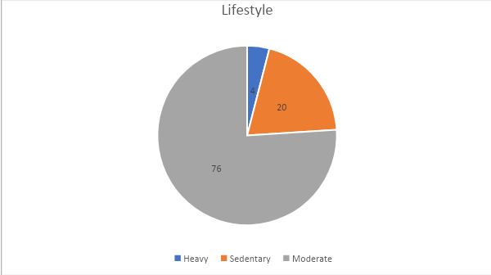
Fig 1. Pie chart showing lifestyle scenario
Lifestyle includes 76 out of 100 women were sedentary worker 20 out of them were moderate worker and 4 out of them were heavy worker.
Age of marriage
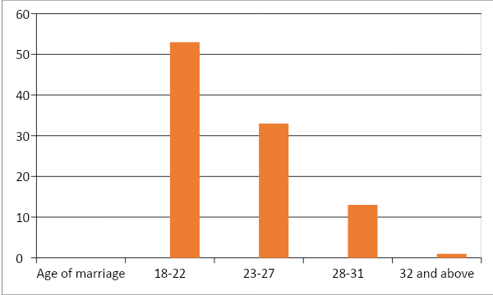

Fig 2. Bar graph showing Age of marriage
This bar graph is showing that out of 100 women 53 women were married between the age of 18-22 , 33 women were married between the age of 23-27,13 women were married between the age of 28-31 and 1 woman was married in the age of 32 years.

Age of 1st pregnancy
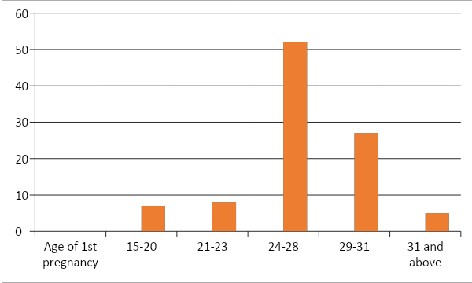
Fig 3. Bar graph showing Age of 1st pregnancy
This graph is showing that 7 women were got pregnant between the age of 15-20 years , 8 women were got pregnant between the age of 21-23 years, 52 women were got pregnant between the age of 24-28 years , 27 were got pregnant between the age of 29-31 years and 5 women got pregnant after 31 years of age.
Table 1. AGE OF 2ND PREGNANCY
24-27 |  | 14
28-32 |  | 19
32-34 |  | 5
35 and above |  | 9
No Respondants |  | 28
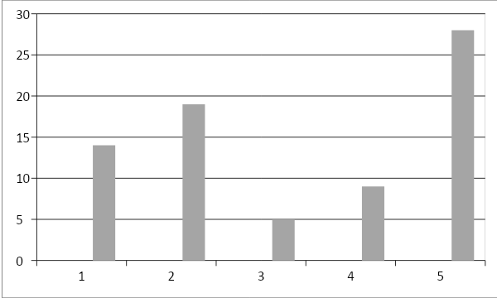
Fig 4. Bar graph showing age of 2nd pregnancy

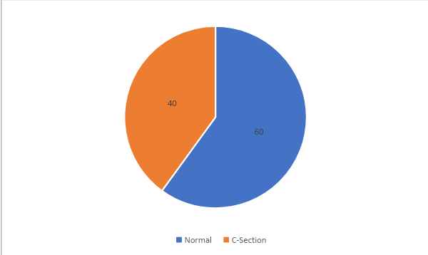

Fig 5. Pie chart showing type of delivery in 1st pregnancy
This result shows 60 out of 100 women had normal delivery and 40 out of them had c-section delivery.
Fig 6.

Type of delivery in 2nd pregnancy

Nromal
C-section
Miscarriage
No reapondants
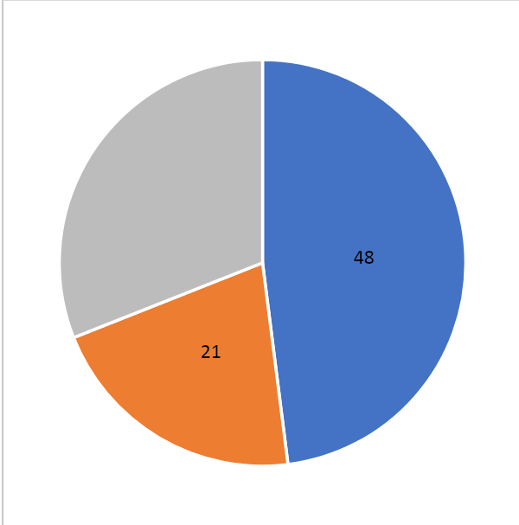

Fig 7. Pie chart showing suffered from PCOD Before Pregnancy
This graph depicts 83 out of 100 women had not suffered from PCOD before pregnancy and 11 outy of 100 women had suffered and 8 out of 100 with no response.

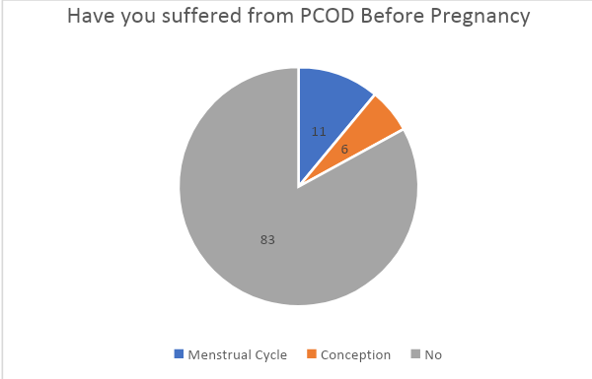
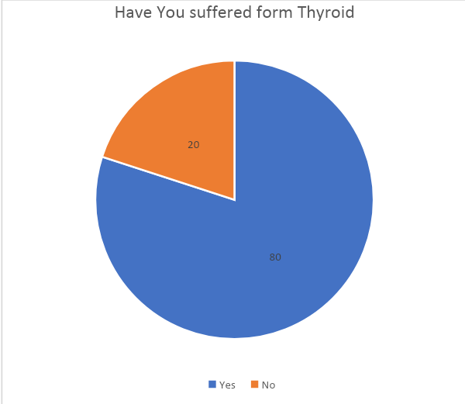
Fig 8. Pie chart showing suffering form Thyroid
This pie chart depicts that 20 women out of 100 were suffering from thyroid and 80 women out of 100 didn’t suffered from thyroid.
Table 2. Common Symptoms during pregnancy
 | Cold | 2
 | Cough | 1
 | Fever | 1
 | Headache | 11
 | Weakness | 36
 | Nausea | 51
 | Vomiting | 52
 | Others | 08
 | Morning sickness  Missed period cycle | 52  35

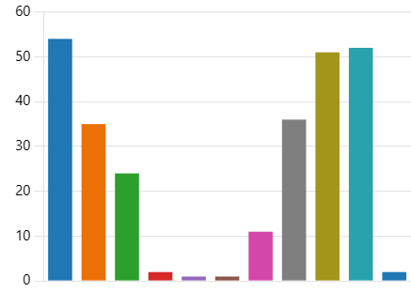

Fig 9. Complications faced during pregnancy
What were the complications suffered during period cycle?
Disturbed cycle 11(16%)

Irregular periods 36(54%)

Pain during menses 20(36%)

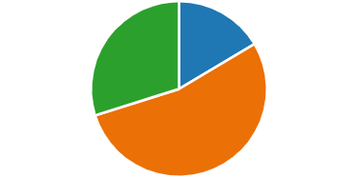
FIG 10: Pie chart showing Diabetes during pregnancy

Did you have diabetes during pregnancy?
Prolonged 10(53%)
Gestational Diabetes 9(47%)
Did you suffer from Covid-19?
During pregnancy |  |  | 8
At the time of delivery |  |  | 5
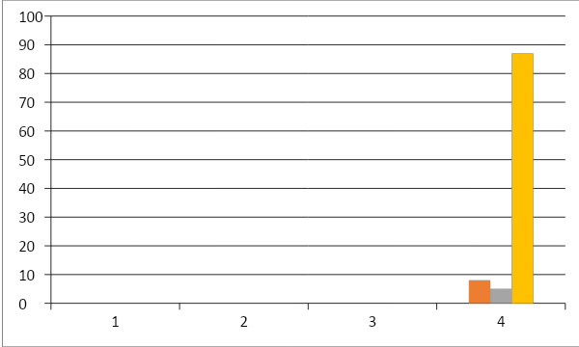
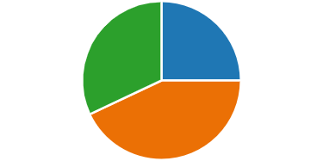

Fig 12. Pie chart showing affect in mental health
Yes 25(25%)

No 43(43%)

Maybe 32(32%)

Table 3. What were the issues?

 | Mood swings | 63
 | Irritation | 35
 | Stress | 32
 | Anxiety | 28
 | Fatigue | 48
 | Relation with family members | 14
 | Others | 5

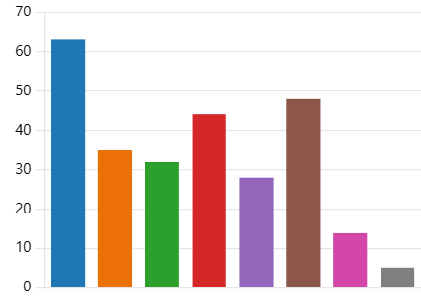
Fig 13. Bar graph showing related issues

Table 4. How did you deal with negative mental health during pregnancy?
 | Going park and relaxing | 10
 | Watching television | 12
 | Doing walk | 20
 | Yoga | 13
 | Meditation | 21
 | Satisfying cravings | 16
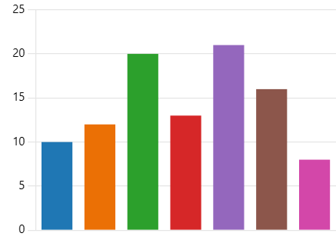
Fig 14. Bar graph showing mental health during pregnancy
What were the cravings you had in your pregnancy?
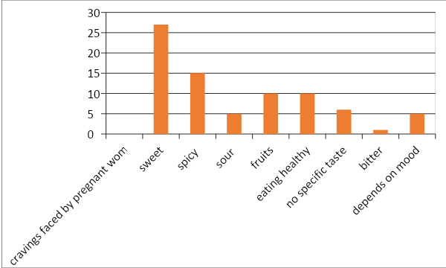
Fig 15. Bar graph showing cravings during pregnancy
This graph depicts various types of cravings were there from which 100 women gone through
What were the complications in your delivery?
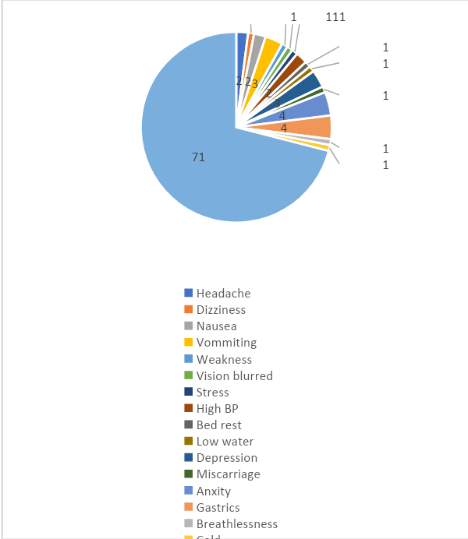
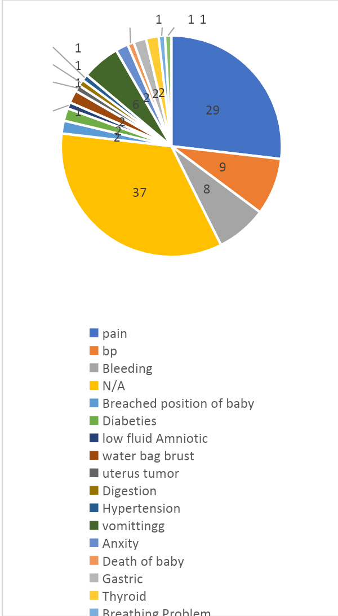

Fig 16. Pie chart showing complications in delivery
This graph represents multiple types of complications from which 10 women suffered at the time of delivery
Any Abortion?
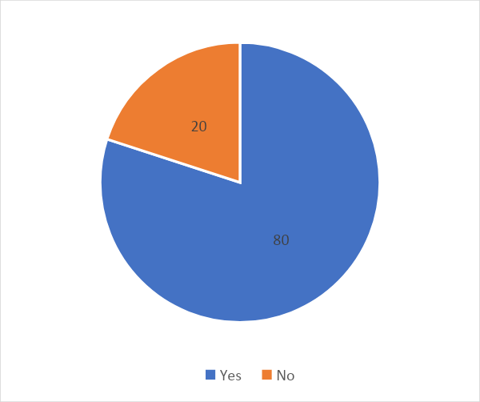
Fig 17. Pie chart showing abortion scenario
This pie chart shows 80 out of 100 women had suffered from abortion and 20 women had not suffered from abortion.

Any Miscarriage?
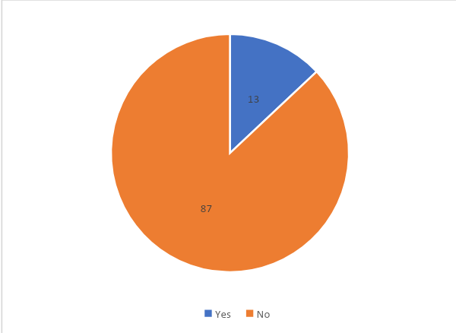

Fig 18. Pie chart showing miscarriage scenario
This pie chart depicts that 13 out of 100 women were suffered from miscarriage and 87 women did not.
In how many weeks your baby was born?
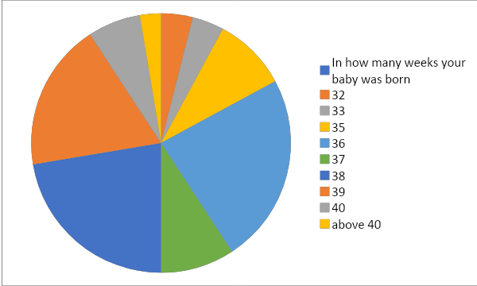

Fig 19. Pie chart showing weeks of born of baby

What was the weight of your baby at the time of birth?
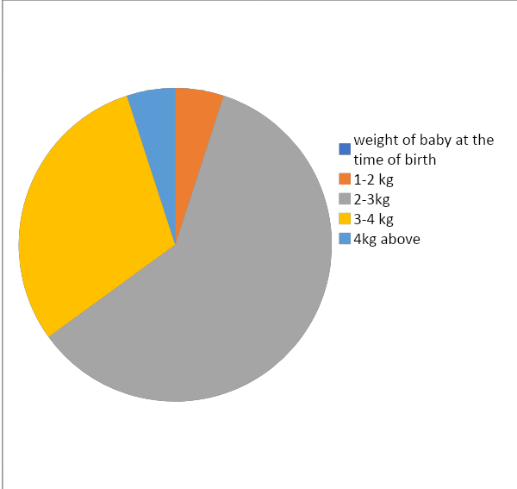
Fig 20. Pie chart showing weight of baby at the time of birth
This pie chart represents that 5 babies were born in the category of 1-2kg birth weight , 60 babies were born in the category of 2-3kg birth weight 30 babies were born in the category of 3-4 kg birth weight and 5 babies were born under the category of above 4 kg birth weight.
What was your weight(in kg) before pregnancy?
Weight category
45-55=35 55-65=35 65 and above=30

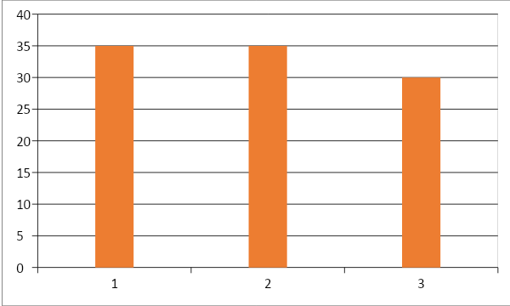

Fig 21. Bar graph showing weight(in kg) before pregnancy
What was your weight(in kg) after pregnancy?
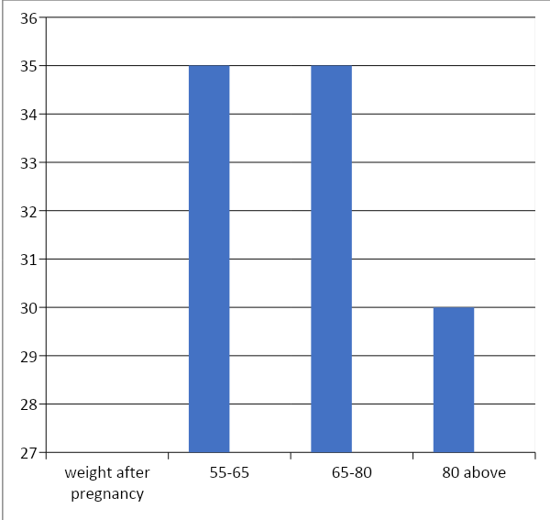
Fig 22. Bar graph showing weight(in kg) after pregnancy
This graph represents that 35 out of 100 women gained weight between the range of 55-65kg and also 35 more women gained weight between the range of 65-80 kg weight and 30 women gained weight above 80 kg.
Conclusion
In this study on 100 different women, we found that , 27 women were suffering from complications during late age pregnancy include Gestational Diabetes , Thyroid , complications due to High Blood Pressure , Cyst in Uterus ,Bed Rest due to previous Miscarriage , Bleeding in Second Trimester , Acute Body Pain, Acute Rise in Blood pressure. Premature delivery was seen due to late age pregnancy. 16 out of 100 women had premature delivery i.e in 33 to 35 weeks of pregnancy or 7th and 8th month of pregnancy. As per risks and complications, diets were also different like low sodium diet. Protein was also in moderate amount because of high blood pressure . This also included taking less amount of saturated fats like oil, butter , ghee and including anti-hypertensive drugs in diet is must. As pregnancy is a period in which a baby develops in a living state so more dietary requirement is there so in this study there were many types of diet recommended as high calorie diet, calcium rich diet , iron rich diet , healthy and nutritious diet with lots of antioxidants like fruits , vegetables and whole grains. Women were recommended some tablets like iron, calcium, folic acid in normal pregnancy and Thyroxine in case women had Thyroid. In late age pregnancy, there were total 59 responses out of 100 , 27(45.7%) women facing problems due to late age pregnancy like high BP, stillbirth , death of fetus in womb , thyroid, gestational diabetes and complications during delivery and 54.20% women were not having any problems.

Women who suffered pregnancy induced hypertension , out of 57women 17(29.82%) were facing problems like depression , anxiety , miscarriage , weakness , vomiting , nausea. Out of 100 women , 9 women suffered from gestational diabetes and 10 women had prolonged diabetes . So from above results , it is considered that women who are 35 years and above are considered to be at “high risk” for pregnancy. Women who were aged 22-30 years didn’t suffer from such diseases but gestational diabetes was observed in some cases. Women who were aged 28-35 years suffered miscarriage and abortion due to unknown reason.
According to Stillbirth Collaborative Research Network Writing Group Association (2011), long before admitting women for emergency situations during parturition, efforts should be directed to mitigation of pathologic risk factors that can be modified, conversely non-pathologic factors that cannot be mitigated. Reddy et al. (2010) said that these factors should not be ignored since they lead to more awareness so that adequate management can be planned.
References
- Barthélémy Tandu-Umba, Muela Andy Mbangama, Kitenge Marc Brunel Kamongola, Armel Georges Kamgang Tchawou, Mawamfumu Perthus Kivuidi, Sam Kasonga Munene, Irène Kambashi Meke, Oscar Kapuku Kabasele, Bituemi Jackson Kondoli, Kibundila Rolly Kikuni, and Simon Kasikila Kuzungu(2014).Pre-pregnancy high-risk factors at first antenatal visit: how predictive are these of pregnancy outcomes? Int J Womens Health; 6: 1011–1018.
- Bergsjø P. What Is the Evidence for the Role of Antenatal Care Strategies in the Reduction of Maternal Mortality and Morbidity? Reduction of Maternal Mortality: A Joint WHO/UNFPA/UNICEF/World Bank Statement. Geneva: World Health Organization; 1999. [Google Scholar.
- Duckitt K, Harrington D. Risk factors for pre-eclampsia at antenatal booking: systematic review of controlled studies. BMJ. 2005;12330(7491):565. [PMC free article] [PubMed] [Google Scholar].
- Global Burden of Disease Study 1990–2017. India State-Level Disease Burden Initiative Malnutrition Collaborators The burden of child and maternal malnutrition and trends in its indicators in the states of India: Lancet Child Adolesc Health. 2019;3:855-70. 10.1016/S2352-4642(19)30273-1 [PMC free article] [PubMed] [CrossRef] [Google Scholar]

- Haas JS, Fuentes-Afflick E, Stewart AL, et al. Prepregnancy health status and the risk of preterm delivery. Arch Pediatr Adolesc Med. 2005;159(1):58–63. [PubMed] [Google Scholar]

- Hedderson MM, Darbinian JA, Sridhar SB, Quesenberry CP. Prepregnancy cardiometabolic and inflammatory risk factors and subsequent risk of hypertensive disorders of pregnancy. Am J Obst Gynecol. 2012;207(1):68. e1–e9. [PMC free article] [PubMed] [Google Scholar].
- Horwood G, Opondo C, Choudhury SS, Rani A, Nair M.Risk factors for maternal mortality among 1.9 million women in nine empowered action group states in India: secondary analysis of Annual Health Survey data. BMJ Open. 2020;10:e038910. 10.1136/bmjopen-2020-038910 [PMC free article] [PubMed] [CrossRef] [Google Scholar].
- India – Sample Registration System (SRS)-Special Bulletin on Maternal Mortality in Indian 2017-19 Available: https://censusindia.gov.in/nada/index.php/catalog/40525#metadata-authors. Accessed: 13 June 2023.
- Kutchi I, Chellammal P, Akila A.Maternal Obesity and Pregnancy Outcome: in Perspective of New Asian Indian Guidelines. J Obstet Gynaecol India. 2020;70:138-44. 10.1007/s13224-019-01301-8 [PMC free article] [PubMed] [CrossRef] [Google Scholar]
- Majoko F, Nyström L, Munjanja S, Lindmark G. Usefulness of risk scoring at booking for antenatal care in predicting adverse pregnancy outcome in a rural African setting. J Obstet Gynaecol. 2002;22(6):604–609. [PubMed] [Google Scholar]
- Mgaya AH, Massawe SN, Kidanto H, Mgaya HN. Grand multiparity: is it still a risk in pregnancy? BMC Pregnancy Childbirth. 2013;13:241. [PMC free article] [PubMed] [Google Scholar.
- Oyerinde K. Can antenatal care result in significant maternal mortality reduction in developing countries? J Community Med Health Educ. 2013;3(2):2–3. [Google Scholar].
- Periyasamy Kuppusamy, Ranjan Kumar Prusty, and Deepali Prakash Kale (2023) High-risk pregnancy in India: Prevalence and contributing risk factors – a national survey-based analysis. J Glob Health. 13: 04116.
- Reddy UM, Laughon SK, Sun L, Troendle J, Willinger M, Zhang J. Prepregnancy risk factors for antepartum stillbirth in the United States. Obstet Gynecol. 2010;116(5):1119–1126. [PMC free article] [PubMed] [Google Scholar].

- Stillbirth Collaborative Research Network Writing Group Association between stillbirth and risk factors known at pregnancy confirmation. JAMA. 2011;306(22):2469–2479. [PMC free article] [PubMed] [Google Scholar].
- Ye L, Cao W, Yao J, Peng G, Zhou R.Systematic review of the effects of birth spacing after caesarean delivery on maternal and perinatal outcomes. Int J Gynaecol Obstet. 2019;147:19-28. 10.1002/ijgo.12895 [PubMed] [CrossRef] [Google Scholar]

