Genetic Diversity of rice bacterial leaf blight pathogen, Xanthomonas oryzae pv. oryzae in Godavari Zone of Andhra Pradesh, India

Abstract
Bacterial leaf blight (BLB), caused by Xanthomonas oryzae pv. oryzae (Xoo), is one of the major biotic constraints limiting yields in paddy in Andhra Pradesh. The present study was conducted at ANGRAU – Regional Agricultural Research Station, Maruteru, Andhra Pradesh, during Kharif 2024 to understand genetic variability among twenty Xoo isolates collected from five districts of the Godavari zone in Andhra Pradesh. Bacterial genomic DNA was extracted, analysed for purity and concentration, followed by PCR amplification using universal 16S rDNA and Xoo-specific JEL marker primers. Most virulent BLB isolate (Xoo7) in the present study was characterised as the Xanthomonas oryzae pv. oryzae by using universal primer 16S rDNA sequence. Genetic diversity assessed using JEL primers (targeting IS1112 sequence) and UPGMA clustering analysis revealed considerable genetic variability among the twenty Xoo isolates; the isolates were grouped in two major clades in the dendrogram. The clustering pattern corresponded with geographical origin and rice cultivars, suggesting localized adaptation. These findings offer valuable insights into the pathogen’s population structure and have implications for disease management strategies and breeding programs.
Keywords: Rice, genetic diversity, BLB, Xanthomonas oryzae pv. oryzae
Introduction
Bacterial leaf blight (BLB) of rice caused by Xanthomonas oryzaepv. oryzae (Xoo), is one of the most devastating bacterial diseases of rice worldwide, particularly in tropical and subtropical rice-growing regions like India. The pathogen invades vascular tissues, leading to wilting and yield losses that can exceed 50% under favourable conditions (Nino-Liu et al., 2006). More than 33 strains of Xoo have been identified from various rice-growing countries worldwide (Oliva et al., 2019; Luo et al., 2021). Traditional identification methods based on symptomology and culture characteristics have limitations in sensitivity and specificity, highlighting the need for molecular approaches to understand the population structure and regional adaptation of the pathogen, such as 16S rDNA sequencing and marker-assisted analysis. (Reddy et al. 2009). The genetic diversity of Xoo strains can be characterised through their transposons, virulence genes, and insertion sequences (IS), one of which is identified using DNA analysis with the IS1112 sequence (Mishra et al., 2013; Yang et al., 2013; Deng et al., 2016). IS1112 is a type of primer based on RAPD-PCR (Shahrestani et al., 2012) that enables the identification of Xoo pathogen isolates and the detection of genetic diversity within a population by analysing specific DNA fragments (Yugander et al., 2017; Chen et al., 2019).JEL-1 and JEL-2 are two IS1112 primers that are frequently used to analyze the variety of Xoo strain (Islam et al., 2016; Manigundan et al., 2017; Sandhu et al., 2018, Lore et al., 20). In Andhra Pradesh, especially in the Godavari zone, BLB outbreaks have been increasingly reported, posing a significant threat to rice production. High genetic diversity of Xoo is found in major rice-producing countries in Asia, such as Indonesia (Djatmiko et al., 2011; Sudir & Yuliani, 2016). Hence, the present study aims to understand genetic diversity among Xoo isolates from the Godavari zone of Andhra Pradesh, using the IS1112-based RAPD PCR approach.
Materials and Methods:
The study was undertaken at ANGRAU – Regional Agricultural Research Station, Maruteru, and Agricultural Research Station, Peddapuram, Andhra Pradesh, during kharif 2024. Bacterial leaf blight infected leaf samples were collected from the five districts of Godavari zone viz., East Godavari, West Godavari, Eluru, Kakinada and Dr. B R Ambedkar Konaseema district. Standard laboratory procedures were followed for the isolation of the causal agent of bacterial leaf blight of rice.
Isolation of DNA:
The twenty cultures of purified Xanthomonas oryzae pv. oryzae isolates, representing five districts of Godavari zone were grown in 10ml nutrient broth for 72 h on shaker at 30⁰C. Subsequently, 1.5 ml of 72 h Xoo culture growth in NB medium was taken in eppendorf tubes, centrifuged at 10,000rpm for 10 min, supernatant was discarded and pellets were air dried and resuspended in 500 µl of TE buffer. To this, 45 µl of 10% SDS and 8 µl of proteinase K were added, followed by incubation at 55°C for 60 min. Next, 280 µl of 5 M NaCl and 140 µl of 10% CTAB were added, and the mixture was incubated at 60°C for 10 min. DNA was extracted using 500 µl of chloroform and isoamyl alcohol (24:1) and centrifuged at 10,000 rpm for 10 minutes. The aqueous layer was transferred to a fresh tube containing 50 µl of chilled 3 M sodium acetate and 300 µl of chilled isopropanol, gently mixed, and incubated overnight at −20°C. The DNA was pelleted by centrifugation at 12,000 rpm for 10 minutes, washed twice with 1 ml of 70% ethanol (ice cold), air-dried, and dissolved in 30 µl of cold TE buffer. The DNA was stored at −20°C for further analysis. Purity and concentration were assessed using a NanoDrop spectrophotometer (DeNovix DS-11 FX) at A260/280, with acceptable purity values ranging from 1.8 to 2.2. DNA integrity was confirmed by 1.0% agarose gel electrophoresis in 1X TAE buffer, stained with ethidium bromide, and visualized using a UV transilluminator with a 1 kb DNA ladder.
Polymerase chain reaction for identification of bacteria using 16S rDNA analysis:
Required volume of reagent mixture (Master mix.12.5ul, PCR water. 7ul, Taq polymerase 0.5ul, Universal primer (Forward: 5’GAG TTT GAT CCT GCT CAG 3’; Reverse: 5’ GTT ACC TTG TTA CGA CTT 3’) each of 1.25ulhaving 5ul of the DNA sample were mixed in PCR tubes and placed in PCR apparatus. Programme of PCR machine was adjusted to initially denaturation for 5 min at 94⁰C and then subjected to 35 cycles of PCR (denaturation for 1min at 94⁰C 1 min annealing at 55⁰C and 2min extension at 72⁰C) and a final extension for 10min at 72⁰C. The purified product of virulent isolate Xoo7 purified, sequenced and compared with 16srRNA sequence of bacteria from NCBI Gene Bank database and accession numbers were obtained.
Study of Genetic diversity and DNA amplification of Xoo isolates using JEL markers:
The genetic diversity of twenty Xoo isolates was assessed using a modified method by (Kumar and Balabaskar, 2013) with outwardly directed primers pJEL1 and pJEL2, targeting the IS1112 repeat element in the Xoo genome. PCR amplification was performed using 7 µl nuclear-free water, 5 µl DNA (20 ng µl⁻¹), and 2 µl primer, 2.5µl 10x buffer on a thermal cycler, following the conditions in Table 2. Products were separated by electrophoresis on 1.0% agarose gel (90 min at 80 V) with a 1 kb DNA ladder. The gels were stained with ethidium bromide and visualised under UV light using a ChemidocBio-Rad™ device.
Table1. PCR cycle and temperature regulation for IS1112 analysis (Islam et al., 2016).
S.No. | Step | Temperature | Duration
1. | Initial Denaturation | 94⁰C | 5min
2. | Denaturation | 94⁰C | 1min
3. | Annealing | 62⁰C | 1min
4. | Extension | 65⁰C | 8min
5. | Final Extension | 65⁰C | 10min
Cluster Analysis
The electropherogram was scored for the presence (1) or absence (0) of the bands. The reproducibility of the DNA profiles of all the isolates was tested by repeating the PCR and only the reproducible bands were considered for analysis. The resulting banding patterns were analysed using neighbour joining (NJ) method NTSYS-PC software (Exeter Software, NY, USA), and a dendrogram was constructed using the Unweighted Pair Group Method with Arithmetic Mean (UPGMA).
Results and Discussion
Identification of Virulent Xanthomonas oryzae pv. oryzae Isolate using universal primers 16srDNA.
Xoo isolates collected from five districts of Godavari zone of Andhra Pradesh yielded ~1500bp amplified product in PCR assays with universal primer pair (Fig. 1). The PCR-amplified product obtained using the universal 16S rDNA primer from the most virulent isolate in the present study, Xoo7, was sequenced, and the resulting DNA sequence was analysed using BLASTn in the NCBI database. Molecular characterisation of the sample confirmed the identity of the isolate as Xanthomonas oryzae pv. oryzae (Table 2), The final consensus sequence was successfully submitted and deposited in the NCBI GeneBank.
Table.2. Phylogenetic identity of 16srRNA gene sequence after blast
Isolate | Percentage Similarity (%) | Strain Identified | NCBI Accession No.
Xoo7 | 100.00 | Xanthomonas oryzae pv. oryzae | PV827154

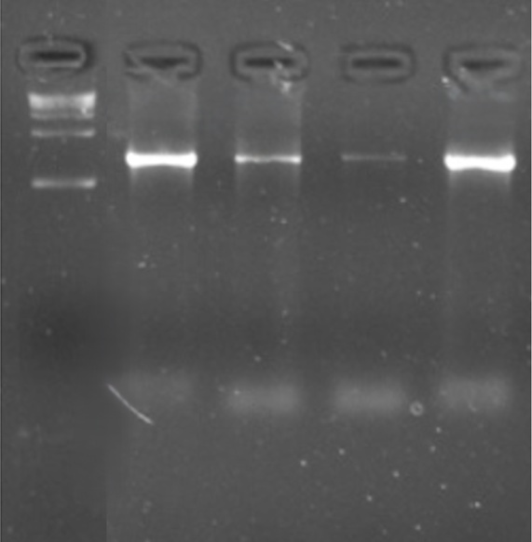
1
M
1500bp
LANE: M- Ladder; 1- Xoo7
Fig 1: Characterisation of virulent isolate of Xanthomonas oryzae pv. oryzae amplified
using universal primer 16srDNA
Genetic Diversity Using JEL Markers
The resulting banding patterns were analysed using the UPGMA (Unweighted Pair Group Method with Arithmetic Mean) algorithm in NTSYS-PC software (Exeter software, NY, USA). Amplicon numbers varied from 5 to 11 among the isolates (Fig 3). Twenty isolates were grouped into two distinct clades as seen in figure 2. Clustering pattern revealed significant genetic variability among the twenty isolates of Xoo, which was crucial for understanding the pathogen's population structure. The isolates were grouped based on their genetic similarities, geographical distribution and cultivated varieties, with the length of the branches indicating the degree of genetic dissimilarity among them.
Majority of Xoo isolates were grouped in Clade I, which has three sub-clades. Sub-clade IA comprised of five isolates Xoo1, Xoo2, Xoo4 and Xoo17, Xoo9 with similarity co-efficient (0.63) most of which were the isolates from East Godavari district, while, sub-clade IB comprises of eight isolates Xoo5, Xoo6, Xoo7, Xoo8, Xoo18, Xoo19, Xoo20 and Xoo3 with similarity co-efficient (0.60). Whereas sub-Clade IC has only one isolate, Xoo16 showing variation among the isolates. Meanwhile Clade II was subdivided into two sub-clades (Table 3). Wheresub-clade IIA comprises of four isolates Xoo10, Xoo11, Xoo14, Xoo15 with similarity index (0.63) and sub clade- IIB contained two isolates, Xoo12, Xoo13 with similarity index (0.85).
The dendrogram analysis revealed that Xanthomonas oryzae pv. oryzae (Xoo) isolates collected from geographically proximate areas and regions cultivating similar rice varieties tended to clade together. This pattern suggests a degree of regional homogeneity and localized adaptation of the pathogen. For instance, isolates from East Godavari (Xoo1, Xoo2, Xoo3, Xoo4) and Kakinada (Xoo17, Xoo19, Xoo20), associated with varieties such as NP-9558 and RGL-2537, grouped into a single clade. This indicates limited gene flow across distant regions and highlights the potential influence of localized environmental conditions and agronomic practices on the pathogen's evolution. Similarly, isolates from the Konaseema district (Xoo5, Xoo6, Xoo7, Xoo8) also grouped within the same major clade but formed a distinct sub-clades. These isolates were associated with rice varieties such as MTU-7029, BPT-5204, and NP-558.
This clustering pattern aligns with the geographic configuration of the Godavari delta, where the river acts as a natural barrier demarcating districts. Consequently, isolates from East Godavari, Konaseema, and Kakinada tended to form one major group, while those from West Godavari and Eluru formed another, suggesting a potential evolutionary relationship shaped by physical boundaries and similar agro-climatic conditions within each zone. However, some isolates from West Godavari (Xoo9, Xoo12) and Eluru (Xoo16) showed significant divergence compared to other isolates, suggesting higher genetic variability. The findings on genetic diversity among Xoo isolates of Godavari zone of Andhra Pradesh could help understand phylogeny and evolution. Characterization of Xanthomonas oryzae pv. oryzae population using IS-sequences was also performed by Yugander et al. (2017), Shanti et al. (2001), Lakshmi and Rabindran, 2012.This diversity among Xoo isolates observed in the study could be attributed to factors such as the preference of rice varieties in the location, micro-environmental variations, and distinct management practices, all of which may exert selective pressure on the pathogen population, leading to greater genetic differentiation in those areas.

Table 3. Grouping of isolates based on amplification by using universal JEL markers
S.no. | Cluster | Sub  Cluster | Number of isolates | Isolate | Rice cultivars from which BLB was collected
1. | I | IA | 05 | Xoo1, Xoo2  Xoo17, Xoo4  Xoo9 | RGL-2537  NP-9558  MTU-1010
1. | I | IB | 08 | Xoo3, Xoo20, Xoo8  Xoo19, Xoo18  Xoo5, Xoo6, Xoo7, | NP-558  BPT-5204  MTU-7029
1. | I | IC | 01 | Xoo16 | MTU-1010
2. | II | IIA | 04 | Xoo10, Xoo11, Xoo14, Xoo15 | MTU-1318
2. | II | IIB | 02 | Xoo12, Xoo13 | MTU-1318

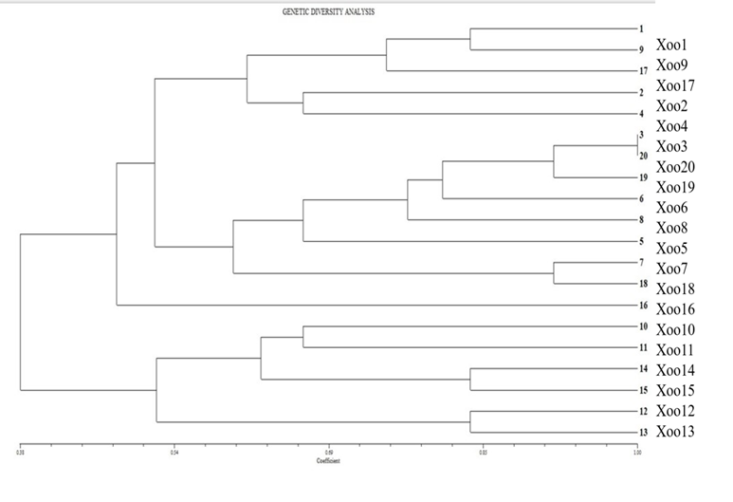
Fig 2. Grouping of isolates based on amplification by using universal JEL markers

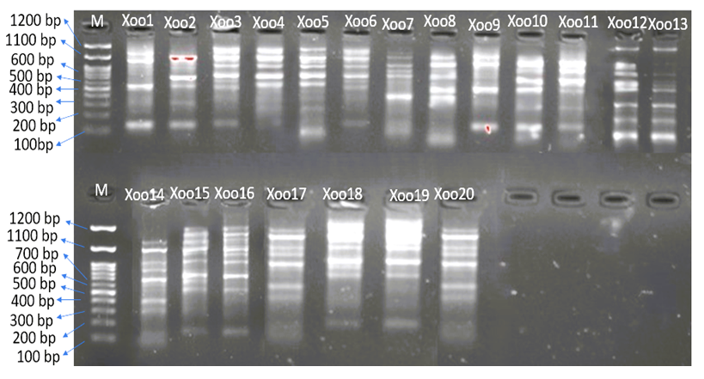
Fig 3. Polymorphism exhibited by twenty Xoo isolates amplified using JEL markers

Conclusion
The study confirmed the bacterial identity using 16S rDNA and demonstrated effective grouping using IS1112-based JEL markers. The genetic variability analysis of Xanthomonas oryzae pv. oryzae isolates from the Godavari zone revealed considerable diversity within the pathogen population. The clustering of isolates by geographical origin and rice variety indicates regional adaptation and limited gene flow. These insights are critical for developing durable resistance in rice breeding programs and tailoring localized disease management strategies.
Disclaimer:
Authors hereby declare that NO generative AI technologies such as large language models and text to image generators have been used during writing or editing of the manuscript

References:
Chen, X., Wei, S., Yan, Q., Huang, F., Ma, Z., Li, R., Cen, Z., Yan, W. & Li, K. (2019). Virulence and DNA fingerprinting analysis of Xanthomonas oryzae pv. oryzae identify a new pathotype in Guangxi, South China. Journal of Basic Microbiology, 59(11), 1082–1091.
Deng, WL., Lin, HA., Shih, Y. C., Kuo, C. C., Tzeng, J. Y., Liu, L. Y. D., Huang, S. T., Huang, C. M. & Chung, C. L. (2016). Genotypic and pathotypic diversity of Xanthomonas oryzae pv. oryzae strains in Taiwan. Journal of Phytopathology, 164(10), 745–759.
Djatmiko, H.A., Prakoso, B. & Prihatiningsih, N. (2011). Penentuanpatotipe dan keragamangenetik Xanthomonas oryzae pv. oryzae pada tanaman padi di wilayah Karesidenan Banyumas. Jurnal Hama dan Penyakit Tumbuhan Tropika, 11(1), 35–46.
Islam, M.R., Alam, M.S., Khan, A.I., Hossain, I., Adam, L.R. & Daayf, F. (2016). Analyses of genetic diversity of bacterial blight pathogen, Xanthomonas oryzae pv. oryzae using IS1112 in Bangladesh. Comptes Rendus Biologies, 339(9-10), 399–407.
Kumar, L.V. & Balabaskar, P. (2013). Survey, isolation, characterization and pathogenicity of Xanthomonas oryzae pv. oryzae causing bacterial leaf blight disease in Rice. Annals of Plant Protection Sciences, 21(1), 131- 135.
Lakshmi, D. L. & Rabindran, R. (2012). Molecular variability in Xanthomonas oryzae pv. oryzae isolates of Tamil Nadu. Indian Journal of Plant Protection, 40(2), 123-128.
Lore, J. S., Vikal, Y., Hunjan, M. S., Goel, R. K., Bharaj, T. S., & Raina, G. L. (2011). Genotypic and pathotypic diversity of Xanthomonas oryzae pv. oryzae, the cause of bacterial blight of rice in Punjab State of India. Journal of Phytopathology, 159(7‐8), 479-487.
Luo, D., Huguet-Tapia, JC., Raborn, R. T., White, F. F., Brendel, V. P. & Yang B. (2021). The Xa7 resistance gene guards the rice susceptibility gene SWEET14 against exploitation by the bacterial blight pathogen. Plant Communications, 2(3), 1–11.
Manigundan, K., Kumar, P. P., Singh, R., Sakthivel, K., Gautam, R.K., Singh, P.K. & Laha, G. S. (2017). Rep-PCR distinguishes rice bacterial blight pathogen (Xanthomonas oryzae pv. oryzae) strains of Indian mainland and bay islands. Journal of Plant Pathology, 99(3), 773–778.
Mishra, D., Vishnupriya, M. R., Anil, M. G., Konda, K., Raj, Y. & Sonti, R. V. (2013). Pathotype and genetic diversity amongst Indian isolates of Xanthomonas oryzae pv. oryzae. PloS One, 8(11), 1–11.
NIÑO‐LIU, D.O., Ronald, P.C. & Bogdanove, A.J., (2006). Xanthomonas oryzae pathovars: model pathogens of a model crop. Molecular plant pathology, 7(5), pp.303-324.
Oliva, R., Ji, C., Atienza-Grande, G., Huguet-Tapia, J.C., Perez-Quintero, A., Li, T., Eom, J.S., Li, C., Nguyen, H., Liu, B., Auguy, F., Sciallano, C., Luu, V. T., Dossa, G.S., Cunnac, S., Schmidt, S. M., White, F. F. & Yang, B. (2019). Broad-spectrum resistance to bacterial blight in rice using genome editing. Nature Biotechnology, 37(11), 1344–1350.
Reddy, L.J., Sirisha, C. & Rao, K.R.S.S. (2009). Assessment of genetic and pathogenic diversity of Xanthomonas oryzae pv. oryzae on high yielding local variety, Tella Hamsa, from farmer fields in Gagillapur and Kompally, Andhra Pradesh. Taiwania, 54(3), 241-247.
Sandhu, A. F., Khan, J. A., Ali, S., Arshad, H. M. I. & Saleem, K. (2018). Molecular characterization of Xanthomonas oryzae pv. oryzae isolates and its resistance sources in rice germplasm. Pakistan Science Mission Microbiology, 3(2), 55–61.
Shahrestani, A. T., Kazempour, M. N., Ebadie, A. A. & Elahinia, S. A. (2012). Genetic diversity of Xanthomonas oryzae pv. oryzae in rice fields of Guilan province (Iran) using RAPD markers. Agricultura Tropica et Subtropica, 45(2), 60–65.
Shanti, M.L., George, M. L. C., Cruz, C. V., Bernardo, M. A., Nelson, R. J., Leung, H., Reddy, J. N & Sridhar, R. (2001). Identification of resistance genes effective against rice bacterial blight pathogen in eastern India. Plant Diseases,85(5), 506-512.
Sudir, S. & Yuliani, D. (2016). Composition and distribution of Xanthomonas oryzae pv. oryzae pathotypes, the pathogen of rice bacterial leaf blight in Indonesia. Agrivita, Journal of Agricultural Science, 38(2), 174–185.
Yang, S. Q., Liu, S. Y., Zhao, S., Yu, Y. H., Li, R. B., Duan, C. J., Tang, J. L. & Feng, J. X. (2013). Molecular and pathogenic characterization of new Xanthomonas oryzae pv. oryzae strains from the coastline region of Fangcheng gang city in China. World Journal of Microbiology and Biotechnology, 29(4), 713–720.
Yugander, A., Sundaram, R. M, Ladhalakshmi, D., Hajira, S. K., Prakasam, V., Prasad, M. S., Madhav, M. S., Babu, V. R. & Laha, G. S. (2017). Virulence profiling of Xanthomonas oryzae pv. oryzae isolates, causing bacterial blight of rice in India. European Journal of Plant Pathology, 149(1), 171–191.

