Original Research Article
PREVALENCE AND ECONOMIC IMPLICATIONS OF FOETAL WASTAGE IN SMALL RUMINANTS (SHEEP AND GOATS) SLAUGHTERED AT JALINGO ABATTOIR, TARABA STATE, NIGERIA

ABSTRACT
The slaughter of pregnant small ruminants resulting in fetal loss represents a significant constraint to livestock production and contributes to protein deficiency in developing countries. This study investigated the prevalence of fetal wastage in small ruminants and its associated economic implications at Jalingo Abattoir in Taraba State, Nigeria. A cross-sectional study was conducted over six months, spanning September 2023 through February 2024. Daily abattoir visits were undertaken to record the total number of sheep and goats slaughtered, examine uteri of slaughtered females for the presence of fetuses, and determine fetal age, sex, and breed through crown-rump length measurements. Economic losses were quantified using prevailing local market values, and data analysis employed descriptive statistics and Chi-square tests. Results showed that 3,785 sheep and 8,662 goats were slaughtered during the study period, with females comprising 75.06% of sheep and 31.10% of goats. Pregnancy was detected in 22.56% of ewes and 20.75% of does among slaughtered females. A total of 678 lamb fetuses and 643 kid fetuses were recovered, yielding prevalence rates of 23.86% and 23.87%, respectively. Female fetuses predominated in both species (53.10% in sheep; 52.57% in goats). The majority of fetuses were in their second or third trimesters, indicating advanced gestational stages. Yankasa sheep and Sokoto Red goats emerged as the most affected breeds. Economic losses over the six-month study period were estimated at ₦5,962,000, projecting to an annual loss of ₦11,924,000.These findings highlight the critical need for enhanced ante-mortem inspection protocols, farmer education on pregnancy detection methods, and stricter enforcement of regulations prohibiting the slaughter of pregnant animals to improve livestock productivity and strengthen food security.
Keywords: Fetal wastage, Small ruminants, Economic losses, Jalingo Abattoir, Pregnancy prevalence

- INTRODUCTION
The world livestock population comprises about 1.340 billion cattle, 1.149 billion sheep, and 390 million goats (Adeyemi et al., 2016). In Nigeria, the sheep and goat populations are estimated to be 38.5 million and 57.4 million, respectively (FAO, 2014). Small ruminants have become increasingly vital to the world’s economy, especially as global food insecurity rises and many countries view them as a sustainable agricultural resource (Khan et al., 2021). In Africa, these animals are recognized for enhancing the livelihoods of those living in poverty and play crucial roles in ensuring food and financial security in developing nations like Nigeria (Gamo et al., 2017). However, despite their significance, Nigeria's human population is growing at an estimated rate of 3.5% per year, while livestock resources are only increasing between 0.8% and 2.9% annually (Alhaji and Odetokun, 2013). The average protein intake per person per day in Nigeria is estimated to be 14.85 g, with meat contributing just 6.8 g (FAO, 2014). This highlights the urgent need to enhance small ruminant production in the country.
A concerning issue in small ruminant production is foetal wastage, which refers to the slaughter of pregnant animals without regard for the developing embryos. This practice has led to the unethical killing of breeding livestock and pregnant animals in many Nigerian abattoirs (Ugwu et al., 2023). Foetal wastage is recognised as a significant contributor to economic losses in the livestock sector and raises serious ethical questions about animal welfare (Mohammed et al., 2023). It's estimated that as much as 60% of small ruminant foetuses are lost due to slaughter practices in abattoirs (Oyekunle et al., 2021), which exacerbates livestock shortages and protein malnutrition in developing countries.
In Africa, the loss of foetuses in small ruminants is a major constraint for production in various regions. Research from East Africa, particularly in Ethiopia (Wakayo and Abrham 2021), has shown that pregnancy loss rates rise between 15-30% in small ruminants at slaughterhouses. Similarly, studies in West Africa, particularly in Ghana, have found prevalence rates of 18-25% in sheep and goats (Mohammed and Anane, 2022; Tasiame et al., 2016). Several intervention strategies have been implemented with mixed results. Ethiopia's community-based pregnancy detection training programmes, which equipped livestock farmers with basic palpation skills, achieved a 40% reduction in pregnant animal slaughter within two years of implementation (Habtegiorg et al., 2022).
Tanzania has made significant strides in enforcing abattoir regulations, introducing mandatory pregnancy checks and penalties for those who don’t comply. This has led to noticeable improvements in reducing foetal wastage (Kashoma et al., 2023). However, not all interventions have proven successful. Voluntary compliance programmes without enforcement mechanisms have shown limited effectiveness, as economic pressures often override voluntary adherence. Awareness campaigns conducted without accompanying practical training in pregnancy detection methods have demonstrated minimal impact on changing slaughter practices (Chama et al., 2019).
However, technology-based interventions face significant barriers to adoption in resource-limited settings. This is due to a mix of high costs, a shortage of technical know-how, and insufficient infrastructure for ongoing maintenance and support (Mohammed and Ibrahim, 2024). These challenges highlight the need for context-sensitive, multi-dimensional strategies that blend education, technology, regulatory measures, and economic incentives.
The economic and ethical implications of foetal wastage in small ruminants have not been adequately assessed in Jalingo Abattoir, Taraba State. This study aims to assess how prevalent foetal wastage is among small ruminants (sheep and goats) and what economic impacts it has at the Jalingo abattoir. Specifically, we examined the rates of foetal wastage, the age, sex, and breed distribution of the foetuses, and calculated the economic losses involved. The findings will provide baseline data for developing evidence-based policies and interventions to reduce this practice and enhance livestock productivity.

- MATERIALS AND METHODS

2.1 Study Area
The study was conducted at Jalingo Abattoir, Taraba State. Jalingo is located located on latitude 8°54' to 9°01'N and longitude 11°22' to 11°30'E, with an altitude of 351 meters above sea level (Yusuf et al., 2015). The abattoir serves as the main slaughter facility for Jalingo, the state capital, and surrounding areas, processing animals from diverse sources throughout the region.

2.2 Study Population
The study population comprised all small ruminants (sheep and goats) slaughtered at Jalingo main abattoir, including the three most common breeds of sheep (Yankasa, Balami and Uda) and goats (Sokoto Red, West African Dwarf and Sahelian) found in Nigeria.

2.3 Research Design and Study Duration
A cross-sectional study design was employed over six months (September 2023 to February 2024). Data were collected daily between 6:00 a.m. and 10:00 a.m., Monday through Saturday, in collaboration with para-veterinary officers (meat inspectors).
FLOW CHART
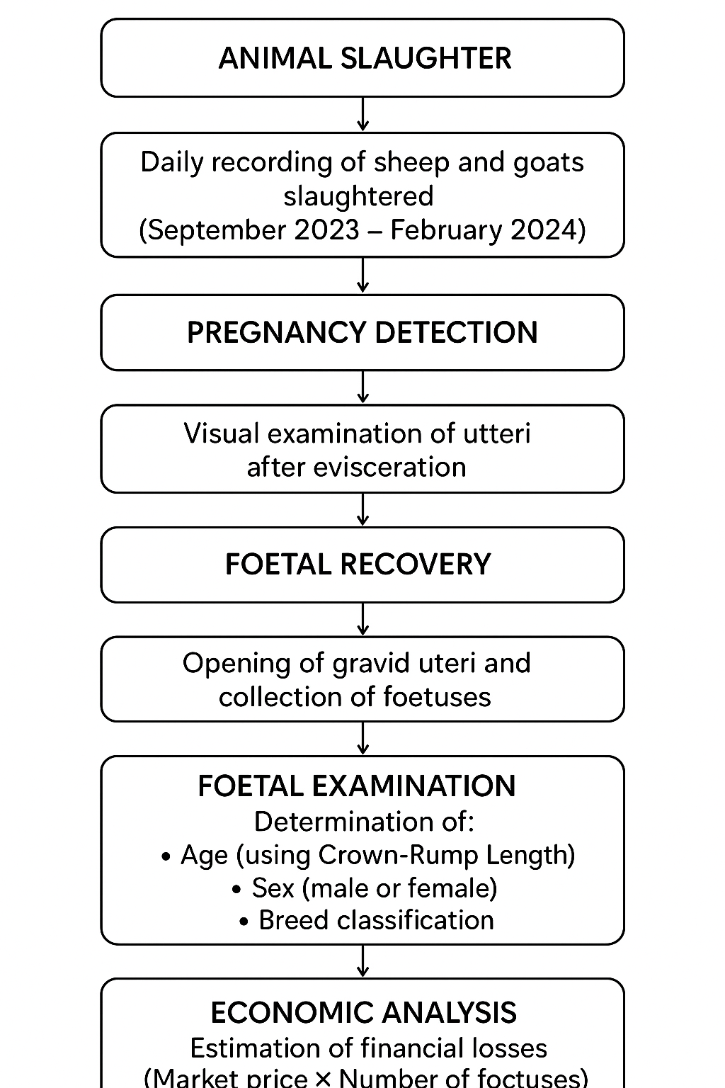

2.4 Data Collection
On each abattoir visit, the total number and breed of small ruminants slaughtered were recorded. After evisceration, uteri of slaughtered ewes and does were examined for pregnancy. Gravid uteri were opened to determine gestational age and sex of foetuses. The number of slaughtered animals, pregnant females, and the age, sex and breed of foetuses were recorded. Some ewes and does carried multiple foetuses, resulting in higher total foetuses than pregnant animals.

2.4.1 Age Determination of Foetuses
Pregnancy status was determined by visual assessment of exposed uteri after slaughter. Foetal age was determined by measuring crown-rump length (CRL) according to Richardson et al. (1990): 0-5 cm = First trimester (0-50 days); 6-21 cm = Second trimester (51-100 days); 22-50 cm = Third trimester (101-150 days).

2.4.2 Prevalence Calculation
Prevalence of foetal wastage was calculated as: % foetal wastage = (total number of foetuses recovered)/(total number of ewes or does slaughtered) × 100

2.4.3 Determination of Breed and Sex of Foetus
A retrieved foetus was physically examined at the posterior regions so as to sex them based on the appearance of developmental reproductive features (i.e. Testicles in male and V-shape slit in female).

2.5 Economic Loss Estimation
Economic loss was estimated as: Amount lost = (total number of foetuses wasted) × (average price of a lamb/kid at birth). Economic losses were calculated using ₦5,000 for lamb at birth and ₦4,000 for kid at birth based on local market prices.
2.6 Ethics Statement
This observational study involved no animal experimentation. Animals examined were commercially slaughtered for meat production independent of this research. Verbal permission was obtained from the Taraba State Ministry of Agriculture before commencing the study. The study was conducted in collaboration with official meat inspectors and adhered to all local regulations governing abattoir operations. No animals were specifically procured or slaughtered for this research. All data were collected anonymously without personal identifiers of animal owners or traders.

2.7 Data Analysis
Data were analyzed using IBM SPSS version 20. Descriptive statistics were used to summarize findings, and Chi-square tests (2 degrees of freedom) were used to determine associations between variables. Results were presented in tables and figures.
- RESULTS
Table 1 presents the monthly distribution of slaughtered sheep and goats. Female animals (ewes) were slaughtered in significantly higher numbers than males (rams), with 2,841 ewes compared to 944 rams (75.06% ewes). The pattern was reversed in goats, with 5,968 bucks compared to 2,694 does (31.10% does). Overall, substantially more goats (8,662) were slaughtered than sheep (3,785).
Table 2 shows that pregnant animals were slaughtered daily throughout the study. Of 2,841 ewes slaughtered, 641 (22.56%) were pregnant, while 559 of 2,694 does (20.75%) were pregnant, with monthly variations observed.
Table 3 presents foetal recovery data. A total of 678 lamb foetuses (23.86% of ewes) and 643 kid foetuses (23.87% of does) were recovered. Higher foetus numbers compared to pregnant animals resulted from twin pregnancies
Table 4 reveals that female foetuses were recovered in higher numbers than males in both species. Among sheep, 360 female lamb foetuses (53.10%) were recovered compared to 318 male lamb foetuses (46.90%). In goats, 338 female kid foetuses (52.57%) were recovered compared to 305 male kid foetuses (47.43%).
Table 5 shows the majority of foetuses were in second and third trimesters. For sheep, first trimester foetuses accounted for 15.93% (108), second trimester 39.68% (269), and third trimester 44.39% (301). In goats, the distribution was 11.66% (75) first trimester, 55.37% (356) second trimester, and 32.97% (212) third trimester. Statistical analysis showed no significant difference in foetal age distribution (χ² = 6.00, df = 2, p > 0.05).
Table 6 presents breed distribution of recovered foetuses. Three breeds of sheep were identified: Yankasa (67.40%, n=457), Balami (18.59%, n=126), and Uda (14.01%, n=95). For goats: Sokoto Red (44.47%, n=286), West African Dwarf (39.66%, n=255), and Sahelian (15.87%, n=102). Statistical analysis revealed no significant difference in breed distribution (χ² = 6.00, df = 2, p > 0.05).
Table 7 presents the estimated economic losses. Based on average unit prices of ₦5,000 per lamb and ₦4,000 per kid, the total economic loss during the six-month study period was ₦5,962,000. Loss from sheep foetuses was ₦3,390,000, while goat foetuses accounted for ₦2,572,000.

Table 1: Monthly Prevalence of Slaughtered Sheep and Goats in Jalingo Abattoir from September 2023 to February 2024
Months | Sheep Slaughtered | Goats Slaughtered | Male Sheep (Ram) | Male Goats (Buck) | Female Sheep (Ewes) | Female Goats (Does) | % Ewes | % Does
Sept | 731 | 1789 | 151 | 1133 | 580 | 656 | 79.34 | 36.67
Oct | 697 | 1579 | 153 | 1022 | 544 | 557 | 78.05 | 35.28
Nov | 548 | 1320 | 140 | 931 | 408 | 389 | 74.45 | 29.47
Dec | 629 | 1370 | 171 | 983 | 458 | 387 | 72.81 | 28.25
Jan | 601 | 1215 | 175 | 899 | 426 | 316 | 70.88 | 26.00
Feb | 579 | 1389 | 154 | 1000 | 425 | 389 | 73.40 | 28.00
Total | 3785 | 8662 | 944 | 5968 | 2841 | 2694 | 75.06 | 31.10

Table 2: Monthly Prevalence of Slaughtered Pregnant Ewes and Does in Jalingo Abattoir from September 2023 to February 2024
Months | Slaughtered Ewes | Slaughtered Does | Pregnant Ewes | Pregnant Does | % Pregnant Ewes | % Pregnant Does
Sept | 580 | 656 | 153 | 86 | 26.38 | 13.11
Oct | 544 | 557 | 150 | 160 | 27.57 | 28.73
Nov | 408 | 389 | 108 | 89 | 26.47 | 22.88
Dec | 458 | 387 | 85 | 73 | 18.56 | 18.86
Jan | 426 | 316 | 61 | 68 | 14.14 | 21.52
Feb | 425 | 389 | 84 | 83 | 19.76 | 21.34
Total | 2841 | 2694 | 641 | 559 | 22.56 | 20.75

Bar Diagram 1: Monthly Prevalence of Pregnancy in Ewes vs. Does
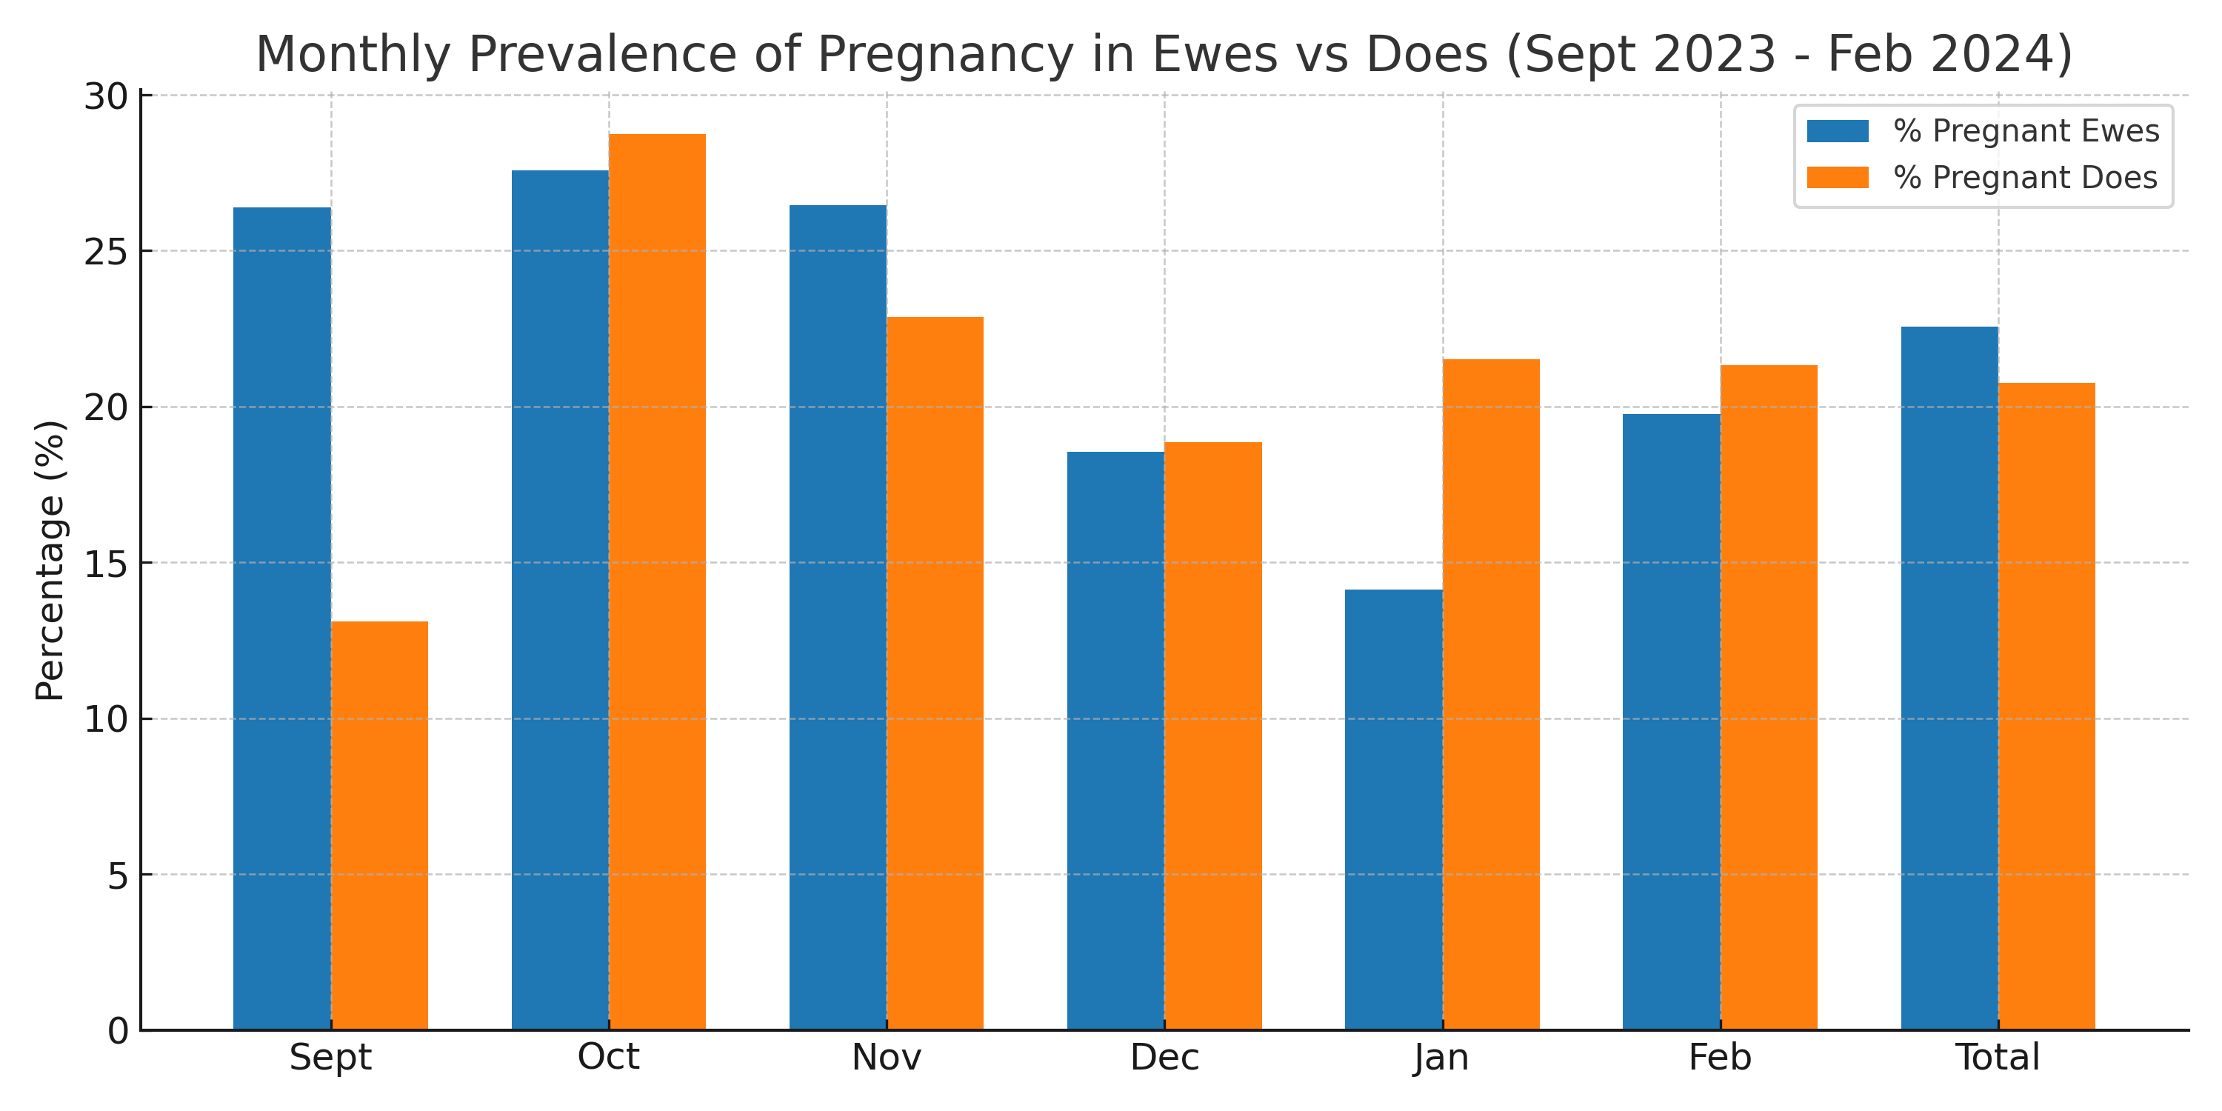

Table 3: Monthly Prevalence of Recovered Foetuses in Jalingo Abattoir from September 2023 to February 2024
Months | Sheep Slaughtered | Goats Slaughtered | Ewes | Does | Lambs Recovered | Kids Recovered | % Lambs | % Kids
Sept | 731 | 1789 | 580 | 656 | 161 | 108 | 27.76 | 16.46
Oct | 697 | 1579 | 544 | 557 | 157 | 174 | 28.86 | 31.24
Nov | 548 | 1320 | 408 | 389 | 115 | 106 | 28.19 | 27.25
Dec | 629 | 1370 | 458 | 387 | 90 | 85 | 19.65 | 21.96
Jan | 601 | 1215 | 426 | 316 | 64 | 77 | 15.02 | 24.37
Feb | 579 | 1389 | 425 | 389 | 91 | 93 | 21.41 | 23.91
Total | 3785 | 8662 | 2841 | 2694 | 678 | 643 | 23.86 | 23.87

Table 4: Sex Prevalence of Foetuses Recovered in Jalingo Abattoir from September 2023 to February 2024
Months | Lambs | Kids | Male Lambs | Male Kids | Female Lambs | Female Kids | % Male Lambs | % Male Kids | % Female Lambs | % Female Kids
Sept | 161 | 108 | 82 | 47 | 79 | 61 | 50.93 | 43.52 | 49.07 | 56.48
Oct | 157 | 174 | 80 | 87 | 77 | 87 | 50.95 | 50.00 | 49.05 | 50.00
Nov | 115 | 106 | 55 | 46 | 60 | 60 | 47.83 | 43.39 | 52.17 | 56.61
Dec | 90 | 85 | 40 | 45 | 50 | 40 | 44.44 | 52.94 | 55.56 | 47.06
Jan | 64 | 77 | 31 | 37 | 33 | 40 | 48.44 | 48.05 | 51.56 | 51.95
Feb | 91 | 93 | 30 | 43 | 61 | 50 | 32.97 | 46.24 | 67.03 | 53.76
Total | 678 | 643 | 318 | 305 | 360 | 338 | 46.90 | 47.43 | 53.10 | 52.57

Bar Diagram 2: Sex Distribution of Foetuses by Species
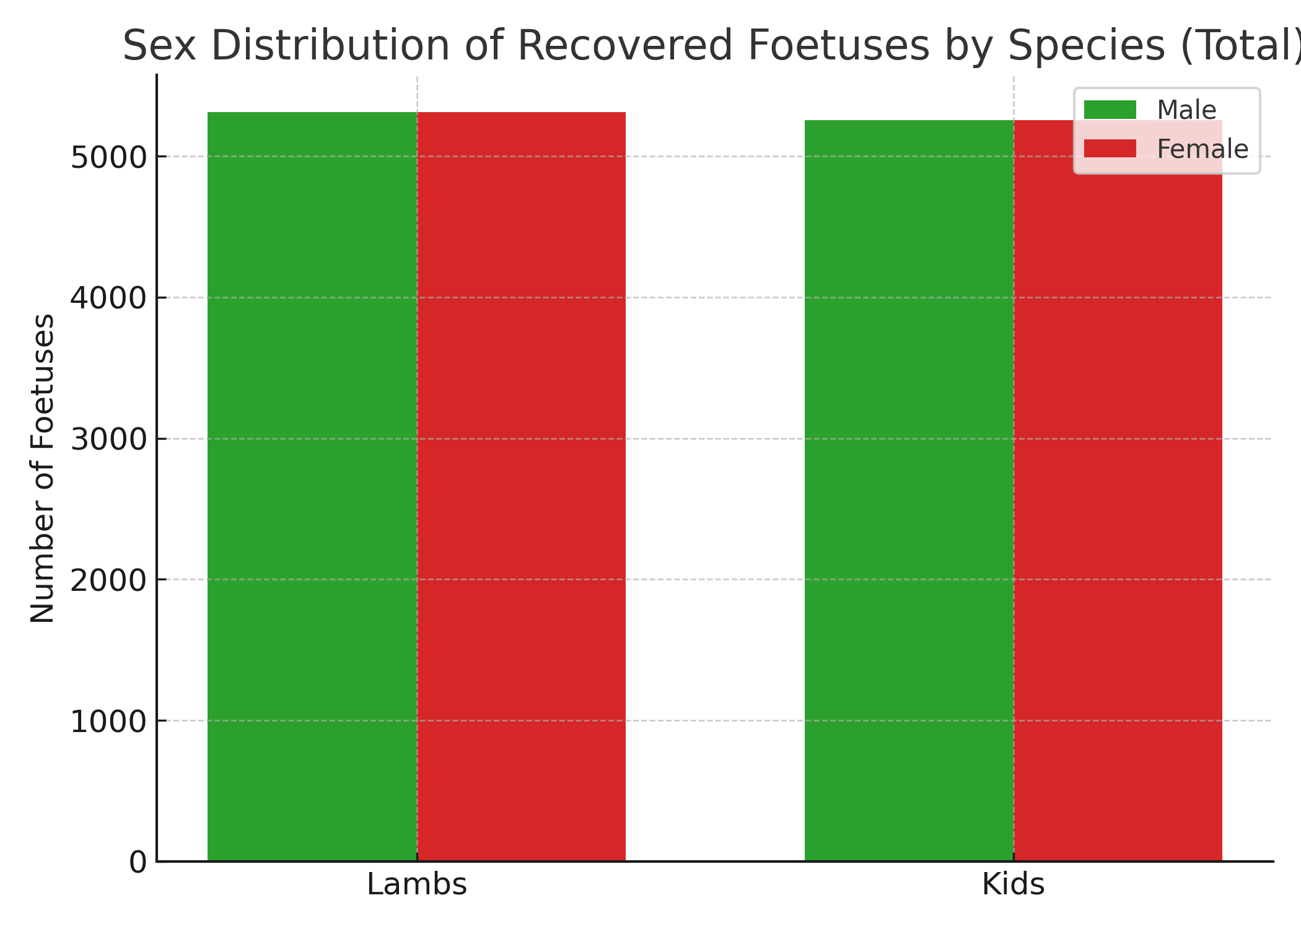

Table 5: Age Distribution of Recovered Foetuses in Jalingo Abattoir from September 2023 to February 2024
Species | Age (Trimester) | Recovered Foetus | Prevalence (%) | χ² | Df | p-value
Sheep | 1st | 108 | 15.93 | 6.00 | 2 | 0.187
2nd | 269 | 39.68
3rd | 301 | 44.39
Goats | 1st | 75 | 11.66 | 6.00 | 2 | 0.491
2nd | 356 | 55.37
3rd | 212 | 32.97

Bar Diagram 3: Trimester Distribution of Recovered Foetuses
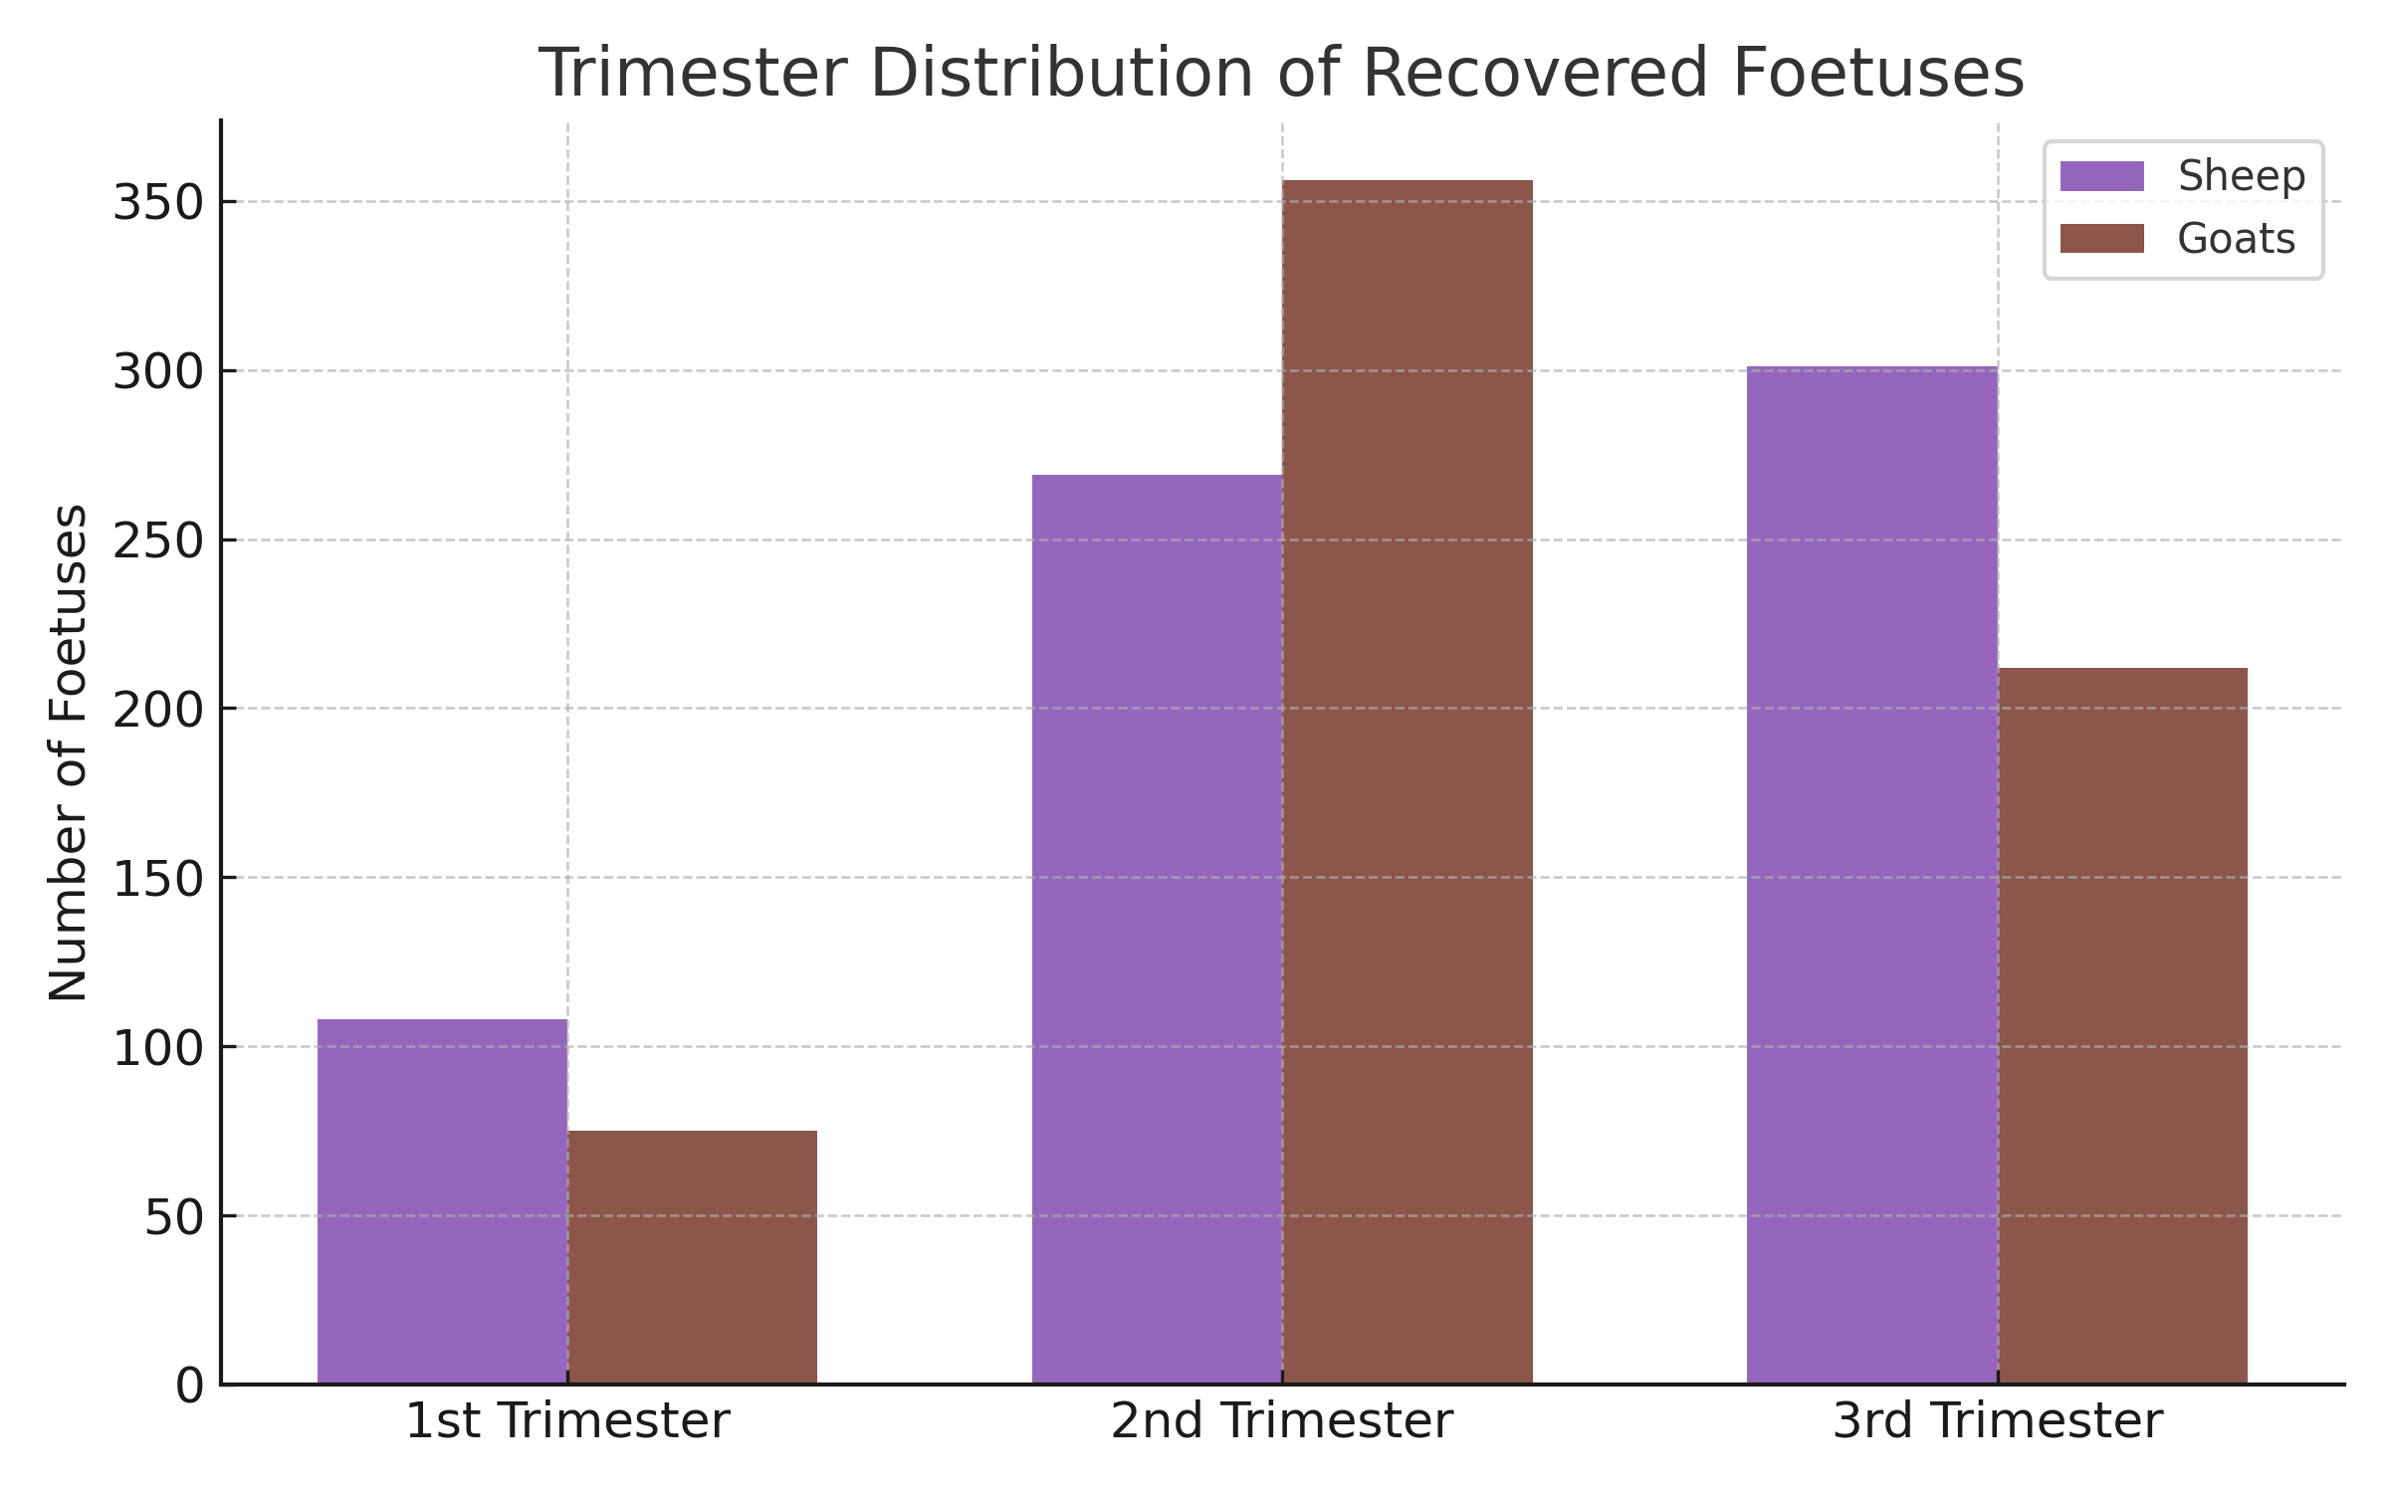
Table 6: Breed Distribution of Recovered Foetuses in Jalingo Abattoir from September 2023 to February 2024
Species | Breeds | Recovered Foetus | Prevalence (%) | χ² | Df | p-value
Sheep | Yankasa | 457 | 67.40 | 6.00 | 2 | 0.202
Balami | 126 | 18.59
Uda | 95 | 14.01
Goats | Sokoto Red | 286 | 44.47 | 6.00 | 2 | 0.187
WAD | 255 | 39.66
Sahelian | 102 | 15.87

Figure 1: Breed Distribution of Recovered Foetuses
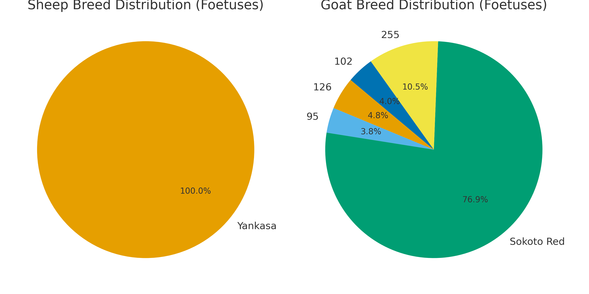

Table 7: Estimated Economic Losses of Foetal Wastages from Smal Ruminants (Sheep and Goats) in Jalingo Abattoir Between September 2023 to February 2024
Species | Animals Slaughtered | Recovered Foetus | Average Unit Price (₦) | Economic Loss (₦)
Sheep | 3,785 | 678 | 5,000 | 3,390,000
Goats | 8,662 | 643 | 4,000 | 2,572,000
Total | 12,447 | 1,321 | 9,000 | 5,962,000

Figure 2: Monthly and Projected Annual Economic Losses from Foetal Wastage
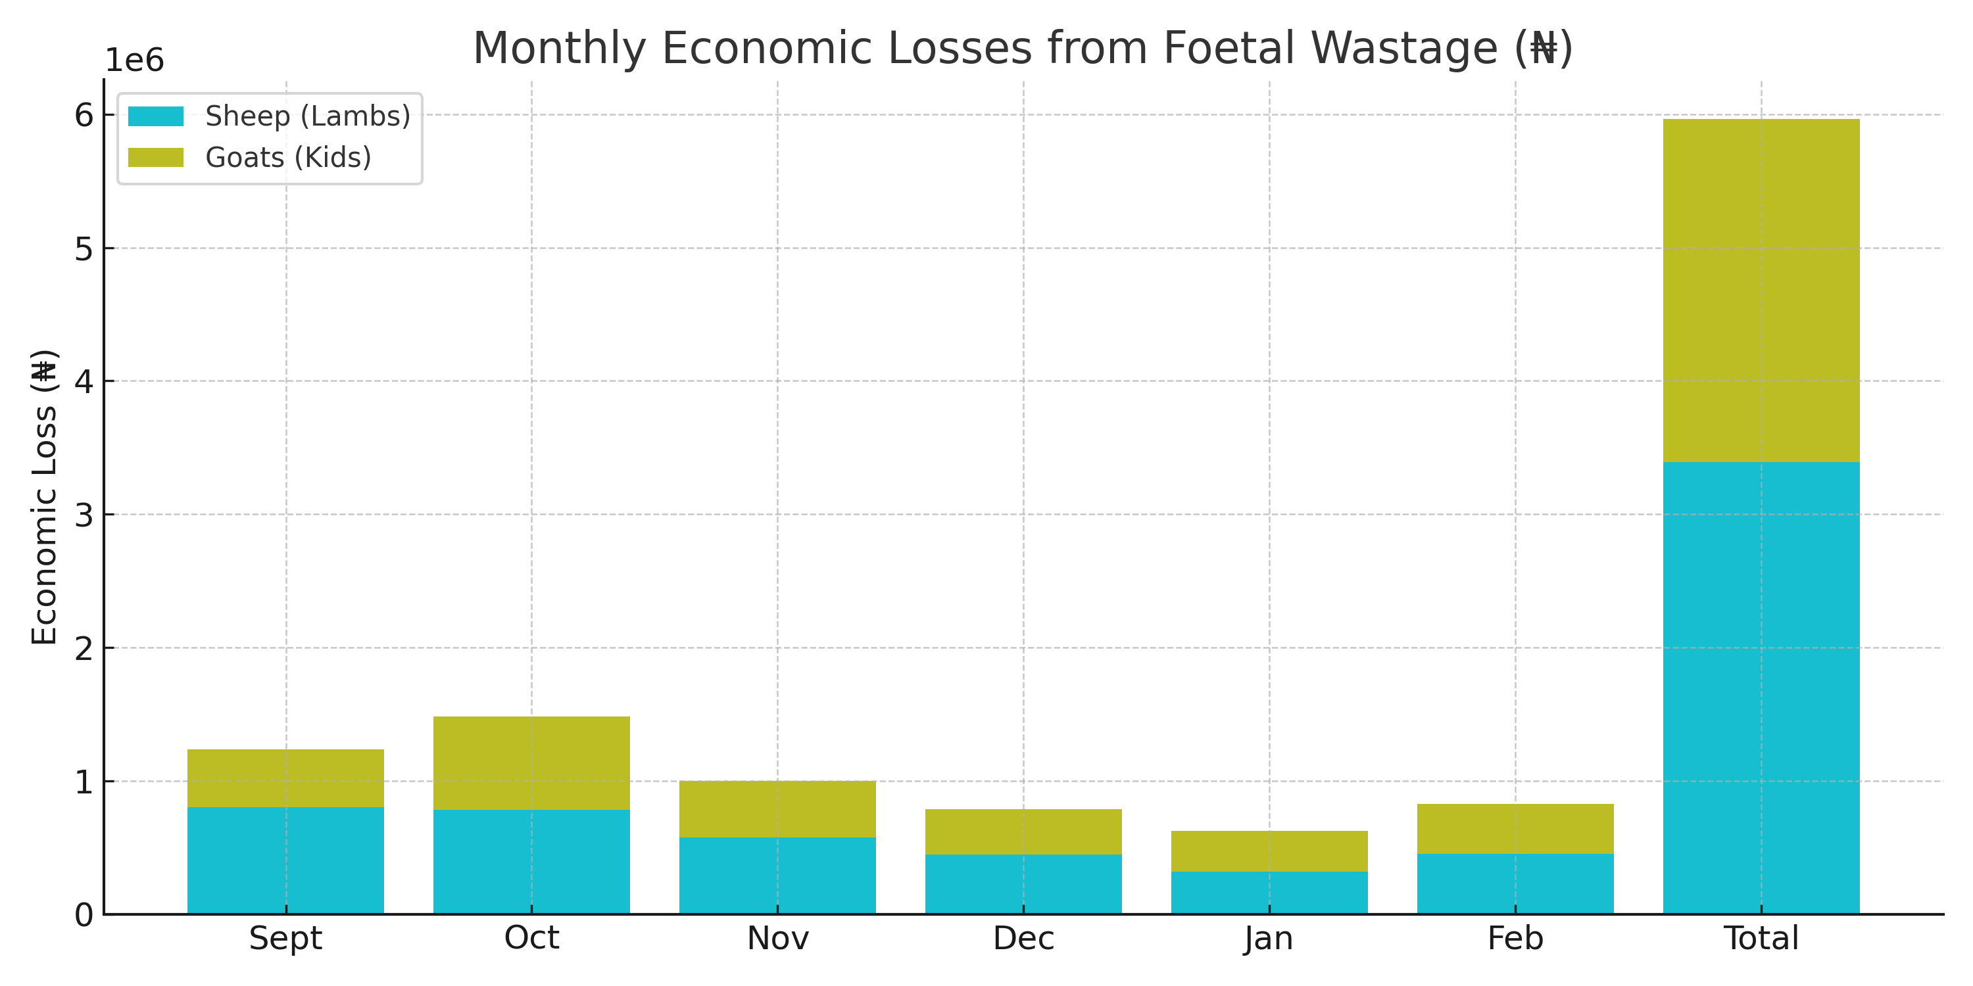
Projection Summary
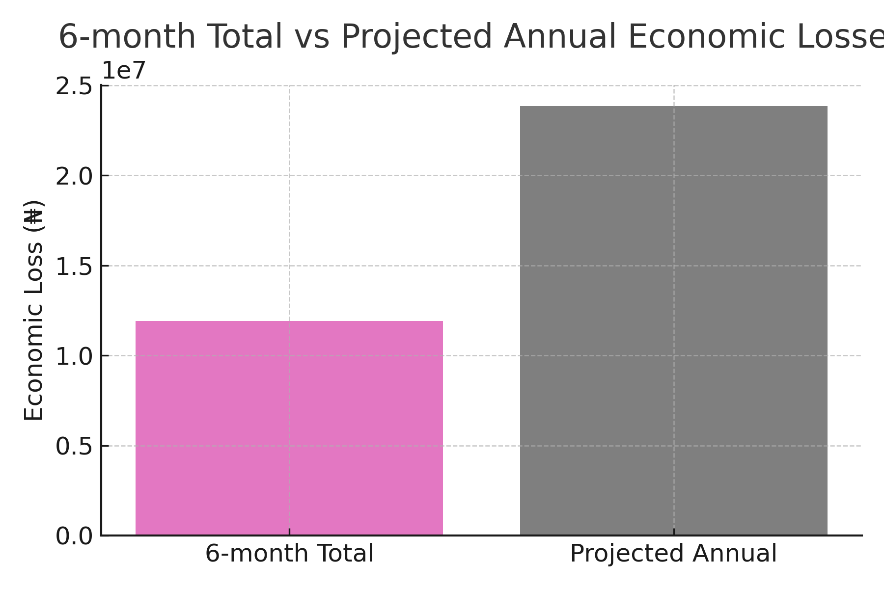

- DISCUSSION

During the study period, a total of 2,841 female sheep were slaughtered compared with 944 males. This aligns with the findings from Chama et al. (2019) at the Jalingo abattoir and Wakayo and Abrham (2021) in Ethiopia. The noticeable difference could likely be attributed to higher female birth rates and the common practice of keeping rams for religious festivities. In contrast, the situation with goats differs, with 5,968 males compared to 2,694 females, reflecting varying marketing preferences.
The study revealed that 22.56% of ewes and 20.75% of does were pregnant at the time of slaughter, which is significantly higher than the rates reported by Gofwan et al. (2021) at the Shendam Slaughtering Slab in Plateau State, where only 9.86% of sheep and 5.95% of goats were found to be pregnant. Several factors contribute to this, including livestock owners being unaware of their animals' pregnancy status, inadequate ante-mortem inspections, financial constraints, and a lack of effective law enforcement. These observations are consistent with broader trends noted across West Africa (Mohammed and Anane, 2022; Tasiame et al., 2016) and highlight the urgent need for better pregnancy detection methods that are accessible to farmers in resource-limited areas (Chama et al., 2019).
A total of 678 lamb fetuses (23.86%) and 643 kid fetuses (23.87%) were lost. Chama et al. (2019) found similar loss rates of 31.10% for sheep and 23.10% for goats in the same abattoir. Interestingly, twin pregnancies were noted in about 5.8% of sheep (with 678 fetuses from 641 pregnant ewes) and 15.0% of goats (with 643 fetuses from 559 pregnant does), which shows that goats tend to have more multiple births, further increasing economic losses. These rates align with findings conducted in Ethiopia (Wakayo and Abrham, 2021) and show that this issue is widespread across the continent.
Based on gender, female foetuses were lost in greater numbers than males, with losses at 53.10% for sheep and 52.57% for goats, which is consistent with the report of Danladi et al. (2019). This loss of potential breeding stock adds to the challenges of herd growth and long-term productivity. Most of the pregnant animals were slaughtered during their second and third trimesters, with the highest losses in sheep occurring in the third trimester (44.39%) and in goats during the second trimester (55.37%).Slaughtering animals in the later stages of pregnancy is particularly wasteful, as these animals were just weeks away from contributing to herd expansion.
Yankasa sheep (67.40%) and Sokoto Red goats (44.47%) were the most affected breeds, reflecting their large populations and high demand in Jalingo and surrounding areas. The estimated economic loss of ₦5,962,000 over six months suggests an annual loss of ₦11,924,000 from just this one abattoir. But it’s not just about the money; losing these edible carcasses poses a serious threat to food security by cutting down on protein availability (Boyd et al., 2022). If we consider all of Nigeria's abattoirs, the total economic impact could easily reach billions of naira each year, which is a significant threat to livestock productivity and national food security.
While this study focuses on a single abattoir, it aligns with many other studies on foetal wastage in Nigeria and other developing nations (Chama et al., 2019; Gofwan et al., 2021; Mohammed and Anane, 2022). Focusing on one abattoir helps provide crucial baseline data that sheds light on regional and national trends. However, we really need multi-center studies to identify nationwide patterns and shape comprehensive policies. The ethical issues surrounding the slaughter of pregnant animals highlight the urgent need for interventions that combine better pregnancy detection, farmer education, and stricter regulatory enforcement, as seen in successful programs in Ethiopia and Tanzania (Wakayo and Abrham, 2021). Modern approaches to ante-mortem inspection and enhanced regulatory frameworks, as described by Atoma et al. (2024), may tackle this challenge in Nigeria.
- CONCLUSION
This study has uncovered some concerning rates regarding foetal wastage at the Jalingo Abattoir, revealing that 23.86% of ewes and 23.87% of does were found to be carrying foetuses at the time of slaughter. With an estimated annual loss of ₦11,924,000 from just one abattoir, it’s clear that the nationwide losses could soar into the billions of naira, which poses serious challenges for both economic productivity and food security. The fact that most of the foetuses were in the second and third trimesters suggests that many of these animals could have contributed to herd growth within just a few weeks if they had been allowed to carry their pregnancies to term.
Several factors contribute to this issue, including a lack of awareness about pregnancy status among owners and traders, inadequate ante-mortem inspections, weak enforcement of regulations, and financial hardship faced by smallholder farmers. The higher rate of wastage among female fetuses is particularly concerning, as these animals are crucial for future breeding and sustainable production.
To tackle this problem, we need a multi-faceted approach: training livestock farmers on how to detect pregnancy, enhancing ante-mortem inspections, enforcing regulations with clear penalties, offering economic incentives, running public awareness campaigns, and introducing affordable pregnancy detection technologies. It would be beneficial to learn from successful strategies implemented in countries like Ethiopia and Tanzania, while also tailoring these solutions to fit local contexts.
This study serves as a foundational resource for targeted interventions in Taraba State and similar areas. It is essential for governments and development partners to prioritize livestock development programs that address this issue as part of broader food security strategies. By reducing fetal wastage, we can significantly boost livestock productivity, enhance food security, improve the livelihoods of smallholder farmers, and help meet Nigeria's protein needs. Future research should delve into the socioeconomic factors at play, assess the effectiveness of interventions, and broaden the geographical focus to better inform national policies
ACKNOWLEDGEMENT
The authors extend their heartfelt gratitude to the staff of Jalingo Modern Abattoir, Nigeria for their invaluable support throughout the experimental period
COMPETING INTERESTS
The authors declare no competing interests, whether financial, non-financial, or personal, that could have influenced the work reported in this paper.
AUTHOR CONTRIBUTIONS

All authors contributed collaboratively to this study. AH conceptualized the research, designed the experimental methodology, and performed the experiments. MBA supervised and co-performed the experiment and contributed to the study design. EBL and ASN jointly drafted the manuscript. MIB and PJA conducted the literature searches. RJM performed the statistical analyses and provided insights in the interpretation of the analysis. All authors critically reviewed and approved the final version of the manuscript.
DISCLAIMER (ARTIFICIAL INTELLIGENCE)

Author(s) hereby declare that NO generative AI technologies such as Large Language Models (ChatGPT, COPILOT, etc.) and text-to-image generators have been used during the writing or editing of this manuscript.

REFERENCES
Adeyemi, A. B., Adamu, M., Dawuda, P. M., & Oyedipe, E. O. (2016). The economic implications of foetal wastage in cattle, sheep and goats in Makurdi abattoir, Benue State, Nigeria. Nigerian Veterinary Journal, 37(4), 198–205.
Alhaji, N. B., & Odetokun, I. A. (2013). Food security and economic implication of small ruminant foetal wastage Nigeria. Development, 25, Article N79. http://www.lrr.org/lrrd25/5/9/ha2579.htm
Atoma, T. B., Szonyi, B., Haile, A. F., Fries, R., Baumann, M. P. O., & Randolph, D. G. (2024). Assessment of health problems of sheep and goats based on ante-mortem and post-mortem inspection at Addis Ababa Abattoir, Ethiopia. Frontiers in Veterinary Science, 11, Article 1406801. https://doi.org/10.3389/fvets.2024.1406801
Boyd, C. E., McNevin, A. A., & Davis, R. P. (2022). The contribution of fisheries and aquaculture to the global protein supply. Food Security, 14, 805–827. https://doi.org/10.1007/s12571-021-01246-9
Chama, T. H., Matthew, D. A., Chama, J. H., & Bala, D. B. (2019). Economic implications of small ruminant foetal wastage: A case study of Jalingo abattoir, Taraba State. Sokoto Journal of Veterinary Sciences, 17(2), 73–76.
Danladi, T., Francis, M., Elkanah, S. O., Buba, Z. M., & Vincent, V. M. (2019). Prevalence of foetal losses in slaughtered pregnant ruminant animals (cattle, sheep and goat) in Mubi Abattoir, Mubi North Local Government, Adamawa State, Nigeria. African Scholar Journal of Agriculture and Agricultural Technology, 15(1), 2877–1990.
Food and Agriculture Organization. (2014). Stocks of cattle, sheep and goats for Nigeria. http://faostat.fao.org
Gamo, M., Nuru, A., & Worku, M. (2017). Contribution of small ruminants to food security and poverty alleviation in Ethiopia: A review. Journal of Animal Science Advances, 7(10), 797–801.
Gofwan, P. G., Dastu, A. J., Machido, H., Damter, S. A., Magaji, S. T., & Guluwa, L. Y. (2021). Six months assessment of foetal loss in sheep and goats at Shendam slaughtering slab, Plateau State, Nigeria. Greener Journal of Agricultural Sciences, 11(2), 123–125.
Habtegiorg, K., Getachew, T., Haile, A., Kirmani, A., Jimma, A., & Gemiyo, D. (2022). Farmers' perceptions to community-based breeding programs: A case study for Doyogena sheep in Ethiopia. Asian Journal of Animal Sciences, 16(1), 45–54. https://doi.org/10.3923/ajas.2022.45.54
Kashoma, I. P., & Luziga, C. D. (2023). Slaughter of pregnant Tanzania shorthorn Zebu cattle at Morogoro abattoir: Prevalence, fetal wastage, and placentome morphology. Applied Veterinary Research, 2(1), Article e2023005. https://doi.org/10.31893/avr.2023005
Khan, A., Muhammed, A. A., Nasreen, N., Iqbal, F., Cossío-Bayúgar, R., Shah, S. S. A., Alanazi, A. D., & Zając, Z. (2021). Tick-borne haemoparasitic diseases in small ruminants in Pakistan: Current knowledge and future perspectives. Saudi Journal of Biological Sciences, 29(3), 1831–1849. https://doi.org/10.1016/j.sjbs.2021.12.046
Mohammed, A., & Anane, K. (2022). Prevalence and economic inference of small ruminant foetal wastage at the Kumasi Abattoir Ltd (Kaase). Asia Pacific Journal of Sustainable Agriculture Food and Energy, 10(1), 25–31. https://doi.org/10.36782/apjsafe.v10i1.105
Mohammed, A., Modu-Kagu, H. A., Balami, S. I., Abdulraheem, A. O., Raji, A. O., & Alfred, B. (2023). Foetal wastage and disease prevalence among slaughtered livestock in Maiduguri Abattoir. Nigerian Journal of Animal Production, 49(6), 94–102. https://doi.org/10.51791/njap.v49i6.3853
Oyekunle, M. A., Olubanjo, O. O., & Fasina, O. E. (2021). Foetal wastage in abattoirs and its implications: Situation report from Ogun State, Nigeria. Nigerian Journal of Animal Production, 19, 187–196. https://doi.org/10.51791/njap.v19i.2081
Richardson, C., Jones, P. C., Bernard, V., Herbert, C. N., Terileki, S., & Wijerratne, W. V. S. (1990). Estimation of developmental age of bovine fetuses and newborn calf. Veterinary Record, 126(12), 279–284.
Tasiame, W., Emikpe, B. O., Folitse, R., Fofie, C. O., Johnson, S., Burimuah, V., Atawalna, J., Boateng, E. A., & Amemor, E. (2016). Foetal wastage in sheep and goats at the Kumasi Abattoir in Ghana: A cross sectional study. Archives of Basic and Applied Medicine, 4(1), 81–86.
Ugwu, P. C., Njoga, E. O., Njoga, U. J., Aronu, C. J., Atadiose, E. O., Okoli, C. E., Onwumere-Idolor, O. S., Ajibo, F. E., Azor, N. N., Bernard, S. N., Ozioko, I. E., Eze, I. S., & Abonyi, F. O. (2023). Indiscriminate slaughter of pregnant goats for meat in Enugu, Nigeria: Cause, prevalence, implications and ways-out. PLoS One, 18(1), Article e0280524. https://doi.org/10.1371/journal.pone.0280524
Wakayo, B. U., & Abrham, Y. (2021). Prevalence and associated economic loss of fetal wastage in small ruminants slaughtered at Addis Ababa municipality abattoir, Ethiopia. Ethiopian Veterinary Journal, 25(1), 92–107. https://doi.org/10.4314/evj.v25i1.7
Yusuf, M. B., Firuza, B. M., & Khairulmaini, O. S. (2015). Survey of rill erosion characteristics of small-scale farmers' crop fields in the Northern part of Taraba State, Nigeria. International Journal of Tropical Agriculture, 33(4), 3305–3313.

