Selection of Superior Clones of Cedrela odorata L. at early age in an Asexual Seed Orchard for Genetic Improvement

Abstract

The selection of plant age in forest species is crucial in a genetic improvement program, as time is a key factor in decision-making. This study aimed to evaluate the variation in clonal growth of Cedrela odorata L. to identify clones with superior performance at an early age. The orchard was established in September 2014, utilizing a completely randomized block design with a planting distance of 4 x 4 m. The experiment comprised 70 clones (ortets), each with 35 replicates (ramets), totaling 2,450 ramets. Selection was based on four key traits: total height (th), clear stem height (csh), normal diameter (nd), and crown diameter (cd). These variables were used to calculate the percentage gain or loss in performance for each clone relative to the population mean. A principal component analysis, analysis of variance (ANOVA), Tukey test (p≤0.05), and cluster analysis were performed to assess the data. The results identified 16 out of the 70 clones as having superior traits. The superior clones included 53-CoSFcoChan07, 2-CoGua344, 15-CoB191, 19-CoKal126, 22-CoKal142, 41-CoTux558, 35-CoTez642, 56-CoTez539, 45-CoTez549, 49-CoTez540, 50-CoTez540, 59-CoTux555, 62-CoCar5, 30-CoBac02, 48-CoTez544, and 10-CoKal16. The average traits of these superior clones were 8.0±0.4 m for total height, 2.6±0.1 m for clear stem height, 0.13±0.0 m for normal diameter, and 4.1±0.2 m for crown diameter, representing a 15% increase over the population mean.

Keywords: clonal silviculture, vegetative propagation, gene-set, clone selection.

1. Introduction
The age of selection plays a critical role in genetic improvement programs, particularly in forestry, where time is a key factor in decision-making. Since forestry results unfold over the long term and the development of these programs is complex, it is crucial to optimize the selection process. For forest geneticists, the need to reduce the time required for a selection cycle and, consequently, maximize genetic gains per unit of time is widely recognized [2]. Early selection is a strategy employed by forest geneticists to identify the best trees based on economically valuable traits, such as commercial volume. This selection is conducted prior to the rotation age to shorten the breeding cycle and maximize profitability per unit of time [28]. Increased efficiency in the selection process enhances genetic gains in a shorter period and reduces the costs of breeding programs [18]. Cedrela odorata L. (red cedar), a tree species of the Meliaceae family native to the tropical regions of the Americas, is highly valued for the exceptional qualities of its wood—durability, color, and aroma—considered fine and precious [15]. This has led to its widespread use in the production of fine furniture, turned articles, musical instruments, crafts, and cabinetmaking, making it the second most commercialized tropical tree species globally [22]. However, overexploitation without adequate management plans has resulted in population decline and fragmentation, limiting gene flow [7] and reducing genetic diversity among populations [14]. C. odorata is currently listed as a vulnerable species by the International Union for Conservation of Nature [10] and is protected under the Convention on International Trade in Endangered Species of Wild Fauna and Flora [6]. In Mexico, it is classified as Subject to Special Protection according to the Mexican Official Standard 059-SEMARNAT-2010 [26]. Given these circumstances, it is urgent to explore efficient propagation methods to rescue, conserve, and improve the genetic quality of this species germplasm. The effectiveness of a propagation program in forestry is directly linked to the time required to achieve genetic gains. Thus, the correlation between the performance of traits of interest at early and adult ages is critical for the success of any genetic improvement program [25]. In this context, grafting as a clonal propagation method is a relatively novel technique in forestry [8]; [4]. Its advantages include the ability to select superior genotypes based on desirable traits, shorten the juvenile period, and accelerate reproductive maturity. These benefits aim to reduce selection cycles and expedite the production of genetically improved seeds through open pollination between vegetative copies of select genotypes. The objective of this study was to evaluate the variation in clonal growth of C. odorata to identify clones with superior performance at an early age.
2. Material and methods
2.1 Plantation location and establishment
The asexual seed orchard is located in the San Cristóbal ejido (19° 32' N, 88° 40' W) in the municipality of José María Morelos, Quintana Roo, Mexico. The plant material (buds) used for grafting was collected from a Cedrela odorata clonal garden established at the San Felipe Bacalar experimental site (18° 46' N, 88° 17' W), which is part of the National Institute of Forestry, Agricultural, and Livestock Research. The grafting technique employed was the "lateral veneer" method. The grafts (clones) were established in September 2014 over a 3.9-hectare area using a completely randomized block design. The planting distance was set at 4 x 4 meters in a square grid. A total of 70 clones (ortets) were used, each with 35 replicates (ramets), resulting in a total of 2,450 ramets.
2.2 Plant variables evaluation
In October 2021, the following variables were evaluated: total height (TH), clean stem height (CSH), normal diameter (ND) and crown diameter (CD). Crown diameter was determined by measuring the projection of the crown in two directions—north-south and east-west—using the ends of the crown's projection on the ground as reference points. Total height and clean stem height were measured using a graduated measuring rod (in cm), while normal diameter was measured with a diameter tape and crown diameter was measured with a measuring tape, both graduated in centimeters.
2.3 Statistical analysis
The data were subjected to principal component analysis (PCA), analysis of variance (ANOVA), mean comparison using Tukey's test at a 5% probability level (p ≤ 0.05) and cluster analysis. All statistical analyses were performed using the STATGRAPHICS Centurion Ver. XV-II software, released in 2006.
3. Results and discussion

3.1 Graft cloning of Cedrela odorata L.
The establishment of the asexual seed orchard of Cedrela odorata L. was carried out using the lateral veneer grafting technique (Figure 1A, B, and C). One of the key advantages of this method is its ability to rejuvenate mature trees and accelerate sexual phenology and the breeding process [27]. Two years after the orchard was established, clones 22-CoKal142, 35-Cotez642 and 59-CoTux555 exhibited early reproductive behavior, as evidenced by the presence of flowers and fruits (Figure 1D, E). This precocity is likely attributable to the more favorable climatic conditions in the orchard compared to the ortets' place of origin, as well as the effective silvicultural management of the ramets. It is worth noting that flowering in ramets of some forest species can be influenced by the type of graft used. However, young asexual seed orchards typically do not produce large quantities of seeds due to low flowering rates [16]. In this study, as the orchard matured, an increase in precocity was observed, with fruit production recorded in 90% of the ramets by the age of seven years (Figure 1F). This outcome can be attributed to efficient clone management, particularly pruning practices aimed at generating a sympodial crown structure, which promoted the abundant development of flower buds.
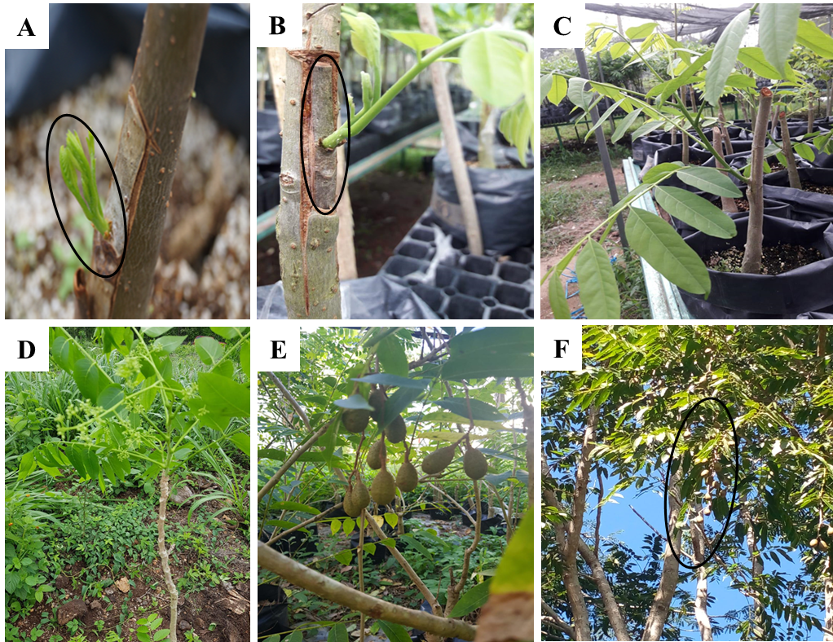

Figure 1. Clones of Cedrela odorata L. with fruits at an early age A, B and C.- Intraspecific grafts of C. odorata using the lateral veneer technique; D, E.- Clones with flowers and fruits at two years of age; F.- Clones with fruits at seven years of age

The grafting of Cedrela odorata was conducted intraspecifically, achieving a 90% grafting success rate and an 88% survival rate six months after grafting. These high percentages confirm the strong taxonomic compatibility and affinity between the bud and the rootstock. Intraspecific grafts generally exhibit greater compatibility due to the anatomical, physiological, and biochemical similarities between the graft components [5]. Additionally, the phenological state of the buds and favorable environmental conditions contributed to the successful growth and development of the vegetative shoot, which became fully attached to the rootstock cambium (Figure 1A, B and C).

3.2 Descriptive Dasometric Analysis
Seven years after the establishment of the asexual seed orchard of Cedrela odorata L., a survival rate of 84% was recorded, representing 2,070 live ramets out of a total of 2,450. The average height growth was 7.3 meters, and the average normal diameter was 11.8 cm. [19] evaluated the survival rate in two clonal trials of C. odorata seven years after establishment, reporting survival rates of 79% and 94%, respectively. Ramet survival in the field is influenced by appropriate silvicultural management, environmental conditions, pest and disease prevalence, and damage caused by harmful fauna [21]. Therefore, successful field performance of ramets is contingent on adequate silvicultural practices tailored to the specific conditions of the establishment site. Although ramet height is not a direct indicator of the operability of an asexual seed orchard [11], it is related to the ramets' sprouting capacity and reflects the fertility of the site, having a moderate genetic component [27]. The results align with those reported by [29], who emphasized that height dominance and stem straightness are critical factors in selecting ramets for an asexual seed orchard. Similarly, [24] concluded that stem shape characteristics are key in selecting ramets for improved seed production, thereby increasing the value of the resulting germplasm in the short and medium term. However, [17] noted that seed quality is determined by the genetic superiority of the trees within the orchard, the degree of relatedness among them, and a balanced representation of branches from all clones.

3.3 Analysis of Variance
The analysis of variance (ANOVA) revealed statistically significant differences between clones and at the block level. Specifically, the variable "crown diameter" showed significant differences (p ≤ 0.05; F = 1.39). Based on these results, a multiple range test was conducted using Tukey's test at a 5% probability level (p ≤ 0.05). The results of this test enabled the selection of clones that demonstrated superiority in the four variables of interest: total height (TH), clean stem height (CSH), normal diameter (ND) and crown diameter (CD) (Figure 2).

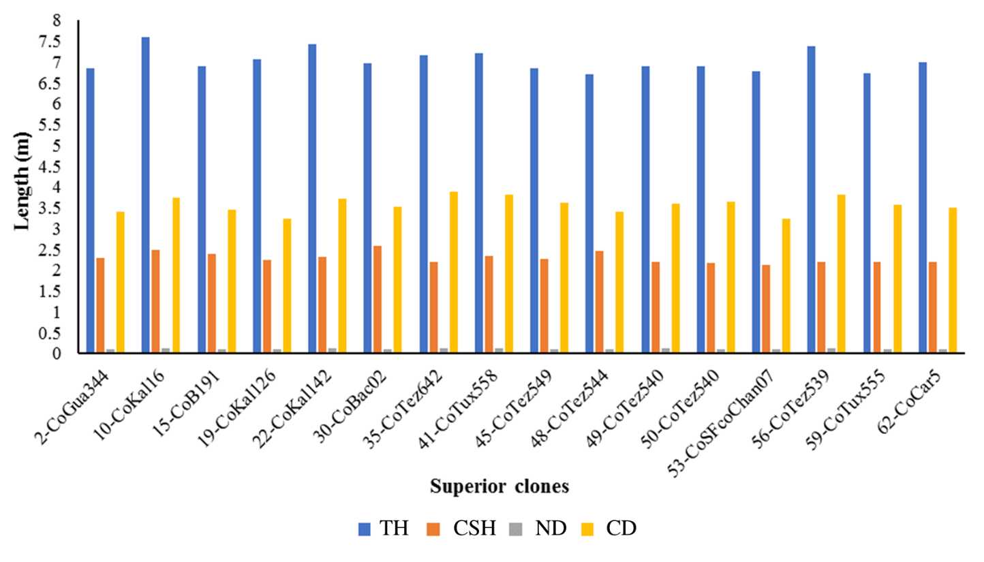
Figure 2. Group of superior red cedar clones that agree with the greatest growth in height, clean trunk, normal diameter and crown diameter

According to the results, 16 clones were identified as superior and are recommended as candidates to remain in the genetic improvement process (Figure 2). [23] emphasizes that the success of genetic improvement programs hinges on the quality of the selected trees and the genetic gains achieved. Additionally, it is crucial to avoid genetic impoverishment, as this is vital for the adaptation and evolutionary changes of the species [3]. Therefore, alongside maximizing the response to selection, it is essential to conserve a broad genetic diversity.

3.4 Cluster Analysis
The results of the cluster analysis were consistent with those obtained from the multiple range test. The dendrogram presented in Figure 3 illustrates the grouping of clones that share similar characteristics. Notably, those highlighted in red represent the clones that demonstrated statistical significance according to the multiple range test and exhibit similar groupings (Figure 3).
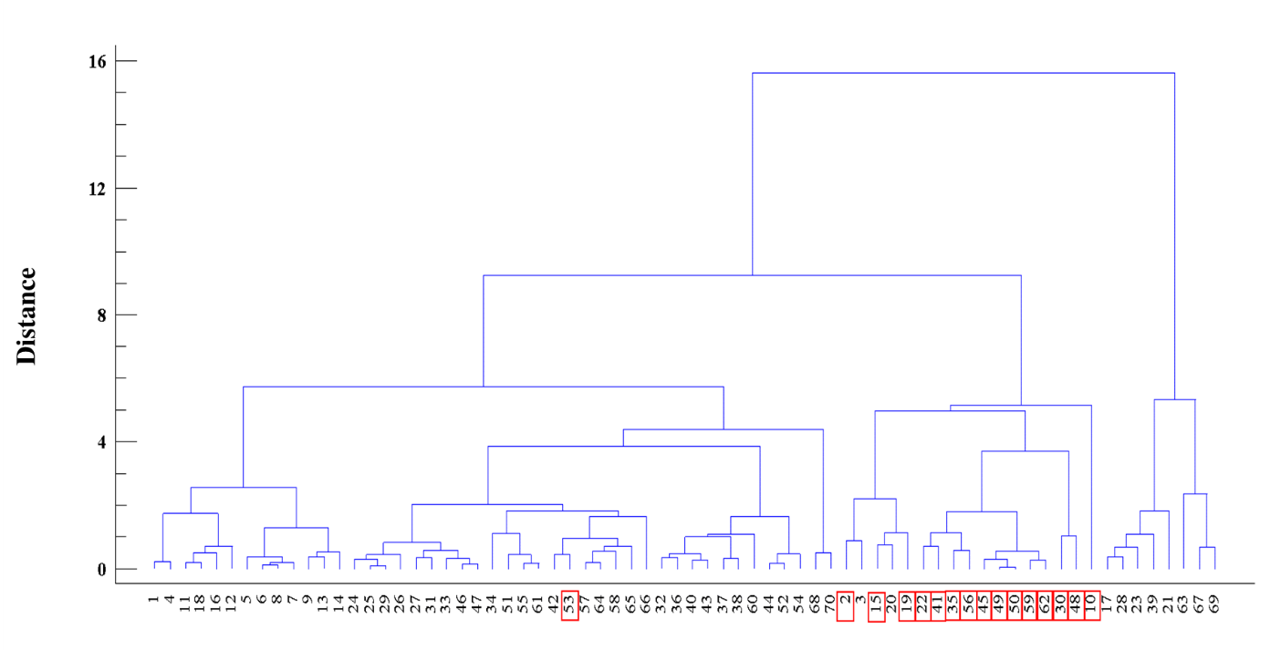
Figure 3. Grouping of 70 clones of Cedrela odorata L. according to the dasometric variables evaluated in the San Cristóbal ejido, Quintana Roo, Mexico.
On the other hand, clones positioned in the lower rankings for the four variables of interest were identified. Figure 4 illustrates the group of clones that, according to the analysis results, exhibited inferior characteristics, corresponding to reduced growth in height, clean stem, normal diameter, and crown diameter. [20] advocates for early selection as a practical strategy aimed at shortening the cycles of the genetic improvement process. However, such decisions should be grounded in prior knowledge of the clones' performance under specific edaphoclimatic conditions [9].
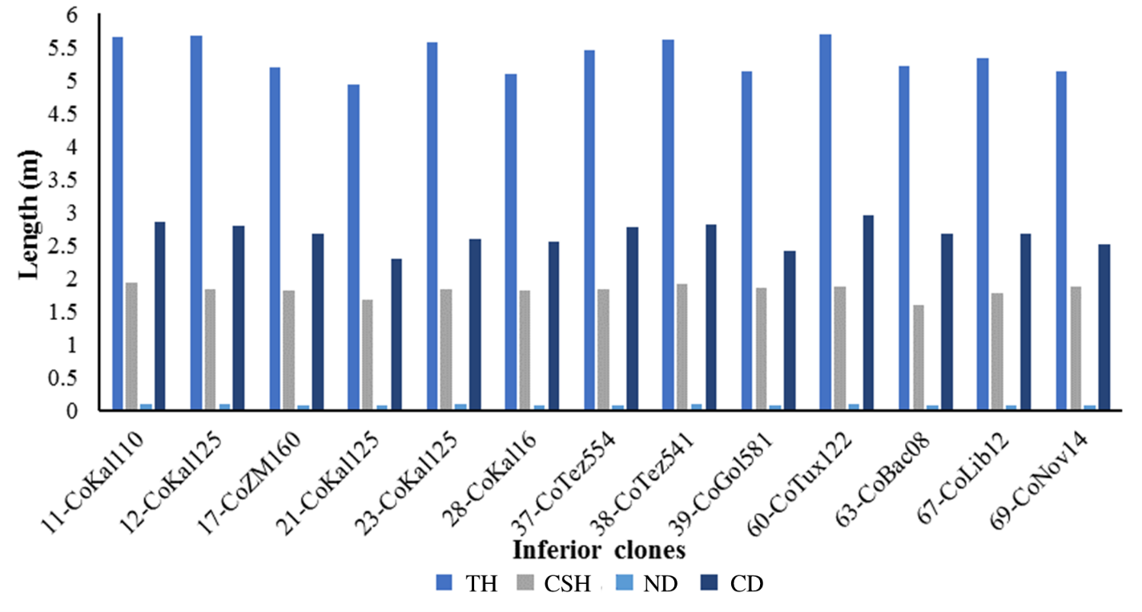
Figure 4. Group of inferior Cedrela odorata L. clones that agree with the lowest growth in height, clean stem height, normal diameter and crown diameter

Differences in clone growth can be attributed to both genetic and environmental factors. Some authors as [1] conclude that site conditions enable selected clones to fully express their genetic potential. This expression positions them as candidates for sexual crossing [12] with other clones that have also been selected for their superior characteristics, aiming to strengthen the genetic foundation of the clonal set [13].

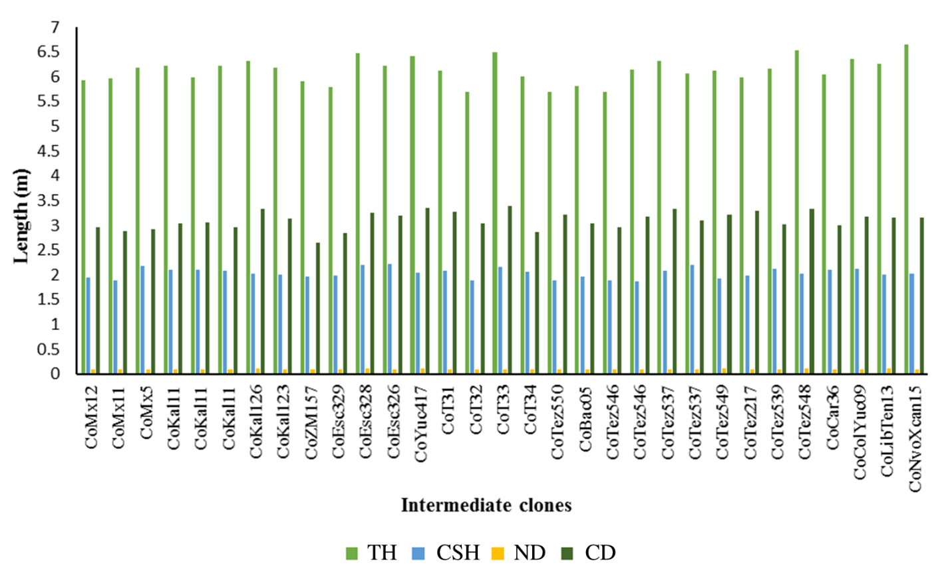
Figure 5. Group of clones of Cedrela odorata L. with intermediate characteristics in height growth, clean stem, normal diameter and crown diameter.

Regarding the intermediate positions (Figure 5), a certain level of stability was observed among the clones and ramets for the four evaluated variables, with no abrupt changes noted. [20] reported a similar pattern of consistency over time in the performance of Gmelina arborea clones, aligning with the findings of the present study. Additionally, some clones exhibited notable performance in certain variables while underperforming in others. This heterogeneous behavior suggests that these clones should remain in the genetic improvement process, allowing for continued studies on the evolution of different growth variables over time. The goal is to recover the strong performance of specific ramets in certain variables in subsequent generations.

4. Conclusion
Clones 53-CoSFcoChan07, 2-CoGua344, 15-CoB191, 19-CoKal126, 22-CoKal142, 41-CoTux558, 35-CoTez642, 56-CoTez539, 45-CoTez549, 49-CoTez540, 50-CoTez540, 59-CoTux555, 62-CoCar5, 30-CoBac02, 48-CoTez544, and 10-CoKal16 were identified as superior and are recommended for continuation in the genetic improvement process.
Clones 11-CoKal110, 12-CoKal125, 17-CoZM160, 21-CoKal125, 23-CoKal125, 28-CoKal16, 37-CoTez554, 38-CoTez541, 39-CoGol581, 60-CoTux122, 63-CoBac08, 67-CoLib12, and 69-CoNov14 were identified as inferior and are recommended for discarding from genetic improvement efforts. If necessary, they should be conserved in germplasm banks for future studies.
The clones identified in the intermediate positions of the hierarchy are recommended for maintenance as candidates to remain in the genetic improvement process, along with continued studies on the evolution of various growth variables over time.
In general, it is recommended to implement genetic thinning in the field to purify inferior clones and remove branches exhibiting physical damage or pest infestation, primarily as a sanitary measure to enhance orchard quality.

References
1. Ávila, C., Murillo, R., Murillo, O., & Sandoval, C. (2015). Selection of superior clones from two genetic sets of Gmelina arborea in the South Pacific of Costa Rica. Journal of Environmental Sciences, 49(1), 17-35. https://doi.org/10.15359/rca.49-1.2
2. Beltrame, R., Bisognin, D. A., Mattos, B. D., Cargnelutti Filho, A., Haselein, C. R., Gatto, D. A., & dos Santos, G. A. (2012). Silvicultural performance and early selection of eucalyptus hybrid clones. Brazilian Agricultural Research, 47(6), 791–796. https://doi.org/10.1590/S0100-204X2012000600009
3. Bernabé, J. (2018). Evaluation of a provenance/progeny trial of Swietenia macrophylla King. established in La Balsa, Veracruz (Master's Thesis). Tropical Research Center, Universidad Veracruzana, Veracruz, Mexico. 47 p.
4. Bonga, J. M. (1982). Vegetative propagation in relation to juvenility, maturity and rejuvenation. In J. Bonga & D. Durzan (Eds.), Tissue Culture in Forestry (pp. 387-412). Boston: Nijhoff M. and W. Junk Publisher.
5. Castro-Garibay, S. L., Villegas-Monter, A., & López-Upton, J. (2017). Anatomy of rootstocks and scions in four pine species. Forest Research, 6(3), 1-6. https://doi.org/10.4172/2168-9776.1000211 6. Convention on International Trade in Endangered Species of Flora and Wildlife (CITES). (2017). Supplementary materials I, II and III. Chatelaine, Geneva, Switzerland. 76 p. https://cites.org/esp/app/index.php 7. De la Torre, A., López, C., Yglesias, E., & Cornelius, J. P. (2008). Genetic (AFLP) diversity of nine Cedrela odorata populations in Madre de Dios, southern Peruvian Amazon. Forest Ecology and Management, 255(2), 334–339. https://doi.org/10.1016/j.foreco.2007.09.058
8. Hartmann, H., & Kester, D. (1990). Plant propagation: principles and practices. Mexico City: Continental Publishing Company. 760 p.
9. Hernández-Castro, W., Badilla-Valverde, Y., Esquivel-Segura, E., & Murillo-Gamboa, O. (2021). Behavior of Gmelina arborea Roxb. clones under acidic soil conditions. Journal of Environmental Sciences, 55(2), 229-249. https://doi.org/10.15359/rca.55-2.11
10. International Union for Conservation of Nature (IUCN). (2017). Cedrela odorata, Spanish Cedar. http://dx.doi.org/10.2305/IUCN.UK.1998.RLTS.T32292A9687734.en
11. Ipinza, R., Gutiérrez, B., Clasing, G., Corti, D., & Molina, M. P. (2016). Design and establishment of an advanced generation clonal seed orchard of Nothofagus obliquia (Mirb.) Oerst. Ciencia & Investigación Forestal, 22(2), 7-22. https://doi.org/10.52904/0718-4646.2016.453
12. Kumar, A. (2007). Growth performance and variability in different clones of Gmelina arborea (Roxb). Silvae Genetica, 56(1-6), 32-36. https://doi.org/10.1515/sg-2007-0005
13. Lauridsen, E. B., & Kjaer, E. D. (2002). Provenance research in Gmelina arborea Linn., Roxb. A summary of results from three decades of research and a discussion of how to use them. International Forestry Review, 4(1), 20-29. https://www.jstor.org/stable/43740942
14. Lesher-Gordillo, J. M., Martínez-Sánchez, J. L., Orduña-Rodas, P., & Hernández-Carreta, A. I. (2018). Genetic diversity of red cedar (Cedrela odorata) in the state of Tabasco, Mexico. Bosque, 39(3), 411–417. https://doi.org/10.4067/S0717-92002018000300411 15. Mader, M., Pakull, B., Blanc-Jolivet, C., Paulini-Drewes, M., Bouda, Z., Degen, B., Small, I., & Kersten, B. (2018). Complete chloroplast genome sequences of four Meliaceae species and comparative analyses. International Journal of Molecular Science, 19(3), 701–714. https://doi.org/10.3390/ijms19030701 16. Méndez-Neri, M., Ramírez-Herrera, C., Vargas-Hernández, J. J., Martínez-Trinidad, T., López-Upton, J., & López, P. A. (2020). Genetic diversity in two seed orchards of Pinus patula Schiede ex Schltdl. et Cham. Revista Fitotecnia Mexicana, 43(1), 113-119. https://doi.org/10.35196/rfm.2020.1.113
17. Merlo, E., & Fernández-López, J. (2004). Analysis of the reproductive parental balance in a seed orchard of Pinus pinaster Ait. Agricultural Research: Forest Systems and Resources, 13(2), 387-397.
18. Morales, C. B., Brizolla, T. F., Teixeira, L. G., Zimback, L., Tambarussi, E. V., Chaves, R., & Mori, E. S. (2014). Estimates of genetic parameters for selection of trees in Eucalyptus. Scientia Forestalis, 42(104), 623−629. http://www.ipef.br/publicacoes/scientia/nr104/cap16.pdf
19. Olvera-Moreno, S., López-Upton, J., Sánchez-Monsalvo, V., & Jiménez-Casas, M. (2022). Genetic parameters and genotype-environment interaction in clonal trials of Cedrela odorata L. Madera y Bosques, 28(1), e2812318. https://doi.org/10.21829/myb.2022.2812318
20. Padua, F. (2004). Juvenile selection of Gmelina arborea clones in the Philippines. New Forest, 28(2-3), 195-200. https://doi.org/10.1023/B:NEFO.0000040946.46722.1c 21. Prescher, F. (2007). Seed orchards-genetic considerations on function, management and seed procurement (Doctoral Thesis). Umeå, Västerbotten, Sweden: Faculty of Forest Sciences, Swedish Universityof Agricultural Sciences. 49 p.
22. Romo-Lozano, J. L., Vargas-Hernández, J. J., López-Upton, J., & Ávila-Angulo, M. L. (2017). Estimation of the financial value of red cedar (Cedrela odorata L.) timber stocks in Mexico. Madera y Bosques, 23(1), 111–120. https://doi.org/10.21829/myb.2017.231473
23. Salas, R. A. (2012). Evaluation of a genetic trial of Gmelina arborea in Siquirres, Limón (Bachelor’s Thesis). Technological Institute of Costa Rica, Cartago, Costa Rica. https://repositoriotec.tec.ac.cr/handle/2238/2949
24. Sánchez, M. V., Honorato, J. A. S., & López, J. U. (2018). Selection of clones of Cedrela odorata L. in the Gulf and southeast of Mexico. pp. 1003–1012. In *Book
25. Santos, A. M., Rosado, S. C. da S., & Oliveira, A. N. (2014). Estimation of genetic parameters and verification of early selection efficiency in baru (Dipteryx alata). Crop Breeding and Applied Biotechnology, 14(4), 238–243. https://doi.org/10.1590/1984-70332014v14n4a37
26. Secretaría de Medio Ambiente y Recursos Naturales (SEMARNAT). (2010). Mexican Official Standard NOM-059-SEMARNAT-2010. Environmental protection - Native Mexican species of wild flora and fauna - Risk categories and specifications for their inclusion, exclusion or change - List of species at risk. Official Gazette of the Federation, December 30, 2010, second section, Mexico.
27. White, T., Adams, W., & Neale, D. (2007). Forest Genetics. Cambridge, MA, USA: CAB International. 682 p.
28. Ye, T. Z., & Jayawickrama, K. J. S. (2012). Early selection for improving volume growth in Coastal Douglas-fir breeding programs. Silvae Genetica, 61(1–6), 186–198. https://doi.org/10.1515/sg-2012-0024
29. Zepahua, A. G. (2014). Growth variation and tolerance of Cedrela odorata L. clones to the attack of Hypsipyla grandella Zeller in the El Palmar experimental field, Tezonapa, Veracruz (Bachelor's Thesis). Instituto Tecnológico Superior de Zongolica, Veracruz, Mexico. 145 p.

