Rebuttals in red and blue fonts
Red = Correct
Blue = Delete
Build on the given document

Role of Local Water Institutions in Water Resources Management in Sanya-Kware Sub-Catchment of the Pangani Basin,Tanzania

Smart topic: Roles of Community Participation in Piped Water Resource Management of Sanya Kware in Pangani Basin, Tanzania

ABSTRACT:
Introduce the topic globally, regionally, locally in Tanzania but in the study information remains undocumented This study investigates the role of Community Participation in piped Water Resource in sub-catchment of the Pangani River Basin, Tanzania. Using a mixed-methods approach of survey and interviews, data were collected from a sample of 96 traditional furrow committee members representing 20 villages across highland, midland, and lowland zones. The research examines the contributions and limitations of conventional furrow committees and their interactions with newly established Water User Associations (WUAs). Results reveal that conventional institutions, deeply rooted in cultural norms, provide effective localized solutions for water allocation and conflict resolution. However, they face challenges such as limited adherence to Integrated Water Resources Management (IWRM) principles, lack of , limited legal enforcement, and insufficient financial and administrative management capacity. Overlapping roles between traditional and formal institutions often lead to conflicts, especially during periods of water scarcity. Despite these challenges, conventional furrow committees remain resilient, effectively managing water resources through collective action and culturally embedded practices. Large-scale irrigators and other stakeholders who engaged with these traditional systems reported better outcomes in water sharing and conflict resolution. The findings highlight the need for a balanced governance framework that integrates the strengths of traditional institutions with formal mechanisms to enhance water resource management. The study concludes by emphasizing the importance of capacity-building, legal recognition, and structured collaboration to ensure equitable and sustainable water governance in sub-catchment areas.
Keywords: Traditional Furrow Community Participation , Water uptake User Association,Sanya-Kware, Pangani Basin Water Office.Tanzania

INTRODUCTION

Community Participation in Water resource management in Tanzania has undergone a series of transformations, mainly in the past decade. Over the past 40 years, the evolution of water institutions responsible for allocating and distributing water has been enormous (Mosha et al. 2016). The debate on water institutions and rights has gained global momentum in recent years (Mosha et al., 2016; Gudaga et al., 2018). According to the World Bank (2015), an institutional arrangement is important in enhancing effective water resource governance. Globally, both developed and developing nations have embraced decentralisation to increase equity, efficiency and sustainability in governing natural resources, including water.
Hence, to realise water-related benefits in different global countries, there should be well-built, interlinked, and arranged water institutions at the national, regional, and local levels (Grafton, Garrick, and Manero 2019).Several studies also have acknowledged the fact that informal local level institutions can make a difference in water management (Bruns and Meinzen-Dick, 2000, Bruns and Meinzen-Dick, 2003, Maganga, 2003, Mwakaje and Sokoni, 2003 and Van Koppen, 2003). Also Studies conducted by Mwaruvanda (2017) on Baseline data on hydrology, water management institutions and water resources use in the Great Ruaha catchment and Kayunze (2019) on Experiences and Guidelines for the formation of sub-catchment water user Associations in the Great Ruaha river catchment found that participation of local communities and other stakeholders in the management of water resources was significant for effective water resources management in the Rufiji basin.
In Tanzania, informal institutions also are rooted within communities and embedded in the existing customs, traditions, beliefs, norms, folklores, and tales (Sokile et al. 2005). According to Saleth & Dinar (2004), informal institutions evolve through incessant interaction in response to emerging situations. In developing countries in general, strong informal institutions are significant for effective water governance and sustainability because they are embedded into the sociocultural context of the communities. The institutions vary in nature and have succeeded in creating a conducive environment for sustainably managing water resources at local levels. Furthermore, the primary role of informal water institutions in developing countries in general is to organize effective provision of water resources in response to the collective needs of water users while also securing the sustainable use of the resource (Mosha et al. 2016).
This paper, explore the emergence, role and challenges faced by local water institutions in Sanya-Kware sub-catchment, Pangani river basin, Tanzania. Local institutions are locally developed water management structures consists of traditional furrow Committees that manage water allocation and solve water conflicts between groups of water users. Example between irrigation canals, locally known as furrows (mifereji). At present furrows are a property of the village and traditional furrow Committee members are in charge for water allocation among group of water users using the same source.
INSTITUTIONAL EMERGENCE AND FUNCTIONING

In the context of this study, institutional bricolage reveals how traditional practices continue to play a significant role in water resource management by using adaptive structures that respond to local needs while resisting rigid formalization. By understanding the nuanced dynamics of bricolage, stakeholders can better grasp how traditional systems contribute to resource distribution in water-scarce regions.
Because of its rivalry and non-excludability characteristics, river water is a common pool resource (CPR) (Ostrom and Gardner, 1993). In addition, because of location asymmetry, appropriation of the water resources leads to potentially conflicting situations between upstream and downstream users, in that upstream users can exercise their claim to water first (Ostrom and Gardner, 1993; Van der Zaag, 2007). Downstream users require the cooperation of their upstream counterparts, which underscores the relevance of collective action over CPR management. However, collective action for CPR management can have various interpretations and may involve a complex set of rules and institutions arising out of historical, ecological and other structural processes (Naidu, 2009; Ostrom, 1993, 2000).
Emergence of institution: Bricolage
The concept of bricolage refers to the construction of works (material or immaterial) from a diversity of things available at the time. A person engaged in bricolage is called a bricoleur. The concept of institutional bricolage was first elaborated by Mary Douglas in 1987, who extended Levi-Strauss’s concept of 'intellectual bricolage' to institutional thinking, and used it to explain how the construction of institutions and decisions to act are rarely made on the basis of individual rational choice (Douglas, 1987 as quoted in Cleaver, 2002). Douglas instead argued that institutions are constructed through a process of bricolage; and that by using existing arrangements (e.g. norms, rules and traditions) to craft new institutions, the bricoleurs lower the transaction cost of creating institutions. In addition, the use of old rules allows the new institutions to gain easier classification and legitimacy. Douglas uses the concept of institutional leakage to show how sets of rules are metaphorically connected with one another, allowing meaning to 'leak' from one context to another, suggesting a less conscious and less rational/functional formation of institutions (Cleaver, 2002).
Several authors have since used the concept of institutional bricolage to explore local-level resources management and macro-social transformation (Sehring, 2009; Jones, 2011; Theesfeld, 2011). Cleaver, for instance, used the concept of institutional bricolage to argue that the mechanism for resource management and collective action are borrowed or constructed from existing institutions, styles of thinking, and sanctioned social relationships (Cleaver, 2000, 2002 and Cleaver). Cleaver there by questions and limits the role of human agency in shaping and reshaping institutions. Cleaver (2002) elaborates on three aspects of bricolage – the complex identities and norms of the bricoleurs, the practice of cultural borrowing and adaptation of institutions to multiple purposes, and the prevalence of common social principles that foster cooperation (as well as conflict) between different groups of stakeholders. Galvan (1997) uses institutional bricolage, or what he called syncretism, to reconcile the structure and agency aspects of both culture and institutions (Galvan, 1997).
Material and Methods
Material?????????????????????????????????????????????????????????????????????
???????????????????????????????????????????????????????????????????????????

RESEARCH METHODS
The methodology adopts a mixed-methods approach, combining qualitative and quantitative data from structured interviews, focus group discussions, and field observations. This multi-faceted approach aims to capture the complexities and operational strategies of traditional water institutions, as well as their interactions with newly established formal frameworks.
Write under following sub topics, study design. Sampling technique, sample size calculation, data management, analysis and and presentation.
The objectives of this research were to describe and analyse the emergence and role of local water management arrangements in Sanya-Kware sub-catchment. To achieve these objectives, this research was premised on the assumption that network flows of water are dependent upon associations of humans and hydrological systems .To identify the actors and their networks, water flow in Sanya-Kware river from upstream to downstream was followed.
To trace the emergence and role of local water management arrangements, Water users and traditional irrigation canals locally known as furrows were identified. These divert water from the river and by gravity convey the water to the plots. Periodic maintenance is required to sustain the intake structures (often made of stone,mud and tree logs ). Subsequently, furrow Committees managing the furrows were also identified in the sub-catchment.

Meetings were held with Traditional furrow committes located in upstream part of Sanya River and downstream part of Kware river (furrow committe on highland,midland and lowland zone of Sanya-Kware river ). Discussions with furrow Committees were conducted as follows; The first part dealt with issues on current norms in use,institutions preferences on water management, challenges of local institutions in water allocation between furrows, how water is allocated to each furrow drawing from the same river and how this is transformed into water access for individual members of a furrow.The discussion also focused on the link between the local water management arrangements with the newly created Sanya-Kware sub-catchment Water User Association (Water User Association (WUA)) as a formal system in water resources management.

Case study: Sanya-Kware- sub-catchment
Study population
Biophysical context
Sanya- Kware sub catchment (table 1) is covering parts of Hai and Siha district, comprising of 18 administrative wards with estimated total population of about 2,164,890 according to census conducted in 2002. It is among of the four sub catchments of Kikuletwa catchment. Sanya Kware sub-catchment can be divided into four agro-ecological zones.
Table1
Agro-ecological zones of Sanya-Kware sub-catchment
Zone & wards | Elevation  (AMSL*) | Rainfall  (mm/yr) | Land use/dominant features
Forest reserve | Above 1 800 m | Above 2000mm | Forest reserve, Kilimanjaro National park
Highland | 1600-1800m | 1250 -1750mm | Subsistence agriculture (Major crops are coffee, sugar cane, banana, vegetables, beans and pigeon peas). Livestock are stalled mainly for dairy cattle. Water is used for domestic, irrigation and livestock.
Mid-highland | 900-1660m | 700 -1250mm | Subsistence agriculture (Seasonal crops grown are maize, beans, sunflower and pigeon peas).  ,commercial activities and livestock keeping.
Lowland | below 900m | 400-700mm | Subsistence agriculture and livestock Major crops grown are onions, vegetables, maize and rice. Livestock are free range, mainly owned by pastoral Maasai migrated from Simanjaro and Hai district. Currently, there is a serious conflict between the livestock keepers and farmers over water use at Rundugai ward.

Sent the map below as an appendix
Figure 3.1: A map of Distribution basin boundaries of Pangani A map of Kikuletwa catchment with sub-catchments in the Pangani basin.Source: PBWO (2012).
FINDINGS or Material , ?????????
Role of local water institutions in the management of water resources at Sanya- Kware sub -catchment
Informal institutions include cultural norms, values, customs, beliefs and traditions governing individuals’ behaviour in society regarding water use (Kabote and John. 2017). Informal institutions are also understood as socially embedded institutions based on culture, social organisation and daily practices (Mosha et al. 2016). Informal institutions have roots in the local communities and are embedded in the existing customs, traditions, norms, beliefs, folklore and tales (Sokile and Koppen, 2004). Unlike formal ones, informal institutions are not purposively designed but evolve through continuous interaction (Saleth Dinar, 2004).send this literature review/ material
The study by Solike et al. (2005) demonstrates the traditional institution for water management in the Mkoji Subcatcment; namely, Njaanwa had two ways of associating for implementing water rotations called kamati ya zamu and a duty-based canal cleaning Committee called nsaragambo or maendeleo. These traditional institutions were able to manage water demand variations in dry and wet seasons. Additionally, in Mkoji substatement among the local ethnic group of the Wasafwa, an array of traditional leaders is called mwene (Pl. mamwene). Mwene is a chief to this ethnic group. Each mwene commands an area of roughly a new ward. The powers of mamwenes are more elaborate in water and natural resources management, where they enforce customs and traditions against cutting riparian trees, cultivating on water banks and polluting water bodies.
Traditional local institutions for water resources management have existed for long time period in Sanya-Kware sub-catchment. The local community tends to maintain social cohesion through customs and norms. These local water institutions have been evolved over time where ownership of furrows based on clan. The clan and family heads are traditionally responsible for managing and maintaining irrigation furrows. At present furrows are a property of the village and traditional furrow Committee member are in charge for water allocation among farmers using the same source.
Figure 2: Local catchment wide governance structure: Sanya-Kware-sub-catchment
EXECUTIVE
COMMITTEE

BRANCHES
COMMITTEE

WATER USERS
(DOMESTIC ,FARMERS LIVESTOCK)

In Sanya-Kware almost traditional furrows Committee have similar structure for water allocation and management between furrows. Executive Committee consists of traditional furrow chairman, vice chairman, secretary and other members. Branch Committees receive orders from the executive and are closely connected to the water users .send this literature review/ material

Local water governance in highland zone
Traditional furrow Committee consisting of furrow chairman, vice furrow chairman, secretary, treasurer, furrow guard and other members. Most of furrows located in the highland have no women involvement in the Committee, instead only men hold different positions in the Committee. They are rigid to cultural norms and most of people are chosen or elected as furrow chairmen. Clan furrow chairman is responsible for allocating and distributing water among members, going to the intake (water source) for checking water level and conducting some rituals in making traditional sacrifices like a goat or sheep to ensure water continues to flow at all seasons.
Furrow Committee is responsible for preparing water allocation schedule, drafting local rules, organizing water users or villagers for furrow cleanliness and maintenance of the furrow. Members of the furrow (farmers) who attend the cleaning and maintenance of the furrow are the ones who have the right to be given water. Elections for the new members in the Committee are held every 3 years at the general village meeting. If the traditional furrow Committee is found to be weak or having conflicts with the villagers is removed and new elections are held to choose other new members. All furrows are not registered with the Pangani Water Office. They have no bank account to keep large sum amount of money collected from members or money collected from law defaulters in water allocation. Traditional furrow Committee are also not aware with the newly created Water User Association (UWAMASAKWA) in the sub-catchment send this literature review/ material
.

Water allocation, conflict and management of furrows in the highland zone
Upstream users in highland area have enough water supplies in almost all seasons. During the wet season water allocation between furrows is done from Monday to Sunday and every farmer is given 6-12 hours depending on the size of farm. There are no much restrictions for abstracting water from the furrow but highland farmers need to inform the furrow Committee.
For each furrow, a water distributor is a person responsible for day-to-day allocation of water to farmers within one furrow and is given a written water allocation schedule by the furrow chairman, which makes it easy to find defaulters on any particular day.
In dry season water allocation to highland farmers is done on rotational basis, 4-6 hours are allocated to each highland farmer depending on water availability and size of the farm. Furrows have no control gates and use a lot of water for irrigations. Sugarcane crops are also grown and planted near furrows and water sources hence polluting the environment and affecting water quality for domestic purposes and the downstream users are the most affected.
Upstream users ignore the downstream users and are reluctant to cooperate and making discussions with downstream users concerning water allocation. For instance they have been a conflict in the highland area concerning water allocation from the Nanguriri spring. Nanguriri springs located at Mese village in the highland, supplies water to Kasaisa furrow at Mese village, Samaki Maini furrow at Samaki Maini village and lastly to Lawate Fuka Water intake whereby, about 50000 people from Siha and Sanya town depend on water from Lawate Fuka Water Supply Trust (LFWST). Upstream users decided to close Kasaisa furrow and did not allow water to flow to Fuka River, Lawate Fuka intake and to the other downstream villages.
According to the discussion held it was discovered that during wet season no water conflicts arise but during dry season local residents at Mese village close the spring which make downstream users suffer.
Pangani Basin Water Office Staffs have tried to solve the conflict by conducting a meeting involving both upstream and downstream users. They insisted that Lawate and Fuka River have no water at all, they should open the Nanguriri spring so as to save the life of many people. Upstream users refused and complained that downstream users at Samaki Maini village use water from Nanguriri spring to prepare traditional local brew that’s why they decided to close the spring.
Community development officer continued to insist and explain to the villagers that Pangani Basin Water Office is under the Ministry of Water and has duty to manage water resources. He insisted that if they abstract water for irrigation they should also remember to allow water to downstream users. Therefore, water source should be protected because population is increasing and demand for water also increases.send this literature review/ material

Engineer Marandu representing Lawate Fuka Water Supply Trust also explained that highland farmers have a right to protect the springs but they should open the spring to allow water to flow to the Lawate Fuka water intake, because hospitals, schools and majority of people living in Sanya town their lives depend on Lawate Fuka water supply for their living. Villagers rejected and argued that Lawate Fuka water supply trust should remove their intake at the spring and water will be able to meet the demand of people for Mese and Samaki Maini village. The local community argued that water is not enough to irrigate their farms and they depend much on agriculture to sustain their livelihoods and if they open the furrow, water will not be enough to meet their demands.
Box 1:Statement from Kasaisa furrow chairman at Mese village
“We cannot open our Kasaisa furrow to allow water to flow to the downstream users because they use water badly by making traditional local beers and us we use water mostly to irrigate our farms and other domestic purposes and our life depends much on water for years now. Lawate Fuka water supply should find another intake, not to rely on our Nanguriri spring and we did not request to be supplied with tap water as an agreement to open our traditional furrow.” KII, discussed o date …..

Box 2: Statement from Engineer Marandu, chairman of Lawate Fuka water board trustees
“Dealing with the local community to solve water conflicts is difficult. He claimed that he has been giving out education through mass media once per week in radio concerning conservation and water allocation for both upstream and downstream users instead some local communities are reluctant while others accept. He went further and said that, the case of Mese village they agreed that if they will get safe and clean water from the Lawate Fuka Supply Trust they will open the Nanguriri spring but surprisingly they have water tank already for clean water but are refusing to open the Nanguriri spring. This is selfishness, they are embedded with their cultural norms and do not want changes, this is too bad”. KII

send this literature review/ material Siha District Commissioner also was involved to solve the conflict and argued that if the local community at Mese village have clean and safe water taps, then they should open the furrow from Nanguriri spring so as to allow water to flow to Fuka River to meet demands for downstream users. She suggested that water for domestic needs should be considered as the first priority. The local community at Mese village should protect water source and be as water guards but not to misuse water. They should also stay 60meters away from the source and ordered the Village environment Committee to be involved in conservation of water source. water use permits should be given to water users (farmers) and charged so as to appreciate the value of water.
Division box should be introduced at Mese village to prevent people not to close the furrow from Nanguriri springs especially at night.
Up to the time I was finishing field work, Lawate Fuka water supply Manager was still complaining that they had blocked their intake with mud soil and stones but opened the furrow to allow water to flow only to the downstream users at Samaki Maini village after negotiating with them not to prepare the traditional local beers which is against their religious beliefs. The newly created WaterUsers Association (UWAMASAKWA) failed to solve the conflict and upstream users do not typically want to work with Water User Association (WUA) because they do not typically see any benefits from joining but they are ready to register their furrow to Pangani basin.
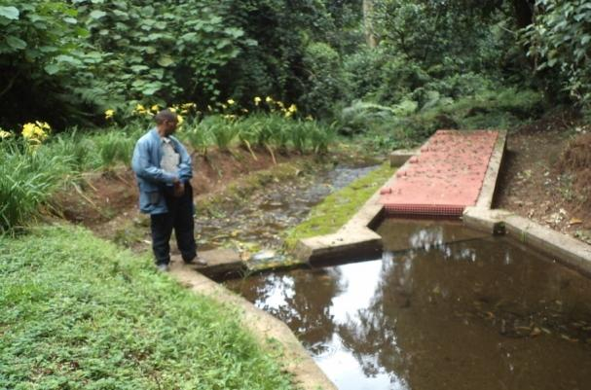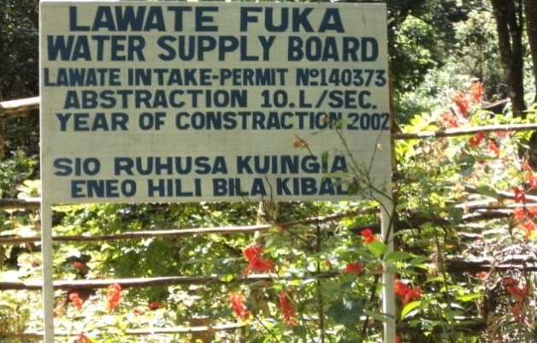
Figure 3: Left picture shows the division box shared between Lawate Fuka water supply and local community located at Kilimanjaro forest reserve. At present conflicts have occurred on water allocation.
Local laws governing water resources management in the highland zone send this literature review/ material

Traditional furrow Committees have formulated unwritten bylaws to guide them in managing water resources .Women are prohibited from going to the water source because of fear water will go back to its source or will dry up but have right to be supplied with water for the irrigation purposes. Only a furrow chairman is allowed to reach at water source or elders from the traditional furrow Committee. Agricultural practitioners are prohibited from going to the water source or intake unless it is for maintenance of the furrow intake which again must be done under the supervision of the traditional furrow Committee. Only furrow leaders are free to check and operate the intake structure. For each furrow,a water distributor or 'mgawamaji' in Swahili is a person responsible for day-to-day allocation of water to farmers within one furrow are given a water allocation schedule by the furrow chairman, which makes it easy to find defaulters on any particular day. Closing of the furrow or getting water of another water user without permission from the furrow Committee is charged 50000Tshs or anything having the same value .Charges or fines for the law breakers (defaulters) are kept by the treasurer to assist in cleaning and repairing the furrow. No charges for using water for domestics purposes from the furrow and regard water as a free gift from God. Failure to participate in cleaning the furrow charges are 5000Tshs or a bunch of banana, Men only are allowed to maintain and repair the furrow and uncircumcised boys are not allowed to take part in cleaning or repairing the furrow because of fear that they will make water to disappear from the furrow intake. No membership fee is charged for joining the furrow Committee.
Local water governance in midland zone
Traditional furrow Committee consisting of furrow chairman, vice furrow chairman, secretary, treasurer, council of elders, furrow guard and other members. Furrows located in the midland have gender consideration both men and women hold different positions in the Committee. They are not rigid to cultural norms as compared to highland furrows because are more aware of the new formal system of water management (Water User Association (WUA)). Elections for the new members in the Committee is held after every 3 years at the general village meeting. The Water User Association (WUA) (UWAMASAKWA) chairman usually invited to attend the elections but not allowed to vote. His main duty is to give advice on how to form the traditional Committee structure and preparation of water allocation schedule among small scale farmers.
Most of traditional furrow Committee in midland zone have a good cooperation with UWAMASAKWA in solving conflicts, water allocation, and management of furrows. Some members of the furrow Committee are in UWAMASAKWA Committee, for instance, furrow chairman. Furrow chairman is responsible for allocating and distributing water to only members who belong to a particular furrow where all water users come and have a general meeting. Furrow chairman knows their members who are supposed to be given water according to the water allocation schedule for irrigation. Members of the furrow who usually participate in cleaning and maintenance of the furrow have the right to be given water. Furrow chairman has the duty to go to the intake (water source) for checking water level and conduct some rituals by making traditional sacrifices like a goat or sheep to ensure water continues to flow at all seasons.
The furrow Committees have a responsibility to prepare water allocation schedule and in the process of forming the schedule all water users have to attend. They also have the responsibility to organize people for cleaning and maintaining of the furrow. If the traditional furrow Committee is found to be weak or having conflicts with the villagers it is removed and new elections are held to choose other new members. Most furrows are registered with the Pangani basin. They also have no bank account to keep large amount of money collected as fee from members or money collected from defaulters.
Water allocation, conflict and management of furrows in the midland zone
In midland, most furrows are well constructed due to fund assistance from the Participatory Agricultural Development and Empowerment Project (PADEP) from the government.During high flows water allocation is done at all hours. Furrow Committee meet once per week for making water allocation schedule and all water users have to attend the meeting. Water users are given 6- 8 hours to irrigate farms and furrow secretary has a mandate to make a follow up and identify members supposed to be allocated water. At the dry season or period of low flows water users are given 2 -3hours per day depending on the size of the farm.
In this zone there are many water users such as farm estates,l ivestockkeepers and the local community depending on the traditional furrows. In case where the furrow is shared between farm estate and the local community (small scale farmers) arrangement for preparation of water allocation schedule and duties are imposed. For instance the furrow shared between the Mbosho village and coffee cooperative society, an agreement on rotational water allocation was reached, coffee cooperative society was allowed to abstract water for two days on Friday and Sunday and the remaining days water is used by the villagers to irrigate their farms. Water users in the village clean the furrow but the cooperative maintain the furrow and pay the water guards. Serious conflicts are occurring in this midland area especially during dry season when there are low flow of water. For instance the first conflict involves upstream users from Mese village closing Nanguriri spring especially during the dry season, affecting downstream users at Samaki Maini village. Furrow elders from Samaki Maini furrow have been trying to negotiate with the Mese elders but there was no solution, but during the wet season there is no serious conflict because they normally open the spring.
According to the interview, the furrow Committee at Samaki Maini village negotiated again with the upstream users so as to construct division box at Nanguriri spring but they refused and said they will never allow that. Upstream users think will loose their legacy in ownership of Nanguriri spring. Second conflict ocurred between upstream users from Sonu village with the downstream users at Mbweera village on construction of division box at furrow intake.Again upstream users were reluctant to ccoperate because of fear that they will loose their legitimacy of ownership at the water intake. According to people interviewed in Mbweera village, they also prefer Water User Association (WUA) because it brings the democracy and avoid dictatorship in water use. They said upstream users in Sonu village are the source of conflict and denies the downstream users from getting water and no measures have been taken.
Third conflict conflict was between one upstream user (farmer) from Sonu village and another downstream (farmer) in Mbweera village, involving stealing of water by upstream user denying the downstream user from accessing water from the furrow. He was caught and called by the traditional furrow Committee and was ordered to pay 50000Tshs but refused to pay and again was taken to the village government by the Committee instead got support from the village government.According to the interview made, one member of the committe complained farmer from Sonu village usually pays bribes to the village chairman and ward executive officer because he has been caught several times stealing water from the furrow but wins the case. During my research I also attended one meeting of the traditional furrow Committee from Mbweera village where the Water User Association (WUA) chairman also attended. In a meeting that farmer from Sonu Village atttended. He was blamed for not attending furrow cleaning, Not obeying traditional furrow laws and Water User Association (WUA) (UWAMASAKWA) laws, stealing of water and being rude to the furrow Committee leaders. He was ordered by Water User Association (WUA) chairman to pay 10000Tshs for not obeying the furrow chairman, 10000Tshs for stealing of water and 1000Tshs for not attending the exercise of cleaning a furrow.These are charges according to UWAMASAKWA laws. He did not accecpt to pay and left the meeting, Water User Association (WUA) chairman and traditional furrow chairman took him to the court and the case is still going on.

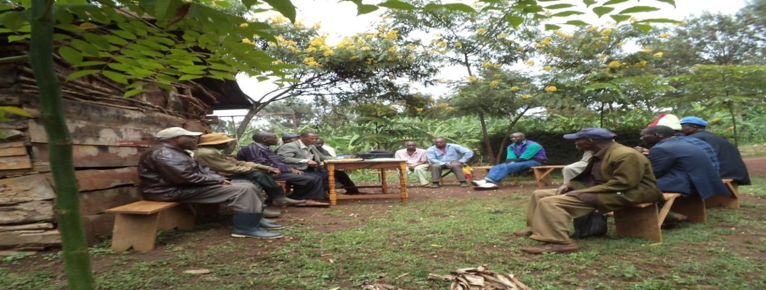
Figure 4: A section of UWAMASAKWA leaders and traditional furrow Committee in a meeting intended to solve the conflict which arose in Mbweera village between the upstream and downstream users. send this literature review/ material

The last conflict in midland zone was between Tulde coffee estate owned by a British citizen and Nroo village in using Kibohehe furrow. The local community from the village complain that all water is directed to the Tulde estate and leaving low flow of water to the villagers to irrigate their coffee crops. The estate owner claimed that he had water right from Pangani office and pay annual fee. Water allocated to them is still not enough to irrigate the whole farm. Villagers also claim that the private owner promised to drill underground water so as to supply more water to the reservoir to be used for the estate and promised not to use water from the furrow but did not fullfill the promise.Water User Association (WUA) leaders, held a meeting involving Tulde estate and traditional furrow Committee, trying to solve the conflict but nothing was achieved and currently still the conflict continues.
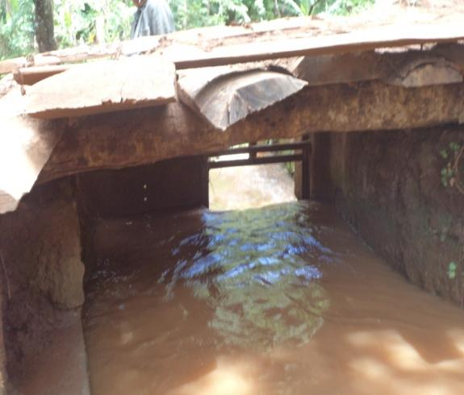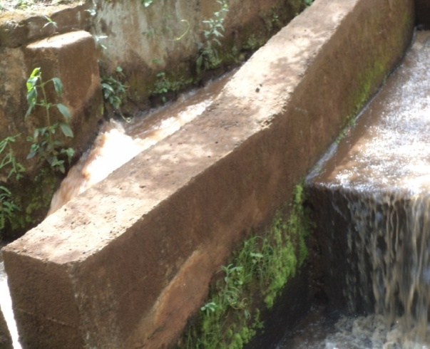
Figure 5: One of the traditional furrows located at Nroo village where there is a conflict between Tulde estate and villagers. Left picture shows more water allocated to estate from the distribution box and right picture shows how the furrow have been divided at the left side where there is highflows belong to the estate and right side where there is low flow belong to the villagers. send this literature review/ material

Local laws governing water resources management in midland zone
Absence in cleaning the furrow, charges are 5000Tshs, interrupting the water allocation schedule fines are 10000Ths, Livestock grazing near the furrow fine is 30000Tshs, water use without permission from the Committee charges are 10000Tshs,absent for cleaning the furrow charges are 5000Tshs,stealing of water charges are 50000Tshs,destroying the furrow source like farming near the water source charges are 10000Tshs,farming should be done 30m away from the water source, Water users are not charged to pay water user fee for irrigation because it is a traditional water and they regard water as a free gift from God.A Women is not allowed to open the furrow gate but may be allowed if she carries a baby boy. Uncircumcised boys are not allowed to reach water source or cleaning and maintenance of the furrow. Allowing pigs to the furrow charges are 50000 Tshs and a person is given 7 days to pay.If he or she fails to pay a pig is taken by the traditional furrow members.
Local water governance in lowland zone
Traditional furrow Committee consists of chairman, secretary, furrow guards, treasurer and council of elders. Furrows in lowland have branches and each branch has furrow chairman, secretary, treasure and elders who play a role as advisors in water allocation. There is gender consideration both men and women hold different position in the Committee. Furrow secretary is responsible for allocating and distributing water because has a list of all water users supposed to get water according to the water allocation schedule. Water is allocated to farmers belonging to a specific furrow in the village, attending thsend this literature review/ material
e cleaning and maintenance of the furrow and those who completed to pay water user fee.
Non members of the furrow like farmers renting land for farming water is allocated to them once they pay water user fee which is somehow large compared to the fee charged to furrow members. Furrow chairman is the overall in charge for all activities in the furrow. Traditional furrow Committees have duty to draft water allocation schedule, organizing people in cleaning and maintenance of the furrow. Women, elders and people with Human immunodeficiency virus (HIV) are excluded in cleaning and maintenance of the furrow.
Election for new members in the Committee is held every 3 years. All furrows in lowland have bank accounts for keeping large amounts of money collected from members as water fee. All furrows are registered with Pangani Basin Water Office where they usually pay annual water fee.
All traditional furrows in the lowland zone are members of Tegemeo Water User Association which existed before the newly created Water user association (UWAMASAKWA) except Mpendaroho furrow in Rundugai villageThe local community from Rundugai village left Tegemeo because of high water fee charges they used to pay as a membership fee, they have many springs which assure them to have more water for the supply to the village. They also left Tegemeo a because leaders of Tegemeo came from other villages which are the downstream users to Rundugai and did not hold high positions in Tegemeo Committee. They are upstream users and water source for other furrows supplying to remaing villages depend much on Rundugai intake. For instance Mtambo furrow supplying Mkalama and Kawaya village, Sumaili furrow supplying to Chekimaji village.
Box 3: Statement from Mpenda Roho chairman at Rundugai village
“We want to continue with our local institutional set up in managing our furrows, we do not want to join any association, for instance the chairman of Tegemeo water user association is also a chairman for Mkalama village and secretary is from Chekimaji village, we are excluded to hold high positions in Tegemeo committee. Furthermore we pay annual fee to Pangani office and why should we pay again money to Tegemeo or UWAMASAKWA? They are confusing us, he complained that for instance UWAMASAKWA is for Sanya-Kware sub catchment but they are not benefiting from Kware River passing at their village, they only depend on their natural springs which assure them enough water.”

Water allocation, conflict and management between furrows in the lowland zone
In the lowland area water allocation during the rainy season tends to have high flow, water users are given 4-6 hours per day depending on the farm size but during the dry period when water flow is low water is allocated on rotational basis, 2- 3 hours per day. A water distributor or furrow secretary has a duty to make a follow up and identify all members who have finished paying the water fee. Those who have paid will have the right to be given water and those who do not typically pay will be denied from accessing water to irrigate their farms.
In lowland zone they are also serious conflicts. For instance Conflict between rice farmers farming near the water source and other small scale farmers growing vegetables like onions and other crops like beans and maize. Rice farmers break the agreement and want to irrigate their farms all the time without following the water allocation schedule and sometimes break the furrow gate to get water. Village government and traditional furrow Committees have failed to solve the problem.This occurs mainly in Chekimaji and Kawaya villages.
Another conflict involves upstream users from Rundugai furrow who do not typically want to cooperate with downstream users on water allocation and sometimes close furrow gates during the dry season. Also do not typically take part in cleaning the furrow with the other water users in the downstream. TEGEMEO tried to negotiate with them so as to allow water to flow to other users but failed because traditional furrow leaders cooperate with the village chairmen from Rundugai village who usually defend them. Famers also are free to use water pumps in Rundugai village while in other downstream villages farmers are prohibited to use pumps and have strict laws preventing them from abstracting water using water pumps.
The last conflict occurred between livestock keepers, who are mostly the Maasai and farmers especially during the dry season. Agricultural practitioners complain that livestock keepers from Hai and Simanjaro migrate to Chekimaji village for pasturing in their farms and sometimes livestock destroy furrows when they pass. Traditional furrow Committee reported the problem to the village government but no measures have been taken to solve the problem and conflict still continues. Tegemeo also is weak because at present they do not typically have a strong Committee to solve water use conflicts.
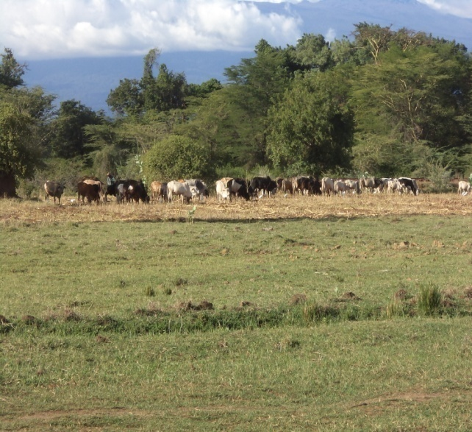
Figure 6: Lowland areas at Rundugai are mainly invaded by the livestock keepers migrating from Simanjaro and Hai district. Not a
Local laws governing water resources management in lowland zone
To be a member of the furrow Committee fee charge is 2000Tshs,disabled people, people with HIV and elders get free water and are excluded to pay water fee, destruction of the furrow fine is 50000 Tshs or a person is taken to the village government or court if he or she fails to pay the fine, Water user charges for irrigation per year is3000Tshs,failure to attend cleaning the furrow charges are 3000Tshs,stealing of water penalty is 10000Tshs.
DISCUSSIONS The juxtaposition of these institutions reveals both cooperative and contentious dynamics, especially in resource allocation and rule enforcement. The analysis of these interactions provides a framework for understanding how decentralized governance can align formal and informal institutions for sustainable management in sub-catchment areas.
Local water institutions in water resources management
Local water institutions have evolved over time in the sub catchment based on cultural beliefs and it is believed that furrows were owned by their ancestors, this made the locals to have fear and respect all water sources such as springs, swamps and catchment forests which were considered as sacred places and nobody was allowed to reach those areas without a permission from traditional furrow chairman. .
Also from the interview conducted on key informants, gave out their views about preferences, and weakness of the traditional approach in management of water resources. Total sample selected was 96 members of the traditional furrows Committees from the total population of 200 members representing 20 villages from the highland to lowland zone.The sample size was determined by applying the formula S= (z/e)2 where the degree of confidence chosen was 95% and value of Z was 1.96.Assumption of accepted error of 10% of the population standard deviation was also chosen. Based on the interview with the selected key informants from the villagers respondents, they were asked to give out their opinions on institutions preference for water resource management and weakness of local institutions in water allocation and management of furrows The results showed that the PBWO was accepted by 8%, local institutions accepted by 52%, Water User Association (WUA) was accepted by 17% and 23% respondents prefered the incorporation of the two institutions (Water User Association (WUA) and local institutions) for water allocation and management of water resources.
Figure7: Respondents preference on institutions for water resources management in Sanya-Kware-Sub-Catchment.

Weakness of local institution in water resources management
Despite their strengths, traditional institutions face several critical weaknesses that hinder their effectiveness in water resource management. According to research findings, 22% of respondents identified a lack of adherence to Integrated Water Resources Management (IWRM) principles as a significant limitation. This gap means that traditional institutions may not fully incorporate modern approaches to water management, such as equitable resource allocation, data-driven planning, or stakeholder engagement (Global Water Partnership, 2000). These shortcomings can lead to inefficiencies and exacerbate conflicts among water users.
A larger proportion of respondents (37%) highlighted the lack of legal enforcement as a key weakness. Traditional institutions often rely on customary laws, which lack the formal backing of legal systems. This limitation allows defaulters to ignore fines or penalties imposed for breaking local rules, undermining the authority of traditional leaders and the effectiveness of their governance (Meinzen-Dick & Nkonya, 2005). Furthermore, 41% of respondents noted that low levels of education among traditional leaders pose a significant challenge. This educational gap limits the ability of these institutions to develop written constitutions, adopt modern financial record-keeping practices, and manage resources transparently (Morris & Stern, 2017). Without these capabilities, it becomes difficult for traditional institutions to gain the trust and cooperation of all stakeholders.
These weaknesses collectively impact the institutions’ ability to allocate water resources efficiently and manage irrigation furrows effectively. In addition, the lack of structured conflict resolution mechanisms further diminishes their capacity to address disputes equitably, leading to prolonged tensions among water users (Swallow et al., 2001). Addressing these weaknesses requires targeted interventions, such as capacity-building programs, integration with formal legal frameworks, and the introduction of modern management tools while preserving the strengths of traditional practices.
Figure 8: Weakness of local Institution for water resources management

Strength of local institution in water resources management
Traditional institutions play a significant role in water resource management, rooted in deep knowledge of the local environment and long-standing practices that align with ecological sustainability. These institutions have evolved over generations, adapting to the natural and social conditions of the areas they serve (Mwangi & Ostrom, 2009). Their intimate familiarity with the land and water systems allows them to implement culturally appropriate and environmentally sensitive strategies for water management. By leveraging indigenous knowledge, they are often able to identify and address specific challenges within their sub-catchments more effectively than external interventions (Berkes et al., 2000).send this literature review/ material

Furthermore, traditional institutions operate within a framework of established cultural norms and practices that foster a collective sense of responsibility among community members. These working rules often include rituals, customs, and taboos designed to protect water sources and ensure equitable distribution among users (Cleaver & Franks, 2005). For example, in many communities, traditional leaders oversee the enforcement of conservation practices and equitable sharing mechanisms, which can help maintain harmony among water users. These institutions also play a pivotal role in conflict resolution, using culturally accepted mechanisms to mediate disputes and maintain social cohesion (Swallow et al., 2001). This inherent social capital makes traditional institutions uniquely positioned to achieve sustainability in water resource management when properly supported and integrated with modern practices. send this literature review/ material

CONCLUSION
This study highlights the resilience and adaptability of traditional water institutions in the Sanya-Kware sub-catchment. Despite the introduction of formalized Water User Associations (WUAs), traditional furrow committees continue to play a pivotal role in water allocation, dispute resolution, and community cohesion. The continued use and local acceptance of these practices indicate the effectiveness of traditional systems in managing water resources in contexts where formal institutions face limitations. The study calls for a balanced approach that recognizes the strengths of traditional institutions while enhancing their integration with formal frameworks to foster sustainable water governance. Conclusion should be in line with your topic place
Local water institutions (traditional furrows Committees) in Sanya-Kware sub-catchment had been continuing with their own institution set up in management of the furrow for a long time before newly created Sanya-Kware sub-catchment Water User Association (Water User Association (WUA)) came in. They have governing local rules, management Committee which collaborates well with the village governments in water allocation, resolving conflicts and punishing defaulters. The new water users association (UWAMASAKWA) is still new to the locals.
Generally, the existing local water management institutions are continuing with their institutional set up in management of irrigation furrows with very little interaction with the Water User Association (Water User Association (WUA)). Although some of traditional furrow Committees in midland and lowlandzone cooperate with the new Water Users Association some of the traditional Committees from the highland zone are reluctant to cooperate with the new sysstem leading to conflicts. Overlapping of roles and responsibilities related to water allocation and management also was observed as one of the issues leading to conflicts. Therefore this study calls for reconsidering the role of informal institutions in water resources management. As evidence indicated in this study, efforts by the government to introduce newly created formal institutions for water resources have not managed to overcome all challenges related to water. Additionally, evidence has been provided on how informal institutions have been useful in water management for years in Sanya-Kware-sub-cathment

References

Awuah-Nyamekye, S. (2009). Salvaging Nature: The Akan Religio-Cultural Perspective. Worldviews: Global Religions, Culture, and Ecology, 13, 251-282. .
Bruns, B., Meinzen-Dick, R. (Eds.), 2000. Negotiating Water Rights.Sage, New Delhi.
Bruns, B., Meinzen-Dick, R., 2003. Framework for Water Rights.International Conference on Water Rights. Hanoi, Vietnam.
Cleaver, F. 2000. Moral ecological rationality, institutions and the management of common property resources. Development and Change 31(2): 361-383.
Cleaver, F. 2002. Reinventing institutions: Bricolage and the social embeddedness of natural resource management. The European Journal of Development Research 14(2): 11- 30.
Dietz, T.; Ostrom, E. and Stern, P.C. 2003. The struggle to govern the commons. Science 302(5652): 1907-1912.
Douglas, M. 1987. How institutions think. London: Routledge and Kegan Paul. Cited in Cleaver (2002).
Fleuret, P. 1985. The social organisation of water control in the Taita hills, Kenya. American Anthropological Association 93(1): 91-114.

Evans, D., & Jackson, T. (2008). Sustainable consumption: Perspectives from social and cultural theory. Ecological Economics, 1-22.

Galvan, D. 1997. Institutional syncretism and the articulation of modes of production in rural Senegalese land tenure relations. African Rural and Urban studies 4(2-3): 59-98.

Grafton, R.Q., Garrick, D., Manero, A. & Do, T.N. (2019). The Water Governance Reform Framework: Overview and Applications to Australia, Mexico, Tanzania, U.S.A and Vietnam. Water, 11(1), 137.

Greider, T. & Garkovich, L. (1994). Landscapes: The Social Construction of Nature and the Environment. Rural Sociology, 59, 1-24. https://doi.org/10.1111/j.1549- 0831.1994.tb00519.x

Gudaga, J.L., Kabote, S.J., & Tarimo, A.K.P.R. (2018). Effectiveness of groundwater governance structures and institutions in Tanzania. Water Science 8, 77. .

Infield, M., & Mugisha, A. (2013). Culture, Values and Conservation: A Review of Perspectives, Policies and Practices for the Integration of Cultural and Ethical Values into Conservation. Fauna and Flora International. .

Jones, S. 2011. Participation as citizenship or payment? A case study of rural drinking water governance in Mali. Water Alternatives 4(1): 54-71.

Kabote, S. & Nyamhanga, P. (2017). Water Governance in Tanzania: Performance of Governance Structures and Institutions. World Journal of Social Sciences and Humanities, 3, 15-25. https://doi.org/10.12691/wjssh-3-1-3

Li, Y., Cheng, Beeton, R., Sigler, T., & Halog, A. (2015). Sustainability from a Chinese cultural perspective: the implications of harmonious development in environmental management. Environment, Development and Sustainability, 18, 679-696. .
Maganga, F.P., 2003. Incorporating customary laws in implementation of IWRM: some insights from Rufiji River Basin, Tanzania.

Physics and Chemistry of the Earth 28, 995–1000.

Mosha, D.B., George, C., Vedeld, P. & Gimbaje, E. 2016 Performance of water management institutions in farmermanaged irrigation schemes in Iringa Rural and Kilombero Districts, Tanzania. International Journal of Asian Social Science 6(8), 430–445.

Mosha, D., Kajembe, G.C., Tarimo, A., Vedeld, P.O., & Mbeyale, G. (2016). Performance of Water Management Institutions in Farmer-Managed Irrigation Schemes in Iringa Rural and Kilombero Districts, Tanzania. International journal of Asian social science, 6, 430-445. .
Kayunze, K. (2019). Processes,Experiences and Guildlines for the Formation of SuCatchment Water User Associations in the Great Ruaha River Catchment areaIringa and Mbeya Region. Consultancy report submitted to WWF- Tanzania Country Office, Dar es Salaam, Tanzania.
Mwakaje, A., Sokoni, C., 2003. Crop–livestock integration in irrigatedfarming systems as a strategy for conflict resolution; a case study ofUsangu Basin Mbarali District, Tanzania. Report Submitted toENRECA, June.
Mwaruvanda,W. (2017).Baseline Data on Hydrology, Water Management Institutions and Water Resources use in the Great Ruaha Catchment area. A consultancy report submitted to World Wide Fund for Nature (WWF)-Tanzania Country Office,Dares Salaam, Tanzania.
Naidu, S.C. 2009. Heterogeneity and collective management: Evidence from common forests in Himachal Pradesh, India. World Development 37(3): 676-686.
Ostrom, E. 2000. Collective action and the evolution of social norms. Journal of Economic Perspectives 14(3): 137-158.
Ostrom, E.; Burger, J.; Field, C.B.; Norgaard, R.B. and Policansky, D. 1999. Revisiting the commons: Local lessons, global challenges. Science 284(5412): 278-282.
Ostrom, E. and Gardner, R. 1993. Coping with asymmetries in the commons: Self-governing irrigation systems can work. Economic Perspectives 7(4): 93-112.
Posey, D. A. (1999). Cultural and Spiritual Values of Biodiversity. London: Intermediate Technology Pubications.
Saleth, M.R. & Dinar, A. 2004. The Institutional Economics of Water: A Cross-Country Analysis of Institutions and Performance. Washington DC: World Bank & Cheltenham: Edward Elgar.
Schama., S. (1996). Landscape and Mamory. London: Fontana Press.
Sehring, J. 2009. Path dependencies and institutional bricolage in post-soviet water governance. Water Alternatives 2(1): 61-81.

Sokile, C. & Koppen, B. (2004). Local water rights and local water user entities: The unsung heroines of water resource management in Tanzania. Physics and Chemistry of the Earth, Parts A/B/C, 29, 1349-1356. https://doi.org/10.1016/j.pce.2004.09.010

Sokile, S.W., Mwaruvanda, W. & van Koppen, B. 2005. Integrated Water Resources Management in Tanzania: Interface between formal and Informal Institutions. https://colinmayfield.com/public/PDF_files/Integrated%20 Water%20Resource%20Management%20in%20Tanzania% 20interface%20between%20formal%20and%20informal% 20institutions.pdf (accessed 30 December 2021).

Theesfeld, I. 2011. Perceived power resources in situations of collective action. Water Alternatives 4(1): 86-103.

Van der Zaag, P. 2007. Asymmetry and equity in water resources management: Critical institutional issues for southern Africa. Water Resources Management 21(12): 1993-2004.
Van Koppen, B., 2003. Water reform in Sub-Saharan Africa: whatis the difference? Physics and Chemistry of the Earth 28, 1047–1054.

World Bank. (2015). Wetland Management, Convenient Solutions to an Inconvenient Truth, Washington DC.USA.

Zavestoski, P. (2007). Ecological Identity. New York: Taylor and Francis.

