RADIOGRAPHIC EVALUATION OF THORACIC AFFECTIONS IN NELLORE BROWN SHEEP

ABSTRACT

The study on radiographic assessment of thoracic disorders in sheep was carried out on animals of different ages and both sexes that were presented with clinical illness to the Department of Veterinary Surgery and Radiology, NTR College of Veterinary Science, Gannavaram. Radiographic examination of the affected sheep revealed different types of lung patterns. Among these, the interstitial pattern was most frequently observed (18 out of 62 cases; 29.03%), followed by the alveolar pattern (15/62; 24.19%), bronchial pattern (8/62; 12.9%), and mixed pattern (10/62; 16.13%). Additionally, a few cases exhibited other thoracic abnormalities such as pleural effusion (5 cases; 8.06%), cardiomegaly (2 cases; 3.23%), pneumothorax (2 cases; 3.23%), and cavitatory lesions (2 cases; 3.23%).

INTRODUCTION

Sheep and goats are important source of meat and milk for a great sector of population in many areas of the world. However, both animals received little attention regarding diagnosis and treatment of different thoracic affections. Small ruminants may suffer from a multitude of health problems that may affect different systems mostly the thoracic organs, particularly the lungs (Abdelhakiem et al. 2020). Small ruminants are highly susceptible to respiratory diseases which contribute to 5.60 per cent of the total diseases (Hindson and Winter, 2002). Thoracic radiography is a valuable tool in veterinary medicine for diagnosing and managing respiratory and cardiac conditions in sheep. By providing detailed

images of the thoracic cavity, it enables veterinarians to provide timely and effective treatment, ultimately improving the health and welfare of sheep populations and aids in the assessment of severity of bacterial pneumonia based on infiltration density, contrast and areas of lung affected (Kattimani et al. 2020). It can also be used to detect various conditions such as bronchopneumonia, pneumonia, pleural effusion, foreign body, thymoma, tracheal collapse, enlarged lymph nodes, or cardiac disease (Smith, 2017). Although the occurrence of surgical affections of the thoracic structures in sheep is lower than that of the large ruminants, knowledge of the different affections is so important for diagnosis, management, treatment and predilection of prognosis.

MATERIALS AND METHODS

The present study carried out on ailing sheep between 3 months to 6 years of age group that were presented to the Department of Veterinary Surgery and Radiology and Department of Veterinary Clinical Complex, NTR College of Veterinary Science, Gannavaram. Sheep ailing from respiratory signs like coughing, nasal discharges, dyspnoea, pyrexia were included and thoracic radiographs obtained were interpreted. Exposure factors of kVp range 55 to 65 and mAs 8-15 used for small to medium sized sheep for lateral views whereas for the DV and VD views a kVp range of 65 to 70 were used. Radiographic evaluation of thorax like different lung patterns, various thoracic affections were recorded and analyzed.

RESULTS
Among 62 sheep showing signs of respiratory disease, thoracic radiographs were performed to assess various lung and thoracic abnormalities. Increased lung opacity was observed in all animals with pulmonary involvement. Most cases exhibited mild to moderate pulmonary changes, while a few showed severe alterations. Interstitial patterns were the most common radiographic finding, followed by alveolar patterns; bronchial and mixed patterns were less frequent. Specifically, interstitial patterns were seen in 18/62 cases (29.03%), alveolar in 15/62 (24.19%), bronchial in 8/62 (12.9%), and mixed patterns in 10/62 (16.13%). Visibility of pulmonary vessels, the aorta, and vena cava was generally reduced, although the caudal vena cava remained clearly visible. Pleural effusion was noted in 5 cases (8.06%), while other findings included cardiomegaly in 2 cases (3.23%), pneumothorax in 2 cases (3.23%), and cavitary lesions in 2 cases (3.23%) (Table 1).

Table 1. Different thoracic affections in affected sheep
S. No | Thoracic Lesions |  | Number | Per cent
1 | Lung patterns in pneumonia cases | Interstitial Pattern | 18 | 29.03
1 | Lung patterns in pneumonia cases | Alveolar Pattern | 15 | 24.19
1 | Lung patterns in pneumonia cases | Bronchial pattern | 8 | 12.90
1 | Lung patterns in pneumonia cases | Mixed Pattern | 10 | 16.13
2 | Pleural effusions |  | 5 | 8.06
3 | Cardiomegaly |  | 2 | 3.23
4 | Pneumothorax |  | 2 | 3.23
5 | Cavitary lesions |  | 2 | 3.23
 | Total |  | 62 | 100.00

Interstitial pattern was the most common lesion noticed in 18 sheep affected with respiratory sign in which 10 showed unstructured pattern (Fig. 1) and 8 showed structured pattern (Figs. 2 and 3) and radiological signs such as presence of fluid, cells or fibrin in the interstitial space or diffuse miliary nodules. Alveolar pattern was the second most common and noticed in 15 sheep affected with respiratory signs which was characterized by consolidation of cranioventral lung field with fluid filled alveoli and air bronchogram (Fig. 4). Bronchial pattern was observed in 8 sheep affected with respiratory signs and was characterized by donuts and tram lines (Fig. 5). Mixed pattern was observed in 10 sheep affected with respiratory signs. Mixed pattern was characterized by the presence of more than one pattern, such as a combination of interstitial, alveolar and bronchial pattern (Fig. 6). Pleural effusions were observed in 5 sheep affected with thoracic affections. Radiographically these effusions obscured the cardiac silhouette. In one case, pleural effusion with leafy lung pattern in progressive hydrothorax, indistinct cranial and middle lung lobes, and mixed lung pattern in caudal lung lobes. In 2nd case, Pleural effusion with mixed lung pattern with border effacement sign of silhouette of heart at right side was noticed. In 3rd case, Pleural effusion with lobar sign between cranial and middle lung lobes in left lateral view of sheep was noticed (Figs. 7, 8 and 9). Cardiomegaly was seen in 2 cases in sheep with thoracic affections. Cardiomegaly with VHS value of 12.5 and heart was extending from second sternebrae to seventh sternebrae with indistinct cranial lung lobes in one case (Fig. 10). In another case, indistinct cranial and middle lung lobes with enlarged heart occupies most of the thoracic cavity and compressing the crura of diaphragm in VD view (Fig. 11). Pneumothorax was seen in 2 cases in sheep with thoracic affections (Fig. 12). Cavity lesions was seen in 2 cases in sheep with thoracic affections. In one case, an ovoid to round thin walled gas and soft tissue opacity filled structures in the region of the right cranial thorax of sheep (Fig 13). In another case, pleural effusion with cavitary sign (round, discrete, single or multiples lesions of soft tissue radio opacity) in hilar region and caudal border of heart (Fig. 14).
DISCUSSION
In the present study, sheep ailing from respiratory signs like coughing, nasal discharges, dyspnea, and pyrexia were included and thoracic radiographs were obtained and interpreted.
Radiographic examination revealed various lung patterns, with the interstitial pattern being the most common (18/62, 29.03%), followed by the alveolar pattern (15/62, 24.19%), mixed pattern (10/62, 16.13%), and bronchial pattern (8/62, 12.9%). Similarly, Reddy et al. (2018) reported an interstitial pattern in 46.15% (24/52) of bovines with bacterial pneumonia, followed by bronchial pattern (25%, 13/52), pulmonary edema (15.38%, 8/52), and alveolar pattern (13.46%, 7/52). Thirunavukkarasu et al. (2006) observed interstitial, bronchial, and alveolar patterns in pneumonic calves with frequencies of 48.15%, 37.03%, and 14.82%, respectively. In contrast, Berman et al. (2020) and Castells et al. (2019) reported the alveolar pattern as the predominant lung pattern in calves with bronchopneumonia and in sheep with chronic bronchopneumonia, respectively. Tyagi and Singh (1993) described various radiographic signs of lung disease in cattle, including alveolar, interstitial, peribronchial, vascular, and mixed patterns in pneumonic lungs.
In the present study, the interstitial pattern was the most commonly observed lesion in 18 sheep showing respiratory signs, of which 8 exhibited a structured pattern and 10 an unstructured pattern. Radiographic features included the presence of fluid, cells, or fibrin in the interstitial space, as well as diffuse miliary nodules. Rozear et al. (1998) suggested that the interstitial pattern represents a generalized inflammatory process, such as pulmonary nocardiosis, and listed differential diagnoses for nodular interstitial patterns, including granulomas from bacterial, fungal, or parasitic pneumonia, pulmonary abscesses, nodular eosinophilic inflammatory disease, or primary/metastatic neoplasia. Unstructured interstitial patterns may result from bronchopneumonia, viral, bacterial, or parasitic pneumonitis, lung fibrosis, or diffuse pulmonary metastasis. Similarly, Nout et al. (2002) reported a predominantly diffuse interstitial pattern in foals affected with chronic pulmonary disease.
Alveolar patterns were the second most common lesion, characterized by consolidation of the cranioventral lung field with fluid-filled alveoli and air bronchograms, while bronchial patterns appeared as donuts and tram lines. Thrall (2013) described alveolar patterns as areas of intense opacity with air bronchograms or lobar signs, and bronchial patterns as tram lines or ring shadows. Castells et al. (2019) reported that sheep affected with ovine respiratory complex exhibited alveolar patterns as white, diffuse opacities, whereas Tegtmeier and Arnbjerg (2000) observed well-defined uni- or multilobular atelectasis with variable air bronchograms and air alveolograms in calves with exudative bronchopneumonia.
Mixed patterns, observed in 10 sheep, were characterized by the coexistence of two or more patterns, such as interstitial, alveolar, and bronchial changes. Pleural effusions were identified in five sheep and were radiographically evident as obscured cardiac silhouettes. Specific observations included pleural effusion with a leafy lung pattern in progressive hydrothorax, indistinct cranial and middle lung lobes with mixed patterns in caudal lobes, effusions causing border effacement of the heart silhouette, and effusions presenting with a lobar sign between cranial and middle lung lobes. Braun et al. (1997) noted that horizontal fluid lines indicate pleural effusions, while Bargai et al. (1989) and Athar et al. (2011) reported that effusions may produce lung opacification, loss of thoracic detail, and indistinct outlines of the heart and diaphragm.
Cardiomegaly was observed in two cases, with enlargement extending from the second to the seventh sternebrae and obscuring cranial lung lobes. Pneumothorax was noted in two cases as well. Cavitary lesions were identified in two sheep; in one case, thin-walled ovoid or round gas- and soft tissue-filled structures were present in the right cranial thorax. Kan et al. (2021) reported similar cavitary pulmonary lesions in lambs, including large and small thin-walled ovoid gas-filled structures in the caudoventral right caudal lung lobe. In another case, pleural effusion was accompanied by cavitary lesions in the hilar region and caudal heart border. Bargai et al. (1989) described bullous or cavitary pneumonia as multiloculated air-filled cavities with partial lung consolidation, and Masseau et al. (2008) noted that cavitary lesions on radiographs may represent either abscesses or emphysematous bullae.
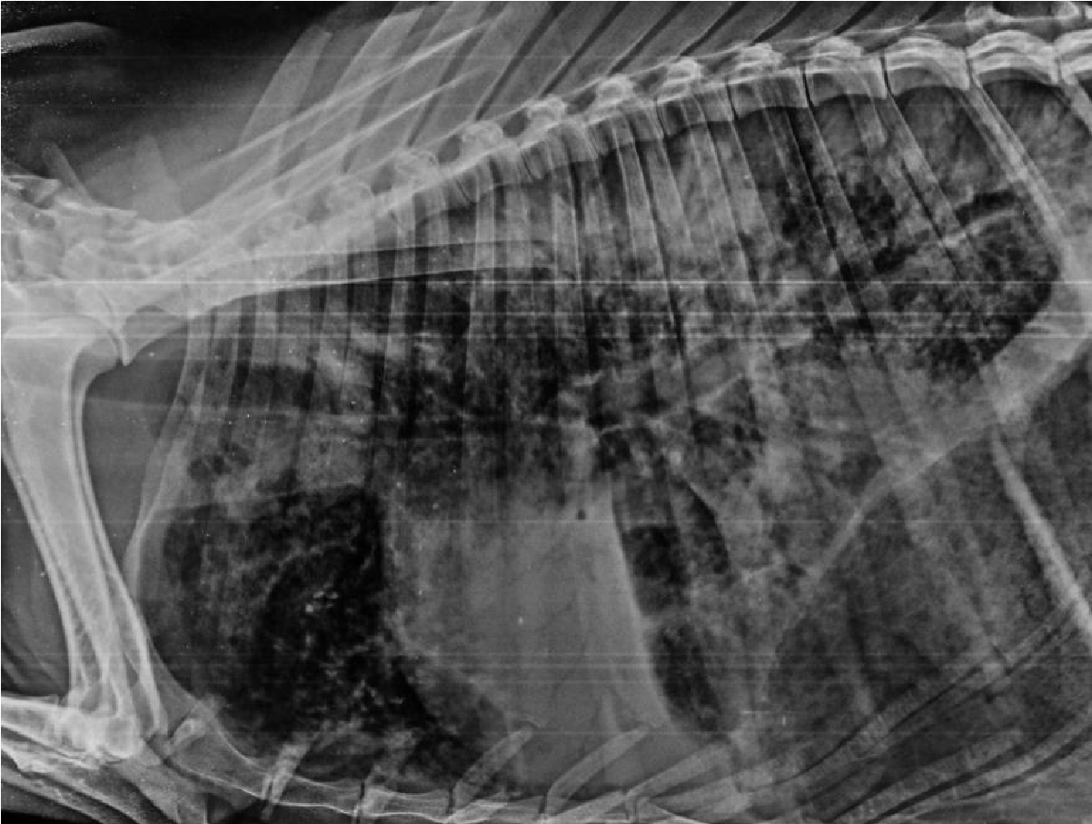
Fig. 1. Unstructured interstitial pattern throughout all the lung lobes in a sheep.

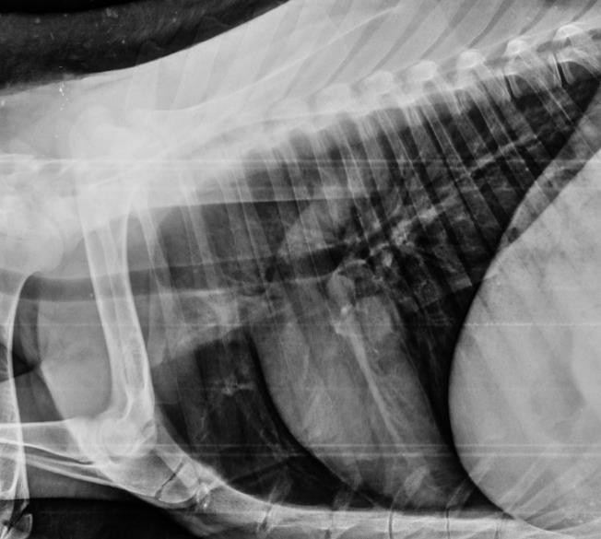
Fig. 2. Multiple nodular interstitial pattern in caudal lung lobes (arrows) in a sheep.

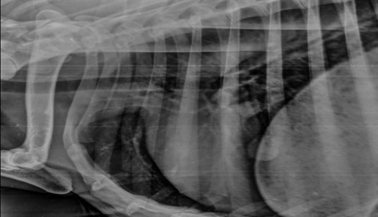
Fig. 3. Large nodule on caudal border of heart area (arrow).

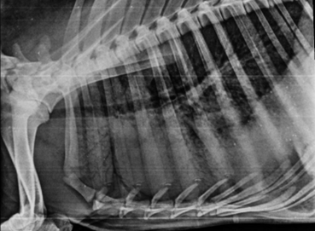
Fig. 4. Alveolar pattern with air Bronchogram in cranial middle and caudal lung lobes. Progressive scalloping sign. Minimal air density in the lungs.
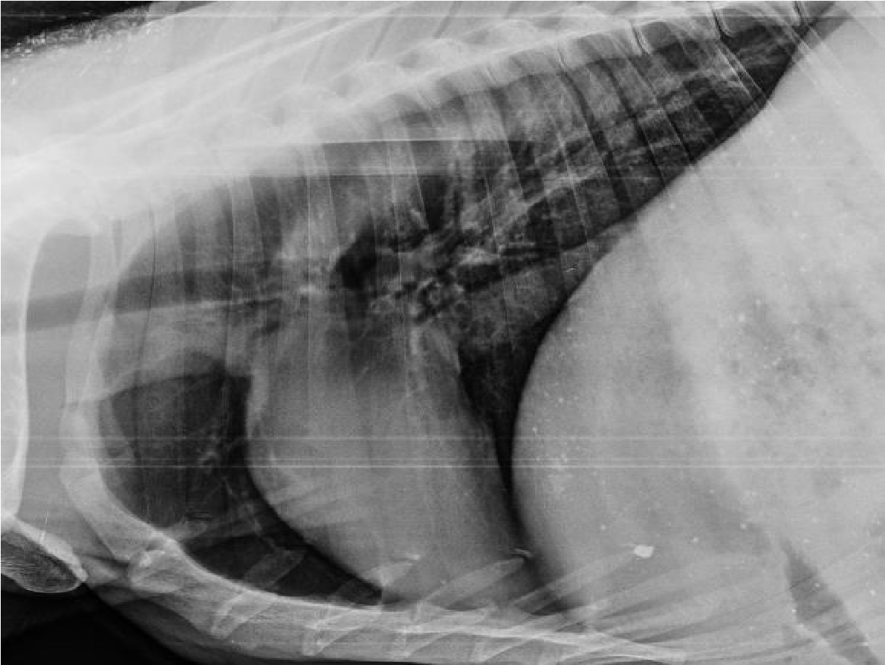
Fig. 5. Bronchial pattern with donuts and tramlines in caudal lung lobe in right lateral view of sheep.

`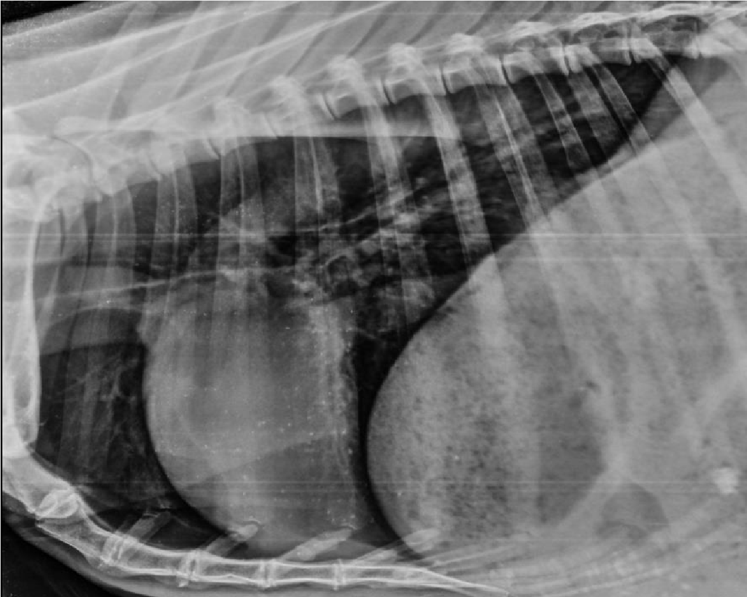
Fig. 6. Mixed lung pattern in caudal lung lobes.

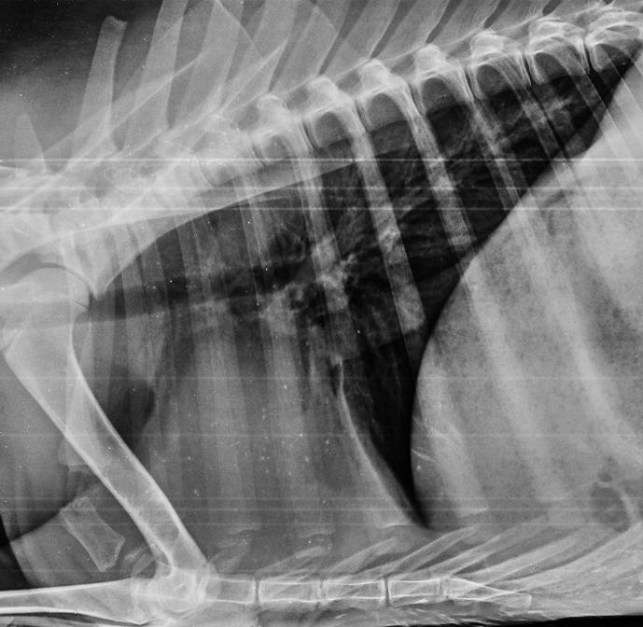
Fig. 7. Pleural effusion with mixed lung pattern with border effacement sign of silhouette of heart at right side.

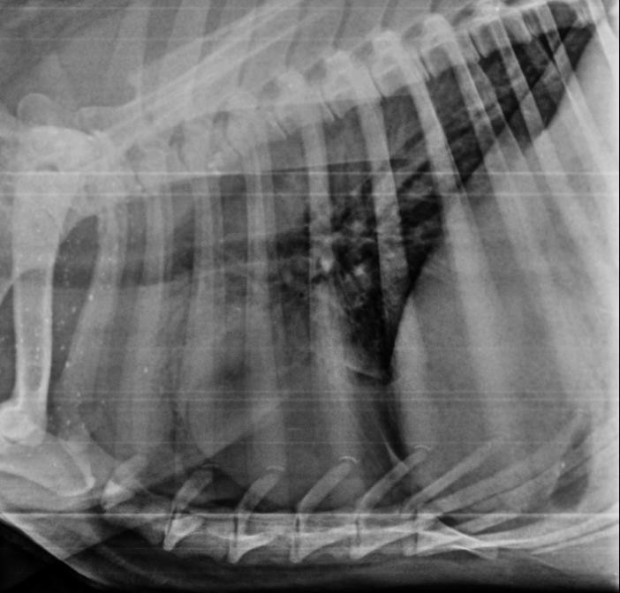
Fig. 8. Pleural effusion with alveolar pattern in cranial and caudal lung lobes.

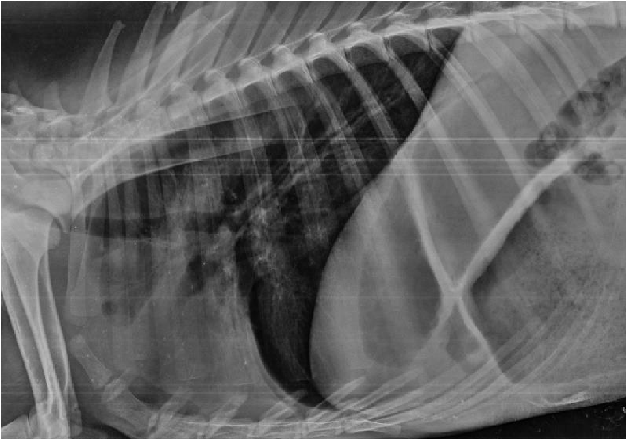
Fig. 9. Pleural effusion with leafy lung pattern in progressive hydrothorax.
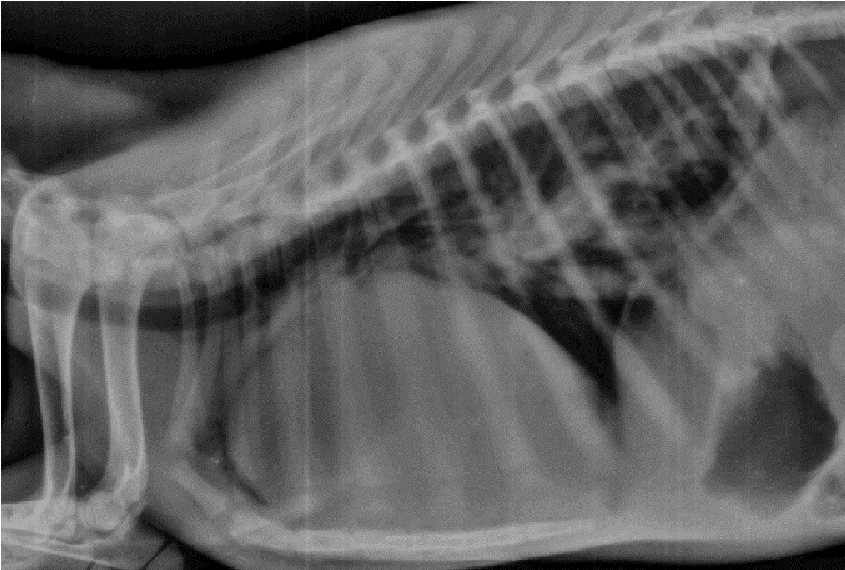
Fig. 10. Cardiomegaly with indistinct cranial lung lobes and extending from second sternebrae to seventh sternebrae. (Note right sided kneeling of heart, segmental elevation of trachea and conspicuous pulmonary oedema).

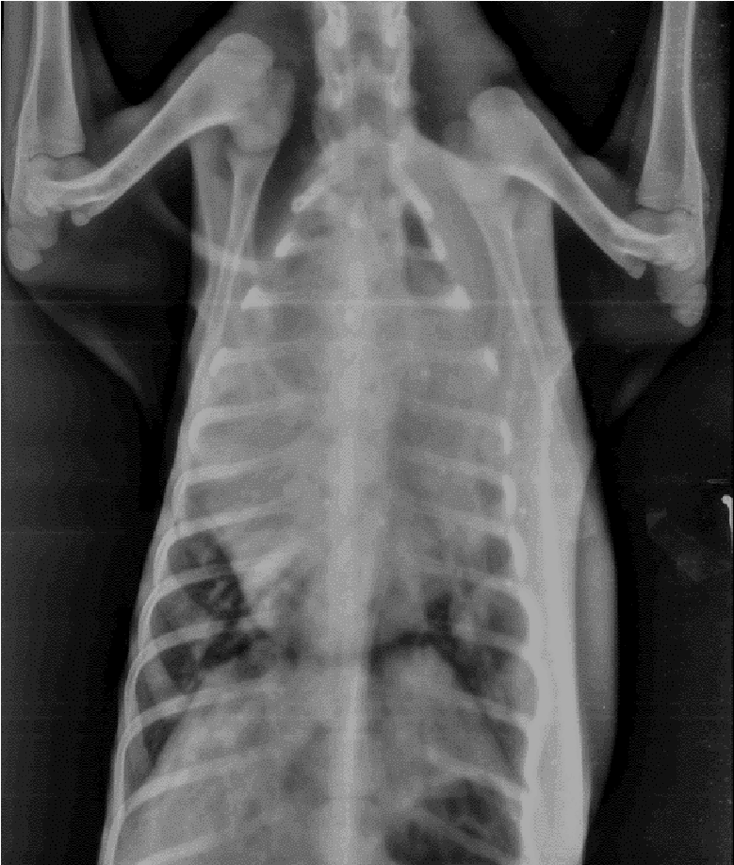
Fig. 11. Indistinct cranial and middle lung lobes with enlarged heart occupies the entire thoracic cavity and cardiac width is more than 70 % of the thoracic width in VD view of sheep.
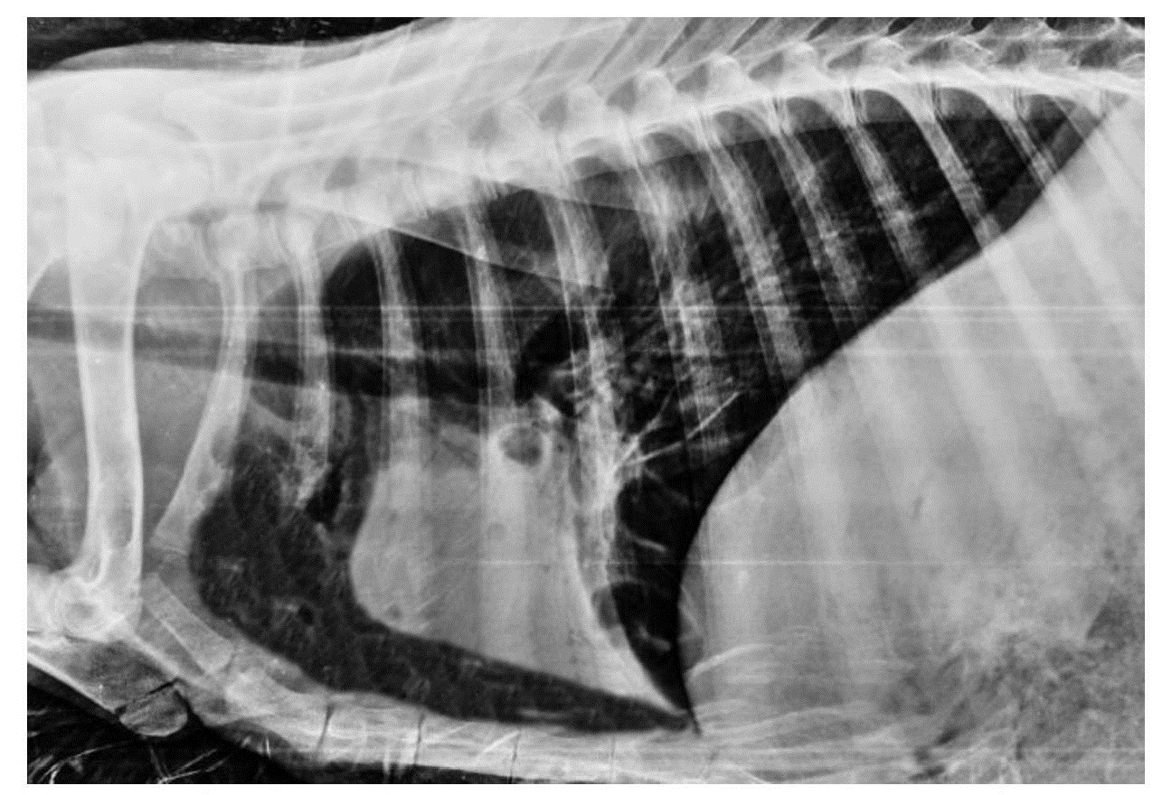
Fig. 12. Pneumothorax in right lateral view of sheep (separation of cardiac silhouette from sternum)
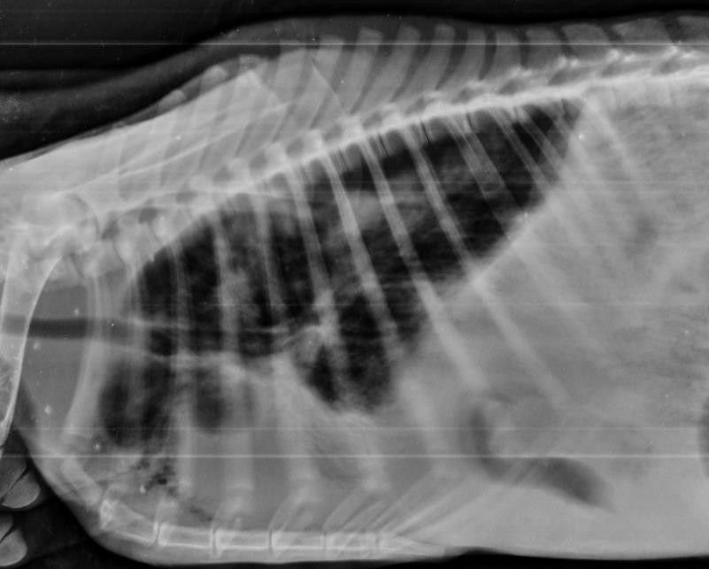
Fig. 13. Ovoid to round thin-walled gas and soft tissue opacity filled structures in the region of the right cranial thorax of sheep.
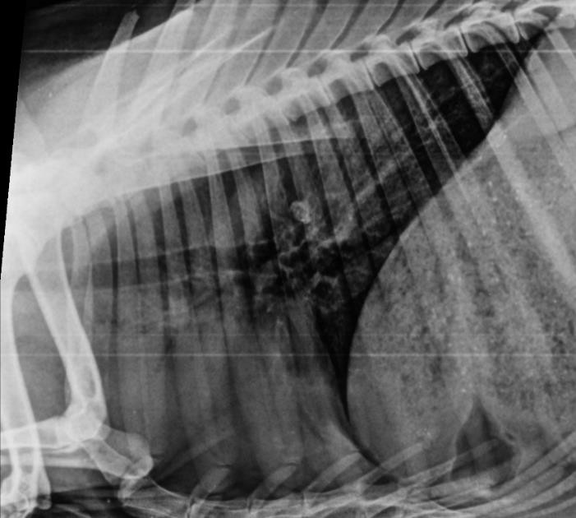
Fig. 14. Pleural effusion with cavitary sign in hilar region and caudal border of heart in a sheep.

REFERENCES
Abdelhakiem, M. A., Khalphallah, A., & Al-Lethie, A. L. A. (2020). Radiographic appearance and measurements of thoracic structures using four radiographic projections in goats. Alexandria Journal of Veterinary Sciences, 64(1).
Athar, H., Mohindroo, J., Randhawa, C. S., Singh, K., & Saini, N. S. (2011). Clinical haematobiochemical radiographic and ultrasonographic findings in bovines suffering from pericarditis and pleural effusions. Indian Journal of Animal Sciences, 81(8): 48- 51.
Bargai, U., Pharr, J. W., & Morgan, J. P. (1989). Radiological diagnosis of thorax. In: Bovine Radiology, (1) (pp. 165-174).
Berman, J., Masseau, I., Fecteau, G., Buczinski, S., & Francoz, D. (2020). Comparison between thoracic ultrasonography and thoracic radiography for the detection of thoracic lesions in dairy calves using a two-stage Bayesian method. Preventive veterinary medicine, 184, 105-153.
Braun, U., Pusterla, N., & Fluckiger, M. (1997). Ultrasonographic findings in cattle with pleuropneumonia. Veterinary Record, 141(1): 12-17.
Castells, E., Lacasta, D., Climent, M., Pérez, M., Sanromán, F., Jiménez, C., & Ferrer, L. M. (2019). Diagnostic imaging techniques of the respiratory tract of sheep. Small Ruminant Research, 180(3): 112-126.
Hindson, J. C., & Winter, A. C. (2002). Manual of Sheep Diseases Blackwell Publishing.
Kan, J., Bauquier, J., Tyrrell, D., O'Byrne, K., Stent, A. W., & Brosnan, B. (2021). Radiographic and CT appearance of cavitary pulmonary lesions in a lamb. Australian Veterinary Journal, 99(12), 529-534.
Kattimani, T. S., Ravindra, B. G., Vinay, T., Shrikant, K., Vivek, R. K., & Patil, N. A. (2020). Evaluation of pulmonary function in goats affected with bacterial pneumonia. International Journal of Current Microbiology and Applied sciences, 9(1): 1044-1053.
Masseau, I., Fecteau, G., Breton, L., Helie, P., Beauregard, G., & Blond, L. (2008). Radiographic detection of thoracic lesions in adult cows: a retrospective study of 42 cases (1995–2002). The Canadian Veterinary Journal, 49(3): 261.
Nout, Y. S., Hinchcliff, K. W., Samii, V. F., Kohn, C. W., Jose‐Cunilleras, E., & Reed, S. M. (2002). Chronic pulmonary disease with radiographic interstitial opacity (interstitial pneumonia) in foals. Equine veterinary journal, 34(6), 542-548.
Reddy, S., & Subramanyam, K. V. (2018). Therapeutic studies on bacterial pneumonia in buffaloes. Buffalo Bulletin 37(3), 343-359.
Rozear, L., Love, N. E., & Van Camp, S. L. (1998). Radiogaphic diagnosis: pulmonary lymphosarcoma in a goat. Veterinary Radiology & Ultrasound, 39(6), 528531.
Smith, M. C. (2017). Diagnosis and treatment of sheep and goat dyspnea: Small ruminant respiratory diseases. In American Association of Bovine Practitioners Conference Proceedings, 140-143.
Tegtmeier, C., & Arnbjerg, J. (2000). Evaluation of radiology as a tool to diagnose pulmonic lesions in calves, for example prior to experimental infection studies. Journal of Veterinary Medicine, 47(3), 229-234.
Thirunavukkarasu, P., Suresh, R. V., & Vasu, K. (2006). Clinical and radiological findings in bovine respiratory disorders. Indian Veterinary Journal, 83:773-775.
Thrall, D. E. (2013). Textbook of Veterinary Diagnostic Radiology (6th ed.). (pp. 585-609).
Tyagi, R. P. S., & Singh, J. (1993). Ruminant surgery (13th ed.). CBS Publishers and Distributors Delhi (pp. 80-120).

