ANTIOXIDANTS AND VITAMIN COMPOSITION OF GINGER AND TUMERIC FORTIFIED CASSAVA-GROUNDNUT SNACK BARS
ABSTRACT

This study evaluated the antioxidant and vitamin composition of cassava-groundnut snack bars fortified with ginger and turmeric. Nine formulations were developed using a 70:30 cassava-groundnut flour blend, supplemented with ginger, turmeric, or a 50:50 ginger-turmeric blend at 3%, 5%, and 7% concentrations. A control sample without spices was also prepared. Antioxidant analysis showed significant improvements in fortified samples, with the 7% ginger sample having the highest gingerol (3.89 mg/100g) and shogaol (2.16 mg/100g) levels, and the 7% turmeric sample exhibiting the highest curcumin content (8.73 mg/100g). The 7% ginger-turmeric blend demonstrated a balanced antioxidant profile with 2.96 mg/100g gingerol, 1.72 mg/100g shogaol, and 6.62 mg/100g curcumin. Vitamin analysis revealed significant improvements, with the 7% ginger-turmeric blend showing the highest retention of vitamins A (16.05 μg/100g), B3 (4.43 mg/100g), C (6.93 mg/100g), D (0.75 mg/100g), and E (1.98 mg/100g). The findings demonstrate the potential of ginger and turmeric as functional ingredients in combating malnutrition, especially among rural dwellers relying on stable crops.

Keywords: Ginger, Turmeric, Fortification, Snack Bars, Antioxidants, Vitamins

1. INTRODUCTION

The growing demand for nutrient-enriched functional foods has sparked interest in fortifying traditional snacks with bioactive compounds to address global micronutrient gaps, particularly in regions reliant on staple crops like cassava (Manihot esculenta) and groundnuts (Arachis hypogaea) (Ajanaku et al., 2022; Vicentiniet al., 2016). Cassava-groundnut snack bars are energy-dense but lack antioxidants and vitamins, limiting their health-promoting potential (Namtala, 2017). Ginger (Zingiber officinale) and turmeric (Curcuma longa) are promising fortificants due to their rich profiles of phenolic compounds and vitamins, including ginger's gingerols, shogaols, and vitamin C (Ajanaku et al., 2022; Abara et al., 2021; Saribaevaet al., 2024), and turmeric's curcuminoids and vitamins B6 and E (Gupta et al., 2021; de Oliveira Filho et al., 2021).
Studies have shown that incorporating ginger and turmeric into food systems can boost antioxidant composition and dietary quality (Saddique et al., 2021; Shaukat et al., 2023; Robinson and Tas, 2025). However, interactions between cassava-groundnut nutritional profile and spice-derived antioxidants during processing remain understudied (Rivero-Pino, 2023). This study investigates the synergistic effects of co-fortifying cassava-groundnut bars with ginger and turmeric, aiming to enhance the retention of curcuminoids and gingerols and provide actionable insights for developing nutrient-enriched snacks for populations in resource-limited regions

2.0 Materials and Methods
2.1 Materials
The primary ingredients used include cassava (TME419), groundnut, turmeric and ginger. These materials were carefully sourced from Relief market, a local market in Owerri in Imo state, and the National Root Crops Research Institute, Umudike, Abia state. The bench work was carried out in the laboratories of the Food Science and Technology department, Federal University of Technology Owerri, and the National Root Crops Research Institute, Umudike. All the chemicals were of analytical grade.
2.2 Methods
2.2.1 Processing of Raw Materials
The cassava was processed following the methods of Shittu et al. (2016), where the tubers were cleaned, peeled, washed, milled, dewatered, dried, and pulverized to obtain High Quality Cassava Flour (HQCF). Similarly, the peanuts were processed according to Wang et al. (2018), involving cleaning, roasting at 120°C for 30 minutes, cooling, dehulling, and milling. The turmeric rhizomes were processed as described by Jayashree and Zachariah (2016), which included washing, soaking, boiling for 90 minutes, sun-drying for 15 days, polishing, and grinding into fine powder. Finally, the ginger was processed following Bag (2018), where it was washed, peeled, sliced, soaked in lime water, sun-dried for one week, and pulverized into powder.
2.2.2 Ingredient Preparation (Mixing)
Cassava-groundnut snack bar was be produced using the process as described by Ezike (2013) and Chilkawar (2017) with slight modifications. The general ingredients include of the cassava-groundnut flour blend, baking soda, salt, sugar, vanilla flavour,cocoa powde, water, and ginger, turmeric, or ginger/turmeric (3,5 and 7% based on the final weight). The general recipe for the cassava-groundnut snack bar is as represented in Table 1.
Table 1: Recipe for cassava-ground snack bar production
Ingredient (%) | T33 | T55 | T77 | G33 | G55 | G77 | GT33 | GT55 | GT77 | CON
Flour blend | 62.11 | 61.35 | 60.61 | 62.11 | 61.35 | 60.61 | 62.11 | 61.35 | 60.61 | 63.29
Sugar | 3.11 | 3.07 | 3.03 | 3.11 | 3.07 | 3.03 | 3.11 | 3.07 | 3.03 | 3.16
Salt | 1.24 | 1.23 | 1.21 | 1.24 | 1.23 | 1.21 | 1.24 | 1.23 | 1.21 | 1.27
Baking soda | 0.62 | 0.61 | 0.61 | 0.62 | 0.61 | 0.61 | 0.62 | 0.61 | 0.61 | 0.63
Cocoa powder | 6.21 | 6.13 | 6.06 | 6.21 | 6.13 | 6.06 | 6.21 | 6.13 | 6.06 | 6.33
Water | 24.84 | 24.54 | 24.24 | 24.84 | 24.54 | 24.24 | 24.84 | 24.54 | 24.24 | 25.32
Ginger | 0.00 | 0.00 | 0.00 | 1.86 | 3.07 | 4.24 | 0.00 | 0.00 | 0.00 | 0.00
Turmeric | 1.86 | 3.07 | 4.24 | 0.00 | 0.00 | 0.00 | 0.00 | 0.00 | 0.00 | 0.00
Ginger/Turmeric (50:50) | 0.00 | 0.00 | 0.00 | 0.00 | 0.00 | 0.00 | 1.86 | 3.07 | 4.24 | 0.00
Total (g) | 100 | 100 | 100 | 100 | 100 | 100 | 100 | 100 | 100 | 100
CON (Control: Bar with no spice), G33 (3% ginger concentration), G55 (5% ginger concentration), G77 (7% ginger concentration), T33 (3% turmeric concentration), T55 (5% turmeric concentration), T77 (7% turmeric concentration), GT3 (3% ginger/turmeric concentration), GT5 (5% ginger/turmeric concentration), GT7 (7% ginger/turmeric concentration)
2.2.2Production of the Ginger and Turmeric spiced cassava-groundnut Snack Bars
The ingredients were prepared following the method described by Alla and Jithendran (2018) with slight modifications (Fig 1, a). The composite flour was prepared by blending cassava and groundnut in ratio of 70:30, and then supplemented with 3%, 5%, and 7% proportional ratios of ginger, turmeric and 50:50 ginger-turmeric flour blend. A control sample was also prepared using 70:30 cassava-groundnut flour without any spice. The corresponding doughs were formed, rolled, and molded to form bars. Finally, the bars were baked in an oven () for 15-20 minutes at 165°C-190°C, cooled, and packaged in polyethylene bags for subsequent analysis. Fig 1, b shows pictures of the ginger and turmeric spiced cassava-groundnut snack bar samples.

2.3 Statistical Analysis
Data obtained in all the analysis will be subjected to 2-Way Analysis of Variance (ANOVA) using SPSS statistical package (version 23.0,2016). The mean values will be evaluated for significant variations using Fisher least significant difference (LSD).
2.4 Experimental Design
This research will be based on a 2 x 3 factorial design comprising of three sources of fortification (ginger, turmeric and ginger/turmeric) and three concentrations of concentrations (3,5 and 7%). Three samples will be processed from each of ginger, turmeric and a blend of
ginger and turmeric at concentrations of 3,5 and 7% while the control will have no fortification making a total of ten samples. The 70:30 cassava groundnut blend is kept constant as a ratio that provides a good balance of carbohydrate and protein while maintaining palatability

(Nwokolo, Okwu, and Akubuo, 2018).

Cassava, Groundnut, Ginger, Turmeric and Other Ingredients
Mixing
Moulding
Baking
(165°C-190°C, 15-20mins)
Cassava-groundnut snack bar
a

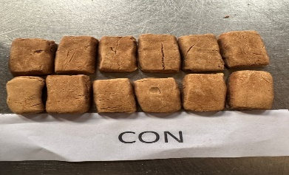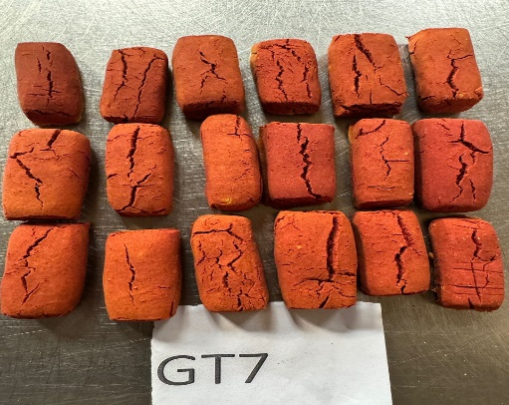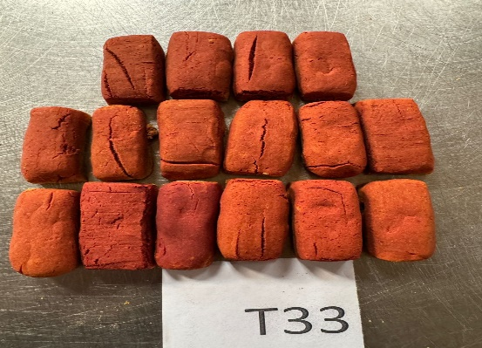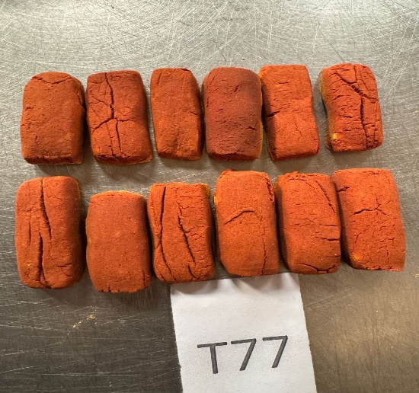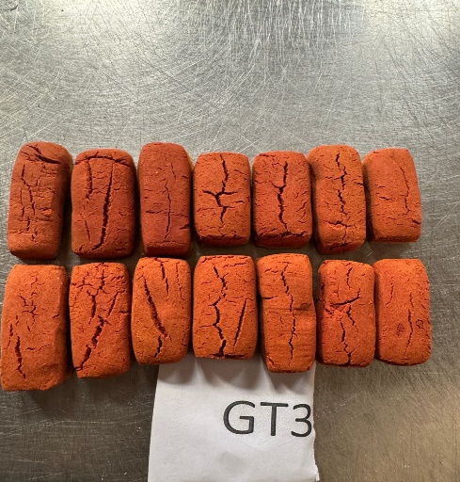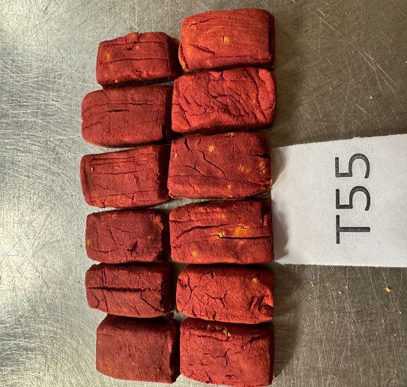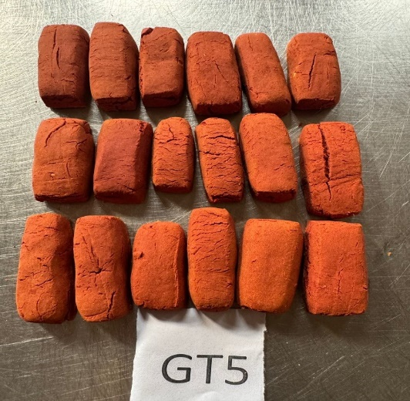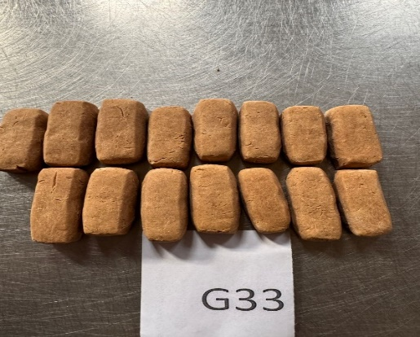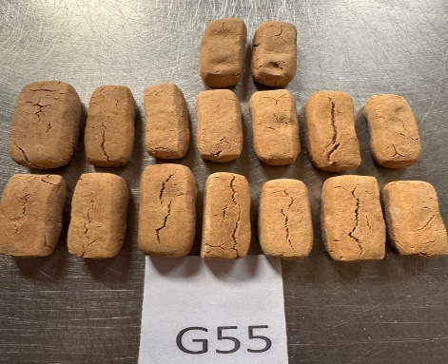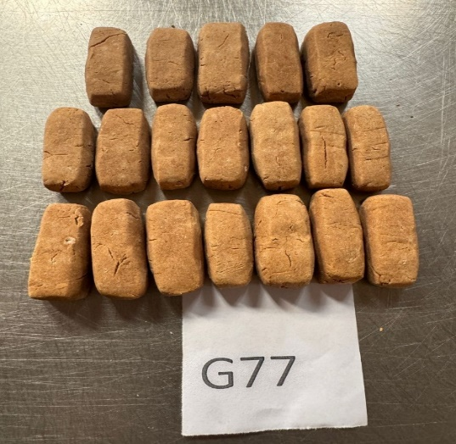
b

Fig 1. (a) Flow chart for the production of the cassava-groundnut snack bar. (b) Cassava-groundnut snack bar samples fortified with ginger and turmeric
2.2.3. Antioxidant Composition
The bioactive compounds gingerol and shogaol were analyzed using HPLC methods described by Makanjuolaet al. (2015). Gingerol was extracted with organic solvents and detected at 280 nm using a C18 column, while shogaol was extracted with ethanol and detected at 270 nm using a C18 column. Curcumin content was determined via spectrophotometry at around 420 nm, as described by Hazra et al. (2015). Eugenol was analyzed using HPLC with a C18 column and detection at around 280 nm, following extraction with organic solvents (Mota et al., 2022).
2.2.4 Determination of Vitamin Composition
The study analyzed vitamins A, B1, B2, B3, C, D, and E using various established methods, including colorimetric reaction for Vitamin A (AOAC, 2010), spectrophotometry for Vitamin E (Vorobyevaet al., 2022), and specific methods for thiamine (B1) and riboflavin (B2) following AOAC (2010). Niacin (B3) was quantified using HPLC with UV detection (Lawrance, 2015), while Vitamin C was assessed via titration and HPLC with UV detection (Najwa et al., 2017). Vitamin D was determined using liquid chromatography-tandem mass spectrometry (LC-MS/MS) (Cashman et al., 2016).
- RESULTS
The results of the antioxidant composition of the ginger and turmeric fortified snack bars are presented in table 2. From the result obtained, it showed that the gingerol content ranged from 0.12-3.89 mg/100g, shogaol ranged from 0.06 -2.16mg/100g, curcumin ranged from 0.02 – 8.73mg/100g and Eugenol ranged from 0.02 - 0.85mg/100g. The results also showed that the control sample, CON (Bar with no spice) had the lowest value ofGingerol (0.12mg/100g), Shagaol (0.06mg/100g), Curcumin (0.02mg/100g) and Eugenol(0.02mg/100g) compared to others. Highest value of Gingerol (3.89 mg/100g), shogaol (2.16 mg/100g) and Eugenol (0.85mg/100g)was recorded in sample G77 (with 7% ginger concentration) compared to othersample while sample T77(7% turmeric concentration)had the highest curcumin value (8.73mg/100g). values obtained were significantly different (P<0.05) among the samples.
Fig 2 shows that all measured vitamins (A, B1, B2, B3, C, D, E) differed significantly (p<0.05) among formulations. Vitamin A ranged 8.16-16.05mg/100g, vitamin B3 - 2.93-4.43mg/100g, vitamin C- 2.86-6.93mg/100g, vitamin D - 0.17-0.75mg/100g. vitamin E - 0.5-1.98mg/100g, vitamin B1 - 0.13-0.62mg/100g and vitamin B2 ranged from 0.11-0.32mg/100g. the results also showed that sample GT7 (7% ginger/turmeric concentration)had highest value for vitamin A,B3,C,D and E. Control sample had highest value of Vitamin B1 (0.62mg/100g) while sample GT5 (5% ginger/turmeric concentration) had highest value in vitamin B2 (0.32mg/100g)
3. DISCUSSION

3.1 Antioxidant Composition of the Ginger and Turmeric Fortified Snack Bars
The fortified snack bars showed a significant increase (p>0.05) in antioxidant content with higher concentrations of ginger and turmeric (Table 2). Gingerol and shogaol levels rose significantly in ginger-fortified bars, reaching 3.89 mg/100g and 2.16 mg/100g, respectively, in the 7% ginger sample and consistent with the high ginger and shogaol contents in ginger (Semwal et al., 2015). Conversely, turmeric‐fortified bars showed minimal gingerol/shogaol but a significant increase in curcumin. Curcumin increased from 0.02 mg/100g in the control to 8.73 mg/100g in the 7% turmeric bar, consistent with turmeric's curcuminoid richness (Evans et al., 2022). Eugenol remained low in all samples (0.02–0.85 mg/100g), peaking in the 7% ginger bar. The ginger-turmeric blends (GT series) exhibited intermediate antioxidant levels, potentially due to synergistic interactions. These bioactive compounds can help attenuate oxidative stress, a key driver of aging and metabolic syndromes (Semwal et al., 2015). Similar findings have been reported in corn snacks fortified with ginger, bay leaves, and turmeric powder (Amer and Rizk, 2022). The antioxidants present, such as gingerol and curcumin, have been shown to have potential health benefits, including reducing oxidative DNA damage, suppressing pro-inflammatory cytokines, and exhibiting neuroprotective and anti-cancer properties (Semwal et al., 2015; Roudsariet al., 2021; Aminnezhadet al., 2023).

Table 2. Antioxidants of the turmeric and ginger fortified cassava-groundnut snack bars
Sample | Gingerol mg/100g | Shogaol mg/100g | Curcumin mg/100g | Eugenol mg/100g
CON | 0.12^{j}±0.01 | 0.06^{j}±0.00 | 0.02^{i}±0.00 | 0.02^{h}±0.00
G33 | 0.62e±0.01 | 0.33^{f}±0.02 | 0.04^{hi}±0.00 | 0.15^{f}±0.01
G55 | 1.73^{c}±0.03 | 1.05^{c}±0.01 | 0.07^{gh}±0.01 | 0.36^{c}±0.02
G77 | 3.89ª±0.01 | 2.16ª±0.01 | 0.09^{g}±0.01 | 0.85ª±0.02
T33 | 0.21^{i}±0.01 | 0.12^{i}±0.01 | 3.47^{d}±0.01 | 0.11^{g}±0.01
T55 | 0.27 ^{h}±0.01 | 0.21^{h}±0.01 | 5.62^{c}±0.01 | 0.15^{f}±0.02
T77 | 0.33^{g}±0.01 | 0.46e±0.01 | 8.73ª±0.02 | 0.22e±0.01
GT3 | 0.52^{f}±0.01 | 0.29^{g}±0.01 | 2.85^{f}±0.02 | 0.09^{g}±0.01
GT5 | 1.47^{d}±0.01 | 0.87^{d}±0.01 | 4.03e±0.02 | 0.27^{d}±0.01
GT7 | 2.96^{b}±0.01 | 1.72^{b}±0.21 | 6.62^{b}±0.01 | 0.51^{b}±0.01
LSD | 0.03 | 0.03 | 0.03 | 0.03
Values are means±standard deviation of duplicate determination. Mean values on the same column with different superscripts (a, b, c…) are significantly different at p<0.05
CON (Control: Bar with no spice), G33 (3% ginger concentration), G55 (5% ginger concentration), G77 (7% ginger concentration), T33 (3% turmeric concentration), T55 (5% turmeric concentration), T77 (7% turmeric concentration), GT3 (3% ginger/turmeric concentration), GT5 (5% ginger/turmeric concentration), GT7 (7% ginger/turmeric concentration)

3.2 Vitamin Composition of the cassava-groundnut snack bars fortified with ginger and turmeric
The control bar was very low in vitamin A (8.16 µg/100g) and contained moderate B1 (0.62 mg), B2 (0.11 mg), B3 (2.98 mg), C (2.86 mg), D (0.17 mg) and E (0.50 mg) per 100g as shown in figure 2. Adding ginger, turmeric, or their blend increased vitamins A, B2, B3, C, D, and E, but slightly decreased thiamine (B1), reflecting the spice composition. According to Ayoade et al. (2023), turmeric is richer in provitamin A (152 µg/100g) than ginger (56 µg/100g), while groundnut flour supplies most B-vitamins. Arya et al., (2016) reported the composition of raw peanuts to contain 0.64 mg thiamine, 0.135 mg riboflavin, 12.1 mg niacin, and 8.33 mg vitamin E per 100g). Although absolute vitamin levels remained below dietary recommendations (e.g., 800 µg vitamin A or 75-90 mg vitamin C per day) (WHO, 2004), the fortified bars showed potential in addressing micronutrient gaps, particularly in regions reliant on cassava-based staples. The increased vitamins A, C, and E support immune function (Wiseman et al., 2017), collagen synthesis, and iron absorption (Carr and Maggini, 2017), and cellular protection (Dubois-Deruyet al., 2020), particularly in regions with cassava-based diets lacking fat-soluble vitamins (Boukid, et al., 2024). The combination of ginger and turmeric in the snack bars may amplify health benefits due to synergistic effects, such as enhanced curcumin bioavailability (Kocaadam and Şanlier, 2017). Thus, regular consumption as part of a balanced diet could contribute to micronutrient intake, particularly in vulnerable populations.

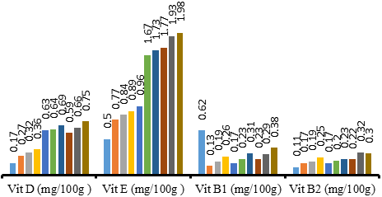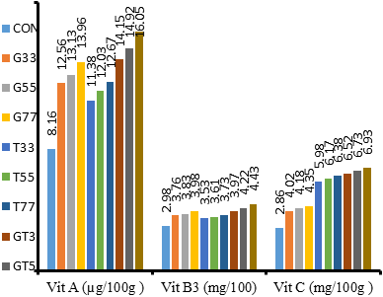

Fig 2. Vitamin composition of the ginger and turmeric fortified cassava-groundnut snack bars
CON (Control: Bar with no spice), G33 (3% ginger concentration), G55 (5% ginger concentration), G77 (7% ginger concentration), T33 (3% turmeric concentration), T55 (5% turmeric concentration), T77 (7% turmeric concentration), GT3 (3% ginger/turmeric concentration), GT5 (5% ginger/turmeric concentration), GT7 (7% ginger/turmeric concentration)

4. Conclusion

The fortification of cassava-groundnut snack bars with ginger and turmeric significantly enhanced their nutritional value, increasing the content of essential vitamins and antioxidants. The bars showed a notable increase in vitamins A (up to 16.05 µg/100g), C (up to 6.93 mg/100g), and E (up to 1.98 mg/100g), as well as bioactive compounds like gingerol (up to 3.89 mg/100g), shogaol (up to 2.16 mg/100g), and curcumin (up to 8.73 mg/100g). These findings suggest that the snack bars could serve as a functional food option, particularly in regions or groups where micronutrient deficiencies and oxidative stress are prevalent. Regular consumption of these fortified snack bars as part of a balanced diet may contribute to improved nutritional status and potentially mitigate the risk of chronic diseases.
References
A.O.A.C., 2010. Official methods of Analysis, 17th ed. Association of official Analytical Chemist, Washington, D.C, U.S.A
Abara, P.N., Adjeroh, L.A., Nwachukwu, M.O. and Osinomumu, I.D., (2021). Journal of Scientific Research, 7(1), pp.17-24.
Ajanaku, C.O., Ademosun, O.T., Atohengbe, P.O., Ajayi, S.O., Obafemi, Y.D., Owolabi, O.A., Akinduti, P.A. and Ajanaku, K.O., (2022). Functional bioactive compounds in ginger, turmeric, and garlic. Frontiers in nutrition, 9, p.1012023.
Amer, S.A. and Rizk, A.E., (2022). Production and evaluation of novel functional extruded corn snacks fortified with ginger, bay leaves and turmeric powder. Food Production, Processing and Nutrition, 4(1), p.4.
Aminnezhad, S., Zonobian, M.A., Moradi Douki, M., Mohammadi, M.R. and Azarakhsh, Y. (2023). Curcumin and their derivatives with anti-inflammatory, neuroprotective, anticancer, and antimicrobial activities: a review. Micro Nano Bio Aspects, 2(4), pp.25-34.
Arya, S.S., Salve, A.R. and Chauhan, S., (2016). Peanuts as functional food: a review. Journal of food science and technology, 53, pp.31-41.
Ayoade, W.G., Gbadamosi, L., Ajayi, M.G. and Badmus, M.O., (2023). Assessment of minerals and vitamin constituents of some commonly consumed spices. International Journal of Science and Research Archive, 10(01), pp.053-061.
Bag, B.B., (2018). Ginger processing in India (Zingiber officinale): A review. International Journal of Current Microbiology and Applied Sciences, 7(04), pp.1639-1651.
Boukid, F., Mefleh, M., Mameri, H. and Rosell, C.M., (2024). Plant protein innovations in snacks and bakery: synergy of market trends and scientific advances. Food Bioscience, p.105580.
Carr, A.C. and Maggini, S., (2017). Vitamin C and immune function. Nutrients, 9(11), p.1211.
Cashman, K.D., Dowling, K.G., Škrabáková, Z., Gonzalez-Gross, M., Valtueña, J., De Henauw, S., Moreno, L., Damsgaard, C.T., Michaelsen, K.F., Mølgaard, C. and Jorde, R., (2016). Vitamin D deficiency in Europe: pandemic?. The American journal of clinical nutrition, 103(4), pp.1033-1044.
de Oliveira Filho, J.G., de Almeida, M.J., Sousa, T.L., dos Santos, D.C. and Egea, M.B., (2021). Bioactive compounds of turmeric (Curcuma longa L.). Bioactive compounds in underutilized vegetables and legumes, pp.297-318.
Dubois-Deruy, E., Peugnet, V., Turkieh, A. and Pinet, F., (2020). Oxidative stress in cardiovasculardiseases. Antioxidants, 9(9), p.864.
Evans, A. C., Martin, K. A., Saxena, M., Bicher, S., Wheeler, E., Cordova, E. J., Porada, C. D., Almeida-Porada, G., Kato, T. A., Wilson, P. F., and Coleman, M. A. (2022). Curcumin Nanodiscs Improve Solubility and Serve as Radiological Protectants against Ionizing Radiation Exposures in a Cell-Cycle Dependent Manner. Nanomaterials (Basel, Switzerland), 12(20), p. 3619. https://doi.org/10.3390/nano12203619
Gupta, S.C., Patchva, S. and Aggarwal, B.B., (2013). Therapeutic roles of curcumin: lessons learned from clinical trials. The AAPS journal, 15, pp.195-218.
Hazra, K., Kumar, R., Sarkar, B.K., Chowdary, Y.A., Devgan, M. and Ramaiah, M., (2015). UV- visible spectrophotometric estimation of curcumin in nanoformulation. International journal of pharmacognosy, 2(3), pp.127-130.
Jayashree, E. and Zachariah, T.J., (2016). Processing of turmeric (Curcuma longa) by different curing methods and its effect on quality.
Kocaadam, B. and Şanlier, N., (2017). Curcumin, an active component of turmeric (Curcuma longa), and its effects on health. Critical reviews in food science and nutrition, 57(13), pp.2889- 2895.
Lawrance, P., (2015). Niacin (vitamin B 3)-A review of analytical methods for use in food. Government Chemist Programme Report, 1(9).
Makanjuola, S.A., Enujiugha, V.N., Omoba, O.S. and Sanni, D.M., (2015). Optimization and prediction of antioxidant properties of a tea‐ginger extract. Food Science and Nutrition, 3(5), pp.443-452.
Mota, L.B., da Silva Campelo, M., de Almeida Silva, G., de Oliveira, C.L.C.G., Gramosa, N.V., Ricardo, N.M.P.S. and Ribeiro, M.E.N.P., (2022). Spectrophotometric method for quantification of eugenol in volatile oil of clove buds and nanoemulsion. Revista Brasileira de Farmacognosia, 32(6), pp.912-920.
Najwa, F.R. and Azrina, A., (2017). Comparison of vitamin C content in citrus fruits by titration and high-performance liquid chromatography (HPLC) methods. International Food Research Journal, 24(2), p.726.
Namtala, E., (2017). Effect of soy fortification on proximate, functional and sensory characteristics of cassavabased flours and products (Doctoral dissertation, University of Eldoret).
Rivero-Pino, F., (2023). Bioactive food-derived peptides for functional nutrition: Effect of fortification, processing and storage on peptide stability and bioactivity within food matrices. Food Chemistry, 406, p.135046.
Robinson, I.E. and Tas, A.A., (2025). Effect of Cassava Flour and Ginger Powder Addition on Physicochemical and Antioxidant Properties of Bread. Applied Sciences, 15(7), p.3762.
Roudsari, N.M., Lashgari, N.A., Momtaz, S., Roufogalis, B., Abdolghaffari, A.H. and Sahebkar, A., (2021). Ginger: A complementary approach for management of cardiovascular diseases. Biofactors, 47(6), pp.933-951.
Saddique, M.S., Sultan, M.T., Iqbal, S.Z., Bosch, C., Akhtar, S., Raza, H., Tariq, N. and Ahmed, W., (2024). Physicochemical, rheological and sensory evaluation of herbal bread containing turmeric, ginger, and black cumin powder. Foods, 13(4), p.555.
Saribaeva, D., Kurbanov, N., Atamirzayeva, S. and Yakubzhanova, Y., (2024). Ginger root as a source of biologically active substances. In E3S Web of Conferences (Vol. 486, p. 02028). EDP Sciences.
Semwal, R. B., Semwal, D. K., Combrinck, S., and Viljoen, A. M. (2015). Gingerols and shogaols: Important nutraceutical principles from ginger. Phytochemistry, 117, 554–568. https://doi.org/10.1016/j.phytochem.2015.07.012
Shaukat, M.N., Nazir, A. and Fallico, B., (2023). Ginger bioactives: a comprehensive review of health benefits and potential food applications. Antioxidants, 12(11), p.2015.
Shittu, T.A., Alimi, B.A., Wahab, B., Sanni, L.O. and Abass, A.B., (2016). Cassava flour and starch: Processing technology and utilization. Tropical roots and tubers: Production, processing and technology, pp.415-450.
Vicentini, A., Liberatore, L. and Mastrocola, D., (2016). Functional foods: Trends and development of the global market. Italian Journal of Food Science, 28(2), p.338.
Vorobyeva, V.M., Vorobyeva, I.S., Frolova, Y.V., Sobolev, R.V. and Bilyalova, A.S., (2022), September. Whole grain baked products enriched with vitamins: Technology, quality, health benefits. In AIP Conference Proceedings (Vol. 2478, No. 1). AIP Publishing.
Wang, Q., WANG., H. and Huang, (2018). Peanut processing characteristics and quality evaluation (pp. 97-98). Springer Singapore.
Wiseman, E.M., Bar-El Dadon, S. and Reifen, R., (2017). The vicious cycle of vitamin a deficiency: A review. Critical reviews in food science and nutrition, 57(17), pp.3703-3714.
World Health Organization, (2004). Vitamin and mineral requirements in human nutrition. World Health Organization.

