High Performance Liquid Chromatography (HPLC)-Based Detection and Quantification of Free Isoflavones (Daidzein and Genistein) in Livestock Feed Ingredients

ABSTRACT
Phytoestrogens are naturally occurring plant compounds, predominantly found in legumes and grains. They can bind to estrogen receptors in the body, either imitating or inhibiting the effects of oestrogen. This study aimed to detect and quantify free isoflavones, specifically genistein and daidzein, in commonly used feed ingredients such as maize, soybean meal (SBM), de-oiled rice bran (DORB), groundnut cake (GNC), gingelly oil cake (GOC), dried fish and wheat bran, which are often included in livestock and poultry feed formulations.
Feed ingredients commonly used in livestock feed mills were randomly selected from the market and analysed for daidzein and genistein levels using high-performance liquid chromatography (HPLC) at the Central Instruments Laboratory, College of Veterinary and Animal Sciences, Mannuthy, Thrissur. The average concentrations of daidzein varied from undetectable (UD) to 567.94 µg/100g, while genistein levels ranged from UD to 551.02 µg/100g across the various feed ingredients. The findings of this study revealed that soybean meal contained significantly higher levels of both daidzein and genistein compared to other ingredients used in livestock and poultry feed formulations.
Key words: High Performance liquid chromatography, Isoflavones, Phytoestrogen
INTRODUCTION
Phytoestrogens represent the group of natural products that, due to the structural similarity with the female sex hormones, have the biological activity as estrogens (Nikolic et al., 2017). Soybean is the main source of plant derived phytoestrogen especially in dairy cows, pigs, goats and poultry species and it substitutes animal proteins like bone meal. The health benefits of isoflavones have been described and should make it desirable to increase soybean/isoflavone consumption. The major driving force that has stimulated the production and consumption of soybean all over the world is the use of soybean meal as high-quality source of protein and unsaturated fatty acids for utilising energy by the animal in livestock feed industry (Blair, 2008; Dei, 2011).
Dietary isoflavones found in soybeans are mainly the glycosidic forms of three base aglycones (daidzein, genistein and glycitein). After consumption, isoflavones are initially hydrolyzed and absorbed in the small intestine into the liver where most are glucuronidated (70%). Isoflavone absorption depends greatly on the individuals’ microflora. Generally, soybean meal provides approximately 150 μg daidzein per gram and 250 μg genistein per gram (Dixon & Ferreira, 2002). However, phytoestrogens contained in soybean can differ greatly from crop to crop, region to region (Stevenson, 2007).
It is possible that isoflavones could be transferred and/or accumulated into animal products, which could become additional sources of dietary isoflavones for humans (Murkies et al., 1998). Diets rich in plant-derived products may supply a variety of phytoestrogens capable of producing various pharmacological effects in the human body. As humans live longer, women particularly are spending more of their lives in menopause, affected by a variety of estrogen-related conditions such as osteoporosis, cognitive and cardiovascular decline, increased risk of breast cancer and other symptoms that decrease the overall quality of life (Cornwell, 2004). It has been widely noted that individuals from countries with high dietary content of soy foods are less likely to develop mammalian cancer (Gilani and Anderson, 2002)
MATERIALS AND METHODS
Table 1 below provides the typical percentages of various feed ingredients commonly incorporated into livestock and poultry feed formulations. The data were collected from feed mills associated with Kerala Veterinary and Animal Sciences University. These feed ingredients were randomly selected from the market and subsequently analyzed for their isoflavone content.
Table 1: Proportions of different feed ingredients in livestock feed formulations
No | Feed ingredients | PER CENT OF INCORPORATION
No | Feed ingredients | CM | CG | CB | DS | DG | DB | CS | DC | PC | PG | PF | LA | RA | HS | GT | DG
1 | Yellow maize | 48 | 52 | 53 |  |  |  | 35 | 14 | 38 | 48 | 36 | 10 | 20 | 20 | 12 | 4.5
2 | De-oiled rice bran | 10 | 23 | 16 | 19 | 20 | 9 |  | 24 | 15 | 15 | 5 |  | 18 | 16 | 27
3 | Soybean meal | 30 | 13 | 20 | 20 | 10 | 20 | 10 |  | 18 | 10 | 20 | 17 |  | 5 |  | 16
4 | Groundnut cake
5 | Wheat bran | 7.5 | 7 |  |  | 7 |  | 20 |  | 18 | 15 | 24 | 10 |  |  |  | 9
6 | Gingelly oil cake |  |  |  |  |  |  | 8 | 17 |  |  | 5 | 20 | 6 |  | 25 | 4.6
7 | Dried fish meal |  |  |  | 2 | 2 | 5 |  |  |  |  | 8 |  | 17 | 13

CM: Chick mash
CG: Chicken grower
CB: Chicken breeder
DS: Duck strater
DG: Duck grower
DB: Duck breeder
CS: Calf starter
DC: Dairy cattle
PC: Pig creep
PG: Pig grower
PF: Pig finisher
LA: Lab Animal
RA: Rabbit
HS: Horse
GT: Goat
DG: Dog

Feed sample preparation to estimate genistein and daidzein content (Megha et al., 2023a)
One gram of feed was extracted with 10 mL of 80% methanol and shaken on an orbital shaker for 1 hour. The mixture was centrifuged at 4500 rpm for 20 minutes, and the supernatant was collected. The extract was evaporated to under 2 mL at 40 ºC, then mixed with 10 mL of sodium acetate (0.1M, pH 5) and 75 μL of β-glucuronidase. After overnight incubation at 37 ºC, the solution was purified using a C-18 column, and the feed samples were analyzed for free isoflavones using HPLC.
Chromatographic and mass spectrometric conditions (Megha et al., 2023b)
Stock solutions of free isoflavones (genistein and daidzein) were prepared by dissolving 1 mg of each standard in 1 mL of HPLC-MS grade methanol (99.9%) in volumetric flasks. Quantification and recovery tests were conducted using composite working standard solutions ranging from 1 to 500 μg/mL, diluted from the stock solution with methanol. Gradient elution systems (Fig. 1) were used as mobile phases: an aqueous solvent A (0.1% acetic acid, 5% acetonitrile in water) and an organic solvent B (0.1% acetic acid in acetonitrile) to separate genistein and daidzein. Chromatograms were generated for each standard and sample using DAD detection over a 30-minute window. Separation was achieved via reverse-phase column elution with a mobile phase flow rate of 1 mL/min and UV-VIS detection was performed at 262 nm.

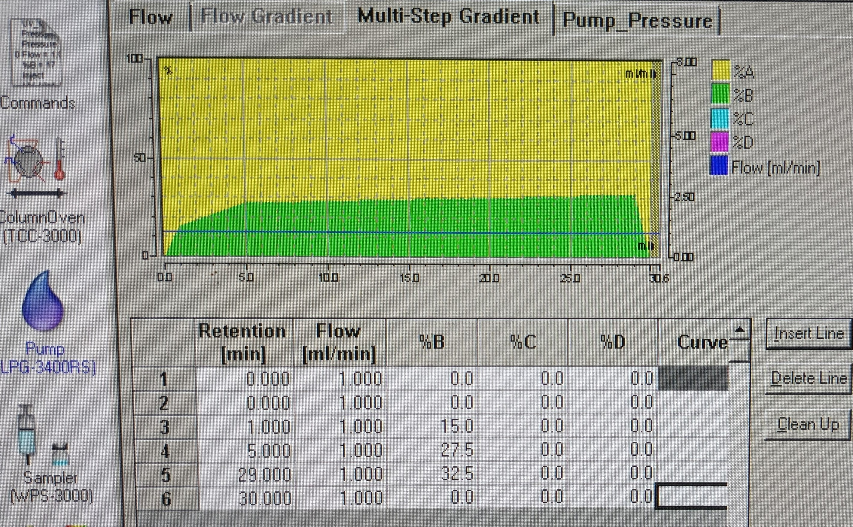

Fig. 1: Gradient elution programme for genistein and daidzein
RESULTS AND DISCUSSION
This study likely represents a pioneering effort in estimating the levels of phytoestrogens in livestock feed ingredients, an area that has not been extensively researched. Due to the limited research available in this field, this work could provide valuable insights and contribute significantly to the understanding of phytoestrogens' effects in animal nutrition
Phytoestrogens are present in all animal-based foods, providing a more accurate estimation of dietary exposure to these compounds (Kuhnle et al., 2008). Phytoestrogen content is a valuable biomarker for distinguishing plant-derived raw materials used in fish feed production, with rapeseed meal, soybean meal, sunflower meal, and wheat meal showing the highest correlations with their origin descriptions (Pavlopoulos et al., 2023). Phytoestrogens in legumes can affect reproductive functions in grazing livestock, but proactive management strategies can help mitigate potential fertility loss and improve growth and performance (Wyse et al., 2022)
In this study, both peak height and area increased proportionally with the concentration of the standards. Figure 2 illustrates the chromatogram of genistein and daidzein standards. Calibration curves were generated using standard concentrations of 1.95, 3.90, 7.81, 15.625, 31.25, 62.5, 125, 250, and 500 μg/mL to quantify isoflavone levels (Fig 3 and fig 4). Isoflavones were studied as possible growth promoters for use in the animal feed industry in the 1950s due to their estrogenic effects in rodents (Messina, 2010). The research study of Hua (2013) developed a rapid HPLC method for detecting soybean isoflavone components in feeds, providing guidance for livestock and poultry production.
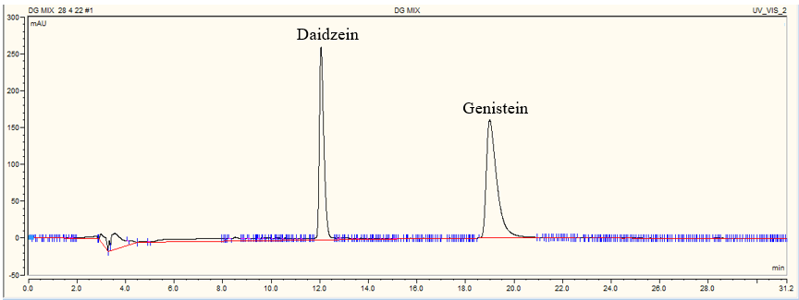 (Megha et al., 2023a)
Fig 2: Chromatogram of daidzein and genistein standards

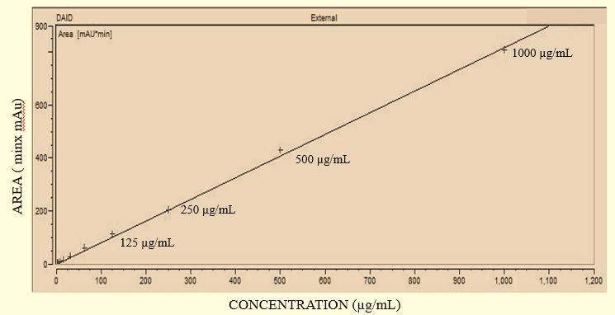
Fig 3: Calibration curve of daidzein with different standard concentrations

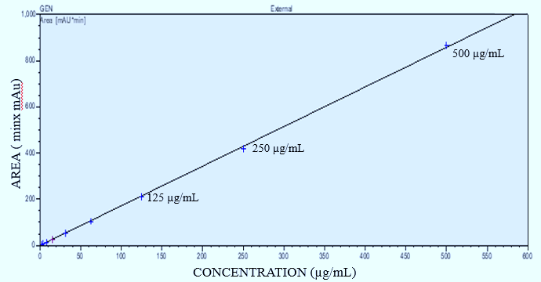
Fig 4: Calibration curve of genistein with different standard concentrations

The chromatogram illustrating the detection of varying levels of daidzein and genistein in different livestock feed ingredients, with each compound corresponding to its specific retention time (RT) are represented in figure 5. The chromatographic analysis consistently revealed that the retention times for genistein and daidzein standards fell within the precise ranges of 18.99 to 19.14 minutes and 12.24 to 12.28 minutes, respectively. These retention times were used as reference points to identify and quantify the presence of these isoflavones in the feed samples analyzed. The consistent retention times indicate the reliability and precision of the chromatographic method used in the study for the detection and quantification of these specific isoflavones in various livestock feed ingredients.
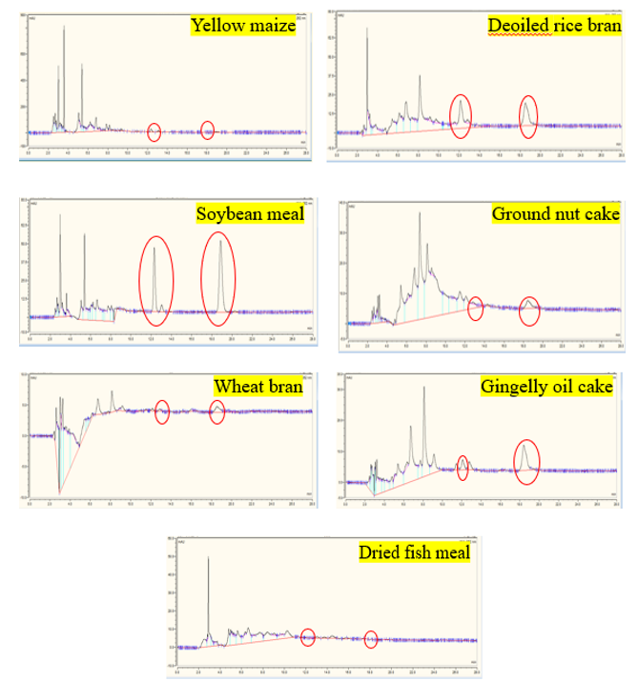
Fig 5: Isoflavone detection in feed ingredients: sample chromatograms
The quantification of free isoflavones, specifically daidzein and genistein, in various livestock feed ingredients are mentioned in Table 2. High concentrations of both daidzein (567.94 µg/100g) and genistein (551.03 µg/100g) were detected in soybean meal, making it a significant source of isoflavones in livestock feed. Soybean seed isoflavone levels exhibit a location-specific response, with temporal variability between years being more influential than location (Laurenz et al., 2017). Other ingredients such as deoiled rice bran, groundnut cake, wheat bran, and gingelly oil cake showed moderate levels of genistein and varying levels of daidzein. Yellow maize contained a minimal amount of daidzein with no detectable genistein, while dried fish meal had no detectable levels of either isoflavone. This data highlights the variability of isoflavone content across different feed ingredients commonly used in livestock nutrition.
Table 2: Isoflavone levels in livestock feed ingredients
INGREDIENTS | Concentration (µg/100g)
INGREDIENTS | DAIDZEIN | GENISTEIN
Yellow maize | 0.76 | 0
Deoiled rice bran | 127.60 | 198.03
Soybean meal | 567.94 | 551.03
Ground nut cake | 0.39 | 198.61
Dried Fish Meal | 0 | 0
Wheat bran | 0.513 | 183.66
Gingelly oil cake | 30.98 | 186.44
Moderate consumption of traditionally prepared and minimally processed soy foods may offer modest health benefits while minimizing potential adverse effects (Zaheer and Akhtar, 2017).Soybean isoflavone plays a crucial role in anti-cancer, cardiovascular disease prevention, osteoporosis, and menopause syndrome, and can be used as a green and effective feed additive for animals (Zheng-li, 2006). Soybean isoflavones, mainly genistein, daidzein, and glycitein, have estrogen and anti-estrogen effects, and are widely used in animal feeding operations for their antioxidation, immune, and reproductive benefits (Hong-de, 2011). Isoflavones, found in soybeans, can be used as alternative therapies for hormonal disorders, but may also be endocrine disruptors, posing potential health risks (Krizova et al., 2019).
Soy isoflavone supplementation during late-gestation and lactation improves reproductive performance and serum antioxidant status of sows, and enhances the growth performance of their offspring in a dose-dependent manner (Li et al., 2021). Isoflavone-enriched feed in dairy cows leads to reduced microbial richness and fewer bacteria in the rumen compared to control cows (Kasparovska, 2016). Soy-derived bioactive compounds show potential as immunomodulatory feed additives for pigs, improving their immune status and growth performance under certain disease challenges (Smith and Dilger, 2018). Feeding extruded full-fat soybeans to lactating dairy cows significantly increases the concentration of phytoestrogens daidzein and genistein in milk and plasma, resulting in higher milk yield and composition (Trinacty et al., 2009). Adding 2.5% soybean oil to wheat bran-based diets improves laying hen performance by reducing feed conversion per egg mass (Novela et al., 2023).
CONCLUSION
Isoflavones, which are phytoestrogens with numerous health benefits, were found in elevated levels in soybean meal compared to other livestock feed ingredients. This raises the possibility of transferring genistein and daidzein from feed into eggs, milk, and tissues, potentially leading to the production of designer eggs, milk, or meat enriched with isoflavones. Long-term clinical trials with standardized phytoestrogen preparations are needed to confirm these beneficial health effects.
REFERENCES
Blair, R. (2008). Nutrition and Feeding of Organic Poultry. Oxford, UK: CAB International.
Cornwell, T. 2004. Dietary phytoestrogens and health. Phytochem. 65: 995–1016.
Dei, H. K. (2011). Soybean as a feed ingredient for livestock and poultry.In Krezhova, D. (Ed.),Recent Trends for Enhancing the Diversity and Quality of Soybean Products. Rijeka: Intech.
Dixon, R. A. & Ferreira, D. (2002). Genistein. Phytochemistry, 60(3), 205-211.
Gilani, G. S. and Anderson, J.J.B. (Eds.), 2002. Phytoestrogens and health. The American Oil Chemists Society Press, Champaign, Illinois, USA.
Hong-de, L. (2011). Soybean Isoflavones:Characteristics and Feed Application. Chinese Journal of Animal Nutrition.
Hua, Y. (2013). A Rapid Method for Determination of Soybean Isoflavone Components in Feeds by HPLC. Soybean Science.
Kasparovska, J., Pečínková, M., Dadakova, K., Krizova, L., Hadrova, S., Lexa, M., Lochman, J., & Kasparovsky, T. (2016). Effects of Isoflavone-Enriched Feed on the Rumen Microbiota in Dairy Cows. PLoS ONE, 11. https://doi.org/10.1371/journal.pone.0154642.
Krizova, L., Dadakova, K., Kašparovská, J., & Kasparovsky, T. (2019). Isoflavones. Molecules, 24. https://doi.org/10.3390/molecules24061076.
Kuhnle, G., Dell'Aquila, C., Aspinall, S., Runswick, S., Mulligan, A., & Bingham, S. (2008). Phytoestrogen content of foods of animal origin: dairy products, eggs, meat, fish, and seafood.. Journal of agricultural and food chemistry, 56 21, 10099-104 . https://doi.org/10.1021/jf801344x.
Laurenz, R., Tumbalam, P., Naeve, S., & Thelen, K. (2017). Determination of isoflavone (genistein and daidzein) concentration of soybean seed as affected by environment and management inputs.. Journal of the science of food and agriculture, 97 10, 3342-3347 . https://doi.org/10.1002/jsfa.8184.
Li, D., Dang, D., Xu, S., Tian, Y., Wu, D., & Su, Y. (2021). Soy isoflavones supplementation improves reproductive performance and serum antioxidant status of sows and the growth performance of their offspring.. Journal of animal physiology and animal nutrition. https://doi.org/10.1111/jpn.13667.
Megha, P.S., Ramnath, V., Karthiayini, K., Beena, V., Chacko, B., Thomas, N., Sapna, P.P., Vishnudas, K.V. 2023b. Influence of Soy Isoflavones on Plasma Isoflavone and Oestradiol Levels in Layer Chicken. Appl. Biol. Res. 25: 475–484. https://doi.org/10.5958/0974-4517.2023.00055.1
Megha, P.S., Ramnath, V., Sapna, P., Vishnudas, K. 2023a. The level of isoflavones (genistein and daidzein) in different chicken feed formulations. Int. J. Adv. Biochem. Res. 7: 43–46. https://doi.org/10.33545/26174693.2023.v7.i2a.241
Messina, M. (2010). A brief historical overview of the past two decades of soy and isoflavone research.. The Journal of nutrition, 140 7, 1350S-4S . https://doi.org/10.3945/jn.109.118315.
Murkies, A. L., Wilcox, G. and Davis, S. R. 1998. Phytoestrogens. J. Clin. Endocrinol. Metab. 83: 297–303.
Nikolic, I., Savic-Gajic, I., Tacic, A. and Savic, I. 2017. Classification and biological activity of phytoestrogens: A review. Adv. Technol. 6: 96–106.
Novela, M., Pinto, S., Tembe, A., Paulo, E., Mabasso, M., Gove, A., Changule, A., Joaquim, L., Tseu, R., & Anjos, F. (2023). Soybean oil addition to wheat bran-based diet improves laying hens’ performance. Veterinary World, 16, 1572 - 1575. https://doi.org/10.14202/vetworld.2023.1572-1575.
Pavlopoulos, D., Myrtsi, E., Tryfinopoulou, P., Iliopoulos, V., Koulocheri, S., & Haroutounian, S. (2023). Phytoestrogens as Biomarkers of Plant Raw Materials Used for Fish Feed Production. Molecules, 28. https://doi.org/10.3390/molecules28083623.
Smith, B., & Dilger, R. (2018). Immunomodulatory potential of dietary soybean-derived isoflavones and saponins in pigs.. Journal of animal science, 96 4, 1288-1304 . https://doi.org/10.1093/jas/sky036.
Stevenson, L. M. (2007). Effects of the soy phytoestrogen genistein on the reproductive development of immature female broiler chickens. Master’s thesis, Auburn University, Alabama, US.
Trinacty, J., Krizova, L., Schulzova, V., Hajslova, J., & Hanus, O. (2009). The effect of feeding soybean-derived phytoestogens on their concentration in plasma and milk of lactating dairy cows. Archives of Animal Nutrition, 63, 219 - 229. https://doi.org/10.1080/17450390902859739.
Wyse, J., Latif, S., Gurusinghe, S., McCormick, J., Weston, L., & Stephen, C. (2022). Phytoestrogens: A Review of Their Impacts on Reproductive Physiology and Other Effects upon Grazing Livestock. Animals : an Open Access Journal from MDPI, 12. https://doi.org/10.3390/ani12192709.
Zaheer, K., & Akhtar, M. (2017). An updated review of dietary isoflavones: Nutrition, processing, bioavailability and impacts on human health. Critical Reviews in Food Science and Nutrition, 57, 1280 - 1293. https://doi.org/10.1080/10408398.2014.989958.
Zheng-li, C. (2006). Biological Function of Soybean Isoflavone and Application in Animal Production. Progress in Veterinary Medicine.

