Original Research Article
Investigating phytochemicals to enhance soybean seed health: A critical evaluation of antifungal activity, seed germination and vigour

Abstract
Soybean (Glycine max) is a vital crop globally, providing oil and protein. However, it's susceptible to various fungal pathogens during development, harvest and storage. This study evaluated the antifungal efficacy of aqueous extracts from seven native plants (Eucalyptus sp., Melia azedarach, Lantana camara, Eupatorium adenophorum, Albizia chinensis, Vitex negundo and Ageratum conyzoides) against three seed-borne fungal pathogens (Aspergillus niger, Colletotrichum truncatum and Alternaria alternata). The plant extracts were assessed at concentrations of 10-50% using the poisoned food technique. Eupatorium adenophorum exhibited the highest inhibition (64.97% against A. niger, 51.90% against C. truncatum and 59.72% against A. alternata) at 50% concentration. Lantana camara and Eucalyptus sp. also demonstrated significant antifungal activity. The seed treatment with E. adenophorum also increased seed germination (87.00, 92.67 and 90.00 %), root length (6.86, 7.02 and 6.93 cm), shoot length (1.40, 1.88 and 1.45 cm) and seedling vigour index (719, 825 and 754) against A. niger, C. truncatum and A. alternata, respectively. This study suggests that native plants can serve as potential sources of eco-friendly and effective antifungal agents for managing seed-borne fungal diseases in soybean. The use of plant extracts as an alternative to chemical treatments can promote sustainable agriculture and reduce environmental pollution.
Keywords Antifungal activity, Seed-borne fungi, Phytochemical control, Seed health, Soybean
1.INTRODUCTION

Soybean (Glycine max) crop is considered as the main source of oil globally and is significant due to its nutritional content and commercial importance (Singh et al. 2019). Cultivation of soybean was instigated in Asia about 5000 years ago, first in China and after that by Japan. It was carried to Europe in the 18th century and then to the United States in the 19th century (Valliyodan et al. 2016; Li et al. 2008; He et al. 2013). Since it is an exceptional source of vegetable oil and proteins (Silva et al., 2017; Singh et al. 2019). Soybean is adapted worldwide for a healthy food due to its high content of isoflavonoids and folic acid which provide health benefits to human. (Kamshybayeva et al. 2017; Tidke et al. 2015).
During the stages of development, harvest and storage, the crop is attacked by several bacterial, fungal and viral species. Mostly fungi cause major infection to grain than other microorganisms. Seed-borne fungi are the most important pathogens affecting the quality of seed among different plant pathogens (Neergard, 1977). The seed-borne pathogens also contaminate the disease-free areas thus, require a variety of seed treatments to eradicate the seed-borne inoculum and enforcement of regulatory procedures. The increased rate of chemical seed treatments has impact on health and environment. Phytochemicals derived from various bio active plant species offer a promising and natural source of safer agrochemicals (Isman, 2006). There are many botanical products commercialized and reported as antifungal compounds that are present among higher plants and are well known entities for disease resistance. These phytochemicals are biodegradable, protective, curative and selective in toxicity (Chowdhury et al. 2008). Therefore, plant extracts is an alternative approach for controlling plant diseases with eco-friendly nature. These phytoextracts are cost effective, relatively safe for farmers who can’t rely on synthetic pesticides. Keeping this in view, the present investigation was undertaken to evaluate the efficacy of different phytoextracts against seed borne fungi in soybean.
2.MATERIALS AND METHODS
Preparation of plant extract
Freshly harvested leaves of locally available plant species viz., Eucalyptus camaldulensis (Eucalyptus), Melia azedarach (Drek), Lantana camara (Lantana), Eupatorium adenophorum (Crofton weed), Albizia chinensis (Ohi), Ageratum conyzoides (Billygoat weed) and Vitex negundo (Bana) were collected from the surroundings and dried under shade. The dried leaves of each plant species were grounded in a blender to obtain fine powder. The powder obtained was stored in a clean paper bag at room temperature with proper labelling. The aqueous extracts of above-mentioned plant species were prepared by taking 100-gram fine powder of each botanical and soaking it overnight in 200 ml of sterilized distilled water (1:2 w/v) in 500 ml conical flask. Next day, the suspension was filtered through a double layer of muslin cloth and final volume of 100 ml of plant extract collected. Sterilization of the botanical extracts was done through tyndallization in autoclave at pressure of 5 lb psi for 30 min for three consecutive days. These extracts were treated as 100 per cent stock solutions.
In vitro evaluation of plant extracts against the mycelial growth of the predominantly occurred mycoflora
The antifungal effect of aqueous extracts of six native plants viz., Eucalyptus sp. (Eucalyptus), Melia azedarach (Drek), Lantana camara (Lantana), Eupatorium adenophorum (Crofton weed), Albizia chinensis (Ohi), Vitex negundo (Bana) and Ageratum conyzoides (Billygoat weed) were evaluated against predominantly occurring seed mycoflora. These plant extracts were evaluated at different concentrations (10, 20, 30, 40 and 50%) for inhibition of growth of pathogens by Poisoned Food Technique (Nene and Thapliyal 1973). The experiment was conducted in a completely randomized design. Each treatment was replicated thrice. The desired concentration of the botanical extract was obtained by mixing its double strength solution in sterilized distilled water with equal quantity of sterilized double strength potato dextrose agar (PDA) medium and poured aseptically in sterilized Petri plates under laminar air flow chamber. Double strength PDA medium was mixed with equal quantity of sterilized distilled water to maintain the control treatment. After solidification of the medium amended with desired concentration of aqueous plant extracts, the Petri plates were then inoculated by placing mycelial discs of 5 mm diameter, taken from actively growing culture of pathogen at the center and incubated at 25±1°Cin BOD incubator. The Petri plates were observed periodically for the growth of the pathogen and mycelial growth was measured when control plates were completely covered by mycelial growth of fungal pathogen. Per cent inhibition in mycelial growth was calculated by using formula given by Vincent (1947)
Per cent inhibition (%) = C-T/C x 100
Where, C = Mycelial growth in control (mm)
T = Mycelial growth in treatment (mm)
Evaluation of different botanicals on seed mycoflora and seed health
To study the effect of different phyto-extracts Eucalyptus sp. (Eucalyptus), Melia azedarach (Drek), Lantana camara (Lantana), Eupatorium adenophorum (Crofton weed) Albizia chinensis (Ohi), Vitex negundo (Bana) and Ageratum conyzoides (Billygoat weed)) on seed mycoflora and seed health, seeds inoculated with predominantly occurring seed mycoflora were soaked in each of the plant extract solutions and organic preparations for 24 hours. For observations on frequency of mycoflora associated with the seeds, blotter paper method was used. Four hundred seeds of soybean from each treatment were taken randomly and then placed on the moist filter paper at the rate of 10 seeds per Petri dish. Frequency of mycoflora associated with the seeds were recorded after seven days of incubation. Then, effect of respective plant extracts on seed health were evaluated by paper towel method. Hundred inoculated seeds of variety Shivalik with each of the isolated fungi were placed on double layer of moist towel paper lined by butter paper and covered with towel paper of same size. The same was folded many times and seeds allowed to germinate at 25±1ºC in BOD incubator. The experiment was conducted with three replications. After seven days, seed germination percentage, root and shoot lengths were recorded from the random seedling sample and seedling vigour index was calculated. Seeds soaked in sterilized distilled water served as control treatment. Hundred seeds from each of the treatment with three replications were tested. After incubation period, observations were recorded on germination percentage, root and shoot lengths and using these observations, vigour index was calculated with the help of formula given by Baki and Anderson, 1973:
Vigour index = % seed germination x (mean root length + mean shoot length)
Statistical analysis
The data obtained were subjected to appropriate statistical analysis wherever necessary. The differences exhibited by the treatments in various experiments were tested for their significance using standard procedures (Gomez and Gomez, 1984). Statistical analysis was also performed by one way and two-way ANOVA (Analysis of Variance) using OPSTAT software (Sheoran et al. 1998). CD (critical difference) is used to compare means of different treatments that have an equal number of replications.
3.RESULTS AND DISCUSSION
In vitro evaluation of botanical extracts to inhibit fungal growth of predominant seed mycoflora
The evaluation of different phyto-extracts viz; Eucalyptus sp. (Eucalyptus), Melia azedarach (Drek), Lantana camara (Lantana), Eupatorium adenophorum (Crofton weed) Albizia chinensis (Ohi), Vitex negundo (Bana) and Ageratum conyzoides (Billygoat weed) was done against seed mycoflora at different concentrations viz., 10, 20, 30, 40 and 50 percent. The data on antimicrobial effect of different botanicals against predominant seed mycoflora is discussed below.
Aspergillus niger
It is apparent from Table 1 that all the botanicals were effective against the mycelial growth of Aspergillus niger. Further, it is evident from data that E. adenophorum showed maximum mycelial inhibition (64.97%) followed by L. camara (52.54%), A. conyzoides (41.03%) and Eucalyptus sp. (41.03%) at 50 per cent concentration. The minimum mycelial inhibition of 17.15 per cent was given by V. negundo at 50 per cent concentration (Fig. 1).
Colletotrichum truncatum
It is apparent from Table 2 that all the botanicals were effective against the mycelial growth of C. truncatum. Further, it is evident from data that E. adenophorum gave maximum mycelial inhibition (51.90%) followed by Eucalyptus sp. (38.89%) and L. camara (35.83%) at 50 per cent concentration. The minimum mycelial inhibition of 18.66 per cent was given by M. azedarach at 50 per cent concentration (Fig. 2).
Alternaria alternata
It is apparent from Table 3 that all the botanicals were effective against the mycelial growth of A. alternata. Further, it is evident from data that E. adenophorum showed maximum mycelial inhibition (59.72%) followed by Eucalyptus sp. (58.11 %) and L. camara (51.21%) at 50 % concentration. The minimum mycelial inhibition of 20.22 % was given by M. azedarach at 50 % concentration (Fig. 3).
As per literature, E. adenophorum contains bioactive compound terpenoid which has antifungal activity making these plants potential sources of safer and more effective treatments (Bhattarai and Shrestha 2009; Kurade et al. 2010; Kundu et al. 2013; Ahluwalia et al. 2014; Chauhan et al. 2015). Kaur (2019) also evaluated aqueous and alcoholic extracts of different botanicals viz., A. conyzoides, E. adenophorum, V. negundo and Eucalyptus sp. and reported that E. adenophorum was effective among all botanicals against Fusarium solani fsp pisi.
Effect of different botanicals on seed health of soybean
The evaluation of different phyto-extracts viz; Eucalyptus sp. (Eucalyptus), Melia azedarach (Drek), Lantana camara (Lantana), Eupatorium adenophorum (Crofton weed) Albizia chinensis (Ohi), Vitex negundo (Bana) and Ageratum conyzoides (Billygoat weed) was done against predominantly occurred mycoflora viz., A. niger, C. truncatum and A. alternata by towel paper method (Fig. 4). The data on effect of botanicals on seed health parametersof artificially inoculated soybean seed is discussed below.
Aspergillus niger
It is apparent from Table 4 that the treatment of soybean seed with E. adenophorum was most effective among all the seed treatments for seed health parameters in case of A. niger. It showed the highest (87.00%) seed germination, followed by Eucalyptus sp. (86.75%) and L. camara (83.65%) against control treatment (66.43%). The least germination (73.15%) was found in seed treatment with M. azedarach. Further, all the treatments showed larger root and shoot lengths and seedling vigour index as compared to the control. Among all the seed treatments, E. adenophorum showed the highest root length (6.86 cm), shoot length (1.40 cm) and seedling vigour index (719). On the contrary, M. azedarach showed the minimum root length (6.35 cm), shoot length (1.53 cm) and seedling vigour index (577).
Colletotrichum truncatum
Table 4 showed that the treatment of soybean seed with E. adenophorum was the most effective among all the seed treatments for seed health parameters in case of C. truncatum. It showed the maximum (92.67%) seed germination, followed by Eucalyptus sp. (90.00%) and L. camara (87.00%) as against the control treatment (68.33%). The least germination was found in seed treatment with M. azedarach (80.00%). Further, all the treatments showed larger root and shoot lengths and seedling vigour index as compared to control. Among all the seed treatments, E. adenophorum showed highest root length (7.02 cm), shoot length (1.88 cm) and seedling vigour index (825). On the contrary, M. azedarach showed the minimum root length (6.48 cm), shoot length (1.27 cm) and seedling vigour index (620).
Alternaria alternata
Data presented in Table 4 showed that the treatment of soybean seed with E. adenophorum was the most effective among all the seed treatments. It showed the highest (90.00%) seed germination, followed by Eucalyptus sp. (88.00%) and L. camara (85.00%) as against the control treatment (67.00%). The least germination was found in seed treatment with M. azedarach (77.67%). Further, all the treatments showed larger root and shoot lengths and seedling vigour index as compared to the control. Among all the seed treatments E. adenophorum showed the highest root length (6.93 cm), shoot length (1.45 cm) and seedling vigour index (754). On the contrary, M. azedarach showed minimum root length (6.40 cm), shoot length (1.56 cm) and seedling vigour index (618).
Patil and Madane (2014) tested aqueous leaf extracts of two weed species viz., Hyptis suaveolens and Eupatorium odoratum on seeds of chickpea and pigeon pea and reported that increase in their concentration decreased seed mycoflora. They also reported that E. odoratum extract was more effective than H. suaveolens. Kaur (2019) also evaluated aqueous and alcoholic extracts of different botanicals (A. conyzoides, E. adenophorum, V. negundo and Eucalyptus sp.) and reported that E. adenophorum was more effective among all the botanicals.
4.CONCLUSION
Among phyto-extracts of different plant species, Eupatorium adenophorum was found most effective against mycelial growth of A. niger, C. truncatum and A. alternata with 64.97, 51.90 and 59.72 % inhibition, respectively at 50 % concentration. While least mycelial growth inhibition was given by M. azedarach. Seed treatment with E. adenophorum was also found effective in controlling seed mycoflora. The seed treatment with E. adenophorum also increased seed germination (87.00, 92.67 and 90.00 %), root length (6.86, 7.02 and 6.93 cm), shoot length (1.40, 1.88 and 1.45 cm) and seedling vigour index (719, 825 and 754) against A. niger, C. truncatum and A. alternata, respectively. The study’s findings demonstrate strong potential for the practical application of plant-based extracts, particularly those from Eupatorium adenophorum, Lantana camara, and Eucalyptus, as effective and farmer-friendly alternatives to synthetic fungicides for managing seed-borne fungal pathogens in soybean. These extracts are relatively easy to prepare using simple, traditional methods and locally available plant material, making them accessible for smallholder farmers. However, challenges remain regarding the standardization of extract potency, limited shelf-life of aqueous formulations, and variability in bioactive compound content due to environmental factors. Addressing these issues through future research-such as developing stable formulations, conducting field-level trials, and establishing quality control protocols-will be crucial for broader adoption. Additionally, exploring synergistic effects with other biological agents and assessing economic feasibility can further enhance the field-level impact and sustainability of these botanical solutions.
DECLARATION
ETHICS APPROVAL AND CONSENT TO PARTICIPATE
This study was conducted with approval from the Directorate of Research CSKHPKV, Palampur 176062, India. All authors have approved and consented to publication.
DATA AVAILABILITY
All data generated or analysed during this study are included in this published article.
DISCLAIMER (ARTIFICIAL INTELLIGENCE)
Author(s) hereby declare that no generative AI technologies such as Large Language Models (ChatGPT, COPILOT, etc) and text-to-image generators have been used during writing or editing of this manuscript.

Table 1 In- vitro evaluation of botanicals against Aspergillus niger

Botanical | Mycelial growth(mm) at different concentrations (%) |  |  |  |  | Mean | Mycelial inhibition (%) at different concentrations (%) * |  |  |  |  | Mean
Botanical | 10 | 20 | 30 | 40 | 50 | Mean | 10 | 20 | 30 | 40 | 50 | Mean
Lantana camera | 86.91 | 78.50 | 77.50 | 64.00 | 42.00 | 69.78 | 1.80  (7.66) | 11.28  (19.56) | 12.42  (20.63) | 27.67  (31.72) | 52.54  (46.44) | 21.14
Eupatorium adenophorum | 68.50 | 64.60 | 41.00 | 35.50 | 31.00 | 48.12 | 22.58  (28.34) | 26.98  (31.26) | 53.67  (47.08) | 59.89  (50.69) | 64.97  (53.69) | 45.62
Melia azedarach | 83.50 | 82.50 | 77.00 | 76.00 | 73.00 | 78.40 | 5.65  (13.39) | 6.73  (14.07) | 12.99  (21.10) | 14.12  (22.04) | 17.49  (24.65) | 11.40
Ageratum conyzoides | 87.57 | 77.03 | 75.65 | 65.73 | 51.24 | 71.44 | 1.04  (5.44) | 12.91  (20.76) | 14.51  (22.37) | 25.72  (30.45) | 42.11  (40.44) | 19.26
Eucalyptus sp. | 65.27 | 59.16 | 57.89 | 54.00 | 52.16 | 57.70 | 26.24  (30.79) | 33.14  (35.13) | 34.58  (36.00) | 38.95  (38.59) | 41.03  (39.81) | 34.79
Albizia chinensis | 80.30 | 76.00 | 74.00 | 68.70 | 58.50 | 71.50 | 9.25  (17.67) | 14.11  (22.03) | 16.38  (23.86) | 22.35  (28.17) | 33.87  (35.57) | 19.19
Vitex negundo | 82.23 | 80.50 | 75.30 | 74.50 | 73.30 | 77.17 | 7.07  (15.23) | 9.04  (17.39) | 14.88  (22.58) | 15.79  (23.34) | 17.15  (24.43) | 12.79
Control | 88.50 | 88.50 | 88.50 | 88.50 | 88.50
Mean | 80.35 | 75.85 | 70.86 | 65.87 | 58.71 |  | 9.20 | 14.27 | 19.93 | 25.56 | 33.65
CD (p = 0.05) Treatment | 1.14 |  |  |  |  |  | 1.49
CD (p = 0.05) Concentration | 0.90 |  |  |  |  |  | 1.18
CD (p = 0.05) Treatment x concentration | 2.54 |  |  |  |  |  | 3.33
*Figures within parentheses are arc sine transformed values

Table 2 In - vitro evaluation of botanicals against Colletotrichum truncatum

Botanical | Mycelial growth(mm) at different concentrations (%) |  |  |  |  | Mean | Mycelial inhibition (%) at different concentrations (%) * |  |  |  |  | Mean
Botanical | 10 | 20 | 30 | 40 | 50 | Mean | 10 | 20 | 30 | 40 | 50 | Mean
Lantana camara | 69.00 | 66.50 | 62.00 | 52.50 | 51.00 | 60.20 | 13.18  (21.26) | 16.32  (23.79) | 21.97  (27.91) | 33.92  (35.60) | 35.83  (36.75) | 24.24
Eupatorium adenophorum | 63.50 | 60.50 | 56.50 | 49.00 | 38.20 | 53.54 | 20.14  (26.65) | 23.86  (29.21) | 28.93  (32.52) | 38.33  (38.23) | 51.90  (46.07) | 32.63
Melia azedarach | 71.33 | 75.00 | 72.16 | 67.90 | 64.66 | 70.21 | 10.28  (18.69) | 5.64  (13.60) | 9.22  (17.50) | 14.53  (22.31) | 18.66  (25.55) | 11.67
Ageratum conyzoides | 74.33 | 70.50 | 66.56 | 62.23 | 58.18 | 66.36 | 6.49  (14.72) | 11.27  (19.48) | 16.23  (23.71) | 21.65  (27.65) | 26.78  (31.14) | 16.48
Eucalyptus sp. | 68.56 | 63.27 | 56.50 | 52.46 | 48.56 | 57.87 | 13.69  (21.57) | 20.35  (26.70) | 28.90  (32.50) | 33.96  (35.62) | 38.89  (38.56) | 27.16
Albizia chinensis | 73.50 | 68.40 | 75.23 | 66.16 | 62.44 | 69.15 | 7.49  (15.63) | 13.95  (21.86) | 5.31  (12.91) | 16.79  (24.16) | 21.42  (27.54) | 12.99
Vitex negundo | 74.76 | 73.66 | 67.66 | 65.65 | 57.40 | 67.83 | 5.97  (14.05) | 7.32  (15.56) | 14.89  (22.61) | 17.39  (24.62) | 27.79  (31.80) | 14.67
Control | 79.50 | 79.50 | 79.50 | 79.50 | 79.50
Mean | 71.81 | 69.67 | 67.01 | 61.93 | 57.49 |  | 9.66 | 12.34 | 15.68 | 22.07 | 27.66
CD (p = 0.05) Treatment | 1.22 |  |  |  |  |  | 1.46
CD (p = 0.05) Concentration | 0.97 |  |  |  |  |  | 1.16
CD (p = 0.05) Treatment x concentration | 2.73 |  |  |  |  |  | 3.27
*Figures within parentheses are arc sine transformed values

Table 3 In - vitro evaluation of botanicals against Alternaria alternata

Botanical | Mycelial growth(mm) at different concentrations (%) |  |  |  |  | Mean | Mycelial inhibition (%) at different concentrations (%) * |  |  |  |  | Mean
Botanical | 10 | 20 | 30 | 40 | 50 | Mean | 10 | 20 | 30 | 40 | 50 | Mean
Lantana camara | 61.71 | 59.56 | 53.00 | 46.33 | 41.19 | 52.36 | 26.88  (31.19) | 29.43  (32.83) | 37.16  (37.53) | 45.12  (42.18) | 51.21  (45.68) | 37.96
Eupatorium adenophorum | 62.00 | 44.50 | 38.50 | 38.10 | 34.00 | 43.42 | 26.51  (30.93) | 47.27  (43.41) | 54.37  (47.49) | 54.86  (47.77) | 59.72  (50.59) | 48.55
Melia azedarach | 83.26 | 77.50 | 76.83 | 68.73 | 67.33 | 74.73 | 1.44  (6.54) | 8.14  (16.16) | 8.97  (17.13) | 18.59  (25.48) | 20.22  (26.66) | 11.47
Ageratum conyzoides | 66.50 | 57.50 | 54.50 | 53.00 | 44.50 | 55.20 | 21.14  (27.23) | 31.94  (34.39) | 35.43  (36.51) | 37.25  (37.60) | 47.28  (43.42) | 34.61
Eucalyptus sp. | 55.33 | 50.83 | 45.33 | 42.66 | 35.33 | 45.90 | 34.41  (35.88) | 39.75  (39.06) | 46.29  (42.86) | 49.47  (44.68) | 58.11  (49.66) | 45.61
Albizia chinensis | 75.52 | 72.34 | 67.75 | 63.45 | 56.68 | 67.15 | 10.52  (18.63) | 14.26  (22.03) | 19.71  (26.27) | 24.82  (29.81) | 32.88  (34.96) | 20.44
Vitex negundo | 77.50 | 73.36 | 70.00 | 66.33 | 64.66 | 70.37 | 8.19  (16.43) | 13.07  (21.05) | 17.08  (24.35) | 21.47  (27.58) | 23.34  (28.79) | 16.63
Control | 84.50 | 84.50 | 84.50 | 84.50 | 84.50
Mean | 70.79 | 65.01 | 61.30 | 57.89 | 53.53 |  | 16.14 | 22.98 | 27.38 | 31.45 | 36.59
CD (p = 0.05) Treatment | 1.31 |  |  |  |  |  | 1.69
CD (p = 0.05) Concentration | 1.03 |  |  |  |  |  | 1.34
CD (p = 0.05) Treatment x concentration | 2.93 |  |  |  |  |  | 3.79
*Figures within parentheses are arc sine transformed value

Table 4 Effect of different botanicals on seed health of artificially inoculated seeds of soybean by towel paper method

Botanicals | Aspergillus niger |  |  |  | Colletotrichum truncatum |  |  |  | Alternaria alternata
Botanicals | Germination  (%) * | Root length (cm) | Shoot length (cm) | Seedling vigour index | Germination  (%) * | Root length (cm) | Shoot length (cm) | Seedling vigour index | Germination (%) * | Root length (cm) | Shoot length (cm) | Seedling vigour index
Eucalyptus sp. | 86.75  (68.70) | 6.82 | 1.30 | 704 | 90.00  (71.58) | 6.94 | 1.82 | 788 | 88.00  (69.84) | 6.90 | 1.32 | 723
Eupatorium adenophorum | 87.00  (68.87) | 6.86 | 1.40 | 719 | 92.67  (74.45) | 7.02 | 1.88 | 825 | 90.00  (71.65) | 6.93 | 1.45 | 754
Vitex negundo | 74.00  (59.32) | 6.48 | 1.73 | 608 | 81.40  (64.45) | 6.65 | 1.47 | 661 | 78.67  (62.51) | 6.53 | 1.78 | 654
Lantana camara | 83.65  (66.21) | 6.78 | 1.10 | 659 | 87.00  (68.99) | 6.90 | 1.72 | 750 | 85.00  (67.24) | 6.83 | 1.17 | 681
Ageratum conyzoides | 81.30  (64.35) | 6.65 | 0.97 | 619 | 86.75  (68.64) | 6.78 | 1.67 | 733 | 84.33  (66.66) | 6.70 | 1.04 | 653
Albizia chinensis | 76.75  (61.16) | 6.42 | 1.60 | 616 | 83.66  (66.13) | 6.64 | 1.54 | 684 | 80.00  (63.41) | 6.57 | 1.65 | 657
Melia azedarach | 73.15  (58.77) | 6.35 | 1.53 | 577 | 80.00  (63.42) | 6.48 | 1.27 | 620 | 77.67  (61.78) | 6.40 | 1.56 | 618
Negative control | 66.43  (54.57) | 5.75 | 0.50 | 415 | 68.33  (55.74) | 4.73 | 0.53 | 360 | 67.00  (54.92) | 4.90 | 0.50 | 362
Positive control | 68.67  (55.94) | 6.67 | 0.70 | 506 | 76.40  (60.92) | 5.86 | 1.05 | 528 | 74.00  (59.32) | 5.53 | 0.83 | 471
CD (P=0.05) | 2.51 | 0.27 | 0.08 |  | 3.15 | 0.50 | 0.22 |  | 3.06 | 0.77 | 0.25
*Figures within parentheses are arc sine transformed values

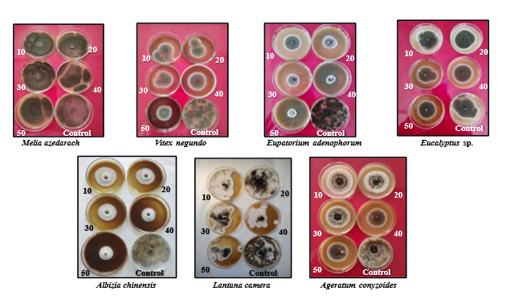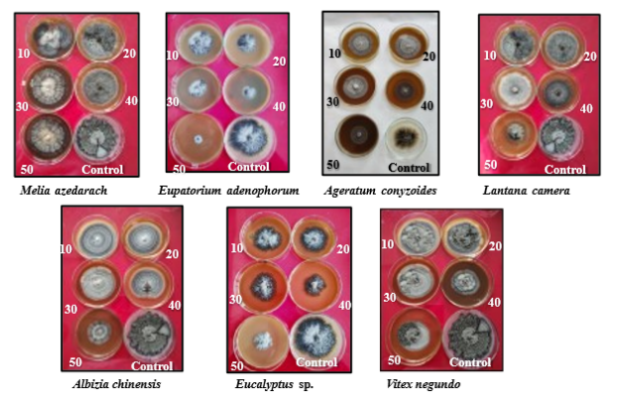
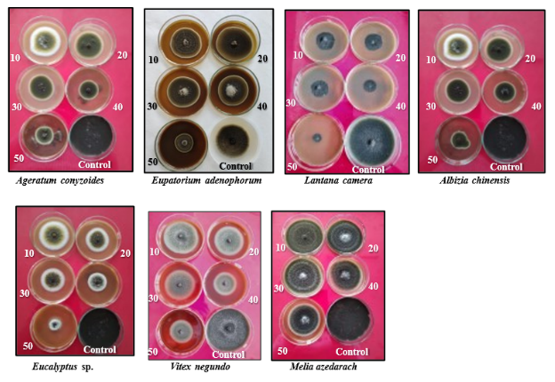
Figure 1: In - vitro evaluation of different botanicals against (a) A. niger;
(b) C. truncatum; (c) A. alternata

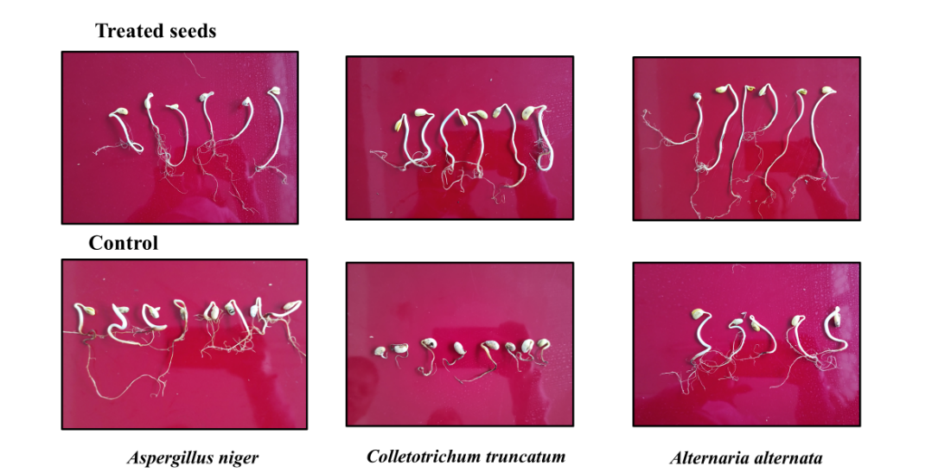
Figure 4: Effect of seed treatment with Eupatorium adenophorum on seed health

REFERENCES
Ahluwalia, V., Sisodia, R., Walia, S, Sati, OP., Kumar, J., & Kundu, A. (2014). Chemical analysis of essential oils of Eupatorium adenophorum and their antimicrobial, antioxidant and phytotoxic properties. Journal of Pest Science, 87, 341-349.
Baki, A. A. A., & Anderson, J. D. (1973). Vigour determination in soybean seed by multiple criteria. Crop Science, 73, 630-633.
Bhattarai, N., & Shrestha, G. (2009). Antibacterial and antifungal effect of Eupatorium adenophorum (Spreng) against bacterial and fungal isolates. Nepal Journal of Science and Technology 10, 91-95.
Chauhan, N., Haider SZ., Lohani H., Godbole S., Gwari G., & Bhandari, U. (2015). Chemical composition and antifungal activity of essential oil of Cymbopogon distans (Nees ex Steud.) W. Watson, Eupatorium adenophorum Spreng and Lantana camara L. grown in Uttarakhand (India). Journal of Biologically Active Products from Nature, 5, 234-240.
Chowdhury, H., Banerjee, T., & Walia, S. (2008). In vitro screening of Curcuma longa its derivatives as antifungal agents against Helminthosporium oryzae and Fusarium solani. Pesticide Research Journal, 20 (1), 6-9.
Gomez, K. A, & Gomez, A. A. (1984). Statistical Procedures for Agricultural Research, 2nd Edition. A Wiley-Interscience Publication, John Wiley and Sons, New York, p-680.
He, F. J., & Chen, J. Q. (2013). Consumption of soybean, soy foods, soy isoflavones and breast cancer incidence: Differences between Chinese women and women in Western countries and possible mechanisms. Food Science Human Wellness, 2, 146–161.
Isman, M.B. (2006). Botanical insecticides, deterrents and repellents in modern agriculture and an increasingly regulated world. Annual Review of Entomology, 51, 45-66.
Kamshybayeva, G., Atabayeva, S.D., Kenzhebayeva, S., Domakbayeva, A., Utesheva, S., Nurmahanova, A., Asrandina, S., Zhuniszhan, A., & Turpanova R. (2017). The importance of soybean (Glycine max) as a source of biologically valuable sub stances. International Journal of Biology and Chemistry, 10(2), 23-27.
Kaur, K. (2019). Eco- friendly management of pea root rot caused by Fusarium solani f. sp. pisi. Department of Plant Pathology, CSK Himachal Pradesh Krishi Vishvavidyalaya, Palampur, India. MSc Thesis pp.37- 40.
Kundu, A., Saha, S., Walia, S., Shakil, N.A., Kumar, J., & Annapurna, K. (2013) Cadinene sesquiterpenes from Eupatorium adenophorum and their antifungal activity. Journal of Environmental Science and Health Bulletin, 48, 516-522.
Kurade, N.P., Jaitak, V., Kau,l V.K., & Sharma, O.P. (2010). Chemical composition and antibacterial activity of essential oils of Lantana camara, Ageratum houstonianum and Eupatorium adenophorum. Pharmaceutical Biology, 48, 539-544.
Li. Y, Guan. R., Liu. Z., Ma. Y., Wang. L., Li. L., Lin. F., Luan. W., Chen. P., Yan. Z., Guan, Y., Zhu, L., Ning, X., Smulders, M.J., Li, W., Piao, R., Cui, Y., Yu, Z., Guan, M., Chang, R., Hou, A., Shi, A., Zhang, B., Zhu, S., & Qiu, L. (2008). Genetic structure and diversity of cultivated soybean (Glycine max (L.) Merrill) Landraces in China. Theoretical Applied Genetics 117(6), 857-871.
Neergard, P. (1977). Seed Pathology. Vol. I. The Macmillan Press, London. p 741.
Nene, Y.L., & Thapliyal, P.N. (1973). Fungicides in plant disease control. Oxford and IBH Publication Company, New Delhi, p.325.
Patil, B.J., & Madane, A.N. (2014). Effect of Hyptis Suaveolens (L.) Poit. and Eupatorium Odoratum L. leaf extracts on seed mycoflora of legume plants. Bioscience Discovery 5(2), 237-240.
Sheoran, O.P., Tonk, D.S., Kaushik, L.S., Hasija, R.C., & Pannu, R.S. (1998). Statistical software package for agricultural research workers. Recent Advances in Information Theory, Statistics and Computer Applications by Hooda D S and Hasija R C. Department of Mathematics Statistics, CCS HAU, Hisar pp-139-143.
Silva, F.C.D.S., Sediyama, T., Oliveira, R.D.C.T., Borém, A., Silva, F.L.D., Bezerra, A.R.G., & Silva, A.F. (2017). Economic Importance and Evolution of Breeding. Soybean Breeding, Springer pp. 1-16.
Singh, G., & Kumar, A. (2019). Synteny analysis of Glycine max and Phaseolus vulgaris revealing conserved regions of NBS-LRR coding genes. Bioscience Biotechnology Research Communication, 12(1), 124-133.
Singh, G., Ratnaparkhe, M., & Kumar, A. (2019). Comparative analysis of transposable elements from Glycine max, Cajanus cajan and Phaseolus vulgaris. Journal of Experimental Biology and Agriculture Sciences, 7(2), 167-177.
Tidke, S.A., Ramakrishna, D., Kiran, S., Kosturkova, G., & Ravishankar, G.A. (2015). Nutraceutical potential of soybean. Asian Journal of Clinical Nutrition, 7(2), 22-32.
Valliyodan, B., Qiu, D., Patil, G., Zeng, P., Huang, J., Dai, L., Chen, C., Li, Y., Joshi, T., Song, L., Vuong, T.D., Musket, T.A., Xu, D., Shannon, J.G., Shifeng, C., Liu, X., & Nguyen, H.T. (2016). Land scape of genomic diversity and trait discovery in soybean. Science Reports, 6, 23598.
Vincent, J.M. (1947). Distortion of hyphae in the presence of certain inhibitors. Nature, 59, 850.

