Assessment of Stability and Genetic Parameters in Poplar (Populus deltoides) Clones

Abstract: A study investigating the stability of leaf traits in Populus deltoides clones was conducted across three locations: Nauni-Solan (HP), RHR&TS center Dhaula Kuan, Sirmaur (HP), and Laddhowal farm, PAU, Ludhiana. Analysis of variance revealed significant clone x site interaction for leaf blade length, midrib length, distance between petiole junction and leaf base, and total leaf length. Utilizing the Eberhart and Russell (1966) model, clone L-621/84 was identified as exhibiting the highest stability for leaf blade length and midrib length. Conversely, clone G-48 demonstrated the greatest stability for the distance between the petiole junction and the leaf base. Both clones L-621/84 and G-48 displayed stable performance for total leaf length. Broad-sense heritability estimates were substantial, with leaf blade length (83.03) exhibiting the highest value, followed by total leaf length (78.29) and midrib length (77.85). Expected genetic gain, expressed as a percentage of the population mean, ranged from 16.42 to 26.68 percent across the evaluated traits.

Keywords: Stability, Poplar, GCV, PCV, Heritability, Genetic gain

INTRODUCTION
Populus deltoides clones, genetically improved for short rotation plantations to maximize wood production, were introduced to India in 1950 (Chaturvedi and Rawat 1994, Chauhan et al., 2012). An effective plant variety protection (PVP) system is crucial. It not only safeguards against the unlawful commercial exploitation of new varieties but also incentivizes their development. Populus deltoides remains the most widely cultivated exotic species. Genotype-by-environment interaction (GxE) can arise from varying levels of variance across different sites, leading to shifts in genotype rankings. Clones, due to the potential contribution of non-additive gene effects, offer a more sensitive tool for assessing GxE compared to seed sources or families. The improvement program should prioritize for growth, yield along with clones, stability across diverse environments for the characters under investigation.
Evaluation of the superior margin of a plantation, the selection of planting material is significantly aided by knowledge of clonal stability. While this integrated approach is common in agriculture, it is less frequent in studies of forest crops (Sixto et al., 2011). A thorough assessment of stability (or adaptability) and genotype x environment interaction (G x E) is crucial for the successful dissemination of planting material.

MATERIALS AND METHODS
Experiments were conducted at three locations: Naganji nursery (Dr. Y.S. Parmar University), RH&TS center Dhaula Kuan, and Laddhowal Farm PAU. The detailed information of three sites given in table 1. Stem cuttings (21 cm length, 10 cm diameter) from fifteen clones were collected from various institutions and planted in randomized block designs with three replications at each site. Stability parameters for leaf blade length, midrib length, distance between petiole junction and leaf base, and total leaf length were determined using the Eberhart and Russell regression model (1966) to identify stable genotypes. Genetic parameters, including phenotypic coefficient of variation (PCV), genotypic coefficient of variation (GCV), broad-sense heritability (H²), genetic advance, and genetic gain as a percentage of the mean, were estimated according to Singh (2006).

RESULTS AND DISCUSSION
Based on the Eberhart and Russell (1966) stability model, clone L-621/84 exhibited the highest stability for leaf blade length and midrib length (Figs. 1 & 2). Clones G-48, L-200/86, and L-30/06, as well as PL-6, were categorized as suitable for rich environments. Conversely, clones 5503, 1007, WSL-22, and S₇C₈, with regression coefficients below unity, phenotypic indices below zero, and minimal deviation from linearity, were deemed suitable for average environments. For midrib length, clone PL-3, with a phenotypic index above zero, regression below unity, and negligible deviation from linearity, was identified as suitable for poor environments. Clones S₇C₈, S₇C₁₅, 1007, WSL-22, and 5503 were also found to be adaptive to average environments for this trait. Clone G-48 demonstrated stability for the distance between the petiole junction and the leaf base (Fig. 3). Clone PL-6 was suitable for rich environments, clones L-6105 and 5503 for poor environments, and clones WSL-22, 1007, S₇C₁₅, L-30/06, and 6503 for average environments.
For total leaf length, clones L-621/84 and G-48 exhibited the highest stability. Clone S₇C₈ was deemed suitable for poor environments, while clones WSL-22 and 5503 were found to be most suitable for average environments (Table 2). Trait variation among clones was observed to be influenced by genotype-environment interaction. Environmental factors were found to contribute significantly to the observed phenotypic variation. Pooled analysis across all three sites revealed that the phenotypic coefficient of variation (PCV) exceeded the genotypic coefficient of variation (GCV) for all traits, indicating a substantial environmental influence. The highest PCV was observed for distance between petiole junction to maximum width of leaf (18.74), while the lowest was recorded for total leaf length (10.18). The GCV was highest for distance between petiole junction to base of leaf (15.58), followed by midrib length (10.20) and leaf blade length (10.11). Conversely, total leaf length exhibited the lowest GCV (9.01) (Table 2).
Trait variation among clones was observed to be influenced by genotype-environment interaction. Environmental factors were found to contribute significantly to the observed phenotypic variation. Pooled analysis across all three sites revealed that the phenotypic coefficient of variation (PCV) exceeded the genotypic coefficient of variation (GCV) for all traits, indicating a substantial environmental influence. The highest PCV was observed for distance between petiole junction to maximum width of leaf (18.74), while the lowest was recorded for total leaf length (10.18). The GCV was highest for distance between petiole junction to base of leaf" (15.58), followed by midrib length (10.20) and leaf blade length (10.11). Conversely, total leaf length exhibited the lowest GCV (9.01) (Table 2).
Heritability estimates ranged from 0.69 to 0.83 across the evaluated traits. Leaf blade length (83.03%) exhibited the highest heritability, followed by total leaf length (78.29%) and midrib length (77.85%). Distance between petiole junction to base of leaf displayed the lowest heritability (69.11%). High heritability estimates, when coupled with high genetic advance as a percentage of the mean, provide a more comprehensive understanding of the potential impact of selection. Total leaf length exhibited the highest genetic advance (5.27), followed by leaf blade length (4.18) and midrib length (3.53). Distance between petiole junction to base of leaf showed the lowest genetic advance (0.80). Expected genetic gain as a percentage of the population mean ranged from 16.42% (total leaf length) to 26.68% (distance between petiole junction to base of leaf) (Table 3).
Our study revealed significant genotype x environment (GxE) interaction for leaf blade length, midrib length, distance between petiole junction to base of leaf, and total leaf length. This finding aligns with previous research by Zahidi et al. (2013) on Aregnia spinosa L., which observed GxE interaction for nine leaf morphometric traits. They found that leaf length, width, area, and ratio exhibited varying degrees of sensitivity to seasonal temperature and rainfall fluctuations, depending on the tree genotype. Guet et al. (2015) also reported significant GxE interaction for lamina length, width, perimeter, area, and petiole length in black poplar (Populus nigra L.). Their study highlighted high genetic and phenotypic variation for these leaf traits, emphasizing their role as key determinants of a population's capacity to respond to environmental changes both in the short-term and across generations.
Studies investigating clone x site interaction are crucial for justifying and selecting appropriate clones for specific environments. Pliura et al. (2007) examined wood and growth traits in poplar hybrids and observed significant hybrid-by-site interaction for dry fiber weight, while height, diameter, and volume exhibited non-significant interactions. Yu and Pulkkinen (2003) evaluated GxE interaction and stability in hybrid aspen (P. tremula x P. tremuloides) growth using a dynamic stability concept, incorporating clonal repeatability and genetic gain. Riemenschneider et al. (2001) reported significant stability for plant height and diameter in poplar with respect to quantitative traits.
Significant 'total length mean square pooled deviation' and 'clone x environment (linear)' interactions indicate unpredictable variability within the dataset (Dabholkar, 1992). Koo et al. (2007) investigated stability parameters, including the Eberhart and Russell model, for 12-year volume in seven Populus davidiana (Korean aspen) clonal trials in South Korea. Several clones were subsequently selected based on their volume stability. Sixto et al. (2011) employed bi-plot symmetrical scaling to analyze GxE interaction for diameter at breast height (DBH) and height in poplar clones. Their findings revealed that clonal responses varied significantly across different site characteristics. Kim et al. (2008) demonstrated a significant provenance x site interaction effect on the height growth of Pinus densiflora.
Genetic parameter analysis revealed high inter-clonal variability for most of the studied traits. Statistically significant differences among clones demonstrated the significant influence of genetic factors on these traits. The observed wide range of means and variances across clones further supported the presence of substantial genotypic differences for the investigated characters.
Lone et al. (2012) observed similar findings in their study on Populus deltoides Bartr. clones. They analyzed genetic parameters in 2- and 3-year-old nursery clones, evaluating 49 exotic and indigenous genotypes for eight traits: plant height, diameter, leaf lamina, petiole length, total leaf length, leaf width, length/breadth ratio, and leaf angle. Sharma et al. (2011) reported high broad-sense heritability for bole straightness in their study, indicating significant potential for genetic improvement of this trait in breeding programs. Ayate and Ujjainkar (2018) conducted genetic analysis on six quantitative traits in teak: plant height, plant girth, number of branches, dry weight of leaves, leaf area, and volume. Significant variability among teak clones was observed. Plant height exhibited the highest heritability (71.80%), while volume demonstrated the highest genetic advance (22.02%). Similar findings were reported by Patil et al. (2016). These results highlight the potential for improving these traits through clonal selection and controlled breeding programs. Ayate et al. (2023) also studied variability in poplar clones leaf traits and reflected that the effect of different locations significantly observed on clones of poplar (Populus deltoides) and the quantitative traits also makes the difference within same clone at different locations.

CONCLUSION
Stability analysis is crucial for identifying clones/varieties suitable for diverse agroclimatic conditions. It provides valuable information about clones that exhibit consistent performance across different environments. The observation that the phenotypic coefficient of variation (PCV) exceeded the genotypic coefficient of variation (GCV) for all traits underscores the significant influence of environmental factors on the expression of these traits. Moderate heritability estimates for most traits suggest the potential benefits of clonal propagation in poplar. The combination of heritability and genetic gain provides a valuable indicator of the potential for trait improvement through breeding programs.

REFERENCES
Ayate, D., Jain, M., Thakur, S. and Sharma J. 2023. Study in variation of quantitative traits of poplar (Populus deltoids) clones in different environment. International Journal of Environment and Climate Change. 13 (9) : 1790-1800.
Ayate D. and Ujjainkar V. 2018. Genetic analysis of quantitative traits in teak (Tectona grandis L.). TECHNOFAME. 7(2) :73-75.
Chaturvedi, A. N. and Rawat B. S. 1994. Poplar tree improvement programme. Indian Forester 120: 97- 104.
Chauhan SK, Chauhan R and Dhillon WS 2012. Status of intercropping in poplar based agroforestry in India. ENVIS Forestry Bulletin 12(1): 49-67.
Dabholkar AR 1992. Elements of biometrical genetics. Concept Publishing Company, New Delhi, ISBN 81-702230080. 338-359.
Eberhart, S.A. and Russell W. A. 1966. Stability parameters for comparing varieties. Crop Science 6: 36- 40.
Guet, J., Febrini, F., Fichot, R., Sabatti, M., Bastein, C. and Brignolas F. 2015. Genetic variation for leaf morphology, leaf structure and leaf carbon isotope discrimination in European populations of black poplar (Populus nigra L.). Tree Physiology 35: 850-863.
Kim, I.S., Kwon, H.Y., Ryu, K.O. and Choi W.Y. 2008. Provenance by site interaction of Pinus densiflora in Korea. Silvae Genetica 57: 131-139.
Koo, Y.B., Yeo, J.K., Woo, K.S. and Kim T.S. 2007. Selection of superior clones by stability analysis of growth performance in Populus davidiana Dode at age 12. Silvae Genetica 56: 93-102.
Lone, A., Bashir, A. and Tewari S.K. 2012. Quantitative estimation of genetic variability in morphological characteristics of Eastern cottonwood (Populus deltoides Bartr.) clones. Journal of Sustainable Forestry. 31: 607-619.
Patil, R, Ayate, D. and Ujjainkar V. V. 2016. Genetic variability studies in clonal population of teak (Tectona grandis L.). International Journal of Farm Sciences. 6 (4): 136-139.
Pliurua, A., Zhang, S.Y., Bousquet, J. and Mackay J. 2007. Genotypic variation in wood density and growth traits of poplar hybrids at four clonal trials. Forest Ecology and Management 238: 92-106.
Riemenschneider, D.E., Berguson, W.E., Dickmann, D. I., Hall, R.B., Isebrands, J.G., Mohn, C.A., Stanosz, G.R. and Tuskan G.A. 2001. Poplar breeding and testing strategies in the north- central U.S.: Demonstration of potential yield and consideration of future research needs. The Forest Chronicle. 77: 245-253.
Sharma, J.P., Singh, N.B., Sankhyan, H.P., Chaudhari, P. and Huse S.K. 2011. Estimation of genetic parameters of newly introduced tree willow clones in Himachal Pradesh, India. Genetika 43: 487-501.
Singh P. 2006. Practicals and numericals in plant breeding. Kalyani Publishers. Ludhiana. pp. 179- 187.
Sixto, H., Salvia, J., Barrio, M., Ciria, M.P. and Canñellas I. 2011. Genetic variation and genotype environment interactions in short rotation Populus plantations in southern Europe. New Forests 42: 163-177.
Yu, Q. and Pulkkinen P. 2003. Genotype-environment interaction and stability in growth of aspen hybrid clones. Forest Ecology and Management 173: 25-36.
Zahidi, A., Bani-Aameur, F. and Mousadik E.L.A. 2013. Morphological diversity of leaf characters in three natural populations of Aargania spinosa L. Skeels. Journal of Experimental Biology and Agricultural Sciences 1: 297-316.

Fig. 1. Stability parameters of leaf blade length Fig. 2. Stability parameters of mid rib length
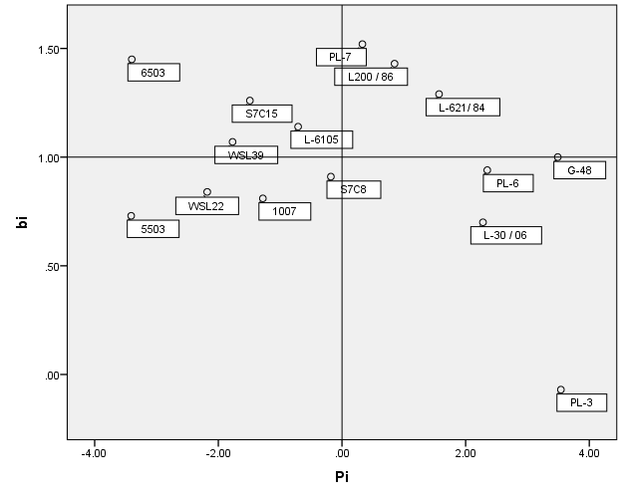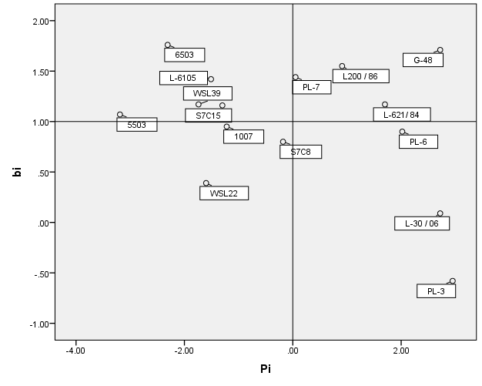

Fig. 3. Stability parameters of distance between Fig. 4. Stability parameters of total leaf length petiole junction to base of leaf
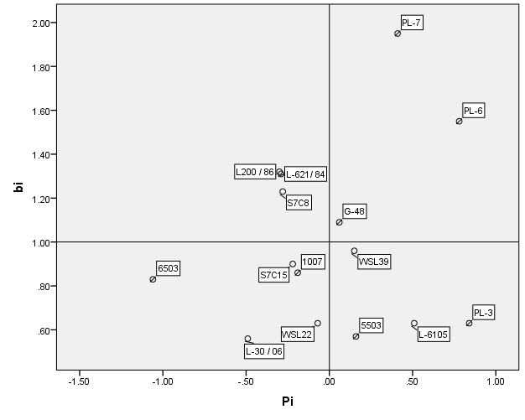

Table 1. The location and climatic condition of the study sites

Sr.No. | Names | Dhaula Kuan | Laddhowal | Naganji Nursery
1) | State | Himachal Pradesh | Punjab | Himachal Pradesh
2) | District | Sirmaur | Ludhiana | Solan
3) | Longitude | 75º 05’ E | 75º 44’ E | 76˚ 11' E
4) | Latitude | 30º 04’ N | 30º 59’ N | 30˚ 51' N
5) | Altitude | 468 m | 229 m | 1200 m
6) | Soil type | Sandy-loam | Ravine type | Sandy-loam
7) | Soil pH | 6.6 | 8.4 | 7.2
8) | Annual rainfall | 662 mm | 780 mm | 750-800 mm
9) | Max. temp. | 45 º C | 45 ºC | 38 ºC
10) | Min. temp. | -0.5 ºC | 5.8 ºC | -2.5 ºC

Table 2. Stability performance for leaf blade, midrib length and distance between petiole junction and base of leaf
Clones | Leaf blade length |  |  |  | Midrib length |  |  |  | Distance between petiole junction and base of leaf |  |  |  | Total length
Clones | Mean | P_{i} | b_{i} | S²_{di} | Mean | P_{i} | b_{i} | S²_{di} | Mean | P_{i} | b_{i} | S²_{di} | Mean | P_{i} | b_{i} | S²_{di}
L-30 / 06 | 24.31 | 2.28 | 0.70 | 13.52 | 21.78 | 2.72 | 0.09 | 7.14 | 2.50 | -0.49 | 0.56 | 0.11 | 36.10 | 4.00 | -0.56 | 6.06
L-62/ 84 | 23.60 | 1.57 | 1.29 | 0.12 | 20.76 | 1.70 | 1.17 | 0.10 | 2.71 | -0.29 | 1.31 | 0.08 | 32.66 | 0.56 | 0.93 | 0.43
G-48 | 25.52 | 3.49 | 1.00 | 1.53 | 21.78 | 2.72 | 1.71 | 1.06 | 3.05 | 0.06 | 1.09 | 0.02 | 36.16 | 4.06 | 0.85 | -0.73
L-61/05 | 21.32 | -0.71 | 1.14 | 4.82 | 17.55 | -1.51 | 1.42 | 0.37 | 3.50 | 0.51 | 0.63 | 0.07 | 31.06 | -1.04 | 1.79 | 2.48
S₇C₁₅ | 20.54 | -1.49 | 1.26 | 0.14 | 17.76 | -1.30 | 1.16 | -0.36 | 2.77 | -0.22 | 0.90 | 0.04 | 30.93 | -1.17 | 1.31 | -0.77
S₇C₈ | 21.84 | -0.18 | 0.91 | 1.09 | 18.88 | -0.18 | 0.80 | 0.60 | 2.72 | -0.28 | 1.23 | 0.19 | 34.23 | 2.13 | 0.37 | 0.82
WSL-22 | 19.85 | -2.18 | 0.84 | 0.68 | 17.46 | -1.60 | 0.39 | -0.31 | 2.92 | -0.07 | 0.63 | 0.03 | 28.62 | -3.47 | 0.83 | -0.26
WSL-39 | 20.26 | -1.77 | 1.07 | 9.91 | 17.32 | -1.74 | 1.17 | 5.00 | 3.15 | 0.15 | 0.96 | 0.35 | 29.49 | -2.61 | 2.06 | 0.39
6503 | 18.63 | -3.40 | 1.45 | 2.13 | 16.75 | -2.31 | 1.76 | 0.05 | 1.94 | -1.06 | 0.83 | 0.07 | 28.50 | -3.59 | 2.31 | 0.39
5503 | 18.62 | -3.41 | 0.73 | 1.53 | 15.87 | -3.19 | 1.07 | 0.06 | 3.15 | 0.16 | 0.57 | 0.05 | 27.77 | -4.33 | 1.20 | 0.26
1007 | 20.75 | -1.28 | 0.81 | 1.16 | 17.84 | -1.22 | 0.95 | 0.43 | 2.80 | -0.19 | 0.86 | 0.02 | 29.84 | -2.26 | 1.43 | 1.90
L-200 / 86 | 22.87 | 0.85 | 1.43 | 1.94 | 19.97 | 0.91 | 1.55 | 0.49 | 2.69 | -0.30 | 1.32 | 0.14 | 31.80 | -0.30 | 1.83 | -0.77
PL-3 | 25.56 | 3.54 | -0.07 | 8.87 | 22.01 | 2.95 | -0.58 | -0.36 | 3.83 | 0.84 | 0.63 | 0.83 | 36.74 | 4.65 | -0.78 | 5.77
PL-6 | 24.37 | 2.35 | 0.94 | 5.78 | 21.08 | 2.02 | 0.90 | 3.60 | 3.78 | 0.78 | 1.55 | 0.15 | 35.39 | 3.29 | 0.04 | 2.53
PL-7 | 22.36 | 0.33 | 1.52 | -0.20 | 19.11 | 0.05 | 1.44 | 0.49 | 3.40 | 0.41 | 1.95 | -0.03 | 32.14 | 0.05 | 1.39 | -0.31

Table 3. Genetic parameters in poplar clones

Characters | Mean | Range | Coefficient of variability (%) |  | Heritability  (%) | Genetic advance | Genetic gain (%)
Characters | Mean | Range | PCV | GCV | Heritability  (%) | Genetic advance | Genetic gain (%)
leaf blade length (cm) | 22.03 | 18.62-25.56 | 11.09 | 10.11 | 83.03 | 4.18 | 18.97
Midrib length (cm) | 19.06 | 15.87-22.01 | 11.56 | 10.20 | 77.85 | 3.53 | 18.54
Distance between petiole junction and base of leaf (cm) | 2.99 | 1.94 - 3.83 | 18.74 | 15.58 | 69.11 | 0.80 | 26.68
Total length (cm) | 32.10 | 27.77 - 36.74 | 10.18 | 9.01 | 78.29 | 5.27 | 16.42

