Original Research Article
Mapping the BRCA1 Protein Interaction Network: Functional Insights and Therapeutic Implications in Cancer

Abstract
Background:
Breast Cancer Type 1 Susceptibility Protein (BRCA1) is an important tumour suppressor gene that plays a crucial role in preserving genomic stability through its involvement in DNA repair, chromatin remodelling, and transcription regulation. The risk of some diseases, such as breast and ovarian cancer, increases significantly when the BRCA1 gene is mutated. However, targeting the BRCA1 gene in cancer therapy has remained a significant challenge for scientists.
Objective:
The study aims to explore the protein interaction network of BRCA1 to elucidate its
functional associations and regulatory mechanisms, identify previously unrecognised
therapeutic targets, and investigate the effect of PI3K-AKT inhibition on BRCA1
Methods:
The BRCA1 interaction network was constructed using the STRING database (v12.0) at a high-confidence interaction score (0.900). Clusters of proteins were obtained through K-means, and the main interactors were grouped into three levels by carrying out a thorough analysis through the Reactome pathway. Some common interactors were identified through frequency analysis. In order to uncover the biological processes related to the BRCA1 network, pathway enrichment was subsequently conducted.
Results:
The insights obtained from this study are expected to contribute to the advancement of
more effective diagnostic and therapeutic approaches for individuals with BRCA-
associated cancers, ultimately improving patient outcomes and reducing the overall
disease burden.
Conclusion:
This comprehensive mapping of the BRCA1 interactome reveals a highly regulated and multi-layered protein interaction system. The identified interactors suggest potential therapeutic targets in cancer therapy, most especially within the PI3K-AKT pathway. Also, BRCA1 functions at the crossroads of endocrine, hormonal, and metabolic regulation, underscoring its integral role in tissue homeostasis and its potential as a target for combined hormonal and metabolic therapies in BRCA1-related cancers. This presents potential strategies for the treatment of BRCA1-associated malignancies.
Keywords: BRCA1, protein-protein interaction, STRING, Reactome, PI3K-AKT, DNA repair, synthetic lethality, bioinformatics
Introduction
BRCA1 (Breast Cancer type 1 susceptibility protein) is a crucial tumour suppressor that plays a central role in maintaining genomic integrity by regulating DNA repair, chromatin remodelling, and transcriptional control (Prakash et al., 2015; Jiang & Greenberg, 2015). The BRCA1 gene contains 24 exons out of which 22 encode protein sequence, and it's located on chromosome 17q21 (Rebbeck et al., 2015). Elevated risk of hereditary breast and ovarian cancers has been linked to mutations distributed throughout the BRCA1 gene. BRCA1 has several functional domains that contribute to its multifaceted role. The N-terminal RING domain confers E3 ubiquitin ligase activity and facilitates dimerisation with BARD1, forming a complex essential for DNA repair and cell cycle regulation (Savage & Harkin, 2014).
Furthermore, the C-terminal BRCT domains mediate interactions with phosphorylated proteins involved in the DNA damage response (DDR), while nuclear localisation signals (NLS) ensure its transport into the nucleus, where it regulates genomic maintenance processes (Dunker et al., 2015; San Martin Alonso & Noordermeer, 2021; Clark et al., 2012). All these structural features enable BRCA1 to be involved in a wide spectrum of cellular functions related to genomic stability. BRCA1 interacts with different proteins, forming a complex and dynamic molecular network involved in DNA repair, apoptosis, cell cycle control, and transcriptional regulation (Prakash et al., 2015; Kim et al., 2021). Alterations in this network, whether due to pathogenic mutations or dysregulated protein expression, can significantly impair cellular homeostasis and promote the development of cancer.
Moreover, therapeutic strategies directly targeting BRCA1 mutations have remained difficult to target effectively because these alterations typically result in a loss of function (Epstein, 2013). Nevertheless, advances in exploiting BRCA1-related vulnerabilities have yielded promising approaches, including PARP inhibitors, platinum-based chemotherapies, and gene therapy. Also, targeting dysregulated signalling pathways such as ATR, ATM, and PI3K-AKT has shown therapeutic potential in preclinical studies of BRCA1/2-mutated cancers (Yip & Papa 2021).
This study explored the protein interaction network of BRCA1 using bioinformatics tools and curated databases, with the aim of elucidating key functional associations, identifying novel therapeutic targets, and examining the effects of PI3K-AKT pathway inhibition. The findings are anticipated to contribute toward the development of more effective diagnostic and therapeutic strategies, ultimately improving outcomes for patients with BRCA-associated malignancies.

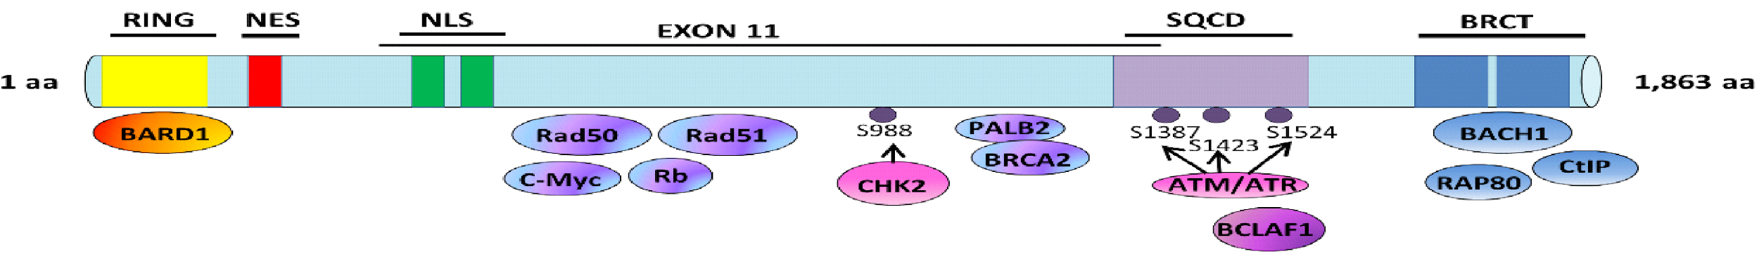
Fig 1. The diagram of BRCA1 illustrates key functional domains and interactions. Phosphorylation sites important for DNA damage signalling are also shown, as well as the kinases responsible for their modification. (Orr & Savage, 2015)
Materials and Methods
The Search Tool for the Retrieval of Interacting Genes/Proteins (STRING) version 12.0, an online resource that specialises in the analysis and visualisation of protein-protein interactions (PPIs) and generating protein networks, was used to obtain the interacting network of BRCA1. The highest confidence (0.900) interaction score was used to ensure that only strong and reliable protein-protein interactions are included in the network. To streamline the network and emphasise the most significant interactions, each protein was limited to a maximum of ten connections. Interaction sources were filtered using parameters such as experimental evidence, co-expression, and text mining. Once the list of interacting genes was generated, they were grouped into three distinct clusters using K-means clustering, a machine learning algorithm that organises data into K clusters based on similarity or distance-based criteria. Results are represented in Figure 2 below.

Figure 2. Protein-protein interaction network of BRCA1 from STRING database.

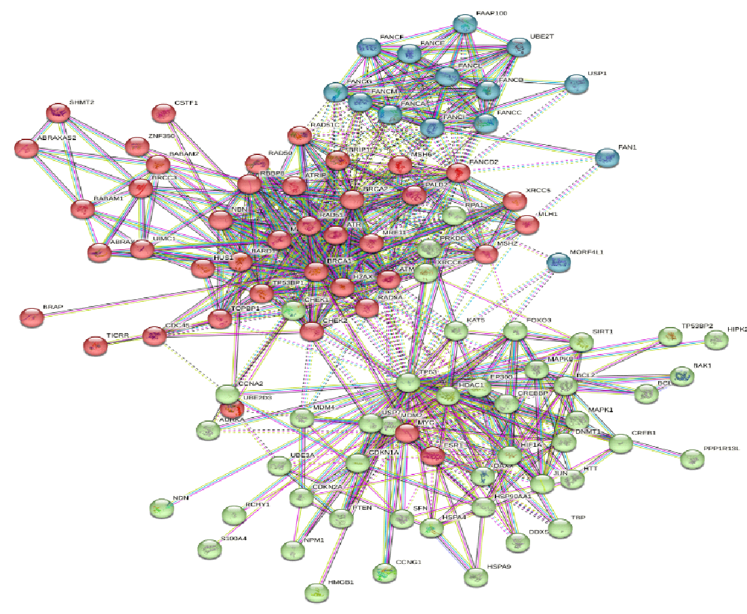
The Reactome Pathway Browser, a curated database of molecular pathways and biological processes, was used to identify both direct and indirect interactors of the 100 proteins obtained from the STRING database, applying a confidence score threshold of 0.700. These interacting proteins were categorised into three levels, with the results shown in Table 1.
A frequency count was then performed to determine the most common interactors; proteins with extensive connections to BRCA1 or its associated partners, summarised in Table 2. Finally, a pathway analysis was conducted to identify key biological processes, with findings illustrated in Figure 3.

Figure 3: Voronoi diagram of the pathway analysis.
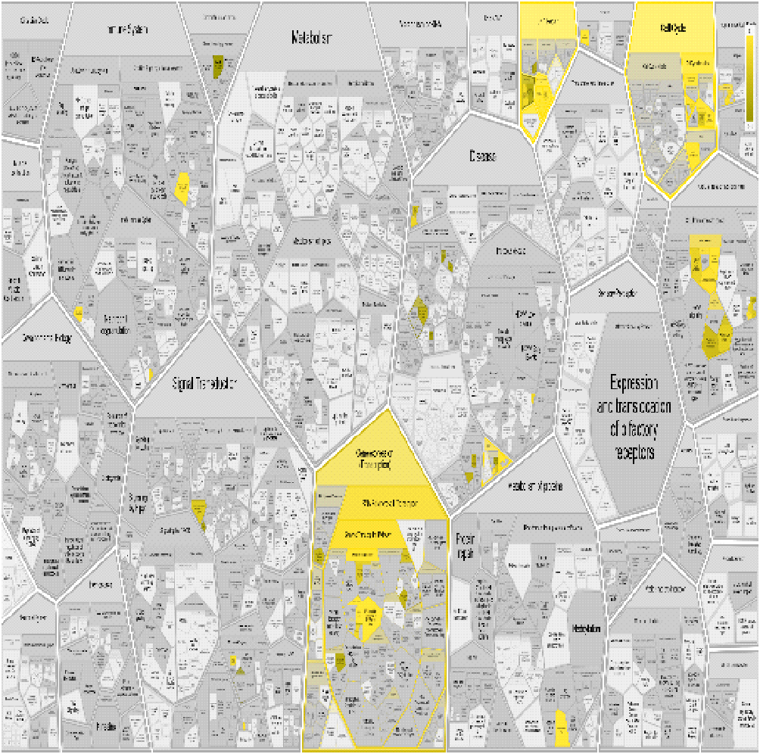

Table 1: Protein Interactors with BRCA1
Level 1 Interactor | Level 2 Interactor | Level 3 Interactor
BRCA1, BARD1, BRCA2, TP53, RAD51, ATR, ATM, AKT1, EGFR, CDK2 | EP300, SIRT1, HDAC2, RELA, PLK1, DNMT1, FOXO3, PARP1, RB1, CCND1 | UBC, SUMO1, TEAD4, BYSL, PIN1, HSPA8, CCNE1, ZMAT2, USP2, H2AFX

Table 2: Common Interactors in the BRCA1 Protein Network
Protein Name | Frequency | Functional Significance
TP53 | 57 | Key regulator of DNA repair and tumor suppression
PARP1 | 14 | Involved in DNA damage response, target of PARP inhibitors
WRN | 13 | DNA helicase involved in genomic maintenance
CDKN1B | 12 | Cell cycle control protein (p27)
HDAC2 | 12 | Histone deacetylase; chromatin remodeling
RB1 | 12 | Tumor suppressor involved in G1 checkpoint control
SIRT1 | 12 | Regulator of transcription and DNA repair
NBN | 11 | DNA damage checkpoint protein (MRN complex)
CDK2 | 10 | Cell cycle regulator involved in BRCA1 signaling
EGFR | 10 | Growth receptor linked to PI3K-AKT signaling
MDM2 | 10 | E3 ligase regulating TP53 degradation
USP7 | 10 | Deubiquitinase stabilizing TP53 and MDM2
YWHAZ | 10 | Signal transduction adaptor; apoptosis control
BAX | 9 | Pro-apoptotic regulator
CCND1 | 9 | Cyclin involved in G1/S transition
DAXX | 9 | Apoptosis regulator and chromatin modifier

Result and Discussion
This study investigates the complex protein interaction network of BRCA1, a key gene essential for preserving genomic integrity. BRCA1 has been widely studied for its crucial functions in DNA repair, transcriptional regulation, and cell cycle regulation (Drost & Jonkers, 2014)
This study successfully mapped a detailed protein interaction network centred on BRCA1, revealing its extensive connectivity within the cell. The analysis showed the interactions of BRCA1 with several key proteins, such as TP53, PARP1, RAD51, ATM, and AKT1, which emphasise its role in diverse cellular pathways. These findings support the view of BRCA1 as a multifunctional protein critical for maintaining genomic stability(Krishnan et al., 2021).
BRCA1 mutations are closely linked to hereditary breast and ovarian cancers, largely due to their disruption of BRCA1's interactions with key DNA repair proteins, compromising the DNA damage response and promoting genomic instability. This study supports the clinical importance of targeting dysregulated pathways in BRCA1-deficient cells, such as through the use of PARP-1 inhibitors, which induce synthetic lethality by blocking DNA single-strand break repair(Lord & Ashworth, 2017; Turk & Wisinski, 2018). Furthermore, CHK1 inhibitors may facilitate the effects of DNA-damaging agents by preventing cell cycle arrest, offering another potential therapeutic method which exploits BRCA1 deficiency in cancer therapy (Booth et al., 2018)
This study identified interactions between BRCA1 and key components of the PI3K-AKT signalling pathway, including PIK3R1, PTEN, and AKT. Some studies have shown that suppression of the PIK3CA gene can downregulate BRCA1 expression, impair homologous recombination (HR), increase DNA damage, and upregulate pro-apoptotic proteins like BAX, consequently promoting cancer cell death (Guney Eskiler, 2019; Wang & Di, 2014). These findings underscore the therapeutic potential of targeting both PI3K signalling and DNA repair pathways to selectively target HR-deficient breast cancers through synthetic lethal mechanisms. However, combination therapies may be challenging due to overlapping toxicities, which necessitate precise dose optimisation and effective management of treatment-related toxicities.
This study confirms BRCA1’s interaction with ESR1, which encodes estrogen receptor alpha (ERα), which also suggests that ERα can be targeted in its downstream pathways, and this may be relevant for BRCA1-mutated breast cancers. Also, BRCA1’s role in epigenetic regulation through its interaction with HDAC2 highlights the potential of using epigenetic therapies, such as histone deacetylase or DNA methyltransferase inhibitors, to restore normal gene expression patterns. Furthermore, BRCA1 interacts with MRE11A, a component of the MRN complex essential for homologous recombination (HR); defects in MRE11A can impair HR initiation, which can lead to genomic instability and increased sensitivity to DNA-damaging agents, such as PARP inhibitors and some cancer therapies that are platinum-based (Pawlowska & Blasiak, 2015; Yazinski et al., 2017).
Furthermore, recent evidence underscores the intricate endocrine regulation of BRCA1, particularly its crosstalk with hormonal and metabolic signalling pathways. BRCA1 has been shown to modulate estrogen receptor α (ERα) activity, thereby affecting the estrogen-dependent gene transcription and cellular proliferation in hormone-responsive tissues such as the breast and ovary (Wang & Di, 2014). This hormonal regulation forms a critical endocrine axis through which BRCA1 contributes to maintaining tissue homeostasis and mitigating carcinogenic risk. Moreover, BRCA1 interacts with insulin and leptin signalling pathways, linking it to energy metabolism and endocrine control of cellular growth (Kang et al., 2012). Dysregulation of the BRCA1–PI3K–AKT axis not only compromises DNA repair but also affects insulin sensitivity and glucose metabolism, potentially contributing to metabolic disorders that may exacerbate cancer progression (Nogueira et al., 2019). These findings suggest that BRCA1 functions at the intersection of endocrine signaling, genomic stability, and metabolic regulation. Consequently, understanding BRCA1’s endocrine interactions may open new avenues for therapeutic interventions that target both hormonal and metabolic pathways in BRCA1-associated malignancies.
Moreover, BRAP, a deubiquitinase enzyme, was found to stabilise BRCA1 by preventing its proteasomal degradation, emphasising the importance of BRCA1 stability in DNA repair and genome maintenance (Dkhissi et al., 2015). Another good therapeutic strategy is to modulate the interactions between BRCA1 and BRAP, especially in BRCA1-deficient cancers. Overall, targeting proteins within the BRCA1 interaction network—particularly those involved in hormone signalling, epigenetic regulation, and DNA repair is a promising area in the development of novel, effective, and more effective cancer therapies (Hengel et al., 2017).
Limitations and Future Directions:
This study provides important insights into the BRCA1 interaction network, but it is limited by its reliance on bioinformatics predictions, which need to be confirmed through experimental validation. Additionally, the analysis provides a fixed snapshot of the interactions, overlooking potential dynamic changes under varying cellular conditions. Future research needs to be conducted to explore these dynamics and consider the role of post-translational modifications in regulating BRCA1 interactions.

Conclusion
This dissertation provided an in-depth analysis of the BRCA1 protein interaction network using bioinformatics tools, revealing BRCA1’s central role in DNA repair, cell cycle regulation, transcription, and chromatin remodelling. The study identified several potential therapeutic targets within this network, which offers a promising opportunity for the development of targeted treatments for BRCA1-related cancers. Furthermore, the research highlighted the interplay between BRCA1 and the PI3K-AKT signalling pathway, indicating that altering this crosstalk may affect BRCA1 activity and impact treatment effectiveness. Also, BRCA1 operates at the intersection of endocrine, hormonal, and metabolic regulation, highlighting its pivotal role in maintaining tissue homeostasis and offering potential targets for integrated therapeutic interventions in BRCA1-associated cancers. Overall, the findings have supported the literature and the existing knowledge about our understanding of BRCA1’s multifaceted roles and support the advancement of targeted cancer treatment approaches.

References
Booth, L., Roberts, J., Poklepovic, A., & Dent, P. (2018). The CHK1 inhibitor SRA737 synergizes with PARP1 inhibitors to kill carcinoma cells. Cancer Biology & Therapy, 19(9), 786–796. https://doi.org/10.1080/15384047.2018.1472189.
Clark, S. L., Rodriguez, A. M., Snyder, R. R., Hankins, G. D. V., & Boehning, D. (2012). Structure-Function Of The Tumor Suppressor BRCA1. Computational and Structural Biotechnology Journal, 1(1), e201204005. https://doi.org/10.5936/csbj.201204005
Drost, R., & Jonkers, J. (2014). Opportunities and hurdles in the treatment of BRCA1-related breast cancer. Oncogene, 33(29), 3753–3763. https://doi.org/10.1038/onc.2013.329
Dunker, A. K., Cortese, M. S., Romero, P., Iakoucheva, L. M., & Uversky, V. N. (2005). Flexible nets. The roles of intrinsic disorder in protein interaction networks. FEBS Journal, 272(20), 5129–5148. https://doi.org/10.1111/j.1742-4658.2005.04948.x
Epstein, R. J. (2013). The unpluggable in pursuit of the undruggable: Tackling the dark matter of the cancer therapeutics universe. Frontiers in Oncology, 3. https://doi.org/10.3389/fonc.2013.00304
Fu, X., Tan, W., Song, Q., Pei, H., & Li, J. (2022). BRCA1 and Breast Cancer: Molecular Mechanisms and Therapeutic Strategies. Frontiers in Cell and Developmental Biology, 10. https://doi.org/10.3389/fcell.2022.813457

Guney Eskiler, G. (2019). The Interaction of PI3K Inhibition with Homologous Recombination Repair in Triple Negative Breast Cancer Cells. Journal of Pharmacy & Pharmaceutical Sciences, 22, 599–611. https://doi.org/10.18433/jpps30684
Hengel, S. R., Spies, M. A., & Spies, M. (2017). Small-Molecule Inhibitors Targeting DNA Repair and DNA Repair Deficiency in Research and Cancer Therapy. Cell Chemical Biology, 24(9), 1101–1119. https://doi.org/10.1016/j.chembiol.2017.08.027
Jiang, Q., & Greenberg, R. A. (2015). Deciphering the BRCA1 Tumor Suppressor Network. Journal of Biological Chemistry, 290(29), 17724–17732. https://doi.org/10.1074/jbc.r115.667931

Kang HJ, Yi YW, Kim HJ, Hong YB, Seong YS, Bae I. BRCA1 negatively regulates IGF-1 expression through an estrogen-responsive element-like site. Cell Death & Disease. 2012;3:e336. doi: 10.1038/cddis.2012.78.

Kim, M., Park, J., Bouhaddou, M., Kim, K., Rojc, A., Modak, M., Soucheray, M., McGregor, M. J., O’Leary, P., Wolf, D., Stevenson, E., Foo, T. K., Mitchell, D., Herrington, K. A., Muñoz, D. P., Tutuncuoglu, B., Chen, K.-H., Zheng, F., Kreisberg, J. F., … Krogan, N. J. (2021). A protein interaction landscape of breast cancer. Science, 374(6563).https://doi.org/10.1126/science.abf3066

Krishnan, R., Patel, P. S., & Hakem, R. (2021). BRCA1 and Metastasis: Outcome of Defective DNA Repair. Cancers, 14(1), 108. https://doi.org/10.3390/cancers14010108
Lord, C. J., & Ashworth, A. (2017). PARP inhibitors: Synthetic lethality in the clinic. Science, 355(6330), 1152–1158. https://doi.org/10.1126/science.aam7344

Nogueira, V., Park, Y., Chen, C. C., Xu, P. Z., Chen, M. L., Tonic, I., Unterman, T., & Hay, N. (2019). Akt determines replicative senescence and oxidative or oncogenic premature senescence and sensitizes cells to oxidative apoptosis. Cancer Cell, 14(6), 458–470. https://doi.org/10.1016/j.ccr.2019.09.008
Orr, K. S., & Savage, K. I. (2015). The BRCA1 and BRCA2 breast and ovarian cancer susceptibility genes—implications for DNA damage response, DNA repair and cancer therapy. In Advances in DNA Repair (pp. 217-253). InTech.

Pawlowska, E., & Blasiak, J. (2015). DNA Repair—A Double-Edged Sword in the Genomic Stability of Cancer Cells—The Case of Chronic Myeloid Leukemia. International Journal of Molecular Sciences, 16(11), 27535–27549. https://doi.org/10.3390/ijms161126049
Rebbeck, T. R., Mitra, N., Wan, F., Sinilnikova, O. M., Healey, S., McGuffog, L., Mazoyer, S., Chenevix-Trench, G., Easton, D. F., Antoniou, A. C., Nathanson, K. L., Laitman, Y., Kushnir, A., Paluch-Shimon, S., Berger, R., Zidan, J., Friedman, E., Ehrencrona, H., Stenmark-Askmalm, M., … Andrulis, I. (2015). Association of type and location ofbrca1andbrca2mutations with risk of breast and ovarian cancer. JAMA, 313(13), 1347. https://doi.org/10.1001/jama.2014.5985
Prakash, R., Zhang, Y., Feng, W., & Jasin, M. (2015). Homologous recombination and human health: The roles of BRCA1, BRCA2, and associated proteins. Cold Spring Harbor Perspectives in Biology, 7(4). https://doi.org/10.1101/cshperspect.a016600
San Martin Alonso, M., & Noordermeer, S. M. (2021). Untangling the crosstalk between BRCA1 and R-loops during DNA repair. Nucleic Acids Research, 49(9), 4848–4863. https://doi.org/10.1093/nar/gkab178
Savage, K. I., & Harkin, D. P. (2014). BRCA1, a ‘complex’ protein involved in the maintenance of genomic stability. The FEBS Journal, 282(4), 630–646. https://doi.org/10.1111/febs.13150
Turk, A. A., & Wisinski, K. B. (2018). PARP inhibitors in breast cancer: Bringing synthetic lethality to the bedside. Cancer, 124(12), 2498–2506. https://doi.org/10.1002/cncr.31307
Wang, L., & Di, L.-J. (2014). BRCA1 And Estrogen/Estrogen Receptor In Breast Cancer: Where They Interact? International Journal of Biological Sciences, 10(5), 566–575. https://doi.org/10.7150/ijbs.8579
Yazinski, S. A., Comaills, V., Buisson, R., Genois, M.-M., Nguyen, H. D., Ho, C. K., Todorova Kwan, T., Morris, R., Lauffer, S., Nussenzweig, A., Ramaswamy, S., Benes, C. H., Haber, D. A., Maheswaran, S., Birrer, M. J., & Zou, L. (2017). ATR inhibition disrupts rewired homologous recombination and fork protection pathways in PARP inhibitor-resistant BRCA-deficient cancer cells. Genes & Development, 31(3), 318–332. https://doi.org/10.1101/gad.290957.116
Yip, H. Y. K., & Papa, A. (2021). Signaling pathways in cancer: therapeutic targets, combinatorial treatments, and new developments. Cells, 10(3), 659.

