Study on The Breeding ground of Mahseer In Narmada River of Jabalpur District

ABSTRACT
The breeding grounds of mahseer within river are of utmost importance, as they serve as critical habitats for the breeding and early stages of development for numerous aquatic organisms. Consequently, river ecosystems are considered to be ecologically sensitive and socio-economically significant systems. This study employed a test harvest or random sampling method to assess the current status of breeding sites. The findings highlight a low in the number of breeding and nursery grounds for mahseer, with some sites completely devoid of such habitats. This decline can be attributed to the escalating anthropogenic activities and pollution in the area. Therefore, it is crucial to implement regular monitoring and mitigate anthropogenic disturbances in order to restore the ideal and natural breeding and nursery grounds.
INTRODUCTION
The River Narmada, often referred to as the "Life Line of Madhya Pradesh," provides a vital habitat for numerous fish species (Sharma et al., 2014). Notably, the mahseer (T. tor), a magnificent cyprinid fish with large scales, holds great significance as a prized and esteemed species in the North and North-eastern regions of India. The fish 'mahseer' is associated with its significant scale size and head length, but it's probable etymology can be traced back to the Persian term 'mahisher' which denotes its aggressive and sportive characteristics (Desai, 2003). Mahseer is commonly used to designate fish species belonging to the Tor, Neolissochilus, and Naziritor genera. Mahseer species are inclined towards fast-flowing rocky streams that offer crystal clear freshwater and high levels of oxygen. In Hora's (1940) study, it was reported that the river Narmada is home to three species of mahseer, namely T. tor, T. putitora, and T. khudree. Desai (2003) further identified ten valid species and three valid subspecies of mahseer in Pakistan, India, China, and Southeast Asia. Additionally, Lal et al. (2012) reported the presence of T. tor in the tributaries of the Godavari and Krishna river system in India.
The presence of clear water, high level oxygen and rocky beds within river creates a diverse and dynamic environment that supports the growth and survival of mahseer. These habitats offer protection from predators, ample food sources, and suitable conditions for reproduction and early life stages. The studies conducted by Ajithkumar et al. (2006), and Telesh et al. (2010) emphasize the importance of these habitats in sustaining the populations of numerous aquatic species. The objective of this research is to bring attention to the research conducted in India in recent years on mahseer, as well as to offer an updated assessment of the status of this endangered fish in Madhya Pradesh. This evaluation will serve as a reference point for the development of conservation plans and will help facilitate a more targeted approach to future research efforts associated with this widespread and ecologically significant fish species.
MATERIAL AND METHODS
A. Study Area
The period of April 2023 to March 2024 saw the implementation of the current study in the Narmada river district Jabalpur. The study area, which extends from Bedhaghat (T1) 23.1306° N, 79.8024° E, Tilwaraghat (T2) 23.1079° N, 79.8758° E, Gwarighat (T3) 23.1100° N, 79.9277° E and Lametaghat (T4) 23.1118° N, 79.8356° E opens up to the Narmada river. It is segmented into four sites with proportionate distances along a 20 Km stretch.
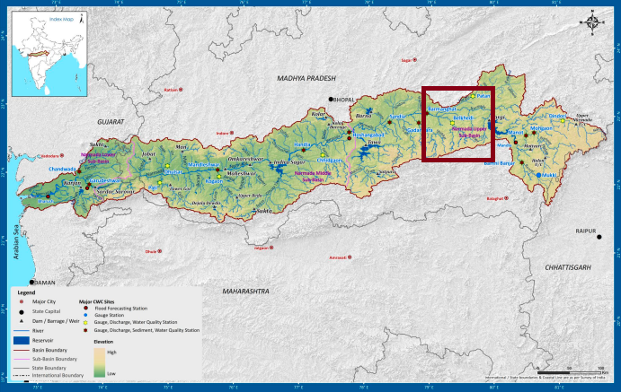
B. Sample Collection and Analysis:
The study involved a continuous assessment of the presence of eggs, fry, and spawn populations through the implementation of either a test harvest method or a random sampling method. A plankton net with a mesh size of 30μm was utilized for data collection purposes.. Furthermore, fishermen were interviewed to gather information on specific locations where eggs and schools of spawn were commonly observed in the past few decades. A dedicated map was created to document these historical sightings.
RESULTS AND DISCUSSION
The extensive use of the test harvest method or random sampling method in this study significantly aided in the identification of breeding grounds. The identified sites was meticulously mapped on Google map. Site T4 exhibited the highest concentration of breeding and nursery grounds for mahseer, followed by sites T2, T3, and T1. Conversely, low breeding and nursery grounds were observed at sites T3 and T1 during the test harvest or random sampling study conducted in the present investigation. The Narmada river was found to have a greater number of breeding grounds compared to the other rivers, possibly due to the slow water flow and shallow depth that enhance dissolved oxygen levels and light penetration. Various factors, such as water quality, substrate type, food availability, spawning period, and water flow, play a significant role in determining the suitability of breeding and nursery habitat. It is concerning to note that these factors are experiencing degradation in the study area, as indicated by Arunachalam (2000) and Pirhalla (2004).
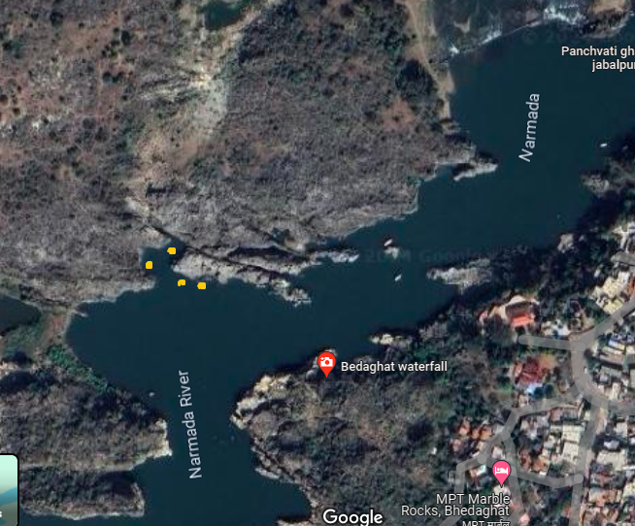
Figure 1 Breeding grounds at Bedhaghat (T1) in Narmada river
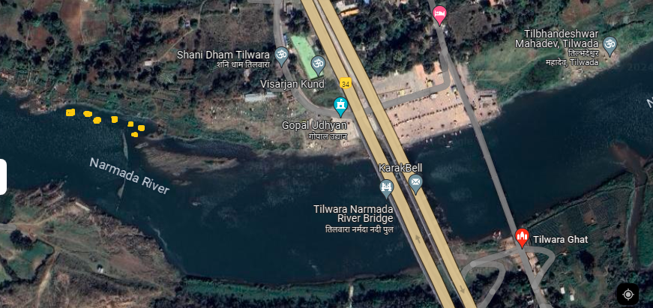
Figure 2 Breeding grounds at Tilwaraghat (T2) in Narmada river
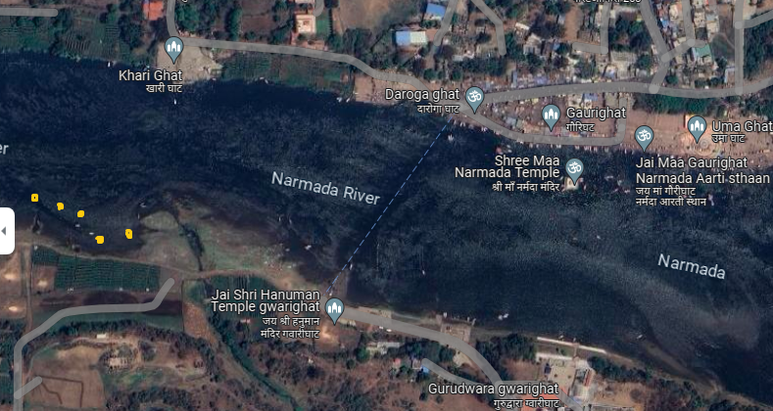
Figure 3 Breeding grounds at Gwarighat (T3) in Narmada river
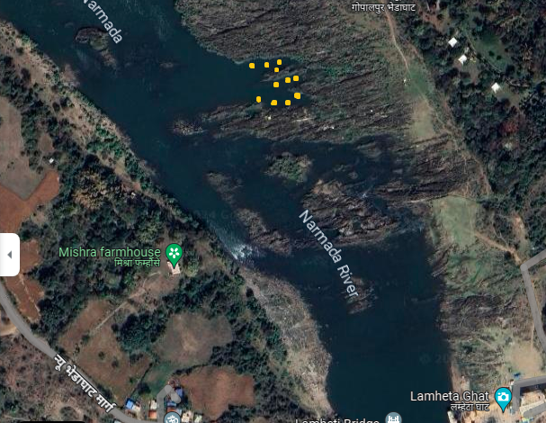Figure 4 Breeding grounds at Lametaghat (T4) in Narmada river
The T. tor fish species, which used to be abundant in the Narmada River, was highly sought after by anglers from both India and abroad. However, due to excessive exploitation, the availability of this fish has become scarce, leading to its near threatened status as declared by Rayamajhi et al. (2010). In Madhya Pradesh, there has been a significant decline in the recorded catch of T. tor, as reported by Tamot (2007). The catch data of T. tor in the Hoshangabad area of the Narmada River has shown a considerable decrease, accounting for only 10-15% of the total fish catch, according to Somdutt et al. (2007). Several researchers, including Bhatt et al. (2004), Desai (2003), and Nautiyal et al. (2008), have also observed a severe decline in the population of mahseer (T. tor) in the Narmada River due to overfishing. The construction of dams across the river is widely believed to be the primary factor contributing to the decline of mahseer.
CONCLUSION
The study presented here offers a comprehensive examination of the breeding ground and habitats of mahseer, specifically focusing on T. tor in the Narmada river Jabalpur district. The objective of this research was to assess the breeding ground status of mahseer. These fish species are known for their sensitivity to environmental changes and are heavily reliant on the specific ecological conditions in which they have evolved. Human activities have significantly endangered the survival of mahseer, potentially leading to the eradication of their population in the Narmada river.
REFERENCE
- Sharma, J., Parashar, A., Bagare, P. & Garg, R.K. (2014a). Ichthyo-faunal divergence of Narmada river in Hoshangabad region and their conservation measures. Intern. J. Appl. Biores., 22: 5-11.
- Desai, V.R. (2003). Synopsis of Biological Data on the Mahseer, Tor tor (Hamilton, 1822). FAO Fish. Synp. No. 158. FAO, Rome, 36 p
- Hora, S.L. (1940). The Game fishes of India. IX. The mahseers or the large-scaled barbels of India. The Tor mahseer, Barbus (Tor) tor (Hamilton). J. Bombay Nat. Hist. Soc., 41: 518- 525
- Lal, K.K., Singh, R.K., Pandey, A., Gupta, B.K., Mohindra, V., Punia, P., Dhawan, S., Verma, J., Tyagi, L.K., Khare, P. & Jena, J.K. (2012). Distributional records of Tor mahseer, Tor tor (Hamilton, 1822) from Southern India. J. Appl. Ichthyol., 29(5): 1-5.
- Ajithkumar T, Thangaradjou T and Kannan L. (2006). Physicochemical and biological properties of the Muthupettai mangrove in Tamil Nadu, Journal of Marine Biological Association of India, 48, pp 131-138.
- Telesh I V, Vladislav V and Khlebovich. (2010). Principal processes within the estuarine salinity gradient: A review, Marine Pollution Bulletin, 61, pp 149-155.
- Arunachalam M. (2000). Assemblage structure of stream fishes in the Western Ghats (India). Hydrobiologia 430: 1-31.
- Pirhalla D E. (2004). Evaluating fish-habitat relationships for refining Regional Indexes of Biotic Integrity: Development of a Tolerance Index of Habitat Degradation for Maryland Stream Fishes. J. Transactions of the American Fisheries Society. 133: 144-159.
- Rayamajhi, A., Jha, B.R. & Sharma, C.M. (2010). Tor tor. The IUCN Red List of Threatened Species.Version 2014. 3.www.iucnredlist.org.Downloded on 02 March 2015.
- Tamot, P. & Saxena, A. (2009). Study of juveniles and adult Narmada mahseer (Tor tor) for their food and feeding habits. Asian J. Exp. Sci., 23: 545-547
- Somdutt, Razvi, S.S.H. & Upadhyay, R.K. (2007). Alarming decline of mahseer (Tor tor)population in Narmada river in and around Hoshangabad (M.P.) - a case study. In: Freshwater Fish Diversity of Central India (eds. Lakra, W.S. & Sarkar, U.K.). NBFGR, Lucknow, p. 81-84
- Bhatt, J.P., Nautiyal, P. & Singh, H.R. (2004). Status (1993- 1994) of the endangered fish Himalayan mahseer,Tor putitora (Hamilton) (Cyprinidae) in the mountain reaches of the River Ganga. Asian Fish. Sci., 17: 341-355.
- Nautiyal, P., Rizvi, A.F. & Dhasmanaa, P. (2008). Life-history traits and decadal trends in the growth parameters of golden mahseer, Tor putitora (Hamilton, 1822) from the Himalayan stretch of the Ganga river system. Turk. J. Fish. Aquat. Sci., 8: 125-132.

