Original Research Article
EVALUATING THE IMPACT OF CLIMATIC CONDITIONS ON ZOOPLANKTON COMMUNITY OF MBO AND EASTERN OBOLO ESTUARY, SOUTH- EASTERN, NIGERIA

Abstract
The study evaluates the impacts of climatic conditions on Zooplankton community of Mbo and Eastern Obolo estuaries, Southeastern Nigeria. This was to determine the productivity levels and assemblage regarding the impact of water quality. Thirty nine (39) samples of zooplankton species belonging to eight (8) phyla were collected across the samples stations during the dry and wet seasons using a fifty five (55) micrometer hydro-bioplankton net mesh size and were preserved in a 4% formalin. The eight (8) phyla were; Copepoda, Rotifera, Cladocera, Gastropoda, Protozoa, Polychaeta, Chordata and Lamellibranchia. The six (6) stations include; Iko jetty, Iko estuary mouth, Etizar, Ibaka port, Ewang and Ebughuo creek mouth. Higher species richness and Shannon-wiener index were recorded in station Ewang in Mbo as 30(S) and 3.25(H’) respectively, while the lowest species richness and Shannon wiener observed at Iko Estuary mouth as 27(S) and 3.11(H’) respectively. Physicochemical parameters such as water temperature, salinity, pH, total dissolved solids (TDS) and dissolved oxygen shows a seasonal variation between the dry and wet seasons. Phytoplankton productivity was recorded higher in Ibaka port and Ewang (2.94±0.37mg/L) across Mbo River Estuary, which also correspond with the high zooplankton richness. Redundancy analysis (RDA) and Pearson’s correlation analysis revealed a significant relationship between water temperature and Canthocampus staphylinus (p < 0.05), Gastropus sp (p < 0.01) and Euchlanis sp (p < 0.05). The spatiotemporal variability of water quality directly affect the zooplankton abundance of the sampled stations.
Keywords: Estuary, zooplankton, assemblage, richness, variability

1.0 Introduction
On the basis of scientific knowledge and observations, it can be noted that climate change has become a reality in the 20th century, which has an anthropogenic origin. Since 1850, global mean temperatures have increased by 0.76⁰C. Between the years of 1995 and 2006, 11 years range had recorded the warmest weather since 1850. In order to determine the effects of climate change expected, the emissions data of social-economic developmental stages are used. Results indicated at least 2⁰C increase in temperature in the 21st century, however it can be 5⁰C as well (IPCC, 2007). Global warming has posed challenges to the marine and freshwater ecosystem and survival of species by altering physiological processes and food web structure (Colombano et al., 2021). The rate of temperature warming in the sea surface is forecasted to be higher in the 21st century compared to past centuries (Jyoti et al., 2019). The effect of warming is higher on the marine ecosystem than the terrestrial ecosystem. Hence, global warming can jeopardize the marine food chain by altering zooplankton production. Fluctuation of plankton production correlates with high temperatures at the bottom of marine food chain, resulting in unstable vertical mixing and stratification (Vallina et al., 2017). Global warming is likely to shift zooplankton distribution and their life history pattern.
Zooplankton comprise of minute aquatic organisms ranging in size from a few microns to a few millimeter’s or more, are either non-motile or weak swimmers drifting in oceans, seas, or freshwater bodies, and are significantly associated with changes in phytoplankton community (Perbiche-Neves et al., 2016). Zooplankton plays a vital role in the aquatic food web by feeding on the phytoplankton and other members of zooplankton (Ward et al., 2012) and hence they act as a major agent in the energy transfer between phytoplankton and fish (Telesh, 2004). The diversity and abundance of the zooplankton community strongly affect the biotic components of the aquatic ecosystem (Jose & Sanalkumar, 2012). The freshwater zooplankton group includes Rotifera, Cladocera, Copepoda, and Ostracoda. Rotifers comprise microscopic, soft-bodied invertebrates, which serve as a major source of food for fishes and also act as bioindicators of water quality (Shayestehfar & Sommer, 2008). Cladocerans are known to be the most significant herbivore in the lake plankton community (Sommer et al., 2006) and are dominated by filter-feeding species. Copepods act as a vital source of food for many larger invertebrates and vertebrates including zooplanktivorous fishes and prawns (Sommer, 2006) and thus encompass a major portion of the consumer biomass in aquatic habitats. Ostracods are of great interest as they are found in heavily polluted areas (Edmondson et al., 1959) therefore, can be used as indicator species of climate and ecosystem changes (Martens et al., 2008).
Zooplankton is the source of life for most aquatic organisms, particularly fish and shellfish larvae, feed on plankton, and move the food chain to the top predators (Morgan, 2020). The zooplankton community is a crucial component of the aquatic food web and plays a major role worldwide for the biogeochemical cycle. They contribute as prey to economically valuable fish, primary-production grazers and carbon and nutrient cycle drivers. These organisms are used as an intermediate species in the food web, transferring energy to the larger invertebrate predator and fish which feed on them from phytoplankton. At the same time, the changing environment has an impact on their dynamics. An increase in marine litter caused a marked and gradual increase in both the total abundance and number of species, changing the structure of the megafaunal community and mangrove ecosystem (Ubulom et al., 2023). The study aimed at determining the impact of climate change on water quality variable on zooplankton community and its biomass due to changes in climate pattern.

2.0 Materials and Methods
2.1 Study Area
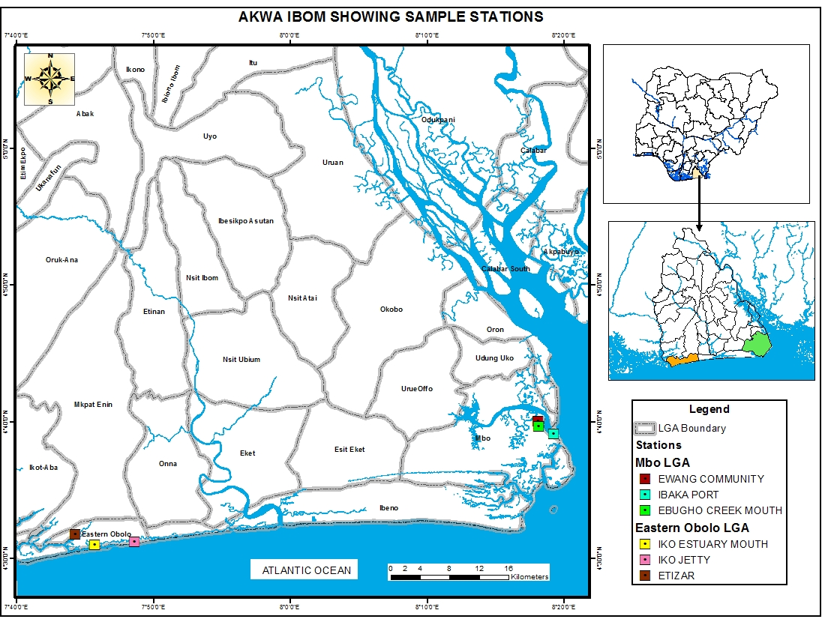
Fig.1: Map of the Study Areas Showing Sample Stations

2.2 Description of study area
Mbo River (Figure 1) is one of the major rivers in Akwa Ibom State, Nigeria, that lies within latitudes 40⁰ 30’ to 50⁰ 30’ North and longitudes 70⁰ 30’ to 80⁰ 30’ West on the South Eastern Nigerian Coastline. It is a near coastal river located within the Cross River Basin and drains into the Cross River Estuary at Ibaka in the Bight of Bonny, with which it maintains a permanent mouth thus exposing the system to tidal ebb and flow. It forms part of the Atlantic Drainage system (Anukam, 1997) east of the Niger which comprises the Cross, Imo, Qua Iboe and Kwa Rivers. Mbo River is located within the tropical rainforest region characterized by tropical humid climate with distinct dry and wet. The dry season is characterized by prevalence of dry tropical continental winds from the Sahara Desert while the wet season is typified by moist tropical wind from the Atlantic Ocean. Eastern Obolo Estuary, located (4⁰ 33՛N - 4⁰ 50՛N; 7⁰ 45՛E – 7⁰ 55՛E) about 650m above sea level in the tropical mangrove forest belt east of the Niger Delta between the lower Imo and Qua Iboe River Estuaries (Fig.1). The tidal range in the area is about 0.8m at neap tides and 2.20m during spring tides with little fresh water input joined by numerous tributaries as they empty into the Atlantic Ocean (NEDECO 1961; Effiong and Inyang 2016). The climate of the area is tropical with distinct rainy and dry seasons with a high annual rainfall averaging about 2500mm (AKUTEC Report, 2005; Gibo, 1988).

2.3 Sample collection
Collections of samples was carried out at 34 stations, in the two study area for six months in the both season (Dry and Wet) between the hours (10:00am – 12noon). The zooplankton samples were collected by towing a 55µm mesh hydro-bios plankton net tied to a motorized boat driven at a low speed limit of 1 knot nautical mile per hour below the water surface at a depth 30-50cm for 5 minutes until sufficient quantity of plankton was collected into the cod end and the plankton sample was release into one litre (plastic bottle). The sample was preserved with 5ml of 4% formaldehyde and was transported to the laboratory for quantitative/qualitative estimation; this method was applied in all the stations in the two study areas.
2.4 Sample Analysis
2.4.1 Analysis of zooplanktons sample
In the laboratory, quantitative sample from each sample stations were concentrated in 10ml. 0.2ml of the concentrated sample was pipetted out from a calibrated pipette into a glass slide. A cover slip was carefully placed, and observed under a binocular compound microscope at 10x and 40x magnification. Lugol’s solution was used for staining the samples to enhance proper discernment of the zooplankton species based on morphological features, as individual species normally takes up the stain, thereby exposing the organelles for proper identification according to Akpan, (1994). The numerical abundance of plankton was done by direct count method. The zooplankton taxa were identified using keys and guides given by Jeje and Fernando (1986) and Fernando (2002).
2.4.2 Statistical analysis
To assess the relationships between environmental parameter and the zooplankton taxa, Redundancy RDA analysis using CANOCOS and Pearson’s correlation analysis (SPSS 22.0) was carried out with the zooplankton taxa. The spatial distribution of 25 most important species was carried out using shad plot analysis in PRIMER V. 7 (PRIMERE-E Ltd, Roborough, Plymouth, UK). Also cluster, SIMPER, and spectrum scale intensity was performed to calculate the average similarity of the sample in the stations but also the average dissimilarity of inter station sample base on the grouping factor generated by the cluster analysis (cluster, SIMPER and spectrum scale intensity was base on Log (×+1) pre-transformed original data metrix.
Statistical analysis was carried out with the aids of SPSS (Version 22.0), CANOCO-5 and PRIMER v. 7. To estimate the significant factor among environmental parameters in the study area, PCA plot (Howlader et al., 2018) was performed carried out, using SPSS 22.0 (IBM Company, Armonk, NY, USA) on fifteen water quality variables.
The variance in the environmental parameter between the site was performed by ANOVA (ONE-way), with t test at a probability level of 5% comparing mean value of variable with significant F between the study areas.
3.1 Results and Discussions
3.1.1 Seasonal changes of the Physico-chemical Parameters across the Stations
The results revealed that the highest range of temperature was 31.3⁰C recorded at Etizar, while lowest value was 28.1⁰C recorded at Iko Jetty. These changes in temperature ranges could ensure dynamic and moderate ecosystem (Table 1 and Figure 2). The results also showed that dissolve oxygen level across the station fall within the range of 4.79 to 5.22mg/l. The lowest value recorded at Ibaka Port and the highest recorded at Etizar. This range of dissolved oxygen could show positive response at Ibaka Port and negative significant at Etizar (Table 1 and Figure 2). Considerably, the level of salinity ranges (18.8 - 30.8‰), lowest range was recorded at Ebugho Creek mouth while the highest value (30.8‰) recorded at Iko Estuary mouth. The result also showed that Iko Estuary mouth and Iko Jetty has salinity preference compared to Ebugho Creek mouth (Table 1 and figure 2). These ranges in temperature dissolved oxygen and salinity is dependent on changes in climate thus, induces positive and negative implication (responses) on both environmental and biological variables in the estuaries.
Table 1 Seasonal variation of the physiochemical parameters across the study areas
Parameters | Ibaka port | Ewang | Eb. Crk Mouth | Iko Jetty | Iko Est. Mouth | Etizar
Temperature (℃) | 29.2±2.04 | 29.5±2.81 | 31.0±2.37 | 28.2±2.32 | 29.8±2.56 | 31.3±2.33
DO (mg/L) | 4.79±0.86 | 4.81±1.01 | 4.85±1.01 | 5.17±1.22 | 5.21±1.28 | 5.22±1.28
Salinity (‰) | 24.17±2.32 | 20.33±1.86 | 18.83±1.17 | 29.67±2.25 | 30.83±1.94 | 28.5±2.43
TDS (mg/L) | 31.26±12.17 | 30.63±12.09 | 30.78±12.09 | 25.57±8.87 | 25.58±9.32 | 25.63±9.09
pH | 6.0±0.87 | 5.97±0.84 | 5.97±0.84 | 5.97±0.96 | 5.91±0.88 | 5.95±0.94

The result of the seasonal variability of the physiochemical parameters in Mbo River Estuary showed that the highest water temperature 32⁰C was recorded at Ebugho Creek mouth station in the month of December (Figure 2A). The lowest temperature 24⁰C was recorded at Ewang station in the month of June. However, water temperature in Eastern Obolo Estuary (Figure 2B) was recorded high (33⁰C) at Etizar, and lowest temperature (25⁰C) was recorded at Iko Jetty in the month of June. Generally, the water temperature from 24⁰C to 33⁰C across the study areas, the water temperature during dry season was significantly different from the wet (Table 1).
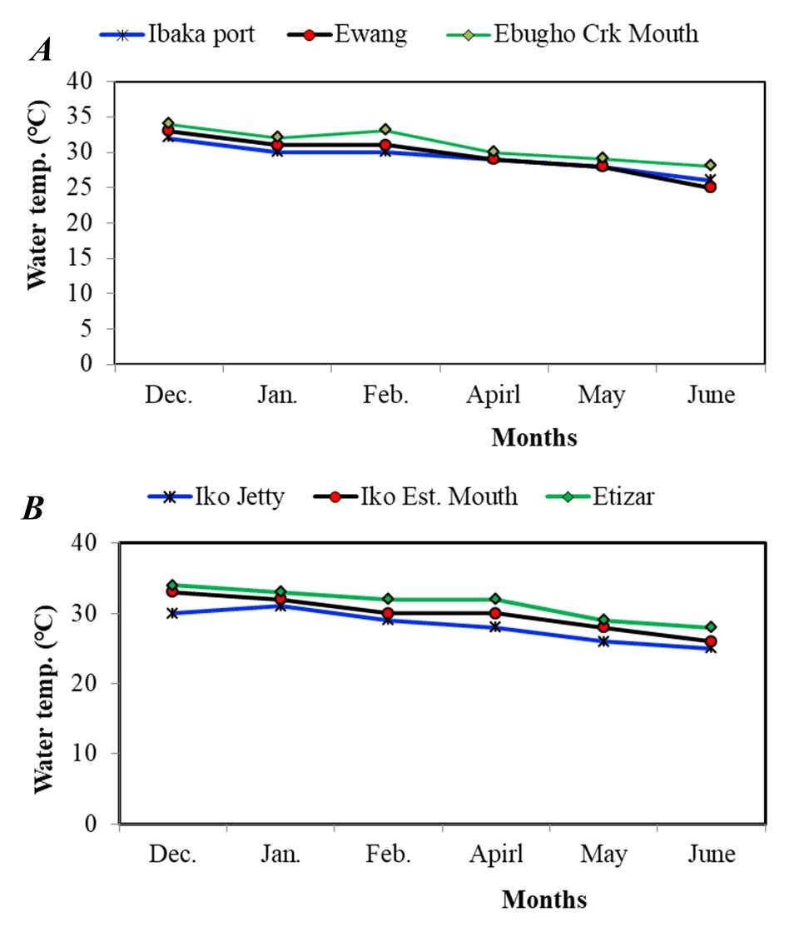
Figure 2: Water temperature variability in Mbo River Estuary (A) and Eastern Oboloh Estuary (B)
In terms of salinity variability, high salinity (28‰) was recorded in Ibaka Port in the month of December 2021 and lower range (17‰) was recorded in Ebugho (station) in the month of June 2022. Moreover, salinity showed high trend (32‰) at Iko creek mouth in the month of December and lower value of salinity (22‰) was recorded at Etizar in the month of June.
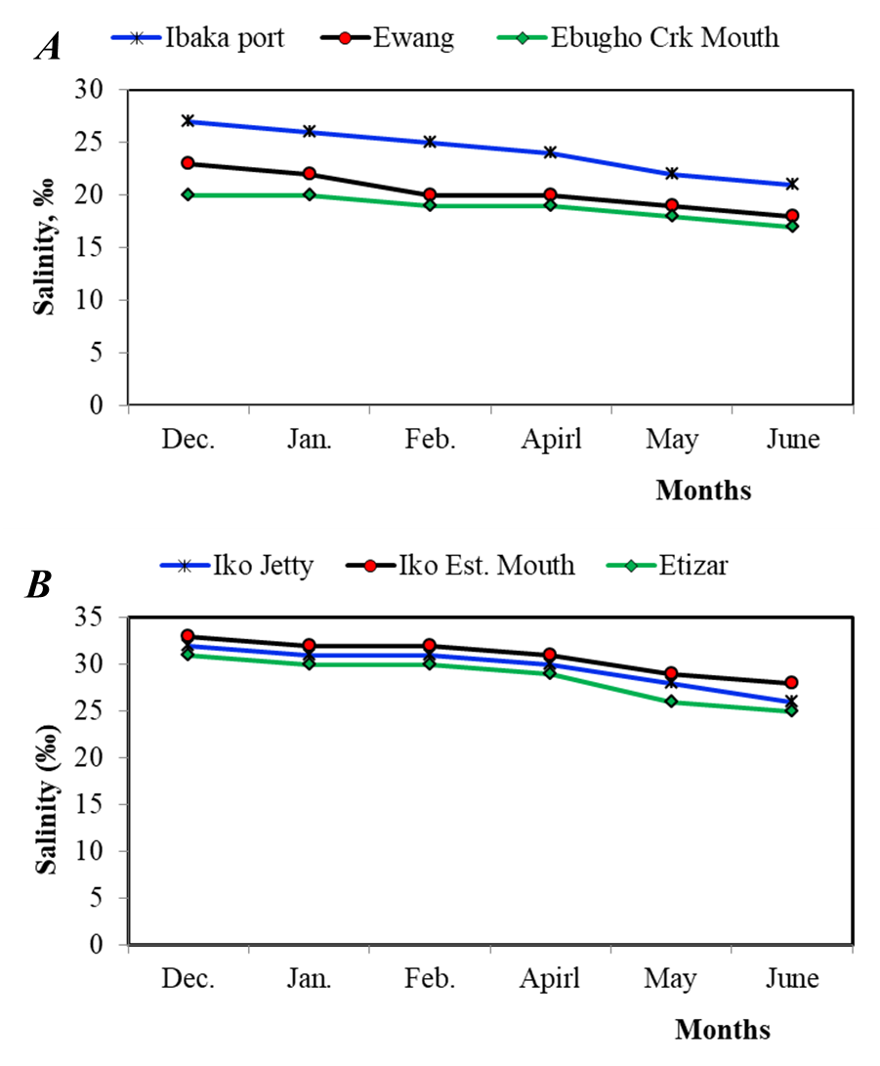
Figure 3: Salinity variability in Mbo River Estuary (A) and Eastern Obolo Estuary (B)
pH: The mean value of seasonality dry and wet (5.303 and 6.656mg/l) this result showed significant difference with (P < 0.05), also revealed moderate pH value in terms of water quality. In Eastern Obolo, mean value seasonality, dry and wet (5.200 and 6.683) pH indicated the result in Eastern Obolo also showed significant difference with (P < 0.05). This also revealed moderate acidity level of the estuary in terms of pH value.
In terms of water quality, 3.978 is above the range of hypoxia meanwhile, 5.652 was within the threshold limits. On the other hand, mean range for DO in Eastern Obolo study area wet and dry season 4.124 and 6.280mg/l were within the range of threshold limit. Moreso, the T-test for salinity in terms of seasonally wet and dry (22.44 and 19.778) showed significant difference with (P < 0.05). Meanwhile in Eastern Obolo, the result recorded showed mean of 31.333 and 28.000‰. In Mbo, the result showed significant difference with (P < 0.05). The salinity level in Mbo recorded moderate (medium) 22.4 and 19.8 º/_{oo} salinity which were within the acceptable limit but on the other hand, salinity level in Eastern Obolo was high, 28.0 º/_{oo} wet season and 31.3 º/_{oo} for dry season was higher but did not exceed the threshold average limit. Moreover, test analysis of total dissolved solid (TDS) seasonally (Dry and Wet) 40.333 and 21.438mg/L in terms of mean, this result showed significant difference with (P < 0.05). In terms of water quality, mean seasonally, dry and wet (40.333 and 21.438), is less than 50mg/l unacceptable limit, as it lack essential minerals. However, in Eastern Obolo study area, the seasonality (dry and wet) showed 95.333 and 84.222mg/l, were recorded and they showed significant difference with (P < 0.05). In terms of water quality 95.333 and 84.222mg/l recorded were within acceptable limit for drinking water.
Table 2: Spatiotemporal T-test analysis of the physiochemical variables across the study areas
 | Water Quality – Mbo |  |  | Water Quality - Eastern Obolo
Parameters | Mean-Dry | Mean-Wet | t - Test | Mean-Dry | Mean-Wet | t - Test
Temperature (℃) | 31.778 | 28.000 | p < 0.05, Sign. | 31.556 | 28.000 | p < 0.05, Sign.
DO (mg/L) | 3.978 | 5.652 | p < 0.05, Sign. | 4.124 | 6.280 | p < 0.05, Sign.
Salinity (‰) | 22.444 | 19.778 | p < 0.05, Sign. | 31.333 | 28.000 | p < 0.05, Sign.
EC (µs/cm) | 74.000 | 62.556 | p < 0.05, Sign. | 95.333 | 84.222 | p < 0.05, Sign.
TDS (mg/L) | 40.333 | 21.438 | p < 0.05, Sign. | 32.461 | 18.717 | p < 0.05, Sign.
pH | 5.303 | 6.656 | p < 0.05, Sign. | 5.200 | 6.683 | p < 0.05, Sign.

The principal Component Analysis (PCA) given in figure 4 produced four principal components that cumulatively explained 99.89% of water quality variation between stations (sites) according to the eigenvalues. Thus, axis 1 (91.78%) and axis 2 (6.76%) with eigen value of 0.9178 and 0.0676 respectively. The total variation of 0.4824 with Tau value as 0.07578 at eigen value of 1 describe the variation between sites. Meanwhile, the following variables such as salinity, Temperature, Dissolved oxygen, Electrical conductivity, pH and Total dissolved solids (TDs), contributed maximally to the quality variation in the study area. The principal component analysis (PCA) result also showed that Ibaka Port pH and TDS were positively significant. Moreover, temperature in Ebugho and DO in Ewang showed positive significant preference and positively responded with salinity in Iko Jetty, Iko Creek mouth (Figure 4.). However, TDS showed negatively significant basically with DO in Etizar and this could be due to the level of nutrient enrichment.
Fig. 4: PCA plot showing the controlling factors at each site in the study area

3.1.2 Zooplankton community structure analysis
Hierarchical clustering (Figure 5) showed two clusters (Mbo and Eastern Obolo) with respective stations. Certainly, Ewang and Ebugho showed 95% level of significance in terms of similarity, moreover, Ibaka Port recorded 85% level of significance; Ibaka was noted to be unique station, it shared species similarity with Ewang and Ebugho Creek mouth on the other hand 98% level of similarity accounted for Iko Estuary mouth in Eastern Obolo study area, while Iko Jetty and Etizer recorded similarity level of 86% level of significance. The two study areas Mbo and Eastern Obolo showed a similarity level of 58% with cophenetic correlation 0.98333.

Figure 5: Hierarchical clustering of dendrogram showing various clusters associated with spatial distribution (group-average linking 6 zooplankton samples of Bray Curtis dissimilarities calculated on Log (X+1) transformed abundance).

3.2 Discussion
Species dominance and richness of zooplankton in the estuary depend on the environmental variables and changes in climate that will provide the competitive advantage to specific group. Temperature is essential parameter to determine influence of climate on zooplankton and this could be best understood through sequential measurement of temperature value, this data can be used to determined climate variability. According to WHO (2011), climate variability may result in cha nging water temperature, rainfall pattern, and flooding at both regional and global levels. Climate change effect resulting in high water temperature facilitate the growth of microorganism (Otogo et al., 2019), reproduction of estuarine invertebrates (Lawrence and Soame, 2004) and may increase other related water problems. The present study showed a relative increased in temperature 28.2⁰C – 31.3⁰C and temperature that is within range recorded by Fafioye et al., (2005). This did not agree with the findings of Otogo et al., (2019) who recorded ranges of 26.0-34.0⁰C in Cross River Estuary. Temperature changes are essentially controlled by global climate. Increase in temperature in the estuary could partly be due to deforestation of mangrove fringing in the estuary by the coastal dwellers for fuel, wood and timber. Akpan (1999) reported that dense vegetation is partly responsible for lower temperature in estuaries. Other reasons for the relatively increased temperatures in this study could be attributed to climate driven changes such as sea water intrusion with elevated temperature into the estuary from the coastal ocean influence by marine heat wave (Asuquo and Oghenekerwe, 2019). The higher value of 31.3⁰C in this study is in agreement with that of Nawa (1982) and Akpan & Ofen (1993). Also the lowest value of 28.2⁰C is not in line with result of 21⁰C by Akpan (1999). However, the reason for low temperature value at Iko Jetty station particularly during the rainy season is due to inflow of fresh water from adjoining tributaries during the rainy season. The high main temperature 31.8, 31.6 and 28.0⁰C from this study is higher than the value of 25.9⁰C – 27.3⁰C recorded by CCKP, (2021) as tended in historical data and high temperature in this study which also showed significant difference with p < 0.05.
The lower and higher seasonal range of temperature 28.2 to 31.3⁰C were higher than values of 25.9⁰C to 27.3⁰C recorded by CCKP, (2021) and Akpan et al., (2022). The mean range of temperature dry and wet in Mbo (31.8 and 28.0⁰C) and (31.6⁰C and 28.0⁰C) in Eastern Obolo all showed significant difference with (P < 0.05). This range still fall within the acceptable limit in terms of water quality and this temperature range is within the range recorded by John et al., (2018) where the temperature was lower during the wet season and higher during the dry season.
This can therefore be concluded that there is progressive regional increase in temperature and extensively, a global increase which might result in redistribution and biodiversity of community of living organism in the estuarine environment thus affecting the growth and function of zooplankton.
Salinity is one of basic physiochemical parameters and measured in part per thousand (‰). Seasonal salinity variations in the two study area were recorded. In the dry season, Mbo and Eastern Obolo had salinity variations of 28 and 32‰, monthly distribution showed that highest salinity of 28‰ was recorded in Ibaka Port and 32‰ was recorded in Iko Creek mouth in the month of December and lower trend of 17‰ and 22‰ (Mbo and Eastern Obolo) were recorded in wet season in the month of June. These result from Mbo and Eastern Obolo Estuaries reflected a typical state of brackish water with salinity ranges (18.8 to 24.2‰) for Mbo and 28.5 – 30.8‰ for Eastern Obolo. The low salinity value with wet season may be due to high precipitation (rainfall) especially in June (wet season) which had caused more quantity of runoff flowing into the estuary. This result is in agreement with the report of Dublin, (1990) that the influx of water mainly due to rainfall has been a major factor controlling seasonal variation in salinity gradient in estuaries of the Niger Delta region. The mean salinity recorded for Dry and wet (22.4 and 28.0‰) in Mbo and that of (31.3 and 28.0‰) for Eastern Obolo all showed significant difference with (P < 0.05) and these values were within the acceptable range of salinity for water quality. High salinity could be due to high temperature elevation caused by high solar radiation, which eventually induces high evaporation of surface water (fresh and sea water) resulting to increase in salinity.
Also, that salinity and temperature has correlative significant the higher the temperature the higher the salinity through surface evaporation.
The range of salinity in this result was found to be wider than the values of (3.2 – 6.03‰) recorded in Lagos, Nigeria by Ayoola, (2009) and greater than the value of 0.16 – 0.48‰ recorded by Akpan & Akpan (1994) for the lower Cross River Estuary. The difference could be as a result of freshwater ecosystem. This may also depend on some other factors as tidal nature of the Creek/river sampled; period sampled and season of the results.
The recorded dissolved oxygen seasonally were within the range of 4.8 to 4.9mg/L in Mbo, 5.2mg/L in Eastern Obolo, whilst Ibaka had higher range followed by Ebugho Creek mouth. The mean value of DO for dry season for Mbo and Eastern Obolo were 3.9 and 4.1mg/L and mean of wet season at the study area revealed 5.6 and 6.2Mg/L respectively. These show a significant difference with (P < 0.05). The mean of DO values were within the permissible limit (UNESCO/WHO, 1978) except mean range of 3.9mg/L recorded and this may be due to biodegradation of polluted water (water washed into estuary by continental runoffs and other related activities (Anthropogenic).
The low DO level in this study may have negative influence in biodiversity and growth of organisms. The low DO level in dry season was in contrast with the report of Inyang et al., (2015b), where low DO was recorded in dry season. The 5.6 and 6.2mg/L was in proximal range in wet season
The measure of total ionic concentration in water revealed that the seasonal variation of TDS across stations Ibaka, Ewang and Ebugho Creek were 31.26, 30.63 and 30.78mg/L Mbo study area. While the result also revealed seasonal TDS values across stations. The level of TDS in Mbo station was lower compared those of Eastern Obolo station. The study recorded higher value of TDS in the wet season. The higher TDS value could be linked with maximum surface runoff and this could influence the pH level (decrease pH level) and notably the levels of TDS recorded in the study were within the permissible limit 500mg/L (W.H.O., 1984) are lower compared to the finding of John et al., (2018) in Okoro River Estuary with higher mean of TDS levels of 21897.87±25811.00mg/L. High concentration of TDS may result in high mineralization of the recovery of estuary with effect of depletion of oxygen (Akpan, 1991, Essien, et al., 2010). The lower value of TDS in this study would be attributed to lack of excessive weathering and dissolution of minerals. The TDS levels were lower than other result in other locations such as River Benue, Markudi (Eneji et al., 2012). The mean value for dry and wet season in the two study areas all showed significant difference with (P < 0.05)
The mean pH value recorded in this study moderate state of the two study areas 15.303 and 6.656mg/L for Mbo and (5.200 and 6.683) showed significant difference across two study areas the pH value were within permissible range 5.5 to 18 (Wetzel, 2001).
Species richness was high in Etizar. Basically, this could be attributed to nutrient level in Etizar; High concentration of these nutrient element usually give rise to high abundance of some zooplankton species in aquatic environment (Adesalu et al., 2010; Nwankwo, 2004) similar regime has also been observes by some workers (Balogun, 2010; Schaefer and Alber, 2007) where they reported that zooplanktons are favored in nutrient rich environment estuaries.
Zooplankton species were identified in the study and each group was widely distributed although, there was case of rarity in some taxa. Moreover, Copepoda group dominated the species identified, followed by Rotifera, Gastropoda, Protozoa, Cladocera, Chordata, Lamellibranchia and Polychaeta. In terms of abundance (percentage composition) Copepoda recorded 31%, Rotifera had 26%, Gastropoda and Protozoa revealed 10%, Cladocera and Chordata accounted for 9%, 3% was revealed for Lamellibranchia meanwhile Polychaeta recorded 2%. On the other hands 13 species were recorded for Rotifera followed by 12 species for Copepoda next was Cladocera with 6 species followed by 3 species for Protozoa and 2 species accounted for Gastropoda and least was 1 recorded for Polycheata, Chordata and Lamillibranchia. Notably dominant of Copepoda is in line with the reported Effiong et al., (2021) and disagree with report by Adeyemi (2012) in Ajelo stream were Rotifera were highly dorminance, Imaoobe, (2011) in Okhuo River and Omowaye et al., (2011) in Ojefu Lake; 12 species of Copepode revealed in this study is in contrast with result of Iloba (2002) in Ikpoda reservoir, Nigeria who recorded Copepoda with only 2 species followed by a single species each apportioned to Cladocera and Protozoa, low abundance and three species of protozoa revealed in this study was higher than that in the report of Wokoma (2016). The rarity of protozoa could be linked to environmental stress.
The remarkably significant of Copepoda to zooplankton community is the same to the report of Iloba (2019) that copepoda made up of 50% of all zooplankton in Aghalokpe wetland in Delta State, Nigeria but greatly different from Arazu and Ogbebu (2017) of River Niger at Onitsha stretch, Niger Delta. Moreover, the result also revealed the rareness (Curious) of Polychaet and Lamellibnranchia.
Consequently, great dominance of Copepoda over Rotifera basically may be distinctly attributed to grazing effect and climatic environmental influence. Also the dominance of Rotifera over Cladocera, Polychaeta and Lamellibanchia was stated to be due to predation pressure from planktivorous fishes that consequently prey on lower size zooplankton and their reproductive success and short developmental rates under favorable condition in most fresh water system (Akin-Oriola, 2003, Imoobe and Adeyinka, 2019).
The study recorded 1339 zooplankton individuals consisting of 8 taxa and 39 species. This range is in close proximity with the range 33 zooplankton species reported by Ali et al., (1985) and 45 species of zooplankton taxonomy groups studied in Mbo River (Essien-Ibok and Ekpo, 2015). These differences might be attributed to the states of the climate or environmental parameters according to Jakha (2013), the zooplankton species, type, number and distribution in any particular aquatic habitat usually create clues on the prevailing physical and chemical condition of that habitat. The interaction between various environmental variable can either favour the growth or mortality of zooplankton both spatially and seasonally (Khanna et al., 2009). Zooplankton has being significant bioindicator following and this enhancing attribute in determining the state of the environmental climatic influence on the aquatic system and this agrees with report of Abowei and Sikoki, (2005) which might because of their easy identification of high density and high sensitivity to aquatic environmental change and seasonality of different zooplankton group in aquatic ecosystem.
4 Conclusions
Evaluation of climatic data of 50 years of rainfall and temperature trend recorded that, there has been progressive changes in climate relating the values with the outcome of recent study. Certainly, there has been increase in some environmental parameters like water temperature, pH, due to slight increase of CO₂ as a result of fossil fuel, coal, greenhouse gas emission etc. There has also been increase in salinity basically due to sea water intrusion into the estuarine waters that may be related to the effects of climate change (ice melting). The physicochemical parameter of the study area reviewed spatial and temporal variation. Most parameters were significantly higher in Etizar and Ebugho Creek mouth due to anthropogenic activities and sea water incursions. Zooplankton species richness varied in abundant and distribution during the study compared to earlier work in the studied area. In view of the above, zooplankton organism was shown to be unique bioindicator for climate change status and productivity of estuaries. The preponderance of zooplankton in the estuary was a function of climate change and environmental parameter. Ebugho Creek mouth, Ewang and Etizar favored more diverse species of zooplankton than Iko Estuary mouth and Ibaka Port.

Recommendations
We hereby recommend that the government agencies should enact policies against undue burning of fossil fuel and promote afforestation for sustainable growth, abundance and functioning of marine ecosystem.
References
Abowei, I. F. N., Sikoki, F. D. (2005). Water poolution management and control. Doublestrust Publications Company, Nigeria. 236pp.
Abowi, J. E. (2010). Salinity, dissolved oxygen, pH and surface water temperature condition in Nkoro River, Niger Delta, Nigeria. Advanced Journal of Food Science and Technology, 2(1), 36-40.
Adeyemi S. O. (2012). Preliminary census of zooplanktons and phytoplankton community of Ajeko Stream, Iyale, North Central Nigeria. Anim. Res. Int. 9(3), 1638-1644.
Ajao. E. A., & Fagade, S. O. (2000). The ecology of Neritna glabrata in Lagos Lagoon, Nigeria. Arch. Hydrobiol., 119(3), 339-350.
Akin-Oriola, G. A. (2003). Zooplankton Association and Environmental Factors in Ogunpa and Ona Rivers, Nigeria. Review of the Biology of the Tropics, 31(2); 31(2); 319-398.
Akoma, O. C. (2008). Phytoplankton nutrient dynamics of a tropical estuarine system, Imo River estuary, Nigeria. African Research Review, 2(2), 253-264.
Akpan U. E, Ita O. Ewa-Oboho and Ini-Ibehe N. E. (2022) Effect of flood on fringe mangrove in south Eastern Nigeria, Journal of Global Ecology and Environment, 16(4):111-127.
Akpan, E. R. & Offem, J. O. (1993). Seasonal variation in water quality of the Cross River, Nigeria. Revue Hydriobioloqie Tropicale, 26(2), 95-03
Akpan, E. R. (1999). Spatio-seasonal trends of physiochemical characteristics of Cross River estuary, Nigeria. Progress in Meteorology, 13, 127-131.
AKUTEC (2005). Final Report for the Implementation of Akwa Ibom State University, p. 202.
Anukam, L. C. (1997). Case study IV Nigeria In: Water pollution control. A guide to the use of water quality management principles R. Helmer and I. Hespanhol eds. United Nations Environemnt Programme. The water supply & sanitation collaborative council and the WHO by E & F. Spon.
Arazu, V. N. and Ogebeibu, A. E. (2017). The composition, abundance and distribution of zooplankton of River Niger at Onitsha Scratch, Nigeria. Animal Research International, 14(10); 2629-2643.
Asuquo, F. E., Oghenkevwe, C. O. (2019). Detection and spatio-temporal variation of Marine Heat Waves in the Gulf of Guinea, Nigeria. Journal of Oceanography and Marine Science 10(2); 11-21.
Balogun, K. and Ladigbolu, I. A. (2010). Nutrients and Phytoplankton production dynamics of a tropical harbor in relation to water quality indices. Journal of American Science. 6(9); 261-276.
Carter J. L., Schindler D. E., Francis T. B. (2017). Effects of climate change on zooplankton community interactions in an Alaskan lake. Climate Change Responses. 4(1), 1-12.
Collins C, Bresnan E, Brown L, Falconer L, Guilder J, Jones L and Stanley M (2020). Impacts of Climate Change on Aquaculture 482-520
Colombano D. D., Litvin S. Y., Ziegler S. L, Alford S. B., Baker R., Barbeau M. A. and Waltham N. J. (2021) Estuaries and Coasts 1-12
Edmondson W. T. (1959). Freshwater Biology. Edn 2, John Wiley and Sons. Inc, London-Chapman and Hall Limited, New York, USA. pp1248.
Effiong Y. I., George U. U., Oboho D. E. and Mbong E. O. (2021). Spatial and temporal variation in zooplankton composition and abundance in a tropical fresh water ecosystem in the Niger Delta, Nigeria. New York Science Journal. 1-12
Effiong, K. S. and Inyang, A. I. (2016). Diversity of phytoplankton in Iragbo part of Yewa Lagoon, Southwest, Nigeria, Am. J. Biosci. 4(4): 41-48.
Ekeh, I. B., & Sikoki, F. D. (2003). The sate and seasonal variability of some physic-chemical parameters in the New Calabar River, Nigeria. Supp ad Acta Hydrobiol. 5, 45-60.
Eneji, I. S., Agada, P. O., Sha’Ato, R. (2012). Special and temporal variation in water quality of River Benue, Nigeria. Journal of Environmental Production, 3: 1-7.
Essien-Ibok, M. and Ekpo, I. (2015). Physic-chemical factor influencing zooplankton community structure of a tropical river, Niger Delta, Nigeria. Journal of Environment and Earth Science 5(17); 23-31.
Fafioye, O. O., Olurin, K. B. and Sowunmi, A. A. (2005). Studies on the Physico-chemical parameters of Omi water body of Ago-Iwoye, Nigeria. African Journal of Biotechnology. 4(9); 1022-1024.
Gibo, A. E. (1988). Relationship between rainfall trends and flooding in the Niger-Benue River basin. J. Meteorol., 13, 132-133.
Häder, D. P., Sinha, R. P. (2005). Solar ultraviolet radiation-induced DNA damage in aquatic organisms: potential environmental impact. Res-Fund. Mol. M. 571(1-2):221-233.
Halsband C. and Kurihara H. (2013). Potential acidification impacts on zooplankton in CCS leakage scenarios. Pollut. Bull. 73(2):495-503.
Imoobe, T. O. T., Adeyinka, M. L. (2009). Zooplankton-based assessment of the trophic state of a tropical forest river. Arch. Biol. Sci., Belgrade 61(4), 733-740
Inyang, A. I., Effiong, K. S. (2016). Spatial distribution of diatoms and nutrients in a mangrove swamp of Eastern Obolo, Niger Delta. Journal of Scientific Research & Reports, 12,1-17.
Inyang, A. I., Effiong, K. S. and Dan, M. U. (2015b). A comparative study of the periphyton on Eichhornia crassipes and phytoplankton communities: An overview of environmental conditions at Ejirin part of Epe Lagoon, South Western Nigeria. British J. Appl. Sci. Technology, 10(5): 1-23.
IPCC (2007). Climate Change 2007, Sinthesis Report. Contribution of Working Group I, II and III to the Fourth Assessment Report of the Intergovernmental Panel of Climate Change. IPCC, Geneva, Switzerland.
Jeje, C. Y., and Fernando, C. H. (1986). A practical guide to the identification of Nigerian zooplankton. Nigeria: Kainji Lake Research Institute..
Jose R. and Sanalkumar M. G. (2012). Seasonal variations in the zooplankton diversity of River Achencovil. IJSRP. 2(11):1-5
Jyoti J, Swapna P, Krishnan R and Naidu C V (2019) Climate Dynamics 1-20
Lawrence, A. J., & Soame, J. M. (2004). The effect of climate change on the reproduction of coastal invertebrates. Ibis, 146, 29-39.
Lowenberg, U., & Keunzel, T. (1992). Investigation on the hydrology of the lower Cross River, Niger Delta, Nigeria. Anim. Rev. Dev., 35,72-75.
Martens K., Schon I., Meisch C., Horne D. J. (2008). Global diversity of Ostracods (Ostracoda: Crustacea) in freshwater. In: Freshwater animal diversity assessment (Balian E., et al., eds). Hydrobiologia. 595:185-193.
Morgan S. G. (2020) Ecology Marine Invertebrate Larvae 279-321
Morris D. P., Hargreaves B. R. (1997). The role of photochemical degradation of dissolved organic carbon in regulating the UV transparency of three lakes on the Pocono Plateau. Oceanogr. 42(2):239-249.
Nawa, I. G. (1982). An ecological study of the Cross River estuary, Nigeria. Unpublished Doctoral Dissertation Thesis. University of Kiel, Germany..
Nwankwo, D. I. (2004). Studies on the Environmental preference of blue green algae (cyanophyta) in Nigeria coastal water. The Nigeria Environmental Society Journal. 5(1): 44-51.
Otongo, G. A., Enin, U. I., and Allison, N. L. (2019). Impact of climate change on ecosystem part A: Science Engineering and Technology, 1(1): 135-146
Schaefer, S. C. and Alber M. (2007). Temporal and Spatial trends in nitrogen and phosphorus inputs to the watershed of the Altamaha River, Georgia, USA. Biochemistry 86: 231-249.
Sommer U., and Sommer F. (2006). Cladocerans versus copepods: the cause of contrasting top-down controls on freshwater and marine phytoplankton. Oecologia. 147(2):183-194.
Telesh I. V. (2004). Plankton of the Baltic estuarine ecosystems with emphasis on Neva Estuary: a review of present knowledge and research perspectives. Pollut. Bull. 49(3):206-219.

Ubulom .S.R; Okwet J.Y; Ubong E.A (2023). Evaluating the distributions and impacts of macroplastic pollutants in Agansa coastal community, South Eastern Nigeria. Journal of Global ecology and environment.18:32-45

Varadharajan, D., Soundarapandian, P., (2013). Zooplankton abundance and diversity from Pointcalimere to Manamelkudi, South East Coast of India. J. Earth Sci. Clim. Change 4(5), 151-161.
Ward B. A., Dutkiewicz S., Jahn O., Follows, M. J. (2012). A size‐structured food‐web model for the global ocean. Oceanogr. 57(6):1877-1891.
Wetzel R. G. (2001). Limnology: Lake and River ecosystem, 3rd edn. Academic Press, New York, 1006pp.
Wokoma, O. A. F. (2016). Zooplankton species composition and Abundance in the Brackish water axis of Sombreiro River, Niger Delta. Applied Science Reports, 15(1); 31-34.
World Health Organization (2011). Guidelines for drinking water quality, 4th edition, NLM classification WA 675, World Health Organization, Geneva, Switzerland. 307-433.

