Evaluation of performance improvement rate of plastic production system using ARENA.
Case study: Phoenix Plastic Services

ABSTRACT
Production improvement has become essential to all industrial activity because of the fierce competition among today's production systems and organizations and the unquenchable customer demand. The shorter product life cycle has significantly increased the demand for prompt reactions to increase the productivity and efficiency of these industrial systems. This study examined the evaluation of performance improvement rate of plastic production system using ARENA. The study utilized the report provide by a plastic industry to perform the analysis. The study identified the bottleneck location after carefully examining the plastic company's data. The study employed Arena to assess and determine the rate of improvement in system performance considering the material transporting process along the production line. The conveyor velocity maintains a lock at 75m/min, despite the company's report stating that the transports run at 30m/min. The optimized and unoptimized processes when obtained from a finished recycling process running for 1000 working hours, indicate that the conveyor process had 1045 and 1027 entity input and output, respectively, and the transporter process had 953 and 929 entities input and output respectively. The remaining number left when considering the number that enters the system with the number that leaves the system went to waste, resulting from the sorting and demagnetization process. The introduction of the conveyor brings 10.549% in the production rate and 50% decrease on expenses spent in labor. The percentage increment of the system can further be increased due to the speed control factor of the conveyor system as an automatic process by increasing the speed of the conveyor system, which will increase the number of the output of the products formed.

Keywords: Arena, Plastic production, Conveyor, Transporter, Entity, Optimization, Plant design.

1.0 INTRODUCTION
Production improvement has become essential to every industrial operation because of the fierce competition amongst today's production systems or companies and the unquenchable customer demand [1, 2]. The rising need for quick responses to boost the productivity and efficiency of the industrial systems has been greatly exacerbated by the shorter product life cycle [3, 4]. The outdated production processes need constant upgrading due to technological advancements and the desire to enhance the products and services these companies provide to satisfy the current demand of humans, and this is true even though significant efforts are dedicated to research and practice improvement strategies, methods, technologies, and implementations [5, 6, 7].
Material handling is still crucial and significant since the smooth and successful flow of materials determines a plant's peak level of system performance, and improper management halts the perfect flow of the material along the production line [8]. A significant disruption can cost an organization more than thirty percent of its revenue [9]. Material handling, a crucial aspect of manufacturing, takes up between 80% and 95% of the time between receiving an order and transportation to the client [10].
One of the main objectives of material handling is to guarantee that products are easily and affordably available at the right time and place [10, 11].
Enhancing the material handling procedure within the company to guarantee a free-flowing supply of production materials is one way to lessen or eliminate limitations, thereby maintaining or raising the product quality within the allotted production time [11, 12, 13]. The improvement in material handling will result in less waste when various goods generate more leftover material [14, 15, 16, 17]. Additionally, to handle the variety of these items, it's necessary to alter the present assembly lines to integrate model assembly lines with the right equipment and designs to manage customers' varying product preferences [18,19].

2.0 MATERIALS AND METHOD
2.1 MATERIALS
The plant system is optimized in this study using the company's report, and data analysis for the plant system's performance enhancement was done using Arena software.
2.2 METHOD
The primary objective of this research project is to increase the plastic manufacturing system's efficiency. The study evaluated the writings of numerous writers to offer further details and explanations about the use of plastic manufacturing systems and the various challenges that arise during the plastic production process. According to the research, several issues have prevented plastic production equipment from operating at maximum efficiency. Optimizing the plastic production system's performance is the study's primary goal.
The study utilized the report provided by a plastic industry to perform the analysis. This report covers the performance aspect of the plastic manufacturing workflow procedures, including installed capacity, actual capacity, labor force, type of material handling equipment, material feeding mode, number of machines used, number of products produced, storage location, and many other details.
The research was aware of the location and activities of the plant since it updated its report and operational point where constraint variables impact plastic manufacturing performance optimization. The study identified the bottleneck after carefully examining the plastic company's report. The study utilized Arena Free to analyze and determine the level at which the system's performance improved.

2.2.1 PLASTIC RECYCLING PRODUCTION PROCESS
The plant system's procedure diagram for recycling plastic is displayed in Figure 1. The methods are linked to the strategic approach utilized to accomplish the objective. In the plant system recycling process, raw materials are delivered, loaded, sorted, de-sanded, and separated by magnetic means, stored, dried, separated by floating, cleaned, chopped, and crushed, melted under pressure and heat, filtered, impurities removed, molded, and final plastic products. After plastic chips are melted and processed, two techniques are used in the plant system to generate the necessary shape for plastic production: injection molding and extrusion molding. A transporter is a machine that transfers goods from one place to another. Because of the material movement bottleneck, conveyors were considered for best performance in the optimization process. from one stage of the manufacturing process to the next.
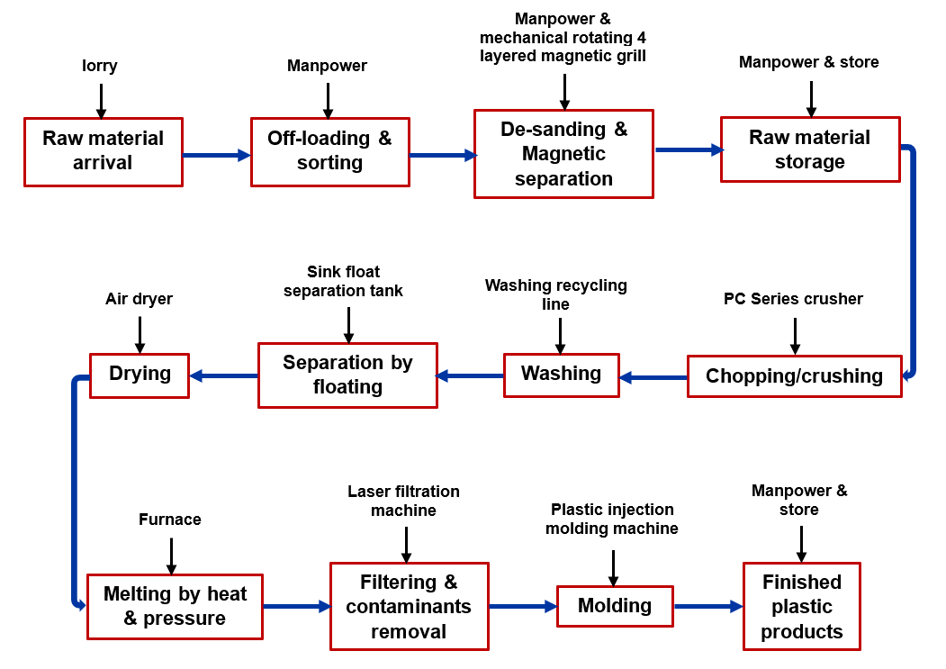
Figure 1: Plastic recycling production process flow chart (Conceptual design).
2.2.2 MODELING FRAMEWORK
The modeling framework uses five key processes to develop simulation models for plastic recycling in ARENA-Free. The model architecture follows the steps shown in Figure 2.

Figure 2: Modeling framework
2.2.3 PLANT LAYOUT DESIGN
Figure 3 dissipates the plant layout design of the plastic recycling company. The layout design houses all the production processes sections as seen in the Figure 3. The company’s principal products include spoons, chairs, plates, and tables. The developed, optimized plant layout operates on an automated conveyor system instead of the conventional transporter system (hand trolley).

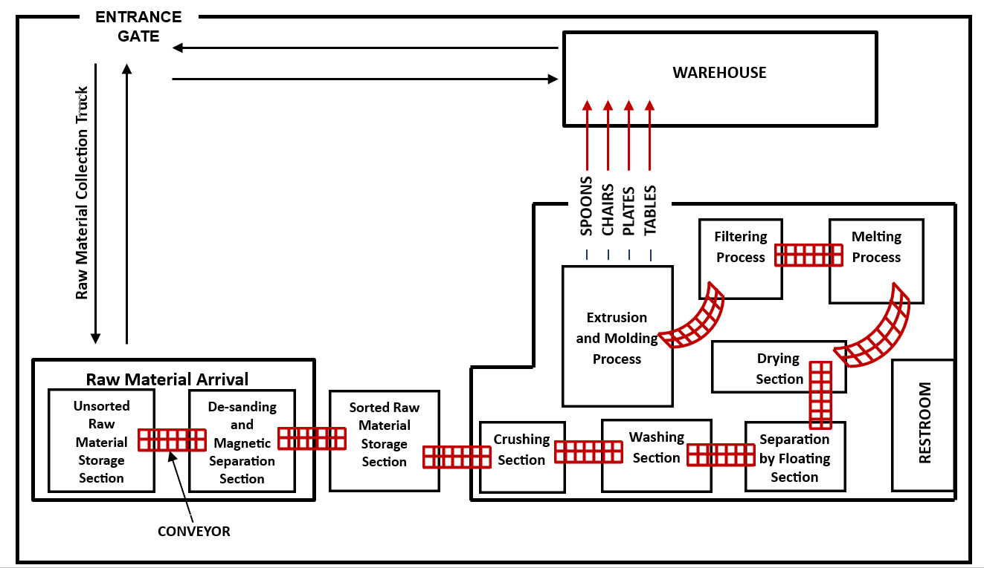
Figure 3: Plant layout design
2.2.4 COMPANY’S REPORT AND PROPOSED FACTORS FOR OPTIMIZATION PROCESS
The company’s report describes the plant mode activities in Table 1. The table reveals the number of workers, material conveying equipment, material handling effectiveness, storing material transporting equipment, feeding material, in-between process distance, transporting equipment velocity, and in-between process distance time coverage.
After being optimized for performance improvement, the evaluation for the report projects the best category that will affect others positively, thereby achieving optimal performance at a moderate cost. Therefore, conveying equipment was selected for optimization, which will reduce the number of workers, optimize the system, minimize the manual handling process, and reduce the distance, time & velocity between processes. Table 2 shows the processing time data from the company’s data while Table 3 shows the assigned time and distance for each process for conveyor and transporter.

Table 1: Company’s report and proposed factors for optimization process
Category | Description | Proposed factor for optimization
Number of workers | 60 | Maximum of 30
Materials conveying equipment | Hand trolley | Conveyor
Material handling effectiveness | Not optimized | Requires optimization
Store material conveying equipment | Hand trolley | Forklift
Feeding material | Manual | Automatic
In-between process distance | 15m | 7m
Conveying equipment velocity | Hand trolley (35m/mins) | Conveyor (50m/mins)
In-between process distance time coverage | 0.428mins | 0.14mins

Table 2: Processing time data from the company’s report
Process | OSS | DMSP | RMSP | CP | WP | SFP | DP | MP | FCRP | MoP
Time (sec) | 300 | 720 | 240 | 180 | 180 | 119 | 180 | 180 | 180 | 360

Table 3: Assigned time and distance for each process for conveyor and transporter
Processes | Transporter |  |  |  |  | Conveyor
Processes | Dist. (m) | Time (hrs.) |  |  |  | Dist. (m) | Time (hrs.)
Processes | Dist. (m) | Process in-between distance time | Entity discharging time | Entity processing time | Total time | Dist. (m) | Process in-between distance time | Entity discharging time | Entity processing time | Total time
OSS Leave 1 | 0 | 0 | 0 | 0.0833 | 0.0833 | 0 | 0 | 0 | 0.0833 | 0.0833
DMSP Enter 1 | 15 | 0.0071 | 0.0011 | 0 | 0.0082 | 7 | 0.0023 | 0.0011 | 0 | 0.0034
DMSP Leave 2 | 0 | 0 | 0 | 0.2 | 0.2 | 0 | 0 | 0 | 0.2 | 0.2
RMSP Enter 2 | 15 | 0.0071 | 0.0011 | 0 | 0.0082 | 7 | 0.0023 | 0.0011 | 0 | 0.0034
RMSP Leave 3 | 0 | 0 | 0 | 0.0667 | 0.0667 | 0 | 0 | 0 | 0.0667 | 0.0667
CP Enter 3 | 15 | 0.0071 | 0.0011 | 0 | 0.0082 | 7 | 0.0023 | 0.0011 | 0 | 0.0034
CP Leave 4 | 0 | 0 | 0 | 0.05 | 0.05 | 0 | 0 | 0 | 0.05 | 0.05
WP Enter 4 | 15 | 0.0071 | 0.0011 | 0 | 0.0082 | 7 | 0.0023 | 0.0011 | 0 | 0.0034
WP Leave 5 | 0 | 0 | 0 | 0.05 | 0.05 | 0 | 0 | 0 | 0.05 | 0.05
SFP Enter 5 | 15 | 0.0071 | 0.0011 | 0 | 0.0082 | 7 | 0.0023 | 0.0011 | 0 | 0.0034
SFP Leave 6 | 0 | 0 | 0 | 0.033 | 0.033 | 0 | 0 | 0 | 0.033 | 0.033
DP Enter 6 | 15 | 0.0071 | 0.0011 | 0 | 0.0082 | 7 | 0.0023 | 0.0011 | 0 | 0.0034
DP Leave 7 | 0 | 0 | 0 | 0.05 | 0.05 | 0 | 0 | 0 | 0.05 | 0.05
MP Enter 7 | 15 | 0.0071 | 0.0011 | 0 | 0.0082 | 7 | 0.0023 | 0.0011 | 0 | 0.0034
MP Leave 8 | 0 | 0 | 0 | 0.05 | 0.05 | 0 | 0 | 0 | 0.05 | 0.05
FCRP Enter 8 | 15 | 0.0071 | 0.0011 | 0 | 0.0082 | 7 | 0.0023 | 0.0011 | 0 | 0.0034
FCRP Leave 9 | 0 | 0 | 0 | 0.05 | 0.05 | 0 | 0 | 0 | 0.05 | 0.05
MoP Enter 9 | 15 | 0.0071 | 0.0011 | 0 | 0.0082 | 7 | 0.0023 | 0.0011 | 0 | 0.0034
MoP Leave 10 | 0 | 0 | 0 | 0.1 | 0.1 | 0 | 0 | 0 | 0.1 | 0.1

N/B:
- The entity processing time for the processes as populated are data gotten from the company’s Process Supervisor during an interview carried out.
- The uniform process in-between distance time for the transporter is measured from the company’s plant machine layout diagram.
- The uniform process in-between distance time for the conveyor is part of the optimization process innovation.

3.0 RESULTS AND DISCUSSION
The results were obtained by duplicating and constructing two production systems that used conveyors and haulage. ARENA Free modeled the proposed plastic recycling company system, taking conveyors and transporters into account, and the results were generated and analyzed. The study conducted on the company's report indicates that the transports run at a 35m/min velocity. The optimization procedure employs an automatic conveyor whose speed rate can be increased or decreased based on the operational process and strategies considered in the system's restrictions. The conveyor velocity is fixed constantly at 50m/min. The ARENA simulation runs at 1000hrs, which conforms with the work of [20].
The simulation performed utilizing the conveyor and transporter system indicates that the queue formed is significantly higher in the transporter than in the conveyor, and this results in higher processing time in the transporter than in the conveyor, which conforms with the work of Lorou et al. [21].

3.1 PLANT SYSTEM DESIGN
ARENA mimics and develops the system for optimal simulation using the plant layout design, production process paths, equipment, and time and distance, and this conforms with the work of John & Joseph [22], stating that only the properly laid out plant can ensure the smooth and rapid movement of material, from the raw material stage to the end product stage. Constraining the Arena design utilizing the appropriate input variables, including time, space, and velocity, helps to increase the performance of the working process by obtaining a steady flow with minimum waiting time, which conforms with the work of John & Joseph [22]. Figure 4 shows the plant system design utilizing ARENA.

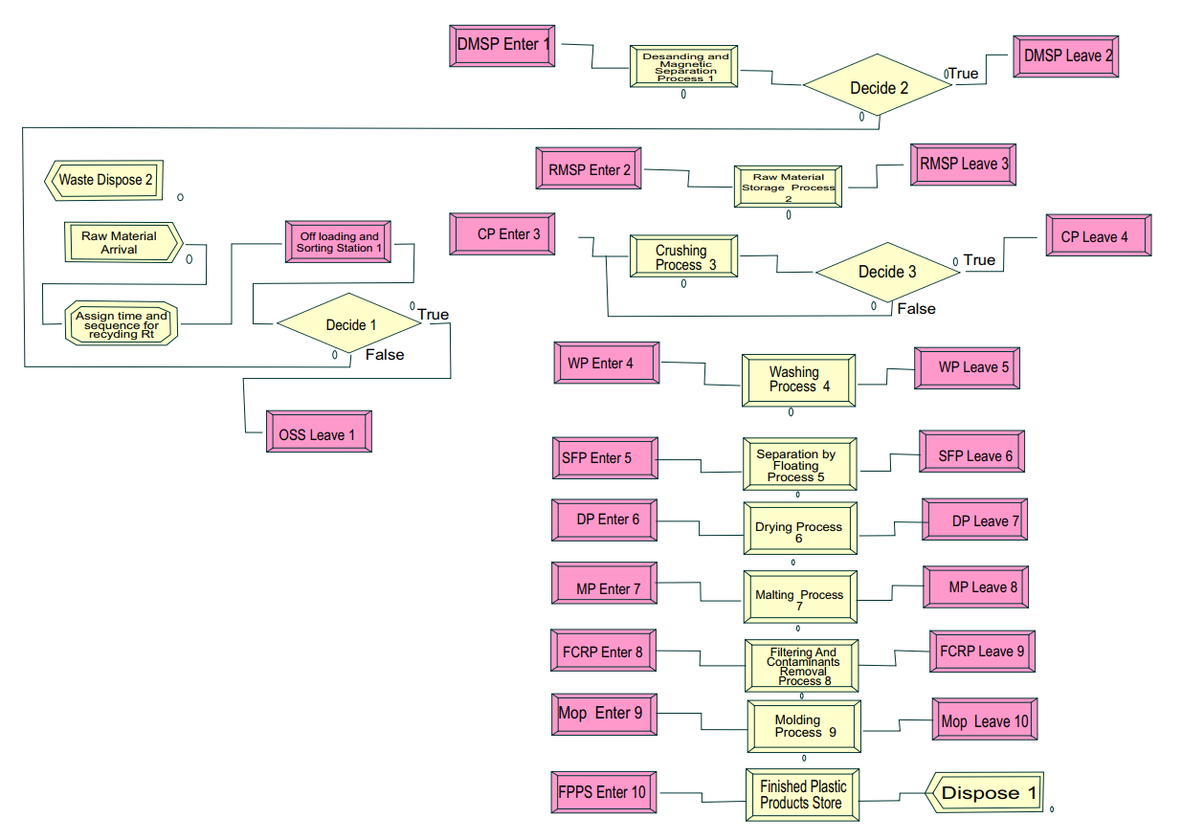
Figure 4: ARENA plant system design
The modified plant system design involves the introduction of a conveyor system as a means of transportation of materials under the production stage from one process to another. Introducing the conveyor system in the new plant production processes will reduce distances between each process because there will be no human transporting materials under the production process from one point of the production process to another. The distance reduction significantly impacts the system, including reducing the time products are being formed and the cost reduction of acquiring unnecessary lengthy conveyor trains. Reducing the production line distance between processes increases the number of products created by increasing production speed and reducing unnecessary costs generated by installing conveyor trains that convey materials from one production process to another in the production system, which conforms with Deep & Singh [23] and Adinarayanan et al., [24] stating that distance traveled by the parts increases which in turn increase the time of production for each product. Hence, reduced productivity and the flow of components will not be smooth.

3.2 WORK IN PROGRESS & ENTITY (IN & OUT)
Figure 5 and Table 4 show the detailed explanation and chart of the number of entities still under production in the system considering the conveyor and transporter. The figure shows that work-in-progress for the transporter is slightly higher than for the conveyor because utilizing the conveyor in production doesn't take time, considering the constant process and velocity at which it moves material in the production channel [25]. Due to the conveyor's minimum WIP due to high constant speed and operation, the entity in and out for the conveyor increases more than the transporter, as represented in Figure 5.

Table 4: Work in progress and Entity (in & out) representation for conveyor and transporter
CATEGORY | WORK IN PROGRESS (WIP) |  | ENTITY
 | Average | Maximum | Entity In | Entity Out
Conveyor | 14.1364 | 26 | 1045 | 1027
Transporter | 14.2476 | 32 | 953 | 929

Figure 5: Work in progress & entity (in & out)

3.3 MATERIAL IN AND OUT EVALUATION (RESULT VALIDATION)
Figure 6 and Table 5 show the entity in and out chats and production process values. The material that enters, processed, and leaves during the production process using a conveyor as a source of movement is much higher than that of a transporter. This process shows that the system was well-optimized. Utilizing a conveyor to transport materials in the production processes will increase performance by improving the quality and quantity of products formed, which conforms with the work of Kawalec et al. [26] and Bashir et al. [27], stating that conveyors can improve the quality and quantity of recycled materials. There will be a reduction in human resources and costs invested in laborers. The validation of the results shows that the system is running at its optimal performance with the aid of a conveyor as a source of material movement along the production processes formed, which conforms with the work of Kovalchuk & Poddubniy [28], stating that the most optimal solution to these problems is the use of long conveyor lines for transportation because Traditional motor vehicles (transporter) is quite expensive, have issues with reliability and leads to extensive gas pollution of the atmosphere, as well as the associated necessary stoppages, which in turn leads to high economic costs. The conveyor process, which runs at a higher velocity than the transporter, contributes to the high yield of the entity in and out. During production, the conveyor system can run continuously for days without causing disruption or interference in the production system.

Table 5: Material in & out using conveyor and transporter
ENTITY |  | MATERIAL IN & OUT
CATEGORY |  | CP | DMSP | DP | FCRP | MP | $$MoP$$ | SFP | WP | RMSP
CONVEYOR | IN | 873 | 917 | 854 | 851 | 852 | 850 | 859 | 855 | 856
CONVEYOR | OUT | 872 | 910 | 852 | 850 | 851 | 849 | 858 | 854 | 855
TRANSPORTER | IN | 865 | 846 | 811 | 808 | 810 | 806 | 821 | 813 | 814
TRANSPORTER | OUT | 860 | 840 | 810 | 806 | 808 | 804 | 819 | 811 | 813

Figure 6: Material in & out using conveyor and transporter

3.4 THROUGHPUT TIME EVALUATION
At a constant entity input production rate without considering the time utilized in moving the materials along the production process, the transporter is higher than the conveyor in the value-added, waiting, and transfer time. In contrast, the conveyor is higher than the transporter during the process of non-value-added time. Considering the total time of value-added, non-value-added, wait time, and transfer time, the transporter is much higher, as shown in Figure 7 and Table 6.

Table 6: Time evaluation for conveyor and transporter
CATEGORY | VA Time |  | NVA Time |  | Wait Time |  | Transfer Time |  | Total Time
 | Average | Maximum | Average | Maximum | Average | Maximum | Average | Maximum | Average | Maximum
Conveyor | 7.3370 | 11.3411 | 0.8297 | 1.4780 | 5.3987 | 16.6340 | 0.04253625 | 0.3363 | 13.6079 | 26.9266
Transporter | 8.8725 | 12.8335 | 0 | 0 | 6.1605 | 28.5775 | 0.07229099 | 0.08333333 | 15.1053 | 39.6621

Figure 7: Time evaluation for conveyor and transporter

3.5 WHOLE SYSTEM QUEUE WAITING TIME
Figure 8 shows the whole system queue waiting time comparative analysis for the conveyor and transporter. The system shows that waiting time is higher in transporters than in conveyors due to the minimum speed in transporting materials non-uniformly from one production channel to another. The effect of waiting time is significantly affected by the material leaving each production stage. The conveyor has more queues from DP to MoPL and SFPL to WPL. In the transporter, the total waiting time is 40.1497, while that of the conveyor is 31.9082.

Figure 8: Queue waiting time

3.6 ACCUMULATED VALUE-ADDED TIME
Figure 9 and Table 7 depict the dissipation of cumulative value-added time. Accumulated value-added time is the accumulated time of an entity in processes and delays. The speed variation at which both transporter and conveyors move the materials from the input to the output shows that the conveyor has more significant accumulated value-added time than the transporter. The conveyor runs at a constant higher speed than the transporter, processing more materials at every process than the transporter. The amount of human strength necessary to power transporter movement limits the transporter's speed rate; as a result, the value-added time suffers due to this constraint. Considering the conveyor, which runs at a constant speed, powered by the machine, it yields a higher accumulated value-added time. However, some restrictions like machine breakdown, power supply, and many more can negatively alter its performance, but its efficiency is higher than that of the transporter.

Table 7: Accumulated value-added time
ENTITY | ACCUMULATED VALUE-ADDED TIME
CATEGORY | CP | DMSP | DP | FCRP | MP | $$MoP$$ | SFP | WP | RMSP
Conveyor | 865.52 | 903.20 | 850.42 | 852.74 | 848.96 | 852.58 | 839.12 | 865.35 | 860.54
Transporter | 852.67 | 833.54 | 807.73 | 815.32 | 801.53 | 790.44 | 811.97 | 813.78 | 819.83

Figure 9: Accumulated value-added time

3.7 ACCUMULATED WAIT TIME
Figure 10 and Table 8 show the accumulated wait time for all production processes for both conveyor and transporter. The accumulated wait time for the conveyor system of each production process is higher than that of the transporter except in CP and RMSP, and this is because of the high speed and shorter distance at which the conveyor conveys materials to the processing machines. The conveyor moves more materials than the transporter, resulting in a higher accumulated wait time than the transporter. The accumulated wait time shows that the conveyor system produces more products than the transporter system.

Table 8: Accumulated wait time
ENTITY | ACCUMULATED WAIT TIME
CATEGORY | CP | DMSP | DP | FCRP | MP | $$MoP$$ | RMSP | SFP | WP
Conveyor | 655.47 | 3244.12 | 330.15 | 235.70 | 275.66 | 240.32 | 0 | 226.22 | 409.04
Transporter | 1626.93 | 2316.71 | 302.58 | 216.78 | 178.96 | 134.33 | 505.60 | 227.77 | 308.25

Figure 10: Accumulated wait time
3.8 ENTITY VALUE-ADDED TIME FOR CONVEYOR AND TRANSPORTER
Figure 11 and Table 9 clearly explain entity value-added time for the conveyor and transporter system. The variation in the value-added time of the two systems is similar because the value-added time does not consider the mode of transporting the material up to the processing point. The entity value-added time only examines the activities happening in the machine, of which both the conveyor and transporter system utilize the same production machine during production. Therefore, the value-added time will remain relatively higher with the transporter than the conveyor, even when considered average. The entity value-added time does not consider the entrance and the leaving process. Moreover, it only examines what happens inside the process per input, and the transporter tends to have more materials per input than the conveyor.

Table 9: Entity value-added time for conveyor and transporter
ENTITY | VALUE-ADDED TIME
CATEGORY | CP | DMSP | DP | FCRP | MP | $$MoP$$ | SFP | WP | RMSP
Conveyor | 1.4809 | 1.4904 | 1.4748 | 1.4741 | 1.4862 | 1.4701 | 1.4804 | 1.4815 | 1.4780
Transporter | 1.4780 | 1.4733 | 1.4748 | 1.4866 | 1.4862 | 1.4565 | 1.4809 | 1.4815 | 1.4904

Figure 11: Entity value-added time

3.9 WAIT TIME PER ENTITY OF CONVEYOR AND TRANSPORTER
Table 10 and Figure 12 dissipate a distinct clarity on the wait time per entity. Considering the wait time per entity, the transporter system is slightly higher due to its extensive material inserted in the production machine for processing, unlike conveyors that do not insert up to that quantity compared to the transporter in the production machine. In not considering the entering and leaving medium, the transporter system has a longer wait time than the conveyor, considering only the quantity of the material inserted in the production machine. Moreover, the conveyor is an automated system that can be structured to carry a particular amount, and it is that quantity that enters the machine, considering its placement and positioning on the conveyor tray. The amount that enters the manufacturing machine for each input, rather than the quantity queued up on the conveyor tray or the move, is typically utilized to estimate the wait time per entity. Therefore, the transporter inserts slightly more material per entity, which results in a higher wait time.

Table 10: Wait time per entity of conveyor and transporter
ENTITY | WAIT TIME
CATEGORY | CP | DMSP | DP | FCRP | MP | $$MoP$$ | SFP | WP | RMSP
Conveyor | 4.4936 | 11.8697 | 2.4808 | 2.5630 | 2.4313 | 2.4516 | 2.2570 | 3.0904 | 0
Transporter | 9.4024 | 13.1087 | 2.6230 | 2.1245 | 1.8016 | 1.6070 | 2.1789 | 2.6097 | 4.6939

Figure 12: Entity wait time

3.10 ENTITY TOTAL TIME
Table 11 and Figure 13 clearly understand the entity's total time. As shown in Figure 14, the entity's real-time includes VA, NVA, wait time and transfer time. In terms of overall time per entity, the transporter system is slightly faster due to the amount of material placed in the manufacturing machine for processing, as opposed to conveyors, which do not insert as much material as the transporter. The transporter system has a longer total time than the conveyor when only considering the quantity of material inserted in the producing machine. Furthermore, the conveyor is an automated configured system that carries a specific amount, and it is the quantity that enters the machine, considering materials placement and positioning on the conveyor tray. The quantity entering the manufacturing machine for each input, rather than the amount queued up on the conveyor tray or the move, is frequently utilized to measure wait time per entity. As a result, the transporter inserts slightly more material into each entity, increasing overall duration.

Table 11: Entity total time
ENTITY | TOTAL TIME
CATEGORY | CP | DMSP | DP | FCRP | MP | $$MoP$$ | SFP | WP | RMSP
Conveyor | 5.4287 | 12.5159 | 3.3637 | 3.7118 | 3.4026 | 3.7101 | 3.2396 | 4.1455 | 1.4780
Transporter | 10.3453 | 14.0096 | 3.6695 | 3.2779 | 2.6982 | 2.8296 | 3.3160 | 3.7325 | 5.6922

Figure 13: Entity total time

3.11 COST ANALYSIS

Output
After completing a recycling process that lasted 1000 working hours, the optimized and unoptimized processes revealed that the conveyor process had 1045 and 1027 entity input and output, respectively, and the transporter process had 953 and 929 entities input and output. Upon comparing the number that entered the system with the number that exited, the system discarded the residual number that remained after the sorting and demagnetization procedure.

Cost percentage implication on production in the optimized system over 1000 hours is gotten as:
$$\frac{Total number of conveyor over 1000hrs- Total number of output of transporter over 1000hrs }{Total number of output of transporter over 1000hrs }×100$$
$$\% product increament was gotten from the optimized process$$
$$\frac{1027- 929 }{929 }×100\%=10.549\%$$
The introduction of the conveyor brings 10.549%. increase in the production rate The percentage increment of the system can further be increased due to the speed control factor of the conveyor system as an automatic process by increasing the speed of the conveyor system, which will increase the number of the output of the products formed.
N/B: Because some input materials in-process went to disposal, utilizing the input factors will not produce the desired outcome. Furthermore, the availability of sufficient raw resources contributed to the limitation of using input factors.

Labor
$$\frac{Total number of labor in transporter-Total number of labor in coveyor}{Total number of labor in transporter}×100\%$$
$$Labor of Transporter=60$$
$$Labor of Conveyor=30$$
$$Reduction in Labor=60-30=30$$
$$\frac{30}{60}×100\%=50\%$$
$$Therefore we have 50\% decrease on expenses spent in labor$$
Plant layout space reduction
Conveyor system installation will free up more space for additional production-related equipment, increasing output and, consequently, the company's profit. The surplus profit will pay the cost of the conveyor.

4.0 CONCLUSION
This research investigates performance improvement of the plastic recycling process. The performed optimization of the production system considered the mode of moving materials from one point in the production process to another. The materials transporting system introduces a conveyor as a new form of transporting material from one point in the production process to another instead of using a transporter (hand trolleys).
The results and discussion of the analyses draw the following conclusions:
- The plastic recycling process's production structure has improved and eliminated constraints restricting the efficiency of the material transport system. The conveyor system increases system flexibility and efficiency for optimum production.
- The simulation using the conveyor and transporter system shows that the queue formed in the transporter is significantly higher than in the conveyor, resulting in a longer processing time in the transporter than in the conveyor.
- The optimization approach uses an automatic conveyor whose speed rate can be increased or decreased based on the operational process and strategies considered in the system's constraints. The conveyor velocity maintains a lock at 75m/min, despite the company's report stating that the transports run at 30m/min.
- The optimized and unoptimized processes when obtained from a finished recycling process running for 1000 working hours, indicate that the conveyor process had 1045 and 1027 entity input and output, respectively, and the transporter process had 953 and 929 entities input and output respectively. The remaining number left when considering the number that enters the system with the number that leaves the system went to waste, resulting from the sorting and demagnetization process.
- The data validation shows that the system is performing optimally with the help of a conveyor as a source of material movement along the production processes. The amount of material that enters production processes and exits during manufacturing when using a conveyor as a source of material transporting is substantially more significant than that of a transporter. This procedure demonstrates that the system was well-optimized. Using a conveyor to carry materials in manufacturing improves performance by increasing the quality and quantity of products formed, which conforms with the work of Kovalchuk et al. [28], stating that the most optimal solution to these problems is the use of long conveyor lines for transportation because Traditional motor vehicles (transporter) is quite expensive, have issues with reliability and leads to extensive gas pollution of the atmosphere, as well as the associated necessary stoppages, which in turn leads to high economic costs.
- There will be a significant reduction in human resources, which will invariably lead to a decrease in labor expenditures and overall run cost of the recycling process over a long period, according to Taneepanichskul et al. [29] and Pati & Majumdar [30], who state that Conveyors can reduce labor costs by up to 50% when compared to transporters, and low labor and low energy requirements are fundamental with belt conveyors when compared to other.
- Optimization involves reducing space, which can lead to space availability to develop more plants and install more equipment and warehouse space.
- Conveyors are a very safe process that supports goal zero (zero-incident) as a safety yardstick for measuring the safety of a production process due to a reduction in human labor conveying material from one production process to another, and this aligns with Mahajan et al. [31] who state that conveyors can improve the safety and efficiency of recycling operations by minimizing human exposure to hazards and optimizing material flow.
- Nomenclature
RMA | Raw Material Arrival
OSS | Offloading & Sorting Station
DMSP | De-sanding & Magnetic Separation Process
RMSP | Raw Material Storage Process
CP | Crushing Process
WP | Washing Process
SFP | Separation by Floating Process
DP | Drying Process
MP | Melting Process
FCRP | Floating & Contaminant Removal Process
$MoP$ | Molding Process
FPPS | Finished Plastic Product Store
WIP | Work in Progress
VA | Value Added
NVA | Non-Value Added

References
- Roos, G. (2016) Design-Based Innovation for Manufacturing Firm Success in High-Cost Operating Environments, The Journal of Design, Economics, and Innovation, 2(1), 5-28, https://doi.org/10.1016/j.sheji.2016.03.001.
- Soosay, C., Nunes, B., Bennett, D. J., Sohal, A., Jabar, J., & Winroth, M. (2016). Strategies for sustaining manufacturing competitiveness. Journal of Manufacturing Technology Management, 27(1), 6–37. https://doi.org/10.1108/JMTM-04-2014-0043.
- Javaid, M., Haleem, A., Singh, R. P., & Suman, R. (2021). Substantial capabilities of robotics in enhancing industry 4.0 implementation. Cognitive Robotics, 1, 58–75. https://doi.org/10.1016/j.cogr.2021.06.001.
- Zhong, R. Y., Xu, X., Klotz, E., & Newman, S. T. (2017). Intelligent Manufacturing in the Context of Industry 4.0: A Review. Engineering, 3(5), 616–630. https://doi.org/10.1016/J.ENG.2017.05.015.
- Fu, Q. (2022). How does digital technology affect manufacturing upgrading? Theory and evidence from China. PloS One, 17(5), e0267299. https://doi.org/10.1371/journal.pone.0267299.
- Pascucci, F., Savelli, E., & Gistri, G. (2023). How digital technologies reshape marketing: evidence from a qualitative investigation. Italian Journal of Marketing. https://doi.org/10.1007/s43039-023-00063-6.
- Shabalov, M. Yu., Zhukovskiy, Yu. L., Buldysko, A. D., Gil, B., & Starshaia, V. V. (2021). The influence of technological changes in energy efficiency on the infrastructure deterioration in the energy sector. Energy Reports, 7, 2664–2680. https://doi.org/10.1016/j.egyr.2021.05.001.
- Caggiano, A. (2014). Manufacturing System. In CIRP Encyclopedia of Production Engineering (pp. 830–836). Springer Berlin Heidelberg. https://doi.org/10.1007/978-3-642-20617-7_6562.
- Katsaliaki, K., Galetsi, P., & Kumar, S. (2022). Supply chain disruptions and resilience: a major review and future research agenda. Annals of Operations Research, 319(1), 965–1002. https://doi.org/10.1007/s10479-020-03912-1.
- Rosenblatt, M. J. (2013). Material Handling. In Encyclopedia of Operations Research and Management Science (pp. 945–948). Springer US. https://doi.org/10.1007/978-1-4419-1153-7_590.
- Hama Kareem, J. A., Mohammed, B. I., & Abdulwahab, S. A. (2022). Optimal Materials Handling Equipment and Defective Product Reduction Skills in Enhance Overall Production Efficiency. SAGE Open, 12(4), 215824402211287. https://doi.org/10.1177/21582440221128769.
- Hosseinzadeh Lotfi, F., Allahviranloo, T., Shafiee, M., & Saleh, H. (2023). Supply Chain Management (pp. 1–46). https://doi.org/10.1007/978-3-031-28247-8_1.
- Zhang, Z., & Li, J. (2020). Big-data-driven low-carbon management. In Big Data Mining for Climate Change (pp. 287–299). Elsevier. https://doi.org/10.1016/B978-0-12-818703-6.00015-5.
- Ajayi, S. O., & Oyedele, L. O. (2018). Waste-efficient materials procurement for construction projects: A structural equation modelling of critical success factors. Waste Management, 75, 60–69. https://doi.org/10.1016/j.wasman.2018.01.025.
- Ayilara, M., Olanrewaju, O., Babalola, O., & Odeyemi, O. (2020). Waste Management through Composting: Challenges and Potentials. Sustainability, 12(11), 4456. https://doi.org/10.3390/su12114456.
- Sadh, P. K., Duhan, S., & Duhan, J. S. (2018). Agro-industrial wastes and their utilization using solid state fermentation: a review. Bioresources and Bioprocessing, 5(1), 1. https://doi.org/10.1186/s40643-017-0187-z.
- Ugwu, C. O., Ozoegwu, C. G., Ozor, P. A., Agwu, N., & Mbohwa, C. (2021). Waste reduction and utilization strategies to improve municipal solid waste management on Nigerian campuses. Fuel Communications, 9, 100025. https://doi.org/10.1016/j.jfueco.2021.100025.
- Boysen, N., Schulze, P., & Scholl, A. (2022). Assembly line balancing: What happened in the last fifteen years? European Journal of Operational Research, 301(3), 797–814. https://doi.org/10.1016/j.ejor.2021.11.043.
- Dwivedi, Y. K., Ismagilova, E., Hughes, D. L., Carlson, J., Filieri, R., Jacobson, J., Jain, V., Karjaluoto, H., Kefi, H., Krishen, A. S., Kumar, V., Rahman, M. M., Raman, R., Rauschnabel, P. A., Rowley, J., Salo, J., Tran, G. A., & Wang, Y. (2021). Setting the future of digital and social media marketing research: Perspectives and research propositions. International Journal of Information Management, 59, 102168. https://doi.org/10.1016/j.ijinfomgt.2020.102168.
- Oljira, D. G., Abeya, T. G., Ofgera, G., & Gopal, M. (2020). Manufacturing System Modeling and Performance Analysis of Mineral Water Production Line using ARENA Simulation. International Journal of Engineering and Advanced Technology, 9(5), 312–317. https://doi.org/10.35940/ijeat.D8033.069520.
- Lorou, B. F. T. E., Muchiri, P. N., Kuloba, P. and Kimotho, J. K. (2021) Performance Improvement of Truck Assembly Line through Modeling and Simulation Using Arena Software. Open Journal of Optimization, 10, 88-100. https://doi.org/10.4236/ojop.2021.103007.
- John, B., & Joseph, J. (2013). Analysis and Simulation of Factory Layout using ARENA. International Journal of Scientific and Research Publications, 3(2). www.ijsrp.org.
- Deep, K., & Singh, P. K. (2015). Design of robust cellular manufacturing system for dynamic part population considering multiple processing routes using genetic algorithm. Journal of Manufacturing Systems, 35, 155–163. https://doi.org/10.1016/j.jmsy.2014.09.008.
- Adinarayanan, A., Dinesh, S., Balaji, DS., & Umanath, K. (2021). Design of machine cell in cellular manufacturing systems using PSO approach. Materials Today: Proceedings, 46, 3951–3955. https://doi.org/10.1016/j.matpr.2021.02.472.
- Ji, J., Miao, C., Li, X., & Liu, Y. (2021). Speed regulation strategy and algorithm for the variable-belt-speed energy-saving control of a belt conveyor based on the material flow rate. PLOS ONE, 16(2), e0247279. https://doi.org/10.1371/journal.pone.0247279.
- Kawalec, W., Król, R., & Suchorab, N. (2020). Regenerative Belt Conveyor versus Haul Truck-Based Transport: Polish Open-Pit Mines Facing Sustainable Development Challenges. Sustainability, 12(21), 9215. https://doi.org/10.3390/su12219215.
- Bashir, M. J. K., Chong, S. T., Chin, Y. T., Yusoff, M. S., Aziz, H. A. (2022). Single Waste Stream Processing and Material Recovery Facility (MRF). Solid Waste Engineering and Management. Handbook of Environmental Engineering, Springer, Cham, 24, 71-164. https://doi.org/10.1007/978-3-030-89336-1_2.
- Kovalchuk, M., & Poddubniy, D. (2019). Improving the efficiency of conveyor transport with the use of network technologies. https://doi.org/10.1051/e3sconf/201914004011.
- Taneepanichskul, N., Purkiss, D., & Miodownik, M. (2022). A Review of Sorting and Separating Technologies Suitable for Compostable and Biodegradable Plastic Packaging. Frontiers in Sustainability, 3. https://doi.org/10.3389/frsus.2022.901885.
- Pati, M., & Majumdar, U. (2020). A Letter on Belt Conveyor System as a Mode of Transportation in Industry. International Journal of Research in Engineering, Science and Management, 3(12), 75–79. https://doi.org/10.47607/ijresm.2020.411.
- Mahajan, A., Ladvanjari, D., Dhanjode, A., Giramkar, A., Patil, R. & Asalekar, A. (2020). Design and Analysis of transporting mechanism used in small scale industries instead of conveyors. Journal of Computational and Theoretical Nanoscience, 26(6), 109-115.

