Original Research Article
Investigating Skin Cancer Diagnosis Using a Webcam-based Microcontroller System

ABSTRACT

Skin cancer can spread fast to nearby tissue and other parts of the human body if it's not diagnosed early. Only if skin cancer is found and treated in early stages, most are curable. Therefore, it's essential to seek a casual way of early diagnosis. This paper assesses a prototype system for skin cancer detection using an Arduino with an ArduCam Mega 5MP, benchmarked against smartphone diagnosis. Bandpass filters capture skin images at red (650 nm), green (532 nm), and blue (450 nm) wavelengths, measuring reflectance values. The approach aims to quantitatively determine skin melanin, oxyhemoglobin, and deoxyhemoglobin levels, aiding in various skin lesions' diagnosis. Evaluation involves comparing pixel reflectance values of images taken by smartphones and the prototype using a 3D mesh grid. Applying the modified Lambert-Beer law to reflectance values of moles, pimples, scars, scabs, and traces predicts relative levels of skin components. The system shows an 87% match with the smartphone standard, demonstrating high reliability. Further study might be needed for clarification of the confirmation with clinical cases.

Keywords: Lambert-Beer Law, Reflectance Value, Skin Cancer Diagnosis, Skin Melanin, Webcam based Microcontroller System

1. INTRODUCTION AND HYPOTHESIS
Skin cancer, particularly melanoma, requires early detection for effective treatment, with survival rates dropping significantly once it spreads. Despite advancements in diagnosis and treatment since the 18th century, the disease's varied appearances complicate early detection. Traditional methods, such as dermoscopy, have limitations, leading to the exploration of more accessible diagnostic tools like microcontroller systems, which promise to enhance early detection efforts without the need for direct consultations.

Early detection of melanoma is crucial for survival, with rates dropping from nearly 100% to 35% once it spreads. Traditional diagnostics, relying on dermatologists' expertise(dermoscopy), have their limits, particularly in early detection despite a high sensitivity. Technological advances have prompted the search for alternative methods, such as algorithm-based diagnostics, but these still lack accessibility and require face-to-face consultations. This highlights the demand for more accessible, reliable diagnostic tools, leading to innovative approaches like using a microcontroller system for early skin cancer detection.

The discussion on melanoma diagnosis emphasizes the significance of melanin, deoxyhemoglobin, and oxyhemoglobin in differentiating melanoma from benign skin conditions. Melanoma lesions exhibit increased melanin levels, while changes in blood supply, influenced by angiogenesis, affect oxyhemoglobin and deoxyhemoglobin levels. The balance between these components offers insights into melanoma metabolic activity, with the relative ratio of oxyhemoglobin to deoxyhemoglobin acting as a potential melanoma indicator.
Building on this foundation, the aim is to enhance melanoma detection through a prototype system designed for early-stage skin cancer diagnosis. This system leverages optical RGB images and a band-filter lens to measure skin reflectance accurately. By applying the Beer-Lambert equation, it quantifies the concentrations of hemoglobin, deoxyhemoglobin, and melanin. This approach facilitates a more accessible means for individuals to evaluate the likelihood of skin cancer, encouraging early medical consultation based on preliminary findings.
Together, these insights and technological advancements highlight the potential of using specific wavelengths, imaging techniques, and quantitative measures to improve early detection of skin cancer. Further research and development in this area promise to yield effective, non-invasive diagnostic tools, significantly impacting patient outcomes by enabling timely treatment of melanoma.

To test the system's effectiveness, the experiment will use optical images from a smartphone with a band-filter lens, serving as a benchmark. These images will be assessed with the modified Beer-Lambert law, supported by studies validating smartphone images for skin cancer diagnosis. The aim is to compare melanin, deoxyhemoglobin, and oxyhemoglobin levels in the images' Regions of Interest (ROIs) with those taken by the system, to evaluate variance and diagnostic accuracy for skin cancer.

2. EXPERIMENTAL MEDHOTS
2.1 Experimental Components
In order to capture Skin ROI images, ASCD(Arduino skin cancer diagnosis) System is an embedded ArduCam Mega 5MP and Arduino Uno. The ArduCam Mega 5MP model features a powerful 5MP CMOS image sensor for enhanced image capturing accuracy. The ASCD System aims to use RGB color channels for detecting and differentiating between moles and melanoma cells, employing OpenCV for image processing. Subsequently, All images are get and saved through the ArduCam Mega (v2.0) - (updated 2023/04/24 -b0cb3b1) before proceeding with image processing. To assess the accuracy of the ASCD System, images of various body parts were captured, referred to as the ROI (Region of Interest). This prototype aims to represent essential parameters for melanoma diagnosis—melanin, deoxyhemoglobin, and hemoglobin—within the skin tissue of the ROI as 3D images. If it's possible to measure the concentrations of these three parameters in specific normal skin areas (moles, pimples, scabs), it indicates the potential of the ASCD System for melanoma detection.
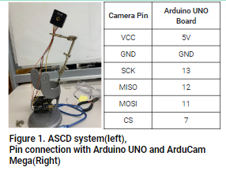
In this experiment, the smartphone is used as the gold standard to compare the diagnostic capabilities of the ASCD System. The optical skin cancer diagnosis ability of smartphones has already been verified and is being used for commercial purposes. All experiments are conducted identically with both the smartphone and the ASCD System.

Three color caps are used when shooting the Region of Interest (ROI). These color caps are equipped with band filter color transparent paper that filters light at 650 nm, 532nm, and 405 nm wavelengths, respectively, and are installed at the front. Their diameter is about 35mm.
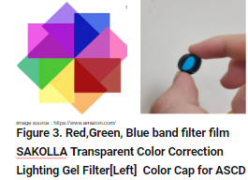
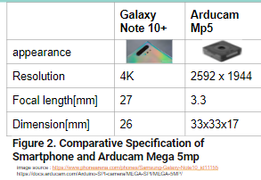

2.2 Our Step-wise Procedure

1. Setup & Calibration: Ensure the ASCD System is ready and attach a color cap to the ArduCam Mega 5MP camera. Capture a calibration image of a white paper with the red color cap to create a reference image (img_white_red).

3. Capture Normal Skin Images: With the red color cap, capture three photos of normal skin without distinct features. Capture the normal skin near the ROI to be photographed later. Use the cv2.imread method to specify the pixel values as an array, saving this array as img_normal_red.

4. Feature and ROI Capture: Using the red color cap, capture the skin feature (dot) as the ROI. Ensure each feature is captured with all color caps and save these images for analysis. Use the cv2.imread method to specify the pixel values as an array, saving this array as img_sample_red.

5. Reflectance Calculation: Insert the following formula into the algorithm to calculate reflectance. All operations must be performed as array calculations:
reflect_i_red = img_sample_red/img_white_red
reflect_bg_red = img_normal_red/img_white_red
reflect_hat_red =reflect_i_red/reflect_bg_red

6. Repeat Steps 2-5 for other color caps to obtain reflect_hat_green and reflect_hat_blue.

7. Data Analysis: Use the modified Beer-Lambert law formula to calculate the concentration of oxyhemoglobin (HbO2), deoxyhemoglobin (Hb), and melanin (m) in the skin based on the reflectance values obtained from the images. The formulas are as follows:

HbO2 = -0.024 ln(reflect_hat_blue) - 0.033 ln(reflect_hat_green) + 0.145 ln(reflect_hat_red)
Hb = 0.057 ln(reflect_hat_blue) - 0.024 ln(reflect_hat_green) - 0.128 ln(reflect_hat_red)
m = -0.806 ln(reflect_hat_blue) + 0.408 ln(reflect_hat_green) - 0.806 ln(reflect_hat_red)
Citation: Delpy, D. T., et al. (1988). Physics in Medicine & Biology.

8. Repeat Steps 2-7 for different ROIs. Display all analyzed images using the colormap "hot" in a surface mesh 3D map.

9. Smartphone Comparison: Repeat Steps 1-8 using a smartphone instead of the ASCD System, following the same method.

10. Verification and Comparison: Validate that the concentrations of hemoglobin, deoxyhemoglobin, and melanin in each ROI match the findings presented in professional articles. Confirm that the biometric information of moles, pimples, and scabs in normal skin tissue matches the research descriptions. Perform a t-test with the dataset of all reflectance array data to statistically compare the reflection values obtained from the smartphone and the ASCD System.
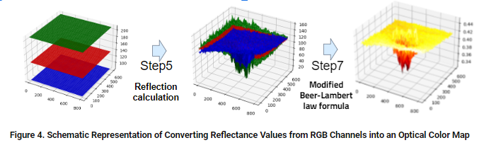

3. RESULTS AND DISCUSSION

3.1 Mole Images and Graphic Interpretation
The analysis of melanin, oxyhemoglobin (HbO2), and deoxyhemoglobin (Hb) in a normal mole through RGB channel reflectance ratios shows distinct patterns as seen in Fig. 5. Melanin concentration peaks in the mole area due to its light-absorbing property. In contrast, HbO2 and Hb display opposite values, aligning with their theoretical opposition. The area surrounding the mole shows a consistent distribution of HbO2 and Hb, unlike the pronounced peak. Smartphone photography failed to confirm smoother peak variations, whereas ASCD outlined peak shapes but didn't capture the normal skin tissue's uniform distribution around them. Additionally, HbO2 and Hb values weren't exact opposites, indicating noise. The Hb peak was unclear and appeared smeared. Nonetheless, the precise melanin peak representation indicates the potential to detect increased melanin in melanoma.

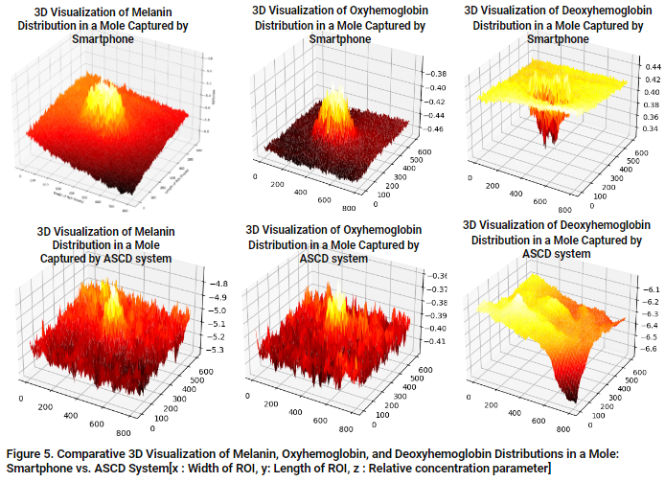

3.2 Pimple Images and Graphic Interpretation

In pimple-affected areas as in Fig. 6 below, an inflammatory response leads to increased blood flow, elevating HbO2 and Hb levels, while melanin levels remain relatively unaffected due to pimples' weak association with melanin increase. Smartphone imaging shows lower reflectance values, and while ASCD presents lower values for HbO2, it more accurately reflects the high levels of HbO2 and Hb associated with pimples' physiological characteristics. Despite some discrepancies in reflectance distribution, both methods indicate elevated HbO2, with ASCD offering a slightly more accurate depiction of HbO2 and Hb levels in pimples.

The distribution of melanin, HbO2, and Hb in a normal scab(Figure 7) reflects the physiological changes during the wound healing process. The formation of a scab results from the coagulation of blood components, which does not directly affect melanin concentration, but melanin production can increase in the skin surrounding the scab. This could be a response from the skin to protect itself from the wound. Both smartphones and the ASCD have shown to effectively represent this melanin production. Meanwhile, the formation of new blood vessels for wound healing increases the concentrations of HbO2 and Hb, particularly noticeable in the area with a scab.

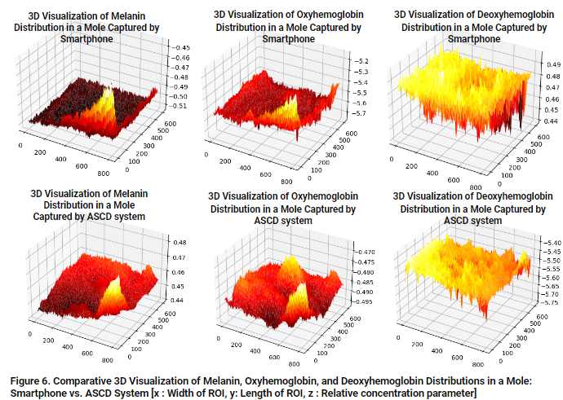

3.3 Scar Images and Graphic Interpretation

The comparison between smartphone and ASCD device images for moles, pimples, and scabs shows no significant differences in melanin, HbO2, and Hb levels, with most p-values indicating no statistical significance. An average p-value of approximately 25.38% suggests a 74.62% likelihood of no significant difference between the two imaging methods, indicating their interchangeability for diagnostic and monitoring purposes, the difference between the images taken with smartphones and ASCD devices.

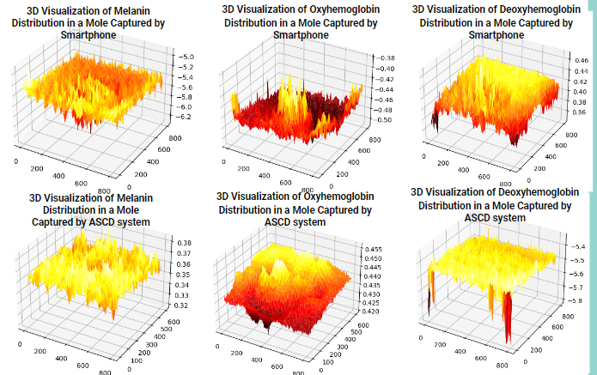

Figure 7. Comparative 3D Visualization of Melanin, Oxyhemoglobin, and Deoxyhemoglobin Distribution in Scars: Smartphone vs. ASCD System [x: Width of ROI, y: Length of ROI, z: Relative concentration parameter]

3.4 Statistical Analysis
The comparison between smartphone and ASCD device images for moles, pimples, and scabs shows no significant differences in melanin, HbO2, and Hb levels, with most p-values indicating no statistical significance. An average p-value of approximately 25.38% suggests a 74.62% likelihood of no significant difference between the two imaging methods, indicating their interchangeability for diagnostic and monitoring purposes. difference between the images taken with smartphones and ASCD devices.

This comprehensive analysis across various skin conditions—moles, pimples, and scabs—reveals significant insights into the diagnostic capabilities of smartphone and Advanced Skin Condition Diagnosis (ASCD) devices. It highlights the intricacies of melanin, oxyhemoglobin (HbO2), and deoxyhemoglobin (Hb) distributions under different skin conditions, offering a window into the physiological processes at play.
For moles, the analysis underscores the elevated melanin concentration, a characteristic feature that both imaging methods can capture, albeit with nuances in their accuracy. The expected theoretical patterns for HbO2 and Hb concentrations demonstrate the challenge in capturing exact physiological responses, with noise interference impacting the clarity of results. This suggests a nuanced approach is necessary when interpreting such data, especially in the context of melanoma detection.
In the case of pimples, the analysis points to an increase in HbO2 and Hb levels due to the inflammatory response, a condition that smartphones and ASCD devices can detect. However, the devices' ability to accurately reflect the elevated levels of these markers varies, indicating a need for careful consideration of the chosen method for specific diagnostic purposes.
The examination of scabs reveals how smartphones and ASCD devices capture the physiological changes of wound healing, such as increased melanin production around the scab and the formation of new blood vessels. The data suggests both devices are capable of reflecting these changes, with nuances in their ability to delineate between normal skin and scab tissue, particularly for HbO2 and Hb concentrations.
The statistical analysis, indicating no significant difference in the performance of smartphones and ASCD devices across a range of p-values, suggests a high degree of interchangeability between these imaging methods for the diagnostic and monitoring of skin conditions. This conclusion, supported by an average p-value translating into a 74.62% likelihood of no significant difference, underscores the potential of using readily available smartphone technology in dermatological assessments alongside more advanced devices.
Ultimately, this analysis not only highlights the potential and limitations of current imaging technology in capturing key physiological indicators across different skin conditions but also opens the door for further research. It calls for the development of more refined imaging techniques and algorithms that can improve the accuracy and reliability of skin condition diagnosis, leveraging the ubiquity and accessibility of smartphone technology to enhance patient care in dermatology.

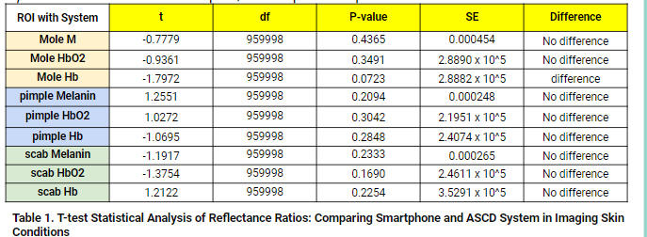

4. CONCLUSION

This study explores the diagnostic capabilities of smartphones & ASCD devices through analysis of melanin, HbO2, & Hb distributions in skin conditions like moles, pimples, & scabs. For moles, both methods captured higher melanin concentration but faced challenges in capturing the theoretical patterns of HbO2 & Hb distributions, suggesting noise interference impacts accuracy. The analysis of pimples highlighted an increase in HbO2 & Hb levels due to the inflammatory response, with ASCD showing a superior ability to distinguish these changes more accurately than smartphones. In the case of scabs, both smartphones & ASCD were effective in capturing physiological changes associated with wound healing, like increased melanin production around the scab & the formation of new blood vessels. However, there were subtle differences in their capabilities to capture HbO2 & Hb concentrations, an important consideration in comparing device performance. Statistical analysis showed no significant difference in performance between smartphone & ASCD, suggesting the two imaging methods can be interchangeably used for the diagnosis & monitoring of skin conditions. In conclusion, ASCD is deemed to have performed satisfactorily enough to potentially replace the diag capabilities of commercially available smartphones. This signifies a promising direction for the future of dermatological assessments, indicating that ASCD can be considered a viable alternative to conventional smrtphn-based diagnostics.

5. REFERENCES
[1] Hans Skvara, M. D. (2005, February 1). Limitations of dermoscopy in the recognition of melanoma. Archives of Dermatology. Retrieved December 23, 2022, from https://jamanetwork.com/journals/jamadermatology/fullarticle/392759
[2] Dick, V., Sinz, C., Mittlböck, M., Kittler, H., &amp; Tschandl, P. (2019, November 1). Accuracy of computer-aided diagnosis of melanoma: A meta-analysis. JAMA dermatology. Retrieved December 23, 2022, from https://www.ncbi.nlm.nih.gov/pmc/articles/PMC6584889/
[3] Narayanamurthy, V., Padmapriya, P., Noorasafrin, A., Pooja, B., Hema, K., Yuhainis Firus Khan, A., Nithyakalyani, K., & Samsuri, F. (2018, August 2). Skin cancer detection using non-invasive techniques. RSC Advances (RSC Publishing). https://pubs.rsc.org/en/content/articlelanding/2018/ra/c8ra04164d
[4] Fawcett, N. F. (2020, March 19). Biomarker Helps Identify Skin Cancer | Michigan Health Lab. University of Michigan. Retrieved December 23, 2022, from https://labblog.uofmhealth.org/lab-report/detecting-when-most-common-skin-cancer-turns-dangerous
[5] Hans Skvara, M. D. (2005, February 1). Limitations of dermoscopy in the recognition of melanoma. Archives of Dermatology. Retrieved December 24, 2022, from https://jamanetwork.com/journals/jamadermatology/fullarticle/392759
[6] Cardinal, D. (2021, April 28). Smartphones vs Cameras: Closing the gap on image quality. DXOMARK. Retrieved December 28, 2022, from https://www.dxomark.com/smartphones-vs-cameras-closing-the-gap-on-image-quality/
[7] Jung, J. M., Cho, J. Y., Lee, W. J., Chang, S. E., Lee, M. W., & Won, C. H. (2021). Emerging Minimally Invasive Technologies for the Detection of Skin Cancer. Journal of Personalized Medicine, 11(10), 951.
[8] Alquran, H., Qasmieh, I. A., Alqudah, A. M., Alhammouri, S., Alawneh, E., Abughazaleh, A., & Hasayen, F. (2017, October). The melanoma skin cancer detection and classification using support vector machine. In 2017 IEEE Jordan Conference on Applied Electrical Engineering and Computing Technologies (AEECT) (pp. 1-5). IEEE.
[9] Ansari, U. B., & Sarode, T. (2017). Skin cancer detection using image processing. Int Res J Eng Technol, 4(4), 2875-2881.
[10] Horsham, C., Snoswell, C., Vagenas, D., Loescher, L. J., Gillespie, N., Soyer, H. P., & Janda, M. (2020). Is teledermoscopy ready to replace face-to-face examinations for the early detection of skin cancer? Consumer views, technology acceptance, and satisfaction with care. Dermatology, 236(2), 90-96.
[11] Giuffrida, R., Conforti, C., Di Meo, N., Deinlein, T., Guida, S., & Zalaudek, I. (2020). Use of noninvasive imaging in the management of skin cancer. Current Opinion in Oncology, 32(2), 98-105.
[12] Herschorn, A. (2012a, July). Dermoscopy for melanoma detection in family practice. Canadian family physician Medecin de famille canadien. https://www.ncbi.nlm.nih.gov/pmc/articles/PMC3395510/#:~:text=Results%20revealed%20a%20sensitivity%20(percentage,examination%20and%2090%25%20using%20dermoscopy.&text=There%20was%20no%20decrease%20in,the%20number%20of%20misdiagnosed%20nonmelanomas.

