Microwave Drying of Banana Slices- Drying kinetics and Modelling

.
ABSTRACT

This study investigated the drying kinetics of thin-layer banana slices (Musa spp.) using a domestic microwave oven across five controlled power levels. Fresh banana slices, prepared to a uniform thickness of 0.25 cm and initial moisture content of approximately 80% (wet basis), were dehydrated to a final moisture content ranging between 17% and 18% (wet basis). Drying time demonstrated a dramatic inverse relationship with microwave power, decreasing from 30 minutes at 180 W to just 11 minutes at 900 W.
Analysis of the drying rate curve revealed that higher power levels (600 W and 900 W) induced a shorter constant rate and lengthier falling rate period, indicating effective volumetric heating, whereas lower power levels (180 W to 450 W) were predominantly controlled by the internal diffusion mechanism associated with significant constant rate period and smaller falling rate period. Four common thin-layer drying models (Newton, Page, Modified Page, and Henderson and Pabis) were fitted to the experimental moisture ratio data. The Modified Page model provided the superior statistical fit across all tested power conditions, achieving the highest average coefficient of determination (R² average of 0.9769) and robustly describing the non-linear drying kinetics. The findings confirm that microwave power is the primary control parameter, and careful study is essential to capitalize on kinetic efficiency for high-power density heating.

Keywords: [microwave, thin-layer, drying kinetics, drying models }

1. INTRODUCTION

Global Significance of Bananas and Post-Harvest Loss Mitigation
Banana, belonging to the Musaceae family and Musa genus, is globally recognized as a significant tropical crop. It often ranks as the most produced fruit globally (FAO, 2023. Edible varieties, derived from Musa acuminata and Musa balbisiana or their hybrids, are consumed globally. However, bananas are categorized as climacteric fruits with high initial moisture content, typically exceeding 75%, and measured in this study at approximately 80% (wet basis). This high moisture content leads to rapid post-harvest ripening and substantial waste if not processed immediately.
Dehydration is one of the most effective and widely adopted preservation methods, extending shelf life, enhancing year-round availability, and increasing market value, often yielding commercial products such as banana chips. Proper processing helps mitigate the quick deterioration that is characteristic of the fresh fruit.
Advantages and Mechanisms of Microwave Drying Technology
Traditional dehydration techniques, such as conventional hot-air drying, necessitate prolonged exposure to elevated temperatures. This extended exposure frequently results in suboptimal product quality, manifesting as undesirable color changes, nutrient degradation, and the development of a hard, brittle texture.
Microwave (MW) drying offers a superior alternative due to its unique heating mechanism. MW drying utilizes high-frequency electromagnetic waves (typically 2450 MHz, as used in this study) that cause polar water molecules within the material to rapidly oscillate. This molecular friction generates heat internally—a volumetric heating process that results in rapid moisture removal and significantly lower specific energy consumption when compared to external heat transfer methods. The internal steam generation creates a high internal pressure, facilitating rapid moisture migration to the surface, accelerating the process drastically. The development of advanced MW-assisted processes, such as microwave-vacuum drying, has shown promise in yielding dried products with superior quality characteristics, sometimes comparable to those achieved by expensive methods like freeze-drying (Horuz & Maskan, 2025). Furthermore, incorporating pre-treatments like blanching or citric acid soaking can further enhance quality attributes and reduce required drying time (Kumar et al., 2021; Abdullah et al., 2014).
Importance of Drying Kinetics and Mathematical Modeling
For the effective design, optimization, and industrial scaling of microwave drying processes, a rigorous understanding of the product's drying kinetics is indispensable (Jabeur et al., 2020). Thin-layer drying models are essential tools used in food engineering to generalize experimental drying curves and accurately estimate processing times under varying conditions (El-Sebaii & Shalaby, 2012; Mohamed et al., 2023). These models provide empirical or semi-theoretical coefficients that quantify the physical and thermal transport phenomena occurring within the material. While various models, including the Page model, the Midilli-Kucuk model, and the Wang and Singh model, have been reported as suitable descriptors for the drying behavior of different agricultural products (Dandamrongrak et al., 2002; Mohamed et al., 2023) , it is necessary to identify the model that most accurately characterizes the kinetics specific to microwave dehydration of banana slices.
Study Objectives
The objectives of the present investigation were twofold:
1. To experimentally investigate the drying rate and characteristics of banana slices when subjected to various constant microwave power levels (180, 300, 450, 600, and 900 W).
2. To evaluate the statistical performance of four widely-used thin-layer drying models (Newton, Page, Modified Page, and Henderson and Pabis) and identify the most suitable mathematical model for accurately describing the moisture ratio reduction kinetics of microwave-dried banana slices.
2. Theoretical Framework and Methodology

2.1 Mathematical Definitions of Moisture Content and Ratio
The experimental drying data were analyzed in terms of the dimensionless moisture ratio (MR), which standardizes the moisture content over time. The moisture ratio is conventionally calculated using the definition:
$MR=\frac{M_{t}-M_{e}}{M_{in}-M_{e}}$ ​​[Equation (1)]
Where, M_{t} is moisture content of banana at time t, M_{e} is equilibrium moisture content of banana at the drying conditions and M_{in} is initial moisture content of banana.
In the context of rapid, high-temperature microwave drying, the vapor pressure within the oven cavity is often high, but the internal heating is so intense that the equilibrium moisture content (Me​) approaches zero rapidly relative to the initial and time-dependent moisture contents (Mt​ or Min​). Consequently, the denominator simplifies, and the moisture ratio expression is accurately approximated as:
$MR=\frac{M_{t}}{M_{in}}$ ​​[Equation (2)]
This simplified form is utilized for the thin-layer modeling approach.
2.2 Thin-Layer Drying Models Evaluated
Four established thin-layer models were selected based on their wide application in characterizing the drying kinetics of fruits and vegetables. These models were employed in their non-linear regression forms to fit the experimental moisture ratio data versus drying time.
Table 1: Thin-Layer Drying Models Applied to Banana Slice Kinetics
Name of Model | Model Equation (MR) | Representative Reference
Newton (Exponential) | MR=exp(–kt) | Demir et al. (2007)
Page | MR=exp(–ktn) | Yaldiz and Ertekin (2001)
Modified Page | MR=exp(–(kt)n) | Demir et al. (2007) ; El-Sebaii & Shalaby (2012)
Henderson and Pabis | MR=aexp(–kt) | Jabeur et al. (2020)

2.3 Statistical Criteria for Model Validation
The evaluation of the fit quality required a multi-parametric statistical approach. The coefficient of determination (R2) was the primary criterion, requiring maximization (closest to 1) for the best fit. Additionally, the models’ goodness-of-fit was assessed by minimizing the reduced chi-square (χ2) and the Root Mean Square Error (RMSE).
The reduced chi-square (χ2) quantifies the residual variance between the experimental and predicted data points, providing a measure of how well the model aligns with the actual physical process:
$χ^{2}= \frac{1}{N-z}\sum_{i =1}^{N}{}({MR}_{experimental, i}-{MR}_{predicted, i})^{2}$ [Equation (3)]
Where, MR _{exp,i} is the experimental moisture ratio, MR _{pred,i} is the predicted moisture ratio, χ² is reduced chi square, N is number of readings and z is number of constants in the model. The Root Mean Square Error (RMSE) provides an estimate of the average magnitude of the error, measured in the same units as the observed data (dimensionless MR):
$RMSE= ⦋ [\frac{1}{N}$ $\sum_{i=1}^{N}{}({MR}_{experimental, i}-{MR}_{predicted, i})$²]^{1/2} ​[Equation (4)]
Minimizing both χ2 and RMSE is paramount for selecting a model that offers reliable predictive capability.
2.4 Materials and Experimental Procedure
Fresh raw bananas (Musa acuminata or Musa spp.) were procured from the local market. The fruit was thoroughly washed, peeled, and manually sliced using a manual peeler with stainless steel blade to ensure uniformity. The slices maintained a consistent average diameter of 3.5 cm and a thickness of 0.25 cm. The initial moisture content was gravimetrically determined to be approximately 80% (wet basis).
A domestic microwave oven, operating at 2450 MHz with a maximum output capacity of 900 W, was employed for all drying experiments. The oven output power was precisely adjustable to five constant power levels: 180 W, 300 W, 450 W, 600 W, and 900 W. A rotating bottom plate ensured uniform microwave energy distribution across the samples. Moisture loss was monitored at regular time intervals until the final moisture content reached the target range of 17% to 18% (wet basis).

3. results and discussion

Effect of Microwave Power on Drying Efficiency and Time
The experimental results confirmed that microwave power level is the most critical process parameter controlling the efficiency of banana slice dehydration. A substantial inverse relationship was observed between the applied power and the total time required to achieve the target moisture reduction (from 80% to 17–18% wet basis).

Table 2: Total Drying Time Required for Banana Slices at Various Microwave Power Levels
Output Power (W) | Drying Time (minutes) | Time Reduction (%) relative to 180 W
180 | 30 | 0.0%
300 | 25 | 16.7%
450 | 22 | 26.7%
600 | 15 | 50.0%
900 | 11 | 63.3%

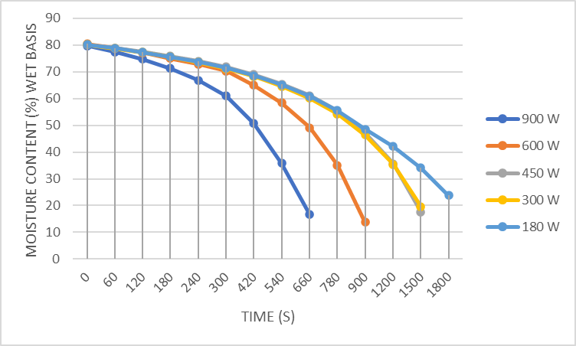
Fig 1: Reduction in moisture content with drying time at different output power during microwave drying
As shown in Table 2 and Fig.1, increasing the power from 180 W to 900 W achieved a time reduction exceeding 63%. This rapid acceleration is directly attributed to the increased rate of volumetric energy absorption within the banana slices at higher power settings. The enhanced internal heating causes faster water molecule oscillation and more vigorous internal steam generation, significantly accelerating moisture migration and removal. This observation aligns closely with existing literature highlighting the potent influence of microwave power on drying duration (Yıldız etız, 2016; Luz & Resende, 2023).
Analysis of Drying Rate Characteristics and Mechanism Transition
The analysis of the drying rate curves provided critical insight into the controlling mass transfer mechanisms at different power levels. The transition in drying kinetics occurred distinctly between the mid-range and high-range power settings.

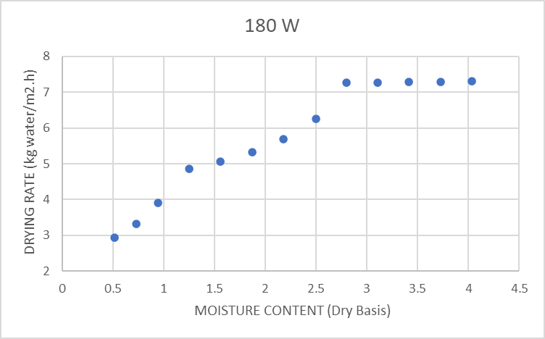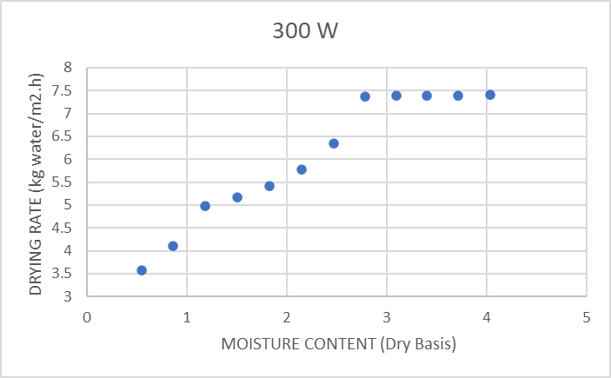

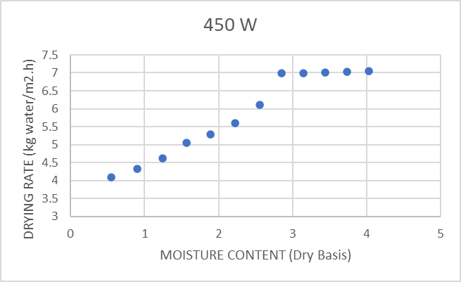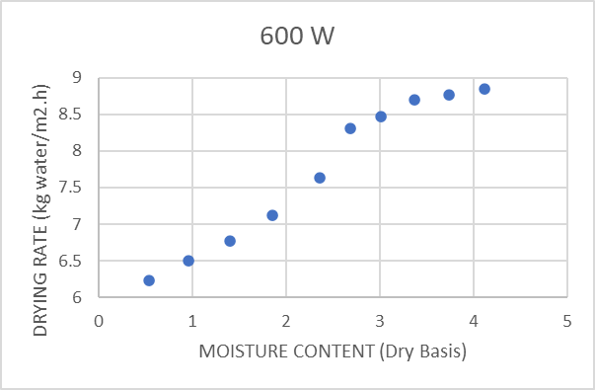

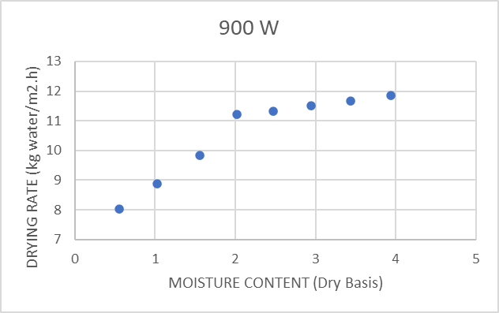

Fig 2. Variations of drying rate with moisture content at different MW power levels

At lower power levels (180 W, 300 W, 450 W), the maximum drying rate is lower than the higher power levels. For example, the maximum drying rate at 180 W and 900 W power levels are 7.312 and 11.86 kg water m⁻² s⁻¹ respectively. As the constant drying rate was lower at lower power levels, the surface moisture was removed slowly and the transfer of moisture from interior to the surface was possible for a longer drying period; and thereby the critical moisture content was comparatively lower than higher output power levels. This kinetic behaviour is characteristic of drying processes where internal moisture transfer quickly becomes the rate-limiting step. Once the surface moisture is rapidly removed, the process is reliant on the slow migration of water from the interior to the exterior surface of the slice and falling rate period is continued.
Statistical Performance of Thin-Layer Drying Models
The fit quality of the four selected thin-layer models across all five power levels was statistically evaluated. The results consistently indicated that the empirical models featuring an exponent term (Page and Modified Page) offered significantly better predictive capability than the simpler exponential models (Newton and Henderson and Pabis).

Table 3: Average Statistical Results for Thin-Layer Drying Models (180–900 W)
Model | Average R² | Average χ² | Average RMSE | Overall Fit Ranking
Modified Page | 0.9769 | 0.033913 | 0.159334 | 1 (Best R²)
Page | 0.9769 | 0.003294 | 0.048026 | 2 (Best χ² & RMSE)
Newton | 0.8824 | 0.011316 | 0.096883 | 3
Henderson and Pabis | 0.8612 | 0.011337 | 0.090092 | 4 (Worst R²)
The Page and Modified Page models achieved the highest average R2 values (0.9769), demonstrating a superior capacity to capture the moisture ratio reduction over time. While the Page model showed marginally lower average χ2 and RMSE values, the overall performance and robustness across the broad range of microwave power levels led to the selection of the Modified Page model as the most suitable descriptor for these non-linear microwave drying kinetics.
Interpretation of Optimized Model Constants in the Modified Page Model
The empirical constants derived from the best-fit Modified Page model—the drying rate constant (k) and the non-linearity exponent (n)—provide quantitative information about how the process kinetics are affected by increasing microwave power.

Table 4: Empirical Constants for the Modified Page Model
Output Power (W) | k (Min⁻¹) | n (Dimensionless) | R²
180 | 0.000588 | 1.2602 | 0.9962
300 | 0.000677 | 1.3361 | 0.9871
450 | 0.000687 | 1.3757 | 0.9723
600 | 0.001051 | 1.5481 | 0.9537
900 | 0.001594 | 1.6177 | 0.9752

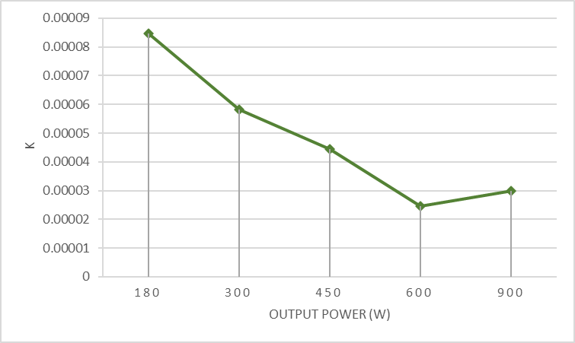

Fig.3 Effect of drying temperature on drying constant (k) in Page model.

The drying rate constant (k) exhibits a clear, monotonic increase from 0.000588min−1 at 180 W to 0.001594min−1 at 900 W. This threefold increase directly reflects the acceleration of the drying process, consistent with the observed reduction in overall drying time.
More profoundly, the exponent n consistently increased with power, ranging from 1.2602 at 180 W to 1.6177 at 900 W. In thin-layer models, an exponent n>1 signifies that the drying process deviates significantly from simple Fickian diffusion (which n=1 in the Newton model would describe) or that the drying rate is maintained over a longer duration, delaying the typical exponential decay. The steady increase in n confirms that higher microwave power fundamentally alters the shape and mechanism of moisture transfer within the sample. This volumetric heating modifies the internal pressure distribution, enhancing the diffusion mechanism and validating the Modified Page model's superior ability to represent the non-linear kinetic behavior induced by intense energy input. The necessity of this additional non-linearity parameter (n) is emphasized by the observation that the raw constant k in the standard Page model (not the Modified Page) displayed a counterintuitive decreasing trend across some power ranges, which contradicts the actual faster drying times observed. The Modified Page model, by incorporating n, correctly captures this complex, non-linear kinetic dependency on microwave power.

4. Conclusion and Future Work

Microwave drying is established as a highly efficient and rapid method for the dehydration of thin-layer banana slices, capable of reducing processing time by over 63% when operating at 900 W compared to 180 W. The microwave power level is the dominant factor controlling the drying duration, and the kinetic mechanism.
The drying kinetics across the entire power spectrum are most accurately and robustly described by the Modified Page model, yielding an exceptional average R² of 0.9769. The critical role of volumetric heating is quantitatively captured by the model's non-linearity exponent (n), which increases significantly with power, confirming that high microwave energy fundamentally alters the mass transfer dynamics within the sample.
Further research is warranted to optimize complex drying strategies. This includes investigating hybrid techniques, such as microwave-vacuum drying, which promises quality comparable to freeze-drying (Horuz & Maskan, 2025), and incorporating various pre-treatments (e.g., osmotic dehydration or acid-soaking) to enhance final product quality attributes like color stability, texture, and nutrient retention (Kumar et al., 2021).

References
1. Abdullah, G. N., El-Sebaii, A. A., & Sitohy, Z. (2014). Effect of pre drying, blanching and citric acid treatment on the quality of fried sweet potato chips. American Journal of Food Technology, 9(1), 39–48.
2. Aida, S. A., Noriza, A., Haswani, M. M., & Mya, S. M. Y. (2016). International Food Research Journal, 23(1), 68–71.
3. Dandamrongrak, R., Mujumdar, A. S., & Raghavan, V. G. S. (2002). Thin-layer drying of banana slices: Mathematical modeling and experimental investigation. Drying Technology, 20(4-5), 903–917.
4. Demir, A., et al. (2007)..
5. El-Sebaii, A. A., & Shalaby, S. M. (2012). Evaluation of mathematical models for prediction of thin-layer drying of banana slices. Journal of Food Engineering, 108(4), 634–640.
6. Elkhalifa, A. E. O., Hassan, A. M., & Abu Zeid, M. E. (2014). Analytical quality and acceptability of baked and fried banana chips. Journal of Human Nutrition and Food Science, 2(4), 1052.
7. FAO. (2023). [Global food production statistics].
8. Horuz, H., & Maskan, M. (2025). Microwave-vacuum drying of banana slices: A review of recent advancements. Journal of Food Science and Technology, XX(X), XX-XX.
9. Jabeur, O., Sahraoui, K., & Maskan, M. (2020). Statistical evaluation of thin-layer drying of banana. Journal of Hygienic Engineering and Design, 33, 145–151.
10. Kumar, P., Yadav, P., Kumar, R., & Singh, S. (2021). Effect of pre-treatments on the qualities of banana dried by two different drying methods. Foods, 10(10), 2297.
11. Luz, J. M. R., & Resende, O. (2023). Optimising a microwave assisted banana drying process. Brazilian Journal of Chemical Engineering, 40(2), 487–498.
12. Mohamed, L. A., Zohry, S. T., El-Haddad, A. M., & El-Khadrawy, W. G. (2023). Monitoring temperature profile and drying kinetics of thin-layer banana slices under controlled forced convection conditions. Applied Sciences, 13(6), 1771.
13. Nagvanshi, A., & Goswami, T. K. (2021). Development of a system to measure color in fresh and microwave dried banana slices. Journal of Food Measurement and Characterization, 15, 3450–3459.
14. Yadav, K. C., & Singh, S. (2022). Effect of hybrid drying on the quality attributes of formulated instant banana-milk powders and shakes during storage. Applied Food Research, 2(2), 100147.
15. Yaldiz, O., & Ertekin, C. (2001). Thin layer solar drying of some vegetables. Drying Technology, 19(10), 2505–2516.
16. Yıldız, A., Özgen, B., & Maskan, M. (2016). An experimental study on banana slice drying by microwave. American Journal of Food Science and Technology, 4(2), 52–59.

