THE OUTLIERS INFLUENCE ON ADEQUATENESS OF CLASSICAL AND ROBUST PATH ANALYSIS

Abstract:
Path analysis is formed from correlation and regression analysis which assumes a normal distribution. This assumption will be disturbed if there are outliers. This research aims to examine the influence of outliers on classical path analysis and robust path analysis. The data used as initial data is secondary data from BPS publications on Indikator Kesejahteraan Rakyat, Statistik Ketenagakerjaan, Statistik Indonesia, and Survei Sosial Ekonomi Nasional. This data are used to generate data with a simulation scheme for the number of samples or n (20, 30, and 100 ), percentage of outliers or p (5%, 25% and 45%) and program repetitions or u (25, 50, 75, 100, 500 and 1000). Based on the combination of 3 treatments, the percentage of adequateness models was measured based on the Wald test and then an anova test was carried out with 2-factor factorial design. The classical path analysis model is influenced by outliers but the robust path analysis model is not influenced by outliers.
Keywords: Path Analysis, Outlier, Robust Path Analysis

1. Introduction
Path analysis was first developed by a geneticist named Sewall Wright in 1921 through his article entitled Correlation and Causation. Sewall Wright developed this method to determine the direct and indirect effects of variables with some variables functioning as causes and others as effects [1]. It is called a causal correlation because it is often used to provide a causal interpretation of the statistical relationships in a data set modeling [2].
In general, path analysis is an analysis used to examine the integrated relationships between variables. This analysis is a special type of multivariate analysis, which is a method related to structured linear regression analysis with standard variables in a closed system. A closed system means that each variable in the system is a linear combination of one or several other variables which may be correlated or independent [2].
Path analysis depends on a combination of knowledge about the correlations between variables in the system and knowledge about the causal relationships between variables [3]. The more complete knowledge about causal relationships between variables, the path analysis will produce more meaningful conclusions. In the path analysis, the mechanism of the causal relationship between variables is obtained by decomposing the correlation coefficient into direct and indirect effects, so that it does not only measure the closeness, such as the correlation coefficient [4]. Therefore, path analysis can provide much more complete information than common correlation.
The relationship between the two variables is measured by the correlation coefficient. If the data are in ratio scale, the correlation coefficient used is Pearson's correlation coefficient. While the special form of the relationship of two or more variables, namely the linear effect of several independent variables on the ratio scale dependent variables is measured by Multiple Linear Regression (MLR) analysis.
Both of these classical analysis, Pearson correlation and MLR, assume that the data are normally distributed. If the data are not normally distributed, the Pearson correlation and MLR analysis is not appropriate. Violations of the normality assumption can be caused by outliers. In fact, according to Raymaekers and Rousseeuw in [5] and [6] Pearson correlation is very susceptible to outliers/anomalies data. The Ordinary Least Squares (OLS) method in regression is known to have poor performance if there are outliers in the data [7].
One way to overcome this violation is outliers removal and then parameter estimation by classical methods on data that is not contaminated with outliers [8]. However, removing outliers causes the data decreasing, which means that the information that should be obtained is also reduced. Even though outliers may contain significant information [9]. Therefore, it is necessary to examine the robust analysis of outliers that still include outliers or do not need to discard data by comparing the results. Huber and Ronchetti in [8] mention robustness signifies insensitivity to small deviation from the assumptions. This robust statistical method is between classical parametric and nonparametric methods [10]. Based on this background, the purpose of this research is to learn the influence of outliers to classical and robust path analysis.

2. Preliminaries
2.1. PATH ANALYSIS
Path analysis procedure are:
- Perform a classical path analysis (path analysis with a numerical response) using the following standard steps:
1. make a path diagram based on theory or the previous research results
2. calculate the correlation coefficient of all variables
3. compile equations based on path diagrams
4. evaluate the equations
5. evaluate the model
- Identify outliers. An outlier is an observation that seems contradictory or inconsistent with other observations [11]. Identification of outliers can be described in a boxplot. If there are n observations of y₁, y₂, ..., y_{n}. Q₁ and Q₃ respectively are the first and third quartiles of data, so according to Tukey, outliers can be detected as observations that are greater than Q₃ + 1.5 (Q₃ – Q₁) or smaller than Q₁ – 1.5 (Q₃ – Q₁). Another alternative in detecting outliers is to make a scatter plot between the variables.
- Selecting the best robust correlation and regression [12]. Robust correlation analysis are such as the median correlation estimator, MAD correlation coefficient, median correlation coefficient, and biweight mid-correlation and robust regression analysis are such as the Huber and Tukey Bisquare/Biweight estimation methods, which has a unique objective function and weighting function. The summary of the robust correlation analysis formula is as follows:

Table 1. Robust Correlation Estimator
No |  | Robust Estimator | Formula
1 | rmad |  | $$r_{MAD}=\frac{{MAD}^{2}\left(u\right)-{MAD}^{2}(v)}{{MAD}^{2}\left(u\right)+{MAD}^{2}(v)}$$
2 | bicor |  | $$bicor\left(x,y\right)=\sum_{a=1}^{m}{{\tilde{x}}_{a}{\tilde{y}}_{a}}$$
3 | rmed |  | $$r_{MED}=\frac{{med}^{2}\left(|u|\right)-{med}^{2}\left(|v|\right)}{{med}^{2}\left(|u|\right)+{med}^{2}\left(|v|\right)}$$
4 | rcomed |  | $$r_{0.5}=rcomed=\frac{med(\left(x-med\left(x\right)\right)\left(y-med\left(y\right)\right))}{MAD\left(x\right)MAD(y)}$$
Note:
- MAD(z)=med(|z-med(z)|)
- u and v are main robust variables
$u=\frac{x-med(x)}{\sqrt{2} MAD(x)}+\frac{y-med(y)}{\sqrt{2} MAD(y)}$ ; $v=\frac{x-med(x)}{\sqrt{2} MAD(x)}-\frac{y-med(y)}{\sqrt{2} MAD(y)}$
- ${\tilde{x}}_{a}=\frac{{(x_{a}-med(x))w}_{a}^{(x)}}{\sqrt{\sum_{b=1}^{m}{{[{(x}_{b}-med\left(x\right))w_{b}^{(x)}]}^{2}}} }$ ; ${\tilde{y}}_{a}=\frac{{(y_{a}-med(y))w}_{a}^{(y)}}{\sqrt{\sum_{b=1}^{m}{{[{(y}_{b}-med\left(y\right))w_{b}^{(y)}]}^{2}}} }$

The following table is robust regression methods and their characteristics [13]:

Table 2. Robust regression estimation, ojective function and weight function.
Method | Objective function | Weight function
Least-Squares ª | $$ρ_{LS}\left(e\right)=e^{2}$$ | $$w_{LS}\left(e\right)=1$$
Huber  (Huber Estimator)^{b} | $$ρ_{H}\left(e\right)=\left\{\begin{matrix}\frac{1}{2}e^{2} for |e|≤k \\ k\left|e\right|-\frac{1}{2}k^{2} for \left|e\right|>k\end{matrix}\right.$$ | $$w_{H}\left(e\right)=\left\{\begin{matrix}1 for |e|≤k \\ k/\left|e\right| for \left|e\right|>k\end{matrix}\right.$$
Tukey Bisquare  (Biweight Estimator)^{c} | $$ρ_{B}\left(e\right)=\left\{\begin{matrix}\frac{k^{2}}{6}\left\{1-{\left[1-{\left(\frac{e}{k}\right)}^{2}\right]}^{3}\right\} for |e|≤k \\ \frac{k^{2}}{6} for \left|e\right|>k\end{matrix}\right.$$ | $$w_{B}\left(e\right)=\left\{\begin{matrix}{\left[1-{\left(\frac{e}{k}\right)}^{2}\right]}^{2} for |e|≤k \\ 0 for \left|e\right|>k\end{matrix}\right.$$
ª=LM; ^{b}=RLM H; ^{c}=RLM MM
- Develop robust path analysis by modifying the standard path analysis steps in step 2, namely calculating robust correlation coefficients for all variables and steps 3 and 4 compiling and evaluating equations.
- In order to enrich the analysis and refine previous research [14] which used classical (not robust) path analysis, the development of this path analysis compares the classic and the robust one by evaluating it using the goodness-of-fit measure M₁, namely the common determination coefficient and testing the hypothesis H₀: Inadequate model vs H₁ : Adequate model with test statistic W=-(n-d) ln Q with Q=(1-M₁)/(1-M₂). Test statistic with n is the number of observations and d is the difference between the number of path coefficients in the two models [3]. In addition to testing the the goodness of fit or adequacy of several models, this model adequacy test can also be used to test the goodness of one model by assuming that M₂ = 0 and d is the number of path coefficients in that model.
2.2. SIMULATION STUDY
The secondary data is used as initial data. These characteristics of initial data are explored and then used as a basis for generating simulation data. The three factors used as treatments in the simulation include the number of samples factor (n) namely 20, 30 and 100, the outlier percentage factor (p) namely 5%, 25% and 45% and program repetitions (u) namely 25, 50, 75, 100, 500 and 1000. These three factors are hypothesized influencing the performance of classical and robust path analysis. The performance of path analysis is measured by the adequateness of path analysis model through the Wald test which produces conclusions about whether the model is adequate/inadequate. The results of the percentage of adequacy of the classic and robust path analysis models were tested using two-way analysis of variance: n and p, n and u, and p and u.
2.3. DATA
The data in this research is secondary data from BPS publications on Indikator Kesejahteraan Rakyat, Statistik Ketenagakerjaan, Statistik Indonesia, and Survei Sosial Ekonomi Nasional 2012 with coverage of 33 provinces in Indonesia. The variables in this study include economic growth as the main response variable as measured by Gross Domestic Product (GDP) per capita (X1), ratio net enrollment rate of girls to boys in primary education level (X2), ratio net enrollment rate of girls to boys in high school education level (X3), ratio of the percentage of female to male in the labor force (X4), ratio of the percentage of men who manage household (X5), mean years school (X6), urbanization level (X7), unemployment level (X8).
3. Main Results
3.1. OUTLIER IDENTIFICATION RESULT
The outlier identification result are:
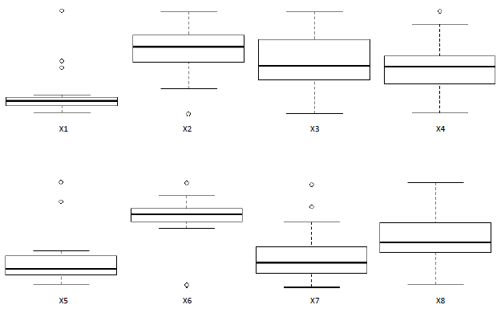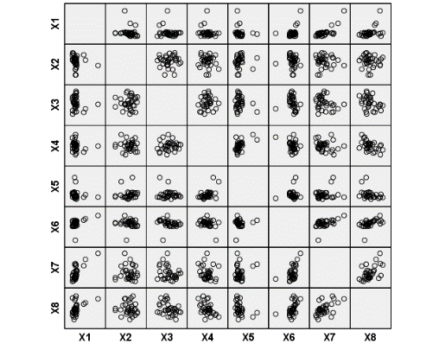
Figure 1. Outlier Detection
Table 3. Outliers Distribution in Eight Variables.
No | Code |  | Province | X₁ | X₂ | X₃ | X₄ | X₅ | X₆ | X₇ | X₈
1 | 10 |  | Kepulauan Riau | 1 |  |  |  |  |  | 1
2 | 11 |  | DKI Jakarta | 1 |  |  |  |  | 1 | 1
3 | 14 |  | DIY |  |  |  |  | 1
4 | 17 |  | Bali |  |  |  | 1 | 1
5 | 23 |  | Kalimantan Timur | 1
6 | 25 |  | Sulawesi Tengah |  | 1
7 | 32 |  | Papua Barat
8 | 33 |  | Papua |  | 1 |  |  |  | 1
 |  | Total |  | 3 | 2 | 0 | 1 | 2 | 2 | 2 | 0
Eight provinces contain at least one datum which is identified as an outlier. If the observation units detected as outliers are discarded, the data are reduced to 25. However, because robust path analysis does not need to discard outlier data, the number of data remains at 33.
3.2. CLASSICAL AND ROBUST PATH ANALYSIS RESULT
According to standard path analysis procedure, the following results and discussion are based on each step.
- Path diagram based on theory or previous research results
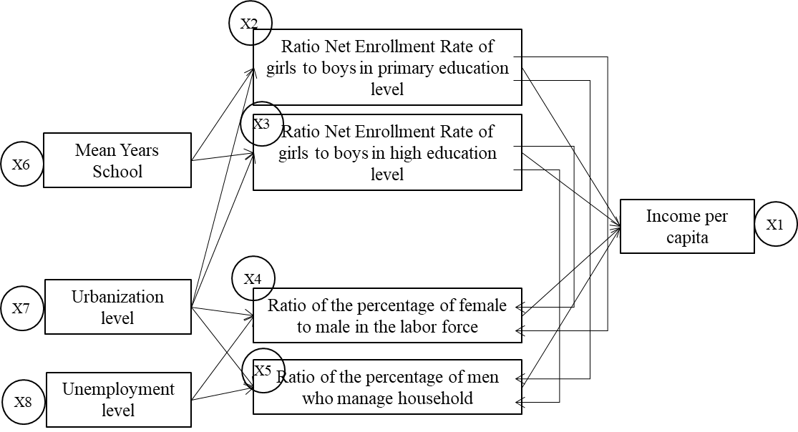
Figure 2. Path Diagram
- Regression coefficient calculation result and its evaluation
After processing the data, namely classical and robust path analysis on data contaminated with outliers, the parameter estimation results are obtained as follows:
Table 4. Regression Coefficients
No | Function | Type | Coefficients
1 | X₁=f(X₂,X₃,X₄,X₅) | Classical | -0.138 | -0.163 | -0.077 | -0.143
 |  | Robust | -0.139* | 0.070 | -0.035 | -0.002
2 | X₂=f(X₆,X₇) | Classical | -0.128 | 0.044
 |  | Robust | -0.037 | -0.095
3 | X₃=f(X₆,X₇) | Classical | -0.052 | -0.247
 |  | Robust | -0.030 | -0.282
4 | X₄=f(X₂,X₃,X₇,X₈) | Classical | -0.119 | -0.073 | 0.092 | -0.567*
 |  | Robust | -0.115 | -0.066 | 0.093 | -0.553*
5 | X₅=f(X₂,X₃,X₇,X₈) | Classical | 0.064 | -0.276* | 0.497* | -0.728*
 |  | Robust | 0.145* | -0.004 | -0.016 | -0.133
*= significants at alpha 10%
- Equations based on path diagrams
The equations are described in table 5 below:

Table 5. Regression Equations
No | Type | Equations
1 | Classical | X₁=-0.138 X₂+(-0.163) X₃+(-0.077) X₄+(-0.143) X₅
 | Robust | X₁=-0.139* X₂+(0.070) X₃+(-0.035) X₄+(-0.002) X₅
2 | Classical | X₂=-0.128 X₆+(0.044) X₇
 | Robust | X₂=-0.037 X₆+(-0.095) X₇
3 | Classical | X₃=-0.052 X₆+(-0.247) X₇
 | Robust | X₃=-0.03018 X₆+(-0.28214) X₇
4 | Classical | X₄=-0.119 X₂+(-0.073) X₃+(0.092) X₇+(-0.567*) X₈
 | Robust | X₄=-0.115 X₂+(-0.066) X₃+(0.093) X₇+(-0.553*) X₈
5 | Classical | X₅=0.064 X₂+(-0.276*) X₃+(0.497*) X₇+(-0.728*) X₈
 | Robust | X₅=0.145* X₂+(-0.004) X₃+(-0.016) X₇+(-0.133) X₈
*= significant at alpha 10%
- Model evaluation result
Hypothesis testing is used to evaluate the model (H₀ = inadequate model vs H₁ = adequate model) with test statistics . The following is the result of the calculation:

Table 6. Model Evaluation Result
No | Equations | Classical |  | Robust
No | Equations | R² | 1-R² | R² | 1-R²
1 | X₁=f(X₂,X₃,X₄,X₅) | 0.083 | 0.917 | 0.939 | 0.061
2 | X₂=f(X₆,X₇) | 0.012 | 0.988 | 0.317 | 0.683
3 | X₃=f(X₆,X₇) | 0.077 | 0.923 | 0.119 | 0.881
4 | X₄=f(X₂,X₃,X₇,X₈) | 0.260 | 0.740 | 0.046 | 0.954
5 | X₅=f(X₂,X₃,X₇,X₈) | 0.408 | 0.592 | 0.734 | 0.266
The response variable variety that can be explained by model |  | M₁ | 0.634 | M₁ | 0.991
The residuals that can not be explained by model |  | 1-M₁ | 0.366 | 1-M₁ | 0.009
The comparison of two models |  | Q | 0.366 | Q | 0.009
Statistics |  | W | 17.071 | W | 79.460
Based on table 6 it can be seen that in the classical path analysis the varaiance of X₁ that can be explained by the model is 63.4% while the remaining 36.6% can not be explained by the model. In robust path analysis, the variety that can be explained by the model is greater than the classical path analysis, which is 99.1%, while the remaining 0.9% can not be explained by the model.
The calculation results obtained W_{stst} for classical path analysis is 17,071. Because 17.071 is less than W _{table} =W;_{10%;16}= 23.54, the model is inadequate. Whereas in robust path analysis the calculation results are W_{stat} = 79,460 which is more than W _{table}. This means that the model in robust path analysis is adequate. Thus it can be concluded that robust path analysis is better than classical path analysis.
3.4. THE INFLUENCE OF n, p, AND u TO MODEL ADEQUATENESS OF CLASSICAL PATH ANALYSIS
The following are the results of a 2-way anova test on the percentage of adequacy of the classical path analysis model:

Table 7. Two Way ANOVA Result for Classical Path Analysis
Percentage (p) and Repetition (n) | p-value | Percentage (p) and Sample Size(n) | p-value | Repetition (u) and Sample Size(n) | p-value
p | .159 | p | .000 | u | .862
u | .987 | n | .000 | n | .000ª
p*u | .999 | p*n | .002 | u*n | .833
Based on the table above, it can be concluded that there is no interaction between p and u, there is interaction between p and n and there is no interaction between u and n (there is a significant difference in the main factor n). The existence of interactions between p and n can be explained in the following graph:

Figure 3. The Adequateness of Classical Path Analysis
Based on the graph above, the adequateness of the classical path analysis model decreases as the number of samples increases. In data with a sample size of 20 (small sample size), the adequateness of the model tends to be the same as in data with outlier percentage of 5%, 25% and 45%. However, in data with sample sizes of 30 and 100 (large sample sizes), the adequateness of the model tends to be different and increases as the percentage of outliers in the data increases. This shows the instability of the adequateness of the classical path analysis model due to the presence of outliers in the data.
Further explanation of the absence of interaction between u and n and that there is a significant difference in the main factor n is shown by the significant difference test in the table below:

Table 8. The Result of Model Adequateness Mean Difference Test on Sample Size(n) Factorª
Sample Size | Mean Difference | p-value
20 and 30 | .153278* | .009
20 and 100 | .512389* | .000
30 and 100 | .359111* | .000
Based on this table, it can be concluded that there is significant difference of classical path analysis model adequateness on sample size 20, 30 or 100. The percentage of model adequateness is decreasing as the number of samples increasing.
3.5. THE INFLUENCE OF n, p, AND u TO MODEL ADEQUATENESS OF ROBUST PATH ANALYSIS
The following are the results of a 2-way anova test on the percentage of adequacy of the robust path analysis model:
Table 9. Two Way ANOVA Result for Robust Path Analysis
Percentage (p) and Repetition (u) | p-value | Percentage (p) and Sample Size(n) | p-value | Repetition (u) and Sample Size(n) | p-value
p | .037^{b} | p | 0.037^{c} | u | 0.358
u | .233 | n | 0.158 | n | 0.227
p*u | .202 | p*n | 0.124 | u*n | 0.772

Based on the table above, it can be concluded that there is no interaction between p and u (there is significant difference in the main factor p), there is no interaction between p and n (there is a significant difference in the main factor p) and there is no interaction between u and n. The absence of interaction between p and n can be explained in the following graph:

Figure 4. The Adequateness of Robust Path Analysis
Based on the graph above, the adequateness of the robust path analysis model is relatively very stable. The model adequateness is slightly different but the value is 0.998 (still close to 1) in a small sample size (20 samples) and 5% outliers. This shows that robust path analysis is adequate to use on small or large sample data with any percentage of outliers (5%, 25% or 45%).
The existence of significant difference in the main factor p is shown by significant difference test in the table below:
Table 10. The Result of Model Adequateness Mean Difference Test on Outlier Percentage Factor (p) ^{b,c}
Outlier Percentage | Mean Difference | p-value
5% and 25% | -.000889* | .026
5% and 45% | -.000889* | .026
25% and 45% | .000000 | 1.000

Based on this table, it can be concluded that there is significant difference in the percentage of robust path analysis models adequateness on 5% vs 25% and 5% vs 45% outlier percentages with the percentage of model adequateness being higher at the larger percentage of outliers.. Meanwhile, the percentages of 25% and 45% do not show a real difference.

CONCLUSION
The classical path analysis model is influenced by outliers but the robust path analysis model is not influenced by outliers.

References
[1] Wright, S., Path Coefficient and Path Regression: Alternative or Complementary Concepts, Biometrics, 16:183-202, 1960.
[2] Li, C.C., The Concept of Path Analysis and Its Impact on Gopulation Genetics, Biometrics, 12:190-209, 1956.
[3] Dillon, W.R. & Goldstein, M., Multivariate Analysis Methods and Application, John Wiley & Sons Inc., New York, 1984.
[4] Grovois, K. A. & Helms, R. S., Path Analysis of Rice Yield Component as Affected by Seeding Rate, J, Agr, 84:1-4, 1992.
[5] Raymaekers, J. & Rousseeuw, P.J., Fast Robust Correlation for High Dimensional Data, 2018.
[6] Rousseeuw, P.J. & Yohai, V.J., Robust Regression by Means of S-Estimators, Robust and Nonlinear Time Series Analysis (J. Franke, W. Hardle adnd R.D. Martin, eds.), pp. 256-272, Springer, New York, 1984.
[7] Ozdemir, S. & Arslan, O., Combining Empirical Likelihood and Robust Estimation Methods for Linear Regression Models, 2018.
[8] Huber P.J. & Ronchetti E.M., Robust Statistics, 2nd edition, Wiley, 2009.
[9] Neter, J., Wasserman, W. & Kutner, M.H., Applied Linear Regression Models, 2nd edition, Irwin, 1989.
[10] Shevlyakov, G.L. & Oja, H., Robust Correlation: Theory and Applications, Wiley, 2016.
[11] Barnett, V. & Lewis, T., Outliers in Statistical Data, John Wiley, 1994.
[12] Lestari, F.C., Notodiputro, K.A. & Sadik, K., Comparison of Classical and Robust Correlation and Regression Analysis in the Study of Determinants of Gender Gaps in Education and Employment and Their Impact on Economic Growth in Indonesia in 2014, National Conference on Mathematics, Brawijaya University, 2018.
[13] Fox, J. & Weisberg, S., Robust Regression in R, An Appendix to an R Companion to Applied Regression, 2nd Edition, 2010.
[14] Usman, H., Lestari, F.C., Gender Equality and Economic Development, International Conference on Social and Political Issues (ICSPI), Volume 2018, Universitas Indonesia, 2016.

