EFFECT OF FLY ASH AND PALM FIBRE ON THE PROPERTIES OF COMPRESSED EARTH BLOCKS

Abstract
The global population growth and escalating cost of building materials have resulted in a global housing deficit. There has also been a growing concern about environmental and ecological issues across the globe. This has necessitated continuous research and development of affordable and eco-friendly building materials for low- and middle-income earners. This research evaluated the effect of fly ash and palm fibre on the density and compressive strength of compressed earth blocks. Fly ash was used to stabilize laterite at 0%, 2.5%, 5%, 7.5% and 10% while palm fibre was fixed at 1% by weight of laterite. The blocks were cured for 28 days after which they were tested. The results obtained indicate that the addition of fly ash in the matrix increased the density and compressive strength of the blocks. The blocks produced with fly ash in the matrix meet the minimum compressive strength requirements for lateritic blocks as specified by the Nigeria Building and Road Research Institute. An optimum stabilization of laterite with 7.5% fly ash and 1% palm fibre by weight of laterite is recommended.
Keywords: palm fibre; compressed earth blocks; fly ash; compressive strength; density
Introduction
The provision of shelter is important as shelter is one of the basic needs of man. The global population growth has resulted in an increased demand for infrastructure. There has also been an escalation in building and construction materials prices. The major cost of construction is incurred on building materials and most of these building materials are cement products. The ever-rising increase in the price of cement and other construction materials has made construction far from reach to low- and middle-income group urban and rural dwellers [1]. This has made building houses expensive and challenging for low-income earners (mostly peasant farmers) across the globe especially in sub-Saharan Africa. Environmental and ecological issues due to climate change have also been at the fore in recent global discussions [2]. This has necessitated continuous research efforts to develop affordable, eco-friendly housing building materials.
Earth is the oldest known building material. More than 30% of the global population makes use of the earth for the construction of shelter. Numerous ancient buildings constructed using earth materials still stand strong and rigid. The use of earth for construction has been a common practice in most rural areas in Nigeria. Adobes and rammed earth are the common earth blocks used, with straw sometimes incorporated into the matrix. The energy crisis, environmental, and ecological issues have brought earth back to the fore as a building material after it fell out of popularity [2-4].
Earth as a building material has numerous benefits among which are its safety, cost-effectiveness, faster and easier construction with less skilled labour required, good strength development, good acoustic and thermal properties, energy efficiency (less carbon emission and embodied energy during production), no direct environmental pollution during its life cycle, low waste generation, environmentally friendly [5,2,1,6-7,4].
In recent times, compressed earth blocks (CEB) have replaced the traditional earth blocks. Earth naturally lacks strength, dimensional stability and durability for building construction. These drawbacks can be overcome through the stabilization of earth by mechanical means (compaction), the addition of chemicals (such as cement, lime, bitumen, fly ash, etc.) and fibres [8]. The same applies to earth block production. The blocks produced with the addition of stabilizers have been commonly termed compressed stabilized earth blocks. CEBs are an improvement on the traditional earth block production technique as standardized procedures/quality control measures have been incorporated into their production process.
The effect of various stabilizers on the properties of CEBs has been investigated by researchers, some of which are: cement and lime [9,3], palm fibre [10] banana fibre [11-12], sugarcane bagasse [13], coconut fibre [14], volcanic tuff [15], corn cob ash [16], clay pozzolana [17], cement and wood ash [18], cement, rice husk ash and saw dust ash [7]. The current study investigated the effect of fly ash and oil palm fibre on the properties (density and compressive strength) of CEBs.
The use of coal in power plants and industries in Nigeria and globally result in the emission of carbon dioxide (CO₂) and the disposal of coal combustion products (CCP) in the environment. The emission of CO₂ and disposal of these CCPs in the environment contribute to the ozone layer depletion, global warming and environmental pollution which are hazardous to humans. Fly ash (FA) is the most widely used CCP in the construction industry due to its functional benefits such as providing substitutes for energy intensive materials and the provision of options for lower embedded carbon [19-22]. Nigeria is one of the largest producers of palm oil globally, with an estimated production of 1.4 million metric tons in the year 2022. This makes waste oil palm fibre (PF) readily available in most parts of Nigeria [23-25].
The use of FA and PF as construction materials would therefore lead to improved environmental waste management and profitable utilization of industrial and agricultural wastes. The current study investigated the effect of fly ash and oil palm fibre on the properties (density and compressive strength) of CEBs.
Materials and Methods
Laterite
The soil (reddish-brown laterite) used for this research was obtained from an existing borrow pit at Akpataega, Idah, Kogi State, Nigeria, at a depth of ~1.5m free from organic matter and deleterious materials. The soil index/geotechnical properties were determined in accordance with BS 1377 [26] to classify the soil. The soil test was carried out at the Soil Mechanics Laboratory, Department of Civil Engineering, The Federal Polytechnic, Idah, Kogi State. The results of the sieve analysis and the soil index/geotechnical properties are presented in Table 1 and Table 2 respectively, while Figure 1 shows the particle size distribution curve.
Table 1: Sieve analysis of the lateritic sample
Sieve opening (mm) | 4.750 | 2.000 | 0.850 | 0.600 | 0.425 | 0.250 | 0.106 | 0.075 | pan
Percentage passing (%) | 99.6 | 61.5 | 34.7 | 25.0 | 12.7 | 7.9 | 4.9 | 3.3 | -

Figure 1: Particle size distribution curve
Table 2: Geotechnical properties of the soil
TEST | RESULT
Specific gravity (%) | 2.61
% passing BS 200 sieve (0.075mm) | 3.3
Natural moisture content (%) | 10.8
Maximum dry density (kg/m³) | 2066.38
Optimum moisture content (%) | 10.6
Condition of sample | Air dried
Liquid limit (%) | 29
Plastic limit (%) | 23
Plasticity index (%) | 6
Coefficient of curvature | 1.98
Coefficient of uniformity | 8.82
USCS classification | ML (silty and clayey fine sand)
ASSHTO classification | A-2-4

Fly ash
The Fly Ash used was sourced from Cinafindev Ltd., (a cement manufacturing plant) in Allo, Kogi state. The fly ash was sieved using sieve No. 200 to obtain fine particles. The colour of the fly ash is dark grey with a specific gravity of 2.6.
Palm Fibre
The Palm fibre used for this research is the mesocarp of oil palm fruits (palm fruit bunch). It was obtained from Ogbogbo town in Idah, Kogi state. The fibre was washed with warm water to remove oil and dirt, and sun-dried before it was used. Figure 2 shows a photograph of the palm fibre used. Some of the physical and mechanical properties of the palm fibre used are presented in Table 3.
Figure 2: Photograph of palm fibre used
Table 3: physical and mechanical properties of palm fibre used
Parameter | Value
Length | 26-53 mm
Radius | 0.15-90 mm
Density | 524N/mm²
Tensile strength | 76N/mm²
Young’s modulus | 495N/mm²
Elongation at break | 18

Water
Fresh, colourless, odourless and tasteless potable water that is free from injurious amounts of oils, alkalis, salts, sugar organic matter or any other substances, was used for this research.
Mixture Proportioning and Moulding of Blocks
The soil was stabilized with fly ash proportions of 0%, 2.5%, 5.0%, 7.5% and 10% by weight of laterite and a constant palm fibre proportion of 1% by weight of laterite for each mix. The palm fibre content was fixed at 1% as various researchers [10-14, 27-30] recommend an optimum fibre content ranging from 0.5% to 1%. The mix proportion of the specimens are presented in Table 4. Block specimens of size 200 mm x 100 mm x 100 mm were moulded from the stabilized lateritic soil samples. A total of 15 blocks were moulded with three blocks for each set of mix and compaction was done in accordance with BS 1377 [26]. Mixing of the materials, moulding and compaction of the blocks was carried out manually. The freshly moulded blocks were carefully extruded in good shape on a clean, hard and flat surface after which they were left to cure under a shade for 28 days. Water was sprayed on the blocks once every morning and evening for the 28-day curing period. Figure 3 shows the freshly moulded blocks.
Table 4: Mix proportion of the specimen
Mix ID | Fly Ash  (Kg/m³) | Palm Fibre  (Kg/m³) | Laterite  (Kg/m³)
F1 (control) | 0 | 0.125 | 12.375
F2 | 0.3125 | 0.125 | 12.0625
F3 | 0.625 | 0.125 | 11.75
F4 | 0.9375 | 0.125 | 11.4375
F5 | 1.25 | 0.125 | 11.125

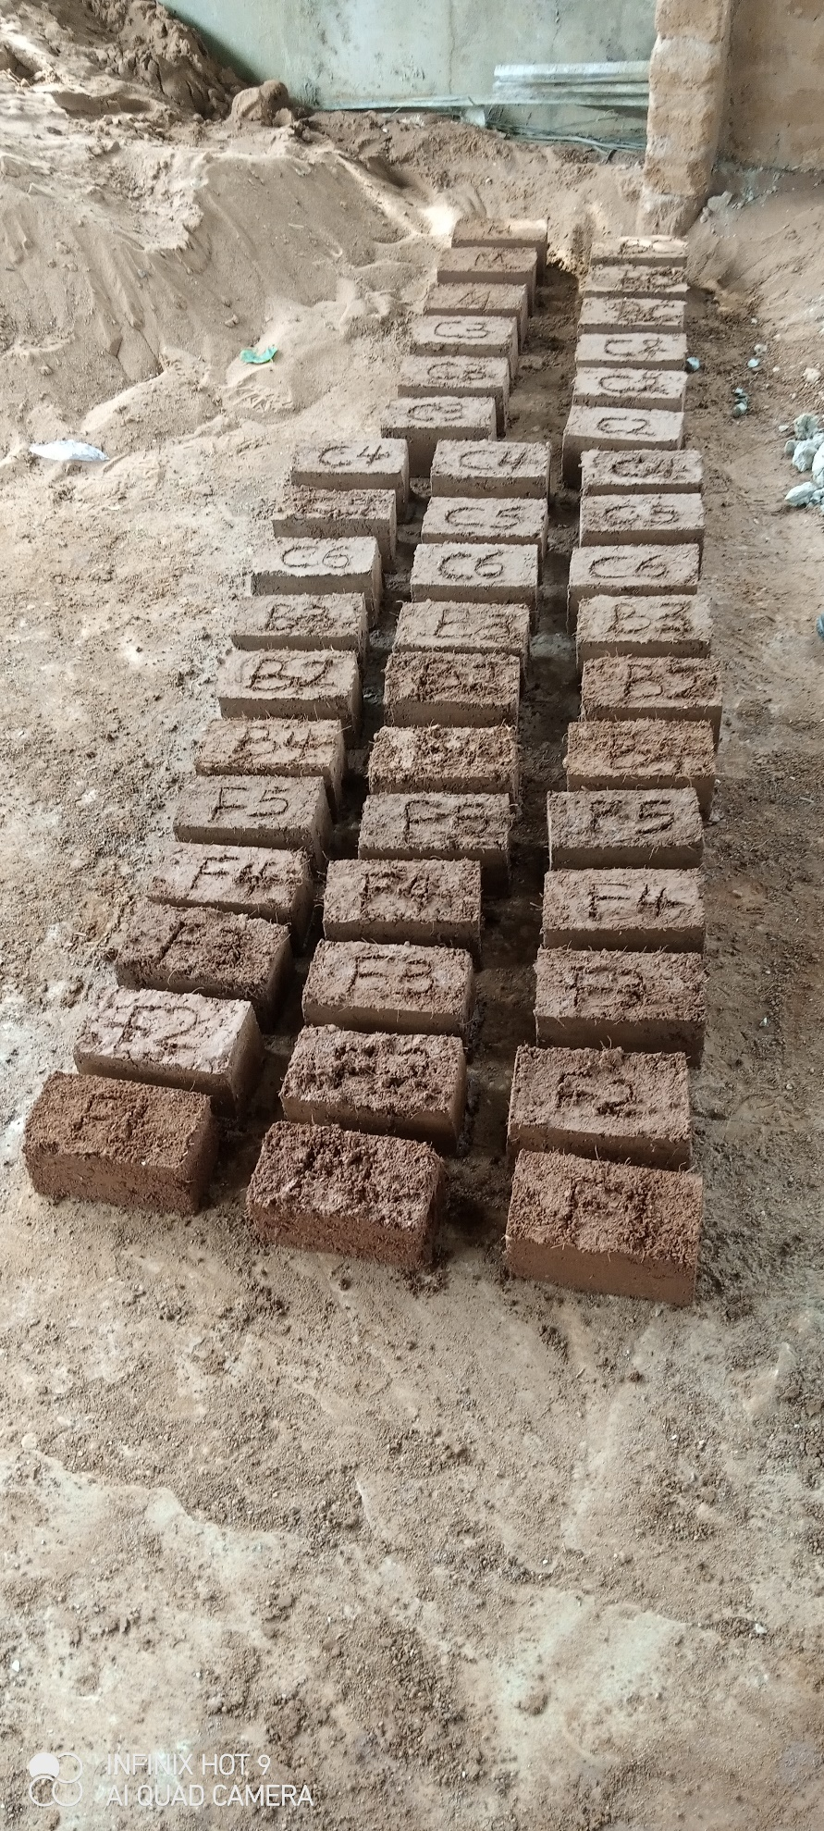
Figure 3: Photograph showing freshly moulded block specimen
Results and Discussions
Density of Blocks
The density of the specimen was determined in accordance with BS EN 771-1 [31]. Three blocks from each mix ratio were selected for the test. Their volumes were calculated and weighed and then the density was calculated.
The results of the average density of the blocks are presented in Table 4 and Figure 4 respectively. From the results obtained, it is observed that the addition of fly ash (from 2.5-10%) to the matrix led to a significant increase in the density of the blocks as compared with the control mix. This increase in the density can be attributed to the fact that fly ash has a filler and cementitious effect which reduces voids in the matrix corroborating the findings of Ahmed [32] and ACAA [21].
Table 5: Average density of compressed stabilized earth blocks
Mix ID | Fly Ash (%) | Palm Fibre (%) | Average Density (Kg/m³) | Change in Density (%)
F1 (control) | 0.0 | 1 | 1766.70 | 0.00
F2 | 2.5 | 1 | 2023.30 | 14.52
F3 | 5.0 | 1 | 2060.00 | 16.60
F4 | 7.5 | 1 | 2076.70 | 17.55
F5 | 10.0 | 1 | 2060.00 | 16.60

Figure 4: Average density of compressed stabilized earth blocks
Compressive Strength
The compressive strength tests of the specimens were carried out in accordance with BS EN 771-1 [31] and BS EN 12390-4 [33]. Three samples of each of the stabilized laterite blocks were crushed in a compression testing machine with metal plates placed above and below the block (see Figure 5). The load was then placed axially and uniformly until failure occurred. The maximum failure load on the brick was measured. This load divided by the cross-sectional area of the block gave the compressive strength of the block.
The results obtained from the compressive strength test are presented in Table 5 and Figure 6 respectively. The compressive strength of the blocks had a similar trend to the density. The addition of fly ash (from 2.5-10%) to the matrix resulted in a significant increase in the compressive strength of the blocks as compared with the control mix. The increase in the compressive strength can be attributed to the pozzolanic nature of the Fly Ash. Fly Ash present in the compressed stabilized earth block acts as a binder as it aids particle parking and reduces the void between the particles of the soil, thereby increasing the density of the blocks and leading to an increase in compressive strength corroborating the findings of Ahmed [32] and ACAA [21]. The addition of fly ash beyond 7.5% to the matrix resulted in a decrease in compressive strength.
The blocks produced with fly ash in the matrix meet the minimum compressive strength requirements of 1.65 N/mm² for lateritic blocks as specified by the Nigeria Building and Road Research Institute [34].
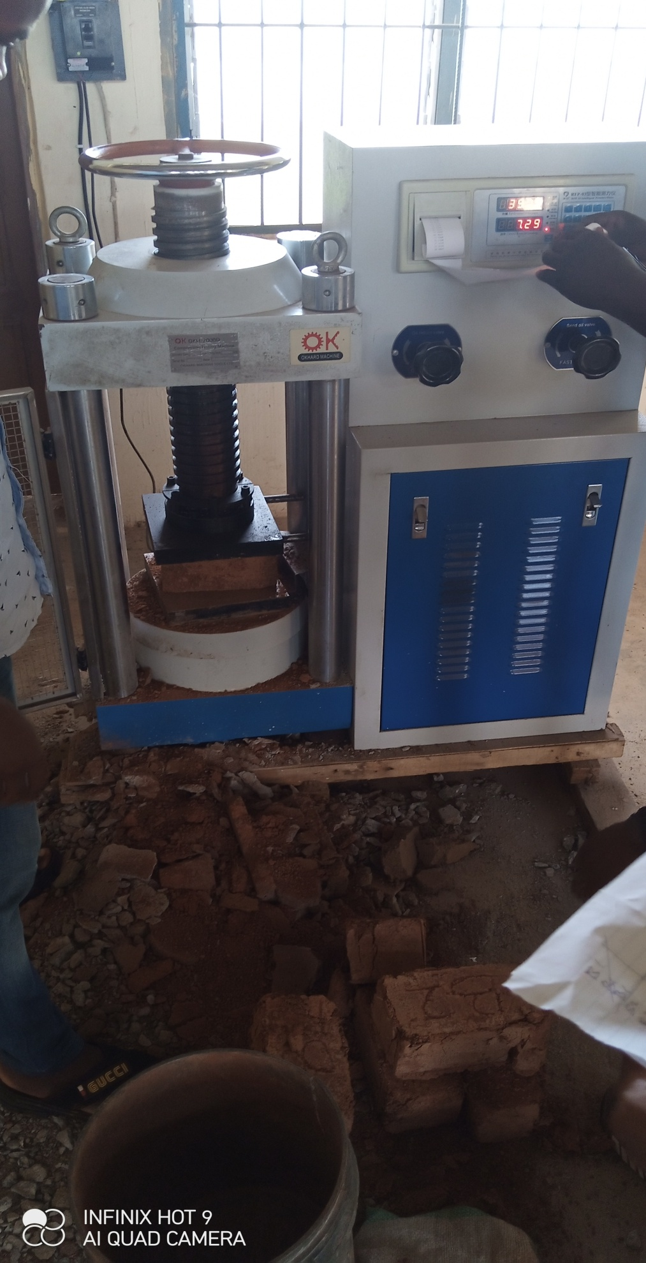
Figure 5: Specimen being tested for compression
Table 6: Average compressive strength of compressed stabilized earth blocks
Mix ID | Fly ash (%) | Palm fibre (%) | Average compressive strength (N/mm²) | Change in Compressive Strength (%)
F1 (control) | 0.0 | 1 | 1.31 | 0.00
F2 | 2.5 | 1 | 1.71 | 30.53
F3 | 5.0 | 1 | 2.04 | 55.73
F4 | 7.5 | 1 | 2.34 | 78.63
F5 | 10.0 | 1 | 2.30 | 75.57

Figure 6: Average compressive strength of compressed stabilized earth blocks
Conclusion
in this research, compressed earth blocks stabilized with fly ash (0-10%) and palm fibre (1%) by weight of laterite were produced and tested for their densities and compressive strengths after 28 days of curing. Mixing of the materials, moulding and compaction of the blocks was carried out manually. The addition of fly ash at 2.5%, 5%, 7.5% and 10% into the matrix resulted in a 14.52%, 16.60%, 17.55% and 16.60% density increase respectively when compared with the control mix. There was also a 30.53%, 55.73%, 78.63% and 75.57% increase in the compressive strength of the blocks when fly ash was added to the matrix at 2.5%, 5%, 7.5% and 10% respectively. All blocks produced with fly ash in their matrix meet the minimum compressive strength requirement of NBRRI. An optimum stabilization of 7.5% fly ash and 1% palm fibre by weight of laterite is recommended.
From the findings of this research, the use of fly ash and palm fibre in the production of compressed earth blocks (CEBs) will promote the profitable utilization of agricultural and industrial wastes, help reduce the pollution caused by the disposal of these materials in the environment, improve the strength of CEBs, and promote the use of CEBs for affordable housing.
References
- Harper, D., Alternative Materials of Stabilisation for Unfired Mud Bricks. 2011, retrieved from https://vdocuments.mx/download/alternative--methods-of-stabilisation-for-unfired-mud-bricks.html
- Riza, F. V., Rahman, I. A. and Zaidi, A. M. A., A brief review of compressed stabilized earth brick (CSEB). International Conference on Science and Social Research (CSSR 2010), Kuala Lumpur, Malaysia, December 5-7, 2010 pp. 999-1004. https://dx.doi.org/10.1109/CSSR.2010.5773936
- Olutoge, F. A., Booth, C. A., Olawole, S. O. A. and Alebiosu, O. A., Lateritic Cement- and Lime-Stabilized Bricks and Blocks for Affordable Housing. Proceedings of the Institution of Civil Engineers – Construction Materials. 171 (5), 2017, pp. 195-202. https://doi.org/10.1680/jcoma.16.00062
- Subramanian, G. K. M., Balasubramanian, M. and Kumar, A. A. J., A Review on the Mechanical Properties of Natural Fiber Reinforced Compressed Earth Blocks. Journal of Natural Fibers. 19(14), 2022, pp. 7687-7701, https://doi.org/10.1080/15440478.2021.1958405
- Adam, E. A. and Agib, A. R. A., Compressed Stabilized Block Manufacture in Sudan. United Nations Educational, Scientific and Cultural Organization, Paris, France. 2001.
- Pacheco-Torgal, F. and Jalali, S., Earth Construction: Lessons from the Past for Future Eco-Efficient Construction, Construction and Building Materials, 29, 2012, pp. 512-519. https://doi.org/10.1016/j.conbuildmat.2011.10.054
- Okere, C. E., Strength Property of Laterite Blocks Made with Different Pozzolanic Materials. NIPES Journal of Science and Technology Research. 2(2), 2020, pp. 152-157. https://doi.org/10.37933/nipes/2.2.2020.15
- Walker, P. J., Strength, Durability and Shrinkage Characteristics of Cement Stabilised Soil Blocks. Cement and Concrete Composites. 17(4), 1995, pp. 301-310. https://doi.org/10.1016/0958-9465(95)00019-9
- Nagaraj, H. B., Sravan M.V., Arun T.G. and Jagadish K.S., Role of Lime with Cement in Long-Term Strength of Compressed Stabilized Earth Blocks. International Journal of Sustainable Built Environment. 3(1), 2014, pp. 54-61. https://dx.doi.org/10.1016/j.ijsbe.2014.03.001
- Onugba, M. A., Omisande, L. A., Alhassan, Y. A. & Abdullahi, A. O. Enhancing Earth-based Building Materials: Effect of Palm Fibre Reinforcement on Compressive Strength. Journal of Engineering Research and Reports, 25(11), 2023, pp. 55-63 https://doi.org/10.9734/JERR/2023/v25i111020
- Mostafa, M and Uddin, N., Effect of Banana Fibers on the Compressive and Flexural Strength of Compressed Earth Blocks. Buildings, 5(1), 2015, pp. 282-296. https://doi.org/10.3390/buildings5010282
- Mostafa, M and Uddin, N., Experimental Analysis of Compressed Earth Block (CEB)with Banana Fibers Resisting Flexural and Compression Forces. Case Studies in Construction Materials, 5 2016, pp. 53–63. https://dx.doi.org/10.1016/j.cscm.2016.07.001
- Danso, H., Martinson, D. B., Ali, M., and Williams, J. B., Effect of Sugarcane Bagasse Fibre on the Strength Properties of Soil Blocks. Academic Journal of Civil Engineering, 33(2), 2015, pp. 251-256. https://doi.org/10.26168/icbbm2015.38
- Thanushan, K., Yogananth, Y., Sangeeth, P., Coonghe, J. G., and Sathiparan, N., Strength and Durability Characteristics of Coconut Fibre Reinforced Earth Cement Blocks. Journal of Natural Fibers. 18(6), 2021, pp. 773-788. https://doi.org/10.1080/15440478.2019.1652220
- Edris, W. F., Jaradat, Y., Al Azzam, A. O., Al Naji, H. M. and Abuzmero, S. A., Effect of Volcanic Tuff on the Engineering Properties of Compressed Earth Block. Archives of Materials Science and Engineering. 106(1), 2020, pp. 5-16. https://doi.org/10.5604/01.3001.0014.5928
- Oyebisi, S. O., Olutoge, F. A., Ofuyatan, O. M. and Abioye, A. A., Effect of Corncob Ash Blended Cement on the Properties of Lateritic Interlocking Blocks. Progress in Industrial Ecology – An International Journal. 11(4), 2017, pp. 373-387, https://doi.org/10.1504/PIE.2017.092729
- Danso, H. and Adu, S. Characterization of Compressed Earth Blocks Stabilized with Clay Pozzolana. Journal of Civil and Environmental Engineering. 9(331), 2019, pp. 1-6
- Olutoge, F. A. and Oladunmoye, O. M., An Investigative Study on the Water Absorption Rate of Laterite Bricks Stabilised with Cement and Wood Ash. International Journal of Civil Engineering and Technology. 8(7), 2017, pp. 13-22
- Harris, D., Heidrich, C., & Feuerborn, J., Global aspects on coal combustion products, 2019, retrieved from https://www.coaltrans.com/insights/article/global-aspects-on-coal-combustion-products, accessed on May 11, 2022
- Vilakazi, A. Q., Ndlovu, S., Chipise, L., Shemi, A., The recycling of coal fly ash: a review on sustainable developments and economic considerations. Sustainability, 14(1958), 2022, pp.1-32; https://doi.org/10.3390/su14041958
- ACAA. Fly Ash Facts for Highway Engineers. American Coal Ash Association, 2003. Retrieved from https://www.fhwa.dot.gov/pavement/recycling/fach07.cfm
- Alhassan, Y. A., Onugba, M. A., Andrew, E. O., & Eze, D. C., Experimental study on the effect of fly ash on concrete, IOSR Journal of Mechanical and Civil Engineering. 19(3), 2022, pp. 40-45, https://doi.org/10.9790/1684-1903034045
- Biodun, M. B., Akinlabi, E. T., Okokpujie, I. P. & Fayomi, O. S. I., An overview of palm oil production processing in Nigeria: A case study of Ilashe, Nigeria. IOP Conference Series: Materials Science and Engineering. 1107(012134), 2021, pp. 1-11, https://doi.org/10.1088/1757-899X/1107/1/012134
- PWC, X-raying the Nigerian palm oil sector. Price Waterhouse Coopers Ltd., 2019, retrieved from https://www.pwc.com/ng/en/publications/x-raying-the-nigerian-palm-oil-sector.html accessed on 14 July, 2023
- Sasu, D. D., Production of palm oil in Nigeria 2009-2022, 2022, retrieved from https://www.statista.com/statistics/1134494/production-of-oil-palm-in-nigeria/ accessed on 14 July, 2023
- BS 1377. Methods of Testing Soils for Civil Engineering Purposes. British Standards Institution, London, 1990
- Onugba, M. A., Ogbaje, D. J., Atonu, Y. A., Uche, B. C., & Adeniyi, D. A., Effect of palm fibre on compressed cement-stabilized earth blocks. Journal of Management and Technology, 19(1), 2023, pp. 356-365
- Donkor, P., Obonyo, E., & Ferraro, C., Fiber reinforced compressed earth blocks: evaluating flexural strength characteristics using short flexural beams. Materials, 14(22), 6906, 2021, https://doi.org/10.3390/ma14226906
- Latha, A. T., Murugesan, B., & Thomas, B. S., Compressed earth block reinforced with sisal fiber and stabilized with cement: Manual compaction procedure and influence of addition on mechanical properties. Materials Today: Proceedings, 2023, https://doi.org/10.1016/j.matpr.2023.04.373
- Alene, T. E., Mohammed, T. A., & Gualu, A. G. Use of sisal fiber and cement to improve load bearing capacity of mud blocks. Materials Today Communications, 33, 104557, 2022, https://doi.org/10.1016/j.mtcomm.2022.104557
- BS EN 771-1. Specification for Clay Masonry Units. Clay Masonry Units. British Standards Institution, London, 2003
- Ahmed, A. G. A., Fly Ash Utilization in Soil Stabilization. International Conference on Civil, Biological and Environmental Engineering (CBEE-2014), Istanbul, Turkey, May 27-28, 2014, pp. 76-78. https://dx.doi.org/10.15242/IICBE.C514601
- BSI 12390-4. Testing Hardened Concrete. Compressive Strength – Specification for Compression Testing Machines. British Standards Institution, London, 2019
- Nigeria Building and Road Research Institute (NBRRI). NBRRI Interlocking Block Making Machine. NBRRI Newsletter 1(1), 2006, pp. 15-17

