A Survey on Polycystic Ovarian Disorder (PCOD) among the hostel girls of MMDU Mullana, Ambala. Haryana,India

Abstract

The aim to present this study was to assess the most affected age group of girls from PCOD and to make them aware by our questionnaire in this descriptive study, 200 girls were selected randomly from hostels of MMDU, MULLANA. A questionnaire was formulated to obtain information regarding symptoms, changes, dietary patterns, etc. This data was differentiated, tabulated, and tested. The data collected shows that the majority of the respondents who participated in the survey were on the edge of PCOD.
Stein and Leventhal are regarded to have been the first investigators of polycystic ovary syndrome however, in 1721 Vallisneri, an Italian scientist; he described a married, infertile woman with shiny ovaries with a white surface, and the size of pigeon eggs. It was not until early 1990 at a national institute of Health (NIH) sponsored conference on PCOD that formal diagnostic criteria were proposed and afterward largely utilized. Many scientists tried to explain the path physiology of PCOD and many studies were made. It is now accepted that it is multifactorial, partly genetic, however, a number of candidate genes have been postulated. Insulin resistance has been noted consistently among many women with PCOD, especially in those with Hyperandrogenism, but it is not included in any of the diagnostic criteria. Now there is strong evidence that cardiovascular diseases risk factors and disturbances in carbohydrate metabolism are all increased in patients with PCOD compared to healthy populations. The criteria was established by a group of experts during a conference in ROTTERDAM held in 2003 are obligatory. The subsequent ROTTERDAM CRITERIA incorporated the size and morphology as determined by an ultrasound, of the ovary into the diagnostic criteria. Centre for Disease Control and Prevention, obesity among children in the U.S. has tripled since 1980 due to various factors like bad eating habits, and lack of physical exercise, and many more children are getting more and more obese. Many researchers have found that PCOD findings are increasing with time. Finding insulin resistance in obese adolescents gave different diagnosis of PCOD. Upon further clinical testing, many other symptoms are found like Hirsutism, acne, and menstrual abnormalities.
Emans (2005) described PCOD as a diagnosis related to the diagnosis of insulin resistance, not being overweight. For insulin resistance, females don't need to be overweight they will have insulin resistance even a normal weight female adolescents also have insulin resistance.
Keywords: PCOD, PCOS, Menstrual abnormalities

INTRODUCTION

The term Polycystic Ovarian Syndrome (PCOD) was first described by IRVING STEIN and MICHAEL LEVENTHAL as a triad of AMENORRHOEA, OBESITY, and HIRSUTISM in 1935 When they observed the relationship between obesity and reproductive disorders. It is hence known as the STEIN –LEVENTHAL SYNDROME or HYPERANDROGENIC ANOVULATION (HA)
and is the most common endocrine ovarian disorder affecting approximately 2-8% of women of reproductive age worldwide. Nowadays it is also referred to as SYNDROME-O (over- nourishment), overproduction of insulin, ovarian confusion, and Ovulatory Disruption. So PCOD is called POLYCYSTIC OVARIAN SYNDROME. PCOD is currently considered a lifestyle disorder affecting 2.2-2.6% of young girls their reproductive age in INDIA. it is primarily characterized by an extremely irregular menstrual cycle in which ovulation may not occur. Normal pubertal events include OLIGOMENORRHOEA, HIRSUTISM, ACNE, and WEIGHT GAIN.
PCOS causes the associated problems because polycystic ovaries are unable to produce the normal levels of hormones required to release one egg at ovulation each month. Multiple cysts start to develop as normal at the beginning of the cycle, but none of them reach the critical size needed for ovulation. Therefore progesterone is not produced and a bleed does not occur the cysts formed also produced excessive amounts of male hormone.
THE COMMON ASSOCIATED PROBLEMS WITH PCOS ARE:

- IRREGULAR PERIODS
- ACNE
- OBESITY
- HIGH BLOOD PRESSURE
- HIGH CHOLESTEROL
- TYPE 2 DIABETES
PCOS is a common disorder, often complicated by chronic ANOVULATORY infertility and HYPERANDROGENISM with the clinical manifestation of OLIGOMENORRHOEA, HIRSUTISM, and ACNE. Many women with this condition are obese and have a higher prevalence of impaired glucose tolerance, type 2 Diabetes, and sleep APNEA than is observed in the general population.
It is possible to identify the early clinical manifestation of PCOS in late puberty and early adolescence. Diseases are on the rise because of lifestyle and environmental changes occurring with modernization. Initially, the condition is asymptomatic in young women, progressing to produce menstrual irregularities; eventually, in late middle age, it leads to several health hazards. Given this and in fact, the prevalence of this syndrome in our community remains unknown.
It is important to try and control PCOS at a younger age to prevent the development of future problems. It is important to treat all the symptoms and not just focus on one such as trying for a baby. Regular diabetes testing should be done. The importance of a healthy diet, regular exercise and not smoking cannot be underestimated in trying to prevent the above-mentioned problems.

OBJECTIVES:
- To Identify the girls who are at high risk of PCOD.

- To Find the association between PCOD risk statuses with selected variables i.e. general health status. PCOD is a common disorder, often complicated by chronic ANOVULATORY infertility and hyperandrogenism with the clinical manifestation of oligomenorrhoea, HIRSUTISM, and ACNE.
- Many women with this condition are obese and have a higher prevalence of impaired glucose tolerance, Type 2 Diabetes, and sleep APNOEA than is observed in the general population. They exhibit an adverse cardiovascular risk profile, characteristic of the cardiometabolic syndrome as suggested by a higher reported incidence of hypertension, dyslipidemia, and obesity.
- PCOD is frequently diagnosed by GYNAECOLOGISTS and it is therefore important that there is a good understanding of the long-term implications of the diagnosis to offer a holistic approach to the disorder.
- To create awareness about PCOD among college going girls.

PREVALENCE OF PCOD:
Estimation of the 'true prevalence has to be made with caution as many of the data available were collected before the new ROTTERDAM diagnostic criteria. Most clinical data suggest a prevalence of 6-7% of the population.

RISK FACTORS OF PCOD:

- CARDIOVASCULAR DISEASES – in January 1997 researchers in New Zealand reported that women with multiple cysts on their ovaries were at increased risk of heart disease. In the study, 42% of women with heart disease also had 8/> ovarian cysts compared to 22% of women without heart disease.
- OBESITY – obesity is also a feature observed and an estimated 50% of PCOS women classically presented in patients with upper body obesity which has been associated with menstrual disturbances.
- INFERTILITY - another complicating feature of PCOD is the effects it has on ovulation and fertility with >75% of women with ANOVULATION infertility and treatment is based upon the patient's characteristics.

CAUSES OF PCOD:
Polycystic ovarian disorder is one of the most common reproductive problems with a broad spectrum of clinical manifestations affecting about 6 -8 % of women of reproductive years
PCOD is seen today almost in 5 – 10% of women of reproductive age. PCOD seems to be a genetic disorder it runs in families if other women in your family have it or have irregular periods or diabetes then your chance of having PCOD becomes higher.
PCOD can be passed down from either your mother or father's side. PCOD causes the related problems as ovaries are not efficient to produce the normal level of hormones that are required to release one egg at ovulation every month.
At the beginning of the cycle multiple cysts start to develop but they do not reach the size which is needed for ovulation.
So, due to this progesterone is not produced, and bleed does not occur as normal. PCOD is also known by many other names.
Some of them are sclerocystic ovarian disease, stein- leventhal syndrome, and polycystic ovarian disease.

COMPLICATIONS OF PCOD:
ENDOMETRIAL CANCER - The long-term follow-up of 786 PCOD women found an increased risk of endometrial cancer.
COMPLICATIONS IN PREGNANCY – women with PCOD have a greater risk of complications, GESTATIONAL DIABETES, PRE- ECLAMPSIA, PRE- TERM LABOUR small for gestational
age, and pregnancy-induced hypertension.

SLEEP APNEA - It has been reported that women with PCOD have increased sleep-disordered breathing (SDB) AND daytime sleepiness.
DEPRESSION – there was a higher prevalence of depression in PCOD patients associated with higher body mass index and greater insulin resistance.

HORMONAL IMBALANCE:
Many women with PCOD are found to have an imbalance of certain hormones including –

Raised level of testosterone – a hormone often thought of as a male hormone usually women produce a very low level of it.
Raised level of lutenising hormone – this hormone stimulates ovulation but it may have an abnormal effect on ovaries if levels are too high.
Low levels of sex hormone binding globulin: a protein in the blood which binds to testosterone and reduces the effect of testosterone.
Raised level of Prolactin (only in women with PCOD)-hormones that stimulate the breast gland to produce milk in pregnancy.
The exact reason why these hormonal changes occur is not known. It is been suggested that the problem may start in the ovary itself, other glands that produce these hormones, or in the part of the brain that controls their production. The changes may also be caused by the resistance to insulin.
PCOD sometimes runs in families if any relative, such as your mother sister or aunt has PCOD then the risk of you developing it is often increased.
This suggests there may be a genetic risk link to PCOD although specific genes associated with the condition have not yet been identified.

SYMPTOMS:
PCOD these days is becoming very common endocrine disorder but still, clinical features, and pathophysiology are not properly understood. PCOD is a condition that is understood by some common symptoms like menstrual irregularities. It is also characterized by elevated androgen levels, and small cysts on both the ovaries hyperandrogenism, are a clinical feature of PCOD that can cause inhibition of follicular development, micro cysts in ovaries, and menstrual changes.
- Irregular periods – one of the most common symptoms of the disease is irregular periods. In this the period either gets disturbed or periods are irregular.
- Heavy bleeding – in this disease the period gets heavier than normal because the uterine lining builds up for a longer period.
- Hair growth – more than 70% of women with this condition grow hair on their face and body – including on their back, belly, and chest. Excess hair growth is called hirsutism.
- Acne – acne develops on the face in this disease as male hormones can make the skin oiler than usual and cause breakouts in areas like the face, chest, and upper back.
- Weight gain – up to 80% of women with PCOS are overweight or obese due to the formation of cysts and irregular periods.
- Male pattern baldness – hair on the scalp gets thinner and falls out.
- Darkening of the skin – dark patches of skin can form in the body and increases like those on the neck, in the groin, and under the breasts.
- Headaches- hormone changes can trigger headaches in some women which can further lead to several problems.

Research suggests that almost 5% to 10% of females of 18 to 44 years are most affected by PCOD and this is becoming the most common endocrine abnormality among women.

TREATMENT:

The most common age of onset of PCOD is adolescence while the common time of diagnosis is during woman’s third or fourth decade of life because of major symptoms. Do not become evident until women reaches the age of 20 or 30 years even though some symptoms may start appearing in the menarche but the clear evidence is not shown as hormones are not started developing at the pubertal age, although PCOD is an endocrine disorder it affects may other systems of body resulting in reproductive, metabolic and psychological consequences.
Treatment for PCOD usually starts with lifestyle changes like weight loss diet and exercise. Losing just 5 to 10 % of your body weight can help regulate your menstrual cycle and improve PCOD symptoms.
Studies comparing diets for PCOD have found that low carbohydrate diets are effective for both weight loss and lowering insulin levels.
Exercise is even more beneficial when combined with a healthy diet. Diet plus exercise helps you lose weight more than either intervention alone, and it lowers your risks for diabetes and heart diseases.

PCOD treatment starts with lifestyle changes like diet and exercise. Losing just 5 to 10% of your body weight if you’re overweight can help improve your symptoms.
A few studies have found that 30 minutes of moderate intensity exercise at least 3 days a week can help women with PCOD. Losing weight with exercise also improves ovulation and insulin levels.
Studies comparing diet for PCOD have found that low carbohydrate diets are effective for both weight loss and lowering insulin levels. A low glycemic index diet that get most carbohydrate from fruits vegetables and whole grains helps regulate the menstrual cycle better than a regular weight loss diet.

PCOD is a very common endocrine disorder encountered in women and is associated with problems, such as menstrual irregularities, hirsuitism, obesity, insulin resistance, acne, and in later life infertility with diabetes mellitus and uterine cancer. Early diagnosis is necessary for early intervention to minimize the immediate and chronic consequences. The prevalence of PCOD among the girl's students has not yet been determined. This study is an attempt to assess the prevalence of PCOD among the girls student in a college. We undertook a survey among the female student of Bishop Herber College, since students from all parts of India study here, the study population represents a random sample of female students in the college, and the age group was between 18-31 years.
The study period was five months from November, 2015 to March 2016. PCOD was diagnosed by using a questionnaire with Rotterdam's criteria and the prevalence was found to be 7.14%.
This study created awareness among the adolescent college girls about PCOD.

METHODOLOGY

The medical history was recorded with anthropometric, clinical, and biochemical parameters by using the questionnaire on whether the participants had been previously diagnosed with PCOD. A few questions were included to exclude thyroid disorders, hyper PROLACTINEMIA, and late- onset congenital adrenal hyperplasia. Menstrual irregularity was assessed as a usual cycle length of less than 21 days or more than 35 days. CLINICAL HYPERANDROGENISM was assessed based on the self–reported degree of HIRSUTISM BY USING SELF ASSESSMENT METHOD. The result was kept confidential. The selected participants likely to have PCOD were asked to go for further clinical and ovarian ultrasound examinations.
This is a questionnaire-based study on the awareness of polycystic ovary disorder. The participants who undertook the survey are undergraduate and postgraduate girl students of a college. a total of 30 questions were asked to 200 girl students from various departments in the college and the age group was between 18 – 30 years. Individually was assured when the subjects filled out the survey. The questionnaire is filled in paper and pen method. After the data collection, statistical measurements are done. The questions include –

LIMITATIONS OF THE STUDY

This study does have some limitations. Menstrual diaries to identify menstrual intervals were not utilized. The patients were not elevated for the presence of biochemical HYPERANDROGENEMIA. Mid-luteal progesterone level was not measured to identify eumenorrheic women, who had sub-clinical menstrual dysfunction. Since the study was performed on students, the majority of the subjects were unmarried, which precluded a vaginal approach for ultrasonography and as a result, this specific and sensitive tool was not used for identifying polycystic ovaries.

RESULTS AND DISCUSSIONS

The study population comprised about 200 girls from various departments. The study reveals that among 200 girls –
Fig 1 : Pie chart showing ratio of low fat and high carb diet

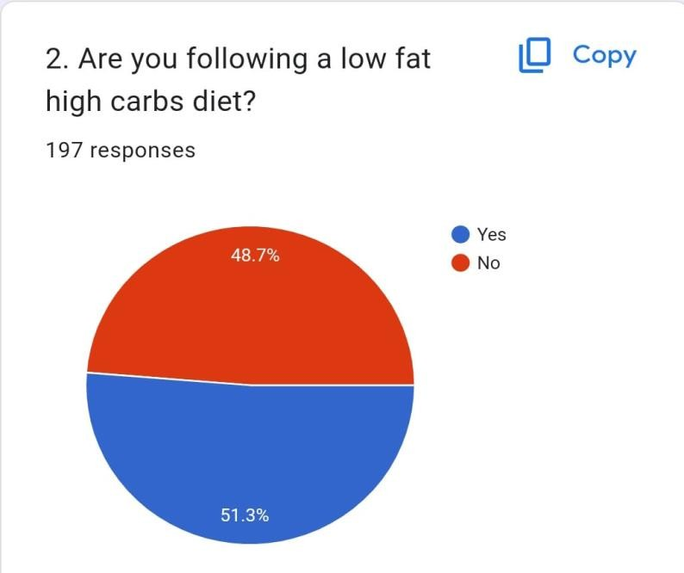

- Are you following low fat high carbs diet?
Almost half, 48.7% of the people who responded to the survey said yes, they are following a low fat, high carbs diet.
Slightly more than half, 51.3% of the people who responded to the survey said no, they are not following a low fat, high carbs diet.
Overall, the survey results show that a low fat, high carbs diet is not the most popular diet choice among the people who responded to this survey.
Fig 2 : Pie chart showing ratio of high fat and low carb diet

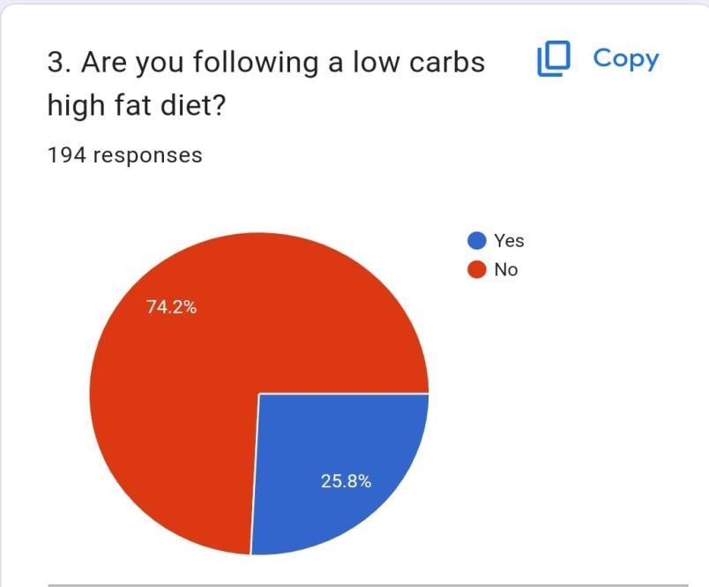

- Are you following low carbs high fat diet?
The total number of respondents was 194. Out of the 194 people surveyed, 74.2%, or 144 people, answered yes.
The remaining 25.8%, or 50 people, answered no.
Fig 3 : Pie chart showing ratio of weight
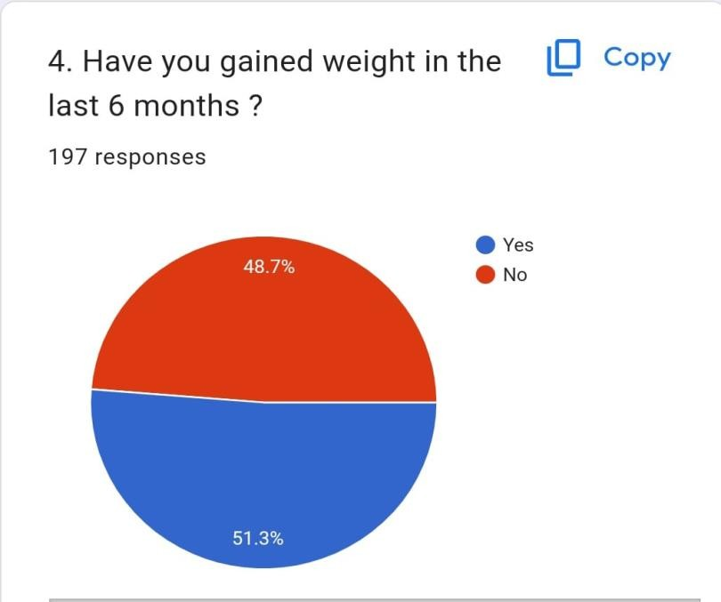

Fig 4 : Pie chart showing skin related issue

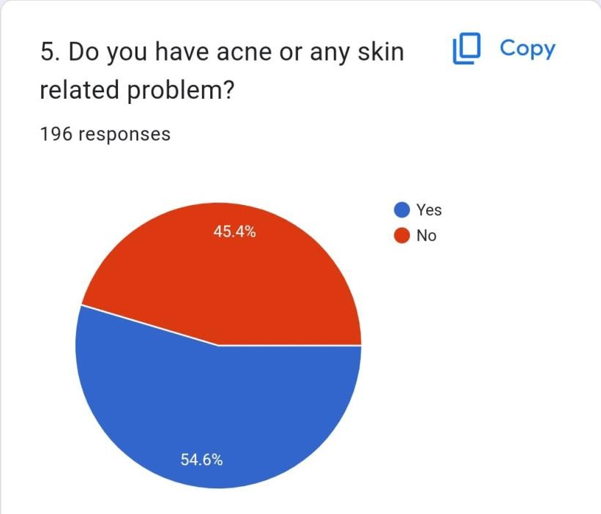
- Have gained weight in the last 6 months?

The red circle represents the percentage of people who have gained weight, at 48.7%. The blue circle represents the percentage of people who have not gained weight, at 51.3%.
In total, the survey results show that slightly more than half of the people surveyed did not gain weight in the last 6 months.

- Do you have acne or any skin related problem?
Out of 200 people surveyed, 108 (54.6%) said yes, they have acne or experience other skin problems.
The remaining 45.4% (92 people) said no.

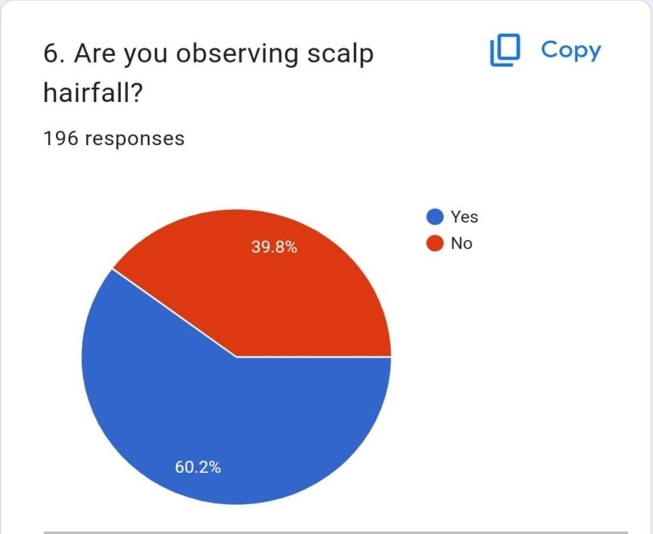
fig 5 : Pie chart showing scalp hairfall ratio
- Are you observing scalp hair fall?
120 GIRLS OUT OF 200 HAVE HAIRFALL PROBLEM".
This translates to 60% of the girls surveyed experiencing hair loss.

- Do you have facial hair growth?
Of the 196 people surveyed, 43% (86 people) answered yes, and 43% (85 people) answered no.
Fig 6 : Pie chart showing ratio of facial hair growth
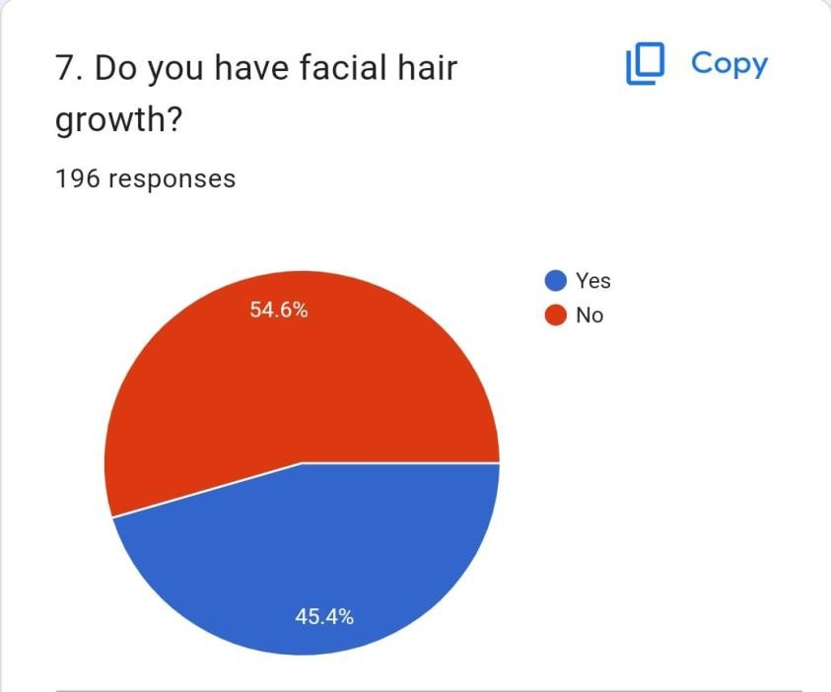
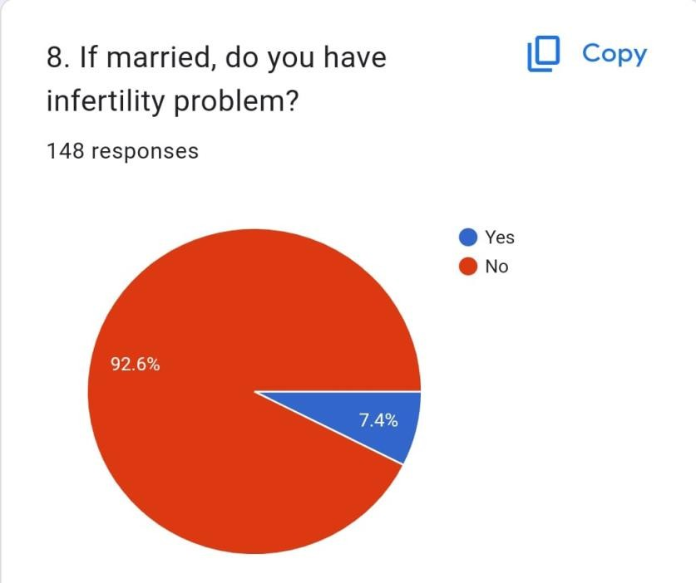
fig 7 : Pie chart showing problem in infertility

- If married, do you have any infertility problems?
14 GIRLS OUT OF 200 have infertility problem and shows a percentage of 7.4%.

- Do you have dark skin or patches on your body?
Of the 196 people surveyed, 63.8% (125 people) answered yes, and 36.2% (71 people) answered no.
A larger portion of the respondents, over 60%, reported having dark skin or patches on their body.
Fig 8 : Pie chart showing presence of dark patches

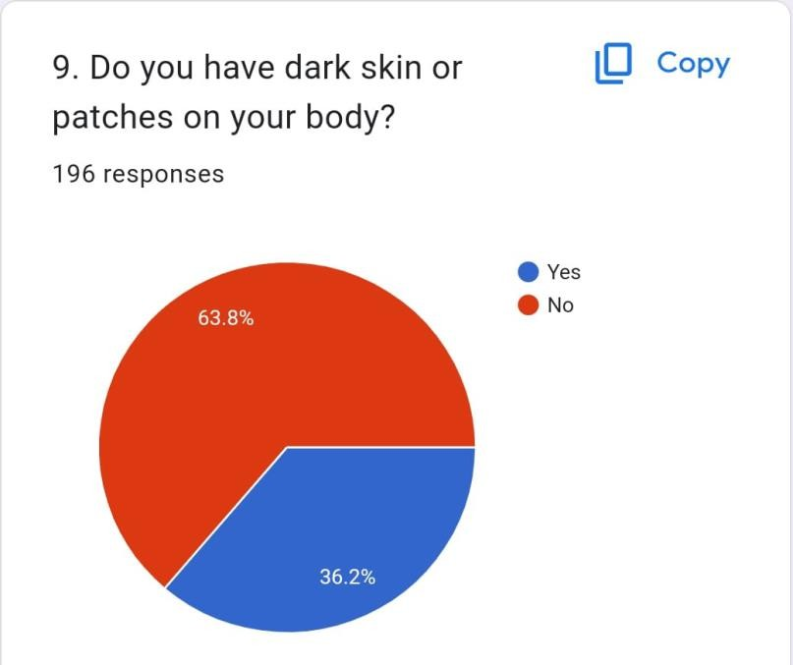
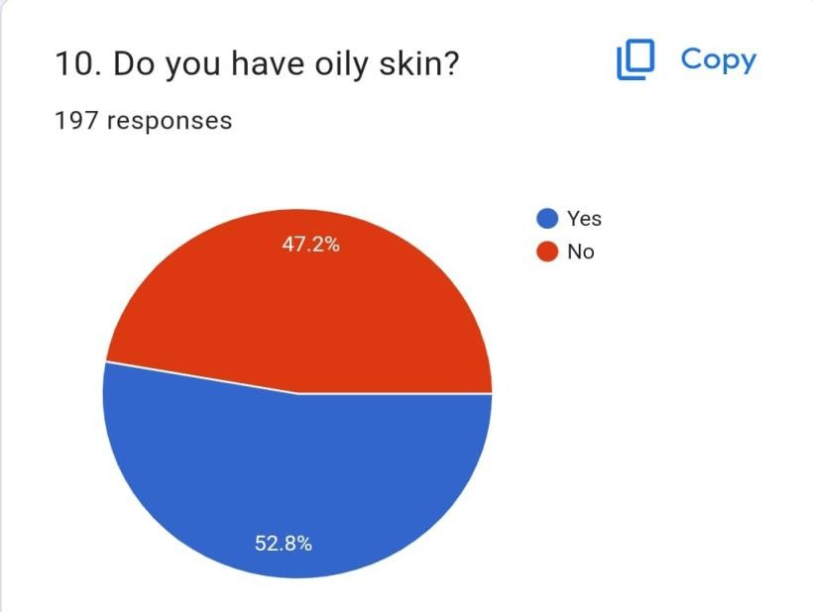
fig 9 : Pie chart showing ratio of oily skin

- Do you have oily skin?
Of the 197 people surveyed, 47.7% (94 people) answered yes, and 52.3% (103 people) answered no.
Almost half, close to 50%, of the respondents reported having oily skin.

- Are you suffering from any diseases like diabetes, thyroid, heart disease, and hypertension and obesity?
A larger portion of the respondents, 74.9% (147 people), answered yes, indicating that they suffer from at least one of the diseases mentioned in the question.
The remaining 25.1% (48 people) answered no.

Fig 10 : Pie chart showing suffering of disease
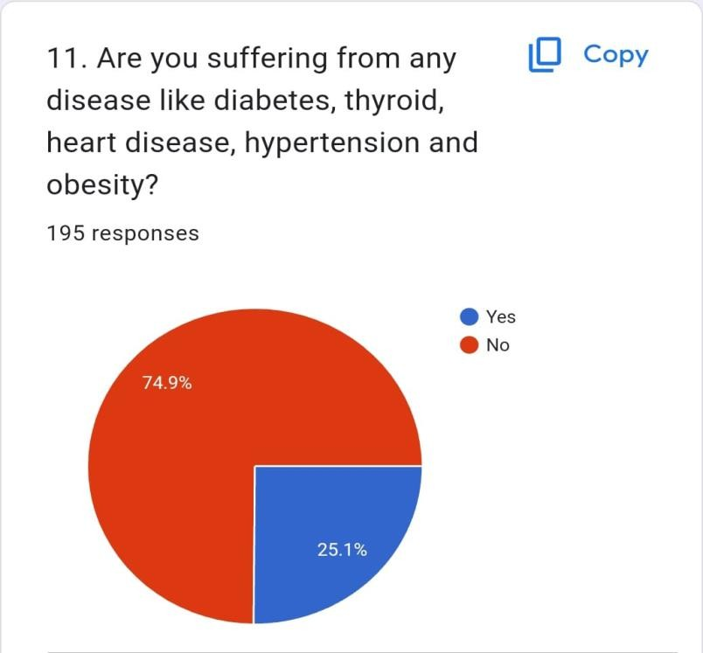
- Do you have frequent headache ?
Of the 197 people surveyed, 46.7% (92 people) answered yes, and 53.3% (105 people) answered no.
Slightly less than half, close to 50%, of the respondents reported having frequent headaches.

Fig 11: Pie chart showing hedach
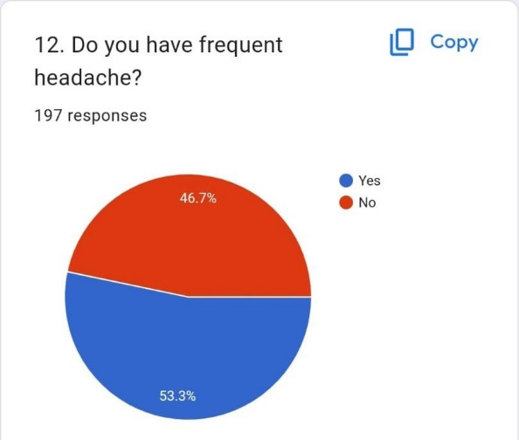

- Do you often feel emotionally stressed ?
Of the 196 people surveyed, 31.1% (61 people) answered yes, and 68.9% (135 people) answered no.
A smaller portion of the respondents, a little over 30%, reported feeling emotionally stressed often.

Fig 12 : Pie chart showing emotional stress
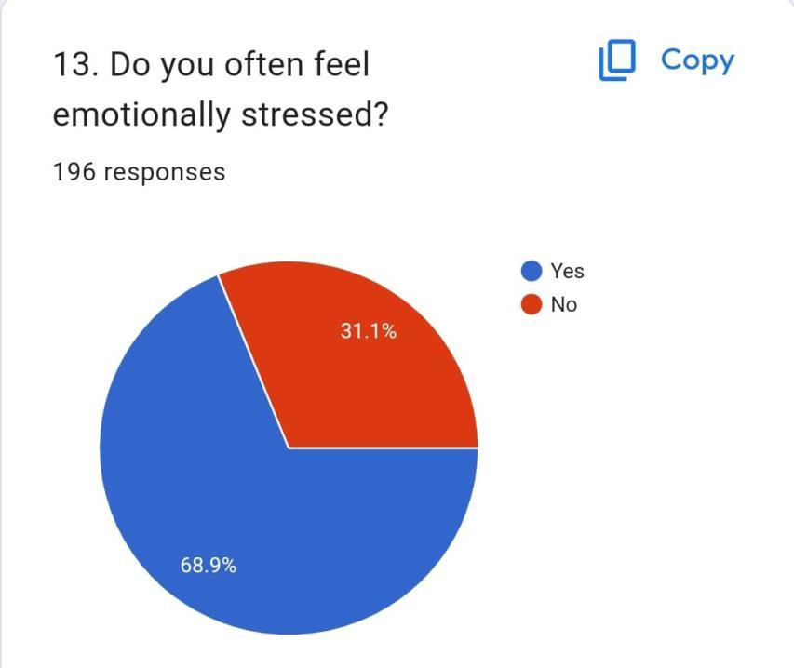
- Do you often feel abdominal pain or bloating?
Of the 196 people surveyed, 63.8% (125 people) answered yes, and 36.2% (71 people) answered no.
A larger portion of the respondents, over 60%, reported often feeling abdominal pain or bloating.
Fig 13 : Pie chart showing abdominal pain
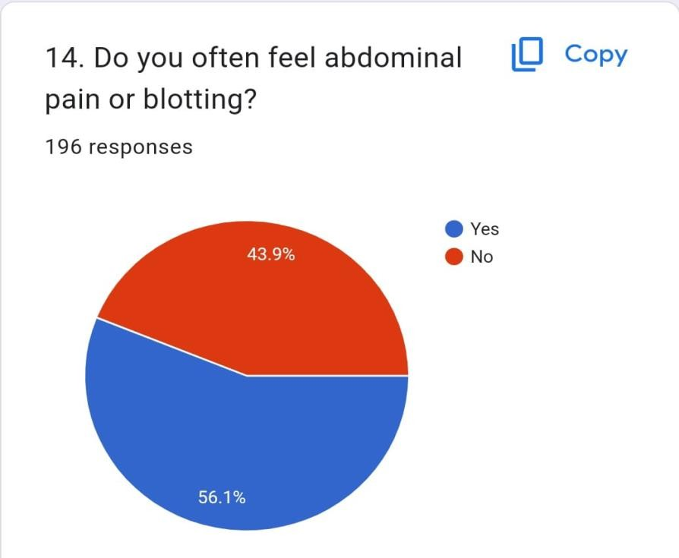
- Do you have any genetic history of pcod ?
Of the 193 people surveyed, 88.6% (171 people) answered yes, and 11.4% (22 people) answered no.
A large majority of the respondents, nearly 90%, reported having a genetic history of PCOD.
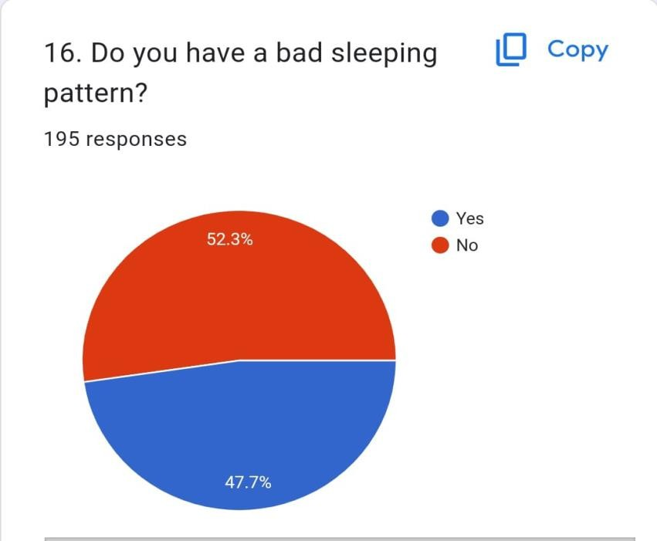
fig 14 : Pie chart showing bad sleeping

fig 15 : Pie chart showing genetic history of PCOD
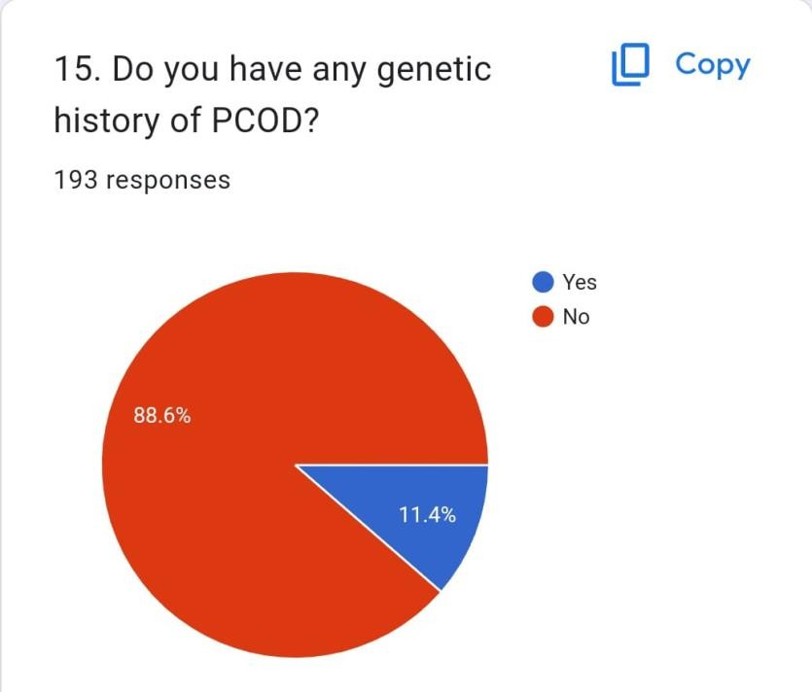

- Do you have a bad sleeping pattern?
Of the 195 people surveyed, 52.3% (102 people) answered yes, and 47.7% (93 people) answered no.
A little over half of the respondents reported having a bad sleeping pattern.

- Do you have irregular periods?
61.4% (121 respondents) said yes, they experience irregular periods.
38.6% (76 respondents) said no, they have regular periods.

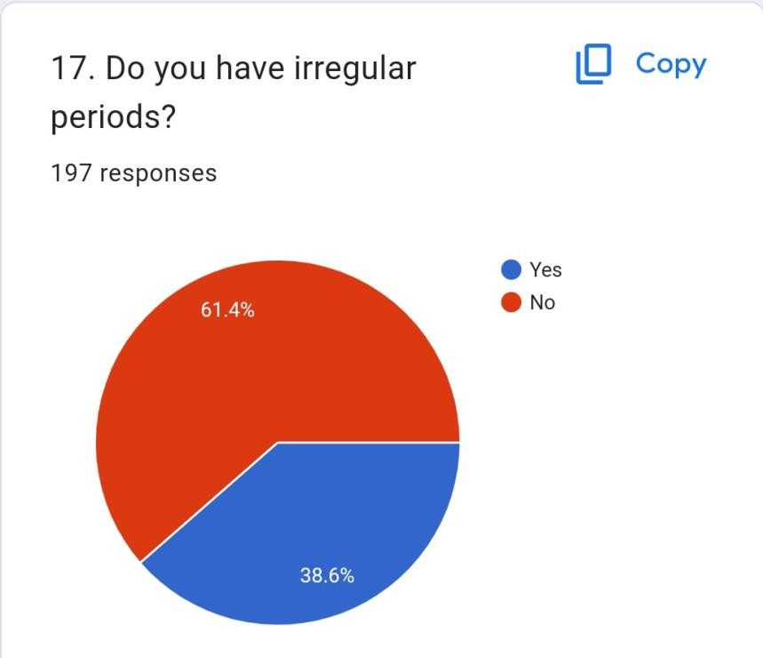
Fig 16 : Pie chart showing periods

- Is there is any gap of more than 35 days between your periods?
Out of 197 responses, 69% (136) of the respondents said yes, while 31% (61) said no.
A significant proportion of the respondents (69%) experience menstrual irregularity, defined in the survey as having a gap of more than 35 days between periods.

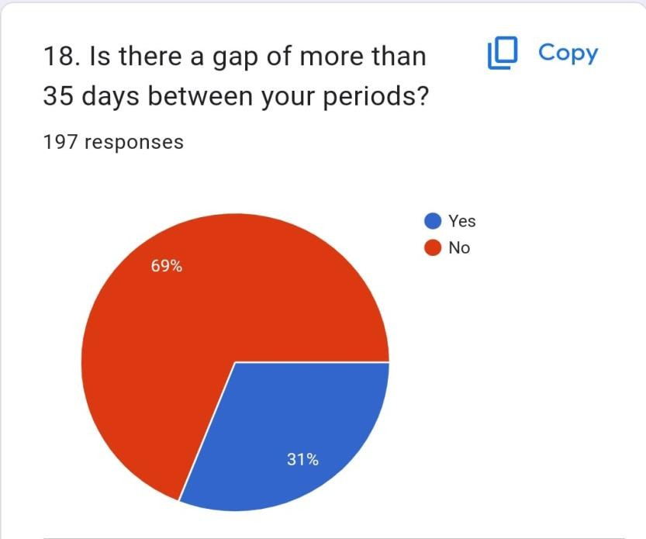

Fig 17 : Pie chart showing period time

- Are you observing excessive hair growth on your face, breast or back area?
Out of 196 responses, 73% said yes and 27% said no.
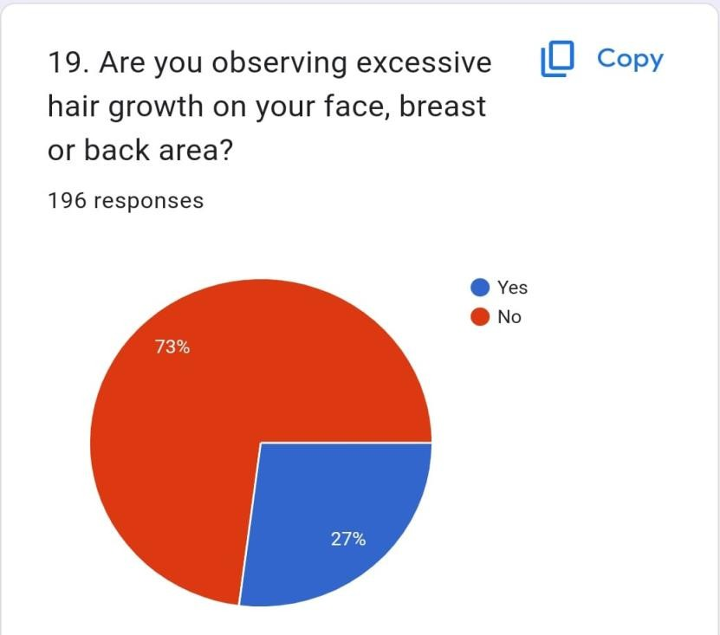
Fig 18 : Pie chart showing excercise
- Have you observed absence of mensuration for more than 2 months?
Out of 195 responses, 77.9% (152) said yes, and 22.1% (43) said no.
A large majority of the respondents (77.9%) reported absence of menstruation for more than 2 months.

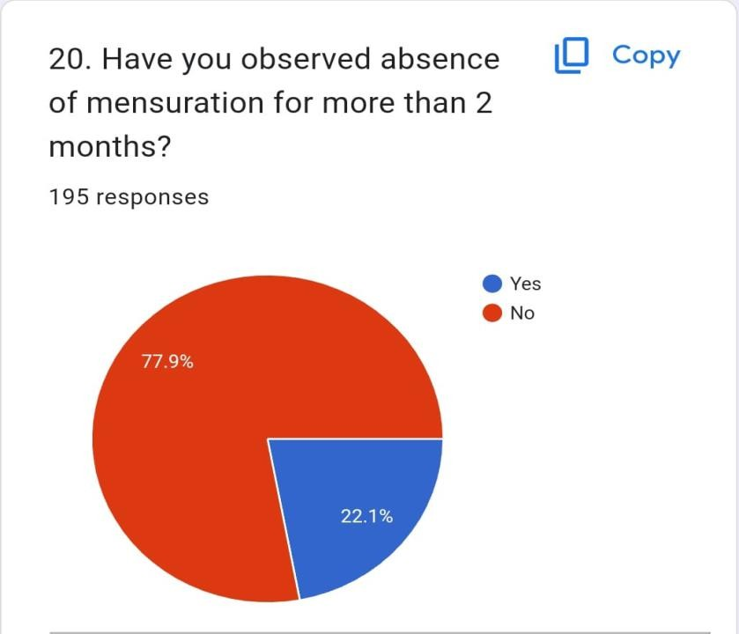

Fig 19 : Pie chart showing mensuration
- Do you have heavy bleeding problems during periods?
Out of 195 responses, 60.5% (119) said yes, and 39.5% (76) said no.
A significant proportion of the respondents (60.5%) reported heavy bleeding problems during their periods.
Fig 20 : Pie chart showing bleeding problem
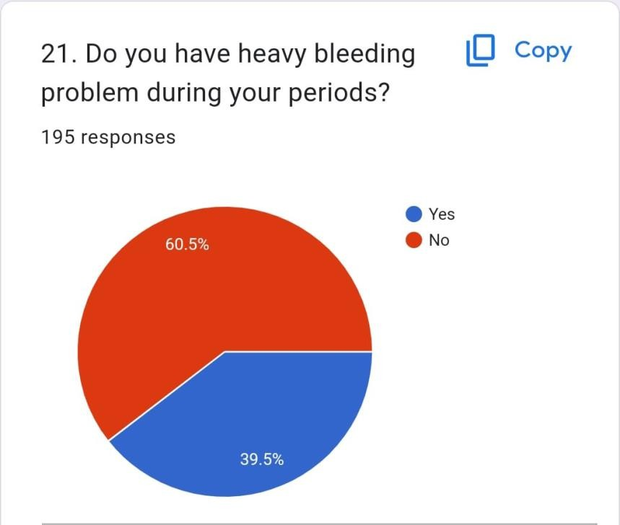

- If married, do you face difficulty in getting pregnant ?
Out of 153 responses, 88.9% (136) said yes, and 11.1% (17) said no.
A large majority of the married respondents (88.9%) reported facing difficulty getting pregnant according to this survey.
Fig 21: Pie chart showing pregnancy



- Do have cysts in their ovaries?
Out of 192 responses, according to the chart, 81.3% (156) said yes, and 18.8% (36) said no.

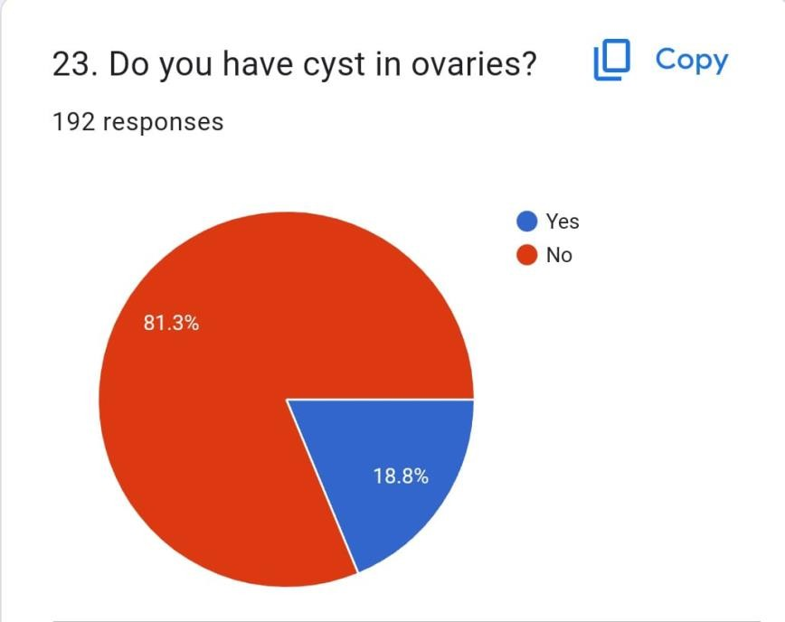

Fig 22: Pie chart showing cyst

- Do you often feel fatigued or tired?
Out of 195 responses, 36.4% (71) said yes, and 63.6% (124) said no.
A smaller proportion of the respondents (36.4%) reported often feeling fatigue or tiredness.

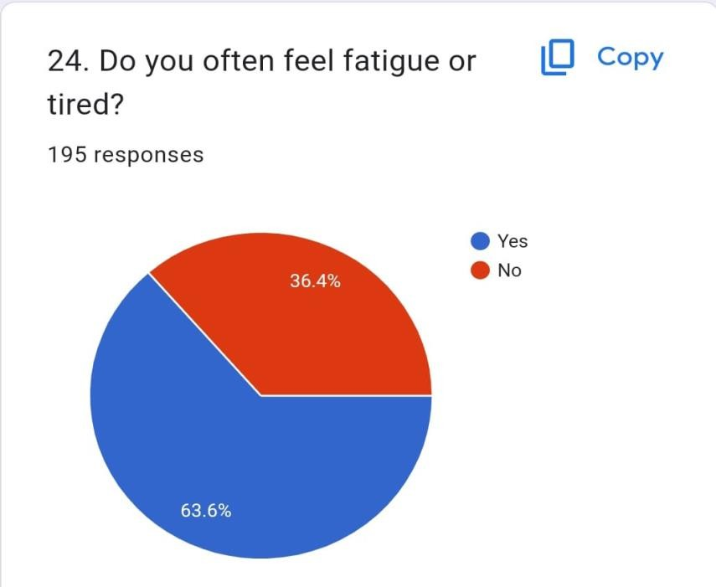
fig 23: Pie chart showing fatugueness

- Do you have sudden mood changes?
Out of 196 responses, 30.6% (60) said yes, and 69.4% (136) said no.
A smaller proportion of the respondents (30.6%) reported having sudden mood swings.

Fig 24 : Pie chart showing mood changing

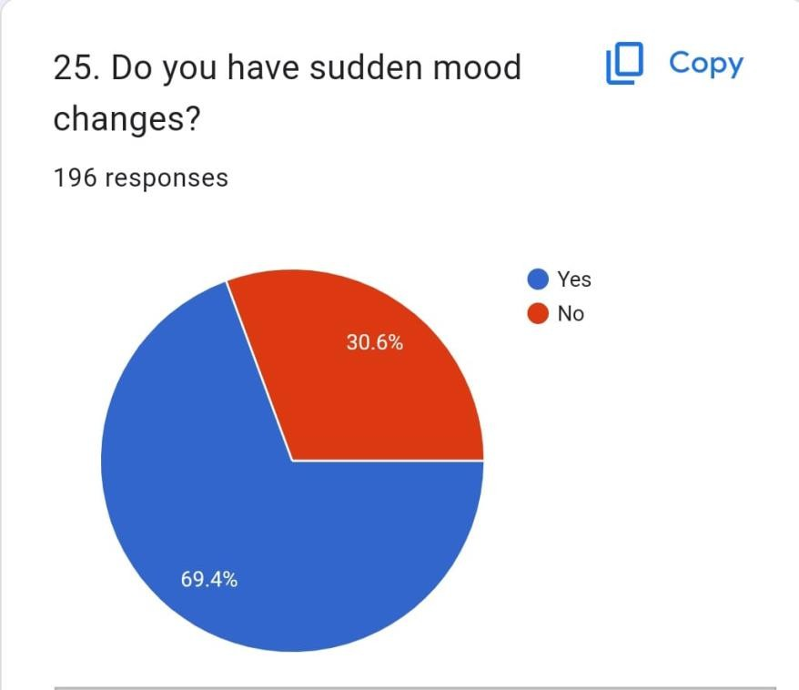
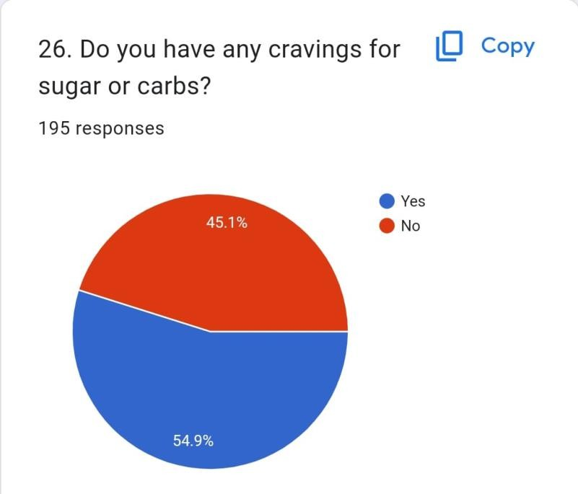
fig 25 : Pie chart showing cravings of sugar

- Do you have cravings for sugar and carbs?
Out of 195 responses, 45.1% (88) said yes, and 54.9% (107) said no.
A slight majority of the respondents (54.9%) reported not having cravings for sugar and carbs.

- Does your periods that last more than 7 days?
81.1% of people responded yes and 18.9% responded no.
Fig 26 : Pie chart showing period time

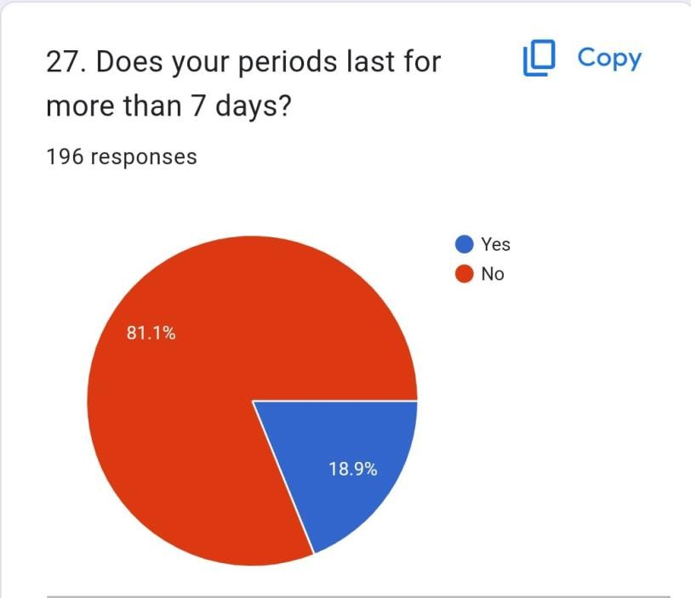
Fig 27 : Pie chart showing wasteline
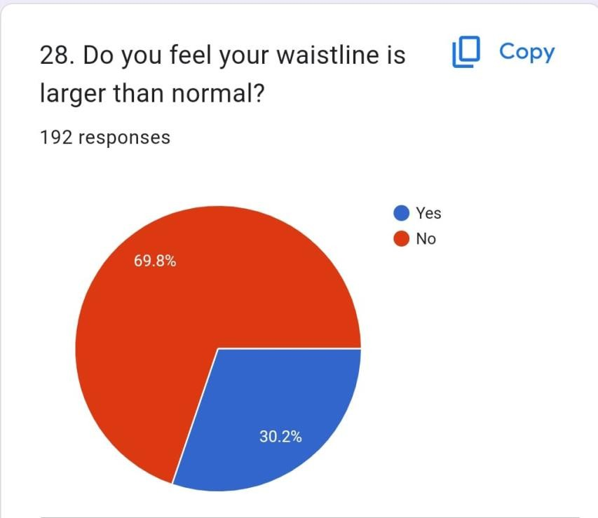

- Do you feel your waistline larger than normal?
Out of 192 responses, 69.8% of people said yes and 30.2% said no.

- Do you feel irritated most of the time?
Of the 195 responses, 45.6% said yes and 54.4% said no.
it shows that out of 195 people, 45.6% said they feel irritated most of the time, while 54.4% said they don't.
fig 28: Pie chart showing irritation
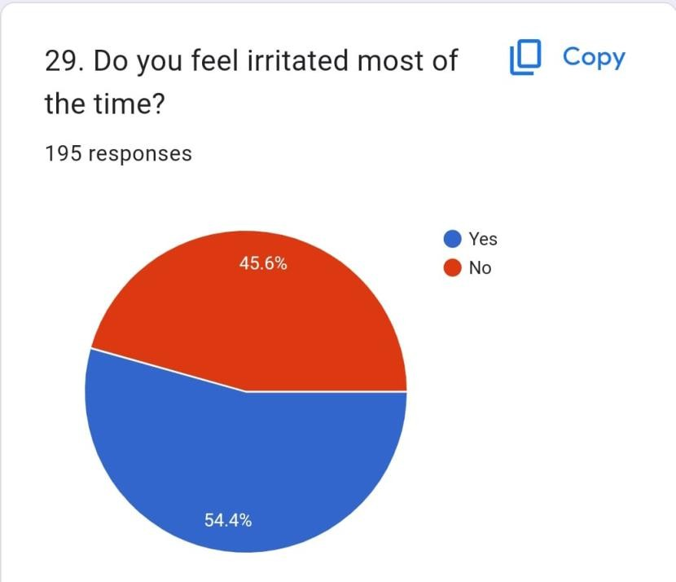
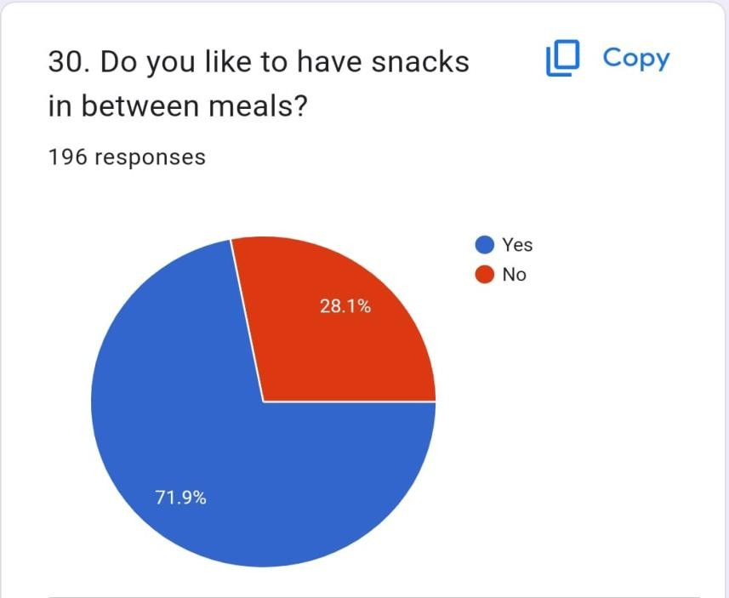
fig 29: Pie chart showing to take snacks

- Do you like to have snacks in between meals?
Out of 196 responses, 71.9% of people said yes and 28.1% said no.
People who like to snack between meals: 71.9%
People who don't like to snack between meals: 28.1%

REFERENCES:

https://www.ncbi.nlm.nih.gov/pmc/articles/PMC5563096/ #:~:text=PCOS%20is%20commonly%20associated%20with, et%20al.%2C%202015).
https://www.ncbi.nlm.nih.gov/pmc/articles/PMC3737989/
https://www.nice.org.uk/advice/esuom6/chapter/referen ces
https://www.msdmanuals.com/en- in/professional/gynecology-and-obstetrics/menstrual- abnormalities/polycystic-ovary-syndrome-pcos
https://academic.oup.com/jcem/article/84/6/1897/28644 36

Radhakrishnan 2018^{1–6}
Shrestha et al. 2019
Islam et al. 2021
Shenoy et al. n.d.
A Review on Health Care Survei… 2023
Chahar et al. 2023

Radhakrishnan R. Health related complications associated with polycystic ovarian disease (PCOD) [Internet]. 2018. Available from: https://www.researchgate.net/publication/328760520
Shenoy PB, Brundha MP. Awareness of Polycystic Ovarian Disease among Females of Age Group 18-30 Years.
Shrestha A, Dixit A, Zaidi A. Assessment of Lifestyle and Diet Modification of Patients Suffering from Polycystic Ovarian Disease (PCOD) in North India. Journal of Food and Nutrition Sciences. 2019;7(4):60.
Islam S, Nabi N, Khushbu SA, Ria NJ, Masum AKM. A Process of Finding Common Symptoms and Diagnosis Age among PCOS Patients Through a Survey. In: 2021 12th International Conference on Computing Communication and Networking Technologies, ICCCNT 2021. Institute of Electrical and Electronics Engineers Inc.; 2021.
A Review on Health Care Surveillance of PCOD. PriMera Scientific Medicine and Public Health. 2023 Nov 8;
Chahar K, Sharma Y, Kumar M, Kumari L, Mishra L, Patel P, et al. A recapitulation of the polycystic ovarian disorder in adult women and the risk of disease associated with the polycystic ovarian disorder. Health Sciences Review. 2023 Sep;8:100110.

appendex

THE SAMPLE QUESTIONNAIRE:
Anthropometric, clinical, and biochemical parameters –

  - AGE YRS
  - HEIGHT CMS
  - WEIGHT KG
  - BODY MASS INDEX (BMI) KG/M2
  - WAIST CIRCUMFERENCE (CM)
  - AGE OF FIRST PERIOD
  - PELVIC PAIN DURING MENSURATION
  - MARITAL STATUS IF MARRIED
  - FERTILITY PROBLEMS
  - DIET (LOW CARBS, LOW PROTEIN)
  - ACNE
  - FAMILY HISTORY
  - OTHER SYSTEMATIC DISORDERS –

DIABETES

HYPERTENSION
HYPERTHYRODI

