Ethnobotanical study on wild edible plants traditionally used by local people of Damoh district Madhya Pradesh, India

.
ABSTRACT

Aims: Many studies have shown a worrying decline in the traditional knowledge of wild edible plants throughout the last few decades. Therefore, the aim of this study was to document the population knowledge on wild edible plants among the local people.
Place and Duration of Study: Damoh district, Madhya Pradesh, India, January 2021 to February 2022.
Methodology: The survey was conducted from January 2021 to February 2022 among local people, mostly at home, in the fields, and other workplaces.
Results: The study documented 46 plant species across 30 genera and 23 families. The most frequently utilized plant parts were fruits (76%) and tubers (15%). Furthermore, the flora used was dominated by trees (46%), followed by herbs (30%). Rutaceae stood out as the most diverse family with 6 species documented. The Most Diverse Families are Rutaceae have 6 species. Dioscoreaceae and Myrtaceae are also diverse, each containing 4 species. Moderately Diverse Families are Asparagaceae, Solanaceae, Tiliaceae, and Verbenaceae each have 3 species. Anacardiaceae, Annonaceae, Arecaceae, Combretaceae, Fabaceae, and Sapotaceae each contain 2 species. Least Diverse Families has a large number of families are represented by only 1 species each. These include Amaranthaceae, Caesalpiniaceae, Ebenaceae, Flacourtiaceae, Hypoxidaceae, Malvaceae, Moraceae, Rhamnaceae, Vitaceae, Zingiberaceae.
Conclusion: This ethnobotanical study highlights the significant, yet diminishing, traditional knowledge possessed by local communities, demonstrating the crucial role of WEPs as a supplementary food source. The findings underscore the urgent need for conservation efforts to protect both these diverse plant resources and the associated indigenous knowledge for future food security and livelihood potential. By implementing these suggestions, society and government can work collaboratively to preserve the invaluable ethnobotanical heritage of Damoh district, ensuring the sustainable use of wild edible plants for the benefit of present and future generations, while also contributing to biodiversity conservation and local economic development.

Keywords: Ethnobotany, Local people, Traditional knowledge, Wild edible plants

1. INTRODUCTION

Food security is an ongoing global challenge influencing the well-being and health of millions of people (Rumicha, T. D., et al., 2025). The term “wild edible plants” (WEPs) refers to species harvested from wild plants or to plants growing spontaneously in an area, i.e. without being cultivated, including native species as well as introduced species that have been naturalized and are ingested as food (Abdul Aziz, Ullah, & Pieroni, 2020; Harisha, Padmavathy, & Nagaraja, 2016; Teklehaymanot, Giday, & ethnomedicine, 2010). The collection and consumption of WEPs have been “a way of life for many rural populations throughout the world, supplementing their dietary requirements (Long, Liu, Zhuo, & Ju, 2013; Lulekal, Asfaw, Kelbessa, & Van Damme, 2011). Knowledge on WEPs is of high direct-use value helping both to reduce the necessity of buying marketed alternatives and achieve food security (Shrestha & Dhillion, 2006). Wild edible fruits (WEFs) refer to edible fruit species which are not cultivated but are collected from their natural habitats (Yangdon, P., 2022). As one of the most important natural and renewable assets, the forest plays a crucial role in maintaining the biodiversity and sustainability of natural ecosystems, where a vast number of wild edible fruits are available (Ngurthankhumi, R., Hazarika, T. K., & Lalruatsangi, E., 2024). During his history, wild edible plants (WEPs) have been an important part of the human diet (Walsh, 2009).
The tradition of ethnomedicine is a complex multidisciplinary method consisting of the use of plants, medicine, spirituality and the natural environment has been a source of healing for people, (Maurya D., et al., 2021). Unfortunately, today, due to the development of modern agriculture and due to urbanization and globalization, the populations are becoming more and more distant from their environment (Turner & Turner, 2008) and the transmission of knowledge between older and younger not always assured (Agea et al., 2011; Hopkins, Stepp, McCarty, Gordon, & Ethnomedicine, 2015). Therefore, they neglect the use of wild plants around them and the knowledge about wild edible plants is declining (Singh, Rajasekaran, Negi, & Pala, 2014). The resulting loss of agricultural and food biodiversity has become a risk to food security (Norris, 2008). Ethnomedicinal knowledge of plants has been decreasing at alarming rate from the nature before proper documentation and evaluation (Uddin, Kibria, & Hassan, 2015).
Plant biodiversity provides human beings with all kinds of ecosystem goods and services. Among them, provisioning services such as food, fodder, medicine, timber and fuelwood are the most fundamental for survival (Assessment, 2005). In most parts of the developing world, humans rely heavily on local environmental resources, especially wild plants, for daily subsistence and health care. Traditional knowledge on the use of these resources is regarded as a means for adaptation during periods of hardship (Quave & Pieroni, 2015). A significant number of peoples live in the forests most isolated and inaccessible areas. The majority of these groups depend on plant species to their food and other health problem (Adhikari, C., 2021). In India, over 53 million tribal people and about 60% of rural communities directly rely on forest resources for their daily needs (Kandari et al., 2012). Wild edible plants include various categories such as fruits, tubers, vegetables, leaves, and roots, among which wild edible fruits play a particularly vital role in supplementing local diets. Many rural and tribal communities rely on these fruits, especially during periods of food scarcity (Karthik, H. N.,2025). This study was conducted to document the different wild edibles in the Damoh, Madhya Pradesh and their ethnobotanical uses.

2. Methodology
Study Area:
Damoh District lies between 23˚9’ and 24˚27’ North latitude and between 79˚3’ and 79˚57’ East longitude in the Northern part of Jabalpur Division. The shape of the district is irregular and elongated from North to South with projection in the East and West (fig.1). It is at an average elevation of 595 metres (1,952 ft). The district is bounded by the district of Chhatarpur in the North and Northwest, Sagar in the West, Narsimhapur and Jabalpur in the South and part of Jabalpur and Panna in the East. The total geographical area is 7306 Sq.km. In the recent years forests are restricted only to the hilly areas which are not suitable for cultivation. According to the information of the district forest office of the region total area covered by the government forests in the region under study comes to about 3043 sq. kms. and the forests are classified as –
1. Reserved Forest - 615 sq. kms (20 per cent)
2. Protected Forest - 2428 sq. kms (80 per cent)
The region has an almost ideal proportion of forest as 20 per cent the total geographical area of the region and the reserved forest in the area were demarcated as early as in the year 1879 the reserved forests are still under the scientific management of government (Maurya D., et al., 2023).
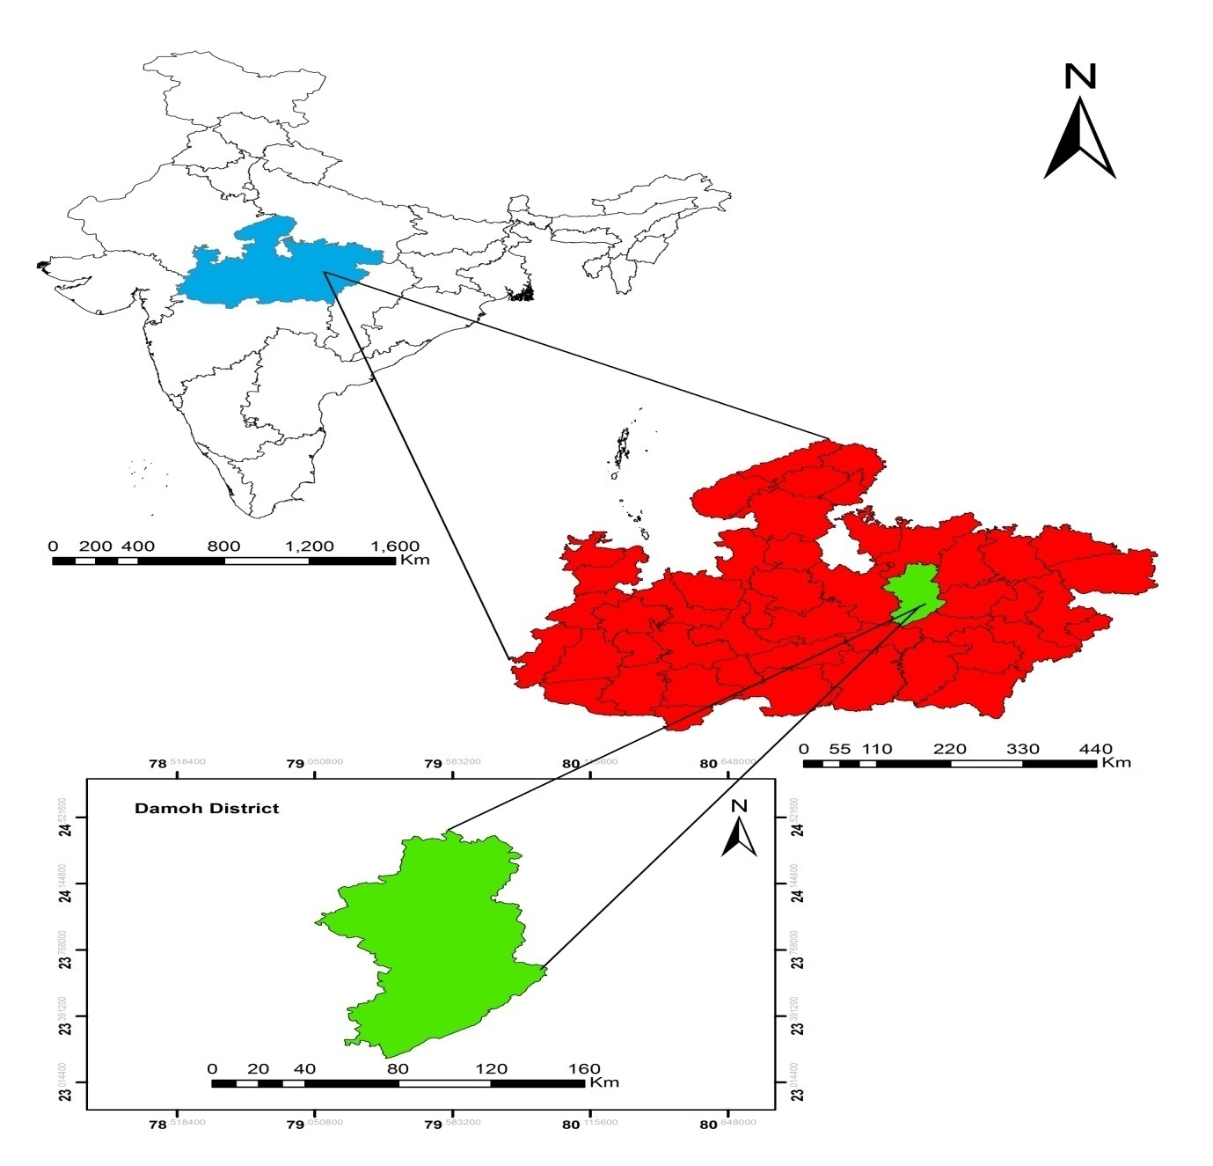Fig. 1. Study area
Data collection:
The survey was conducted from January 2021 to February 2022 among local people, mostly at home, in the fields, and other workplaces. The data were initially recorded in the local dialect and later translated into English for analysis. In the beginning, informed consent of the informant was obtained after having explained the content of the research.
Identification of Plant:
The authors of this paper taxonomically identified all the plant species collected during the present study using the Flora of Madhya Pradesh, ((Khanna, 2001; Mudgal et al., 1997), and expert of regional herbaria viz., Department of Botany, Dr. Harisingh Gour Vishwavidyalaya, Sagar. Also check the World Flora Online (www.worldfloraonline.org accessed in January 2024) was used to determine the currently accepted botanical names and author citations for the identified plant species.
Data Analysis:
All graph preparation had been done through using MS Excel and RAW2.0 Software.
3. results and discussion

Taxonomic Diversity of Plants
The present study provides information about wild edible plants of 46 plant species belonging 30 genera of 23 families. The Most Diverse Families are Rutaceae stands out as the most diverse family with 6 species. Dioscoreaceae and Myrtaceae are also highly diverse, each containing 4 species. Moderately Diverse Families are Asparagaceae, Solanaceae, Tiliaceae, and Verbenaceae each have 3 species. Anacardiaceae, Annonaceae, Arecaceae, Combretaceae, Fabaceae, and Sapotaceae each contain 2 species. Least Diverse Families has a large number of families are represented by only 1 species each. These include Amaranthaceae, Caesalpiniaceae, Ebenaceae, Flacourtiaceae, Hypoxidaceae, Malvaceae, Moraceae, Rhamnaceae, Vitaceae, Zingiberaceae.
Family Representation Summary are 1 family Rutaceae has 6 species, 2 families Dioscoreaceae and Myrtaceae have 4 species, 4 families Asparagaceae, Solanaceae, Tiliaceae, Verbenaceae have 3 species, 6 families, Anacardiaceae, Annonaceae, Arecaceae, Combretaceae, Fabaceae, Sapotaceae have 2 species and 10 families Amaranthaceae, Caesalpiniaceae, Ebenaceae, Flacourtiaceae, Hypoxidaceae, Malvaceae, Moraceae, Rhamnaceae, Vitaceae, Zingiberaceae. have 1 species, (Fig. 2).
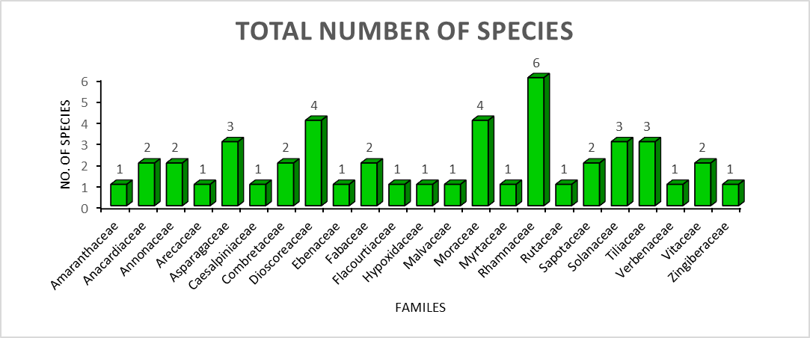
Fig. 2. Total number of species belonging families

The diagram shows connections between several plant families (listed on the left side of the circle) and individual plant species (listed on the right side of the circle). The thickness of the bands connecting them likely indicates the number of species within a family that are utilized, or perhaps the intensity/frequency of their use (fig. 3).

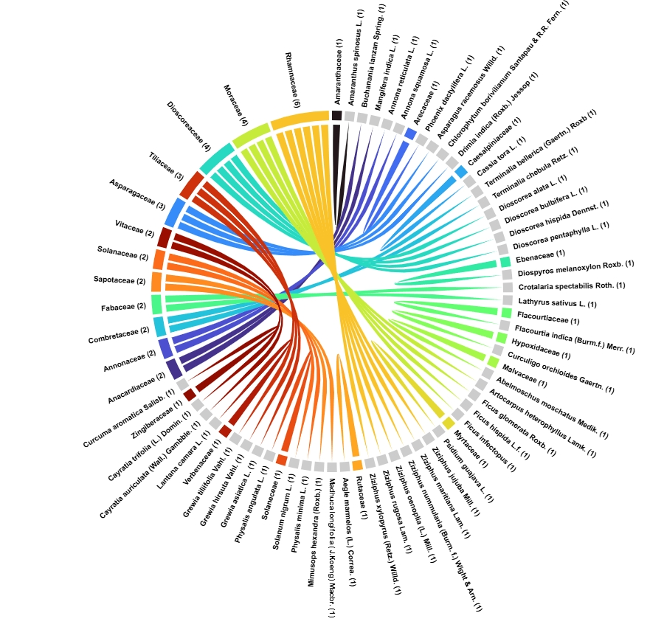
Fig. 3. Chord diagram is showing the total number of species belonging families.
Plant part used
The data clearly indicates a strong preference or prevalence in the use of plant fruits (76%), followed by tubers (15%), leaves (5%), bulbs (2%), and roots (2%) being much less frequently utilized (fig. 4).

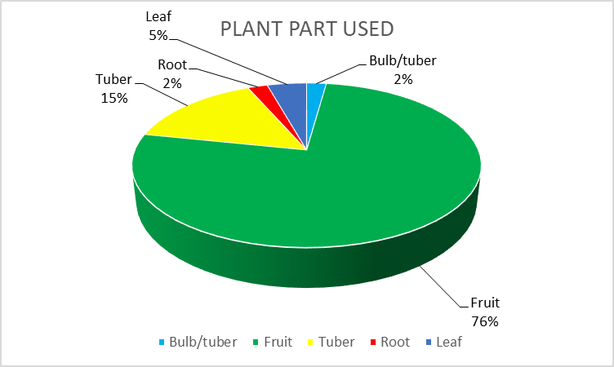
Fig. 4. Plant part used in percent showing in this pie chart.

Life form
The flora is primarily dominated by trees (46%), followed by herb (30%), with climbers (13%), shrubs (7%), and small trees (4%) contributing to a lesser extent (fig. 5).

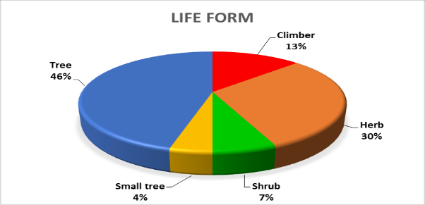
Fig. 5. life form in percent showing in this pie chart.

In the given data of total number of plant and their details of Botanical name of plants, family, Vernacular name, Habits, and used part (Table.1).

Table 1: Total number of plant and their details.
S. No. | Plant species | Voucher Number | Family | Vernacular name | Life form | Used part
1 | Abelmoschus moschatus Medik. | DHSGU-H-179 | Malvaceae | Jangli bhindi | Herb | Fruit
2 | Aegle marmelos (L.) Correa. | DHSGU-H-139 | Rutaceae | Bel | Tree | Fruit
3 | Amaranthus spinosus L. | DHSGU-H-258 | Amaranthaceae | Katili Chaulai | Herb | Leaf
4 | Annona reticulata L. | DHSGU-H-282 | Annonaceae | Ram phal | Small tree | Fruit
5 | Annona squamosa L. | DHSGU-H-283 | Annonaceae | Sita phal | Small tree | Fruit
6 | Artocarpus heterophyllus Lamk. | DHSGU-H-337 | Moraceae | Kathal | Tree | Fruit
7 | Asparagus racemosus Willd. | DHSGU-H-329 | Asparagaceae | Satawari | Herb | Root
8 | Buchanania lanzan Spring. | DHSGU-H-54 | Anacardiaceae | Achar | Tree | Fruit
9 | Cassia tora L. | DHSGU-H-269 | Caesalpiniaceae | Panwar | Herb | Leaf
10 | Cayratia auriculata (Wall.) Gambble. | DHSGU-H-257 | Vitaceae | Jangali Angoor | Climber | Fruit
11 | Cayratia trifolia (L.) Domin. | DHSGU-H-120 | Vitaceae | Jangali Angoor | Climber | Fruit
12 | Chlorophytum borivilianum Santapau & R.R. Fern. | DHSGU-H-272 | Asparagaceae | Safed musli | Herb | Tuber
13 | Crotalaria spectabilis Roth. | DHSGU-H-338 | Fabaceae | Jhunjhunia | Herb | Fruit
14 | Curculigo orchioides Gaertn. | DHSGU-H-68 | Hypoxidaceae | Kali Musli | Herb | Tuber
15 | Curcuma aromatica Salisb. | DHSGU-H-339 | Zingiberaceae | Jangali Haldi | Herb | Tuber
16 | Dioscorea alata L. | DHSGU-H-208 | Dioscoreaceae | Jami ghuniya | Climber | Tuber
17 | Dioscorea bulbifera L. | DHSGU-H-248 | Dioscoreaceae | Jangali aloo | Climber | Tuber
18 | Dioscorea hispida Dennst. | DHSGU-H-207 | Dioscoreaceae | Jangali aloo | Climber | Tuber
19 | Dioscorea pentaphylla L. | DHSGU-H-340 | Dioscoreaceae | Jangali aloo | Climber | Tuber
20 | Diospyros melanoxylon Roxb. | DHSGU-H-24 | Ebenaceae | Tendu | Tree | Fruit
21 | Drimia indica (Roxb.) Jessop | DHSGU-H-341 | Asparagaceae | Jangli piyaj | Herb | Bulb/tuber
22 | Ficus glomerata Roxb. | DHSGU-H-342 | Moraceae | Dumar | Tree | Fruit
23 | Ficus hispida L.f. | DHSGU-H-97 | Moraceae | Umar | Tree | Fruit
24 | Ficus infectopus L.f. | DHSGU-H-343 | Moraceae | Pakar | Tree | Fruit
25 | Flacourtia indica (Burm.f.) Merr. | DHSGU-H-36 | Flacourtiaceae | Kaker | Tree | Fruit
26 | Grewia asiatica L. | DHSGU-H-233 | Tiliaceae | Phalsa | Tree | Fruit
27 | Grewia hirsuta Vahl. | DHSGU-H-32 | Tiliaceae | Makor | Herb | Fruit
28 | Grewia tiliifolia Vahl. | DHSGU-H-149 | Tiliaceae | Phalsa | Tree | Fruit
29 | Lantana camara L. | DHSGU-H-297 | Verbenaceae | Lantana | Shrub | Fruit
30 | Lathyrus sativus L. | DHSGU-H-344 | Fabaceae | Jangali Makar | Herb | Fruit
31 | Madhuca longifolia (J.Koeng) Macbr. | DHSGU-H-265 | Sapotaceae | Mahua | Tree | Fruit
32 | Mangifera indica L. | DHSGU-H-225 | Anacardiaceae | Aam | Tree | Fruit
33 | Mimusops hexandra (Roxb.) | DHSGU-H-197 | Sapotaceae | Khirni | Tree | Fruit
34 | Phoenix dactylifera L. | DHSGU-H-313 | Arecaceae | Khajur | Tree | Fruit
35 | Physalis angulata L. | DHSGU-H-345 | Solaneceae | Makoi | Herb | Fruit
36 | Physalis minima L. | DHSGU-H-53 | Solanaceae | Makoi | Herb | Fruit
37 | Psidium guajava L. | DHSGU-H-284 | Myrtaceae | Amrod | Tree | Fruit
38 | Solanum nigrum L. | DHSGU-H-290 | Solanaceae | Makoi | Herb | Fruit
39 | Terminalia bellerica (Gaertn.) Roxb | DHSGU-H-52 | Combretaceae | Baheda | Tree | Fruit
40 | Terminalia chebula Retz. | DHSGU-H-291 | Combretaceae | Harra | Tree | Fruit
41 | Ziziphus jujuba Mill. | DHSGU-H-346 | Rhamnaceae | Ber | Tree | Fruit
42 | Ziziphus maritiana Lam. | DHSGU-H-14 | Rhamnaceae | Ber | Shrub | Fruit
43 | Ziziphus nummularia (Burm. f.) Wight & Arn. | DHSGU-H-76 | Rhamnaceae | Ber | Shrub | Fruit
44 | Ziziphus oenoplia (L.) Mill. | DHSGU-H-251 | Rhamnaceae | Ber | Tree | Fruit
45 | Ziziphus rugosa Lam. | DHSGU-H-173 | Rhamnaceae | Churna | Tree | Fruit
46 | Ziziphus xylopyrus (Retz.) Willd. | DHSGU-H-79 | Rhamnaceae | Ghot | Tree | Fruit

The results of the present study diverged from previously reported ethnobotanical studies conducted in India (Yesodharan, K., & Sujana, K. A., 2007; Mahapatra, A. K., & Panda, P. C., 2012). The present study provides information about wild edible plants of 46 plant species belonging 30 genera of 23 families. In most previous ethnobotanical studies, herbs were found to be the most commonly used (Mansoor, A., et al., 2025; Angami, A.,2006; Bhattarai, S., 2009; Wagner A., 2008), but, in this study, most frequently used of tree species rather than herbs is second most used. Fruits were more frequently used instead of leaves, as observed in previous studies conducted in India as well as all over the world, (Ngurthankhumi, R., et al., 2024; Bhatia, H., et al., 2018; Sreekumar, V. B., 2020; Shrestha N, Shrestha K.K., 2012). The life form dominated by trees (46%), followed by herb (30%), with climbers (13%), shrubs (7%), and small trees (4%) contributing to a lesser extent similar work done by other researcher in other part of India as we worldwide (Abhilash, K. S., 2025; Jamir, S. A., et al., 2006; Abbasi, A. M., et al., 2013; Ngurthankhumi, R., et al., 2024; Ul Abidin, S. Z., et al., 2023). Although the current study enlists WEPs and their medicinal uses with little attention to documenting the ecological aspects or conservation status of the species. Further investigation of the nutritional value of these species is needed. The current exploration deals with data collection from specific localities, and a more comprehensive study is required to enlist all WEPs and their traditional uses in India.

4. Conclusions

This ethnobotanical study highlights the significant traditional knowledge possessed by the local communities of Damoh district regarding wild edible plants, which serve as a crucial supplementary food source, especially during lean seasons and times of food scarcity. The present study provides information about wild edible plants of 46 plant species belonging 30 genera of 23 families. The Most Diverse Families are Rutaceae have 6 species. Dioscoreaceae and Myrtaceae are also diverse, each containing 4 species. Moderately Diverse Families are Asparagaceae, Solanaceae, Tiliaceae, and Verbenaceae each have 3 species. Anacardiaceae, Annonaceae, Arecaceae, Combretaceae, Fabaceae, and Sapotaceae each contain 2 species. Least Diverse Families has a large number of families are represented by only 1 species each. These include Amaranthaceae, Caesalpiniaceae, Ebenaceae, Flacourtiaceae, Hypoxidaceae, Malvaceae, Moraceae, Rhamnaceae, Vitaceae, Zingiberaceae. The diverse array of wild edible plants identified not only contributes to the nutritional security of these communities but also represents a rich, yet often overlooked, component of the region's biodiversity. The study underscores the urgent need for conservation efforts to protect these plant resources and the associated indigenous knowledge, which hold immense potential for sustainable food security, livelihood generation, and the development of novel food products. Local communities should be empowered and encouraged to actively participate in documenting their traditional knowledge about wild edible plants. By implementing these suggestions, society and government can work collaboratively to preserve the invaluable ethnobotanical heritage of Damoh district, ensuring the sustainable use of wild edible plants for the benefit of present and future generations, while also contributing to biodiversity conservation and local economic development.

Consent

Not applicable

Ethical approval
Not applicable
But, Prior to data collection, all participants were thoroughly briefed on the objectives of the study and provided informed consent.

Disclaimer (Artificial intelligence)
Option 1:
Author(s) hereby declare that NO generative AI technologies such as Large Language Models (ChatGPT, COPILOT, etc.) and text-to-image generators have been used during the writing or editing of this manuscript.

References

Abdul Aziz, M., Ullah, Z., & Pieroni, A. J. S. (2020). Wild food plant gathering among Kalasha, Yidgha, Nuristani and Khowar speakers in Chitral, NW Pakistan. 12(21), 9176.
Abbasi, A. M., Khan, M. A., & Zafar, M. (2013). Ethno-medicinal assessment of some selected wild edible fruits and vegetables of Lesser-Himalayas, Pakistan. Pak. J. Bot, 45(51), 215-222.
Abhilash, K. S., Alen, A. P., Gayathri, T. S., & Leeja, L. (2025). Rapid Threat Assessment of ethnomedicinal Pteridophytes used among tribals of Attappady, Palakkad, Southern Western Ghats, India. Vegetos, 38(4), 1523-1532.
Adhikari, C., Devanand, Kumar, T., & Bishwas, A. J. (2021). Review on ethno-medicinal plants used for healing skin ailments in Madhya Pradesh, India. Indian journal of ecology, 48(3), 709-715.
Agea, J. G., Kimondo, J. M., Okia, C. A., Abohassan, R. A. A., Obua, J., Hall, J., & Teklehaimanot, Z. (2011). Contribution of wild and semi-wild food plants to overall household diet in Bunyoro-Kitara Kingdom, Uganda.
Angami, A., Gajurel, P. R., Rethy, P., Singh, B., & Kalita, S. K. (2006). Status and potential of wild edible plants of Arunachal Pradesh. Indian Journal of Traditional Knowledge, 5(4), 541-550.
Assessment, M. E. (2005). Ecosystems and human well-being: wetlands and water: World Resources Institute.
Bhatia, H., Sharma, Y. P., Manhas, R. K., & Kumar, K. (2018). Traditionally used wild edible plants of district Udhampur, J&K, India. Journal of Ethnobiology and Ethnomedicine, 14(1), 73.
Bhattarai, S., Chaudhary, R. P., & Taylor, R. S. (2009). Wild edible plants used by the people of Manang district, central Nepal. Ecology of Food and Nutrition, 48(1), 1-20.
Harisha, R., Padmavathy, S., & Nagaraja, B. J. A. E. E. R. (2016). Traditional ecological knowledge (TEK) and its importance in south India: perspecive from local communities. 14(1), 311-326.
Hopkins, A. L., Stepp, J. R., McCarty, C., Gordon, J. S. J. J. o. E., & Ethnomedicine. (2015). Herbal remedy knowledge acquisition and transmission among the Yucatec Maya in Tabi, Mexico: a cross-sectional study. 11(1), 1-10.
Jamir, S. A., Upadhaya, K., & Pandey, H. N. (2006). Life form composition and stratification of montane humid forests in Meghalaya, northeast India. Tropical Ecology, 47(2), 183-190.
Kandari, L. S., Phondani, P. C., Payal, K. C., Rao, K. S., & Maikhuri, R. K. (2012). Ethnobotanical study towards conservation of medicinal and aromatic plants in upper catchments of Dhauli Ganga in the central Himalaya. Journal of Mountain Science, 9(2), 286-296.
Karthik, H. N., Basha, M., Rathod, C. B., Hegde, A., & Rathod, A. (2025). Traditional Knowledge and Ethnobotany of Wild Plants from the Central Western Ghats, Karnataka, India. Archives of Current Research International, 25(3), 102-116.
Khanna, K.K., (2001). Supplement to the flora of Madhya Pradesh: Botanical Survey of India.
Long, C., Liu, B., Zhuo, J., & Ju, Y. (2013). Eating from the wild: diversity of wild edible plants used by Tibetans in Shangri-la region, Yunnan, China.
Lulekal, E., Asfaw, Z., Kelbessa, E., & Van Damme, P. J. A. f. (2011). Wild edible plants in Ethiopia: a review on their potential to combat food insecurity. 24(2), 71-122.
Mahapatra, A. K., & Panda, P. C. (2012). Wild edible fruit diversity and its significance in the livelihood of indigenous tribals: Evidence from eastern India. Food Security, 4(2), 219-234.
Mansoor, A., Mir, B. A., Banoo, M., Banoo, S., & Peer, L. A. (2025). Ethnobotanical exploration of medicinal plants in the Himalayan temperate forests of Veshew range, Kulgam, Jammu & Kashmir, India: diversity, utilization, and health significance. Ethnobotany Research and Applications, 31, 1-21.
Maurya, D., Adhikari, C., Kumar, T., & Bishwas, A. J., (2021). A review: Aganosma dichotoma (Roth) K. Schum.: Traditional use, phytochemical constituents and pharmacological properties, International Journal of Botany Studies. 6(6), 1276-1279.
Maurya, D., Adhikari, C., Kumar, T., & Bishwas, A. J., (2023). The practice of using Ethno-medicinal plants in maintaining oral health: Knowledge, perception and attitude of Damoh district Madhya Pradesh, India, International Journal of Research and Analytical Reviews (IJRAR), 10(4), 614-621.
Mudgal, V., Khanna, K.K., & Hajra, P.K., (1997). Flora of Madhya Pradesh Vol, II, Botanical Survey of India, Calcutta, 681.
Ngurthankhumi, R., Hazarika, T. K., & Lalruatsangi, E. (2024). Nutritional composition and anti-nutritional properties of wild edible fruits of northeast India. Journal of Agriculture and Food Research, 16, 101221.
Ngurthankhumi, R., Hazarika, T. K., & Lalruatsangi, E. (2024). Nutritional composition and anti-nutritional properties of wild edible fruits of northeast India. Journal of Agriculture and Food Research, 16, 101221.
Norris, K. J. C. l. (2008). Agriculture and biodiversity conservation: opportunity knocks. 1(1), 2-11.
Quave, C. L., & Pieroni, A. J. N. P. (2015). A reservoir of ethnobotanical knowledge informs resilient food security and health strategies in the Balkans. 1(2), 1-6.
Rumicha, T. D., Belew, S., Hasen, G., Teka, T. A., & Forsido, S. F. (2025). Food, Feed, and Phytochemical Uses of Wild Edible Plants: A Systematic Review. Food Science & Nutrition, 13(6), e70454.
Shrestha, P. M., & Dhillion, S. S. J. A. S. (2006). Diversity and traditional knowledge concerning wild food species in a locally managed forest in Nepal. 66(1), 55-63.
Shrestha N, Shrestha KK (2012) Vulnerability assessment of highvalued medicinal plants in Langtang National Park. Biodiversity 13(1):24–36. https:// doi. org/ 10. 1080/ 14888386. 2012. 666715
Singh, J., Rajasekaran, A., Negi, A., & Pala, N. A. J. I. J. U. M. (2014). Wild vegetable plants used by tribal people of Kinnaur district, Himachal Pradesh, India. 15(2), 47-56.
Sreekumar, V. B., Sreejith, K. A., Hareesh, V. S., & Sanil, M. S. (2020). An overview of wild edible fruits of Western Ghats, India. Genetic Resources and Crop Evolution, 67(7), 1659-1693.
Teklehaymanot, T., Giday, M. J. J. o. e., & ethnomedicine. (2010). Ethnobotanical study of wild edible plants of Kara and Kwego semi-pastoralist people in Lower Omo River Valley, Debub Omo Zone, SNNPR, Ethiopia. 6(1), 1-8.
Turner, N. J., & Turner, K. L. J. B. (2008). “Where our women used to get the food”: cumulative effects and loss of ethnobotanical knowledge and practice; case study from coastal British Columbia. 86(2), 103-115.
Uddin, M. Z., Kibria, M. G., & Hassan, M. A. J. J. o. t. A. S. o. B., Science. (2015). Study Of Ethnomedicinal Plants Used By The Local People Of Feni District, Bangladesh. 41(2), 203-223.
Ul Abidin, S. Z., Khan, R., Ahmad, M., Cuerrier, A., Zafar, M., Ullah, A., ... & Kazi, M. (2023). Wild edible fruits as a source of food and medicine: a study among tribal communities of Southern Khyber Pakhtunkhwa. Plants, 13(1), 39.
Walsh, M. J. É. O. I. (2009). The use of wild and cultivated plants as famine foods on Pemba Island, Zanzibar. (42-43), 217-241.
WWW.worldfloraonline.org
Wagner A, Kriechbaum M, Koch MA (2008) Applied vulnerability assessment of useful plants: a case study of Tibetan medicinal plants from Nepal. Bot Jahrb Syst 127(3):359–387. https:// doi.org/ 10. 1127/ 0006- 8152/2008/ 0127- 0359
Yangdon, P., Araki, T., Rahayu, Y. Y. S., & Norbu, K. (2022). Ethnobotanical study of wild edible fruits in eastern Bhutan. Journal of Ethnobiology and Ethnomedicine, 18(1), 27.
Yesodharan, K., & Sujana, K. A. (2007). Wild edible plants traditionally used by the tribes in the Parambikulam Wildlife Sanctuary, Kerala, India. Natural product radiance, 6(1), 74-80.

