NUTRITIONAL PROFILING AND ITS IMPORTANCE IN CHICKPEA: A REVIEW

ABSTRACT
Chickpea (Cicer arietinum L.), including desi and kabuli types, is a globally significant pulse crop cultivated in over fifty countries, including South Asia, Southern Europe, the Middle East, North Africa, the Americas, Australia, and China. Rich in carbohydrates and proteins (about 80% of dry weight), chickpea is valued for its high fiber, micronutrients (iron, zinc, folate), and bioactive compounds (polyphenols, flavonoids), establishing it as a 'functional food' with growing popularity. It is also a key plant-based protein source, making it a staple in vegetarian diets and a sustainable alternative to animal proteins.
Nutritional profiling aids breeding programs in enhancing chickpea varieties' nutritional value and resilience. Biofortification strategies to boost essential micronutrients and proteins are crucial for tackling malnutrition. The integration of molecular breeding techniques, such as genome-wide association studies (GWAS) and marker-assisted selection (MAS), accelerates the identification of genes linked to desirable agronomic and nutritional traits, enabling the development of biofortified cultivars. Additionally, optimizing post-harvest processing is essential to retain and enhance chickpea's nutritional value.
Key Words: Chickpea, Nutritional value, MAS, GWAS, Micronutrients, biofortified cultivars

Introduction
“Pulses, known as the "meat for poor men," are valued for their high protein content, making them a key nutrition source in economically disadvantaged regions. These nitrogen-fixing legumes improve soil fertility and support economic and environmental sustainability. Chickpeas, among the earliest cultivated legumes, date back about 7,500 years in the Middle East” [Zhao et al., 2021]. “Pulse crops, commonly known as food grain legumes, are cultivated across diverse agro-climatic zones and play a crucial role in the predominantly vegetarian diet of the Indian subcontinent, contributing approximately 25-28% of global pulse production. These crops possess distinctive attributes such as high protein content—containing 2 to 3 times more protein than cereals—along with nitrogen-fixing capabilities, soil-enhancing properties, and resilience under adverse environmental conditions, making them a vital component of sustainable agriculture, especially in dryland farming systems” {}.
With rising animal protein costs and a predominantly plant-based diet, pulses are a key protein source for much of India’s population. Despite food grain self-sufficiency, pulse demand outpaces production due to slow productivity growth and a shortage of high-yielding, pest- and disease-resistant varieties. Pulse productivity faces challenges like non-synchronous maturity, long-duration varieties, flower drop, and adverse effects of natural calamities and human activities. Research on climate-resilient varieties and advanced breeding is crucial for improving yields and ensuring nutritional security. Recent initiatives, such as the establishment of a pulse processing unit in Raichur, Karnataka, aim to enhance the pulse value chain and support local farmers in boosting pulse production [Economic Times, 2025].
Origin, Types, and Distribution of Chickpea
Chickpea (Cicer arietinum L.), a key pulse crop in the Fabaceae family, is globally cultivated and known by various names, including garbanzo (Spanish), chana (Hindi), and Bengal gram (English) [Singh & Diwakar, 1995]. It holds historical and agricultural significance, ranking among the world’s most important legumes [Ladizinsky, 1975]. Chickpea is the world's third most important pulse, covering 14.84 million hectares with a production of 15.08 million tons and an average yield of 1.01 t/ha in 2020. It thrives in arid and semi-arid regions across 50+ countries, including the Mediterranean, Central Asia, East Africa, and the Americas [Shimrit et al., 2017]. Predominantly grown in developing nations, over 90% of its production is consumed domestically, with the Indian subcontinent contributing nearly 70% of the global supply [Jain et al., 2013]. Recent data indicates that global chickpea production reached 17.8 million tonnes in the 2025/26 season, marking a 1.4% increase from the previous season [International Grains Council, 2025].

Fig.1: Leading chickpea producers and contributors to the global production (Begum et al., 2023)

Recent studies further emphasize the growing importance of chickpea cultivation. Recent studies highlight the growing importance of chickpea cultivation. In 2020, Pakistan, Bangladesh, and India led imports, while Russia, Australia, and Canada were top exporters. Over 2.3 billion people, or 30% of the global population, suffer from malnutrition due to inadequate food intake and low-nutrient diets. Chickpea, rich in protein, fiber, unsaturated fatty acids, vitamins, and essential nutrients, offers significant health benefits [Kaur & Prasad, 2021]. It helps combat cardiovascular disease, diabetes, digestive disorders, and certain cancers [Jukanti et al., 2012; Merga & Haji, 2019]. Studies highlight its role in reducing anemia, improving gut health and lowering cholesterol and heart disease risk.
Chickpea has two main cultivars: Desi and Kabuli, each with distinct traits. Desi chickpeas (microsperma) have pink flowers, a thick-colored seed coat, and seeds weighing 0.1–0.3 g, while Kabuli chickpeas (macrosperma) have white flowers, smooth beige seeds, and a ram’s head shape, weighing 0.2–0.6 g [Moreno & Cubero, 1978]. Desi varieties dominate Asia and Africa (80–85% of production), while Kabuli types are prevalent in West Asia, North Africa, North America, and Europe. Chickpeas are cultivated in over 50 countries, including the Indian subcontinent, North Africa, the Middle East, Europe, the Americas, and Australia [Jukanti et al., 2012]. As an affordable protein source, chickpea is vital in low-income diets where animal protein is scarce [Ribeiro et al., 1990]. India is the leading producer, followed by Pakistan, Turkey, Australia, Myanmar, Ethiopia, Iran, Mexico, Canada, and the USA [Jukanti et al., 2012; Varshney et al., 2013].
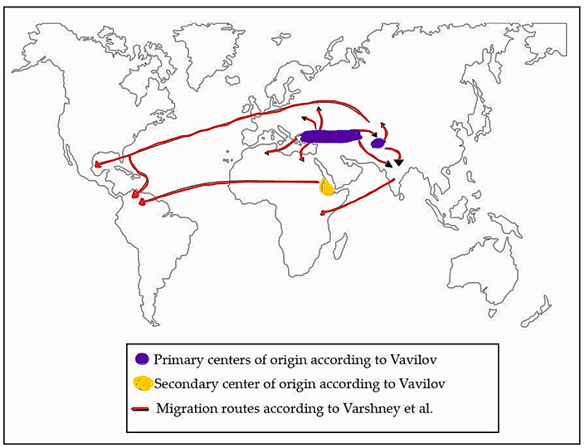

Fig.2: The regions where cultivated chickpea (C. arietinum) originated and its subsequent global distribution. Primary centers of origin according to Vavilov [Vavilov, 1926], Secondary center of origin according to Vavilov [Vavilov, 1926], Migration routes according to Varshney et al., 2019. Adapted from Osvin et al. [2022].
NUTRITIONAL QUALITY OF CHICKPEA SEEDS
Carbohydrate
Chickpea (Cicer arietinum L.) is a nutrient-rich legume, with carbohydrates and protein making up 80% of its dry mass. Consumed since ancient times [Jukanti et al., 2012], it is widely used in global cuisines—chickpea flour in Indian snacks [Chavan et al., 1987] and whole chickpeas in stews, soups, and salads across Asia and Africa [Ibrikci et al., 2003], contributing to its worldwide popularity [Jukanti et al., 2012]. Chickpea's carbohydrate profile includes monosaccharides (ribose, glucose), disaccharides (sucrose, maltose), and oligosaccharides (stachyose, ciceritol) [Han & Baik, 2006]. Glucose concentration is about 0.7% (w/w) [Sánchez-Mata et al., 1998], with starch as the main carbon storage (41–50% of total carbohydrates) [Özer et al., 2010]. Kabuli varieties have higher soluble sugar content than Desi types [Jambunathan & Singh, 1980; Varshney et al., 2013]. Chickpea seeds contain about 525 g/kg dry matter as starch, with 35% as resistant starch and 65% as available starch [Yolanda et al., 2009b]. It’s in vitro starch digestibility (37–60%) is relatively high among pulses [Khalil et al., 2007], enhancing its role as a key global food source [Rehman & Shah, 2005].
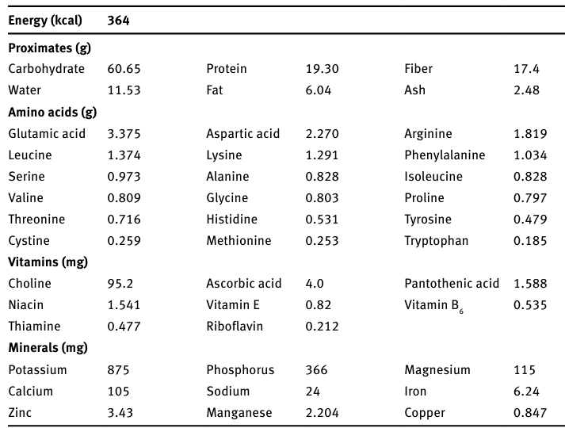
Table 1: Nutritional composition of mature chickpea seeds (value per 100 g edible portion) (Adapted from Kozgar, 2014)

Protein and Amino Acid
Chickpea is recognized for its high protein content, typically ranging from 17% to 22% of the dry seed weight [Hulse, 1989; Zhang et al., 2024]. Its protein quality surpasses that of several other pulse crops, including Vigna mungo L., Vigna radiata L., and Cajanus cajan L. However, crude protein concentration varies between Kabuli and Desi types. Some studies indicate a significant difference, with Kabuli containing 241 g/kg and Desi 217 g/kg, while others report more comparable values, with Kabuli at 217 g/kg and Desi at 215 g/kg [Rincón et al., 1998]. These variations highlight the need to consider specific chickpea varieties and growing conditions when evaluating their nutritional composition.
Chickpea seeds contain 18 amino acids, contributing to their high-quality protein [Wang & Daun, 2004; Wang et al., 2010]. Both Kabuli and Desi varieties have similar amino acid compositions, providing comparable nutritional benefits [Wang et al., 2010]. This makes chickpeas a valuable plant-based protein source for diverse diets.
Chickpeas contain both essential and non-essential amino acids, offering a well-balanced protein profile. They surpass many legumes, such as lentils and beans, due to higher levels of sulfur-containing amino acids like methionine and cysteine [Haug & Lantzsch, 1983]. This makes them an ideal complement to cereal grains, supporting complementary protein nutrition. Their consistent protein quality and additional benefits reinforce their importance in a balanced plant-based diet.
Table 2: The protein content of the different chickpea varieties:
Sample | Protein Content | Reference
Chickpea flour | 24.4–25.4% | Rachwa-Rosiak et al., 2015
Desi chickpea | 20.3 g/100 g | Torres-Fuentes et al., 2011
Chickpea (Dry) | 20.47 g/100 g | Wallace et al., 2016
Chickpea (Cooked) | 8.86 g/100 g | Wallace et al., 2016

Dietary Fiber
Chickpeas are rich in dietary fiber (DF), containing 18–22 g per 100 g [Yolanda et al., 2009b; Tosh & Yada, 2010]. They provide 4–8 g of soluble DF and 10–18 g of insoluble DF per 100 g. Though chickpea hulls have less fiber (75%) than lentils (87%) and peas (89%) (Wood, 2007), they still significantly contribute to fiber intake. Desi chickpeas have higher total and insoluble dietary fiber than Kabuli types due to their thicker seed coat, which makes up 11.5% of seed weight compared to 4.3–4.4% in Kabuli [Rincón et al., 1998]. This distinction highlights chickpea’s nutritional diversity and value as a dietary staple [Wood & Grusak, 2007; Jukanti et al., 2012]. Their rich fiber content and health benefits make them a key part of a balanced diet [Tharanathan & Mahadevamma, 2003]. Recent studies confirm that chickpeas are a rich source of dietary fiber, contributing to gut health and overall well-being [Ajay, 2024].
Minerals and Vitamins
Chickpeas are rich in essential minerals like iron, zinc, magnesium, calcium, and selenium [Carmen et al., 2003]. A 100 g serving provides 5.0 mg iron, 4.1 mg zinc, 138 mg magnesium, and 160 mg calcium, meeting daily iron and zinc needs and fulfilling magnesium requirements with 200 g [FAO, 2002]. Kabuli and Desi varieties have similar mineral content, except for calcium [Wang & Daun, 2004; Quinteros et al., 2001].
Chickpeas contain trace elements like aluminum, chromium, and nickel in low amounts [Guillon & Champ, 2002]. They are also rich in folic acid, essential for cell growth [Harun et al., 2010], and provide moderate levels of B vitamins, including B2, B5, and B6 [Lebiedzińska & Szefer, 2006]. These nutrients enhance chickpeas’ role as a nutritious, health-supporting food.
Table 3: Nutritional Profile of Chickpea (Cicer arietinum L.) (Koul et al., 2022)
Nutrients | Nutrient Value (Per 100 g)
Carbohydrate (g) | 39.56–54.2
Fiber (g) | 7.4–12.22
Protein (g) | 18.77–24
Fat (g) | 4.1–6.04
Calories | 378–396
Ash (g) | 3.4
Vitamins
β-carotene (g) | 67
Thiamine (mg) | 0.45–0.5
Pyridoxine (mg) | 0.3–0.38
Pantothenic acid (mg) | 1–2
Folic acid (mg) | 206–290
Riboflavin (mg) | 0.2–0.26
Niacin (mg) | 1.54–2
Tocopherol (mg) | 11.2–12.9
Amino Acids
Serine (g) | 4.8–5.2
Proline (g) | 4–4.3
Glutamic acid (g) | 16–17
Aspartic acid (g) | 10–11
Alanine (g) | 3.7–4.1
Valine (g) | 3.9–4.6
Tryptophan (g) | 0–0.9
Threonine (g) | 3.4–3.5
Tyrosine (g) | 3–3.3
Methionine (g) | 1.2–1.4
Lysine (g) | 6.6–7.2
Cysteine (g) | 0–1
Arginine (g) | 8–8.8
Glycine (g) | 3.5–4
Histidine (g) | 2.3–2.5
Isoleucine (g) | 3.5–4.4
Leucine (g) | 7.1–7.6
Phenylalanine (g) | 5.5–6.6
Minerals
Ca (mg) | 57–160
P (mg) | 250–310
Fe (mg) | 4.0–12.3
Na (mg) | 24
K (mg) | 700–718
Zn (mg) | 2.76–4.1
Mg (mg) | 79–138

Fatty Acid Profile
Chickpea fat content ranges from 3.40%–8.83% in Kabuli and 2.90%–7.42% in Desi varieties, exceeding that of lentils, kidney beans, and cereals [Wood & Grusak, 2007]. Its fatty acid profile includes 66% polyunsaturated (PUFAs), 19% monounsaturated (MUFAs), and 15% saturated fats (SFAs). Kabuli types have more oleic acid, while Desi types are richer in linoleic acid. Chickpeas are a superior source of essential PUFAs, particularly linoleic (51.2%) and oleic acid (32.6%) [Wang & Daun, 2004].
Chickpeas have a balanced fatty acid profile, with linoleic acid as the main component, followed by oleic and palmitic acids. These fats support heart health, reduce inflammation, and aid cellular functions [Yolanda et al., 2009a]. Their high linoleic acid content and optimal MUFA-PUFA ratio make them a valuable fat source, especially for plant-based diets [Haug & Lantzsch, 1983].
Table 4: Fatty acid composition of raw and processed chickpea (Mittal et al., 2012)
Treatment | Fatty Acid (%)
 | Palmitic acid | Oleic acid | Linoleic acid | Linolenic acid
Raw seed | 9.7 | 27.9 | 57.3 | 1.6
Boiling | 10.8 | 33.4 | 51.3 | Trace
Pressure cooking | 9.6 | 27.7 | 56.3 | 1.6
Roasting | 10.1 | 28.2 | 50.1 | 1.2

BIOACTIVE COMPOUNDS IN CHICKPEA
Chickpeas are a rich source of bioactive compounds, contributing to both their nutritional value and health-promoting properties. These compounds play a significant role in preventing and managing diseases, including cardiovascular disorders, diabetes, and cancer (Jukanti et al., 2012).
1. Phenolic Compounds
Chickpeas contain flavonoids and phenolic acids, such as ferulic, p-coumaric, and vanillic acids. These compounds exhibit strong antioxidant activities that help combat oxidative stress and reduce inflammation [Rachwa-Rosiak et al., 2015]. The phenolic profile in chickpea seeds varies depending on genotype and environmental factors [Shimrit et al., 2017].
2. Saponins
Chickpeas are rich in saponins, mainly soyasaponins, found in the seed coat. These compounds help lower cholesterol by reducing absorption and promoting bile acid excretion [Shi et al., 2004]. Additionally, saponins exhibit anti-carcinogenic properties by inducing apoptosis and inhibiting cancer cell growth, making them valuable for disease prevention.
3. Lectins
Chickpeas contain lectins, proteins with immune-modulating and antimicrobial properties [Peumans & Van Damme, 1995]. However, raw or undercooked chickpeas may cause digestive issues and hinder nutrient absorption. Proper cooking neutralizes lectins, making chickpeas safe to eat. Research also explores their potential in targeting pathogens and cancer cells.
4. Oligosaccharides
Chickpeas contain prebiotic oligosaccharides like raffinose, stachyose, and verbascose, which promote gut health by supporting beneficial bacteria [Niu et al., 2025]. However, their fermentation can cause gas buildup [Muir et al., 2009]. Soaking, cooking, enzymatic treatments, or germination help reduce this effect while preserving digestive benefits.
5. Phytosterols
Chickpeas are rich in phytosterols, which compete with dietary cholesterol for absorption, reducing overall cholesterol levels [Phillips et al., 2005]. This lowers LDL cholesterol, a major risk factor for cardiovascular diseases.
6. Isoflavones
Chickpeas contain isoflavones like genistein and daidzein, which act as phytoestrogens, mimicking or modulating estrogen activity [Shimrit et al., 2017]. They may help manage menopausal symptoms, support bone health, and reduce hormone-related cancer risks [Lampe, 2003].
7. Tannins
Tannins, abundant in colored chickpea seed coats, exhibit strong antioxidant and antimicrobial properties [Dueñas et al., 2004]. These polyphenols aid plant defense by deterring herbivores, inhibiting microbes, and mitigating environmental stress. Their concentration varies with genetics, cultivation, and environmental factors, being higher in wild or pigmented varieties than in white-seeded types.
8. Dietary Fiber
Chickpeas are rich in soluble and insoluble fiber, promoting digestion, gut health, and bowel regularity [Jukanti et al., 2012]. Soluble fiber regulates blood sugar, while insoluble fiber aids waste elimination. Dietary fiber also lowers cholesterol, reduces inflammation, and supports heart health [Rebello et al., 2014]. Regular consumption enhances satiety, aiding weight management and disease prevention.
IMPORTANCE OF NUTRITIONAL PROFILING IN CHICKPEA
1. Role in Enhancing Dietary Quality and Nutritional Security
Nutritional profiling of chickpeas identifies key nutrients like proteins, fiber, vitamins, and minerals, aiding dietary quality and food security [Jukanti et al., 2012]. Rich in iron and zinc, they help address deficiencies in vegetarian diets. Profiling supports informed agriculture to cultivate nutrient-rich crops for vulnerable populations [Shimrit et al., 2017].
2. Development of Biofortified Chickpea Varieties
Biofortification enhances crops' nutritional value, increasing iron, zinc, and protein [Howarth & Saltzman, 2017]. Nutritional profiling aids in selecting nutrient-rich chickpea varieties with good agronomic traits. Zinc- and iron-enriched chickpeas help combat "hidden hunger" [Velu et al., 2014], promoting sustainability and reducing nutrient deficiencies in low-income populations.
3. Use in Designing Functional Foods and Nutraceuticals
Chickpea-based ingredients, rich in protein, fiber, and bioactive compounds, are widely used in functional foods and nutraceuticals for health benefits beyond basic nutrition [Rachwa-Rosiak et al., 2015]. Nutritional profiling aids in selecting antioxidant- and fiber-rich cultivars for products targeting cholesterol, diabetes, and gut health. The growing demand for gluten-free, high-protein snacks further boosts chickpea flour’s use in functional foods.
ADVANCES IN NUTRITIONAL PROFILING TECHNIQUES FOR CHICKPEA
1. Chromatography and Spectroscopy Methods for Nutrient Analysis
Advanced analytical techniques such as High-Performance Liquid Chromatography (HPLC), Gas Chromatography-Mass Spectrometry (GC-MS), and Ultraviolet-Visible (UV-Vis) spectroscopy are extensively used for precise nutrient profiling in chickpeas. These methods enable the identification and quantification of essential components such as amino acids, phenolics, flavonoids, and vitamins. HPLC analyzes carbohydrates and phenolics, GC-MS identifies volatile compounds and fatty acids, and UV-Vis assesses antioxidants and pigments, ensuring precise chickpea nutrient profiling for better breeding and food formulations [Figueiredo et al., 2008].
2. Genomic Approaches to Identify Nutrient-Dense Cultivars
The integration of genomic tools such as genome-wide association studies (GWAS), quantitative trait loci (QTL) mapping, and next-generation sequencing (NGS) has revolutionized the identification of nutrient-dense chickpea cultivars [Roorkiwal et al., 2016]. These approaches help pinpoint genetic markers linked to key nutritional traits like high protein content, iron, and zinc accumulation [Varshney et al., 2013]. Transcriptomics and proteomics reveal gene expression in nutrient biosynthesis, aiding biofortified chickpea development for global nutrition [Thudi et al., 2016]. MAS and GS accelerate breeding of high-nutrient cultivars.
HEALTH BENEFITS OF CHICKPEA
Chickpea consumption provides numerous physiological benefits, positioning it as a potential functional food, in addition to its well-known role in supplying protein and fiber [Jukanti et al., 2012].
Weight Control
Chickpea supplementation helps prevent weight gain and fat accumulation in animal models. A study found that rats on a high-fat diet with chickpeas weighed less (562 g vs. 654 g) and had lower fat pad ratios (0.023 g/g vs. 0.032 g/g) [Yang et al., 2007]. As a low-GI food, chickpeas aid weight management by promoting satiety and reducing intake. In a 12-week study, participants consuming 104 g/day of chickpeas experienced reduced fat accumulation [Murty et al., 2010]. Their high fiber and protein content contribute to appetite control, making them beneficial for weight loss. Regular chickpea consumption also helps regulate blood sugar, preventing obesity-related complications.
Additionally, chickpeas improve gut microbiota, which supports digestion and weight regulation, while their nutrient profile promotes cardiovascular health. Recent studies confirm their role in weight management. A study by Novotny et al. (2025) measured the metabolizable energy value of chickpeas and lentils in humans, finding that their actual calorie content was lower than previously estimated, suggesting they are less energy-dense than assumed, which may support weight management efforts.
Diabetes and Blood Pressure
Chickpeas' high resistant starch and amylose content aid glucose metabolism by slowing digestion and glucose release, reducing insulin demand and glycemic index [Pittaway et al., 2007; Muir & O’Dea, 1992]. This helps manage type II diabetes. Additionally, their linoleic acid supports prostaglandin production, aiding blood pressure regulation [Jackson et al., 2024].
Reduce the Risk of Cancer
Chickpeas contain butyrate, which inhibits cell proliferation and induces apoptosis, reducing colorectal cancer risk [Cummings et al., 1981; Mathers, 2002]. β-sitosterol limits colonic tumor development, while lycopene is linked to lower prostate cancer risk [Raicht et al., 1980; Giovannucci et al., 1995]. Chickpea isoflavones inhibit tumor growth while sparing healthy cells [Girón-Calle et al., 2004]. Antioxidants like flavonoids and polyphenols reduce oxidative stress, and chickpea fiber supports gut health, lowering colorectal cancer risk.
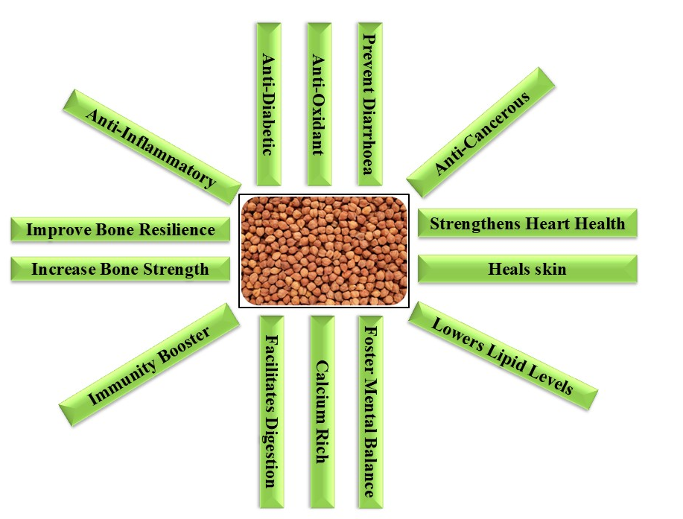

Fig.3: Chickpea Health Benefits
Gut Health
Studies show that consuming 140 g/day of chickpea and chickpea flour for six weeks increased dietary fiber intake by 18% [Nestel et al., 2004]. Murty et al. (2010) reported improved bowel health, including increased defecation frequency and softer stools, with a chickpea-based diet. Similarly, Singh et al. (2020) found that regular chickpea intake enhances bowel regularity, its fiber content alleviates constipation and boosts gut microbiota diversity, reinforcing its role in digestive health.
Other Health Benefits
Chickpea peptides exhibit antidiabetic, anticancer, antihypertensive, and antioxidant properties, along with antimicrobial, anti-inflammatory, and hypocholesterolemic effects. They also promote skin health and inhibit inflammation. A purified chickpea peptide (RQSHFANAQP) significantly reduced tumor necrosis factor-α expression in rats fed 20 mg/kg body weight/day [Real Hernandez & Gonzalez, 2019].
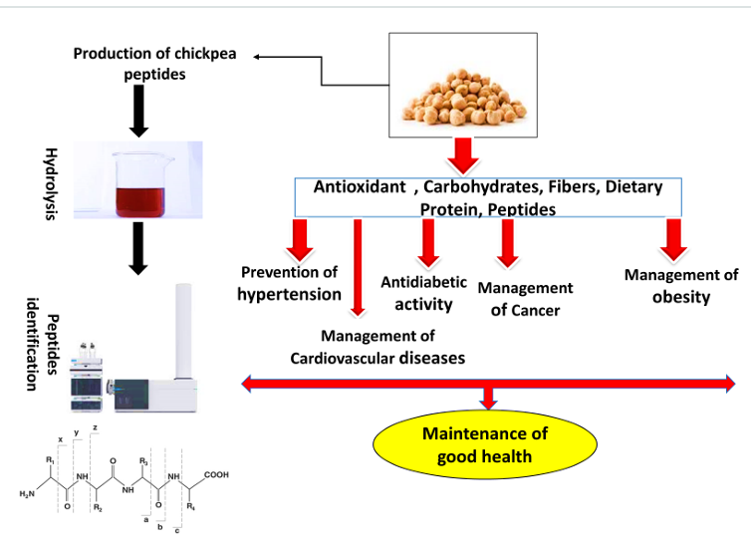

Fig.4: Health Benefits of Chickpea (Begum et al., 2023)
CHALLENGES IN CHICKPEA NUTRITIONAL RESEARCH
1. Genetic Variability and Environmental Factors Affecting Nutritional Composition
Chickpea nutritional research faces challenges due to genetic variability and environmental influences on nutrient expression. Protein, mineral, and bioactive compound levels vary across cultivars and growing conditions [Gaur et al., 2008]. Drought and high temperatures reduce seed protein and starch content. Breeding nutrient-dense cultivars is complex due to genotype-by-environment interactions [Varshney et al., 2013], requiring multi-location trials and genomic studies for stable, nutrient-rich varieties [Roorkiwal et al., 2016].
2. Post-Harvest Processing Impacts on Nutrient Retention
Post-harvest processing, such as dehulling, soaking, cooking, and roasting, enhances chickpea digestibility and reduces anti-nutritional factors but may also cause nutrient losses [Jukanti et al., 2012]. Boiling reduces water-soluble vitamins like thiamine and riboflavin, while roasting decreases certain phenolic compounds. Mineral retention in chickpeas, especially iron and zinc, varies with cooking methods and duration. Traditional cooking causes higher nutrient losses than steaming or pressure cooking. Optimizing processing techniques to balance nutrient retention and bioavailability remains a key research focus.
FUTURE PERSPECTIVES AND RESEARCH NEEDS IN CHICKPEA NUTRITIONAL RESEARCH
1. Breeding for High-Yield, Nutrient-Rich Varieties
Future chickpea breeding aims to develop high-yielding, nutrient-rich cultivars using genetic diversity, genomics, marker-assisted selection (MAS), and genomic selection (GS). Efforts focus on enhancing protein, micronutrient profiles, and stress resilience, with an emphasis on improving iron, zinc, and folate bioavailability for global nutrition [Varshney et al., 2013]. Integrating genetic approaches with modern agronomy is key to optimizing chickpea yield while preserving nutrition for food security [Velu et al., 2014]. Balancing yield and nutrient quality can produce high-yielding cultivars with significant health benefits. Recent advancements in genomic selection techniques, such as the DPCformer model, have demonstrated improved prediction accuracy for complex traits in chickpea, offering promising avenues for accelerated breeding [Deng et al., 2025].
2. Addressing Anti-Nutritional Factors such as Phytates and Tannins
Anti-nutritional factors like phytates and tannins in chickpeas hinder nutrient bioavailability. Phytates bind minerals like iron and zinc, reducing absorption, while tannins interfere with protein digestion and amino acid utilization [Jukanti et al., 2012]. Research aims to reduce anti-nutritional factors in chickpeas through breeding, genetic modification, and CRISPR-Cas9. Eco-friendly processing methods like soaking, fermentation, and sprouting also help mitigate these factors while preserving nutrients.
3. Integration of Advanced Technologies for Precision Nutritional Analysis
Advanced technologies like high-throughput sequencing, metabolomics, and multi-dimensional chromatography enable precise nutritional analysis of chickpeas. These tools help profile metabolites, identify nutrient-gene interactions, and assess environmental impacts on nutrient composition. AI and ML can analyze genomic, phenotypic, and nutritional data to predict chickpea nutrient profiles across environments [Gaur et al., 2008]. This accelerates the identification of nutrient-dense varieties and enhances agricultural practices for next-generation functional foods. Recent advancements highlight the integration of AI in phytochemical research, enabling efficient analysis of high-dimensional 'omics' data and facilitating the discovery of novel metabolites, structural elucidation, and metabolite profiling in plants [Varghese et al., 2025].
Conclusion
Chickpea (Cicer arietinum L.) is a vital crop for global nutrition and food security, offering high protein, essential amino acids, B-complex vitamins, minerals (iron, zinc, magnesium), and dietary fiber. Its bioactive compounds, including antioxidants, polyphenols, and flavonoids, help reduce inflammation, combat oxidative stress, and lower the risk of chronic diseases like cardiovascular ailments, diabetes, and obesity.
Nutritional profiling aids breeding programs in enhancing chickpea varieties' nutritional value and resilience. Biofortification strategies to boost micronutrient and protein levels are crucial for addressing malnutrition. Additionally, profiling supports food scientists in developing chickpea-based products for health-conscious consumers. Advancing research in genomics, bioinformatics, and food processing technologies will further unlock chickpea’s full potential.

Disclaimer
The opinions and conclusions presented in this article are solely those of the authors and do not necessarily reflect the perspectives of their affiliated institutions. While the authors have made every effort to ensure the accuracy and completeness of the information provided, they disclaim any liability for direct or indirect losses arising from its use.

Conflict of interest
The authors declare no conflicts of interest concerning the publication of this article. The study's design, data collection, analysis, decision to publish, and manuscript preparation were not influenced by any funding or sponsorship.

Disclaimer (Artificial intelligence)
Option 1:
Author(s) hereby declare that NO generative AI technologies such as Large Language Models (ChatGPT, COPILOT, etc.) and text-to-image generators have been used during the writing or editing of this manuscript.

References

Ajay, A. (2024). Chickpeas and gut microbiome: Functional food implications. Frontiers in Nutrition, 10, 39498070. https://doi.org/10.3389/fnut.2024.39498070.
Bar-El Dadon, S., Pascual, C. M., & Reifen, R. (2017). Nutritional aspects of chickpeas as a functional food: A review. British Journal of Nutrition, 108(S1), S11–S26.
Begum, N., Khan, Q. U., Liu, L. G., Li, W., Liu, D., & Haq, I. U. (2023). Nutritional composition, health benefits, and bioactive compounds of chickpea (Cicer arietinum L.). Frontiers in Nutrition, 10, 1218468.
Carmen Cabrera, Fuensanta Lloris, Rafael Giménez, Manuel Olalla, M. Carmen López. (2003). Mineral content in legumes and nuts: contribution to the Spanish dietary intake, Science of The Total Environment, 308(1–3): 1-14.
Chavan, J. K., Kadam, S. S., Salunkhe, D. K., & Beuchat, L. R. (1987). Biochemistry and technology of chickpea (Cicer arietinum L.) seeds. C R C Critical Reviews in Food Science and Nutrition, 25(2), 107–158. https://doi.org/10.1080/10408398709527449.
Cummings, J. H., Stephen, A. M., & Branch, W. J. (1981). Implications of dietary fibre breakdown in the human colon. Banbury report, 7, 71-81.
Deng, P., Liu, K., Zhou, M., et al. (2025). DPCformer: An Interpretable Deep Learning Model for Genomic Prediction in Crops. arXiv. arXiv:2510.08662.
Dueñas, M., Estrella, I. & Hernández, T. (2004). Occurrence of phenolic compounds in the seed coat and the cotyledon of peas (Pisum sativum L.). Eur Food Res Technol, 219, 116–123. https://doi.org/10.1007/s00217-004-0938-x.
Economic Times. (2025, October 16). Finance Minister Sitharaman inaugurates pulse processing unit in Raichur, pledges support to farmers. The Economic Times. Retrieved from https://economictimes.indiatimes.com/articleshow/124607061.cms.
Figueiredo, A. C., Barroso, J. G., Pedro, L. G., & Scheffer, J. J. (2008). Factors affecting secondary metabolite production in plants: volatile components and essential oils. Flavour and Fragrance journal, 23(4), 213-226.
Gaur, P. M., Krishnamurthy, L., & Kashiwagi, J. (2008). Improving Drought-Avoidance Root Traits in Chickpea (Cicer arietinum L.) -Current Status of Research at ICRISAT. Plant Production Science, 11(1), 3–11. https://doi.org/10.1626/pps.11.3.
Giovannucci, E., Ascherio, A., Rimm, E. B., Stampfer, M. J., Colditz, G. A., & Willett, W. C. (1995). Intake of carotenoids and retino in relation to risk of prostate cancer. JNCI Journal of the National Cancer Institute, 87(23), 1767-1776.
Girón-Calle, J., Vioque, J., del Mar Yust, M., Pedroche, J., Alaiz, M., & Millán, F. (2004). Effect of chickpea aqueous extracts, organic extracts, and protein concentrates on cell proliferation. Journal of Medicinal Food, 7(2), 122-129.
Guillon, F., & Champ, M. J. (2002). Carbohydrate fractions of legumes: uses in human nutrition and potential for health. British Journal of Nutrition, 88(S3), 293-306.
Han, I. H., & Baik, B. K. (2006). Oligosaccharide content and composition of legumes and their reduction by soaking, cooking, ultrasound, and high hydrostatic pressure. Cereal chemistry, 83(4), 428-433.
Harun, C., Ozkaya, A., Çevrimli, B. S., & Bakoğlu, A. (2010). Levels of fat-soluble vitamins in some foods. Asian Journal of Chemistry, 22(4), 1251–1256.
Haug, W., & Lantzsch, H. J. (1983). Sensitive method for the rapid determination of phytate in cereals and cereal products. Journal of the Science of Food and Agriculture, 34(12), 1423-1426.
Howarth E. Bouis & Amy Saltzman. (2017). Improving nutrition through biofortification: A review of evidence from HarvestPlus, 2003 through 2016, Global Food Security, 12: 49-58.
Hulse, J. H. (1989). Nature, composition and utilization of grain legumes. Uses of tropical grain legumes, 27(11).
Ibrikci, H., Knewtson, S. J., & Grusak, M. A. (2003). Chickpea leaves as a vegetable green for humans: evaluation of mineral composition. Journal of the Science of Food and Agriculture, 83(9), 945-950.
International Grains Council. (2025). Global chickpea production is expected to increase in 2025/26. Tridge. Retrieved from https://www.tridge.com/news/global-chickpea-production-is-expected-to-in-tdwxrf.
Jackson, K.H., Harris, W.S., Belury, M.A. et al. Beneficial effects of linoleic acid on cardiometabolic health: an update. Lipids Health Dis 23, 296 (2024). https://doi.org/10.1186/s12944-024-02246-2.
Jain, M., Misra, G., Patel, R. K., Priya, P., Jhanwar, S., Khan, A. W., ... & Chattopadhyay, D. (2013). A draft genome sequence of the pulse crop chickpea (C icer arietinum L.). The Plant Journal, 74(5), 715-729.
Jambunathan, R., & Singh, U. (1980, February). Studies on Desi and Kabuli chickpea (Cicer arietinum) cultivars. 1. Chemical composition. In Proceedings of the international workshop on chickpea improvement (Vol. 28, pp. 61-66). ICRISAT Hyderabad, India.
Jukanti, A. K., Gaur, P. M., Gowda, C. L. L., & Chibbar, R. N. (2012). Nutritional quality and health benefits of chickpea (Cicer arietinum L.): a review. British Journal of Nutrition, 108(S1), S11-S26.
Kaur, R., & Prasad, K. (2021). Nutritional characteristics and value-added products of Chickpea (Cicer arietinum)—A review. Journal of Postharvest Technology, 9(2), 1-13.
Kendall, C. W., Emam, A., Augustin, L. S., & Jenkins, D. J. (2004). Resistant starches and health. Journal of AOAC international, 87(3), 769-774.
Khalil, A. W., Zeb, A., Mahmood, F., Tariq, S., Khattak, A. B., & Shah, H. (2007). Comparison of sprout quality characteristics of desi and kabuli type chickpea cultivars (Cicer arietinum L.). LWT-Food Science and Technology, 40(6), 937-945.
Koul, B., Sharma, K., Sehgal, V., Yadav, D., Mishra, M., & Bharadwaj, C. (2022). Chickpea (Cicer arietinum L.) biology and biotechnology: from domestication to biofortification and biopharming. Plants, 11(21), 2926.
Kozgar, I. (2014). Mutation Breeding in Chickpea: Perspectives and Prospects for Food Security.
Ladizinsky, G. (1975). A new Cicer from Turkey. Notes from the Royal Botanic Garden Edinburgh, 34(2), 201-202.
Lampe, J. W. (2003). Isoflavonoid and lignan phytoestrogens as dietary biomarkers. The Journal of nutrition, 133(3), 956S-964S.
Lebiedzińska, A., & Szefer, P. (2006). Vitamins B in grain and cereal–grain food, soy-products and seeds. Food Chemistry, 95(1), 116-122.
Mathers, J. C. (2002). Pulses and carcinogenesis: potential for the prevention of colon, breast and other cancers. British Journal of Nutrition, 88(S3), 273-279.
Merga, B., & Haji, J. (2019). Economic importance of chickpea: Production, value, and world trade. Cogent Food & Agriculture, 5(1), 1615718.
Mittal, R., Nagi, H. P. S., Sharma, P., & Sharma, S. (2012). Effect of processing on chemical composition and antinutritional factors in chickpea flour. Journal of Food Science and Engineering, 2(3), 180.
Moreno, M. T., & Cubero, J. I. (1978). Variation in Cicer arietinum L. Euphytica, 27(2), 465-485.
Muir, J. G., & O'Dea, K. (1992). Measurement of resistant starch: factors affecting the amount of starch escaping digestion in vitro. The American journal of clinical nutrition, 56(1), 123-127.
Muir, J. G., Rose, R., Rosella, O., Liels, K., Barrett, J. S., Shepherd, S. J., & Gibson, P. R. (2009). Measurement of short-chain carbohydrates in common Australian vegetables and fruits by high-performance liquid chromatography (HPLC). Journal of agricultural and food chemistry, 57(2), 554-565.
Murty, C. M., Pittaway, J. K., & Ball, M. J. (2010). Chickpea supplementation in an Australian diet affects food choice, satiety and bowel health. Appetite, 54(2), 282-288.
Nestel, P., Cehun, M., & Chronopoulos, A. (2004). Effects of long-term consumption and single meals of chickpeas on plasma glucose, insulin, and triacylglycerol concentrations123. The American journal of clinical nutrition, 79(3), 390-395.
Niu, J., Yang, Y., Zhao, L., Cao, N., Xiong, X., Yun, Z., Yang, F., Xu, Y., Tu, H., Zhong, K., Wang, H., Gao, H., Zhang, Y., Qin, Z., Wang, L. and Shi, B. (2025), Sensory Lexicon Construction and Quantitative Descriptive Analysis of Jiang-Flavor Baijiu. Food Sci Nutr, 13: e4652. https://doi.org/10.1002/fsn3.4652.
Novotny, J.A., Henderson, T., & Baer, D.J. (2025). Metabolizable Energy Value of Chickpeas and Lentils in the Human Diet: A Randomized Controlled Trial. Nutrients, 17(8), 2725. https://doi.org/10.3390/nu17172725.
Osvin, A., Cacciuttolo, F., Cabeza, R. A., Carrasco, B., & Schwember, A. R. (2022). A comprehensive review on chickpea (Cicer arietinum L.) breeding for abiotic stress tolerance and climate change resilience. International Journal of Molecular Sciences, 23(12), 6794.
Özer, S., Karaköy, T., Toklu, F., Baloch, F. S., Kilian, B., & Özkan, H. (2010). Nutritional and physicochemical variation in Turkish kabuli chickpea (Cicer arietinum L.) landraces. Euphytica, 175(2), 237-249.
Peumans, W. J., & Van Damme, E. J. (1995). Lectins as plant defense proteins. Plant physiology, 109(2), 347.
Phillips, K. M., Ruggio, D. M., & Ashraf-Khorassani, M. (2005). Phytosterol composition of nuts and seeds commonly consumed in the United States. Journal of agricultural and food chemistry, 53(24), 9436-9445.
Pittaway, J. K., Ahuja, K. D., Robertson, I. K., & Ball, M. J. (2007). Effects of a controlled diet supplemented with chickpeas on serum lipids, glucose tolerance, satiety and bowel function. Journal of the American College of Nutrition, 26(4), 334-340.
Quinteros, A., Farré, R., & Lagarda, M. J. (2001). Optimization of iron speciation (soluble, ferrous and ferric) in beans, chickpeas and lentils. Food Chemistry, 75(3), 365-370.
Rachwa-Rosiak, D., Nebesny, E., & Budryn, G. (2015). Chickpeas—composition, nutritional value, health benefits, application to bread and snacks: a review. Critical reviews in food science and nutrition, 55(8), 1137-1145.
Raicht, R. F., Cohen, B. I., Fazzini, E. P., Sarwal, A. N., & Takahashi, M. (1980). Protective effect of plant sterols against chemically induced colon tumors in rats. Cancer Research, 40(2), 403-405.
Real Hernandez, L. M., & Gonzalez de Mejia, E. (2019). Enzymatic production, bioactivity, and bitterness of chickpea (Cicer arietinum) peptides. Comprehensive reviews in food science and food safety, 18(6), 1913-1946.
Rebello, C. J., Greenway, F. L., & Finley, J. W. (2014). Whole grains and pulses: A comparison of the nutritional and health benefits. Journal of agricultural and food chemistry, 62(29), 7029-7049.
Rehman, Z. U., & Shah, W. H. (2005). Thermal heat processing effects on antinutrients, protein and starch digestibility of food legumes. Food chemistry, 91(2), 327-331.
Ribeiro, R. J. M. C., & Melo, I. M. (1990). Composition and nutritive value of chickpea. Options Méditerranéennes-Série Séminaires, 9, 107-111.
Rincón, F., Martínez, B., & Ibáñez, M. V. (1998). Proximate composition and antinutritive substances in chickpea (Cicer arietinum L) as affected by the biotype factor. Journal of the Science of Food and Agriculture, 78(3), 382-388.
Sánchez-Mata, M. C., Peñuela-Teruel, M. J., Cámara-Hurtado, M., Díez-Marqués, C., & Torija-Isasa, M. E. (1998). Determination of mono-, di-, and oligosaccharides in legumes by high-performance liquid chromatography using an amino-bonded silica column. Journal of Agricultural and Food Chemistry, 46(9), 3648-3652.
Shi, J., Arunasalam, K., Yeung, D., Kakuda, Y., Mittal, G., & Jiang, Y. (2004). Saponins from edible legumes: chemistry, processing, and health benefits. Journal of medicinal food, 7(1), 67-78.
Shimrit Bar-El Dadon, Shahal Abbo, Ram Reifen (2017). Leveraging traditional crops for better nutrition and health - The case of chickpea, Trends in Food Science & Technology, 64: 39-47.
Singh, F., & Diwakar, B. (1995). Chickpea botany and production practices.
Tharanathan, R. N., & Mahadevamma, S. (2003). Grain legumes—a boon to human nutrition. Trends in Food Science & Technology, 14(12), 507-518.
Thudi, M., Khan, A.W., Kumar, V. et al. (2016). Whole genome re-sequencing reveals genome-wide variations among parental lines of 16 mapping populations in chickpea (Cicer arietinum L.). BMC Plant Biol 16 (Suppl 1), 10. https://doi.org/10.1186/s12870-015-0690-3.
Torres-Fuentes, C., Alaiz, M., & Vioque, J. (2011). Affinity purification and characterisation of chelating peptides from chickpea protein hydrolysates. Food Chemistry, 129(2), 485-490.
Tosh, S. M., & Yada, S. (2010). Dietary fibres in pulse seeds and fractions: Characterization, functional attributes, and applications. Food research international, 43(2), 450-460.
Varghese, R., et al. (2025). Artificial intelligence driven approaches in phytochemical research. Plant Molecular Biology, 98(2), 123–145. https://doi.org/10.1007/s11101-025-10096-8.
Varshney, R. K., Graner, A., & Sorrells, M. E. (2005). Genomics-assisted breeding for crop improvement. Trends in plant science, 10(12), 621-630.
Varshney, R. K., Song, C., Saxena, R. K., Azam, S., Yu, S., Sharpe, A. G., ... & Cook, D. R. (2013). Draft genome sequence of chickpea (Cicer arietinum) provides a resource for trait improvement. Nature biotechnology, 31(3), 240-246.
Varshney, R. K., Thudi, M., Roorkiwal, M., He, W., Upadhyaya, H. D., Yang, W., ... & Liu, X. (2019). Resequencing of 429 chickpea accessions from 45 countries provides insights into genome diversity, domestication and agronomic traits. Nature genetics, 51(5), 857-864.
Vavilov, N. L. (1926). Centers of Origin of Cultivated Plants. Inst. Appl. Bot. Plant Breed., 16(2).
Velu, G., Ortiz-Monasterio, I., Cakmak, I., Hao, Y., & Singh, R. Á. (2014). Biofortification strategies to increase grain zinc and iron concentrations in wheat. Journal of cereal science, 59(3), 365-372.
Wallace, T. C., Murray, R., & Zelman, K. M. (2016). The nutritional value and health benefits of chickpeas and hummus. Nutrients, 8(12), 766.
Wang, N., & Daun, J. K. (2004). The chemical composition and nutritive value of Canadian pulses. Canadian Grain Commission Report, 28, 19-29.
Wang, X., Gao, W., Zhang, J., Zhang, H., Li, J., He, X., & Ma, H. (2010). Subunit, amino acid composition and in vitro digestibility of protein isolates from Chinese kabuli and desi chickpea (Cicer arietinum L.) cultivars. Food Research International, 43(2), 567-572.
Wood, J. A., & Grusak, M. A. (2007). Nutritional value of chickpea. In Chickpea breeding and management (pp. 101-142). Wallingford UK: CABI.
Yang, Y., Zhou, L., Gu, Y., Zhang, Y., Tang, J., Li, F., ... & Chen, M. (2007). Dietary chickpeas reverse visceral adiposity, dyslipidaemia and insulin resistance in rats induced by a chronic high-fat diet. British Journal of Nutrition, 98(4), 720-726.
Yolanda, A, Esteban, R. M., & Benítez, V. (2009a). Starch, functional properties, and microstructural characteristics in chickpea and lentil as affected by thermal processing. Journal of Agricultural and Food Chemistry, 57(22), 10682–10688.
Yolanda, A., Martín-Cabrejas, M. A., Benítez, V., Mollá, E., López-Andréu, F. J., & Esteban, R. M. (2009b). Changes in carbohydrate fraction during dehydration process of common legumes. Journal of Food Composition and Analysis, 22(8), 678–683.
Zhang, J.; Wang, J.; Zhu, C.; Singh, R.P.; Chen, W. (2024). Chickpea: Its Origin, Distribution, Nutrition, Beneﬁts, Breeding, and Symbiotic Relationship with Mesorhizobium Species. Plants, 13, 429. https://doi.org/10.3390/plants13030429.
Zhao, X., Sun, L., Zhang, X., Wang, M., Liu, H., & Zhu, Y. (2021). Nutritional components, volatile constituents and antioxidant activities of 6 chickpea species. Food Bioscience, 41, 100964.

