Production of Bioethanol from Tropical Fruit Waste (pineapple, banana, and papaya) through Alcoholic Fermentation

ABSTRACT: The use of fruit waste as a raw material for bioethanol production offers significant advantages in terms of reducing greenhouse gas emissions and producing new sources of renewable energy from biomass.The aim of this study was to recycle tropical fruit peels (pineapple, banana, and papaya) to produce second-generation biofuels. Fresh fruit peels were collected, sorted and kept at 4°C. Fermentation was carried out in four fermenters, followed by simple distillation (78–80°C), rectification, and then dehydration with magnesium sulfate to obtain high-purity bioalcohol. The results obtained for the organoleptic parameters showed that, during fermentation, the must from the fruit peels was a yellow to orange color, an initially sweet-tart smell that evolved into an alcoholic smell, and a fruity-sweet taste that evolved into a pronounced alcohol taste at the end of fermentation. During fermentation, a decrease in Brix degree was observed from 14 to 9 for musts from pineapple peels, and from 13 to 7 for musts from banana and papaya peels. This indicated good fermentation potential. After dehydration, the probable alcohol content of pineapple musts increased from 4.67% to over 53% (v/v) for P1 and from 5.35% to over 60% for P2 (v/v). Thus, converting fruit waste into bioethanol could lead to a sustainable process, with the dual advantage of solving the problem of food waste disposal while meeting the energy needs of a growing population.
Key words: waste, fermentation, alcohol, banana, pineapple, papaya

- INTRODUCTION

The recycling and recovery of solid waste are currently major challenges for environmental research. In the current context of sustainable development, the international community strongly encourages the use of renewable energy sources, such as biofuels for transportation. Biofuels, produced from the conversion of organic biomass, represent a strategic alternative for reducing dependence on fossil fuels [1]. Among these approaches, the recovery of biodegradable waste through the production of bioethanol is both an environmentally friendly and economically
viable solution. Bioethanol is the most widely used liquid biofuel as a fuel or gasoline enhancer. Since ethanol has a higher oxygen content than other liquid biofuels, a smaller amount of additive is required. The increased percentage of oxygen allows for better oxidation of gasoline hydrocarbons, resulting in reduced emissions of carbon monoxide (CO) and aromatic compounds [2]. Biofuels are generally produced by fermenting agricultural and forestry waste. The complexity of the production process depends on the raw material [3]. This process addresses the major challenges of waste management, pollution reduction, and energy transition [4]. Indeed, the

covers an area of 342,000 km². It is located in Central Africa, straddling the equator between latitudes 3°30' North and 5° South and longitudes 11° and 18° East. South and longitudes 11° and 18° East [10]. Brazzaville metropolitan area covers an area of nearly 265 km² and is located in the southern part of Congo, between latitudes 4°6'15'' and 4°22'30'' South and between longitudes 15°6'0'' and 15°19'15'' East [11]. The districts of Brazzaville targeted for this operation are: Makélékélé, Bacongo, Poto-Poto, Talangaï, Mfilou, and Madibou (Figure 1). These sites were chosen for several reasons, namely the high density of commercial activities related to fruit sales and processing; the presence of unloading points for fruit from rural areas, particularly banana ripening facilities; and the diversity of consumption methods (frying, doughnuts, artisanal processing), which generates significant quantities of usable organic waste. This study was conducted within the Faculty of Science and Technics of Marien NGOUABI University at Brazzaville.
  - Material and reagents
The biological material used in this study consists of organic waste from tropical fruits, specifically banana peels (Musa spp.), pineapple peels (Ananas comosus), and papaya peels (Carica papaya). These residues were selected for their high content of fermentable sugars (glucose, fructose, sucrose) as well as their local availability and production in large quantities, particularly in urban areas with high commercial activity. The reagents used consist of distilled water, sodium

concept of waste treatment has evolved from simple collection to recovery and recycling in various forms [5]. In Congo-Brazzaville, where approximately 70% of the waste produced is In Congo-Brazzaville, where approximately 70% of the waste produced is biodegradable [6], banana, pineapple, and papaya waste is abundant in urban areas, particularly in Brazzaville. This surplus represents an opportunity to develop innovative solutions for energy and environmental recovery. The alcoholic fermentation of juices extracted from this fruit waste produces bioethanol of a quality comparable to that obtained from fresh fruit, such as pineapple or sugar cane [7]. This recovery not only reduces greenhouse gas emissions, but also strengthens local sustainability by promoting green energy. Furthermore, the development of second-generation bioethanol, based on lignocellulosic biomass (banana, papaya, pineapple), offers a credible alternative to the depletion of fossil resources, while limiting the effects of climate change and air pollution [8]. This potential is reinforced by the overproduction of fruit linked to logistical difficulties in areas of high production. Finally, the use of microorganisms such as Saccharomyces cerevisiae facilitates the conversion of this biomass into ethanol, confirming the scientific and technical relevance of the process [9].
2. MATERIALS AND METHODS
2.1 Description of the study site
This study was conducted at Brazzaville, capital of Republic of Congo. The Republic of Congo

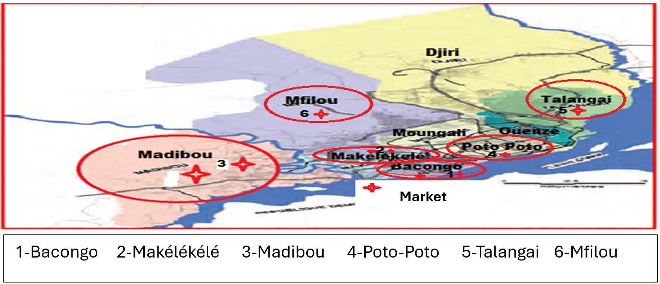

Figure 1 : Zone de collecte des déchets [12]
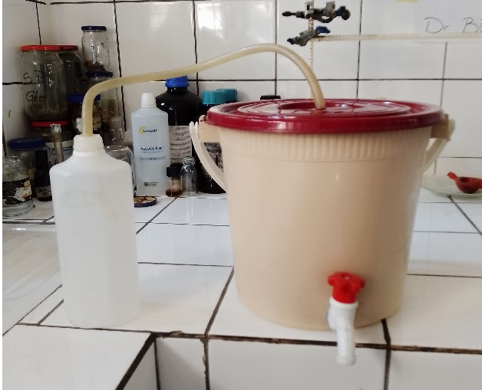

Figure 2 : Fermenters after design

four fermentation tanks of 10 liters each, in orderto test the effect of different quantities of yeast and substrate on bioethanol yield. The codes are defined as follows:

- Sample 1 (Figure 3): pineapple skins, distributed equally among four separate tanks (P1, P2, P3, and P4).
- Sample 2 (Figure 4): banana peels, distributed among four fermenters (B1, B2, B3, and B4), with varying amounts of yeast and substrate.
- Sample 3 (Figure 5): Carica papaya peels, also divided into four fermenters (C1, C2, C3, and C4) in different proportions.

The peels of tropical fruits (bananas, pineapples, and papayas) were collected in plastic bags and transported to the laboratory for physical pretreatment. Après collecte, les pelures de fruits tropicaux ont été triés, découpés en petits morceaux, nettoyés à l’eau distillée pour éliminer les impuretés (poussières, sables, etc.), puis broyées mécaniquement à l’aide d’un mixeur afin d’obtenir une pulpe homogène. La Figure 6 illustre le substrat fermentescible des pelures de la banane.
2.5 Fermentation process
After weighing, the peels of the collected tropical fruits were cut up, rinsed, and crushed to obtain a virtually homogeneous mixture (must), whose initial parameters (before fermentation) were measured, namely: organoleptic parameters (color, smell, and taste) to properly monitor the fermentation process. The mixture (must) thus formed was placed in a fermentation tank after

sodium hydroxide (NaOH) for pH adjustment, sulfuric acid (H₂SO₄) for possible hydrolysis, Fehling's solution for detecting reducing sugars, DNS reagent (3,5-dinitrosalicylic acid) for estimating total sugars, Saccharomyces cerevisiae yeast used for inoculation, and magnesium sulfate (MgSO₄) used as a dehydrating agent.

2.3 Experimental device: design of
artisanal fermenters

As part of our study, artisanal fermenters with a capacity of 10 liters were designed and assembled manually (Figure 2). Their installation followed several methodical steps aimed at ensuring the efficiency of the fermentation process and the safety of the device. For preparation of containers, we used plastic buckets with airtight lids. Holes were made at two levels: one in the center of the lid to insert a plastic tube of sufficient length, and the other at the base of the bucket, where a tap was installed to allow samples to be taken during fermentation. For ensuring airtightness, to prevent any gas or liquid leaks, the interface between the lid and the plastic tube was sealed with silicone sealant to ensure a perfect seal. For degassing device, 1-liter and 1.5-liter plastic bottles were perforated and then filled with distilled water and lime water, respectively. These solutions served as gas traps for the visualization and analysis of the gas (CO₂) produced during fermentation. For system connection, the bottles were connected to the fermenter lids using flexible plastic tubes. These tubes passed through the lid and into the solutions contained in the bottles. This system allowed the formation of gas bubbles, a sign of fermentation activity, to be observed. For immersion level control, special attention was paid to ensuring that the ends of the tubes remained submerged in the liquids in the bottles throughout the process. This ensured unidirectional degassing while preventing any outside air from entering, which could compromise the anaerobic conditions necessary for alcoholic fermentation.
2.4 Sampling and sample pretreatment
Three (03) types of samples were selected for this study. Each type of substrate was subdivided into

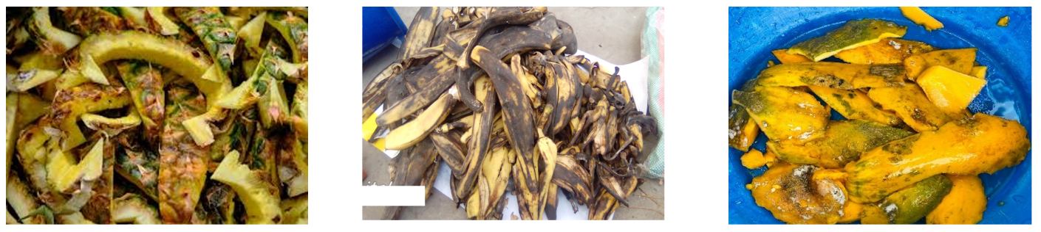
Figure 5: Carica Papaya peels
Figure 4: Banana peels
Figure 3: Pineapple peels

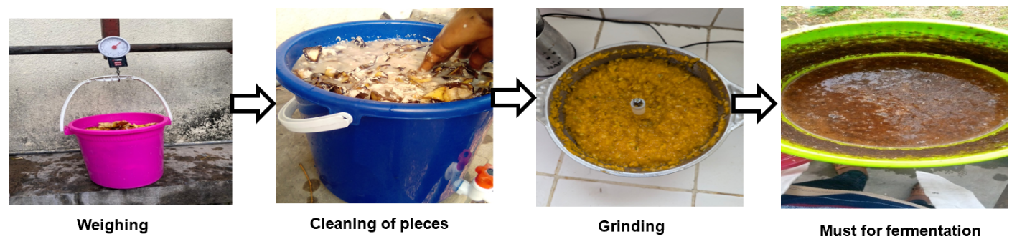
Figure 6 : Pelures de bananes pesées, nettoyées, broyées et obtention du moût
adding water (2 liters) and yeast (Saccharomyces cerevisiae, 40g). For each peel, the fermentation tank (fermenter) will be hermetically sealed, as fermentation must take place in an anaerobic environment between 15-35°C to allow the yeast to convert glucose into alcohol. Fermentation lasted one week. The fermented must obtained is then filtered (Figure 7).
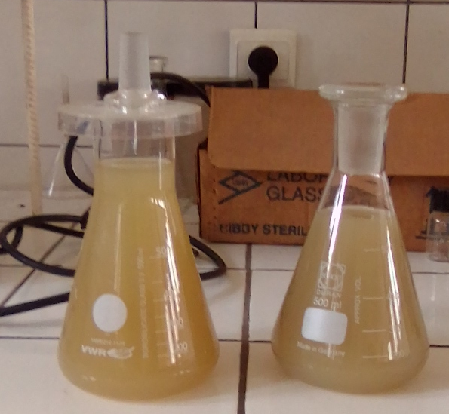
2.6 Simple distillation and fractional
distillation of the must
At the end of fermentation, the mixture (must) was filtered and then subjected to simple distillation in a 2000 ml flask and placed in the distillation apparatus prepared beforehand to recover a hydroalcoholic solution. This is an important phase of this work for obtaining second-generation alcohol. This operation separates alcohol from water based on their different boiling points: water boils at 100°C, while ethanol boils at 78.5-80°C.
At 20°C, the first drops of distillate (hydroalcoholic solution) began to fall into the hydroalcoholic solution recovery vessel. The hydroalcoholic solution obtained then undergoes fractional distillation or rectification, which is a process for purifying a low-alcohol solution to obtain a high-alcohol solution (Figure 8). A very short column head was used because the operation must be carried out at a well-controlled temperature (78-80°C) in order to obtain alcohol at 78°C. The alcohol yield was then calculated based on the amount of initial substrate and the volume of pure alcohol obtained.
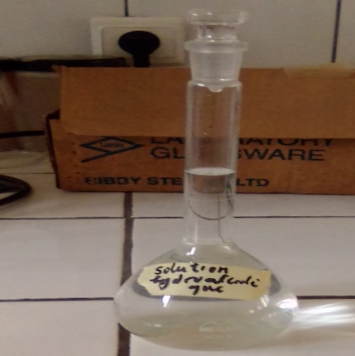

2.7 Dehydration with magnesium sulfate

The alcohol solution obtained by rectification was purified to obtain anhydrous alcohol. After distillation, 50 ml was taken for dehydration with

Figure 8 : Rectified alcohol

4. RESULTS AND DISCUSSION
4.1 Organoleptic parameters

4.1.1. The colour of the must

The same observations were noted for the three types of waste (pineapple, banana and papaya peel). Visual assessment revealed that the colour of the must was yellowish, with slight turbidity. This colour is mainly due to the natural pigments contained in the fruit, such as carotenoids (particularly β-carotene in papaya) and phenolic compounds (in banana peel). According to Jena et al. [14], the initial colour of the must is an indirect indicator of its sugar and pigment composition. During fermentation, the colour of the must may change due to enzymatic activity, oxidation of phenolic compounds and alcohol formation. In particular, compounds such as flavonoids can be converted into oxidised quinones, giving the must a browner or more orange hue as fermentation progresses [15]. Monitoring the colour therefore not only allows the degradation of organic matter to be tracked, but also enables any contamination to be identified.
4.1.2. The smell of the must
The organoleptic analysis of the smell was carried out on the second day of fermentation, approximately 24 hours after inoculation, and continued until the end of the fermentation process. The same observations were noted for the three types of waste (pineapple, banana and papaya peel). Before fermentation (fresh must), we noted fruity and sweet odour, characteristic of substrates rich in glucose and sucrose. At the start of fermentation (Day 1–Day 2), we noted appearance of a slightly acidic and yeasty odour, linked to the metabolic activation of yeasts. In the middle of fermentation (Day 3–Day 5), the smell became alcoholic, sometimes with sour notes due to the production of organic acids (acetic acid, lactic acid) by certain contaminating bacteria or yeasts. At the end of fermentation (Day 6–Day 7), the smell was stronger, dominated by ethanol notes (solvent) indicating increased alcohol production. According to Jiang et al. [16], the olfactory evolution during fermentation is a reliable indicator of the progression of yeast metabolism. The initial fruity smell results from the natural esters present in the fruit. The yeasty odour is

magnesium sulfate. During this dehydration, an exothermic reaction was observed. After dehydration, 35 ml of anhydrous alcohol was obtained.

3. ANALYSIS PARAMETERS
  - Organoleptic parameters

During fermentation, organoleptic parameters (color, smell, and taste) were monitored. These same parameters were checked before and at the end of fermentation. After physical pre-treatment, the pineapple, banana, and papaya peels were crushed using a mechanical blender to obtain a homogeneous mixture. The mixture obtained was then transferred to a transparent Erlenmeyer flask for visual observation in natural light. Organoleptic analysis of the smell was carried out on the second day of fermentation, approximately 24 hours after inoculation, and continued until the end of the fermentation process. The method consisted of gently shaking the fermenter to homogenize the contents, then opening the sampling tap and smelling the odor at a distance of 5 to 10 cm from the nose. The taste of the must from pineapple, papaya, and banana peels was analyzed using a simple organoleptic approach, taking care to ensure hygienic conditions to avoid any risk of contamination. Small samples were taken at different stages of fermentation to assess the product's taste development. A quantity of must was taken using a previously sterilized Erlenmeyer flask. The filtered must was then heated to between 70 and 80°C to ensure it was sterilized before any organoleptic analysis. The tasting was carried out at room temperature. The taste was evaluated when fresh (before fermentation), then at different stages of fermentation (beginning, middle, end).
3.2 Physical parameters

During this work, two (02) methods were used for physical analysis, namely: the refractometry method to determine the Brix degree (°B) of the must and the calculation method to determine the probable alcohol content of the must. The Brix degree was determined using an FG-103 Brix refractometer and the probable alcohol content is estimated by using the correspondence table for the different scales [13].

Signs of microbiological imbalance.
4.2 Physicals parameters

4.2.1. The Brix degree

Figures 9, 10 and 11 show the variation in the Brix degree of the musts produced from pineapple, banana and papaya peels in the different fermenters. These figures show the evolution of the sugar content in the must before and after fermentation. For pineapple peels, before fermentation, we can see a high fermentable sugar content. The results show that the Brix degree of pineapple peels before fermentation varied between 12°B and 14°B (Figure 9) depending on the fermenter (P1 to P4), indicating a high soluble sugar content that is favourable for good alcoholic fermentation. Comparative studies were conducted by De Freitas et al. (2024) [25], who observed a Brix degree of 13°B in pineapple juice used to produce alcoholic beverages in Madagascar, as well as Baba-Odé et al. [26], who reported an initial content of 14°B in juice extracted from pineapple waste. During fermentation, the Brix degree gradually decreased, reflecting the consumption of sugars by yeasts (Saccharomyces cerevisiae) to produce alcohol. This decrease was a direct sign of fermentation activity. After fermentation, the Brix degree was around 9°B to 11°B, indicating that most of the sugars have been metabolised, but that a non-fermentable fraction was remained. These results are comparable to the studies by Rasoanaivo [27], who observed a residual sugar content of 6°B to 7°B in their study on pineapple vinegar after alcoholic and acetic fermentation, and Bertan et al. [28], who emphasized that pineapple peel contained highly active wild yeasts, but that fermentation could leave residual sugars depending on the conditions and duration. For banana peels, it appears that Brix values were ranged between 12°B and 14°B (Figure 10) before fermentation, depending on the fermenters (B1 to B4). At the end of fermentation, the Brix value stabilized at around 7°B to 9°B. This indicates that not all sugars have been consumed. These results are comparable to those found by Kayath et al. [29], who observed a drop in Brix degree in Mbamvu banana wine, with a direct
typical of the multiplication of Saccharomyces cerevisiae strains, the main yeast responsible for alcoholic fermentation. Subsequently, the appearance of more pronounced aromas (alcohol, sourness) is associated with the conversion of sugars into ethanol and the production of secondary volatile compounds (esters, aldehydes, acids). However, an overly sour or rotten odour may indicate contamination by lactic or acetic bacteria (e.g. Lactobacillus, Acetobacter), which can compromise bioethanol yield [17].
4.1.3. The taste of the must

The taste characteristics observed during the different stages are as follows: Before fermentation (fresh must), the taste was sweet, fruity and pleasant, typical of ripe fruits rich in simple sugars such as glucose, fructose and sucrose. At the Start of fermentation (Day 1 to Day 2), a slightly acidic taste appeared due to the production of organic acids, accompanied by a slight yeasty aftertaste. In the middle of fermentation (Day 3 to Day 5): a gradual alcoholic taste appeared, indicating the progress of alcoholic fermentation. At the End of fermentation (Day 6 to Day 7): pronounced alcoholic taste, characteristic of a completed fermentation process. The taste of the must is strongly influenced by the initial sugar composition, the volatile aromatic compounds present in the peels, and the transformation of these compounds by microorganisms during fermentation [18]. Pineapple peels add sweet and tart notes, rich in citric acid and fruity esters [19]. Banana peels are milder, with a sweet taste and a pasty texture due to residual starch [20]. Papaya peels can add a slight bitterness and a more neutral sweetness [21]. During fermentation, yeasts convert simple sugars into alcohol and carbon dioxide, resulting in a loss of the initial sweetness [22]. At the same time, other secondary compounds such as esters, organic acids (lactic, acetic) and aldehydes are formed, which enrich the flavour profile but can also cause excessive acidity or an unpleasant, taste in the event of bacterial contamination [23]. According to Rosa et al. [24], a well-fermented must from tropical fruits has a balance between acidity and alcohol, without unpleasant notes such as sourness, intense bitterness or rot, which are

correlation between the decrease in Brix degree and the increase in alcohol content. The observed decrease was typical of a well-conducted alcoholic fermentation. Yeasts, particularly Saccharomyces cerevisiae, converted sugars into alcohol and CO₂. For carica papaya peels, the initial Brix values of carica papaya peels varied between 10 and 13°B (Figure 11) depending on the fermenters (C1 to C4). These values indicate a high content of soluble sugars essential for alcoholic fermentation. Fermenter C2 has presented the highest Brix degree (13°B), suggesting greater ripeness or a high sugar concentration. These results are consistent with those reported by Olubode et al. [30], who pointed out that ripe papayas could reach 12°B to 14°B, making them particularly suitable for fermentation. At the end of fermentation, a decrease in Brix degree was observed for all fermenters, reflecting the consumption of sugars by yeasts, mainly Saccharomyces cerevisiae, to produce ethanol and CO₂.

4.2.2. Probable alcoholic content (%Vol)

Pineapple musts have the highest Brix degrees at the end of fermentation compared
to banana and papaya. These differences can be explained by the degree of ripeness of the varieties and, above all, by the sugar content [31]. This section will therefore focus solely on pineapple. Table 1 shows the variation in the probable alcohol content of musts from pineapple fermenters (P1, P2, P3, P4). The probable alcohol content is estimated from the Brix degree of the musts using the correspondence table for the different scales used to measure the sugar concentration of musts [13]. The probable alcohol content of musts P1 and P2 is therefore between 4 and 6. After dehydration of two pineapple distillates (P1 and P2), the probable alcohol content of the musts rose to over 53% (v/v) for P1 and over 60% for P2 (v/v). These results show a significant increase in alcohol content. This increase could be due to the removal of a large amount of water contained in the alcohol. The difference in yield between P1 and P2 can be explained by initial differences in fermentable sugar concentration, fermentation yield, and distillate purity. These results are consistent with several previous studies [32; 33; 34], which, working on lignocellulosic substrates, also showed that dehydration could increase ethanol purity from 20% to over 90% (v/v), depending on the technique

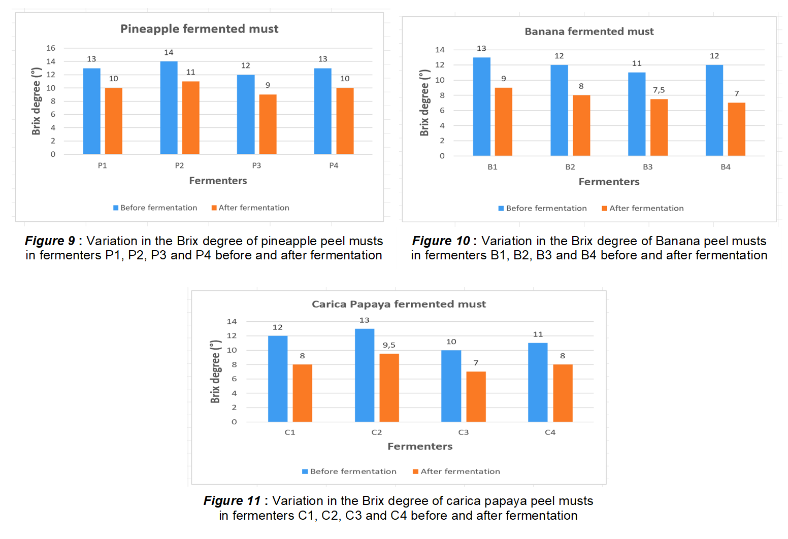

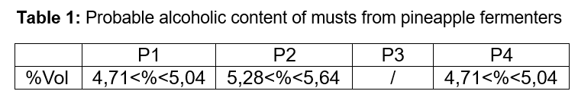
Used. From a physicochemical point of view, the increase in alcohol content after dehydration is based on the difference in affinity between ethanol and dehydrating agents (molecular sieves, zeolites or others), which selectively retain water molecules while allowing ethanol to pass through. This results in a purer alcohol.
4.2.3. Temperatures and pH

Table 2 shows the average temperatures and pH levels of the musts from the pineapple, banana, and papaya fermenters at the start and end of fermentation. The average temperatures range from 26°C to 30°C before and after fermentation. These values comply with the minimum and maximum temperature limits allowed during fermentation. We can see a drop in temperature after fermentation. This drop is due to the natural cooling of the must. The above values are consistent with those found by Rasoanaivo and al.

[27] who studied the fermentation of banana waste in Madagascar by maintaining a temperature between 30°C and 32°C to optimize yeast activity (Saccharomyces cerevisiae). In addition, Ravoninjatovo and al. [35] showed that temperatures between 28°C and 32°C promote maximum ethanol production. The average pH values vary between 3.5 and 6.01 before and after fermentation in the different fermenters. During fermentation, the pH decreases. This decrease is caused by the production of organic acids. These studies are comparable to those conducted by Akin et al. [36] who modeled a drop in pH at the start of fermentation, followed by a rise linked to ethanol. pH is a good indicator of yeast activity during fermentation. The pH values of the musts are within the maximum and minimum limits for a good fermentation range, which is between 2.5 and 8,5 [37]. Outside this range, inhibition of growth and alcohol production is observed [37].

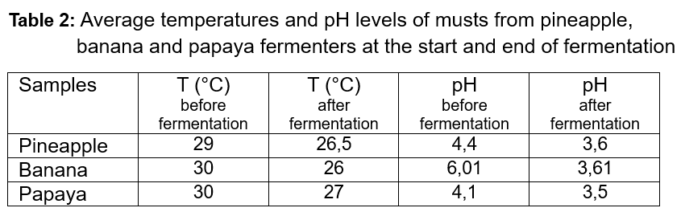
study showed that tropical fruit peels, particularly those of pineapple, banana and papaya, have great potential for the production of bioalcohol via alcoholic fermentation. The organoleptic parameters (colour, smell, taste) were rigorously monitored in order to evaluate the fermentation dynamics of each substrate. Thus, the yellowish colour of the musts, typical of their richness in natural pigments (carotenoids, phenols), evolved during fermentation, reflecting gradual biochemical changes. The evolution of the aroma (from fruity to alcoholic) and taste (from sweet to alcoholic) confirmed the normal course of fermentation, with distinct profiles for each fruit: sweet and mild for banana, tart for pineapple, and slightly bitter for papaya. The decrease in Brix degree throughout fermentation attested to the consumption of soluble sugars by the yeasts, with initial values for

- CONCLUSION

The biological material used in this study consists of organic waste from tropical fruits, specifically banana peels (Musa spp.), pineapple peels (Ananas comosus), and papaya peels (Carica papaya). As part of our study, 10-litre artisanal fermenters were designed and assembled manually. Each type of waste was subdivided into four fermentation tanks, each with a capacity of 10 litres: P1, P2, P3, and P4 for pineapple, B1, B2, B3, and B4 for banana, and C1, C2, C3, and C4 for Carica papaya. This fruit waste was then fermented for one week. The fermented must obtained underwent simple distillation followed by fractional distillation, which is a purification process used to obtain high-proof alcohol. Two pineapple musts were then dehydrated. The results obtained in this

- Mgeni, S. T., Mero, H. R., Mtashobya, L. A., & Emmanuel, J. K. (2024). The prospect of fruit wastes in bioethanol production : A review. Heliyon, 10(19).
- Salem, F., Djaafri, M., Kaidi, K., Atelge, M. R., Khelafi, M., Tahri, A., ... & Atabani, A. E. (2024). Semi-continuous mesophilic anaerobic digestion of date palm (Phoenix dactelifyra L.) leaflets of the H'mira cultivar from the Adrar region of Southern Algeria using an alkaline pre-treatment. Process Safety and Environmental Protection, 187, 385-397.
- Ngoulou, J.R.C., Mbemba, K.M., Mabiala Loubilou, M.B., Okeni, J.G., Diele Mouko, G.R., Litebe, A.C., Ngoma Tsaty, V.J. and Kaya-Kaya, P.A.C. (2025). Effect of Wood Ash on Soil Chemical Properties, Growth and Yield of Tomato (Lycopersicum esculentum) in Brazzaville, Republic of Congo. Journal of Basic and Applied Research International. Volume 31, Issue 5, Page 99-109, 2025.
- Chapman, D. and Kimstach, V. 1996. Chapman edition, 2nd ed. E & FN Spon, London, ISBN 0 419 21590 5 (HB) 0 419 21600 6 (PB), 59-126.
- Gret. (2015). Support for the private and associative sector involved in waste pre-collection in Brazzaville. Filipa Brazzaville.
- Ribéreau-Gayon, P., Dubourdieu, D., Donèche, B., & Lonvaud, A. (2012). Treatise on Oenology—Volume 1—6th edition—Microbiology of Wine. Winemaking. Dunod.
- Nguyen, B. T., Bujna, E., Fekete, N., Tran, A. T., Rezessy-Szabo, J. M., Prasad, R., & Nguyen, Q. D. (2019). Probiotic beverage from pineapple juice fermented with Lactobacillus and Bifidobacterium strains. Frontiers in nutrition, 6, 54.
- Rudra, K., Ghosh, S., Ganguly, N., Goyal, P., & Ghosh, S. (2015). Extracting situational information from microblogs during disaster events: a classification-summarization approach. In Proceedings of the 24th ACM international on conference on information and knowledge management (pp. 583-592).
- Xu, W., Jiang, H., Liu, T., He, Y., & Chen, Q. (2019). Qualitative discrimination of yeast fermentation stages based on an olfactory visualization sensor system integrated with a pattern recognition algorithm. Analytical Methods, 11(26), 3294-3300.
- Ray, B., & Sandine, W. E. (2019). Acetic, propionic, and lactic acids of starter culture bacteria as biopreservatives. In Food biopreservatives of microbial origin (pp. 103-136). CRC press.
- Rajendran, S., Silcock, P., & Bremer, P. (2023). Flavour volatiles of fermented vegetable and fruit substrates: A review. Molecules, 28(7), 3236.

pineapple (up to 14°Brix), followed by banana and papaya (up to 13°Brix). The highest probable alcohol content was obtained with pineapple musts. After dehydration, the probable alcohol content of pineapple musts increased over to 53% (v/v) for P1 and 60% for P2 (v/v). Temperatures and pH values of the musts are within the maximum and minimum limits for a good fermentation range. These results reinforce the value of energy recovery from tropical bio-waste based on a detailed understanding of fermentation parameters.
Authors’ contributions
This work was carried out in close collaboration with all the authors. Author KMB defined the subject and supervised all the study. Author Litébé A.C. performed the analysis and wrote the first draft of the manuscript. All authors read and approved the final manuscript.

DISCLAIMER (ARTIFICIAL INTELLIGENCE)

Author(s) hereby declare that NO generative AI technologies such as Large Language Models

COMPETING INTERESTS

Authors have declared that no competing interests exist.
REFERENCES

- Cherwoo, L., Gupta, I., Flora, G., Verma, R., Kapil, M., Arya, S. K., ... & Ashokkumar, V. (2023). Biofuels an alternative to traditional fossil fuels: A comprehensive review. Sustainable Energy Technologies and Assessments, 60, 103503.
- Thangavelu, S. K., Ahmed, A. S., & Ani, F. N. (2014). Bioethanol production from sago pith waste using microwave hydrothermal hydrolysis accelerated by carbon dioxide. Applied Energy, 128, 277-283.
- Raikar, R. V. (2012). Enhanced production of Ethanol from grape waste. International Journal of Environmental Sciences, 3(2), 776-783.
- Jena, N., & Kar, M. K. (2019). Ethanol production from various plant sources using Saccharomyces cerevisiae. Int J Chem Stud, 7(6), 2968-2971.Collins, E. J., Bowyer, C., Tsouza, A., & Chopra, M. (2022).
- Maalouf, A., & Agamuthu, P. (2023). Waste management evolution in the last five decades in developing countries–A review. Waste Management & Research, 41(9), 1420-1434.
- Mbemba K.M., Mabiala M.B and Ouamba J.M. (2019). Heavy metals leaching of cementitiousmatrices containing waste ash from Brazzaville landfills (Republic of Congo). International Research Journal of Pure and applied Chemistry. 20(2):1-11.
- Mgeni, S. T., Mtashobya, L. A., & Emmanuel, J. K. (2024). Bioethanol production from pineapple fruit waste juice using bakery yeast. Heliyon, 10(19).

- Kayath, C. A., Ibala Zamba, A., Goma-Tchimbakala, J., Mamonékéné, V., Mombo Makanga, G. M., Lebonguy, A. A., & Nguimbi, E. (2019). Microbiota landscape of gut system of guppy fish (Poecilia reticulata) plays an outstanding role in adaptation mechanisms. International journal of Microbiology, 2019(1), 3590584.
- Olubode, O. O., Odeyemi, O. M., & Aiyelaagbe, I. O. O. (2023). Papaya. In Tropical and subtropical fruit crops (pp. 617-699). Apple Academic Press.
- Agouazi O. (2013). Contribution to the physicochemical characterization of Vitis vinifera ssp vinifera grape varieties native to Algeria. Thesis, Mouloud Mammeri University of Tizi-Ouzou. Algeria.
- Sornvoraweat, B., & Jirasak, K. (2009). Dilute acid hydrolysis, enzymatic saccharification and fermentation of water hyacinth to ethanol. In Pure and Applied chemistry International Conference (PACCON 2009), Naresuan University, Thailand.
- Bello, M. G. D., Knight, R., Gilbert, J. A., & Blaser, M. J. (2018). Preserving microbial diversity. Science, 362(6410), 33-34.
- Aransiola, S. A., Ijah, U. J. J., & Abioye, O. P. (2013). Phytoremediation of lead polluted soil by Glycine max L. Applied and Environmental Soil Science, 2013(1), 631619.
- Ravoninjatovo, M., Ralison, C., Servent, A., Morel, G., Achir, N., Andriamazaoro, H., & Dornier, M. (2022). Effects of soaking and thermal treatment on nutritional quality of three varieties of common beans (Phaseolus vulgaris L.) from Madagascar. Legume Science, 4(4), e143.
- Akın, M., Eyduran, S. P., Çelik, K., Taş, A., & Gundogdu, M. (2025). New Approaches in Cold Storage of Fruits: Impact of Postharvest Spermidine and Salicylic Acid Applications on Phenolic Compounds and Quality Characteristics of Raspberry Fruits. Food Science & Nutrition, 13(6), e70389.
- Thiviya, P., Gamage, A., Kapilan, R., Merah, O., & Madhujith, T. (2022). Production of single-cell protein from fruit peel wastes using palmyrah toddy yeast. Fermentation, 8(8), 355.

- Sornnarin, A., Beckles, D. M., Sangsoy, K., Havananda, T., & Luengwilai, K. (2025). The role of citric acid and enzyme activities on sourness in pineapple fruit after low temperature storage. Horticulture, Environment, and Biotechnology, 66(3), 435-447.
- Paul, V., Muniyasamy, S., Kanny, K., Joseph Botlhoko, O., & Sivakumar, P. M. (2024). Improving the performance and biodegradability of biocomposites made from banana sap and banana fibres. Journal of Chemistry, 2024(1), 8503770.
- Zhou, Z., Ford, R., Bar, I., & Kanchana-Udomkan, C. (2021). Papaya (Carica papaya L.) flavour profiling. Genes, 12(9), 1416.
- Wilson, J., Miller, A., Hoang, A., Collette, J., & Dubose, T. (2019). Sucrose increases the emission of CO2 during yeast (Saccharomyces cerevisiae) fermentation faster than glucose. Journal of Undergraduate Biology Laboratory Investigations, 2(1).
- KR, R., Gopi, S., & Balakrishnan, P. (2022). Introduction to flavor and fragrance in food processing. In Flavors and fragrances in food processing: Preparation and characterization methods (pp. 1-19). American Chemical Society.
- Rosa, L. O., Pereira, O. G., Ribeiro, K. G., Valadares Filho, S. C., & Cecon, P. R. (2018). Fermentation profile and microbial population in soybean silages with inoculant and powdered molasses. Arquivo Brasileiro de Medicina Veterinária e Zootecnia, 70, 1586-1594.
- De Freitas, A. P., Krause, W., Arantes, D. S. O., Silva, D. C., Santos, E. A., & da Silva Campos, R. A. (2024). Agronomic performance and fruit sensory and quality analyses of pineapple cultivars. Comunicata Scientiae, 15, e4193-e4193.
- Baba-Ode, M., Gnimassou, Y. M., Ahoussi, E., Yehouenou, B., Chabi, N. W., & Satchivi, Z. (2014). Valorisation De La Filiere Ananas Par La Diversification De Ses Produits Derives. Epac/Uac.
- Rasoanaivo, M. A. (2022). Effect of beech proliferation on sugar maple transpiration (Doctoral dissertation, University of Quebec in Outaouais).
- Bertan, F. A. B., da Silva Pereira Ronning, E., Marchioro, M. L. K., Oldoni, T. L. C., Dekker, R. F., & da Cunha, M. A. A. (2022). Valorization of pineapple processing residues through acetification to produce specialty vinegars enriched with red-Jambo extract of Syzygium malaccense leaf. Scientific Reports, 12(1), 19384.

