GC-MS characterization, antioxidant activities and in silico docking studies of essential oil components of Commiphora kerstingii leaves

.

ABSTRACT
The present study investigated the chemical composition, antioxidant potential, and molecular docking properties of Commiphora kerstingii essential oil (CKEO). Gas chromatography–mass spectrometry (GC–MS) analysis identified 25 compounds, with α-phellandrene (55.06 %), α-pinene (33.62 %), γ-muurolene (2.42 %), santolina triene (2.23 %), and ylangene (4.06 %) as the predominant constituents. Antioxidant assays revealed that CKEO exhibited concentration-dependent inhibition of free radicals. In the DPPH assay, the oil demonstrated 42.11–59.90 % inhibition across 2.5–10 µL/mL with an IC₅₀ value of 1.667 ± 2 µL/mL, while vitamin C achieved higher inhibition (52.56–90.40 %) at the same concentrations. Similarly, in the H₂O₂ scavenging assay, CKEO showed inhibition values ranging from 44.46–72.08 % with an IC₅₀ of 2.849 ± 2 µL/mL, compared to vitamin C (79.13–90.12 %). The result of this study revealed that Vitamin C which served as the standard reference drug demonstrated high antioxidant properties over the essential oil in both bioassays. Molecular docking studies further revealed γ-muurolene as the most active ligand among the tested compounds, with the best docking affinity against 8WEJ (–93.6306 kcal/mol), 8U85 (–64.1925 kcal/mol), and 8GZ3 (–67.8085 kcal/mol) protein receptors interactions. Although quercetin, used as a reference compound, exhibited superior docking scores. The results of the docking studies highlight the pharmacological potential of CKEO constituents, particularly γ-muurolene, as promising leads for antioxidant and therapeutic applications. The findings suggest that the bioactive compounds of C. kerstingii essential oil could serve as valuable natural agents for drug discovery.

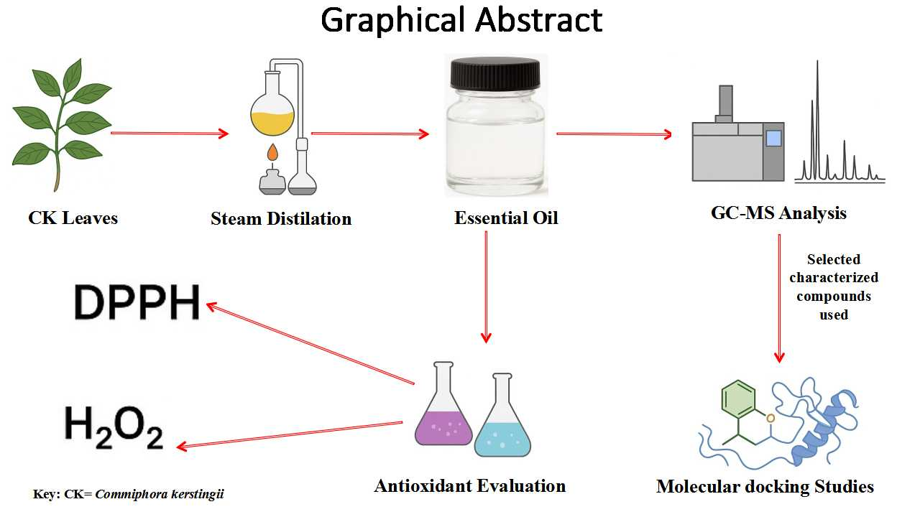

Keywords: Commiphora kerstingii, Antioxidant activities, molecular docking, Essential oil, Bioassays

1. INTRODUCTION

“Many tropical and subtropical plants that attract the attention of scientists and researchers worldwide have been investigated for their potential as eco-friendly natural resources” [1]. “Medicinal plants have been used for centuries as remedies for human diseases because they contain components of therapeutic value. The acceptance of traditional medicine as an alternative form of health care and the development of microbial resistance to the available antibiotics have led researchers to investigate the antimicrobial activity of medicinal plants” [2]. “Herbal medicines are in great demand in both developed and developing countries as a source of primary health care owing to their attributes of having wide biological and medicinal activities” [3]. “Commiphora kerstingii bark is used traditionally as protection against fire, as a cure for arrow poison, and to treat diabetes” [4]. Due to the role of medicinal plants in combating various degrees of illnesses traditionally, there is a growing demand for scientific validation of these plants used as herbs.
“Essential oils are mixtures of low molecular weight substances with a wide variation in their chemical properties” [5]. “They are defined as volatile substances from plants whose constituents are a complex mixture of terpenic hydrocarbons and oxygenated derivatives such as aldehydes, ketones, esters, and alcohols” [6]. “An estimated 1,200 compounds, including terpenes and their corresponding aldehydes, ketones, alcohols, phenylpropanoids, hydrocarbons, esters, oxides, and sulfur, have been identified in essential oils. In general, the constituents in essential oils are terpenes (monoterpenes and sesquiterpenes), aromatic compounds (aldehydes, alcohols, phenols, methoxy derivatives, and so on), and terpenoids (isoprenoids)” [6,7]. Murthy et al. [8] reported that “the volatile oil of Commiphora kerstingii contained (Z)-α-bisabolene, β-bisabolene, linalool, and trans-α-bergamotene as the major constituents. They contain volatile compounds of plant origin with unique properties that have been prized worldwide for a long period of time. Because of the large amount of plant material required to produce natural essential oils, products of essential oils in the market are often adulterated with low-grade oils or synthetic compounds” [9].
“Essential oils, being also capable of scavenging free radicals, may play an important role in some disease prevention such as brain dysfunction, cancer, heart disease, and immune system decline. If essential oils are able to scavenge some free radicals, they can also act as anti-inflammatory agents, because one of the inflammatory responses is the oxidative burst that occurs in diverse cells such as monocytes, neutrophils, eosinophils, and macrophages” [10].
The study of essential oils in plants will help in overcoming problems of the high cost of materials used in pharmaceuticals, perfumes, cosmetics, and beverages. This study will provide insight into antioxidant properties in the essential oils, which could serve as a motivation for using the plants for the promotion of human health, and this work will also serve as a baseline reference material for anyone who may want to venture into further research on this plant species.

2. material and methods

2.1 Sample Collection

Commiphora kerstingii leaves were collected from the bush area of Sukur Settlement, Madagali Local Government Area of Adamawa State, Nigeria and were identified by Professor Dimas Kubmarawa, a Professor of Natural Products, Modibbo Adama University, Yola, Nigeria. The leaves were collected from different trees in the same location into a sack with appropriate labeling and stored in an ice cooler until being transported to the laboratory for extraction and further analysis [11].

2.2 Sample Preparation

The sample of the Plant was properly washed and allowed to dry for 30 minutes in the laboratory. The leaves were then cut into tiny slices to increase the surface area for contact with solvent during extraction process [12].

2.3 Extraction of the Essential Oil

kg of leaves of Commiphora kerstingii sample collected were washed with distilled water and subjected to extraction to avoid loss of some essential oils as a result of the drying process, and using a modified type of steam distillation apparatus (in which the receiver end of the condenser pass-through another vessel containing ice). The time taken for the isolation of the oil is 2 and half hours [13]. The process was repeated for each plant’s batch until a total mass of 3.56405 kg was used for extraction. The sample collected was subjected to steam distillation using the Clevenger-like apparatus according to the British Pharmacopoeia (BP) method [14].

2.4 Gas Chromatography Mass Spectrometry (GC/MS) Analysis of essential oil

Essential oil extracted from the leaves of Commiphora kerstingii was analyzed for its chemical constituents by gas chromatography coupled with mass spectrometry (GC-MS). Agilent 19091S-433 Gas Chromatography-Mass Spectrometry System, operating at a pressure of 11.649 psi equipped with a split-splitless injector, was used. Helium was used as a carrier gas at the flow rate of 1 mL/min. The columns used were HP-5MS, capillary column (30 m × 250 μm × 0.25 μm), stationary phase: 5 % phenyl methyl silox. The initial temperature was programmed at 60 °C for 0.5 min then 10 °C/min to 300 °C for 3 min followed by a constant temperature at 310 °C for 22.5 min. Sample (0.2 μL) was injected into the column programmed at 310 °C and the resolution of components was attained. Identification of components was performed by matching their retention indices and mass spectra with those obtained from the NIST library [15]. The spectrum from the GC-MS is shown in Figure 1.

2.5 Determination of free scavenging activity of CKEO

2.5.1 DPPH radical scavenging activity

DPPH has been widely used for the measurement of the free radical scavenging ability of antioxidants. This method is based on the reduction of an alcoholic DPPH solution in the presence of a hydrogen-donating antioxidant [16]. The DPPH assay was performed using a standard method with minor modification. The hydrogen atom or electron-donating abilities of the compounds were measured from the bleaching of the purple colored methanol solution of 2, 2-diphenyl-1-picryl hydrazyl (DPPH). This spectrophotometric assay uses the stable free radical, DPPH as a reagent. One thousand microliters of diverse concentrations (2.5 μL/mL) of the essential oil in ethanol were added to 4 mL of 0.004 % methanol solution of DPPH. After a 30 min incubation period at room temperature, the absorbance was read against a blank at 517 nm and compared to the standard antioxidants, Ascorbic acid (vitamin C). The DPPH radical scavenging effect was calculated as inhibition percentage (I %) using equation (2): $DPPH Inhibition \% = \frac{A (Blank) - A (sample) }{A (Blank)} X100$ (2)
Where, A (Blank) is the absorbance of the control reaction (containing all reagents except the test compound) and A (sample) is the absorbance of the test compound. The values of inhibition were calculated for various concentrations of the essential oil. Tests were conceded out in triplicate.

2.5.2 Hydrogen Peroxide Scavenging Activity

The ability of the essential oil to scavenge hydrogen peroxide was determined according to the method with modification. A solution of hydrogen peroxide (40 mM) was prepared in phosphate buffer (ρH = 7.4). Extracts (2.5-25 μg/mL) in methanol were added to a H₂O₂ solution (0.6 mL, 40 mM). The absorbance value of the reaction mixture was recorded at 230 nm. The blank solution contained the phosphate buffer without H₂O₂ [17]. The percentage inhibition of H2O2 scavenging assay was calculated using equation (3).
$H_{2}O_{2} Inhibition \%= \frac{A (control) - A (sample)}{A (control)} X100$ (3)
Where A (control) is the absorbance of the control, and A (sample) is the absorbance in the presence of the sample or standards.

2.6 Molecular Docking Studies

A Molegro Virtual Docker (MVD) software package (Molegro version 6.0) was employed for the ligand–protein docking simulation in this study due to its ability to produce accurate and reproducible results compared to other docking software [18]. Before docking, the prepared protein structures (PDB IDs: 8GZ3, 8U85, and 8WEJ) were obtained from the Protein Data Bank (https://www.rcsb.org) and optimized using Spartan 14.1 software and then imported into the MVD workspace. Cavities were detected and surfaces were created.
The selection of ligands α-Phellandrene, α-Pinene, and γ-Muurolene for molecular docking was based on the percentage peak area obtained from the GC–MS chromatographic analysis, with compounds representing the major constituents of the essential oil chosen for further in silico evaluation. The 2D structures of the selected ligands, as well as the reference compound quercetin, were drawn using ChemDraw Pro 8.0. Their 3D structures were retrieved from the PubChem database in SDF format [19]. Ligand preparation was performed by setting default options to: assign bonds, assign bond orders and hybridization, assign charges, assign Tripos atom types, create explicit hydrogens, and detect flexible torsions.
The prepared ligands, along with the reference drug quercetin, were imported onto the MVD surface, and docking was carried out using a grid resolution of 0.30 Å. The docking algorithm was set to a maximum of 1500 iterations with a maximum population size of 50. Docking simulations were run a minimum of 10 times, and the best poses were determined based on scoring functions such as the MolDock score and the Re-rank score.
Visualization of intermolecular interactions, including hydrogen bonding, alkyl, and π–alkyl interactions, was performed using Discovery Studio Visualizer (Discovery Studio 21.0). Quercetin was also redocked onto the active site of all the three protein receptors to validate the docking protocol.

3. results and discussion

3.1 Percentage yield of the essential oil from C. kerstingii

3.56405 kg of C. kerstingii fresh leaves were subjected to steam distillation for the extraction of essential oil components from the plants. The percentage yield was 0.05 % obtained by using the using equation (1):
$\% Yield=\frac{Weight of oil \left(WO\right)}{Weight of plant \left(WP\right)}x 100$ (1)

3.2 Antioxidant Activity of essential oil against DPPH and H₂O₂

Commiphora kerstingii essential oil exhibited a free radical scavenging activity, 10 μL/mL (59.90 %), which indicates that the plant is a less effective antioxidant compared to the standard (ascorbic acid), which had a scavenging activity of 90.40 %. The antioxidant activity of C. kerstingii leaves in this work agrees with the findings of Toma et al. [20], which showed that C. kerstingii leaves have antioxidant properties that may be due to the presence of phenolic compounds in the plant. This agreement with previous studies demonstrated that several Commiphora species had considerable antibacterial activity against some Gram-positive and Gram-negative bacteria. The present study depicted that the ability to scavenge DPPH radical increases significantly with increasing concentration, indicating higher hydrogen-donating ability of the essential oil.
The ability of the essential oil to scavenge hydrogen peroxide was assessed using the hydrogen peroxide radical method. Scavenging of hydrogen peroxide at different concentrations of the essential oil of C. kerstingii leaves is presented in Table 1. The percentage of H₂O₂ scavenging activity in Commiphora kerstingii was found to be 72.08 % at 10 μL/mL. Similarly, both ascorbic acid (vitamin C) and the extracts showed an increase in inhibition percentage with increasing concentration. In comparison to the antioxidant activity of the plant’s crude extract against hydrogen peroxide, as reported by Lawrence et al. [21], C. kerstingii crude extract exhibited a free radical scavenging activity, indicating that it is a more effective antioxidant compared to the essential oil. Similarly, both ascorbic acid (vitamin C) and the extracts showed an increase in inhibition percentage with increasing concentration. The IC₅₀ values of the essential oil for DPPH and hydrogen peroxide, determined using GraphPad Prism, were 1.66 ± 2 μL/mL and 2.849 ± 2 μL/mL, respectively, as shown in the dose-response curves in Fig. 2a and 2b.

Table 1. Percentage Inhibition of CKEO against DPPH and H₂O₂

Assay | Conc. (μL/mL) |  | 2.5 | 5 | 7.5 | 10 | IC₅₀ Values
DPPH Assay (517 nm) | Antioxidants | CKEO (%) | 42.11 | 50.83 | 56.61 | 59.90 | 1.667±2
DPPH Assay (517 nm) | Antioxidants | Vitamin C (%) | 52.56 | 65.26 | 79.06 | 90.40 | -
H₂O₂ Assay (230 nm) | Antioxidants | CKEO (%) | 44.460 | 55.34 | 66.66 | 72.08 | 2.849±2
H₂O₂ Assay (230 nm) | Antioxidants | Vitamin C (%) | 79.13 | 86.59 | 88.71 | 90.12 | -

Fig. 1. GC-MS Spectrum of essential oil extracted from C. kerstingii

3.3 Chemical Composition of Essential oil of leaves of leaves of Commiphora kerstingii

In Table 2, the constituents of essential oil obtained by GC–MS are presented. A total of 25 compounds were identified. The major components in the essential oil of Commiphora kerstingii leaves were α-pinene (33.62 %), α-phellandrene (55.06 %), γ-muurolene (2.42 %), santolina triene (2.23 %), and ylangene (4.06 %).
Similar research by Murthy et al, revealed that the volatile oil of C. kerstingii contained (Z)-α-bisabolene, β-bisabolene, linalool, and trans-α-bergamotene as the major constituents [8]. A previous examination of Commiphora gileadensis oils from Israel reported that the essential oils were dominated by monoterpene hydrocarbons, followed by oxygenated monoterpenoids. The major components in C. gileadensis oils were α-pinene (11.1–18.4 %), sabinene (15.8–35.9 %), β-pinene (5.8–18.0 %), p-cymene (4.8–8.4 %), limonene (1.3–6.2 %), γ-terpinene (0.7–8.1 %), and terpinen-4-ol (5.3–18.5 %). Sesquiterpenoid concentrations were very low in these samples, constituting only 0.8 %, 10.6 %, and 2.4 % in the stem, leaf, and fruit oils, respectively [23].
When compared with previous studies, the present work indicates notable differences in the chemical composition and relative percentages. These differences may be attributed to variations in temperature, topology, environmental factors, and growth stages.

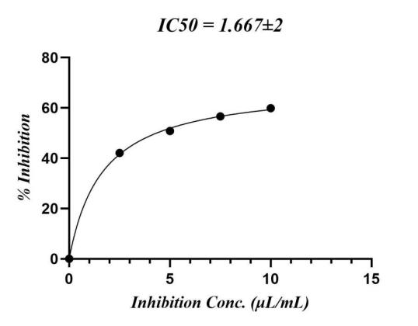
Fig. 2a IC₅₀ Curves of CKEO against DPPH Radical

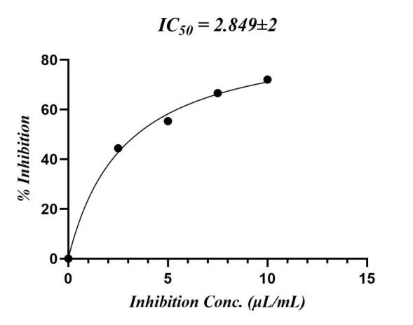
Fig. 2b IC₅₀ Curves of CKEO against H₂O₂ Radical

Table 2. GC-MS analysis of essential oil of C. kerstingii leaves

S/N | Constituents | Mol. Formula | Rt(Min) | Area (%)
1 | alpha.-Pinene | C₁₀H₁₆ | 10.754 | 33.62
2 | alpha.-Phellandrene | C₁₀H₁₆ | 22.811 | 55.06
3 | 2-Carene | C₁₀H₁₆ | 16.431 | 0.76
4 | (+)-4-Carene | C₁₀H₁₆ | 8.681 | 0.37
5 | gamma.-Muurolene | C₁₅H₂₄ | 29.895 | 2.42
6 | Santolina triene | C₁₀H₁₆ | 19.769 | 2.23
7 | cis-Thujopsene | C₁₅H₂₄ | 10.747 | 0.58
8 | Ylangene | C₁₅H₂₄ | 11.065 | 4.06
9 | gamma.-Terpinene | C₁₀H₁₆ | 14.622 | 0.06
10 | Alloaromadendrene | C₁₅H₂₄ | 16.613 | 0.17
11 | Tetracosane, 1-bromo- | C₂₄H₄₉Br | 20.140 | 0.02
12 | Eicosane | C₂₀H₄₂ | 65.173 | 0.15
13 | Octadecane, 1-chloro- | C₁₈H₃₇Cl | 46.728 | 0.10
14 | 6,6-Diethylhoctadecane | C₂₂H₄₆ | 23.145 | 0.01
15 | Tetradecane, 1-chloro- | C₁₄H₂₉Cl | 23.500 | 0.04
16 | Eicosane, 2-methyl- | C₂₁H₄₄ | 50.475 | 0.10
17 | Estra-1,3,5(10)-trien-17.beta.-ol | C₁₈H₂₄O | 24.757 | 0.06
18 | Cyclotetradecane | C₁₄H₂₈ | 24.908 | 0.03
19 | Octadecane, 1-[2-(hexadecyloxy)ethoxy]- | C₃₆H₇₄O₂ | 25.097 | 0.02
20 | alpha.-Ketostearic acid | C₁₈H₃₄O₃ | 25.188 | 0.01
21 | Tetrapentacontane, 1,54-dibromo- | C₅₄H₁₀₈Br₂ | 25.332 | 0.03
22 | 2-Piperidinone, N-[4-bromo-n-butyl]- | C₉H₁₆BrNO | 25.438 | 0.04
23 | Hexadecane, 1-(ethenyloxy)- | C₁₈H₃₆O | 51.376 | 0.02
24 | Octacosanal | C₂₈H₅₆O | 26.134 | 0.04
25 | Cyclohexane,1,1'-(2-propyl-1,3 propanediyl)bis- | C₁₈H₃₄ | 26.498 | 0.01
 | TOTAL |  |  | 100.01

Table 3. Molecular docking scores and the corresponding residual amino acid interactions of the selected ligands against 8WEJ, 8U85 and 8GZ3 protein receptors

Protein Receptors | Compounds | Interactions | Interacting Residues | Distance (Å) | MolDock Scores (kcal/mol) | Rerank Score (kcal/mol)
8WEJ | α-Phellandrene | Pi-Alkyl - B Chain | TYR324 | 4.81, 5.20 | -73.8409 | -63.8482
8WEJ | α-Phellandrene | Pi-Alkyl - B Chain | PHE570 | 3.80 | -73.8409 | -63.8482
8WEJ | α-Pinene | Alkyl and Pi-Alkyl - B Chain | ALA105 | 5.5 | -56.5465 | -45.7128
8WEJ | α-Pinene | Alkyl and Pi-Alkyl - B Chain | ILE190 | 3.754.61 | -56.5465 | -45.7128
8WEJ | α-Pinene | Alkyl and Pi-Alkyl - B Chain | TRP106 | 5.56, 6.60 | -56.5465 | -45.7128
8WEJ | α-Pinene | Alkyl and Pi-Alkyl - B Chain | HIS101 | 5.90 | -56.5465 | -45.7128
8WEJ | α-Pinene | Alkyl and Pi-Alkyl - B Chain | LYS102 | 4.38, 4.52, 4.62 | -56.5465 | -45.7128
8WEJ | α-Pinene | Alkyl and Pi-Alkyl - B Chain | HIS209 | 6.31 | -56.5465 | -45.7128
8WEJ | γ-Muurolene | Alkyl and Pi-Alkyl - B Chain | ARG73 | 5.54 | -93.6306 | -78.6413
8WEJ | γ-Muurolene | Alkyl and Pi-Alkyl - B Chain | TYR324 | 6.34 | -93.6306 | -78.6413
8WEJ | γ-Muurolene | Alkyl and Pi-Alkyl - B Chain | ALA394 | 3.89 | -93.6306 | -78.6413
8WEJ | γ-Muurolene | Alkyl and Pi-Alkyl - B Chain | LEU76 | 4.07, 6.23 | -93.6306 | -78.6413
8WEJ | Quercetin | Conventional Hydrogen Bond- B Chain | ASN569 | 3.14 | -138.395 | -98.3083
8WEJ | Quercetin | Conventional Hydrogen Bond- B Chain | LEU94 | 5.07 | -138.395 | -98.3083
8WEJ | Quercetin | Conventional Hydrogen Bond- B Chain | SER77 | 3.32 | -138.395 | -98.3083
8WEJ | Quercetin | Carbon Hydrogen Bond- B Chain | ASP95 | 3.38 | -138.395 | -98.3083
8WEJ | Quercetin | Pi-Sigma B Chain | THR393 | 4.61 | -138.395 | -98.3083
8WEJ | Quercetin | Pi-Pi Stacked B Chain | TYR324 | 4.58 | -138.395 | -98.3083
8WEJ | Quercetin | Pi-Alkyl B Chain | LEU76 | 4.45 | -138.395 | -98.3083
8U85 | α-Phellandrene | Alkyl and Pi-Alkyl - A Chain | LEU196 | 6.64 | -62.2065 | -51.124
8U85 | α-Phellandrene | Alkyl and Pi-Alkyl - A Chain | PHE267 | 5.38 | -62.2065 | -51.124
8U85 | α-Phellandrene | Alkyl and Pi-Alkyl - A Chain | LEU270 | 4.32 | -62.2065 | -51.124
8U85 | α-Phellandrene | Alkyl and Pi-Alkyl - A Chain | PRO260 | 4.94 | -62.2065 | -51.124
8U85 | α-Pinene | Alkyl and Pi-Alkyl - A Chain | CYS195 | 4.10 | -50.6612 | -42.6676
8U85 | α-Pinene | Alkyl and Pi-Alkyl - A Chain | LEU270 | 3.98, 5.52 | -50.6612 | -42.6676
8U85 | α-Pinene | Alkyl and Pi-Alkyl - A Chain | LEU196 | 4.04, 4.40, 5.01, 5.31 | -50.6612 | -42.6676
8U85 | α-Pinene | Alkyl and Pi-Alkyl - A Chain | PHE267 | 4.06, 4.67, 4.72 | -50.6612 | -42.6676
8U85 | γ-Muurolene | Alkyl and Pi-Alkyl- A Chain | PRO445 | 4.98 | -64.1925 | -53.6737
8U85 | γ-Muurolene | Alkyl and Pi-Alkyl- A Chain | HIS444 | 4.54, 4.91, 4.99 | -64.1925 | -53.6737
8U85 | γ-Muurolene | Alkyl and Pi-Alkyl- A Chain | PHE446 | 5.84, 7.09 | -64.1925 | -53.6737
8U85 | Quercetin | Conventional Hydrogen Bond- A Chain | GLN467 | 3.98 | -118.109 | -95.7086
8U85 | Quercetin | Conventional Hydrogen Bond- A Chain | TRP468 | 4.85, 5.92 | -118.109 | -95.7086
8U85 | Quercetin | Conventional Hydrogen Bond- A Chain | THR469 | 2.54 | -118.109 | -95.7086
8U85 | Quercetin | Conventional Hydrogen Bond- A Chain | ARG463 | 2.56 | -118.109 | -95.7086
8U85 | Quercetin | Conventional Hydrogen Bond- A Chain | PRO445 | 4.09 | -118.109 | -95.7086
8U85 | Quercetin | Pi-PiT-Shaped- A Chain | PHE446 | 4.68, 5.21 | -118.109 | -95.7086
8U85 | Quercetin | Pi-Cation- A Chain | ARG463 | 3.79 | -118.109 | -95.7086
8U85 | Quercetin | Carbon-Hydrogen Bond- A Chain | PRO445 | 3.70 | -118.109 | -95.7086
8GZ3 | α-Phellandrene | Alkyl and Pi-Alkyl - A Chain | VAL89 | 4.79 | -53,8625 | -42.7414
8GZ3 | α-Phellandrene | Alkyl and Pi-Alkyl - A Chain | ARG90 | 3.51 | -53,8625 | -42.7414
8GZ3 | α-Phellandrene | Alkyl and Pi-Alkyl - A Chain | LEU52 | 5.68, 7.36 | -53,8625 | -42.7414
8GZ3 | α-Phellandrene | Alkyl and Pi-Alkyl - A Chain | LEU93 | 4.07, 5.68 | -53,8625 | -42.7414
8GZ3 | α-Phellandrene | Alkyl and Pi-Alkyl - A Chain | PHE80 | 4.20 | -53,8625 | -42.7414
8GZ3 | α-Pinene | Alkyl and Pi-Alkyl - A Chain | LEU52 | 4.68, 4.73, 7.10 | -43.4025 | -37.3293
8GZ3 | α-Pinene | Alkyl and Pi-Alkyl - A Chain | PHE48 | 6.56 | -43.4025 | -37.3293
8GZ3 | α-Pinene | Alkyl and Pi-Alkyl - A Chain | PHE80 | 4.79, 5.56, 7.18 | -43.4025 | -37.3293
8GZ3 | α-Pinene | Alkyl and Pi-Alkyl - A Chain | PHE83 | 3.94, 4.47 | -43.4025 | -37.3293
8GZ3 | α-Pinene | Alkyl and Pi-Alkyl - A Chain | LEU93 | 3.99, 4.77, 4.40 | -43.4025 | -37.3293
8GZ3 | α-Pinene | Alkyl and Pi-Alkyl - A Chain | VAL89 | 5.10 | -43.4025 | -37.3293
 | γ-Muurolene | Alkyl and Pi-Alkyl - A Chain |  |  | -67.8085 | -34.944
 | γ-Muurolene | Alkyl and Pi-Alkyl - A Chain | PHE48 | 5.73 | -67.8085 | -34.944
 | γ-Muurolene | Alkyl and Pi-Alkyl - A Chain | PHE80 | 5.27 | -67.8085 | -34.944
 | γ-Muurolene | Alkyl and Pi-Alkyl - A Chain | PHE83 | 4.25, 4.53 | -67.8085 | -34.944
 | γ-Muurolene | Alkyl and Pi-Alkyl - A Chain | ARG90 | 4.34 | -67.8085 | -34.944
 | γ-Muurolene | Alkyl and Pi-Alkyl - A Chain | VAL89 | 4.05 | -67.8085 | -34.944
 | γ-Muurolene | Alkyl and Pi-Alkyl - A Chain | LEU52 | 4.07, 4.81 | -67.8085 | -34.944
 | Quercetin | Conventional Hydrogen Bond- A Chain | PHE83 | 5.46 | -104.283 | -66.114
 | Quercetin | Carbon-Hydrogen Bond and Pi-Alkyl- A Chain | VAL77 | 5.79 | -104.283 | -66.114
 | Quercetin | Carbon-Hydrogen Bond and Pi-Alkyl- A Chain | LEU52 | 4.03, 5.79, 5.90 | -104.283 | -66.114
 | Quercetin | Carbon-Hydrogen Bond and Pi-Alkyl- A Chain | ARG90 | 3.28 | -104.283 | -66.114
 | Quercetin | Carbon-Hydrogen Bond and Pi-Alkyl- A Chain | LEU93 | 4.48, 5.48 | -104.283 | -66.114
 | Quercetin | Pi-Pi T-Shaped and Amide Pi-Stacked | LEU51 | 6.81 | -104.283 | -66.114
 | Quercetin | Pi-Pi T-Shaped and Amide Pi-Stacked | PHE48 | 7.05 | -104.283 | -66.114
 | Quercetin | Pi-Pi T-Shaped and Amide Pi-Stacked | PHE80 | 5.28 | -104.283 | -66.114

3.4 Molecular Docking Studies

γ-Muurolene was identified as the best ligand among the three tested against the 8WEJ protein receptor, as it had the highest MolDock score of –93.6306 kcal/mol. It interacted with the 8WEJ receptor through alkyl and π–alkyl interactions with ARG73, TYR324, ALA394, and LEU76 amino acids at corresponding distances of 5.54, 6.34, 3.89, and 4.07–6.23 Å, respectively. Against the 8U85 and 8GZ3 protein receptors, γ-muurolene also demonstrated superior docking compared to α-phellandrene and α-pinene, with docking scores of –64.1925 and –67.8085 kcal/mol, respectively.
For validation of docking results, quercetin (Fig. 3), which was used as the control drug, was docked against the three protein receptors and demonstrated the highest docking scores compared to the ligands considered (Table 3). Quercetin interacted with the protein receptors through conventional hydrogen bonding, carbon–hydrogen bonding, π–sigma, π–π stacked, π–alkyl, π–π T-shaped, π–cation, and amide–π stacked interactions. The docking scores of quercetin were recorded as –138.395, –118.109, and –104.283 kcal/mol against 8WEJ, 8U85, and 8GZ3, respectively.
The 2D and 3D pictorial representations of γ-muurolene docked against the three protein receptors are shown in Fig. 4, Fig. 5, and Fig. 6, while the comprehensive docking structures of all ligands against the three protein receptors are provided as supplementary material.

Fig. 3 Structure of Standard Control Antioxidant, Quercetin (L0)

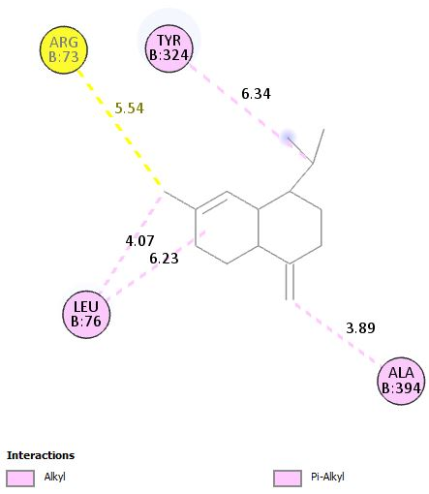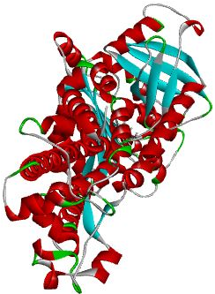

Fig. 4. 2D and 3D binding interactions of γ-Muurolene against 8WEJ

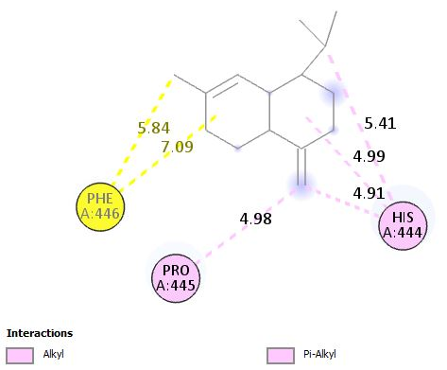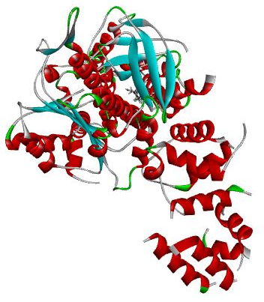

Fig. 5. 2D and 3D binding interactions of ɤ-Muurolene against 8U85

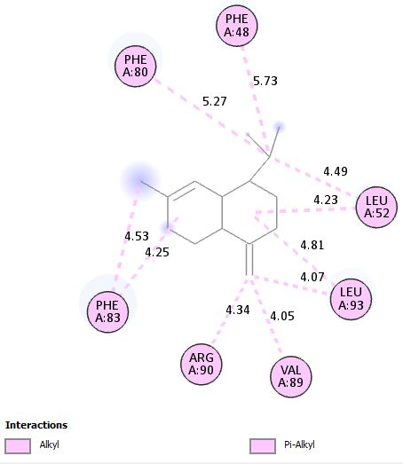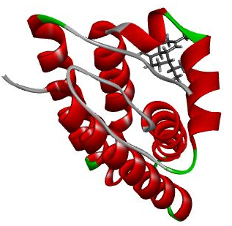

Fig. 6. 2D and 3D binding interactions of γ-Muurolene against 8GZ

4. Conclusion

This study establishes that the essential oil of Commiphora kerstingii leaves is rich in monoterpene hydrocarbons, dominated by α-phellandrene and α-pinene, and demonstrates appreciable antioxidant activity in both DPPH and H2O2 assays. Although its activity was lower than vitamin C, the concentration-dependent inhibition observed affirms its free radical scavenging potential. Molecular docking analysis further identified γ-muurolene as the most promising bioactive compound, displaying strong interactions with key protein receptors, thereby underscoring its therapeutic relevance. Variations between the present chemical profile and earlier reports suggest that environmental and geographical factors may influence oil composition. Collectively, these findings provide novel insights into the bioactivity of C. kerstingii essential oil and support its potential as a natural source of antioxidant agents and lead compounds for further pharmacological development.

Supplementary Material

Only the best-scoring docking pose for each protein is presented in this article, the complete set of docking results, including all 2D and 3D structures, is provided as supplementary material. The supplementary material can be accessed at www.doi.org/XXXXXXXX - for the supplementary file’s link)

Data Availability

Data supporting the conclusion of this research are presented in the tables and figures in this article.

Conflicts of Interest

The authors declare that there are no conflicts of interest related to this article.

Disclaimer (Artificial intelligence)
Author(s) hereby declare that generative AI technologies such as Large Language Models, etc. have been used during the writing or editing of manuscripts. This explanation will include the name, version, model, and source of the generative AI technology and as well as all input prompts provided to the generative AI technology
Details of the AI usage are given below:
Author(s) hereby declare that Chatgpt AI tool was used during the writing of manuscripts, solemnly for the purpose of paraphrasing in some cases.

References

- Alanazi, N. A., Alamri, A. A., Mashlawi, A. M., Almuzaini, N. A., Mohamed, G., & Salama, S. A. (2024). Gas chromatography–mass spectrometry chemical profiling of Commiphora myrrha resin extracts and evaluation of larvicidal, antioxidant, and cytotoxic activities. Molecules, 29(8). https://doi.org/10.3390/molecules29081778
- Dabai, Y. U., Kawo, A. H., & Aliyu, R. M. (2012). Phytochemical screening and antibacterial activity of the leaf and root extracts of Senna italic. African Journal of Pharmacy and Pharmacology, 6(12), 914–918.
- Yahaya, M. F., Osemeahon, S. A., Shagal, M. H., & Hauwa, A. (2022). Phytochemicals, antimicrobial, antioxidants and cytotoxicity properties of the ethanolic extracts of Commiphora africana and Butryospermum paradox. Adamawa State University Journal of Scientific Research, 10(2), 37–44.
- Simeon, O. O., Olabisi, O. L., Abiodun, O., Oluwatoyin, A. L., Omodele, A. O., Oluwadare, O. J., Ogungbe, L. G., Amos, V. O., Ayodeji, A. F., & Ladokun, O. A. (2022). Protective effects of methanolic stem bark extract of Commiphora kerstingii Engl. on pancytopenia and hyperlipidemia induced with CdCl2 in male Wistar rats. Journal of Biological Sciences, 22(1), 1–10. https://doi.org/10.3923/jbs.2022.1.10
- Acar, Ü., Yıldırım, Ö., Baba, E., Zemheri Navruz, F., Hacisa, M., & Yılmaz, S. (2025). Effects of a myrrh (Commiphora myrrha) essential oil supplemented diet on haemato-biochemical parameters, expression of tissue-specific immune- and stress-related genes, and resistance of Cyprinus carpio to Aeromonas hydrophila infection. Turkish Journal of Fisheries and Aquatic Sciences, 25(8). https://doi.org/10.4194/TRJFAS27525
- Bakkali, F., Averbeck, S., Averbeck, D., & Idaomar, M. (2008). Biological effects of essential oils: A review. Food and Chemical Toxicology, 46(2), 446–475.
- Mohamed, A. A., El-Emary, G. A., & Ali, H. F. (2010). Influence of some citrus essential oils on cell viability, glutathione-S-transferase and lipid peroxidation in Ehrlich ascites carcinoma cells. Journal of American Science, 6(6), 820–826.
- Murthy, K. S. R., Chandrasekhara, R. M., Sandhya, R. S., & Pullaiah, T. (2016). Bioactive principles and biological properties of essential oils of Burseraceae: A review. Journal of Pharmacognosy and Phytochemistry, 5(2), 247–258.
- Cortes, H. J., & Rothman, D. L. (1990). Study on the chemical composition variability of some processed bergamot (Citrus bergamia) essential oils. Flavour and Fragrance Journal, 5(4), 219–250.
- Miguel, M. G. (2010). Antioxidant and anti-inflammatory activities of essential oils: A short review. Molecules, 15(12), 9252–9287. https://doi.org/10.3390/molecules15129252
- Biswas, B., Rogers, K., McLaughlin, F., Daniels, D., & Yadav, A. (2013). Antimicrobial activities of leaf extracts of guava (Psidium guajava L.) on two gram-negative and gram-positive bacteria. International Journal of Microbiology, 2013, Article 746165. https://doi.org/10.1155/2013/746165
- Ibrahim, M., Ankwai, G. E., Gungshik, J. R., & Taave, P. (2021). Comparative extraction of essential oil of Mentha piperita (mint) by steam-distillation and enfleurage. Nigerian Journal of Chemical Research, 26(2), 56–63. http://dx.doi.org/10.4314/njcr.v26i2.2
- Attama, C., Luka, L., & Ndakudu, C. B. (2024). Chemical characterization and antioxidant activities of essential oil of Ficus elastica Roxb. ex Hornem. leaves. International Journal of Secondary Metabolite, 11(3), 562–573. https://doi.org/10.21448/ijsm.1377543
- British Pharmacopoeia Commission. (2020). British Pharmacopoeia (Vol. IV). Medicines and Healthcare Products Regulatory Agency.
- Iqbal, Z., Saeed, A., Mansha, M., Saeed, K., Afzal, S., Khalil, H. I., Gulzar, Z., & Tara, Z. (2018). Essential oil from the aerial roots of Ficus elastica and their antioxidant activity. International Journal of Advanced Research, 6(1), 137–140. http://dx.doi.org/10.21474/IJAR01/6195
- Fatiha, M., & Abdelkader, T. (2019). Study of antioxidant activity of pyrimidinium betaines by DPPH radical scavenging method. Journal of Analytical & Pharmaceutical Research, 8(2), 33–36. https://doi.org/10.15406/japlr.2019.08.00308
- Ebrahimzadeh, M. A., Seyed, M. N., Seyed, F. N., Bahman, E., & Zahra, R. (2010). Antioxidant and antihaemolytic activities of the leaves of kefe cumin (Laser trilobum L., Umbelliferae). Tropical Journal of Pharmaceutical Research, 9(5), 441–449. https://doi.org/10.4314/tjpr.v9i5.61053
- Thomsen, R., & Christensen, M. H. (2006). MolDock: A new technique for high-accuracy molecular docking. Journal of Medicinal Chemistry, 49(11), 3315–3321. https://doi.org/10.1021/jm051197e
- Kim, S., Chen, J., Cheng, T., Gindulyte, A., He, J., He, S., Li, Q., Shoemaker, B. A., Thiessen, P. A., Yu, B., Zaslavsky, L., Zhang, J., & Bolton, E. E. (2025). PubChem 2025 update. Nucleic Acids Research, 53(D1), D1516–D1525. https://doi.org/10.1093/nar/gkae1059
- Toma, I., Gidado, K., Khan, M., & Abel, A. (2016). Phytochemical screening, antioxidant and antibacterial activities of Commiphora kerstingii. International Biological and Biomedical Journal, 2(3), 128–133.
- Lawrence, L., Attama, C., Yahaya, M. F., Kwaji, N., & Polar, T. (2022). Phytochemical screening and bioassay of the ethanolic extracts of Ocimum basilicum and Commiphora kerstingii leaves. World Scientific News, 167, 28–40.
- Dudai, N., Shachter, A., Satyal, P., & Setzer, W. N. (2017). Chemical composition and monoterpenoid enantiomeric distribution of the essential oils from apharsemon (Commiphora gileadensis). Medicines, 4(3), 66. https://doi.org/10.3390/medicines4030066

