ASSESSING THE RELATIONSHIP BETWEEN FARMING SYSTEMS, AGRICULTURAL PRACTICES, AND SOIL DEGRADATION IN ADAMAWA STATE, NIGERIA

ABSTRACT
Aim on the impact of various farming systems and practices on the soil degradation. The paper examines the endemic challenges of decreased soil fertility and productivity due to mismanagement of lands and climate change. The study adopted cross sectional research design, and data were collected from 384 farmers through surveys and field observations, and analyzed using Chi-square tests. The findings revealed that there was no significant correlation between the type of farming system and soil degradation (χ² = 5.6873, p = 0.133). In the same vein, crop rotation (χ² = 2.935, p > 0.05) and tillage method (χ² = 2.482, p > 0.05) were not significant. However, irrigation practice had a significant relationship (χ² = 11.949, p < 0.05), indicating its role in improving soil resilience. The article formulated Adaptive Nutrient Resilience Framework (ANRF) to guide sustainable soil management through climate-smart irrigation, conservation agriculture, and integrated nutrient management.
Keywords: Farming systems, Soil degradation, Agricultural practices, Nutrient resilience framework

- INTRODUCTION
Agricultural systems in sub-Saharan Africa are facing increasing threats that are posed by the intertwined effects of unsustainable agricultural farming and altered climatic conditions, which promote soil erosion and nutrient loss (Lal, 2015; Panagos et al., 2017). In Nigeria, especially in the semi-arid areas like Adamawa State, organic matter, nutrient leaching and erosion driven by the improper land use systems have been steadily lowering the productivity of farmlands (Olaniyi et al., 2023). These issues are even aggravated by the prevalence of smallholder subsistence agriculture with low input utilization, perennial cultivation, and low uptake of conservation measures (Morton, 2007; FAO, 2019). The rate and directions of soil resources either being sustained or degraded depend on the farming systems. Mixed cropping, shifting cultivation, and irrigated farming are all different systems in Adamawa State that have varying pressures on the soil environment affecting physical structure, nutrient cycling, and climatic stress resilience (Chukwu et al., 2022; Atanga et al., 2020). Among other factors, the process of expanding agricultural land into vulnerable uplands and marginal lands has over the years caused widespread erosion, compaction, and loss of fertility, especially in regions where the climate change is causing increasing rainfall variability and erosivity (Panagos et al., 2017; Panagos et al., 2023).
Although evidence on the biophysical susceptibility of the soils in the area continues to accumulate, there is a lack of the incorporation of climate adaptation framework into soil nutrient management. The majority of farmers use the conventional amendments like animal manure or shifting cultivation which are no longer adequate in the new climate realities (Palm et al., 2014). This means that there is an urgent need to come up with sustainable nutrient management framework that is climate resistant and specific to the varying farming systems of Adamawa State. The framework should also facilitate the restoration of soils, increase the level of nutrient efficiency and create adaptive capacity of farmers to withstand extreme weather conditions. Also, current soil management techniques are mostly generic and pay attention to traditional fertilization and blanket soil restoration techniques without paying attention to spatial heterogeneity, farming intensity, and climate variability (IPCC, 2021; FAO, 2019). These fragmented approaches do not consider the interplay between weather variability and farming activities as well as nutrient cycling, making people more susceptible to climate shock like droughts and floods.
This paper therefore examines the relationship between farming systems, agricultural activities, and the process of soil degradation and also attempts to provide sustainable soil nutrient management techniques that would make the agricultural soils in the Adamawa State more resilient to the increasing challenges of climate change. In order to achieve the aim of this study, the following objectives were rigorously pursued:
- Examine association between farming systems and agricultural practices and soil degradation in Adamawa State.
- Develop sustainable soil nutrient management strategies to enhance resilience against climate change impacts
- STUDY AREA
This study was conducted in Adamawa State, northeastern Nigeria lie between latitudes of latitudes 7°–11°N and longitudes of 11°–14°E with an area covering approximately 36,917 km². The state borders Borno to the north, Gombe to the west and Taraba to the south, the eastern frontier of the state is marked by Cameroon border and Mandara Mountains. It has a varied physical geography of the highlands in the east which is over 1,500 meters high to central plains, river valleys and Benue River basin in the south west. This topographic diversity defines the local hydrology, vegetative distribution, and micro climatic changes making Adamawa a hot-spot of agriculture and ecology in Nigeria (Britannica, 2024; Adamawa State Government, 2024). The economy of the state is mainly agrarian, and more than three-quarters of the population is involved in crop production, animal rearing, and fishing (NBS, 2021). Cross-border livestock trade between Nigeria and neighbouring countries is part of the broader West African live-animal network, demonstrating the importance of cattle, sheep and goats in transboundary commerce (Valerio, 2020). Despite industrial opportunities such as limestone, gypsum and kaolin deposits, the area faces mounting climate-related pressures: unpredictable precipitation, prolonged droughts and periodic flooding have aggravated soil erosion, deforestation and falling bio-productivity, often worsening frictions between farmers and herders over resource access (Wazakari & Kefas, 2024; Egbule & Okonta, 2024).
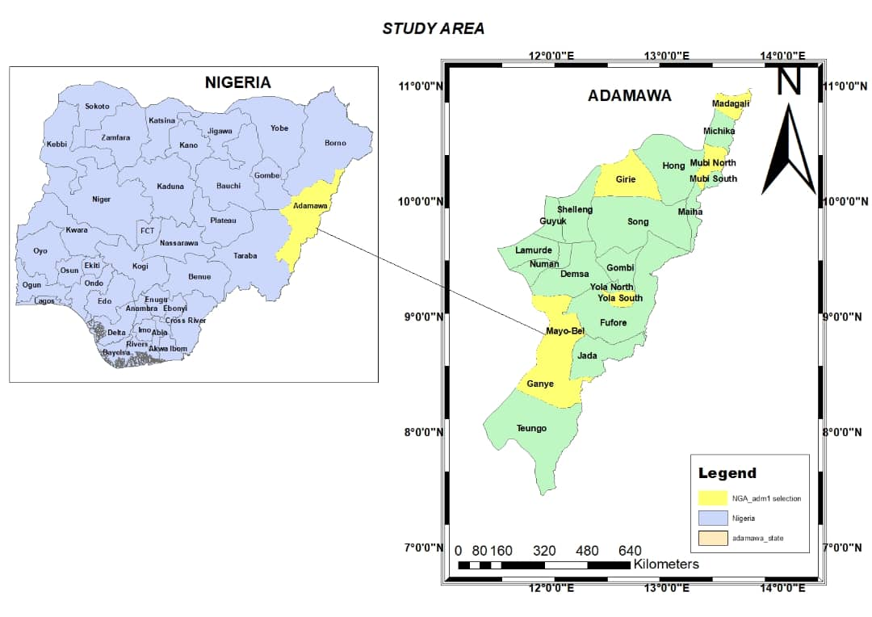
Figure 1 The Study Area
- MATERIALS AND METHODS
This study adopted a cross-sectional research design to examine the association between farming systems, agricultural practices, and soil degradation, with the aim of developing sustainable soil nutrient management strategies that enhance climate resilience in Adamawa State, Nigeria. The approach enabled the simultaneous collection of data from diverse ecological zones and stakeholder groups to capture variations in land-use practices and soil management behavior. The target population comprised registered farmers, agricultural extension officers, environmental scientists, and government officials responsible for agricultural and environmental management in the state.
Table 1 Summary of the Study Population
Category of Respondents | Estimated Population | Source
Registered Farmers | 4,812 | AADP (2024)
Agricultural Extension Officers | 580 | Adamawa Ministry of Agriculture (2024)
Environmental Scientists | 320 | Adamawa State Environmental Protection Agency (ASEPA, 2024)
Government Officials (Policy & Planning) | 210 | Adamawa State Ministry of Environment (2024)
Total Population | 5,922 | -
Source: Adamawa Agricultural Development Programme (AADP, 2024)
A stratified random sampling method was employed to ensure fair representation of these groups. Using Cochran’s (1977) formula for proportions (z = 1.96, p = 0.50, e = 0.05), an initial sample size of 384 was derived. After applying a finite population correction for the total sampling frame (N = 5,922), a final sample size of 361 was obtained. To address potential non-responses, a 10% buffer was added, resulting in approximately 397 individuals being approached. The final sample included 287 registered farmers, 34 agricultural extension officers, 20 environmental scientists, and 20 government policy and planning officials. This stratified approach ensured balanced subgroup sizes for meaningful analysis and maintained statistical precision while accommodating field realities.Primary data were collected through structured questionnaires and key informant interviews focusing on farming systems, land management practices, and indicators of soil degradation. Supplementary information was obtained from institutional records (Adamawa Agricultural Development Programme AADP) and relevant literature. Data analysis involved descriptive statistics to summarize response patterns and Chi-square (χ²) tests to determine significant associations between farming systems, agricultural practices, and soil degradation levels.
4. RESULTS
4.1 Distribution of Farming Systems Practices
The findings (Table 2) revealed that, subsistence farming is the leading agricultural activity with 50.3% respondents practicing the agricultural activity. This is an indication of a smallholder-based farming system where production rates are mainly in the form of household consumption and not the markets. The subsistence farmers are usually operating using little inputs and low access to the knowledge or technology of sustainable land management. This observation correlates with the research conducted by Pretty et al. (2008) who concluded that subsistence and smallholder agribusiness in sub-Saharan Africa is frequently typified by sparse external input application and high liability to soil erosion. A comparatively small percentage of commercial farmers (16.1%) also confirms the observations of Tittonell and Giller (2013), who reported that commercial agriculture in West Africa is still small because of infrastructural, institutional, and market constraints. Mixed farming where 28.1% of the respondents engage in it implies that a substantial number of farmers produce crops alongside livestock implying that a considerable proportion of farmers may be able to reduce nutrient loss by recycling nutrients. Vanlauwe et al. (2015) however, clarify that the advantages of mixed farming systems can only be achieved when they are managed effectively, and in most of Nigeria, these systems are not well optimized.

Table 2: Distribution of Farming Systems Practiced (n = 384)
Farming System | Frequency | Percentage (%)
Subsistence Farming | 193 | 50.3%
Commercial Farming | 62 | 16.1%
Mixed Farming | 108 | 28.1%
Others | 21 | 5.5%
Total | 384 | 100%
Source: Field Survey Result (2024)
4.2 Type of Land Ownership
Table3 revealed that, half of the respondents (50%) own their land, which promotes a greater likelihood of investment in long-term soil conservation method. However, the remaining 50% either rent, (24.5%) share communal land (17.2%), or farm on government-allocated land (8.3%). This situation mirrors observations made by Place and Hazell (1993) and later confirmed by FAO (2011), who found that insecure land tenure is a significant barrier to the adoption of sustainable soil fertility management practices. Insecurity in land access discourages long-term planning, resulting in mining of soil nutrients without replenishment. Thus, in Adamawa State, where a large portion of farmers do not own their land, soil nutrient depletion is likely to be more acute, especially under changing climate conditions.
Table 3 Type of Land Ownership (n = 384)
Land Ownership | Frequency | Percentage (%)
Personal | 192 | 50.0%
Rented | 94 | 24.5%
Communal | 66 | 17.2%
Government Allocated | 32 | 8.3%
Total | 384 | 100%
Source: Field Survey Result (2024)

4.3 Observation of Soil Degradation
Table 4 found that, the perception of soil degradation is notably high, with 77.3% of respondents acknowledging that they have observed soil degradation on their farms. This high level of perceived degradation reflects a significant threat to soil nutrient stability and aligns with broader regional studies. Lal (2009) and Eswaran et al. (2001) reported that land degradation is widespread in Nigeria due to intensive land use, poor land management, and the growing pressures of climate variability. Importantly, these authors emphasized that such degradation contributes directly to nutrient loss, reduced agricultural productivity, and declining resilience of rural farming systems.

Table 5: Type of Soil Degradation Observed (n = 297)
(Only for respondents who answered "Yes" to Table 5. Multiple responses allowed.)
Type of Soil Degradation | Frequency | Percentage (% of 295)
Soil Erosion | 193 | 65.0%
Loss of Soil Fertility | 180 | 60.6%
Salinization | 39 | 13.1%
Waterlogging | 35 | 11.9%
Source: Field Survey Result (2024)
4.5 Agricultural Practices among Respondents
The tables 6 revealed that, the majority of farmers cultivate cereal crops such as maize, rice, and millet, representing 29.7% of respondents. This is closely followed by mixed cropping (25.3%) and legumes (21.6%), while root crops like yam and cassava are the least cultivated at 6.8%. The dominance of cereal and legume cultivation suggests a cropping pattern that could either support or stress soil nutrient dynamics depending on the intensity and diversity of use.A significant proportion of the farmers (77.1%) practice crop rotation, a technique widely acknowledged for its potential to restore soil fertility and break pest cycles. Among these, 41.7% rotate crops every 2–4 years and 37.0% do so annually, indicating moderate adherence to agronomic recommendations. However, 21.3% only rotate crops every five years or more, which may reduce the potential benefits of this practice in maintaining soil health. The varying frequency of rotation could also reflect differences in awareness, land availability, or economic constraints.
Tillage practices show a mixed pattern of traditional and conservation-oriented approaches. Conventional tillage remains the most used method at 36.2%, followed by minimum tillage (25.8%) and no-tillage systems (19.3%). Additionally, 18.7% use manual techniques such as hand hoeing and digging, which could be linked to low mechanization and subsistence-level farming. The continued use of conventional tillage, known for disrupting soil structure and increasing erosion risks, may undermine efforts toward sustainable soil management despite the growing adoption of less intensive methods.Regarding water use, 38.8% of respondents indicated that they employ irrigation, while 61.2% depend entirely on rainfall. Among those who irrigate, 27.3% use sprinkler systems and 19.0% use drip irrigation both recognized as efficient water-saving techniques that also help prevent soil nutrient leaching. Traditional methods like surface irrigation (9.6%) and bucket irrigation (10.9%) are still in use, likely due to limited access to modern infrastructure.
Table6: Agricultural Practices among Respondents (n = 384)
Agricultural Practice | Frequency (n=384) | percentage
Types of Crops Cultivated
Cereal Crops (e.g., maize, rice, millet) | 114 | 29.7%
Legumes (e.g., beans, groundnut) | 83 | 21.6%
Root Crops (e.g., yam, cassava) | 26 | 6.8%
Vegetables (e.g., tomatoes, pepper) | 64 | 16.7%
Mixed cropping | 97 | 25.3%
Crop Rotation Practice
Practice Crop Rotation (Yes) | 296 | 77.1%
Practice Crop Rotation (No) | 88 | 22.9%
Crop Rotation Frequency (for those who rotate)
Annually | 142 | 37.0%
Every 2–4 Years | 160 | 41.7%
Every 5+ Years | 82 | 21.3%
Tillage Methods Used
Conventional Tillage | 139 | 36.2%
Minimum Tillage | 99 | 25.8%
No-Tillage | 74 | 19.3%
Others (e.g., hand hoeing, manual digging) | 72 | 18.7%
Use of Irrigation
Yes | 147 | 38.8%
No | 237 | 61.2%
Irrigation Methods (among irrigators)
Surface Irrigation | 37 | 9.6%
Drip Irrigation | 28 | 19.0%
Sprinkler Irrigation | 40 | 27.3%
Others (e.g., bucket irrigation) | 42 | 10.9

Source: Field Survey (2025)

5. DATA ANALYSIS
Table7: Chi-SquareTest of Independence between Farming System and Observation of Soil Degradation
Statistical Measure | Value
Test Type | Chi-square Test of Independence
Variable 1 | Farming System
Variable 2 | Observation of Soil Degradation
Sample Size (n) | 384
Chi-square Statistic (χ²) | 5.6873
Degrees of Freedom (df) | 3
Critical Value (χ²₀.₀₅,₃) | 7.81
p-value | 0.133
Level of Significance (α) | 0.05
Decision | Fail to reject the null hypothesis

Source: Field Data Analysis, SPSS Version 25 (2025)
Table 8: Chi-SquareTest of independence results for agricultural practices and observed soil degradation:
Variables | Chi-square Statistic (χ²) | Degrees of Freedom (df) | Critical Value (χ²₀.₀₅) | p-value Significance
Crop Rotation vs. Soil Degradation | 2.935 | 1 | 3.841 | Not Significant
Tillage Method vs. Soil Degradation | 2.482 | 3 | 7.815 | Not Significant
Use of Irrigation vs. Soil Degradation | 11.949 | 1 | 3.841 | Significant

Source: Field Data Analysis, SPSS Version 25 (2025)

6. DISCUSSION
The results on Table 7 and Table 8 explore the correlation between agricultural practices, soil degradation and farming systems in the Adamawa State. The chi-square value (χ² = 5.6873, p = 0.133) shows that there is no statistically significant relationship between the type of farming system used and the occurrence of soil degradation. It implies that even though cases of degradation were most common among subsistence and mixed farmers (121 and 116 cases respectively), such differences could not be considered statistically significant enough to draw any dependence conclusion. This is in line with the findings of Akamigbo (2019) who found that constant cultivation and subsistence agriculture leads to soil nutrient depletion and soil erosion due to fewer fallow periods, however, the impact is usually mitigated by local soil management procedures and environmental fluctuation. Therefore, the study indicates that degradation is affected more by environment specific factors (e.g., rainfall erosivity, slope and soil type) rather than by the type of farming system.
Also, the analysis of Table 8(agricultural practices) shows mixed results. The crop rotation (χ² = 2.935, p > 0.05) and tillage method (χ² = 2.482, p > 0.05)did not significantly relate with the soil degradation. This implies that although these practices might be agronomically significant, their role in causing apparent degradation might be indirect or hidden by other more significant forces such as variability in rainfall and soil texture. Nonetheless, soil degradation had a significant relationship with irrigation practice (χ² = 11.949, p < 0.05). The farmers who had engaged in irrigation reported less cases of degradation (113) as compared to those who depended on rainfall only (213). This shows that irrigation is able to serve as a soil-conservation buffer to stabilize the moisture content and lessen the erosion potential. This finding is in line with the findings of both Lal (2020) and FAO (2019), who highlighted that controlled irrigation increases the soil structure, crust, and nutrient retention, which in turn alleviate the effects of degradation caused by climate. In summary, the findings indicate that although the farming systems and traditional agricultural practices (e.g., crop rotation and tillage) have a limited direct effect on the soils degradation, the irrigation has a strong impact on the improvement of soil stability and resilience.

7. DEVELOPMENT OF THE ADAPTIVE SOIL NUTRIENTS RESILIENCE FRAMEWORK
This is a model derived from the empirical findings of this study. The findings from the study established that although farming systems and land management practices vary significantly across Adamawa State, their influence on soil degradation is mediated by multiple climatic and socio-institutional factors. The study further revealed that soil degradation, particularly nutrient loss, is widespread and shaped by weak land tenure security, sub-optimal irrigation practices, and limited adoption of climate-smart agronomic techniques. The absence of a coordinated and adaptive soil-nutrient management system underscores the need for a new framework capable of linking climatic, biophysical, and socio-economic dynamics into a unified management platform.The adaptive soil nutrients resilience framework was therefore developed as a holistic framework that integrates the adaptive management concept and the sustainable livelihoods approach to promote climate-resilient soil fertility management in Adamawa State and other vulnerable agro-ecological regions.

6.1 Rationale for Developing the Framework
Existing soil management interventions in Nigeria are largely fragmented, focusing on fertilizer distribution, erosion control, or land-tenure reforms in isolation. Findings from this research revealed that despite the predominance of subsistence and mixed farming systems, soil degradation persists because of weak institutional coordination, insecure land ownership, and low technological adoption.Empirical analyses further showed that irrigation had a statistically significant association with reduced soil degradation (χ² = 11.949, p < 0.05), implying that adaptive water-management strategies can enhance soil resilience. However, most farmers lack the resources and technical guidance to implement such measures effectively. This reality demonstrates the necessity for a comprehensive framework that unites environmental diagnostics, farm-system profiling, adaptive interventions, and continuous learning under a single operational mechanism. The ASNRF was thus conceived as an outcome of this research to fill that conceptual and practical void.

6.2Componentsof the Adaptive Soil Nutrient Resilience Framework (ASNRF)
The AINRF consists of six inter-connected components operating in a feedback loop:
- Assessment and Diagnostics
- Farming System Profiling
- Decision-Support System (DSS)
- Intervention Toolbox
- Implementation and Governance
- Monitoring, Evaluation, and Learning (MEL)
Assessment and Diagnostics is the first component focuses on determining the current vulnerability of the soil nutrients, degradation trends, and socio-economic limitation. It incorporates soil nutrient information, indices of climate variability, degradation maps and socio economic surveys to create a Soil Nutrient Vulnerability Index (SNVI) and map out Priority Intervention Zones (PIZs) on which targeted actions should be taken. The analytical heart of ANRF is the Soil Nutrient Vulnerability Index (SNVI), expressed as:
SNVI = (E_{w}× D_{s}) + (S_{c} × M_{i}) − (R_{c})
Where:
- E_{w}= Erosivity weight (rainfall and slope intensity)
- D_{s} = Degradation score from field observation
- S_{c} ​ = Soil conservation score (presence of practices like contouring, rotation)
- M_{i} = Management intensity factor
- R_{c} ​ = Resilience capacity (irrigation use, organic matter content, tenure security)
High SNVI values identify critical intervention zones, guiding targeted action.
The second component (Farming System Profiling) categorizes systems of farming practices by management systems, the level of production and input. The systems are categorized by the use of field data into subsistence, mixed and commercial. Each category is provided with context specific interventions - e.g. mixed systems are using manure recycling where subsistence farmers are using composting and cover cropping so that the management strategies are coping with the reality on farm. Decision Support System (DSS) is the third component, which is the analytical core of the framework. It combines the data of Components 1 and 2, incorporating the soil test analysis, land tenure, and data of farming practice to support the evidence-based decision-making. The DSS helps users to estimate the best and location-specific nutrient management strategies in every zone.
The fourth component (Intervention Toolbox) is a combination of biophysical and socio-technical interventions to improve the nutrient resilience. The agroecological approaches involved include cover cropping, reduced tillage, contour farming, organic additions, technological advancements that encompass biochar use, drip irrigation, and precise scheduling of nutrients; policy and institutional changes that consist of land tenure security, input subsidies, and capacity building of farmers through extension services and field schools. The fifth element is the Implementation and Governance that focuses on stakeholder partnerships. The interventions are coordinated by farmers, cooperatives, traditional leaders, extension officers and ministries (agriculture, environment and rural development) via Public-Private-Community Partnerships (PPCP). This will guarantee collective accountability, openness and sustainability in the execution of nutrient management programs. Last but not least is the sixth component, which is Monitoring, Evaluation, and Learning (MEL), and offers the feedback mechanism of maintaining the flexibility of the framework. MEL system can monitor how soil quality, crop yield, and climate resilience changes over time with the help of GIS based soil health dashboards and farmer self-assessment systems. The insights that will be created at this stage are fed back into the assessment process and would guarantee continuous improvement and contextual adaptation of the ANRF with the new challenges.
As a whole, the ANRF is a participant-driven, data-driven, and dynamic mechanism that facilitates the translation of environmental diagnostics to feasible decisions and fosters soil nutrient management that could lead to climate resilience in the Adamawa state and even further.
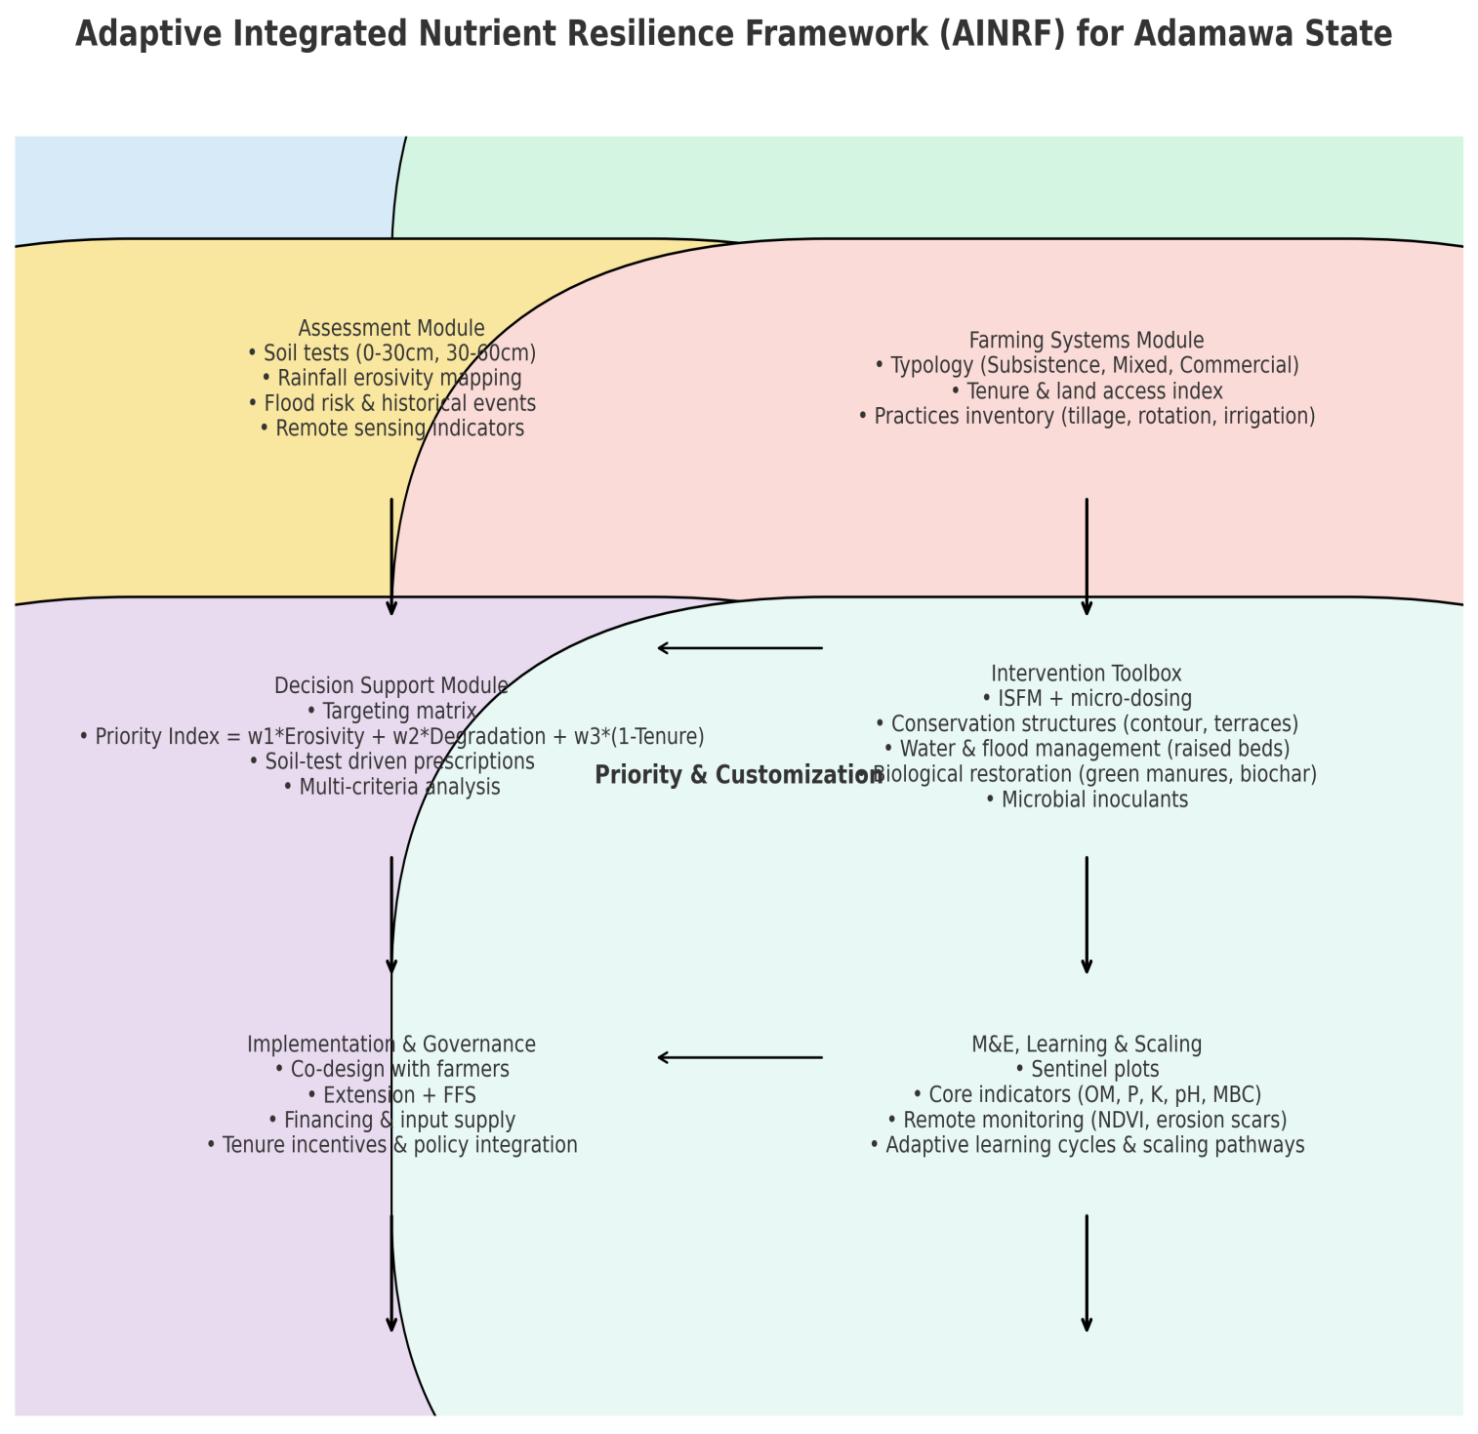Source: Author’s Field Synthesis, 2025.
Figure 2: Adaptive Nutrient Resilience Framework (ANRF)
- CONCLUSION
The findings of this study reveal that farming systems and agricultural practices in Adamawa State exhibit varying degrees of influence on soil degradation, though not all relationships are statistically significant. The Chi-square analysis showed no significant association between farming systems and observed soil degradation (χ² = 5.6873, p = 0.133), suggesting that soil degradation cuts across all types of farming, regardless of system classification. However, subsistence and mixed farming systems displayed higher frequencies of degradation, implying that smallholder farmers are more vulnerable due to continuous cropping, nutrient mining, and limited soil conservation measures. Similarly, among agricultural practices, both crop rotation (χ² = 2.935) and tillage method (χ² = 2.482) were not significantly associated with soil degradation, indicating that these practices are inconsistently applied or poorly managed in ways that limit their protective effects. Conversely, the use of irrigation (χ² = 11.949, p < 0.05) showed a significant relationship with soil degradation, with farmers employing irrigation experiencing lower levels of degradation. This underscores irrigation’s role as a critical adaptive measure for maintaining soil moisture balance, reducing erosion, and enhancing soil resilience under increasing climatic variability. In essence, while statistical tests revealed weak or no direct associations for most variables, the pattern of results underscores the need for integrated soil management strategies that combine improved irrigation systems, appropriate tillage, and long-term soil fertility measures to curb degradation across farming systems in Adamawa State.
- RECOMMENDATIONS
- Government and development partners should expand access to affordable irrigation infrastructure, particularly solar-powered and small-scale systems, to help farmers maintain soil moisture, reduce erosion, and enhance resilience to dry spells.
- Farmers should be trained and supported to combine organic manure, composting, crop residue retention, and minimal inorganic fertilizer use to maintain nutrient balance and prevent long-term degradation.
- Extension agencies should promote reduced tillage, mulching, and cover cropping practices that minimize soil disturbance and improve structure, organic matter, and microbial activity.
- Policies should enhance farmers’ access and ownership rights to land, thereby motivating long-term soil conservation investments and discouraging exploitative short-term cultivation practices.
- Establish community-based soil monitoring units that track degradation trends and support farmers with real-time advisory services on sustainable practices, guided by the proposed Adaptive Integrated Nutrient Resilience Framework (AINRF).

Disclaimer (Artificial intelligence)
Option 1:
Author(s) hereby declare that NO generative AI technologies such as Large Language Models (ChatGPT, COPILOT, etc.) and text-to-image generators have been used during the writing or editing of this manuscript.
Option 2:
Author(s) hereby declare that generative AI technologies such as Large Language Models, etc. have been used during the witing or editing of manuscripts. This explanation will include the name, version, model, and source of the generative AI technology and as well as all input prompts provided to the generative AI technology
Details of the AI usage are given below:
1.
2.
3.

REFERENCES
- Adamawa State Government. (2024). About Adamawa State: Geography and economy overview. Yola: Ministry of Information and Strategy. Retrieved from https://www.adamawastate.gov.ng
- Akamigbo, F. O. R. (2019). Principles of sustainable soil management in tropical agroecosystems. University of Nigeria Press. https://ir.unn.edu.ng/handle/123456789/4876
- Britannica. (2024). Adamawa State, Nigeria. In Encyclopaedia Britannica. Retrieved from https://www.britannica.com/place/Adamawa-state-Nigeria
- Egbule, P. O., & Okonta, E. C. (2024). How climate change induced land conflicts and food insecurity in Africa: A case of herdsmen-farmers crisis in Nigeria. African Journal on Land Policy and Geospatial Sciences, 7(1). https://doi.org/10.48346/IMIST.PRSM/ajlp-gs.v7i1.46128
- Eswaran, H., Lal, R., & Reich, P. F. (2001). Land degradation: An overview. In E. M. Bridges, I. D. Hannam, L. R. Oldeman, F. W. T. Pening de Vries, S. J. Scherr, & S. Sompatpanit (Eds.), Response to Land Degradation (pp. 20-35). Science Publishers. https://www.nrcs.usda.gov/Internet/FSEDOCUMENTS/nrcs142p2052820.pdf
- FAO (Food and Agriculture Organization). (2011). The State of the World's Land and Water Resources for Food and Agriculture (SOLAW): Managing systems at risk. Food and Agriculture Organization of the United Nations. https://www.fao.org/3/i1688e/i1688e.pdf
- FAO (Food and Agriculture Organization). (2019). The State of the World's Biodiversity for Food and Agriculture. Food and Agriculture Organization of the United Nations. http://www.fao.org/3/CA3129EN/ca3129en.pdf
- IPCC. (2021). Climate Change 2021: Impacts, adaptation and vulnerability. Contribution of Working Group II to the Sixth Assessment Report of the Intergovernmental Panel on Climate Change. Cambridge University Presshttps://www.ipcc.ch/report/ar6/wg1/downloads/report/IPCC_AR6_WGI_SPM_final.pdf
- Lal, R. (2009). Soil degradation as a reason for inadequate human nutrition. Food Security, 1(1), 45-57. https://doi.org/10.1007/s12571-008-0009-0
- Lal, R. (2015). Restoring soil quality to mitigate soil degradation. Sustainability, 7(5), 5875-5895. https://doi.org/10.3390/su7055875
- Morton, J. F. (2007). The impact of climate change on smallholder and subsistence agriculture. Proceedings of the National Academy of Sciences, 104(50), 19680-19685.
- National Bureau of Statistics (NBS). (2022). Labour Force Statistics: Employment and Underemployment Report Q4 2022. Abuja: NBS. https://nigerianstat.gov.ng/elibrary
- Olaniyi, A. O., Ajala, O., Adesina, I. M., & Ogunkunle, O. (2023). Comparative assessment of soil degradation potentials of commodity crops grown in Nigeria. Agricultura Tropica et Subtropica, 56(1), 19-32. https://doi.org/10.2478/ats-2023-0003
- Palm, C. A., Smukler, S. M., Sullivan, C. C., Mutuo, P. K., Nyadzi, G. I., & Walsh, M. G. (2014). Identifying potential synergies and trade-offs for meeting food security and climate change objectives in sub-Saharan Africa. Proceedings of the National Academy of Sciences, 107(46), 19661–19666
- Panagos, P., Borrelli, P., Meusburger, K., Yu, B., Klik, A., Lim, K. J., & Alewell, C. (2017). Global rainfall erosivity assessment based on high-temporal resolution rainfall records. Scientific Reports, 7, 4175. https://doi.org/10.1038/s41598-017-04282-8
- Place, F., & Hazell, P. (1993). Productivity effects of indigenous land tenure systems in sub-Saharan Africa. American Journal of Agricultural Economics, 75(1), 10-19. https://doi.org/10.2307/1242969
- Pretty, J. (2008). Agricultural sustainability: Concepts, principles and evidence. Philosophical Transactions of the Royal Society B: Biological Sciences, 363(1491), 447-465. https://doi.org/10.1098/rstb.2007.2163
- Tittonell, P., & Giller, K. E. (2013). When yield gaps are poverty traps: The paradigm of ecological intensification in African smallholder agriculture. Field Crops Research, 143, 76-90. https://doi.org/10.1016/j.fcr.2012.10.007
- Valerio, V. (2020). The structure of livestock trade in West Africa (West African Papers, No. 29). OECD Publishing. https://doi.org/10.1787/f8c71341-en
- Vanlauwe, B., Descheemaeker, K., Giller, K. E., Huising, J., Merckx, R., Nziguheba, G., & Zingore, S. (2015). Integrated soil fertility management in sub-Saharan Africa: Unravelling local adaptation. SOIL, 1, 491-508. https://doi.org/10.5194/soil-1-491-2015
- Vanlauwe, B., Wendt, J., & Giller, K. E. (2019). A fourth principle is required to define Conservation Agriculture in sub-Saharan Africa: The appropriate use of fertilizer to enhance crop productivity. Field Crops Research, 155, 10-13. https://doi.org/10.1016/j.fcr.2013.10.002
- Wazakari, R. R., & Kefas, M. T. (2024). Effects of climate change and farmers-herders conflicts on the socio-economic development of farmers in Adamawa State. Lapai International Journal of Management and Social Sciences, 16(2). https://ojs.ibbujournals.com.ng/index.php/lijomass/article/view/1399

