Effect of wood ash on soil chemical properties, growth and yield of tomato (Lycopersicum esculentum) in Brazzaville, Republic of Congo

ABSTRACT: In Central Africa and particularly in the Republic of Congo, the chemical poverty of soils considerably affects the growth of food and vegetable crops such as tomato (Lycopersicon esculentum), which nevertheless represents a source of income for producers. This study focused on the evaluation of the effect of wood ash on the chemical properties of the soil, growth and yield of Lycopersicon esculentum. The completely randomized Ficher experimental design with 5 treatments and 4 repetitions was used. The treatments consisted of wood ash inputs at 0; 12.5; 25; 50 and 100g/kg of soil. Observations and measurements focused on physicochemical parameters of the growing media and the number of leaves per plant, plant size, stem diameter, the number of fruits per plant, the weight of 10 fruits and yield. Results showed an improvement in the chemical properties of the soil. Wood ash additions significantly increased stem diameter, number of fruits per plant, weight of 10 fruits, and yield compared to the control. The best results on growth parameters and yield were obtained with wood ash addition at 12.5 g/kg. Wood ash addition is recommended for market gardeners in the Brazzaville City.
Key words: Wood ash, soil amendment, tomato, agriculture

- INTRODUCTION

The tomato, Lycopersicon esculentum (Solanaceae) is an annual herbaceous plant native to the Andes and America, widely cultivated for its fruit eaten fresh or processed [1]. Regular consumption of tomatoes or tomato-based products reduces the risk of cancer, but also of cardiovascular diseases, diabetes and osteoporosis [2]. It is one of the most important plants in most regions of the world where its importance comes second only to the potato [3]. Annual global production of tomatoes is growing steadily. It is estimated at 153,833,368 tons in 2009 compared to 110,192,365 tons in 2000 [4]. This culture is confronted with the limiting factor which is the sensitivity to ecological conditions,

that is to say edaphic and climatic [5]. The major constraint of agricultural production in Africa on degraded soils is the low level of fertility of these soils [6]. For certain regions of Africa, the decline in land productivity is the result of the galloping population pressure than in other regions [6]. Added to this are poor cultural practices on the soils subsequently leading to a depletion of nutrients in the soils becoming less productive or infertile [7]. The problem of soil fertility is a primary concern for farmers who are faced with the high cost of inputs as well as for researchers whose research aims to maintain the productivity of degraded soils for a good Intensification of agricultural production. [8].

To meet the ever-increasing needs of the population for vegetables, market gardeners do not allow the land to rest in any season, which weakens the land to rest in any season, which weakens the yield and impoverishes their soil. Thus, they resort to chemical fertilizers, which lead to pollution of chemical elements in the soil and in the environment. These fertilizers are responsible for soil pollution, but are above all the major cause of air and water pollution, which leads to the eutrophication phenomenon. Thus, to remedy all this, it would be interesting to use natural fertilizers, hence the importance of recycling agricultural waste [9]. In this study we consider the valorization of wood ash as a source of fertilizing elements for tomato and the neutralizing power of acidic soils [10] in agriculture, in order to improve crops and the restoration of degraded soils. Specifically it is about determining the effect of wood ash on the chemical properties of the soil and on the growth parameters of the tomato.
2. MATERIALS AND METHODS
2.1 Description of the study site

This study was conducted at Brazzaville in Republic of Congo. The Republic of Congo covers an area of 342,000 km². It is located in Central Africa, straddling the equator between latitudes 3°30' North and 5° South and longitudes 11° and 18° East. South and longitudes 11° and 18° East. The Brazzaville metropolitan area covers an area of nearly 265 km². Brazzaville is located in the southern part of Congo, between latitudes 4°6'15'' and 4°22'30'' South and between longitudes 15°6'0'' and 15°19'15'' East [11]. This study was conducted within the Faculty of Science and Technics of Marien NGOUABI University in Brazzaville.
2.2 Material

The plant material used consisted of tomato seeds (L. esculentum), of the Mongal hybrid F1 variety (one 5g sachet) and purchased commercially. This is an improved variety from the TECHNISEM company. It was chosen for its germination rate of 85%, a purity of 99%, the high weight of its fruits and its rigor which ensures staggered harvests.

2.3 Manures

The inputs used in this study were mainly consisted of wood ash collected from different households in the city of Brazzaville.

2.4 Experimental device

This experiment was conducted in the period from July 16 to October 30, 2023 according to a completely randomized design with five treatments repeated four times. The treatments consisted mainly of wood ash compared to the control treatment without organic or mineral matter. The experimental unit was a bag containing 20 kg of soil with or without input. The preparation of the device was carried out on July 17, 2023. After one week, the implementation of the test took place. This test consisted of studying the response of Lycopersicum Esculentum under the effect of a single factor: mineral manure or wood ash with 5 treatments: T0, T1, T2, T3 and T. The doses provided were as follows:

- T0: soil without ash addition (control),
- T1: 12.5g of ash per kilogram of soil,
- T2: 25 g of ash per kilogram of soil,
- T3: 50 g of ash per kilogram of soil,
- T4: 100 g of ash per kilogram of soil.

2.5 Sample preparation

The sampling method chosen was the systematic random type. The sample taken were of the composite type, i.e. derived from the mixture of a series of point sub-samples taken in accordance with the systematic random sampling strategy with a depth of 20 cm in accordance with the ISO-18400-102 standard. The soil was taken from the Faculty of Science and Technics. This soil was crumbled and dried in the open air under cover at room temperature (25°C). Then 14 days before sowing, 20 kg of soil were introduced into plastic bags with or without mineral amendment.

2.6 Sowing and monitoring of the culture
2.6.1 Tomato nursery

To conduct the trial, nursery seedlings were planted in August 2023 in vertically cut containers.
    - Semi and maintenance

14 days after sowing in the nursery, the tomato

calcium chloride then potassium nitrate. Potassium and sodium by the flame spectrophotometric method, calcium and magnesium by the complexometric method with EDTA reagent.

    - Data analysis

The statistical analysis of the data collected during the various observations was carried out according to the multifactorial factorial model. This is the analysis of variance using Graphpad software Prism version 7.00 with ANOVA.

3. RESULTS AND DISCUSSION

  - Physicochemical characterization of ash and soil results

The analysis results showed that our soil was acidic, black in color and low in major nutrients. Our study reported that the ash had a basic pH. Nitrogen, phosphorus, and potassium levels were low. The results of the physicochemical analyses are presented in Tables 1 and 2.

  - Results of wood ash effect on soil physicochemical properties

    - Wood ash effect on pH, Electrical Conductivity (EC), Maximum Water Retention Capacity (MWRC), Organic Carbon (OC) and Organic Matter (OM)

Figure 1 presents the different physicochemical parameters evaluated in this work.

plants were transplanted into plastic bags with vigorous feet per bag. To do this, the seedlings were pulled up with the clod of earth. This was done to reduce the risk of wilting of the seedlings during transport to the supports intended to accommodate them. The final supports were also watered to create favorable conditions for the recovery of the seedlings. Water was supplied by watering twice a day, morning and evening, with a quantity of approximately 250 ml of water. Some maintenance work, such as weeding and hoeing, was carried out as needed.

  - Measured parameters

The growth and agronomic parameters observed during this study were the number of leaves/plant, the height of the stem at the collar to the tip of the last leaf, number of fruits per treatment, stem diameter and the weight of 10 fruits. The yield was estimated in tons per hectare.

2.7.1 Physicochemical analysis method

The soil was analyzed for particle size by the Robinson pipette method (fine silt, coarse silt, fine sands and coarse sands), the pH measured according to the NF X 31-103 standard and the international standard ISO-10390 by measuring a suspension of soil in distilled water according to the ratio 1/5 (mass/volume) with a Water Quality type pH meter Meter EZ9908. Nitrogen by the Kjeldahl method, carbon by the Walkley and Black method, phosphorus by the colorimetric method with the Realy and Murphy reagent, Cation Exchange Capacity by the saturation method with

Table 1: Physicochemical characteristics of soil and wood ash
Parameters | pH | EC (µS/cm) | CMRE ( %) | N (mg/kg) | P (mg/kg) | K (mg/kg) | TOC (%) | MO (%) | CEC  (meq/100g) | Clay (%) | LF (%) | LG (%) | SF (%) | SG (%)
Soil | 5.68 | 44 | 20 | 1 | 1,8977 | 4 | 2.44 | 4.21 | 6.38 | 7 | 2 | 1.53 | 39.61 | 42.20

Table 2: Physicochemical characteristics of soil and wood ash
Parameters | T (°C) | pH | EC (µS/cm) | TDS (ppm) | CMRE (%) | N  (mg/kg) | P  (mg/kg) | K  (mg/kg) | Ca (mg/kg) | Mg  (mg/kg) | Na  (mg/kg)
Wood ash | 26.2 | 11 | 9270 | 4620 | 95 | 657 | 191 | 1469 | 155300 | 49600 | 2100
The pH of the growing media was measured before sowing and at harvest to study the effects
of ash on soil pH over time. We noted a decrease in pH during the study in the treatments with ash amendment, the values evolve from 9.500±2.121 to 10.320±0.283 at the beginning and from 8.750±1.141 to 8.930±1.414 at the end. On the other hand in the control treatment, we noted an increase in pH, the values evolve from 5.680±0.141 at the beginning to 6.800±0.566 at the end. The evolution of pH is proportional to the contribution of ash in the soil.
For the electrical conductivity (EC), a decrease was noted during the study. In the treatments with ash amendment, the values evolve from 222,000±14,142 to 1124,320±5,657 at the beginning and from 90,000±14,142 to 125,000±7,071. The same observation was made for the control treatment where a decrease in conductivity is noted, the values evolve from 47,000±2,828 at the beginning to 27,000±3,536 at the end. The evolution of the electrical conductivity is proportional to the contribution of ash in the soil.
For the Maximum Water Retention Capacity (MWRC), the results of Sidak 's multiple comparisons test indicate that there is no

statistically significant difference between the means of the "Before" and "After" groups for any of the comparisons (T0, T1, T2, T3, T4). The smallest value was recorded with the T0 treatment (12±1.41) and the largest with T4 (24±3.67) before experimentation and after experimentation, we note T0 (16±1.83) and T4 (18±0.71).
For organic carbon (OC), the results suggest that the intervention or condition measured had a significant impact at T0, T1, T3 and T4. Only the difference at T2 is not significant. Before experimentation, the smallest value was recorded with treatment T0 (1.61±0.06) and the largest value with T1 (2.71±0.14) and after experimentation, we noted T4 (1.35±0.07) and the largest value with T2 (1.98±0.11).
For organic matter (OM), Sidak multiple comparison test indicated that there was no statistically significant difference between the "Before" and "After" groups at all measurement points (T0 to T4). Before experimentation, the smallest value was recorded with the T0 treatment (1.99±1.27), and the largest value with T2 (3.82±1.55) and after experimentation, we note T4 (2.32±0.17) and the largest value with T2 (3.40±1.41).

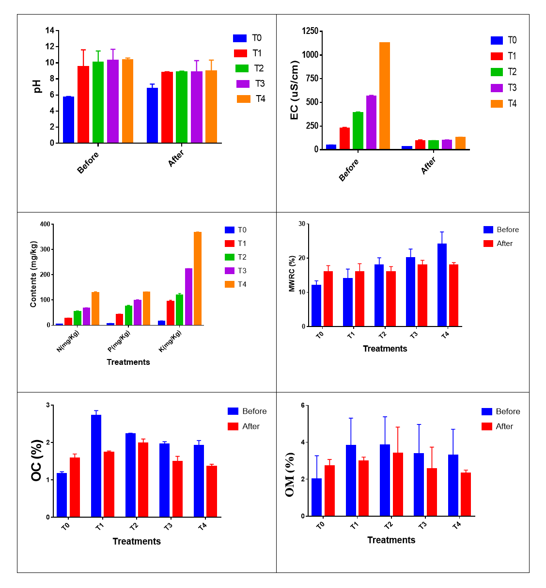
Figure 1 : Effect of ash on some physicochemical parameters
(p = 0.0064 and p = 0.0204) at the 1st week respectively for T1 and T2 compared to the control treatment. A significant difference (p $<$0.0001) was observed for treatments T1, T2 and T3 at the 2nd and 3rd week compared to the control. At the 4th week, a difference (p $≤$0.0001 and p = 0.0262) was observed respectively for treatments from T1, T3 and T4. It is from the 5th week that a significant difference was noted (p $<$0.0001) on all treatments having received the ash amendment compared to the control. Treatment T1 presented the plants with the greatest number of leaves. This analysis showed that treatment T1 presented the most vigorous plants with a diameter of 10.133±1.070.
Effect of wood ash on stem height: Evolution curves of stems height are presented in figure 2.c. Analysis did not show any significant difference (p >0.05) from the 1st to the 3rd week compared to the control treatment. However, at the 4th and 5th weeks, only the T1 treatment significantly influenced (p = 0.0055 and (p <0.0001) the height of the stems compared to the control treatment. We noted that the other treatments did not influence the height of the stems. It is from the 6th week that we noted a significant difference (p <0.0001) on all the treatments having received the ash amendment compared to the control. The T1 treatment presented the plants with the greatest

The contribution of ash increases the nitrogen, phosphorus and potassium contents, proportionally to the quantity of ash provided, compared to the control treatment.
    - Wood ash effect on growth parameters

This section presents the effects of ash on growth parameters. These data were subjected to an analysis of variance and results are reported in Figure 2.
Effect of wood ash on leaf number: The results obtained after the addition of wood ash on the number of leaves are presented in Figure 2.a. Analysis did not show a significant difference (p $>$0.05) from the 1st to the 5th week compared to the control treatment. A significant difference (p $<$0.0001) was observed for treatments T1 and T2 at the 6th, compared to the control. It is from the 7th week that a significant difference (p $<$0.0001) was noted on all treatments having received the ash amendment compared to the control. Treatment T1 presented the plants with the greatest number of leaves.
Effect of wood ash on stem diameter: the results obtained after the addition of wood ash on the diametrical growth are presented in Figure 2.b. Analysis showed a significant difference

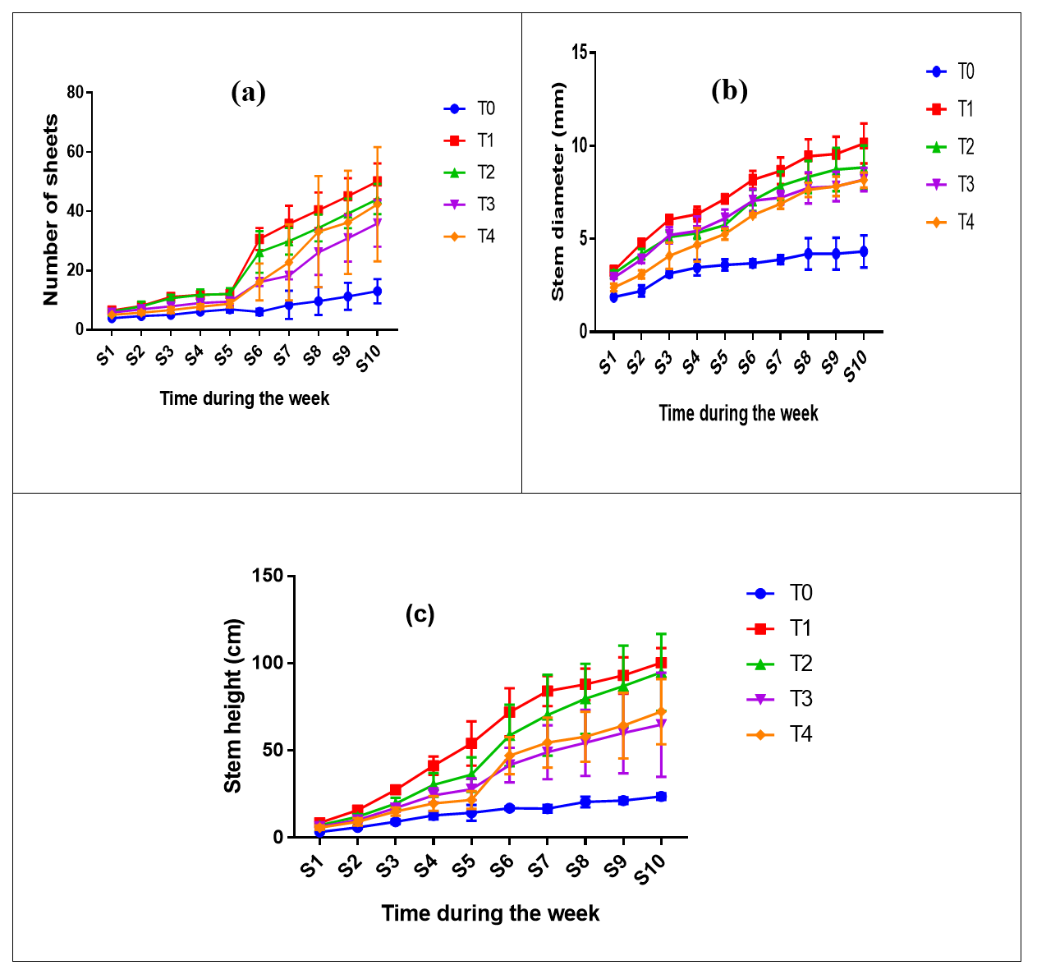
Figure 2 : Effect of ash on growth parameters
out on the soil without ash input (0.00 fruits/plant) (Figure 3.a).
Effect of wood ash on weight of fruits: Figure 3.b shows that the input of wood ash influenced (p $<$0.0001) the average weight of 10 fruits compared to the control treatment which did not produce fruits. The T1 substrate yielded the weight of 10 fruits higher compared to the other substrates. With regard to Figure 3.b, the contribution of ash at 12.5 g/kg of soil allowed to obtain good size of tomato.
Effect of wood ash on fruit yield: The variation in tomato fruit yield according to the amendments is shown in Figure 3.c. Analysis of variance showed that ash amendments induced significant differences between the different treatments (p $<$0.0001, p=0.0007, p=0.0026, p=0.0082) for T1, T2, T3 and T4 respectively. However, it should be noted that the highest tomato yield was obtained with treatment T1 (16.620±1.344 t/ha), followed by T2 (12.860±1.513 t/ha) and finally the lowest yield was recorded in the control treatment (zero yield).

number of leaves. Moreover, as appeared for the previous parameters, the height of the stems obtained with the T1 treatment was higher.
    - Wood ash effect on agronomic parameters

This section presents the effects of ash on agronomic parameters. Then the agronomic parameters related to fruit yield are presented in Figure 3.
Effect of wood ash on number of fruits: The results obtained from the analysis of variance indicated that there was an effect of mineral fertilizer (ash) input to the soil on the number of fruits per tomato plant for treatment T1 (p = 0.0148). On the other hand, the other treatments that received ash amendment did not have significant effects (p $>$0.05) compared to the controls. It is therefore on the substrate fertilized with ash at 12.5 g/kg that the greatest average number of fruits develops (6, 875±1,414 fruits/plant). And the low average number stands

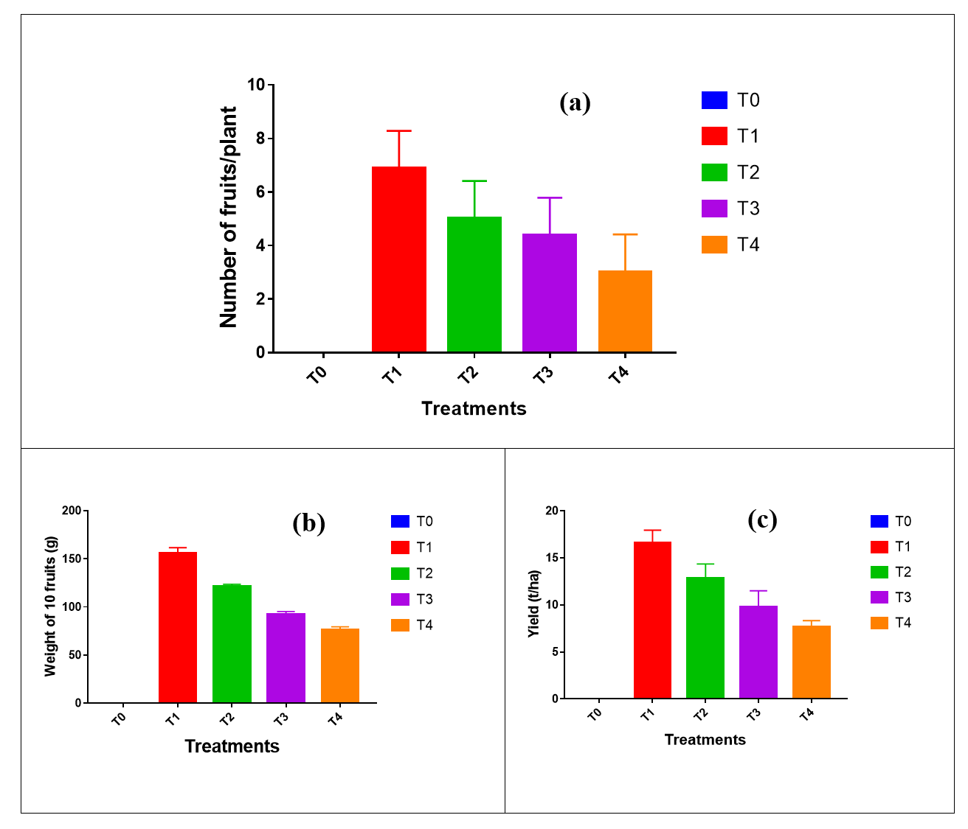
Figure 3 : Effect of ash on agronomic parameters

  - Discussion

    - Discussion on physicochemical parameters

The previous parameter (pH), the electrical conductivity of growing media strongly depended on the type of amendment and the duration of cultivation. The lowest electrical conductivities were obtained in the control treatment (unamended). The amendment with ash provided an ionic supply to the soil and thus increased the value of the electrical conductivity of the growing media in comparison with the control treatment. These results are in agreement with those of Hargreaves and al. (2008) [12] and Wong and al. (1996) [13]. These authors have in fact highlighted the increase in the electrical conductivity of the soil following the amendments compared to the unamended control. The measured values were the highest for the T4 treatment. According to Ben Bessis (2022) [14], the decrease in electrical conductivity corresponds to the decrease in soluble salts (Na ⁺, Mg ²⁺, Ca²⁺). This reduction could be explained by the activity of the roots and the absorption of salts by the plant. The analyses showed that the EC values are in accordance with this range of 500 to 2000 µs/cm cited by Groga and al. (2018) [15] which stated that the growing media should have a low electrical conductivity of less than 3000 µs/cm. The results revealed an evolution of the maximum water retention capacity (MWRC) of soils after the experiment with different doses of ash. In general, an increase in MWRC was observed after the addition of ash, compared to the initial state ("Before"). The increase in MWRC in treatments T1 to T4 compared to the control T0 is a notable result. Wood ash, in minerals, improves soil structure, thus promoting its capacity to retain water. This finding was consistent with several studies that have highlighted the beneficial effect of organic amendments on soil water properties. Herawati and al. (2021) [16] showed that the application of wood ash improved the water retention capacity of clayey and sandy soils. Similarly, Agegnehu and al. (2023) [17] concluded that the incorporation of organic matter, including ash, increased soil porosity and consequently its capacity to store water. Analysis of the experimental results revealed complex changes in soil organic carbon and organic matter after ash addition for tomato cultivation. Contrary to expectations, ash addition did not systematically lead to an increase in CO and OM in the treatments (T1 to T4).

For Organic Carbon, the results showed a decrease in the organic carbon level after the experiment for the treatments where ash was added (T1, T2, T3 and T4). For example, for T1, the CO decreased from 2.71% to 1.73%. This trend was consistent for all ash doses. Only the control group (T0), without ash, showed a slight increase in CO (from 1.16% to 1.58%). This decrease can be explained by several mechanisms. Wood ash has a high pH, which can stimulate microbial activity and accelerate the decomposition of native soil organic matter, thus releasing CO₂ into the atmosphere [17]. Although ash contains nutrients, it did not provide a large amount of stable organic carbon. Soil organic matter could therefore be used by crops and microorganisms without being sufficiently replenished by the addition of ash. This observation is in line with some studies that highlight the risks of applying ash without additional organic matter. For example, Demeyer and al. (2001) [18] showed that using ash without compost or other carbon sources can lead to long-term soil carbon loss due to increased mineralization. The results for organic matter are in line with those for organic carbon. The data indicate a decrease in organic matter in treatments T1 to T4. Apart from the fertilizing elements, wood ash contains phosphorus, sulfur and trace elements which play a vital role in plant growth [10]. It should be noted that at high doses, ash inhibits good plant growth, thus leading to low yields. This is explained by the fact that excess potassium is likely to limit the absorption of calcium, magnesium and reduce the availability of iron and manganese. Our results are not similar to those of Hébert and al. (2008) [10] who estimated that better yield and good growth are obtained at doses of ash not exceeding the threshold of 2.5 g/kg, for corn, wheat, soybean and bean crops. The addition of ash resulted in plants with a larger collar diameter. Wood ash increases the water and nutrient retention capacity in the soil, stimulates microbial activity and increases crop growth [15, 19]. The results obtained for this study in terms of yield, number of fruits per plant and average weight of 10 fruits are higher than those of Nyembo and al. (2020) [20] which obtained tomato fruit yields of 11.0 t/ha.
    - Discussion on growth and agronomic parameters

The good growth and yield of Lycopersicon

esculentum plants observed in treatments fertilized with wood ash compared to the treatment without amendment, showed the need to fertilize this acidic soil poor in fertilizing elements such as nitrogen, phosphorus and potassium. The better behavior of the plants was remarkable with the low dose of ash provided. The behavior of Lycopersicon esculentum can be translated by an improvement in the chemical fertility of the soil used. Wood ash contains high levels of nitrogen, calcium, magnesium, potassium and sodium (Table II). These results on ash corroborate with those of Baziramakenga (2003) [21]. The mineral amendment in the form of wood ash, whose pH values are on average greater than or equal to 11, led to an increase in the initial pH of the soil by the contribution of hydroxide and alkaline ions. This could be explained by the presence of dissolved salts brought by wood ash. Wood ash brought into the soil helps to correct the structure and acidity of the soil by providing nutrients such as calcium cations (Ca²⁺) and magnesium (Mg²⁺) to the plants. This progressive increase in the pH value reflects a decrease in soil acidity as described by Belaroussi (2014) [22]. Indeed, Maltas and al. (2014) [23] and Ognalaga and al. (2016) [24] confirm these results. The work of these authors revealed that the pH of wood ash is alkaline which promotes better root absorption of nutrients [25]. The fertilizing effect of wood ash has been observed on several other species other than Lycopersicon esculentum such as sunflower [23], ryegrass [26], sorrel [24], cereals [10]. The work of Hébert and al. (2008) [10] has made it possible to observe an increase in yields following the addition of wood ash.

- CONCLUSION

The main objective of this study was to evaluate the effect of wood ash on the chemical properties of an acidic ferralitic soil and the productivity of tomato under ash amendments in order to popularize the ratio that can influence tomato production. The research on the response of tomato to ash amendment was done through a bag test on an acidic soil in the city of Brazzaville. Overall, the phenological data reported that there is a difference between these amendments compared to the control. The results showed that all treatments that were amended with wood ash

gave positive and greater results than the control treatment regardless of the parameters considered. In view of the above, the results obtained showed that wood ash can be used as a fertilizer at a reasonable dose (12.5g/kg) for a significant improvement in the growth and yield of tomato. The results obtained on tomato production indicated that average yields vary between 0 t/ha and 16,620±1,344 t/ha. The application of ash to the soil at 12.5 g/kg allowed for a high average tomato yield. This difference was observed on all other parameters. Furthermore, the treatment without amendment did not produce any fruit. Wood ash-based manure is recommended for tomato production for market gardeners in the city of Brazzaville.
DISCLAIMER (ARTIFICIAL INTELLIGENCE)
Author(s) hereby declare that NO generative AI technologies such as Large Language Models (ChatGPT, COPILOT, etc.) and text-to-image generators have been used during the writing or editing of this manuscript.
REFERENCES

- Batsatsashvili, K. (2020). Lycopersicon esculentum Mill. Solanaceae. Ethnobotany of Mountain Regions.
- Kumar, A., Kumar, V., Gull, A., & Nayik, G. A. (2020). Tomato (Solanum Lycopersicon). In Antioxidants in vegetables and nuts-Properties and health benefits (pp. 191-207). Singapore: Springer Singapore.
- Gulati, A., Wardhan, H., & Sharma, P. (2022). Tomato, Onion and Potato (TOP) value chains. Agricultural value chains in India, 33.
- Faostat. (2012). Food and Agriculture Organization of the United Nations. FAOSTAT. http://faostat.fao.org/
- Collins, E. J., Bowyer, C., Tsouza, A., & Chopra, M. (2022). Tomatoes: An extensive review of the associated health impacts of tomatoes and factors that can affect their cultivation. Biology, 11(2), 239.
- Saïdou, A., Bachabi , SFX, Padonou , GE, Biaou , ODB, Balogoun , I., & Kossou, D. (2012) . Effect of organic fertilizer application on the chemical properties of a ferralitic soil and lettuce production in southern Benin. Rev. CAMES-Series A, 13 (2), 281-285.
- Biaou, D., Yabi, JA, Yegbemey, RN, & Biaou, G. (2016). Technical and economic performance of cultural practices for

managing and conserving soil fertility in market gardening production in the commune of Malanville, North Benin. International Journal of Innovation and Scientific Research, 21 (1), 201-211.
- Saidou, A., Kossou, D., Azontonde, A., & Hougni , DG (2009) . Effect of the nature of
the fallow on the colonization of the subsequent crop by endomycorrhizal fungi: case of the cassava ' fallow' system on tropical ferruginous soils of Benin. International Journal of Biological and Chemical Sciences, 3 (3).
- Sharma, B., Vaish, B., Monika, Singh, U. K., Singh, P., & Singh, R. P. (2019). Recycling of organic wastes in agriculture: an environmental perspective. International journal of environmental research, 13(2), 409-429.
- Hébert, M., & Breton, B. (2008) . Agricultural recycling of wood ash in Quebec – Status report, impacts and good agro-environmental practices. Agrosolutions 19: 18-33.
- Kimbatsa FG, Mahoungou E., Berton Ofouemé Y. (2018). The Importance Of Horticulture In The Fight Against Food Insecurity, Poverty And Environmental Protection In Brazzaville (Republic Of Congo). Openedition Journals Caribbean Studies. 38-40, pp. 1 47
- Hargreaves JC, Adl MS, Warman PR, (2008). A review of the use of composted municipal solid waste in agriculture. Agric. Ecosystem. Approx., 123: 1–14.
- Usman, M., Anastopoulos, I., Hamid, Y., & Wakeel, A. (2023). Recent trends in the use of fly ash for the adsorption of pollutants in contaminated wastewater and soils: Effects on soil quality and plant growth. Environmental Science and Pollution Research, 30(60), 124427-124446.
- Ben Bessis , Y. (2022). Phyto-desalination of saline soils by the cultivation of halophytes in the Ouargla region (Northern Sahara, Eastern Algeria) (Doctoral dissertation, Kasdi University Merbah Ouargla).
- Groga , N., Diomande , M., Beugre , GAM, Ouattara, Y., & Akaffou , DS (2018). Comparative study of the quality of symbiosis (Anabaena azollae , Azolla caroliniana ), compost and NPK on vegetative growth and yield of tomato (Lycopersicon esculentum mill. Solanaceae) in Daloa (Ivory Coast). Journal of Applied Biosciences , 129 , 13004-13014.
- Herawati, A., Syamsiyah, J., Baldan, S. K., & Arifin, I. (2021). Application of soil amendments as a strategy for water holding capacity in sandy soils. In IOP Conference Series: Earth and Environmental Science (Vol. 724, No. 1, p. 012014). IOP Publishing.

- Agegnehu, G., Amede, T., Desta, G., Erkossa, T., Legesse, G., Gashaw, T., ... & Schulz, S. (2023). Improving fertilizer response of crop yield through liming and targeting to landscape positions in tropical agricultural soils. Heliyon, 9(6).
- Mukhopadhyay, S., & Masto, R. E. (2019). Effect of fly ash on carbon mineralization of biochar and organic manures added to mine spoil. SN Applied Sciences, 1(9), 1119.
- Hamidi, N. H., Ahmed, O. H., Omar, L., & Ch’ng, H. Y. (2021). Soil nitrogen sorption using charcoal and wood ash. Agronomy, 11(9), 1801.
- Nyembo, DN, Nsomue, AN, Mulungu , HB, Malale , MCN, & Pangu , JPW (2020) . Evaluation of tomato (Lycopersicum esculentum Mill) productivity under organic and mineral amendments in the town of Kabinda, Lomami Province, Democratic Republic of Congo. Africa Science, 16 (6), 161-168.
- Okoli, N. A., Nwafor, I. C., Ihegboro, M., Emma-Okafor, L. C., Nwosu, B. O., Onwuchekwa, C. U., & Ibeawuchi, I. I. (2024). Integrated application of wood ash and inorganic fertilizer sources on vegetative growth, fruit yield, and nutrient quality of Solanum aethiopicum L. International Journal of Recycling of Organic Waste in Agriculture, 13(3).
- Belaroussi, M. (2014). Agronomic valorization of ash from palm grove waste in the Ouargla region (Doctoral dissertation, University Kasdi Merbah Ouargla). 71p.
- Maltas, A., & Sinaj, S. (2014). Wood ash: a new fertilizer for Swiss agriculture. Swiss Agricultural Research, 5 (6), 232-239.
- Ognalaga, M., Moupéla , C., Mourendé , GA, & Odjogu , PIO (2016) . Comparative effects of Chromolaena ashes odorata (L.) King RM & HE Rob and a water-soluble mineral fertilizer (NPK 15 15 15) on the growth and yield of Guinea sorrel (Hibiscus sabdariffa L.). Tropicultura, 34 (3).
- Ondo, JA, Biyogo , RM, Ollui-Mboulou , M., Eba , F., & Omva-Zue , J. (2012). Macronutrients in edible parts of food crops in the region of Moanda, Gabon. Agricultural Sciences, 3 (5), 697-701.
- Kebli, H., Maltas, A., & Sinaj, S. (2017). Agronomic potential of ashes from recycled wood. Swiss Agricultural Research, 8 (1), 30-37).

