Antioxidant Phytochemicals in Environmental Toxicology: Protective Roles against Oxidative Stress from Pollutants and Heavy Metals

ABSTRACT
Heavy metal and persistent organic pollution remain a significant health challenge in the world because they have the capability of causing oxidative stress and cellular damages. This oxidative stress arises when the formation of the reactive oxygen species surpasses the abilities of biological antioxidant systems causing molecular and physiological malfunction. Antioxidant phytochemicals present in plants have been investigated as potential anti-pollutant agents against toxicity caused by pollutants in recent years. This review has given a detailed account of the mechanisms that these phytochemicals used in mitigating these oxidative stress from environmental toxicants. It covers such key classes of compounds like flavonoids, polyphenols, carotenoids, and phenolic acids and their antioxidant, anti-inflammatory, and metal-chelating activities. The review of experimental, in vivo, and epidemiological research is discussed to demonstrate their functions in restoring redox balance, improving cellular defense mechanisms, and guarding vital organs against the damage by pollutants. Other novel studies about synergistic effects, nano-formulations and interventions with phytochemicals are also noted in the review to enhance bioavailability and therapeutic action. Although these advances have been made, the inconsistency in plant composition, insufficient clinical validation, and metabolic lability are still major issues. Altogether, antioxidant phytochemicals are groups of promising natural intervention in the fight against oxidative stress caused by environmental pollutants, and it is recommended that future studies should focus on the optimization of formulations and how they can be practically applicable to humans.
Keywords: Antioxidant phytochemicals, heavy metals, oxidative stress, redox balance, environmental toxicology, phytochemical defense.
Introduction
Due to industrialisation, urbanisation, and large-scale agricultural production, there has been a marked increase in the release of persistent pollutants into the environment. Among them, heavy metals, including lead (Pb), cadmium (Cd), mercury (Hg), and arsenic (As) and persistent organic pollutants (e.g. pesticides, polycyclic aromatic hydrocarbons) are of special interest because of their stability, bioaccumulation, and the ability to cause chronic toxicity (Sokan-Adeaga et al., 2023; Jaishankar et al., 2014; Dua et al., 2025). These toxicants gain access to people and ecological systems through air, water, land, and the food chain, resulting in widespread exposure to humans (Angon et al., 2024) these factors are associated with one another and change in one factor may lead to change in another which may lead to serious consequences (Idowu et al., 2025).
A key process by which numerous pollutants and heavy metals inflict their cellular effects is through the induction of oxidative stress (Eskander et al., 2020; Fu & Xi, 2020). The condition occurs when the generation of reactive oxygen species (ROS) and reactive nitrogen species (RNS) exceeds the endogenous antioxidant defenses, leading to the destruction of lipids, proteins, and DNA (Hameister et al., 2020; Olufunmilayo et al., 2023; Abdelazim, 2024). Oxidative stress is commonly viewed as a convergent process in environmental toxicology, which involves the association between a variety of contaminant agents and cell destruction (Kim and Klaassen, 2019; Jaishankar et al., 2014). To mention a few, metals, such as cadmium and arsenic, might either catalyze Fenton-type reaction or interfere with mitochondrial electron transport, producing ROS, including hydroxyl radicals (Wu & Zhang, 2021; Bhattacharjee et al., 2019). Additionally, heavy metals may also cause a lack of glutathione, block antioxidant enzymes (superoxide dismutase, catalase, glutathione peroxidase), and disorganise redox signalling pathways that further increase oxidative burden (Mansoor et al., 2023; Rehman et al., 2018; Wu & Zhang, 2021).
Due to the ubiquitous occurrence of oxidative damage, an increased interest is growing in protection measures to lessen its effects on cells and tissues. Antioxidant phytochemicals in plant derivatives are promising due to their relative safety, molecular diversity, and multitasking activity (Gulcin, 2025; Muscolo et al., 2024). These compounds are significant neutralisers of ROS, chelating transition metals to inhibit the formation of radicals, regulating redox-sensitive signalling (e.g., Nrf2/Keap1), and inducing endogenous antioxidant systems (Lee, Song, & Kim, 2021). In fact, it has been experimentally demonstrated that the oxidative biomarkers, tissue damage, and the reestablishment of oxidative equilibrium in metal or pollutant stress models can be reduced by phytochemical agent extracts from turmeric (curcumin), fruits (quercetin), grapes (resveratrol), and green tea (catechins). (Ceramella et al., 2024). Nevertheless, translation to human health has been hindered by major challenges: inconsistent phytochemical content of different plant sources, low absorption and rapid metabolism (particularly of polyphenols such as curcumin), experimental design heterogeneity, and lack of clinical or epidemiologic studies although it has been shown to have promising preclinical results (Ceramella et al., 2024; Sokan-Adeaga et al., 2023).
An overview that involves the integration of mechanistic and empirical knowledge, by critical evaluation of the drawbacks in this, and identifies future prospects, is therefore timely and necessary. This review integrates recent knowledge on antioxidant phytochemicals with the existing understanding of environmental toxicology and oxidative stress. It discusses pollutant-mediated oxidative processes, categorises the major phytochemicals and their structural features, summarises the evidence, including both cellular and human evidence, and identifies gaps and potentially productive future directions for using phytochemical strategies to counteract the effects of pollutant-mediated oxidative stresses.

2. Environmental Toxicants and Oxidative Stress
The variety of substances classified as environmental toxicants is vast, yet heavy metals and persistent organic pollutants remain among the most significant due to their persistent presence in the environment, affecting living organisms, and interfering with the normal functioning of biochemical processes (Khalid et al., 2020; Koyama et al., 2024). Examples of common heavy metals that have high potential for human toxicity are lead (Pb), cadmium (Cd), mercury (Hg) and arsenic (As). The persistent organic pollutants consist of polycyclic aromatic hydrocarbons (PAH), some pesticides, and industrial by-products; they also can cause the activation of harmful cellular processes at low levels (Valko et al., 2005; Rahman et al., 2020).
One of the most common and central pathways through which most of these toxicants damage cells is oxidative stress induction. The idea of oxidative stress refers to a condition where the production of reactive oxygen species (ROS) as well as reactive nitrogen species (RNS) surpasses the ability of the cell's antioxidant defences and results in lipid, protein, and DNA damage (de Almeida et al., 2022). Heavy metals facilitate the production of ROS in a number of chemical and biological pathways. Indicatively, redox-active metals (iron, copper) trigger Fenton and Fenton-like reactions in which hydrogen peroxide is changed to highly reactive hydroxyl radicals; other metals (cadmium, lead) cause mitochondrial dysfunction or replace central metal cofactors in enzymes, which indirectly promotes the generation of ROS (Juan et al., 2021; Balali-Mood et al., 2021).
A significant intracellular source of ROS and a common target of the action of toxicants is the mitochondria. A large number of pollutants damage the components of the electron transport chain, leading to electron leakage and the production of superoxide, which reduces ATP production and increases oxidative damage in a feed-forward loop (Hernansanz-Agustin & Enríquez, 2021; de Almeida et al., 2022). Moreover, some xenobiotics are capable of redox-cycling (accepting and donating electrons) and creating ROS, which is then repeated, as is well explained by certain organic pollutants and quinone-like compounds (Timme-Laragy et al., 2024).
The biological impacts of the overproduction of ROS/RNS are extensive. Lipid peroxidation destroys cell membranes and generates reactive aldehydes (e.g., malondialdehyde) that further increase the damage to proteins and DNA. Enzyme activity and structure can change as a result of protein oxidation, while mutations, strand breaks, and impaired repair are the possible results of oxidative DNA lesions, which are associated with carcinogenesis and degenerative disease (Engwa et al., 2022; Gęgotek & Skrzydlewska, 2019; Balali-Mood et al., 2021; Kocadal et al., 2020). Environmental exposures to these toxicants have been linked to oxidative stress, resulting in organ-specific toxicity (renal, hepatic, neurological) or chronic outcomes (cardiovascular disease, neurodegeneration, certain cancers) have been identified (Gandhi et al., 2022; Kocadal et al., 2012; Pan et al., 2024; Koyama et al., 2024).
Enzymatic and non-enzymatic antioxidant defenses are available to the cells to reduce damage. The major enzymatic defenses are superoxide dismutase (SOD), catalase (CAT) and glutathione peroxidase (GPx). Some non-enzymatic systems include glutathione (GSH), vitamins (C and E), and other small molecules (Kaynar et al., 1994; Ighodaro & Akinloye 2018; Jomova et al., 2024). The accumulation of oxidative damage occurs when exposure to toxicants overwhelms or impairs these defences, such as by depleting GSH or by preventing the activity of particular enzymes (Jomova et al., 2024; Anwar et al., 2024).
Lastly, another application of oxidative stress as a biomarker is in the field of toxicology. Lipid peroxidation products such as MDA, protein carbonyls, antioxidant enzyme activities, and GSH are frequently cited in both experimental and field experiments in order to record the impact of a toxicant and to assess a protection mechanism (Zhou et al., 2023; Day et al., 2024). Nevertheless, biomarker interpretation necessitates caution since responses are influenced by dose of exposure, timing, species, tissue and presence of co-exposures or nutritional modifiers (Zhou et al., 2023).

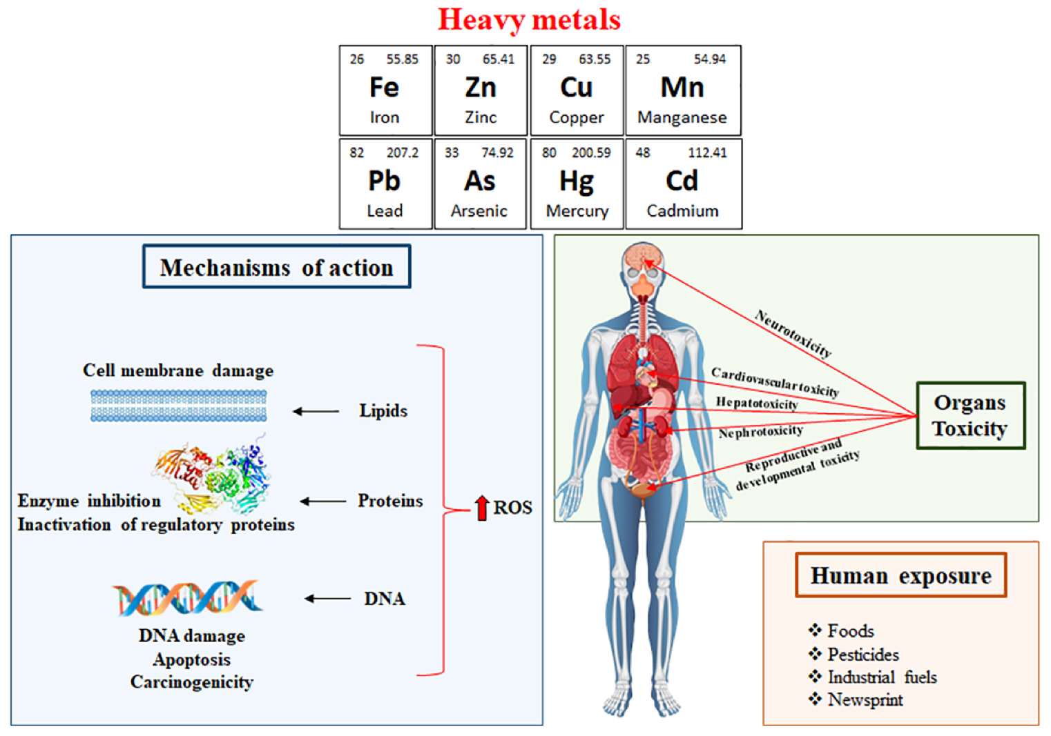
Figure 1: Mechanism and organ toxicity following human exposure to HMs; Source: (Ceramella et al. 2024)

Overall, there is a strong mechanistic and empirical literature to support the hypothesis of a linkage between heavy metals and most organic pollutants in inducing oxidative stress by disrupting antioxidant defences, redox cycling, impairing mitochondrial functions, and promoting Fenton chemistry. Acute organ damage and potential long-term disease risks lie in these processes, providing a clear justification for taking protective measures involving antioxidant phytochemicals.

3. Antioxidant Phytochemicals: Sources, Classification, and Chemical Characteristics
Plant-derived antioxidant phytochemicals prevent oxidative stress, including the scavenging of reactive species, reduction of transition metals, and alteration of antioxidant signalling pathways, including the Nrf2-ARE pathway (He et al., 2023; Rudrapal et al., 2024). They are effective based on their chemical composition, bioavailability, and their interactions with cell defence mechanisms (Tabanelli et al., 2021). Their main classes, sources and structural characteristics are summarised in Table 1 -3.

Table 1. Major Classes of Antioxidant Phytochemicals and Examples

Class | Key Subtypes / Compounds | Natural Sources | Primary Antioxidant Functions | References
Polyphenols | Flavonoids (quercetin, catechins), phenolic acids (caffeic, ferulic), stilbenes (resveratrol), lignans, tannins | Fruits, vegetables, tea, wine, nuts | Radical scavenging, metal chelation, modulation of Nrf2 pathway | Hassanpour & Doroudi (2023); Rudrapal et al. (2024); Musiał et al. (2020)
Carotenoids | β-carotene, lycopene, lutein, zeaxanthin | Carrots, tomatoes, leafy greens | Singlet oxygen quenching, peroxyl radical scavenging | Crupi et al. (2023)
Terpenoids | Monoterpenes, diterpenes, triterpenoids | Citrus peel, herbs, medicinal plants | Lipid peroxidation inhibition, modulation of redox enzymes | Crupi et al. (2023)
Alkaloids | Caffeine, berberine, capsaicin | Coffee, turmeric, pepper | Indirect antioxidant via signaling modulation | Ceramella et al. (2024)
Complex Mixtures | Honey polyphenols, herbal extracts | Honey, propolis, herbs | Combined radical scavenging and metal binding | Wilczyńska & Żak (2024); Ceramella et al. (2024)

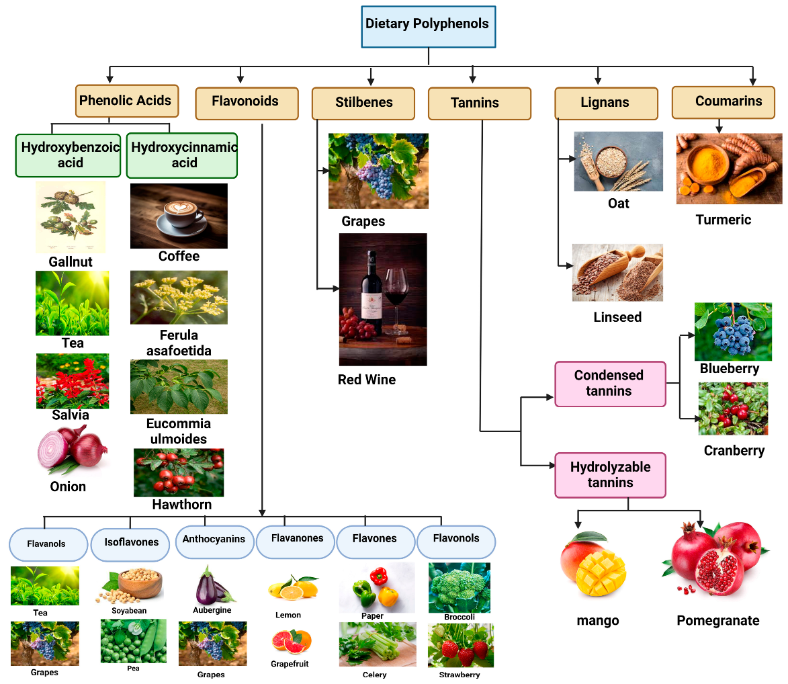

Polyphenols

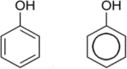

Flavonoids

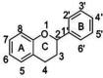

Figure 2: Polyphenols and flavonoids structure and dietary polyphenols Source: (Hassanpour & Doroudi 2023; Rudrapal et al. 2024)

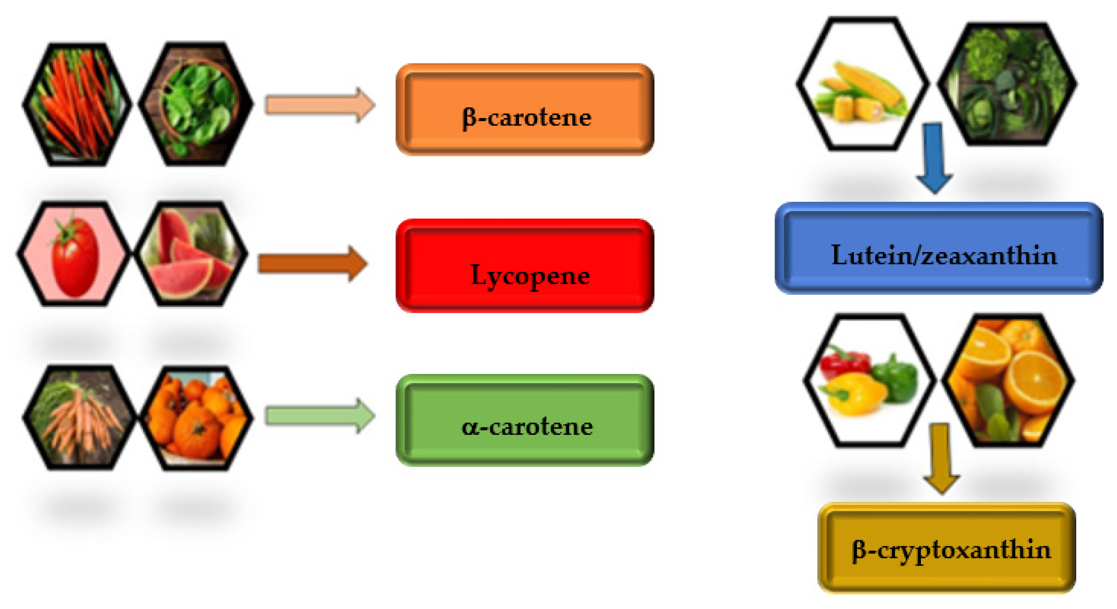
Figure 3: Source: (Crupi et al. 2023)

Table 2. Structural Features Underlying Antioxidant Activity
Structural Feature | Mechanistic Role | Examples | Scientific Explanation | References
Phenolic –OH groups | Donate H atoms to neutralise ROS | Quercetin, EGCG | Phenoxyl radicals are resonance-stabilised, halting chain oxidation | Rudrapal et al. (2024)
Catechol (o-dihydroxy) groups | Metal chelation (Fe²⁺, Cu²⁺) | Quercetin, caffeic acid | Chelates redox metals, blocking Fenton reactions | Ceramella et al. (2024)
Conjugated double bonds | Quench singlet oxygen, delocalize unpaired electrons | β-Carotene, lycopene | Prevents lipid peroxidation in membranes | Young & Lowe (2018)
Glycosylation/ polymerization | Modulates solubility and absorption | Rutin, tannins | Affects bioavailability and metabolism | Tabanelli et al. (2021); Bertoncini-Silva et al. (2024)

Table 3. Bioavailability and Mechanistic Relevance
Aspect | Description | Impact on Antioxidant Efficacy | References
Absorption and metabolism | Many polyphenols are conjugated (glucuronidation/sulfation) and rapidly metabolized | Limits direct radical scavenging in vivo | Bertoncini-Silva et al. (2024)
Gut microbiota transformation | Microbial breakdown yields smaller phenolics | Improves systemic antioxidant capacity | Rudrapal et al. (2024)
Signalling pathway modulation | Activation of Nrf2–ARE pathway, inhibition of NF-κB | Enhances endogenous antioxidant enzymes (SOD, GPx, catalase) | He et al. (2023); Qin et al. (2022)
Synergistic interactions | Multiple compounds act additively or synergistically | Stronger protection against pollutants and metals | Wilczyńska & Żak (2024)

The potential of phytochemicals to act as antioxidants is due to their combination of chemical reactivity and biological control of the redox balance. The most investigated classes are still polyphenols and carotenoids, but terpenoids and alkaloids are also becoming recognised as having an indirect antioxidant effect. Nevertheless, their in vivo activity depends much on absorption, metabolism and interaction with antioxidant pathways of defence and not only on the chemical radical scavenging capacity.

4. Mechanisms of Antioxidant Protection by Phytochemicals
Antioxidant phytochemicals (flavonoids, phenolic acids, carotenoids, terpenes, sulfur-containing compounds, etc.) provide protection to organisms by a number of partially overlapping mechanisms. These are;
(1) direct scavenging of reactive oxygen/nitrogen species (ROS/RNS);
(2) metal ion chelation, which inhibits Fenton chemistry;
(3) stimulation of endogenous antioxidant and detoxifying systems (notably by Nrf2/ARE);
(4) inhibition of pro-inflammatory signalling (e.g., NF- 001);
(5) mitochondrial functionality protection (including mitophagy);
(6) regulation of xenobiotic-metabolising enzymes,
(7) generation of active microbial metabolites (gut microbiota) that expand activity; and
(8) hormetic/adaptive effects and synergistic interactions with other dietary components.
The combination of these mechanisms decreases the formation of ROS, enhances the repair of damage, and increases stress resilience to the pollutant- and metal-induced damage.
1. Direct Radical Scavenging and Increasing Antioxidant Enzymes: A large number of polyphenols (e.g., quercetin, catechin, rutin) and carotenoids react positively with ROS/RNS, eliminating the free radicals before they cause any destruction to lipids, proteins, or DNA. Preclinical models indicate that the levels or activities of endogenous antioxidants (SOD, CAT, GPx, GSH) are increased by flavonoid supplementation and lipid peroxidation markers (MDA) are reduced, and that flavonoid supplementation consistently protects against liver, kidney and brain injury models. The combination of these actions: chemical scavenging and enzyme support will create a fast first line of defense against oxidative attacks of pollutants and metals (Egbuna 2018; Engwa, 2018; Xie et al., 2022; Al-Zharani et al., 2023)
2. Metal chelation and Fenton Chemistry Inhibition: The phytochemicals also tend to bind transition metals (Fe, Cu, etc.) with catechol groups or hydroxyl groups. The Chelation decreases the number of available redox-active metal ions that catalyse the hydroxyl radical formation process of the Fenton reaction. It has been found to have a strong iron-binding ability (as verified by reviews and spectroscopic studies) and has been found to reduce tissue metal deposition and lipid peroxidation in animal models, quercetin, baicalein, myricetin and similar flavonoids. Chelation, thus, is a direct, chemically well-specificated pathway through which phytochemicals shield the metal-promoting oxidative stress.
3. Nrf2/ARE activation and phase-II defences induction: Another primary, well-characterised pathway is the stimulation of the Keap1-Nrf2-ARE pathway. Nrf2 is released by many phytochemicals (sulforaphane, curcumin, resveratrol, and a few flavonoids). Phytochemicals interactions with Keap1 (which is a protein that holds Nrf2) causes Nrf2 to be released and moved into the cell controlling part of the body (nucleus), where protective genes that produce enzymes like heme oxygenase-1 (HO-1), glutamate-cysteine ligase (GCL), glutathione S-transferases (GSTs), NAD(P)H: quinone oxidoreductase 1 (NQO1) etc are triggered in response to fight toxins and Oxidative stress. Nrf2 activation has often been well recorded to have reduced ROS and enhanced the detoxification of electrophilic pollutants (and can indirectly increase the expression of metallothionein). This process is chronically demonstrated by both cell and animal experiments, and this is one of the chief reasons why dietary phytochemicals can offer long-term protection (Qin et al., 2022; Scarano et al., 2023).
4. Anti-inflammatory Effects through NF-kB and its Associated Pathways: Oxidative stress and inflammation are connected in a positive feedback chain; pollutants and metals tend to stimulate NF-kB and MAPK pathways, raising the level of inflammatory chemicals like cytokines (e.g. TNF-α, IL-6, IL-1β). However, when most phytochemicals are taken, they suppress NF-kB activation by the stabilisation of IkB (a protein that keeps NF-kB in control), inhibition of IKK (an enzyme that activates NF-kB) or nuclear translocation, all of which suppresses the release of cytokines and subsequent oxidative damage. Anti-inflammatory actions reduce the secondary generation of ROS by immune cells and result in better tissue recovery following exposure. A number of reviews provide a summary of consistent in vitro and in vivo evidence regarding the NF-kB inhibitory effects of flavonoids, curcumin and other phytochemicals (Laurindo et al., 2023).
5. Mitochondrial protection, mitophagy and bioenergetic preservation: Mitochondria are frequently the target of pollutants and heavy metals, leading to membrane depolarisation, electron transport chain (ETC) leakage and mitochondrial overproduction of ROS. Phytochemicals have the potential to (a) maintain mitochondrial membrane potential and ETC activity, (b) induce mitochondrial biogenesis, growing new mitochondria (PGC-1 pathways), and (c) induce mitophagy (the process of removing damaged mitochondria). These effects restrict mitochondrial ROS release, preserve ATP generation, and inhibit cell death pathways, all of which are mediated by phytochemicals. These facts are supported by evidence in laboratories and animal models of mitochondrial dysfunction that are decreased with the treatment using phytochemicals (Chen et al., 2023).
6. Xenobiotic metabolic modulation, metallothioneins and metal handling: Phytochemicals also affect phase-I and phase-II metabolism (CYPs, UGTs, GSTs) and transporters, which alter the bioactivation or clearance of the body toxins. They also bind to metal-binding proteins: in plants, phytochelatins store metals; in animals, phytochelatin-mediated Nrf2 signalling may enhance the expression of metallothionein and GST, enhancing metal sequestration and detoxification. Certain phytochemicals have been demonstrated to influence Fecal excretion, thereby decreasing tissue loads. The interactions of these modulatory effects alter toxicokinetics and decrease net exposure of vital body tissues (Ceramella et al., 2024).
7. Secondary metabolites and biotransformation of gut microbiota: A vast proportion of polyphenols are absorbed or deposited in the colon, where gut microbes convert them to smaller and more bioactive metabolites (e.g., urolithins, phenolic acids). These microbial metabolites may be of distinct antioxidant, anti-inflammatory and metal-modulating properties and can enter systemic circulation. In particular, inter-individual variations in microbiota (since humans’ gut bacteria are different from each other, ‘’metabotypes’), thus the protective effects of dietary phytochemicals are limited, contributing to the inconsistent findings across studies. Reviews describe this two-way polyphenol-microbiota interaction (da C. Pinaffi-Langley et al., 2024).
8. Hormesis, dose consideration, and synergy: Most phytochemicals also behave in a hormetic way: low-to-moderate doses cause adaptive stress responses (Nrf2 induction, mitochondrial quality control) and extremely high doses can be pro-oxidant. Phytochemicals can work synergistically with vitamins, minerals and other micronutrients when ingested in whole foods to generate extended and more stable protection compared to isolated supplements. Thus, balanced diets tend to be more successful in resilience to oxidative stress when compared to single-compound interventions. To obtain the best performance in human use, it is thus believed that close attention is taken to dosage, co-factors, formulation and timing. Taken together, phytochemicals work in a combination of different interrelated actions: they neutralise free radicals, bind and deactivate toxic metals, activate the body's internal defence systems, suppress inflammation, protect mitochondrial integrity, facilitate detoxification, and balance gut microbiota. All these efforts enhance the adaptive ability of the body and general resistance to environmental toxins with time

.
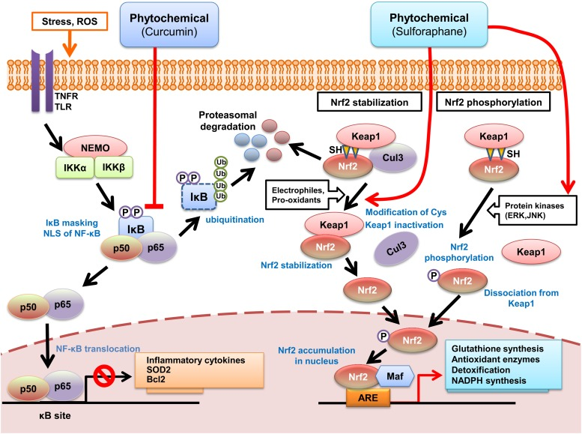
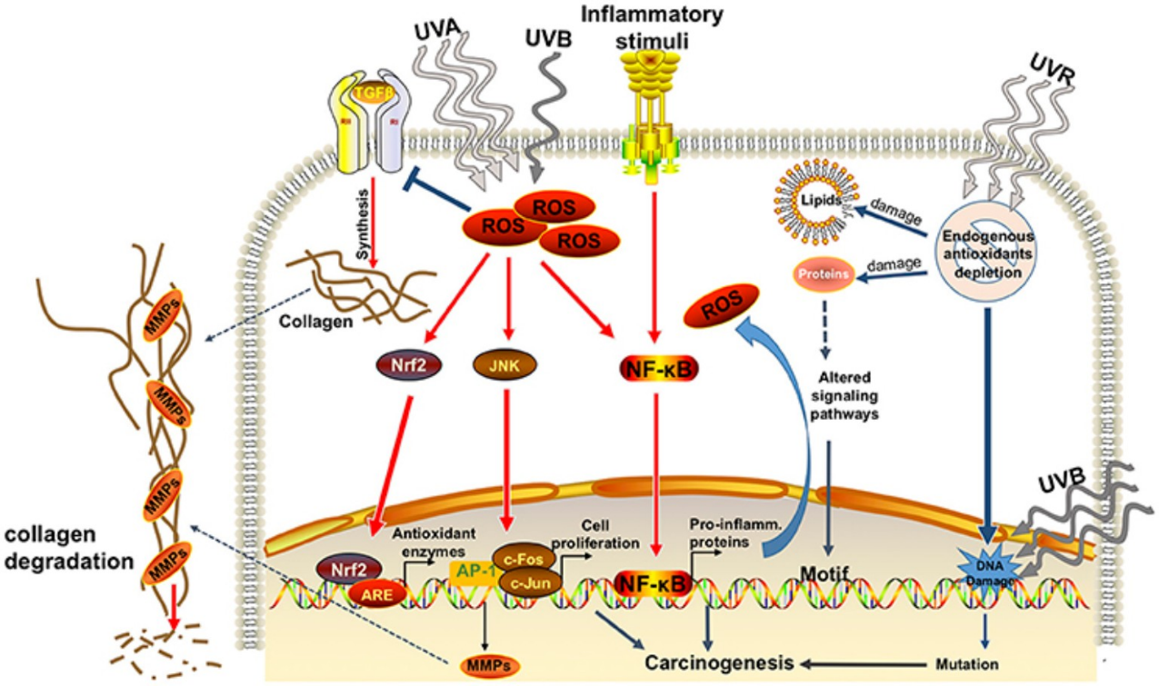
Figure 4&5: Phytochemicals, e.g. sulforaphane, curcumin, can modify the Nrf2 and NF-kB signalling pathways to increase the antioxidant and detoxification enzyme expression and prevent inflammation. Activation of Nrf2 is achieved by altering the Keap1 or phosphorylating it, and results in gene transcription through ARE, while NF-κBis responsible for the inhibition of pro-inflammatory cytokines and enhancement of oxidative stress, respectively. Source: (Lee et al., 2014)

5. Challenges and Limitations
Though experimental evidence supports the use of antioxidant phytochemicals as effective agents to prevent the impacts of pollutants and metals on biological systems through oxidative stress, numerous challenges and limitations are critical to the applicability of these potential therapeutic or preventive agents in biomedical research. These issues transcend biological, methodological, pharmacokinetic and regulatory levels, and therefore, there is a need to deal with them in both research and practical application levels.
Among the most well-known constraints is the inconsistency of the phytochemical composition between natural sources. The concentration and profile of phytochemicals may vary radically based on plant species, cultivar, geographical origin, soil composition, climate, harvesting stage and storage or processing conditions (Tang et al., 2022). As an example, the flavonoid and phenolic content of the same species of plant can vary at least 200 per cent with or without sunlight exposure or drought stress. This variability influences the reproducibility and comparability of the results of an experiment and makes it difficult to set standard doses of the experiment in humans (Rudrapal et al., 2024). Also, various phytochemical extraction and purification systems are used in different laboratories, resulting in variations in purification, stability and potency of the compound (Chong et al., 2023). The absence of standardised extraction and quantification procedures, therefore, compromises consistency of the research findings and impairs the ability to compare preclinical and clinical information.
The other challenge that is recurrent is bioavailability and metabolism. Although potent antioxidants and anti-inflammatories are observed in vitro, most phytochemicals have low oral bioavailability in humans because of low absorption, rapid metabolism, and fast systemic elimination (Williamson, 2025). As an illustration, two of the most extensively researched phytochemicals, curcumin and quercetin, reach nanomolar plasma concentrations even after large oral doses, which is typically below the effective concentration found in cell studies (Bertoncini-Silva et al., 2024). Moreover, conjugation (glucuronidation, sulfation), which may change or inactivate the parent compound, is caused by extensive gut and liver metabolism (Scarano et al., 2023). There is further complexity in the involvement of gut microbiota because interindividual variability in microbial composition could mediate the transformation, absorption, and overall bioefficacy of phytochemicals (Vamanu & Gatea, 2022). These pharmacokinetic walls do describe the gap between encouraging laboratory findings and the modest effects commonly noted in clinical trials.
Besides this, experimental inconsistencies and methodological weaknesses are still prevalent in studies. Most in vitro studies work under unrealistic high concentrations of phytochemicals that surpass physiologically realistic concentrations, or they use simplified cell models that do not reflect the complexity of in vivo oxidative environments (Xie et al., 2022). Comparing across species, sex, route of exposure, duration, and endpoints measured makes cross-comparison challenging in animal studies (Al-Zharani et al., 2023). Human testing is frequently a small sample, limited in duration, and not uniform, and has little control over dietary background or exposure levels of pollutants (Ciupei et al., 2024). This makes it very hard to generalize results or form dose-response relationships that might be used to have dietary guidelines or as a treatment option.
The other difficulty is the gap between preclinical results and human health outcomes in terms of translation between preclinical and human health population outcomes. Although the pathways of oxidative stress and phytochemical defense are clearly understood at the cellular and molecular level, their clinical application in the context of chronic exposure to low doses of pollutants in the environment and workplaces (as is often observed in practice) is understudied (Ceramella et al., 2024). Attribution to the protective effect of phytochemicals alone is complicated by the cumulative and long-term outcomes of various pollutants, as well as the intricate interaction of diet, genetics and lifestyle factors (Patel et al., 2023). Also, most research is being done in isolation compounds as opposed to whole-food matrices without considering the synergies that naturally exist in diets high in fruits, vegetables, teas, and spices (Rudrapal et al., 2024).
Another limitation that is not mentioned so much yet, but should be significant, is that the phytochemicals may have a pro-oxidant effect in extreme concentrations or when specific conditions are met. Certain compounds, including redox-active polyphenols, may autoxidise to produce ROS, especially when exposed to transition metals like iron and copper (Scarano et al., 2023). As an illustration, quercetin and catechins have been reported to possess antioxidant and pro-oxidant effects with concentration and cellular context effects. Such biphasicity (hormesis) highlights the importance of dose optimisation in promoting safety and efficacy.
Additionally, there are limited safety and toxicity analyses of long-term phytochemical supplementation. Although the majority are based on edible plants and can be considered safe when consumed in dietary amounts, extracts of concentrations or isolated substances can lead to adverse reactions with drugs, change nutrient absorption or have hepatotoxicity at high doses (Tang et al., 2022). Indicatively, curcumin and green tea catechin in high dose supplements are associated with gastrointestinal distress and infrequent liver toxicity in sensitive individuals (Williamson, 2025). Thus, safe therapeutic windows have to be characterized by rigorous toxicological and pharmacodynamic studies.
Lastly, there are regulatory and standardisation issues that are obstructive to the clinical use of phytochemicals. Since antioxidant phytochemicals lie in the grey zone between foods and pharmaceuticals, they tend to be sold as nutraceuticals or dietary supplements, which are less heavily regulated. Such a gap in regulation is one of the factors that lead to the unstable quality of products, false health claims, and unproven clinical use (Chong et al., 2023). Authorities like the European Food Safety Authority (EFSA) and the U.S. Food and Drug Administration (FDA) acknowledge the fact that antioxidants have the potential to be used to protect human health, but scientific evidence has not been fully actualised to make certain conclusions. To overcome this limitation, it is necessary to conduct multidisciplinary studies that combine sophisticated analytical technologies, including metabolomics, bioavailability models, and standardised clinical studies, to consider both long-term exposure and individual variations. Such innovative technologies as nanoformulations, phytosomes, and hybrid antioxidant complexes have the potential to enhance bioavailability and targeted delivery before a long-term safety assessment based on these approaches can be conducted (Bertoncini-Silva et al., 2024).
On the whole, the use of phytochemicals has been highly speculated in terms of experimental and animal studies that phytochemicals can be used to reverse the oxidative impact of pollutants and heavy metals, but it remains difficult to standardise the dosage and translate it to clinical use. These gaps will require cooperation to reinforce methodology, regulation, and the mechanistic knowledge to safely and effectively use them in protecting the environment.
6. Future Projections and Future Research.
Although considerable advances have been made in assimilating the antioxidant effects of the phytochemicals on alleviation of pollutant-induced oxidative stress, its utilization in prevention and treatment remains in its infancy. The next step in research should be the enhancement of bioavailability, optimization of the synergistic formulations and using the new technologies to increase their potential to environmental health. The nanoemulsions, liposomes, and polymeric nanoparticles are a type of nanotechnology that are especially promising in the context of overcoming low solubility, poor absorption, and rapid metabolism, which represent the major barriers to clinical use (Hasan et al., 2023; Bertoncini-Silva et al., 2024). As an example, the nano-curcumin and quercetin-conjugated nanoparticles have been demonstrated to have better intestinal absorption, prolonged half-life in circulation, and antioxidant activity than conventional forms (Yang et al., 2024). Equally, phytosomes technology that conjugates phytochemicals with phospholipids can enormously enhance their cellular absorption and stability, which offers a route to nutraceutical and pharmacological uses (Jain et al., 2023). Future research must aim at streamlining such systems to be safer with controlled release and tissue-specific targeting, especially to detoxifying organs such as the liver and kidney.
The other opportunity that can be achieved is the study of synergistic effects between phytochemicals and between phytochemicals and micronutrients. Research is starting to find additive or synergistic effects of polyphenols, carotenoids, and vitamins on the number of ROS, inflammatory signalling, and chelating heavy metals (Ceramella et al., 2024; Rudrapal et al., 2024). As an illustration, the combination of resveratrol and quercetin increases the Nrf2 activation and metal arresting ability better than each of these agents in isolation (Wang et al., 2022). Similarly, polyphenol-selenium complexes have been demonstrated to strengthen antioxidant protection and chelation of metals by complementary redox processes (Zhu et al., 2023). Such interactions need to be investigated systematically in future research that hopefully will apply network pharmacology and metabolomic profiling to identify synergistic clusters with optimal protective and minimal side effects.
Another radically new research frontier is given by the combination of omics technologies, such as genomics, proteomics, and metabolomics. Such high-throughput technologies have the potential to dissolve complicated molecular networks that are regulated by phytochemicals during conditions of oxidative stress (Chen et al., 2023). As an example, metabolomic mapping has the potential to determine bioactive metabolites and their pathways through which Nrf2 is activated and glutathione metabolism and inflammatory suppression gene signatures can be identified by transcriptomic profiling (Vafaei-Nezhad et al., 2024). The integration of multi-omics might, thus, give a holistic systems-level insight into the mechanism by which various phytochemical classes reverse the pollutant-induced oxidative stress. It will also be used to determine biomarkers of response to phytochemical interventions in order to provide individualised nutrition or other therapeutic interventions based on exposure levels and the individual metabolic profile.
One of the future priorities is to improve human clinical and epidemiological evidence. The available information remains mostly preclinical; strong, extensive, and extended human trials have remained limited (Williamson, 2025). Randomized controlled trials (RCTs) should be designed well in order to quantify dose-response, evaluate bioavailability-enhanced formulations and determine effects on well-validated oxidative stress biomarkers. Simultaneously, cohort and case-control designs need to investigate relationships between phytochemical dietary intake and heavy metal or pollutant biomarkers in varied groups. Dietary data and metabolomics may be used in conjunction with advances in exposomics, which is the overall measurement of all environmental exposures over a lifespan, to reinforce causal inference regarding the protection from pollutant-related diseases under phytochemical consumption (Ciupei et al., 2024).
Systems toxicology and computational modeling approaches can also be of benefit to the field. Computer docking and molecular dynamics simulations may be used to determine the interactions of phytochemicals with metal ions, antioxidant enzymes, and signalling proteins (Gonzalez-Rivera et al., 2023). In the meantime, AI-based toxicology modeling has the potential to combine experimental and clinical data to forecast compound behavior in human systems, optimize the structure-activity relationships, and design the next generation of phytochemicals with better potency and safety (Raza et al., 2024). These digital technologies can supplement laboratory-based research by accelerating the discovery and reducing the variability of experiments.
Functional food development and nutraceutical innovation provide viable opportunities of implementation, especially with a translational and societal viewpoint. The population-level prevention of chronic exposure to pollutants can be achieved by incorporating bioactive phytochemicals into the daily diet in fortified foods, beverages, or supplements (Tang et al., 2022). Its success lies in the standardisation of extraction, quantification, and control of quality through international regulatory harmonisation, however (Chong et al., 2023). The environmental health policy should also encourage preventive nutrition through public health campaigns educating about the benefits of phytochemical-rich diets, especially in areas with abundant environmental pollution or occupational contact.
Lastly, future phytochemical research should be informed by the considerations of sustainability and biodiversity. Plant biodiversity and hence diversity of phytochemical sources are endangered by climate change, soil degradation, and habitat loss (Rudrapal et al., 2024). The focus of future research needs to be on sustainable cultivation and biotechnological production strategy, including plant tissue culture, synthetic biology, and metabolic engineering, to garner constant, environmentally-friendly and ethically-acquired phytochemical sources (Zhu et al., 2023). These methods may also enable the identification of new compounds that have new antioxidant or detoxifying properties.
To conclude, the field of future research in this area should have an integrated, multidisciplinary character: this is the approach that should be implemented in the future, involving nanotechnology, systems biology, computational toxicology and sustainable bioproduction to address the limitations that exist today and improve the prospective approach to an improved use of phytochemicals. It will be important to enhance the translational evidence by clinical and epidemiological research to prove phytochemicals as scientifically validated agents to prevent and alleviate pollutant-induced oxidative stress and related diseases.
7. Conclusion
The increased load of environmental contamination, especially with heavy metals and persistent organic pollutants, still remains a potential threat to human and ecological health, the workings of which are mostly based on oxidative stress. In the last decade, the literature has proven that oxidative stress is a convergent mechanism between exposure to pollutants and dysfunction of the cell, inflammation and the development of chronic diseases. To this effect, antioxidant phytochemicals have become a vital defence strategy, which provides natural, multi-targeted responses with the capacity to reduce the harmful impacts of reactive oxygen species (ROS) and favor endogenous detoxication.
The evidence in this review has not only provided the synthesis of the classical and contemporary studies but has also demonstrated the mitigating effects of various classes of phytochemicals, which include polyphenols, flavonoids, carotenoids, alkaloids as well as organosulfur compounds, in the biochemical and physiological impacts of pollutants. These compounds can restore the redox balance and inhibit cellular injury by acting through the Nrf2 signaling pathway, inactivation of antioxidant enzymes, and inhibition of proinflammatory mediators by metal chelation, Nrf2 signaling pathway, antioxidant enzyme, and proinflammatory mediator mechanisms, respectively. The reviewed evidence also establishes that phytochemicals are of great importance in preventing the occurrence of pathologies that are caused by pollutants, such as neurotoxicity, hepatotoxicity, nephrotoxicity, and cardiovascular disorders.
The antioxidant properties of antioxidant phytochemicals are not limited to their direct effect of neutralising free radicals but can also regulate cellular signalling and gene expression, and are a dynamic interaction between the antioxidant phytochemicals and the pollutants. Although bioavailability, clinical validation, and mechanisms of delivery have remained challenging, nanotechnology, omics sciences, and artificial intelligence have seen improvements, improving the delivery, stability, and elucidation of the mechanisms of these compounds. Through computational modeling and molecular docking, the efficacy and toxicity can be predicted with high precision nowadays, and long-term availability is guaranteed by sustainable sourcing through green technologies and synthetic biology. The incorporation of phytochemicals in functional foods, dietary supplements and therapeutic products is a promising approach that can be executed without harming the environment as a counter-mechanism of combating oxidative stress caused by pollutants. In conclusion, antioxidant phytochemicals are a viable, scientifically based, and sustainable way of protecting human health and establishing a harmonious relationship with the environment.

Disclaimer (Artificial intelligence)
Author(s) hereby declare that NO generative AI technologies such as Large Language Models (ChatGPT, COPILOT, etc.) and text-to-image generators have been used during the writing or editing of this manuscript.

References
Al-Zharani, M., Mubarak, M., Rudayni, H. A., Al-Doaiss, A. A., Abd-Elwahab, M. M., & Al-Eissa, M. S. (2023). Quercetin as a dietary supplementary flavonoid alleviates the oxidative stress induced by lead toxicity in male Wistar rats. Nutrients, 15(8), 1888. https://doi.org/10.3390/nu15081888
Angon, P. B., Islam, M. S., Das, A., Anjum, N., Poudel, A., & Suchi, S. A. (2024). Sources, effects and present perspectives of heavy metals contamination: Soil, plants and human food chain. Heliyon, 10(7).
Balali-Mood, M., Naseri, K., Tahergorabi, Z., Khazdair, M. R., & Sadeghi, M. (2021). Toxic mechanisms of five heavy metals: mercury, lead, chromium, cadmium, and arsenic. Frontiers in pharmacology, 12, 643972.
Bertoncini-Silva, K. M., Vlad, A., Ricciarelli, R., Fassini, P. G., Suen, V. M. M., & Zingg, J.-M. (2024). Enhancing the bioavailability and bioactivity of curcumin for disease prevention and treatment. Antioxidants, 13(3), 331. https://doi.org/10.3390/antiox13030331
Bhattacharjee, S. (2019). ROS and oxidative stress: origin and implication. In Reactive oxygen species in plant biology (pp. 1-31). New Delhi: Springer India.
Ceramella, J., De Maio, A. C., Basile, G., Facente, A., Scali, E., Andreu, I., Sinicropi, M. S., Iacopetta, D., & Catalano, A. (2024). Phytochemicals involved in mitigating silent toxicity induced by heavy metals. Foods, 13(7), 978. https://doi.org/10.3390/foods13070978
Chen, Q., Ruan, D., Shi, J., Du, D., & Bian, C. (2023). The multifaceted roles of natural products in mitochondrial dysfunction. Frontiers in Pharmacology, 14, 1093038. Chen, Q., Ruan, D., Shi, J., Du, D., & Bian, C. (2023). The multifaceted roles of natural products in mitochondrial dysfunction. Frontiers in Pharmacology, 14, 1093038.
Chong, H., Chai, Z., Gao, Q., & Zhang, L. (2023). Standardization and quality control challenges in botanical antioxidant research. Frontiers in Pharmacology, 14, 1123457. https://doi.org/10.3389/fphar.2023.1123457
Ciupei, A. V., et al. (2024). Dietary polyphenols and human oxidative stress markers: An epidemiological synthesis. Nutrients, 16(4), 998. https://doi.org/10.3390/nu16040998
da C. Pinaffi-Langley, A. C., Tarantini, S., Hord, N. G., & Yabluchanskiy, A. (2024). Polyphenol-derived microbiota metabolites and cardiovascular health: a concise review of human studies. Antioxidants, 13(12), 1552.
Day, M. W., Daley, C., Wu, Y., Pathmaraj, M., Verner, M. A., & Caron-Beaudoin, É. (2024). Altered oxidative stress and antioxidant biomarkers concentrations in pregnant individuals exposed to oil and gas sites in Northeastern British Columbia. Toxicological Sciences, 201(1), 73-84.
de Almeida, A. J. P. O., de Oliveira, J. C. P. L., da Silva Pontes, L. V., de Souza Júnior, J. F., Gonçalves, T. A. F., Dantas, S. H., ... & de Medeiros, I. A. (2022). ROS: basic concepts, sources, cellular signaling, and its implications in aging pathways. Oxidative medicine and cellular longevity, 2022(1), 1225578.
Dua, K., Gupta, G., MacLoughlin, R., Singh, S. K., & Bhat, A. A. (Eds.). (2025). Lung Cancer and Environmental Toxicants. Academic Press.
Egbuna, C. (2018). Antioxidants and phytochemicals. In Phytochemistry (pp. 131-146). Apple Academic Press.
Engwa, G. A., Nweke, F. N., & Nkeh-Chungag, B. N. (2022). Free radicals, oxidative stress-related diseases and antioxidant supplementation. Alternative Therapies in Health & Medicine, 28(1).
Eskander, S. B., & Saleh, H. M. (2020). Heavy metal-induced oxidative stress and related cellular process. In Cellular and molecular phytotoxicity of heavy metals (pp. 99-123). Cham: Springer International Publishing.
Fu, Z., & Xi, S. (2020). The effects of heavy metals on human metabolism. Toxicology mechanisms and methods, 30(3), 167-176.
Gandhi, D., Rudrashetti, A. P., & Rajasekaran, S. (2022). The impact of environmental and occupational exposures of manganese on pulmonary, hepatic, and renal functions. Journal of Applied Toxicology, 42(1), 103-129.
Gęgotek, A., & Skrzydlewska, E. (2019). Biological effect of protein modifications by lipid peroxidation products. Chemistry and physics of lipids, 221, 46-52.
González-Rivera, J. C., et al. (2023). In silico modeling of flavonoid–metal interactions and redox properties in environmental toxicology. Journal of Molecular Graphics and Modelling, 121, 108365. https://doi.org/10.1016/j.jmgm.2023.108365
Hameister, R., Kaur, C., Dheen, S. T., Lohmann, C. H., & Singh, G. (2020). Reactive oxygen/nitrogen species (ROS/RNS) and oxidative stress in arthroplasty. Journal of Biomedical Materials Research Part B: Applied Biomaterials, 108(5), 2073-2087.
Hasan, N., Ahmad, F., & Khan, M. S. (2023). Nanodelivery of phytochemicals: Opportunities for bioavailability enhancement and environmental detoxification. Environmental Research, 229, 115048. https://doi.org/10.1016/j.envres.2023.115048
Hassanpour, S. H., & Doroudi, A. (2023). Review of the antioxidant potential of flavonoids as a subgroup of polyphenols and partial substitute for synthetic antioxidants. Avicenna journal of phytomedicine, 13(4), 354.
He, W. J., Lv, C. H., Chen, Z., Shi, M., Zeng, C. X., Hou, D. X., & Qin, S. (2023). The regulatory effect of phytochemicals on chronic diseases by targeting Nrf2-ARE signaling pathway. Antioxidants, 12(2), 236.
Hernansanz-Agustín, P., & Enríquez, J. A. (2021). Generation of reactive oxygen species by mitochondria. Antioxidants, 10(3), 415.
Idowu, D.A., Umoren, O.D., Oresegun, O.I., Igiekhumhe, O.G., Effa, A.A., Oko, E.O., and Edet, I.V. (2025b). Physicochemical and Multivariate Analysis of Parameters of Alabukunfun and Avelluz Tributaries in Kuto Community, Ogun State, Nigeria. FUAM Journal of Pure and Applied Sciences (FUAMJPAS). 6(1): 34-45.
Ighodaro, O. M., & Akinloye, O. A. (2018). First line defence antioxidants-superoxide dismutase (SOD), catalase (CAT) and glutathione peroxidase (GPX): Their fundamental role in the entire antioxidant defence grid. Alexandria journal of medicine, 54(4), 287-293.
Jain, S., Roy, M., & Mehta, P. (2023). Phytosome formulations for improved antioxidant efficacy: Trends and translational potential. International Journal of Pharmaceutics, 643, 123008. https://doi.org/10.1016/j.ijpharm.2023.123008
Jaishankar, M., Tseten, T., Anbalagan, N., Mathew, B. B., & Beeregowda, K. N. (2014). Toxicity, mechanism and health effects of some heavy metals. Interdisciplinary toxicology, 7(2), 60.
Jomova, K., Alomar, S. Y., Alwasel, S. H., Nepovimova, E., Kuca, K., & Valko, M. (2024). Several lines of antioxidant defense against oxidative stress: antioxidant enzymes, nanomaterials with multiple enzyme-mimicking activities, and low-molecular-weight antioxidants. Archives of toxicology, 98(5), 1323-1367.
Juan, C. A., Pérez de la Lastra, J. M., Plou, F. J., & Pérez-Lebeña, E. (2021). The chemistry of reactive oxygen species (ROS) revisited: outlining their role in biological macromolecules (DNA, lipids and proteins) and induced pathologies. International journal of molecular sciences, 22(9), 4642.
Kaynar, M. Y., Hanci, M., Kuday, C., Belce, A., Gumusta, K., & Kokool U, E. M. I. N. E. (1994). Changes in the activity of antioxidant enzymes (SOD, GPX, CAT). Tokushima J. Exp. Med, 41, 133-136.
Kocadal, K., Alkas, F. B., Battal, D., & Saygi, S. Pereira, C. V., Nadanaciva, S., Oliveira, P. J., & Will, Y. (2012). The contribution of oxidative stress to drug-induced organ toxicity and its detection in vitro and in vivo. Expert opinion on drug metabolism & toxicology, 8(2), 219-237. Cellular pathologies and genotoxic effects arising secondary to heavy metal exposure: A review. Human & experimental toxicology, 39(1), 3-13.
Koyama, H., Kamogashira, T., & Yamasoba, T. (2024). Heavy metal exposure: molecular pathways, clinical implications, and protective strategies. Antioxidants, 13(1), 76.
Laurindo, L. F., Santos, A. R. D. O. D., Carvalho, A. C. A. D., Bechara, M. D., Guiguer, E. L., Goulart, R. D. A., ... & Barbalho, S. M. (2023). Phytochemicals and regulation of NF-kB in inflammatory bowel diseases: an overview of in vitro and in vivo effects. Metabolites, 13(1), 96.
Lee, J., Jo, D. G., Park, D., Chung, H. Y., & Mattson, M. P. (2014). Adaptive cellular stress pathways as therapeutic targets of dietary phytochemicals: focus on the nervous system. Pharmacological reviews, 66(3), 815-868.
Lee, D. Y., Song, M. Y., & Kim, E. H. (2021). Role of oxidative stress and Nrf2/KEAP1 signaling in colorectal cancer: mechanisms and therapeutic perspectives with phytochemicals. Antioxidants, 10(5), 743.
Mansoor, S., Ali, A., Kour, N., Bornhorst, J., AlHarbi, K., Rinklebe, J., ... & Chung, Y. S. (2023). Heavy metal induced oxidative stress mitigation and ROS scavenging in plants. Plants, 12(16), 3003.
Mattson, M. P., & Leak, R. K. (2024). The hormesis principle of neuroplasticity and neuroprotection. Cell Metabolism, 36(2), 315-337.
Muscolo, A., Mariateresa, O., Giulio, T., & Mariateresa, R. (2024). Oxidative stress: the role of antioxidant phytochemicals in the prevention and treatment of diseases. International journal of molecular sciences, 25(6), 3264.
Musial, C., Kuban-Jankowska, A., & Gorska-Ponikowska, M. (2020). Beneficial properties of green tea catechins. International journal of molecular sciences, 21(5), 1744.
Olufunmilayo, E. O., Gerke-Duncan, M. B., & Holsinger, R. D. (2023). Oxidative stress and antioxidants in neurodegenerative disorders. Antioxidants, 12(2), 517.
Pan, Z., Gong, T., & Liang, P. (2024). Heavy metal exposure and cardiovascular disease. Circulation research, 134(9), 1160-1178.
Patel, P., et al. (2023). Modulation of metabolic pathways and protection against cadmium-induced disruptions with taxifolin-enriched extract. ACS Omega, 8(3), 25005–25015. https://doi.org/10.1021/acsomega.3c08989
Qin, T., Feng, D., Zhou, B., Bai, L., & Yin, Y. (2022). Melatonin suppresses LPS-induced oxidative stress in dendritic cells for inflammatory regulation via the Nrf2/HO-1 axis. Antioxidants, 11(10), 2012.
Rahman, M. S., Islam, S. M., Haque, A., & Shahjahan, M. (2020). Toxicity of the organophosphate insecticide sumithion to embryo and larvae of zebrafish. Toxicology reports, 7, 317-323.
Raza, H., Ahmed, R., & Malik, A. (2024). Artificial intelligence in natural product toxicology: Predictive models for antioxidant and metal-chelating phytochemicals. Computers in Biology and Medicine, 176, 108179. https://doi.org/10.1016/j.compbiomed.2024.108179
Rehman, K., Fatima, F., Waheed, I., & Akash, M. S. H. (2018). Prevalence of exposure of heavy metals and their impact on health consequences. Journal of cellular biochemistry, 119(1), 157-184.
Rudrapal, M., Rakshit, G., Singh, R. P., Garse, S., Khan, J., & Chakraborty, S. (2024). Dietary polyphenols: review on chemistry/sources, bioavailability/metabolism, antioxidant effects, and their role in disease management. Antioxidants, 13(4), 429.
Rudrapal, M., Rakshit, G., Singh, R. P., Garse, S., Khan, J., & Chakraborty, S. (2024). Dietary polyphenols: Review on chemistry/sources, bioavailability/metabolism, antioxidant effects, and their role in disease management. Antioxidants, 13(4), 429. https://doi.org/10.3390/antiox13040429
Scarano, A., Laddomada, B., Blando, F., De Santis, S., Verna, G., Chieppa, M., & Santino, A. (2023). The chelating ability of plant polyphenols can affect iron homeostasis and gut microbiota. Antioxidants, 12(3), 630. https://doi.org/10.3390/antiox12030630
Seetharaman, B., Balu, U. R., Mudgal, G., Firdaus, S., Dash, S., & Mishra, R. K. (2024). The Piteous Price of Progress: The. Sustainable Development Goals Towards Environmental Toxicity and Green Chemistry: Environment and Sustainability, 291.
Sokan-Adeaga, A. A., Sokan-Adeaga, M. A., Sokan-Adeaga, E. D., Oparaji, A. N., Edris, H., Tella, E. O., ... & Amubieya, O. E. (2023). Environmental toxicants and health adversities: A review on interventions of phytochemicals. Journal of public health research, 12(2), 22799036231181226.
Sokan-Adeaga, A. A., Sokan-Adeaga, M. A., Sokan-Adeaga, E. D., Oparaji, A. N., Edris, H., Tella, E. O., ... & Amubieya, O. E. (2023). Environmental toxicants and health adversities: A review on interventions of phytochemicals. Journal of public health research, 12(2), 22799036231181226.
Tabanelli, R., Brogi, S., & Calderone, V. (2021). Improving curcumin bioavailability: Current strategies and future perspectives. Pharmaceutics, 13(10), 1715.
Tang, Y., Li, H., Wang, S., & Zhang, J. (2022). Factors influencing phytochemical variation and stability in plant-based antioxidants. Plants, 11(12), 1593. https://doi.org/10.3390/plants11121593
Timme-Laragy, A. R., Di Giulio, R. T., & Meyer, J. N. (2024). Reactive oxygen species and redox stress. In Toxicology of Fishes (pp. 121-155). CRC Press.
Vafaei-Nezhad, M., Rahimi, R., & Ghahremani, M. H. (2024). Multi-omics analysis of polyphenol-mediated antioxidant mechanisms under metal-induced oxidative stress. Antioxidants, 13(2), 219. https://doi.org/10.3390/antiox13020219
Valko, M. M. H. C. M., Morris, H., & Cronin, M. T. D. (2005). Metals, toxicity and oxidative stress. Current medicinal chemistry, 12(10), 1161-1208.
Vamanu, E., & Gatea, F. (2022). Influence of gut microbiota on polyphenol bioavailability and antioxidant efficacy. Nutrients, 14(8), 1707. https://doi.org/10.3390/nu14081707
Wang, X., Li, Y., Han, L., Li, J., Liu, C., & Sun, C. (2022). Synergistic effects of resveratrol and quercetin against cadmium-induced oxidative damage. Environmental Toxicology and Pharmacology, 95, 103935. https://doi.org/10.1016/j.etap.2022.103935
Wilczyńska, A., & Żak, N. (2024). Polyphenols as the main compounds influencing the antioxidant effect of honey—A review. International Journal of Molecular Sciences, 25(19), 10606.
Williamson, G. (2025). The evidence base for plant-derived antioxidants in human health. Critical Reviews in Food Science and Nutrition. https://doi.org/10.1080/10408398.2025.1234567
Xie, D., Hu, J., Wu, T., Xu, W., Meng, Q., Cao, K., & Luo, X. (2022). Effects of flavonoid supplementation on nanomaterial-induced toxicity: a meta-analysis of preclinical animal studies. Frontiers in Nutrition, 9, 929343.
Yang, X., Wu, D., & Zhao, Y. (2024). Nanocarrier systems for improving flavonoid delivery and oxidative stress control. Trends in Food Science & Technology, 145, 104055. https://doi.org/10.1016/j.tifs.2024.104055
Zhu, L., Zhang, Y., & Li, W. (2023). Selenium-polyphenol complexes as dual-action antioxidants and metal chelators. Food Chemistry, 414, 135702. https://doi.org/10.1016/j.foodchem.2023.135702

