Original Research Article
Epidemiological Analysis Of Sheep Mortality Under Temperate Conditions In A Closed Nucleus Flock

ABSTRACT
Understanding epidemiological risk factors is absolutely crucial for minimizing livestock mortality, particularly in sheep farming. A comprehensive study analyzed a decade of data from the Sheep Breeding Research Station, Sandynallah, The Nilgiris, Tamil Nadu, to definitively assess the influence of factors such as age, breed, sex, lambing period, season, weaning period, fecundity and weather parameters on sheep mortality.
The results unequivocally showed that 58.6% of the deaths occurred in young sheep, while a staggering 60.7% of the overall mortality was in females. The main lambing period exhibited a significantly higher birth rate and was responsible for a striking 84.8% of the deaths. Notably, summer months accounted for a substantial 49.3% of all mortalities, the highest among all seasons. Pre-weaning lambs experienced an alarming 74.82% of the deaths, compared to a mere 25.18% in the post-weaning period. Furthermore, weather parameters, especially summer and rainfall, were unequivocally established as major contributors to the mortality.
In conclusion, this study conclusively found that sheep mortality in a closed nucleus flock was undeniably linked to epidemiological risk factors including young age, female sex, lambing period, summer season, weaning stage and environmental factors like temperature, humidity, wind speed, frost, and rainfall. These findings provide indisputable insights for reducing mortality in similar sheep farming environments.
Keywords:Sheep, lamb, mortality, risk factors, climatic factors

1. INTRODUCTION
Sheep production plays a vital role in supporting the livelihood security of rural communities, particularly in arid and semi-arid regions (Banda and Tanganyika, 2021). However, high mortality among lambs continues to restrict productivity and profitability across both organized and traditional systems (Flinn et al., 2020). Mortality rates are governed by a multifactorial interplay of epidemiological determinants such as age, sex, birth type, lambing and weaning stages, and management-related factors including nutrition, disease control, and housing. Environmental stressors such as temperature, humidity, rainfall, and wind further exacerbate losses by impairing thermoregulation, reducing feed intake, and predisposing animals to diseases (Thornton et al., 2021). Adoption of adaptive management and genetic selection for thermo-tolerant and resilient breeds can therefore play a crucial role in minimizing mortality and improving overall flock productivity (Niyas et al., 2015)
The Nilgiri district of Tamil Nadu provides a unique ecological setting for the Nilagiri sheep, the only recognized wool breed of the state. However, seasonal fluctuations and climatic variability often exacerbate production losses. The Sheep Breeding Research Station (SBRS), Sandynallah, maintains a closed nucleus flock with systematic recording of production and health parameters, providing an excellent framework for long-term epidemiological investigations. The present study analyzed ten years of mortality data with the aim of assessing the impact of epidemiological and environmental risk factors on sheep survival.
2. MATERIALS AND METHODS
The study was conducted at SBRS, Sandynallah, The Nilgiris, Tamil Nadu. The farm maintains a closed nucleus flock of about 1500 sheep of various breeds viz., Nilagiri, Sandyno, Garole-Sandyno cross and Dorset – Nilagiri cross under organized management. The region is characterized by cool temperate climate which goes below 0ºC with rainfall reaching upto 3000mm per annum. Mortality records covering a 10-year period (2009–2018) were collected from farm registers. Data were categorized by age, sex, weaning status, lambing period and season. Meteorological data on temperature, rainfall and wind speed were obtained from the station observatory. Parameters such as age (young vs adult), sex (male vs female), weaning stage (pre-weaning (0-3 months old) vs post-weaning (Above 3months)), season (winter (Dec-Feb), summer (Mar-May), southwest monsoon (Jun-Aug) and northeast (Sep-Nov) monsoon) and lambing season (main (Feb-Apr) vs off-season (Sep-Nov)) were analyzed using descriptive epidemiological methods to calculate mortality percentages across variables.

3. RESULTS
3.1. Month-wise mortality details from 2009-2018
The data on month-wise and year-wise mortality of sheep from 2009-2018 are presented in
Table 1. A total of 967 deaths were recorded during the 10-year period (Fig. 1), with considerable variation across years. The lowest mortality was observed in 2017 (50 deaths, 5.2%), while the highest occurred in 2018 (156 deaths, 16.1%), followed by 2016 (129 deaths, 13.3%) and 2014 (108 deaths, 11.2%). Mortality remained moderate during 2009–2015, ranging between 68 and 102 deaths annually, except in 2014 when a sudden rise was noted. A sharp increase was recorded in 2016 and 2018, with these two years together accounting for about 30% of the total mortality.

Table 1. Month-wise mortality details from 2009-2018
Year | Jan | Feb | Mar | Apr | May | Jun | Jul | Aug | Sep | Oct | Nov | Dec | Total
2009 | 6 | 11 | 17 | 4 | 6 | 3 | 8 | 0 | 2 | 5 | 2 | 4 | 68
2010 | 1 | 6 | 16 | 8 | 4 | 9 | 9 | 4 | 7 | 5 | 12 | 6 | 87
2011 | 6 | 3 | 42 | 15 | 8 | 20 | 5 | 0 | 0 | 1 | 2 | 0 | 102
2012 | 3 | 2 | 11 | 22 | 8 | 17 | 8 | 8 | 2 | 3 | 2 | 4 | 90
2013 | 7 | 4 | 12 | 11 | 11 | 23 | 8 | 4 | 4 | 2 | 1 | 4 | 91
2014 | 2 | 7 | 18 | 16 | 32 | 5 | 6 | 2 | 4 | 7 | 6 | 3 | 108
2015 | 9 | 3 | 12 | 5 | 6 | 11 | 5 | 3 | 13 | 4 | 6 | 9 | 86
2016 | 5 | 17 | 25 | 37 | 31 | 7 | 3 | 1 | 2 | 0 | 0 | 1 | 129
2017 | 2 | 3 | 7 | 10 | 10 | 3 | 4 | 2 | 4 | 3 | 2 | 0 | 50
2018 | 6 | 10 | 35 | 29 | 9 | 17 | 18 | 7 | 7 | 5 | 8 | 5 | 156
Total | 47 | 66 | 195 | 157 | 125 | 115 | 74 | 31 | 45 | 35 | 41 | 36 | 967

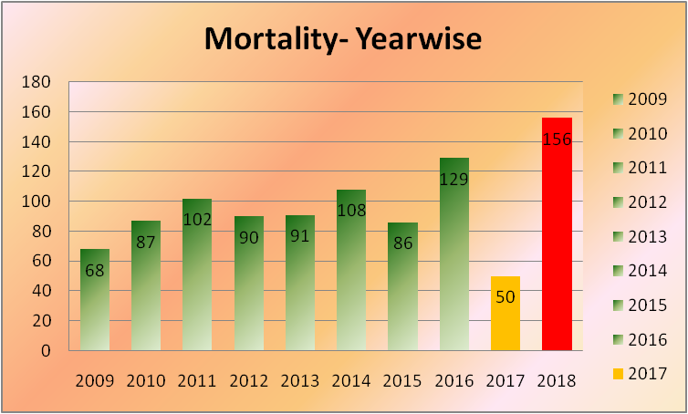
Fig.1 Year-wise mortality from 2009-2018

3.2 Effect of age and weaning stage on mortality rate from 2009-2018
The data on effect of age and weaning on mortality rate from 2009-2018 are presented in
Table 2. The data suggests that young sheep accounted for 58.6% of deaths, while pre-weaning lambs (0-3 months old) contributed an alarming 74.8% of mortalities.
Table 2. Effect of age and weaning stage on mortality
Year | Young | Adult | Pre-weaning | Post-weaning
2009 | 43 | 25 | 31 | 12
2010 | 52 | 35 | 40 | 12
2011 | 75 | 27 | 67 | 8
2012 | 59 | 31 | 43 | 16
2013 | 56 | 35 | 31 | 25
2014 | 55 | 53 | 39 | 16
2015 | 40 | 46 | 21 | 19
2016 | 73 | 57 | 69 | 4
2017 | 21 | 29 | 19 | 2
2018 | 94 | 62 | 65 | 29
Total (967) | 568 (59%) | 399 (41%) | 425 (75%) | 143 (25%)

3.3. Effect of sex of the animals on mortality rate from 2009-2018
The data suggests that mortality was higher in females (60.7%) compared to males (39.3%)
(Fig 2).

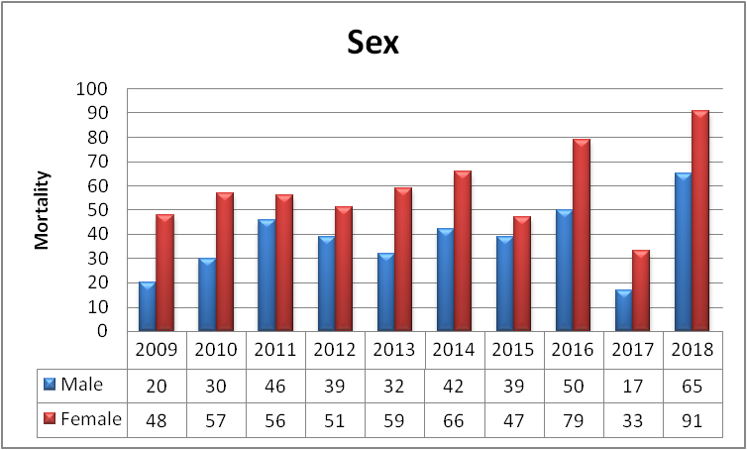
Fig 2. Effect of sex of the animals on mortality rate

3.4. Effect of season on mortality rate from 2009-2018
The data on effect of season on mortality rate from 2009-2018 are presented in Table 3. The data suggests that seasonal variation had a strong influence on the mortality rate of animals. Summer contributed nearly 49.3% of all deaths, followed by South-West (SW) monsoon (22.7%), North-East (NE) monsoon (12.5%) and winter (15.4%).
Table 3. Seasonal distribution of mortality
Year | Mortality | Winter  (Dec-Feb) | Summer  (Mar-May) | SW Monsoon (Jun-Aug) | NE Monsoon (Sep-Nov)
2009 | 68 | 21 | 27 | 11 | 9
2010 | 87 | 13 | 28 | 22 | 24
2011 | 102 | 9 | 65 | 25 | 3
2012 | 90 | 9 | 41 | 33 | 7
2013 | 91 | 15 | 34 | 35 | 7
2014 | 108 | 12 | 66 | 13 | 17
2015 | 86 | 21 | 23 | 19 | 23
2016 | 129 | 23 | 93 | 11 | 2
2017 | 50 | 5 | 27 | 9 | 9
2018 | 156 | 21 | 73 | 42 | 20
Total | 967 | 149 | 477 | 220 | 121

3.5. Effect of lambing season on mortality rate from 2009-2018
The data on effect of lambing season on mortality rate from 2009-2018 are presented in Table 4. The data suggests that main lambing period (Feb-Apr) recorded disproportionately high losses (84.8%), compared to off-season (Sep-Nov) lambing (15.2%).
3.6. Effect of metrological parameters on mortality rate from 2009-2018
The data on effect of lambing season on mortality rate from 2009-2018 are presented in Table 5. The data suggests that high summer temperatures, rainfall extremes and wind variations were associated with mortality fluctuations. The years with higher rainfall (e.g., 2018: 156 deaths) corresponded to peak mortality events.
Table 4. Lambing season and mortality rate
Year | Mortality | Main season | Off season
2009 | 68 | 56 | 12
2010 | 87 | 65 | 22
2011 | 102 | 89 | 13
2012 | 90 | 79 | 11
2013 | 91 | 80 | 11
2014 | 108 | 94 | 14
2015 | 86 | 56 | 30
2016 | 129 | 122 | 7
2017 | 50 | 40 | 10
2018 | 156 | 139 | 17
Total | 967 | 820 | 147

Table 5. Weather parameters and mortality (2009–2018)
Year | Mortality | Temperature |  | Windspeed  (km/hr) | Rainfall (mm)
Year | Mortality | Max | Min | Windspeed  (km/hr) | Avg | Total
2009 | 68 | 19.70 | 11.10 | 5.62 | 132.66 | 1591.9
2010 | 87 | 19.92 | 10.80 | 4.77 | 114.13 | 1369.6
2011 | 102 | 19.60 | 9.58 | 4.59 | 111.11 | 1333.3
2012 | 90 | 20.29 | 9.53 | 4.32 | 70.95 | 851.4
2013 | 91 | 20.20 | 10.89 | 4.69 | 107.38 | 1288.6
2014 | 108 | 19.83 | 11.02 | 4.06 | 116.02 | 1392.2
2015 | 86 | 20.10 | 11.01 | 3.76 | 117.48 | 1409.8
2016 | 129 | 21.10 | 10.86 | 4.43 | 51.15 | 613.8
2017 | 50 | 20.81 | 10.78 | 3.95 | 102.53 | 1230.3
2018 | 156 | 20.80 | 11.04 | 4.00 | 141.06 | 1692.7

3.7. Etiological classification of mortality in Sheep from 2009–2018
The data on etiological classification of mortality in Sheep from 2009–2018 are presented in Fig.3 and the data suggest that digestive disorders were the leading cause of death, accounting for 31.91% of total losses. Cold shock, weakness and debility followed closely (24.90%), while respiratory disorders contributed 24.12% of total deaths. Toxemic conditions such as enterotoxemia and septicemia comprised 8.17%, and other causes (including trauma and parasitic infestations) represented 0.89% of total mortality.
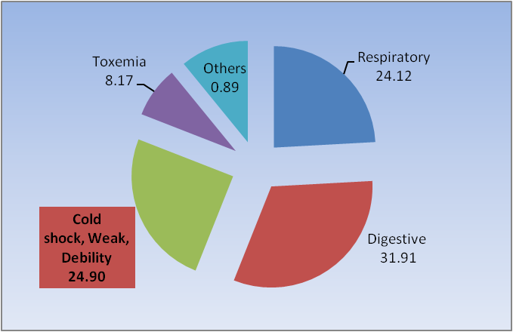Fig.3 Distribution of mortality causes in sheep from 2009 to 2018
4. DISCUSSION
4.1. Month-wise mortality details from 2009-2018
The results revealed that monthly mortality rates peak between March and June. This increase may be attributed to severe winter frost occurring from November to February, which makes green fodder unavailable for animals until the next monsoon season. This issue is exacerbated by the following summer, further worsening fodder scarcity. Additionally, heat stress negatively affects metabolism and immune function, increasing susceptibility to disease and dehydration. A review by Sejian et al. (2018) highlights heat stress as a major factor adversely influencing livestock production and survival, especially when it occurs alongside other stressors. Flinn et al. (2020) discuss how environmental stress, along with physiological and management factors, influences neonatal lamb mortality, noting that the majority of lamb losses happen very early, within the first few days.
4.1.1 Year-wise mortality trend (2009–2018)
The results also show substantial inter-annual variation, with years such as 2016 and 2018 contributing disproportionately to total mortality. This suggests that climatic extremes and disease outbreaks could drastically increase mortality rates. Thornton et al. (2021) indicate that the risk of extreme heat stress for livestock species is expected to rise across many tropical and temperate zones, implying that years with particularly severe heat may lead to spikes in mortality. The observed increase in mortality rates during those years may be linked to the occurrence of prolonged frost burn that occurred during the season.
4.2. Effect of Age and Weaning Stage
Age is a critical determinant of mortality, with young animals (58.6%) and particularly pre-weaning lambs (74.8%) being the most affected. Most deaths of lambs occur in the first few days of birth that are typically associated with inadequate colostrum intake, poor maternal care, lower birth weight which also led to weakness, taking longer time to stand up and reduced chance of survival than lambs of heavier weight (Demis et al 2020). According to Flinn et al. (2020), risk factors such as birth weight, litter size, dystocia and failure to suckle greatly influence lamb survival. Additionally, Wallace et al. (2021) review perinatal complications (such as stillbirth, dystocia, birth injury, and starvation) as primary causes of early lamb death, especially in contexts involving low birth weight and management stress. The importance of adequate colostrum intake is emphasized by immunological studies; Sawyer (1977) found that failure of passive immunoglobulin transfer was common in lambs that died between 24 hours and 5 weeks of age.
4.3. Effect of Sex on Mortality
Mortality rates were higher in females (60.7%) than in males (39.3%). Female sheep are more susceptible to stress during gestation, parturition and lactation, which compromises their immunity and increases disease risk. This susceptibility may be due to nutritional depletion during late pregnancy, reproductive stress and higher exposure to pathogens.
4.4. Effect of season on mortality
Seasonal variation significantly influenced mortality, with the highest losses occurring during summer (49.3%), followed by the southwest monsoon (22.7%). Frostbite on pasture grass during winter places animals under metabolic and immunological strain, amplifying the effects of diseases and nutritional deficits. Sejian et al. (2018) discuss how animals under nutritional stress shift metabolic energy away from productive functions towards coping and survival mechanisms. Furthermore, climate-livestock risk projections by Thornton et al. (2021) suggest that increasing extreme climatic stress poses a growing threat to livestock survival globally.
4.5. Effect of lambing season on mortality
The results revealed that mortality was notably higher during the main lambing season (84.8%) compared to the off-season (15.2%). This increase occurs because many neonates are born under similar environmental and management conditions, which increases the likelihood of disease spread due to both environmental and maternal factors. Field studies and herd management reviews recommend spreading out lambing, improving hygiene in lambing pens and ensuring adequate supervision to reduce clustered neonatal mortality (Genfors et al., 2023).
4.6. Effect of meteorological parameters
Climatic factors such as temperature, rainfall and wind speed were closely associated with fluctuations in mortality rates. The years 2016 (characterized by high temperatures and low rainfall) and 2018 (marked by high rainfall and humidity) recorded the highest mortality rates. This indicates that both heat stress and excessive moisture can elevate mortality risk. Temperature extremes may impair immune competence and increase oxidative stress in small ruminants, while a strong positive correlation exists between rainfall and disease-related mortality, significantly affecting survival and productivity in sheep. Sejian et al. (2018) argue that heat stress impairs immune competence, forces metabolic trade-offs and increases vulnerability to disease. Climate projections by Thornton et al. (2021) indicate that risks from extreme climatic conditions may become more prevalent, further challenging livestock survival, particularly in tropical zones.
4.7. Mortality pattern (2009–2018)
The study revealed that digestive disorders were the leading cause of mortality in lambs, consistent with the findings of Flinn et al. (2020), who observed that the predominant causes of lamb deaths can vary by region based on factors such as exposure to pathogens, feed quality, the environment and management practices. Gastrointestinal diseases and enteric infections, particularly those caused by Clostridium perfringens and various parasites, significantly contribute to lamb mortality across many systems. Studies frequently detect C. perfringens in fatal enteric outbreaks, highlighting the importance of vaccination and proper feeding management (Hussain et al. 2022). High incidences of gastrointestinal disturbances in organized flocks are often linked to sudden dietary changes, the ingestion of contaminated feed or parasitic infections. This underscores the necessity of balanced nutrition and regular deworming to minimize digestive-related losses.
Cold shock, weakness and debility accounted for nearly one-fourth of total deaths, particularly affecting newborn and young lambs. In case of neonatal lamb mortality, cold stress and hypothermia are recognized as secondary contributors in situations of poor management or exposure (Flinn et al. 2020). Newborns are particularly susceptible to hypothermia and malnutrition under harsh climatic conditions and inadequate housing. Therefore, providing proper thermal protection, ensuring adequate colostrum intake and managing nutrition during the lambing season are crucial (Genfors et al. 2023).
Respiratory disorders accounted for 24.12% of total deaths, primarily due to pneumonia and upper respiratory infections that are triggered by fluctuations in temperature and humidity. Recent studies have identified bacteria such as Mannheimia haemolytica and Pasteurella spp. in pneumonic outbreaks, linking respiratory deaths to stressors such as transport, poor ventilation and climatic shifts (Jesse et al. 2019).
Toxemic conditions, including enterotoxemia and septicemia, contributed to 8.17% of deaths and were characterized by sudden onset and high fatality rates. Radostits et al. (2010) emphasized the role of Clostridium perfringens infections, particularly under conditions of high nutrition or stress. Implementing appropriate vaccination and feed management practices can effectively reduce such outbreaks.
5. CONCLUSION
The study demonstrates that sheep mortality is a multifactorial outcome of environmental, physiological and managemental interactions. High summer temperatures, nutritional deficits, perinatal stress and extreme rainfall were the main determinants of flock mortality. Strategies such as improved neonatal care, adaptive feeding during summer, shade provision, vaccination and continuous health monitoring can substantially reduce losses and enhance flock sustainability under changing climatic conditions.
DISCLAIMER (ARTIFICIAL INTELLIGENCE): Author(s) here by declares that No generative AI technologies such as Large Language Models (ChatGPT, COPILOT, etc.) and text-to-image generators have been used during the writing or editing of this manuscript.
COMPETING INTERESTS: Authors have declared that no competing interests exist.

References

Banda, L.J. and Tanganyika, J. 2021. Livestock provide more than food in smallholder production systems of developing countries. Anim. Front. 11: 7–14
Demis, C., Aydefruhim, D., Wondifra, Y., Ayele, F., Alemnew, E. and Asfaw T (2020). Maternal immunoglobulin in the serum of newborn lambs and its relation with neonatal mortality. J. Anim. Feed Res., 10(3): 119-124.
Flinn, T., Kleemann, D.O., Swinbourne, A.M., Kelly, J.M., Weaver, A.C., Walker, S.K., Gatford, K.L., Kind, K.L. and van Wettere, W.H.E.J. 2020. Neonatal lamb mortality: major risk factors and the potential ameliorative role of melatonin. J. Anim. Sci. Biotechnol. 11: 107.
Genfors, E., Magnusson, U., Moliso, M. M., Wieland, B., König, U., Hallenberg, G. S., and Bage, R. (2023). Preventive herd management practices and their effect on lamb mortality in Ethiopia. Tropical Animal Health and Production, 55(1), 42.
Hussain, R., Guangbin, Z., Abbas, R. Z., Siddique, A. B., Mohiuddin, M., Khan, I., Rehman, T. U., and Khan, A. (2022). Clostridium perfringens Types A and D Involved in Peracute Deaths in Goats Kept in Cholistan Ecosystem During Winter Season. Frontiers in Veterinary Science, 18:849856
Jesse, A. F. F., Amira, N. A., Isa, K. M., Maqbool, A., Ali, N. M., Teik Chung, E. L., and Mohd Lila, M. A. (2019). Association between Mannheimia haemolytica infection with reproductive physiology and performance in small ruminants: A review. Veterinary World, 12: 978.
Niyas, P.A.A., Chaidanya, K., Shaji, S., Sejian, V., and Bhatta, R. (2015). Adaptation of livestock to environmental challenges. Journal of Veterinary Science and Medical Diagnosis, 4: 138.
Radostits, O.M., Gay, C.C., Hinchcliff, K.W., and Constable, P.D. (2010). Veterinary Medicine: A textbook of the diseases of cattle, horses, sheep, pigs and goats (10th ed.). Saunders Elsevier, London.
Sawyer, M., Willadsen, C.H., Osburn, B.I., and McGuire, T.C. (1977). Passive transfer of colostral immunoglobulins from ewe to lamb and its influence on neonatal lamb mortality. Journal of the American Veterinary Medical Association, 171(12), 1255–1259
Sejian, V., Bhatta, R., Gaughan, J.B., Dunshea, F.R., and Lacetera, N. (2018). Review: Adaptation of animals to heat stress. Animal, 12(s2), s431–s444
Thornton, P., Nelson, G., Mayberry, D., and Herrero, M. (2021). Increases in extreme heat stress in domesticated livestock species during the twenty‐first century. Global Change Biology, 27(22), 5762. https://doi.org/10.1111/gcb.15825
Wallace, J. M., Shepherd, P. O., Milne, J. S., and Aitken, R. P. (2021). Perinatal complications and maximising lamb survival in an adolescent paradigm characterised by premature delivery and low birthweight. PLoS ONE, 16(11), e0259890. https://doi.org/10.1371/journal.pone.0259890

