Original Research Article

Enhancement of Selected Pathogenesis Related Genes Function in papaya upon Application of Nanoencapsulated Recombinant Type III Secretion Protein

Abstract: Erwinia mallotivora has been identified as the causal pathogen of papaya dieback disease in Malaysia. In response, papaya plants have evolved various defence mechanisms against the pathogens such as Systemic Acquired Resistance (SAR) which is characterized by wide spectrum regulation of disease and associated coordinated expression of a group of pathogenesis-related (PR) genes and proteins also known as SAR-markers. In this research, chitosan nano-encapsulated recombinant protein Type III secretion SysteM (CNP- Type III secretion System) was tested and characterized for its effect and potential as an elicitor that can increase papaya defence against E. mallotivora through the activation of the SAR mechanism. Semiquantitative reverse transcription PCR (RT-qPCR) analysis was used to characterize the expression level of this gene after papaya was treated with the CNP- Type III secretion System. Based on the study, it shows that the papaya plant that was treated with CNP- Type III secretion System showed higher resistance to the papaya dieback pathogen compared to the untreated plant and treatment with Type III secretion System as a single agent. The nano-encapsulated recombinant protein had induced SAR based on physiological and molecular analysis; increased the expression of selected SAR associated with the defence gene and increased papaya resistance to the papaya dieback pathogen.
Keywords: Systemic Acquired Resistance, Papaya, Type III Secretion System, Defence
related gene.
1. INTRODUCTION
Papaya is a common fruit in the tropical and subtropical regions and is available commercially. Papaya is a significant source of antioxidant nutrients such as carotene, vitamin C and flavonoids, vitamin B vitamins such as folate and pantothenic acid, minerals such as potassium and magnesium, and fibre. Carica papaya L. var Eksotika is a papaya fruit that was resulted from the cross between the large-fruited Subang 6 variety and Hawaiian Sunrise Solo variety that has excellent eating qualities (Sekeli et al., 2018). Eksotika is also a good fruit bearer and is able to achieve fruit production of about 60 tons per harvested area per year (Mitra & Sharma, 2020). Malaysia was known as the second most important exporter of papaya in the world in 2004 with the overall amount of 58,149 mt constitutes 21% of global trade. After 2005, Malaysian papaya production declined rapidly due to two reasons which are the outbreak of the bacterial dieback (Erwinia) disease and fruit fly quarantine restrictions from China. These situations have affected the Malaysian papaya export industry leading to a decrease of production by 60% (Chan and Baharuddin, 2010).
A wide range of diseases was reported for various papaya varieties including infection by pests and microorganisms. One disease that was reported to have emerged and posed a major threat that has affected a few papaya varieties including Eksotika was known as the papaya dieback disease (Redzuan et al. 2014) which has a common symptom characterized by progressive death, beginning at the tips, of twigs, branches, shoots, or roots (Nihata and Makabu, 2018).
In varieties of crop plants, Erwinia sp is responsible for typical forms of plant disease with necrosis, blight, soft rot, and wilt symptoms (Mohd Taha et al. 2019). As an example, fire blight caused by E. amylovora is the most destructive disease in pear and apple orchards in many parts of the world (Zhao et al., 2019). The papaya dieback disease was caused by Erwinia mallotivora Erwinia mallotivora (EM) passes through stomata and wound openings through the papaya host (Mohd Taha et al. 2019). Later, all parts of the papaya plant including shoot, leaf, frond and bar as well as the fruit will be infected leading to early slimy, greasy, water-drenched areas, in addition to signs and symptoms around the leaves and petioles. This inevitably results in necrosis, blemish or premature drop in the fruit and the death of the papaya plant (Sekeli et al., 2018).
When attacked by a pathogen, plants protect themselves by activating plant defence mechanism that involves oxidative cell burst, alteration in cell wall composition and de-novo synthesis of compounds such as phytoalexin, and elevated pathogenesis-related (PR) protein expression (Abu Bakar et al. 2017). The plant defence mechanisms include immunity triggered by MAMP (MTI), immunity triggered by an effector (ETI) and systemic acquired resistance (SAR) indicate different layers of active plant defence strategy (Yan & Dong, 2014). Plants often have the ability to enable quantitative defence against a wide range of microorganisms by inoculating with a pathogen, exogenously adding proteins from microorganisms or by adding chemical substances (Bai et al., 2018). Systemic acquired resistance (SAR) is an inducible disease resistance response in plant species (Samsuddin et al., 2018). It is found in a large range of plant species including papaya and characterized by broad-spectrum disease control and an associated coordinated expression of a set of pathogenesis-related (PR) genes and proteins which are also known as SAR markers (Abu Bakar et al., 2018). SAR induction is characterised by salicylic acid (SA) accumulation to activate defence mechanisms, often resulting in a hypersensitive, localised response (Peng et al. 2021). SA is not a mobile signal agent, but it is suggested to be the first chemical to induce pathogenesis-related (PR) genes, especially PR-11 genes (Wani et al., 2018). PR genes code and play a role in preventing or slowing the invasion of pathogens in the host, for proteins such as chitinases and β-1,3-glucanases, among others (Jha, 2019).
Previous studies have shown that several recombinant proteins have the potential to increase the papaya defence mechanism against papaya dieback disease (Abu Bakar et al., 2018). One way to maintain and improve the stability of biological compounds is through the application of nanotechnology. Encapsulation is a promising alternative to minimize degradation or loss during processing and storage (Bangun 2018). Studies have also shown that encapsulation is beneficial and can be used as a method of slow-releasing compounds to their environment in a timely and stable manner (Jogaiah et al., 2020). Chitosan has been one of the most promising polymers for the successful delivery of agrochemicals and micronutrients to nanoparticles (Fu et al., 2019). The improved efficiency and efficacy of nano formulations were attributable to the higher surface area, induction of systemic operation due to smaller particle size and higher mobility, and lower toxicity due to the removal of organic solvents compared to conventionally used pesticides and their formulations (Zhao et al., 2017).
Biodegradable polymers of natural origins are of increasing interest, in line with the motivation to develop nanotechnological formulations that are less harmful to the environment. Therefore, chitosan, a natural non-toxic biopolymer derived from the deacetylation of chitin, was selected for this research. Chitosan-based nanoparticles have gained considerable interest due to their biocompatibility, biodegradability, high permeability, cost-effectiveness and non-toxic properties (Chandra et al., 2015). It has immense structural possibilities for chemical and mechanical modification to generate novel properties and functions to be used in the field of agriculture. Furthermore, chitosan-based nanoparticles are well recognized as an antimicrobial, immune-modulatory and plant growth promoter agent (El Hadrami et al., 2010)
The encapsulation of SAR-inducing recombinant protein in chitosan nanoparticles has the potential to protect the protein against degradation, leading to enhance efficacy and effective duration in field conditions which increases the innate immunity in plants, thus it can effectively enhance the defence system of papaya to combat papaya dieback disease. Thus, the aim of this study was to develop a formulation of chitosan nanoparticles loaded with selected recombinant protein as an alternative strategy to manage papaya dieback disease.

2. MATERIALS AND METHODS
2.1 Nanoencapsulation of recombinant Type III secretion protein
The _Type III Secretion System gene (1.392 kbp) from Erwinia mallotivora, which encodes a full-length hairpin protein, was obtained from MARDI Serdang (Abu Bakar et al., 2018). This gene was inserted into a pET-32b expression vector and introduced into Escherichia coli BL21(DE3) cells using chemical transformation whereby a single positive colony was grown overnight in LB broth at 37°C, then transferred to a larger volume of LB with ampicillin and induced with 0.5 mM IPTG to express the protein. The bacterial cells were harvested and lysed using BugBuster reagent and protease inhibitors and purified using a Ni-NTA column via the AKTAPrime Chromatography System. Protein purity was confirmed by SDS-PAGE and Western blotting using anti-His antibodies. Protein concentration was measured with the Bradford assay (Kielkopf et al., 2020) using BSA as a standard, and samples were stored at –80°C.
Chitosan nanoparticles (CNP) and chitosan-encapsulated Type III Secretion System protein (CNP-Type III Secretion System) were prepared using the ionic gelation method (Masaruddin et al., 2015) and as described by Zamri et al., 2024. A 1.0% chitosan solution was made in glacial acetic acid, diluted to 0.5%, and adjusted to pH 5. A 0.7% TPP solution was separately prepared and adjusted to pH 2. For plain CNP, chitosan and TPP were mixed directly. For CNP-Type III Secretion System, the protein was first mixed with chitosan before adding TPP. All samples were then centrifuged, sonicated, and analyzed for particle size, PDI, and morphology using DLS and TEM. Three separate batches were prepared to ensure reproducibility.
2.2 Seed priming treatment
Prior to sowing, the papaya seeds were soaked with four different priming treatments for two days (48 hours). The priming formulations were prepared by dissolving the purified recombinant protein and encapsulated protein, CNP-P as well as CNP (powder form) in sterile distilled water to a final concentration of 1μg/ml (final volume 20ml). The seeds that were treated with distilled water were used as the positive control. 20 papaya seeds were soaked in each priming treatment and sowed in a seed tray filled with peat soil. After three weeks, the papaya seedlings were moved to polybag and grow plants at MARDI’s Biotechnology & Nanotechnology infection house. Then at two months’ age, the plants were artificially inoculated with the causative agent of dieback.
2.3 RNA extraction and pathogenesis-related gene analysis via semiquantitative RT-PCR
The samples were collected from papaya leaves before and after pathogen inoculation. Tissue collection and total RNA extraction: leaf tissue amounting to 30g were grounded to a fine powder using liquid nitrogen, and divided into approximately 100 mg into each 2 ml tubes. Total RNA was extracted using the RNeasy plant mini kit protocol (QIAGEN, USA). Semiquantitative RT-PCR was used to measure the expression of pathogenesis-related (PR) genes in papaya. Total RNA (2 μg) was treated with DNAse to remove genomic DNA contamination, then converted into cDNA using BioRad Reverse Transcription Kit.The cDNA served as a template for RT-PCR, using PR1d primers to assess gene expression related to Systemic Acquired Resistance (SAR), with actin as the housekeeping gene for normalization. The reaction was carried out using the SensiFast SYBR Hi-ROX kit under thermal cycles consisting of denaturation at 95°C, annealing at 61°C/71°C, and extension at 72°C. PCR products were separated on a 1.5% agarose gel containing ethidium bromide (EtBr), run at 80V for 30 minutes, and visualized under UV light using a gel documentation system. The band intensity was analysed using ImageJ software (Rha et al. 2015) to quantify gene expression levels.
3. RESULTS AND DISCUSSION
3.1 Nanoencapsulation of recombinant Type III Secretion Protein
The goal of this activity was to investigate whether treatment of papaya with a chitosan nano-encapsulated Type III Secretion System N, derived from Erwinia mallotivora can increased the expression of selected pathogenesis related genes that activate systemic acquired resistance (SAR). The Type III Secretion System gene was cloned and used to produce recombinant protein. The protein was expressed with an N-terminal His-tag, allowing it to be purified using a nickel-based (Ni-NTA) affinity column.The purified protein had a molecular weight of approximately 30 kDa and was successfully isolated using inclusion body extraction followed by Ni-NTA affinity chromatography (ÄKTAprime plus system). The amount of purified protein obtained was sufficient for seed priming experiments to evaluate its ability to trigger SAR and enhance papaya seedling resistance to papaya dieback disease.
Chitosan nanoparticles (CNPs) were synthesized using the ionic gelation method, involving the cross-linking of positively charged chitosan (CS) with negatively charged sodium triphosphate (TPP) (Masaruddin et al., 2015). Two formulations, CNP-1 and CNP-2, were created with different CS concentrations. Dynamic Light Scattering (DLS) analysis showed that CNP-1 (92.09 nm, PDI 0.271) had larger and more varied particles compared to CNP-2 (58.02 nm, PDI 0.203), which had more uniform size distribution (Figure 1). Higher CS concentrations led to larger and less stable particles due to reduced cross-linking efficiency. The most stable and uniform CNPs (under 150 nm, low PDI) were achieved at 0.5 mg/mL CS and 0.7 mg/mL TPP. When Type III Secretion System protein was encapsulated into CNPs, particle size and PDI increased, indicating successful protein incorporation but reduced uniformity (Figure 2).Incorporation of different preparation protocols have been conducted in various experiments to obtained chitosan nanoparticles with varying degree of effectiveness and drawbacks (Gan and Wang 2007 and Danaei et al., 2018) and in our case to obtain the best fabricated nanoparticles of Type III Secretion System. The optimal formulation with 0.04 mg/mL protein-maintained particle size under 150 nm with low PDI (<0.2) was determined, confirming its suitability for CNP-Type III Secretion System synthesis.
0.15
PDI
40
0.1
20
0.05
0
0
0.125 mg/ml: 0.700 mg/ml 0.500 mg/ml: 0.700 mg/ml
size (d.nm)
60
59.82
0.2
0.203
80
0.25
0.271
92.09
100
0.3
120
Concentration of CS: Concetration of TPP

Figure 1. Influence of CS concentration on particle size distribution and polydispersity index of CNP. Synthesis of CNP under parameter set (600ul +200ul 883 of TPP), represented by bar (particle size distribution) and line (polydispersity index) graph. pH values of CS and TPP were 5 and 2, respectively. Error bars represent standard averaged from two independent replicates.

300
PDI
0.1
200
143.81
100
59.82
0.05
0
0
CS:TPP (control)
CS:TPP + 0.025
mg/ml
CS:TPP + 0.04 mg/mlCS:TPP + 0.05 mg/ml
size (d.nm)
0.15
331.29
0.16
400
0.18
0.2
500
0.203
600
0.25
635.040.25
700
0.3
800
0.500 mg/ml CS : 0.700 mg/ml +concentration of protein

Figure 2. Influence of Type III secretion System encapsulation on particle size distribution and polydispersity index of CNP-Type III secretion System. CNP were synthesized under parameter set (600μl of 0.500 mg/ml CS + +200μl of 0.700mg/ml TPP), represented by bar (particle size distribution) and line (polydispersity index) graph. The pH values of CS and TPP were 5 and 2, respectively. Error bars represent standard deviation averaged from three independent replicates.
Morphological visualization of CNP and CNP-Type III secretion System was performed by using TEM. Sample imaging on TEM showed the morphology of CNP and CNP-Type III secretion System in a single spherical shape which less than nm (43 nm to 94 nm) and 200 nm (166 nm to 200 nm) in size respectively, thus confirming the formulation of CNP and CNP-Type III secretion System after cross-linking (Figure 3). This is an accordance to similar experiments conducted by Serna et al. 2017 whereby nanoparticles antimicrobial peptide GWH1 was generated to be around 50nm and showed positive activity on selected Gram-positive and Gram-negative bacteria. In another experiment, recombinant IL-17RC was also encapsulated using CS nanoparticles via ionic cross-linking technique exhibiting nanosized molecules and successfully inhibit mucus secretion via intranasal intervention for the treatment of asthma (Lv et al. 2021).
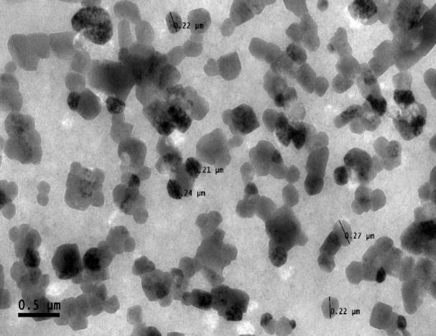
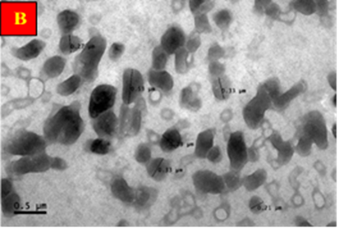
A

Figure 3. Morphological images by TEM analysis. Morphological visualisation of (A) CNP and (B) CNP-Type III secretion System. CNP exhibited in particle size from 43 nm to 94 nm, while CNP-Type III secretion System showed particle sizes from 166 nm to 200 nm.
3.2 Effects of CNP and CNP-Type III secretion system in plant
In vitro cellular uptake of CNP and CNP-Type III secretion System in the cells of the treated leaves was studied using FITC-tagged (CNP-FITC) and (CNP-Type III secretion System-FITC). By using the qualitative fluorescence microscopy method, tracking started as early as at 0-hour post-treatment, followed by 6 and 24 hours. The fluorescent microscopic images of such leaves are depicted in Figure 4. Both CNP-FITC and CNP-Type III secretion System -FITC treated sets showed intensely illuminated cell walls of the subsidiary cells in the lower epidermal peels compared to the FITC treated control set. It was found that CNP-Type III secretion System-FITC entered the cells as 6 hours post-treatment. This due to the appearance of green fluorescence emitted by FITC. The binding of CNP-FITC was generally lower than that of CNP-Type III secretion System -FITC prepared from the same chitosan sample. This is because, FITC is the derivative of fluorescein with an isothiocyanate reactive group, rendering it reactive towards the amine group of the protein (Chen et al., 2019).
Cells incubated with CNP-Type III secretion System-FITC at ambient temperature exhibited a thicker layer of stronger fluorescence around the cell walls than cells incubated under the same conditions with CNP-FITC. As control sets were incubated in water containing FITC only, no such fluorescence signal was observed in epidermal cells.
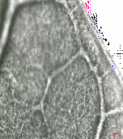
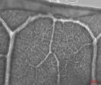
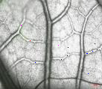
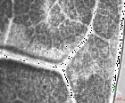
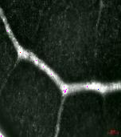
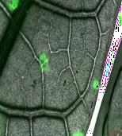
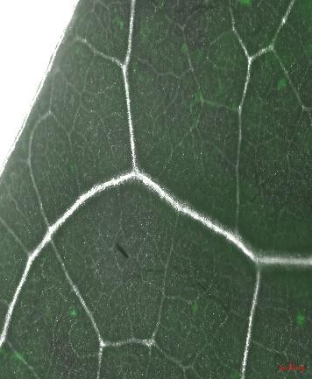
A
B
0 hour
0 hour
6 hour
24 hour
C
0 hour
6 hour
24 hour

Figure 4. FITC tracking by fluorescence microscopy of relative bioaccumulation and bio accessibility of CNP and CNP-Type III secretion System in treated leaves. The epidermal peals incubated with FITC tagged (B) CNP (CNP-FITC) and (C) CNP-Type III secretion System (CNP-Type III secretion System-FITC) manifest intense green fluorescence around the cell walls against water treated counterparts (A) Control. Figures are representative of three independent experiments done under similar conditions.

Interestingly, Figure 4 showed that FITC-tagged nanoparticles were able to enter the cell and was found that FITC-CNP-Type III secretion System entered the cells as early as 6 hours post- treatment. Comparison between fluorescence intensity in cells after (0,6, and 24) hours post-treatment with CNP-Type III secretion System-FITC showed an increase in the number of nanoparticles accumulated, revealing that CNP-Type III secretion System has taken quite well in papaya plant cells. These cellular localization studies also showed that both CNP and CNP-Type III secretion System bind to the cell extracellularly. More intense localization of fluorescence caused by FITC tagged to CNP might be correlated with the results related to a high level of defence response in CNP-Type III secretion System treated leaves when compared to that of CNP. Extracellular localization of chitosan in suspension culture of tobacco leaf cells was also reported by Zhang et al., (2019) where fluorescent-labelled oligochitosan was found to be present around the cell walls. In agreement, nanoparticles uptake into the plant leaves cell are via active transport through stoma leaves opening and was shown to escalate plants physiological and morphological effects by increasing the enzyme activities (Yavaş, İ., 2021).
3.3 Determination of selected pathogenesis response genes expression after seed priming treatment
The experiment consisted of three treatments and a control was conducted at MARDI’s Biotechnology & Nanotechnology infection house. Protein inducer treatments were carried out by seed priming treatment. Water treated plants were included as positive control. The effect of the treatments on papaya plants that were not inoculated by pathogen (uninfected) was assessed. However, no differences in plant height, stem diameter and root mass were observed between control, Type III secretion System, CNP and CNP-Type III secretion System-treated plants indicating there was no effect of the treatments on the plant health. To assess the protein ability to increase papaya tolerance against the papaya dieback pathogen, inoculation of E. mallotivora was carried out at two months of age of the plant for the response to disease symptoms and inducer treatments. The plant height, stem diameter and root mass of plants that were treated with CNP-Type III secretion System shows an obvious positive growth effect compared to other treatments which indicates the plant health in response to SAR as reported by Abu Bakar et al. (2021).
Analysis of defence reaction will give valuable details for papaya dieback disease management methods. This will offer valuable information for the development of a durable, economical, and broad-spectrum management approach for the disease. Accordingly, to see the impact of the formulations on the expression of selected papaya defence genes expression, leaves from papayas that were treated with formulations and management plants were taken from every treatment and management replicates. The CNP-Type III secretion System _N was tested to evaluate its effectiveness in inducing SAR in papaya for elevated disease resistance response and to suppress the development of papaya dieback disease. Previously Abu Bakar et al. (2018, 2021) have shown that many pathogenesis-related genes, including PR-1b, PR1d, Osmotin and NPR1, have the potential to be used as SAR markers due to increasing levels of gene expression a few days after treatment with recognised SAR inducers. These genes were used after application with the inducers to evaluate the plant defence response using semi quantitative PCR analysis.
Based on the semi quantitative Reverse Transcription-PCR analysis (Figure 5), it was suggested that the application of recombinant Type III secretion System, chitosan nanoparticles, encapsulated recombinant Type III secretion System chitosan nanoparticle increased the PRD1, NPR and Osmotin plant defence-related gene expressions that are related to the SAR. Interestingly, the level of Osmotin, PR1D and NPR gene expression expression increased after EM infection across all treatments, indicating its role in defense. These aligns with known priming effects of EM, activating SA-dependent pathways mediated by NPR1 and strengthens the evidence that EM can enhance the plant's immune readiness, reducing susceptibility to pathogens (Espinas et al. 2016, Bakar et al. 2023). However, the papaya plants not pre-treated with any chitosan and elicitors immune stimulant show limited activation of the selected Osmotin, PR1D and NPR defense genes after EM infection. The lower Osmotin, PR1D and NPR gene expression before EM infection suggests a basal or uninduced state which reflects a normal, unprimed immune state. This supports the idea without a priming agent like chitosan or potential elicitors, EM alone is not enough to activate the defense plant response to its full potential. Increased Osmotin, PR1D and NPR gene expression especially in the present of elicitors priming indicates activation of plant defence pathways, likely mediated by salicylic acid (SA) suggesting a primed immune state that could lead to faster or stronger responses to EM attack (Samsuddin et al. 2018).
Table 1 Analysis of Gene Expression
Gene | Samples
Gene | Non-infected |  |  |  |  |  | Infected
Gene | Water | Type III | CNP-(0) | CNP-TypeIII) | Water | Type III | CNP-(0) | CNP-(Type III)
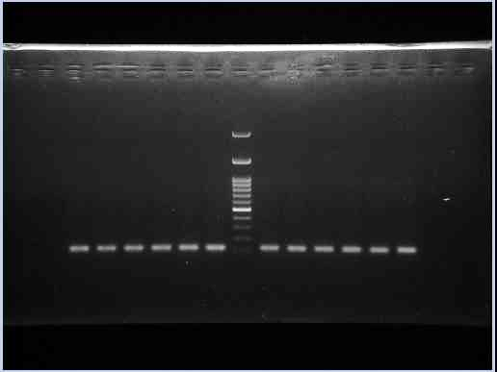
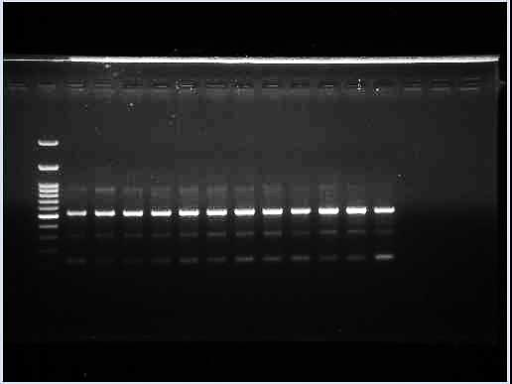
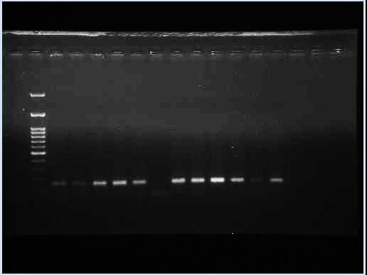
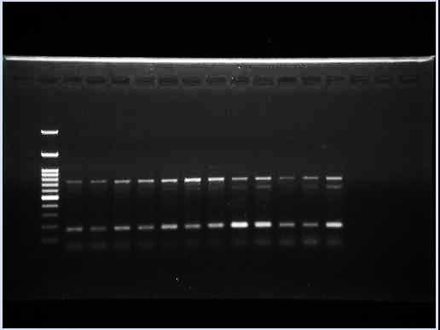
Actin (HK gene)
Osmotin

PR1d
NPR

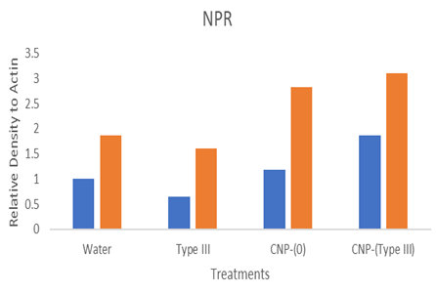
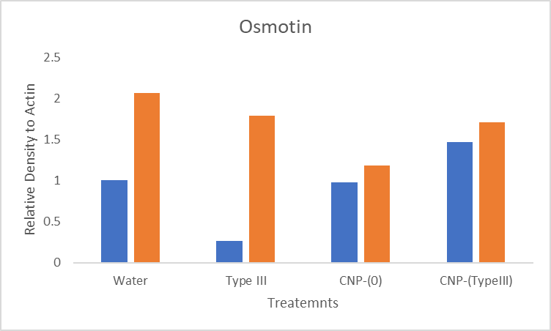
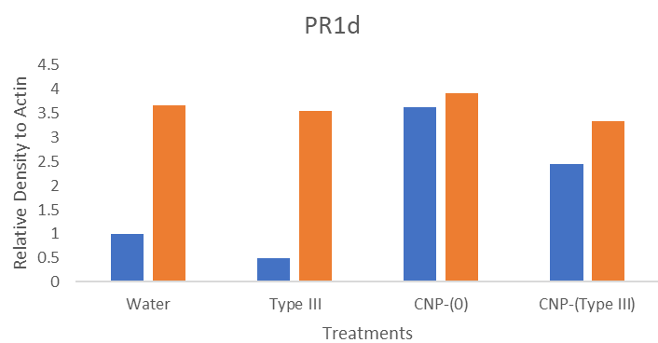

Figure 5. The semi-quantitative gel and expression profiling of PR1d, NPR and Osmotin genes in control plant (non-treated) and Type III secretion System, CNP, CNP-Type III secretion System treated papaya leaf tissues as analysed using J Image software.
This pattern suggests that EM and elicitors treatment may enhance resistance by priming the plant immune system, leading to higher activation of selected defence related genes upon pathogen challenge (Gozo 2003). These results are in line with prior findings that selected defense related genes are reliable markers of systemic acquired resistance (SAR), often induced by chitosan-based treatments which is known to mimic pathogen-associated molecular patterns (PAMPs), triggering defense responses such as PR1d, Osmotin and NPR transcription (Gao et al. 2021., El Hadrami et al., 2010). Chitosan nanoparticles (CNPs) act as elicitors, strongly inducing PR1d even before pathogen challenge. Interestingly, while Water and Type III treatments showed large post-infection increases, CNP-pre-treated samples maintained consistently minimal increased of expression, highlighting their preventative potential.
It was also observed that increased expression of the Osmotin, PR1D and NPR gene were observed in plants treated with CNP-Type III secretion System are quite similar to plants that were treated with only recombinant Type III secretion System (Figure 5). This supports the notion that encapsulating the recombinant protein that treats the infected papaya plant can enhance the resistance of the plant against the dieback disease albeit the smaller amount of proteins needed. Furthermore, the production of molecular markers for the identification of resistant cultivars or donor varieties for molecular breeding of papaya, the expression pattern of the selected genes has the potential to be used for improved tolerance or resistance to papaya dieback pathogens (Azhar et al., 2020)
4. CONCLUSION
The recombinant protein Type III secretion System from E. mallotivora was successfully transformed and expressed for the encapsulation of chitosan nanoparticles. Moreover, the optimum formulation of CNP and CNP (Type III secretion System) were synthesized and used for characterization and seed priming treatment for the papaya plant. The seed priming treatment of the encapsulated a single recombinant protein Type III secretion System in chitosan nanoparticles was tested to evaluate its effectiveness in inducing SAR in papaya for enhanced disease 1resistance to papaya dieback pathogen.
The effectiveness of the selected CNP-Type III secretion System protein had been shown by the expression of PR1d gene, inducing the SAR response in papaya to manage the papaya dieback disease. The papaya plant that was treated with CNP-Type III secretion System is expected to show higher resistance to the papaya dieback pathogen compared to the untreated plant and treatment with Type III secretion System as a single agent. It was concluded that encapsulated recombinant protein in chitosan nanoparticles had the potential to be used as a SAR chemical inducer. Therefore, for positive SAR inducement, encapsulated recombinant Type III secretion System in chitosan nanoparticles is sufficient to enhance the defence system of papaya to combat papaya dieback disease. The research has indicated that the encapsulation of recombinant protein in chitosan nanoparticle is a stable manner which has a better bio accessibility to manage the papaya dieback disease. Further molecular biology which includes more detail expression analysis of selected pathogenesis related proteins, using a more sensitive approach; Real Time quantitative PCR will also be conducted. The following recommendations are suggested for further research.
DISCLAIMER (ARTIFICIAL INTELLIGENCE)
Author(s) hereby declares that No generative AI technologies such as Large Language Models (ChatGPT, COPILOT, etc.) and text-to-image generators have been used during the writing or editing of this manuscript.
COMPETING INTERESTS
Authors have declared that no competing interests exist.
REFERENCES
Abu Bakar, N., Juri, N.M., Bakar, R.A.H., Sohaime, M.Z., Badrun, R., Sarip, J, Hassan, M.A., Ahmad, K. (2021). Recombinant Protein Foliar Application Activates Systemic Acquired Resistance and Increases Tolerance against Papaya Dieback Disease. Asian Journal of Agriculture and Rural Development. 11(1): 1-9
Abu Bakar, N., Badrun, R., Rozano, L., Ahmad, L., Mohd Raih, M.F., Tarmizi, A.A. (2017). Identification and validation of putative Erwinia mallotivora effectors via quantitative proteomics and Real Time Analysis. J. Agric. Food. Tech. 7(9): 10-21.
Abu Bakar, N., Sohaime, M., Juri, N.M., Badrun, R., Sarip, J, (2018). Induction of systemic acquired resistance in papaya by foliar application of HrpN recombinant protein for increased resistance against papaya dieback pathogen. Current Investigations in Agriculture and Current Research. 2(3). Doi: https://doi.org/10.32474/CIACR.2018.02.000136.
Agarwal, M., Agarwal, M.K., Shrivastav, N., Pandey, S., Das, R., Gaur, P. (2018). Preparation of chitosan nanoparticles and their in-vitro characterization. International Journal of Life-Sciences Scientific Research, 4(2), 1713-1720. doi:10.21276/ijlssr.2018.4.2.17
Azhar, H.M., Johari, S., Sulastri, J.N., Razali, M., Zulfa, M.M., Faimah, G.N., & Mariatulqabtiah, A.R. (2020). Field performance of selected papaya hybrids for tolerance to dieback disease. J. Trop. Agric. and Fd. Sc, 48(1), 25-33.
Bakar, R.A.H., Abu Bakar, N., Ahmad, K., Shaharuddin, N.A., & Mohd As’wad, A.W. (2023). Recombinant protein application induced defense mechanism in host plant against papaya dieback disease. Jurnal Teknologi, 85(6), 187-199. https://doi.org/10.11113/jurnalteknologi.v85.20092
Bai, Y., Kissoudis, C., Yan, Z., Visser, R.G., & Van der Linden, G. (2018). Plant behaviour under combined stress: Tomato responses to combined salinity and pathogen stress. The Plant Journal, 93(4), 781-793. doi:10.1111/tpj.13800
Bangun, H. (2018). Preparation and evaluation of chitosan-tripolyphosphate nanoparticles suspension as an antibacterial agent. Journal of Applied Pharmaceutical Science, 8(12), 147-156. doi:10.7324/japs.2018.81217 1151
Chan, Y., & Baharuddin, A. (2010). Rejuvenating the flagging papaya industry in Malaysia: The role of MAFC. Acta Horticulturae, 1166 (851), 37-40. doi:10.17660/actahortic.2010.851.2
Chandra, S., Chakraborty, N., Dasgupta, A., Sarkar, J., Panda, K., & Acharya, K. (2015). Chitosan nanoparticles: A positive modulator of innate immune responses in plants. Scientific Reports, 5(1). doi:10.1038/srep15195
Chen, Y., Wu, K., Tang, J., Loredo, A., Clement, J., Pei, J., & Xiao, H. (2019). Addition of isocyanide-containing amino acids to the genetic code for protein labelling and activation. ACS Chemical Biology, 14(12), 2793-2799. doi:10.1021/acschembio.9b00678
Chun, S., & Chandrasekaran, M. (2019). Chitosan and chitosan nanoparticles induced expression of pathogenesis-related proteins genes enhances biotic stress tolerance in tomato. International Journal of Biological Macromolecules, 125, 1 948-954. doi: 10.1016/j.ijbiomac.2018.12.167 1
Danaei, M., Dehghankhold, M., Ataei, S., Hasanzadeh Davarani, F., Javanmard, R., Dokhani, A., & Mozafari, M. (2018). Impact of particle size and polydispersity index on the clinical applications of lipidic nanocarrier systems. Pharmaceutics, 10(2), 57. doi:10.3390/pharmaceutics10020057
El Hadrami, A., Adam, L.R., El Hadrami, I., & Daayf, F. (2010). Chitosan in plant protection. Marine Drugs, 8(4), 968-987. doi:10.3390/md8040968
Espinas, N.A., Saze, H., & Saijo. Y. (2016). Epigenetic Control of Defense Signaling and Priming in Plants. Front Plant Sci.Aug 11;7:1201. doi: 10.3389/fpls.2016.01201. PMID: 27563304; PMCID: PMC4980392.
Fu, L., Wang, Z., Dhankher, O.P., & Xing, B. (2019). Nanotechnology as a new sustainable approach for controlling crop diseases and increasing agricultural production. Journal of Experimental Botany, 71(2), 507-519. 1194 doi:10.1093/jxb/erz314
Gao, H., Guo, M., Song, J., Ma, Y., & Xu, Z. (2021). Signals in systemic acquired resistance of plants against microbial pathogens. Mol Biol Rep. 48(4):3747-3759. doi: 10.1007/s11033-021-06344-7. Epub 2021 Apr 24. PMID: 33893927
Gozzo, F. (2003). Systemic acquired resistance in crop protection: from nature to a chemical approach. J Agric Food Chem.30;51(16):4487-503. doi: 10.1021/jf030025s. PMID: 14705870.
Jha, Y. (2019). Endophytic bacteria mediated anti-autophagy and induced catalase, β-1202 1, 3-glucanases gene in paddy after infection with pathogen Pyricularia grisea. Indian Phytopathology, 72(1), 99-106.
Jogaiah, S., Satapute, P., De Britto, S., Konappa, N., & Udayashankar, A.C. (2020). Exogenous priming of chitosan induces upregulation of phytohormones and resistance against cucumber powdery mildew disease is correlated with localized biosynthesis of defense enzymes. International Journal of Biological Macromolecules, 162, 1825-1838. doi: 10.1016/j.ijbiomac.2020.08.124
Kielkopf, C.L., Bauer, W., & Urbatsch, I.L. (2020). Methods for measuring the concentrations of proteins. Cold Spring Harb Protoc. 2020 Apr 1;2020(4):102277. doi: 10.1101/pdb.top102277. PMID: 32238598.
Lv, Y., Zhang, J., & Wang, C. (2021). Self-assembled chitosan nanoparticles for intranasal delivery of recombinant protein interleukin-17 receptor C (IL-17RC): preparation and evaluation in asthma mice. Bioengineered ;12(1):3029-3039. doi: 10.1080/21655979.2021.1940622. PMID: 34180764; PMCID: PMC8806589.
Masarudin, M.J., Cutts, S.M., Evison, B.J., Phillips, D.R., & Pigram, P.J. (2015). Factors determining the stability, size distribution, and cellular accumulation of small, monodisperse chitosan nanoparticles as candidate vectors for anticancer drug delivery: Application to the passive encapsulation of [14C]-doxorubicin. Nanotechnology, Science and Applications, 67. doi:10.2147/nsa. s91785
Mitra, S., & Sharma, S.K. (2020). Varieties and Crop Improvement. The Papaya: Botany, Production and Uses, 68.
Mohd Taha, M.D., Mohd, Jaini, M.F., Saidi, N.B., Abdul Rahim. R., Md Shah, U.K., & Mohd Hashim, A. (2019). Biological control of Erwinia mallotivora, the causal agent of papaya dieback disease by indigenous seed-borne endophytic lactic acid bacteria consortium. PLOS ONE, 14(12). doi: 1248 10.1371/journal.pone.0224431
Nthata, R., & Makhabu, S.W. (2018). Determinants of vegetation type patch dieback in a semi-arid area, Tutume Sub-District, Botswana. Journal of Ecology and The Natural Environment, 10(1), 1-12.
Peng, Y., Yang, J., Li, X., & Zhang, Y. (2021). Salicylic acid: biosynthesis and signaling. Annu Rev Plant Biol. 2021 Jun 17; 72:761-791. doi: 10.1146/annurev-arplant-081320-092855. Epub 2021 Mar 23. PMID: 33756096
Rha, E.Y., Kim, J.M., & Yoo, G. (2015). Volume Measurement of various tissues using the Image J software. J Craniofac Surg. 2015 Sep;26(6):e505-6. doi: 10.1097/SCS.0000000000002022. PMID: 26352364.
Redzuan, R.A., Abu Bakar, N., Rozano, L., Badrun R, Mat Amin, N., & Mohd Raih, M.F. (2014). Draft Genome Sequence of Erwinia mallotivora BT-MARDI, 1289 Causative Agent of Papaya Dieback Disease. Genome Announcements, 2(3). doi:10.1128/genomea.00375-
Samsuddin, N., Abu Bakar., Shaharuddin, N., Azzeme, A., Laboh, R., Badrun, R., & Muhamad Nor, A. (2018). Establishment of systemic acquired resistance (SAR) in papaya by external salicylic acid application as a strategy to control dieback disease. International Journal of Current Research. 10(10). Vol. 10, Issue, 10, pp.74440-74448. DOI: https://doi.org/10.24941/ijcr.32696.10.2018
Sekeli, R., Hamid, M.H., Razak, R.A., Wee, C., & Ong-Abdullah, J. (2018). Malaysian Carica papaya L. var. Eksotika: Current Research Strategies Fronting Challenges. Frontiers in Plant Science, 9. doi:10.3389/fpls.2018.01380
Serna, N., Sánchez-García, L., Sánchez-Chardi, A., Unzueta, U., Roldán, M., Mangues, R., Vázquez, E., & Villaverde, A. (2017) Protein-only, antimicrobial peptide-containing recombinant nanoparticles with inherent built-in antibacterial activity. Acta Biomater. 2017 Sep 15;60:256-263. doi: 10.1016/j.actbio.2017.07.027. Epub 2017 Jul 19. PMID: 28735028.
Toni, L. S., Garcia, A. M., Jeffrey, D. A., Jiang, X., Stauffer, B. L., Miyamoto, S. D., & Sucharov, C., C. (2018). Optimization of phenol-chloroform RNA extraction. MethodsX, 5, 599-608. doi: 10.1016/j.mex.2018.05.011 1322
Wani, M.Y., Mehraj, S., Rather, R.A., Rani, S., Hajam, O.A., Ganie, N.A., Mir, M.R., Baqual, M.F., & Kamili, A.S. (2018). Systemic acquired resistance (SAR): A novel strategy for plant protection with reference to mulberry. Int. J. Chem. Stud, 2, 1184-1192.
Yan, S., & Dong, X. (2014). Perception of the plant immune signal salicylic acid. Current Opinion in Plant Biology, 20, 64-68. doi: 10.1016/j.pbi.2014.04.006
Yavaş, İ. (2021). The Effect of Nanoparticle Applications on Plants under Some Stress Conditions. Turkish Journal of Range and Forage Science, 2(2), 52-62. https://doi.org/10.51801/turkjrfs.954843
Zamri, B., Wahid, N.S., Abu Bakar, N., Sohaime, M.Z., & Masdor, N.A. (2024). Unlocking the potential of chitosan nanoparticle as a carrier for systemic acquired resistance (SAR)-inducing recombinant protein: A preliminary study. Asia Pacific Journal of Molecular Biology and Biotechnology. 44-56. 10.35118/apjmbb.2024.032.1.05.
Zhang, H., Yin, H., & Jin, G. (2019). Function of nitric oxide in chitosan oligosaccharide-induced resistance to tobacco mosaic virus. Int J Agric Biol, 1318 21(1), 85-92.
Zhao, P., Ji, Y., Yang, H., Meng, X., & Liu, B. (2023). Soy protein isolate-chitosan nanoparticle-stabilized pickering emulsions: stability and in vitro digestion for DHA. Mar Drugs, 21(10):546. doi: 10.3390/md21100546. PMID: 37888481; PMCID: PMC10608249.
Zhao, X., Cui, H., Wang, Y., Sun, C., Cui, B., & Zeng, Z. (2017). Development Strategies and Prospects of Nano-based Smart Pesticide Formulation. Journal of Agricultural and Food Chemistry, 66(26), 6504-6512. doi: 10.1021/acs.jafc.7b02004
Zhao, Y., Tian, Y., Wang, L., Geng, G., Zhao, W., Hu, B., & Zhao, Y. (2019). Fire blight disease, a fast-approaching threat to apple and pear production in China. Journal of Integrative Agriculture, 18(4), 815-820. 1329 doi:10.1016/s2095-3119(18)62033-7

